Irene Rains over the East Coast-Draft
by
Richard H. Grumm
National Weather Service State College, PA

Abstract:

Hurricane Irene brought heavy rains and flooding from the Carolinas to New England from 26-28 August 2011. As the storm underwent extratropical transition, the heavy rainfall shifted to the left of the track. The heaviest rains were experienced just inland from North Carolina to Maine. The storm made landfall over North Carolina, New Jersey, and as tropical storm over New York City crossing central Park around 9 AM 28 August 2011. The tropical force winds extended well inland on the west side of the storm. As with many tropical storms, the heaviest rainfall was observed mainly along and west of the storm track.

A 100-200 km swath of heavy rain was observed from the Carolinas to northern New England. Area averaged rainfall from gauge and radar data indicated a broad swath of 75 to 250 mm (3 to 10 inches) of rainfall. Individual rain gages showed locally heavy rainfall amount in excess of 325 mm (13 inches). The rainfall in the mountains of western New England and eastern New York produced devastating flooding. Towns were cut-off as roads flooded and bridges were swept away by flood waters. Portions of Vermont and New Yorks experienced the worst flooding in over a century.

It is shown herein that the forecasts of the heavy rain, to include the higher end amounts and the general location were well predicted by the NCEP models and ensemble forecasts systems. The surge of high precipitable water along a quasi-north south boundary in the coastal plain and strong winds was good signals for heavy rainfall. The models kept this feature close to where it set up and they did surprisingly well bringing the storm up along the coast. In the 2-4 day time frame the storm track was relatively well predicted.

- INTRODUCTION

Hurricane Irene heavy rain brought heavy rainfall (Fig. 1) to the Mid-Atlantic region and New England. Many gauge reports (Table 1) received over 8 inches of rainfall and over 388 gauges received 4 inches or more of rainfall. Previous rains over the region (Grumm 2011) and the heavy rains associated with Irene produced flooding. Vermont likely experienced some of the worst flooding since 1927 with water inundating Bennington and Brattleboro Vermont (Associated Press). Some locations reported the worst flooding in over a Century. Floods in Vermont closed roads and washed away historic covered bridges which had withstood over 120 years of rain, snow and floods. Severe flooding was observed in the Catskills were some of the heaviest rain was reported during the event. In New Jersey the heavy rains came within two weeks of previously significant rain event. This produced record flood stages at several points in New Jersey. Flooding in Pennsylvania was confined to the eastern third of the Commonwealth. In New England and New York, over 81 river gages reported flooding, the data was incomplete as several gages were either lost or destroyed.
The heaviest rain with Irene fell along and to the west of the track of Irene (Fig. 1b). Hurricane Irene began to undergo extra-tropical transition around 1200 UTC 27 August 2011 as the storm became more asymmetrical (Hart 2003; Hart and Evans 2001; and Hart et al. 2006). Extratropical transition impacts the distribution of precipitation around the cyclone (Bosart 1982) and several notable hurricanes have produced devastating floods along and west of their track. Atallah et al (Table 1: 2007) list tropical cyclones which were associated with extratropical transitions. The table shows the periods when the rainfall was focused to the right or left of the cyclone track. Hurricane Floyd was forecast to produce extensive wind damage as it accelerated northward, however the heavy rainfall and flooding associated with Floyd produced most of the damage (Atallah 2007, Atallah and Bosart 2003). Floyd was an example where forward speed was considered better for wind damage and a mechanism to reduce precipitation. Several slow moving storms produced far less precipitation than Floyd.
Forecasts from deterministic models (DM) and ensemble forecasts system (EFS) suggest that the general near-shore track of Irene was well predicted by most systems. The exact track varied and there were a few forecasts slightly west of the verifying track and a few east of this track. The key to the forecast along the Mid-Atlantic and northeastern United States was the speed and intensity of Irene. It will be shown that the DMs and EFSs correctly predicted the rainfall along and west of the track of this system.
This paper will document the large scale pattern and rainfall associated with Irene. The focus is on the impacts related to the heavy rainfall and winds, mainly along and west of the storm track. Precipitation forecasts are compared to verifying precipitation datasets. Issues related to hurricane strength, categorical ranking, details on the extratropical transition, and wind speeds are left to others to address.

- METHODS AND DATA
The 500 hPa heights, 850 hPa temperatures and winds, and other standard level fields were derived from the NCEP Global Forecast System (GFS), North American Mesoscale Model (NAM), Global Ensemble Forecast System (GEFS), Short Range Ensemble Forecast (SREF) and the NCEP/NCAR (Kalnay et al. 1996) reanalysis data. The means and standard deviations used to compute the standardized anomalies were from the NCEP/NCAR data as described by Hart and Grumm (2001). Anomalies were displayed in standard deviations from normal, as standardized anomalies are used to show the anomalies, the probability of heavy rainfall and the Quantitative Precipitation Forecasts (QPF) associated with this event. All data were displayed using GrADS (Doty and Kinter 1995).
The standardized anomalies computed as:
SD = (F – M)/σ (1)

Where F is the value from the reanalysis data at each grid point, M is the mean for the specified date and time at each grid point and σ is the value of 1 standard deviation at each grid point.
Model and ensemble data shown here were primarily limited to the GFS and GEFS. The NAM and SREF data were also available for use in this study. Displays will focus on the observed pattern and some forecast issues associated with the pattern.
Both the unified precipitation dataset (UPD: Seo 1998) and the stage-IV precipitation data (Lin and Mitchell 2005; Nelson et. al. 2010) were used to evaluate the rainfall associated with this event. The stage-IV data are presented in this document. The first estimates of the rainfall were derived from the National Mosaic and Multi-sensor Quantitative precipitation estimate site.
Point data from rain gages was obtained in real-time from National Weather Service Cooperative observers and spotters.
In addition to computing standardized anomalies for distinct times associated during the event, multi-period standardized anomaly values over 0.5 to 2 day periods were computed. This facilitated identifying the signal and the persistence in the long-term signal of the pattern. This concept was then used to obtain multi-day pattern forecasts from the NCEP GFS and GEFS.
Verification was computed for the 24-hour period where the heaviest rainfall fell along the East Coast (0000 UTC 28 through 0000 UTC 29 August 2011). The Stage-IV data was used as ground truth. For each system, the NAM, GFS, and SREF, the mean QPF was computed and the Stage-IV data was remapped to each systems grid. The QPF (mm) for each model cycles is displayed. Beneath each forecast the model QPF and the remapped Stage-IV data was shown as forecast minus observed. Positive (negative) values indicated over (under) forecasting of QPF. As will be shown, the regions of heaviest rainfall routinely had under forecast errors of over 50 mm (2 inches).
For brevity, times will be displayed in day and hour format such a 28/0000 UTC signifies 28 August 2011 at 0000 UTC.
- METEOROLOGICAL OVERVIEW
- Synoptic scale pattern
The mid-tropospheric pattern from 25/1200 UTC through 29/1200 UTC (Fig. 2) shows the evolution of the pattern as the circulation of Irene merged with the westerlies over eastern North America. Irene appeared as an anomalous 500 hPa center over the Bahamas (Fig. 2a) at 25/1200 UTC. The large ridge over western North America stayed in place during the evolution of the storm. The mid-level circulation moved toward the East Coast of the United States (Fig. 2b-d) and was off the South Carolina coast by 27/0000 UTC. The 500 hPa low with Irene appeared to interact with the westerlies by 27/1200 UTC (Fig. 2e) and the pattern favoring left-of-track rainfall (Fig. 10a: Atallah et al. 2007) was evident. The mid-level circulation accelerated into the westerly between 28/0000 and 29/0000 UTC (Figs. 2f-h) and was part of the westerlies by 29/1200 UTC (Fig. 2i). The heaviest rainfall over the Mid-Atlantic region and New England fell during this period of acceleration (Fig. 3).
The 250 hPa winds and wind anomalies (Fig. 4) show the strengthening jet over northeastern North America as Irene moved northward (Fig. 4a-f). A strong confluent area and jet, similar to Atallah et al. (2007: Fig. 10a) develops. Irene accelerated rapidly into this feature (Fig. 5). The pattern shown here clearly support a left of cyclone (LOC) track heavy rain pattern.
The surface cyclone (Fig. 5) had surface pressure anomalies in excess of 6σ below normal and it was associated with a plume of tropical moisture (Fig. 6). Precipitable water values over 70 mm are rare (Figs. 6a-g) and values over 80 mm (Fig. 6d) are extremely rare events. The validity of these data needs to be examined. However, anomalous PW values are often associated with tropical cyclones and excessive rainfall amounts. In addition to the high PW values and large anomalies, the cyclone had strong winds. The 850 hPa winds (Fig. 7) about the cyclone were 6σ above normal were associated with the 850 hPa cyclone center at all times shown. Moisture flux (not shown) was also in excess of 6σ above normal due to the strong winds and highly anomalous moisture.
Figure 5 shows the general evolution and path of Irene which appears to make landfall in North Carolina at around 27/1200 UTC (Fig. 5a) and New Jersey around 28/1200 UTC (Fig. 5e). The RUC (not shown) hourly data implied western Long Island about 28/1300 UTC. Based on National Hurricane Center (NHC) advisories, Irene first made landfall, near Cape Lookout, along the North Carolina coast around 730 AM with maximum sustained winds around 85 mph. A weakened Irene made landfall near Little Egg Inlet at 535 AM 28 August 2011. The weakened to a Tropical Storm, Irene made landfall at 905 AM in New York City, near Coney Island, crossing over Central Park as it headed northward up the Hudson Valley. From a life cycle perspective, NHC began issuing statements on Irene on 20 August 2011. The storm’s life as a tropical cyclone will likely encompass about 8.5 days.

- Precipitation and flooding
The total precipitation (Fig. 1) showed the rainfall over the Mid-Atlantic region and New England. The period of heavy rainfall over the region, in 6-hour increments (Fig. 4) showed how fast the rainfall accumulated, likely contributing to the flash flood aspects associated with the event. The 6-hourly data show rainfall accumulations on the order of 48 to 128 mm of rainfall. The Catskill region of New York State had 2 consecutive periods of 128 mm of rainfall between 28/0600 and 28/1800 UTC. This likely produced the dramatic images of flash floods in the Catskills were images of raging streams impacted Margaretville, Tannersville, and Woodstock, New York.
In the Mid-Atlantic region 46 points went over flood stage (Table 2) ranking second in terms of total points over flood stage during the month of August. This event was second only to the flooding of 17-21 August 1955 from the twin hurricanes of Connie and Diane which caused 71 points to exceed flood stage. Major flooding with Irene was observed over most of New Jersey and portions of eastern Pennsylvania and New York.

- Forecasts
There are many forecast aspects and forecast lengths related to this storm worth of study. The focus here is on the cyclone, moisture, and precipitation shield. DM data is the focus here with limited use of EFS data. Though not shown, all DMs and EFSs predicted significant anomalies in fields such as PW, MSLP, and winds and would add little to the salient points relative to the 00-hour forecasts already presented.
The EC, GFS, and NAM forecast and forecast errors of MSLP and precipitable water (PW) (Figs. 8-10) show that each model kept the storm close to the coastal plain and had large values of precipitable water. Longer range forecasts had a deeper cyclone relative to latter forecasts and verification. The EC (Fig. 10) and NAM (Fig. 8) had high PW values, over 80 mm at times which verified in the NAM analysis. The 90-100 mm PW contours in the EC were well above verifying analysis values. All three DM longer range forecasts were too slow. In the analyzed atmosphere, Irene accelerated rapidly and shorter range forecasts indicated this acceleration relative to longer range forecasts. This acceleration impacted the timing of the precipitation.
The 24-hour quantitative precipitation forecasts (QPFs) for the NAM, GFS and EC (Figs. 11-13) valid at 29/0000 UTC shows the impacts of the acceleration cyclone on the location of the heavy rainfall. The effect was more dramatic in 12-hour QPFs ending at 29/0000 UTC (not shown). These 24-hour data also show a shift in the track of the cyclone and its impact on the precipitation error patterns. The GFS (Fig. 12) was initially too far east with QPF while the EC was initially too far west with the QPF (Fig. 13). The EC also produced considerably less QPF than the GFS which led to a large underestimated QPF axis from New Jersey into the Hudson Valley (Fig. 12d-12e) in the EC forecasts. GFS (Fig. 12) with the extreme amounts of QPF and eastward rainfall axis over predicted the precipitation from eastern Virginia into eastern New England and under predicted the rainfall from Virginia into eastern New York State. The 256 mm contour in the GFS forecasts is a rare event and was significantly higher than the maximum produced in the EC. The NAM (Fig. 11) produced more QPF than the EC but less than the GFS. Despite the high QPF amount in eastern New York, all three systems generally under predicted the rainfall in this area.
The GEFS mean QPF from 9 forecast cycles (Fig. 14) shows the focus of the heavy rainfall in this forecast system along the coast and into New England. Despite the fact that each panel is composed of 21 members and the forecast length covers 5 days, these forecasts are relatively consistent. Though not shown, the NCEP SREF showed similar success and consistency at shorter ranges.
- CONCLUSIONS
Hurricane Irene rolled up the East Coast of the United States 26-28 August 2011 making landfall in North Carolina (27/1016), New Jersey (28/0935) and New York (28/1305) the barreled inland up the Hudson Valley and into northern New England and Canada. In its wake, tropical storms winds downed trees and wires from the Carolinas to New England. Similar to hurricane Floyd (1999) heavy rains along and left of the track of Irene produced flash flooding and rapid rises along rivers and streams. Many locations in New Jersey saw river points peak at record levels.
Floyd was is a good comparison storm (Atallah 2007) as it accelerated as it moved poleward producing heavy rainfall and devastating flooding. Floyd was initially viewed as a storm which would produce strong winds. Irene produced less damage due to winds as it accelerated northwards, despite the increased poleward speed; the storm produced extremely heavy rainfall and devastating flooding. In New England, the storm was compared to the Hurricane of 1938. This fast moving storm was more noteworthy for its wind damage and storm surge than Irene.
Forecasts from deterministic models (DM) and ensemble forecasts system (EFS) suggest that the general near-shore track of Irene was well predicted by most systems. The exact track varied and there were a few forecasts slightly west of the verifying track and a few east of this track. The key to the forecast along the Mid-Atlantic and northeastern United States was the speed and intensity of Irene. It will be shown that the DMs and EFSs correctly predicted the rainfall along and west of the track of this system.
The DM and EFS were too slow to move Irene poleward; longer range forecasts suggested a slower cyclone with longer time-on-target rainfall. The storm produced extremely heavy rainfall but in a shorter window than indicted by many longer range forecasts. Figures 7-10 clearly show the trend for a faster moving storm relative to previous forecast cycles.
The QPFs shown here in the 3 DMs and the GEFS suggest that the precipitation shield was correctly predicted to lie west of the track of Irene. There was a generally consistent trend to predict the heaviest rainfall from eastern Virginia into New York and New England. The verification data suggest that the exact amounts and locations were not so well predicted. However, pattern recognition and over-forecasting errors in the GFS likely contributed to successful human forecasts and the potential for record flooding. The details, location, and timing were clearly inexact. But these QPFs, despite their errors were useful.

- Acknowledgements
Irene track, advisory and landfall information was obtained from Chris Landsea and Michael Brennan of the National Hurricane Center. Conversations, links to references, and information on extratropical transitions were provided Shawn Milrad. Flooding data and history was provided by Charles Chillag, MARFC.

- REFERENCES
Associated Press, 2011: Hurricane Irene makes landfall in North Carolina (Daily wire reports with similar titles were published from 27 to 28 August 2011.)

Associated Press, 2011: VT Battles floods in Irene’s aftermath (Daily wire reports with similar titles were published from 28 to 29 August 2011.)

Atallah, E. H., and L. F. Bosart, 2003: Extratropical transition and precipitation distribution: A case study of Floyd (1999). Mon.Wea. Rev., 131, 1063–1081.
Atallah, E. H., L. F. Bosart and A.R. Aiyyer: 2007: Precipitation distribution associated with land falling tropical cyclones over the eastern United States. Mon.Wea. Rev., 135, 2185-2206.
Faye E. Barthold, F.E, M. J. Bodner, D. R. Novak, R. Bann, R. Oravec, B. Sullivan, A. R. Dean, I. L. Jirak, C. J. Melick, R. A. Sobash, A. J. Clark, F. Kong, S. J. Weiss, and M. Xue; 2011: The quantitative precipitation forecasting component of the 2010 NOAA Hazardous Weather Testbed Spring Experiment. AMS, Seattle WA.
Doty, B. E., and J. L. Kinter III, 1995: Geophysical data and visualization using GrADS. Visualization Techniques Space and Atmospheric Sciences, E. P. Szuszczewicz and Bredekamp, Eds., NASA, 209–219.
Fritsch, J. M., and R. E. Carbone, 2004: Improving quantitative precipitation forecasts in the warm season. Bull. Amer. Meteor. Soc., 85, 955-965
Graham, R.A and R.H. Grumm, 2010: Utilizing normalized anomalies to assess synoptic-scale weather events in the western United States. Wea. Forecasting, 25,428-445.
Grumm, R.H., and R. Hart, 2001a: Anticipating Heavy Rainfall: Forecast Aspects. Preprints, Symposium on Precipitation Extremes, Albuquerque, NM, Amer. Meteor. Soc., 66-70.
Grumm, R.H., and R. Holmes, 2007: Patterns of heavy rainfall in the mid-Atlantic. Pre-prints, Conference on Weather Analysis and Forecasting, Park City, UT, Amer. Meteor. Soc., 5A.2.
Grumm, Richard H. 2000, "Forecasting the Precipitation Associated with a Mid-Atlantic States Cold Frontal Rainband", National Wea. Digest, 24, 37-51.
Hart, R. E., and R. H. Grumm, 2001: Using normalized climatological anomalies to rank synoptic scale events objectively. Mon. Wea. Rev., 129, 2426–2442.
--------, M.J. Brennan, F. Pereira, M.J. Bodner, and R.H. Grumm, 2009: Assessing the Potential for Rare Precipitation Events with Standardized Anomalies and Ensemble Guidance at the Hydrometeorological Prediction Center. Bull. Amer. Meteor. Soc., 90, 445–453.
Hart, R. E., 2003: A cyclone phase space derived from thermal wind and thermal asymmetry. Mon. Wea. Rev., 131, 585–616.
——, and J. L. Evans, 2001: climatology of the extratropical transition of Atlantic tropical cyclones. J. Climate, 14, 546–564.
——, ——, and C. Evans, 2006: Synoptic composites of the extratropical transition life cycle of North Atlantic tropical cyclones: Factors determining post transition evolution. Mon.Wea. Rev., 134, 553–578
.
Stensrud, D.J., M. Xue, L.J. Wicker, K.E. Kelleher, M.P. Foster, J.T. Schaefer, R.S. Schneider, S. G. Benjamin, S. Weygandt, J.T. Ferree and J.P. Tuell (2009), CONVECTIVE-SCALE WARN-ON-FORECAST SYSTEM A Vision for 2020, Bulletin of the American Meteorological Society, 90,1487, 10.1175/2009BAMS2795.1.

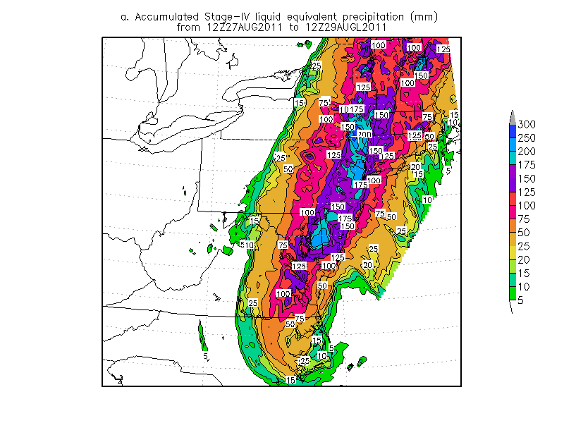
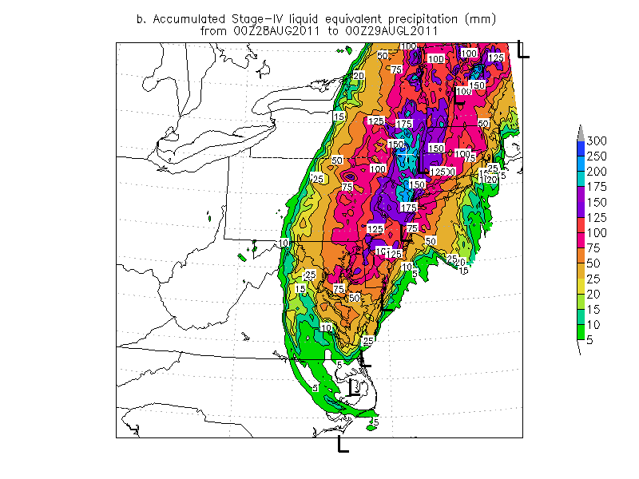
Figure 1. Stage-IV data showing total rainfall for the period of a) 1200 UTC 27 through 12000 UTC 29 August 201 and b) 0000 UTC 28 to 000 UTC 29 August 2011. The 6-hourly position from Irene, taken from the NCEP NAM 00-hour forecasts is shown in panel b. Contours and shading are in (mm) as indicated by the color bar to the right of the image. White plus centered on Woodstock, New York. Return to text.
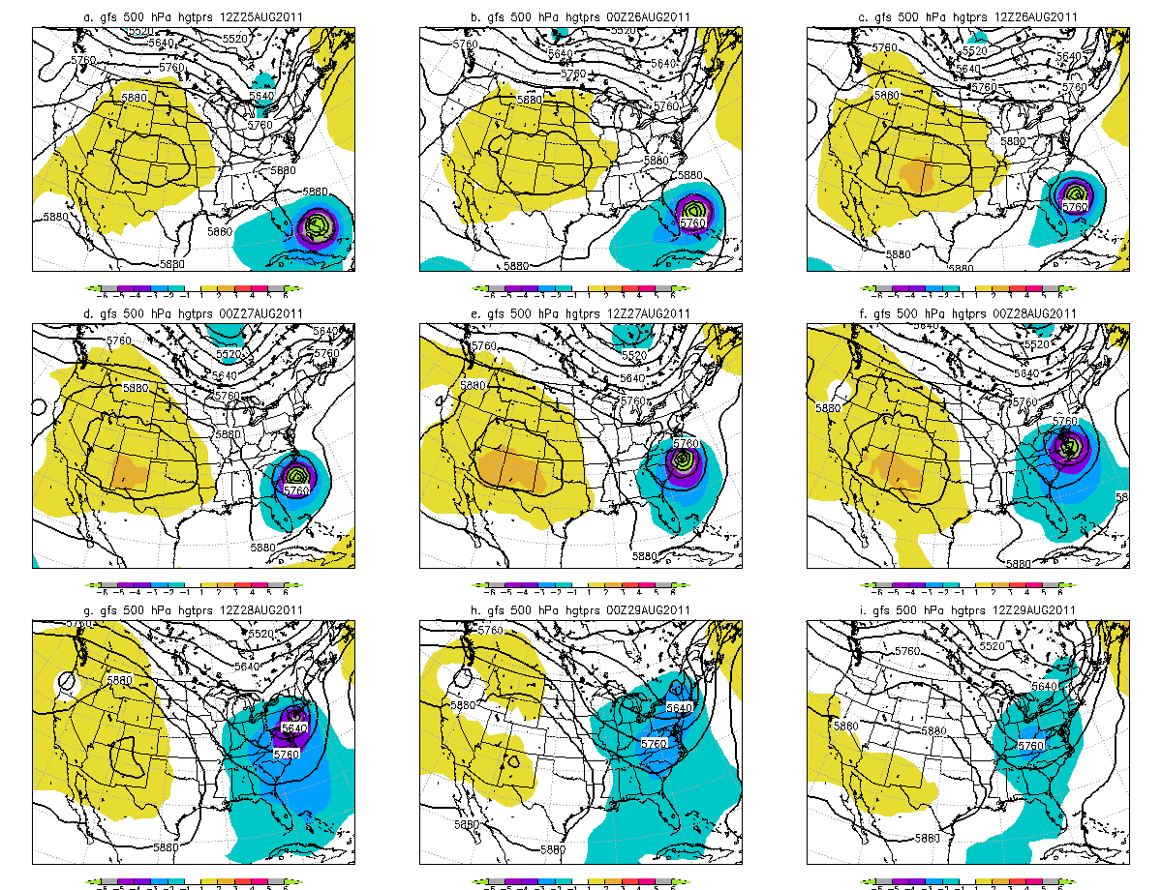
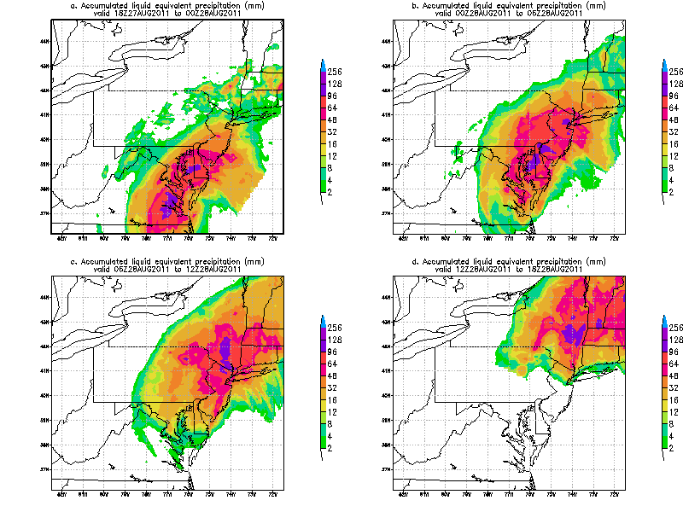
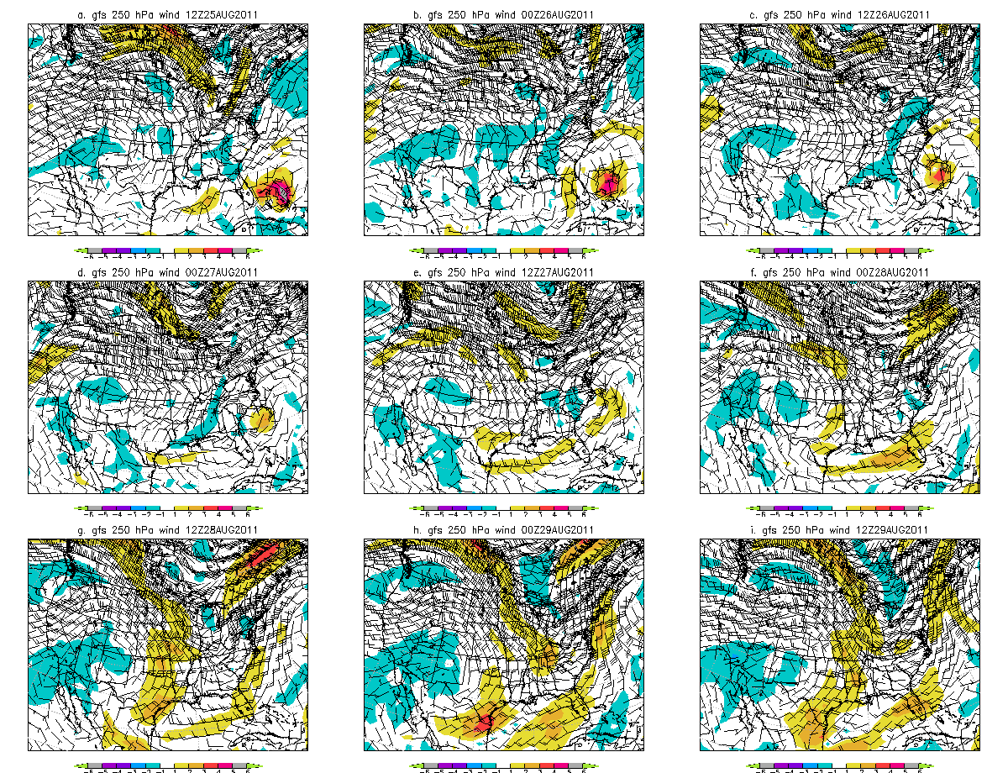
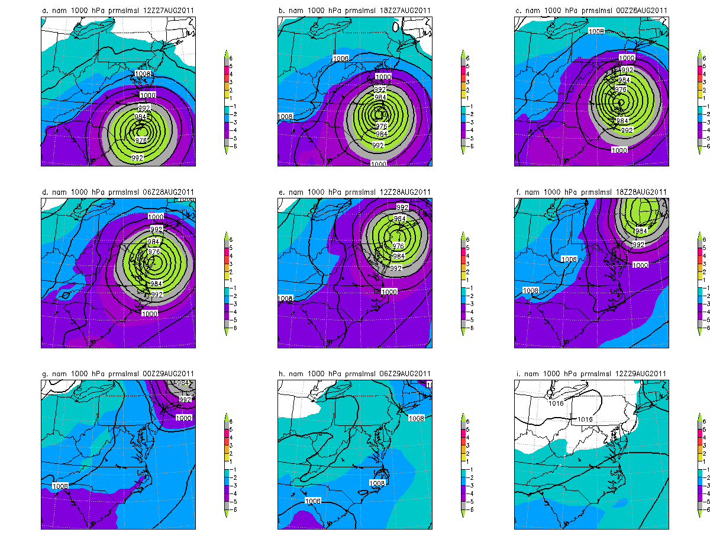
Figure 2 GFS 00-hour forecasts of 500 hPa heights (m) and standardized height anomalies (standard deviations) for the 12-hour period from 1200 UTC 25 August through 1200 UTC 29 August 2011. Return to text.
Figure 3. As in Figure 1 except for precipitation in 6-hour increments from a) 1800 UTC 27 August through d) 1800 UTC 28 August 2011. Return to text.
Figure 4. As in Figure 2 except for 250 hPa winds (ms-1) and total wind anomalies. Return to text.
Figure 5. As in Figure 2 except for mean sea-level pressure (hPa) and pressure anomalies from the NAM in 6-hour increments from a) 1200 UTC 27 August 2011 through i) 1200 UTC 29 August 2011. Return to text.
County | Location | State | Rain
beaufort | BUNYAN | NC | 14.00
GREENE | EAST DURHAM | NY | 13.30
GLOUCESTER | SEWELL | NJ | 13.20
CALVERT | PLUM POINT | MD | 12.96
GREENE | EAST JEWETT | NY | 12.22
WORCESTER | OCEAN CITY | MD | 12.09
TALBOT | EASTON | MD | 11.34
beaufort | WASHINGTON | NC | 11.31
craven | NEW BERN | NC | 11.13
CITY OF SUFFOLK | SUFFOLK AIRPORT | VA | 11.04
Pitt | GRIFTON | NC | 10.53
CAROLINE | HICKMAN | MD | 10.50
RICHMOND | NEWLAND | VA | 10.50
SUSSEX | ELLENDALE | DE | 10.43
HUNTERDON | STOCKTON | NJ | 10.32
carteret | NEWPORT-CROATAN | NC | 10.22
LITCHFIELD | NEW HARTFORD | CT | 10.15
beaufort | WENONA | NC | 10.13
KENT | ADAMSVILLE | DE | 10.00
ST MARYS | CALIFORNIA | MD | 9.76
KENT | VIOLA | DE | 9.64
MORRIS | PETERSBURG | NJ | 9.52
TALBOT | EASTON | MD | 9.44
MORRIS | LINCOLN PARK | NJ | 9.37
SUSSEX | MILFORD | DE | 9.26
SUSSEX | WAKEFIELD | VA | 9.25
BERKSHIRE | SAVOY | MA | 9.00
Table 1. County, town or location and State showing rainfall from gauge reports where the gages received 9 inches or more rainfall during the storm. Data from National Weather Service Public information statements. Return to text.
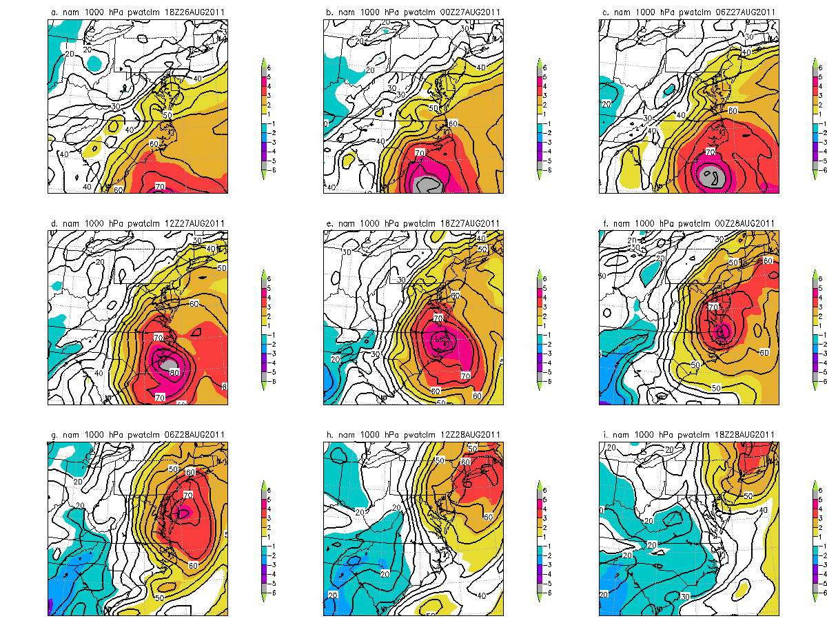
Figure 6. As in Figure 5 except for NAM analysis of precipitable water (mm) and precipitable water anomalies. Return to text.
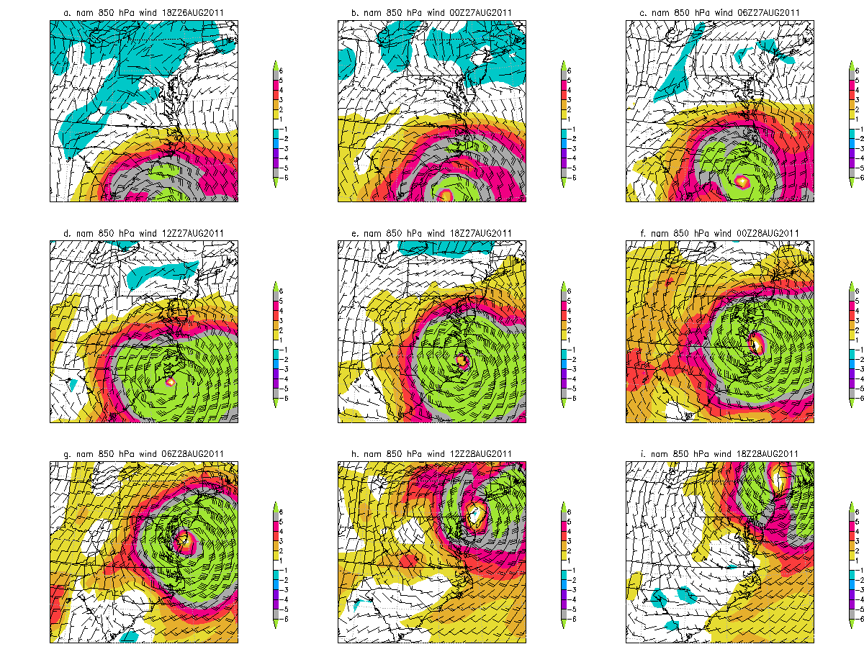
Figure 7. As in Figure 5 except for NAM 00-hour forecast of 850 hPa winds (ms-1) and total wind anomalies. Return to text.

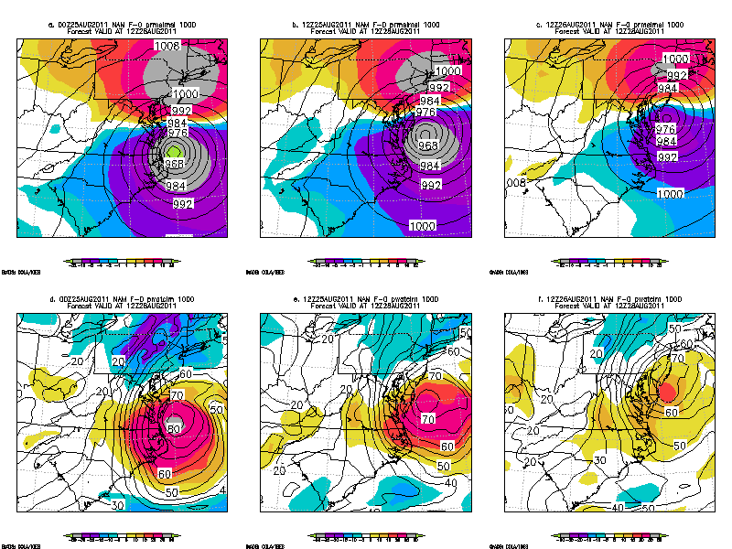
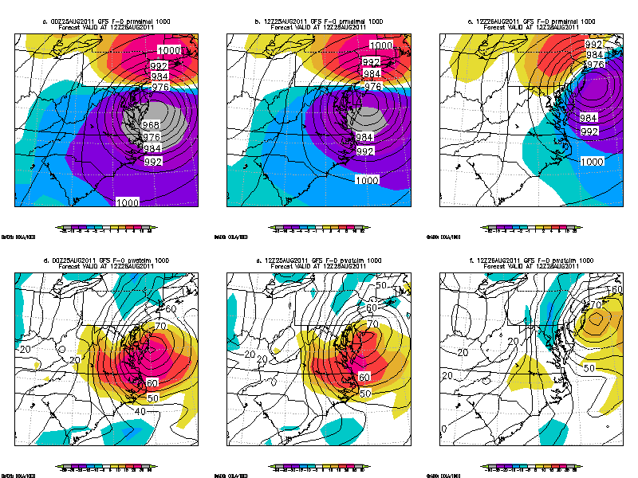
Figure 8. NAM forecasts valid at 1200 UTC 28 August 2011 showing forecasts (contours) and forecast errors (shading) of a) 0000 UTC 25 August NAM mean sea-level (hPa) pressure and pressure errors (hPa), b) 1200 UTC 25 August NAM mean sea-level (hPa) pressure and pressure errors (hPa), c) 1200 UTC 26 August NAM mean sea-level (hPa) pressure and pressure errors (hPa), c) 0000 UTC 25 August NAM precipitable water (mm) and precipitable water errors (mm), d) 1200 UTC 25 August NAM precipitable water (mm) and precipitable water errors (mm), e) 1200 UTC 26 August NAM precipitable water (mm) and precipitable water errors (mm). Isobars are every 4 hPa and precipitable water is every 5mm. Errors are as in the color bars in hPa or mm as required. Return to text.

Figure 9. GFSM forecasts valid at 1200 UTC 28 August 2011 showing forecasts (contours) and forecast errors (shading) of a) 1200 UTC 24 August GFS mean sea-level (hPa) pressure and pressure errors (hPa), b) 1200 UTC 25 August GFS mean sea-level (hPa) pressure and pressure errors (hPa), c) 1200 UTC 26 August GFS mean sea-level (hPa) pressure and pressure errors (hPa), c) 0000 UTC 25 August GFS precipitable water (mm) and precipitable water errors (mm), d) 1200 UTC 25 August GFS precipitable water (mm) and precipitable water errors (mm), e) 1200 UTC 26 August GFS precipitable water (mm) and precipitable water errors (mm). Isobars are every 4 hPa and precipitable water is every 5mm. Errors are as in the color bars in hPa or mm as required. Return to text.

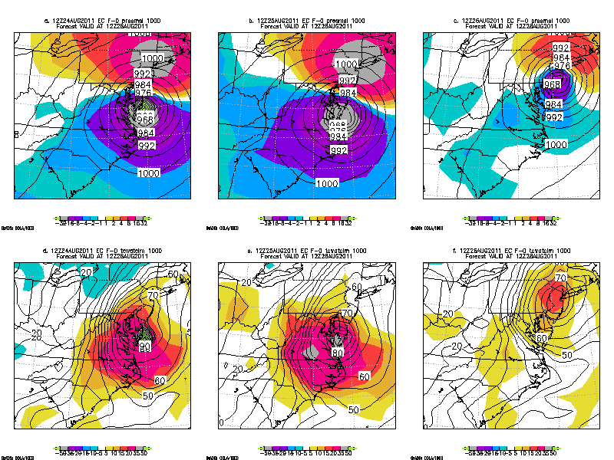
Figure 10. As in Figure 9 except for European Center forecasts. Return to text.
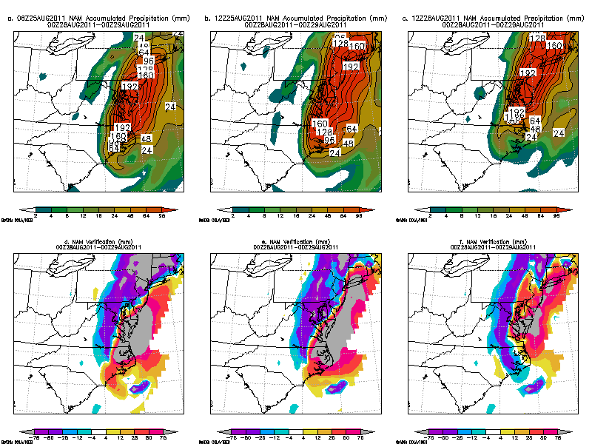
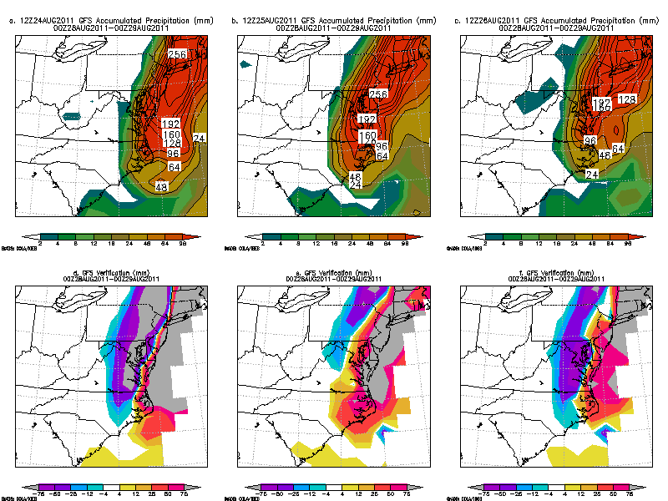
Figure 11. NAM 24-hour quantitative precipitation forecasts (mm) valid at 0000 UTC and precipitation errors (mm) from NAM forecasts initialized at a&d) 0600 UTC 25 August 2011, b&e) 1200 UTC 25 August 2011, and c&f) 1200 UTC 26 August 2011. Return to text.
Figure 12. GFS 24-hour quantitative precipitation forecasts (mm) valid at 0000 UTC and precipitation errors (mm) from GFS forecasts initialized at a&d) 1200 UTC 24 August 2011, b&e) 1200 UTC 25 August 2011, and c&f) 1200 UTC 26 August 2011. Return to text.

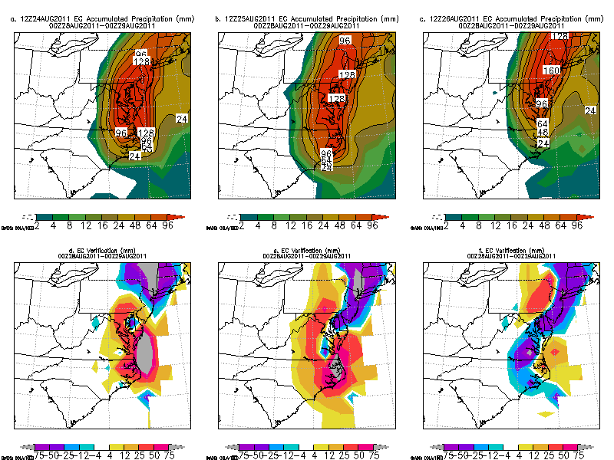
Figure 13. As in Figure 12 except for EC 24-hour precipitation forecasts valid at 0000 UTC 29 August 2011. Return to text.
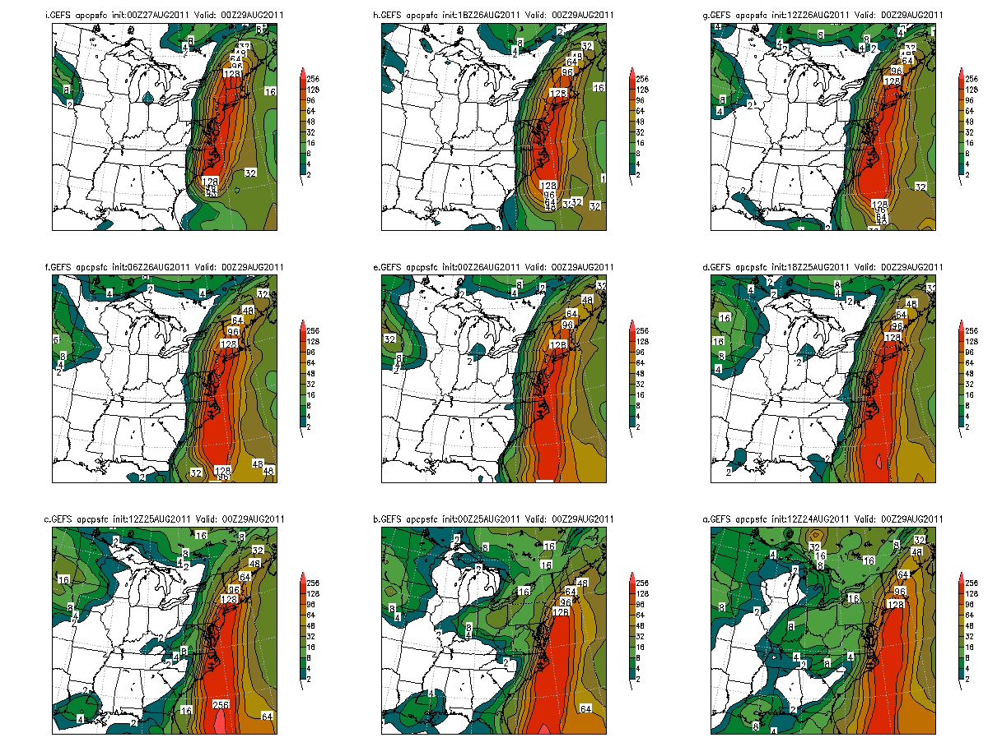
Figure 14. NCEP Global Forecast system total accumulated QPF for the period ending at 0000 UTC 29 August 2011 from forecasts initialized at a) 0000 UTC 27 August, b) 1800 UTC 26 August, c) 1200 UTC 26 August, d) 0600 UTC 26 August, e) 00000 UTC 26 August 2011, f) 1800 UTC 25 August, g) 1200 UTC 25 August, h) 0000 UTC 25 August and i) 1200 UTC 24 August 2011. Return to text. (need to re-letter text).

Rank | Date | Points | Minor | Moderate | Major | Unknown | Mod + Maj | Number
1 | 8/17/1955 - 8/21/1955 | 71 | 17 | 19 | 34 | 1 | 53 | 453
2 | 8/27/2011 - 9/X/2011 | 46 | 14 | 12 | 20 | 0 | 32 | 274
3 | 8/23/1933 - 8/25/1933 | 35 | 16 | 10 | 9 | 0 | 19 | 156
Table 2. Flood records sorted by rank based on points over flood stage, the date of the flood and the number of points to exceed thresholds of flood stages. Return to text.

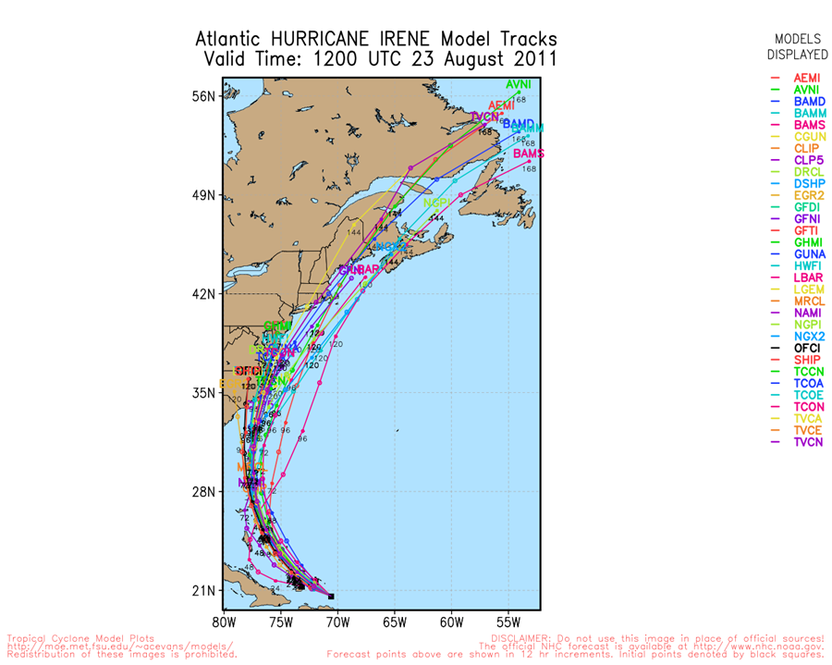
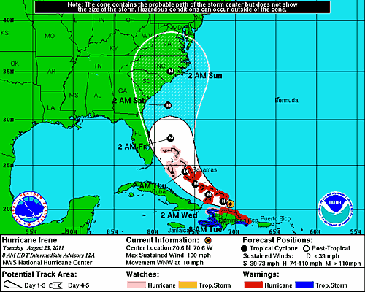

Based on NHC archives on Hurricane Irene accessible at http://www.nhc.noaa.gov/archive/2011/IRENE.shtml

