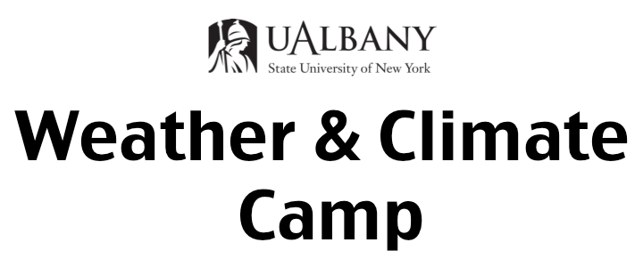

Overview
The University at Albany Weather & Climate Camp (UAWCcamp) is a weeklong day camp for teens from the Capitol District's urban centers (Schenectady, Albany, Troy). The UAWCcamp is designed to be an interactive experience where students learn about the science of weather and climate through first hand experience under the instruction of experts in the field. Students will also learn about: career opportunities and the college application & financial aid process.
Funding for the UAWCcamp is provided by the National Science Foundation. The camp is hosted by the University at Albany Department of Atmospheric and Environmental Science and lead by Assistant Professor Justin Minder.

Logistics

Students attend the UAWCcamp free of charge. The camp will meet on the University at Albany main campus from 9am-5pm each day during the week of Aug 6-10, 2018. One day of the camp will have extended hours (approximately 7 am-8:30 pm) to allow a field trip to the Whiteface Mountain Observatory in the Adirondack Mountains. Lunch will be provided free of charge each day.

Eligibility

Current 9th, 10th, and 11th graders from Schenectady, Albany, Troy, Rensselaer, and Watervliet are eligible. Fill out a short form to apply.

For more information
- Check out the website:
  - http://www.atmos.albany.edu/facstaff/jminder/UAWCcamp
- Contact Justin Minder (camp organizer):
  - jminder@albany.edu
  - 518-437-3732

Student Application for UAlbany Weather & Climate Camp

Complete the following application form (in its entirety, including reference letter) and return it by April 20th by one of the following methods:

- Complete in electronic format (including scanned parent/guardian signature) and email to Dr. Justin Minder:
jminder@albany.edu

…OR…

- Mail completed paper copy to:
Dr. Justin Minder, Weather Camp Coordinator
DAES – ES 351
State University of New York at Albany
1400 Washington Ave
Albany, NY 12222

Contact Justin Minder, Weather Camp organizer, with any questions
(518-437-3732 jminder@albany.edu)

Contact information

Name: ________________________________________
Camper Email: _______________________________ Gender: __________
Parent/Guardian Email: ____________________________

Address: ________________________________________
________________________________________

Phone number: ________________________

Secondary phone number: _________________________

School name: ________________________________

School address: ______________________________________________________________

How did you hear about Weather Camp? _____________________________

Birthdate: ____________ Current grade level: ________ Expected graduation year: ________

Current GPA: ________

High School coursework completed or in progress
Please list courses using descriptive names, NOT course numbers. For example “algebra I, algebra II” NOT “math 203, 204”.

List all of your high school math courses to date:

List all of your high school science courses to date:

List and briefly describe all academic extracurricular activities you have participated in that might relate to Weather Camp (math or science fairs, summer camps, outdoor experiences, etc).

Letter of Recommendation

Please include one letter of recommendation from either a science or math teacher. Provide the teacher information about the camp (website or description) and ask them to comment on:
- Your motivation to learn
- Your academic skills
- Your in-class behavior

Send recommendation to Dr. Justin Minder (above email or mail address) by April 20th. Only sealed envelopes or emails directly from teachers are acceptable.

Written Responses
Please write short responses (<300 words each) to the following:

Written response 1: Describe either a weather or climate phenomena that interests you or an event that impacted you. Why is this interesting to you?

Written response 2: What do you hope to get out of Weather Camp? Why do you wish to be selected to participate in this program?

