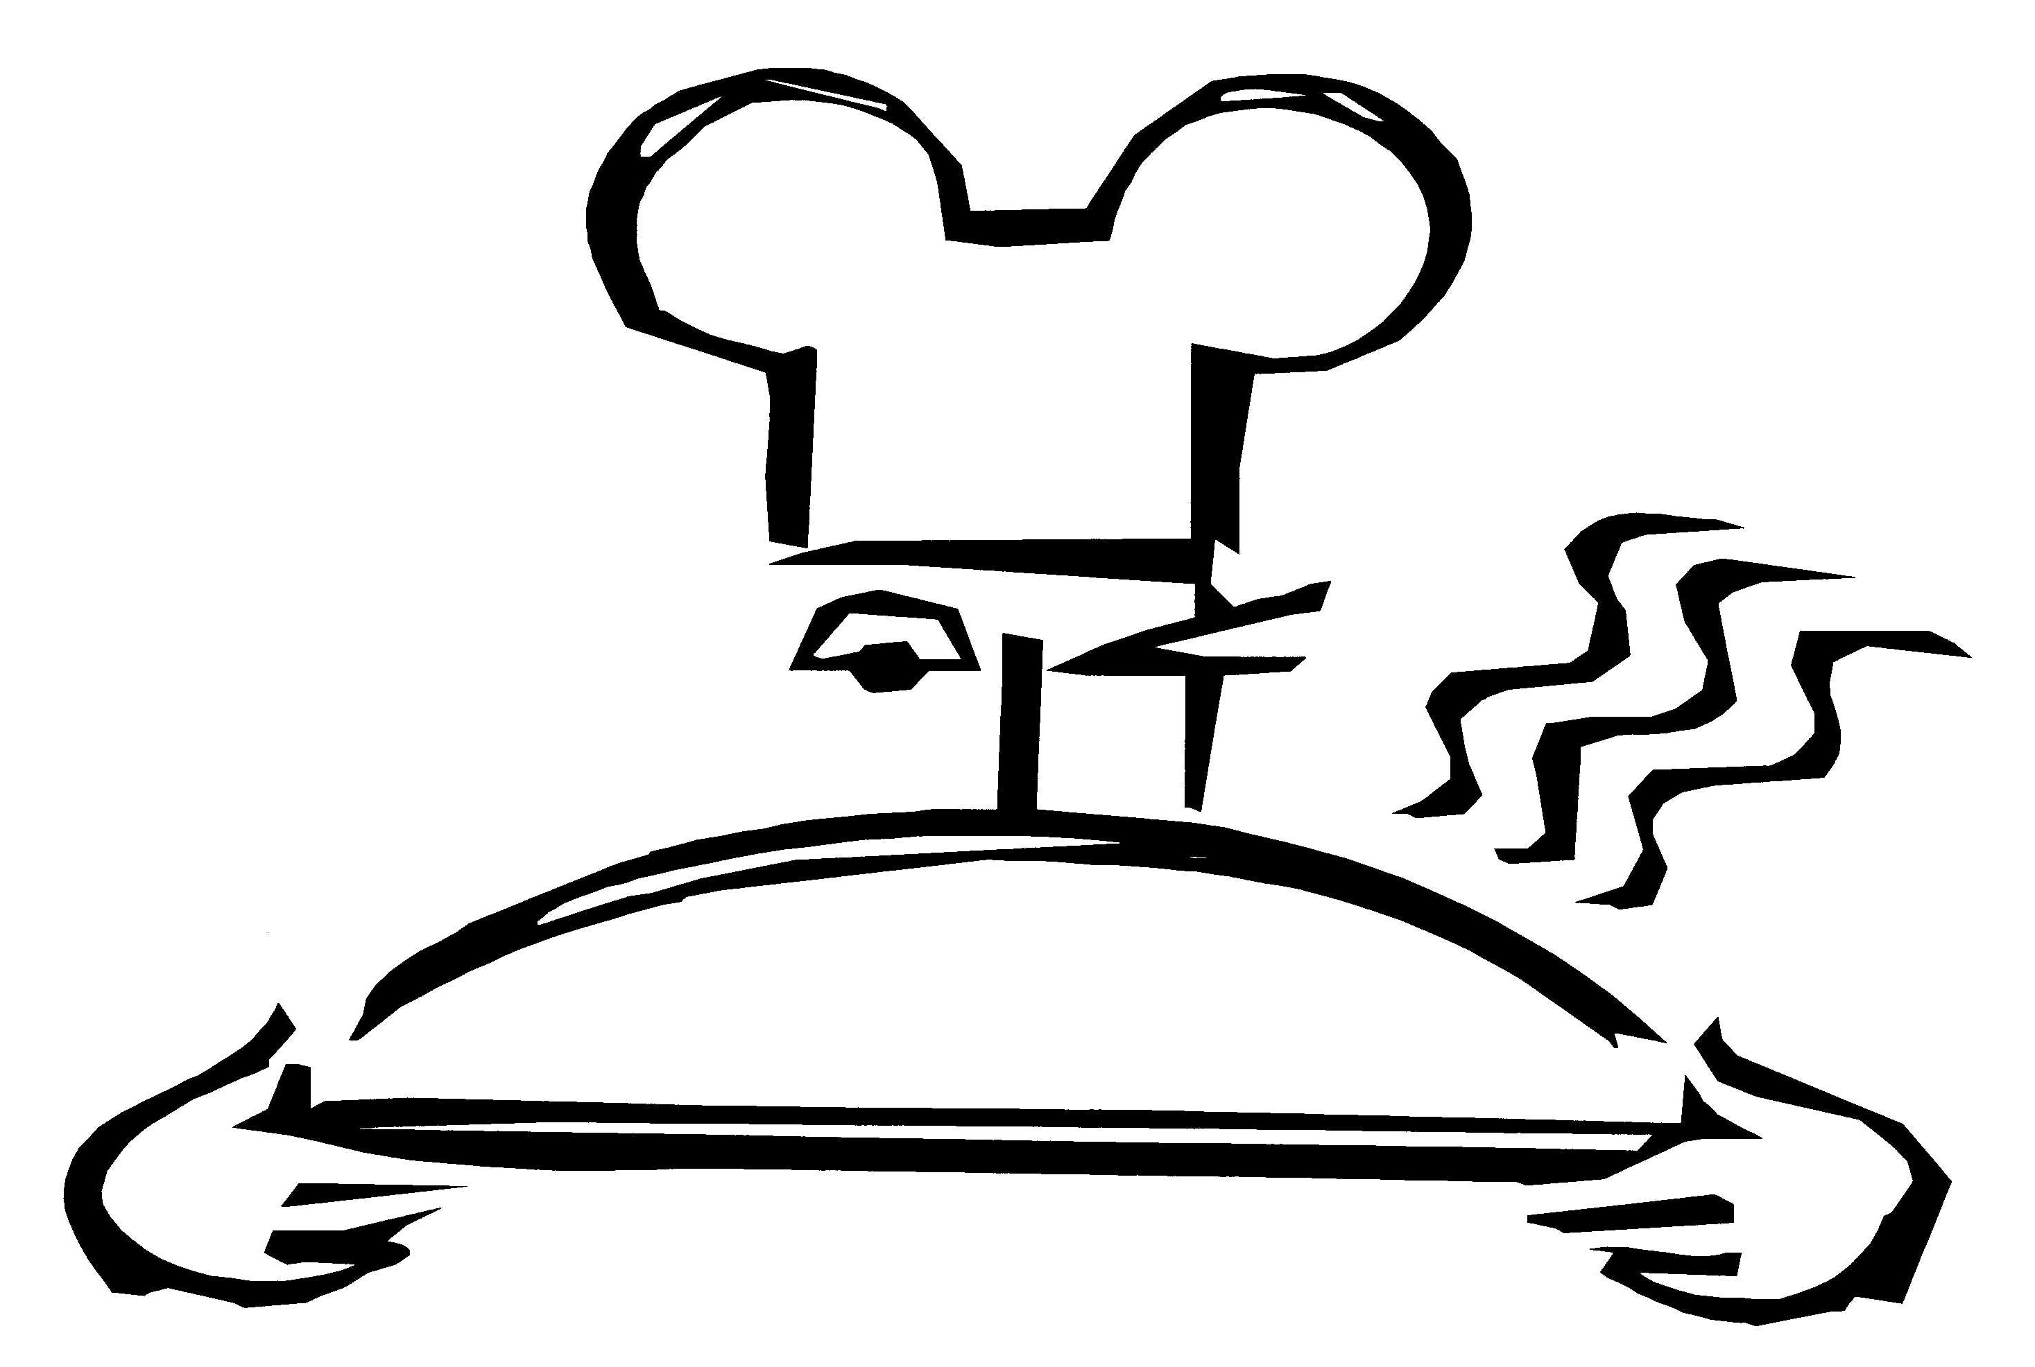

Walt Disney World®
Food & Beverage

MAGIC KINGDOM® Park
No Gluten Added Products

Below are products that we believe are gluten-free based on our review of the manufacturer’s ingredient label. **Always ask to speak to a chef or manager, vendors and ingredients change and we are always striving to improve. Ingredient labels are available upon request.

Cosmic Ray’s Starlight Cafe | Aloha Isle
Rotisserie Chicken | Pineapple juice, Dole
Hamburger with an EnerG Foods Hamburger Bun | Dole Whip Vanilla
Hot Dog with an EnerG Foods Hot Dog Bun | Dole Whip Chocolate
Fries done in an oven | Dole Whip Pineapple

Grilled chicken on an EnerG Foods Bun
 | Sunshine Tree
El Pirata Y El Perico (Seasonal) | Orange Concentrate
Chips | Vanilla flavored ice cream
Salsa | Chocolate flavored ice cream
Turkey Wagon/Lunching Pad | Pinocchio Village Haus
Smoked Turkey Drumstick - Crofton & Sons | Gluten-free Pizza (Amy’s)
Scuttle’s Landing | Pecos Bills Tall Tale Inn & Cafe
Assorted carbonated frozen beverages | Hamburger with EnerG Foods Bun
Toon Town Farmer’s Market/Liberty Square Market | Main Street Bakery
Fresh fruit and fruit cups | Cut Fruit
Potato Cart – Liberty Square | *Delicious Fudgie Brownie - It’s OK
 | *Chocolate Chip Cookie – It’s OK
Plaza Ice Cream Parlor | *Crispy Rice Treat – It’s OK
Gluten-free ice cream | * Also lactose and peanut free
Dairy-free ice cream

Outdoor food carts
Itzakadoozie Cool Creations | Auntie Gravities
Minnie’s Strawberry Fruit Bar – Natural Fruit Corp. | Soft serve without the cone
Mickey’s Premium Ice Cream Bar | Smoothies – Strawberry, Banana
Huey, Duey & Louie Orange Juice Bar – Natural Fruit | Cappuccino, Mango-Passion,
Minute Maid Frozen Lemonade – Coca Cola | Orange-Pineapple, Pina-Colada
Popcorn
Frozen Banana | Enchanted Grove
 | Strawberry Swirl
 | Soft Serve Vanilla without cone

Walt Disney World®
Food & Beverage

Epcot®
No Gluten Added Products

**Always ask to speak to a chef or manager, vendors and ingredients change.
Ingredient labels are available upon request.

Liberty Inn
Hamburger with EnerG Foods Hamburger Bun
Hot dog with EnerG Foods Hot Dog Bun
Pizza (Amy’s)
Macaroni and Cheese (Amy’s)
Baked Fries with Advance Notice
Chocolate Chip Cookies (GLP)
Brownie (GLP)
Turkey Cart in American Adventure
Smoked Turkey Drumstick – Croften and Sons
Outdoor Food Carts
Itzakadoozie Cook Creations
Mickey’s Premium Ice Cream Bar
Minnie’s Strawberry Fruit Bars – Natural Fruit Corp.
Huey, Duey & Louie Orange Juice Bar – Natural Fruit Corp.
Popcorn
Minute Maid frozen Lemonade
Frozen Banana
Fresh Fruit
Hot Dog Cart
Hot Dog without Bun
Sunshine Seasons (Located in the Land Pavilion)
Brownie
Rice Pasta with Advance Notice
Dinner Roll with Advance Notice
Chocolate Chip Cookies (Pamela’s)
Pecan Shortbread Cookies (Pamela’s)

Turkey Cart – Test Track
Turkey Leg

Walt Disney World®
Food & Beverage

Disney’s Animal Kingdom® Park
No Gluten Added Products
Below are products that we believe are gluten-free based on our review of the manufacturer’s ingredient label. **Always ask to speak to a chef or manager, vendors and ingredients change and we are always striving to improve. Ingredient labels are available upon request.

AFRICA
Harambe Fruit Cart
Fresh fruit and Fruit Cups

DISCOVERY ISLAND
Flame Tree BBQ
BBQ Ribs and BBQ Chicken
BBQ Chicken Salad w/o Tortilla

Fresh Fruit Plate

Minute Maid Soft Frozen Lemonade

Turkey Wagon
Smoked Turkey Drumstick – Crofton & Sons

Pizzafari
Amy’s Rice Crust Cheese Pizza

DINOLAND
Restarantosaurus | Dino Diner
Hamburger w/EnerG Foods Hamburger Bun | Assorted Carbonated Frozen Beverages

Hot dog w/Ener-G Foods Hot Dog Bun
Amy’s Rice Mac & Cheese | Dino Bites
 | Ice Cream

OUTDOOR FOOD CARTS
Frozen Strawberry Fruit Bar – Natural Fruit Corp. | Frozen Banana
Mickey’s Premium Ice Cream Bar | Popcorn
Frozen Orange Juice Bar – Natural Fruit Corp. | Minute Maid Frozen Lemonade – Coca Cola

Walt Disney World®
Food & Beverage

Disney’s Hollywood Studios™
No Gluten Added Products
Below are products that we believe are gluten-free based on our review of the manufacturer’s ingredient label. **Always ask to speak to a chef or manager, vendors and ingredients change and we are always striving to improve. Ingredient labels are available upon request.

Teen’s and Tween’s
Soft Serve Ice Cream without the cone
Smoothie’s- Mango-Passion, Orange-Pineapple, Strawberry, Banana, Cappuccino

ABC Commissary
All-Beef Hamburger with the Ener-G Foods Bun
French Fries in a designated fryer

Backlot Express
All-Beef Hamburger with the Ener-G Foods Bun
All-Beef Hot Dog with Ener-G Foods Bun
Black Bean Salad
Southwest Salad

Dinosaur Gertie’s
Chocolate and Vanilla Soft Serve Ice Cream without the cone

Min & Bill’s Dockside Diner
Chocolate and Vanilla Milk Shakes

Outdoor Foods
Frozen Banana
Itzakadoozie
Mickey’s Premium Ice Cream Bar
Minnie’s Strawberry Fruit Bar
Popcorn

Studio Catering Co. Flatbread Grill
Grilled Chicken Breast Quarter with Black Beans and White Rice
Greek Salad
All-Beef Hot Dog without the Chili

Sunset Market Ranch

Anaheim Produce: Whole Fruits, Seasonal Berries, Carrots, Grapes, and Mixed Fruit

Rosie’s: Hamburger without the Bun – Potato Salad
Toluca Legs: Smoked Turkey Leg, All-Beef Hot Dog without Chili, Pork Salad

Toy Story Pizza Planet
Amy’s Brand Gluten Free Pizza
Toy Story Chicken Salad
Caprese Salad
Side Salad

