FIGURES

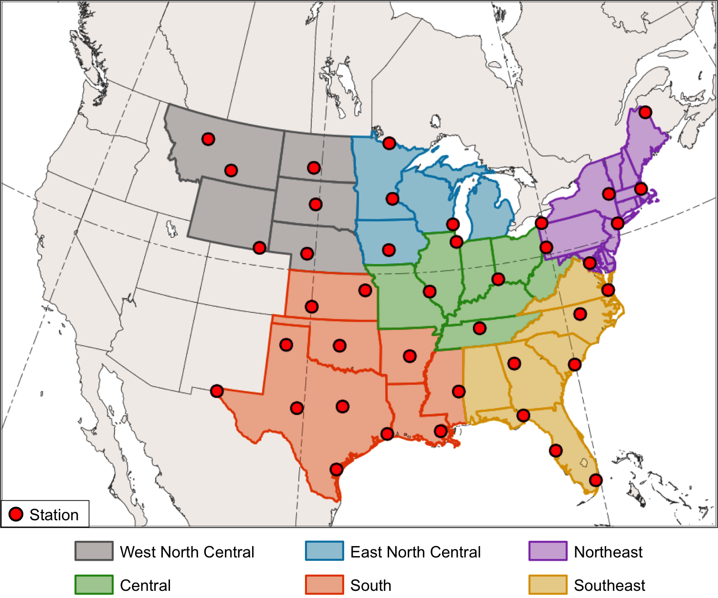

FIG. 1. NCEI climate regions (color shading) and GHCN-Daily stations (red dots) over the central and eastern U.S. used in Murphy (2017).
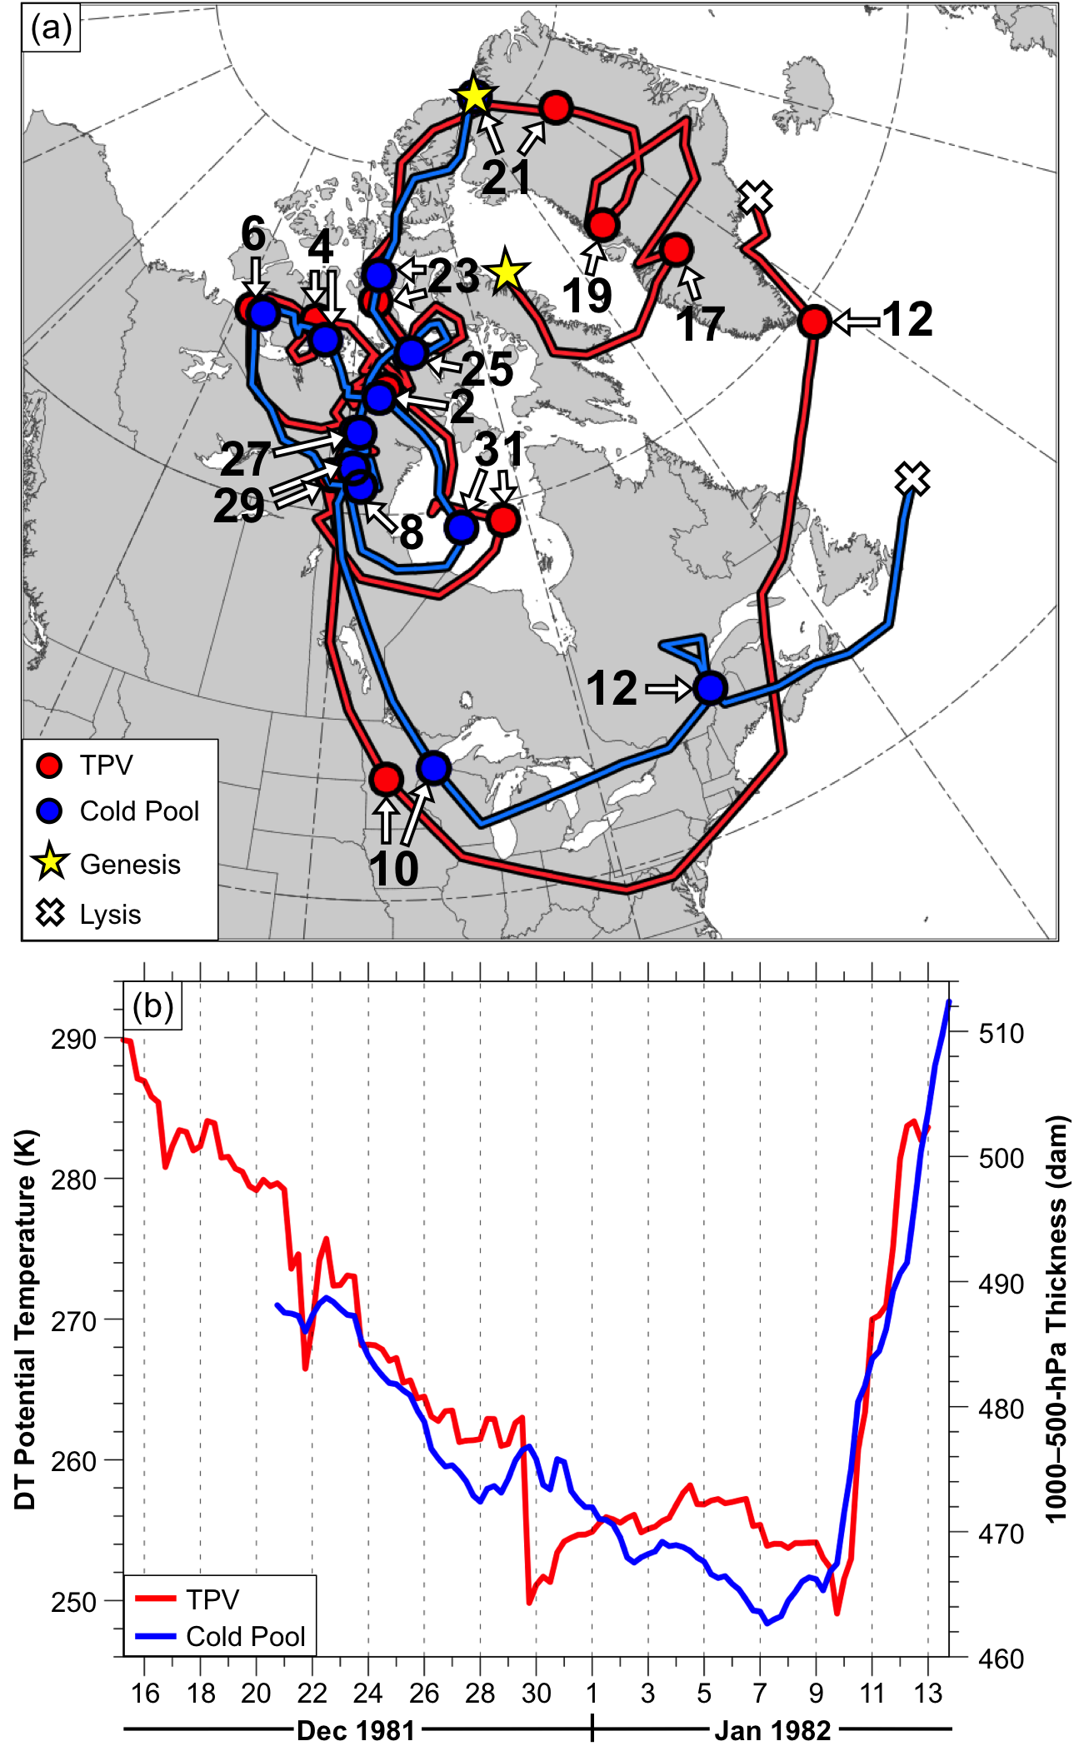
FIG. 2. (a) Tracks of TPV (red) every 6 h from 0600 UTC 15 December 1981 to 0000 UTC 13 January 1982 and cold pool (blue) every 6 h from 1800 UTC 20 December 1981 to 1800 UTC 13 January 1982 for January 1982 CAO case. Stars denote locations of genesis, crosses denote locations of lysis, and red and blue dots denote 0000 UTC positions of TPV and cold pool, respectively, every 48 h. Numbers adjacent to arrows pointing toward dots denote dates of the 0000 UTC positions of the TPV and cold pool. (b) Time series of minimum DT potential temperature of TPV (K, red) and minimum 1000–500-hPa thickness of cold pool (dam, blue) every 6 h for same respective time periods as in (a).

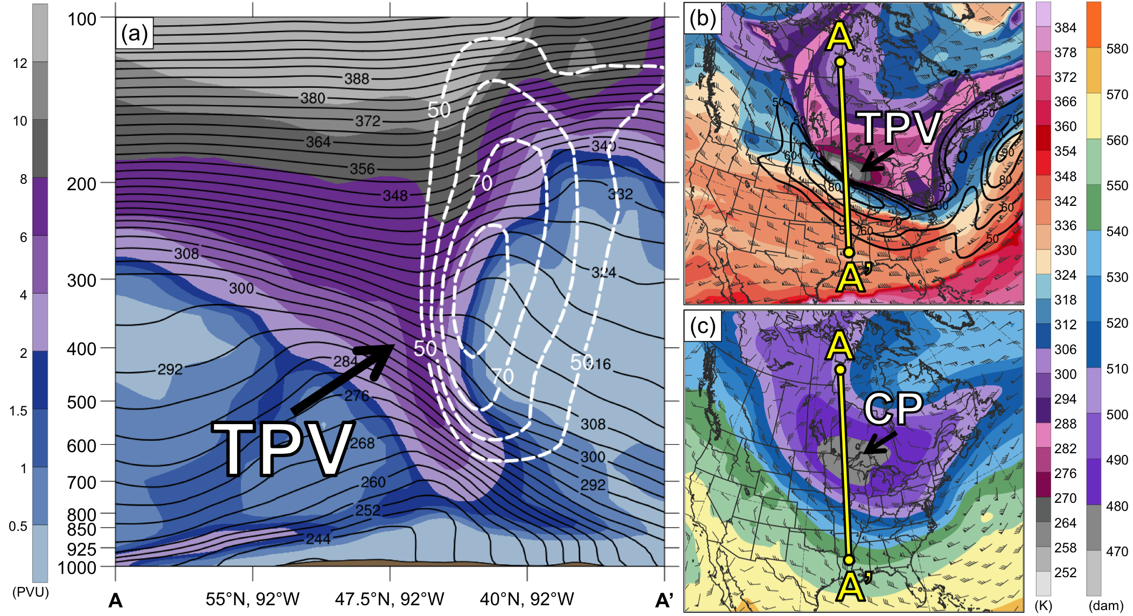

FIG. 3. (a) Cross section along line AA’ of PV (PVU, shading), potential temperature (K, black), and wind speed (dashed white contours every 10 m s⁻¹, beginning at 50 m s⁻¹); (b) DT (2-PVU surface) potential temperature (K, shading), wind speed (black contours every 10 m s⁻¹, beginning at 50 m s⁻¹), and wind (m s⁻¹, flags and barbs); and (c) 1000–500-hPa thickness (dam, shading) and 700-hPa wind (m s⁻¹, flags and barbs). Yellow line in (b) and (c) denotes location of cross section AA’. Labels “TPV” and “CP” denote locations of TPV and cold pool, respectively. Analyses shown in (a)–(c) are for 0000 UTC 10 January 1982. Data source: ERA-Interim.

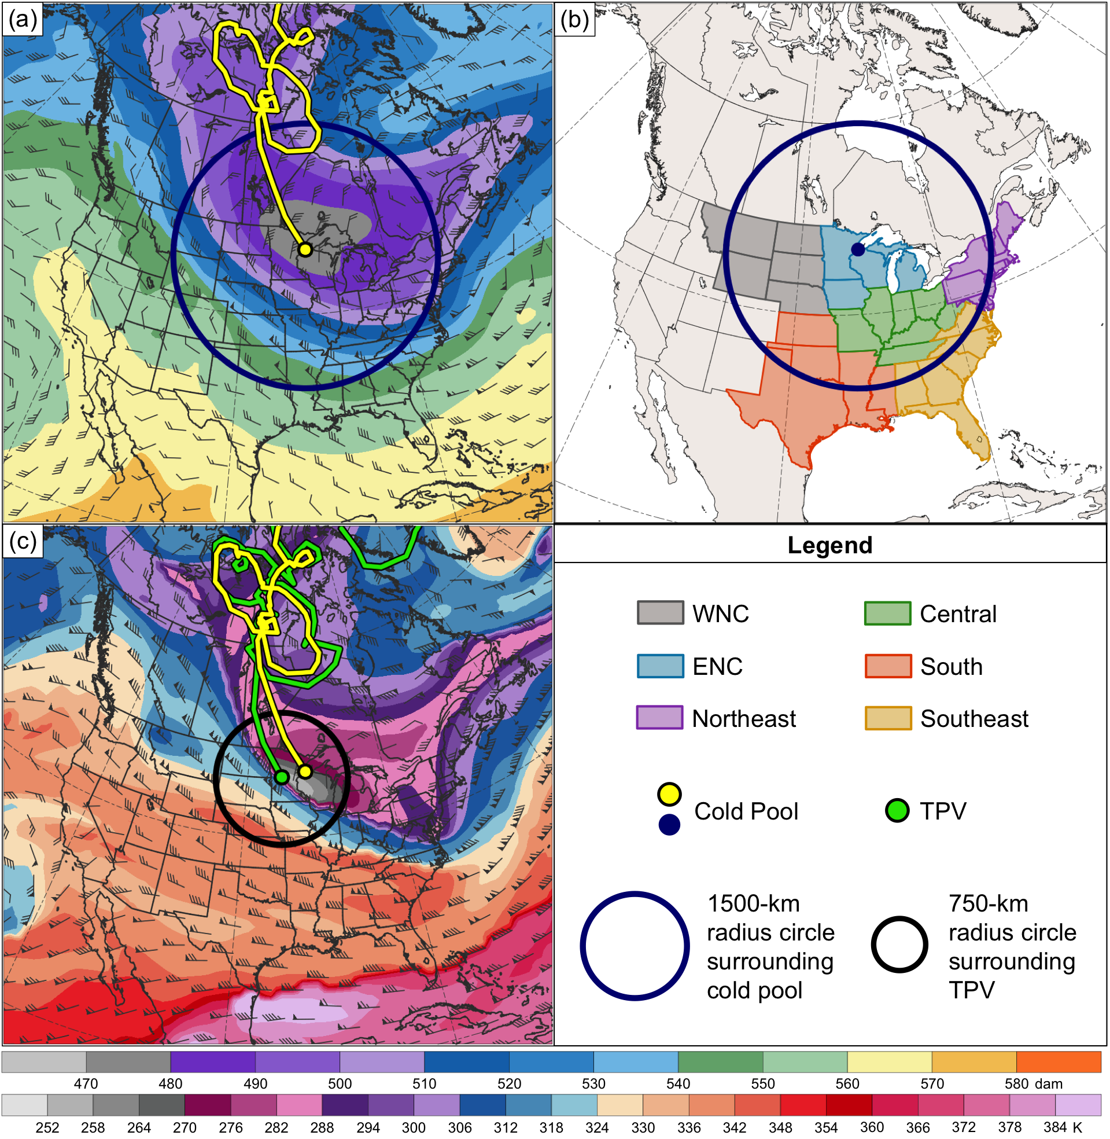

FIG. 4. (a) 1000–500-hPa thickness (dam, shading), 700-hPa wind (m s⁻¹, flags and barbs), cold pool track (yellow line), and 1500-km radius circle (blue circle) surrounding cold pool center (yellow dot) at 0000 UTC 10 January 1982. (b) NCEI climate regions (color shading) and same circle as in (a) surrounding cold pool center (blue dot) at 0000 UTC 10 January 1982. (c) DT (2-PVU surface) potential temperature (K, shading) and wind (m s⁻¹, flags and barbs), TPV and cold pool tracks (green and yellow lines, respectively), position of TPV center and cold pool center (green and yellow dots, respectively), and 750-km radius circle (black circle) surrounding TPV center at 0000 UTC 10 January 1982. TPV and cold pool tracks are repeated from Fig. 2a from the respective times of genesis of the TPV and cold pool to 0000 UTC 10 January 1982. Data source: ERA-Interim.

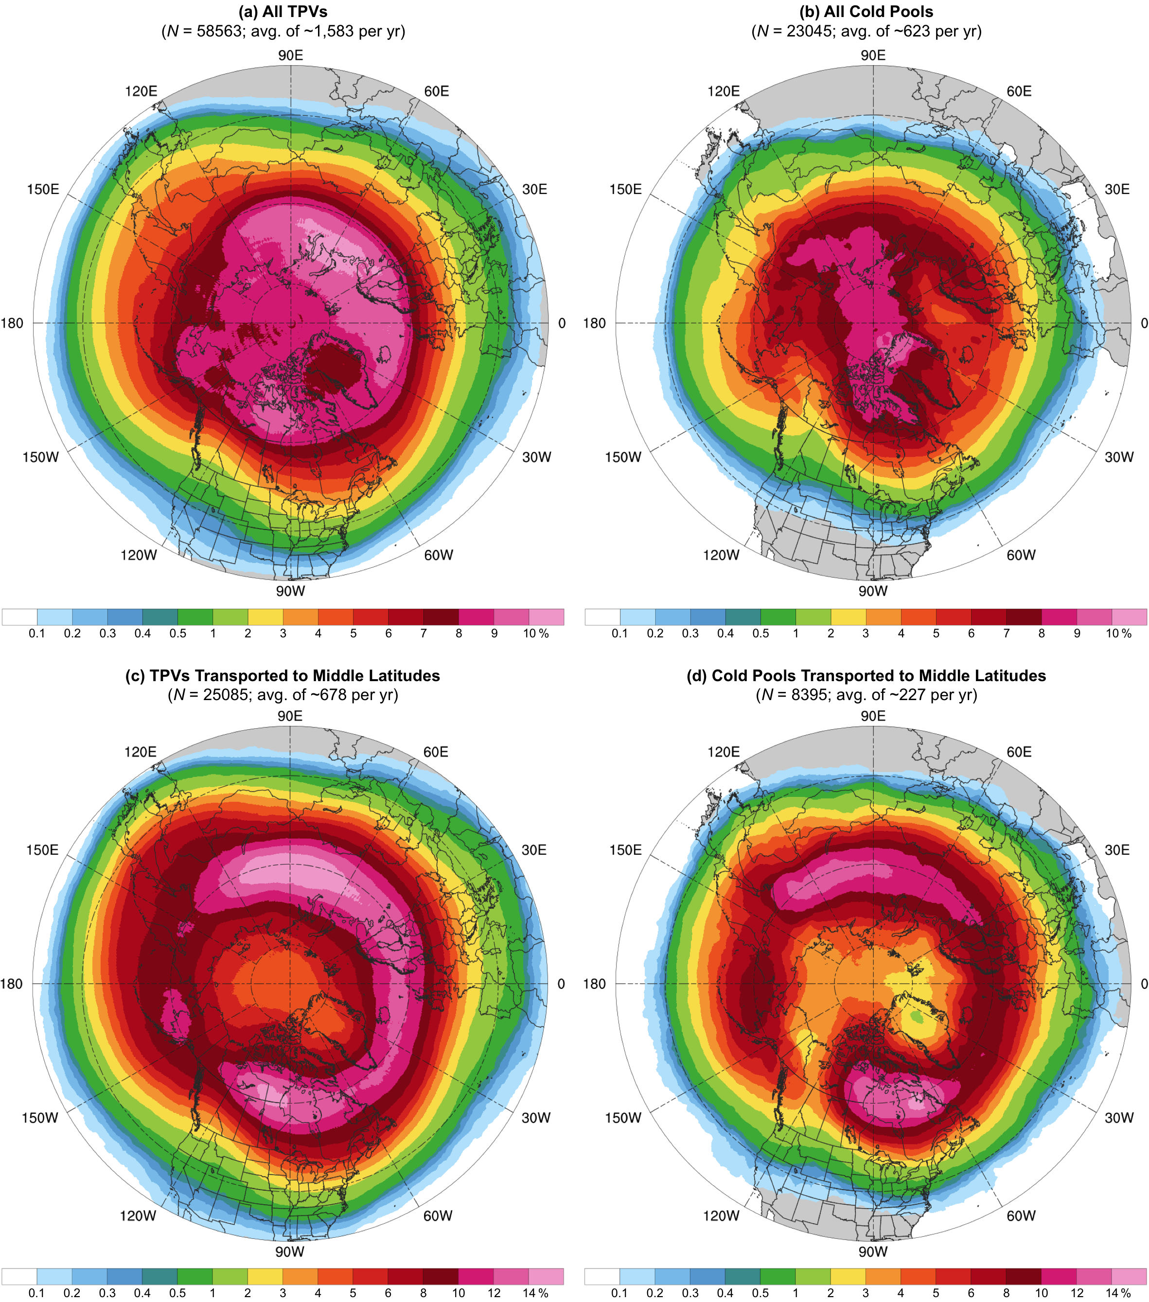

FIG. 5. Track density of (a) all TPVs, (b) all cold pools, (c) TPVs transported to middle latitudes (equatorward of 60°N), and (d) cold pools transported to middle latitudes (equatorward of 60°N), shaded according to the percentage of these respective features passing within 500 km of a given grid point (using a 0.5° grid) during 1979–2015 when normalized by the total number of these respective features. An individual TPV and an individual cold pool can only be counted once for the track density at a given grid point.
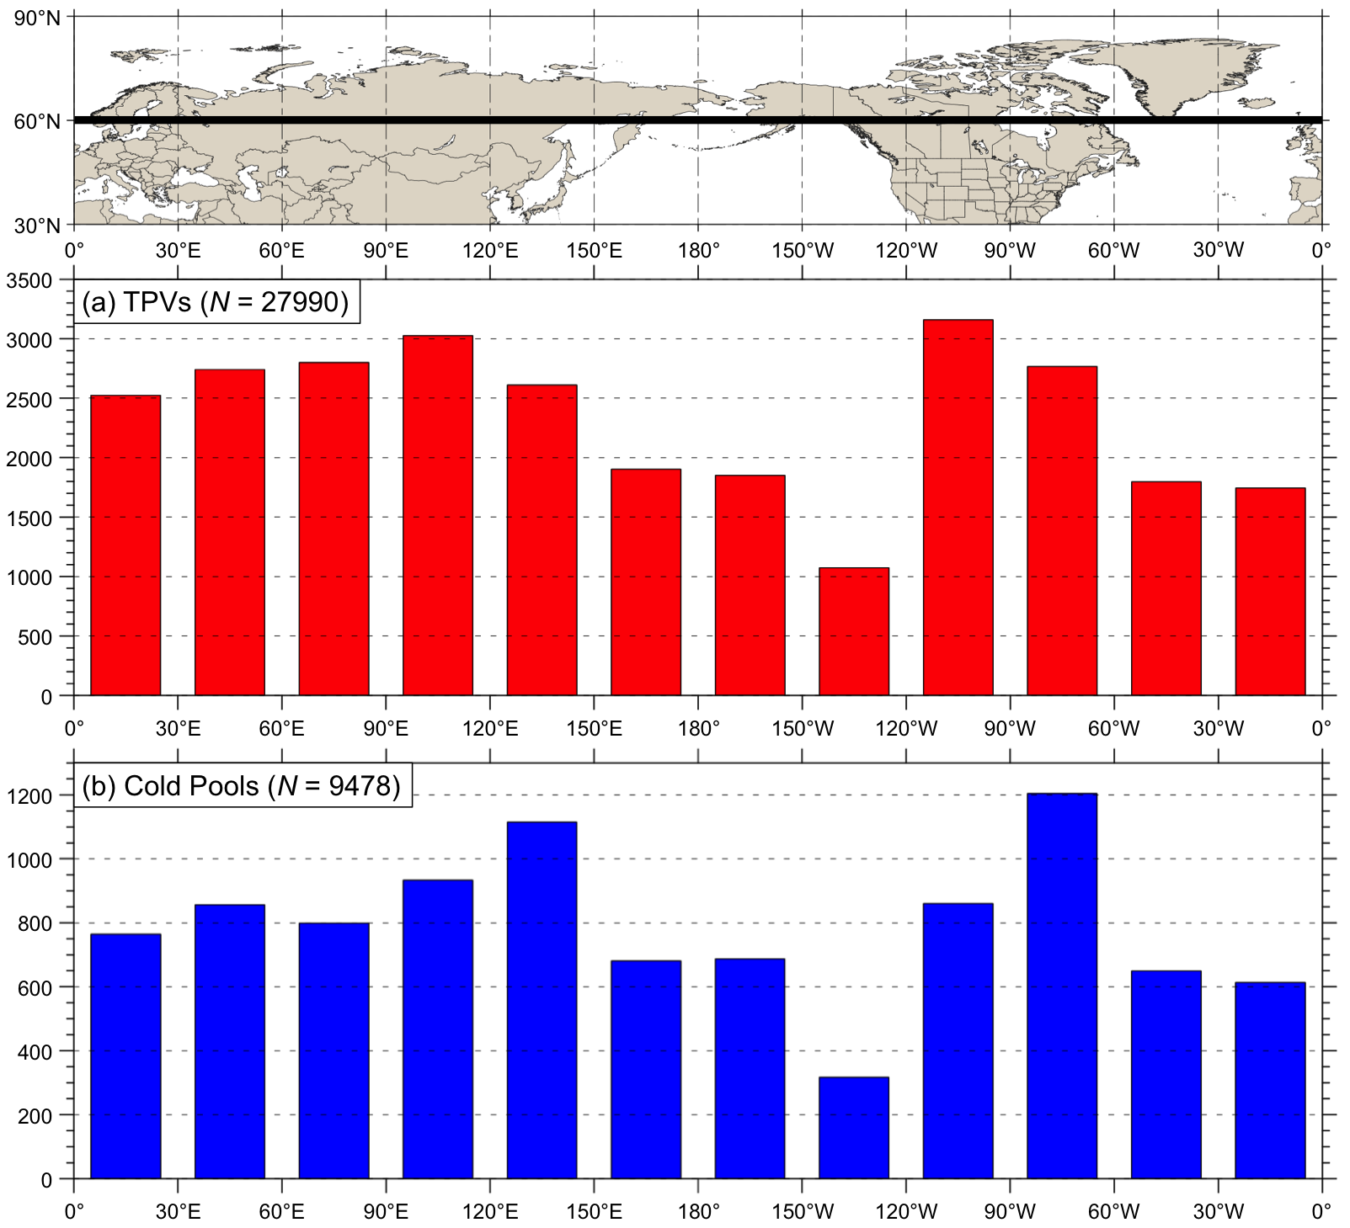

FIG. 6. Histograms showing the total number of instances in which (a) TPVs and (b) cold pools cross equatorward of 60°N (black line on map) for each 30° longitudinal bin globally during 1979–2015. An individual TPV and an individual cold pool may be counted more than once if they cross equatorward of 60°N after returning poleward of 60°N.

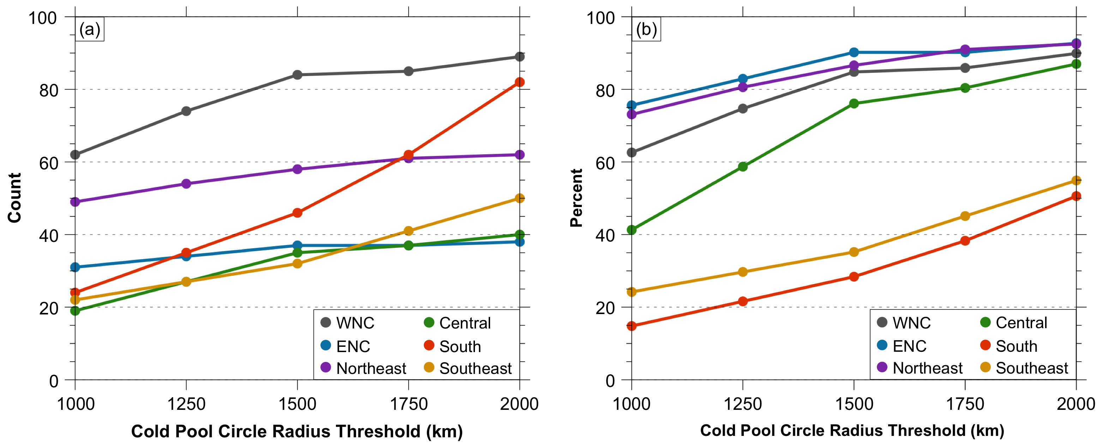

FIG. 7. (a) Number and (b) percentage of CAOs linked to cold pools for each climate region and for cold pool circle radius thresholds of 1000 km to 2000 km, every 250 km. Percentage of CAOs linked to cold pools is defined as number of CAOs linked to cold pools divided by number of CAOs (given in Table 2).

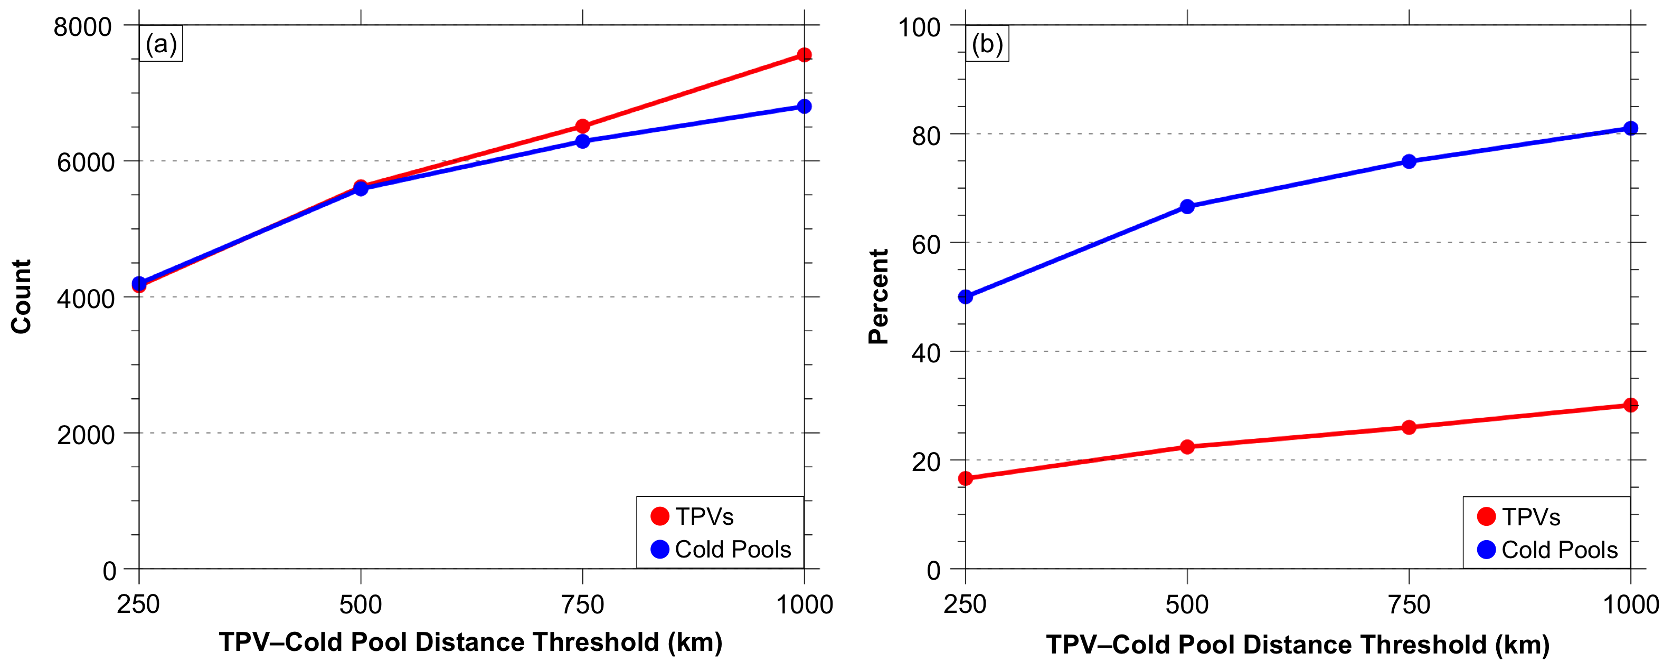

FIG. 8. (a) Number and (b) percentage of TPVs associated with cold pools (red) and cold pools associated with TPVs (blue) for TPV–cold pool distance thresholds of 250 km to 1000 km, every 250 km. Percentage of TPVs associated with cold pools is defined as number of TPVs associated with cold pools divided by number of TPVs transported to middle latitudes (given in Fig. 5c). Percentage of cold pools associated with TPVs is defined as number of cold pools associated with TPVs divided by number of cold pools transported to middle latitudes (given in Fig. 5d).

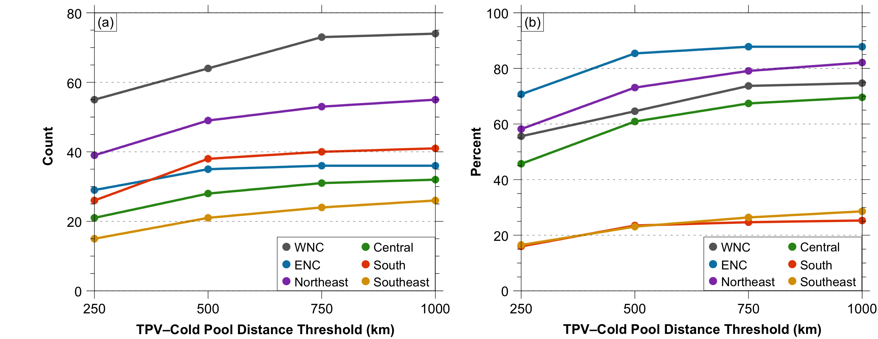

FIG. 9. (a) Number and (b) percentage of CAOs linked to cold pools associated with TPVs for each climate region and for TPV–cold pool distance thresholds of 250 km to 1000 km, every 250 km. A 1500-km cold pool circle radius threshold is used. Percentage of CAOs linked to cold pools associated with TPVs is defined as number of CAOs linked to cold pools associated with TPVs divided by number of CAOs (given in Table 2).

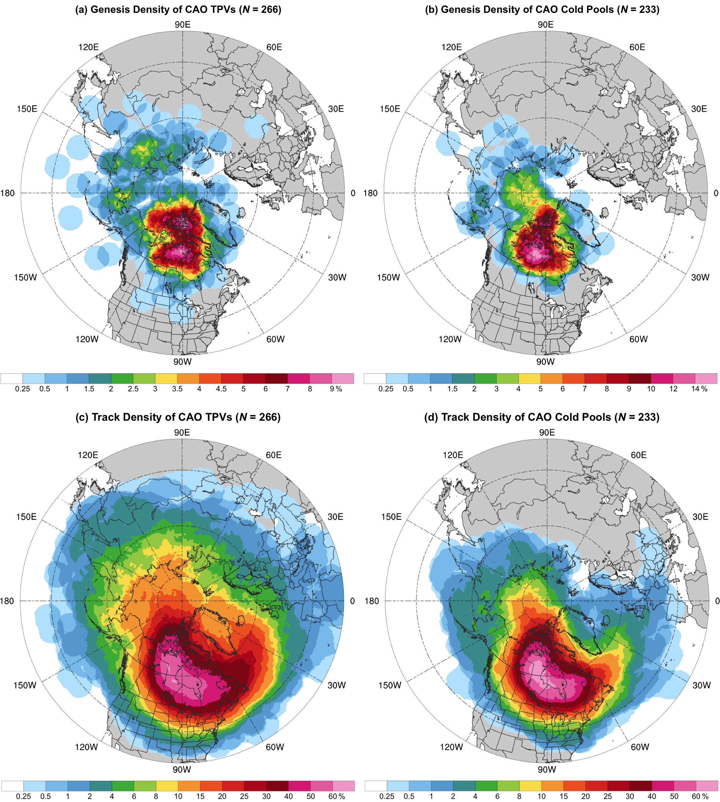

FIG. 10. Genesis density of (a) CAO TPVs and (b) CAO cold pools for all climate regions, shaded according to the percentage of CAO TPVs and CAO cold pools, respectively, forming within 500 km of a given grid point (using a 0.5° grid) when normalized by the total number of CAO TPVs and CAO cold pools, respectively. Track density of aforementioned (c) CAO TPVs and (d) CAO cold pools, shaded according to the percentage of CAO TPVs and CAO cold pools, respectively, passing within 500 km of a given grid point (using a 0.5° grid) when normalized by the total number of CAO TPVs and CAO cold pools, respectively. If an individual CAO TPV or individual CAO cold pool impacts multiple regions, that CAO TPV or CAO cold pool is only counted once in the total count of CAO TPVs and CAO cold pools (given by N), respectively. An individual CAO TPV and an individual CAO cold pool can only be counted once for the genesis density and track density at a given grid point.

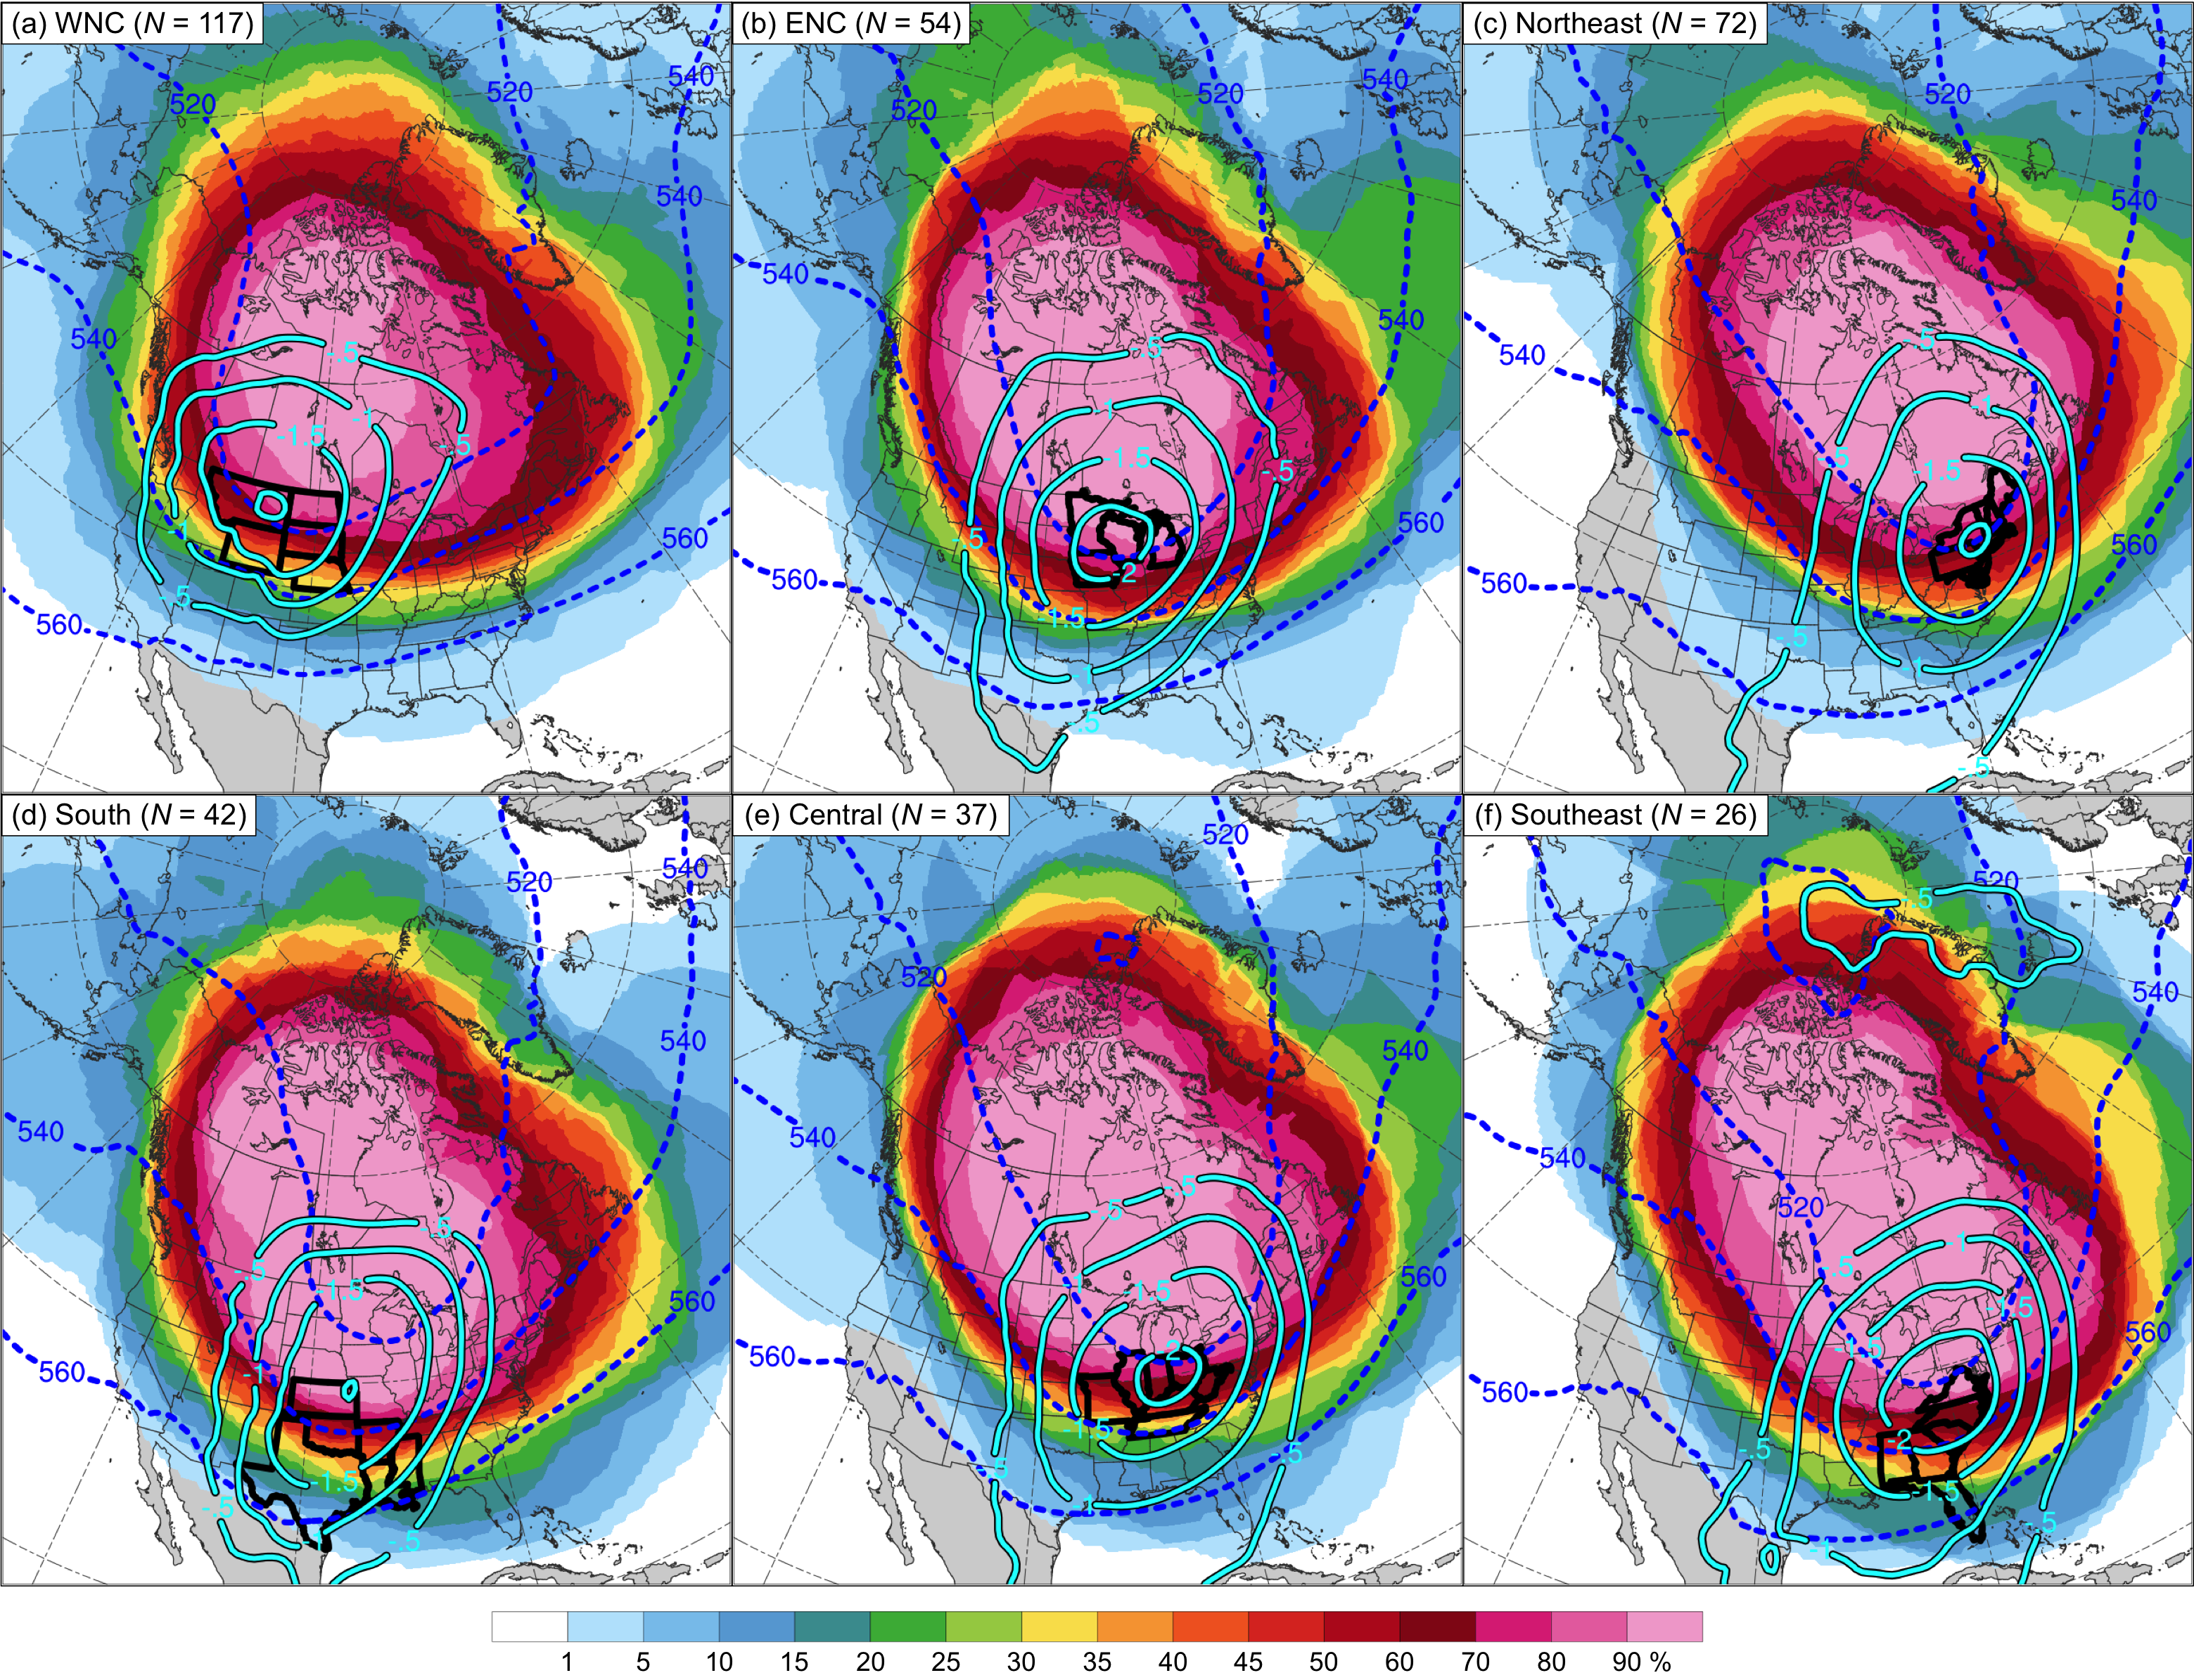
FIG. 11. Track density of CAO cold pools for the (a) WNC, (b) ENC, (c) Northeast, (d) South, (e) Central, and (f) Southeast regions, shaded according to the percentage of CAO cold pools passing within 1500 km of a given grid point (using a 0.5° grid) when normalized by the total number CAO cold pools for each climate region. Composite 1000–500-hPa thickness (every 20 dam, dashed blue contours) and composite negative values of standardized anomaly of 1000–500-hPa thickness (every 0.5 σ, solid cyan contours) at t_{lowest} (defined in text in section 3c). States in each climate region are outlined in thick black. The same CAO cold pool can impact multiple regions, and thus the same CAO cold pool can be included in the total count of CAO cold pools (given by N) for multiple regions. An individual CAO cold pool can only be counted once for the track density at a given grid point.

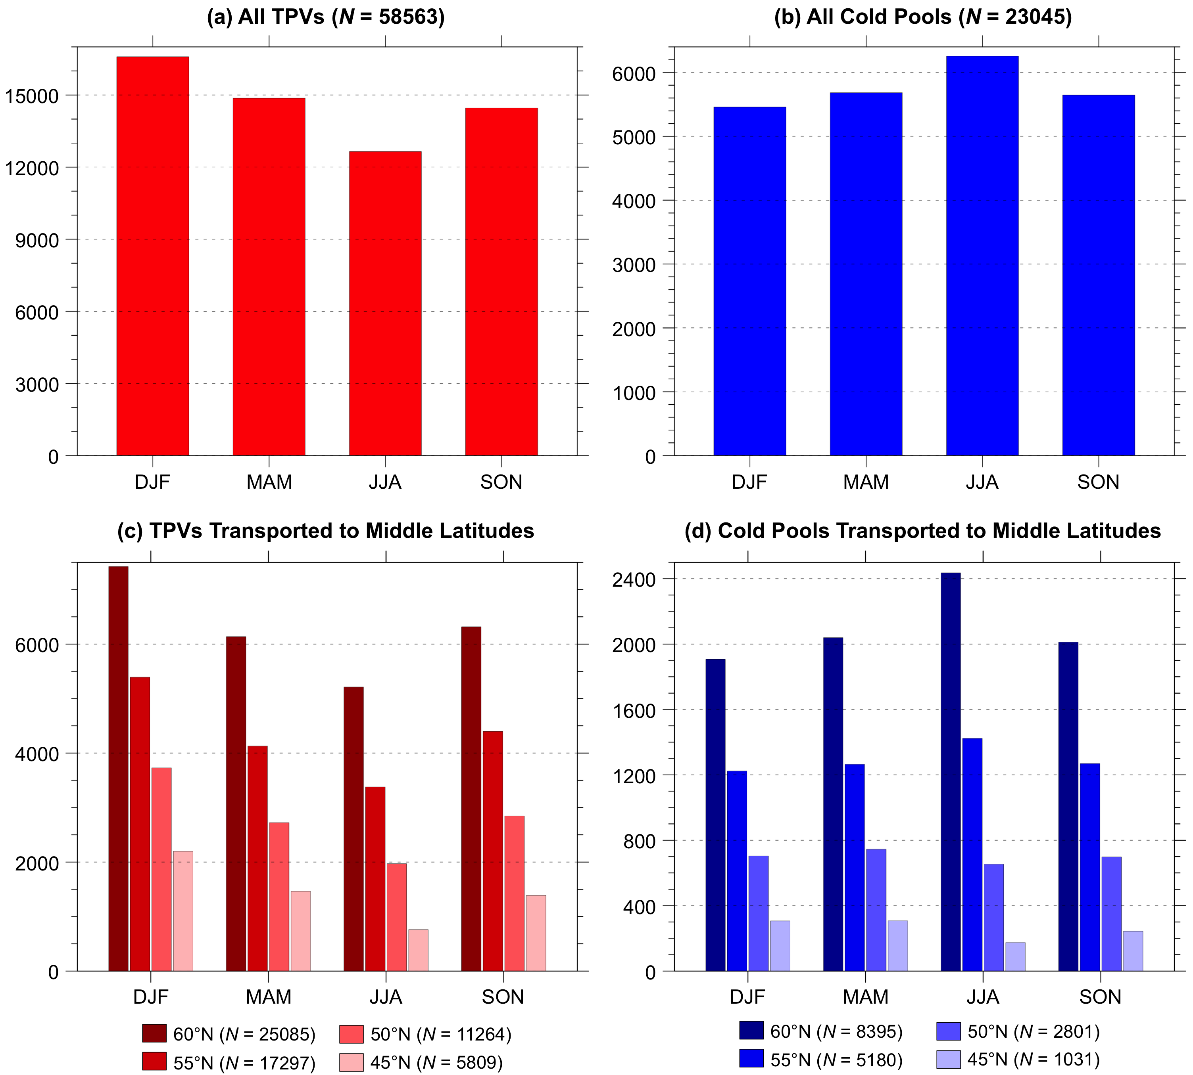

FIG. 12. Number of (a) all TPVs and (b) all cold pools each season during 1979–2015. Number of (c) TPVs and (d) cold pools transported equatorward of crossing latitudes ranging from 60°N to 45°N, every 5°, for each season during 1979–2015, where each bar is colored according to the crossing latitude. The seasons are DJF (winter), which denotes December, January, and February, MAM (spring), which denotes March, April, and May, JJA (summer), which denotes June, July, and August, and SON (autumn), which denotes September, October, and November. TPVs and cold pools are separated into these respective seasons based on the month of their genesis date.

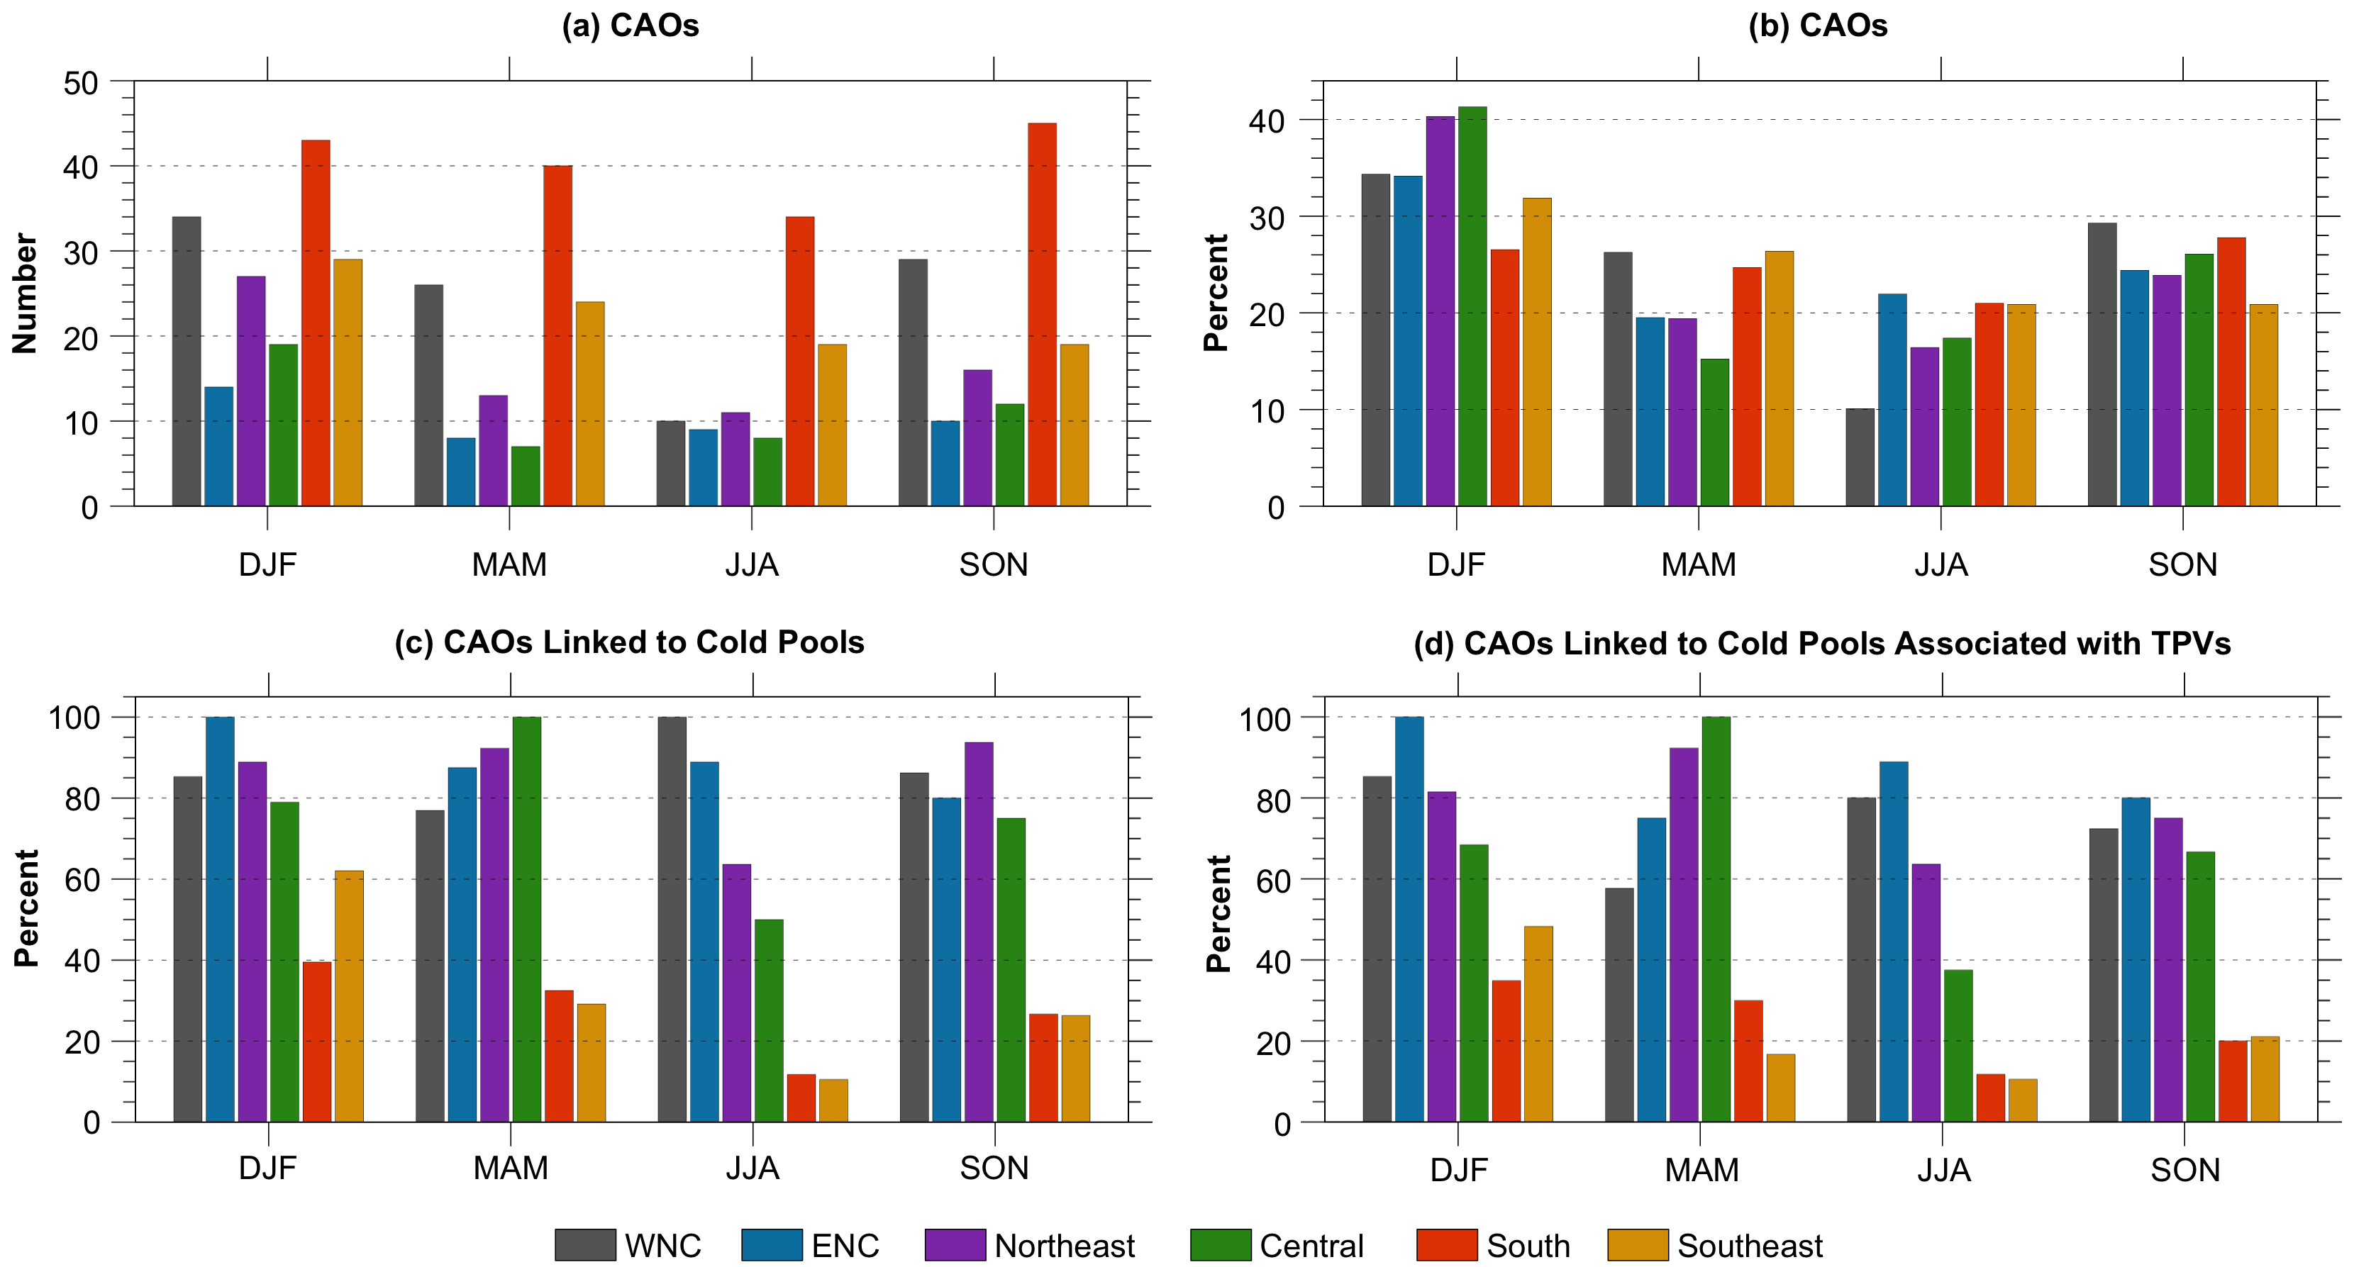

FIG. 13. (a) Number of CAOs for each climate region and season. (b) Percentage of CAOs for each climate region occurring each season, where this percentage is defined as number of CAOs for that climate region and season divided by number of CAOs for that climate region (given in Table 2). (c) Percentage of CAOs linked to cold pools for each climate region and season, where this percentage is defined as number of CAOs linked to cold pools for that climate region and season divided by number of CAOs for that climate region and season. (d) Percentage of CAOs linked to cold pools associated with TPVs for each climate region and season, where this percentage is defined as number of CAOs linked to cold pools associated with TPVs for that climate region and season divided by number of CAOs for that climate region and season. Seasons are as described in Fig. 12, where CAOs are separated into these respective seasons based on the month of their first date of occurrence.

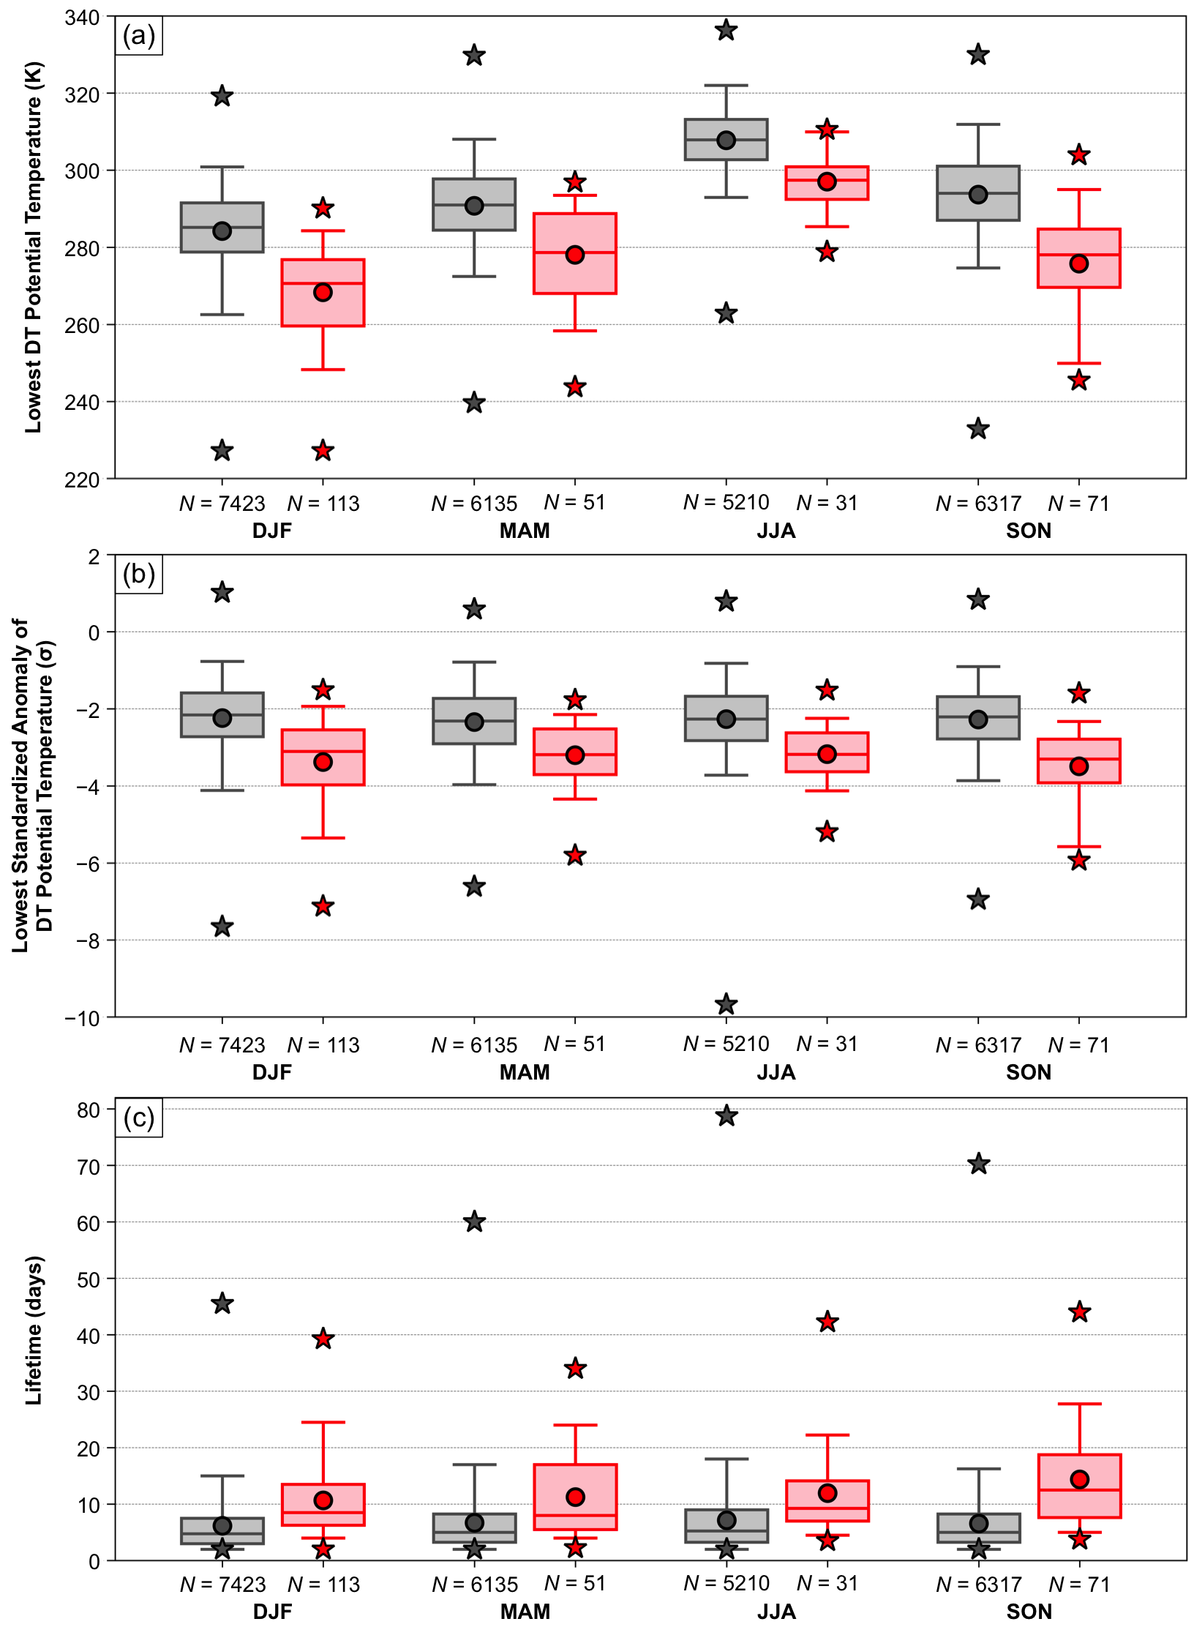

FIG. 14. Box and whisker plots showing a comparison between climatological TPVs (gray) and CAO TPVs (red) each season for the following characteristics: (a) lowest DT potential temperature (K) during the lifetime of the TPVs, (b) lowest standardized anomaly of DT potential temperature (σ) at the TPV center during the lifetime of the TPVs, and (c) lifetime of the TPVs (days). Boxes extend from 25th to 75th percentiles, with median values denoted by solid line within each box. Whiskers extend to 5th and 95th percentiles. Circles denote the mean values and stars denote the minimum and maximum values. Mean values are given in Table 4. The number of TPVs for each box and whiskers plot is indicated. Seasons are as described in Fig. 12, where TPVs are separated into these respective seasons based on the month of their genesis date.

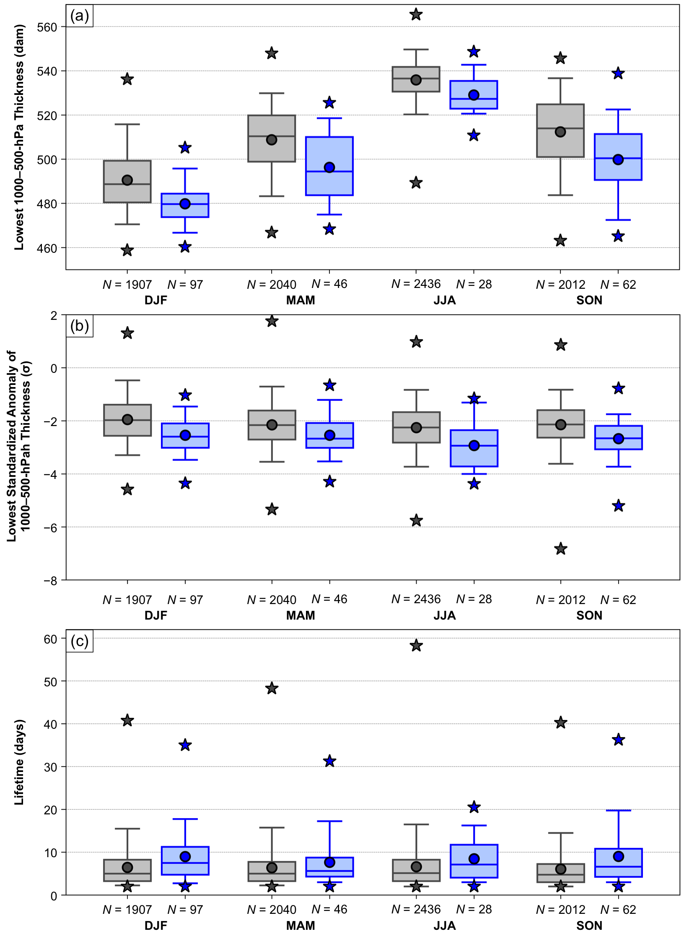

FIG. 15. Box and whisker plots showing a comparison between climatological cold pools (gray) and CAO cold pools (blue) each season for the following characteristics: (a) lowest 1000–500-hPa thickness (dam) during the lifetime of the cold pools, (b) lowest standardized anomaly of 1000–500-hPa thickness (σ) at the cold pool center during the lifetime of the cold pools, and (c) lifetime of the cold pools (days). Boxes extend from 25th to 75th percentiles, with median values denoted by solid line within each box. Whiskers extend to 5th and 95th percentiles. Circles denote the mean values and stars denote the minimum and maximum values. Mean values are given in Table 5. The number of cold pools for each box and whisker plot is indicated. Seasons are as described in Fig. 12, where cold pools are separated into these respective seasons based on the month of their genesis date.

