Kevin Biernat’s plans for next period:

I plan to write my Ph.D. dissertation throughout the summer of 2021. My Ph.D. dissertation is tentatively titled “An Examination of the Arctic Environment and Arctic Cyclones during Periods of Low and High Forecast Skill of the Synoptic-Scale Flow.” I plan to defend my Ph.D. dissertation in late summer or early fall of 2021, and my anticipated graduation date is December 2021. I also plan to contribute to the forecasting effort for the THINICE field campaign during August 2021. After I defend my Ph.D. dissertation, I plan to prepare and submit for publication a portion of my Ph.D. dissertation that focuses on a comparison of the Arctic environment and Arctic cyclones (ACs) between periods of low and high forecast skill of the synoptic-scale flow over the Arctic during summer, hereafter referred to as low-skill and high-skill periods, respectively. In the planned publication, I will compare the evolution of the forecast skill of the synoptic-scale flow over the Arctic between low-skill and high-skill periods. I will then compare dynamic and thermodynamic quantities characterizing the Arctic environment between low-skill and high-skill periods. I will lastly compare the frequency, location, intensity, and forecast skill of ACs, and dynamic and thermodynamic quantities characterizing ACs, between low-skill and high-skill periods.

Results Dissemination

Conference and workshop presentations:

Biernat, K., L. F. Bosart, and D. Keyser, 2020: Composite analyses of low-skill Arctic cyclones during summer. Poster presentation, American Geophysical Union Fall 2020 Meeting, Virtual Platform, Monday 14 December 2020.
Abstract: https://agu.confex.com/agu/fm20/meetingapp.cgi/Paper/694182.
Presentation: http://www.atmos.albany.edu/student/kbiernat/ONR_report_2021/Biernat_et_al_AGU_2020_poster.pdf.

Biernat, K. A., D. Keyser, and L. F. Bosart, 2021: Composite analyses of low-skill Arctic cyclones during summer. Poster presentation, American Meteorological Society 34th Conference on Climate Variability and Change, 101st American Meteorological Society Annual Meeting, Virtual Platform, Thursday 14 January 2021.
Abstract: https://ams.confex.com/ams/101ANNUAL/meetingapp.cgi/Paper/377998.
Presentation: http://www.atmos.albany.edu/student/kbiernat/ONR_report_2021/Biernat_etal_34CCVC_101AMS_poster.pdf.

Biernat, K. A., L. F. Bosart, and D. Keyser, 2021: Composite analyses of low-skill Arctic cyclones during summer. Oral presentation, American Meteorological Society 16th Conference on Polar Meteorology and Oceanography, Virtual Platform, Wednesday 2 June 2021.
Abstract: https://ams.confex.com/ams/16Polar/meetingapp.cgi/Paper/387109.
Presentation:
http://www.atmos.albany.edu/student/kbiernat/ONR_report_2021/Biernat_et_al_AMS_Polar_2021_presentation.pdf.

ONR Arctic DRI presentation:

Biernat, K. A., L. F. Bosart, and D. Keyser, 2021: An examination of low-skill Arctic cyclones during summer. Oral presentation, ONR Arctic DRI Meeting, Friday 26 February 2021.
Presentation:
http://www.atmos.albany.edu/student/kbiernat/ONR_report_2021/Biernat_et_al_presentation_ONR_Arctic_meeting_26Feb2021.pdf.

Refereed journal article:

Biernat, K. A., L. F. Bosart, and D. Keyser, 2021: A climatological analysis of the linkages between tropopause polar vortices, cold pools, and cold air outbreaks over the central and eastern United States. Mon. Wea. Rev., 149, 189–206, https://doi.org/10.1175/MWR-D-20-0191.1.

Topic 1: Composite Analyses of Low-Skill Arctic Cyclones during Summer

Biernat, K., L. F. Bosart, and D. Keyser, 2020: Composite analyses of low-skill Arctic cyclones during summer. Poster presentation, American Geophysical Union Fall 2020 Meeting, Virtual Platform, Monday 14 December 2020.

Biernat, K. A., D. Keyser, and L. F. Bosart, 2021: Composite analyses of low-skill Arctic cyclones during summer. Poster presentation, American Meteorological Society 34th Conference on Climate Variability and Change, 101st American Meteorological Society Annual Meeting, Virtual Platform, Thursday 14 January 2021.

Biernat, K. A., L. F. Bosart, and D. Keyser, 2021: An examination of low-skill Arctic cyclones during summer. Oral presentation, ONR Arctic DRI Meeting, Friday 26 February 2021.

Biernat, K. A., L. F. Bosart, and D. Keyser, 2021: Composite analyses of low-skill Arctic cyclones during summer. Oral presentation, American Meteorological Society 16th Conference on Polar Meteorology and Oceanography, Virtual Platform, Wednesday 2 June 2021.

Summary:
Low-skill Arctic cyclones (ACs) occurring during periods of low forecast skill of the synoptic-scale flow over the Arctic during June–August of 2007–2017 are identified based on medium-range forecasts from the 11-member NOAA GEFS reforecast dataset version 2. AC-centered composite analyses of intense low-skill ACs are performed using ERA5 at various lag times relative to the time of lowest sea level pressure (SLP) of the ACs when located in the Arctic. Figures 1a,b show the track and intensity of the intense low-skill ACs for lags −48 h to 36 h. The majority of the ACs track east-northeastward, with a few of the ACs reaching peak intensity over the Barents and Kara Seas and a larger number of the ACs reaching peak intensity farther east over or near the central Arctic (Fig. 1a). The ACs generally intensify quickly during lags −48 h to 0 h, and then generally weaken slowly thereafter (Fig. 1b). Figure 2a shows that at lag −48 h, the composite AC is positioned in a region of upper-tropospheric jet coupling and strong lower-to-midtropospheric baroclinicity. Between lags −48 h and −12 h, the coupled jet streaks evolve into a single jet streak, with the composite AC crossing the jet streak to the left-exit region while intensifying in the region of strong baroclinicity (Figs. 2a–d). The composite AC reaches peak intensity at lag 0 h and then begins to weaken afterward (Figs. 2e,f). Figure 3a shows that there is a region of lower-to-midtropospheric ascent, and upper-tropospheric divergence and irrotational outflow in the immediate vicinity of the composite AC at lag −48 h. The lower-to-midtropospheric ascent, and upper-tropospheric divergence and irrotational outflow are likely being supported by the upper-tropospheric jet coupling (Fig. 2a), forcing for ascent associated with an upper-tropospheric potential vorticity maximum upstream of the composite AC (Fig. 3a), and a corridor of tropospheric-integrated vapor transport on the southern and eastern sides of the composite AC (not shown). The lower-to-midtropospheric ascent, upper-tropospheric divergence and irrotational outflow, and moisture transport and moisture flux convergence associated with the corridor of tropospheric-integrated vapor transport suggest that latent heating is occurring in the vicinity of the composite AC and likely supporting the intensification of the composite AC. Latent heating appears to continue through lag 0 h (Figs. 3b–e) and then wanes afterward (Fig. 3f). The composite analyses suggest that a combination of baroclinic processes and latent heating play important roles in the intensification of intense low-skill ACs.

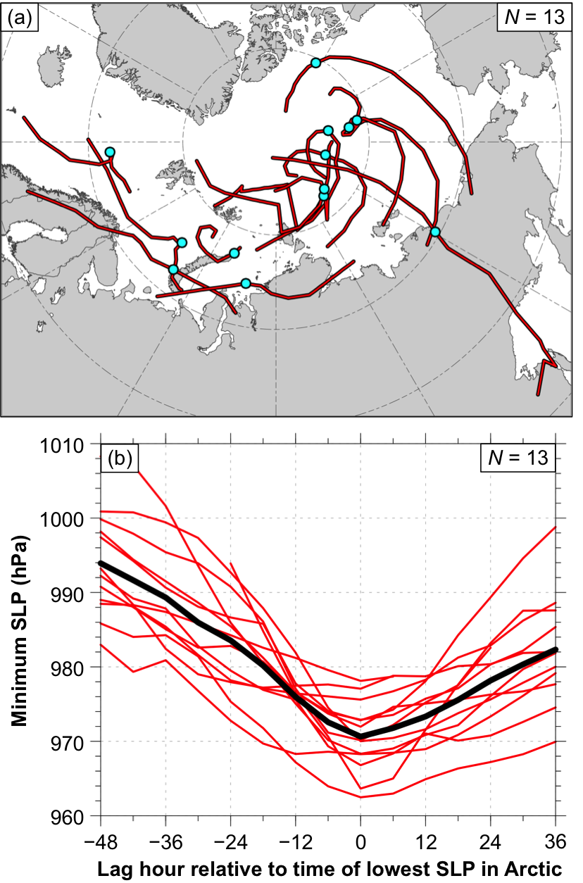

FIG. 1. (a) Tracks of the intense low-skill ACs (red lines) during lags −48 h to 36 h and locations of the ACs at lag 0 h, the time of lowest SLP of the ACs in the Arctic (cyan dots). (b) Time series of minimum SLP (hPa) of the ACs (red) and of composite minimum SLP (hPa) of the ACs (black) during lags −48 h to 36 h.

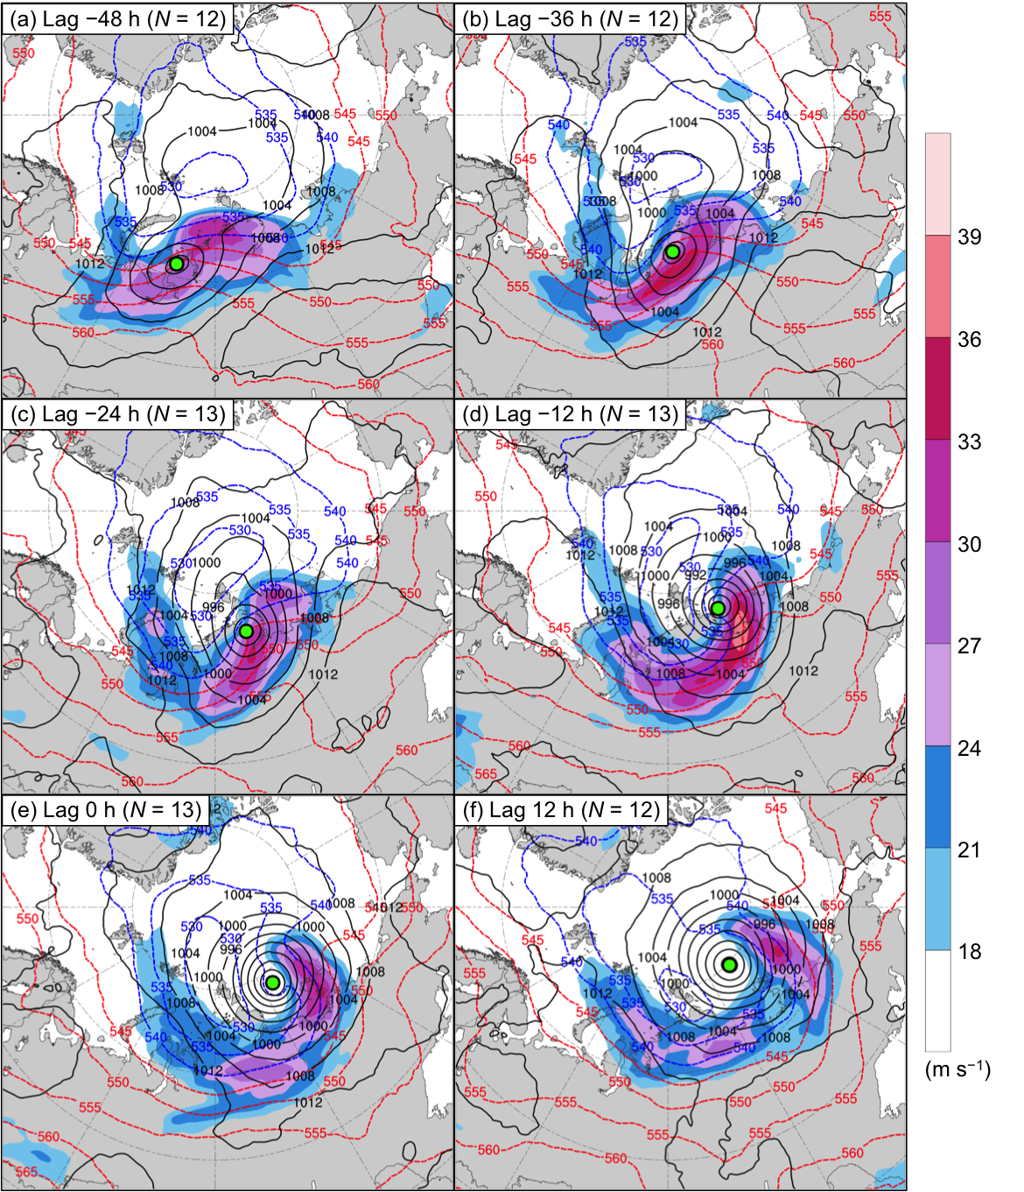

FIG. 2. AC-centered composites of 300-hPa wind speed (m s⁻¹; shading), 1000–500-hPa thickness (dam; dashed red and blue), and SLP (hPa; black) at lag (a) −48 h, (b) −36 h, (c) −24 h, (d) −12 h, (e) 0 h, and (f) 12 h. The green dot shows the location of the composite AC.

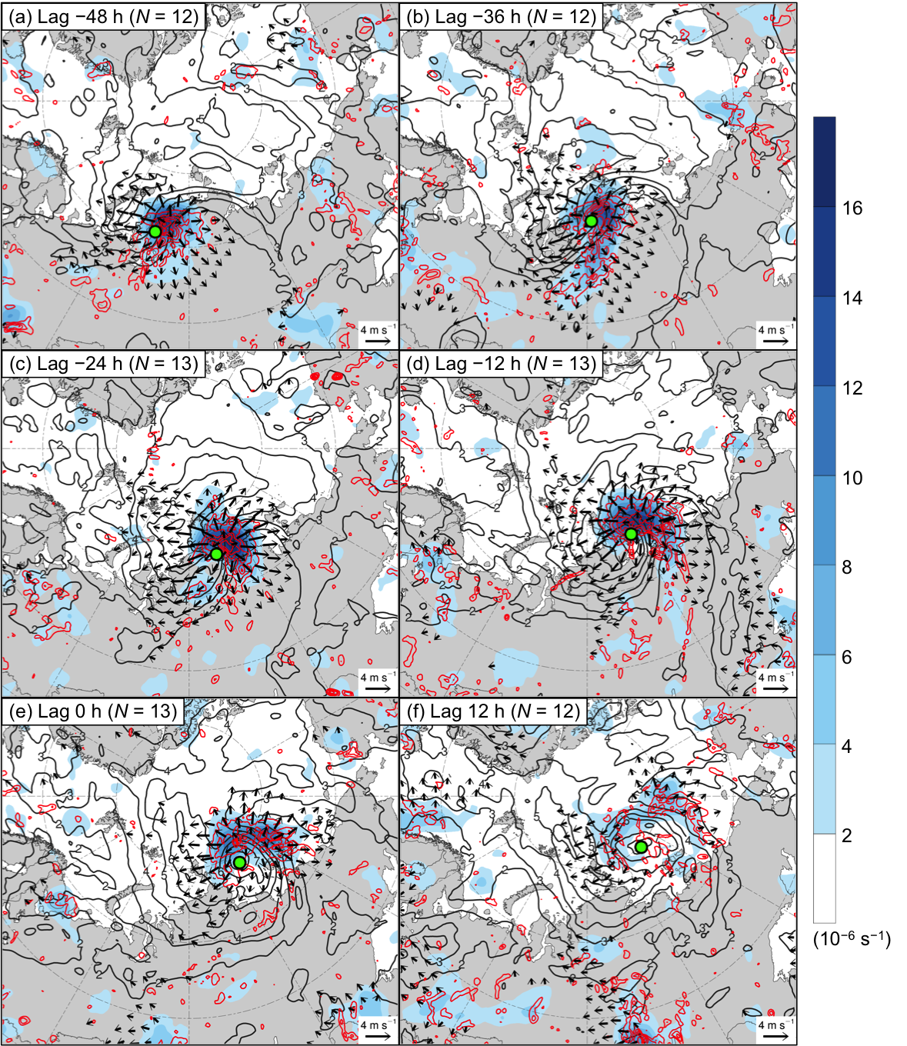

FIG. 3. AC-centered composites of 350–250-hPa divergence area averaged within 200 km of each grid point (10⁻⁶ s⁻¹; shading), 350–250-hPa irrotational wind (m s⁻¹; vectors), 350–250-hPa potential vorticity (PVU; dark gray), and negative values of 800–600-hPa ω (every 1 × 10⁻³ hPa s⁻¹; red) at lag (a) −48 h, (b) −36 h, (c) −24 h, (d) −12 h, (e) 0 h, and (f) 12 h. The green dot shows the location of the composite AC.

