A Climatological Comparison of the Arctic Environment and Arctic Cyclones between Periods of Low and High Forecast Skill of the Synoptic-Scale Flow

Kevin A. Biernat,ª Daniel Keyser,ª and Lance F. Bosartª
ª Department of Atmospheric and Environmental Sciences, University at Albany, State University of New York, Albany, New York

Corresponding author: Kevin A. Biernat, kevin.a.biernat@gmail.com

ABSTRACT
The prediction of weather conditions in the Arctic is important to human activities in the Arctic. Arctic cyclones (ACs), which are extratropical cyclones that originate within the Arctic or move into the Arctic from lower latitudes, can be associated with hazardous weather conditions that may adversely affect human activities. The purpose of this study is to increase understanding of processes that influence the forecast skill of the synoptic-scale flow over the Arctic and of ACs. The 11-member NOAA Global Ensemble Forecast System (GEFS) reforecast dataset version 2 is utilized to identify periods of low and high forecast skill of the synoptic-scale flow over the Arctic, hereafter referred to as low-skill and high-skill periods, respectively, during the summers of 2007–2017, and to evaluate the forecast skill of ACs during these respective periods. The ERA-Interim dataset is used to examine characteristics of the Arctic environment and characteristics of ACs during low-skill and high-skill periods. The Arctic environment tends to be characterized by more vigorous baroclinic processes and latent heating during low-skill periods compared to high-skill periods. ACs occur more frequently over much of the Arctic, tend to be stronger, and tend to be located in regions of larger lower-tropospheric baroclinicity, lower-to-midtropospheric Eady growth rate (EGR), and latent heating, during low-skill periods compared to high-skill periods. ACs during low-skill periods that are characterized by low forecast skill of intensity tend to be relatively strong and tend to be located in regions of relatively large lower-tropospheric baroclinicity, lower-to-midtropospheric EGR, and latent heating.

1. Introduction
Human activities, such as shipping (e.g., Eguíluz et al. 2016; Melia et al. 2016, 2017; Yamagami and Matsueda 2021), tourism (e.g., Hall and Saarinen 2010; Maher 2017), and military operations (e.g., U.S. Department of the Navy 2021), are increasing in the Arctic. These human activities may be adversely impacted by hazardous weather conditions in the Arctic, which is why accurate weather prediction over the Arctic is increasingly important. Although previous studies have evaluated the forecast skill of the synoptic-scale flow over the Arctic based on forecasts of 500-hPa geopotential height (e.g., Jung and Leutbecher 2007; Bauer et al. 2016; Jung and Matsueda 2016; Sandu and Bauer 2018), there has been a dearth of research that has examined Arctic environmental conditions associated with periods of low and high forecast skill of the synoptic-scale flow over the Arctic, with the exception of a recent study by Yamagami and Matsueda (2021). In the present study, Arctic environmental conditions refer to the state of the troposphere in the Arctic described in terms of the synoptic-scale flow configuration, horizontal and vertical motions, baroclinicity, moisture, and latent heating.
Yamagami and Matsueda (2021) examine Arctic weather patterns associated with forecast busts over the Arctic during summer, and find that one of the more frequent Arctic weather patterns is referred to as the “Arctic Cyclone (AC)” pattern, which is characterized by anomalously low 500-hPa geopotential height and sea level pressure (SLP) over the Arctic. They suggest that some forecast busts over the Arctic during summer may be linked to forecast errors in the intensity and position of ACs. ACs are extratropical cyclones that originate within the Arctic or move into the Arctic from lower latitudes (e.g., Serreze 1995; Zhang et al. 2004; Serreze and Barrett 2008; Simmonds and Rudeva 2012, 2014; Crawford and Serreze 2016; Valkonen et al. 2021). There are regional differences in the frequencies of ACs between winter and summer, with relatively high frequencies of ACs over the North Atlantic side of the Arctic during winter, and over the Eurasian side of the Arctic and the central Arctic Ocean during summer (e.g., Serreze and Barret 2008; Crawford and Serreze 2016). ACs may be associated with strong surface winds and high waves (e.g., Zhang et al. 2013; Thomson and Rogers 2014), and may contribute to rapid sea ice loss (e.g., Asplin et al. 2012; Zhang et al. 2013; Stern et al. 2020; Peng et al. 2021). Since ACs may influence the forecast skill of the synoptic-scale flow over the Arctic, it is of interest to understand how the frequency of ACs, characteristics of ACs, and forecast skill of ACs compare between periods of low and high forecast skill of the synoptic-scale flow over the Arctic, hereafter referred to as low-skill periods and high-skill periods, respectively.
Various features and processes may influence the development and intensification of ACs. Tropopause polar vortices (TPVs) (e.g., Simmonds and Rudeva 2012; Tao et al. 2017a,b; Yamagami et al. 2017) and baroclinic processes (e.g., Aizawa et al. 2014; Tao et al. 2017a,b; Yamagami et al. 2017) have been shown to play important roles in the development and intensification of ACs. TPVs are coherent tropopause-based cyclonic vortices that are characterized by a local minimum of dynamic tropopause potential temperature and a cyclonic potential vorticity (PV) anomaly (e.g., Cavallo and Hakim 2009, 2010, 2012). Hoskins et al. (1985, section 6e) show that an upper-tropospheric cyclonic PV anomaly (e.g., a TPV) moving over a baroclinic zone can lead to the development of a lower-tropospheric cyclonic PV anomaly (e.g., a surface cyclone), and further show that these PV anomalies can become phase-locked and mutually amplify one another. Two notable examples of ACs in the literature for which TPVs and baroclinic processes have been shown to play important roles in the development and intensification of ACs are a strong AC that occurred during August 2012, hereafter referred to as AC12 (e.g., Simmonds and Rudeva 2012; Tao et al. 2017b), and a strong AC that occurred during August 2016, hereafter referred to as AC16 (Yamagami et al. 2017). Tao et al. (2017b) show that the interaction of a TPV with an upper-tropospheric jet streak contributes to the intensification of the jet streak, and that upper-tropospheric divergence associated with the upper-tropospheric jet streak supports the development of AC12. Both AC12 and AC16 have been shown to develop and intensify downshear of TPVs in baroclinic zones associated with high values of EGR [AC12 (e.g., Simmonds and Rudeva 2012; Tao et al. 2017b); AC16 (Yamagami et al. 2017)]. Furthermore, both AC12 and AC16 have been shown to contribute to rapid sea ice loss [AC12 (e.g., Zhang et al. 2013; Stern et al. 2020); AC16 (Peng et al. 2021)].
Latent heating may also influence the development and intensification of ACs. Latent heating associated with the formation of clouds and precipitation has been shown to contribute to the development and intensification of midlatitude cyclones in numerous studies (e.g., Tracton 1973; Kuo and Reed 1988; Reed et al. 1988, 1992; Davis et al. 1993; Stoelinga 1996; Wernli et al. 2002). However, there has been a dearth of research on the influence of latent heating on the development and intensification of ACs. Previous studies have shown that ACs can be associated with intrusions of warm, moist air into the Arctic (e.g., Binder et al. 2017; Messori et al. 2018; Fearon et al. 2021). It is possible that latent heating occurring in conjunction with intrusions of warm, moist air into the Arctic may influence the development and intensification of ACs.
Although there have been a limited number of predictability studies of ACs in the literature, interest in the predictability of ACs recently has been increasing (e.g., Yamazaki et al. 2015; Yamagami et al. 2018a,b, 2019; Capute and Torn 2021; Johnson and Wang 2021; Blanchard-Wrigglesworth et al. 2022). Yamagami et al. (2018a) examine the forecast skill of AC12 with five operational ensemble prediction systems (EPSs) and find that forecasts initialized only 2–3 days prior or closer to the time of peak intensity of AC12 are accurate. Yamagami et al. (2018b) assess the forecast skill of 10 strong ACs that they refer to as “extraordinary ACs” and that occur during the summers of 2008–2016 with five operational EPSs. Yamagami et al. (2018b) state that the forecast skill of the extraordinary ACs is lower than that of midlatitude cyclones in the Northern Hemisphere. Capute and Torn (2021) compare the forecast skill of the intensity and position of ACs and of midlatitude cyclones over the North Atlantic using the NOAA GEFS reforecast dataset version 2. They show that ACs are less predictable in terms of position compared to midlatitude cyclones over the North Atlantic, and show that ACs are more predictable in terms of intensity compared to midlatitude cyclones over the North Atlantic. Blanchard-Wrigglesworth et al. (2022) examine the predictability of the strongest AC on record, which occurred during January 2022. They show that this AC was well predicted up to 8 days in advance while changes in sea ice were not, which was likely due to biases in the initial sea ice conditions and missing physics of wave-sea interactions in the forecast model used in their study.
Forecast errors related to baroclinic processes have been shown to contribute to forecast errors in the synoptic-scale flow over middle latitudes (e.g., Tribbia and Baumhefner 2004; Davies and Didone 2013; Boisserie et al. 2014; Selz and Craig 2015) and to forecast errors in midlatitude cyclones (e.g., Sanders 1986; Zhu and Thorpe 2006; Zhang et al. 2007; Zheng et al. 2013). In addition, forecast errors related to latent heating have been shown to contribute to forecast errors in the synoptic-scale flow over middle latitudes (e.g., Rodwell et al. 2013; Martínez-Alvarado et al. 2016; Grams et al. 2018) and to forecast errors in midlatitudes cyclones (e.g., Zhang et al. 2003, 2007). It is expected that forecast errors related to baroclinic processes and latent heating may also contribute to forecast errors in the synoptic-scale flow over the Arctic and to forecast errors in the intensity and position of ACs. Capute and Torn (2021) find that ACs characterized by lower predictability in terms of intensity are typically located in environments characterized by larger lower-to-midtropospheric EGR compared to ACs characterized by higher predictability in terms of intensity. Despite expectations to the contrary, they find that there is no systematic difference in latent heating between ACs characterized by lower predictability in terms of intensity and ACs characterized by higher predictability in terms of intensity. Furthermore, they do not find substantial differences in environmental properties between ACs characterized by lower predictability in terms of position and ACs characterized by higher predictability in terms of position. Aside from Capute and Torn (2021), there has been limited research that has compared ACs characterized by lower and higher predictability in terms of intensity and position.
The purpose of this study is to increase understanding of processes that influence the forecast skill of the synoptic-scale flow over the Arctic and of ACs. Specifically, the present study aims to compare characteristics of the Arctic environment, and the frequency, characteristics, and forecast skill of ACs, between low-skill and high-skill periods. It is hypothesized that there is a higher frequency of ACs, and more vigorous baroclinic processes and latent heating over the Arctic, during low-skill periods compared to high-skill periods. It is also hypothesized that ACs characterized by low forecast skill of intensity are located in regions of more vigorous baroclinic processes, but similar latent heating, compared to ACs characterized by high forecast skill intensity. The remainder of this paper is organized as follows. Section 2 presents data and methodology used to identify low-skill and high-skill periods, identify ACs, determine characteristics of the Arctic environment and ACs, and determine the forecast skill of ACs. Section 3 compares Arctic forecast skill, characteristics of the Arctic environment, and the frequency, characteristics, and forecast skill of ACs, between low-skill and high-skill periods. Section 4 summarizes the results of the paper.

2. Data and methodology
a. Identification of low-skill and high-skill periods
Day-5 forecasts of 500-hPa geopotential height from the 11-member 1° NOAA GEFS reforecast dataset version 2 (Hamill et al. 2013) initialized daily at 0000 UTC during the summers (June–August) of 2007–2017 are utilized to evaluate the forecast skill of the synoptic-scale flow over the Arctic (≥ 70°N). Refer to Fig. 1 for a map of the Arctic and geographical features to be discussed in the present study. A fixed model (i.e., the 2012 operational version of the NCEP GEFS) is used to produce the ensemble forecasts, such that forecast skill can be evaluated from the ensemble forecasts without having to account for changes in model configuration over time (e.g., Hamill and Kiladis 2014). Day-5 forecasts of 500-hPa geopotential height are utilized because medium-range (e.g., day 5 or day 6) forecasts of 500-hPa geopotential height have commonly been utilized to evaluate the forecast skill of operational numerical weather prediction systems (e.g., Kalnay et al. 1991; Langland and Maue 2012; Sandu and Bauer 2018). The summer season is examined because human activities in the Arctic like tourism (e.g., Hall and Saarinen 2010) and shipping (e.g, Eguíluz et al. 2016) are increased during summer, and strong winds, high waves, and rapid sea ice loss and movement that can be associated with strong ACs during summer (e.g., Zhang et al. 2013) may pose hazards to the human activities in the Arctic (e.g., Inoue 2021).
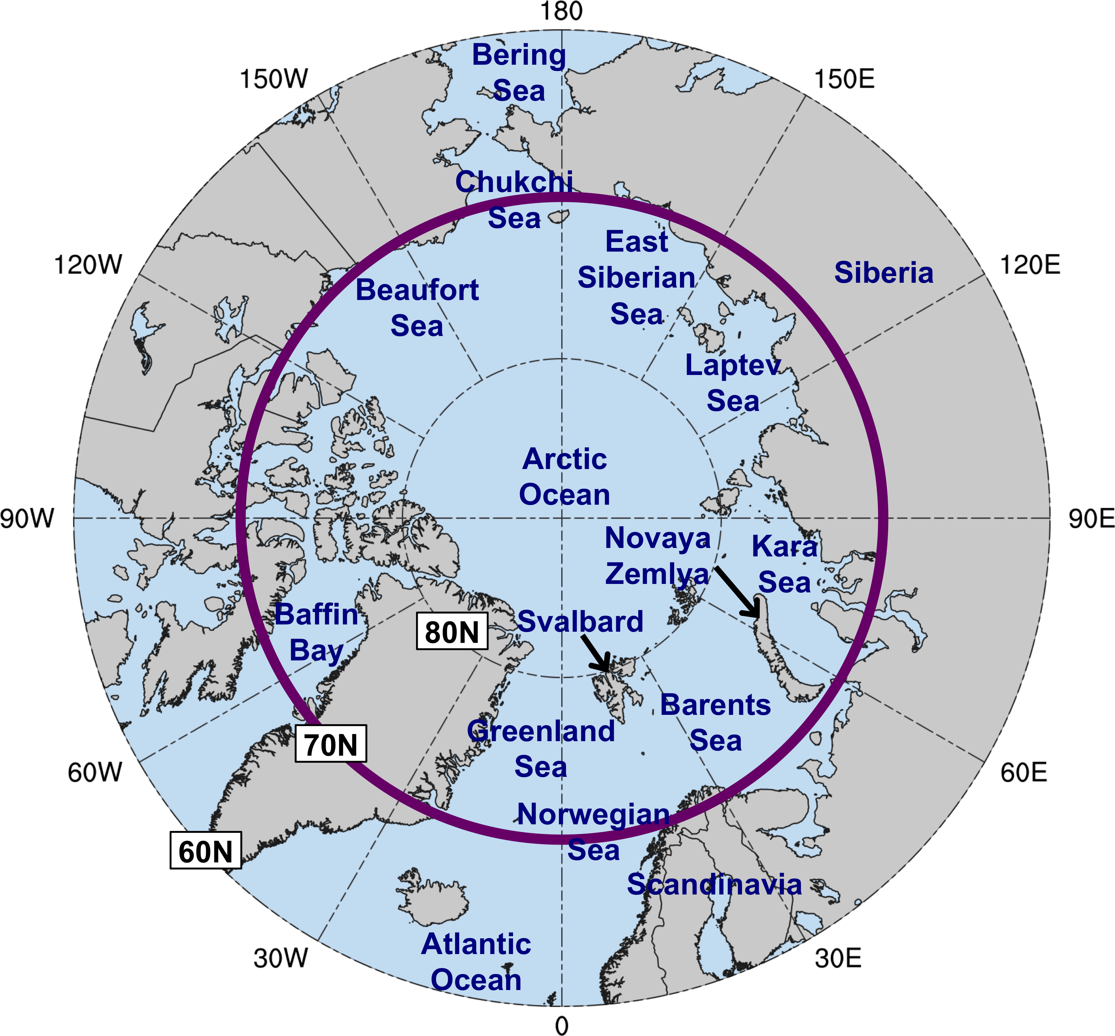
Fig. 1. Map of Arctic geography, including names of seas and nations. The region north of the purple circle (70°N) denotes the Arctic for the purposes of the present study.

The root mean square error (RMSE) of the day-5 forecasts of 500-hPa geopotential height is first calculated at each grid point (k) over the Arctic via
$RMSE= \sqrt{\frac{1}{N }\sum_{n=1}^{N}{{\left[f_{n}(k)-O(k)\right]}^{2}}}$ , (1)
where N denotes the number of ensemble members (i.e., 11), n denotes the nth ensemble member, f_{n} denotes the 500-hPa geopotential height from the nth ensemble member, and O denotes the 500-hPa geopotential height from ERA-Interim (Dee et al. 2011) at 1° horizontal resolution. After the RMSE is calculated at each grid point over the Arctic, the RMSE values are area-averaged over the Arctic to obtain an area-averaged RMSE value. Area-averaged RMSE contains the forecast error of individual ensemble members at individual grid points that is area-averaged over the Arctic. Standardized anomalies of area-averaged RMSE, hereafter referred to as σ_{RMSE}, relative to a 1985–2017 climatology of area-averaged RMSE, are then calculated following the approach used by Moore [2017, section 4b(3)]. This approach consists of subtracting the climatological mean of area-averaged RMSE from each value of area-averaged RMSE and then dividing by the climatological standard deviation of area-averaged RMSE, where the climatological mean and climatological standard deviation are smoothed by retaining only the first four harmonics of the annual cycle determined from a Fourier analysis. In addition to calculating area-averaged RMSE and σ_{RMSE} for the day-5 forecast lead time, area-averaged RMSE and σ_{RMSE} is also calculated for all other forecast lead times of 0–5.5 days, every 0.5 days, in order to examine the evolution of forecast skill during days 0–5.5.
Forecasts associated with the top and bottom 10% of σ_{RMSE} at day 5 are referred to as low-skill forecasts and high-skill forecasts, respectively. There are 101 low-skill forecasts and 101 high-skill forecasts. Time periods extending from day 0 through day 5 that are encompassed by low-skill forecasts and high-skill forecasts correspond to the low-skill periods and high-skill periods, respectively, that were defined in section 1. There are instances in which a given low-skill period may overlap a given high-skill period when these periods occur in relatively short succession, resulting in some days occurring during both a low-skill period and a high-skill period, hereafter referred to as overlapping days. In order to avoid including an overlapping day in both a low-skill period and a high-skill period, the overlapping day is assigned to the period that occurs earlier. As an example of an instance in which there are overlapping days, a high-skill period was identified to occur during 8–13 June 2010 and a low-skill period was identified to occur during 12–17 June 2010, making 12–13 June 2010 overlapping days. Since the high-skill period occurs earlier than the low-skill period, 12–13 June 2010 are assigned to the high-skill period and removed from the low-skill period. There were 345 days and 297 days originally determined to occur during low-skill periods and high-skill periods, respectively. Subsequently, 17 overlapping days were removed from low-skill periods, resulting in a total of 328 days during low-skill periods (Table 1), and 16 overlapping days were removed from high-skill periods, resulting in a total of 281 days during high-skill periods (Table 1). Time periods extending from day 0 through day 5 that are encompassed by all forecasts initialized during the summers of 2007–2017 are collectively referred to as “the 2007–2017 climatological period.” There are a total of 1067 days during the 2007–2017 climatological period (Table 1).

 | The 2007–2017 climatological period | Low-skill periods | High-skill periods
Number of days | 1067 | 328 | 281
Number of ACs | 665 | 283 | 182

Table 1. Number of days and ACs during the 2007–2017 climatological period, low-skill periods, and high-skill periods.

b. Identification of ACs
An objective SLP-based cyclone tracking algorithm developed by Crawford et al. (2021) is used to track cyclones every 6 h over the Northern Hemisphere. ERA-Interim SLP data at 1° horizontal resolution that is regridded to a 50-km north-polar Lambert azimuthal equal-area grid (Brodzik et al. 2012) is used as input for the tracking algorithm. ACs in the present study are identified as cyclones that have a lifetime of ≥ 48 h and spend at least 6 h within the Arctic (> 70°N). This latitudinal requirement is the same as that used by Simmonds and Rudeva (2012, 2014) to identify ACs. All ACs that occur at any time within the Arctic during the 2007–2017 climatological period, low-skill periods, and high-skill periods are identified. A given AC can be identified for more than one of the periods (e.g., low-skill periods and high-skill periods) as long as the AC occurs at any time within the Arctic during these periods. Furthermore, since low-skill periods and high-skill periods are subsets of the 2007–2017 climatological period, ACs during low-skill periods and ACs during high-skill periods are subsets of ACs during the 2007–2017 climatological period. There are 665 ACs during the 2007–2017 climatological period, 283 ACs during low-skill periods, and 182 ACs during high-skill periods (Table 1).
c. Characteristics of the Arctic environment and ACs
Selected dynamic and thermodynamic quantities are calculated using the 6-hourly 1° ERA-Interim dataset to characterize the Arctic environment and ACs. Although the ERA5 dataset (Hersbach et al. 2020) could be used, the present study will focus on comparisons of area-averages of selected dynamic and thermodynamic quantities between low-skill periods and high-skill periods, which are expected to yield consistent results between ERA-Interim and ERA5 even if there are differences in the magnitude of these quantities between these datasets. The present study will examine area averages of the following dynamic and thermodynamic quantities: upper-tropospheric flow and lower-tropospheric flow, corresponding to 300-hPa wind speed and 850-hPa wind speed, respectively; lower-tropospheric baroclinicity, corresponding to the magnitude of the 850-hPa potential temperature (θ) gradient; lower-to-midtropospheric baroclinic growth rate, corresponding to EGR calculated over the 850–600-hPa layer; upper-tropospheric divergence, corresponding to positive values of 350–250-hPa divergence; lower-to-midtropospheric ascent, corresponding to negative values of 800–600-hPa ω; moisture transport, corresponding to 1000–300-hPa integrated water vapor transport (IVT); and latent heating, where positive values of 1000–300-hPa integrated horizontal moisture flux convergence (IMFC) are used as a proxy for latent heating (e.g., Torn and Hakim 2015). In the calculation of EGR, the formulation of Hoskins and Valdes (1990) is adopted, i.e.,
$EGR=0.31\frac{f}{N}\left|\frac{∂v}{∂z}\right|$, (2)
where v is the horizontal vector wind; z is the height, which, for expediency, is evaluated using geopotential height in the present paper; f is the Coriolis parameter; and N is the Brunt–Väisälä frequency.
The aforementioned quantities are area-averaged over the Arctic to characterize the Arctic environment and are area-averaged within a 1000-km radius from the center of each AC to characterize the ACs. The 1000-km radius is motivated by Yamagami et al. (2018b), who show that the mean radius of the 10 extraordinary ACs that were mentioned in section 1 of the present paper is approximately 938 km, and Valkonen et al. (2021), who show in their Fig. 5a that the interquartile ranges of average cyclone radius in the Arctic for June–August of 1979–2015 for three different reanalysis datasets encompass a value of 1000 km. Minimum SLP is used to characterize the intensity of ACs. The largest magnitude value of each area-averaged quantity, and the lowest value of minimum SLP, for each AC among all 6-h time steps during which the AC is located within the Arctic during a period of interest (i.e., the 2007–2017 climatological period, low-skill periods, or high-skill periods) is determined. The largest magnitude value of each area-averaged quantity and the lowest value of minimum SLP are hereafter referred to as the most extreme value of the respective quantities.
d. Forecast skill of ACs
Ensemble forecasts of SLP from the 11-member NOAA GEFS reforecast dataset version 2 initialized daily at 0000 UTC are used to evaluate the forecast skill of the intensity and position of the ACs identified in section 2b for forecast lead times of 1–7 days, every 1 day, with respect to a verification time. The ACs identified in section 2b are hereafter referred to as “analysis ACs” in the present subsection. The verification time for a given analysis AC during a period of interest (i.e., the 2007–2017 climatological period, low-skill periods, or high-skill periods) is considered the 0000 UTC time of lowest SLP of the given analysis AC when located within the Arctic during the period of interest. If there is no 0000 UTC time at which a given analysis AC is located within the Arctic during the period of interest, the following procedure is used. The time of lowest SLP of the AC when located within the Arctic during the period of interest is determined, and each surrounding 0000 UTC time for which the following two criteria are met is considered a candidate verification time: 1) the AC exists at that surrounding 0000 UTC time, and 2) that surrounding 0000 UTC time occurs during the period of interest. Figure 2 shows the possible situations involving the identification of candidate verification times. If there are two candidate verification times (Situation A in Fig. 2), the candidate verification time at which the minimum SLP of the AC is lower is considered the verification time. If there is one candidate verification time, it is considered the verification time. There is one candidate verification time if either of the aforementioned two criteria is not met for one of the surrounding 0000 UTC times, which can happen if the first 6-h time step of the AC occurs after the earlier surrounding 0000 UTC time (Situation B in Fig. 2), if the last 6-h time step of the AC occurs before the later surrounding 0000 UTC time (Situation C in Fig. 2), or if the later surrounding 0000 UTC time does not occur during the period of interest (Situation D in Fig. 2). For the additional, rare instance in which there is no candidate verification time, which happens if the first 6-h time step of the AC occurs after the earlier surrounding 0000 UTC time and the later surrounding 0000 UTC time does not occur during the period of interest (Situation E in Fig. 2), the later surrounding 0000 UTC time is considered the verification time.

Fig. 2. Schematic diagram of the possible situations involving the identification of candidate verification times for an AC. Boxes indicate hypothetical times, every 6 h, from 0000 UTC of a given day (D₀) to 0000 UTC of the next day (D₀+1), with gray and white boxes indicating times that occur and that do not occur, respectively, during a period of interest (i.e., the 2007–2017 climatological period, low-skill periods, or high-skill periods). Label “AC” in a box indicates that the AC exists at the time shown in the box. The red bolded time corresponds to a hypothetical time of lowest SLP of the AC when located within the Arctic during the period of interest. A thick black border around a box indicates a surrounding 0000 UTC time that is considered to be a candidate verification time, which is a time for which the following two criteria are met: 1) the AC exists at that surrounding 0000 UTC time (box contains label “AC”), and 2) that surrounding 0000 UTC time occurs during the period of interest (box is gray).

The objective SLP-based cyclone tracking algorithm developed by Crawford et al. (2021) is used to track cyclones every 6 h over the Northern Hemisphere in ensemble forecasts initialized 1–7 days, every 1 day, prior to the verification time of each analysis AC. Ensemble SLP data at 1° horizontal resolution that is regridded to the 50-km north-polar Lambert azimuthal equal-area grid (Brodzik et al. 2012) is used as input for the tracking algorithm. A cyclone matching procedure developed by Korfe and Colle (2018) to match extratropical cyclone tracks in the ERA-Interim with those in ensemble forecasts of various EPSs is adapted to match the analysis ACs with cyclones in the ensemble forecasts. The adapted matching procedure matches a cyclone in an ensemble forecast with a given analysis AC based on criteria that require the cyclone in the ensemble forecast and the given analysis AC to be located sufficiently close to each other in space and to be sufficiently coincident in time. For each cyclone with a lifetime of ≥ 24 h in the ensemble forecast, the percentage of 6-h time steps of the given analysis AC track for which the center of the cyclone is ≤ 1200 km from the center of the given analysis AC, and is the closest among the centers of all cyclones to the center of the given analysis AC, is determined. The cyclone associated with the aforementioned percentage that is the largest and ≥ 40% is recorded. If at least 40% of the 6-h time steps of the recorded cyclone coincide in time with those of the analysis AC, the recorded cyclone is considered to be a “matching forecast AC.” Readers interested in further documentation are referred to Biernat [2021, section 2b(4)].
A minimum number of ensemble members with a matching forecast AC occurring at the verification time for a given analysis AC and a given forecast lead time is needed to evaluate the forecast skill of the given analysis AC for the given forecast lead time. Following Froude (2010), the present study requires that ≥ 5 (out of 11) ensemble members have a matching forecast AC occurring at the verification time for a given analysis AC and a given forecast lead time. The forecast skill of the intensity of a given analysis AC for a given forecast lead time is determined by calculating the intensity RMSE via
$RMSE= \sqrt{\frac{1}{N}\sum_{n=1}^{N}{{\left(f_{n}-O\right)}^{2}}}$ , (3)
where N denotes the number of ensemble members with a matching forecast AC occurring at the verification time, n denotes the nth ensemble member, f_{n} denotes the minimum SLP of the matching forecast AC for the nth ensemble member at the verification time, and O denotes the minimum SLP of the given analysis AC at the verification time. The forecast skill of the position of a given analysis AC for a given forecast lead time is determined by calculating the position RMSE via Eq. (3), except that f_{n} − O now represents the great circle distance between the center of the matching forecast AC for the nth ensemble member and the center of the given analysis AC.
The following four “skill categories” of ACs are determined based on intensity RMSE for the 5-day lead time: low-skill ACs during low-skill periods, high-skill ACs during low-skill periods, low-skill ACs during high-skill periods, and high-skill ACs during high-skill periods. Low-skill ACs during low-skill periods and high-skill ACs during low-skill periods are defined as ACs during low-skill periods associated with the top and bottom 25% of intensity RMSE for the 5-day lead time, respectively. Similarly, low-skill ACs during high-skill periods and high-skill ACs during high-skill periods are defined as ACs during high-skill periods associated with the top and bottom 25% of intensity RMSE for the 5-day lead time, respectively. The 5-day lead time is chosen for consistency with using forecasts of 5-day lead time to evaluate the forecast skill of the synoptic-scale flow over the Arctic. The dynamic and thermodynamic quantities introduced in section 2c and the minimum SLP introduced in section 2c are used to characterize the aforementioned four skill categories of ACs. While the aforementioned four skill categories of ACs will be emphasized in section 3c, the corresponding four skill categories of ACs determined based on position RMSE for the 5-day lead time will be considered briefly in section 3c.
Bootstrap resampling with replacement tests are used to determine statistical significance at the 95% confidence level of the following quantities: area-averaged RMSE of 500-hPa geopotential height and σ_{RMSE} of 500-hPa geopotential height over the Arctic, the dynamic and thermodynamic quantities introduced in section 2c, the minimum SLP introduced in section 2c, and the intensity RMSE and position RMSE of ACs. Two types of tests are used: The first type determines the statistical significance of a quantity for a subgroup (e.g., ACs during low-skill periods) with respect to a corresponding climatological group (e.g., ACs during the 2007–2017 climatological period). The second type determines the statistical significance of differences of a quantity between two subgroups (e.g., low-skill ACs during low-skill periods and high-skill ACs during low-skill periods) within a common group (e.g., ACs during low-skill periods). Readers interested in further documentation are referred to Biernat [2021, section 2b(5)].

3. Results
a. Arctic forecast skill and characteristics of the Arctic environment
Figures 3a and 3b show the evolution of area-averaged RMSE of 500-hPa geopotential height over the Arctic and σ_{RMSE} of 500-hPa geopotential height over the Arctic, respectively, for low-skill and high-skill forecasts during day 0–5.5, every 0.5 days. Area-averaged RMSE increases during day 0–5.5 for both low-skill forecasts and high-skill forecasts (Fig. 3a), but increases at a faster rate for low-skill forecasts compared to high-skill forecasts (Fig. 3a). In addition, area-averaged RMSE is statistically significantly high and low relative to climatology for low-skill forecasts and high-skill forecasts, respectively, for day 1–5.5 (Fig. 3a). The quantity σ_{RMSE} increases and decreases throughout most of day 0–5.5 for low-skill forecasts and high-skill forecasts, respectively (Fig. 3b), and plateaus at day 5 for low-skill forecasts and at day 5.5 for high-skill forecasts (Fig. 3b). The increase and decrease in σ_{RMSE} throughout most of day 0–5.5 for low-skill forecasts and high-skill forecasts, respectively, indicates that the forecast skill of the synoptic-scale flow over the Arctic becomes increasingly anomalously low and high relative to climatology throughout most of day 0–5.5 for low-skill forecasts and high-skill forecasts, respectively.
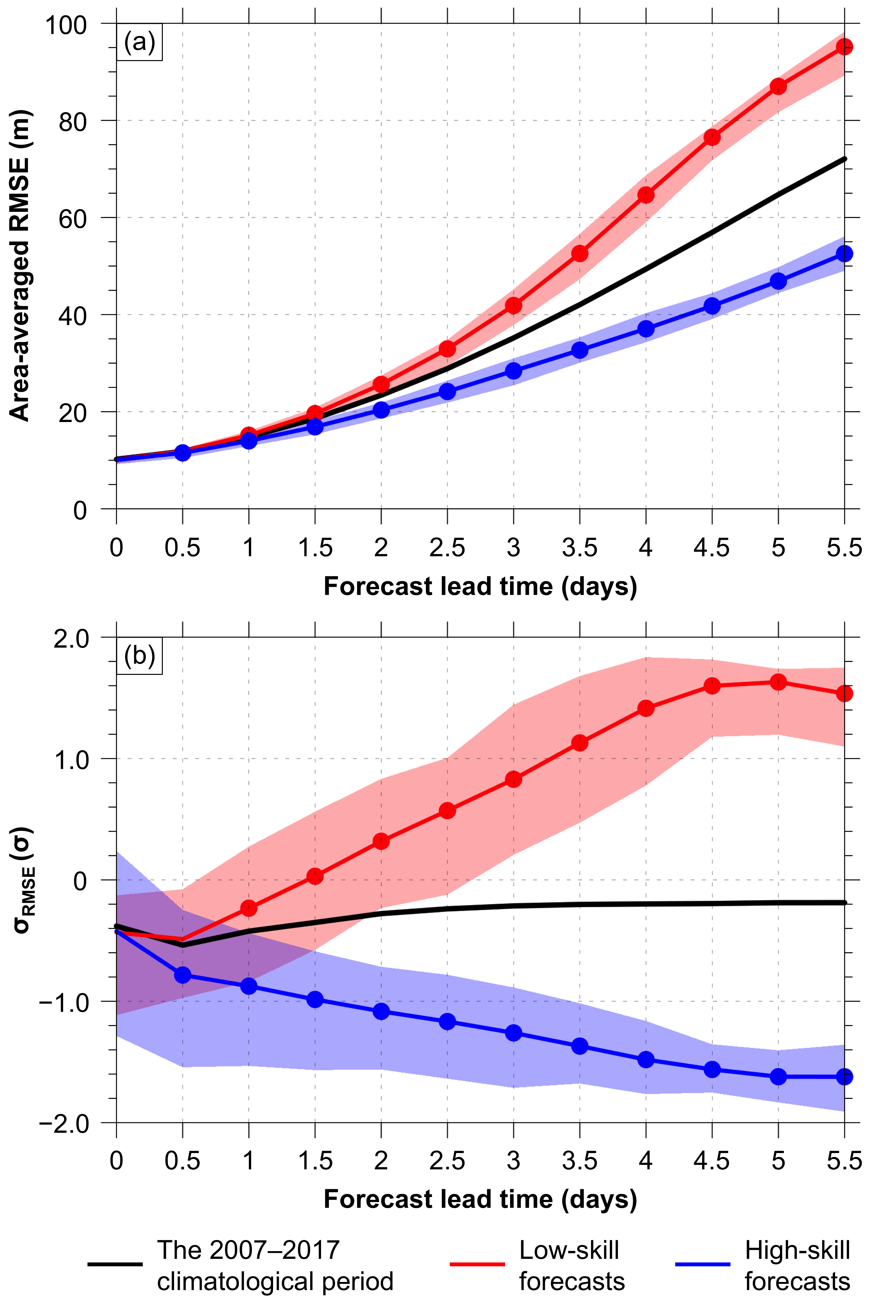
Fig. 3. Mean values of (a) area-averaged RMSE of 500-hPa geopotential height over the Arctic (m) and (b) σ_{RMSE} of 500-hPa geopotential height over the Arctic (σ), as defined in section 2a, for low-skill forecasts (red line), high-skill forecasts (blue line), and all forecasts during the 2007–2017 climatological period (black line) at days 0–5.5, every 0.5 days. Shading in (a) and (b) indicates the interquartile range (IQR) (25th–75th percentile values) of the respective quantities for low-skill forecasts (red) and high-skill forecasts (blue). Dots in (a) and (b) indicate statistical significance at the 95% confidence level of the mean values of the respective quantities for low-skill forecasts (red) and high-skill forecasts (blue) with respect to a climatology of the respective quantities that is composed of the values of the respective quantities for all forecasts during the 2007–2017 climatological period.

Quantities characterizing the Arctic environment, as introduced in section 2c, are now examined at day 0–5.5, every 0.5 days, for the 101 low-skill forecasts and 101 high-skill forecasts in Figs. 4 and 5. Day 0–5.5 for low-skill forecasts and high-skill forecasts correspond to low-skill periods and high-skill periods, respectively, with the exception of overlapping days that were removed from these respective periods, as discussed in section 2a. The timeseries shown in Figs. 4 and 5 for low-skill forecasts and high-skill forecasts are constructed by considering all values of the quantities corresponding to day 0–5.5, every 0.5 days, with the exception of values of the quantities corresponding to overlapping days that were removed from low-skill periods and high-skill periods, respectively. There tends to be anomalously strong upper-tropospheric flow (Fig. 4a), anomalously strong lower-tropospheric flow (Fig. 4b), anomalously strong lower-tropospheric baroclinicity (Fig. 4c), and anomalously large lower-to-midtropospheric EGR (Fig. 4d) over the Arctic relative to climatology throughout low-skill periods. Conversely, there tends to be anomalously weak upper-tropospheric flow (Fig. 4a), anomalously weak lower-tropospheric flow (Fig. 4b), anomalously weak lower-tropospheric baroclinicity (Fig. 4c), and anomalously small lower-to-midtropospheric EGR (Fig. 4d) over the Arctic relative to climatology throughout high-skill periods.

Fig. 4. Timeseries of (a) area-averaged 300-hPa wind speed (m s⁻¹), (b) area-averaged 850-hPa wind speed (m s⁻¹), (c) area-averaged 850-hPa θ gradient magnitude [K (100 km)⁻¹], and (d) area-averaged 850–600-hPa EGR (day⁻¹) over the Arctic at days 0–5.5, every 0.5 days, for low-skill forecasts (red) and high-skill forecasts (blue), with solid lines indicating the mean values and shading indicating the IQR. Black lines indicate the mean values of the quantities across all times during the 2007–2017 climatological period. Dots indicate statistical significance at the 95% confidence level of the mean values of the quantities for low-skill forecasts (red) and high-skill forecasts (blue) with respect to a climatology of the quantities that is composed of the values of the quantities for all times during the 2007–2017 climatological period.

There tends to be anomalously strong upper-tropospheric divergence (Fig. 5a), anomalously strong lower-to-midtropospheric ascent (Fig. 5b), anomalously strong moisture transport (Fig. 5c), and anomalously large latent heating (Fig. 5d) over the Arctic relative to climatology throughout low-skill periods. Conversely, there tends to be anomalously weak upper-tropospheric divergence (Fig. 5a), anomalously weak lower-to-midtropospheric ascent (Fig. 5b), anomalously weak moisture transport (Fig. 5c), and anomalously small latent heating (Fig. 5d) over the Arctic relative to climatology throughout high-skill periods.
Fig. 5. As in Fig. 4, but for (a) area-averaged positive values of 350–250-hPa divergence (10⁻⁶ s⁻¹), (b) area-averaged negative values of 800–600-hPa ω (10⁻³ hPa s⁻¹), (c) area-averaged 1000–300-hPa IVT (kg m⁻¹ s⁻¹), and (d) area-averaged positive values of 1000–300-hPa IMFC (W m⁻²) over the Arctic.

Figures 4 and 5 indicate that there is a tendency for more vigorous baroclinic processes and latent heating over the Arctic during low-skill periods compared to high-skill periods. Since baroclinic processes and latent heating may support AC development and intensification, the tendency for more vigorous baroclinic processes and latent heating over the Arctic during low-skill periods compared to high-skill periods suggests that there is a tendency for Arctic environmental conditions to be more conducive to AC development and intensification during low-skill periods compared to high-skill periods. Arctic environmental conditions that are more conducive to AC development and intensification during low-skill periods compared to high-skill periods may be expected to correspond to more frequent occurrences of ACs and stronger ACs during low-skill periods compared to high-skill periods.
As discussed in section 1, forecast errors related to baroclinic processes and latent heating have been shown to contribute to forecast errors in the synoptic-scale flow over middle latitudes. It is expected that the more vigorous baroclinic processes and latent heating over the Arctic during low-skill periods compared to high-skill periods may be associated with greater forecast errors that may help explain the lower forecast skill of the synoptic-scale flow over the Arctic during low-skill periods compared to high-skill periods. Relatively large lower-to-midtropospheric EGR for low-skill periods during days 1.5–3.5 (Fig. 4d) and relatively large latent heating for low-skill periods during days 2.5–4.5 (Fig. 5d) may suggest that there are relatively large forecast errors related to baroclinic processes and latent heating during these respective times that contribute to low forecast skill of the synoptic-scale flow over the Arctic during low-skill periods.
b. Frequency and characteristics of ACs
Track frequencies of ACs during the 2007–2017 climatological period, ACs during low-skill periods, and ACs during high-skill periods are shown in Figs. 6a–c, respectively. There are relatively high track frequencies of ACs during the 2007–2017 climatological period (Fig. 6a), ACs during low-skill periods (Fig. 6b), and ACs during high-skill periods (Fig. 6c) over the Barents, Kara, and Laptev Seas, portions of the central Arctic Ocean, central portions of the northern Eurasian coast, and portions of the Canadian Archipelago (refer to Fig. 1 for map of Arctic geographical features). Crawford and Serreze (2016) and Fearon et al. (2021) similarly show relatively high frequencies of ACs during summer over the Kara and Laptev Seas, the central Arctic Ocean, and central portions of the northern Eurasian coast. Crawford and Serreze (2016) show that Eurasia is an important source region for ACs during summer. AC genesis over Eurasia during summer may be linked in part to a reduction in static stability associated with turbulent and radiative heat fluxes from the heated landmass, lee cyclogenesis downstream of mountain ranges over northern Eurasia, and upper-tropospheric divergence associated with frequent upper-tropospheric troughs that are located east of the Ural Mountains (e.g., Crawford and Serreze 2016). In addition, along the Arctic coast there is a band of strong horizontal temperature gradient, which is strongest near the surface and extends into the upper troposphere, that is referred to as the Arctic frontal zone (AFZ) (e.g., Crawford and Serreze 2015). The AFZ becomes established due to differential heating between the heated landmass and the cold Arctic Ocean and sea ice (e.g., Crawford and Serreze 2015, 2016), and has been shown to contribute to the intensification of ACs crossing the Arctic coast (e.g., Crawford and Serreze 2016).

Fig. 6. Track frequency (shading) of (a) ACs during the 2007–2017 climatological period, (b) ACs during low-skill periods, and (c) ACs during high-skill periods. Track frequency of the respective ACs is calculated at each grid point (using a 1° grid) by determining the number of the respective ACs for which the grid point is located within 500 km of the center of the respective ACs at any time during the respective periods, and then normalizing by the number of days in the respective periods (given in Table 1). Units: number of ACs day⁻¹.

There are higher track frequencies of ACs during low-skill periods compared to ACs during the 2007–2017 climatological period over much of the Arctic (compare Fig. 6b with Fig. 6a; Fig. 7a), and there are lower track frequencies of ACs during high-skill periods compared to ACs during the 2007–2017 climatological period over much of the Arctic (compare Fig. 6c with Fig. 6a; Fig. 7b). Furthermore, there are higher track frequencies of ACs during low-skill periods compared to ACs during high-skill periods over much of the Arctic (compare Fig. 6b with Fig. 6c; Fig. 7c). The higher track frequencies of ACs during low-skill periods compared to ACs during high-skill periods is consistent with the suggestion in section 3a that Arctic environmental conditions tend to be more conducive to more frequent occurrences of ACs during low-skill periods compared to high-skill periods.

Fig. 7. Difference in track frequency between (a) ACs during low-skill periods and ACs during the 2007–2017 climatological period (Fig. 6b minus Fig. 6a), (b) ACs during high-skill periods and ACs during the 2007–2017 climatological period (Fig. 6c minus Fig. 6a), and (c) ACs during low-skill periods and ACs during high-skill periods (Fig. 6b minus Fig. 6c; also Fig. 7a minus Fig. 7b). Units: number of ACs day⁻¹.

There tends to be lower 500-hPa geopotential height over much of the Arctic and higher 500-hPa geopotential height over much of the surrounding middle latitudes during low-skill periods compared to high-skill periods (Fig. 8a). The aforementioned 500-hPa geopotential height differences imply that there tends to be stronger 500-hPa geopotential height gradients and concomitantly stronger lower-to-midtropospheric baroclinicity in the vicinity of the Arctic coast, and correspondingly, the AFZ, during low-skill periods compared to high-skill periods. The stronger lower-to-midtropospheric baroclinicity in the vicinity of the AFZ corresponds to larger lower-to-midtropospheric EGR in the vicinity of the AFZ during low-skill periods compared to high-skill periods (Fig. 8b). There is also larger lower-to-midtropospheric EGR over much of the Arctic during low-skill periods compared to high-skill periods (Fig. 8b). In addition, there is stronger moisture transport in the vicinity of the AFZ and over much of the Arctic during low-skill periods compared to high-skill periods (Fig. 8c). Regions of larger lower-to-midtropospheric EGR (Fig. 8b) and stronger moisture transport (Fig. 8c) during low-skill periods compared to high-skill periods generally coincide with regions of higher track frequency of ACs during low-skill periods compared to high-skill periods (Fig. 7c).

Fig. 8. Shading shows differences of (a) mean 500-hPa geopotential height (dam), (b) mean 850–600-hPa EGR (day⁻¹), and (c) mean 1000–300-hPa IVT (kg m⁻¹ s⁻¹) between low-skill periods and high-skill periods (i.e., low-skill periods minus high-skill periods). Black contours show (a) mean 500-hPa geopotential height during low-skill periods (every 6 dam), (b) mean 850–600-hPa EGR during low-skill periods (every 0.06 day⁻¹), and (c) mean 1000–300-hPa IVT during low-skill periods (every 20 kg m⁻¹ s⁻¹).

Distributions of the most extreme value, as defined in section 2c, of quantities characterizing ACs are now examined. ACs during low-skill periods tend to be statistically significantly stronger (Fig. 9a), and tend to be located in regions characterized by statistically significantly stronger lower-tropospheric flow (Fig. 9b), stronger lower-tropospheric baroclinicity (Fig. 9c), and larger lower-to-midtropospheric EGR (Fig. 9d), compared to ACs during high-skill periods. ACs during low-skill periods also tend to be located in regions characterized by statistically significantly stronger upper-tropospheric divergence (Fig. 10a), stronger lower-to-midtropospheric ascent (Fig. 10b), stronger moisture transport (Fig. 10c), and larger latent heating (Fig. 10d) compared to ACs during high-skill periods. When compared to ACs during the 2007–2017 climatological period, only for ACs during high-skill periods is there statistical significance in the mean values of all quantities shown in Figs. 9 and 10. Figures 9b–d and Figs. 10a–d suggest that ACs tend to be located in environments more conducive to development and intensification during low-skill periods compared to high-skill periods. The tendency for ACs to be located in environments more conducive to development and intensification during low-skill periods compared to high-skill periods likely is consistent with the tendency for ACs to be statistically significantly stronger during low-skill periods compared to high-skill periods (Fig. 9a).

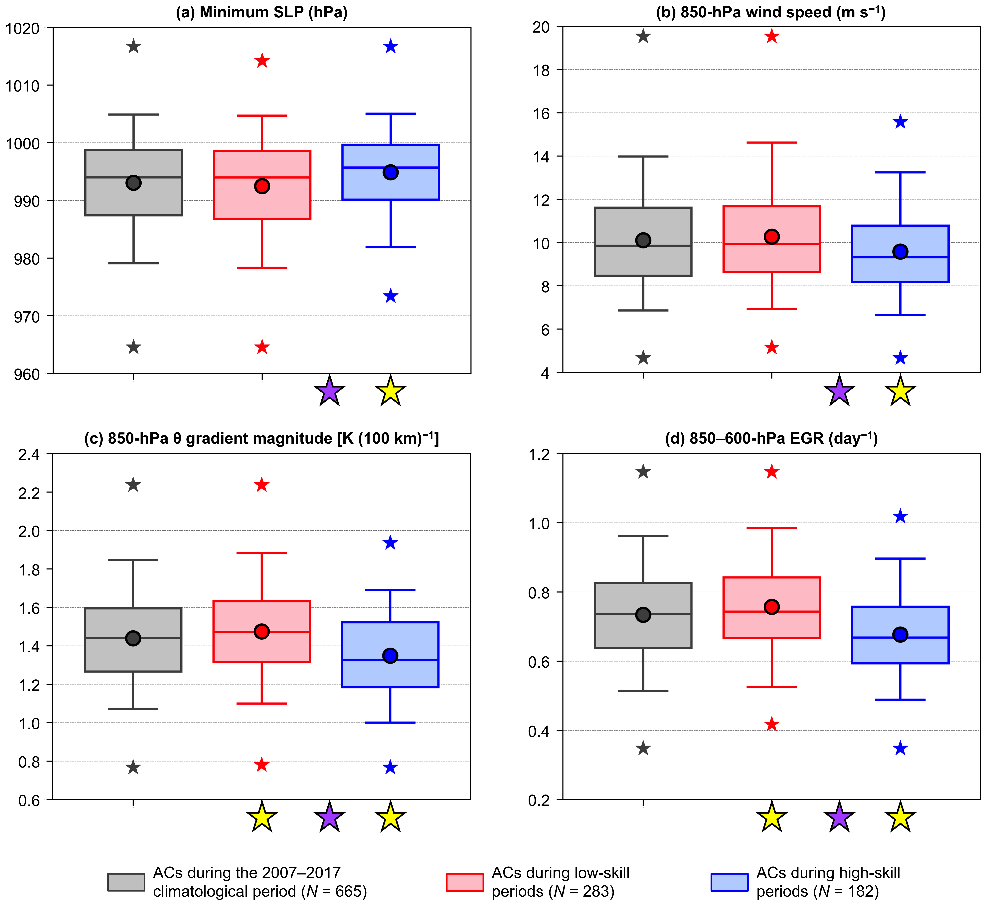
Fig. 9. Distributions of the most extreme value, as defined in section 2c, of quantities characterizing ACs during the 2007–2017 climatological period (gray), ACs during low-skill periods (red), and ACs during high-skill periods (blue) when located within the Arctic during the respective periods. The selected quantities are (a) minimum SLP (hPa), (b) area-averaged 850-hPa wind speed (m s⁻¹), (c) area-averaged 850-hPa θ gradient magnitude [K (100 km)⁻¹], and (d) area-averaged 850–600-hPa EGR (day⁻¹). The quantities in (b)–(d) are area-averaged within a 1000-km radius from the centers of the ACs. Dots indicate the mean values, boxes indicate the IQR, and whiskers extend to the 5th and 95th percentiles. Gray, red, and blue stars indicate the minimum and maximum values of the distributions. Yellow stars indicate statistical significance at the 95% confidence level of the mean values of the quantities for ACs during low-skill periods and for ACs during high-skill periods with respect to the mean values of the quantities for ACs during the 2007–2017 climatological period. Purple stars indicate statistical significance at the 95% confidence level between the mean values of the quantities for ACs during low-skill periods and the mean values of the quantities for ACs during high-skill periods.

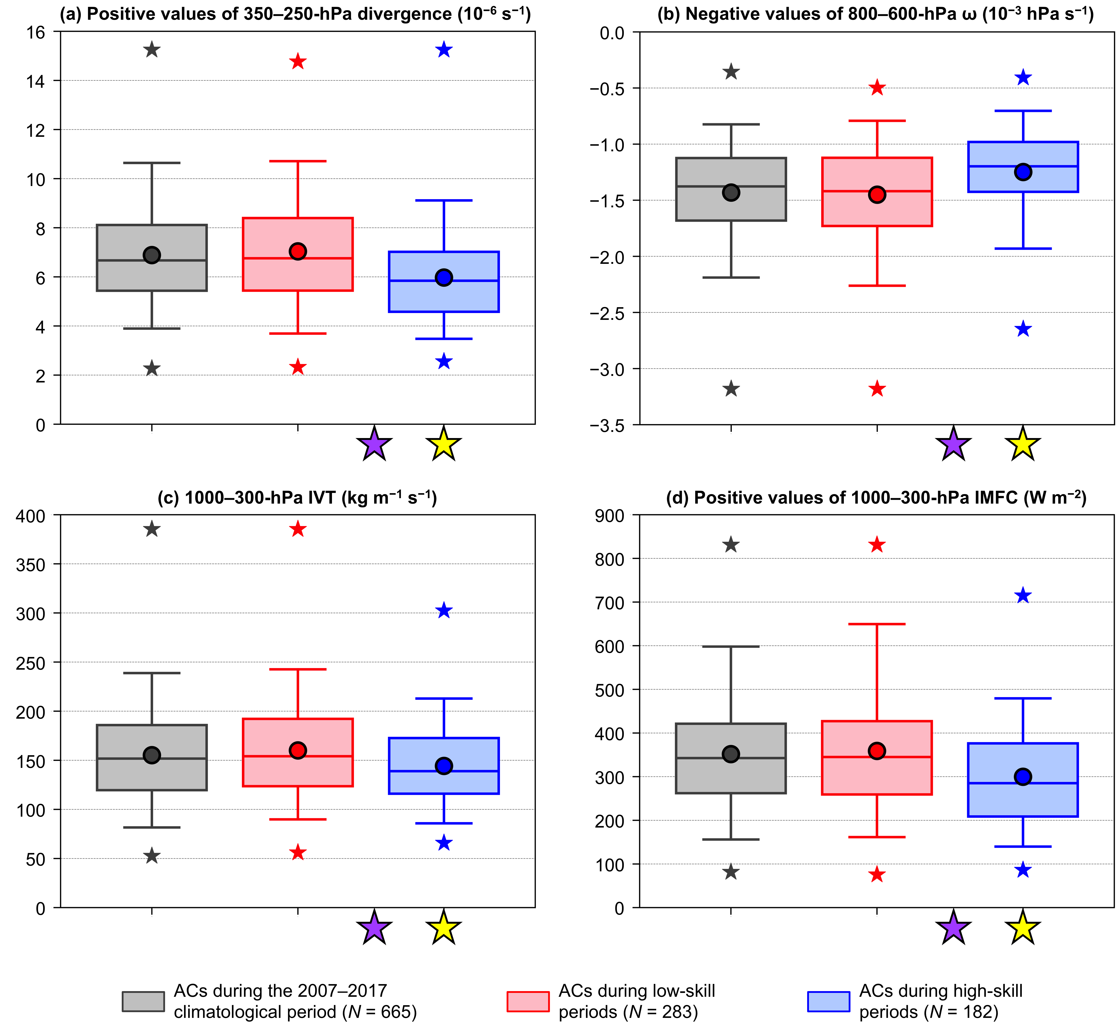
Fig. 10. As in Fig. 9, but for (a) area-averaged positive values of 350–250-hPa divergence (10⁻⁶ s⁻¹), (b) area-averaged negative values of 800–600-hPa ω (10⁻³ hPa s⁻¹), (c) area-averaged 1000–300-hPa IVT (kg m⁻¹ s⁻¹), and (d) area-averaged positive values of 1000–300-hPa IMFC (W m⁻²). The quantities in (a)–(d) are area-averaged within a 1000-km radius from the centers of the ACs.

c. Forecast skill of ACs
As discussed in section 1, forecast errors related to baroclinic processes and latent heating can contribute to forecast errors in midlatitude cyclones. Zhu and Thorpe (2006) state that forecast errors can grow exponentially through baroclinic processes, and Zhang et al. (2003) show in simulations of a midlatitude cyclone along the East Coast of the U.S. that setting latent heat of condensation to zero greatly reduces the growth of forecast errors. It is expected that the stronger lower-tropospheric baroclinicity, larger lower-to-midtropospheric EGR, and larger latent heating for ACs during low-skill periods compared to ACs during high-skill periods (Figs. 9c,d and Fig. 10d; discussed in section 3b) may be associated with greater forecast errors that contribute to lower forecast skill of the intensity and position of ACs during low-skill periods compared to ACs during high-skill periods.
The forecast skill of the intensity (Fig. 11a) and position (Fig. 11b) of ACs during the 2007–2017 climatological period, ACs during low-skill periods, and ACs during high-skill periods are now examined for forecast lead times of 1–7 days, every 1 day, relative to the verification time of the ACs (see section 2d for definition of the verification time). Refer to Table 2 for the number of ACs during the 2007–2017 climatological period, ACs during low-skill periods, and ACs during high-skill periods for these forecast lead times. The intensity RMSE (Fig. 11a) and the position RMSE (Fig. 11b) of ACs during the 2007–2017 climatological period, ACs during low-skill periods, and ACs during high-skill periods tend to increase with increasing forecast lead time. For example, the mean intensity RMSE of ACs during the 2007–2017 climatological period increases from approximately 2.2 hPa for the 1-day lead time to approximately 7.0 hPa for the 7-day lead time, and the mean position RMSE of ACs during the 2007–2017 climatological period increases from approximately 208 km for the 1-day lead time to approximately 809 km for the 7-day lead time.

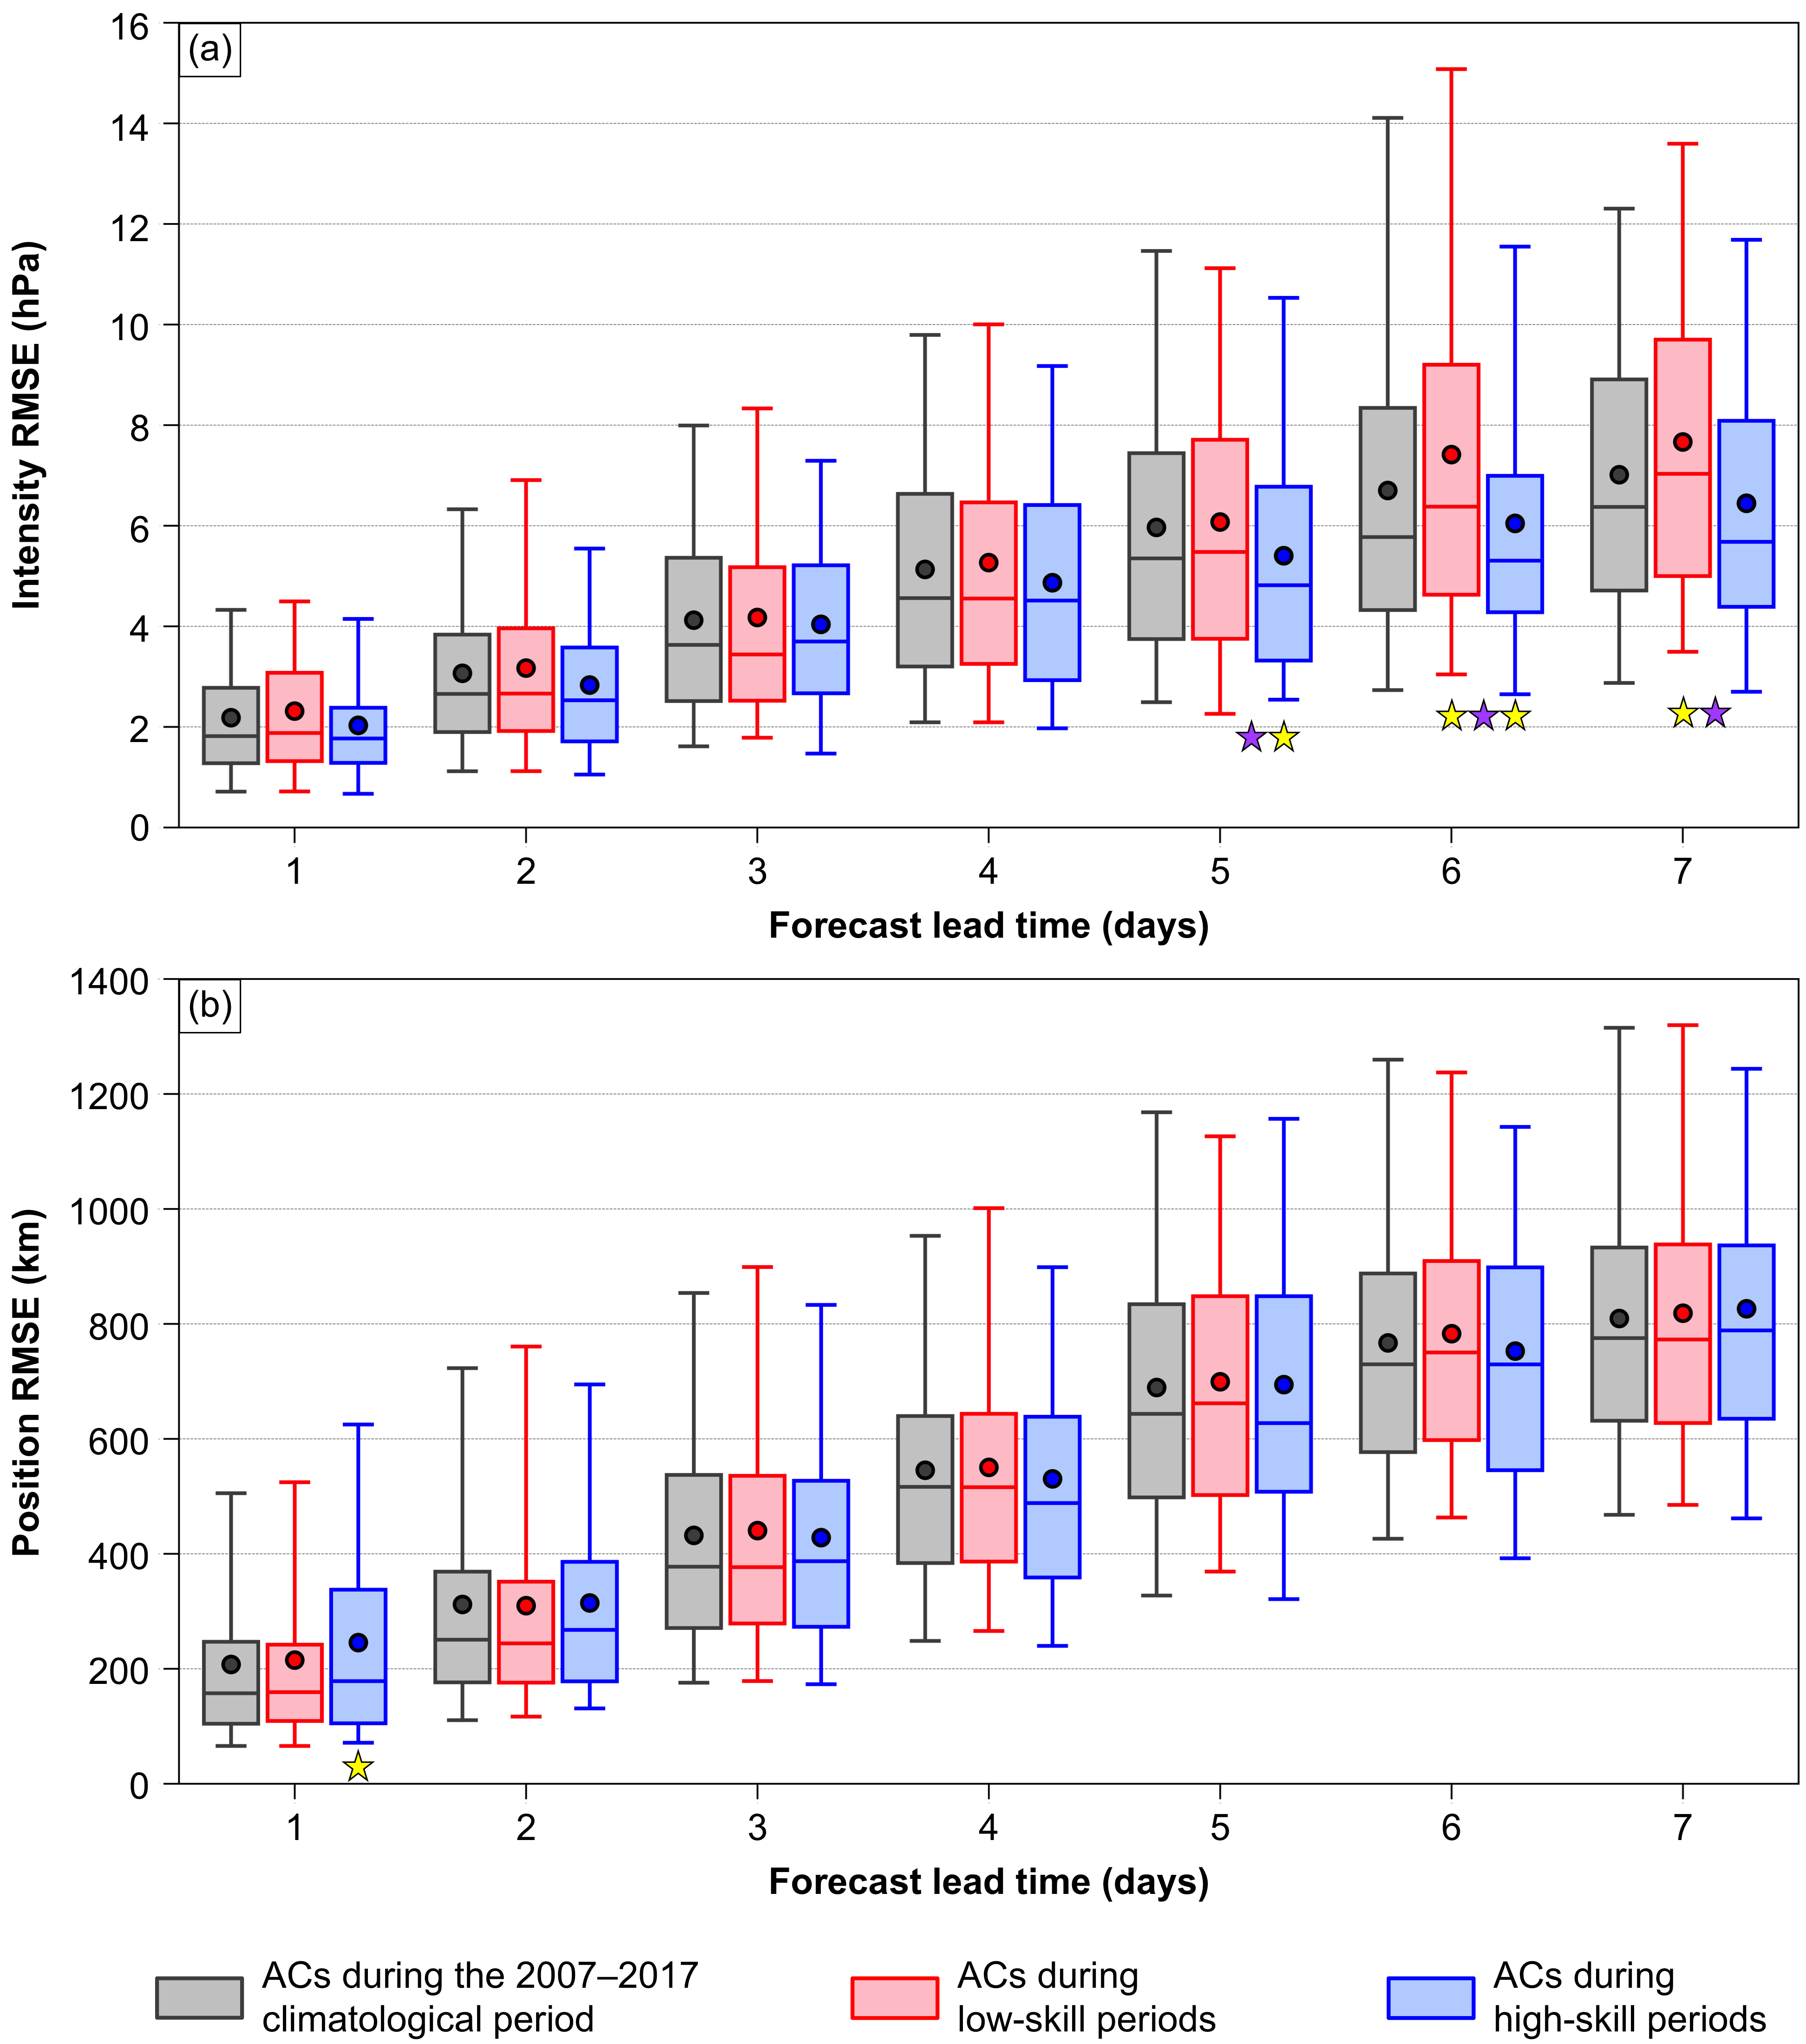
Fig. 11. Distributions of (a) intensity RMSE (hPa) and (b) position RMSE (km) of ACs during the 2007–2017 climatological period (gray), ACs during low-skill periods (red), and ACs during high-skill periods (blue) for which forecast skill can be evaluated at forecast lead times of 1–7 days, every 1 day. Dots indicate the mean values, boxes indicate the IQR, and whiskers extend to the 5th and 95th percentiles. Yellow stars in (a) indicate statistical significance at the 95% confidence level of the mean value of intensity RMSE for ACs during low-skill periods and ACs during high-skill periods with respect to the mean value of intensity RMSE for ACs during the 2007–2017 climatological period. Yellow star in (b) indicates statistical significance at the 95% confidence level of the mean value of position RMSE for ACs during high-skill periods with respect to the mean value of position RMSE for ACs during the 2007–2017 climatological period. Purple stars in (a) indicate statistical significance at the 95% confidence level between the mean value of intensity RMSE for ACs during low-skill periods and the mean value of intensity RMSE for ACs during high-skill periods.

 | Forecast lead time (days)
 | 1 | 2 | 3 | 4 | 5 | 6 | 7
The 2007–2017 climatological period | 504 | 557 | 549 | 528 | 509 | 450 | 343
Low-skill periods | 213 | 238 | 231 | 223 | 208 | 176 | 142
High-skill periods | 126 | 148 | 147 | 143 | 145 | 135 | 93

Table 2. Number of ACs during the 2007–2017 climatological period, ACs during low-skill periods, and ACs during high-skill periods for which forecast skill can be evaluated at forecast lead times of 1–7 days, every 1 day.

The mean intensity RMSE of ACs during low-skill periods is only slightly higher than the mean intensity RMSE of ACs during high-skill periods for forecast lead times of 1–4 days (Fig. 11a), and statistically significantly higher than the mean intensity RMSE of ACs during high-skill periods for forecast lead times of 5–7 days (Fig. 11a). The statistically significantly higher mean intensity RMSE of ACs during low-skill periods compared to high-skill periods for only three of the seven forecast lead times provides weak evidence that ACs are associated with lower forecast skill of intensity during low-skill periods compared to high-skill periods. The mean intensity RMSE of ACs during low-skill periods is statistically significantly higher than the mean intensity RMSE of ACs during the 2007–2017 climatological period for forecast lead times of 6–7 days (Fig. 11a), and the mean intensity RMSE of ACs during high-skill periods is statistically significantly lower than the mean intensity RMSE of ACs during the 2007–2017 climatological period for forecast lead times of 5–6 days (Fig. 11a). There are no statistically significant differences in the mean values of position RMSE between ACs during low-skill periods and ACs during high-skill periods for all forecast lead times (Fig. 11b). The mean position RMSE of ACs during high-skill periods is statistically significantly higher than the mean position RMSE of ACs during the 2007–2017 climatological period for only the 1-day forecast lead time. The relatively small number of instances of statistically significant differences in the mean values of intensity RMSE, and the lack of statistically significant differences in the mean values of position RMSE, between ACs during low-skill periods and ACs during high-skill periods suggest that the forecast skill of the intensity and position of ACs cannot be inferred from the forecast skill of the synoptic-scale flow over the Arctic, such that ACs during low-skill periods are not necessarily associated with lower forecast skill of intensity and position compared to ACs during high-skill periods.
Distributions of the most extreme value, as defined in section 2c, of quantities characterizing the four skill categories of ACs based on intensity RMSE for the 5-day lead time, which were introduced in section 2d, are now examined. These four skill categories are: low-skill ACs during low-skill periods, high-skill ACs during low-skill periods, low-skill ACs during high-skill periods, and high-skill ACs during high-skill periods. Low-skill ACs during low-skill periods tend to be statistically significantly stronger (Fig. 12a), and tend to be located in regions characterized by statistically significantly stronger lower-tropospheric flow (Fig. 12b), stronger lower-tropospheric baroclinicity (Fig. 12c), and larger lower-to-midtropospheric EGR (Fig. 12d), compared to high-skill ACs during low-skill periods. Low-skill ACs during high-skill periods tend to be statistically significantly stronger (Fig. 12a), and tend to be located in regions characterized by statistically significantly stronger lower-tropospheric flow (Fig. 12b), compared to high-skill ACs during high-skill periods.

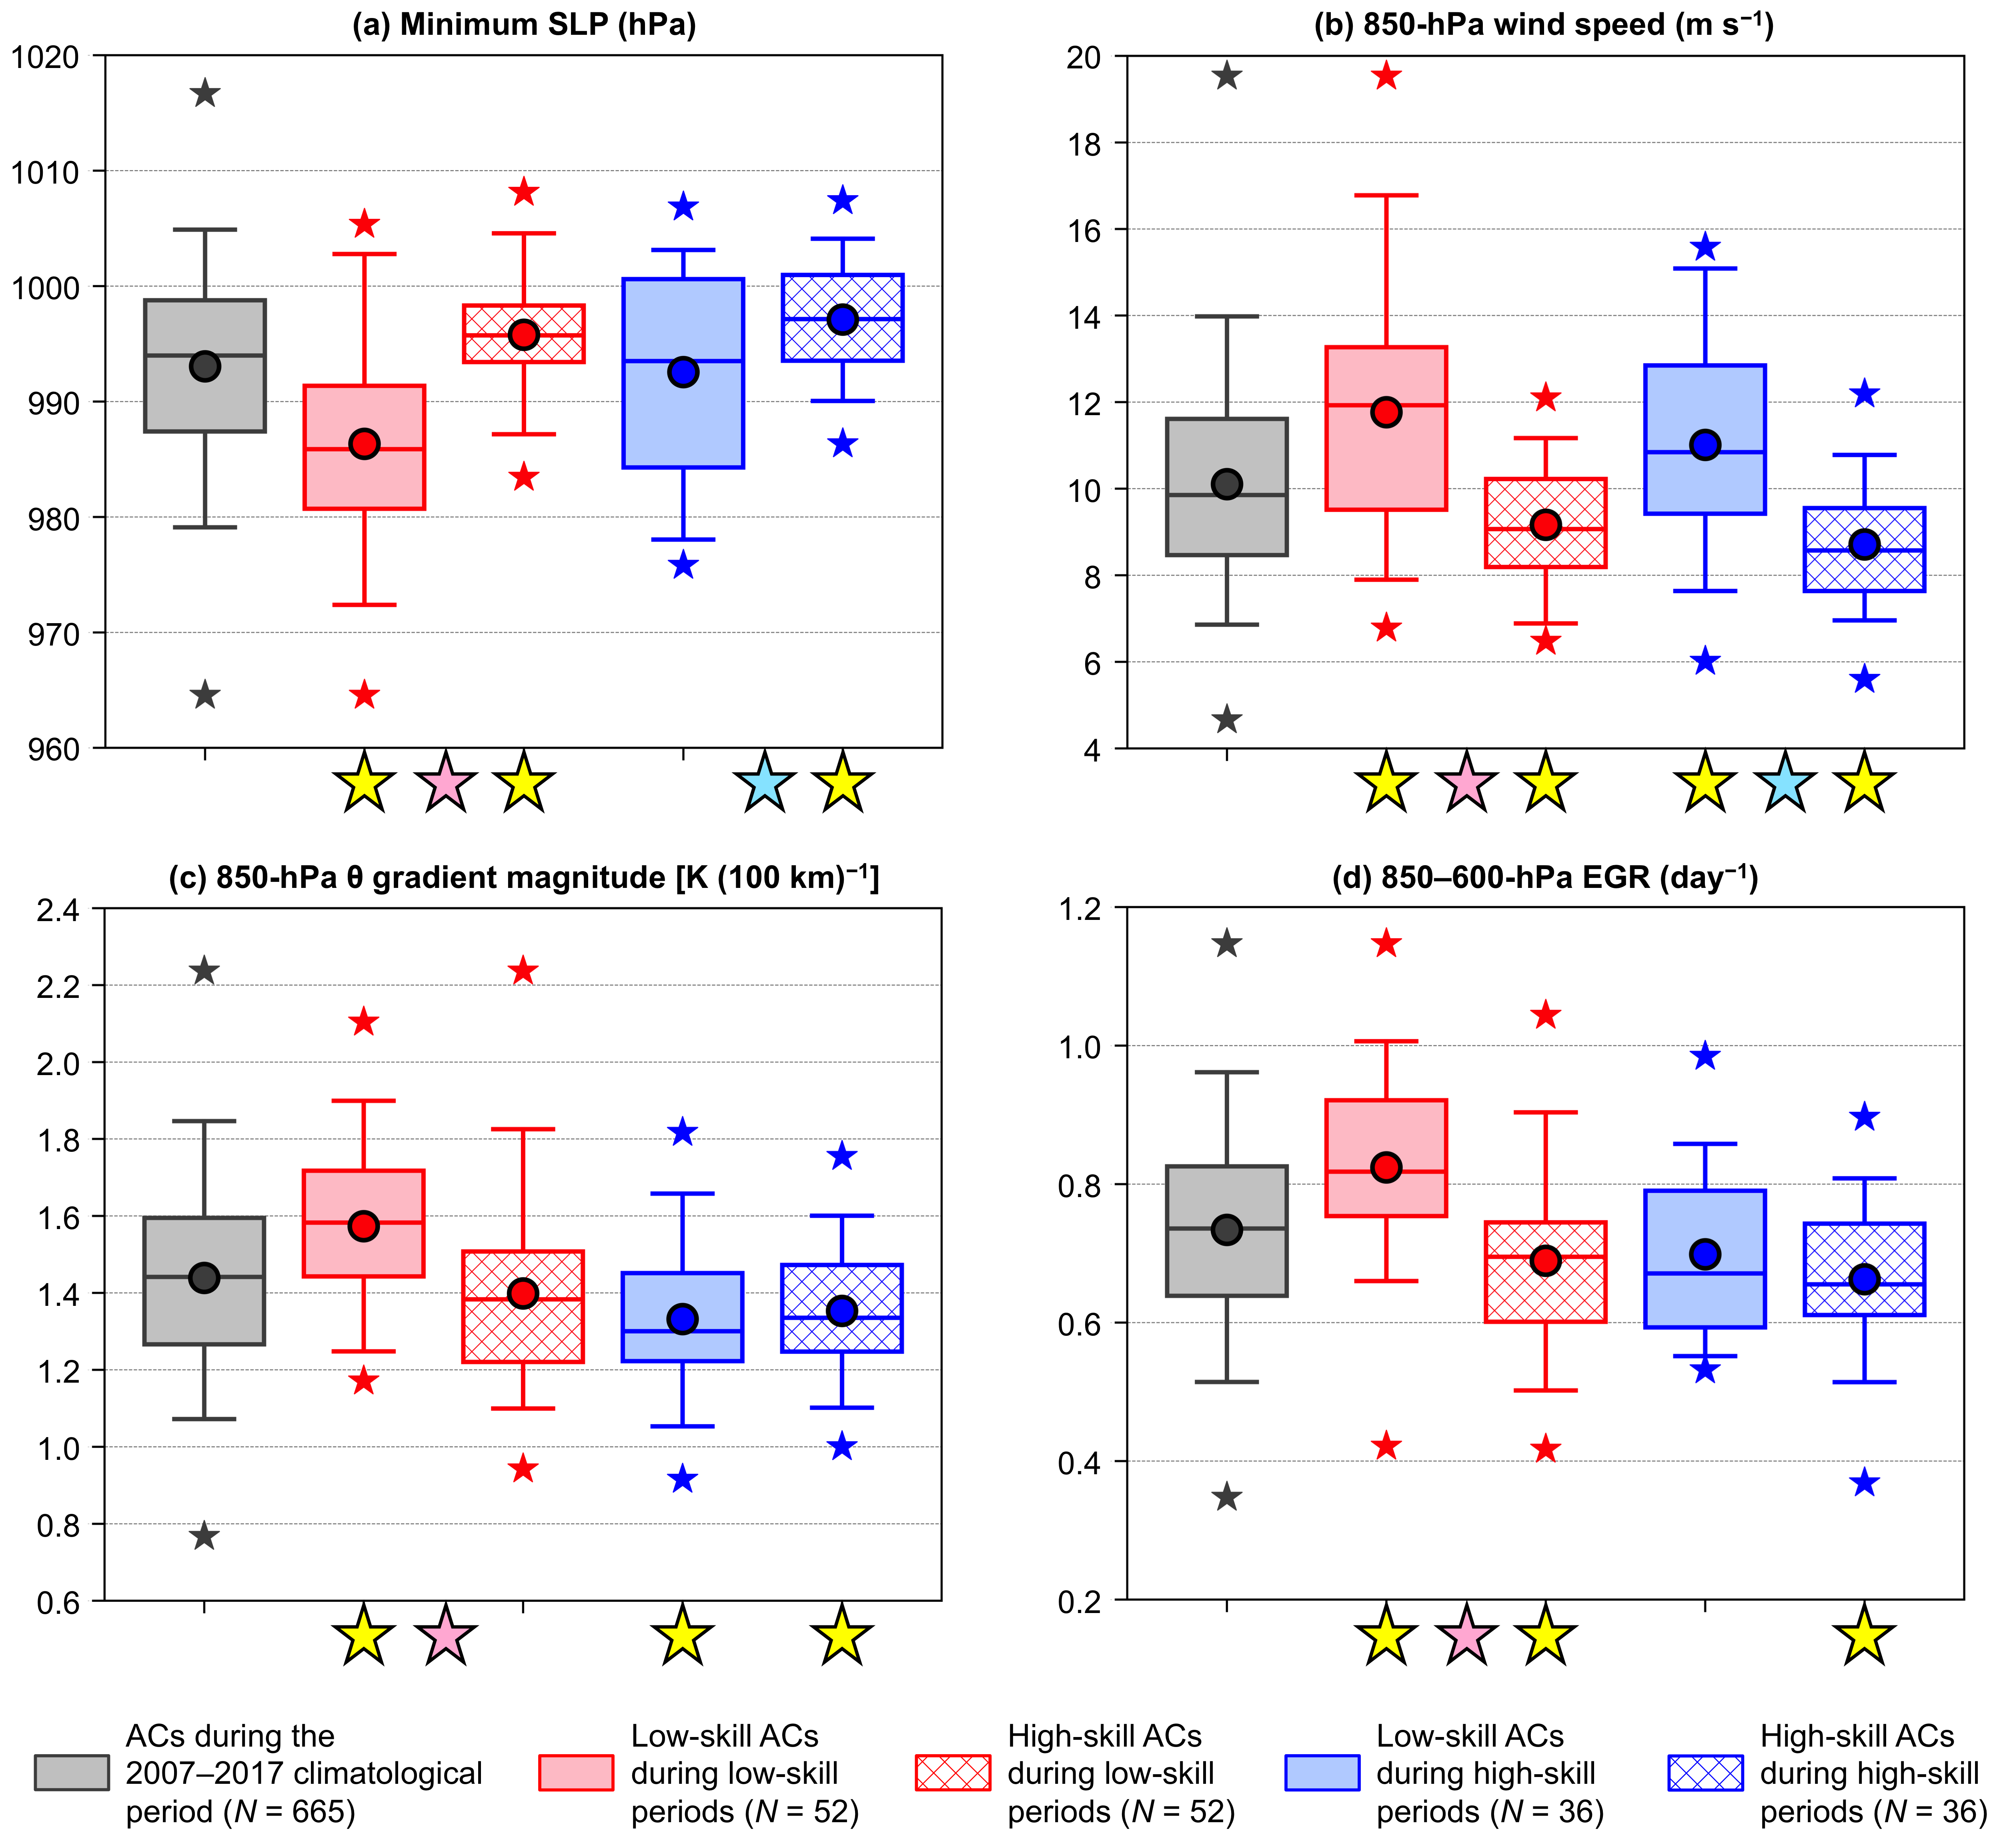
Fig. 12. Distributions of the most extreme value, as defined in section 2c, of quantities characterizing ACs during the 2007–2017 climatological period (gray), low-skill ACs during low-skill periods (red solid), high-skill ACs during low-skill periods (red hatched), low-skill ACs during high-skill periods (blue solid), and high-skill ACs during high-skill periods (blue hatched) when located within the Arctic during the respective periods. The selected quantities are (a) minimum SLP (hPa), (b) area-averaged 850-hPa wind speed (m s⁻¹), (c) area-averaged 850-hPa θ gradient magnitude [K (100 km)⁻¹], and (d) area-averaged 850–600-hPa EGR (day⁻¹). The quantities in (b)–(d) are area-averaged within a 1000-km radius from the centers of the ACs. Dots indicate the mean values, boxes indicate the IQR, and whiskers extend to the 5th and 95th percentiles. Gray, red, and blue stars indicate the minimum and maximum values of the distributions. Yellow stars indicate statistical significance at the 95% confidence level of the mean values of the quantities for low-skill ACs during low-skill periods and high-skill ACs during high-skill periods with respect to the mean values of the quantities for ACs during the 2007–2017 climatological period. Pink stars indicate statistical significance at the 95% confidence level between the mean values of the quantities for low-skill ACs during low-skill periods and the mean values of the quantities for high-skill ACs during low-skill periods. Light blue stars indicate statistical significance at the 95% confidence level between the mean values of the quantities for low-skill ACs during high-skill periods and the mean values of the quantities for high-skill ACs during high-skill periods.

The tendency for low-skill ACs during low-skill periods to be statistically significantly stronger than high-skill ACs during low-skill periods and the tendency for low-skill ACs during high-skill periods to be statistically significantly stronger than high-skill ACs during high-skill periods are consistent with the findings of Yamagami et al. (2019) and Capute and Torn (2021), who both show that ACs with lower predictability in terms of intensity tend to be stronger. The tendency for low-skill ACs during low-skill periods to be located in regions characterized by statistically significantly larger lower-to-midtropospheric EGR compared to high-skill ACs during low-skill periods is consistent with the findings of Capute and Torn (2021). As discussed in section 1, Capute and Torn (2021) find that ACs characterized by lower predictability in terms of intensity are typically located in environments characterized by larger lower-to-midtropospheric EGR compared to ACs characterized by higher predictability in terms of intensity.
Low-skill ACs during low-skill periods tend to be located in regions characterized by statistically significantly stronger upper-tropospheric divergence (Fig. 13a), stronger lower-to-midtropospheric ascent (Fig. 13b), stronger moisture transport (Fig. 13c), and larger latent heating (Fig. 13d) compared to high-skill ACs during low-skill periods. Low-skill ACs during high-skill periods tend to be located in regions characterized by statistically significantly stronger lower-to-midtropospheric ascent (Fig. 13b) and stronger moisture transport (Fig. 13c) compared to high-skill ACs during high-skill periods. Low-skill ACs during high-skill periods and high-skill ACs during high-skill periods tend to be located in regions characterized by comparable latent heating (no statistically significant difference), as suggested by the substantial overlap of the distributions of latent heating for low-skill ACs during high-skill periods and high-skill ACs during high-skill periods (Fig. 13d). The tendency for low-skill ACs during high-skill periods and high-skill ACs during high-skill periods to be located in regions characterized by comparable latent heating is consistent with the finding of Capute and Torn (2021) of no systematic difference in latent heating between ACs characterized by lower predictability in terms of intensity and ACs characterized by higher predictability in terms of intensity. However, the tendency for low-skill ACs during low-skill periods to be located in regions characterized by statistically significantly larger latent heating compared to high-skill ACs during low-skill periods is not consistent with the aforementioned finding from Capute and Torn (2021).

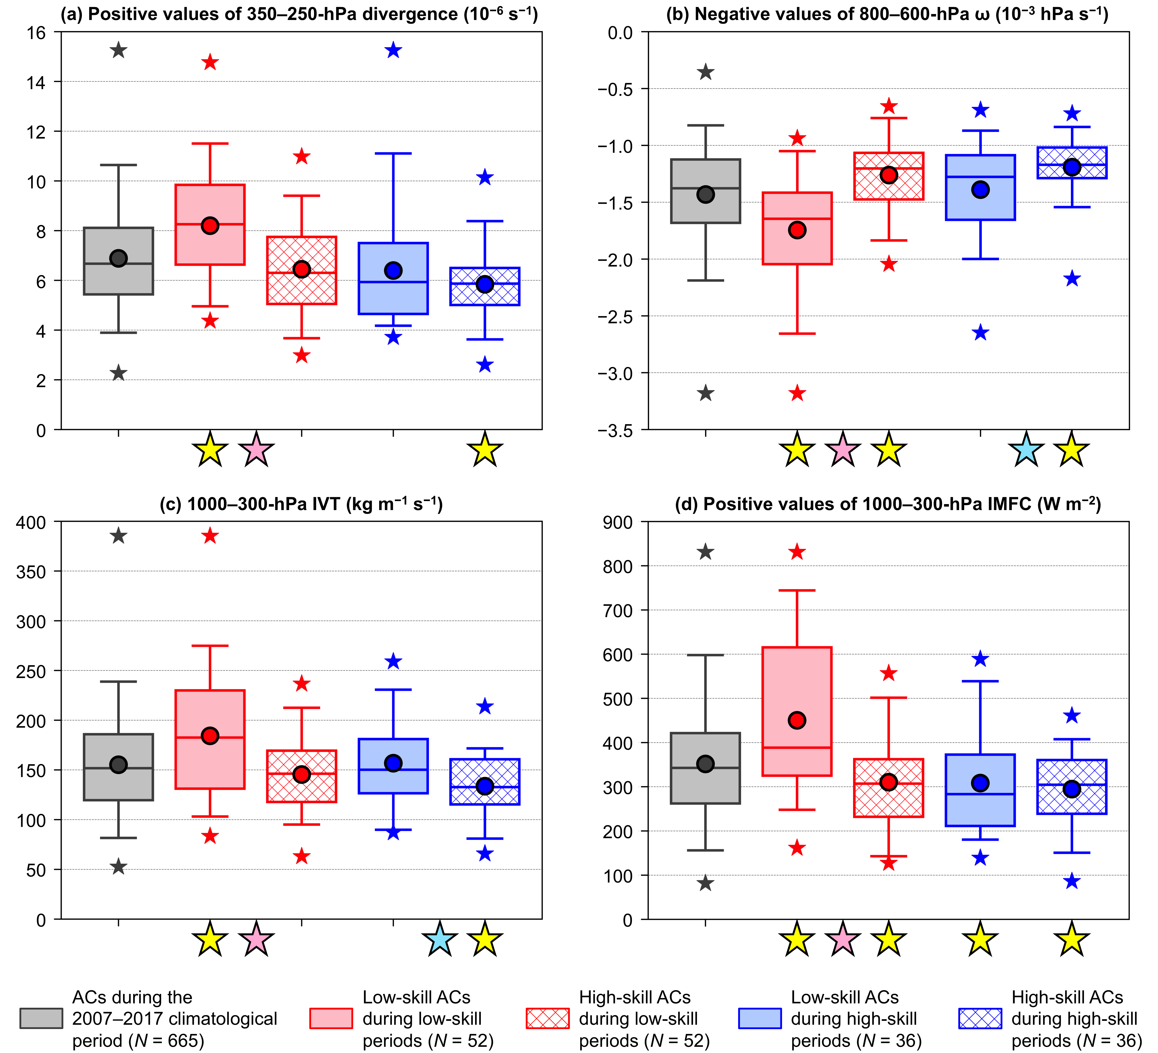
Fig. 13. As in Fig. 12, but for (a) area-averaged positive values of 350–250-hPa divergence (10⁻⁶ s⁻¹), (b) area-averaged negative values of 800–600-hPa ω (10⁻³ hPa s⁻¹), (c) area-averaged 1000–300-hPa IVT (kg m⁻¹ s⁻¹), and (d) area-averaged positive values of 1000–300-hPa IMFC (W m⁻²). The quantities in (a)–(d) are area-averaged within a 1000-km radius from the centers of the ACs.

When compared to ACs during the 2007–2017 climatological period, there is statistical significance in the mean values of all quantities shown in Figs. 12 and 13 for low-skill ACs during low-skill periods. Low-skill ACs during low-skill periods are characterized by low forecast skill of intensity. It is expected that relatively large forecast errors that may be associated with relatively strong lower-tropospheric baroclinicity, relatively large lower-to-midtropospheric EGR, and relatively large latent heating in the vicinity of low-skill ACs during low-skill periods may help explain the low forecast skill of intensity of low-skill ACs during low-skill periods.
When considering the four skill categories of ACs based on position RMSE for the 5-day lead time (not shown), there are no statistically significant differences in the quantities shown in Figs. 12 and 13 between low-skill ACs during low-skill periods and high-skill ACs during low-skill periods, and between low-skill ACs during high-skill periods and high-skill ACs during high-skill periods. Similarly, Capute and Torn (2021) indicate that ACs characterized by lower predictability in terms of position and ACs characterized by higher predictability in terms of position are not associated with substantial differences in environmental properties. The forecast skill of the position of ACs is likely less sensitive to the conduciveness of the environment to AC development and intensification than the forecast skill of the intensity of ACs.

4. Summary
Although there has been previous research that has examined the forecast skill of the synoptic-scale flow over the Arctic (e.g., Jung and Leutbecher 2007; Bauer et al. 2016; Jung and Matsueda 2016; Sandu and Bauer 2018), there has been a dearth of research that has examined Arctic environmental conditions during low-skill periods and high-skill periods, with the exception of a recent study by Yamagami and Matsueda (2021). There also has been limited research on the predictability of ACs, though interest in the predictability of ACs has recently been increasing (e.g., Yamazaki et al. 2015; Yamagami et al. 2018a,b, 2019; Capute and Torn 2021; Johnson and Wang 2021). The present study provides insights into how characteristics of the Arctic environment, and the frequency, characteristics, and forecast skill of ACs, compare between low-skill periods and high-skill periods.
The present study finds that there is a statistically significant tendency for more vigorous baroclinic processes and latent heating over the Arctic during low-skill periods compared to high-skill periods. Baroclinic processes have been shown to contribute to the development and intensification of ACs (e.g., Aizawa et al. 2014; Tao et al. 2017a,b; Yamagami et al. 2017). Although there has been limited research on the influence of latent heating on the development and intensification of ACs, it is possible that latent heating may contribute to the development and intensification of ACs. The tendency for more vigorous baroclinic processes and latent heating over the Arctic during low-skill periods compared to high-skill periods suggests that there is a tendency for Arctic environmental conditions to be more conducive to AC development and intensification during low-skill periods compared to high-skill periods. It was expected that Arctic environmental conditions that are more conducive to AC development and intensification during low-skill periods compared to high-skill periods may correspond to more frequent occurrences of ACs and stronger ACs during low-skill periods compared to high-skill periods. Consistent with expectations, the present study finds that there are higher track frequencies of ACs over much of the Arctic, and that there is a tendency for ACs to be statistically significantly stronger, during low-skill periods compared to high-skill periods.
ACs during low-skill periods tend to be located in regions characterized by statistically significantly stronger lower-tropospheric baroclinicity, statistically significantly larger lower-to-midtropospheric EGR, and statistically significantly larger latent heating compared to ACs during high-skill periods. It was expected that the stronger lower-tropospheric baroclinicity, larger lower-to-midtropospheric EGR, and larger latent heating for ACs during low-skill periods compared to ACs during high-skill periods may be associated with greater forecast errors that contribute to lower forecast skill of the intensity and position of ACs during low-skill periods compared to ACs during high-skill periods. However, there is only weak evidence that ACs are associated with lower forecast skill of intensity during low-skill periods compared to high-skill periods and there is no evidence that ACs are associated with lower forecast skill of position during low-skill periods compared to high-skill periods.
ACs are decomposed into four skill categories based on intensity RMSE for the 5-day lead time. Low-skill ACs during low-skill periods tend to be statistically significantly stronger, and tend to be located in regions of statistically significantly stronger lower-tropospheric baroclinicity, larger lower-to-midtropospheric EGR, stronger moisture transport, and larger latent heating, when compared to high-skill ACs during low-skill periods and ACs during the 2007–2017 climatological period. It is expected that relatively large forecast errors that may be associated with relatively strong lower-tropospheric baroclinicity, relatively large lower-to-midtropospheric EGR, and relatively large latent heating may help explain the low forecast skill of intensity of low-skill ACs during low-skill periods. The present study thus suggests that conditions forecasters may expect to see to indicate a higher likelihood of poor intensity forecasts of ACs include relatively strong lower-tropospheric baroclinicity, relatively large lower-to-midtropospheric EGR, relatively strong moisture transport, and relatively large latent heating.
There are limitations of the present study. One limitation is that when comparing ACs of different forecast skill, the relationship between the stage of the ACs (i.e., developing, mature, and decaying stages) and differences in the forecast skill and characteristics of the ACs is not examined. It is speculated that there may be greater forecast errors related to more vigorous baroclinic processes and latent heating, and correspondingly lower forecast skill of the intensity of ACs, during the developing and mature stages compared to the decaying stage. Another limitation of the present study is that the influence of the geographical location of ACs on the forecast skill and characteristics of ACs is not considered. It is speculated, for instance, that ACs originating from lower-latitude regions with relatively large coverage of observational data may tend to be associated with higher forecast skill compared to ACs originating over the Arctic, where there is relatively sparse coverage of conventional data (e.g., Lawrence et al. 2019). An additional limitation of the present study is that ACs for which there are < 5 ensemble members with a matching forecast AC occurring at the verification time for a given forecast lead time are not examined. ACs for which there are < 5 ensemble members with a matching forecast AC may be considered ACs characterized by low forecast skill of existence. There is a higher number ACs characterized by low forecast skill of existence during low-skill periods compared to high-skill periods for forecast lead times of 1–7 days (not shown), suggesting that low-skill periods may be associated with lower forecast skill of the existence of ACs compared to high-skill periods.
Although the present study identifies processes that may influence the forecast skill of ACs through the examination of area-averages of selected dynamic and thermodynamic quantities, a limitation of these area-averages is that they cannot fully capture the detailed evolution of key features (e.g., TPVs) and processes influencing the evolution and forecast skill of ACs. The evolution of AC12, which is associated with limited forecast skill (e.g., Yamagami et al. 2018a), has been shown to be influenced by the interaction between a TPV and an upper-tropospheric jet streak in a region of strong baroclinicity (e.g., Tao et al. 2017b). Better understanding of features and processes influencing the evolution and forecast skill of low-skill ACs during low-skill periods is especially of interest since these ACs may pose challenges to human activities in the Arctic that may be impacted by potential hazardous weather conditions associated with this category of ACs. Thus, features and processes influencing the evolution and forecast skill of low-skill ACs during low-skill periods are the topic of a future paper.

Acknowledgments.
The authors thank three anonymous reviewers for constructive feedback on a prior version of this manuscript. The authors thank Steven Cavallo (University of Oklahoma), Andrea Lang (University at Albany, SUNY), and Ryan Torn (University at Albany, SUNY) for helpful discussions. The authors thank Alex Crawford (Centre for Earth Observation Science, University of Manitoba) for providing cyclone tracking code. This research was performed as part of the first author’s Ph.D. dissertation at the University at Albany, SUNY, and was funded by ONR Grant N00014-18-1-2200.

Data availability statement.
The NOAA GEFS reforecast dataset version 2 data used in this study were obtained from the NOAA Physical Sciences Laboratory (https://psl.noaa.gov/forecasts/reforecast2/). The ERA-Interim data used in this study were obtained from European Centre for Medium-Range Weather Forecasts (2009).

REFERENCES
Aizawa, T., H. L. Tanaka, and M. Satoh, 2014: Rapid development of arctic cyclone in June 2008 simulated by the cloud resolving global model NICAM. Meteor. Atmos. Phys., 126, 105–117, https://doi.org/10.1007/s00703-013-0272-6.
Asplin, M. G., R. Galley, D. G. Barber, and S. Prinsenberg, 2012: Fracture of summer perennial sea ice by ocean swell as a result of Arctic storms. J. Geophys. Res., 117, C06025, https://doi.org/10.1029/2011JC007221.
Bauer, P., L. Magnusson, J.-N. Thépaut, and T. M. Hamill, 2016: Aspects of ECMWF model performance in polar areas. Quart. J. Roy. Meteor. Soc., 142, 583–596, https://doi.org/10.1002/qj.2449.
Biernat, K. A., 2021: An examination of the Arctic environment and Arctic cyclones during periods of low and high forecast skill of the synoptic-scale flow. Ph.D. dissertation, University at Albany, State University of New York, Albany, NY, 166 pp, https://www.proquest.com/openview/50a9a3a684cacaf144ed6578d7f93ebe.
Binder, H., M. Boettcher, C. M. Grams, H. Joos, S. Pfahl, and H. Wernli, 2017: Exceptional air mass transport and dynamical drivers of an extreme wintertime Arctic warm event. Geophys. Res. Lett., 44, 12028–12036, https://doi.org/10.1002/2017GL075841.
Blanchard-Wrigglesworth, E., M. Webster, L. Boisvert, C. Parker, and C. Horvat, 2022: Record Arctic cyclone of January 2022: Characteristics, impacts, and predictability. J. Geophys. Res. Atmos., e2022JD037161, https://doi.org/10.1029/2022JD037161.
Boisserie, M., P. Arbogast, L. Descamps, O. Pannekoucke, and L. Raynaud, 2014: Estimating and diagnosing model error variances in the Météo-France global NWP model. Quart. J. Roy. Meteor. Soc., 140, 846–854, https://doi.org/10.1002/qj.2173.
Brodzik, M. J., B. Billingsley, T. Haran, B. Raup, and M. H. Savoie, 2012: EASE-Grid 2.0: Incremental but significant improvements for Earth-gridded data sets. ISPRS Int. J. Geoinf., 1, 32–45, https://doi.org/10.3390/ijgi1010032.
Capute, P. K., and R. D. Torn, 2021: A comparison of Arctic and Atlantic cyclone predictability. Mon. Wea. Rev., 149, 3837–3849, https://doi.org/10.1175/MWR-D-20-0350.1.
Cavallo, S. M., and G. J. Hakim, 2009: Potential vorticity diagnosis of a tropopause polar cyclone. Mon. Wea. Rev., 137, 1358–1371, https://doi.org/10.1175/2008MWR2670.1.
Cavallo, S. M., and G. J. Hakim, 2010: Composite structure of tropopause polar cyclones. Mon. Wea. Rev., 138, 3840–3857, https://doi.org/10.1175/2010MWR3371.1.
Cavallo, S. M., and G. J. Hakim, 2012: Radiative impact on tropopause polar vortices over the Arctic. Mon. Wea. Rev., 140, 1683–1702, https://doi.org/10.1175/MWR-D-11-00182.1.
Crawford, A., and M. Serreze, 2015: A new look at the summer Arctic frontal zone. J. Climate, 28, 737–754, https://doi.org/10.1175/JCLI-D-14-00447.1.
Crawford, A. D., and M. C. Serreze, 2016: Does the summer Arctic frontal zone influence Arctic Ocean cyclone activity? J. Climate, 29, 4977–4993, https://doi.org/10.1175/JCLI-D-15-0755.1.
Crawford, A. D., E. A. P. Schreiber, N. Sommer, M. C. Serreze, J. C. Stroeve, and D. G. Barber, 2021: Sensitivity of Northern Hemisphere cyclone detection and tracking results to fine spatial and temporal resolution using ERA5. Mon. Wea. Rev., 149, 2581–2598, https://doi.org/10.1175/MWR-D-20-0417.1.
Davies, H. C., and M. Didone, 2013: Diagnosis and dynamics of forecast error growth. Mon. Wea. Rev., 141, 2483–2501, https://doi.org/10.1175/MWR-D-12-00242.1.
Davis, C. A., M. T. Stoelinga, and Y.-H. Kuo, 1993: The integrated effect of condensation in numerical simulations of extratropical cyclogenesis. Mon. Wea. Rev., 121, 2309–2330, https://doi.org/10.1175/1520-0493(1993)121<2309:TIEOCI>2.0.CO;2.
Dee, D. P., and Coauthors, 2011: The ERA-Interim reanalysis: Configuration and performance of the data assimilation system. Quart. J. Roy. Meteor. Soc., 137, 553–597, https://doi.org/10.1002/qj.828.
Eguíluz, V. M., J. Fernández-Gracia, X. Irigoien, and C. M. Duarte, 2016: A quantitative assessment of Arctic shipping in 2010–2014. Sci. Rep., 6, 30682, https://doi.org/10.1038/srep30682.
European Centre for Medium-Range Weather Forecasts, 2009: ERA-Interim Project. National Center for Atmospheric Research Computational and Information Systems Laboratory Research Data Archive, accessed 01 January 2019, https://doi.org/10.5065/D6CR5RD9.
Fearon, M. G., J. D. Doyle, D. R. Ryglicki, P. M. Finocchio, and M. Sprenger, 2021: The role of cyclones in moisture transport into the Arctic. Geophys. Res. Lett., 48, e2020GL090353, https://doi.org/10.1029/2020GL090353.
Froude, L. S. R., 2010: TIGGE: Comparison of the prediction of Northern Hemisphere extratropical cyclones by different ensemble prediction systems. Wea. Forecasting, 25, 819–836, https://doi.org/10.1175/2010WAF2222326.1.
Grams, C. M., L. Magnusson, and E. Madonna, 2018: An atmospheric dynamics perspective on the amplification and propagation of forecast error in numerical weather prediction models: A case study. Quart. J. Roy. Meteor. Soc., 144, 2577–2591, https://doi.org/10.1002/qj.3353.
Hall, C. M., and J. Saarinen, 2010: Polar tourism: Definitions and dimensions. Scand. J. Hospitality Tourism, 10, 448–467, https://doi.org/10.1080/15022250.2010.521686.
Hamill, T. M., and G. N. Kiladis, 2014: Skill of the MJO and Northern Hemisphere blocking in GEFS medium-range reforecasts. Mon. Wea. Rev., 142, 868–885, https://doi.org/10.1175/MWR-D-13-00199.1.
Hamill, T. M., G. T. Bates, J. S. Whitaker, D. R. Murray, M. Fiorino, T. J. Galarneau Jr., Y. Zhu, and W. Lapenta, 2013: NOAA’s second-generation global medium-range ensemble reforecast dataset. Bull. Amer. Meteor. Soc., 94, 1553–1565, https://doi.org/10.1175/BAMS-D-12-00014.1.
Hersbach, H., and Coauthors, 2020: The ERA5 global reanalysis. Quart. J. Roy. Meteor. Soc., 146, 1999–2049, https://doi.org/10.1002/qj.3803.
Hoskins, B. J., and P. J. Valdes, 1990: On the existence of storm-tracks. J. Atmos. Sci, 47, 1854–1864, https://doi.org/10.1175/1520-0469(1990)047<1854:OTEOST>2.0.CO;2.
Hoskins, B. J., M. E. McIntyre, and A. W. Robertson, 1985: On the use and significance of isentropic potential vorticity maps. Quart. J. Roy. Meteor. Soc., 111, 877–946, https://doi.org/10.1002/qj.49711147002.
Inoue, J., 2021: Review of forecast skills for weather and sea ice in supporting Arctic navigation. Polar Sci., 27, 100523. https://doi.org/10.1016/j.polar.2020.100523.
Johnson, A., and X. Wang, 2021: Observation impact study of an Arctic cyclone associated with a tropopause polar vortex (TPV)-induced Rossby wave initiation event. Mon. Wea. Rev., 149, 1577–1591, https://doi.org/10.1175/MWR-D-20-0285.1.
Jung, T., and M. Leutbecher, 2007: Performance of the ECMWF forecasting system in the Arctic during winter. Quart. J. Roy. Meteor. Soc., 133, 1327–1340, https://doi.org/10.1002/qj.99.
Jung, T., and M. Matsueda, 2016: Verification of global numerical weather forecasting systems in polar regions using TIGGE data. Quart. J. Roy. Meteor. Soc., 142, 574–582, https://doi.org/10.1002/qj.2437.
Kalnay, E., R. Petersen, M. Kanamitsu, and W. E. Baker, 1991: United States operational numerical weather prediction. Rev. Geophys., 29, 104–114, https://doi.org/10.1002/rog.1991.29.s1.104.
Korfe, N. G., and B. A. Colle, 2018: Evaluation of cool-season extratropical cyclones in a multimodel ensemble for eastern North America and the western Atlantic Ocean. Wea. Forecasting, 33, 109–127, https://doi.org/10.1175/WAF-D-17-0036.1.
Kuo, Y.-H., and R. J. Reed, 1988: Numerical simulation of an explosively deepening cyclone in the eastern Pacific. Mon. Wea. Rev., 116, 2081–2105, https://doi.org/10.1175/1520-0493(1988)116<2081:NSOAED>2.0.CO;2.
Langland, R. H., and R. N. Maue, 2012: Recent Northern Hemisphere mid-latitude medium-range deterministic forecast skill. Tellus, 64A,1–10, https://www.tandfonline.com/doi/full/10.3402/tellusa.v64i0.17531.
Lawrence, H., N. Bormann, I. Sandu, J. Day, J. Farnan, P. Bauer, 2019: Use and impact of Arctic observations in the ECMWF numerical weather prediction system. Quart. J. Roy. Meteor. Soc., 145, 3432–3454, https://doi.org/10.1002/qj.3628.
Maher, P. T., 2017: Tourism futures in the Arctic. The interconnected Arctic—UArctic Congress 2016, K. Latola and H. Savela, Eds., Springer, Cham, 213–220.
Martínez-Alvarado, O., E. Madonna, S. Gray, and H. Joos, 2016: A route to systematic error in forecasts of Rossby waves. Quart. J. Roy. Meteor. Soc., 142, 196–210, https://doi.org/10.1002/qj.2645.
Melia, N., K. Haines, and E. Hawkins, 2016: Sea ice decline and 21st century trans-Arctic shipping routes. Geophys. Res. Lett., 43, 9720–9728, https://doi.org/10.1002/2016GL069315.
Melia, N., K. Haines, E. Hawkins, and J. J. Day, 2017: Towards seasonal Arctic shipping route predictions. Environ. Res. Lett., 12, 084005, https://doi.org/10.1088/1748-9326/AA7A60.
Messori, G., C. Woods, and R. Caballero, 2018: On the drivers of wintertime temperature extremes in the high Arctic. J. Climate, 31, 1597–1618, https://doi.org/10.1175/JCLI-D-17-0386.1.
Moore, B. J., 2017: Rossby wave breaking and widespread extreme precipitation events in the central and eastern U.S. Ph.D. dissertation, University at Albany, State University of New York, Albany, NY, 182 pp, https://www.proquest.com/openview/4ee7040dae0befb4c6d0833e012af300.
Peng, L., X. Zhang, J.-H. Kim, K.-H. Cho, B.-M. Kim, Z. Wang, and H. Tang, 2021: Role of intense Arctic storm in accelerating summer sea ice melt: An in situ observational study. Geophys. Res. Lett., 48, e2021GL092714, https://doi.org/10.1029/2021GL092714.
Reed, R. J., A. J. Simmons, M. D. Albright, and P. Undén, 1988: The role of latent heat release in explosive cyclogenesis: Three examples based on ECMWF operational forecasts. Wea. Forecasting, 3, 217–229, https://doi.org/10.1175/1520-0434(1988)003<0217:TROLHR>2.0.CO;2.
Reed, R. J., M. T. Stoelinga, and Y.-H. Kuo, 1992: A model-aided study of the origin and evolution of the anomalously high potential vorticity in the inner region of a rapidly deepening marine cyclone. Mon. Wea. Rev., 120, 893–913, https://doi.org/10.1175/1520-0493(1992)120<0893:AMASOT>2.0.CO;2.
Rodwell, J., and Coauthors, 2013: Characteristics of occasional poor medium-range weather forecasts for Europe. Bull. Amer. Meteor. Soc., 94, 1393–1405, https://doi.org/10.1175/BAMS-D-12-00099.1.
Sanders, F., 1986: Explosive cyclogenesis over the west-central North Atlantic Ocean, 1981–84. Part II: Evaluation of LFM model performance. Mon. Wea. Rev., 114, 2207–2218, https://doi.org/10.1175/1520-0493(1986)114<2207:ECOTWC>2.0.CO;2.
Sandu, I., and P. Bauer, 2018: Improving prediction and climate monitoring of polar regions–challenges and priorities. ECMWF science blog, https://www.ecmwf.int/en/about/media-centre/science-blog/2018/improving-prediction-and-climate-monitoring-polar-regions.
Selz, T., and G. C. Craig, 2015: Upscale error growth in a high-resolution simulation of a summertime weather event over Europe. Mon. Wea. Rev., 143, 813–827, https://doi.org/10.1175/MWR-D-14-00140.1.
Serreze, M. C., 1995: Climatological aspects of cyclone development and decay in the Arctic. Atmos.–Ocean, 33, 1–23, https://doi.org/10.1080/07055900.1995.9649522.
Serreze, M. C., and A. P. Barrett, 2008: The summer cyclone maximum over the central Arctic Ocean. J. Climate, 21, 1048–1065, https://doi.org/10.1175/2007JCLI1810.1.
Simmonds, I., and I. Rudeva, 2012: The great Arctic cyclone of August 2012. Geophys. Res. Lett., 39, L23709, https://doi.org/10.1029/2012GL054259.
Simmonds, I., and I. Rudeva, 2014: A comparison of tracking methods for extreme cyclones in the Arctic basin. Tellus, 66A, 25252, https://doi.org/10.3402/tellusa.v66.25252.
Stern, D. P, J. D. Doyle, N. P. Barton, P. M. Finocchio, W. A. Komaromi, and E. J. Metzger, 2020: The impact of an intense cyclone on short-term sea ice loss in a fully coupled atmosphere-ocean-ice model. Geophys. Res. Lett., 47, e2019GL085580, https://doi.org/10.1029/2019GL085580.
Stoelinga, M. T., 1996: A potential vorticity–based study of the role of diabatic heating and friction in a numerically simulated baroclinic cyclone. Mon. Wea. Rev., 124, 849–874, https://doi.org/10.1175/1520-0493(1996)124<0849:APVBSO>2.0.CO;2.
Tao, W., J. Zhang, and X. Zhang, 2017a: The role of stratosphere vortex downward intrusion in a long-lasting late-summer Arctic storm. Quart. J. Roy. Meteor. Soc., 143, 1953–1966, https://doi.org/10.1002/qj.3055.
Tao, W., J. Zhang, Y. Fu, and X. Zhang, 2017b: Driving roles of tropospheric and stratospheric thermal anomalies in intensification and persistence of the Arctic superstorm in 2012. Geophys. Res. Lett., 44, 10017–10025, https://doi.org/10.1002/2017GL074778.
Thomson, J., and W. E. Rogers, 2014: Swell and sea in the emerging Arctic Ocean. Geophys. Res. Lett., 41, 3136–3140, https://doi.org/10.1002/2014GL059983.
Torn, R. D., and G. J. Hakim, 2015: Comparison of wave packets associated with extratropical transition and winter cyclones. Mon. Wea. Rev., 143, 1782–1803, https://doi.org/10.1175/MWR-D-14-00006.1.
Tracton, M. S., 1973: The role of cumulus convection in the development of extratropical cyclones. Mon. Wea. Rev., 101, 573–593, https://doi.org/10.1175/1520-0493(1973)101<0573:TROCCI>2.3.CO;2.
Tribbia, J. J., and D. P. Baumhefner, 2004: Scale interactions and atmospheric predictability: An updated perspective. Mon. Wea. Rev., 132, 703–713, https://doi.org/10.1175/1520-0493(2004)132<0703:SIAAPA>2.0.CO;2.
U.S. Department of the Navy, 2021: A strategic blueprint for the Arctic. 28 pp, https://media.defense.gov/2021/Jan/05/2002560338/-1/-1/0/ARCTIC%20BLUEPRINT%202021%20FINAL.PDF/ARCTIC%20BLUEPRINT%202021%20FINAL.PDF.
Valkonen, E., J. Cassano, and E. Cassano, 2021: Arctic cyclones and their interactions with the declining sea ice: A recent climatology. J. Geophys. Res. Atmos., 126, e2020JD034366. https://doi.org/10.1029/2020JD034366.
Wernli, H., S. Dirren, M. A. Liniger, and M. Zillig, 2002: Dynamical aspects of the life cycle of the winter storm ‘Lothar’ (24–26 December 1999). Quart. J. Roy. Meteor. Soc., 128, 405–429, https://doi.org/10.1256/003590002321042036.
Yamagami, A., and M. Matsueda, 2021: Statistical characteristics of Arctic forecast busts and their relationship to Arctic weather patterns in summer. Atmos. Sci. Lett., 22, e1038. https://doi.org/10.1002/asl.1038.
Yamagami, A., M. Matsuda, and H. L. Tanaka, 2017: Extreme Arctic cyclone in August 2016. Atmos. Sci. Lett., 18, 307–314, https://doi.org/10.1002/asl.757.
Yamagami, A., M. Matsueda, and H. L. Tanaka, 2018a: Predictability of the 2012 Great Arctic Cyclone on medium-range timescales. Polar Sci., 15, 13–23, https://doi.org/10.1016/j.polar.2018.01.002.
Yamagami, A., M. Matsueda, and H. L. Tanaka, 2018b: Medium-range forecast skill for extraordinary Arctic cyclones in summer of 2008–2016. Geophys. Res. Lett., 45, 4429– 4437, https://doi.org/10.1029/2018GL077278.
Yamagami, A., M. Matsueda, and H. L. Tanaka, 2019: Skill of medium-range reforecast for summertime extraordinary Arctic cyclones in 1986–2016. Polar Sci., 20, 107–116, https://doi.org/10.1016/j.polar.2019.02.003.
Yamazaki, A., J. Inoue, K. Dethloff, M. Maturilli, and G. König-Langlo, 2015: Impact of radiosonde observations on forecasting summertime arctic cyclone formation. J. Geophys. Res. Atmos., 120, 3249–3273, https://doi.org/10.1002/2014JD022925.
Zhang, F., C. Snyder, and R. Rotunno, 2003: Effects of moist convection on mesoscale predictability. J. Atmos. Sci., 60, 1173–1185, https://doi.org/10.1175/1520-0469(2003)060<1173:EOMCOM>2.0.CO;2.
Zhang, F., N. Bei, R. Rotunno, C. Snyder, and C. C. Epifanio, 2007: Mesoscale predictability of moist baroclinic waves: Convection-permitting experiments and multistage error growth dynamics. J. Atmos. Sci., 64, 3579–3594, https://doi.org/10.1175/JAS4028.1.
Zhang, J., R. Lindsay, A. Schweiger, and M. Steele, 2013: The impact of an intense summer cyclone on 2012 Arctic sea ice retreat. Geophys. Res. Lett., 40, 720–726, https://doi.org/10.1002/grl.50190.
Zhang, X., J. E. Walsh, J. Zhang, U. S. Bhatt, and M. Ikeda, 2004: Climatology and interannual variability of Arctic cyclone activity: 1948–2002. J. Climate, 17, 2300–2317, https://doi.org/10.1175/1520-0442(2004)017<2300:CAIVOA>2.0.CO;2.
Zheng, M., E. K. M. Chang, and B. A. Colle, 2013: Ensemble sensitivity tools for assessing extratropical cyclone intensity and track predictability. Wea. Forecasting, 28, 1133–1156, https://doi.org/10.1175/WAF-D-12-00132.1.
Zhu, H., and A. Thorpe, 2006: Predictability of extratropical cyclones: The influence of initial condition and model uncertainties. J. Atmos. Sci., 63, 1483–1497, https://doi.org/10.1175/JAS3688.1.

