Forecast Skill of the Development of a Strong Extratropical Cyclone Linked to Tropopause Polar Vortices

Kevin A. Biernat

ATM 621: Structure and Dynamics of Extratropical Cyclones
Spring 2017

Department of Atmospheric and Environmental Sciences, University at Albany,
State University of New York, Albany, New York

ABSTRACT
Coherent vortices in the vicinity of the tropopause, referred to as tropopause polar vortices (TPVs), may be extracted from high latitudes in conjunction with high-latitude upper-level ridge amplification events. Once extracted, TPVs may interact with and strengthen midlatitude jet streams, as well as act as precursor disturbances for the development of strong extratropical cyclones (ECs). Strong ECs may lead to extreme weather events (EWEs) that can pose significant hazards to life and property. Given the role TPVs may play in the development of strong ECs, accurate forecasting of strong ECs may depend on accurate forecasting of TPVs that interact with the midlatitude flow. The primary goal of this research is to investigate how the forecast skill a strong EC linked to TPVs is related to the forecast skill of the TPVs
The forecast skill of an explosively deepening EC occurring during 30–31 December 1996 near Labrador is compared to the forecast skill of two interacting TPVs (TPV 1 and TPV 2) hypothesized to play important roles in the development of the EC. The Global Ensemble Forecasting System (GEFS) reforecast dataset and ERA-Interim dataset are used to evaluate the forecast skill of the EC and TPVs. A statistically significant positive (negative) correlation was found between the forecast skill of the EC and of TPV 1 (TPV 2). A comparison of the best and worst GEFS members in terms of forecast skill of the EC suggest that differences in the structure and intensity of TPV 1 may play important roles in differences in the development of the EC. Although the best GEFS member has the best intensity forecast of TPV 1, it has the worst track forecast of TPV 2 and a poorer representation of the merger of TPVs 1 and 2 in comparison to the worst member. These results suggests that errors in TPV 1 may play a more important role than errors in TPV 2 and/or its merger with TPV 1 in contributing to errors in the development of the EC.
1. Introduction
Hoskins et al. (1985) were among the first to conceptualize tropopause-based vortices from a potential vorticity (PV) perspective as upper-level cyclonic PV anomalies. These upper-level cyclonic PV anomalies can be thought of as coherent tropopause disturbances (CTDs; Pyle et al. 2004) or TPVs (Hakim and Canavan 2005; Cavallo and Hakim 2009, 2010). CTDs are tropopause-based material features and TPVs represent a subset of CTDs that are required to spend at least a portion of their lifetimes in high latitudes. Regardless of the terminology, these features may be of dynamical importance to the development of cyclones, as illustrated by Hoskins et al. (1985). They show that when an upper-level, cyclonic PV anomaly approaches a lower-tropospheric baroclinic zone, the upper-level cyclonic PV anomaly may induce cyclonic flow in the lower troposphere, which can act to produce a lower-level cyclonic PV anomaly and thus a surface cyclone. The PV anomalies can mutually amplify one another and, if moisture is present, diabatic heating may reduce the static stability and increase the Rossby penetration depth of the PV anomalies, resulting in greater mutual amplification of the PV anomalies and more robust cyclogenesis.
One of the first papers to diagnose the role of coherent tropopause-based disturbances on cyclogenesis from a case-study perspective is Uccellini et al. (1985). They diagnose the role of a polar jet (PJ)-trough system on the development of the Presidents’ Day Storm of 1979. Figures 1a,c,e show that the PJ-trough system corresponds to a CTD the progresses from the Dakotas to off the U.S. East Coast from 18 to 20 February 1979. As the CTD progresses eastward toward the East Coast and interacts with a subtropical jet in place on 18 February, rapid cyclogenesis ensues off the U.S. East Coast between 19 and 20 February (Figs. 1b,d,f). Uccellini et al. (1985) found that geostrophic deformation forces subsidence near the PJ, leading to tropopause folding associated with the CTD. Vertical stretching of stratospheric air that extrudes downward toward 800 hPa within the tropopause fold contributes to an increase in absolute vorticity and concomitant rapid surface cyclogenesis near the U.S. East Coast.
Subsequent studies have documented the important role of CTDs on the development of strong ECs. Hakim et al. (1995, 1996) discuss the importance of the wave merger of two CTDs on the development of the 1978 Cleveland Superbomb. Bosart et al. (1996) show that the interaction of two CTDs is also important in the development of the Superstorm of 1993. Pyle et al. (2004) illustrate that the interaction of CTDs with midlatitude jet streams may lead to the formation and strengthening of jet streaks. Strengthening ageostrophic circulations associated with strengthening jet streaks may play important roles in the development of tropopause folds and vertical motion patterns that may aid in cyclogenesis. Given the impact TPVs may have on the development of ECs, the goal of this study is to examine how the forecast skill of a strong EC linked to TPV is related to the forecast skill of TPVs. It is hypothesized that 1) forecast errors of strong ECs linked to TPVs are at least partially attributed to misrepresentation of TPV track and structure, as well as misrepresentation of the interaction of TPVs with the synoptic-scale flow and 2) forecasts with low forecast skill of ECs linked to TPVs are associated with larger errors in TPV track and intensity and larger errors in the interaction of TPVs with the synoptic-scale flow compared to forecasts with high forecast skill.

2. Data and Methodology
2.1 Case Selection and Synoptic Overview
In order to address the foregoing hypotheses, the forecast skill of a strong EC linked to TPVs will be investigated. The EC that will be investigated is an EC that explosively deepened during 30–31 December 1996 near Labrador. This case was chosen because 1) the EC’s development is likely influenced by TPVs and 2) the EC was identified in climatology of ECs leading to EWEs over central and eastern North America created by Alicia Bentley, a current graduate student at the University at Albany (Bentley et al. 2017). Figure 2 shows the tracks of two TPVs hypothesized to play important roles in the development of the EC. The TPVs were tracked objectively for the ERA-Interim dataset (Dee et al. 2011) by utilizing and adapting a TPV tracking algorithm developed by Nicholas Szapiro and Steven Cavallo (https://github.com/nickszap/tpvTrack). The first TPV (TPV1) has a long lifetime of 44 days, as it circumnavigates the high latitudes of the northern hemisphere before being forced equatorward into southern Canada between 26 and 28 December 1996 (Fig. 2a). The second TPV (TPV 2) has a lifetime of ~16 days, much of it spent meandering around Canada (Fig. 2b).
Figure 3 shows the evolution of the TPVs and synoptic-scale flow pattern leading up to and during the explosive development of the EC. From 0000 UTC 28 December to 1200 UTC 29 December, TPVs 1 and 2 move equatorward as a ridge amplifies over the eastern North Pacific and builds northeastward into western North America in response to poleward advection of warm, moist air downstream of a cyclone over the eastern North Pacific (Figs. 3a–h). During this same time period, a compact jet streak on the poleward side of the amplifying ridge strengthens from 60–70 m s⁻¹ to over 100 m s⁻¹ at 250 hPa as TPV 1 and then TPV 2 approach and interact with the jet streak. The ridge and TPVs then move eastward, allowing the strong jet streak to move eastward as well over southern Canada and by 0000 UTC 30 December, the EC of interest forms over northeastern Maine just downstream of the jet streak (Fig. 3i,j). At this time, TPV 1 appears to be moving northeastward over Quebec while TPV 2 become elongated along the cyclonic shear side of jet streak. As TPV 2 and the associated jet streak continue to approach the EC, the EC explosively deepens by 47 hPa between 0000 UTC 30 December and 0000 UTC 31 December (Figs. 3i–n). By 1200 UTC 31 December, the remnants of TPV 2 have become cyclonically wrapped up with the EC, which has deepened another 5 hPa, reaching a minimum mean sea level pressure (MSLP) value during its lifetime, or peak intensity of 952 hPa (Figs. 3o,p). Based on this analysis, it is anticipated that both TPVs play an important role in the development of the EC.

2.2 Evaluation of Forecast Skill
To evaluate the forecast skill associated with the prediction of the December 1996 EC, version 2 of the GEFS reforecast dataset (Hamill et al. 2013) will be used. The GEFS reforecast dataset includes forecasts from an 11-member ensemble initialized once daily (0000 UTC). All forecast fields are available at 1° horizontal resolution. The ERA-Interim regridded to 1° horizontal resolution will be used as the verification. GEFS ensemble forecasts initialized at 0000 UTC 26 December 1996, 5.5 days prior to the time of maximum EC intensity in the ERA-Interim (1200 UTC 31 December 1996) will be analyzed because at this time, the TPVs of interest are still located over the high latitudes (Fig. 2), prior to their interaction with the jet streak and prior to the formation of the EC.
Forecast skill of the GEFS ensemble members will be assessed in terms of a metric combining the forecast track and intensity error of the EC. This metric will be calculated by adapting from the methodology used by Lamberson et al. (2016) to rank ensembles by forecast accuracy in terms of both forecast track and intensity errors for Extratropical Cyclone Joachim, which impacted northwestern Europe during December 2011. Track and intensity error are calculated every 12 h from 0000 UTC 30 Dec 1996 (time of EC genesis in ERA-Interim) to 0000 UTC 1 January 1997 (12 h after peak intensity of EC in ERA-Interim) for each GEFS member. Track error for each time is calculated as the great circle distance between the location of the EC in the ERA-Interim and in each GEFS member, where the location of the EC at a time corresponds to the location of minimum MSLP value of the EC at that time. Intensity error for each time is calculated as the absolute difference in intensity of the EC in the ERA-Interim and in each GEFS member, where intensity of the EC at a time corresponds to the minimum MSLP value of the EC at that time. The track and intensity errors are then averaged over time and the GEFS members are ranked 1–11 for both track and intensity, with 1 corresponding to the member with lowest average error. The track error rank is added with the intensity error rank to determine a combined track and intensity error rank for each GEFS member. The GEFS member with the lowest and highest combined track and intensity error rank are defined in this study as the best and worst GEFS member, respectively. The synoptic evolution of the TPVs and EC in the best and worst GEFS members and in the ERA-Interim will be compared to better understand how differences in the evolution of the TPVs and their interaction with the synoptic-scale flow lead to differences in the evolution of the EC.
In order to investigate how the forecast skill of the EC is related to the forecast skill of the TPVs, the forecast skill of the TPVs are also assessed. The same error ranks calculated for the EC are calculated for each TPV, but using minimum dynamic tropopause (DT) potential temperature instead of minimum MSLP. Track and intensity error for each TPV are calculated every 12 hours from forecast initialization (0000 UTC 26 December 1996) to the last time each TPV could be tracked for all GEFS members and the ERA-Interim (1200 UTC 29 December 1996 for TPV 1 and 0000 UTC 30 December 1996 for TPV 2). After the track, intensity, and combined track and intensity error ranks are calculated for each TPV individually, these respective error ranks for each TPV are then added together to determine track, intensity, and combined track and intensity error ranks for the two TPVs together. The square of the linear correlation (r²) is computed between the combined track and intensity error ranks for the EC and the track, intensity, and combined track and intensity error ranks for the TPVs separately and together. Statistical significance of these linear correlations is tested using a two-sided Student’s t test.

3. Results
3.1 Forecast skill of the EC
Table 1 shows the track, intensity, and combined track and intensity error ranks for the EC. The best member (member 8) has the second best track and intensity error ranks, indicating it does a relatively good job forecasting the track and intensity of the EC compared to the other GEFS members. The worst member (member 10) has the worst track error rank and the second worst intensity error rank, indicating it does a relatively bad job forecasting the track and intensity of the EC compared to the other GEFS members. Figure 4 shows the intensity and tracks of all GEFS members and of the ERA-Interim between 0000 UTC 30 December 1996 and 0000 UTC 1 January 1997. The evolution of intensity of the EC in the best GEFS member is similar to that in the ERA-Interim; however, the best GEFS member shows that the EC over-strengthens and peaks in intensity 6 h too early in comparison to the ERA-Interim (Fig. 4a). The worst GEFS member shows that the EC develops too quickly in comparison to the ERA-Interim, possessing a minimum MSLP value of ~986 hPa at 0000 UTC 30 December in comparison to ~1004 hPa in the ERA-Interim at the same time. The worst member also shows that the EC under-strengthens and peaks in intensity 12 h too early in comparison to the ERA-Interim. In terms of track, most members track the EC too far to the northwest of the actual EC track, especially the worst member (Fig. 4b). Overall, for all GEFS members, there are two general groups. One group generally develops the EC too quickly and tracks the EC too far to the northwest of actual EC, like the worst member. The other group generally develops the EC more slowly like the actual EC and tracks it closer to actual EC, but still too far to the northwest.

3.2 Analyses of Linear Correlations
Figure 5 is a scatterplot showing the combined track and intensity error ranks for the EC and the combined track and intensity error ranks for the two TPVs together. GEFS members (x-axis) are ordered from lowest to highest combined track and intensity error rank for the EC. Therefore, the points representing combined track and intensity error ranks for the EC approximately form a straight line. If the combined track and intensity error ranks for the TPVs together were perfectly correlated with those for the EC, points for the combined track and intensity error ranks for the TPVs together should line up with those for the EC. However, the points for combined track and intensity error ranks for the TPVs together are quite scattered. Thus, the r² value between these sets of points is only ~0.001, which of course is not statistically significant and indicates that there is no linear correlation between forecast skill of the TPVs together and that of the EC. These results suggest that forecast errors of the TPVs together are perhaps not contributing to the forecast errors of the EC and that there are other factors that may be more important in contributing to the forecast errors of the EC.
However, it is possible that the apparent lack of correlation described above may be resulting from the correlations between the combined track and intensity error ranks for the EC and those for each TPV individually being of opposite sign. Thus, the r² value was also calculated between the combined track and intensity error ranks for the EC and those for the TPVs individually. A statistically significant positive linear correlation at the 95% confidence level (r = 0.323 and r² = 0.104) was found between the combined track and intensity error ranks of the EC and those of TPV 1. To determine whether this correlation is due to errors in TPV intensity and/or track, the linear correlation between the combined track and intensity error ranks for the EC and the intensity and track error ranks for TPV 1 were computed individually. A statistically significant positive correlation at the 99% confidence level (r = 0.456 and r² = 0.208) was found for the intensity error ranks of TPV 1 (Fig. 6). However, there are a couple members (members 2 and 10) with error ranks that are quite different for the combined track and intensity of the EC and intensity of TPV 1, indicating that errors in intensity of TPV 1 alone do not always correlate well to errors in the combined track and intensity of the EC. No statistically significant correlation was found for the track error ranks of TPV 1 (r = −0.009 and r² = 0.00008; not shown). These results suggest that although forecast errors in the intensity of TPV 1 may play a role in forecast errors of the EC, forecast errors in the track of TPV 1 may not matter much in terms of the forecast errors of the EC. Unexpectedly, there is a statistically significant negative correlation at the 95% confidence interval (r = −0.307 and r² = 0.094) between the combined track and intensity error ranks for the EC and those for TPV 2 (not shown), which suggests that worse forecasts of TPV 2 may be correlated with better forecasts of the EC, which is contradictory from expectations. This result is illustrated by the fact that the best GEFS member has the worst representation of the track of TPV 2 (not shown). These results suggest that TPV 2 perhaps may not play as an important role in the evolution of the EC as TPV 1 does.

3.3 Comparison between Best and Worst GEFS Members and ERA-Interim
In order to better understand how differences in the representation of the TPVs and their interaction with the synoptic-scale flow may impact the evolution of the EC, the synoptic evolution of the TPVs and EC is compared between the best and worst GEFS members and the ERA-Interim. Given that intensity error for TPV 1 is shown to be correlated with combined track and intensity errors for the EC, and given that the best GEFS member has the best intensity forecast of TPV 1 while the worst GEFS member has the third worst intensity forecast of TPV 1 (Fig. 6), a synoptic comparison between the best and worst GEFS members and the ERA-Interim should serve to illuminate how intensity differences in TPV 1 may play a role in differences in the evolution of the EC.
Beginning at 0000 UTC 29 December, TPV 1 is already larger and stronger in the worst member (Fig. 8a) compared to the best member (Fig. 7a) and ERA-Interim (Figs. 3e). TPV 2 is depicted quite differently in the best and worst members, with the best member depicting a more zonally elongated TPV 2 (Fig. 7a), and the worst member depicting a stronger, more isotropic TPV 2 (Fig. 8a), more similar to what is shown by the ERA-Interim (Fig. 3e). In addition, there are already large differences in the MSLP field over the Great Plains, with MSLP values lower than 1006 hPa over northwestern South Dakota in the worst member (Fig. 8b) but around 1018 hPa and 1022 hPa in the best member (Fig. 7b) and ERA-Interim (Fig. 3f), respectively. At 500-hPa, a region of cyclonic relative vorticity associated with TPV 1 is slightly larger in magnitude, and located slightly further south in the vicinity of the Canada–U.S. border in the worst member (Fig. 10b) compared to in the best member (Fig. 10a) and in the ERA-Interim (Fig. 9a). Furthermore, the 500-hPa short-wave trough associated with TPV 1 is more amplified in the worst member (Fig. 10b) compared to that in the best member (Fig. 10a) and ERA-Interim (Fig. 9a). With TPV 1 being stronger and more amplified as it interacts with the jet streak, it may be contributing to enhanced baroclinicity, evidenced by the larger area of winds exceeding 100 m s⁻¹ within the core of the jet streak in the worst member (Fig. 8b) compared to in the best member (Fig. 7b) and ERA-Interim (Fig. 3f). Therefore, a stronger TPV 1 associated with a more amplified short-wave trough interacting with a concomitantly stronger jet streak may be contributing to the lower MSLP values over the Great Plains in the worst member compared to in the best member and ERA-Interim.
In addition, an important difference between the ERA-Interim and both the best and worst GEFS members at 0000 UTC 29 December is the existence of a region of low pressure over the Great Lakes (broad closed 1012 hPa contour) in the ERA-Interim (Fig. 3f) that does not show up well in both the best and worst GEFS members (Figs. 7b and 8b, respectively) which display MSLP values of 1018–1024 hPa over the same region. At 500-hPa, there is a distinct relative vorticity maxima located over western Ontario in the ERA-Interim (Fig. 9a) located downstream of the vorticity maximum associated with TPV 1. An amplifying short-wave ridge is located just downstream of this vorticity maxima. Both the best and worst GEFS member show an elongated area of cyclonic relative vorticity extending eastward from TPV 1 into western Ontario, but there is no indication of a distinct, organized vorticity maximum here (Figs. 10a,b). Thus, there is likely greater differential positive vorticity advection over the Great Lakes and Ontario contributing to lowered MSLP values over this region and more amplified flow over Ontario and Quebec in the ERA-Interim compared to the best and worst GEFS members. By 1200 UTC 29 December, the ERA-Interim already shows the area of low pressure that was over the Great Lakes has moved northeastward to just east of James Bay and has strengthened slightly (Fig. 3h). Neither the best or worst GEFS member show this surface cyclone just east of James Bay, but do show that the main EC of interest, which has yet to form in the ERA-Interim, has formed over the Great Lakes (Figs. 7d and 8d). The existence of the preceding weaker cyclone in the ERA-Interim may be leading to the slower development of the EC of interest in comparison to the best and worst GEFS members. One reason may be that equatorward cold air advection behind the weak surface cyclone in the ERA-Interim is acting to keep 500-hPa heights lower over the Great Lakes region and over Ontario, preventing the flow from amplifying in response to TPV 1 as much in the ERA-Interim compared to in the best and especially worst GEFS members (compare Figs. 9b, 10c, and 10d).
Furthermore, the structure of TPV 1 (compare Figs. 3g, 7c, 8c) and associated vorticity maximum (compare Figs. 9b, 10c, and 10d) are different in the ERA-Interim compared to in the best and worst GEFS members at 1200 UTC 29 December. The ERA-Interim shows that a portion of the vorticity maximum associated with TPV 1 has merged with the lead vorticity maximum discussed before and another portion of the vorticity maximum associated with TPV 1 is located in and around northern Minnesota (Figs. 3g and 9b). The vorticity maximum associated with TPV 1 is more concentrated and amplified over western Ontario and northern Minnesota and less strung out in the best GEFS member (Figs. 7c and 10c) and especially in the worst GEFS member (Figs. 8c and 10d) in comparison to in the ERA-Interim (Figs. 3g and 9b). This is tied to the fact that TPV 1 is stronger over this region in the best and especially worst member. Because the vorticity maximum is concentrated further southwestward in the poleward exit region of the jet streak in the best and especially worst GEFS member, the EC is able to develop earlier over the Great Lakes in these members compared to in the ERA-Interim (compare Figs. 3h, 7d, and 8d). In addition, given that TPV 1 is stronger and more isotropic in the worst member (Fig. 8c) compared to the best member (Fig. 7c), the corresponding 500-hPa vorticity maximum is stronger and associated short-wave trough is more amplified in the worst GEFS member (Fig. 10d) compared to the best GEFS member (Fig. 10c). As a result, the EC of interest develops more rapidly in the worst member (Fig. 8d) compared to in the best GEFS member (Fig. 7d). Furthermore, because there is no clear lead vorticity maximum in the worst GEFS member (Fig. 10d) in the way of TPV 1 over Ontario, 500-hPa heights are able to amplify more quickly downstream of TPV 1 in the worst GEFS member compared to in the ERA-Interim (Fig. 9b), contributing concomitantly to more diffluent flow in the exit region of the strong jet streak in the worst GEFS member, allowing the EC to more quickly intensify.
By 0000 UTC 30 December, the EC of interest has finally developed over northeastern Maine in the ERA-Interim (Fig. 3j). TPV 2 in the worst GEFS member (Fig. 8e) becomes elongated on the cyclonic shear side of the jet streak, similar to TPV 2 in the ERA-Interim (Fig. 3i). At 500 hPa, the associated elongated vorticity maximum on the cyclonic shear side of the jet streak in the ERA-Interim (Fig. 9c) and the worst GEFS member (Fig. 10f) appear to begin merging with the vorticity maximum associated with TPV 1 further downstream. The vorticity maximum associated with TPV 2 in the best GEFS member is located further to the north and is more separate from the vorticity maximum associated with TPV 1 (Figs. 7e and 10e). Thus, there is perhaps more similar representation of the phasing of the TPVs between the ERA-Interim and worst GEFS member compared to the best GEFS member.
Between 1200 UTC 30 December and 0000 UTC 31 December, the EC in the ERA-Interim (Figs. 3l,n), best GEFS member (Figs. 7h,j), and worst GEFS member (Figs. 8h,j) are undergoing rapid intensification. Given their earlier development, the ECs in the best and worst GEFS members track northeastward further to the northwest of the EC in the ERA-Interim (Fig. 4b). Phasing of the vorticity maxima associated with TPVs 1 and 2 appears to occur in the ERA-Interim (Figs. 9d–f), best GEFS member (Figs. 10g,i,k), and worst GEFS member (Figs. 10h,j,l) through 1200 UTC 31 December. The low DT potential temperature air associated with the TPVs also wrap cyclonically with the cyclone through 1200 UTC 31 December, suggesting strong interaction of the TPVs with the cyclone and the cyclone becoming more vertically stacked (Figs. 3k,m,o, 7g,i,k, and 8g,i,k). Intensity changes are slower after 0000 UTC 31 December, with the most notable difference being that the EC in the worst GEFS member weakens through 1200 UTC 31 December (Fig. 8l) while the EC in the best GEFS member (Fig. 7l) and ERA-Interim (Fig. 3p) continue to strengthen slightly. The earlier development of the EC in the worst member is possibly contributing to an earlier occlusion of the EC and thus earlier weakening of the EC.

4. Discussion, Conclusions, and Suggestions for Future Work
As shown in the synoptic analyses of the ERA-Interim, best GEFS member, and worst GEFS member, the TPVs are likely playing an important role in the development of the EC, which explosively deepens of the poleward exit region of a strong jet streak the TPVs interact with. Although it was found that the combined track and intensity error ranks for the EC are not correlated with the combined track and intensity error ranks for the TPVs together, there is a statistically significant positive linear correlation between the combined track and intensity error ranks for the EC and intensity error ranks for TPV 1. This result is supported by 1) the best GEFS member having the best intensity forecast of TPV 1 and 2) the worst GEFS member having the third worst intensity forecast of TPV 1. Since TPV 1 is stronger in the worst GEFS member compared to in the best GEFS member and ERA-Interim, it likely contributes to the earlier rapid development of the EC in the worst GEFS member as it interacts with the concomitantly stronger jet streak. The earlier rapid development of the EC in the worst GEFS member also supports a track further to the northwest of the actual EC track. Unexpectedly, there is a negative correlation between the combined track and intensity error ranks for the EC and those for TPV 2. This negative correlation is exemplified by the best GEFS member having the worst representation of the track of TPV 2. In addition, because the ERA-Interim and GEFS members show that the TPVs interact and merge, it is not clear from this analysis the degree to which the forecast skill of the merger of the TPVs plays a role in the forecast skill of the EC. For example, the phasing between the TPVs is more similar between the ERA-Interim and worst GEFS member, not the best GEFS member. Overall, these results suggest that perhaps TPV 1 may be playing a more important role in the development of the EC and thus more accurate forecasts of TPV 1, regardless of how accurate they depict TPV 2 and the phasing of the TPVs, may be associated with more accurate forecasts of the EC. Regardless, there are a couple GEFS members that have quite dissimilar forecast skill of the combined track and intensity of the EC and intensity of TPV 2, so it is still unclear the extent to which TPV 1 may play a more important role in the development of the EC, if it truly does.
In addition, a key difference between the ERA-Interim and both the best and worst GEFS members is the development of an EC over the Great Lakes prior to the development of the EC of interest in the ERA-Interim that was not forecasted by both the best and worst GEFS members. This weak EC develops in response to a well-defined vorticity maximum located ahead of the vorticity maximum associated with TPV 1 that was not captured well in both the best and worst GEFS forecasts. This vorticity maxima along with cold air advection behind the associated EC may have prevented earlier amplification 500-hPa heights just downstream of TPV 1 and concomitant earlier development of the TPV of interest in the ERA-Interim. GEFS forecasts from shorter lead times could be examined to determine the degree to which ensembles that develop this leading, weaker EC over the Great Lakes increases the forecast skill of the main EC of interest.
In order to better understand the relationship between the forecast skills of ECs and the forecast skills of TPVs, other cases should be examined. Furthermore, alternative methods could be used to evaluate the role of TPVs in the development of ECs. For example, vortex removal of TPVs could be done using the Weather Research and Forecast Model as done by Cavallo (2015) to examine the impacts of the TPVs on the development of ECs. For this case, each TPV could be removed separately to determine their individual impacts on the development of the EC.

REFERENCES
Bentley, A. M., L. F. Bosart, and D. Keyser, 2017: Strong extratropical cyclones leading to
noteworthy cool-season extreme weather events over central and eastern North America.
28th Conference on Weather Analysis and Forecasting/24th Conference on Numerical
Weather Prediction, Seattle, WA, Amer. Meteor. Soc., 3A.4.
Bosart, L. F., G. J. Hakim, K. R. Tyle, M. A. Bedrick, W. E. Bracken, M. J. Dickinson, and D.
M. Schultz, 1996: Large-scale antecedent conditions associated with the 12–14 March 1993 cyclone (“superstorm ‘93”) over eastern North America. Mon. Wea. Rev., 124, 1865–1891.
Cavallo, S. M, 2015: Polar cyclone concepts within the threefold tropopause framework. 17th
Cyclone Workshop, Pacific Grove, CA, 1–68.
Cavallo, S. M., and G. J. Hakim, 2009: Potential vorticity diagnosis of a tropopause polar
cyclone. Mon. Wea. Rev., 137, 1358–1371.
Cavallo, S. M., and G. J. Hakim, 2010: The composite structure of tropopause polar cyclones
from a mesoscale model. Mon. Wea. Rev., 138, 3840–3857.
Dee, D. P., and Coauthors, 2011: The ERA-Interim reanalysis: configuration and performance of
the data assimilation system. Quart. J. Roy. Meteor. Soc., 137, 553–597.
Hakim, G. J., L. F. Bosart, and D. Keyser, 1995: The Ohio Valley wave-merger cyclogenesis
event of 25–26 January 1978. Part I: Multiscale case study. Mon. Wea. Rev., 123, 2663–
2692.
Hakim, G. J., D. Keyser, and L. F. Bosart, 1996: The Ohio Valley wave-merger cyclogenesis
event of 25–26 January 1978. Part II: Diagnosis using quasigeostrophic potential vorticity inversion. Mon. Wea. Rev., 124, 2176–2205.
Hakim, G. J. and A. K. Canavan, 2005: Observed cyclone-anticyclone tropopause asymmetries.
J. Atmos. Sci., 62, 231–240.
Hamill, T. M., G. T. Bates, J. S. Whitaker, D. R. Murray, M. Fiorino, T. J. Galarneau Jr.,
Y. Zhu, and W. Lapenta, 2013: NOAA’s second-generation global medium range
ensemble reforecast dataset. Bull. Amer. Meteor. Soc., 94, 1553–1565.
Hoskins, B. J., M. E. McIntyre, and A. W. Robertson, 1985: On the use and significance of
isentropic potential vorticity maps. Quart. J. Roy. Meteor. Soc., 111, 877–956.
Lamberson, W. S., R. D. Torn, and L. F. Bosart, 2016: Diganosis of the source and evolution of
medium-range forecast errors for Extratropical Cyclone Joachim. Wea. Forecasting, 31, 1197–1214
Pyle, M. E., D. Keyser, and L. F. Bosart, 2004: A diagnostic study of jet streaks: Kinematic
signatures and relationship to coherent tropopause disturbances. Mon. Wea. Rev., 132, 297–319.
Uccellini, L. W., D. Keyser, K. F. Brill, and C. H. Walsh, 1985: The Presidents’ Day cyclone of
18–19 February 1979: Influence of upstream trough amplification and associated
tropopause folding on rapid cyclogenesis. Mon. Wea. Rev., 113, 962–988.

TABLES
Table 1. Track error rank, intensity error rank, and combined track and intensity error rank of all GEFS members for the EC. The best and worst GEFS members are highlighted in blue and red, respectively.
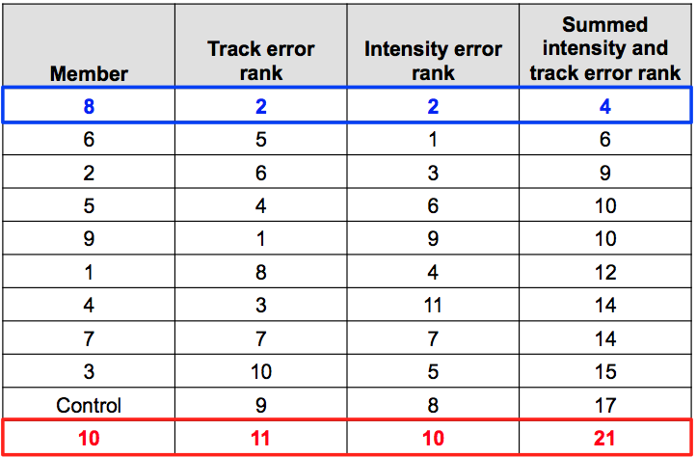

FIGURES
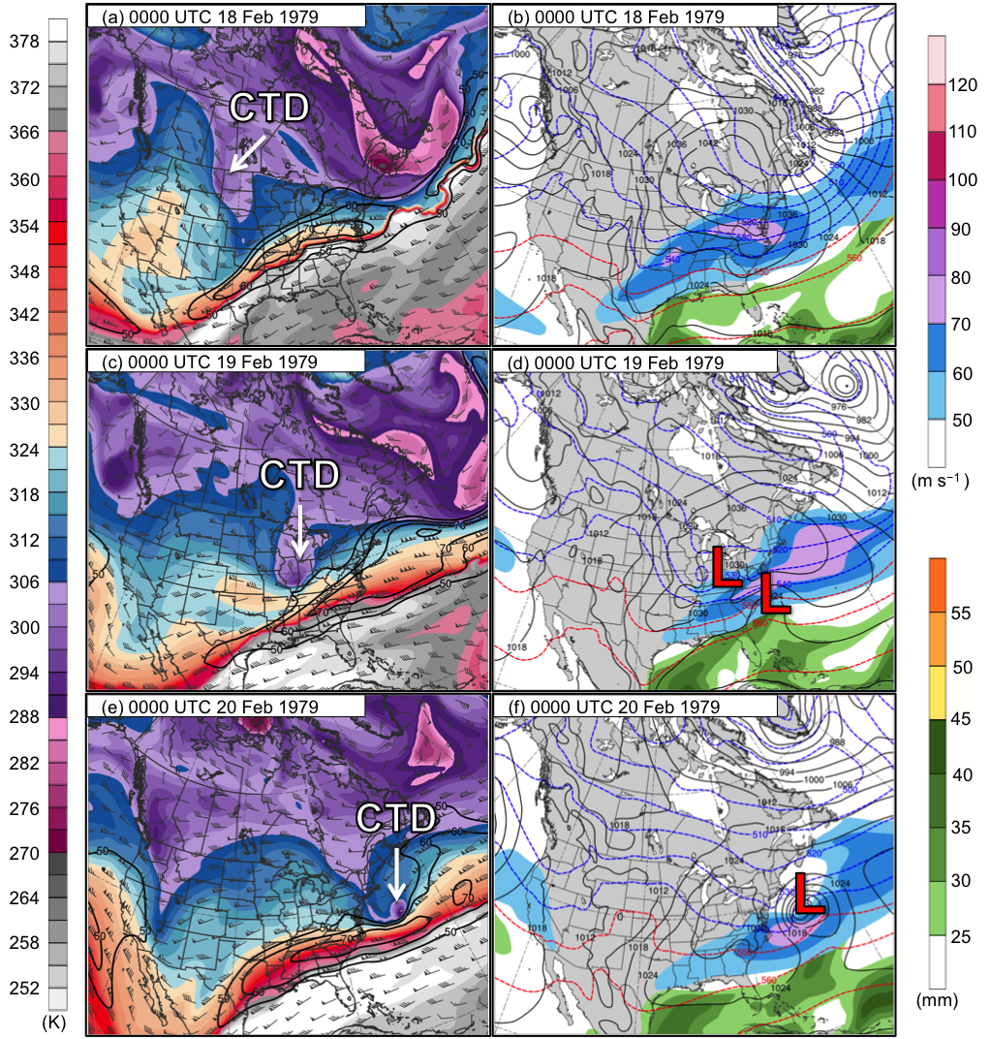
Fig. 1. Analysis of DT (2-PVU surface) potential temperature (shaded, K), wind speed (black contours every 10 m s⁻¹, beginning at 50 m s⁻¹), and wind (flags and barbs, m s⁻¹) at (a) 0000 UTC 18 February, (c) 0000 UTC 19 February, and (e) 0000 UTC 20 February 1979; 250-hPa wind speed (shaded, m s⁻¹), 1000–500-hPa thickness (dashed red and blue contours every 10 dam, contoured red for greater than 540 dam and blue otherwise), MSLP (black contours every 6 hPa), and precipitable water (shaded, mm) at (b) 0000 UTC 18 February, (d) 0000 UTC 19 February, and (f) 0000 UTC 20 February 1979. Labels “CTD” and “L” represent location of the CTD and surface cyclones, respectively.
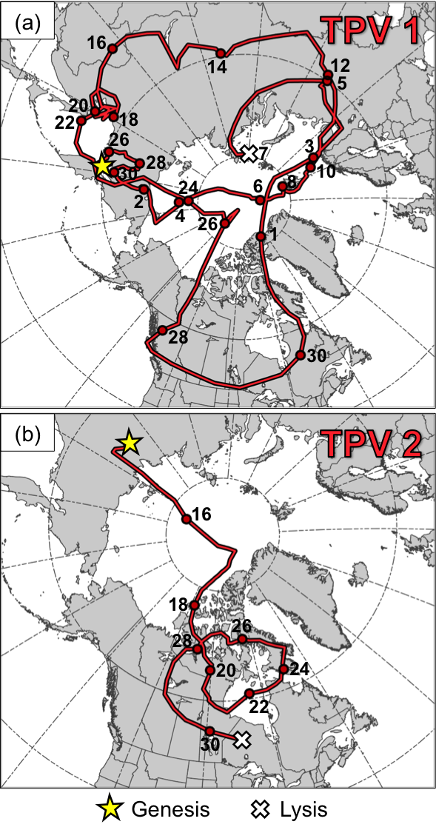
Fig. 2. (a) Track of TPV 1 for 0600 UTC 24 November 1996–0000 UTC 7 January 1997 and (b) track of TPV 2 for 0600 UTC 14 December 1996–0600 UTC 30 December 1996. Red dots denote 0000 UTC times along TPV tracks every 48 h; these dots are labeled with a number denoting the date. Yellow stars and white crosses denote locations of genesis and lysis, respectively, of the TPVs.

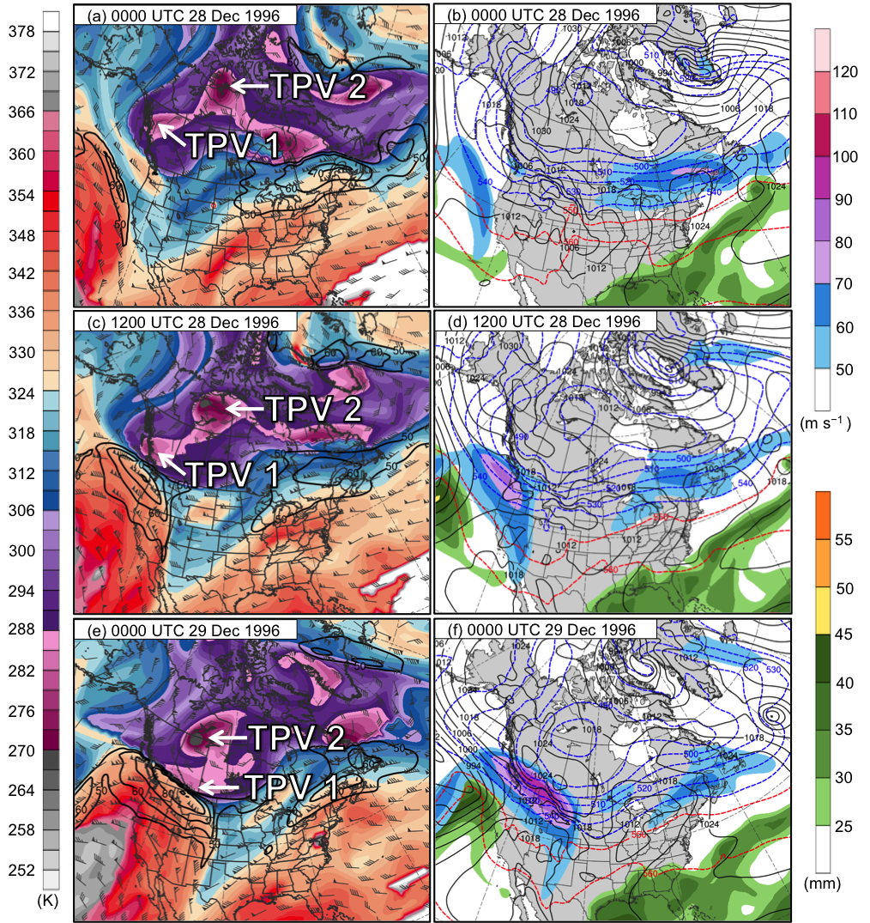
Fig. 3. (ERA-Interim) Analysis of DT (2-PVU surface) potential temperature (shaded, K), wind speed (black contours every 10 m s⁻¹, beginning at 50 m s⁻¹), and wind (flags and barbs, m s⁻¹) at (a) 0000 UTC 28 December, (c) 1200 UTC 28 December, (e) 0000 UTC 29 December, (g) 1200 UTC 29 December, (i) 0000 UTC 30 December, (k) 1200 UTC 30 December, (m) 0000 UTC 31 December, and (o) 1200 UTC 31 December 1996; 250-hPa wind speed (shaded, m s⁻¹), 1000–500-hPa thickness (dashed red and blue contours every 10 dam, contoured red for greater than 540 dam and blue otherwise), MSLP (black contours every 6 hPa), and precipitable water (shaded, mm) at (b) 0000 UTC 28 December, (d) 1200 UTC 28 December, (f) 0000 UTC 29 December, (h) 1200 UTC 29 December, (j) 0000 UTC 30 December, (l) 1200 UTC 30 December, (n) 0000 UTC 31 December, and (p) 1200 UTC 31 December 1996. Labels “TPV 1”, “TPV 2”, and “L” represent locations of TPV 1, TPV 2, and the EC, respectively. Number on bottom of panels (j), (l), (n), and (p) indicate minimum MSLP value of EC in hPa.

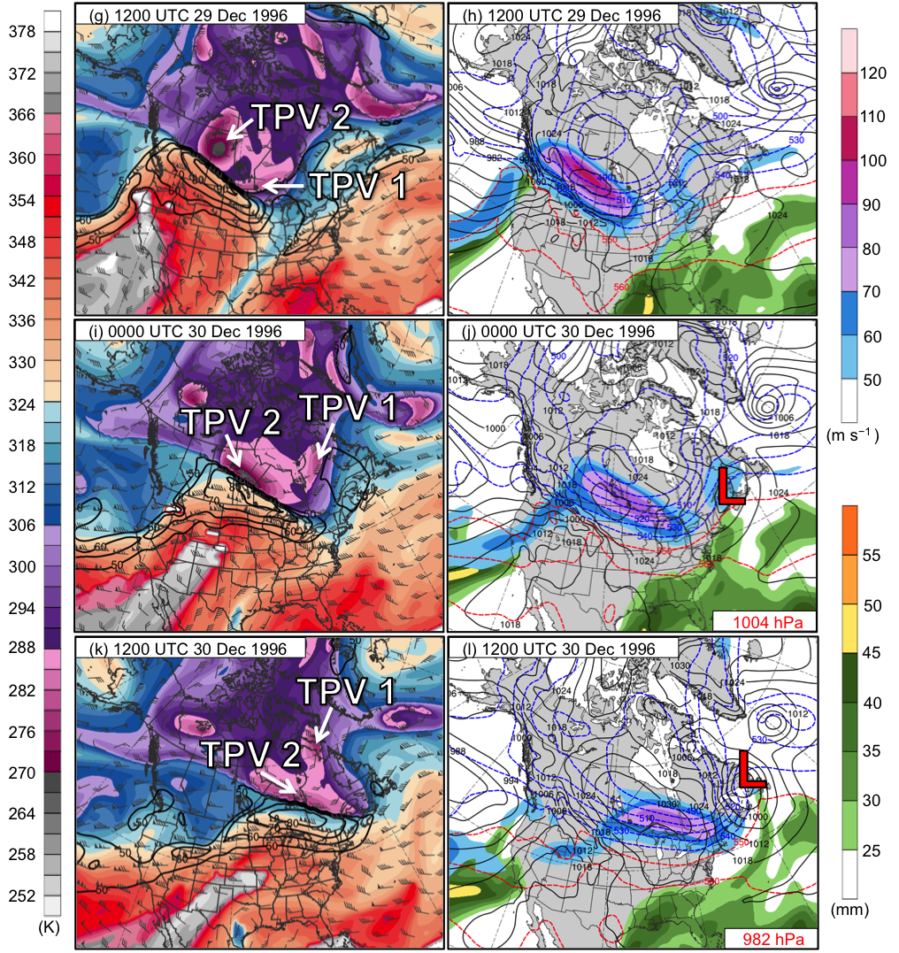
Fig. 3. continued

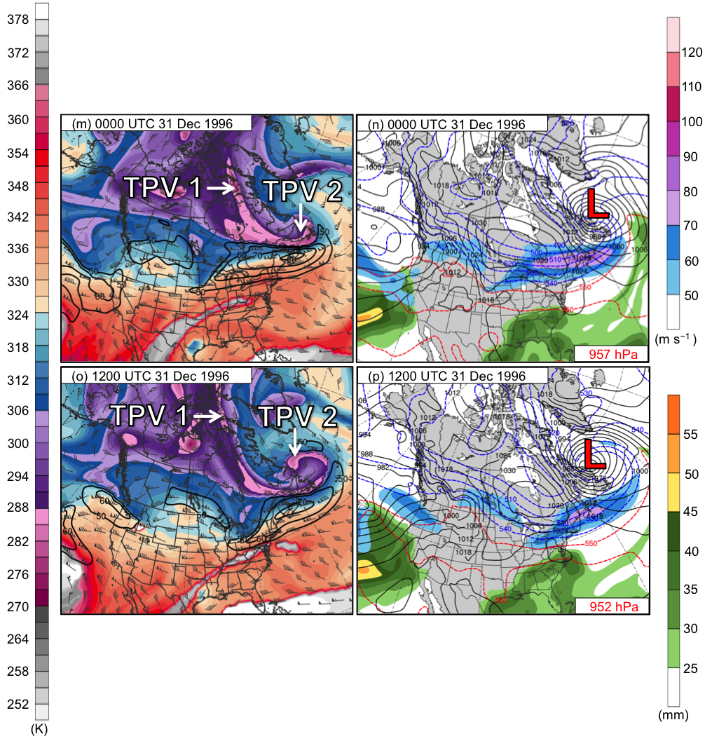

Fig. 3. continued

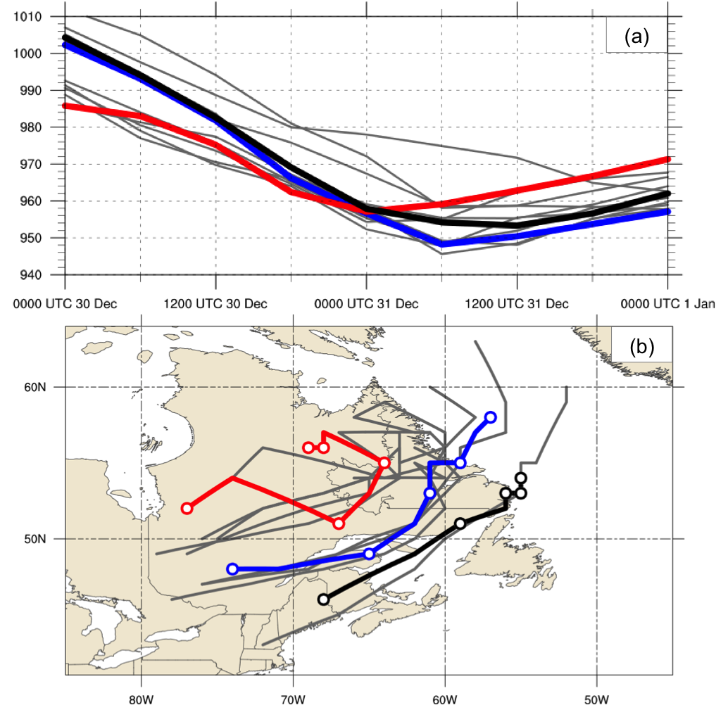

Fig. 4. (a) Time series of minimum MSLP (hPa) of EC every 6 h from 0000 UTC 30 December 1996 to 0000 UTC 1 January 1997 for ERA-Interim (thick black), best GEFS member (thick blue), worst GEFS member (thick red), and all other GEFS members (thin gray). (b) Tracks of EC every 6 h (circles every 12 h for ERA-Interim, best GEFS member, and worst GEFS member) during same time period as in (a) for ERA-Interim (thick black), best GEFS member (thick blue), worst GEFS member (thick red), and all other GEFS members (thin gray).

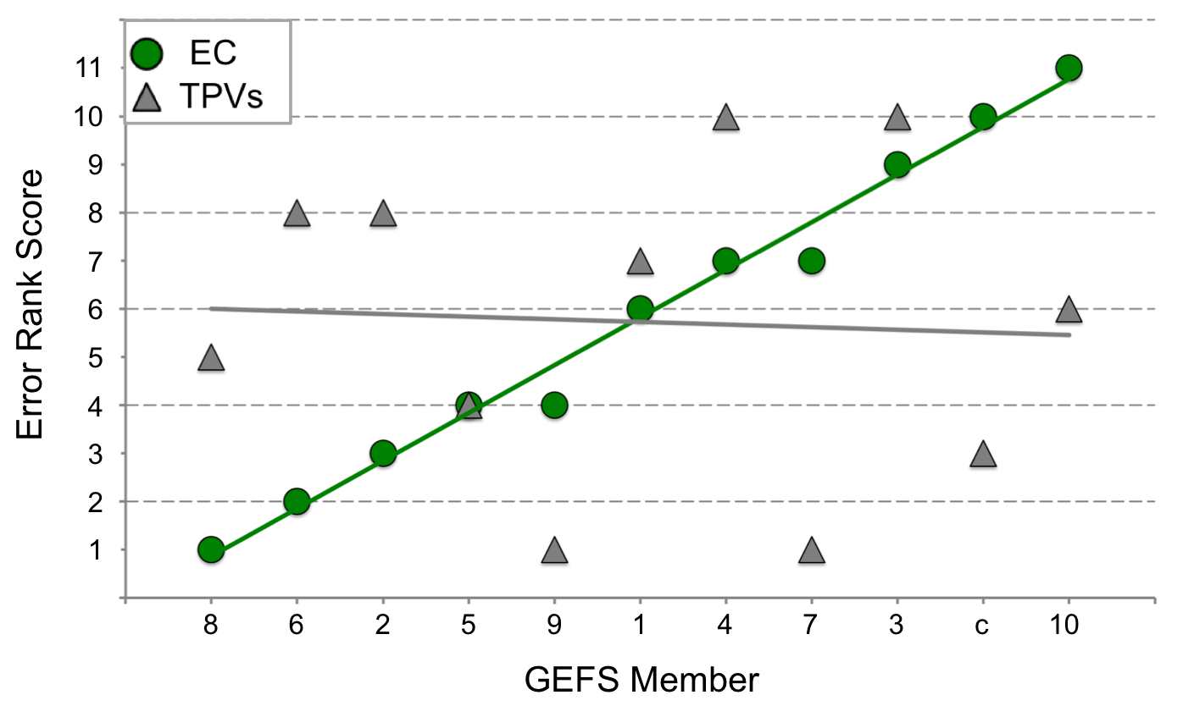

Fig. 5. Scatterplot and trend lines of combined track and intensity error ranks of all GEFS members for the EC (green dots and green line) and combined track and intensity error ranks of all GEFS members for the TPVs together (gray triangles and gray line). Labels on x-axis correspond to GEFS member names, ordered from lowest to highest combined track and intensity error rank for the EC. Labels on the y-axis correspond to the error rank score.

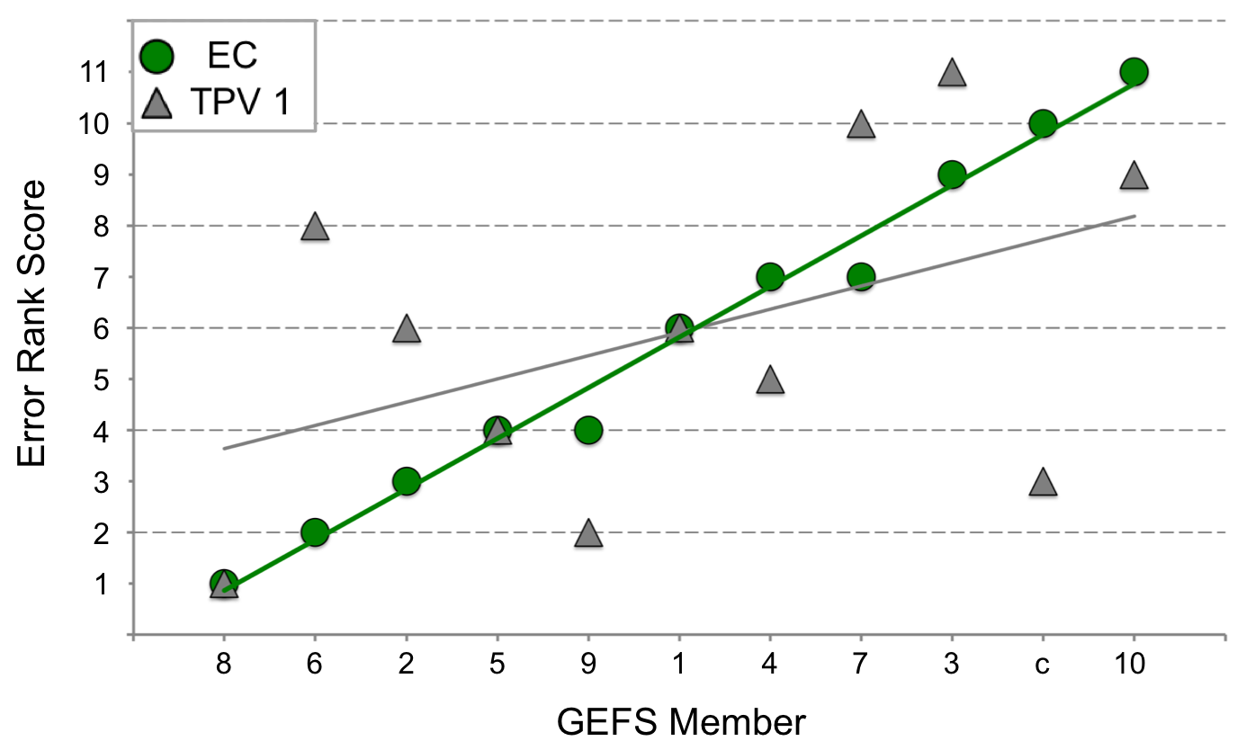

Fig. 6. Scatterplot and trend lines of combined track and intensity error rank of all GEFS members for the EC (green dots and green line) and intensity error ranks of all GEFS members for TPV 1 (gray triangles and gray line). Labels on x-axis correspond to GEFS member names, ordered from lowest to highest combined track and intensity error rank for the EC. Labels on the y-axis correspond to the error rank score.
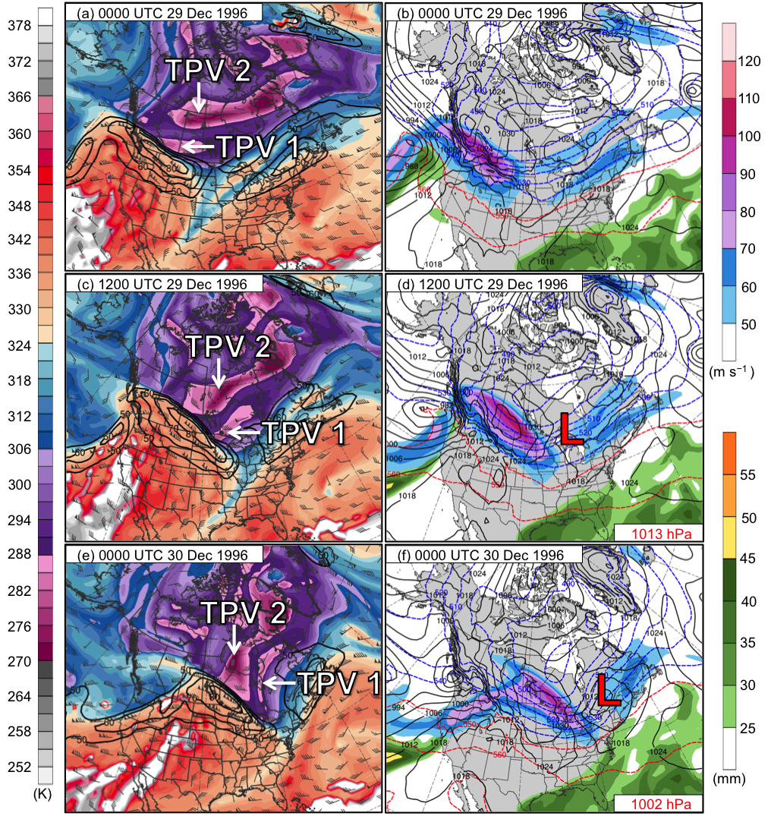

Fig. 7. (Best GEFS member) Analysis of DT (2-PVU surface) potential temperature (shaded, K), wind speed (black contours every 10 m s⁻¹, beginning at 50 m s⁻¹), and wind (flags and barbs, m s⁻¹) at (a) 0000 UTC 29 December, (c) 1200 UTC 29 December, (e) 0000 UTC 30 December, (g) 1200 UTC 30 December, (i) 0000 UTC 31 December, and (k) 1200 UTC 31 December 1996; 250-hPa wind speed (shaded, m s⁻¹), 1000–500-hPa thickness (dashed red and blue contours every 10 dam, contoured red for greater than 540 dam and blue otherwise), MSLP (black contours every 6 hPa), and precipitable water (shaded, mm) at (b) 0000 UTC 29 December, (d) 1200 UTC 29 December, (f) 0000 UTC 30 December, (h) 1200 UTC 30 December, (j) 0000 UTC 31 December, and (l) 1200 UTC 31 December 1996. Labels “TPV 1”, “TPV 2”, and “L” represent locations of TPV 1, TPV 2, and the EC, respectively. Number on bottom of panels (d), (f), (h), (j), and (l) indicate minimum MSLP value of EC in hPa.
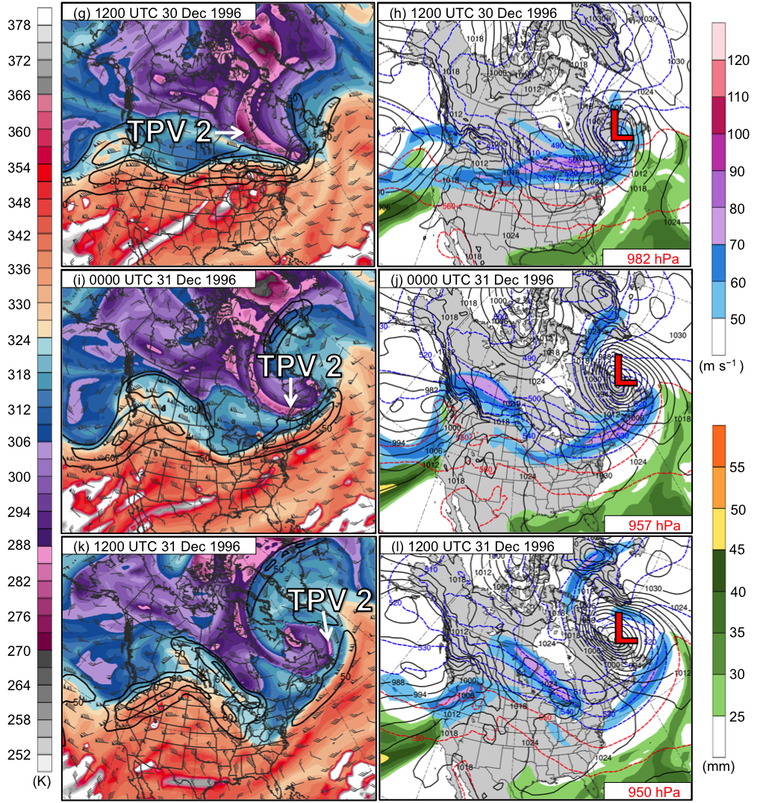

Fig. 7. continued

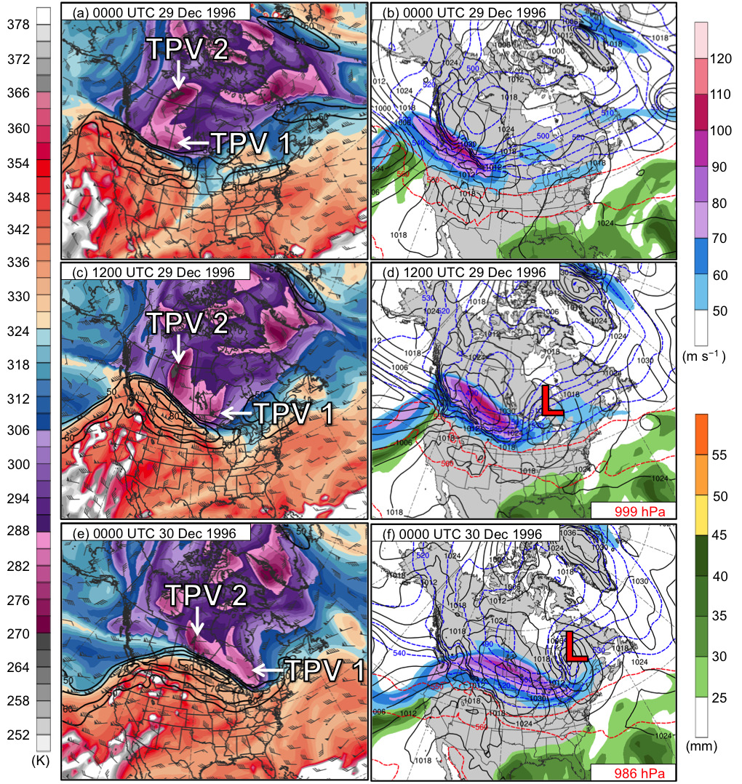

Fig. 8. As in Fig. 7, but for worst GEFS member.

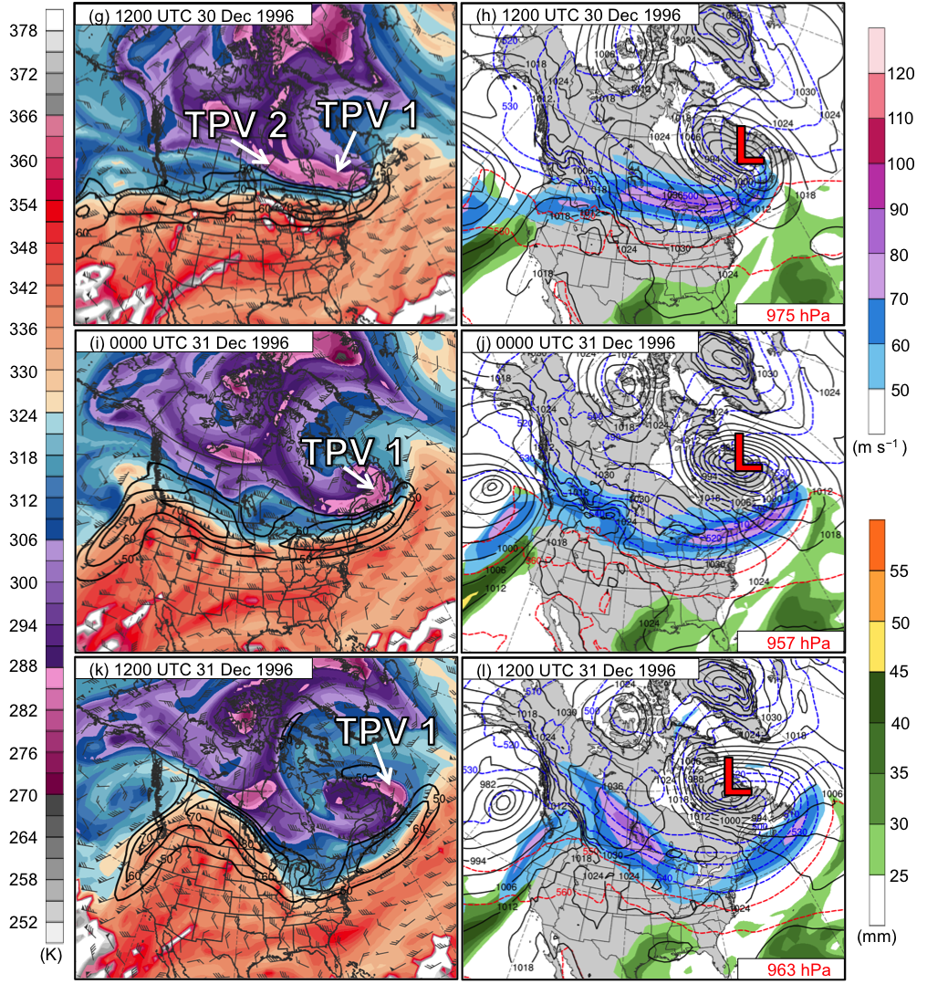

Fig. 8. continued

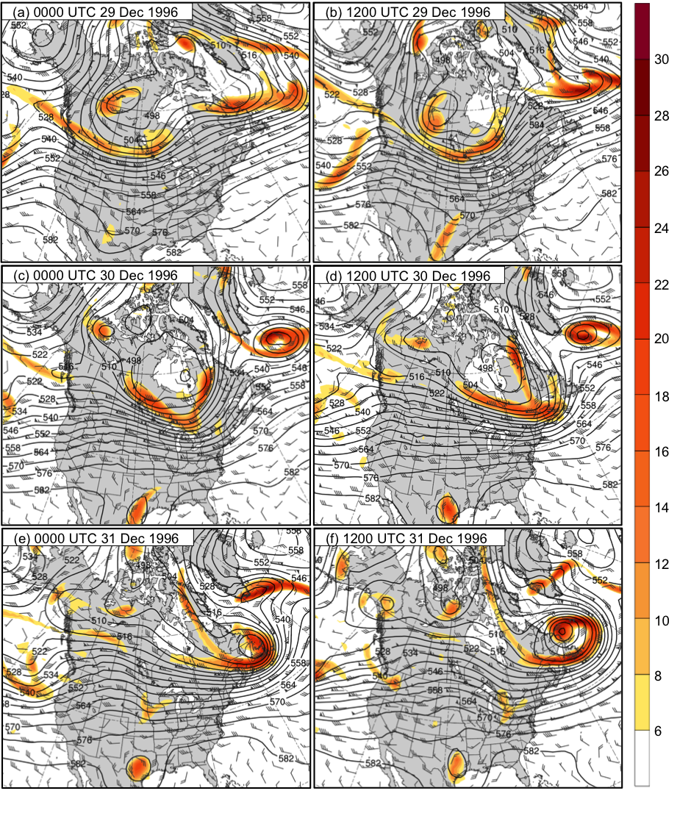
Fig. 9. (ERA–Interim) Analysis of 500-hPa geopotential height (black contours, every 6 dam), relative vorticity (shading, ×10⁻⁵ s⁻¹), and wind (flags and barbs, m s⁻¹) at (a) 0000 UTC 29 December, (b) 1200 UTC 29 December, (c) 0000 UTC 30 December, (d) 1200 UTC 30 December, (e) 0000 UTC 31 December, and (f) 1200 UTC 31 December 1996 for ERA-Interim.
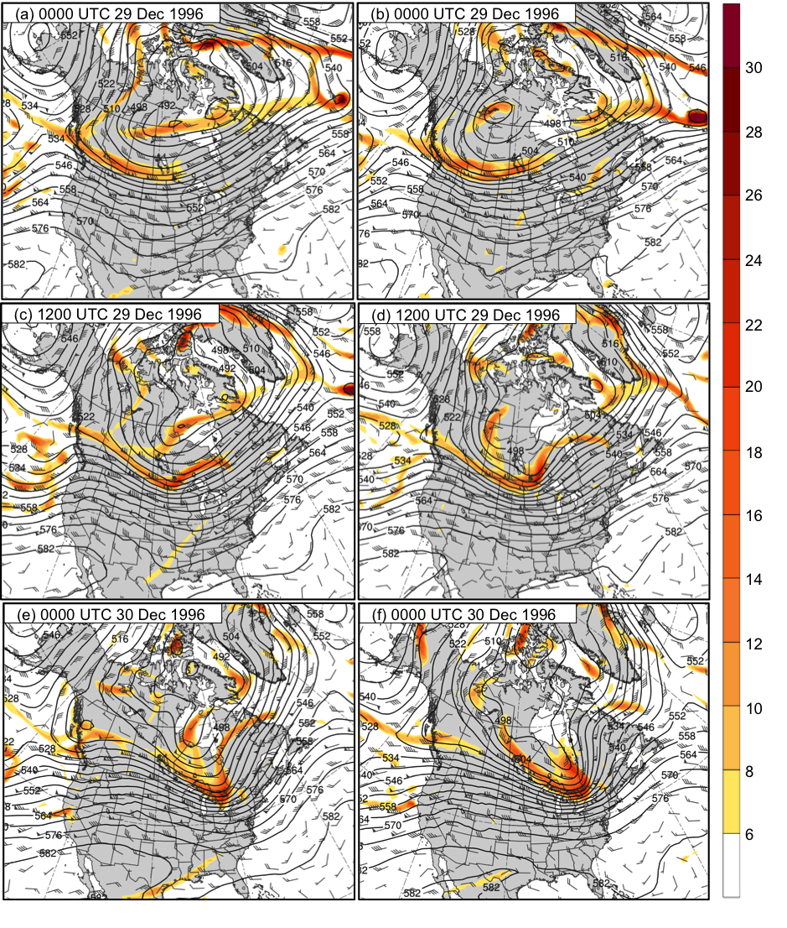
Fig. 10. (left panels: best GEFS member; right panels: worst GEFS member) Analysis of 500-hPa geopotential height (black contours, every 6 dam), relative vorticity (shading, ×10⁻⁵ s⁻¹), and wind (flags and barbs, m s⁻¹) at (a) 0000 UTC 29 December, (c) 1200 UTC 29 December, (e) 0000 UTC 30 December, (g) 1200 UTC 30 December, (i) 0000 UTC 31 December, and (k) 1200 UTC 31 December 1996 for best GEFS member; at (b) 0000 UTC 29 December, (d) 1200 UTC 29 December, (f) 0000 UTC 30 December, (h) 1200 UTC 30 December, (j) 0000 UTC 31 December, and (l) 1200 UTC 31 December 1996 for worst GEFS member.

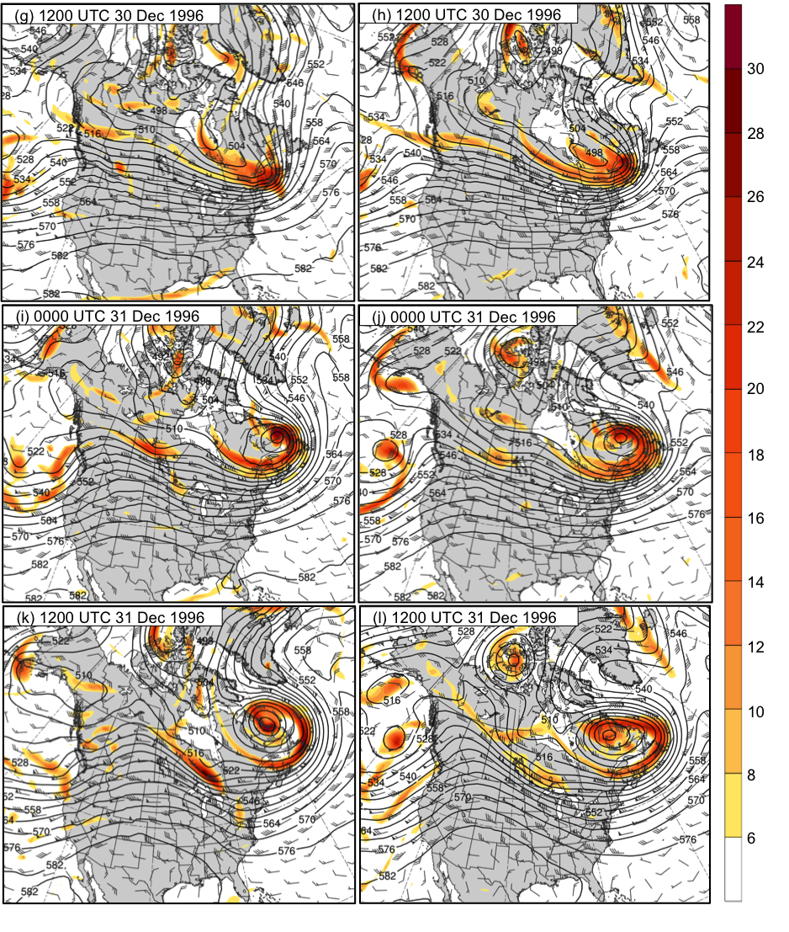
Fig. 10. continued

