A Multiscale Analysis and Predictability Study of a Polar Low Linked to a Tropopause Polar Vortex

Kevin A. Biernat

ATM 631: Mesoscale Dynamics
Spring 2018

Department of Atmospheric and Environmental Sciences, University at Albany,
State University of New York, Albany, New York

ABSTRACT
The purpose of this study is to 1) analyze the evolution of a polar low that is linked to a tropopause polar vortex (TPV), and 2) investigate factors influencing the predictability of the evolution of the polar low. An existing database of TPVs constructed using the ERA-Interim is compared to the Sea Surface Temperature and Altimeter Synergy for Improved Forecasting of Polar lows (STARS) database of polar lows in the Nordic Seas to identify polar lows that may be linked to the TPVs. A multiscale analysis is performed, using the ERA5, on a polar low that occurs during 10–11 February 2011 over the Barents Sea and that is linked to a TPV transported equatorward along a tropospheric-deep baroclinic zone. The analysis shows that the TPV and a concomitant favorable thermodynamic environment likely play an important role in supporting the development and strengthening of the polar low.
The 51-member ECMWF Ensemble Prediction System (EPS) from TIGGE is utilized to evaluate forecast skill of the evolution of the polar low. The ensemble members are separated in two groups: the most and least accurate members in terms of track and intensity errors of the polar low. Normalized composite differences between the two groups suggest that the TPV is located significantly farther northward and that the tropospheric-deep baroclinic zone is positioned significantly farther eastward in the most accurate group compared to the least accurate group, which likely contributes to a significantly farther north and east, and more accurate, track of the polar low in the most accurate group (track over the Barents Sea) compared to the least accurate group (track predominately over Scandinavia). The thermodynamic environment is likely more conducive for polar low development in the most accurate group compared to the least accurate group, which may contribute to the polar low being significantly stronger in the most accurate group compared to the least accurate group as well.
1. Introduction
Polar lows are intense, maritime mesoscale cyclones that often form within a cold air mass or along an Arctic front at the leading edge of a cold air mass moving over relatively warmer sea surfaces in high latitudes (e.g., Rasmussen and Turner 2003). Polar lows may be associated with strong winds, large waves, and heavy precipitation, posing hazards to shipping and infrastructure. The northern North Atlantic and adjacent Arctic seas are favorable regions for the development for polar lows (e.g., Kolstad 2011; Smirnova et al. 2015). Kolstad (2011) shows that favorable environments for polar low development consist of low values of lower-tropospheric static stability, arising in response to cold surges occurring over relatively warm sea surfaces, and a lowered tropopause, indicative of forcing associated with upper-level disturbances. Cold surges occurring over relatively warm sea surfaces in combination with strong surface winds may lead to large surface sensible and latent heat fluxes (e.g., Emanuel and Rotunno 1989), which may lead to a reduction of lower-tropospheric static stability. Baroclinic zones, including those associated with Arctic fronts at the leading edge of CAOs (e.g., Shapiro et al. 1989; Grønås and Skeie 1999), may be associated with relatively strong low-level cyclonic relative vorticity and convergence, which may support the development of polar lows (e.g., Shapiro et al. 1987a; Shapiro and Fedor 1989). Upper-level cyclonic potential vorticity (PV) anomalies moving over baroclinic zones may provide QG forcing for ascent that may support the development of polar lows (e.g., Bracegirdle and Gray 2009).
TPVs (e.g., Cavallo and Hakim 2009, 2010) are coherent vortices in the vicinity of the tropopause that may provide QG forcing for ascent, which may aid in the development of polar lows. In addition, TPVs may be accompanied by cold surges, with Arctic fronts located at the leading edges of the cold surges (e.g., Shapiro et al. 1987b). QG forcing for ascent associated with TPVs, reductions of lower-to-midtropospheric static stability that may occur in response to TPVs and associated cold surges moving over relatively warm waters, surface heat fluxes, and low-level convergence at Arctic fronts at the leading edge of cold surges associated with TPVs may support strong lower-to-midtropospheric ascent and stratiform and convective precipitation The resulting latent heat release may contribute to polar low development by, for example, leading to low-level PV production and intensification of the polar low (e.g. Montgomery and Farrell 1992). Therefore, TPVs may play important roles in the evolution of polar lows.
It is anticipated that uncertainties in the track and intensity of TPVs may influence the predictability of the evolution of polar lows. It is hypothesized that 1) forecast errors in the track and intensity of TPVs may contribute to forecast errors in the track and intensity of polar lows that are linked to TPVs, and 2) forecast errors in the track and intensity of TPVs may contribute to forecast errors in the position and structure of baroclinic zones, which may also contribute to forecast errors in the track and intensity of polar lows that are linked to TPVs. This research will address these hypotheses for a selected case of a polar low that is linked to a TPV.

2. Case Selection and Analysis
Polar lows that may be linked to TPVs are first identified. Polar lows are obtained from the STARS database of polar lows in the Norwegian Sea and Barents Sea (Sætra et al. 2010). The STARS database covers the 2002–2011 period, for a total of 140 polar lows. Of the total 140 polar lows, 137 occur during the months of October–April, while 3 occur during September or May. The polar lows were identified and tracked hourly via manual inspection of satellite products and operational weather forecasts. The polar low database is compared to a 1979–2015 TPV database constructed using the ERA-Interim (Dee et al. 2011) and a TPV tracking algorithm developed by Nicholas Szapiro and Steven Cavallo at the University of Oklahoma (https://github.com/nickszap/tpvTrack). In order to determine which polar lows may be linked to TPVs, polar lows are required to be located within a certain distance threshold of at least one TPV at any point in the lifetime of the polar low. A distance threshold of 500 km is utilized for this study to ensure that the TPVs are located close enough to the polar lows to potentially have an influence on the life cycles of the polar lows. By making this requirement, 104 out of a total 140 polar lows, or 74.3%, match with at least one TPV.
Figure 1 shows that tracks of all polar lows, including those that may be linked to TPVs. The polar lows are distributed throughout the Norwegian and Barents Sea, with relatively high frequency of polar lows near Scandinavia. There is no apparent difference in preference for the locations of polar lows that may be linked to TPVs compared to polar lows not linked to TPVs. Figure 2 shows the lifetime distribution of polar lows that may be linked to TPVs. The mean lifetime is 12.9 h and median lifetime is 9 h, indicating that the lifetime distribution has a positive skew, with a large number of polar lows having a relatively short lifetime of less than 12 h, but only several polar lows having a relatively long lifetime of at least 30h.
From the identified polar lows that may be linked to TPVs, one case is selected for analysis. In order to choose a case, a few criteria are imposed. The first criterion is that the ERA5 reanalysis dataset (Hersbach and Dee 2016) can be used for analysis. Utilization of the ERA5 is motivated by its relatively high horizontal resolution (31 km) and high temporal resolution (1 h). As of the time this study was conducted, ERA5 was only available from 2010 onward, meaning that only polar lows occurring during the last two years of the STARS database (2010 and 2011) were considered. The second criterion is that the polar low is capable of being identified and tracked in the ERA5 and in the 51-member ECMWF EPS (Buizza et al. 2007) from TIGGE (Bougeault et al. 2010). As will be explained more in Section 3a, the selected polar low will be tracked for all ensemble members in the 51-member ECMWF EPS as part of the predictability portion of this study. The polar low will be tracked based on the maximum of 850-hPa relative vorticity, a quantity that has been utilized to help track polar lows in reanalysis datasets in other polar low studies (e.g., Zappa et al. 2014; Smirnova and Golubkin 2017). It is critical that a maximum of 850-hPa relative vorticity associated with a polar low is capable of being identified and tracked in the ERA5 and in the ECMWF EPS in order to carry out the predictability portion of this study. The third criterion is that the selected polar low is clearly related to a single TPV. Cases in which there may be multiple TPVs and/or other disturbances that may play a role in the evolution of a polar low will be avoided given the potential complications of determining the relative importance of each feature on the evolution of the polar low.
After considering the above criteria, a polar low occurring during 10–11 February 2011 was chosen and will now be analyzed using the ERA5 downloaded at 0.3° horizontal resolution. Figure 3a shows the track of the polar low according to the STARS database. The polar low forms at 1800 UTC 10 February 2011 just off the northern coast of Scandinavia. The polar low moves east-southeastward over the Barents Sea, before temporarily meandering slowly and then moving south-southwestward toward the northern coast of Scandinavia. According to the STARS database, the polar low undergoes lysis at 1200 UTC 11 February 2011, for a lifetime of 18 h, which is at the ~72nd percentile of the polar low lifetime distribution shown in Fig. 2. Figure 3a also shows that this polar low develops near a region of baroclinicity between Svalbard and Scandinavia, suggesting that baroclinic processes may play an important role in the development of the polar low. The polar low is identified to be link with a TPV, the track of which is shown in Fig. 3b. The TPV track was obtained using the previously discussed TPV tracking algorithm with ERA5. The TPV forms on 31 January over northeastern Russia and moves westward near the Arctic coast of Eurasia before moving into the Barents Sea by 7 February. This westward movement of the TPV is likely related to upper-level ridging over the Arctic (not shown). The TPV then meanders for a few days over the Barents Sea before being transported equatorward toward Scandinavia by 11 February, likely in response to anomalous upper-level ridging over the northern North Atlantic and Arctic (Fig. 3b).
The evolution of the synoptic-scale flow responsible for the equatorward transport of the TPV will now be examined. An upper-level ridge (R1) amplifies over Greenland and the northern North Atlantic during 0000 UTC 8–0000 UTC 10 February, likely in response to a strong extratropical cyclone that moves northeastward toward southeastern Greenland (Figs. 4a–f). A second strong extratropical cyclone then develops and moves northeastward toward southeastern Greenland during 0000 UTC 10–0000 UTC 11 February, leading to additional ridge amplification over the northern North Atlantic (Figs. 4e–h). This additional ridge amplification may support the eastward movement of R1 during this same time period (Figs. 4e,g). In addition, another ridge, R2, moves northwestwards from western Russia into the Arctic during 0000 UTC 9–0000 UTC 11 February (Figs. 4c,e,g). R1 and R2 approach one another by 0000 UTC 11 February, helping to force the TPV, which has been previously meandering around the Barents Sea (Figs., 4a,c,e), to begin moving equatorward toward Scandinavia (Fig. 4g). In addition, Figs. 4b,d,f,h show that the TPV is associated with cold air throughout the depth of the troposphere, as indicated by the relatively low values of 1000–500-hPa thickness beneath and near the location of the TPV. The juxtaposition of the TPV and associated region of cold air with R1 supports a tropospheric-deep baroclinic zone and associated jet streak between Svalbard and Scandinavia, with the polar low developing near the left exit region of the jet streak (Figs. 4g,h), again suggesting that baroclinic processes may play an important role in the development of the polar low. The development and evolution of the polar low will now be examined more closely.
Figures 5a–g show that the evolution of the polar low and TPV during 1800 UTC 10–1200 UTC 11 February. At 1800 UTC 10 February, the polar low, identified as a maximum of 850-hPa relative vorticity that is nearly collocated with the position of the polar low according to the STARS database, is located downstream of the TPV and in the left exit region of the jet streak (Fig. 5a,b). The polar low is associated with a sea level pressure (SLP) trough located to southwest of a preexisting surface cyclone and is associated with areas of lower-to-midtropospheric ascent (Fig. 5b). Over the next 12 h, as the TPV approaches and moves overhead the polar low, the polar low intensifies, as indicated by an increase in 850-hPa relative vorticity and decrease in SLP, and a concentrated region of relatively strong lower-to-midtropospheric ascent becomes established near the north side of the polar low (Figs. 5c–f). By 1200 UTC 11 February, the polar low weakens as it moves south-southwestward into Scandinavia along with the TPV (Figs. 5g,h). The strengthening of the polar low and the establishment of a concentrated region of relatively strong lower-to-midtropospheric ascent as the TPV approaches the polar low suggests that the TPV is likely playing an important role in the evolution of the polar low. How the TPV and other factors may be influencing the evolution of the polar low will now be discussed.
QG forcing for ascent associated with the TPV is analyzed using Q and Q forcing for vertical motion in pressure coordinates, calculated following Hoskins and Pedder (1980). Figure 6a shows that at 0300 UTC 11 February, there is a region Q convergence and associated Q forcing for ascent just downstream of the TPV over the polar low. This region of Q forcing for ascent is likely tied directly to the TPV as the TPV interacts with the tropospheric-deep baroclinic zone between Svalbard and Scandinavia. In addition, given that the TPV is associated with cold air throughout the depth of the troposphere (e.g., Fig. 4h), and given that the TPV is moving over the relatively warmer waters of the Barents Sea, characterized by sea surface temperatures (SSTs) upwards of 3–4°C, equatorward of the Arctic sea-ice margin (Fig. 6b), the TPV is associated with low values of lower-to-midtropospheric static stability (Fig. 6b). Furthermore, with this cold air moving over the relatively warmer waters of the Barents Sea, there are upward sensible and latent heat fluxes (Figs. 6c and 6d, respectively) over the Barents Sea, which may further contribute to the low values of lower-to-midtropospheric static stability.
A meridional cross section through the TPV and polar low at 0300 UTC 11 February shows that the TPV is characterized by a downward protrusion of high PV air to ~550 hPa where the associated low values of DT potential temperature are located (Figs. 7a–b), while the polar low is characterized by a low-level PV maximum where the associated 850-hPa relative vorticity maximum is located (Figs. 7a,c). The low values of lower-to-midtropospheric static stability shown in Fig. 6b are evident in Fig. 7a by the low values of PV beneath the TPV and surrounding the polar low. The Q forcing for ascent associated with the TPV, low values of lower-to-midtropospheric static stability, and upward sensible and latent heat fluxes likely together support the development and strengthening of the polar low and the establishment of the concentrated region of relatively strong lower-to-midtropospheric ascent above and just north of the polar low shown in Figs. 7a,c. Precipitation that may be tied to this region of ascent may be associated with latent heat release. This latent heat release may lead to low-level PV production, which may support and strengthen the low-level PV maximum associated with the polar low. Overall, the TPV and concomitant favorable thermodynamic environment likely play an important role in allowing the polar low to develop and strengthen. In the next section, the forecast skill of the polar low will be evaluated, and the degree to which the forecast skill of the polar low is influenced by the forecast of the TPV will be diagnosed in order to address the hypotheses established at the end of Section 1.

3. Evaluation of forecast skill and diagnosis of forecast error
a. Data and methods
To evaluate the forecast skill associated with the prediction of the polar low, the 51-member ECMWF EPS from TIGGE, downloaded at 0.5° horizontal resolution, will be utilized. The ERA5 regridded to 0.5° horizontal resolution will be used as the verification, with only data from ERA5 at the 0000, 0600, 1200, and 1800 UTC hours considered for consistency with the 6-h resolution of the ECMWF EPS. Ensemble forecasts from the ECMWF EPS initialized at 1200 UTC 9 February 2011 are utilized because there appeared to be a relatively large degree of spread in the evolution of the polar low amongst these ensemble forecasts when conducting a cursory examination of these ensemble forecasts. Also, since the forecast initialization time is only 30 h prior to the time of polar low genesis, evaluating forecast skill with forecasts from this initialization time will help to illustrate the degree of difficulty there may be in forecasting polar lows at relatively short forecast lead times.
Forecast skill of the polar low is assessed in terms of a metric combining forecast track and intensity error of the polar low. This metric is calculated by adapting the methodology used by Lamberson et al. (2016) to evaluate the forecast skill of a strong extratropical cyclone. Track and intensity error are calculated every 6 h from 1800 UTC 10 February to 1200 UTC 11 February, as this time period corresponds to that of the life cycle of the polar low in the STARS database. Track error for each time is calculated as the great circle distance between the location of the polar low in the ERA5 and in each ensemble member, where the location of the polar low at a time corresponds to the location of the maximum value of 850-hPa relative vorticity of the polar low at that time. The intensity error for each time is calculated as the absolute difference in intensity of the polar low in the ERA5 and in each ensemble member, where intensity of the polar low at a time corresponds to the maximum value of 850-hPa relative vorticity of the polar low at that time. The 850-hPa relative vorticity maximum associated with the polar low for each ensemble was tracked subjectively starting from 1800 UTC 10 February. The 850-hPa relative vorticity maximum associated with the polar low in the ERA5 at this time was the dominant 850-hPa relative vorticity maximum in the vicinity of northern Scandinavia and the adjacent Barents Sea, not including that associated with the preexisting cyclone to the northeast of the polar low (Fig. 5b). Because some ensemble members showed multiple 850-hPa relative vorticity maxima in this region at this time, the strongest 850-hPa relative vorticity maximum in this region at this time, not including that associated with the aforementioned preexisting cyclone, was tracked forward in time for each ensemble member. If the 850-hPa relative vorticity maximum was subjectively determined to merge with another 850-hPa relative vorticity maximum afterward, the track was continued to follow the merged 850-hPa relative vorticity maximum. It should be noted that not all tracked 850-hPa relative vorticity maxima may actually develop into a polar low. However, hereafter for simplicity, the 850-hPa relative vorticity maximum in each ensemble forecast will be referred to as a polar low.
The track and intensity errors are then averaged over time and the ensemble members are ranked 1–51 for both track and intensity, with 1 corresponding to the member with lowest average error. The track error rank is added with the intensity error rank to determine a combined track and intensity error rank for each ensemble member. The ensemble members are then subdivided into two groups: the eight most accurate and eight least accurate ensemble members in terms of combined track and intensity error rank of the polar low. Normalized composite differences are calculated between the two groups for selected quantities and various forecast times following Lamberson et al. (2016). Normalized composite differences are defined as
$∆x_{i}= \frac{{{\overline{x}}_{i}}^{most accurate}- {{\overline{x}}_{i}}^{least accurate}}{σ_{x_{i}}}$ ,
where ${{\overline{x}}_{i}}^{most accurate}$ and ${{\overline{x}}_{i}}^{least accurate}$ represent the mean of the ith state variable for the ensemble members in the most accurate and least accurate groups, respectively, and $σ_{x_{i}}$ represents the standard deviation of $x_{i}$ computed from all ensemble members. Statistical significance of differences between the two groups for the mean values of various quantities are assessed using a two-sided Student’s t test.

b. Results
Table 1 shows that for each ensemble member in the most accurate group, the track error rank and intensity error rank are generally both low, contributing to a low combined track and intensity error rank. Contrarily, Table 2 shows that for each ensemble in the least accurate group, the track error rank and intensity error rank are generally both high, contributing to a high combined track and intensity error rank. It is important to note that originally another ensemble member, ensemble member 19, was included in the least accurate group, but because it was an outlier in terms of track and especially intensity compared to the rest of the ensembles, it was not included, and the member with the ninth highest combined track and intensity error rank, ensemble member 45, was instead placed in the least accurate group. Figure 8a shows that during 1800 UTC 10–1200 UTC 11 February, the tracks of the polar low in the most accurate group are generally farther to the north and east of the tracks of the polar low in the least accurate group, closer to the track of the polar low in the ERA5. In fact, the mean position of the polar low in the most accurate group during 1800 UTC 10–1200 UTC 11 February is significantly farther northward (70.2°N vs 68.8°N) and eastward (33.6°E vs 29.5°E) than that of the polar low in the least accurate group, closer to the mean position of the polar low in ERA5 (70°N, 32°E) during the same time period (Table 3).
Figure 8b shows that during 1800 UTC 10–1200 UTC 11 February, the polar low tends to be stronger in the forecasts from the most accurate group, generally characterized by a larger absolute maximum value of 850-hPa relative vorticity, closer to that of the polar low in ERA5, than the polar low in the forecasts from the least accurate group. In fact, the mean absolute maximum value of 850-hPa relative vorticity of the polar low during 1800 UTC 10–1200 UTC 11 February is significantly larger (33.1×10⁻⁵ s⁻¹ vs 23.2×10⁻⁵ s⁻¹) in the most accurate group compared to the least accurate group, closer to the absolute maximum value of 850-hPa relative vorticity of the polar low in ERA5 (39.9×10⁻⁵ s⁻¹) during the same time period (Table 3). Also, the mean absolute minimum value of SLP at the location of the polar low during 1800 UTC 10–1200 UTC 11 February is significantly lower (1003.6 hPa vs 1009.1 hPa) in the most accurate group compared to the least accurate group, closer to the absolute minimum value of SLP at the location of the polar low in ERA5 (1004.0 hPa) during the same time period (Table 3).
Normalized composite differences between the most accurate and least accurate group for selected variables are now utilized to help determine what may contribute to the significant track and intensity differences of the polar low between the two groups. Normalized composite differences of DT potential temperature at 1800 UTC 10 February 2011, a 30 h forecast, show a dipole structure about the ensemble mean position of the TPV, with statistically significant negative and positive normalized composite differences in DT potential temperature to the north and south of the ensemble mean position of the TPV, respectively (Fig. 9a). This dipole structure suggests that the TPV is significantly farther northward in the most accurate group compared to the least accurate group, and thus may not be transported equatorward as quickly in the most accurate group compared to the least accurate group. A similar dipole structure is noted in the normalized composite differences of 500-hPa geopotential height, with statistically significant negative and positive normalized composite differences of 500-hPa geopotential height to the north and south of the ensemble mean position of a 500-hPa geopotential height minimum associated with the TPV, respectively (Fig. 9b).
Furthermore, there are statistically significant negative normalized composite differences of 500-hPa geopotential height along the axis of and within the northern portion of R1 and within the western portion of R2 (Fig. 9b). These differences suggest that R1 and R2 may both be less amplified in the most accurate group compared to the least accurate group. Less amplification of R1 and R2 in the most accurate group compared to the least accurate group may allow the TPV to not be transported equatorward as quickly, and thus be located farther north, in the most accurate group compared to the least accurate group. Since the polar was shown to develop in ERA5 downstream, to the south of the TPV, in the region of Q forcing for ascent associated with the TPV, and since the polar low is eventually forced southward along with the TPV in ERA5, the position of the TPV likely plays a crucial role in where the polar low may develop and track. Thus, a farther north and south position of the TPV would likely contribute to the polar low being located farther to the north and south, respectively.
Normalized composite differences of 1000–500-hPa thickness (Fig. 9c) and 850-hPa temperature (Fig. 9d) suggest that that there are statistically significant higher values of 1000–500-hPa thickness and 850-hPa temperature within the tropospheric-deep baroclinic extending south-southeastward from Svalbard to Scandinavia and statistically significant lower values of these quantities to the east of this baroclinic zone in the most accurate group compared to the least accurate group. These statistically significant differences in 1000–500-hPa thickness and 850-hPa temperature suggest that the tropospheric-deep baroclinic zone may be located farther to the east in the most accurate group compared to the least accurate group.
The further north position of the TPV combined with the further east position of the tropospheric-deep baroclinic zone likely together contribute to the mean track of the polar low being located farther to the north and east in the most accurate group compared to the least accurate group (Figs. 9a–d). Additionally, the dipole structure of the normalized composite differences in the 500-hPa geopotential height field suggest that there may be anomalous westerly geostrophic flow over and near the polar low in the most accurate group relative to the least accurate group (Fig. 9b), which may also support a further eastward track of the polar low in the most accurate group compared to the least accurate group. Since the mean polar low track is over the Barents Sea in the most accurate group, but predominately over Scandinavia in the least accurate group (Figs. 9a–d), the polar low is likely in a more conducive thermodynamic environment for development in the most accurate group compared to the least accurate group, which may contribute to the significant intensity differences of the polar low between the two groups. For example, Figs. 6c and 6d, show upward sensible and latent heat fluxes, respectively, over the Barents Sea, which would support polar low development in the most accurate group, but downward sensible and latent heat fluxes, respectively, over Scandinavia, which would not support polar low development in the least accurate group.

4. Discussion and conclusions
The development and evolution of the polar low in this case appears to be clearly related to a well-defined TPV interacting with a tropospheric-deep baroclinic zone. The TPV provides Q forcing for ascent over the location of the polar low and contributes to low values of lower-to-midtropospheric static stability. In addition, upward sensible and latent heat fluxes in the vicinity of the polar low likely further contribute to the low values of lower-to-midtropospheric static stability, fostering a favorable thermodynamic environment for polar low development. The Q forcing for ascent and the favorable thermodynamic environment likely support the concentrated region of relatively strong lower-to-midtropospheric ascent associated with the polar low along with any precipitation tied to this region of ascent. Associated latent heat release may support the lower-tropospheric PV maximum associated with the polar low via low-level PV production.
The normalized composite differences between the most and least accurate groups of forecasts of the polar low suggest a further northward position of the TPV and eastward position of the tropospheric-deep baroclinic zone in the most accurate group compared to the least accurate group, which likely contribute to allowing the polar low in the most accurate group to track significantly further north and east, over the Barents Sea, than the polar low in the least accurate group, which tracks predominately over Scandinavia. The more conducive thermodynamic environment for polar low development over the Barents Sea compared to over Scandinavia likely contributes to the polar low being significantly stronger in the most accurate group compared to the least accurate group.
This study suggests that TPVs may play an important role in the development of polar lows and that position errors of TPVs and baroclinic zones may contribute to track and intensity errors of polar lows. In this case, because the polar low develop just off the Scandinavian coast, this case illustrates that even subtle errors in the position of TPVs and baroclinic zones may play a significant role on whether the 850-hPa vorticity maximum associated with a polar low is over land versus water, and thus whether a polar low can actually develop or not. Furthermore, it is important to emphasize that in this study, the ECMWF EPS initialization is only 30 h prior to polar low genesis. Thus, even at relatively short forecast lead times, there may be significant differences in the forecast evolution of the synoptic-scale flow and concomitantly, the position of TPVs and baroclinic zones, which may contribute to significant differences in the evolution of polar lows. Combine synoptic-scale forecast errors with the fact that smaller-scale processes associated with polar lows (e.g., latent heating associated with convection) may be more difficult to predict, forecasting polar lows may be challenging. The degree to which forecast errors at different scales (e.g., synoptic scale and mesoscale) contribute to forecast errors in the evolution of polar lows should be examined closely in a variety of polar low cases to gain a further understanding of the predictability associated with polar lows. It is anticipated that improved predictability of the track of TPVs and the position of baroclinic zones may lead to improved predictability of polar lows. Although polar lows may not be well predicted, especially at relatively long forecast lead times, improved forecast skill of features and environments that may support polar low development (e.g., a TPV associated with QG forcing for ascent and low values of lower-to-midtropospheric static stability) may at least allow forecasters to better anticipate the potential for polar low development.

Acknowledgements
The author would like to acknowledge and thank Jeremy Berman for providing code to calculate normalized composite differences and for his technical assistance. The author would also like to thank Dr. Dan Keyser, fellow classmates of ATM 631, Jeremy Berman, and Andrew Winters for thoughtful comments and feedback when conducting this project.

REFERENCES

Bougeault, P., and Coauthors, 2010: The THORPEX Interactive Grand Global Ensemble. Bull.
Amer. Meteor. Soc., 91, 1059–1072.

Bracegirdle, T. J., and S. L. Gray, 2009: The dynamics of a polar low assessed using potential
vorticity inversion. Quart. J. Roy. Meteor. Soc., 135, 880–893.

Buizza, R., J. R. Bidlot, N. Wedi, M. Fuentes, M. Hamrud, G. Holt, and F. Vitart, 2007: The new
ECMWF VAREPS (Variable Resolution Ensemble Prediction System). Quart. J. Roy. Meteor. Soc., 133, 681–695.

Cavallo, S. M., and G. J. Hakim, 2009: Potential vorticity diagnosis of a tropopause polar
cyclone. Mon. Wea. Rev., 137, 1358–1371.

——, and ——, 2010: Composite structure of tropopause polar cyclones. Mon. Wea. Rev., 138,
3840–3857.

Dee, D. P., and Coauthors, 2011: The ERA-Interim reanalysis: Configuration and performance
of the data assimilation system. Quart. J. Roy. Meteor. Soc., 137, 553–597.

Emanuel, K. A., and R. Rotunno, 1989: Polar lows as arctic hurricanes. Tellus, 41A, 1–17.

Grønås, S, and P. Skeie, 1999: A case study of strong winds at an arctic front. Tellus, 51A, 865–
879.

Hersbach, H., and D. Dee, 2016: ERA5 reanalysis is in production. ECMWF Newsletter No.
147, 1 pp, https://software.ecmwf.int/wiki/display/CKB/What+is+ERA5?preview=/58140637/58140636/16299-newsletter-no147-spring-2016_p7.pdf.

Hoskins, B. J., and M. A. Pedder, 1980: The diagnosis of middle latitude synoptic development.
Quart. J. Roy. Meteor. Soc., 106, 707–719.

Kolstad, E. W., 2011: A global climatology of favourable conditions for polar lows. Quart. J.
Roy. Meteor. Soc., 137, 1749–1761.

Lamberson, W. S., R. D. Torn, and L. F. Bosart, 2016: Diganosis of the source and evolution of
medium-range forecast errors for Extratropical Cyclone Joachim. Wea. Forecasting, 31, 1197–1214.

Montgomery, M. T., and B. F. Farrell, 1992: Polar low dynamics. J. Atmos. Sci., 49, 2484–2505.

Rasmussen, E., and J. Turner, 2003: Polar Lows: Mesoscale Weather Systems in the Polar
Regions. Cambridge University Press, 612 pp.

Sætra, Ø., Y. Gusdal, S. Eastwood, J. Debernard, P.-E. Isachesen, H. Schyberg, B. Furevik, and
G. Noer, 2010: Scientific analysis plan (d3). Tech. Rep., Norwegian Meteorological Institute, 49 pp.

Shapiro, M. A., and L. S. Fedor, 1989: A case study of an ice-edge boundary layer front and
polar low development over the Norwegian and Barents Seas. Polar and Arctic Lows, P. F. Twitchell, E. Rasmussen, and K. L. Davidson, Eds., Deepak, 257–277.

——, L. S. Fedor, and T. Hampel, 1987a: Research aircraft measurements of a polar
low over the Norwegian Sea. Tellus, 39A, 272–306.

——, T. Hampel, and A. J. Krueger, 1987b: The Arctic tropopause fold. Mon. Wea. Rev.,115,
444–454.

——, T. Hampel, and L. S. Fedor, 1989: Research aircraft observations of an arctic front over
the Barents Sea. Polar and Arctic Lows, P. F. Twitchell, E. Rasmussen, and K. L. Davidson, Eds., Deepak, 279–289.

Smirnova, J. and P. Golubkin, 2017: Comparing polar lows in atmospheric reanalyses: Arctic
system reanalysis versus ERA-Interim. Mon. Wea. Rev., 145, 2375–2383.
——, ——, L. P. Bobylev, E. V. Zabolotskikh, and B. Chapron, 2015: Polar low climatology
over the Nordic and Barents Seas based on satellite passive microwave data. Geophys.
Res. Lett., 42, 5603–5609.

Zappa, G., L. Shaffrey, and K. Hodges, 2014: Can polar lows be objectively identified and
tracked in the ECMWF operational analysis and the ERA-Interim reanalysis? Mon. Wea.
Rev., 142, 2596–2608.

Tables

TABLE 1. Track error rank, intensity error rank, and combined track and intensity error rank for the eight ensemble members in the most accurate group.

Member | Track error rank | Intensity error rank | Combined track and intensity error rank
15 | 1 | 2 | 3
16 | 5 | 3 | 8
41 | 8 | 8 | 16
6 | 10 | 7 | 17
39 | 16 | 9 | 25
1 | 15 | 12 | 27
8 | 17 | 10 | 27
3 | 2 | 27 | 29

TABLE 2. Track error rank, intensity error rank, and combined track and intensity error rank for the eight ensemble members in the least accurate group.

T
Member | Track error rank | Intensity error rank | Combined track and intensity error rank
45 | 39 | 32 | 71
47 | 30 | 42 | 72
9 | 45 | 28 | 73
36 | 49 | 24 | 73
42 | 38 | 37 | 75
5 | 51 | 34 | 85
48 | 44 | 43 | 87
20 | 46 | 51 | 97

TABLE 3. The values of mean latitude, mean longitude, and absolute maximum 850-hPa relative vorticity (ζ) of the polar low, and absolute minimum SLP at the location of the polar low during 1800 UTC 10–1200 UTC 11 February 2011 for ERA5 regridded to 0.5°. Only values of ERA5 at the 0000, 0600, 1200, and 1800 UTC hours are considered for consistency with 6-h resolution of the ECMWF EPS. Also, the ensemble mean and standard deviation of mean latitude, mean longitude, and absolute maximum 850-hPa ζ of the polar low, and the ensemble mean and standard deviation of absolute minimum SLP at the location of the polar low during 1800 UTC 10–1200 UTC 11 February 2011 for the most accurate group and least accurate group. The difference between the means of the most accurate and least accurate group for each quantity are shown as well, with confidence levels for the significance of the difference between the means of the most accurate and least accurate group for each quantity based on a two-sided Student’s t test given in parentheses.

Quantity | ERA5 |  | Most  accurate | Least  accurate | Difference (confidence level)
Mean Latitude (°N) |  | 70.0 | 70.2 ± 0.3 | 68.8 ± 0.7 | +1.4 (99.9%)
Mean Longitude (°E) |  | 32.0 | 33.6 ± 1.7 | 29.5 ± 4.6 | +4.1 (96.0%)
Maximum 850-hPa ζ (10⁻⁵ s⁻¹) |  | 39.9 | 33.1 ± 4.9 | 23.2 ± 5.0 | +9.9 (99.8%)
Minimum SLP (hPa) |  | 1004.0 | 1003.6 ± 2.6 | 1009.1 ± 3.4 | −5.5 (99.7%)

Figures

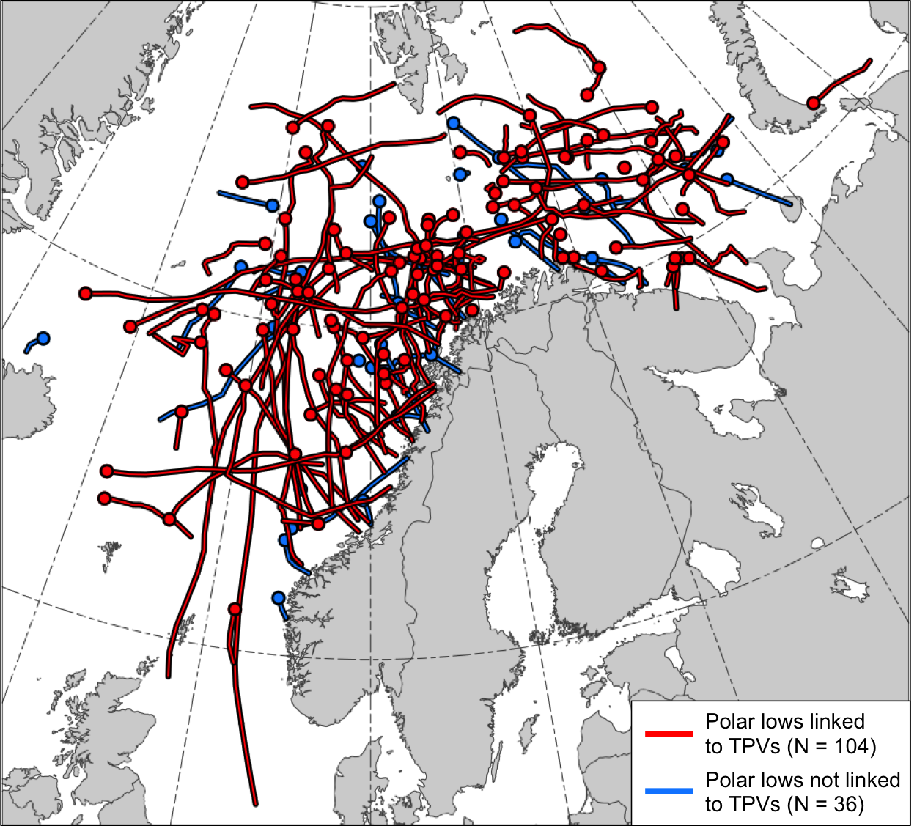

FIG. 1. Tracks of the polar lows in the STARS database. Tracks of polar lows that may be linked to TPVs are shown in red and tracks of polar lows that are not linked to TPVs are shown in blue. Dots indicate the genesis locations of the polar lows.

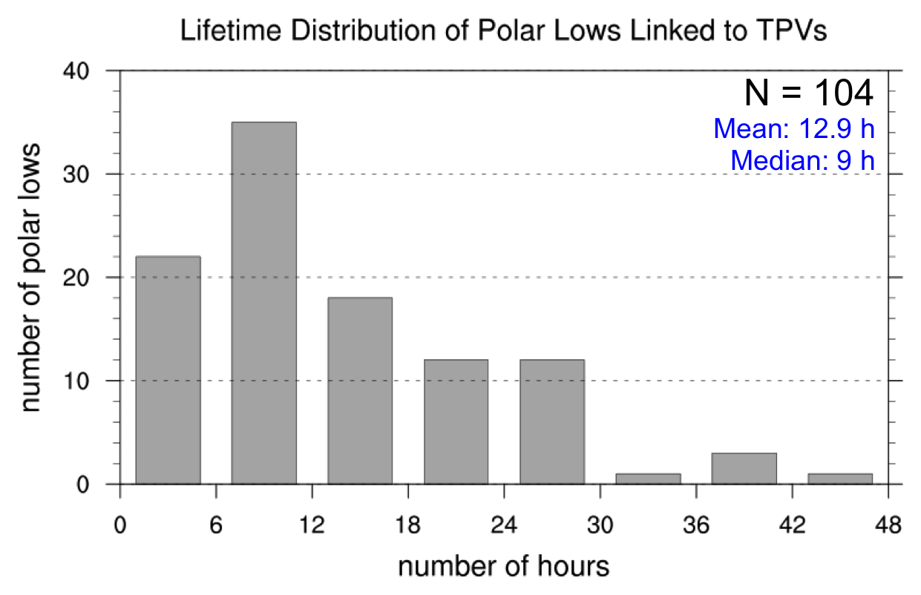

FIG. 2. Lifetime distribution of polar lows that may be linked to TPVs, with lifetime in number of hours. For each bin, the first number on the bottom axis is inclusive while the second number on the bottom axis is exclusive. For example, the second bin includes polar lows that last ≥ 6 h and < 12 h.
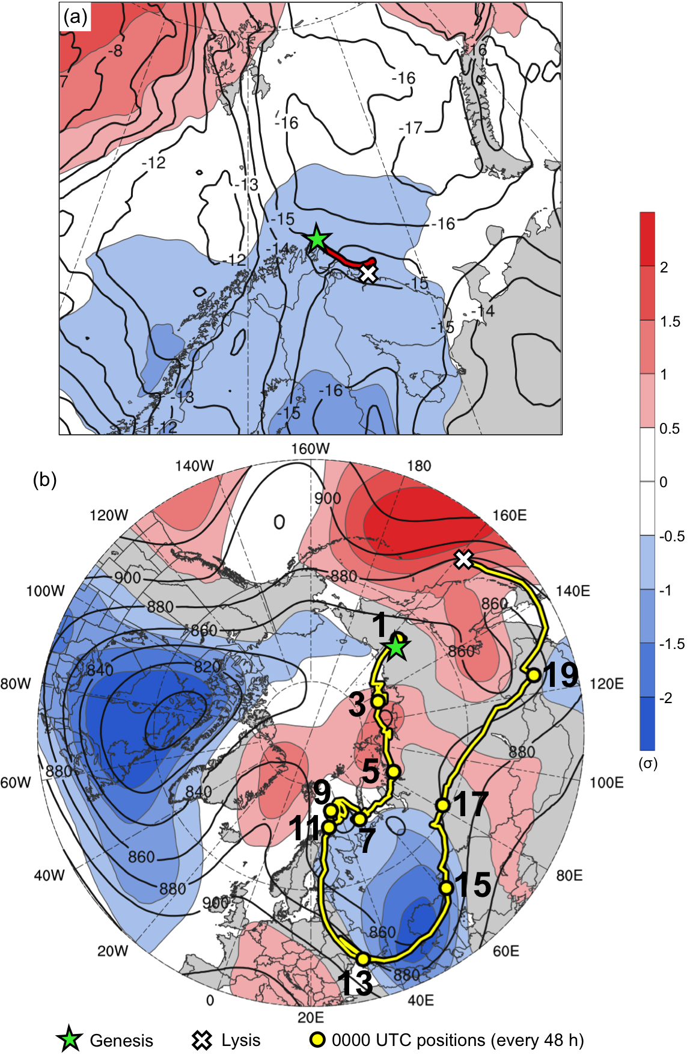

FIG. 3. Track of (a) polar low (red) from 1800 UTC 10 February to 1200 UTC 11 February 2011 and (b) the TPV linked to the polar low (yellow) from 1200 UTC 31 January to 1200 UTC 20 February 2011. Also, the 10–11 February 2011 time-mean (a) 850-hPa temperature (K, black) and standardized anomaly of 850-hPa temperature (σ, shaded), and (b) 300-hPa geopotential height (dam) and standardized anomaly of 300-hPa geopotential height (σ, shaded). Stars denote locations of genesis, crosses denote locations of lysis, and yellow dots in (b) represent 0000 UTC positions of TPV every 48 h. Numbers in (b) represent the corresponding dates of the 0000 UTC positions of the TPV in February 2011.
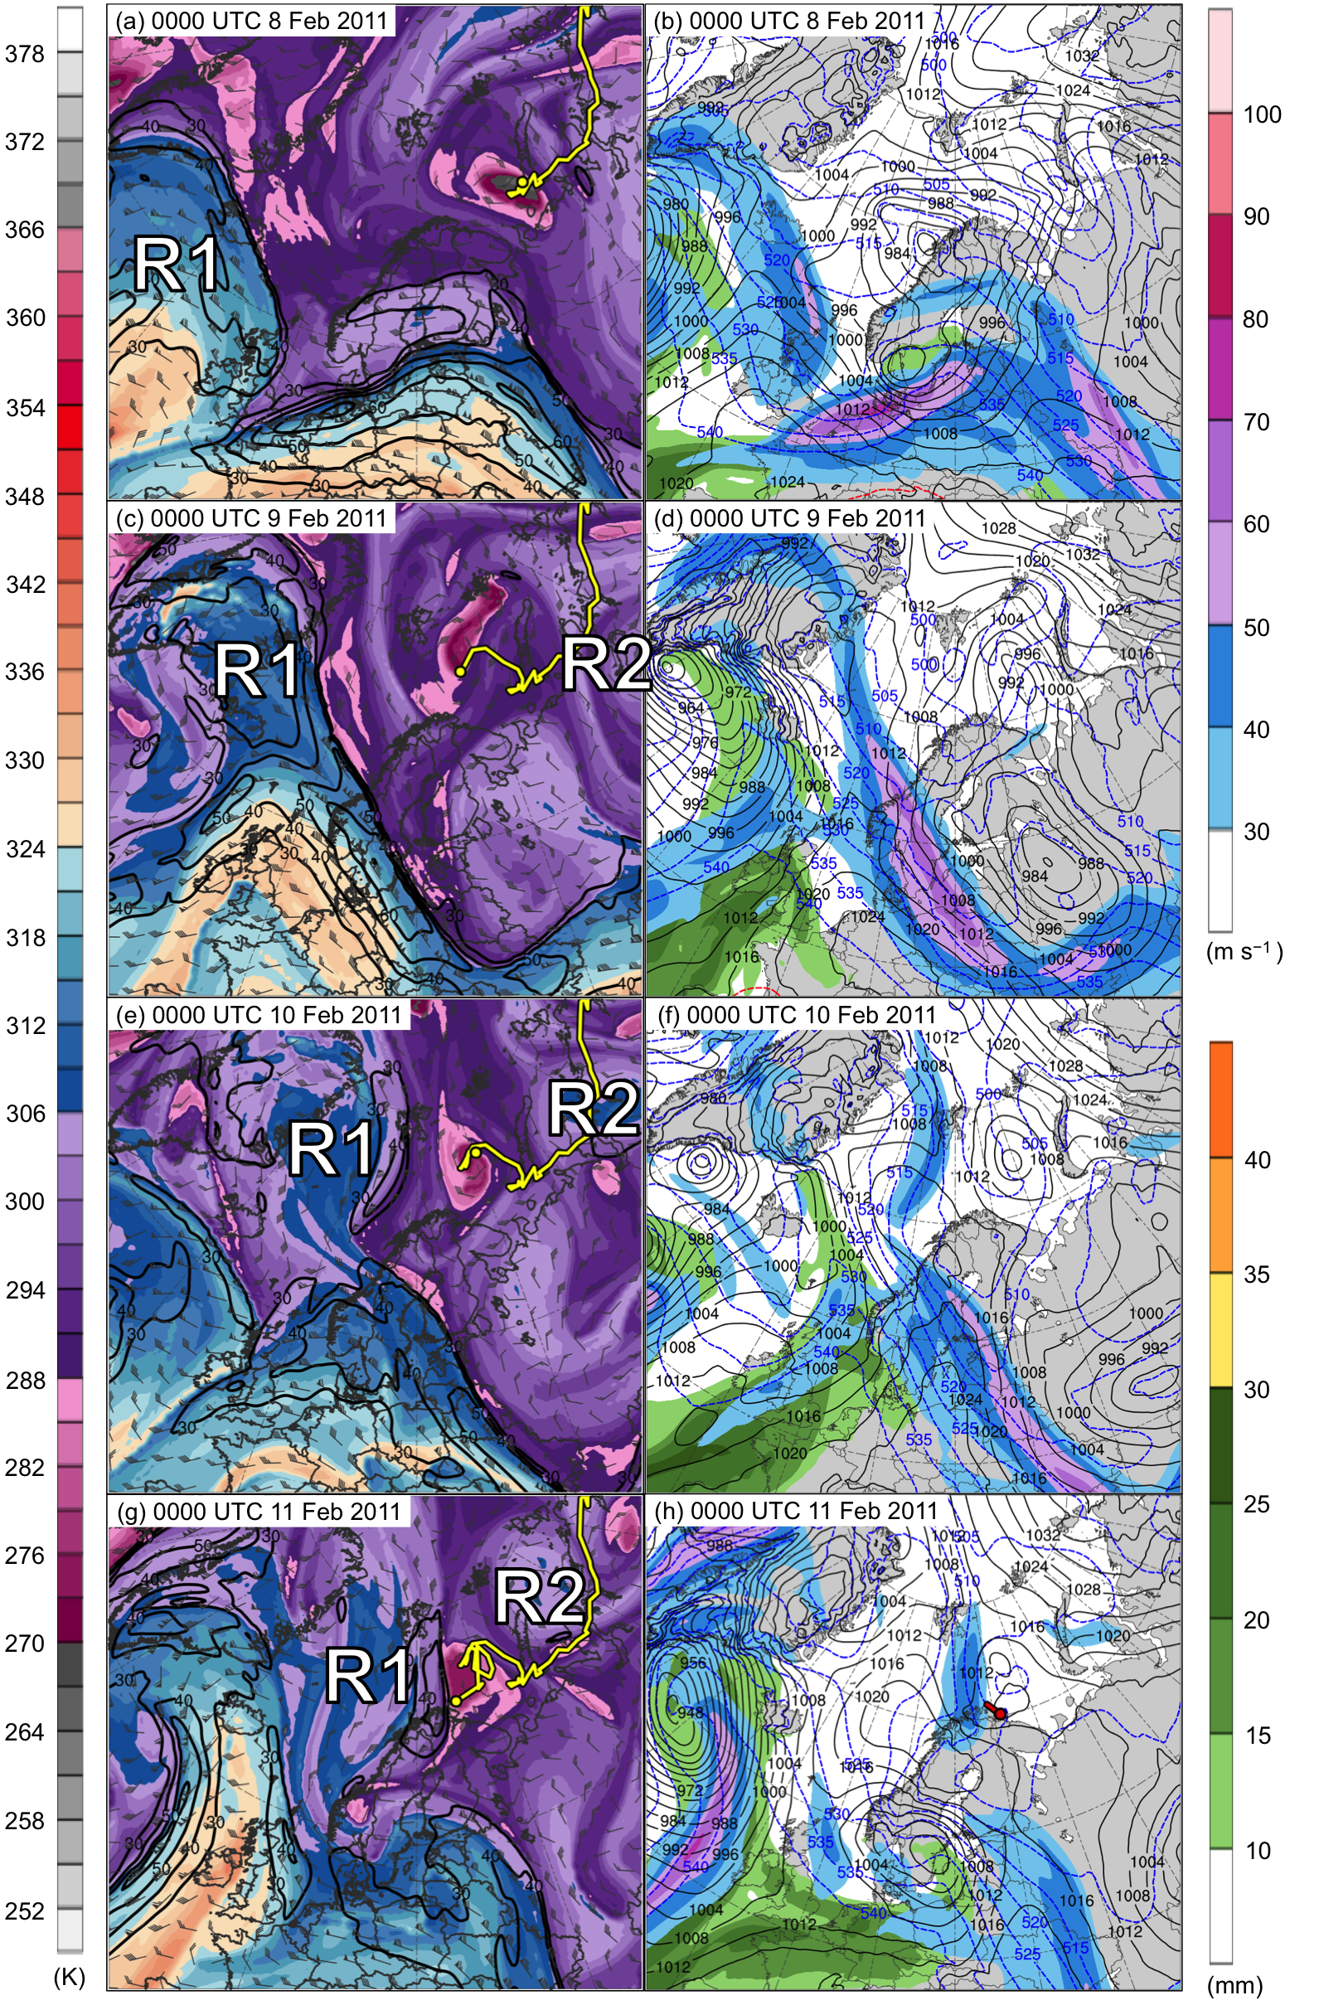
FIG. 4. DT (2-PVU surface) potential temperature (K, shaded), wind speed (black contours every 10 m s⁻¹, beginning at 30 m s⁻¹), and wind (m s⁻¹, flags and barbs) at (a) 0000 UTC 8 February, (c) 0000 UTC 9 February, (e) 0000 UTC 10 February, and (g) 0000 UTC 11 February 2011; 300-hPa wind speed (m s⁻¹, shaded), 1000–500-hPa thickness (dashed red and blue contours every 5 dam, contoured red for values >540 dam and blue otherwise), SLP (black contours every 4 hPa), and precipitable water (mm, shaded) at (b) 0000 UTC 8 February, (d) 0000 UTC 9 February, (f) 0000 UTC 10 February, and (h) 0000 UTC 11 February 2011. Yellow line and dot represent track and position of TPV, respectively, and red line and dot represent track and position of polar low, respectively, according to STARS database. Labels “R1” and “R2” represent the position of R1 and R2, respectively.

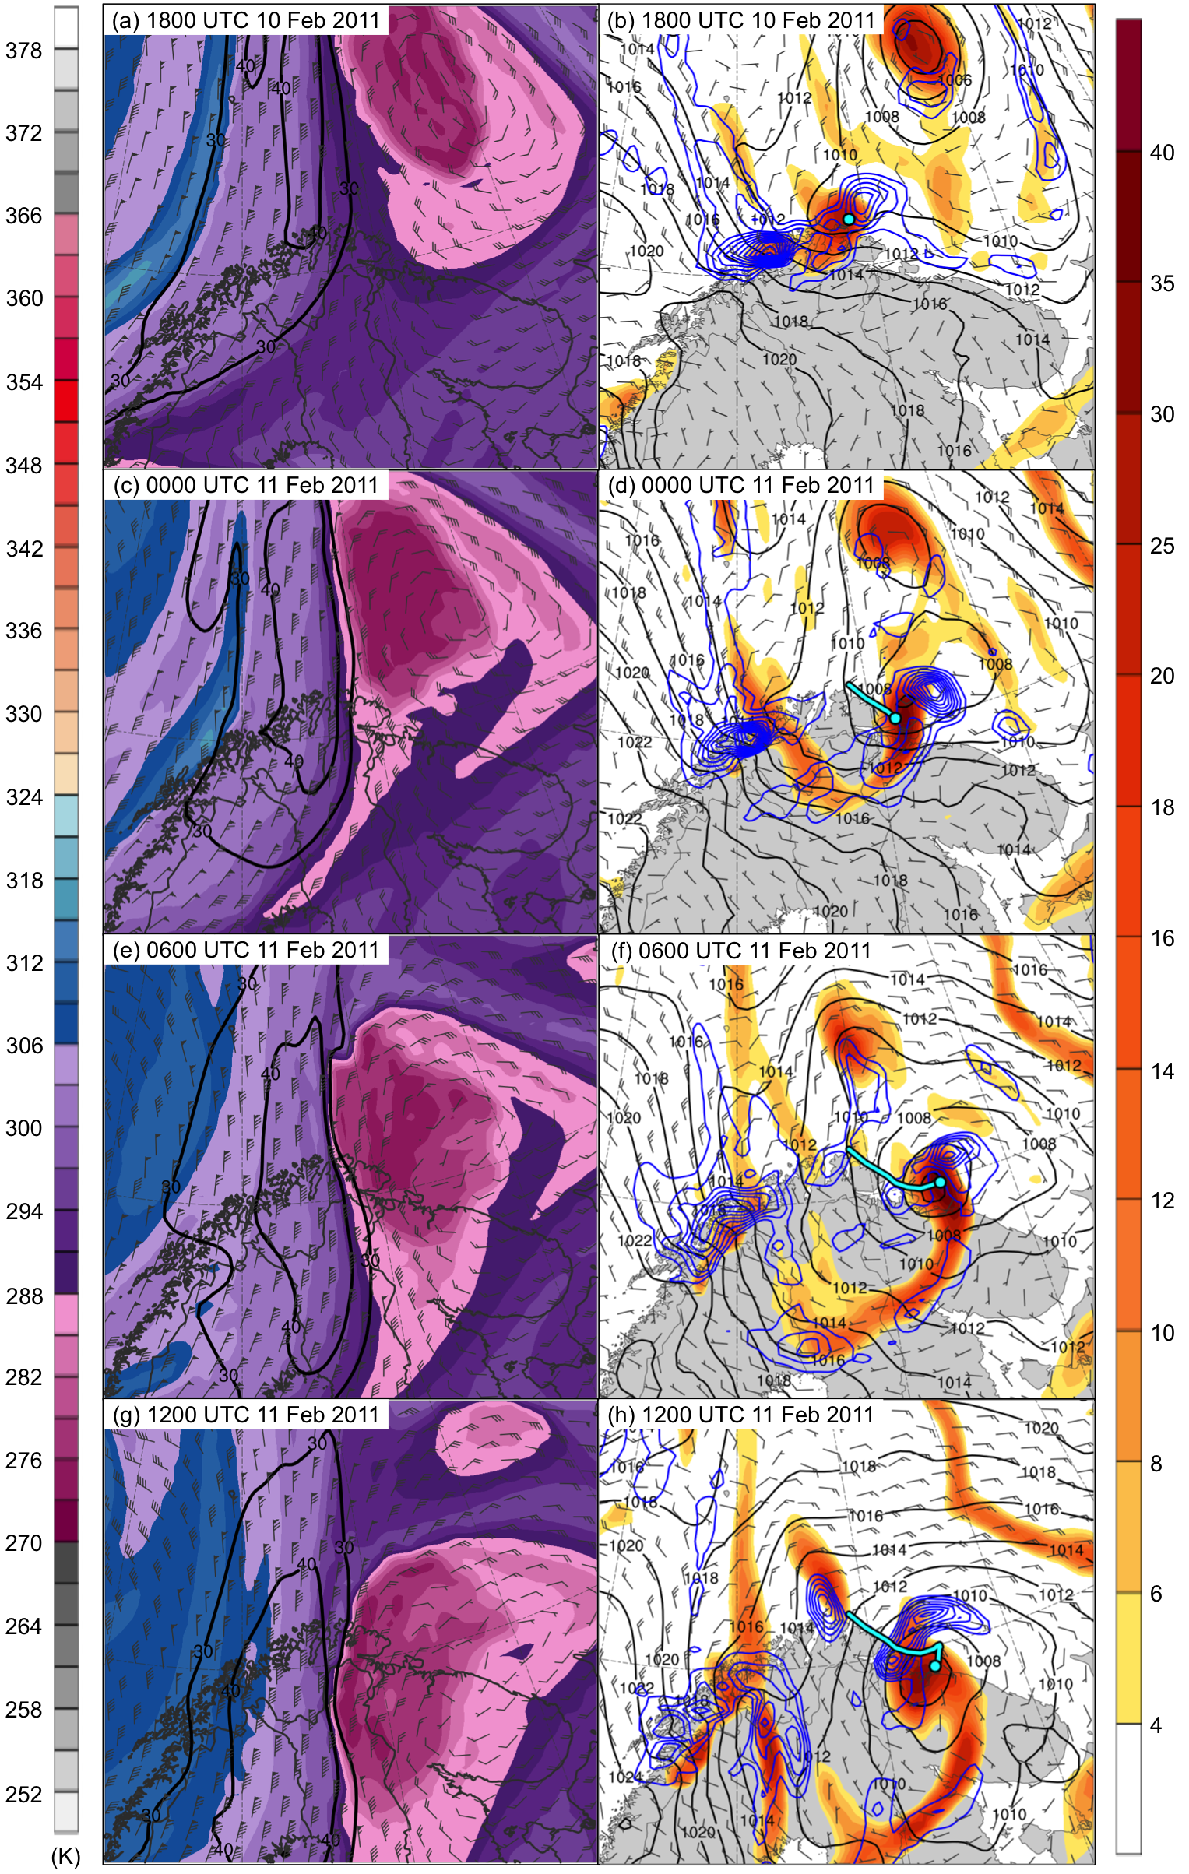
FIG. 5. DT (2-PVU surface) potential temperature (K, shaded), wind speed (black contours every 10 m s⁻¹, beginning at 30 m s⁻¹), and wind (m s⁻¹, flags and barbs) at (a) 1800 UTC 10 February, (c) 0000 UTC 11 February, (e) 0600 UTC 11 February, and (g) 1200 UTC 11 February 2011; 850-hPa relative vorticity (10⁻⁵ s⁻¹, shaded), 850–600-hPa layer-averaged ascent (blue contours every 2.5 × 10⁻³ hPa s⁻¹, beginning at −2.5 × 10⁻³ hPa s⁻¹), SLP (black contours every 2 hPa), and 10-m wind (m s⁻¹, barbs) at (b) 1800 UTC 10 February, (d) 0000 UTC 11 February, (f) 0600 UTC 11 February, and (h) 1200 UTC 11 February 2011. Cyan line and dot represent track and position of polar low, respectively, according to STARS database.

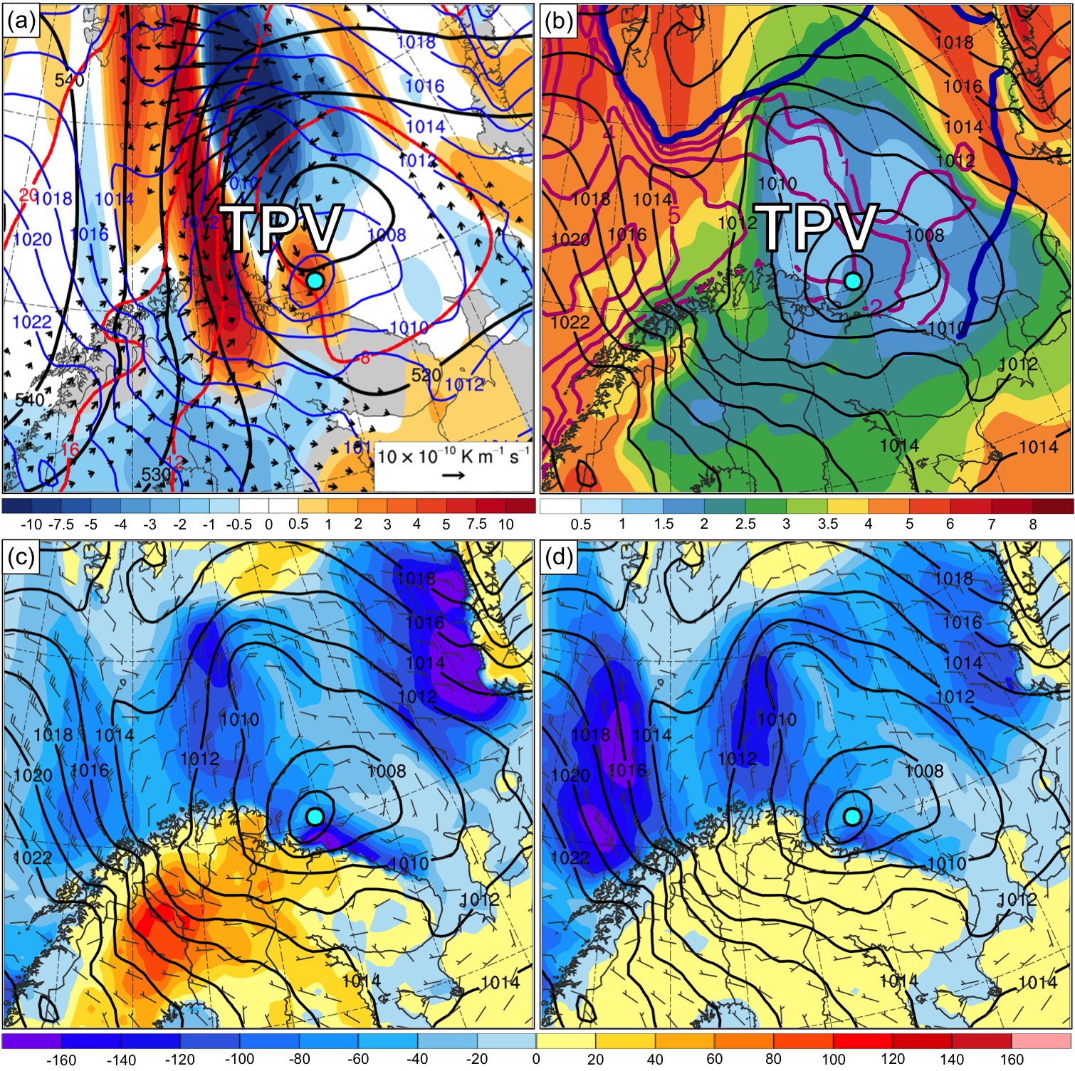

FIG. 6. (a) SLP (blue contours every 2 hPa), and 600–400-hPa layer-averaged Q (K m⁻¹ s⁻¹, vectors), Q forcing for vertical motion (10⁻¹⁷ Pa⁻¹ s⁻³, shaded), geopotential height (black contours every 5 dam), and potential temperature (dashed red contours every 4°C); (b) 900–600-hPa layer-averaged static stability, SLP (black contours every 2 hPa), SST (purple contours every 1°C beginning at 1°C), and 20% contour of sea-ice concentration (thick blue); (c) SLP (black contours every 2 hPa), 10-m wind (m s⁻¹, barbs), and forecast sensible heat flux (W m⁻², shaded); and (d) as in (c), but forecast latent heat flux at 0300 UTC 11 February 2011. Label “TPV” denotes position of TPV and cyan dot denotes position of polar low in ERA5.

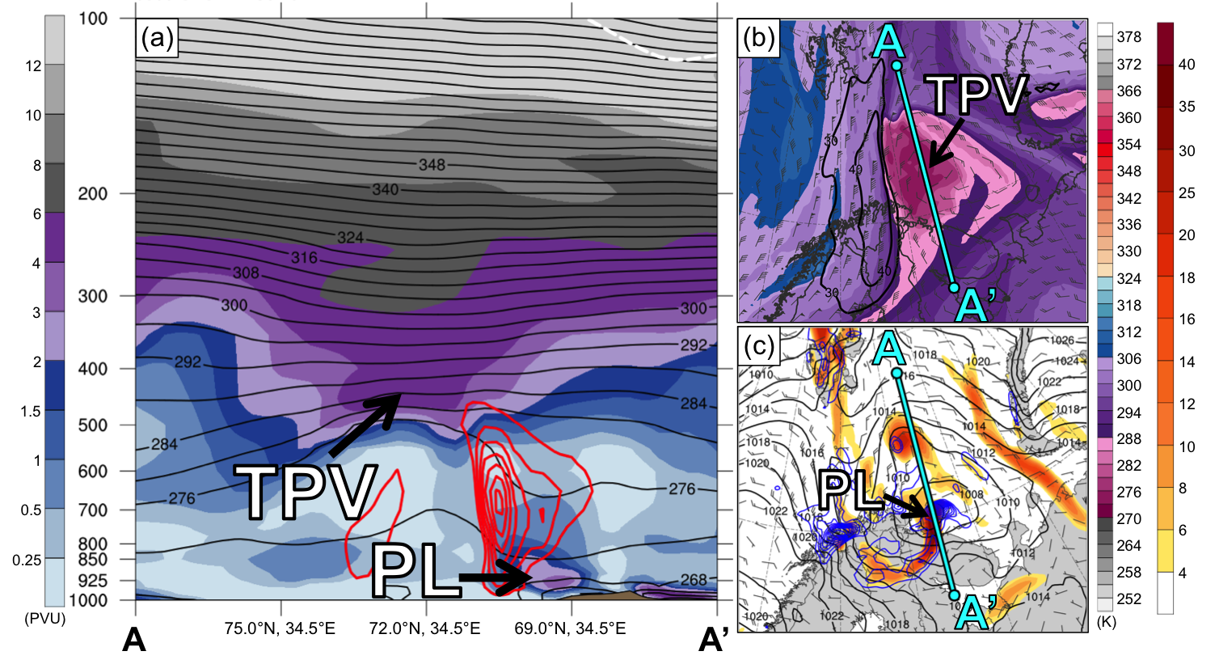

FIG. 7. (a) Cross section along line AA’ of PV (PVU, shading), potential temperature (K, black), ascent (red contours every 2.5 × 10⁻³ hPa s⁻¹, beginning at −2.5 × 10⁻³ hPa s⁻¹), and wind speed (dashed white contours every 10 m s⁻¹, beginning at 30 m s⁻¹); (b) DT (2-PVU surface) potential temperature (K, shaded), wind speed (black contours every 10 m s⁻¹, beginning at 30 m s⁻¹), and wind (m s⁻¹, flags and barbs); and (c) 850-hPa relative vorticity (10⁻⁵ s⁻¹, shaded), 850–600-hPa layer-averaged ascent (blue contours every 2.5 × 10⁻³ hPa s⁻¹, beginning at −2.5 × 10⁻³ hPa s⁻¹), SLP (black contours every 2 hPa), and 10-m wind (m s⁻¹, barbs) at 0300 UTC 11 February 2011. Cyan line in (b) and (c) represents transect of cross section AA’. Arrows and labels “TPV” and “PL” point to locations of TPV and polar low, respectively.

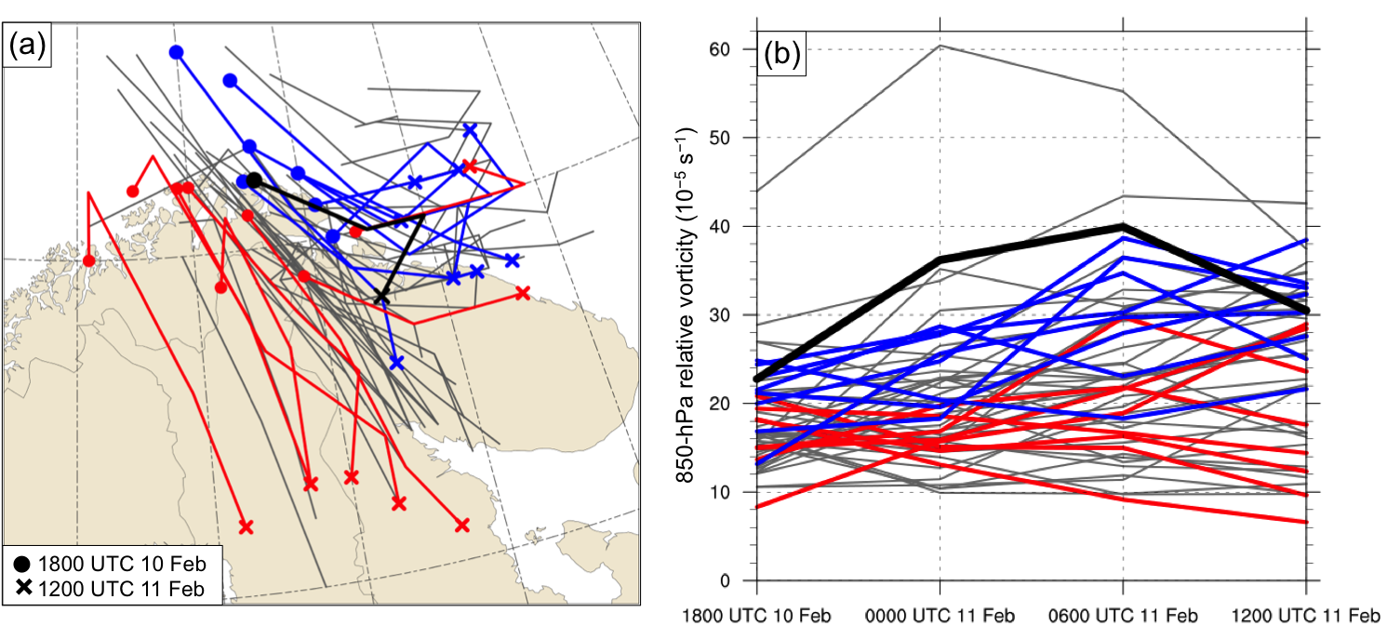

FIG. 8. (a) Track of the polar low, as represented by the track of its associated 850-hPa relative vorticity maximum, and (b) intensity of the polar low, as represented by the value of its associated 850-hPa relative vorticity maximum (10⁻⁵ s⁻¹), every 6 h during 1800 UTC 10 February–1200 UTC 11 February 2011 for ERA5 (black), ensemble members in the most accurate group (blue), ensemble members in least accurate group (red), and for all other ensemble members (gray). Dots and crosses in (a) represent position of polar low at 1800 UTC 10 February and 1200 UTC 11 February, respectively, for ERA5 and ensemble members in most and least accurate group.

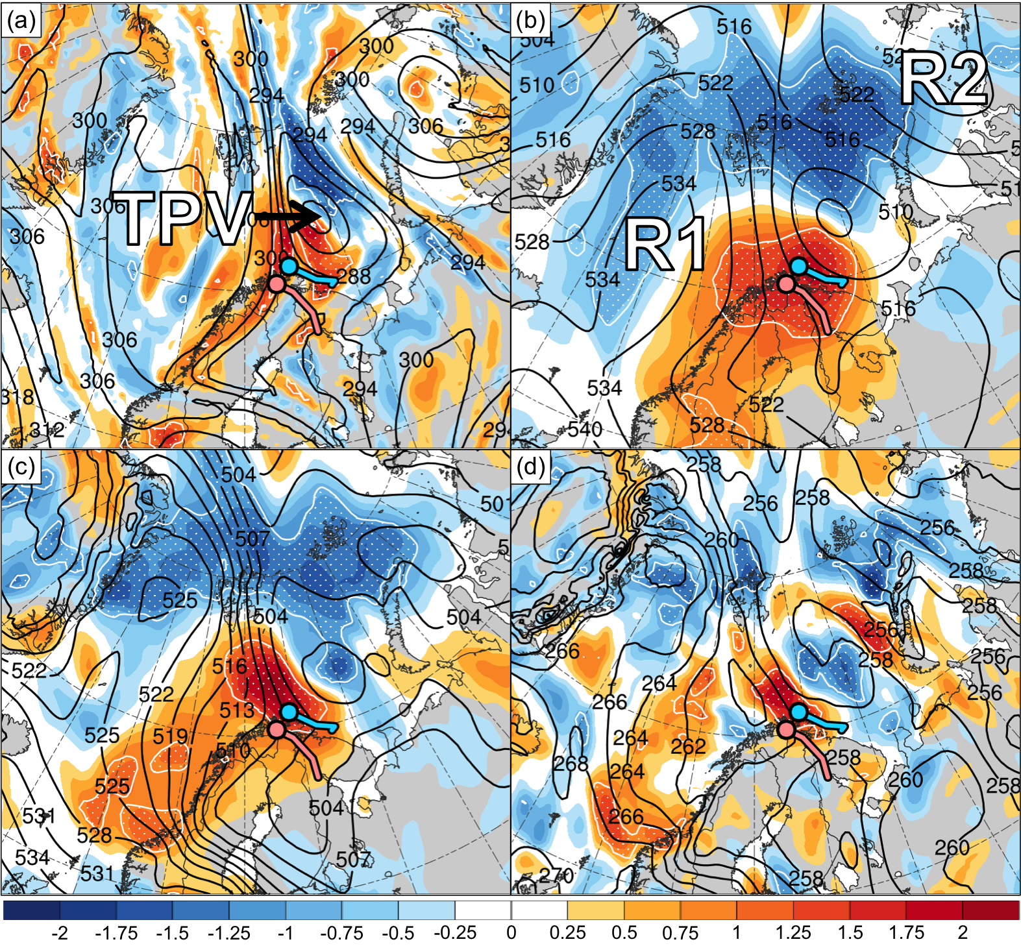

FIG. 9. Normalized composite difference between the most accurate and least accurate group (most accurate minus least accurate; shading; units: standardized anomaly) and ensemble mean (black contours) of (a) DT (2-PVU surface) potential temperature (K), (b) 500-hPa geopotential height (dam), (c) 1000–500-hPa thickness (dam), and (d) 850-hPa temperature (K) at 1800 UTC 10 February 2011 (30 h forecast). White stippling indicates where there is a statistically significant difference at the 95% confidence level between the mean of the most accurate group and mean of the least accurate group for each quantity according to a two-sided Student’s t test. Blue and pink dot represent mean position of polar low in most accurate and least accurate group, respectively, at 1800 UTC 10 February 2011, and blue and pink line represent mean track of polar low in most accurate and least accurate group, respectively, during 1800 UTC 10 –1200 UTC 11 February 2011. Labels “TPV”, “R1”, and “R2” represent the ensemble mean position of the TPV, R1, and R2, respectively.

