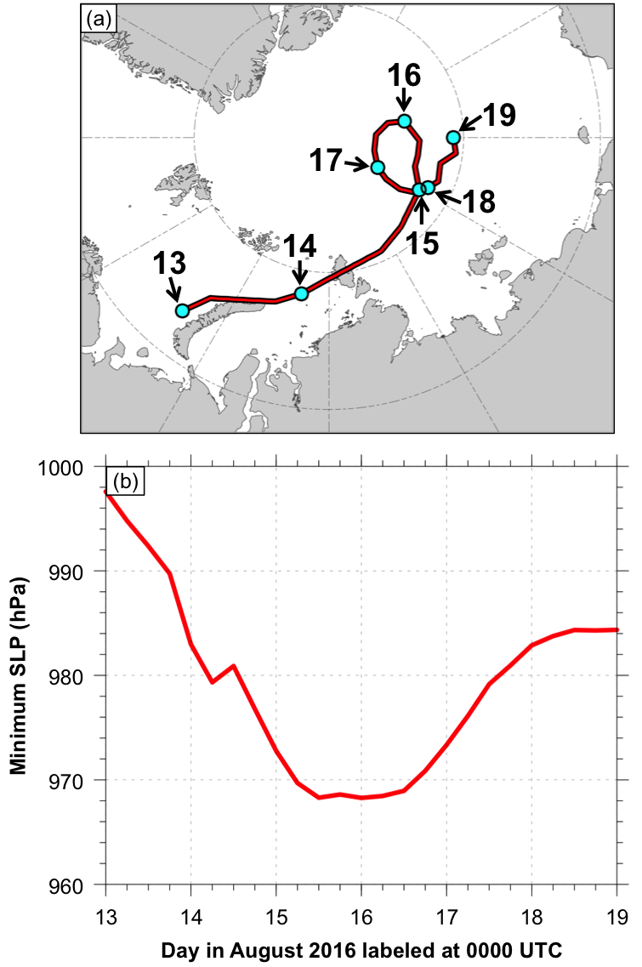

Fig. 4.1. (a) Track (red line) and (b) minimum SLP (red line) of AC16 during 0000 UTC 13–0000 UTC 19 August 2016, every 6 h. Cyan dots in (a) indicate 0000 UTC positions of AC16.

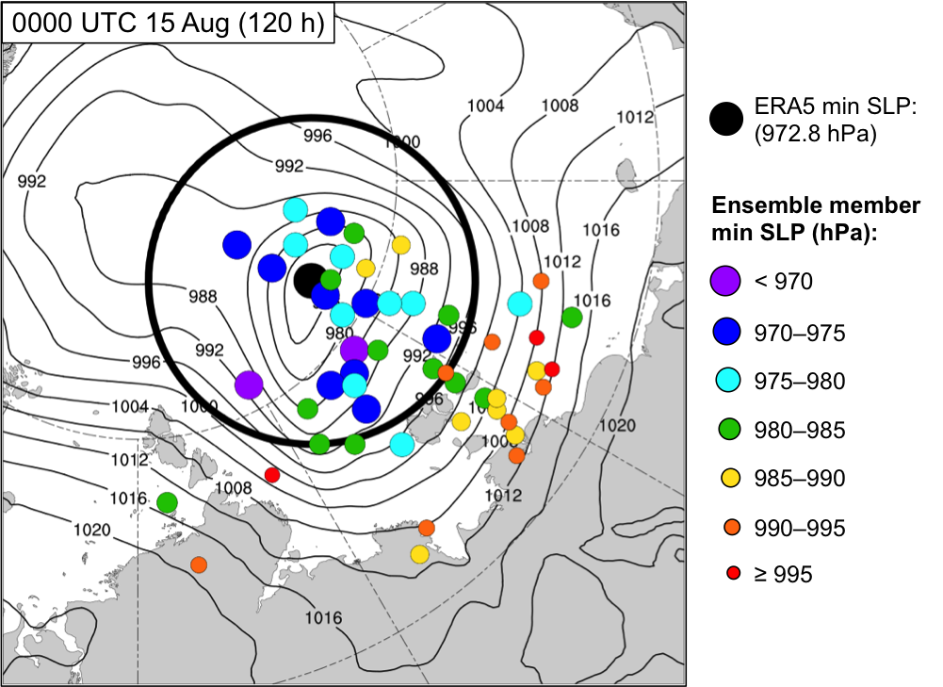

Fig. 4.2. Positions of AC16 for the ensemble forecasts (colored dots; N = 51) at 0000 UTC 15 August (120 h). Dots are colored and sized by minimum SLP (hPa) at 0000 UTC 15 August (120 h) according to the legend. The position of AC16 for ERA5 at 0000 UTC 15 August is given by the black dot. The corresponding minimum SLP of AC16 for ERA5 is 972.8 hPa. Black contours denote SLP (hPa) from ERA5 at 0000 UTC 15 August. Black circle of 700-km radius denotes region over which J_{AC} is calculated.

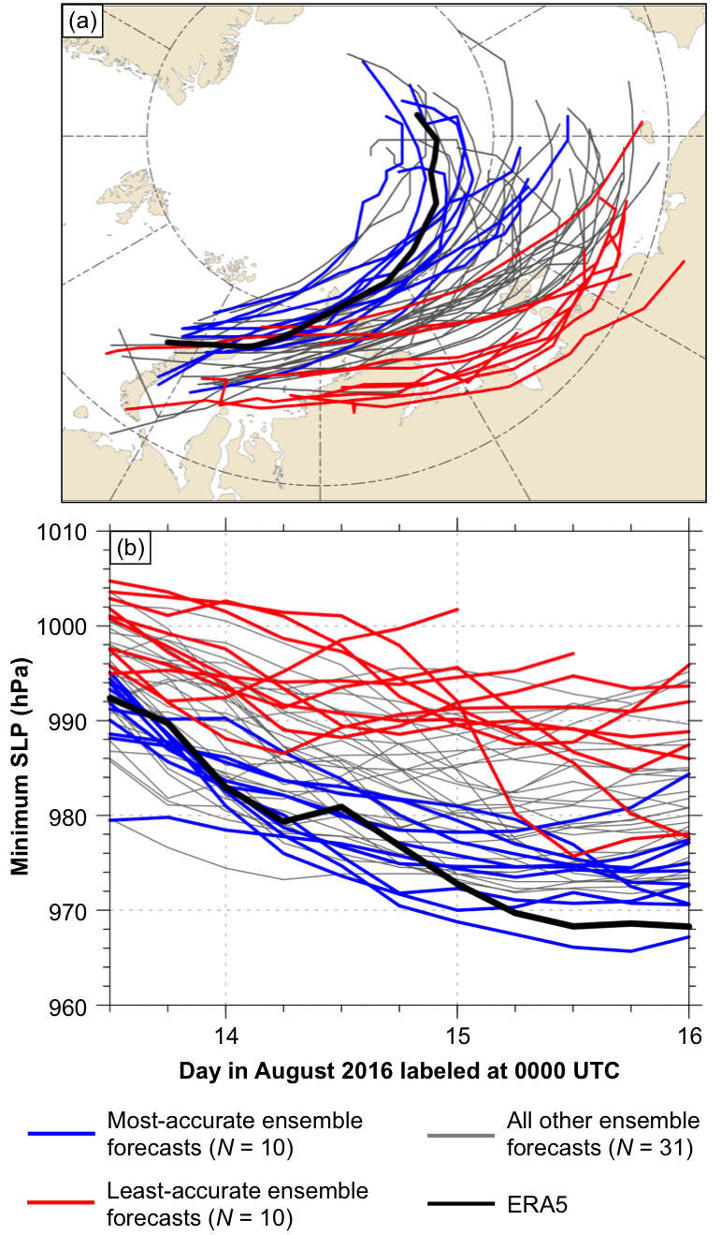

Fig. 4.3. (a) Tracks and (b) minimum SLP (hPa) during 1200 UTC 13–0000 UTC 16 August, every 6 h, for most-accurate ensemble forecasts (blue), least-accurate ensemble forecasts (red), all other ensemble forecasts (gray), and ERA5 (black).

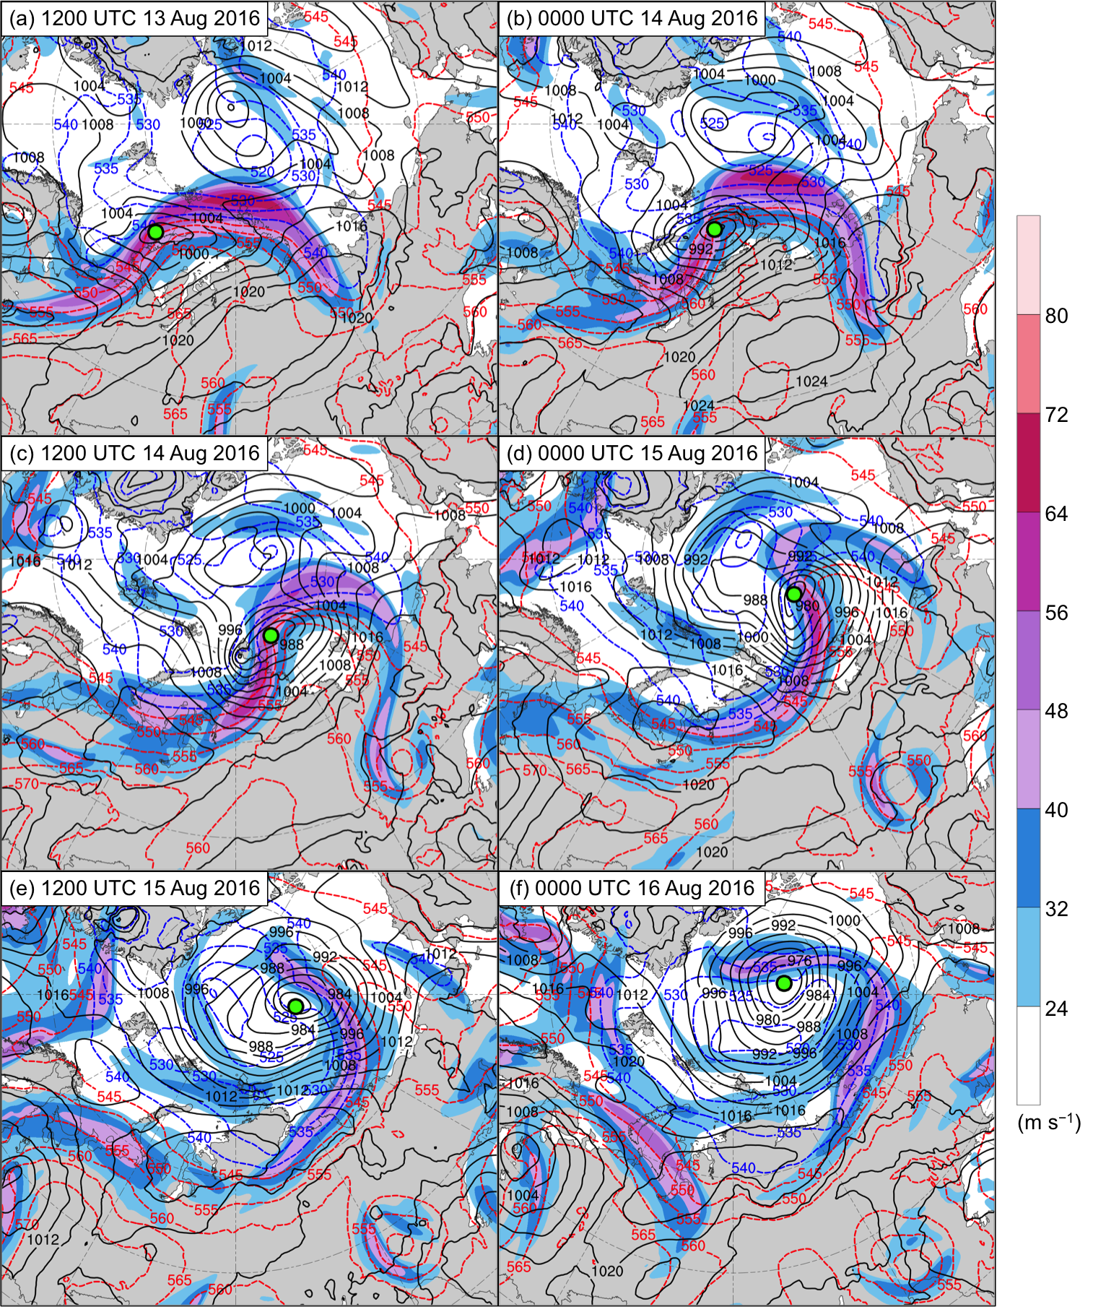

Fig. 4.4. ERA5 analyses of 300-hPa wind speed (m s⁻¹; shading), 1000–500-hPa thickness (dam; dashed red and blue contours), and SLP (hPa; black contours) at (a) 1200 UTC 13 August, (b) 0000 UTC 14 August, (c) 1200 UTC 14 August, (d) 0000 UTC 15 August, (e) 1200 UTC 15 August, and (f) 0000 UTC 16 August. The green dot shows the location of AC16.
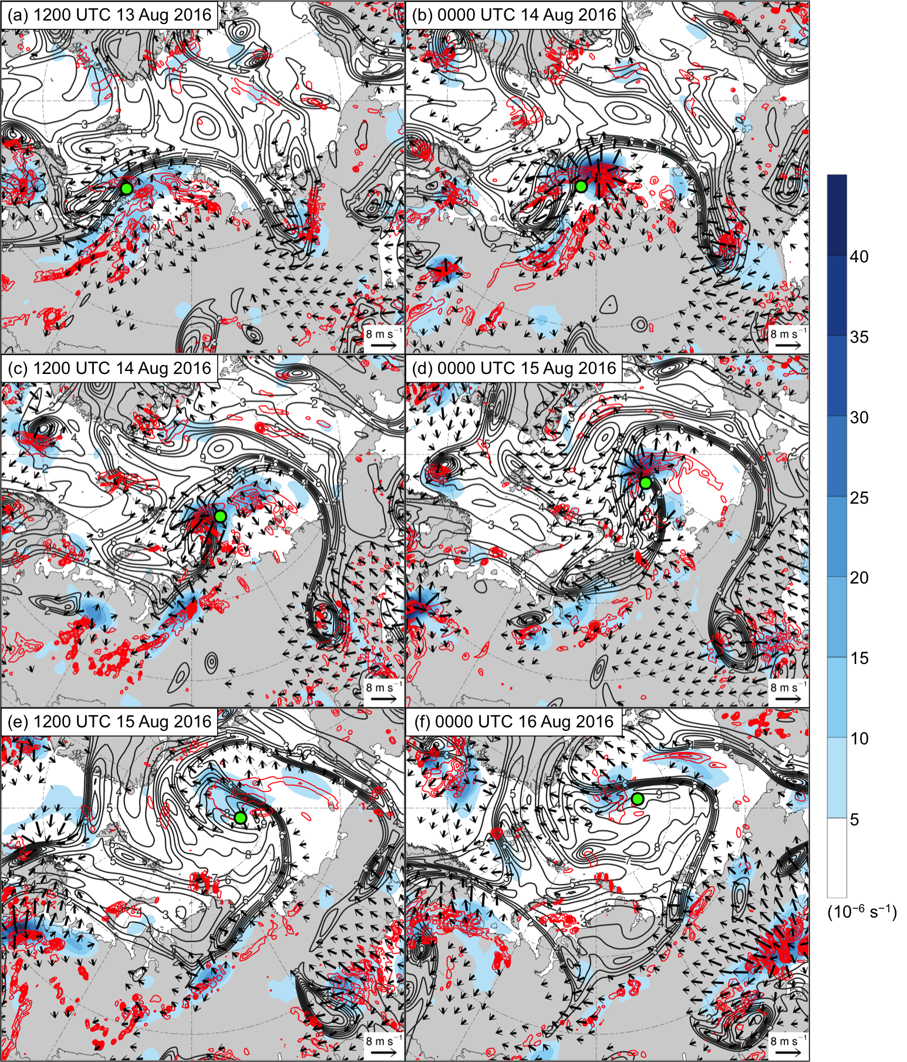

Fig. 4.5. As in Fig. 4.4, but for ERA5 analyses of 350–250-hPa divergence area averaged within 200 km of each grid point (10⁻⁶ s⁻¹; shading), 350–250-hPa irrotational wind (m s⁻¹; vectors), 350–250-hPa PV (PVU; dark gray contours), and negative values of 800–600-hPa ω (every 1 × 10⁻³ hPa s⁻¹; red contours).

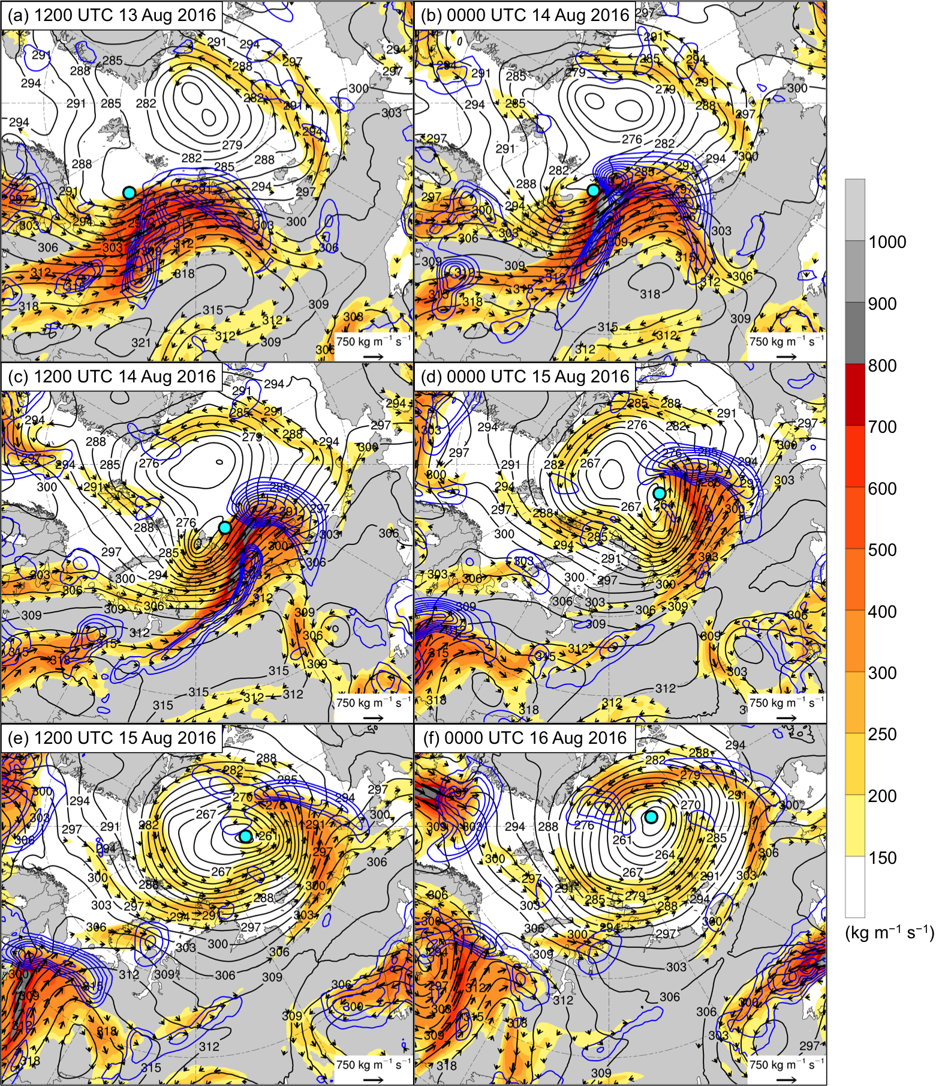

Fig. 4.6. As in Fig. 4.4, but for ERA5 analyses of 1000–300-hPa IVT (kg m⁻¹ s⁻¹; shading and vectors), positive values of 1000–300-hPa IMFC area averaged within 200 km of each grid point (every 100 W m⁻²; blue contours), and 700-hPa geopotential height (dam; black contours).

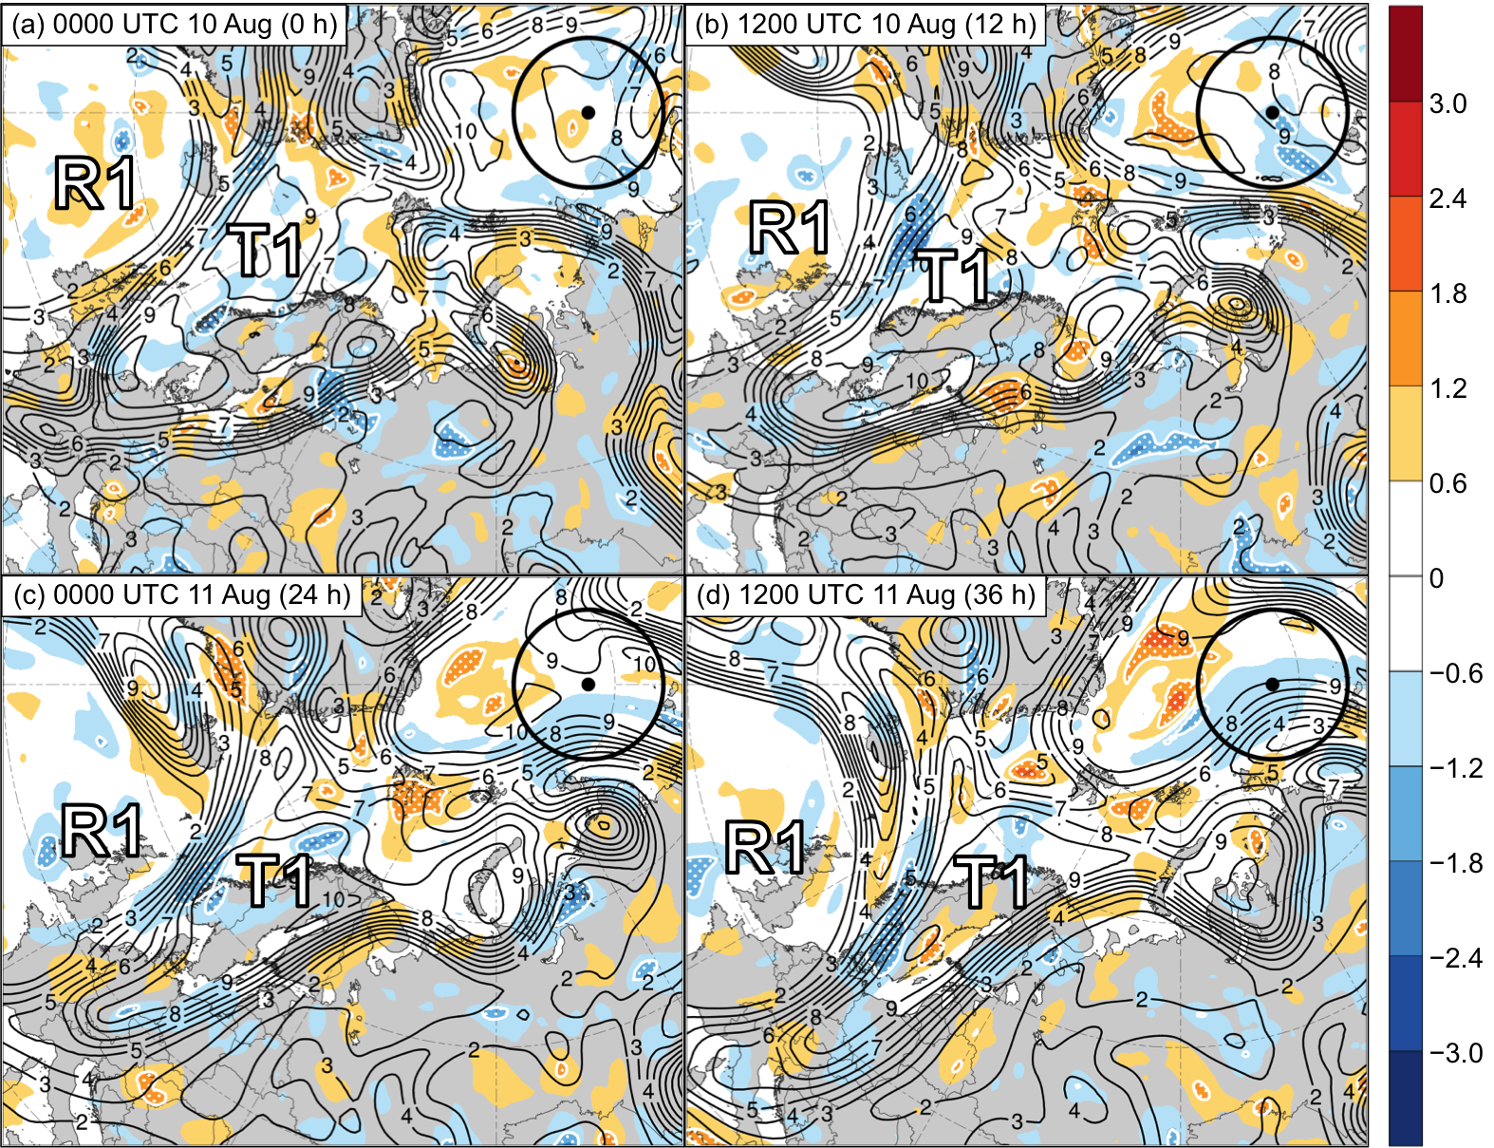

Fig. 4.7. Sensitivity of J_{AC} to 250-hPa PV area averaged within 200 km of each grid point (hPa; shading) and ensemble mean 250-hPa PV area averaged within 200 km of each grid point (PVU; dark gray contours) at (a) 0000 UTC 10 August (0 h), (b) 1200 UTC 10 August (12 h), (c) 0000 UTC 11 August (24 h), and (d) 1200 UTC 11 August (36 h). Regions of white stippling enclosed by white contours indicate where sensitivity is statistically significant at the 95% confidence level. Black dot indicates ERA5 position of AC16 at 0000 UTC 15 August 2016. Black circle indicates region over which J_{AC} is calculated. Labels “R1” and “T1” indicate the positions of these respective features, which are defined in the text. Positive values of sensitivity given by warm colors indicate that increasing 250-hPa PV area averaged within 200 km of each grid point correlates with a decrease in J_{AC} and thus correlates with a more accurate prediction of AC16. Negative values of sensitivity given by cool colors indicate that decreasing 250-hPa PV area averaged within 200 km of each grid point correlates with a decrease in J_{AC} and thus with a more accurate prediction of AC16.

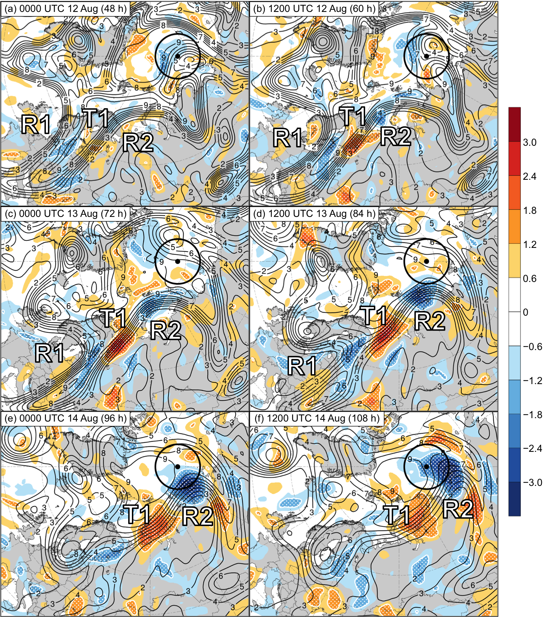

Fig. 4.8. As in Fig. 4.7, but at (a) 0000 UTC 12 August (48 h), (b) 1200 UTC 12 August (60 h), (c) 0000 UTC 13 August (72 h), (d) 1200 UTC 13 August (84 h), (e) 0000 UTC 14 August (96 h), and (f) 1200 UTC 14 August (108 h). Labels “R1”, “R2”, and “T1” indicate the positions of these respective features, which are defined in the text.

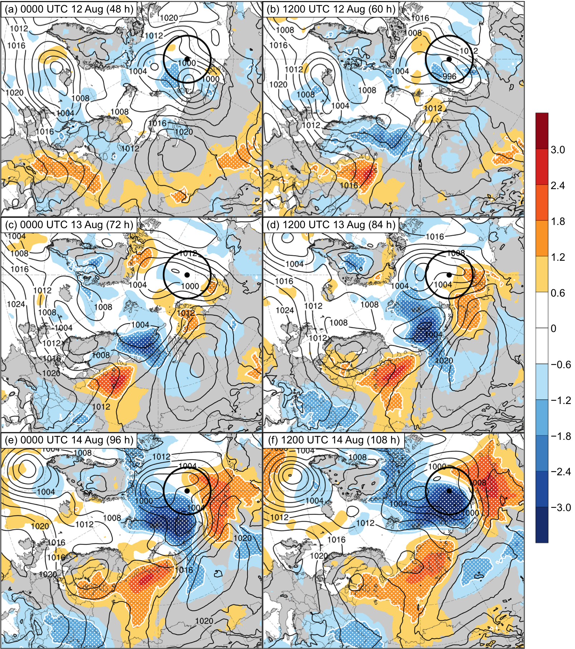

Fig. 4.9. As in Fig. 4.7, but for sensitivity of J_{AC} to SLP (hPa; shading) and ensemble mean SLP (hPa; black contours) at (a) 0000 UTC 12 August (48 h), (b) 1200 UTC 12 August (60 h), (c) 0000 UTC 13 August (72 h), (d) 1200 UTC 13 August (84 h), (e) 0000 UTC 14 August (96 h), and (f) 1200 UTC 14 August (108 h).

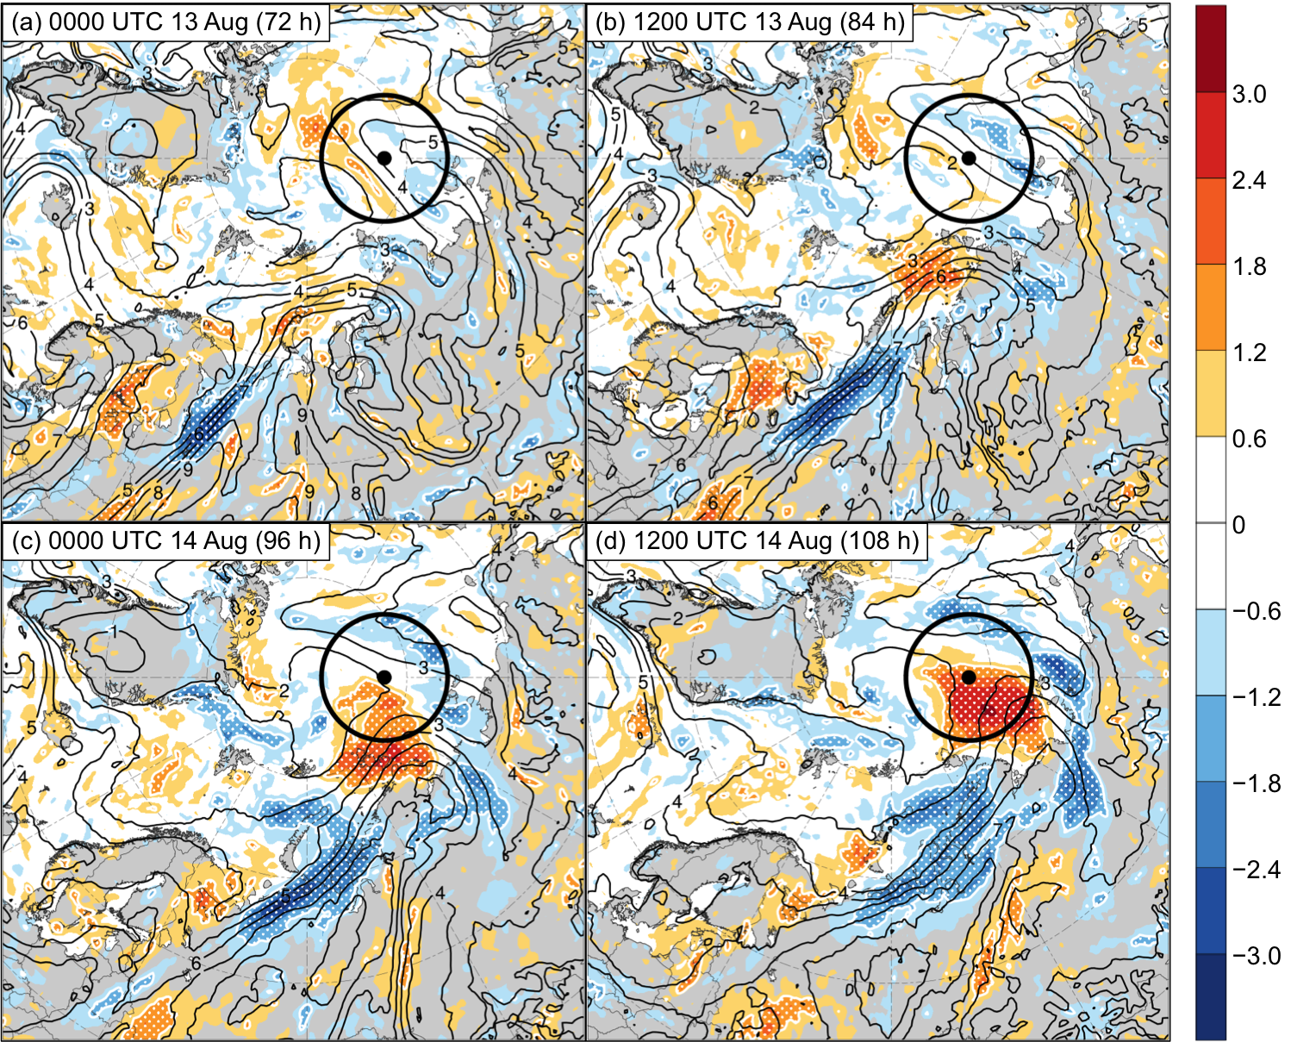

Fig. 4.10. As in Fig. 4.7, but for sensitivity of J_{AC} to 850-hPa specific humidity (hPa; shading) and ensemble mean 850-hPa specific humidity (g kg⁻¹; black contours) at (a) 0000 UTC 13 August (72 h), (b) 1200 UTC 13 August (84 h), (c) 0000 UTC 14 August (96 h), and (d) 1200 UTC 14 August (108 h).

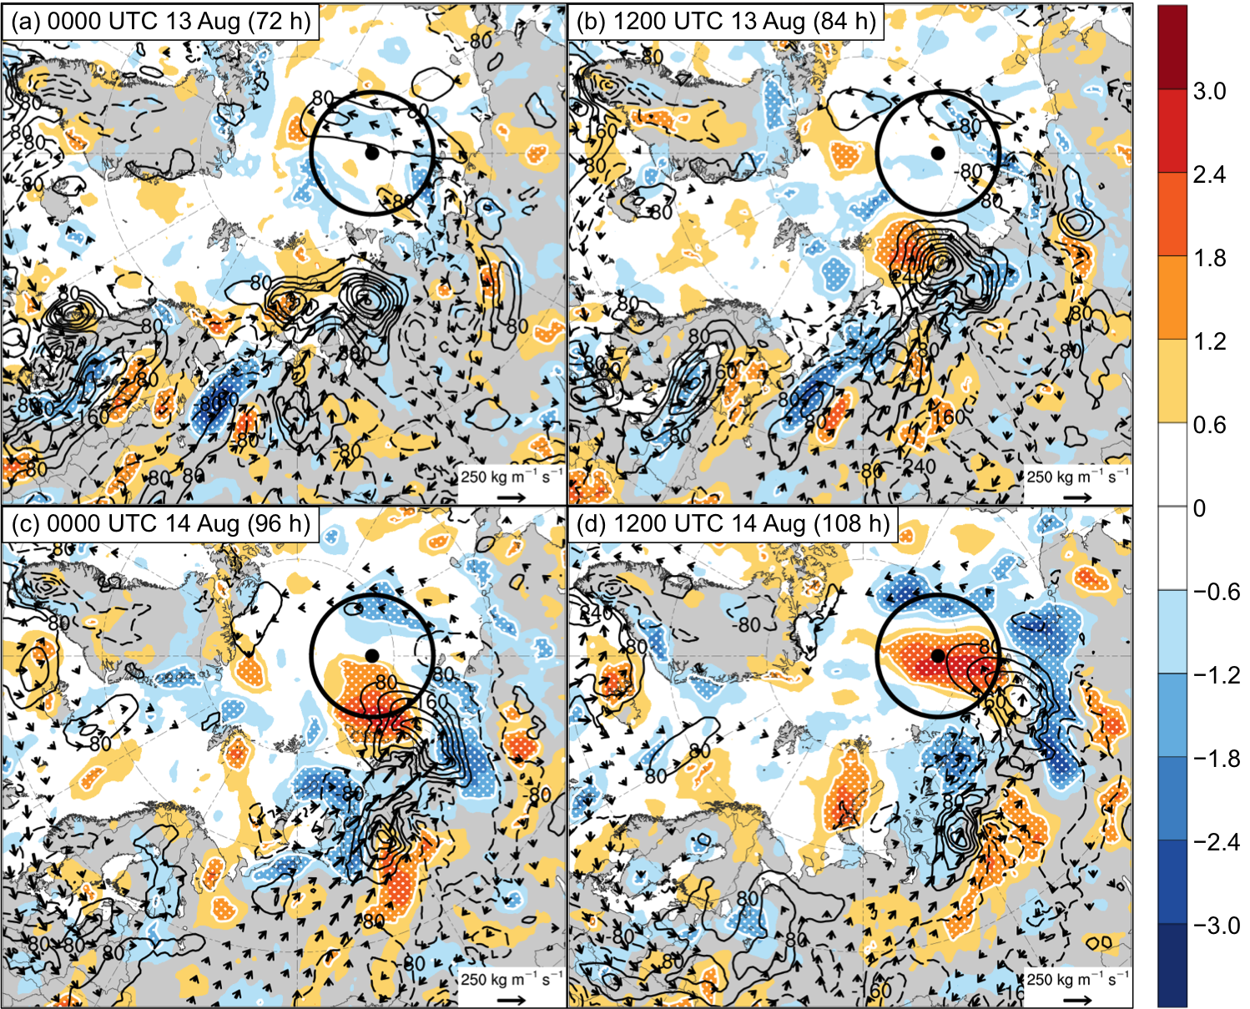

Fig. 4.11. As in Fig. 4.7, but for sensitivity of J_{AC} to 1000–850-hPa IMFC area averaged within 200 km of each grid point (hPa; shading), ensemble mean 1000–850-hPa IMFC area averaged within 200 km of each grid point [every 100 W m⁻²; black contours (solid for positive values and dashed for negative values)], and ensemble mean 1000–850-hPa IVT (kg m⁻¹ s⁻¹; vectors) at (a) 0000 UTC 13 August (72 h), (b) 1200 UTC 13 August (84 h), (c) 0000 UTC 14 August (96 h), and (d) 1200 UTC 14 August (108 h).

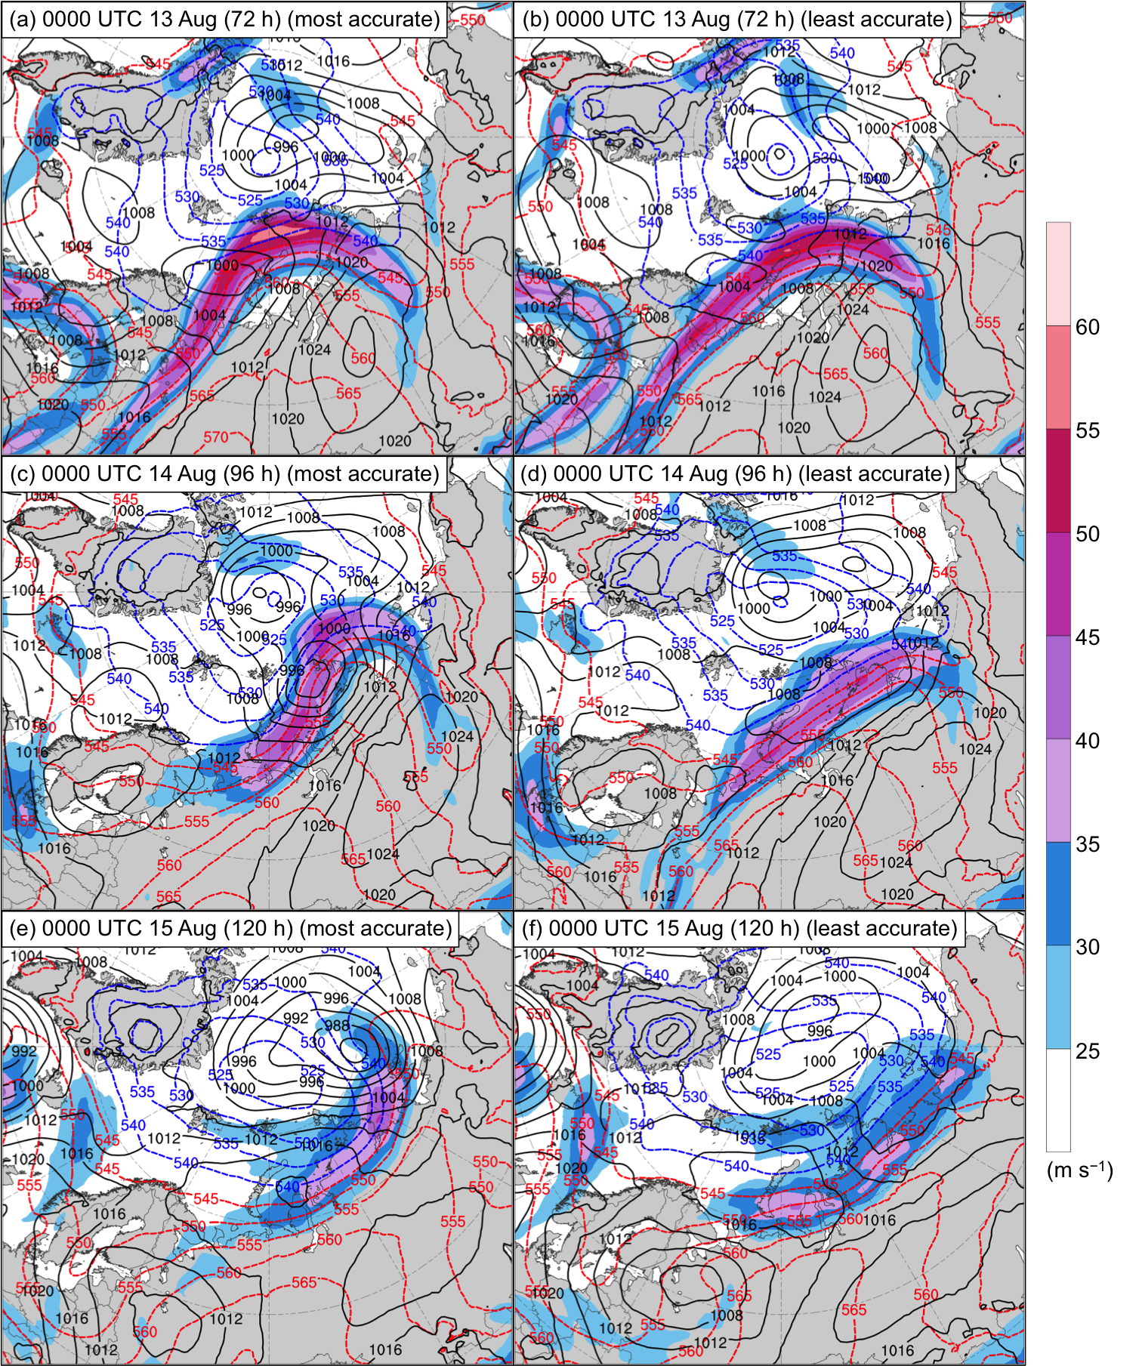

Fig. 4.12. Composites of 300-hPa wind speed (m s⁻¹; shading), 1000–500-hPa thickness (dam; dashed red and blue contours), and SLP (hPa; black contours) at (a),(b) 0000 UTC 13 August (72 h), (c),(d) 0000 UTC 14 August (96 h), and (e),(f) 0000 UTC 15 August (120 h). Composites for most-accurate ensemble forecasts are given in (a),(c),(e) and composites for least-accurate ensemble forecasts are given in (b),(d),(f).
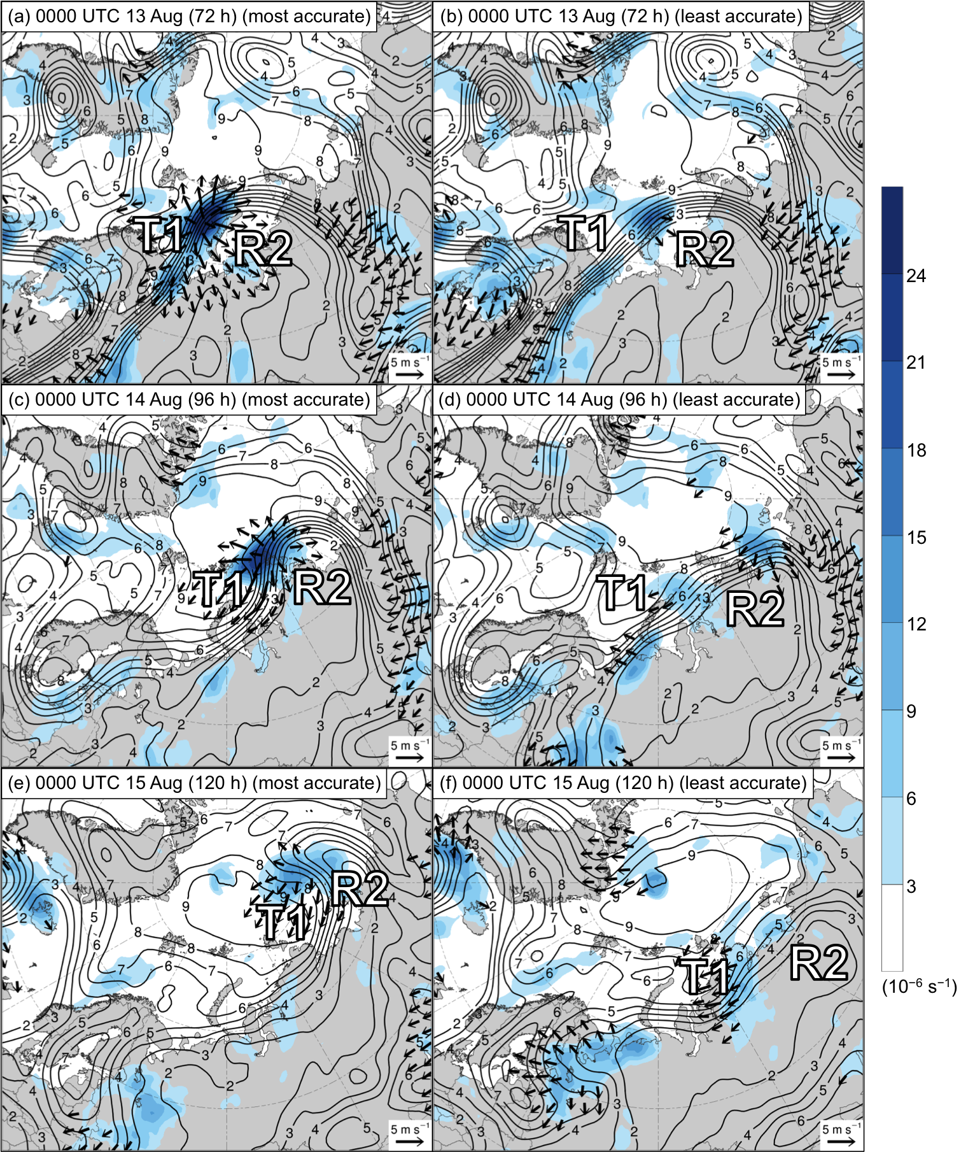

Fig. 4.13. As in Fig. 4.12, but for 300-hPa divergence area averaged within 200 km of each grid point (10⁻⁶ s⁻¹; shading), 300-hPa irrotational wind area averaged within 200 km of each grid point (m s⁻¹; vectors), and 250-hPa PV area averaged within 200 km of each grid point (PVU; dark gray contours). Labels “R2” and “T1” indicate the positions of these respective features, which are defined in the text.
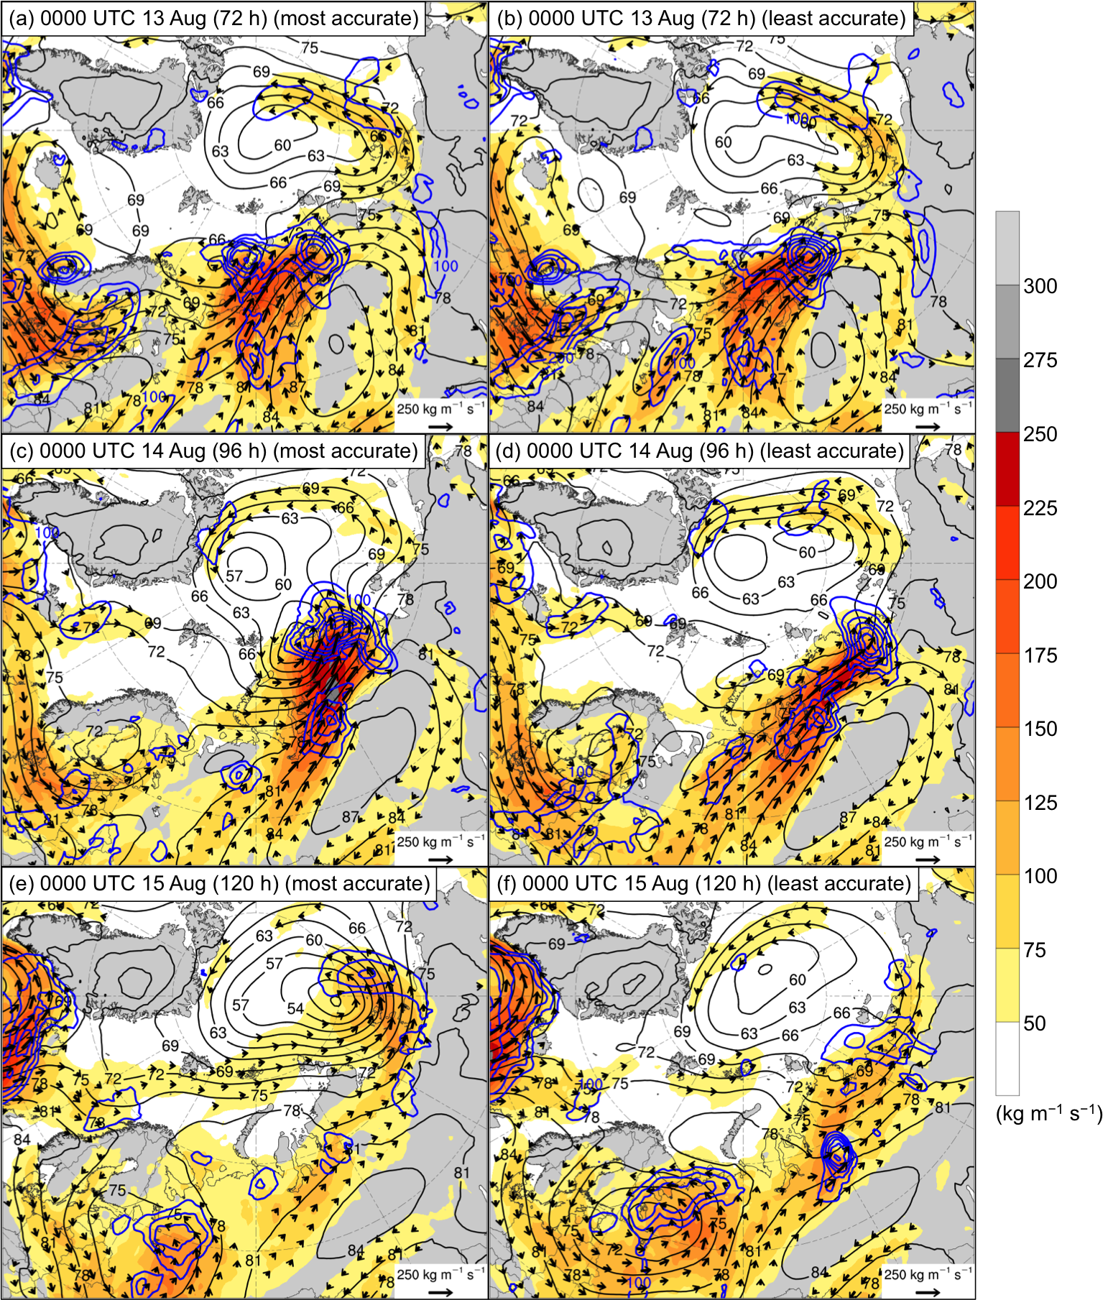

Fig. 4.14. As in Fig. 4.12, but for 1000–850-hPa IVT (kg m⁻¹ s⁻¹; shading and vectors), positive values of 1000–850-hPa IMFC area averaged within 200 km of each grid point (every 100 W m⁻²; blue contours), and 925-hPa geopotential height (dam; black contours).

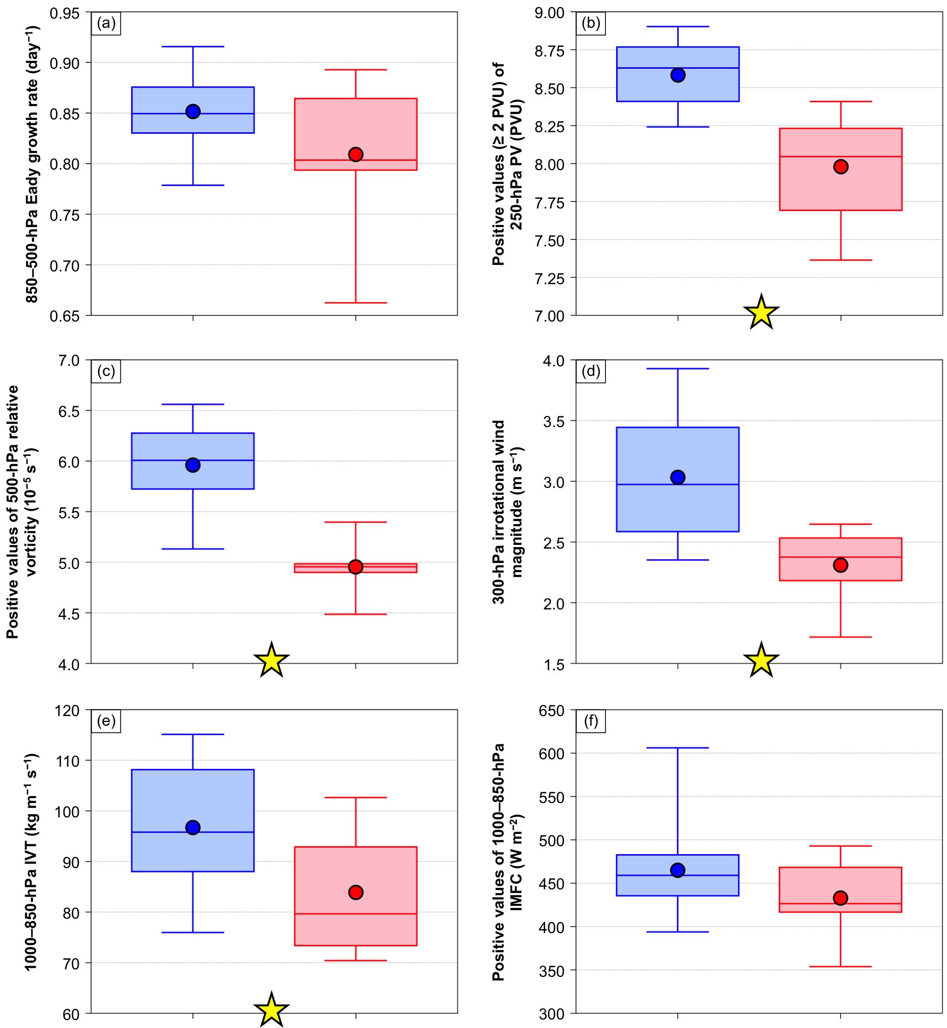

Fig. 4.15. Distributions of (a) area-averaged 850–500-hPa Eady growth rate (day⁻¹), (b) area-averaged positive values (≥ 2 PVU) of 250-hPa PV (PVU), (c) area-averaged positive values of 500-hPa relative vorticity (10⁻⁵ s⁻¹), (d) area-averaged 300-hPa irrotational wind magnitude (m s⁻¹), (e) area-averaged 1000–850-hPa IVT (kg m⁻¹ s⁻¹), and (f) area-averaged positive values of 1000–850-hPa IMFC (W m⁻²) for the most-accurate ensemble forecasts (blue) and the least-accurate ensemble forecasts (red). The quantities in (a)–(f) are area-averaged within a 1000-km radius from the center of AC16 for the aforementioned ensemble forecasts. Dots indicate the mean values, boxes indicate the IQR, and whiskers extend to the minimum and maximum values. Yellow stars indicate statistical significance at the 95% confidence level between the mean values of the quantities for the most-accurate ensemble members and the mean values of the quantities for the least-accurate ensemble members.

