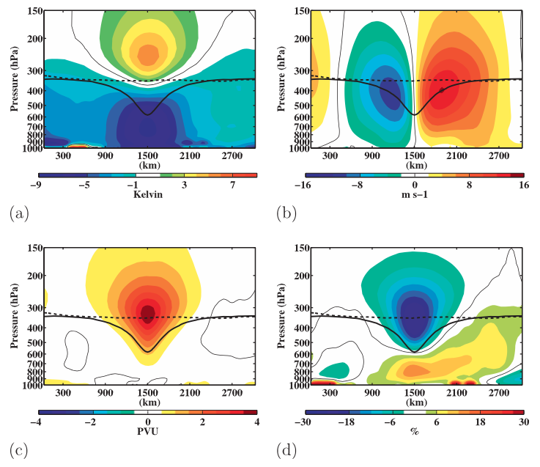

Fig. 1. Composite west-to-east cross sections of TPVs of anomalous (a) temperature (K), (b) v-wind component (m s⁻¹), (c) Ertel PV (PVU), and (d) relative humidity (%). Thick solid black contour is the composite tropopause, thick dashed black contour is a background tropopause, and thin solid contour is the 0 contour. [Figure 9 and adapted caption from Cavallo and Hakim (2010).]

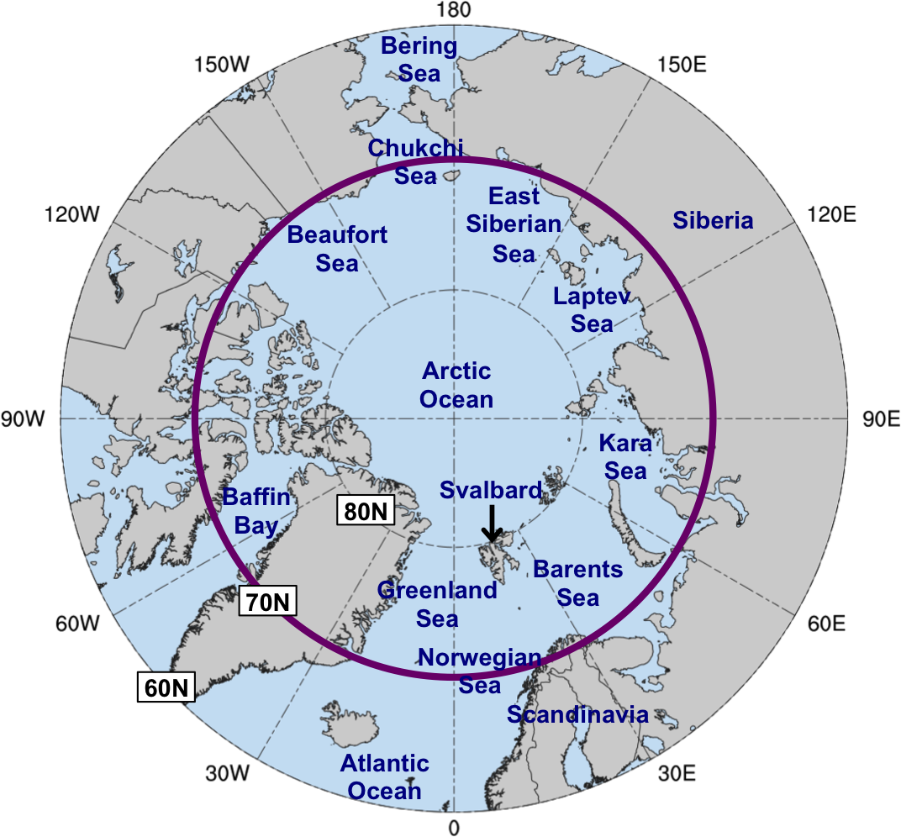
Fig. 2. Map of Arctic geography, including names of seas and nations discussed in this prospectus. Anywhere north of the purple circle (70°N) denotes the Arctic for the purposes of identifying Arctic cyclones and for calculating Arctic forecast skill, as discussed in section 2.2.1. The entire map (60–90°N) pertains to the domain to calculate area-averaged σ_{V500} and to identify blocks, as discussed in section 2.2.1.

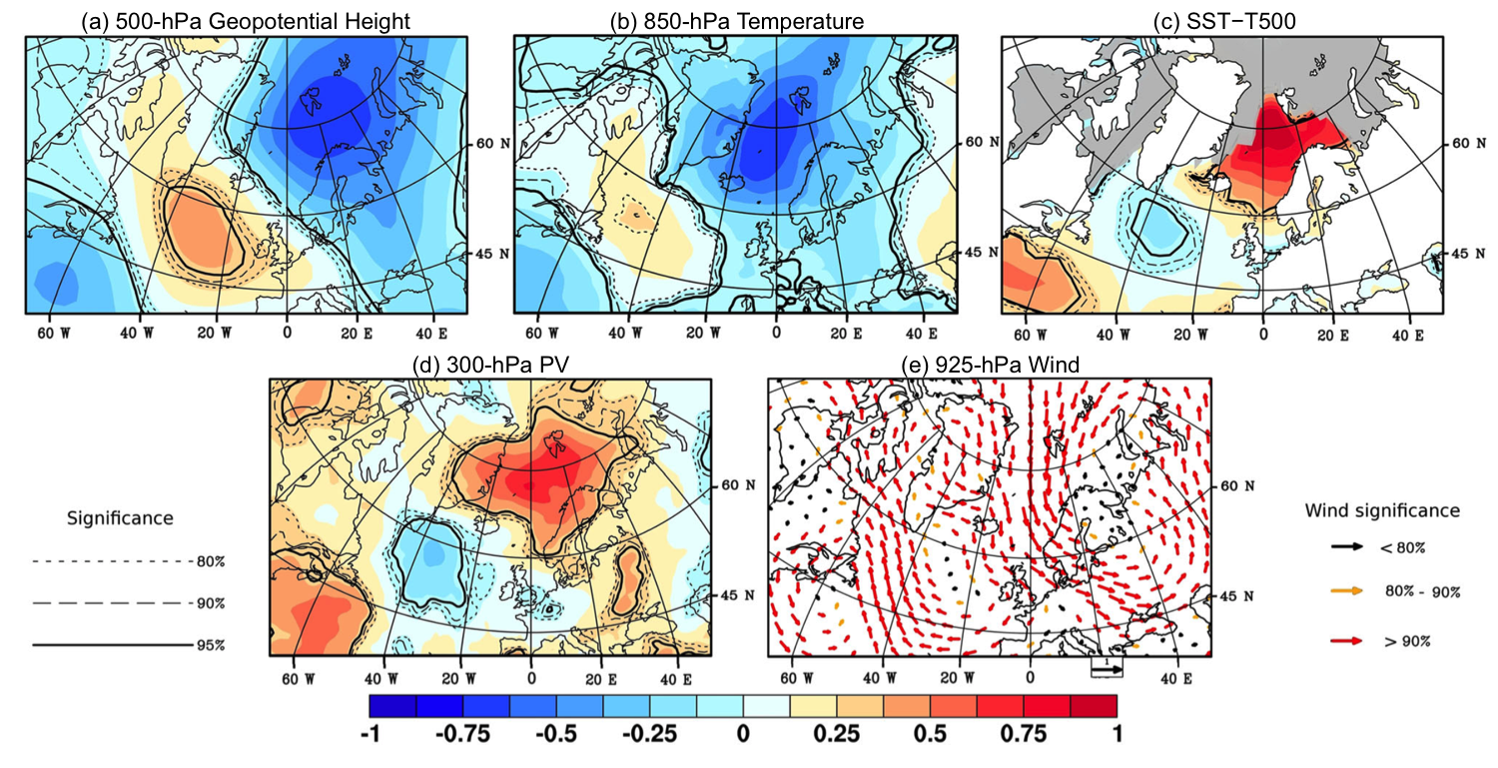
Fig. 3. Composite standardized anomalies of (a) 500-hPa geopotential height, (b) 850-hPa temperature, (c) SST−T500, (d) 300-hPa PV, and (e) 925-hPa wind for the date of formation of 134 polar lows from Noer et al. (2011) occurring during the months of October–March during 1999–2011. Gray areas correspond to maximal monthly sea ice extent during 1979–2007. The significance levels are indicated by solid and dotted lines for (a)–(d) and the color of the arrows for (e). Data source: ERA-Interim. [Figure 2 and caption adapted from Mallet et al. (2013).]

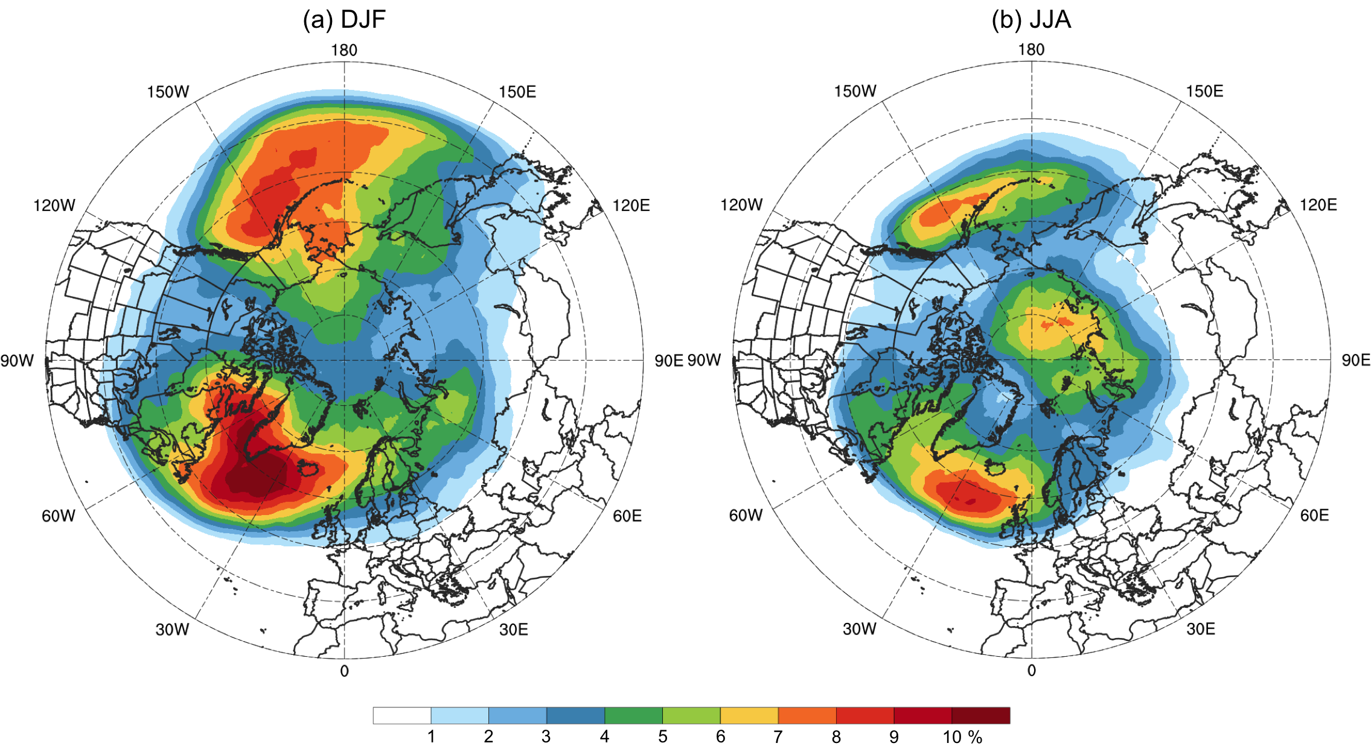

Fig. 4. Average percentage of 6-h time steps that a block is located at a grid point during (a) December–February (DJF) and (b) June–August (JJA) of 1979–2014 in the ERA-Interim. Data to create images obtained from: Institute for Atmospheric and Climate Science–ETH Zürich (2015).

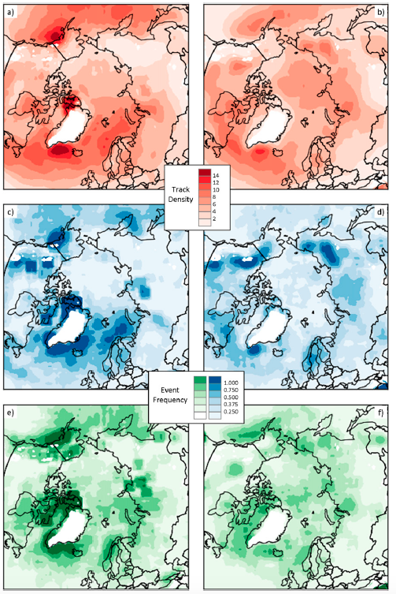

Fig. 5. Frequency of (a),(b) cyclone tracks, (c),(d) cyclogenesis events, and (e),(f) cyclolysis events for (a),(c),(e) winter (DJF) and (b),(d),(f) summer (JJA), averaged for the period 1979–2014. Units are the number of tracks or events per 500 km² area per month. [Figure 3 from Crawford and Serreze (2016).]
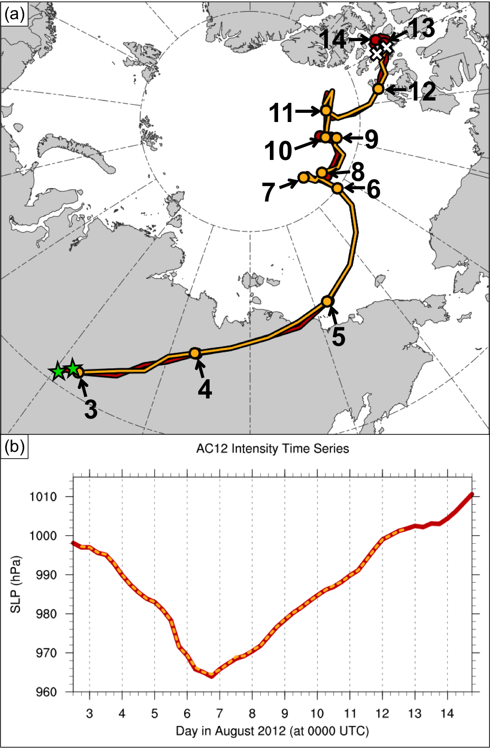

Fig. 6. (a) Track of AC12, as represented by the track of its associated SLP minimum, and (b) intensity of AC12, as represented by the value of its associated SLP minimum (hPa), every 6 h for manual tracking with ERA-Interim at 0.5° horizontal resolution (red) and objective tracking from Sprenger et al. (2017) with ERA-Interim at 1° horizontal resolution (gold). In (a), stars denote locations of genesis, crosses denote locations of lysis, dots represent 0000 UTC positions of AC12, every 24 h, and numbers pointing toward dots represent day in August 2012 corresponding to the 0000 UTC positions.
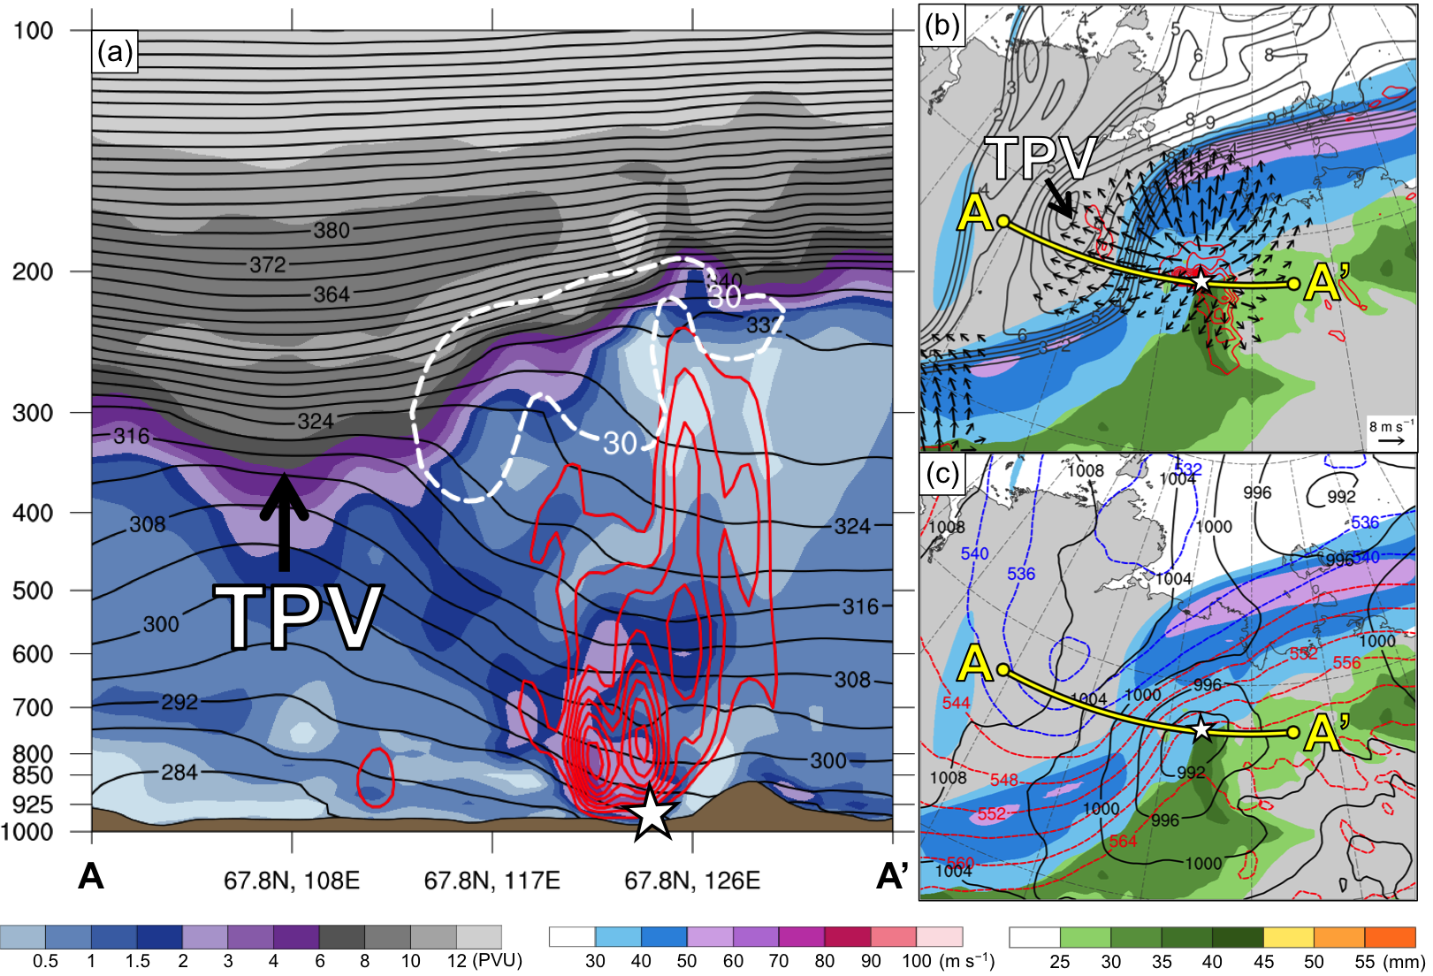

Fig. 7. (a) Cross section along line AA’ of PV (PVU, shading), potential temperature (K, black), ascent (red contours every 5 × 10⁻³ hPa s⁻¹), and wind speed (dashed white contour of 30 m s⁻¹); (b) 350–250-hPa layer-averaged PV (PVU, gray) and irrotational wind (m s⁻¹, vectors), 300-hPa wind speed (m s⁻¹, shading), 800–600-hPa layer-averaged ascent (red contours every 5 × 10⁻³ hPa s⁻¹), and precipitable water (mm, shading); and (c) 300-hPa wind speed (m s⁻¹, shading), 1000–500-hPa thickness (dashed red and blue contours every 4 dam, contoured red for values >540 dam and blue otherwise), SLP (black contours every 4 hPa), and precipitable water (mm, shading). Yellow line in (b) and (c) represents transect of cross section AA’. Arrows and label “TPV” point to location of TPV. White star denotes location of SLP minimum of AC12. Analysis is valid for 2100 UTC 3 August 2012. Data source: ERA5.

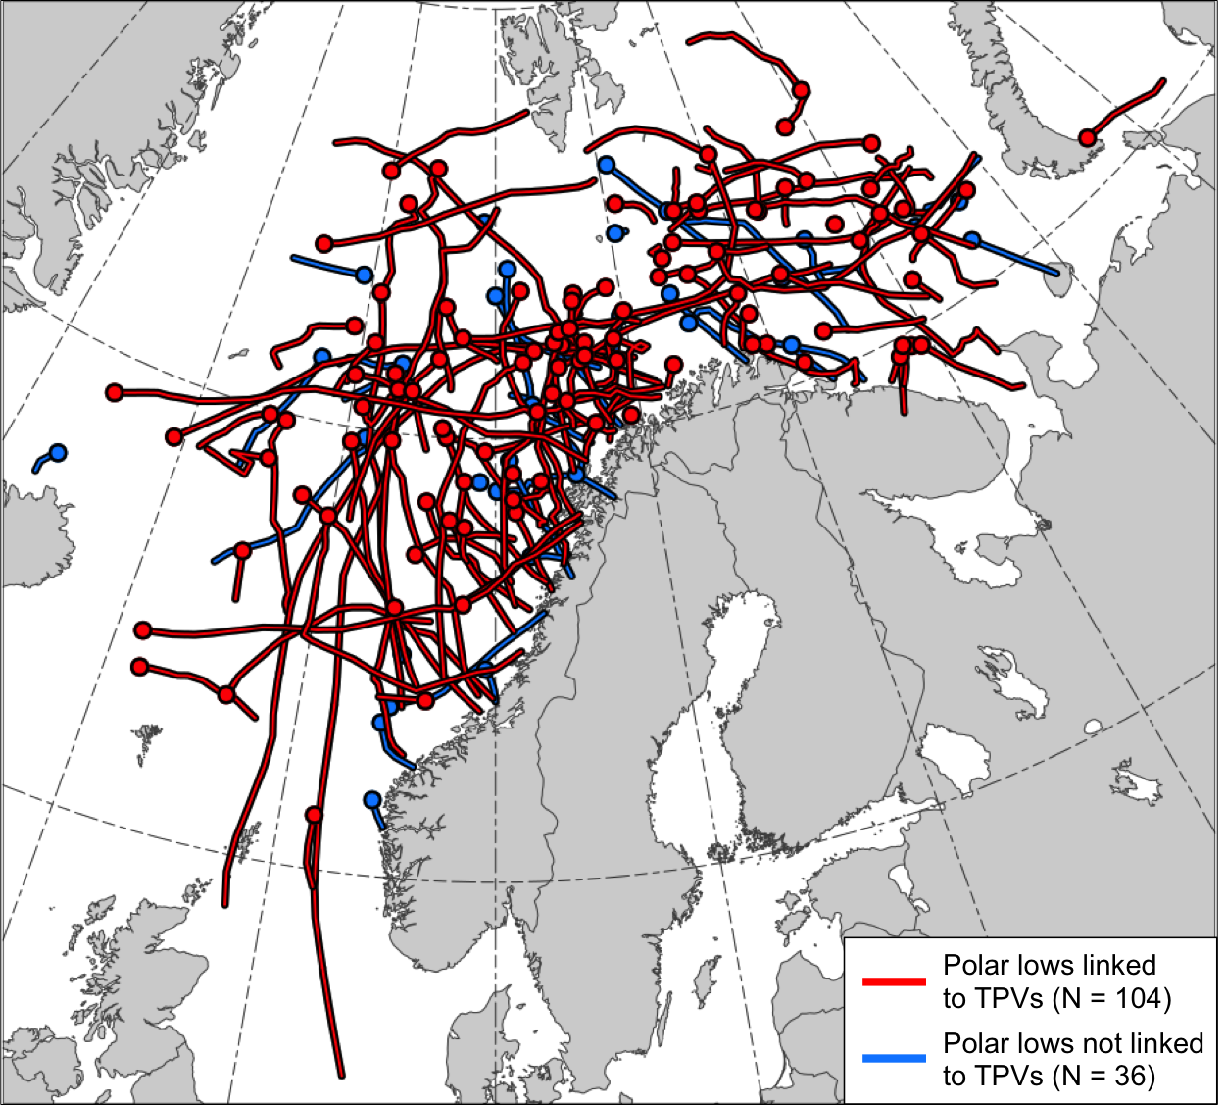

Fig. 8. Tracks of the polar lows in the STARS database. Tracks of polar lows that are linked to TPVs are shown in red and tracks of polar lows that are not linked to TPVs are shown in blue. Dots indicate the genesis locations of the polar lows.

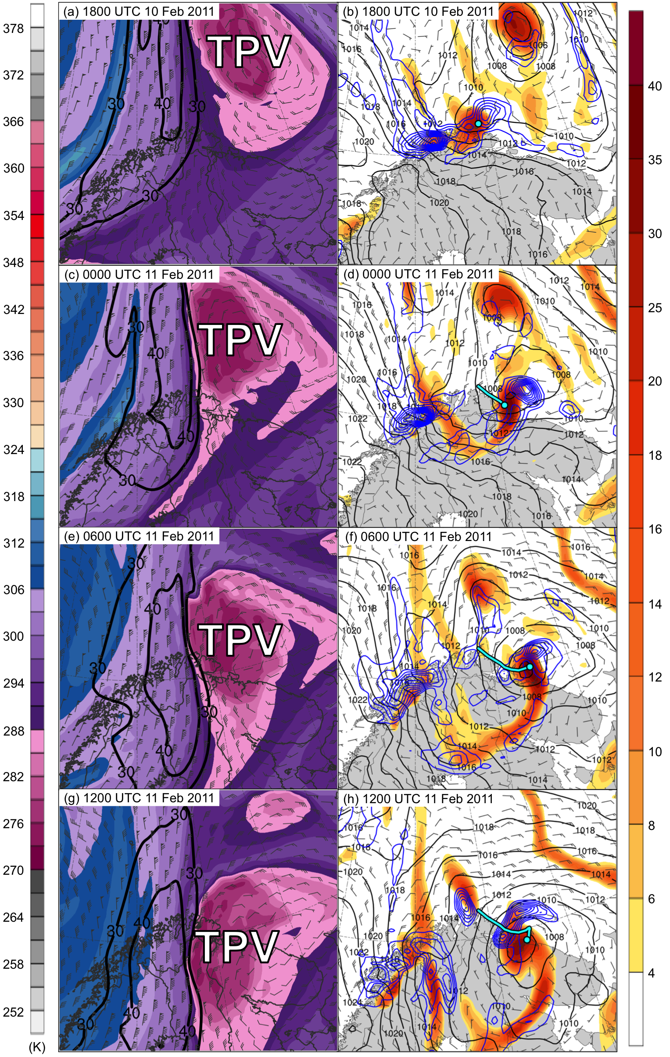
Fig. 9. DT (2-PVU surface) potential temperature (K, shaded), wind speed (black contours every 10 m s⁻¹, beginning at 30 m s⁻¹), and wind (m s⁻¹, flags and barbs) at (a) 1800 UTC 10 February, (c) 0000 UTC 11 February, (e) 0600 UTC 11 February, and (g) 1200 UTC 11 February 2011; 850-hPa relative vorticity (10⁻⁵ s⁻¹, shaded), 850–600-hPa layer-averaged ascent (blue contours every 2.5 × 10⁻³ hPa s⁻¹), SLP (black contours every 2 hPa), and 10-m wind (m s⁻¹, barbs) at (b) 1800 UTC 10 February, (d) 0000 UTC 11 February, (f) 0600 UTC 11 February, and (h) 1200 UTC 11 February 2011. Cyan line and dot represent track and position of polar low, respectively, according to STARS database. Label “TPV” denotes the position of the TPV.

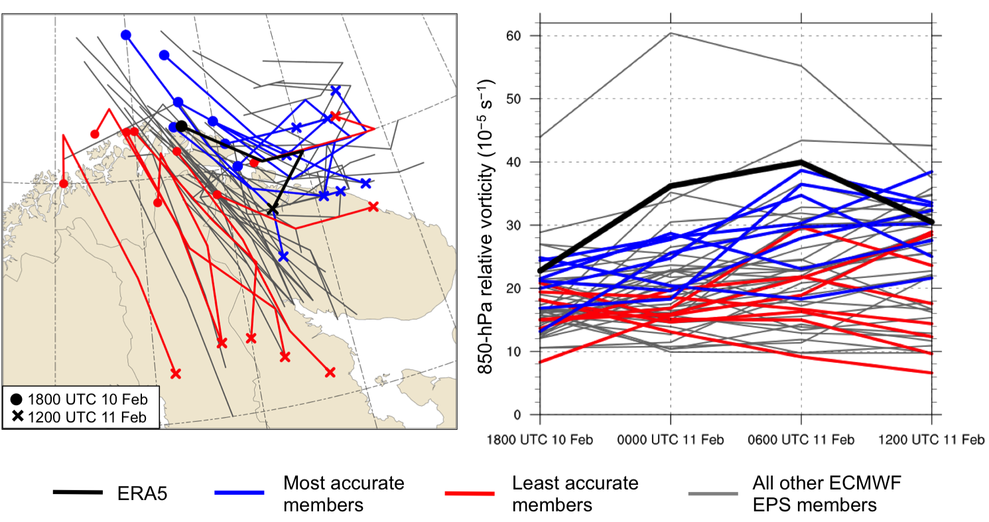

Fig. 10. (a) Track of the polar low, as represented by the track of its associated 850-hPa relative vorticity maximum, and (b) intensity of the polar low, as represented by the value of its associated 850-hPa relative vorticity maximum (10⁻⁵ s⁻¹), every 6 h during 1800 UTC 10 February–1200 UTC 11 February 2011 for ERA5 (black), ensemble members in the most accurate group (blue), ensemble members in least accurate group (red), and for all other ensemble members (gray). Dots and crosses in (a) represent position of polar low at 1800 UTC 10 February and 1200 UTC 11 February 2011, respectively, for ERA5 and ensemble members in most and least accurate group.

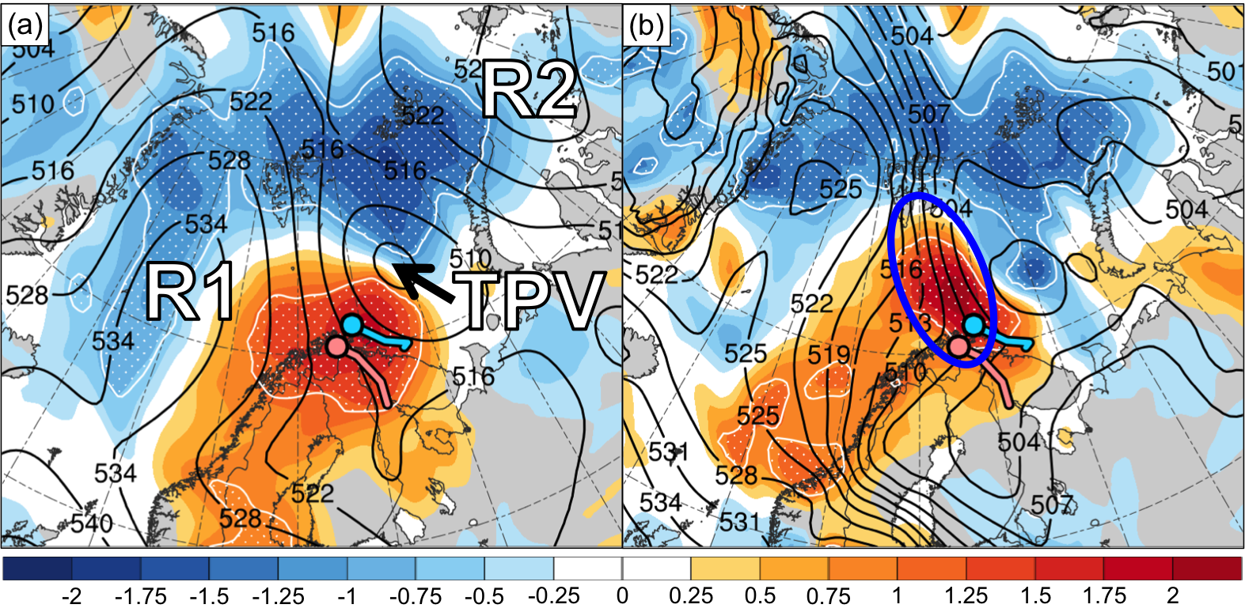

Fig. 11. Normalized composite difference between the most accurate and least accurate group (most accurate minus least accurate; shading; units: standardized anomaly) and ensemble mean (black contours) of (a) 500-hPa geopotential height (dam) and (b) 1000–500-hPa thickness (dam) at 1800 UTC 10 February 2011 (30 h forecast). White stippling indicates where there is a statistically significant difference at the 95% confidence level between the mean of the most accurate group and mean of the least accurate group for each quantity according to a two-sided Student’s t test. Blue and pink dot represent mean position of polar low in most accurate and least accurate group, respectively, at 1800 UTC 10 February 2011, and blue and pink line represent mean track of polar low in most accurate and least accurate group, respectively, during 1800 UTC 10–1200 UTC 11 February 2011. Labels “TPV”, “R1”, and “R2” in (a) represent the ensemble mean position of the TPV, R1, and R2, respectively. The blue-circled region in (b) indicates the ensemble mean position of the tropospheric-deep baroclinic zone.

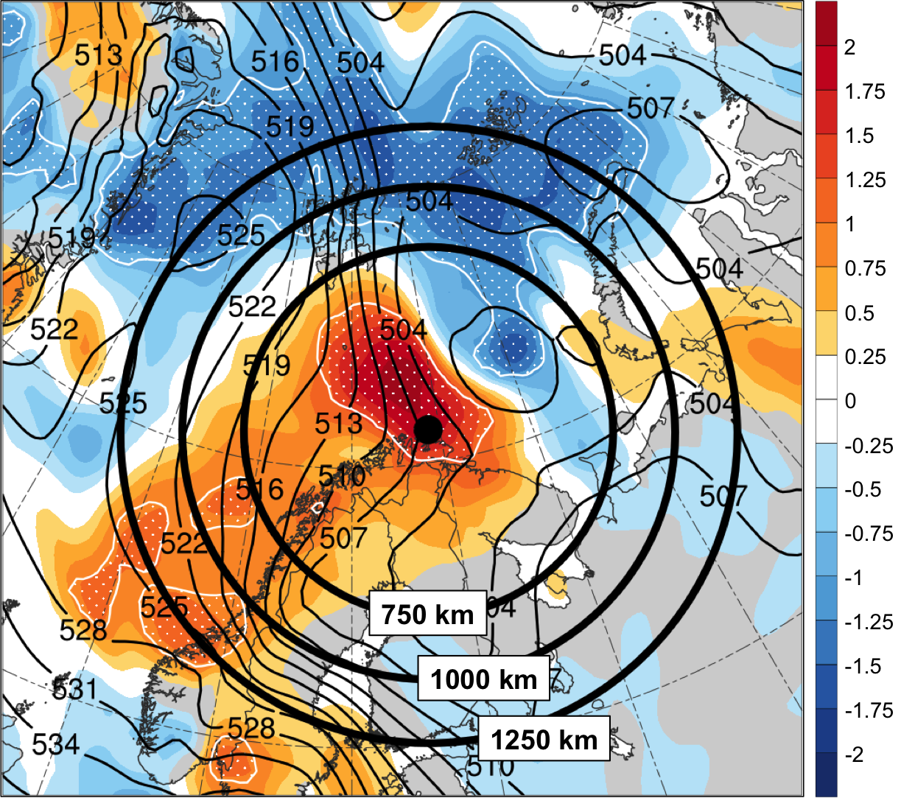

Fig. 12. Shading, contours, and stippling are same as in Fig. 11b for 1800 UTC 10 February 2011. Black dot represents genesis position of polar low at 1800 UTC 10 February 2011 according to the STARS database. Black circles show circular domains of radii 750, 1000, and 1250 km extending from the genesis position of the polar low to calculate the area-averaged standardized anomaly of ensemble spread of 1000–500-hPa thickness, as discussed in section 2.1.3.

