Improving Understanding and Predictability of Polar Lows and Arctic Cyclones that are linked to Tropopause Polar Vortices

Ph.D. Dissertation Prospectus

Kevin A. Biernat
Department of Atmospheric and Environmental Sciences
University at Albany, State University of New York

1. Introduction
1.1 Motivation and purpose
Polar lows and Arctic cyclones are common surface cyclones in the high latitudes. Strong surface winds, large waves, and heavy precipitation that may be associated with polar lows (e.g., Shapiro et al. 1987a; Businger and Reed 1989; Rasmussen and Turner 2003) and Arctic cyclones (e.g., Parkinson and Comiso 2013; Zhang et al. 2013) may pose hazards to shipping, infrastructure, and coastal communities. In addition, strong surface winds and poleward advection of warm, moist air associated with Arctic cyclones may contribute to reductions in Arctic sea-ice extent (e.g., Zhang et al. 2013; Binder et al. 2017; Cavallo et al. 2017). Tropopause polar vortices (TPVs), which are coherent tropopause-based vortices that are common in the high latitudes (e.g., Cavallo and Hakim 2009, 2010, 2012, 2013), may play important roles in the evolution of polar lows (e.g., Bracegirdle and Gray 2009; Kolstad 2011) and Arctic cyclones (e.g., Simmonds and Rudeva 2012; Tao et al. 2017a,b). As the Arctic becomes increasingly ice-free and used for shipping and tourism (e.g., Jung et al. 2016), it becomes critical to better understand and forecast polar lows and Arctic cyclones that are linked to TPVs. There have been predictability studies that have shown that forecast skill over the Arctic may be worse than in the middle latitudes (e.g., Sandu and Bauer 2018), and that some polar lows (e.g., Kristjánsson et al. 2011) and Arctic cyclones (e.g., Yamagami et al. 2018a) may be associated with especially low forecast skill. Still, predictability studies of polar lows and Arctic cyclones are lacking in the literature.
The primary goals of this Ph.D. dissertation are to improve understanding of polar lows and Arctic cyclones that are linked to TPVs and factors limiting the forecast skill of polar lows and Arctic cyclones that are linked to TPVs. Specifically, polar lows that are linked to TPVs and associated with low forecast skill will be identified, and factors limiting the forecast skill of these polar lows will be examined. Periods of low and high Arctic forecast skill will be identified, and the characteristics of Arctic cyclones occurring during these periods will be compared. The forecast skill of Arctic cyclones occurring during periods of low Arctic forecast skill will be determined, and the forecast skill of those Arctic cyclones that are linked to TPVs will be compared to the forecast skill of those Arctic cyclones that are not. For those Arctic cyclones linked to TPVs and associated with low forecast skill, factors limiting the forecast skill of these Arctic cyclones and concomitantly limiting Arctic forecast skill will be examined.

1.2. Literature review
1.2.1 TPVs
TPVs are subsynoptic and mesoscale coherent tropopause-based vortices, characterized by a local minimum of potential temperature on the dynamic tropopause (DT) and a local maximum of pressure on the DT (e.g., Pyle et al. 2004; Hakim and Canavan 2005; Cavallo and Hakim 2009, 2010). Cavallo and Hakim (2010) created composite west-to-east cross sections of TPVs, showing a downward displacement of the DT at the location of the TPV (Figs. 1a–d), anomalously cold air located within the TPV and throughout the depth of the troposphere beneath the TPV (Fig. 1a), anomalously cyclonic flow located around the TPV (Fig. 1b), and anomalously positive potential vorticity (PV) located within and above the TPV (Fig. 1c). Furthermore, anomalously dry air within and above the TPV associated with stratospheric air is located above anomalously moist air beneath the TPV (Fig. 1d). Cavallo and Hakim (2013) show that longwave radiative cooling associated with large-magnitude vertical gradients in water vapor content near the tropopause implied by Fig. 1d is important for TPV maintenance and intensification, and may allow TPVs to live from days to months (e.g., Hakim and Canavan 2005; Cavallo and Hakim 2012).
TPVs may play an important role in the development of polar lows and Arctic cyclones, especially given that climatologies of TPVs from Cavallo et al. (2012) show that TPVs are prevalent features in the high latitudes. Hoskins et al. (1985, section 6e) illustrated the dynamical importance of upper-level cyclonic PV anomalies, which may include TPVs, on surface cyclone development, showing that the approach of an upper-level cyclonic PV anomaly over a lower-level baroclinic zone may lead to the development of a surface cyclone. TPVs may also interact with the jet stream and lead to the formation and intensification of jet streaks (e.g., Pyle et al. 2004), which may support the development and intensification of surface cyclones (e.g. Uccellini and Kocin 1987). TPVs may also be associated with cold air outbreaks (CAOs; e.g., Shapiro et al. 1987b; Biernat 2017), given that TPVs may be associated with cold air throughout the depth of the troposphere (Fig. 1a). The role of TPVs and associated CAOs on the development of polar lows and Arctic cyclones will be considered in the next two sections of this literature review.

1.2.2 Polar Lows
Although the precise definition of polar lows has varied, polar lows may be considered mesoscale maritime cyclones with horizontal scales of 10s to 100s of km that often form within a cold air mass or along an Arctic front at the leading edge of a cold air mass moving over relatively warmer sea surfaces in high latitudes (e.g., Businger and Reed 1989; Rasmussen and Turner 2003). Furthermore, polar lows are often characterized by short lifetimes, rapid evolution, and strong surface winds (e.g., Smirnova et al. 2015). A recent global climatological study of polar lows by Stoll et al. (2018) based on the ERA-Interim (Dee et al. 2011) during 1979–2016 and Arctic System Reanalysis version 1 (Bromwich et al. 2010, 2016) during 2000–2012 illustrates that polar lows occur in all high-latitude marine basins. The Norwegian and Barents Seas (Fig. 2) is shown by Stoll et al. (2018) to be a region of particularly high density of polar lows and this region has been a focus of many polar low studies (e.g., Wilhelmsen 1985; Businger 1985; Ese et al. 1988; Noer et al. 2011; Mallet et al. 2013; Zappa et al. 2014; Terpstra et al. 2016). In the Norwegian and Barents Seas, many favorable ingredients for polar low development can come together. These favorable ingredients for polar low development will be discussed in the context of Fig. 2 from Mallet et al. (2013; Fig. 3 here), which shows composite standardized anomalies of several variables from the ERA-Interim on the date of formation of 134 polar lows occurring over the Norwegian and Barents Seas during 1999–2011.
Statistically significant negative 500-hPa geopotential height anomalies (Fig. 3a) and statistically significant negative 850-hPa temperature anomalies (Fig. 3b) over the Norwegian and Barents Seas are suggestive of a CAO occurring in conjunction with a cold upper-level trough, which may partly be a manifestation of TPVs associated with CAOs, over the relatively warm sea surfaces in this region (Fig. 3c). CAOs occurring over relatively warm sea surfaces in combination with strong surface winds may lead to large surface sensible and latent heat fluxes and a reduction of lower-to-midtropospheric stability, as suggested by the statistically significant positive anomalies of temperature difference between the sea surface and 500 hPa (SST–T500; Fig. 3c), providing a favorable thermodynamic environment for polar low development (e.g., Reed 1979; Emanuel and Rotunno 1989; Kolstad 2011). In addition, the anomalous northerly flow from the Arctic sea ice to the open waters of the Norwegian and Barents Seas as implied by Fig. 3e may support strong low-level baroclinicity, as shown in Businger (1985). Baroclinicity has been shown to be an important ingredient for the development of polar lows (e.g., Harrold and Browning 1969; Reed 1979; Yanase and Niino 2007). Baroclinic zones, including those associated with Arctic fronts at the leading edge of CAOs, may be associated with relatively strong low-level cyclonic relative vorticity and convergence, which may support the development of polar lows (e.g., Shapiro et al. 1987a; Shapiro and Fedor 1989).
Figure 3d shows statistically significant positive anomalies of 300-hPa PV situated where the CAO may be occurring, suggesting that upper-level cyclonic PV anomalies, which may include TPVs associated with CAOs, play an important role in the development of polar lows. Upper-level cyclonic PV anomalies may provide upper-level forcing for ascent over the polar low (e.g., Bracegirdle and Gray 2009), may become vertically coupled with polar lows (e.g., Føre et al. 2011; Sergeev et al. 2018), and, along with associated CAOs, may destabilize the lower troposphere (e.g., Mallet et al. 2013), allowing polar lows to develop and strengthen. The combination of upper-level forcing associated with TPVs, reductions of lower-to-midtropospheric static stability that may occur in response to TPVs and associated CAOs occurring over relatively warm waters, surface heat fluxes, and low-level convergence at baroclinic zones along the leading edge of these CAOs may support strong lower-to-midtropospheric ascent and precipitation. The resulting latent heat release may further contribute to polar low development by, for example, leading to low-level PV production and intensification of the polar low (e.g. Montgomery and Farrell 1992).
The predictive skill of polar lows may be limited due to their mesoscale horizontal dimensions, relatively short lifetimes, and rapid evolution. Short-term forecasts from operational models, including high-resolution models, sometimes exhibit large forecast errors for polar lows (e.g., Kristjánsson et al. 2011). However, there have only been a limited number of predictability studies of polar lows (e.g., Aspelien et al. 2011; Kristiansen et al. 2011). For example, Kristiansen et al. (2011) examine short-range forecasts of a polar low from ensemble prediction systems (EPSs) for a limited-area high-resolution model for different domain sizes centered over the Norwegian Sea, finding forecast differences amongst ensembles members of the EPSs in polar low position that may be related to forecast differences in the position of a nearby synoptic cyclone. However, this study does not go into a detailed discussion of processes involved in polar low development in these forecasts. Given the multitude of factors that may influence the evolution of polar lows (e.g., TPVs and associated CAOs, and baroclinic zones), forecast errors for these different factors should be investigated for a variety of cases to determine the degree to which these forecast errors limit the forecast skill of polar lows.

1.2.3 Arctic Cyclones
Arctic cyclones are synoptic-scale cyclones over the Arctic that may be associated with intrusions of warm, moist air into the Arctic, which may contribute to Arctic warming (e.g., Messori et al. 2018) and to Arctic sea-ice reduction (e.g., Binder et al. 2017). As shown by Woods and Caballero (2016), intrusions of warm, moist air into the Arctic can lead to increased downward longwave radiation associated with the increased moisture content and associated clouds, which can lead to surface warming and sea-ice melt. High-latitude blocking, which is often manifested as longitudinally confined, high-amplitude ridges, can further facilitate intrusions of warm, moist air into the Arctic (e.g., Woods et al. 2013;Yang and Magnusdottir 2017). High-latitude blocking may be found to varying degrees over regions such as the northern North Atlantic, Greenland, northern Europe and Russia, the Gulf of Alaska, and the Arctic during the winter (Fig. 4a) and summer (Fig. 4b) (Institute for Atmospheric and Climate Science–ETH Zürich 2015; Sprenger et al. 2017). As an example, Binder et al. (2017) show that during late December 2015 and early January 2016, warm, moist air from as far equatorward as the subtropics was transported poleward between a series of cyclones moving northward from the Atlantic toward the Arctic and a blocking anticyclone over Scandinavia. This event led to maximum 2-m temperatures greater than 0°C north of 82°N around Svalbard and the Kara Sea, and more than 30 cm of sea ice thinning in the Barents and Kara Seas (Binder et al. 2017).
There are seasonal differences in preferred regions of Arctic cyclones. Crawford and Serreze (2016) show that during the winter, there are more Arctic cyclones originating from the North Atlantic and Norwegian and Barents Seas, as shown by the relatively high track (Fig. 5a) and genesis (Fig. 5c) density of cyclones in these regions, compared to other regions. These Arctic cyclones are generally related to dynamical support associated with the North Atlantic storm track in the winter (e.g., Serreze 1995). However, during the summer, more Arctic cyclones originate over Eurasia, as shown by the relatively high track (Fig. 5b) and genesis (Fig. 5d) density of cyclones in this region, compared to other regions. Cyclogenesis over Eurasia during summer may be linked in part to a reduction in static stability associated with turbulent and radiative heat fluxes from the heated landmass, as well as lee cyclogenesis downstream of mountain ranges over northern Eurasia (Crawford and Serreze 2016). Low-level baroclinic zones in the vicinity of sea ice margins and along a band of strong horizontal temperature gradient along the Arctic coastline of Eurasia, referred to as the Arctic frontal zone (e.g., Crawford and Serreze 2015), may be enhanced during the summer and may contribute to the intensification of Arctic cyclones moving into the Arctic from Eurasia (e.g., Crawford and Serreze 2016). The Great Arctic Cyclone of August 2012 (AC12; Simmonds and Rudeva 2012) is a notably intense Arctic cyclone that originated over Eurasia (see track and intensity in Figs. 6a and 6b, respectively). AC12 led to a rapid and widespread loss of sea ice due to strong surface winds and wave action on the margins of the sea ice field that moved around sea ice and led to upward ocean heat transport that melted sea ice (e.g., Parkinson and Comiso 2013; Zhang et al. 2013). In both winter and summer, ~35–40% of Arctic cyclones originate over the Arctic, with Arctic cyclones often decaying over the Arctic, as suggested by Figs. 5e,f.
TPVs, baroclinic processes, and latent heating may play important roles in the evolution of Arctic cyclones. Strong Arctic cyclones (e.g., Simmonds and Rudeva 2014) and Arctic cyclones linked to extreme sea-ice loss events (e.g., Cavallo et al. 2017) have been shown to be frequently associated with TPVs. Simmonds and Rudeva (2012), Yamazaki et al. (2015), and Tao et al. (2017b) illustrate that a TPV and baroclinic instability play an important role in the evolution of AC12. Latent heat release that may accompany intrusions of warm, moist air associated with Arctic cyclones may contribute to low-level PV production, which has been shown to contribute to the intensification of cyclones (e.g., Reed et al. 1992; Wernli et al. 2002). For example, latent heating related to relatively strong lower-to-midtropospheric ascent in the presence of warm, moist air likely contributes to the development of a PV tower associated with AC12 (Figs. 7a,b) and concomitant intensification of AC12 at 2100 UTC 3 August 2012 (Fig. 6b). At this time, AC12 is located downstream of a TPV (Figs. 7a,b), in a region of strong tropospheric-deep baroclinicity (Fig. 7c). Coincident with this region of tropospheric-deep baroclinicity is a dual upper-level jet structure, with jet coupling over AC12 (Fig. 7c). Forcing for ascent associated with the TPV and the jet coupling likely support the relatively strong lower-to-midtropospheric ascent and implied latent heating. In addition, upper-level divergent outflow associated with the latent heating contributes to negative PV advection to the north of AC12 (Fig. 7b), which likely strengthens the jet streak to the north of AC12 and supports ridge amplification downstream of AC12 (not shown). Tao et al. (2017b) show that the TPV and AC12 later become vertically coupled, allowing AC12 to live for an extended period of time.
As for polar lows, there have only been a limited number of predictability studies of Arctic cyclones in the literature. For example, Yamagami et al. (2018a) examine the medium range forecast skill of AC12 and Yamagami et al. (2018b) examine and compare the medium range forecast skill of 10 strong Arctic cyclones occurring during the summers of 2008–2016 with five operational EPSs. Yamagami et al. (2018a) find that AC12 has low predictability, with accurate forecasts of AC12 only out to 2–3 d lead time prior to the peak intensity of AC12. Yamagami et al. (2018a) also find that a more accurate prediction of upper-level features, which may include TPVs, in the vicinity of AC12 results in a more accurate prediction of AC12, which suggests that the forecast skill of TPVs and other upper-level features may play an important role in the forecast skill of Arctic cyclones. Yamagami et al. (2018b) show that the forecast skill of the strong Arctic cyclones they examine is lower than that of midlatitude cyclones in the Northern Hemisphere.
Since forecast skill in the Arctic may be lower than in the middle latitudes (e.g., Sandu and Bauer 2018), and Arctic cyclones may be associated with low forecast skill, it may be anticipated that low forecast skill in the Arctic is related to these Arctic cyclones and their associated low forecast skill. Forecast errors in a variety of factors (e.g., TPVs, baroclinic zones, and latent heat release) may limit the forecast skill of Arctic cyclones and the resulting forecast skill of the Arctic, and should be investigated for a variety of cases. For example, forecast errors in latent heating have been shown to contribute to forecast errors in extratropical cyclones (e.g., Zhang et al. 2003), with forecast errors in latent heating related to areas of convection (e.g., Rodwell et al. 2013) and warm conveyor belts (e.g., Madonna et al. 2015) contributing to forecast errors in the downstream synoptic-scale flow. Such forecast errors in latent heating, along with forecast errors in TPVs, may especially limit the forecast skill of Arctic cyclones linked to TPVs and associated with intrusions of warm, moist air into the Arctic.

1.3. Research questions and hypotheses
This Ph.D. dissertation will attempt to answer the following research questions:
- What factors limit the forecast skill of low-skill polar lows linked to TPVs?
- How do the characteristic of Arctic cyclones differ between periods of low and high Arctic forecast skill?
- Do Arctic cyclones linked to TPVs exhibit any difference in forecast skill compared to Arctic cyclones not linked to TPVs during periods of low Arctic forecast skill?
- What factors limit the forecast skill of low-skill Arctic cyclones linked to TPVs and concomitantly limit Arctic forecast skill?

The remainder of this prospectus will address these research questions by motivating, and developing a research plan to test, the following hypotheses:
- Forecast errors in TPVs and associated CAOs, and baroclinic zones, which may be related to forecast errors in the synoptic-scale flow, especially limit the forecast skill of low-skill polar lows linked to TPVs.
- When compared to periods of high Arctic forecast skill, periods of low Arctic forecast skill are associated with
  - a greater number of Arctic cyclones;
  - stronger Arctic cyclones;
  - a greater number and higher percentage of Arctic cyclones originating from outside of the Arctic;
  - a greater number of Arctic cyclones occurring when the large-scale flow is more amplified and when there are more instances of atmospheric blocking;
  - a similar percentage of Arctic cyclones linked to TPVs.
- There is no significant difference in forecast skill between Arctic cyclones linked to TPVs and Arctic cyclones not linked to TPVs during periods of low Arctic forecast skill.
- Forecast errors in TPVs and baroclinic zones, which may be related to forecast errors in the synoptic-scale flow, especially limit the forecast skill of low-skill Arctic cyclones linked to TPVs and concomitantly limit Arctic forecast skill, with forecast errors in latent heating also limiting the forecast skill of Arctic cyclones linked to TPVs and associated with intrusions of warm, moist air into the Arctic.

2. Data and Methods
2.1 Polar Lows
2.1.1 Climatology of polar lows linked to TPVs
Polar lows that are linked to TPVs are first identified. Polar lows have been obtained from a database of polar lows in the Norwegian and Barents Seas called the Sea Surface Temperature and Altimeter Synergy for Improved Forecasting of Polar lows (STARS) database (Sætra et al. 2010; Noer et al. 2011). The STARS database has been utilized in a number of polar low studies (e.g., Noer et al. 2011; Zappa et al. 2014; Terpstra et al. 2016; Sergeev et al. 2018; Stoll et al. 2018). The STARS database covers the 2002–2011 period, for a total of 140 polar lows occurring during September–May. According to Noer et al. (2011), the polar lows in STARS were identified and tracked at the Norwegian Meteorological Institute hourly via manual inspection of satellite products and operational weather forecasts. The polar low database has been compared to a 1979–2015 TPV database constructed using the ERA-Interim and a TPV tracking algorithm (Szapiro and Cavallo 2018), which identifies and tracks TPVs as minima of DT potential temperature. In order to determine which polar lows are linked to TPVs, polar lows are required to be located within 500 km of at least one TPV at any point in the lifetime of the polar low. This 500-km distance threshold is utilized to ensure that the TPVs are located relatively close to the polar lows to potentially have an influence on the life cycle of the polar lows. By invoking this requirement, 104 out of a total 140 polar lows, or 74.3%, match with at least one TPV. Figure 8 shows the tracks of all polar lows, including those that are linked to TPVs. The polar lows are distributed throughout the Norwegian and Barents Seas, with a relatively high frequency of polar lows near Scandinavia.

2.1.2 Illustrative predictability study of a polar low linked to a TPV
To motivate hypothesis 1 concerning factors that may limit the forecast skill of polar lows linked to TPVs, an illustrative predictability study of a polar low linked to a TPV occurring during 1800 UTC 10–1200 UTC 11 February 2011 was performed. This case was analyzed using the ERA5 (Hersbach and Dee 2016), given its relatively high horizontal resolution (31 km) and high temporal resolution (1 h). Selection of this case was motivated by the polar low in this case exhibiting a clear linkage to a single well-defined TPV. Figures 9a–h show the evolution of the polar low and TPV. At 1800 UTC 10 February, the polar low, identified as a maximum of 850-hPa relative vorticity, is located downstream of the TPV and in the left exit region of a jet streak associated with a tropospheric-deep baroclinic zone (Figs. 9a,b). Over the next 12 h, as the TPV approaches and moves over the polar low, the polar low intensifies, and a concentrated region of relatively strong lower-to-midtropospheric ascent becomes established near the north side of the polar low (Figs. 9c–f). By 1200 UTC 11 February, the polar low weakens as it moves into Scandinavia along with the TPV (Figs. 9g,h). Although not shown, QG forcing for ascent linked to the interaction between the TPV and the tropospheric-deep baroclinic zone and reductions of lower-to-midtropospheric static stability associated with the movement of the TPV and an accompanying CAO over the Barents Sea likely support the relatively strong lower-to-midtropospheric ascent and the intensification of the polar low.
To evaluate the forecast skill associated with the polar low, the 51-member ECMWF EPS (Buizza et al. 2007) from TIGGE (Bougeault et al. 2010) was utilized, with the ERA5 used as the verification. Ensemble forecasts initialized at 1200 UTC 9 February 2011 (30 h prior to polar low genesis) were utilized because of a relatively large degree of spread in the forecast evolution of the polar low among these ensemble forecasts. Forecast skill of the polar low was assessed in terms of a metric combining forecast track and intensity error of the polar low based on 850-hPa relative vorticity. For brevity, the details of the calculation of track and intensity error will not be discussed here. The ensemble members were subdivided into two groups: the eight most accurate and eight least accurate ensemble members in terms of combined track and intensity error of the polar low. Figure 10a shows that the tracks of the polar low in the most accurate group are farther to the north and east of the tracks of the polar low in the least accurate group, closer to the track of the polar low in the ERA5. Figure 10b shows that the polar low tends to be stronger in the forecasts from the most accurate group, generally characterized by a larger maximum value of 850-hPa relative vorticity, closer to that of the polar low in the ERA5, than the polar low in the forecasts from the least accurate group.
Normalized composite differences were calculated between the two groups for selected quantities and various forecast lead times following Torn et al. (2015) and Lamberson et al. (2016) in order to determine what factors may contribute to the track and intensity differences of the polar low between the two groups. Normalized composite differences are defined as
$∆x_{i}= \frac{{{\overline{x}}_{i}}^{most accurate}- {{\overline{x}}_{i}}^{least accurate}}{σ_{x_{i}}}$ (1)
where ${{\overline{x}}_{i}}^{most accurate}$ and ${{\overline{x}}_{i}}^{least accurate}$ represent the means of the ith state variable for the ensemble members in the most accurate and least accurate groups, respectively, and $σ_{x_{i}}$ represents the standard deviation of $x_{i}$ computed from all ensemble members. Normalized composite differences of 500-hPa geopotential height at 1800 UTC 10 February 2011 show a dipole structure about the ensemble mean position of the TPV, with statistically significant negative and positive normalized composite differences in 500-hPa geopotential height to the north and south of the ensemble mean position of the TPV, respectively (Fig. 11a), suggesting that the TPV is located farther north in the most accurate group. Furthermore, there are statistically significant negative normalized composite differences of 500-hPa geopotential height within portions of ridges flanking the TPV (R1 and R2; Fig. 11a). These differences suggest that R1 and R2 may be less amplified in the most accurate group, which may allow the TPV to be located farther north in the most accurate group.
Normalized composite differences of 1000–500-hPa thickness (Fig. 11b) indicate that there are statistically significant higher and lower values of 1000–500-hPa thickness within and to the east, respectively, of the tropospheric-deep baroclinic zone extending from Svalbard to Scandinavia in the most accurate group compared to the least accurate group. These differences suggest that the baroclinic zone may be located farther to the east in the most accurate group compared to the least accurate group. The farther-north position of the TPV combined with the farther-east position of the baroclinic zone likely contributes to the mean polar low track being located farther to the north and east in the most accurate group (compare tracks in Figs. 11a,b). Since the mean polar low track is over the Barents Sea in the most accurate group, but mainly over Scandinavia in the least accurate group, the polar low is likely in a more conducive thermodynamic environment for development in the most accurate group, which may contribute to the intensity differences of the polar low between the two groups.

2.1.3 Identifying low-skill polar lows linked to TPVs
The aforementioned predictability study suggests that forecast errors in the synoptic-scale flow may contribute to forecast errors in the position and structure of TPVs and baroclinic zones, which may contribute to forecast errors in the track and intensity of polar lows, supporting hypothesis 1. Forecast errors in TPVs and associated CAOs, and baroclinic zones, may be associated with forecast errors in dynamical and thermodynamic processes related to these features that impact polar lows, such as baroclinic instability and surface sensible and latent heating. In order to further address hypothesis 1, factors limiting the forecast skill of a variety of polar lows linked to TPVs that may be associated with low forecast skill will be examined. In order to elucidate which polar lows linked to TPVs may be associated with low forecast skill, the forecast skill of the synoptic-scale environment surrounding the polar low will be evaluated. The dataset that will be utilized is version 2 of the NOAA Global Ensemble Forecasting System (GEFS) reforecast dataset (Hamill et al. 2013), which includes forecasts from an 11-member ensemble initialized once daily (0000 UTC) during December 1984–present. Forecast fields are available at 1° horizontal resolution. The advantage of using the GEFS reforecast dataset is that the forecasts are produced using a fixed model, which is the 2012 version of the NCEP GEFS, and thus the forecast skill for all cases can be compared consistently, without needing to consider the influence of changes in the model configuration (e.g., Hamill and Kiladis 2014).
In order to assess the forecast skill of the synoptic-scale environment surrounding the polar low in each case, an area-averaged standardized anomaly of ensemble spread, or standard deviation, of 1000–500-hPa thickness over a domain surrounding the polar low at or near the time of genesis will first be considered. An area-averaged standardized anomaly of ensemble spread provides a measure of forecast uncertainty, with higher values indicating higher forecast uncertainty, and has been utilized to evaluate forecast skill of the synoptic-scale flow in prior studies (e.g., Torn 2017). The 1000–500-hPa thickness field is used as it may reveal the location and structure of synoptic flow features, TPVs and associated CAOs, and baroclinic zones that may influence the evolution of polar lows. Circular domains of radii of 750, 1000, and 1250 km extending from the genesis position of the polar low will be used. These radii are motivated by the illustrative predictability study, in which areas of statistically significant differences in 1000–500-hPa thickness between the two groups of forecasts, which may be suggestive of areas of enhanced ensemble spread, are found, to varying degrees, within these radii of the genesis position of the polar low (Fig. 12). Multiple domain sizes are used to test for consistency of the resulting identification of low-skill polar lows linked to TPVs.
To calculate the standardized anomaly of ensemble spread and thus determine if the ensemble spread is enhanced or reduced relative to the baseline skill of the GEFS reforecast dataset, a climatological mean and standard deviation of ensemble spread of 1000–500-hPa thickness for 1985–2016 will be calculated. The climatological mean and standard deviation of ensemble spread are a function of horizontal location, day of the year, and forecast lead time. Similar to Torn (2017), the climatological mean and standard deviation of spread values will be computed by considering all forecasts initialized within ±14 days of each forecast initialization day of interest. The standardized anomaly of ensemble spread will be calculated for each forecast of interest at each grid point within each domain by subtracting the climatological mean spread value corresponding to the initialization day, forecast lead time, and grid point of interest from the spread value at that grid point and then dividing by the corresponding climatological standard deviation of spread. Subsequently, an area-weighted average of the standardized anomalies of ensemble spread in each domain for each forecast is taken to calculate the area-averaged standardized anomaly of ensemble spread in each domain for each forecast. Short-range (24- and 48-h) forecasts valid at or near the time of polar low genesis will be considered, since polar lows may have limited short-range predictability. For both 24- and 48-h forecasts, cases that fall within the top and bottom quintiles of area-averaged standardized anomaly of ensemble spread will be considered candidate low-skill and high-skill, respectively, polar lows linked to TPVs for each domain. Polar lows that are consistently identified as candidate low-skill and high-skill polar lows linked to TPVs among the different domains for either the 24- or 48-h forecasts will be deemed low-skill and high-skill polar lows linked to TPVs, respectively.
The aforementioned identification of low- and high-skill polar lows linked to TPVs will be repeated for other variables, aside from 1000–500-hPa thickness, to determine the sensitivity of the identification of low- and high-skill polar lows linked to TPVs to the variable used. For example, sea level pressure (SLP) may be used as it can indicate the location and strength of the polar low itself and other nearby surface features that may influence the position and strength of the polar low. Another possible variable is DT wind speed as jet streaks represented in the DT wind speed field may be related to upper-level forcing for ascent and tropospheric-deep baroclinic zones that may influence the evolution of polar lows.
Once the low- and high-skill polar lows linked to TPVs are identified, the ERA5 can be used to determine if there are any significant differences in the characteristics of the polar lows and of the dynamical and thermodynamic environments surrounding the polar lows between the low- and high-skill polar lows linked to TPVs. Characteristics of the polar lows may include polar low intensity and duration. The dynamical environment can be represented, for example, by the magnitude of QG forcing for ascent over the polar low, and the thermodynamic environment can be represented, for example, by the magnitude of lower-to-midtropospheric static stability over the polar low. Differences in these aforementioned variables between low- and high-skill polar lows linked to TPVs can be tested for statistical significance. Although in the illustrative predictability study, a Student’s t test was used for statistical significance testing (Fig. 11), bootstrap resampling tests will be used for statistical significance testing in this dissertation, since an advantage of bootstrap resampling tests is that these tests do not assume a Gaussian distribution for the quantity of interest.

2.1.4 Case studies and predictability studies of low-skill polar lows linked to TPVs
After the low-skill polar lows linked to TPVs are identified, several illustrative cases will be considered for analysis. Cases in which the polar lows are identified as low-skill polar lows linked to TPVs for multiple variables will especially be considered. In addition, cases will be selected to be representative of different possible types of polar low evolution. The ERA5 will be utilized to investigate key factors that influence the life cycle of these polar lows. Once the polar lows have been analyzed, the Model for Prediction Across Scales (MPAS; Skamarock et al. 2012) will be utilized to diagnose factors that may limit the forecast skill of these polar lows. The MPAS offers the benefit of variable horizontal resolution, with high resolution focused on a geographic region of interest. Ideally, the MPAS will be run with enhanced grid spacing (e.g., 15 km) over the Arctic and adjacent regions (including the Norwegian and Barents Seas), degrading to lower resolution across the rest of the globe. The higher resolution over the Arctic and adjacent Norwegian and Barents Seas will be useful to capture mesoscale structures associated with polar lows, as well as mesoscale structures of TPVs and baroclinic zones influencing the evolution of the polar lows. The Data Assimilation Research Testbed (DART; Anderson et al. 2009) software will be utilized to assimilate observations and generate an ensemble of analyses that will be initialized in MPAS. The MPAS–DART system will be used to produce numerous ensemble forecasts (e.g., 50 or more ensemble forecasts) for each case. Although at this stage, the exact configurations of the MPAS–DART system remain to be determined, the author will consult with selected members of his Ph.D. committee on determining optimal configurations for the purposes of this dissertation. These ensemble forecasts will be initialized 24–48 h prior to polar low genesis, given that the low-skill polar low cases of interest were chosen based on low short-range forecast skill, and the ensemble forecasts will be integrated forward until the end of the life cycle of the polar low in each case.
Once the forecasts have been generated, a variety of ensemble analysis and forecast tools can be utilized to diagnose the degree to which forecast errors in TPVs and associated CAOs, baroclinic zones, as well as other key features identified in the ERA5 analyses limit the forecast skill of low-skill polar lows linked to TPVs, in order to address hypothesis 1. For example, ensemble members can be separated into two subgroups based on an appropriate metric for the case of interest (e.g., track and intensity error of the polar low) and normalized composite differences between the two subgroups can be calculated for various quantities at various forecast lead times to diagnose factors limiting the forecast skill of the polar lows, as is done in the illustrative predictability study. Another possible method to separate ensemble members into subgroups exhibiting differences in forecast skill is fuzzy clustering (e.g., Scott and Symons 1971) and principal component analysis (e.g., Richman 1986), which were utilized by Zheng et al. (2017) to separate ensemble forecasts of U.S. East Coast extratropical cyclones into well-separated forecast scenarios using various state variables. Another useful tool that may be utilized is ensemble sensitivity analysis (e.g., Ancell and Hakim 2007; Torn and Hakim 2008). For an ensemble of size M, ensemble sensitivity analysis can be used to determine how sensitive a forecast metric of interest J is to a model state variable x_{i} at an earlier forecast lead time via
$\frac{∂J}{∂x_{i}}=\frac{cov(J,{ x}_{i})}{var(x_{i})}$ (2)
where J and x_{i} are 1 × M ensemble estimates of the forecast metric and ith model state variable, respectively, cov denotes the covariance, and var denotes the variance. As a candidate example, the forecast metric J may be the position of the polar low and the model state variable x_{i} may be upper-level PV, such that the sensitivity of the position of the polar low to the structure of the upper-level PV field associated with a TPV can be examined. In addition, statistical piecewise PV inversion (Hakim and Torn 2008) is a useful tool that can be applied to upper-level PV differences related to upper-level features between two groups of forecasts to elucidate how such differences may influence the position and intensity other upper-level features, as done, for example, by Lamberson et al. (2016), and elucidate how such differences may influence the position of baroclinic zones, as done, for example, by Berman et al. (2017). Thus, statistical piecewise PV inversion may be useful in examining the influence of forecast differences in upper-level features on the position and intensity of TPVs and baroclinic zones that may influence the position and intensity of polar lows.

2.2. Arctic Cyclones
2.2.1 Arctic forecast skill and Arctic cyclone characteristics
As stated in section 1.2.3, forecast skill may be worse in the Arctic compared to the middle latitudes (e.g., Sandu and Bauer 2018), and Arctic cyclones may be associated with low forecast skill (e.g., Yamagami et al. 2018a,b). To understand how forecast skill in the Arctic may be impacted by Arctic cyclones, an Arctic cyclone climatology is required. Arctic cyclone tracks will be obtained from a 1979–2016 1° ERA-Interim cyclone climatology constructed by Sprenger et al. (2017). These cyclones were tracked every 6 h utilizing a SLP-based cyclone tracking algorithm from Wernli and Schwierz (2006). Motivation for using this climatology is based on the excellent agreement of track (Fig. 6a) and intensity (Fig. 6b) of AC12 from this climatology compared to manual tracking of AC12 in the ERA-Interim. Only cyclones during 1985–2016 will be considered for consistency with the availability of the GEFS reforecast dataset, which will be utilized to evaluate Arctic forecast skill. Arctic cyclones will be deemed cyclones that last at least 24 h and spend at least some portion of their lifetimes in the Arctic (>70°N; Fig. 2), as is done by Simmonds and Rudeva (2014).
To evaluate Arctic forecast skill, an area-averaged standardized anomaly of ensemble spread will be calculated using the GEFS reforecast dataset as described in section 2.1.3, but for all forecasts valid at day 5 of 500-hPa geopotential height over the Arctic (>70°N; Fig. 2) during 1985–2016 (a total of 11,687 5-d forecasts). It is anticipated that the structure of the synoptic-scale flow, as represented by 500-hPa geopotential height, may be significantly impacted by Arctic cyclones and associated intrusions of warm, moist air into the Arctic. The forecast days valid at day 5 associated with the top and bottom 5% of area-averaged standardized anomaly of ensemble spread will be referred to as low and high Arctic forecast skill days (~584 days of each type), respectively. The time periods beginning five days prior to day 5 (i.e. day 0) to day 5, where day 5 corresponds to the low and high Arctic forecast skill days, will be referred to as low and high Arctic forecast skill periods, respectively.
All Arctic cyclones that exist in the Arctic (>70°N) at any time within the low and high Arctic forecast skill periods will be tallied to address the hypothesis that there are more Arctic cyclones during low Arctic forecast skill periods compared to high Arctic forecast skill periods (hypothesis 2a). It was also hypothesized that there are stronger Arctic cyclones during low Arctic forecast skill periods compared to high Arctic forecast skill periods (hypothesis 2b), as stronger Arctic cyclones may be associated with larger fluxes of warm, moist air into the Arctic and greater amounts of latent heating compared to weaker cyclones. Larger forecast errors that may be associated with the greater latent heating may contribute to larger forecast errors in the synoptic-scale flow over the Arctic. Furthermore, since stronger Arctic cyclones tend to be larger in size and longer lived (e.g., Zahn et al. 2018), it is anticipated that stronger Arctic cyclones may impact larger areas of the Arctic for a longer period of time, contributing more significantly to low Arctic forecast skill than weaker Arctic cyclones. In order to address hypothesis 2b, the minimum SLP of Arctic cyclones occurring during the low and high Arctic forecast skill periods will be determined, and the distribution and mean value of the minimum SLP of the Arctic cyclones for the two periods will be compared. Statistical significance of the difference between the distributions of minimum SLP for the two periods will be tested. Furthermore, the distribution of the duration of Arctic cyclones over the Arctic (>70°N) can be determined for, and compared between, the low and high Arctic forecast skill periods, to help determine if, in addition to being stronger, Arctic cyclones are located over the Arctic for a longer duration during low Arctic forecast skill periods.
It was hypothesized that there is a greater number and higher percentage of Arctic cyclones originating outside of the Arctic during low Arctic forecast skill periods compared to high Arctic forecast skill periods (hypothesis 2c). Arctic cyclones that originate outside of the Arctic may be associated with larger intrusions of warm, moist air and latent heating, which as discussed previously, may contribute to lower forecast skill in the Arctic. Related to hypothesis 2c is hypothesis 2d, in which Arctic cyclones during low Arctic forecast skill periods occur when the large-scale flow is more amplified and when there are more instances of high-latitude blocking compared to when Arctic cyclones during high Arctic forecast skill periods occur. More highly amplified flow and blocking may facilitate more cyclones originating from outside of the Arctic impacting the Arctic, and may enhance the transport of warm, moist into the Arctic (e.g., Binder et al. 2017). To test hypothesis 2c, the number of Arctic cyclones originating outside and within the Arctic will be tallied for both low and high Arctic forecast skill periods, with Arctic cyclones originating outside and within the Arctic considered those with a genesis latitude of ≤70°N and >70°N, respectively. The number and percentage of Arctic cyclones originating outside of the Arctic will then be compared between the two periods. Furthermore, the distributions of the genesis latitudes of Arctic cyclones for the two periods will be compared, and the difference between these distributions will be tested for statistical significance. The longitude at which Arctic cyclones originating outside of the Arctic enter the Arctic (i.e., cross poleward of 70°N) in both periods will also be identified to determine if there are any differences in preferred longitudinal corridors of these Arctic cyclones between the two periods.
To test hypothesis 2d, an area-averaged standardized anomaly of the absolute value of 500-hPa meridional wind (hereafter area-averaged σ_{V500}) will be calculated using the ERA-Interim in a domain covering 60–90°N (Fig. 2) throughout the low and high Arctic forecast skill periods during which Arctic cyclones are present. The calculation of area-averaged σ_{V500} will be performed similarly to the calculation of the area-averaged standardized anomaly of ensemble spread discussed in section 2.1.3. The domain is larger than the Arctic domain used previously (>70°N) to account for part of the large-scale flow extending into the middle latitudes that may influence Arctic cyclones moving poleward into the Arctic. The area-averaged σ_{V500} will be calculated throughout the low and high Arctic forecast skill periods to determine if area-averaged σ_{V500} is larger and thus the large-scale flow is more amplified during low Arctic forecast skill periods. To further test hypothesis 2d, a 1979–2016 climatology of atmospheric blocks created by Sprenger et al. (2017; block information in Fig. 4 is from this climatology) has been obtained. These blocks were identified using the ERA-Interim following the methodology of Schwierz et al. (2004), in which blocks are identified as regions where there is a negative anomaly of 500–150-hPa vertically averaged PV exceeding −1.3 PVU that persists for at least five days. All blocks that intersect the 60–90°N domain will be tallied for both low and high Arctic forecast skill periods in which Arctic cyclones are present, with the anticipation that there is a greater number of blocks during the low Arctic forecast skill periods.
The percentage of Arctic cyclones linked to TPVs will be determined for both low and high Arctic forecast skill periods to address hypothesis 2e. To identify Arctic cyclones linked to TPVs, TPVs must be located within 500 km of the center of an Arctic cyclone for at least four consecutive 6-h time steps to help ensure that the TPVs are persistently close enough to the Arctic cyclones to influence the life cycle of the Arctic cyclones. Furthermore, the sensitivity of the number of Arctic cyclones linked to TPVs to the aforementioned spatial and temporal thresholds will be tested. Strong Arctic cyclones, which are anticipated to be more and less common during low and high Arctic forecast skill periods, respectively, are frequently linked to TPVs (e.g., Simmonds and Rudeva 2014). Thus, based on cyclone strength, it may be anticipated that there is a higher percentage of Arctic cyclones linked to TPVs during low Arctic forecast skill periods. However, an additional factor to consider is the anticipation that there may be more and fewer Arctic cyclones originating outside of the Arctic during low and high Arctic forecast skill periods, respectively. Given that TPVs are less frequent outside of the Arctic, it may be anticipated, based on the location of the Arctic cyclones, that there is a higher percentage of Arctic cyclones linked to TPVs during high Arctic forecast skill periods. Thus, it not clear if there would be an appreciable difference in the percentage of Arctic cyclones linked to TPVs between the low and high Arctic forecast skill periods, and so it is hypothesized that there is a similar percentage of Arctic cyclones linked to TPVs between the two periods (hypothesis 2e).

2.2.2 Identifying low-skill Arctic cyclones
Since it is anticipated that low-skill Arctic cyclones will especially contribute to low Arctic forecast skill, low-skill Arctic cyclones that occur during low Arctic forecast skill periods will be identified. The forecast skill of Arctic cyclones will be measured in terms of ensemble spread of Arctic cyclone position and intensity, using the GEFS reforecast dataset. A cyclone tracking algorithm based on area-averaged 850-hPa relative vorticity, developed by Tomer Burg at the University at Albany, will be used to track the Arctic cyclones in all 0–144-h ensemble forecasts valid at any time during the life cycle of the Arctic cyclones. Once the tracks have been obtained, the ensemble spread will be calculated for both position and intensity for these forecasts valid during the life cycle of the Arctic cyclones. Position and intensity of an Arctic cyclone at a given time is the location and value, respectively, of the maximum of area-averaged 850-hPa relative vorticity of the Arctic cyclone at that time. All of the spread values for both position and intensity for each cyclone will be averaged separately such that each cyclone is associated with a single average value of spread for position and a single average value of spread for intensity. Arctic cyclones within the upper quintile of average spread for either position or intensity will be considered low-skill Arctic cyclones. The geographical distribution of these low-skill Arctic cyclones will be examined to determine if there are any preferred regions in which low-skill Arctic cyclones occur and concomitantly lead to low Arctic forecast skill.
The distributions of the average spread for both position and intensity will be compared between all Arctic cyclones linked to TPVs and all Arctic cyclones that are not linked to TPVs during low Arctic forecast skill periods, and the statistical significance of differences in the distributions will be assessed to address hypothesis 3. It is anticipated that forecast errors in a variety of factors, including TPVs, other upper-level precursors to cyclogenesis, baroclinic zones, and latent heating, may limit the forecast skill of Arctic cyclones. It is also anticipated that there is variability in the degree to which forecast errors in these factors may limit the forecast skill of Arctic cyclones. For example, there may be variability in the degree to which TPVs are resolved and thus variability in forecast errors in TPVs such that some Arctic cyclones linked to TPVs may have relatively low forecast skill while others may have relatively high forecast skill. It may be possible that forecast errors in factors, including upper-level precursors to cyclogenesis not classified as TPVs (e.g., short-wave troughs), can limit the forecast skill of Arctic cyclones not linked to TPVs to a similar degree as to which forecast errors in TPVs can limit the forecast skill of Arctic cyclones linked to TPVs. Thus, it is not clear if there would be a significant difference in forecast skill between Arctic cyclones linked to TPVs and those that are not linked to TPVs, and so it hypothesized that there is no significant difference in forecast skill between Arctic cyclones linked to TPVs and those that are not linked to TPVs (hypothesis 3). Still, it is anticipated that low-skill Arctic cyclones that are linked to TPVs may be associated with relatively large forecast errors in TPVs (related to hypothesis 4).

2.2.3 Case studies and predictability studies of low-skill Arctic cyclones linked to TPVs
From the low-skill Arctic cyclones identified, several which are linked to TPVs will be considered for further study with the ERA5 and MPAS–DART. Cases will be selected to be representative of different possible types of Arctic cyclone evolution. For example, a low-skill Arctic cyclone linked to a TPV that occurs in conjunction with atmospheric blocking could be analyzed. Since the preferred geographical region for Arctic cyclones varies seasonally, low-skill Arctic cyclones linked to TPVs would ideally be selected for different geographical regions and seasons. The ERA5 will be utilized to investigate key factors that influence the life cycle of the low-skill Arctic cyclones linked to TPVs. Subsequently and similarly as described for polar lows, the MPAS–DART system will be utilized to generate numerous ensemble forecasts for each case. Ensemble forecasts for Arctic cyclones will be integrated longer than those for polar lows, given the longer lifetimes of Arctic cyclones. As described in section 2.1.4, a variety of ensemble analysis and forecast tools can be utilized to diagnose the degree to which forecast errors in TPVs, baroclinic zones, and latent heating, as well as other key factors identified in the ERA5 analyses, limit the forecast skill of low-skill Arctic cyclones linked to TPVs and subsequently limit Arctic forecast skill, in order to address hypothesis 4. It is especially of interest for low-skill Arctic cyclones linked to TPVs that are associated with intrusions of warm, moist air into the Arctic to compare the relative contributions of forecast errors in the TPVs and forecast errors in the intrusions of warm, moist air and associated latent heating to forecast errors in the Arctic cyclones and in the resulting synoptic-scale flow in the Arctic.
3. Timeline of Work
Year 1:
- Identify low- and high-skill polar lows linked to TPVs.
- Compare characteristics of low- and high-skill polar lows linked to TPVs.
- Construct Arctic cyclone climatology.
- Identify low and high Arctic forecast skill periods.
- Identify Arctic cyclones occurring during low and high Arctic forecast skill periods and compare characteristics of Arctic cyclones between these two periods.
- Identify low-skill Arctic cyclones occurring during low Arctic forecast skill periods.

Years 2–3:
- Compare forecast skill of Arctic cyclones linked to TPVs to Arctic cyclones that are not linked to TPVs during low Arctic forecast skill periods.
- Use ERA5 to identify factors influencing the evolution of several illustrative low-skill polar lows linked to TPVs and low-skill Arctic cyclones linked to TPVs.
- Identify optimal configurations of the MPAS–DART system under advisement of selected members of Ph.D. committee.
- Run the MPAS–DART system on the illustrative low-skill polar lows linked to TPVs and low skill Arctic cyclones linked to TPVs, and diagnose factors limiting the forecast skill of these features.
- Write and defend Ph.D. dissertation.

4. References

Ancell, B. C., and G. J. Hakim, 2007: Comparing adjoint- and ensemble-sensitivity analysis with
applications to observation targeting. Mon. Wea. Rev., 135, 4117–4134.

Anderson, J. L., T. Hoar, K. Raeder, H. Liu, N. Collins, R. D. Torn, and A. Arellano, 2009: The
Data Assimilation Research Testbed: A community facility. Bull. Amer. Meteor. Soc., 90, 1283–1296.

Aspelien, T., T. Iversen, J. B. Bremnes, and I.-L. Frogner, 2011: Short-range probabilistic
forecasts from the Norwegian limited-area EPS: long-term validation and a polar low study. Tellus, 63A, 564–584.

Berman, J. D., R. D. Torn, G. S. Romine, and M. L. Weisman, 2017: Sensitivity of northern
Great Plains convection forecasts to upstream and downstream forecast errors. Mon. Wea. Rev., 145, 2141–2163.

Biernat, K. A., 2017: Linkages between tropopause polar vortices and the development of cold
air outbreaks over central and eastern North America. M.S. thesis, Department of Earth and Atmospheric Sciences, University at Albany/SUNY, Albany, NY, 101 pp.

Binder, H., M. Boettcher, C. M. Grams, H. Joos, S. Pfahl, and H. Wernli, 2017: Exceptional air
mass transport and dynamical drivers of an extreme wintertime Arctic warm event. Geophys. Res. Lett., 44, 12028–12036.

Bougeault, P., and Coauthors, 2010: The THORPEX Interactive Grand Global Ensemble. Bull.
Amer. Meteor. Soc., 91, 1059–1072.

Bracegirdle, T. J., and S. L. Gray, 2009: The dynamics of a polar low assessed using potential
vorticity inversion. Quart. J. Roy. Meteor. Soc., 135, 880–893.

Bromwich, D. H., A. B. Wilson, L. S. Bai, G. W. Moore, and P. Bauer, 2016: A comparison of
the regional Arctic System Reanalysis and the global ERA-Interim Reanalysis for the Arctic. Quart. J. Roy. Meteor. Soc., 142, 644–658.

——, Y. H. Kuo, M. Serreze, J. Walsh, L.-S. Bai, M. Barlage, K. Hines, and A. Slater, 2010:
Arctic system reanalysis: Call for community involvement. Eos, Trans. Amer. Geophys. Union, 91, 13–14.

Buizza, R., J. R. Bidlot, N. Wedi, M. Fuentes, M. Hamrud, G. Holt, and F. Vitart, 2007: The new
ECMWF VAREPS (Variable Resolution Ensemble Prediction System). Quart. J. Roy. Meteor. Soc., 133, 681–695.

Businger, S., 1985: The synoptic climatology of polar low outbreaks. Tellus, Ser. A, 37, 419–
432.

——, and R. J. Reed, 1989: Cyclogenesis in cold air masses. Wea. Forecasting, 4, 133–
156.

Cavallo, S. M., and G. J. Hakim, 2009: Potential vorticity diagnosis of a tropopause polar
cyclone. Mon. Wea. Rev., 137, 1358–1371.

——, and ——, 2010: Composite structure of tropopause polar cyclones. Mon. Wea. Rev., 138,
3840–3857.

——, and ——, 2012: Radiative impact on tropopause polar vortices over the Arctic. Mon. Wea.
Rev., 140, 1683–1702.

——, and ——, 2013: Physical mechanisms of tropopause polar vortex intensity change. J.
Atmos. Sci., 70, 3359–3373.

——, N. Szapiro, and U. Gutierrez, 2017: Atmospheric dynamics and impacts on abrupt Arctic
summer sea ice loss events. 14th Conference on Polar Meteorology and Oceanography, Seattle, WA, Amer. Meteor. Soc., 4.6.

Crawford, A., and M. Serreze, 2015: A new look at the summer Arctic frontal zone. J. Climate,
28, 737–754.

——, and ——, 2016: Does the summer Arctic frontal zone influence Arctic Ocean cyclone
activity? J. Climate, 29, 4977–4993.

Dee, D. P., and Coauthors, 2011: The ERA-Interim reanalysis: Configuration and performance
of the data assimilation system. Quart. J. Roy. Meteor. Soc., 137, 553–597.

Føre, I., J. E. Kristjánsson, Ø. Saetre, Ø. Breivik, B. Røsting, and M. Shapiro, 2011: The full life
cycle of a polar low over the Norwegian Sea observed by three research aircraft flights. Quart. J. Roy. Meteor. Soc., 137, 1659–1673.

Emanuel, K. A., and R. Rotunno, 1989: Polar lows as arctic hurricanes. Tellus, 41A, 1–17.

Ese, T., I. Kanestrom, and K. Pedersen, 1988: Climatology of polar lows over the Norwegian and
Barents Seas. Tellus, Ser A, 40, 248–255.

Hakim, G. J., and A. K. Canavan, 2005: Observed cyclone-anticyclone tropopause asymmetries.
J. Atmos. Sci., 62, 231–240.

——, and R. D. Torn, 2008: Ensemble synoptic analysis. Synoptic–Dynamic Meteorology and
Weather Analysis and Forecasting: A Tribute to Fred Sanders, Meteor. Monogr., No. 55, Amer. Meteor. Soc., 147–162.

Hamill, T. M., and G. N. Kiladis, 2014: Skill of the MJO and Northern Hemisphere blocking in
GEFS medium-range reforecasts. Mon. Wea. Rev., 142, 868–885.
——, G. T. Bates, J. S. Whitaker, D. R. Murray, M. Fiorino, T. J. Galarneau Jr., Y. Zhu, and W.
Lapenta, 2013: NOAA’s second-generation global medium-range ensemble reforecast dataset. Bull. Amer. Meteor. Soc., 94, 1553–1565.

Harrold, T. W., and K. A. Browning, 1969: The polar low as a baroclinic disturbance. Quart. J.
Roy. Meteor. Soc., 95, 710–723.

Hersbach, H., and D. Dee, 2016: ERA5 reanalysis is in production. ECMWF Newsletter, No. 147
ECMWF, Reading, United Kingdom, 7. [Available online at www.ecmwf.int/sites/ default/files/elibrary/2016/16299-newsletter-no147-spring-2016.pdf.]

Hoskins, B. J., M. E. McIntyre, and A. W. Robertson, 1985: On the use and significance of
isentropic potential vorticity maps. Quart. J. Roy. Meteor. Soc., 111, 877–956.

Institute for Atmospheric and Climate Science–ETH Zürich, 2015: Feature-based ERA-Interim
Climatologies. Available online at: http://www.eraiclim.ethz.ch.

Jung, T., and Coauthors, 2016: Advancing polar prediction capabilities on daily to seasonal time
scales. Bull. Amer. Meteor. Soc., 97, 1631–1647.

Kolstad, E. W., 2011: A global climatology of favourable conditions for polar lows. Quart. J.
Roy. Meteor. Soc., 137, 1749–1761.

Kristiansen, J., S. L. Sørland, T. Iversen, D. Bjørge, and M. O. Køltzow, 2011: High-resolution
ensemble prediction of a polar low development. Tellus, 63A, 585–604.

Kristjánsson, J., and Coauthors, 2011: The Norwegian IPY–THORPEX: Polar lows and Arctic
fronts during the 2008 Andøya campaign. Bull. Amer. Meteor. Soc., 92, 1443–1466.

Lamberson, W. S., R. D. Torn, and L. F. Bosart, 2016: Diganosis of the source and evolution of
medium-range forecast errors for Extratropical Cyclone Joachim. Wea. Forecasting, 31, 1197–1214.

Madonna, E., M. Boettcher, C. M. Grams, H. Joos, O. Martius, and H. Wernli, 2015:
Verification of North Atlantic warm conveyor belt outflows in ECMWF forecasts. Quart. J. Roy. Meteor. Soc., 141, 1333–1344.

Mallet, P.-E., C. Claud, C. Cassou, G. Noer, and K. Kodera, 2013: Polar lows over the Nordic
and Labrador Seas: Synoptic circulation patterns and associations with North Atlantic-Europe wintertime weather regimes, J. Geophys. Res. Atmos., 118, 2455–2472.

Messori, G., C. Woods, and R. Caballero, 2018: On the drivers of wintertime temperature
extremes in the high Arctic. J. Climate, 31, 1597–1618.

Montgomery, M. T., and B. F. Farrell, 1992: Polar low dynamics. J. Atmos. Sci., 49, 2484–2505.

Noer, G., Ø. Saetra, T. Lien, and Y. Gusdal, 2011: A climatological study of polar lows in the
Nordic Seas. Quart. J. Roy. Meteor. Soc., 137, 1762–1772.

Parkinson, C. L., and J. C. Comiso, 2013: On the 2012 record low Arctic sea ice cover:
Combined impact of preconditioning and an August storm. Geophys. Res. Lett., 40, 1356–1361.

Pyle, M. E., D. Keyser, and L. F. Bosart, 2004: A diagnostic study of jet streaks: Kinematic
signatures and relationship to coherent tropopause disturbances. Mon. Wea. Rev., 132, 297–319.

Rasmussen, E., and J. Turner, 2003: Polar Lows: Mesoscale Weather Systems in the Polar
Regions. Cambridge University Press, 612 pp.

Reed, R. J., 1979: Cyclogenesis in polar air streams. Mon. Wea. Rev., 107, 38–52.

——, M. T. Stoelinga, and Y-H. Kuo, 1992: A model-aided study of the origin and evolution of
the anomalously high potential vorticity in the inner region of a rapidly deepening marine cyclone. Mon. Wea. Rev., 120, 893–913.

Richman, M. B., 1986: Rotation of principal components. J. Climatol., 6, 293–335.

Rodwell, M. J., and Coauthors, 2013: Characteristics of occasional poor medium-range weather
forecasts for Europe. Bull. Amer. Meteor. Soc., 94, 1393–1405.

Sætra, Ø., Y. Gusdal, S. Eastwood, J. Debernard, P.-E. Isachesen, H. Schyberg, B. Furevik, and
G. Noer, 2010: Scientific analysis plan (d3). Tech. Rep., Norwegian Meteorological Institute, 49 pp.

Sandu, I., and P. Bauer, 2018: Improving prediction and climate monitoring of polar regions–
challenges and priorities. ECMWF science blog. Accessed 12 August 2018,
https://www.ecmwf.int/en/about/media-centre/science-blog/2018/improving-prediction-and-climate-monitoring-polar-regions.

Schwierz, C., M. Croci-Maspoli, and H. C. Davies, 2004: Perspicacious indicators of
atmospheric blocking. Geophys. Res. Lett., 31, L06125.

Scott, A. J., and M. J. Symons, 1971: Clustering methods based on likelihood ratio criteria.
Biometrics, 27, 387–397.

Serreze, M. C., 1995: Climatological aspects of cyclone development and decay in the Arctic.
Atmos.–Ocean, 33, 1–23.

Sergeev, D., I. A. Renfrew, and T. Spengler, 2018: Modification of Polar Low Development by
Orography and Sea ice. Mon. Wea. Rev., in press.

Shapiro, M. A., and L. S. Fedor, 1989: A case study of an ice-edge boundary layer front and
polar low development over the Norwegian and Barents Seas. Polar and Arctic Lows, P. F. Twitchell, E. Rasmussen, and K. L. Davidson, Eds., Deepak, 257–277.

——, L. S. Fedor, and T. Hampel, 1987a: Research aircraft measurements of a polar low over
the Norwegian Sea. Tellus, 39A, 272–306.

——, T. Hampel, and A. J. Krueger, 1987b: The Arctic tropopause fold. Mon. Wea. Rev.,115,
444–454.

Simmonds, I., and I. Rudeva, 2012: The great Arctic cyclone of August 2012. Geophys. Res.
Lett., 39, L23709.

——, and ——, 2014: A comparison of tracking methods for extreme cyclones in the Arctic
basin. Tellus, 66A, 25252.

Skamarock, W. C., J. B. Klemp, M. G. Duda, L. Fowler, S.-H. Park, and T. D. Ringler, 2012: A
multi-scale nonhydrostatic atmospheric model using centroidal Voronoi tesselations and C-grid staggering. Mon. Wea. Rev., 140, 3090–3105.

Smirnova, J., and P. Golubkin, 2017: Comparing polar lows in atmospheric reanalyses: Arctic
system reanalysis versus ERA-Interim. Mon. Wea. Rev., 145, 2375–2383.

——, ——, L. P. Bobylev, E. V. Zabolotskikh, and B. Chapron, 2015: Polar low climatology
over the Nordic and Barents Seas based on satellite passive microwave data. Geophys. Res. Lett., 42, 5603–5609.

Stoll, P., R. G. Graversen, G. Noer, and K. Hodges, 2018: An objective global climatology of
polar lows based on reanalysis data. Quart. J. Roy. Meteor. Soc., in press.

Szapiro, N., and S. Cavallo, 2018: TPVTrack v1.0: A watershed segmentation and overlap
correspondence method for tracking tropopause polar vortices. Geosci. Model Dev. Discuss., in review.

Tao, W., J. Zhang, and X. Zhang, 2017a: The role of stratosphere vortex downward intrusion in a
long-lasting late-summer Arctic storm. Quart. J. Roy. Meteor. Soc., 143, 1953–1966.

——, ——, Y. Fu, and X. Zhang, 2017b: Driving roles of tropospheric and stratospheric thermal
anomalies in intensification and persistence of the Arctic superstorm in 2012. Geophys.
Res. Lett., 44, 10017–10025.

Terpstra, A., C. Michel, and T. Spengler, 2016: Forward and reverse shear environments during
polar low genesis over the northeast Atlantic. Mon. Wea. Rev., 144, 1341–1354.

Torn, R. D., 2017: A comparison of the downstream predictability associated with ET and
baroclinic cyclones. Mon. Wea. Rev., 145, 4651–4672.

——, and G. J. Hakim, 2008: Ensemble-Based Sensitivity Analysis. Mon. Wea. Rev., 136,
663–677.

——, J. S. Whitaker, P. Pegion, T. M. Hamill, and G. J. Hakim, 2015: Diagnosis of the
source of GFS medium-range track errors in Hurricane Sandy (2012). Mon. Wea. Rev., 143, 132–152.

Uccellini, L. W., and P. J. Kocin, 1987: The interaction of jet streak circulations during heavy
snow events along the East Coast of the United States. Wea. Forecasting, 2, 289–308.

Wernli, H., S. Dirren, M. A. Liniger, and M. Zillig, 2002: Dynamical aspects of the life cycle
of the winter storm ‘Lothar’ (24–26 December 1999). Quart. J. Roy. Meteor. Soc., 128, 405–429.

——, and C. Schwierz, 2006: Surface cyclones in the ERA40 data set (1958–2001). Part I:
Novel identification method and global climatology. J. Atmos. Sci., 63, 2486–2507.

Wilhelmsen, K., 1985: Climatological study of gale-producing polar lows near Norway. Tellus,
Ser. A, 37, 451–459.

Woods, C., and R. Caballero, 2016: The role of moist intrusions in winter Arctic warming and
sea ice decline. J. Climate, 29, 4473–4485.

——, ——, and G. Svensson, 2013: Large-scale circulation associated with moisture intrusions
into the Arctic during winter. Geophys. Res. Lett., 40, 4717– 4721.

Yamagami, A., M. Matsueda, and H. L. Tanaka, 2018a: Predictability of the 2012 great Arctic
cyclone on medium-range timescales. Polar Science, 15, 13–23.

——, ——, and ——, 2018b: Medium-range forecast skill for extraordinary Arctic cyclones in
summer of 2008–2016. Geophys. Res. Lett., 45, 4429– 4437.

Yamazaki, A., J. Inoue, K. Dethloff, M. Maturilli, and G. König-Langlo, 2015: Impact of
radiosonde observations on forecasting summertime arctic cyclone formation. J.
Geophys. Res. Atmos., 120, 3249–3273.

Yanase, W., and H. Niino, 2007: Dependence of polar low development on baroclinicity and
physical processes: An idealized high-resolution numerical experiment. J. Atmos. Sci.,
64, 3044–3067.

Yang, W., and G. Magnusdottir, 2017: Springtime extreme moisture transport into the Arctic and
its impact on sea ice concentration. J. Geophys. Res. Atmos., 122, 5316–5329.

Zahn, M., M. Akperov, A. Rink, F. Feser, and I. I. Mokhov, 2018: Trends of cyclone
characteristics in the Arctic and their patterns from different reanalysis data. J. Geophys. Res. Atmos., 123, 2737–2751.

Zappa, G., L. Shaffrey, and K. Hodges, 2014: Can polar lows be objectively identified and
tracked in the ECMWF operational analysis and the ERA-Interim reanalysis? Mon. Wea.
Rev., 142, 2596–2608.

Zhang, J., R. Lindsay, A. Schweiger, and M. Steele, 2013: The impact of an intense summer
cyclone on 2012 Arctic sea ice retreat. Geophys. Res. Lett., 40, 720–726.

Zhang, F., C. Snyder, and R. Rotunno, 2003: Effects of moist convection on mesoscale
predictability. J. Atmos. Sci., 60, 1173–1185.

Zheng, M., E. Chang, B. A. Colle, Y. Luo, and Y. Zhu: 2017: Applying fuzzy clustering to a
multimodel ensemble for U.S. East Coast winter storms: Scenario identification and forecast verification. Wea. Forecasting, 32, 881–903.

Figures

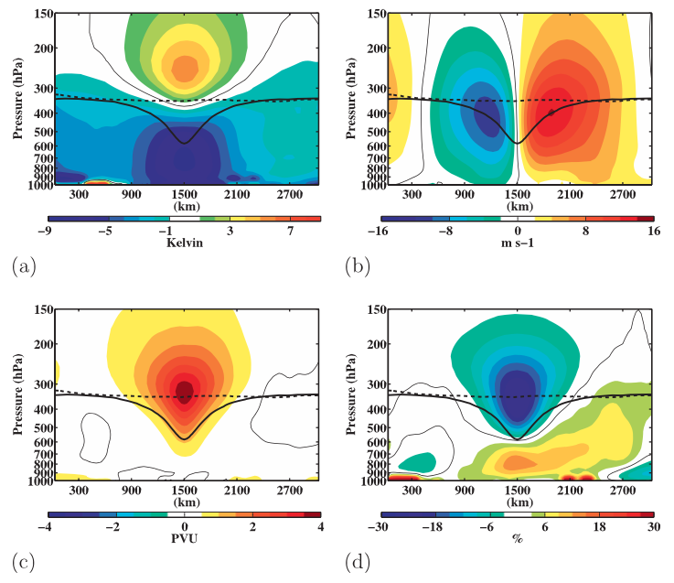

Fig. 1. Composite west-to-east cross sections of TPVs of anomalous (a) temperature (K), (b) v-wind component (m s⁻¹), (c) Ertel PV (PVU), and (d) relative humidity (%). Thick solid black contour is the composite tropopause, thick dashed black contour is a background tropopause, and thin solid contour is the 0 contour. [Figure 9 and adapted caption from Cavallo and Hakim (2010).]

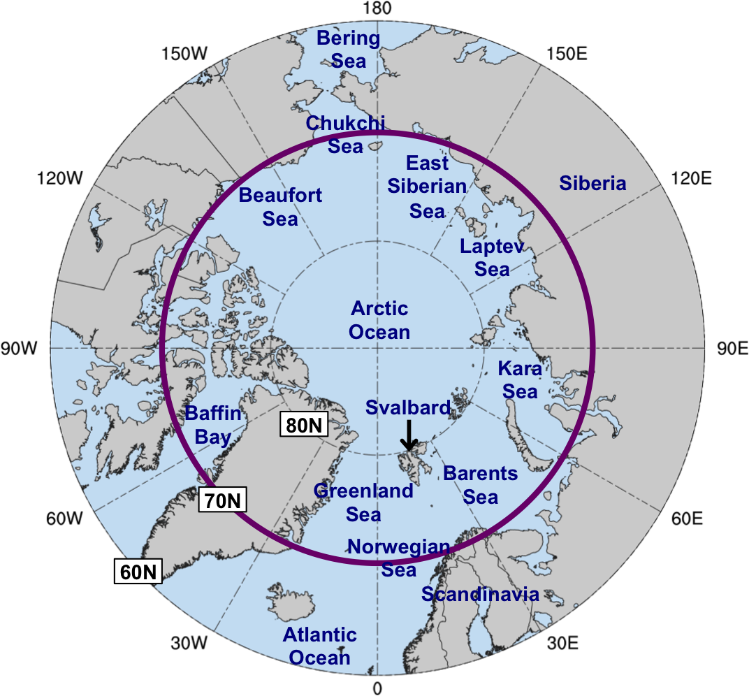
Fig. 2. Map of Arctic geography, including names of seas and nations discussed in this prospectus. Anywhere north of the purple circle (70°N) denotes the Arctic for the purposes of identifying Arctic cyclones and for calculating Arctic forecast skill, as discussed in section 2.2.1. The entire map (60–90°N) pertains to the domain to calculate area-averaged σ_{V500} and to identify blocks, as discussed in section 2.2.1.

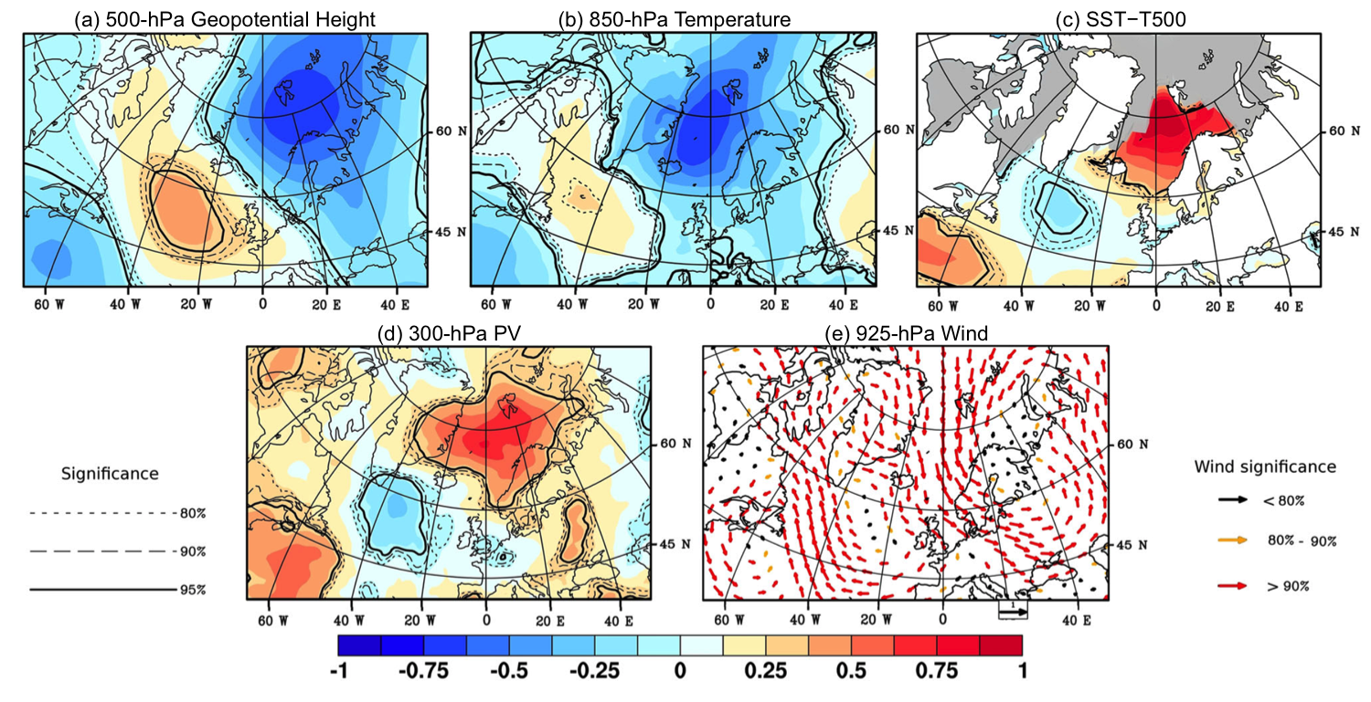
Fig. 3. Composite standardized anomalies of (a) 500-hPa geopotential height, (b) 850-hPa temperature, (c) SST−T500, (d) 300-hPa PV, and (e) 925-hPa wind for the date of formation of 134 polar lows from Noer et al. (2011) occurring during the months of October–March during 1999–2011. Gray areas correspond to maximal monthly sea ice extent during 1979–2007. The significance levels are indicated by solid and dotted lines for (a)–(d) and the color of the arrows for (e). Data source: ERA-Interim. [Figure 2 and caption adapted from Mallet et al. (2013).]

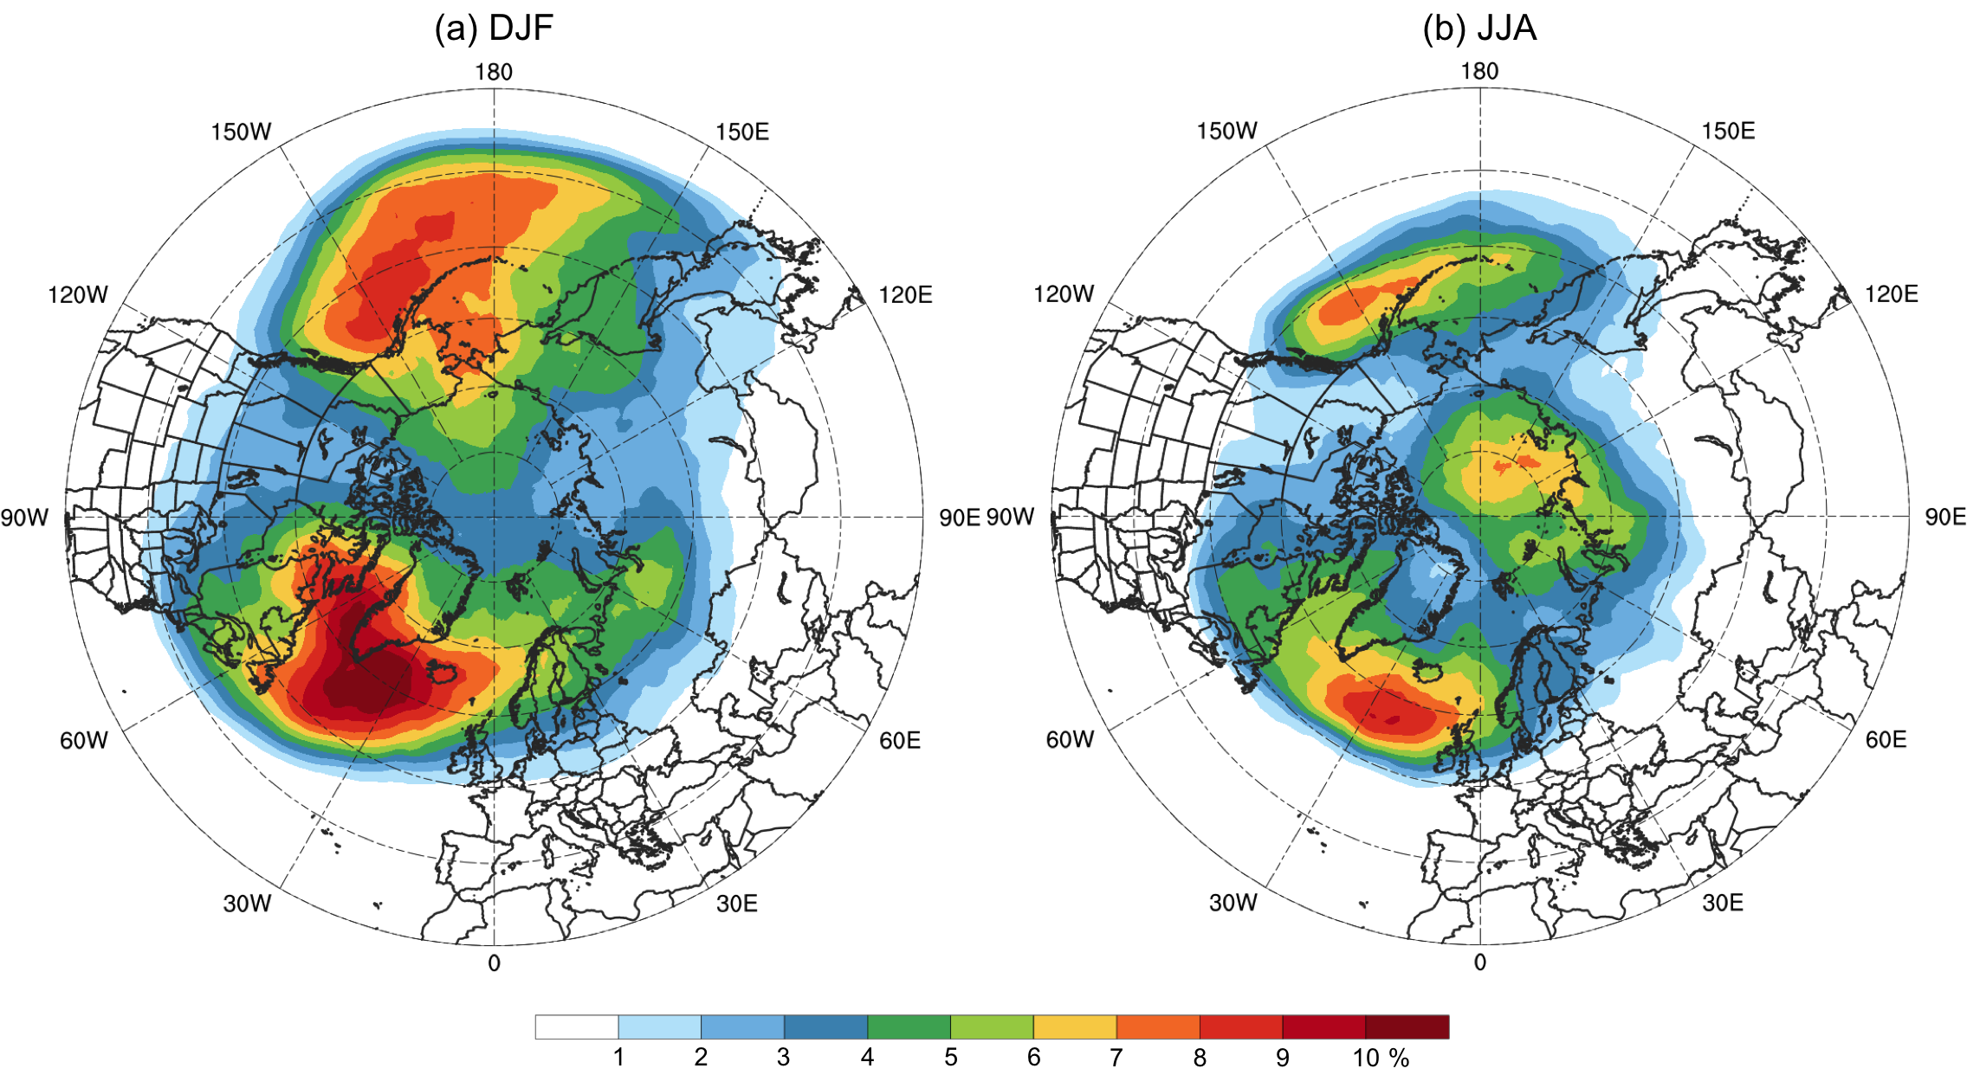

Fig. 4. Average percentage of 6-h time steps that a block is located at a grid point during (a) December–February (DJF) and (b) June–August (JJA) of 1979–2014 in the ERA-Interim. Data to create images obtained from: Institute for Atmospheric and Climate Science–ETH Zürich (2015).

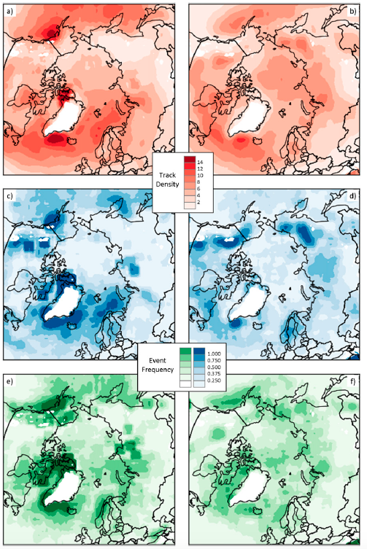

Fig. 5. Frequency of (a),(b) cyclone tracks, (c),(d) cyclogenesis events, and (e),(f) cyclolysis events for (a),(c),(e) winter (DJF) and (b),(d),(f) summer (JJA), averaged for the period 1979–2014. Units are the number of tracks or events per 500 km² area per month. [Figure 3 from Crawford and Serreze (2016).]
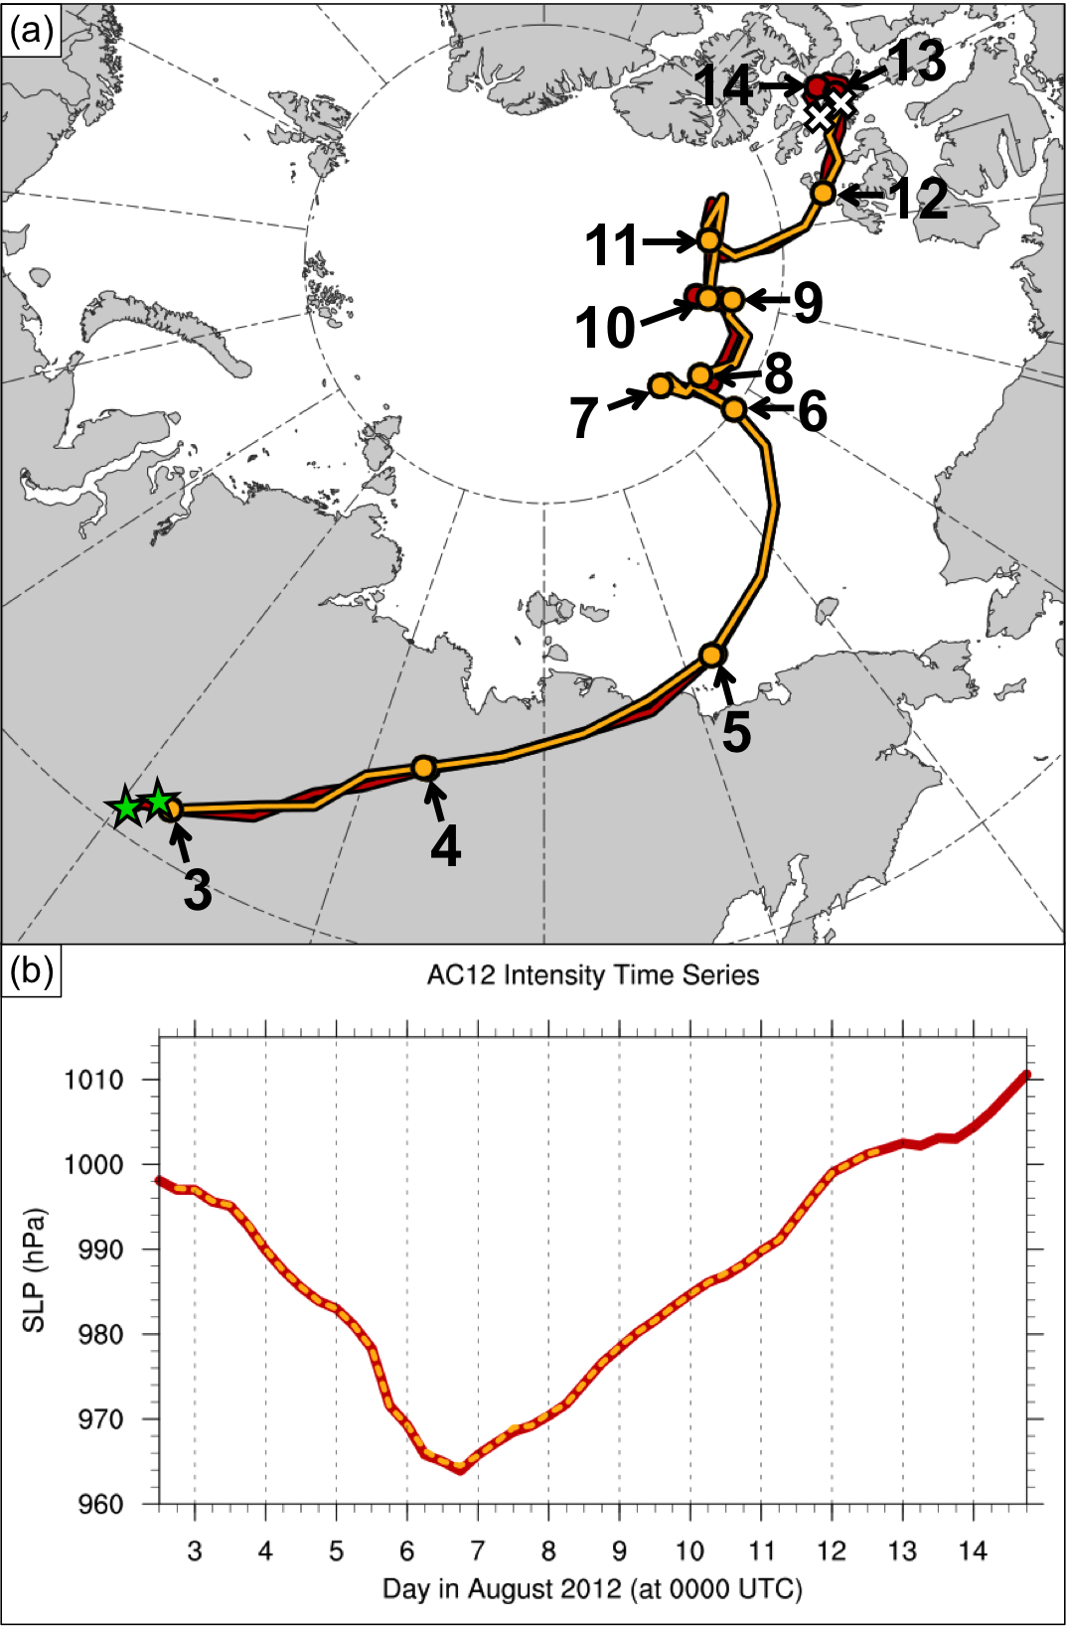

Fig. 6. (a) Track of AC12, as represented by the track of its associated SLP minimum, and (b) intensity of AC12, as represented by the value of its associated SLP minimum (hPa), every 6 h for manual tracking with ERA-Interim at 0.5° horizontal resolution (red) and objective tracking from Sprenger et al. (2017) with ERA-Interim at 1° horizontal resolution (gold). In (a), stars denote locations of genesis, crosses denote locations of lysis, dots represent 0000 UTC positions of AC12, every 24 h, and numbers pointing toward dots represent day in August 2012 corresponding to the 0000 UTC positions.
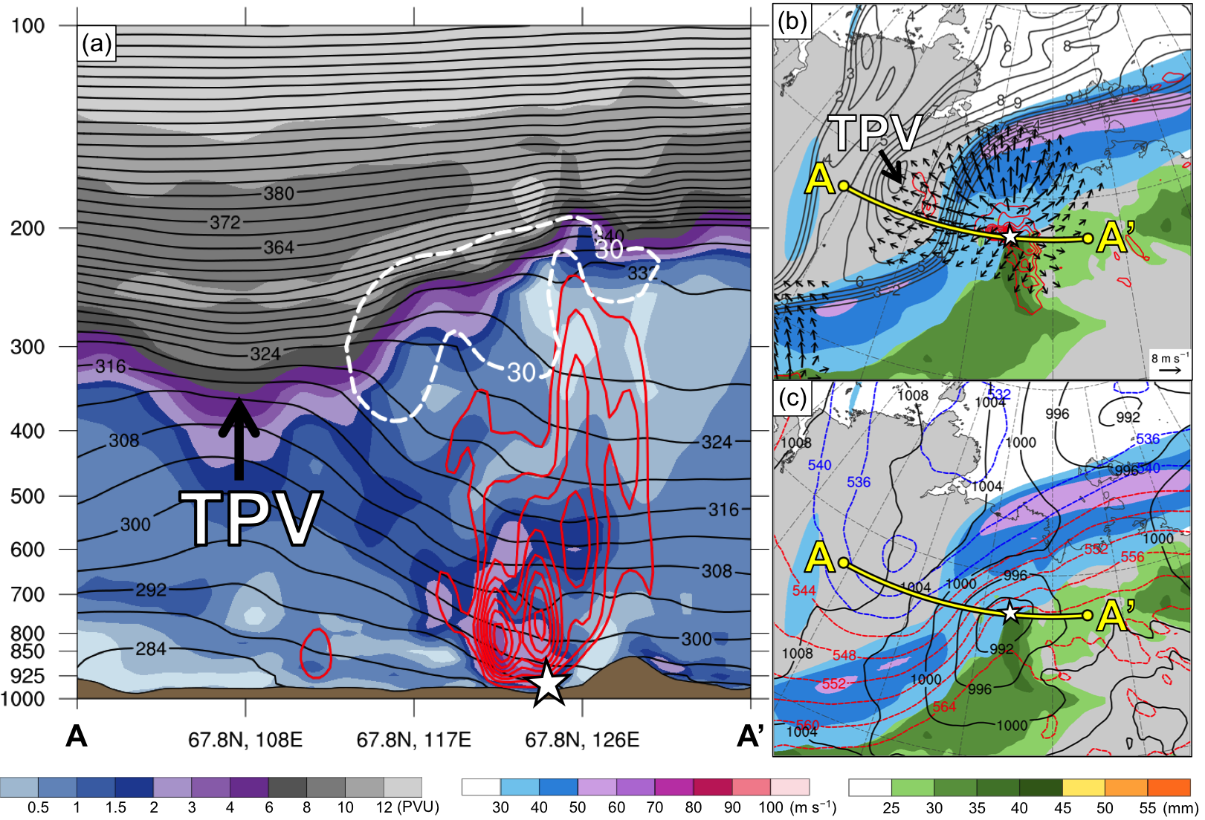

Fig. 7. (a) Cross section along line AA’ of PV (PVU, shading), potential temperature (K, black), ascent (red contours every 5 × 10⁻³ hPa s⁻¹), and wind speed (dashed white contour of 30 m s⁻¹); (b) 350–250-hPa layer-averaged PV (PVU, gray) and irrotational wind (m s⁻¹, vectors), 300-hPa wind speed (m s⁻¹, shading), 800–600-hPa layer-averaged ascent (red contours every 5 × 10⁻³ hPa s⁻¹), and precipitable water (mm, shading); and (c) 300-hPa wind speed (m s⁻¹, shading), 1000–500-hPa thickness (dashed red and blue contours every 4 dam, contoured red for values >540 dam and blue otherwise), SLP (black contours every 4 hPa), and precipitable water (mm, shading). Yellow line in (b) and (c) represents transect of cross section AA’. Arrows and label “TPV” point to location of TPV. White star denotes location of SLP minimum of AC12. Analysis is valid for 2100 UTC 3 August 2012. Data source: ERA5.

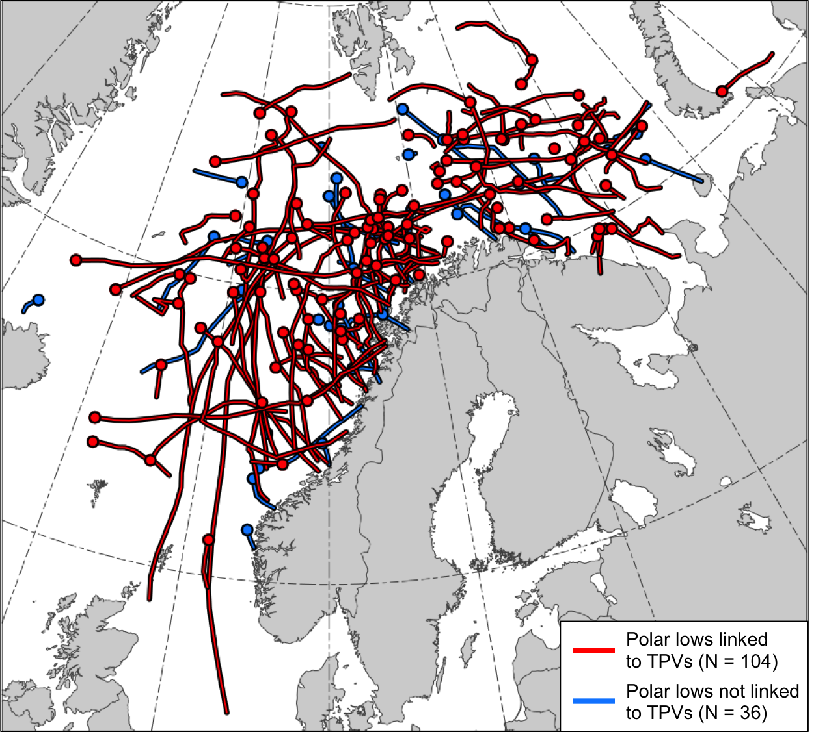

Fig. 8. Tracks of the polar lows in the STARS database. Tracks of polar lows that are linked to TPVs are shown in red and tracks of polar lows that are not linked to TPVs are shown in blue. Dots indicate the genesis locations of the polar lows.

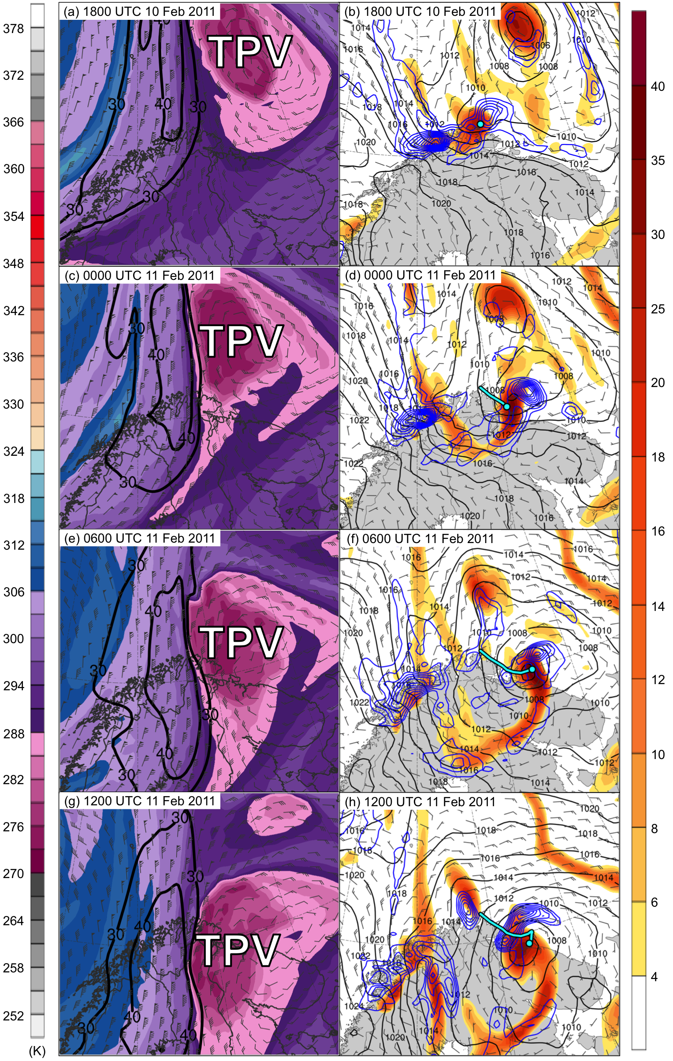
Fig. 9. DT (2-PVU surface) potential temperature (K, shaded), wind speed (black contours every 10 m s⁻¹, beginning at 30 m s⁻¹), and wind (m s⁻¹, flags and barbs) at (a) 1800 UTC 10 February, (c) 0000 UTC 11 February, (e) 0600 UTC 11 February, and (g) 1200 UTC 11 February 2011; 850-hPa relative vorticity (10⁻⁵ s⁻¹, shaded), 850–600-hPa layer-averaged ascent (blue contours every 2.5 × 10⁻³ hPa s⁻¹), SLP (black contours every 2 hPa), and 10-m wind (m s⁻¹, barbs) at (b) 1800 UTC 10 February, (d) 0000 UTC 11 February, (f) 0600 UTC 11 February, and (h) 1200 UTC 11 February 2011. Cyan line and dot represent track and position of polar low, respectively, according to STARS database. Label “TPV” denotes the position of the TPV.

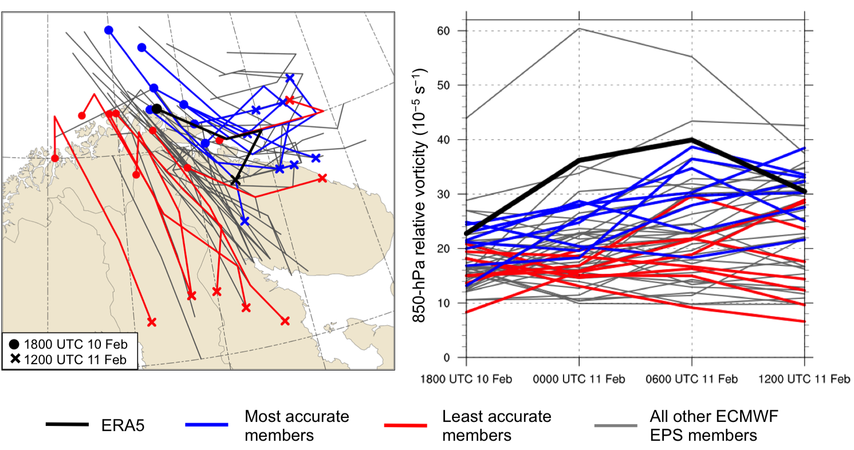

Fig. 10. (a) Track of the polar low, as represented by the track of its associated 850-hPa relative vorticity maximum, and (b) intensity of the polar low, as represented by the value of its associated 850-hPa relative vorticity maximum (10⁻⁵ s⁻¹), every 6 h during 1800 UTC 10 February–1200 UTC 11 February 2011 for ERA5 (black), ensemble members in the most accurate group (blue), ensemble members in least accurate group (red), and for all other ensemble members (gray). Dots and crosses in (a) represent position of polar low at 1800 UTC 10 February and 1200 UTC 11 February 2011, respectively, for ERA5 and ensemble members in most and least accurate group.

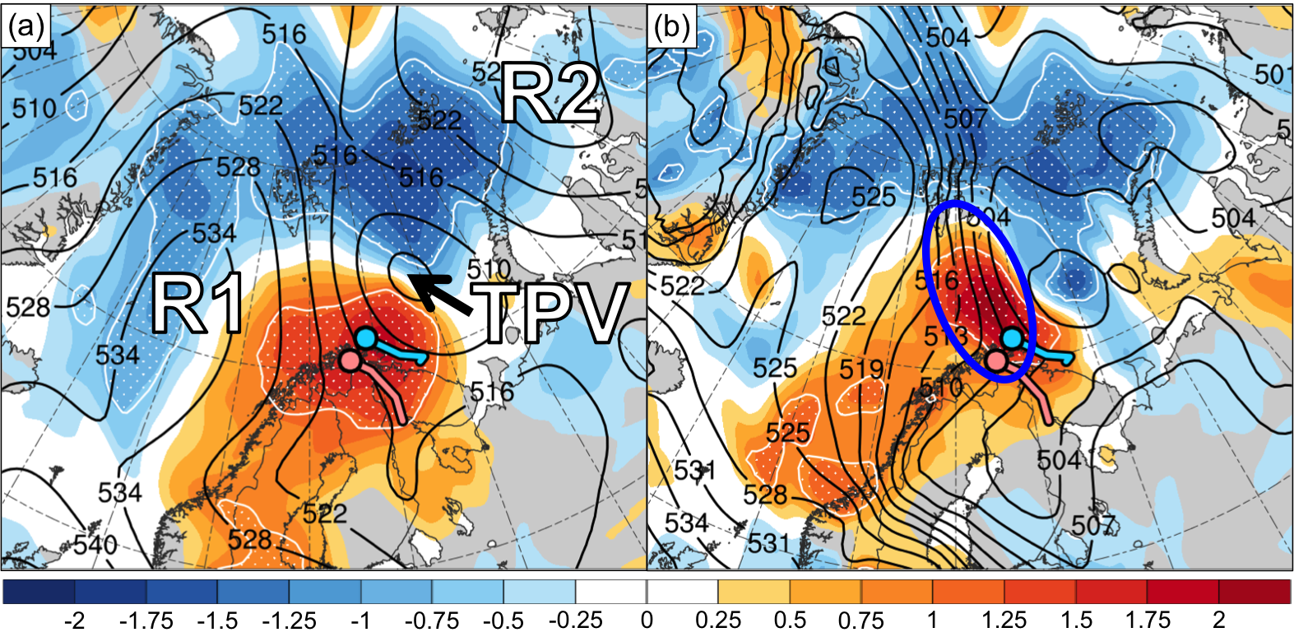

Fig. 11. Normalized composite difference between the most accurate and least accurate group (most accurate minus least accurate; shading; units: standardized anomaly) and ensemble mean (black contours) of (a) 500-hPa geopotential height (dam) and (b) 1000–500-hPa thickness (dam) at 1800 UTC 10 February 2011 (30 h forecast). White stippling indicates where there is a statistically significant difference at the 95% confidence level between the mean of the most accurate group and mean of the least accurate group for each quantity according to a two-sided Student’s t test. Blue and pink dot represent mean position of polar low in most accurate and least accurate group, respectively, at 1800 UTC 10 February 2011, and blue and pink line represent mean track of polar low in most accurate and least accurate group, respectively, during 1800 UTC 10–1200 UTC 11 February 2011. Labels “TPV”, “R1”, and “R2” in (a) represent the ensemble mean position of the TPV, R1, and R2, respectively. The blue-circled region in (b) indicates the ensemble mean position of the tropospheric-deep baroclinic zone.

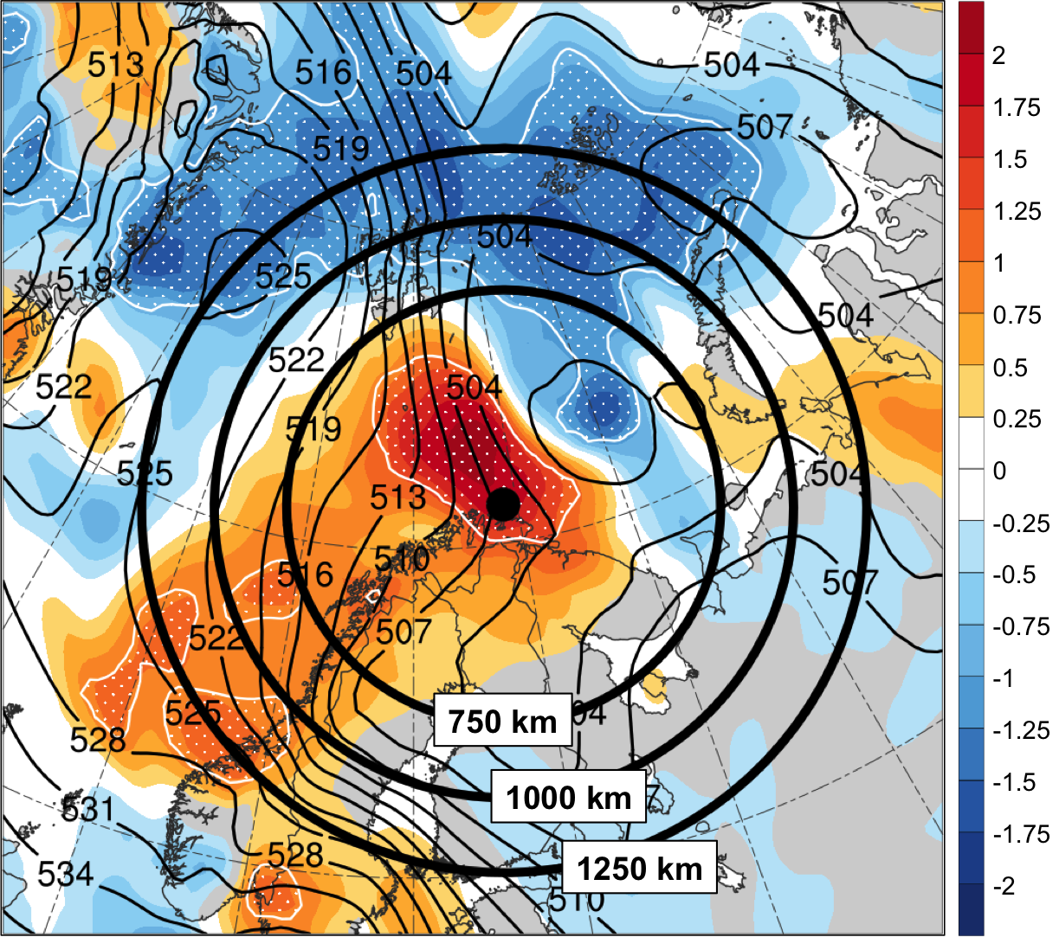

Fig. 12. Shading, contours, and stippling are same as in Fig. 11b for 1800 UTC 10 February 2011. Black dot represents genesis position of polar low at 1800 UTC 10 February 2011 according to the STARS database. Black circles show circular domains of radii 750, 1000, and 1250 km extending from the genesis position of the polar low to calculate the area-averaged standardized anomaly of ensemble spread of 1000–500-hPa thickness, as discussed in section 2.1.3.

See Fig. 2 hereafter for map of Arctic geography, including names of seas and nations discussed in this prospectus.

