4. Case Studies
4.1 9–14 January 1982 CAO
4.1.1 Case Overview

During 9–14 January 1982, a CAO impacted a widespread area of central and eastern North America, leading to significant socioeconomic impacts. According to NOAA NCEI, the 9–14 January 1982 CAO (hereafter referred to as the January 1982 CAO) contributed to an estimated cost of 1.7 billion dollars, after consumer price index adjustment, and contributed to 85 deaths (https://www.ncdc.noaa.gov/billions/). The January 1982 CAO qualifies as a CAO for the Northeast, Central, South, and Southeast regions (see Fig. 2.1 for map of regions) and a CAO that is linked to a cold pool associated with a TPV for all of these regions as well. Given the widespread and significant socioeconomic impacts of the January 1982 CAO, this CAO and its linkages to the cold pool associated with a TPV will be examined in detail.

4.1.2 TPV and Cold Pool Track and Intensity

Figure 4.1 shows the tracks of the TPV and cold pool of interest for the January 1982 CAO. The TPV forms over Baffin Bay at 0600 UTC 15 December 1981. The TPV moves over Greenland between 17 and 21 December 1981, before moving southwestward over northern Canada. The TPV then spends much of its lifetime meandering over northern and central Canada during late December 1981 and early January 1982. The TPV moves equatorward into the U.S. during 8–10 January 1982, then moves eastward over the U.S. during 10–11 January 1982 before moving quickly northeastward toward southern Greenland through 12 January 1982. The TPV undergoes lysis off the southeast coast of Greenland at 0000 UTC 13 January 1982. Overall, the TPV has a long lifetime of ~29 days. The cold pool forms over the northern coast of Greenland at 1800 UTC 20 December 1981, several days after the TPV forms. The cold pool has a similar track to the TPV throughout much of its lifetime, spending much of its lifetime meandering over northern and central Canada before moving equatorward into the U.S. between 8 and 10 January 1982. However, unlike the TPV, the cold pool meanders over eastern North America during 11–12 January 1982 before finally moving off the east coast of North America. The cold pool undergoes lysis at 1800 UTC 13 January 1982 east of Newfoundland. Overall, the cold pool also has a long lifetime (~24 days). The large spatial overlap and temporal coincidence of the TPV and cold pool tracks suggest that the TPV and cold pool are dynamically linked. Furthermore, the movement of the TPV and cold pool over and near the U.S. during 9–11 January 1982, when the January 1982 CAO is occurring, suggests that these features play an important role in the development of the January 1982 CAO.
To understand the intensity evolution of the TPV and cold pool during their lifetimes, Fig. 4.2 shows a time series of the minimum DT potential temperature of the TPV and the minimum 1000–500-hPa thickness of the cold pool. In general, ignoring rapid fluctuations of TPV intensity as evident by large spikes in the time series of the minimum DT potential temperature of the TPV (e.g. during 29 December 1981), which may be numerical artifacts, the TPV gradually intensifies during late December 1981, with the minimum DT potential temperature of the TPV decreasing from ~290 K at genesis on 15 December 1981 to close to 260 K on 28 December 1981. During early January 1982, the minimum DT potential temperature of the TPV is very low (around ~255 K) and decreases to ~249 K at 1800 UTC 9 January 1982. However, during 10–12 January 1982, the TPV rapidly weakens as the minimum DT potential temperature of the TPV increases to ~284 K at lysis at 0000 UTC 13 January 1982. The overall gradual intensification of the TPV suggests that longwave radiative cooling likely contributes importantly to the intensification of the TPV, especially given that Cavallo and Hakim (2009, 2010, 2012, 2013) have shown that longwave radiative cooling can play a critical role in the intensification of TPVs. In addition, as will be shown in section 4.1.3, an extratropical cyclone (EC) undergoes rapid cyclogenesis during 10–11 January 1982 off the east coast of North America, and latent heat release associated with this EC may contribute to the weakening of the TPV. Also, TPV–jet interaction, as will be shown in section 4.1.3, and associated flow deformation, may contribute to the weakening of the TPV as well.
About two days after the cold pool forms, similarly as the TPV, the cold pool gradually intensifies during late December 1981 and early January 1982, with the minimum 1000–500-hPa thickness of the cold pool decreasing from ~488 dam at genesis on 20 December 1981 to ~463 dam on 7 January 1982 (Fig. 4.2). Between 7 and 9 January 1982, the cold pool slowly weakens as it moves toward southern Canada and into the U.S., but rapidly weakens as the TPV does during 10–13 January 1982. Longwave radiative cooling (e.g., Curry 1983; Emanuel 2008) may contribute to the gradual intensification of the cold pool during late December 1981 and early January 1982. Some of the weakening of the cold pool during 7–13 January 1982 may be related to sensible heat fluxes from the surface, especially as the cold pool moves over the relatively warmer land of the U.S compared to that of Canada, considering that there may be less snow cover and a thinner snowpack over the U.S. compared to Canada. Latent heat release and warm air advection associated with the aforementioned EC that undergoes rapid cyclogenesis during 10–11 January 1982 off the U.S. east coast may also contribute to the weakening of the cold pool during 10–13 January 1982. Overall, the similar patterns in intensity changes for the TPV and cold pool further suggest that the TPV and cold pool may be dynamically linked.

4.1.3 Synoptic Evolution of TPV, Cold Pool, and CAO

Ridge amplification over the eastern North Pacific and western North America likely plays an important role in the equatorward transport of the TPV and cold pool. At 0000 UTC 5 January 1982, an EC is intensifying over the central North Pacific in the left exit region of the North Pacific jet stream, downstream of a short-wave trough (Figs. 4.3a,b). Warm air advection as suggested by the nearly perpendicular orientation of the SLP contours to the 1000–500-hPa thickness contours downstream of the EC (Fig. 4.3b) and diabatically-driven upper-tropospheric divergent outflow and associated negative PV advection by the irrotational wind (not shown) downstream of the EC likely support ridge amplification that occurs downstream of the EC over the central and eastern North Pacific from 0000 UTC 5 to 0000 UTC 6 January 1982 (Figs. 4.3a,c). Between 0000 UTC 6 and 0000 UTC 8 January 1982, the aforementioned trough over the central North Pacific moves eastward, narrows, and becomes negatively tilted, with a narrow corridor of precipitable water values in excess of 30 mm becoming established from the Subtropics poleward toward the Gulf of Alaska (Figs. 4.3c–h). Continued warm air advection east of the EC as suggested in Figs. 4.3d,f,h along with continued upper-tropospheric negative PV advection by the irrotational wind (not shown) likely support the additional ridge amplification over the eastern North Pacific and into western North America and concomitant anticyclonic wave breaking that occur (Figs. 4.3c,e,g). Furthermore, as the ridge comes into closer proximity with the TPV and associated cold pool located over western North America, the thermal gradient over the Gulf of Alaska and southwestern Canada strengthens, supporting the development and intensification of a jet streak over this region (Figs. 4.3e–h).
Between 0000 UTC 8 and 0000 UTC 9 January 1982, as the ridge continues to build eastward into western North America and comes into closer proximity with the location of the TPV and associated cold pool, the jet streak between the ridge and TPV and associated cold pool strengthens, with winds within the core of the jet streak on the DT increasing from ~80 m s⁻¹ to >90 m s⁻¹ (Figs. 4.4a–d). Interaction between the TPV and jet streak has also resulted in equatorward movement of the TPV and associated cold pool. In addition, it is evident that as the ridge builds into western North America and as TPV–jet interaction occurs, a strong surface anticyclone over northwestern North America strengthens and expands in the left entrance region of the jet streak. By 0000 UTC 10 January 1982, the TPV and cold pool have quickly moved southeastward into the northern U.S., and the surface anticyclone has rapidly strengthened in the left entrance region of the jet streak the TPV is interacting with (Figs. 4.4e,f). Furthermore, the surface anticyclone has quickly expanded equatorward into the central U.S., just east of the Rocky Mountains. Strong cold air advection is evident over the Great Plains given the nearly perpendicular orientation of the SLP contours to the 1000–500-hPa thickness contours, as well as given the strong SLP and 1000–500-hPa thickness gradients in place as shown in Fig. 4.4f. The strong cold air advection allows cold air associated with the cold pool to spread far away from the core of the cold pool, suggesting that the cold pool associated with the TPV has a geographically widespread impact.
By 0000 UTC 11 January 1982, the TPV and cold pool have moved eastward toward the U.S east coast, and cold air associated with the cold pool has overspread the entire eastern U.S., with strong cold air advection suggested over the southeastern U.S. (Figs. 4.4g,h). As discussed in section 4.1.2, the TPV and cold pool rapidly weaken on 11 January 1982. Horizontal shear associated with TPV–jet interaction may contribute to deformation of the shape of the TPV and weakening of the TPV from 0000 UTC 10 to 0000 UTC 11 January 1982 (Figs. 4.4e,g) 1982. In addition, Figs. 4.4f,h show that rapid cyclogenesis of an EC occurs in the left exit region of the jet streak the TPV interacts with between 0000 UTC 10 and 0000 UTC 11 January 1982. Latent heat release associated with widespread ascent found in the vicinity of the EC (not shown) may contribute to the weakening of the TPV and cold pool, and warm air advection that is suggested over Labrador and eastern Quebec at 0000 UTC 11 January 1982 (Fig. 4.4h) may further contribute to the weakening of the cold pool.
Overall, the cold pool associated with the TPV likely plays a crucial role in CAO development. In section 4.1.4, the evolution of the three-dimensional structure of the TPV and cold pool will be examined to gain more insight on how these features evolve together over time. In addition, it was discussed that a strong surface anticyclone rapidly strengthens and expands in the left entrance region of a strong jet streak over northwestern North America during the time of TPV–jet interaction. The relationship between TPV–jet interaction and the development of the strong surface anticyclone that is important for the evolution of the CAO in this case will be explored further in section 4.1.5.

4.1.4 Three-dimensional Structure of TPV and Cold Pool

Figure 4.5 shows a meridional cross section (AA’) transecting the TPV early in its lifecycle at 1200 UTC 16 December 1981, when the TPV is relatively weak and located over Baffin Bay. Using the position of the 2-PVU surface in the cross section as a proxy for the position of the DT, the TPV only extends downward to ~450 hPa, which is not too far beneath the background DT. Overall, the TPV is a mesoscale feature embedded in a much broader region of lowered DT and relatively low DT potential temperature air. Although the TPV has not been objectively identified to be associated with a cold pool at this time, there is a broad region of cold air characterized by 1000–500-hPa thickness values below 500 dam where the TPV and broad region of relatively low DT potential temperature air is located, suggesting that the TPV is still associated with cold air beneath it throughout the troposphere. The cross section indeed shows an upward bowing of isentropes beneath the TPV, with potential temperature values less than 268 K in the lower troposphere beneath the TPV.
As illustrated in Fig. 4.2, the TPV strengthens throughout late December 1981 and is intense during early January 1982, and the cold pool intensifies during late December 1981 and early January 1982 after forming on 20 December 1981. Figure 4.6 shows a meridional cross section (BB’) transecting the TPV and cold pool at 1200 UTC 2 January 1982, when both features are intense, well defined, highly isotropic in shape, and vertically aligned. Compared to early in its lifecycle (Fig. 4.5), the cross section in Fig. 4.6 shows that the TPV has become a much better defined, larger, and deeper feature, with the TPV now extending downward to ~650 hPa. In addition, there is substantial upward bowing of the isentropes within and beneath the TPV throughout the depth of the troposphere, indicative of the well-defined cold pool that is collocated with the TPV. Potential temperature values are less than 240 K near the surface beneath the TPV, indicative of the very cold air associated with the TPV and cold pool. Overall, as the TPV has become better defined and deeper, there has become a more robust upward bowing of the isentropes beneath the TPV and concomitantly a better defined and intense cold pool, illustrating that there is likely a dynamical linkage between the TPV and cold pool. It is also evident in the cross section that near the surface, isentropes spread horizontally outward, far away from the center of the TPV and cold pool, indicative of surface-based Arctic air spreading far from the center of the TPV and cold pool. In fact, especially to the south and north of the TPV, there is a very strong near-surface vertical potential temperature gradient, with near-surface PV values in excess of 4 PVU north of the TPV. As shown by Emanuel (2008), Arctic air can be characterized by relatively high values of PV. The strong near-surface vertical potential temperature gradient also suggests that a steep temperature inversion is in place, which is likely related to strong longwave radiative cooling (e.g., Curry 1983). Overall, the cross section illustrates that the influence of the TPV extends throughout the depth of the troposphere and over a widespread geographical area.
Figure 4.7 shows a meridional cross section (CC’) transecting the TPV and cold pool at 0000 UTC 10 January 1982 when both features have moved into the northern U.S. and are contributing to CAO development, as well as when the TPV is interacting with the strong jet streak discussed in section 4.1.3. Compared to at 1200 UTC 2 January 1982 (Fig. 4.6), the TPV has become even deeper, now extending downward to ~750 hPa at 0000 UTC 10 January 1982 (Fig. 4.7). A PV wall associated with a large horizontal PV gradient is evident throughout much of the troposphere between the TPV and warm air to its south, concomitant with the strong jet streak. There continues to be a very notable upward bowing of isentropes throughout the troposphere within and beneath the TPV, illustrative of the cold pool associated with the TPV. The surface-based Arctic air continues to spread far away from the center of the TPV and cold pool, with the leading edge of the Arctic air associated with the Arctic front likely being located south of 40°N where there is a strong surface horizontal potential temperature gradient. Furthermore, within the Arctic air, the boundary layer appears well mixed and neutrally stable given the nearly vertical orientation of the isentropes within the boundary layer. A well-mixed boundary layer was also shown by Shapiro et al. (1987; Fig. 1.7 in this thesis) in a cross section transecting the January 1985 “polar vortex” feature (or TPV as will be discussed in section 4.2), and they suggest that this well-mixed boundary layer may result from diabatic heating induced by the flow of Arctic air over the relatively warm land surface. Overall, as the cross section in Fig. 4.6, the cross section in Fig. 4.7 illustrates that the influence of the TPV extends throughout the depth of the troposphere and over a widespread geographical area, and also illustrates that the TPV and associated cold pool plays a crucial role in CAO development

4.1.5 Q-vector Diagnosis

The concomitant occurrence of the interaction of the TPV with a jet streak over western North America and the rapid strengthening and southeastward expansion of the strong surface anticyclone over western North America in the left entrance region of the strong jet streak during 8–10 January 1982 (Figs. 4.4a–f) suggests that TPV–jet interaction may play an important role in the rapid strengthening and expansion of the strong surface anticyclone. Figure 4.8 shows plots of 600–400-hPa Q_{n} and Q_{s} and their associated forcings for vertical motion from 1200 UTC 8 to 0000 10 January 1982. At 1200 UTC 8 January 1982, between the ridge and the TPV, there is a region of divergence of Q_{n} and Q_{n} forcing for descent collocated with and to the south and east of the ~1047 hPa surface anticyclone over western North America (Fig. 4.8a). The orientation of the Q_{n} vectors from cold to warm air suggests that upper-level frontogenesis may be occurring, which may support a strengthening of the jet streak over western North America and concomitantly a strengthening of the thermally direct ageostrophic circulation in the entrance region of the jet streak. A strengthened thermally direct ageostrophic circulation in the entrance region of the jet streak may be associated with increased descent and thus increased forcing for anticyclogenesis in the left entrance region of the jet streak. There is also a small region of Q_{s} forcing for descent over northern Alberta on the downstream side of the ridge and to the south and east of the surface anticyclone (Fig. 4.8b). The region of Q_{n} and Q_{s} forcing for descent over and to the south and east of the surface anticyclone suggests that the surface anticyclone may strengthen and expand southeastward.
By 0000 UTC 9 January 1982, the maximum SLP of the surface anticyclone remains ~1047 hPa, but the surface anticyclone has expanded in size southward and eastward over the last 12 h (compare Figs. 4.8a,c). As the TPV has come into closer proximity with the jet streak between the TPV and ridge (Fig. 4.4c), the magnitude of Q_{n} and Q_{n} forcing for descent has concomitantly increased between the TPV and the ridge, in the left entrance region of the jet streak, over and to the south and east of the surface anticyclone (Fig. 4.8c). Additionally, the angle between the geopotential height contours and potential temperature contours suggest that geostrophic cold air advection is occurring in the region of Q_{n} forcing for descent, on the cyclonic shear side of the jet streak. Shapiro (1981) has shown that geostrophic cold air advection in cyclonic shear may provide a favorable environment for upper-level frontogenesis, which is again suggested by the orientation of the Q_{n} vectors from cold to warm air over western North America. Furthermore, it is evident by comparing Figs. 4.8b,d that the region of Q_{s} forcing for descent has increased in size and magnitude between 1200 UTC 8 and 0000 UTC 9 January 1982, with a maximum of Q_{s} forcing for descent located upstream of the TPV, over and to the south and east of the surface anticyclone at 0000 UTC 9 January 1982. This region of Q_{s} forcing for descent may be related the large curvature of the flow associated with TPV, as noted in the geopotential height contours. The maximum of Q_{s} forcing for descent being located upstream of the TPV is also anticipated given that Lang and Martin (2010) have shown that divergence of Q_{s} and thus Q_{s} forcing for descent is expected to be located upshear of an isolated vertical vorticity maximum. Overall, the position of the regions of Q_{n} and Q_{s} forcing for descent over and to the south and east of the surface anticyclone suggests that the surface anticyclone may strengthen and continue to build southeastward.
Indeed, between 0000 UTC and 1200 UTC 9 January 1982, the surface anticyclone rapidly strengthens from ~1047 hPa to ~1054 hPa, or by ~7 hPa in 12 h, and builds southward and especially eastward (compare Figs. 4.8c,e). At 1200 UTC 9 January 1982, as the TPV is interacting with the jet streak, Q_{n} and Q_{s} and their associated forcings for descent have continued to increase, with a maximum of both Q_{n} and Q_{s} forcing for descent located upstream of the TPV, over and to the south and east of the surface anticyclone (Figs. 4.8e,f). The relatively strong Q_{n} and Q_{s} forcing for descent over and to the south and east of the surface anticyclone suggest that the surface anticyclone may continue to strengthen and build southeastward. Between 1200 UTC 9 and 0000 UTC 10 January 1982, the surface anticyclone does indeed strengthen from ~1054 hPa to ~1060 hPa, or by ~6 hPa in 12 h, and does build southeastward (compare Figs. 4.8e,g). The pattern of Q_{n} and Q_{s} and their associated forcings for descent at 0000 UTC 10 January 1982 are similar to those at 1200 UTC 9 January 1982 (compare Figs. 4.8e,f with Figs. 4.8g,h) and support continued southeastward expansion of the surface anticyclone that occurs between 0000 UTC 10 and 0000 UTC 11 January 1982 (Figs. 4.4f,h). Overall, the concomitant occurrence of the increase in magnitude of Q_{n} and Q_{s} and their associated forcings for descent during TPV–jet interaction with the rapid strengthening and expansion of the surface anticyclone suggests that TPV–jet interaction may play an important role in the rapid strengthening and expansion of the surface anticyclone. Given the important role this surface anticyclone plays in the development of the January 1982 CAO, TPV–jet interaction may play an important role in CAO development.

4.2 19–24 January 1985 CAO
4.2.1 Case Overview

During 19–24 January 1985, a CAO impacted a widespread area of central and eastern North America, leading to significant socioeconomic impacts. According to NOAA NCEI, the 19–24 January 1985 CAO (hereafter referred to as the January 1985 CAO) contributed to an estimated cost of 1.9 billion dollars, after consumer price index adjustment, and contributed to 150 deaths (https://www.ncdc.noaa.gov/billions/). As with the January 1982 CAO, the January 1985 CAO qualifies as a CAO for the Northeast, Central, South, and Southeast regions (see Fig. 2.1 for map of regions) and a CAO that is linked to a cold pool associated with a TPV for all of these regions as well. Given the widespread and significant socioeconomic impacts of the January 1985 CAO, this CAO and its linkages to the cold pool associated with a TPV will be examined in detail. Furthermore, this research confirms that the “polar vortex” examined by Shapiro et al. (1987) to play an important role in the development of the January 1985 CAO, as discussed in Chapter 1, qualifies as a TPV associated with a cold pool.

4.2.2 TPV and Cold Pool Track and Intensity

Figure 4.9 shows the tracks of the cold pool and TPV of interest for the January 1985 CAO. The cold pool is identified to form over the northeastern coast of Baffin Island at 1800 UTC 11 January 1985. The cold pool meanders for several days over northern Canada before being transported equatorward from northern Canada into the U.S. during 17–20 January 1985. The cold pool then moves northeastward toward Labrador during 21–22 January 1985 and meanders over and near Labrador during 22–27 January 1985. The cold pool undergoes lysis over Quebec at 0600 UTC 28 January 1985. In total, the cold pool has a lifetime of ~17 days. The TPV forms at 1800 UTC 16 January 1985 over north central Canada, several days after the cold pool is identified to form. The TPV moves generally westward over the next day before being quickly transported equatorward into southern Canada and then into the central U.S. between 18 and 20 January 1985 together with the cold pool. Similarly to the cold pool, the TPV is quickly transported northeastward toward Labrador during 21–22 January 1985, and then meanders over and near Labrador during 22–27 January 1985. Unlike the cold pool, the TPV then moves over the northwestern North Atlantic, where it meanders for a few more days before undergoing lysis at 1200 UTC 2 February 1985. Overall, the TPV has a lifetime of 17 days. In general, the large spatial overlap and temporal coincidence of the TPV and cold pool tracks when the TPV and cold pool move over North America suggest that the these features are dynamically linked. Furthermore, the movement of the TPV and cold pool over and near the U.S. during 19–21 January 1985, when the January 1985 CAO is occurring, suggests that these features play an important role in the development of the January 1985 CAO.
Figure 4.10 shows a time series of the minimum DT potential temperature of the TPV and the minimum 1000–500-hPa thickness of the cold pool. At the beginning of its lifecycle, the cold pool is already characterized by a 1000–500-hPa thickness value of ~478 dam. Although the cold pool is objectively identified to form on 11 January 1985, subjectively, the cold pool appears to form several days earlier (not shown). There may have been separate 1000–500-hPa thickness minima embedded within the cold pool that may have contributed to multiple cold pool tracks. In a general sense, the cold pool strengthens during 11–19 January 1985, with the minimum 1000–500-hPa thickness of the cold pool reaching a minimum value of ~468 dam at 0000 UTC 19 January 1985 (Fig. 4.10) over southern Canada (Fig. 4.9). The cold pool then weakens as it moves across the U.S. and then northeastward toward Labrador during 19–22 January 1985. The cold pool then generally intensifies as is meanders over and near Labrador until 27 January 1985, before weakening again. When the TPV forms, it is characterized by an already low minimum DT potential temperature value of ~269 K. As will be shown in section 4.2.3, the TPV forms from a preexisting broad area of low DT potential temperature air, and thus once the TPV is identified, it already begins with a low minimum DT potential temperature value. In general, the TPV intensifies until 20 January 1985 as the cold pool intensifies, though reaches a minimum DT potential temperature value of ~259 K at 0600 UTC 20 January 1985, when the cold pool is already weakening. Afterward, during 21–29 January 1985, the patterns of intensity change of the TPV are similar to that of the cold pool.
The periods of strengthening of both the cold pool and TPV may be related to longwave radiative cooling as in the January 1982 CAO case. Weakening of both the cold pool and TPV during 21–22 January 1985 may be related to latent heat release in association with a strong EC that rapidly intensifies during 21–22 January 1985 over the east coast of North America (not shown). In addition, weakening of the cold pool as it moves across the U.S. during 19–21 January 1985 may be related to sensible heat fluxes from the surface as the cold pool moves over the relatively warmer land of the U.S compared to that of Canada, especially considering that there may be less snow cover and a thinner snowpack over the U.S. compared to Canada. Also, as will be shown in section 4.2.3, the TPV interacts with a jet streak as it moves across the U.S and northeastward toward Labrador and deformation associated with TPV–jet interaction may contribute to weakening of the TPV as well.

4.2.3 Synoptic Evolution of TPV, Cold Pool, and CAO

The equatorward transport of the TPV and cold pool is likely tied to flow amplification over the North Pacific and North Atlantic. Starting at 0000 UTC 14 January 1985, an EC is strengthening in the left exit region of a strong North Pacific jet stream over the central North Pacific, downstream of a short-wave trough (Figs. 4.11a,b). Warm air advection downstream of the EC, as suggested in Fig. 4.11b, in combination with diabatically driven upper-tropospheric divergent outflow and associated negative PV advection by the irrotational wind (not shown) likely supports ridge amplification that occurs over the eastern North Pacific between 0000 UTC 14 and 0000 UTC 15 January 1985 (Figs. 4.11a,c). In addition, poleward fluxes of warm, moist air associated with an EC moving poleward off the coast of Labrador supports ridge amplification into Greenland and cyclonic wave breaking between 0000 UTC 14 and 0000 UTC 15 January 1985 (Figs. 4.11a–d). Meanwhile, during this same time period, the cold pool over northeastern North America moves southward on the west side of this ridge over Greenland. Collocated with the cold pool is a broad region of low DT potential temperature air that will evolve into the TPV of interest. By 0000 UTC 16 January 1985 the ridge over the eastern North Pacific has continued to amplify, now extending eastward into western North America (Fig. 4.11e). Over the central North Pacific, a broad region of cyclonic flow is evident in association with a strong EC located to the southwest of the Aleutian Islands (Fig. 4.11f). This broad region of cyclonic flow likely supports ridge amplification over Alaska and northwestern North America evident between 0000 UTC 16 and 0000 UTC 17 January 1985 (Figs. 4.11e,g). Meanwhile, a new EC rapidly develops and then occludes as it moves from the northeastern U.S. to southeastern Canada between 0000 UTC 15 and 0000 UTC 17 January 1985, contributing to additional ridge amplification over the northwestern North Atlantic and Greenland as well as cyclonic wave breaking (Figs. 4.11c–h). Also, at 0000 UTC 17 January 1985, the broad region of low DT potential temperature air has consolidated into a single TPV that is now objectively tracked (Fig. 4.11g).
The combination of ridging over western North America and over Greenland and Baffin Bay force the TPV and cold pool to move equatorward over Canada between 0000 UTC 18 and 0000 UTC 19 January 1985 (Figs. 4.11i–l). As the TPV moves equatorward, a jet streak forms and strengthens between the TPV and the ridge over western North America. In addition, a strong surface anticyclone over the Arctic and extending southward into the Canadian Archipelago strengthens and builds southeastward over western Canada in the left entrance region of the aforementioned jet streak the TPV is interacting with. As the TPV and cold pool continue moving equatorward into the northern U.S. through 0000 UTC 20 January 1985, the aforementioned jet streak moves equatorward along with the TPV, and the strong surface anticyclone strengthens in the left entrance region of the jet streak and rapidly builds southeastward into the central U.S (Figs. 4.11m,n). Strong cold air advection is noted over the southern and central U.S., given the nearly perpendicular orientation of the SLP contours to the 1000–500-hPa thickness contours, as well as given the strong SLP and 1000–500-hPa thickness gradients in place over these regions as suggested by Fig. 4.11n. As the TPV and cold pool move eastward over the U.S. through 0000 UTC 21 January 1985 (Figs. 4.11o–p), the cold air associated with the cold pool overspreads the entire eastern U.S., with strong cold air advection over the southeastern U.S. suggested by Fig. 4.11p. Also, as the TPV has been interacting with the jet streak to its south and east, it has become deformed in shape and weakens between 0000 UTC 20 and 0000 UTC 21 January 1985 (Figs. 4.11m,o). Cyclogenesis of an EC is noted over southeastern Canada at 0000 UTC 21 January 1985 in the left exit region of the aforementioned jet streak the TPV is interacting with (Figs. 4.11o,p), and this EC undergoes rapid cyclogenesis over the next day (not shown). As briefly mentioned in the section 4.2.2, latent heat release associated with this EC (not shown) may be contributing to the weakening of the TPV and cold pool during 21–22 January 1985 shown in Fig. 4.10.
Overall, as in the January 1982 CAO case, a cold pool associated with a TPV likely plays a crucial role in CAO development in the January 1985 CAO case. To get a better sense of the evolution of the three-dimensional structure of the TPV and cold pool in the January 1985 CAO case, cross sections of these features at different points of their lifecycle will be examined in section 4.2.4. In addition, similarly as in the January 1982 CAO case, a surface anticyclone strengthens and expands in the left entrance region of a jet streak over western North America during the time of TPV–jet interaction in the January 1985 CAO case. The relationship between TPV–jet interaction and the development of the strong surface anticyclone that is important for the evolution of the CAO in the January 1985 CAO case will be explored further in section 4.2.5.

4.2.4 Three-dimensional Structure of TPV and Cold Pool

Figure 4.12 shows a meridional cross section (DD’) transecting the cold pool early in its lifecycle at 0000 UTC 13 January 1985, a time during which the TPV has not yet been identified. At this time, there is broad region of low DT potential temperature air collocated with the broad cold pool, with individual DT potential temperature minima embedded within the broad region of low DT potential temperature air. The cross section shows that this broad region of low DT potential temperature air corresponds to a broad region of depressed DT extending downward below 400 hPa, with embedded mesoscale undulations of the DT. There is a broad region of upward bowing of isentropes in the cross section beneath the broad region of lowered DT, indicative of the broad cold pool, with potential temperature values near the surface as low as 240 K illustrating the very cold air associated with the cold pool.
Figure 4.13 shows a meridional cross section (EE’) transecting the TPV and associated cold pool at 0000 UTC 17 January 1985, shortly after the TPV has been first identified. Since the broad region of low DT potential temperature air has consolidated into a single TPV, there is now a more focused region of lowered DT in the cross section in Fig. 4.13 compared to in the cross section in Fig. 4.12. In addition, the DT in the cross section in Fig. 4.13 extends downward below 500 hPa where the TPV is positioned, which is generally lower that the position of the DT associated with the broad region of low DT potential temperature air in the cross section in Fig. 4.12. Also, there is more robust upward bowing of the isentropes beneath the TPV in the cross section in Fig. 4.13 at 0000 UTC 17 January 1985 compared to beneath the broad region of low DT potential temperature air in the cross section in Fig. 4.12 at 0000 UTC 13 January 1985, which also corresponds to a more intense cold pool at 0000 UTC 17 January 1985 (Fig. 4.13) compared to at 0000 UTC 13 January 1985 (Fig. 4.12).
Figure 4.14 shows a meridional cross section (FF’) transecting the TPV and cold pool at 0000 UTC 20 January 1985, when both features have moved into the northern U.S. and are contributing to CAO development. The TPV has intensified and now extends downward to ~750 hPa. The robust upward bowing of the isentropes within and beneath the TPV illustrates the impressive cold pool collocated with the TPV. In addition, the TPV is interacting with a jet streak to its south, and a PV wall similar to that in the cross section in Fig. 4.7 for the January 1982 CAO case extends throughout much of the troposphere between the TPV and warm air to the south, concomitant with the jet streak. Near the surface, the isentropes spread horizontally outward, far away from the core of the TPV and cold pool, with the Arctic front associated with the leading edge of Arctic air likely located south of 37.5°N where there is a strong surface horizontal potential temperature gradient. As discussed by Shapiro et al. (1987) for a cross section transecting the same TPV and cold pool (Fig. 1.7 in this thesis), the cross section in Fig. 4.14 shows that within the Arctic air, the boundary layer appears well-mixed and neutrally stable, which, as suggested by Shapiro et al. (1987), may result from diabatic heating induced by the flow of Arctic air over the relatively warm land surface. Overall, the cross section in Fig. 4.14 illustrates that the TPV has a tropospheric deep influence and impacts a widespread geographical area, playing an important role in the development of the January 1985 CAO.

4.2.5 Q-vector Diagnosis

The concomitant occurrence of the interaction of the TPV with a jet streak over western North America and the strengthening and rapid southeastward expansion of the strong surface anticyclone over western North America in the left entrance region of the jet streak during 18–20 January 1985 (Figs. 4.11i–n) suggests that TPV–jet interaction may play an important role in the strengthening and expansion of the strong surface anticyclone. Figure 4.15 shows plots of 600–400-hPa Q_{n} and Q_{s} and their associated forcings for vertical motion from 1200 UTC 18 to 0000 20 January 1985. At 1200 UTC 18 January 1985, a region of divergence of Q_{n} and Q_{n} forcing for descent is located to the northwest of the TPV, over and to the southeast of the surface anticyclone over northwestern Canada (Fig. 4.15a). The orientation of the Q_{n} vectors from cold to warm air in this region suggests that upper-level frontogenesis may be occurring, which would support the strengthening of the jet streak over western North America that occurs between 0000 UTC 18 and 0000 UTC 19 January 1985 (Figs. 4.11i–l). The strengthened jet streak may be associated with a strengthened thermally direct ageostrophic circulation in the entrance region of the jet streak and concomitantly increased descent and thus increased forcing for anticyclogenesis in the left entrance region of the jet streak. Also at 1200 UTC 18 January 1985, over northwestern North America, the Q_{s} vectors are weak in magnitude and there is not an organized region of Q_{s} forcing for descent (Fig. 4.15b). The region of Q_{n} forcing for descent over and to the southeast of the surface anticyclone suggests that the surface anticyclone may strengthen and expand southeastward.
By 0000 UTC 19 January 1985, while the surface anticyclone has not strengthened, it has expanded southeastward over western Canada since 1200 UTC 18 January 1985 (compare Figs. 4.15a,c). As the TPV is interacting with the strengthening jet steak over western Canada (Fig. 4.11k), the magnitude of Q_{n} has increased and the region of Q_{n} forcing for descent has expanded in areal coverage just northwest of the location of the TPV, in the left entrance region of the jet streak, and over and to the south and east of the surface anticyclone (Fig. 4.15c). In addition, given the angle between the geopotential height contours and potential temperature contours, there is suggestion that geostrophic cold air advection is occurring in and near the region of Q_{n} forcing for descent, on the cyclonic shear side of the jet streak, providing additional evidence that upper-level frontogenesis may be occurring. The region of Q_{n} forcing for descent being located over and to the south and east of the surface anticyclone suggests that the surface anticyclone may strengthen and expand southeastward. Also at 0000 UTC 19 January 1985, there is now an organized region of Q_{s} forcing for descent positioned west of the TPV and to the south and east of the surface anticyclone (Fig. 4.15d), which would at least suggest the surface anticyclone may build southeastward.
Between 0000 UTC and 1200 UTC 19 January 1985, the surface anticyclone does indeed strengthen from ~1046 hPa to ~1051 hPa, or by ~5 hPa in 12 h, and expands southeastward into the U.S (compare Figs. 4.15c,e). There continues to be a broad region of Q_{n} forcing for descent just west of the TPV, over and to the southeast of the surface anticyclone (Fig. 4.15e) as well as a smaller and weaker area of Q_{s} forcing for descent west of the TPV and to the south and east of the surface anticyclone (Fig. 4.15f), suggesting that the surface anticyclone may strengthen further and build southeastward. The surface anticyclone indeed continues to strengthen between 1200 UTC 19 and 0000 UTC 20 January 1985 from ~1051 hPa to ~1054 hPa, or by about 3 hPa in 12 h, continues to build southeastward, and there continues to be generally similar patterns of Q_{n} and Q_{s} and their associated forcings for descent near the TPV at 0000 UTC 20 January 1985 as 12 h earlier (compare Figs. 4.15e,f with Figs. 4.15g,h). In general, the concomitant occurrence of the increase in magnitude of Q_{n} and increase in areal coverage of the Q_{n} forcing for descent during TPV–jet interaction with the strengthening and expansion of the surface anticyclone suggests that TPV–jet interaction may play an important role in the strengthening and expansion of the surface anticyclone. Given the important role this surface anticyclone plays in the development of the January 1985 CAO, TPV–jet interaction may play an important role in CAO development.

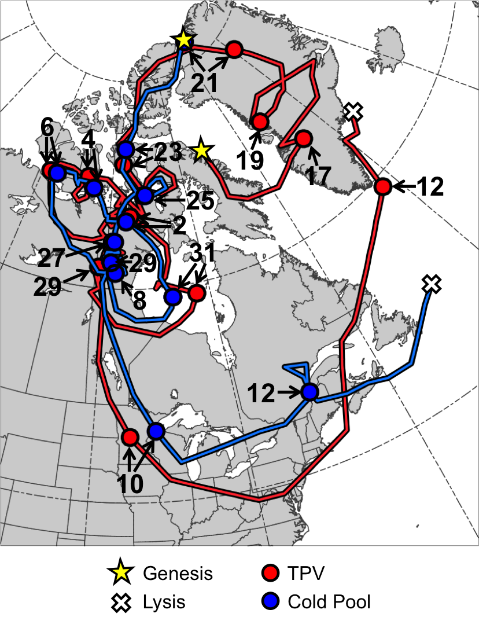
Fig. 4.1. Tracks of TPV (red) from 0600 UTC 15 December 1981 to 0000 UTC 13 January 1982 and cold pool (blue) from 1800 UTC 20 December 1981 to 1800 UTC 13 January 1982 for January 1982 CAO case. Stars denote locations of genesis, crosses denote locations of lysis, and red and blue dots represent 0000 UTC positions of TPV and cold pool, respectively, every 48 h. Numbers pointing toward dots represent dates of the 0000 UTC positions of the TPV and cold pool, such that numbers ≥17 correspond to dates in December 1981 and numbers ≤12 correspond to dates in January 1982.

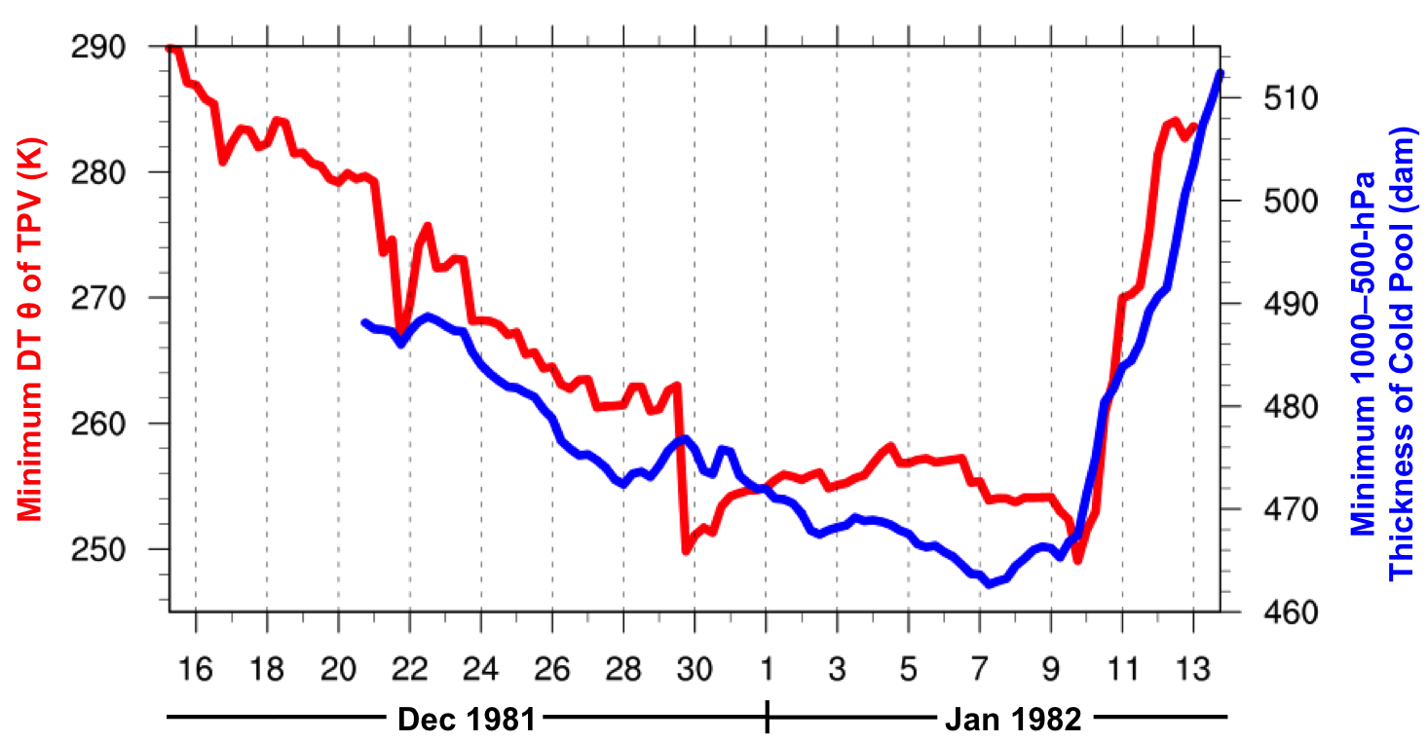
Fig. 4.2. Time series of minimum DT potential temperature (θ) of TPV (K, red) every 6 h from 0600 UTC 15 December 1981 to 0000 UTC 13 January 1982 and minimum 1000–500-hPa thickness of cold pool (dam, blue) every 6 h from 1800 UTC 20 December 1981 to 1800 UTC 13 January 1982 for January 1982 CAO case.
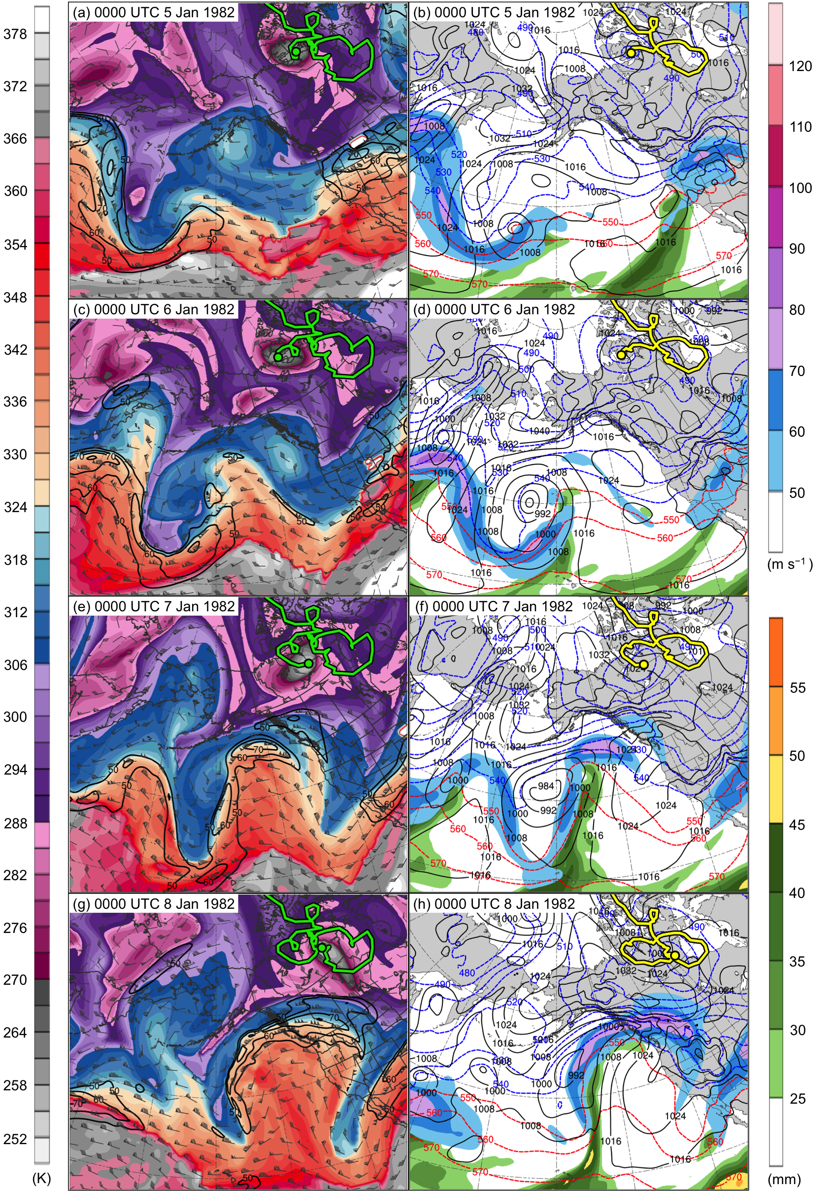
Fig. 4.3. DT (2-PVU surface) potential temperature (K, shaded), wind speed (black contours every 10 m s⁻¹, beginning at 50 m s⁻¹), and wind (m s⁻¹, flags and barbs) at (a) 0000 UTC 5 January, (c) 0000 UTC 6 January, (e) 0000 UTC 7 January, and (g) 0000 UTC 8 January 1982; 250-hPa wind speed (m s⁻¹, shaded), 1000–500-hPa thickness (dashed red and blue contours every 10 dam, contoured red for values >540 dam and blue otherwise), SLP (black contours every 8 hPa), and precipitable water (mm, shaded) at (b) 0000 UTC 5 January, (d) 0000 UTC 6 January, (f) 0000 UTC 7 January, and (h) 0000 UTC 8 January 1982. Green line and dot represent track and position of TPV, respectively, and yellow line and dot represent track and position of cold pool, respectively.
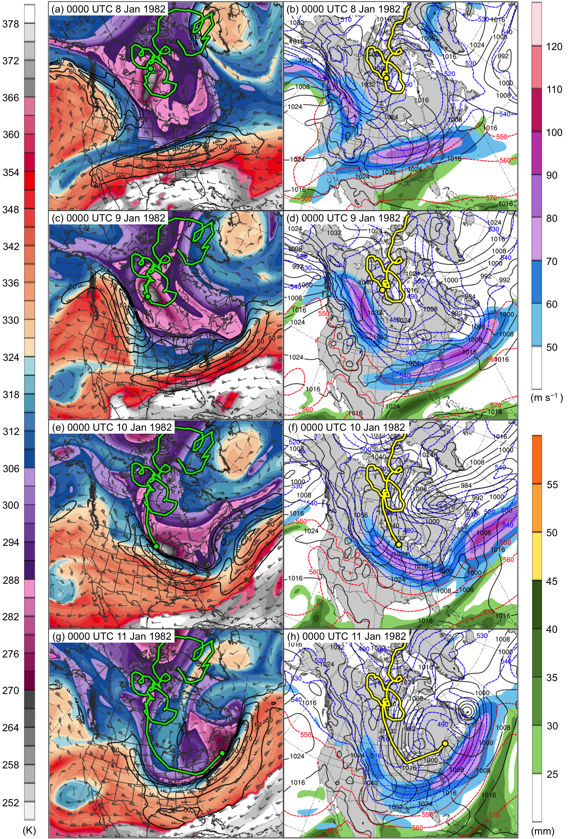
Fig. 4.4. DT (2-PVU surface) potential temperature (K, shaded), wind speed (black contours every 10 m s⁻¹, beginning at 50 m s⁻¹), and wind (m s⁻¹, flags and barbs) at (a) 0000 UTC 8 January, (c) 0000 UTC 9 January, (e) 0000 UTC 10 January, and (g) 0000 UTC 11 January 1982; 250-hPa wind speed (m s⁻¹, shaded), 1000–500-hPa thickness (dashed red and blue contours every 10 dam, contoured red for values >540 dam and blue otherwise), SLP (black contours every 8 hPa), and precipitable water (mm, shaded) at (b) 0000 UTC 8 January, (d) 0000 UTC 9 January, (f) 0000 UTC 10 January, and (h) 0000 UTC 11 January 1982. Green line and dot represent track and position of TPV, respectively, and yellow line and dot represent track and position of cold pool, respectively.
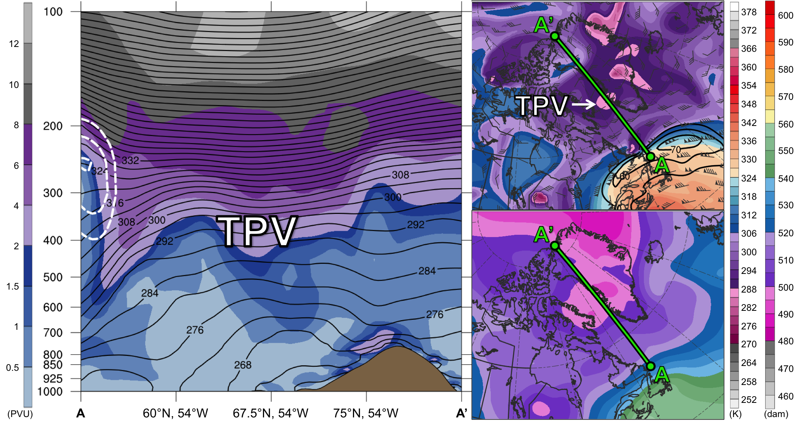
Fig. 4.5. (left) Cross section along line AA’ of PV (PVU, shading), potential temperature (K, black), and wind speed (dashed white contours every 10 m s⁻¹, beginning at 50 m s⁻¹); (upper-right) DT (2-PVU surface) potential temperature (K, shaded), wind speed (black contours every 10 m s⁻¹, beginning at 50 m s⁻¹), and wind (m s⁻¹, flags and barbs); and (lower-right) 1000–500-hPa thickness (dam, shading) at 1200 UTC 16 December 1981. Green line in upper-right and lower-right panels represents transect of cross section AA’. Label “TPV” represents location of TPV.

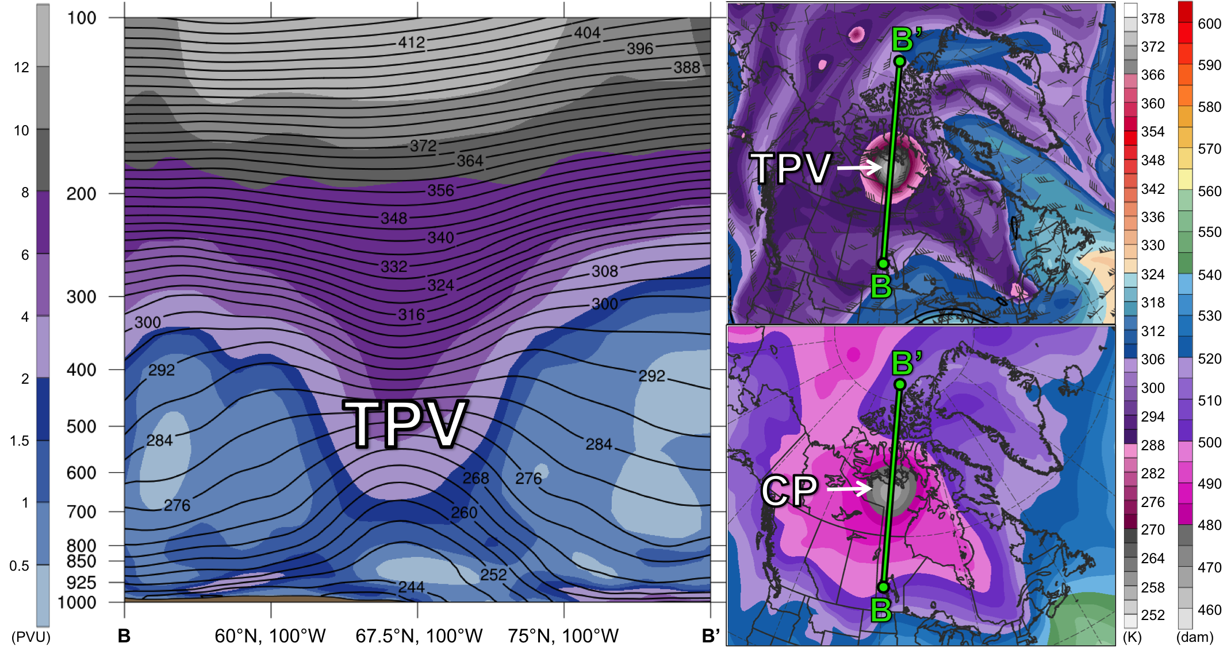
Fig. 4.6. As in Fig. 4.5, but for cross section along line BB’ at 1200 UTC 2 January 1982. Label “CP” represents location of cold pool.

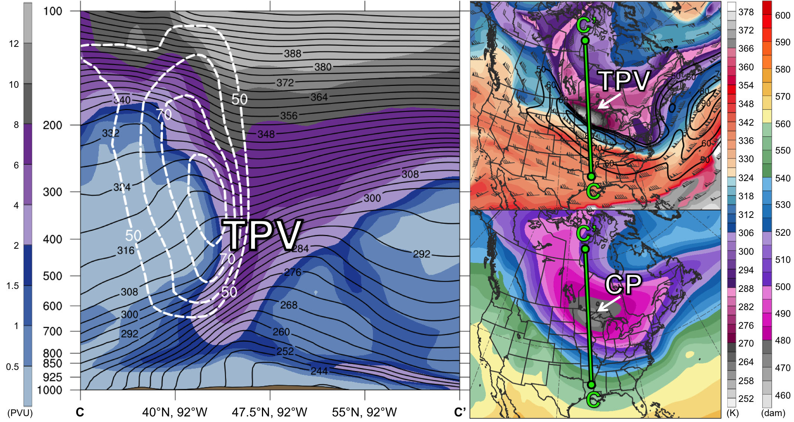
Fig. 4.7. As in Figs. 4.5 and 4.6, but for cross section along line CC’ at 0000 UTC 10 January 1982.
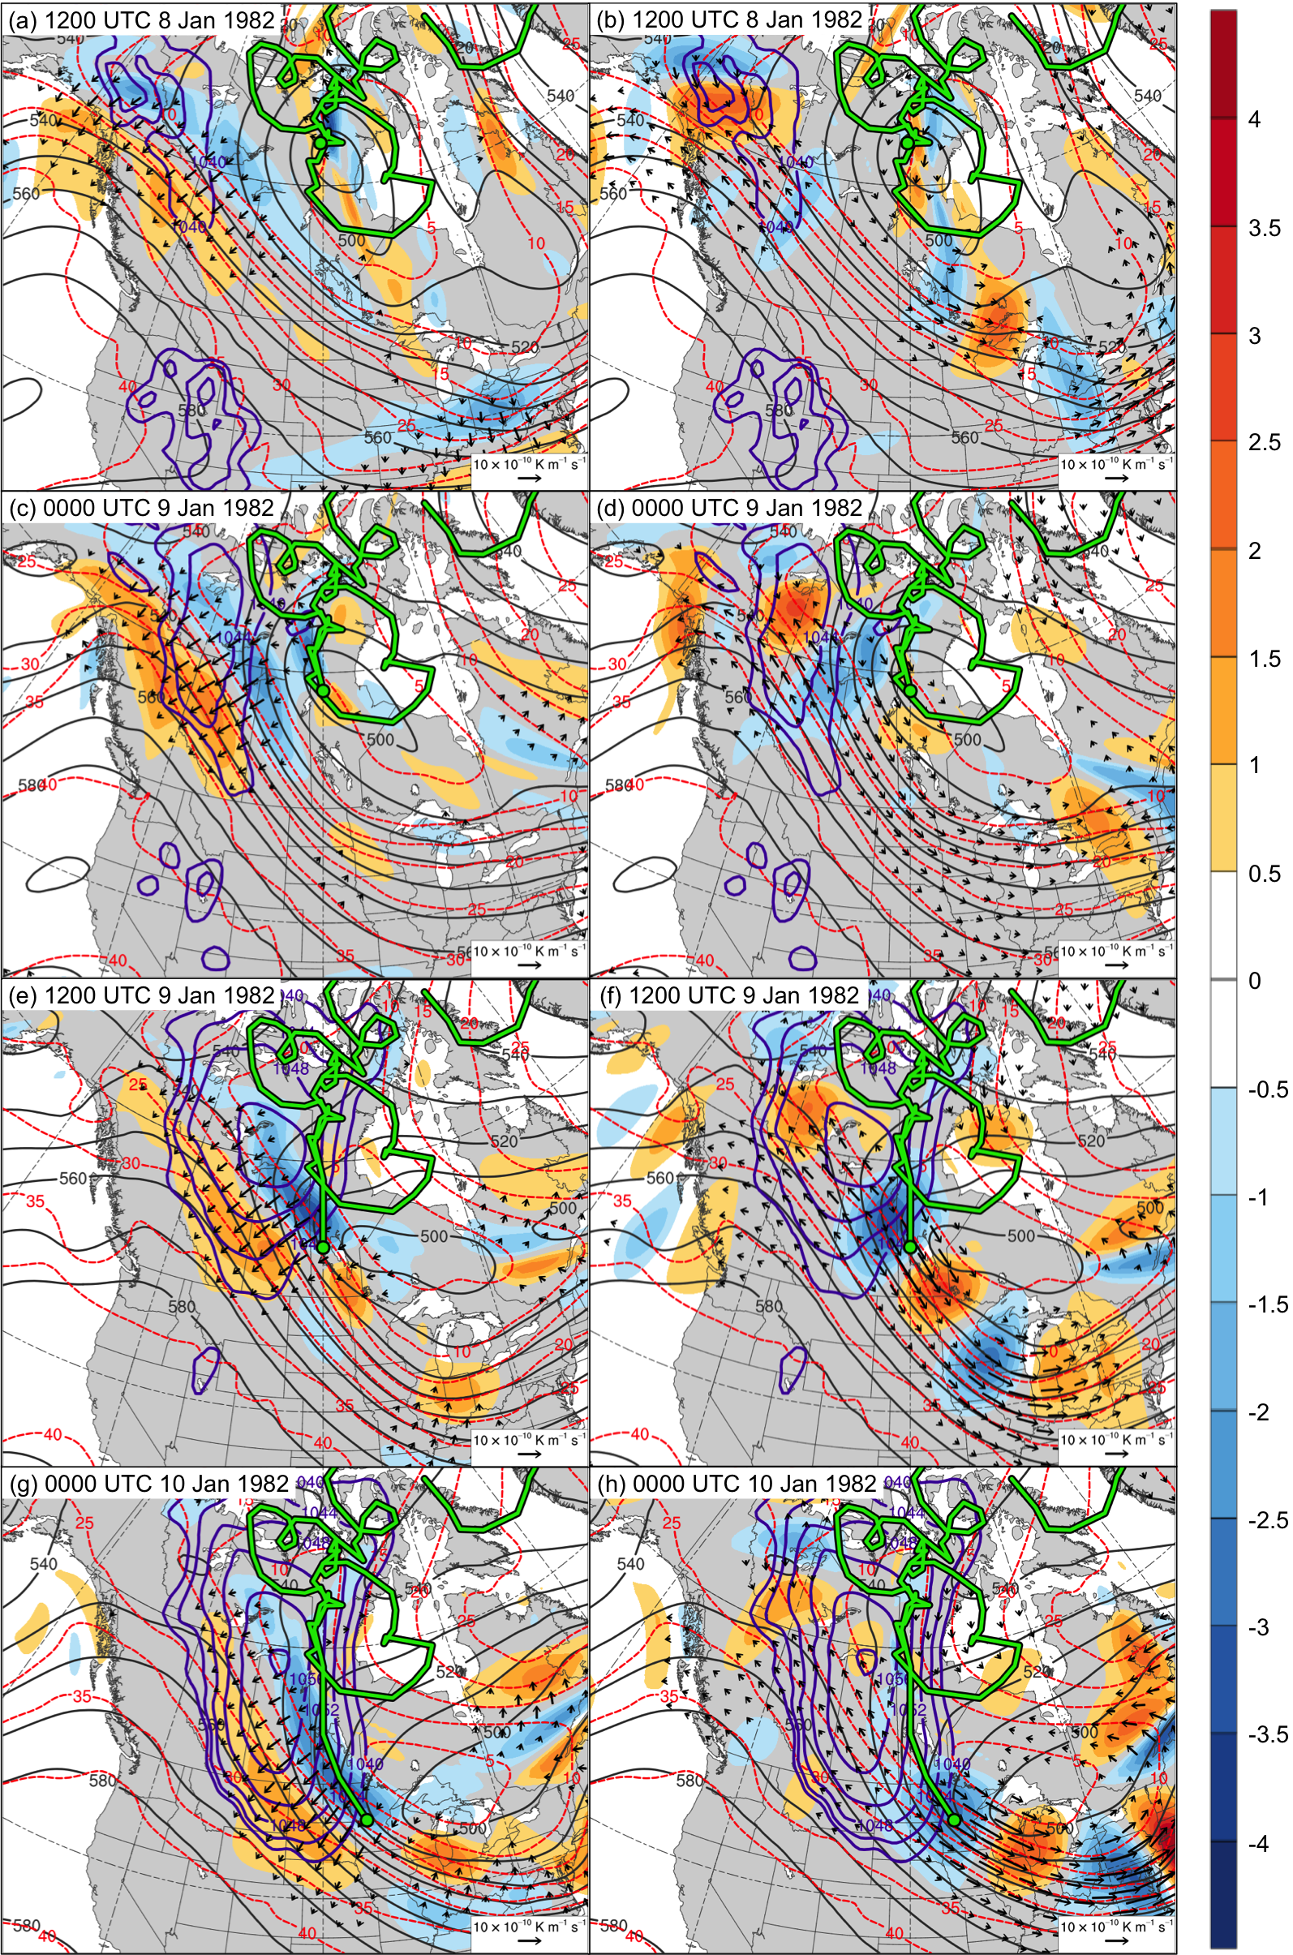
Fig. 4.8. 600–400-hPa Q_{n} (K m⁻¹ s⁻¹, vectors), Q_{n} forcing for vertical motion (10⁻¹⁷ Pa⁻¹ s⁻³, shaded), geopotential height (dark gray contours every 10 dam), potential temperature (dashed red contours every 5°C), and SLP (purple contours every 4 hPa, beginning at 1040 hPa) at (a) 1200 UTC 8 January, (c) 0000 UTC 9 January, (e) 1200 UTC 9 January, and (g) 0000 UTC 10 January 1982; 600–400-hPa Q_{s} (K m⁻¹ s⁻¹, vectors), Q_{s} forcing for vertical motion (10⁻¹⁷ Pa⁻¹ s⁻³, shaded), geopotential height (dark gray contours every 10 dam), potential temperature (dashed red contours every 5°C), and SLP (purple contours every 4 hPa, beginning at 1040 hPa) at (b) 1200 UTC 8 January, (d) 0000 UTC 9 January, (f) 1200 UTC 9 January, and (h) 0000 UTC 10 January 1982. Green line and dot represent track and position of TPV, respectively.
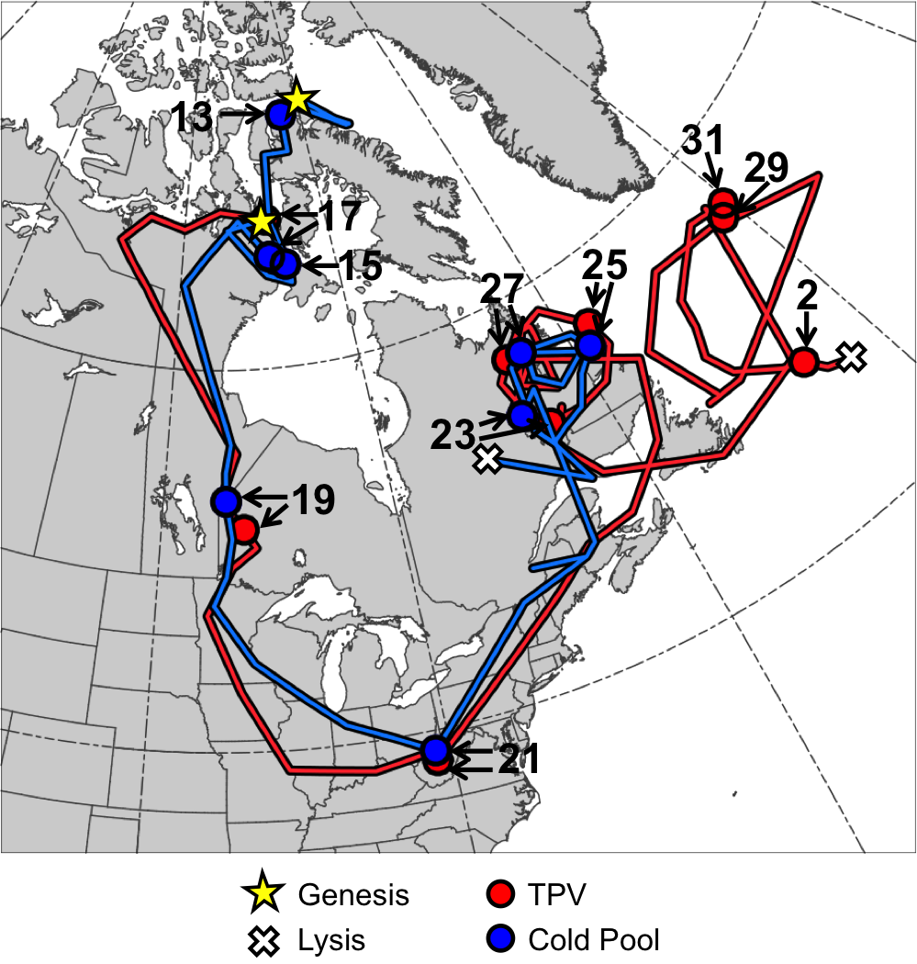
Fig. 4.9. Tracks of TPV (red) from 1800 UTC 16 January to 1200 UTC 2 February 1985 and cold pool (blue) from 1800 UTC 11 January to 0600 UTC 28 January 1985 for January 1985 CAO case. Stars denote locations of genesis, crosses denote locations of lysis, and red and blue dots represent 0000 UTC positions of TPV and cold pool, respectively, every 48 h. Numbers pointing toward dots represent dates of the 0000 UTC positions of the TPV and cold pool, such that numbers ≥13 correspond to dates in January 1985 and the number “2” corresponds to 2 February 1985.

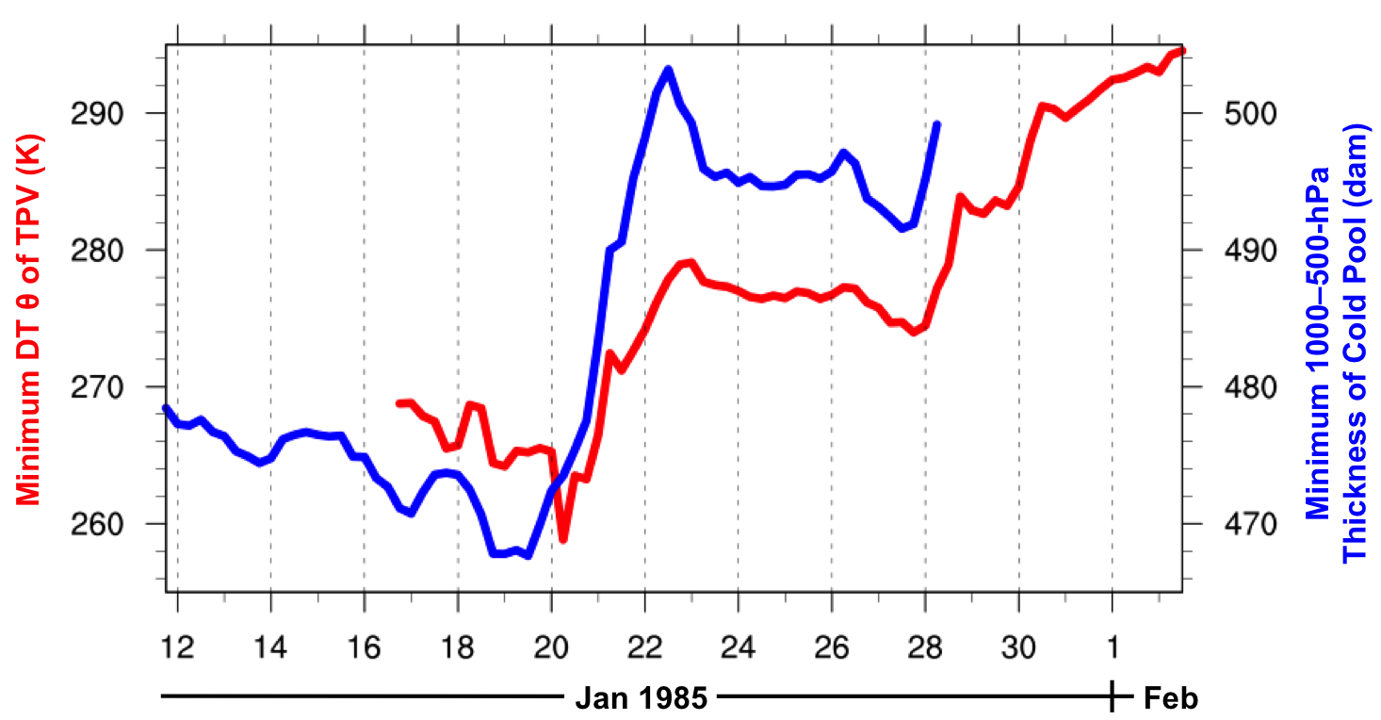
Fig. 4.10. Time series of minimum DT potential temperature (θ) of TPV (K, red) every 6 h from 1800 UTC 16 January to 1200 UTC 2 February 1985 and minimum 1000–500-hPa thickness of cold pool (dam, blue) every 6 h from 1800 UTC 11 January to 0600 UTC 28 January 1985 for January 1985 CAO case.
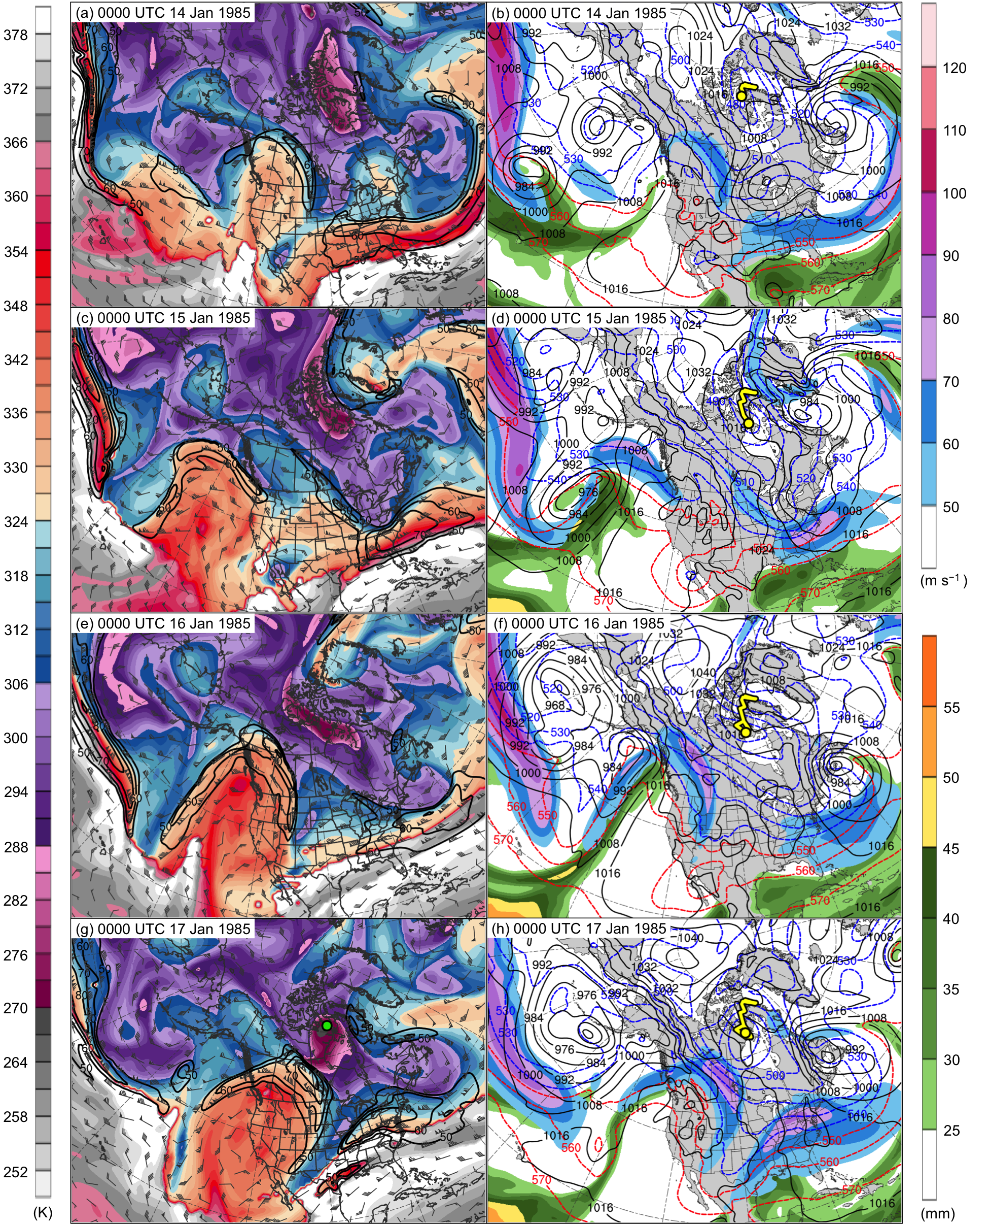
Fig. 4.11. DT (2-PVU surface) potential temperature (K, shaded), wind speed (black contours every 10 m s⁻¹, beginning at 50 m s⁻¹), and wind (m s⁻¹, flags and barbs) at (a) 0000 UTC 14 January, (c) 0000 UTC 15 January, (e) 0000 UTC 16 January, (g) 0000 UTC 17 January, (i) 0000 UTC 18 January, (k) 0000 UTC 19 January, (m) 0000 UTC 20 January, and (o) 0000 UTC 21 January 1985; 250-hPa wind speed (m s⁻¹, shaded), 1000–500-hPa thickness (dashed red and blue contours every 10 dam, contoured red for values >540 dam and blue otherwise), SLP (black contours every 8 hPa), and precipitable water (mm, shaded) at (b) 0000 UTC 14 January, (d) 0000 UTC 15 January, (f) 0000 UTC 16 January, (h) 0000 UTC 17 January, (j) 0000 UTC 18 January, (l) 0000 UTC 19 January, (n) 0000 UTC 20 January, and (p) 0000 UTC 21 January 1985. Green line and dot represent track and position of TPV, respectively, and yellow line and dot represent track and position of cold pool, respectively.
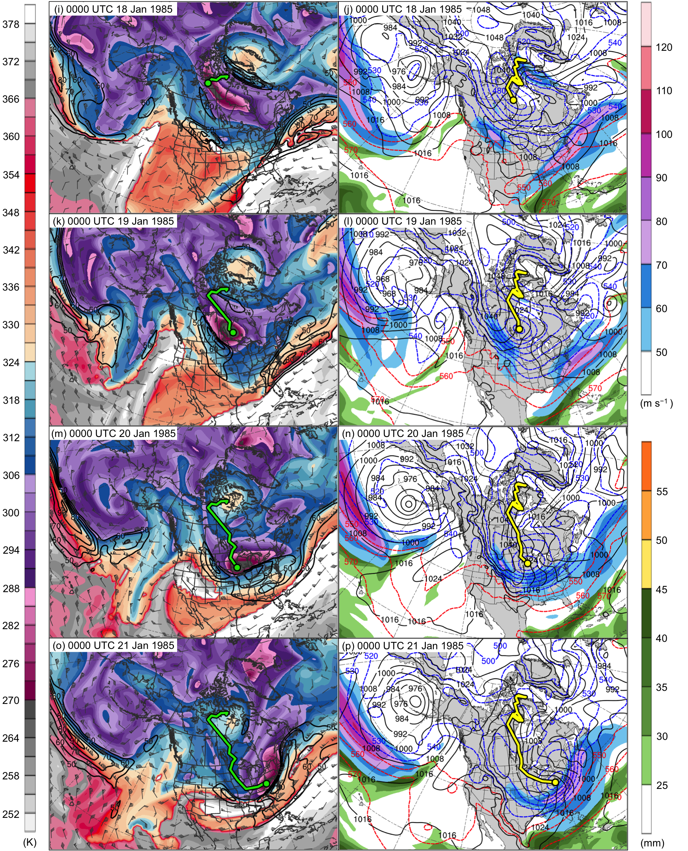
Fig. 4.11. continued.
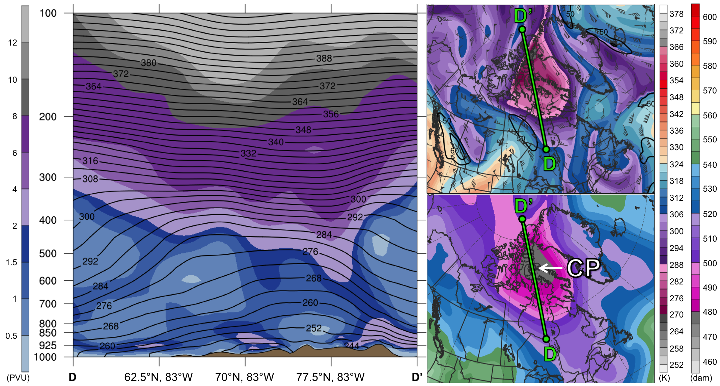
Fig. 4.12. As in Fig. 4.5, but for cross section along line DD’ at 0000 UTC 13 January 1985.

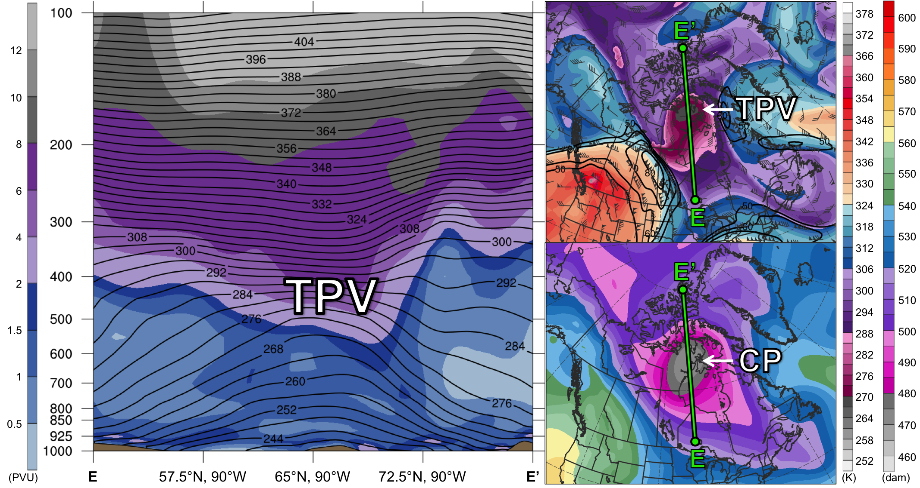
Fig. 4.13. As in Fig. 4.5, but for cross section along line EE’ at 0000 UTC 17 January 1985.

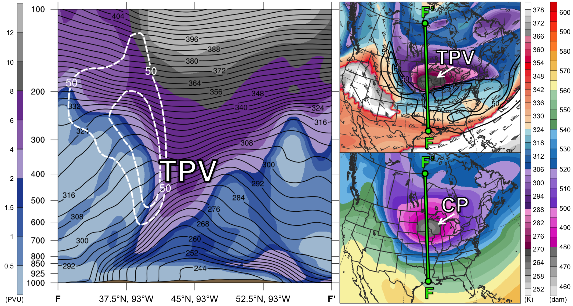
Fig. 4.14. As in Fig. 4.5, but for cross section along line FF’ at 0000 UTC 20 January 1985.

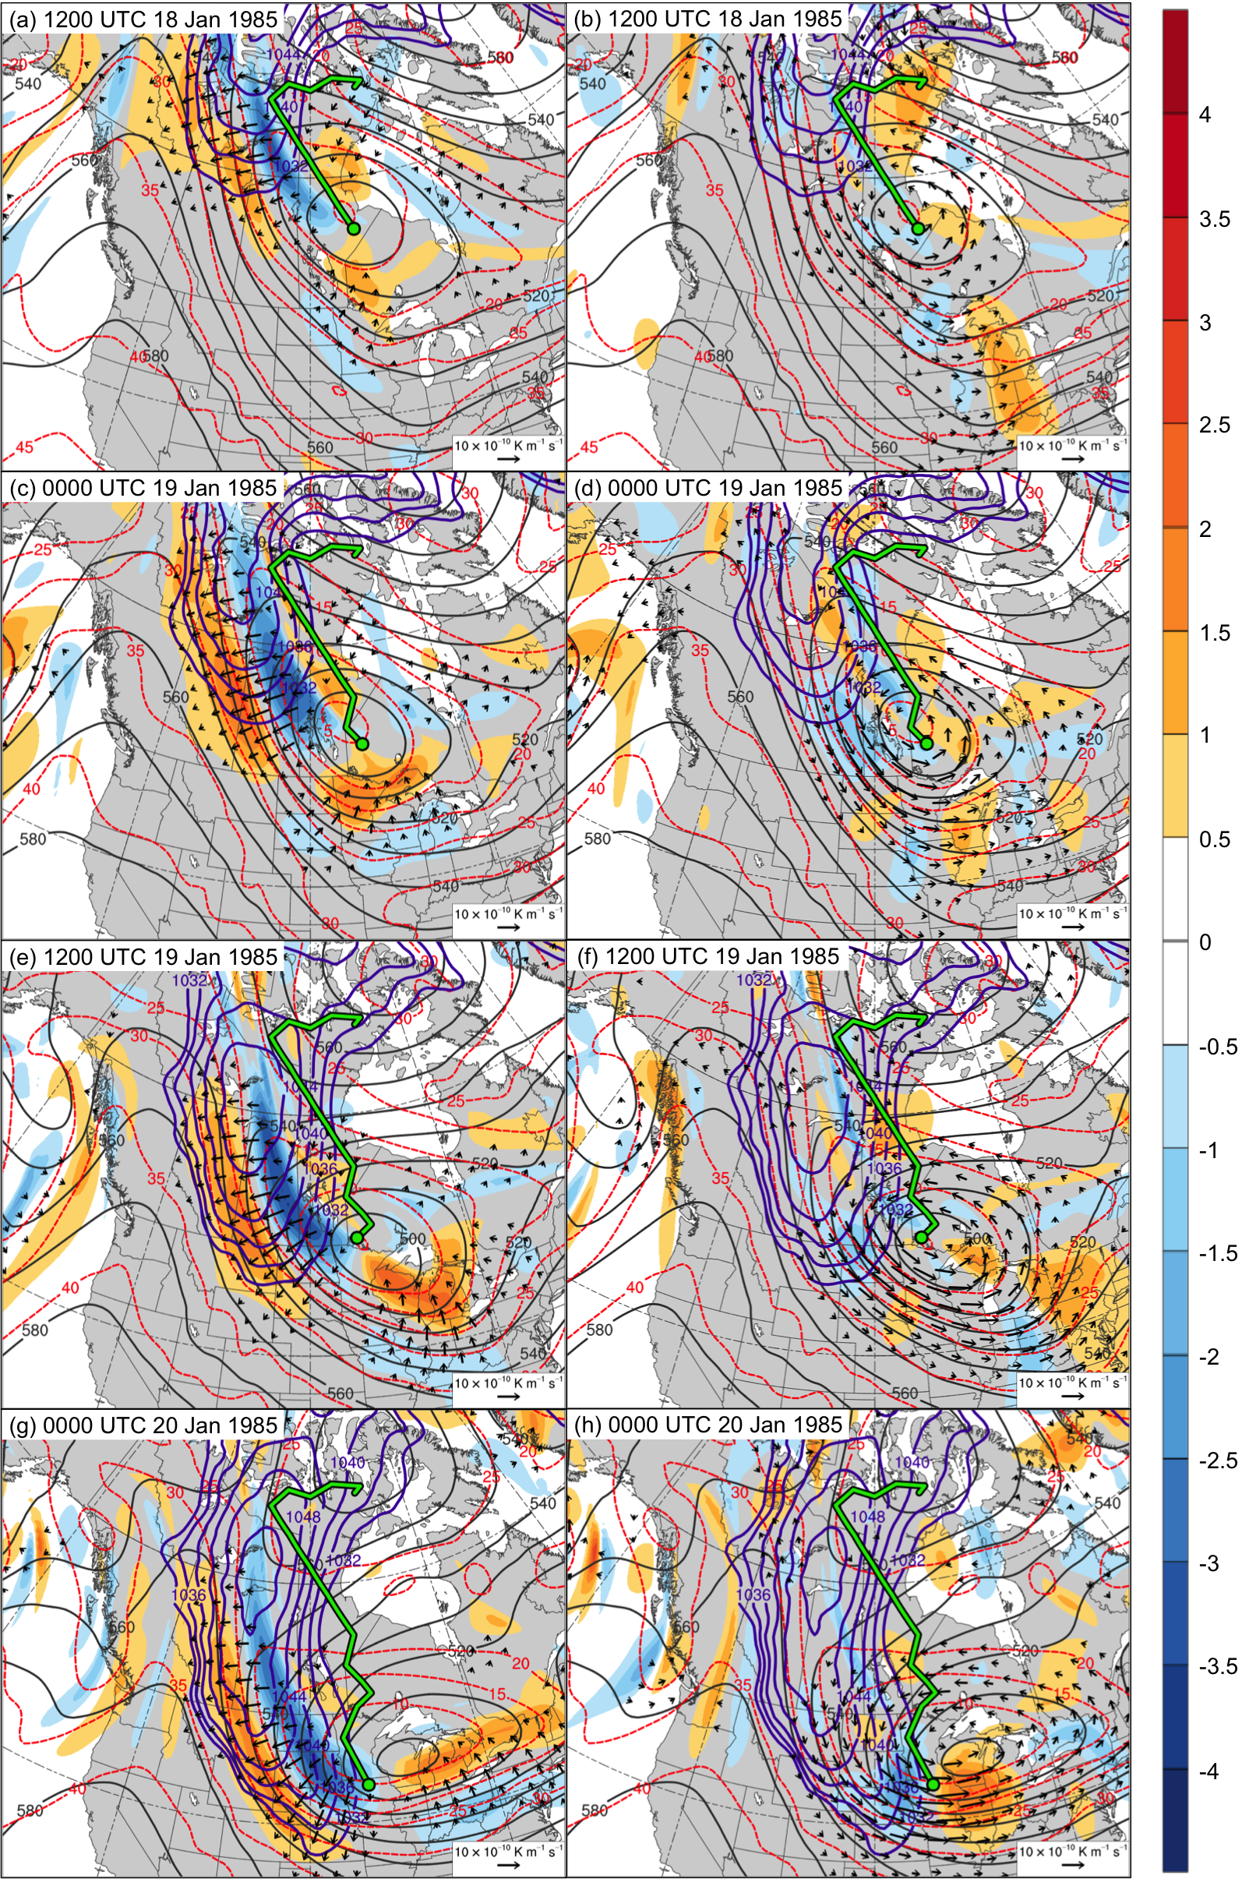
Fig. 4.15. 600–400-hPa Q_{n} (K m⁻¹ s⁻¹, vectors), Q_{n} forcing for vertical motion (10⁻¹⁷ Pa⁻¹ s⁻³, shaded), geopotential height (dark gray contours every 10 dam), potential temperature (dashed red contours every 5°C), and SLP (purple contours every 4 hPa, beginning at 1032 hPa) at (a) 1200 UTC 18 January, (c) 0000 UTC 19 January, (e) 1200 UTC 19 January, and (g) 0000 UTC 20 January 1985; 600–400-hPa Q_{s} (K m⁻¹ s⁻¹, vectors), Q_{s} forcing for vertical motion (10⁻¹⁷ Pa⁻¹ s⁻³, shaded), geopotential height (dark gray contours every 10 dam), potential temperature (dashed red contours every 5°C), and SLP (purple contours every 4 hPa, beginning at 1032 hPa) at (b) 1200 UTC 18 January, (d) 0000 UTC 19 January, (f) 1200 UTC 19 January, and (h) 0000 UTC 20 January 1985. Green line and dot represent track and position of TPV, respectively.

