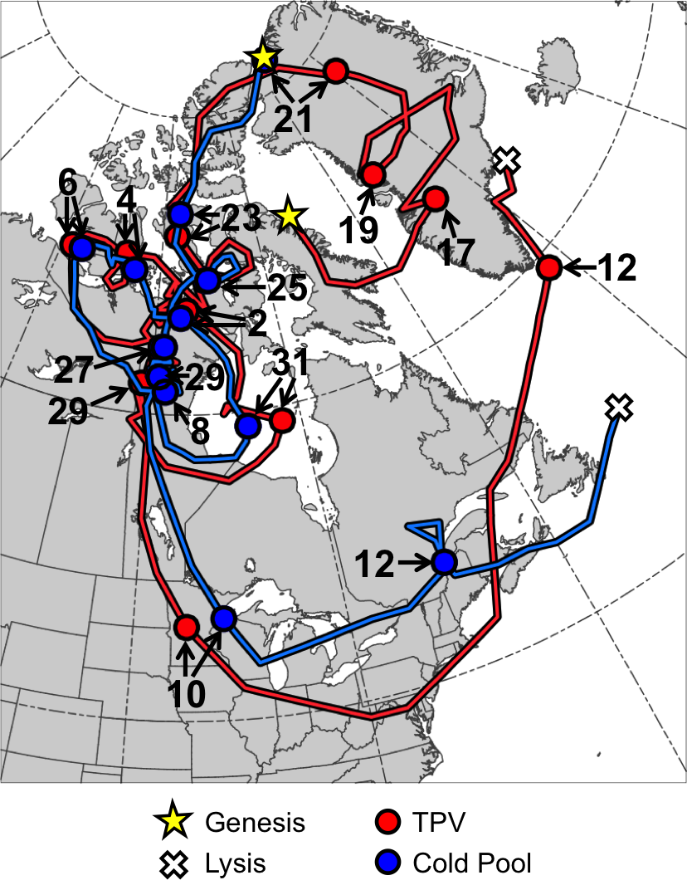
Fig. 4.1. Tracks of TPV (red) from 0600 UTC 15 December 1981 to 0000 UTC 13 January 1982 and cold pool (blue) from 1800 UTC 20 December 1981 to 1800 UTC 13 January 1982 for January 1982 CAO case. Stars denote locations of genesis, crosses denote locations of lysis, and red and blue dots represent 0000 UTC positions of TPV and cold pool, respectively, every 48 h. Numbers pointing toward dots represent dates of the 0000 UTC positions of the TPV and cold pool, such that numbers ≥17 correspond to dates in December 1981 and numbers ≤12 correspond to dates in January 1982.

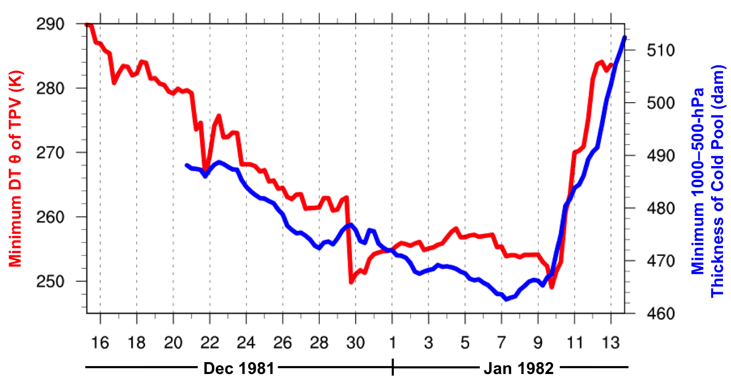
Fig. 4.2. Time series of minimum DT potential temperature (θ) of TPV (K, red) every 6 h from 0600 UTC 15 December 1981 to 0000 UTC 13 January 1982 and minimum 1000–500-hPa thickness of cold pool (dam, blue) every 6 h from 1800 UTC 20 December 1981 to 1800 UTC 13 January 1982 for January 1982 CAO case.
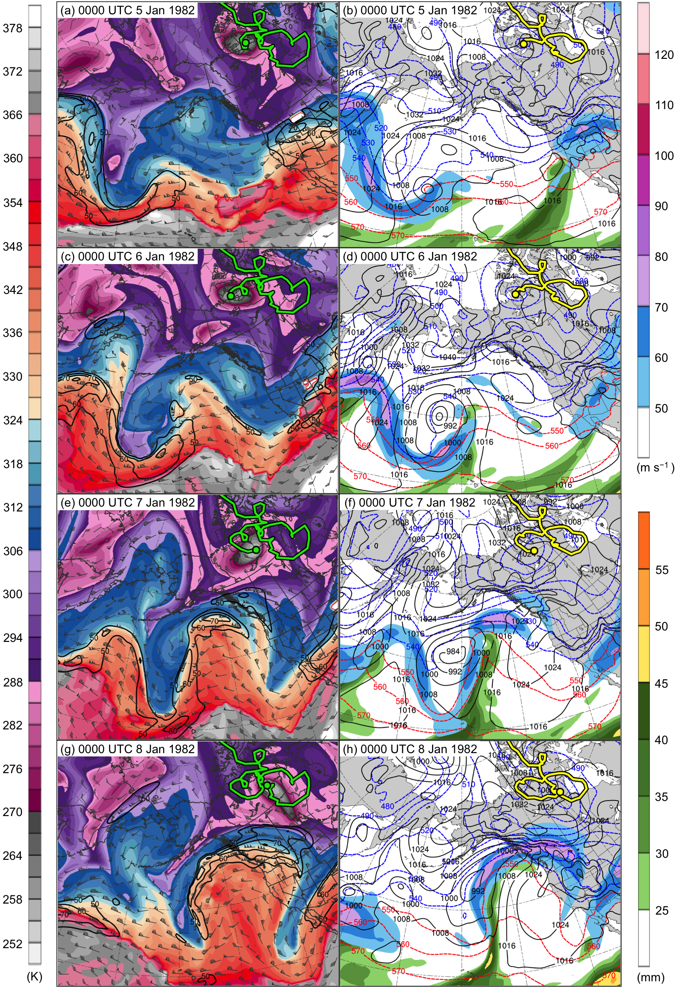
Fig. 4.3. DT (2-PVU surface) potential temperature (K, shaded), wind speed (black contours every 10 m s⁻¹, beginning at 50 m s⁻¹), and wind (m s⁻¹, flags and barbs) at (a) 0000 UTC 5 January, (c) 0000 UTC 6 January, (e) 0000 UTC 7 January, and (g) 0000 UTC 8 January 1982; 250-hPa wind speed (m s⁻¹, shaded), 1000–500-hPa thickness (dashed red and blue contours every 10 dam, contoured red for values >540 dam and blue otherwise), SLP (black contours every 8 hPa), and precipitable water (mm, shaded) at (b) 0000 UTC 5 January, (d) 0000 UTC 6 January, (f) 0000 UTC 7 January, and (h) 0000 UTC 8 January 1982. Green line and dot represent track and position of TPV, respectively, and yellow line and dot represent track and position of cold pool, respectively.
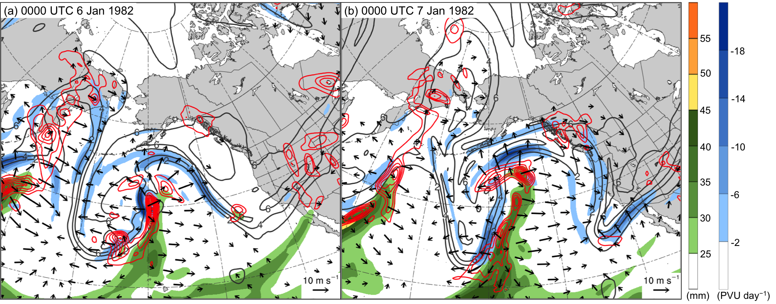

Fig. 4.4. Precipitable water (mm, shaded), 600–400-hPa ascent (red contours every 2.5 × 10⁻³ hPa s⁻¹), and 300–200-hPa PV (PVU, gray) and negative PV advection by the irrotational wind (PVU day⁻¹, shaded) at (a) 0000 UTC 6 January and (b) 0000 UTC 7 January 1982.

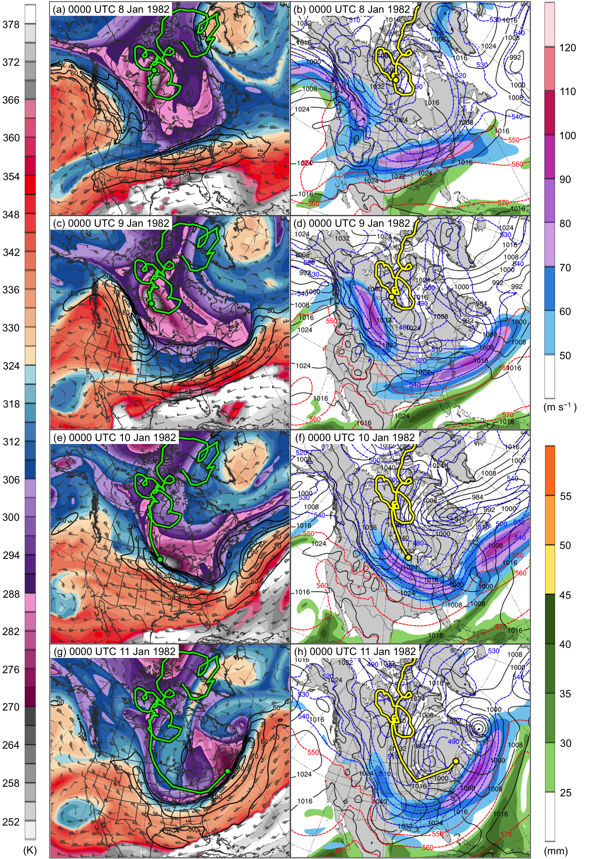
Fig. 4.5. DT (2-PVU surface) potential temperature (K, shaded), wind speed (black contours every 10 m s⁻¹, beginning at 50 m s⁻¹), and wind (m s⁻¹, flags and barbs) at (a) 0000 UTC 8 January, (c) 0000 UTC 9 January, (e) 0000 UTC 10 January, and (g) 0000 UTC 11 January 1982; 250-hPa wind speed (m s⁻¹, shaded), 1000–500-hPa thickness (dashed red and blue contours every 10 dam, contoured red for values >540 dam and blue otherwise), SLP (black contours every 8 hPa), and precipitable water (mm, shaded) at (b) 0000 UTC 8 January, (d) 0000 UTC 9 January, (f) 0000 UTC 10 January, and (h) 0000 UTC 11 January 1982. Green line and dot represent track and position of TPV, respectively, and yellow line and dot represent track and position of cold pool, respectively.
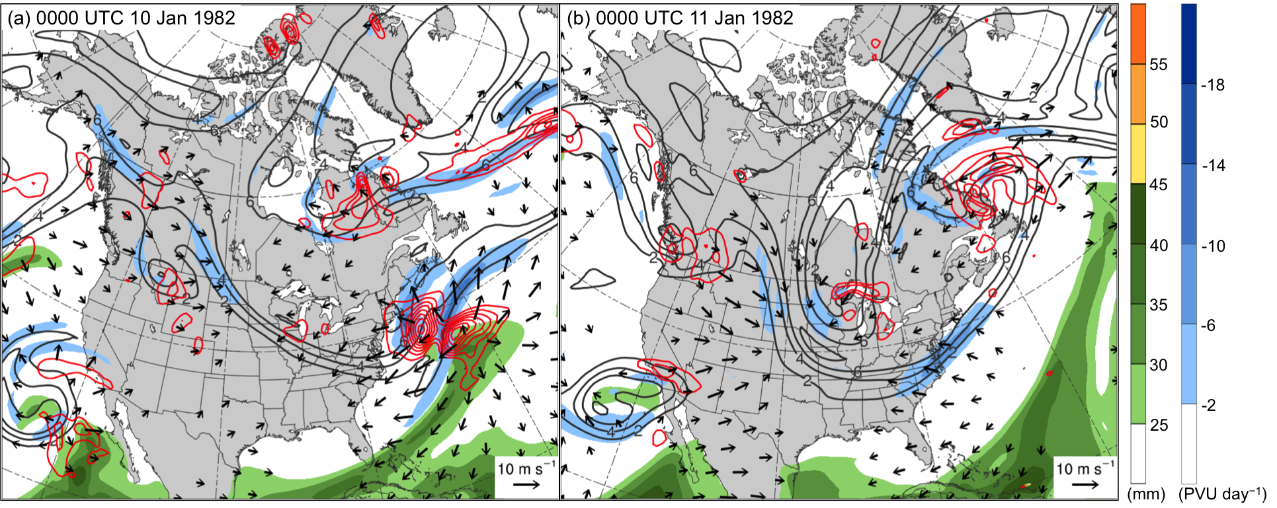

Fig. 4.6. Precipitable water (mm, shaded), 600–400-hPa ascent (red contours every 2.5 × 10⁻³ hPa s⁻¹), and 300–200-hPa PV (PVU, gray) and negative PV advection by the irrotational wind (PVU day⁻¹, shaded) at (a) 0000 UTC 10 January and (b) 0000 UTC 11 January 1982.

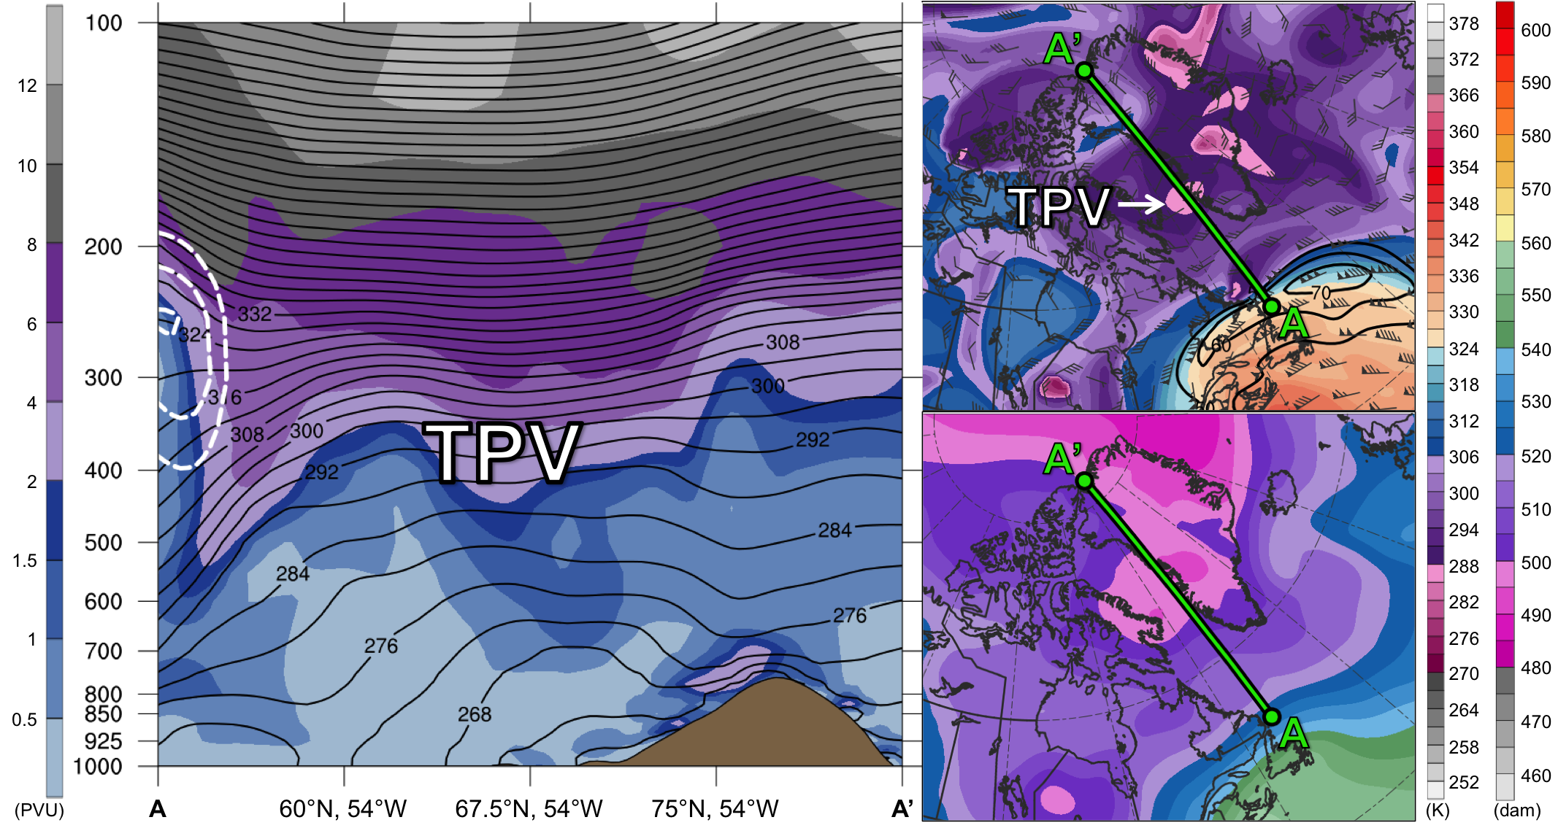
Fig. 4.7. (left) Cross section along line AA’ of PV (PVU, shading), potential temperature (K, black), and wind speed (dashed white contours every 10 m s⁻¹, beginning at 50 m s⁻¹); (upper-right) DT (2-PVU surface) potential temperature (K, shaded), wind speed (black contours every 10 m s⁻¹, beginning at 50 m s⁻¹), and wind (m s⁻¹, flags and barbs); and (lower-right) 1000–500-hPa thickness (dam, shading) at 1200 UTC 16 December 1981. Green line in upper-right and lower-right panels represents transect of cross section AA’. Label “TPV” represents location of TPV.
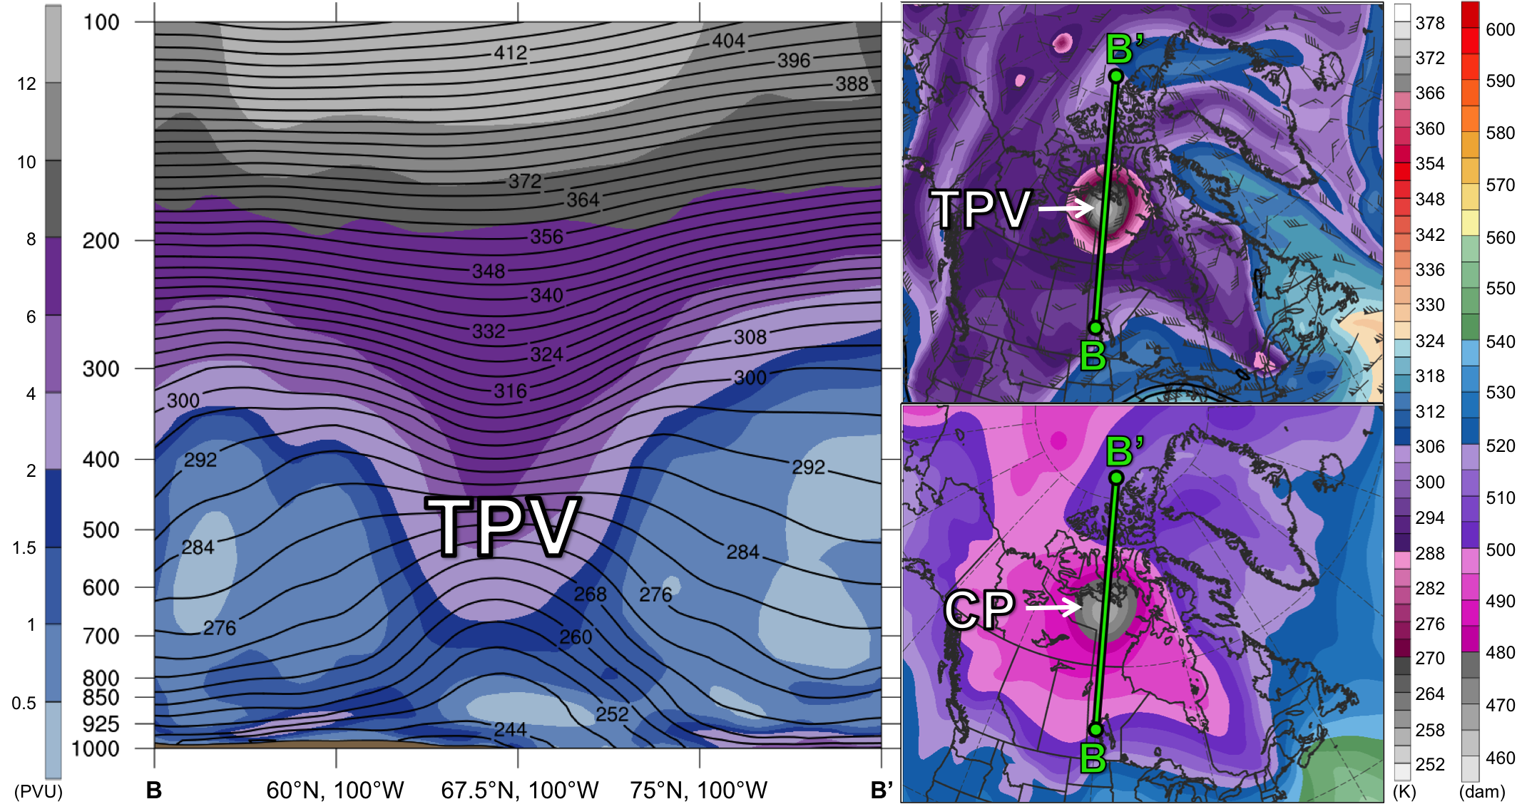
Fig. 4.8. As in Fig. 4.7, but for cross section along line BB’ at 1200 UTC 2 January 1982. Label “CP” represents location of cold pool.

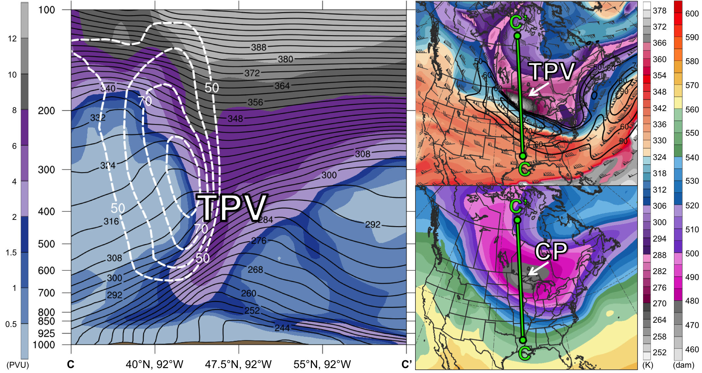
Fig. 4.9. As in Figs. 4.7 and 4.8, but for cross section along line CC’ at 0000 UTC 10 January 1982.

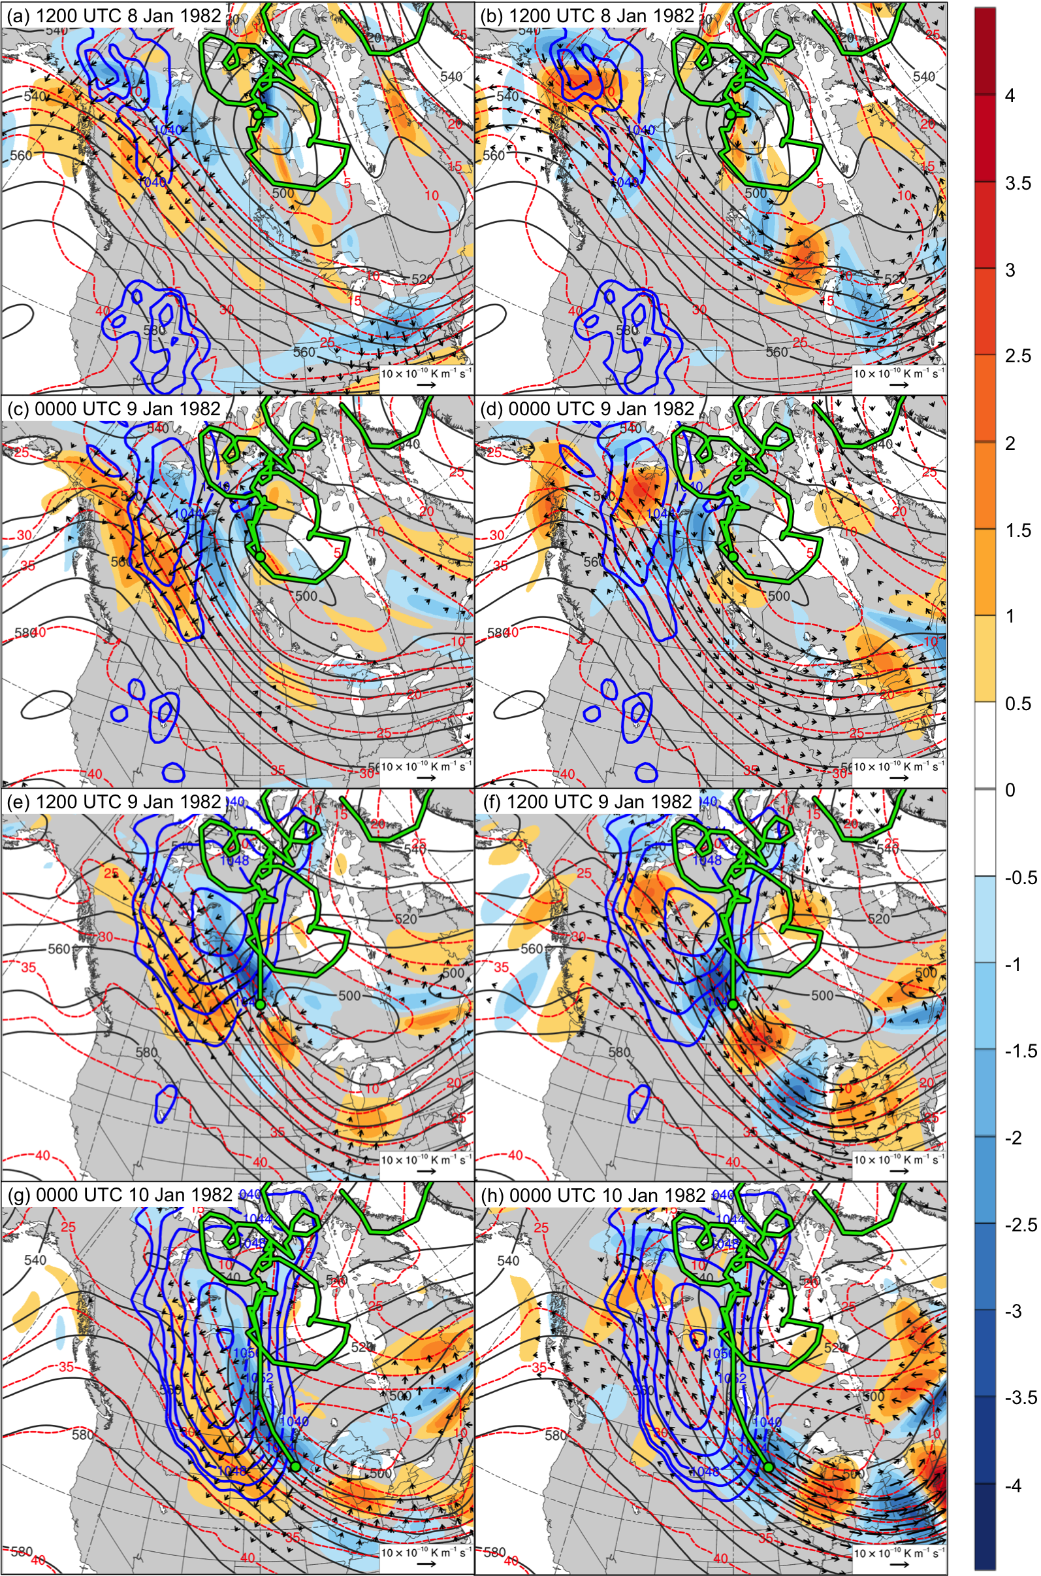
Fig. 4.10. SLP (blue contours every 4 hPa, beginning at 1040 hPa) and 600–400-hPa Q_{n} (K m⁻¹ s⁻¹, vectors), Q_{n} forcing for vertical motion (10⁻¹⁷ Pa⁻¹ s⁻³, shaded), geopotential height (dark gray contours every 10 dam), and potential temperature (dashed red contours every 5°C) at (a) 1200 UTC 8 January, (c) 0000 UTC 9 January, (e) 1200 UTC 9 January, and (g) 0000 UTC 10 January 1982; SLP (blue contours every 4 hPa, beginning at 1040 hPa) and 600–400-hPa Q_{s} (K m⁻¹ s⁻¹, vectors), Q_{s} forcing for vertical motion (10⁻¹⁷ Pa⁻¹ s⁻³, shaded), geopotential height (dark gray contours every 10 dam), and potential temperature (dashed red contours every 5°C) at (b) 1200 UTC 8 January, (d) 0000 UTC 9 January, (f) 1200 UTC 9 January, and (h) 0000 UTC 10 January 1982. Green line and dot represent track and position of TPV, respectively.
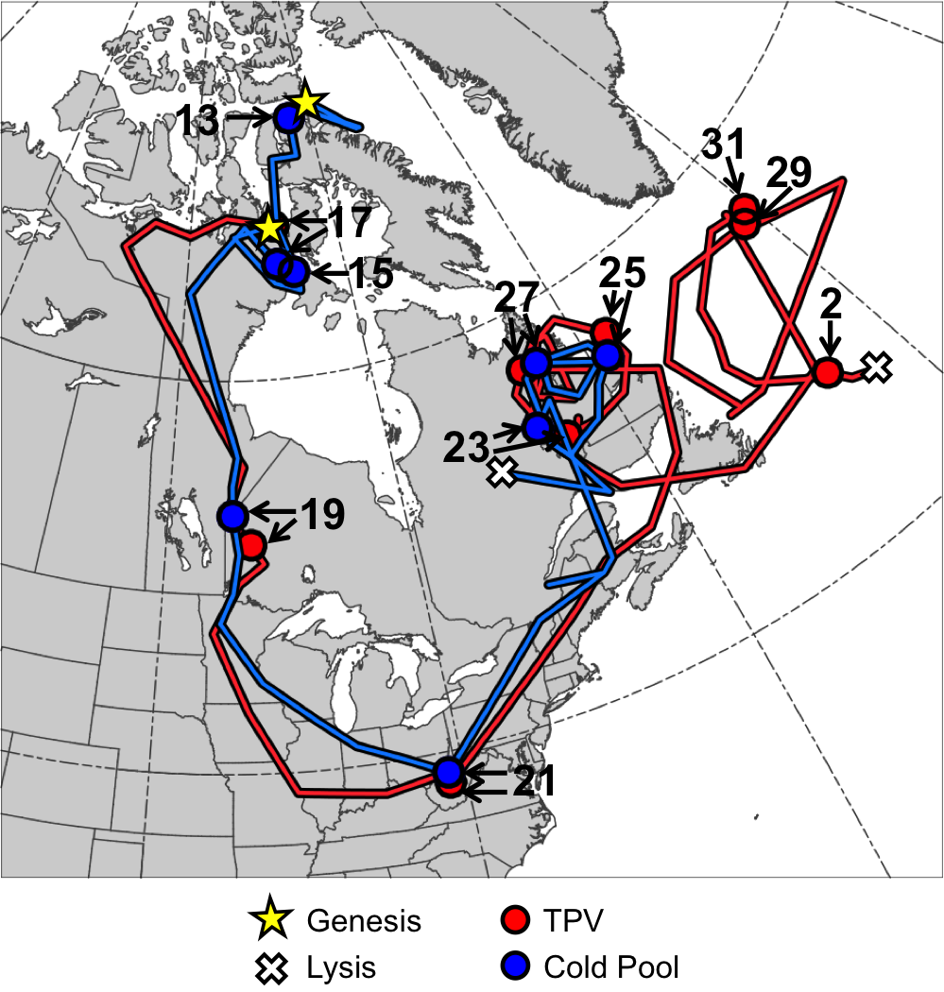
Fig. 4.11. Tracks of TPV (red) from 1800 UTC 16 January to 1200 UTC 2 February 1985 and cold pool (blue) from 1800 UTC 11 January to 0600 UTC 28 January 1985 for January 1985 CAO case. Stars denote locations of genesis, crosses denote locations of lysis, and red and blue dots represent 0000 UTC positions of TPV and cold pool, respectively, every 48 h. Numbers pointing toward dots represent dates of the 0000 UTC positions of the TPV and cold pool, such that numbers ≥13 correspond to dates in January 1985 and the number “2” corresponds to 2 February 1985.

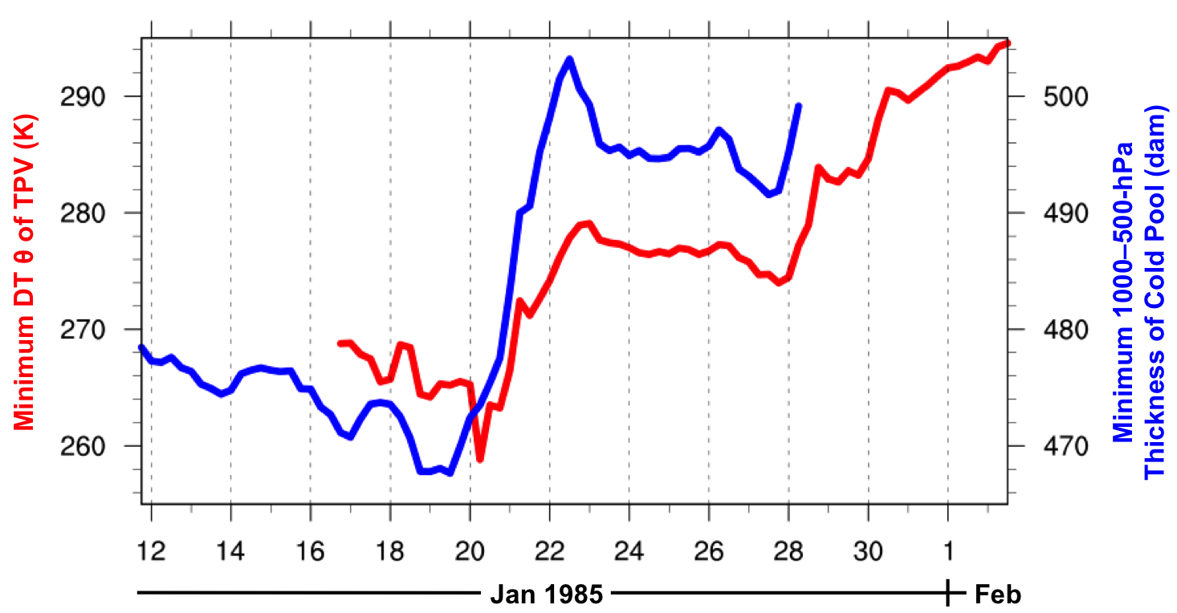
Fig. 4.12. Time series of minimum DT potential temperature (θ) of TPV (K, red) every 6 h from 1800 UTC 16 January to 1200 UTC 2 February 1985 and minimum 1000–500-hPa thickness of cold pool (dam, blue) every 6 h from 1800 UTC 11 January to 0600 UTC 28 January 1985 for January 1985 CAO case.
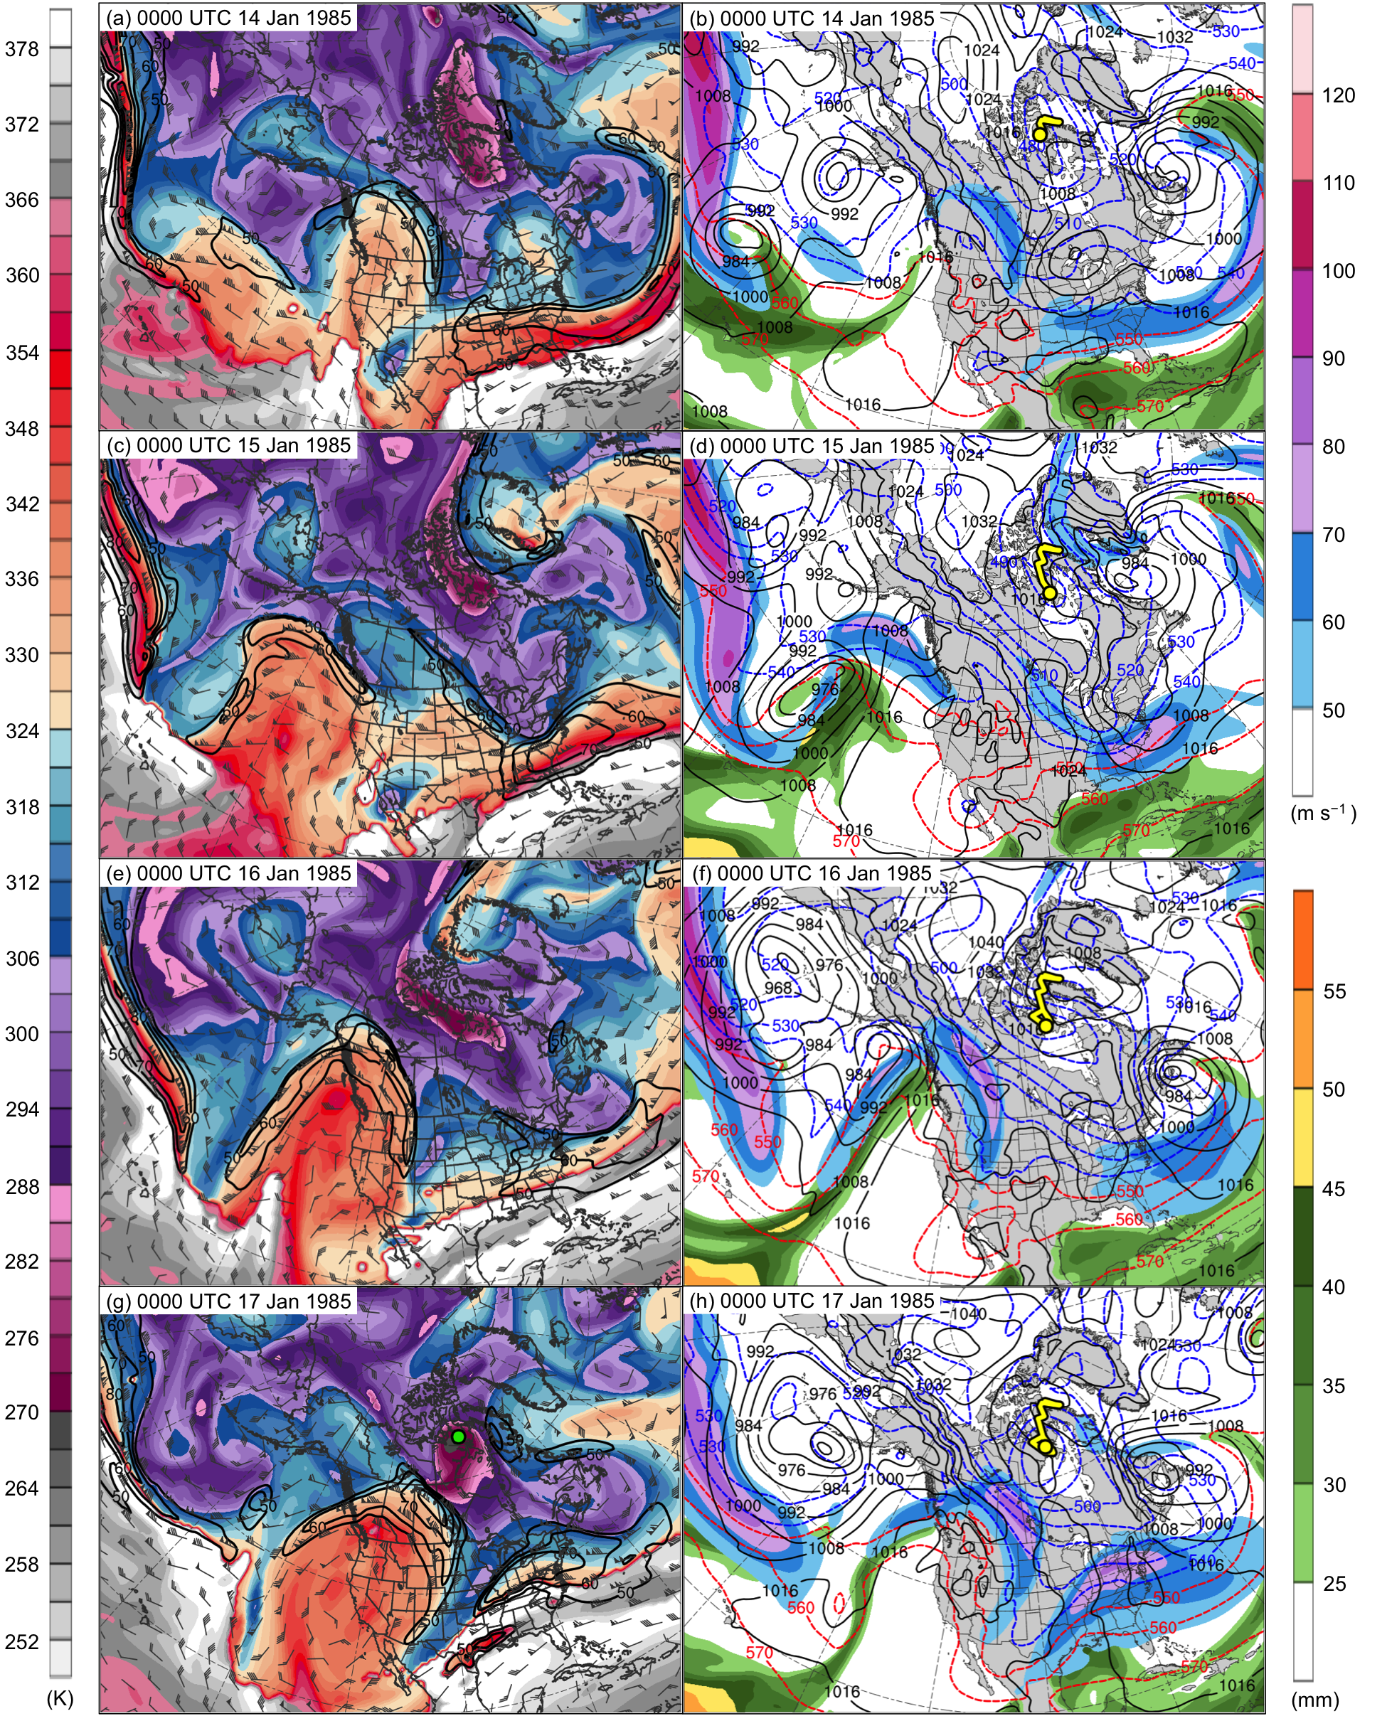
Fig. 4.13. DT (2-PVU surface) potential temperature (K, shaded), wind speed (black contours every 10 m s⁻¹, beginning at 50 m s⁻¹), and wind (m s⁻¹, flags and barbs) at (a) 0000 UTC 14 January, (c) 0000 UTC 15 January, (e) 0000 UTC 16 January, and (g) 0000 UTC 17 January 1985; 250-hPa wind speed (m s⁻¹, shaded), 1000–500-hPa thickness (dashed red and blue contours every 10 dam, contoured red for values >540 dam and blue otherwise), SLP (black contours every 8 hPa), and precipitable water (mm, shaded) at (b) 0000 UTC 14 January, (d) 0000 UTC 15 January, (f) 0000 UTC 16 January, and (h) 0000 UTC 17 January 1985. Green line and dot represent track and position of TPV, respectively, and yellow line and dot represent track and position of cold pool, respectively.

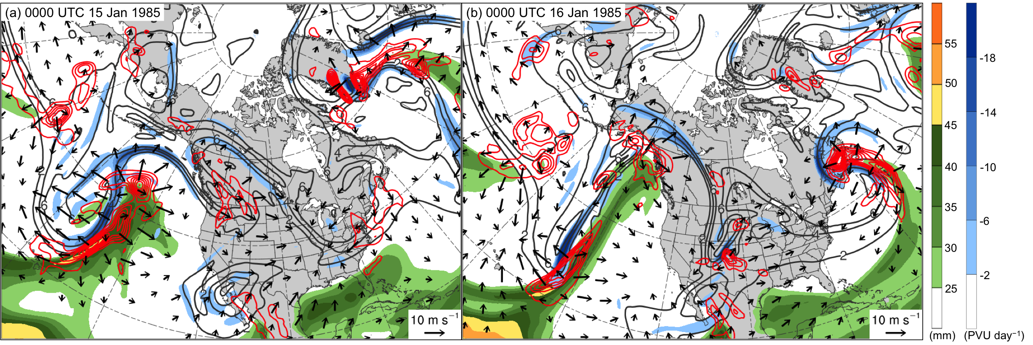

Fig. 4.14. Precipitable water (mm, shaded), 600–400-hPa ascent (red contours every 2.5 × 10⁻³ hPa s⁻¹), and 300–200-hPa PV (PVU, gray) and negative PV advection by the irrotational wind (PVU day⁻¹, shaded) at (a) 0000 UTC 15 January and (b) 0000 UTC 16 January 1985.

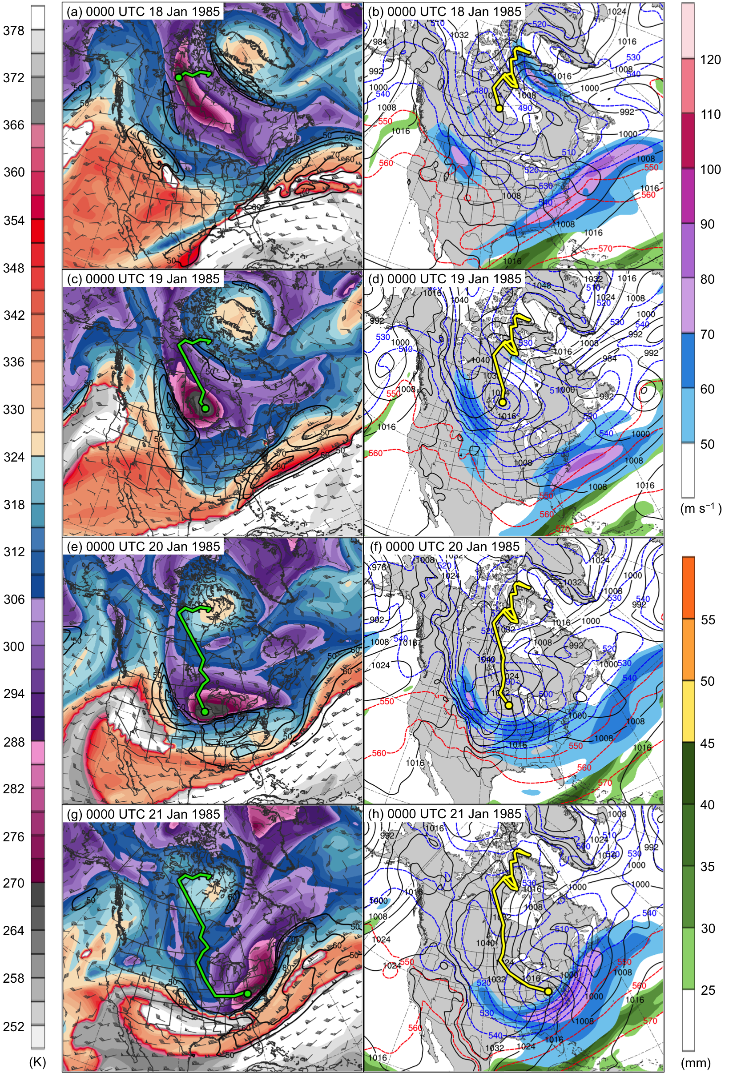

Fig. 4.15. DT (2-PVU surface) potential temperature (K, shaded), wind speed (black contours every 10 m s⁻¹, beginning at 50 m s⁻¹), and wind (m s⁻¹, flags and barbs) at (a) 0000 UTC 18 January, (c) 0000 UTC 19 January, (e) 0000 UTC 20 January, and (g) 0000 UTC 21 January 1985; 250-hPa wind speed (m s⁻¹, shaded), 1000–500-hPa thickness (dashed red and blue contours every 10 dam, contoured red for values >540 dam and blue otherwise), SLP (black contours every 8 hPa), and precipitable water (mm, shaded) at (b) 0000 UTC 18 January, (d) 0000 UTC 19 January, (f) 0000 UTC 20 January, and (h) 0000 UTC 21 January 1985. Green line and dot represent track and position of TPV, respectively, and yellow line and dot represent track and position of cold pool, respectively.
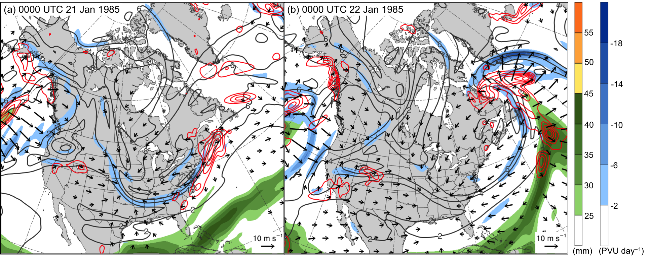

Fig. 4.16. Precipitable water (mm, shaded), 600–400-hPa ascent (red contours every 2.5 × 10⁻³ hPa s⁻¹), and 300–200-hPa PV (PVU, gray) and negative PV advection by the irrotational wind (PVU day⁻¹, shaded) at (a) 0000 UTC 15 January and (b) 0000 UTC 16 January 1985.

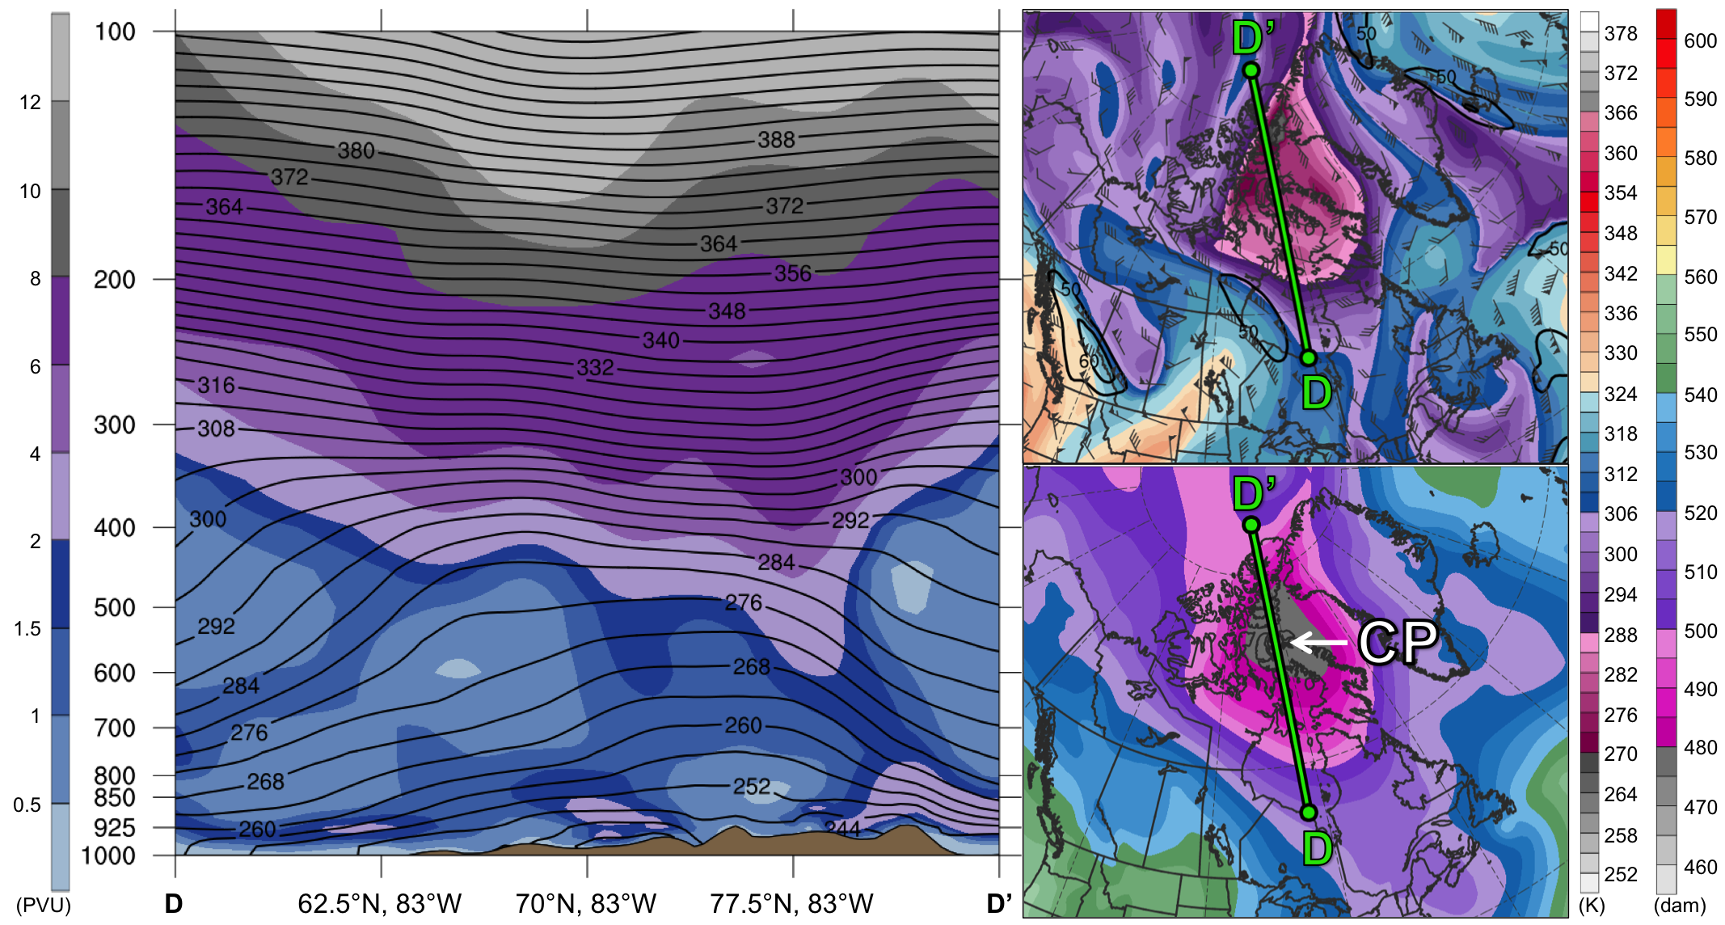
Fig. 4.17. As in Fig. 4.7, but for cross section along line DD’ at 0000 UTC 13 January 1985.

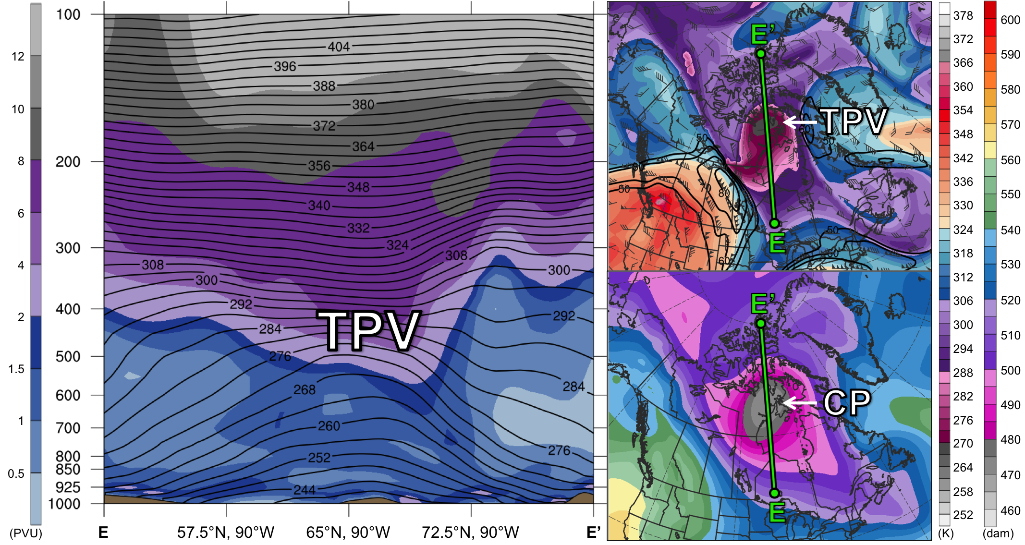
Fig. 4.18. As in Fig. 4.7, but for cross section along line EE’ at 0000 UTC 17 January 1985.

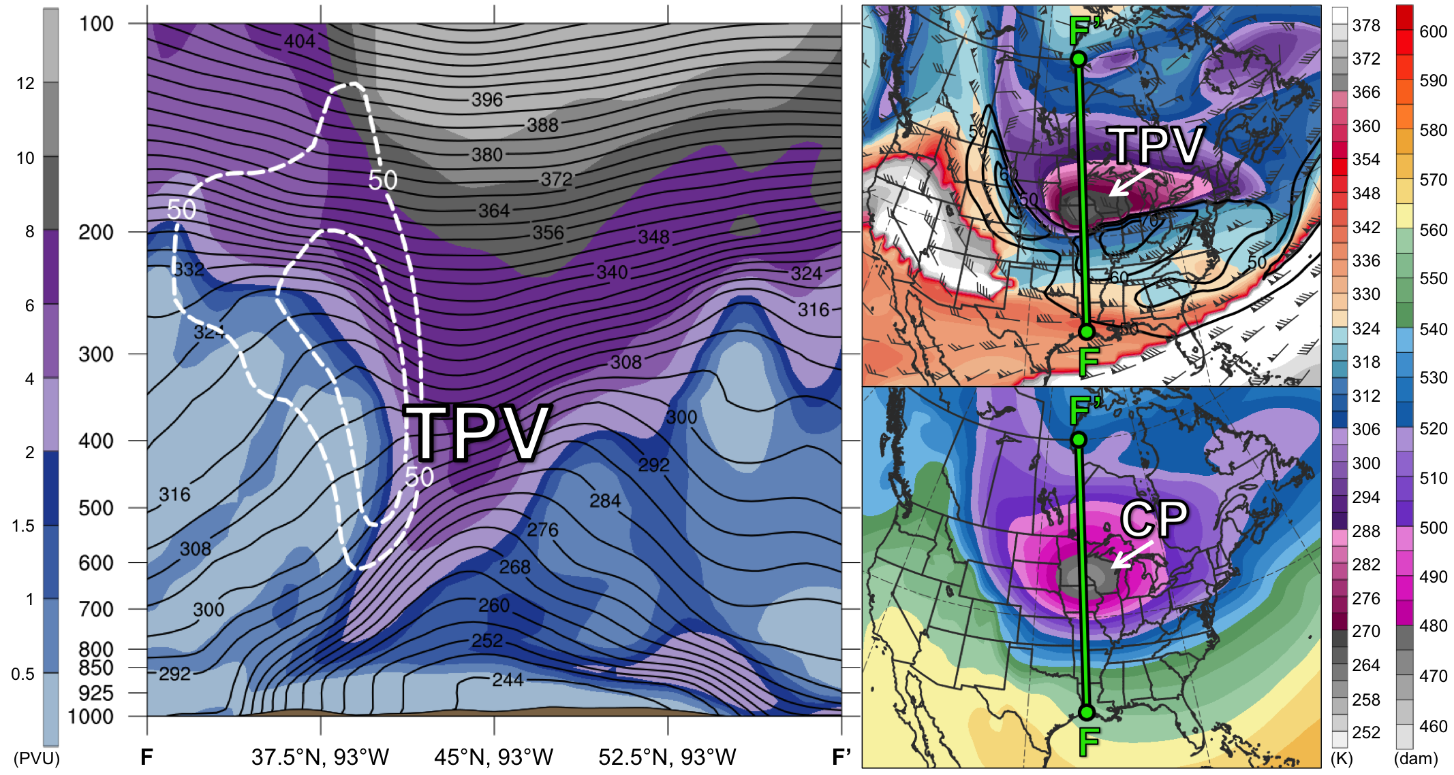
Fig. 4.19. As in Fig. 4.7, but for cross section along line FF’ at 0000 UTC 20 January 1985.

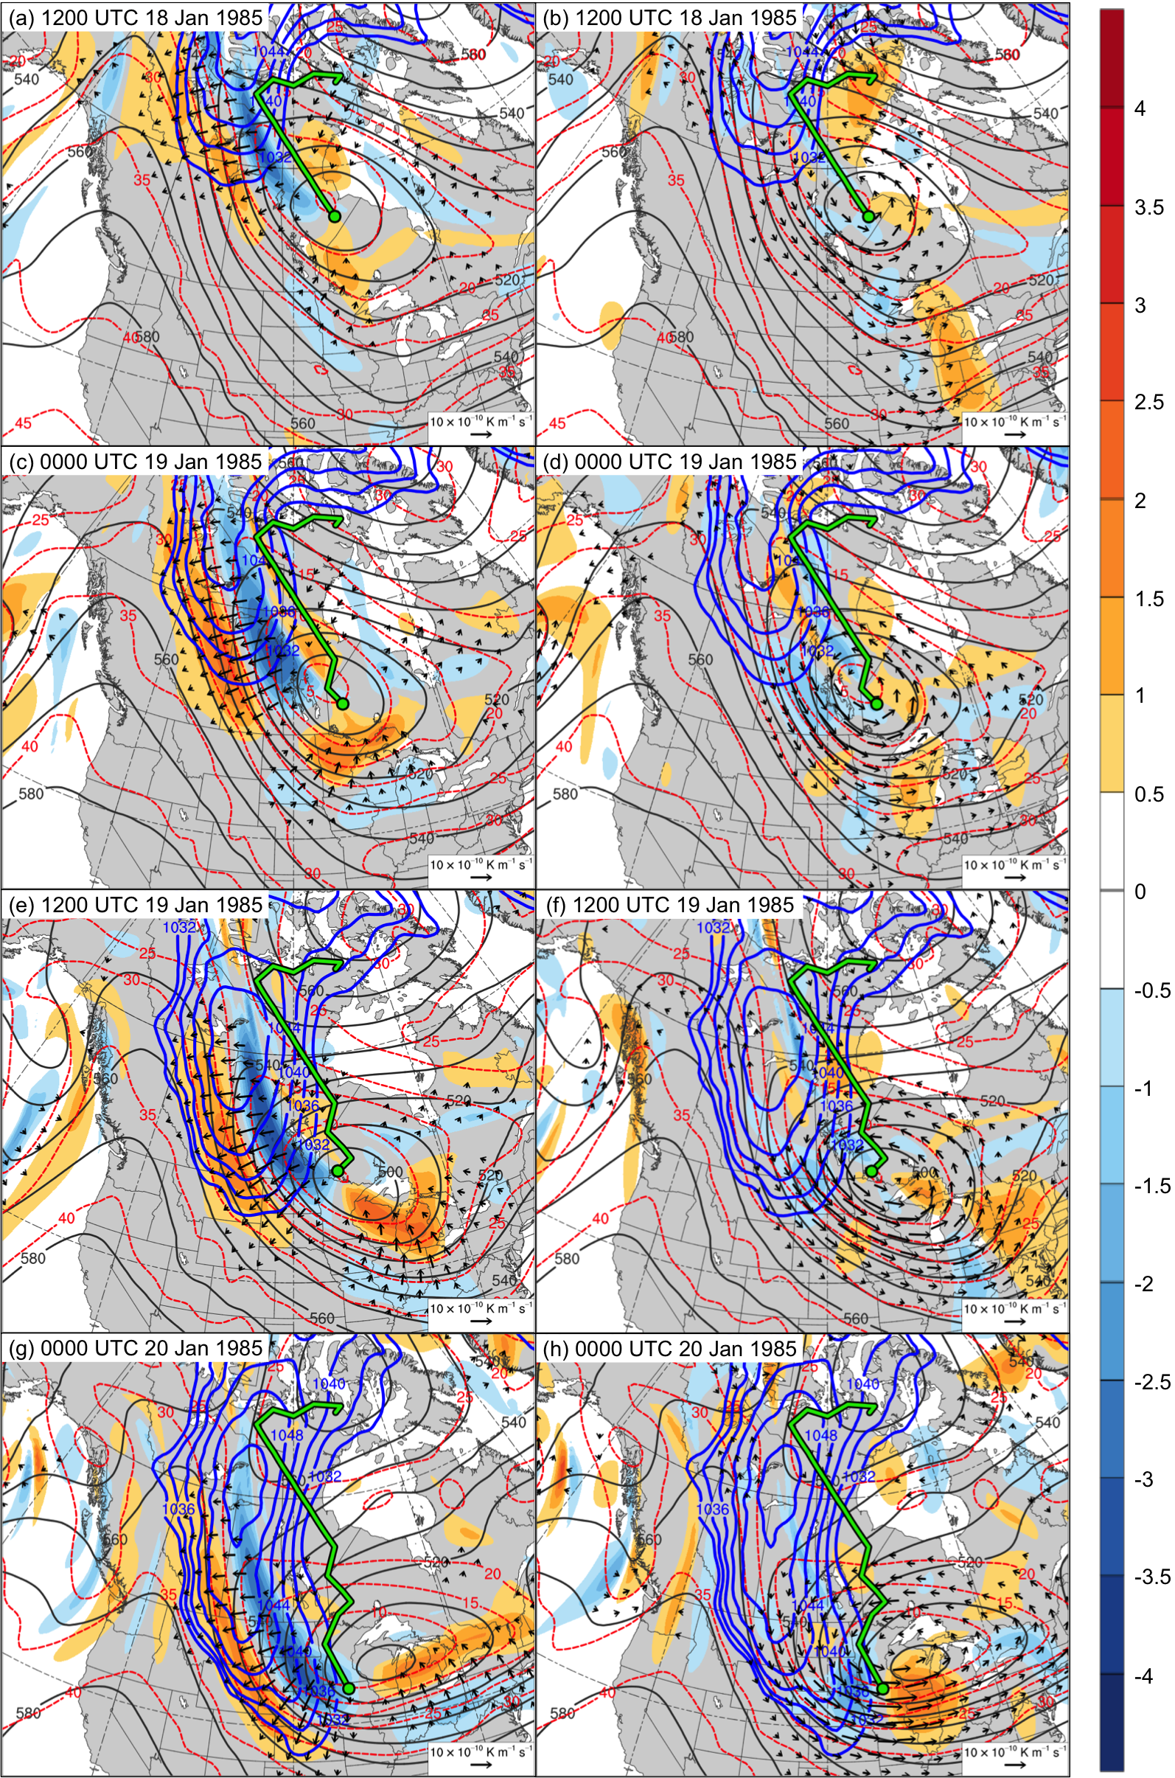
Fig. 4.20. SLP (blue contours every 4 hPa, beginning at 1032 hPa) and 600–400-hPa Q_{n} (K m⁻¹ s⁻¹, vectors), Q_{n} forcing for vertical motion (10⁻¹⁷ Pa⁻¹ s⁻³, shaded), geopotential height (dark gray contours every 10 dam), and potential temperature (dashed red contours every 5°C) at (a) 1200 UTC 18 January, (c) 0000 UTC 19 January, (e) 1200 UTC 19 January, and (g) 0000 UTC 20 January 1985; SLP (blue contours every 4 hPa, beginning at 1032 hPa) and 600–400-hPa Q_{s} (K m⁻¹ s⁻¹, vectors), Q_{s} forcing for vertical motion (10⁻¹⁷ Pa⁻¹ s⁻³, shaded), geopotential height (dark gray contours every 10 dam), and potential temperature (dashed red contours every 5°C) at (b) 1200 UTC 18 January, (d) 0000 UTC 19 January, (f) 1200 UTC 19 January, and (h) 0000 UTC 20 January 1985. Green line and dot represent track and position of TPV, respectively.

