4. Case Studies
4.1 9–14 January 1982 CAO
4.1.1 Case Overview

During 9–14 January 1982, a CAO impacted a widespread area of central and eastern North America, leading to significant socioeconomic impacts. According to NOAA NCEI, during 10–16 January 1982, a cold wave, which includes the 9–14 January 1982 CAO (hereafter referred to as the January 1982 CAO), and a winter storm in the U.S. contributed to an estimated cost of 1.7 billion dollars, after 2017 consumer price index adjustment, and 85 deaths (https://www.ncdc.noaa.gov/billions/). The January 1982 CAO lead to widespread record low surface temperatures across the central and eastern U.S., with all-time record low temperatures of −32.2°C (−26°F) and −17.2°C (1°F) recorded in Chicago, IL and Augusta, GA on 10 and 11 January 1982, respectively (Wagner 1982). The January 1982 CAO qualifies as a CAO for the Northeast, Central, South, and Southeast regions (see Fig. 2.1 for map of regions) and a CAO that is linked to a cold pool associated with a TPV for all of these regions as well. Given 1) the well-defined structure and longevity of the TPV and cold pool involved in the January 1982 CAO, as will be shown, and 2) the extremely cold air and significant socioeconomic impacts associated with the January 1982 CAO, this CAO will be examined in detail.

4.1.2 TPV and Cold Pool Track and Intensity

Figure 4.1 shows the tracks of the TPV and cold pool of interest for the January 1982 CAO. The TPV forms over Baffin Bay at 0600 UTC 15 December 1981. The TPV moves over Greenland between 17 and 21 December 1981 and then spends much of its lifetime meandering over northern and central Canada during late December 1981 and early January 1982. The TPV moves equatorward into the U.S. and then eastward across the U.S. during 8–11 January 1982, before moving quickly northeastward toward southern Greenland through 12 January 1982. The TPV undergoes lysis off the southeast coast of Greenland at 0000 UTC 13 January 1982. Overall, the TPV has a lifetime of ~29 days. The cold pool forms over the northern coast of Greenland at 1800 UTC 20 December 1981, several days after the TPV forms (Fig. 4.1). The cold pool has a similar track to the TPV throughout much of its lifetime, spending much of its lifetime meandering over northern and central Canada before moving equatorward into the U.S. between 8 and 10 January 1982. However, unlike the TPV, the cold pool meanders over eastern North America during 11–12 January 1982 before finally moving off the east coast of North America. The cold pool undergoes lysis at 1800 UTC 13 January 1982 east of Newfoundland. Overall, the cold pool has a lifetime of ~24 days. The large spatial overlap and temporal coincidence of the TPV and cold pool tracks suggest that the TPV and cold pool are dynamically linked. Furthermore, the movement of the TPV and cold pool over and near the U.S. during 9–11 January 1982, when the January 1982 CAO is occurring, suggests that these features play an important role in the development of the January 1982 CAO.
To understand the evolution of the intensity of the TPV and cold pool during their lifetimes, Fig. 4.2 shows a time series of the minimum DT potential temperature of the TPV and the minimum 1000–500-hPa thickness of the cold pool. In general, ignoring rapid fluctuations of TPV intensity as evident by large spikes in the time series of the minimum DT potential temperature of the TPV (e.g., during 29 December 1981), which may be numerical artifacts, the TPV gradually intensifies during late December 1981, with the minimum DT potential temperature of the TPV decreasing from ~290 K on 15 December 1981 to close to 260 K on 28 December 1981. During early January 1982, the minimum DT potential temperature of the TPV is low (~255 K) and decreases to ~249 K on 9 January 1982. However, during 10–12 January 1982, the TPV rapidly weakens, with the minimum DT potential temperature of the TPV increasing to ~284 K by 13 January 1982. The overall gradual intensification of the TPV suggests that longwave radiative cooling likely contributes importantly to the intensification of the TPV, especially given that Cavallo and Hakim (2009, 2010, 2012, 2013) have shown that longwave radiative cooling can play a critical role in the intensification of TPVs. The weakening of the TPV during 10–12 January 1982 may be related to latent heat release associated with an extratropical cyclone (EC) that undergoes rapid cyclogenesis off the east coast of North America during 10–11 January 1982, which will be shown in section 4.1.3.
About two days after the cold pool forms, similarly as the TPV, the cold pool gradually intensifies during late December 1981 and early January 1982, with the minimum 1000–500-hPa thickness of the cold pool decreasing from ~488 dam on 20 December 1981 to ~463 dam on 7 January 1982 (Fig. 4.2). Between 7 and 9 January 1982, the cold pool slowly weakens as it moves toward southern Canada and into the U.S., but similarly as the TPV, rapidly weakens during 10–13 January 1982. Longwave radiative cooling (e.g., Curry 1983; Emanuel 2008) may contribute to the gradual intensification of the cold pool during late December 1981 and early January 1982. Some of the weakening of the cold pool during 9–12 January 1982 may be related to sensible heat fluxes from the surface as the cold pool moves over the relatively warmer land of the U.S compared to that of Canada, especially considering that there is a thinner snowpack over southern portions of the Great Lakes region of the U.S. and southern portions of the northeastern U.S. compared to over Canada (not shown). Sensible heat fluxes from the relatively warm waters of the North Atlantic may contribute to the weakening of the cold pool on 13 January 1982. Latent heat release and warm air advection associated with the aforementioned EC may also contribute to the weakening of the cold pool during 10–13 January 1982. The similar patterns in intensity changes for the TPV and cold pool also suggest that the TPV and cold pool may be dynamically linked.

4.1.3 Synoptic Evolution of TPV, Cold Pool, and CAO

Ridge amplification over the eastern North Pacific and western North America likely plays an important role in the equatorward transport of the TPV and cold pool. At 0000 UTC 5 January 1982, an EC is intensifying over the central North Pacific in the left exit region of the North Pacific jet stream, downstream of a shortwave trough (Figs. 4.3a,b). Afterward, through 0000 UTC 8 January 1982, the EC moves northeastward toward the Gulf of Alaska and the aforementioned trough over the central North Pacific moves eastward and becomes negatively tilted, with a corridor of precipitable water values in excess of 25 mm becoming established from the subtropics poleward toward the Gulf of Alaska (Figs. 4.3c–h). Warm air advection, as implied by the nearly perpendicular orientation of the SLP contours to the 1000–500-hPa thickness contours downstream of the EC during 5–8 January 1982 (Figs. 4.3b,d,f,h), likely supports the ridge amplification that occurs downstream of the EC over the eastern North Pacific and into western North America (Figs. 4.3a,c,e,g). In addition, Figs. 4.4a,b show that at 0000 UTC 6 January and 0000 UTC 7 January 1982, associated with the EC over the central North Pacific and with the corridor of precipitable water values in excess of 25 mm is a widespread region of midlevel ascent. The concomitant diabatically driven upper-tropospheric divergent outflow and associated negative PV advection by the irrotational wind shown in Figs. 4.4a,b likely also supports the aforementioned ridge amplification. Furthermore, as the ridge comes into closer proximity with the TPV and associated cold pool located over western North America, the thermal gradient over the Gulf of Alaska and southwestern Canada strengthens, supporting the development and intensification of a jet streak over this region during 7–8 January 1982 (Figs. 4.3e–h).
Between 0000 UTC 8 January and 0000 UTC 9 January 1982, as the ridge continues to build eastward and comes into closer proximity with the TPV and associated cold pool, the jet streak between the ridge and TPV strengthens as TPV–jet interaction begins to occur (Figs. 4.5a–d). Between 0000 UTC 9 January and 0000 UTC 10 January 1982, as TPV–jet interaction occurs, the TPV and associated cold pool move equatorward into the U.S., and a strong surface anticyclone in the left entrance region of the jet streak rapidly strengthens and expands equatorward over western North America into the central U.S., just east of the Rocky Mountains (Figs. 4.5c–f). Strong cold air advection over the Great Plains, as suggested in Fig. 4.5f, along with an expected terrain-tied northerly component of low-level motion on the east side of the Rocky Mountains (e.g., Colle and Mass 1995) likely help allow the cold air from the cold pool associated with the TPV to spread far away from the core of the cold pool. Thus, the cold pool associated with the TPV has a geographically widespread impact. The development of the strong surface anticyclone over western North America in association with the CAO has been similarly shown in past studies, including Boyle and Bosart (1983), Colucci and Davenport (1987), Konrad and Colucci (1989), Colle and Mass (1995), and Walsh et al. (2001).
By 0000 UTC 11 January 1982, the TPV and cold pool have moved eastward toward the U.S east coast, and cold air associated with the cold pool has overspread the entire eastern U.S. (Figs. 4.5g,h). As discussed in section 4.1.2, the TPV and cold pool rapidly weaken during 10–12 January 1982. Between 0000 UTC 10 January and 0000 UTC 11 January 1982, TPV–jet interaction occurs, with the TPV located on the cyclonic shear side of the jet streak. As TPV–jet interaction occurs, the TPV becomes deformed as suggested by the TPV becoming more anisotropic (Figs. 4.5e,g). Horizontal shear on the cyclonic shear side of the jet streak in combination with confluent flow in the entrance region of the jet streak and diffluent flow in the exit region of the jet streak, as suggested in Figs. 4.5e,g, may contribute to the deformation of the TPV, which may contribute to the weakening of the TPV. In addition, rapid cyclogenesis of an EC occurs off the east coast of North America, in the left exit region of the jet streak between 0000 UTC 10 January and 0000 UTC 11 January 1982 (Figs. 4.5f,h). Latent heat release associated with widespread ascent in the vicinity of the EC during 0000 UTC 10 January and 0000 UTC 11 January 1982 (Figs. 4.6a,b) may also contribute to the weakening of the TPV and cold pool, and warm air advection that is implied over Labrador and eastern Quebec at 0000 UTC 11 January 1982 (Fig. 4.5h) may further contribute to the weakening of the cold pool.
The fact that the TPV and cold pool move in tandem into the U.S. during the time of the January 1982 CAO suggests that the TPV and cold pool are dynamically linked, as discussed at the end of section 4.1.2, and that the TPV and cold pool play an important role in the development of the January 1982 CAO. In section 4.1.4, the evolution of the three-dimensional structure of the TPV and cold pool will be examined to gain more insight on how these features evolve together over time. In addition, the relationship between TPV–jet interaction and the development of the strong surface anticyclone important for the evolution of the CAO will be explored further in section 4.1.5.

4.1.4 Three-dimensional Structure of TPV and Cold Pool

Figure 4.7 shows a meridional cross section (AA’) transecting the TPV early in its life cycle at 1200 UTC 16 December 1981, when the TPV is relatively weak and located over Baffin Bay, and when the cold pool has not yet formed. Using the position of the 2-PVU contour in the cross section as a proxy for the position of the DT, the TPV extends downward to ~450 hPa, which is not too far beneath the position of the background DT (Fig. 4.7a). The TPV is a mesoscale feature embedded in a broad region of lowered DT (Fig. 4.7a) and relatively low DT potential temperature air (Fig. 4.7b). Although the cold pool has not yet formed, there is a broad region of cold air characterized by 1000–500-hPa thickness values below 500 dam where the TPV and broad region of relatively low DT potential temperature air is located (Figs. 4.7b,c), suggesting that the TPV is still associated with cold air beneath it throughout the troposphere. Also, the cross section shows an upward bowing of isentropes beneath the TPV, with potential temperature values less than 268 K in the lower troposphere beneath the TPV (Fig. 4.7a).
As shown in Fig. 4.2, the TPV strengthens throughout late December 1981 and is intense during early January 1982. Also, the cold pool intensifies during late December 1981 and early January 1982. Figure 4.8 shows a meridional cross section (BB’) transecting the TPV and cold pool at 1200 UTC 2 January 1982. Compared to early in its life cycle, at 1200 UTC 16 December 1981 (Fig. 4.7a), the cross section in Fig. 4.8a at 1200 UTC 2 January 1982 shows that the TPV has become a much better defined, larger, and deeper feature, with the TPV now extending downward to ~650 hPa. Furthermore, the TPV (Fig. 4.8b) and cold pool (Fig. 4.8c) are intense, isotropic, and vertically aligned at 1200 UTC 2 January 1982. The substantial upward bowing of the isentropes within and beneath the TPV throughout the depth of the troposphere (Fig. 4.8a) is indicative of the well-defined cold pool (Fig. 4.8c) that is collocated with the TPV (Fig. 4.8b) and the tropospheric-deep influence of the TPV. Also, potential temperature values are less than 240 K near the surface beneath the TPV (Fig. 4.8a), indicative of the very cold air associated with the cold pool. As the TPV has become better defined and deeper, there has become a more pronounced upward bowing of the isentropes beneath the TPV and concomitantly a better defined and intense cold pool, illustrating that the TPV and cold pool are likely dynamically linked. It is also evident in the cross section that near the surface, isentropes spread outward, far away from the center of the TPV and cold pool (Fig. 4.8a), indicative of surface-based Arctic air spreading far from the center of the TPV and cold pool. In fact, especially to the south and north of the TPV, there is a very strong near-surface vertical potential temperature gradient, with near-surface PV values in excess of 4 PVU north of the TPV and between 2 and 4 PVU south of the TPV (Fig. 4.8a). As shown by Emanuel (2008), Arctic air can be characterized by relatively high values of PV. The strong near-surface vertical potential temperature gradient also suggests that a steep temperature inversion is in place, which is likely related to longwave radiative cooling (e.g., Curry 1983).
Figure 4.9 shows a meridional cross section (CC’) transecting the TPV and cold pool at 0000 UTC 10 January 1982, when both features have moved into the northern U.S. and are contributing to CAO development. Compared to at 1200 UTC 2 January 1982 (Fig. 4.8a), the TPV is even deeper at 0000 UTC 10 January 1982, now extending downward to ~750 hPa (Fig. 4.9a). The TPV is interacting with a jet streak at this time (Fig. 4.9b) and a PV wall associated with a large horizontal PV gradient is evident throughout much of the troposphere between the TPV and warm air to its south, coincident with the jet streak (Fig. 4.9a). There continues to be a very notable upward bowing of isentropes throughout the troposphere within and beneath the TPV (Fig. 4.9a), illustrative of the cold pool (Fig. 4.9c) associated with the TPV (Fig. 4.9b). The surface-based Arctic air continues to spread far away from the center of the TPV and cold pool, with the leading edge of the Arctic air associated with the Arctic front located south of 40°N where there is a strong surface horizontal potential temperature gradient (Fig. 4.9a). Furthermore, within the Arctic air, the boundary layer appears well mixed given the nearly vertical orientation of the isentropes within the boundary layer. A well-mixed boundary layer was also shown by Shapiro et al. (1987; Fig. 1.7 in this thesis) in a cross section transecting the January 1985 “polar vortex” feature (or TPV as will be discussed in section 4.2), and they suggest that this well-mixed boundary layer may result from diabatic heating induced by the flow of Arctic air over the relatively warm land surface. Overall, the cross sections, in particular those in Figs. 4.8a and 4.9a, illustrate that the influence of the TPV extends throughout the depth of the troposphere and over a widespread geographical area, and also illustrate that the TPV and associated cold pool plays a crucial role in CAO development.

4.1.5 Q-vector Diagnosis

The concomitant occurrence of the interaction of the TPV with a jet streak over western North America and the rapid strengthening and southeastward expansion of the strong surface anticyclone over western North America in the left entrance region of the jet streak during 8–10 January 1982 (Figs. 4.5a–f) suggests that TPV–jet interaction may play an important role in the rapid strengthening and expansion of the strong surface anticyclone. Figure 4.10 shows plots of 600–400-hPa wind speed, as well as Q_{n} and Q_{s} and their associated forcings for vertical motion from 1200 UTC 8 January to 0000 UTC 10 January 1982. At 1200 UTC 8 January 1982, between the ridge and the TPV, and in the left entrance region of a broad jet streak over western North America, there is a region of divergence of Q_{n} and Q_{n} forcing for descent collocated with and to the south and east of the ~1047 hPa surface anticyclone (Figs. 4.10a,b). The orientation of the Q_{n} vectors from cold to warm air suggests that the geostrophic flow may be contributing to upper-level frontogenesis, which may support a strengthening of the jet streak. In addition, there is a small region of Q_{s} forcing for descent over northern Alberta, to the south and east of the surface anticyclone (Fig. 4.10c). The Q_{n} and Q_{s} forcing for descent over and to the south and east of the surface anticyclone may provide forcing for anticyclogenesis, suggesting that the surface anticyclone may strengthen and expand southeastward.
By 0000 UTC 9 January 1982, the maximum SLP of the surface anticyclone remains ~1047 hPa, but the surface anticyclone has expanded southeastward over the previous 12 h (compare Figs. 4.10a,d). In addition, the jet streak has intensified, likely related to TPV–jet interaction beginning to occur as the TPV has come into closer proximity with the jet streak (compare Figs. 4.10a,d). Concomitantly, the magnitude of Q_{n} and Q_{n} forcing for descent have increased in the left entrance region of the jet streak, over and to the south and east of the surface anticyclone (compare Figs. 4.10d,e to Figs. 4.10a,b). The orientation of the Q_{n} vectors from cold to warm air in the entrance region of the jet streak (Figs. 4.10d,e) continues to suggest that the geostrophic flow may be contributing to upper-level frontogenesis. Furthermore, by comparing Figs. 4.10c,f, the region of Q_{s} forcing for descent has increased in size and magnitude between 1200 UTC 8 January and 0000 UTC 9 January 1982. At 0000 UTC 9 January 1982, the region of Q_{s} forcing for descent is located upstream of the TPV, in the left entrance region of the jet streak, over and to the south and east of the surface anticyclone (Figs. 4.10d,f). This region of Q_{s} forcing for descent may be related a shortwave trough over northern Saskatchewan that is associated with the TPV (Fig. 4.10f). The location of the maximum of Q_{s} forcing for descent upstream of the shortwave trough is anticipated from Sanders and Hoskins (1990). The position of the regions of Q_{n} and Q_{s} forcing for descent over and to the south and east of the surface anticyclone suggests that the surface anticyclone may strengthen and build southeastward.
Between 0000 UTC and 1200 UTC 9 January 1982, the surface anticyclone rapidly strengthens from ~1047 hPa to ~1054 hPa, or by ~7 hPa in 12 h, and builds southward and eastward in the left entrance region of the jet streak, which continues to intensify as TPV–jet interaction continues to occur (compare Figs. 4.10d,g). Furthermore, the magnitude of the 600–400-hPa potential temperature gradient associated with the jet streak has strengthened during the same time period (not shown), indicating that the previously suggested upper-level frontogenesis may be occurring. Also, accompanying the intensification of the jet streak is increased confluence in the entrance region of the jet streak as indicated by the increase in along stream changes in the 600–400-hPa wind speed in the entrance region of the jet streak (compare Figs. 4.10d,g). The increased confluence in the entrance region of the jet streak suggests that the thermally direct ageostrophic circulation in the entrance region of the jet streak may have strengthened, which would support increased forcing for descent in the left entrance region of the jet streak. Concomitantly, the magnitude of Q_{n} and Q_{n} forcing for descent has increased upstream of the TPV, in the left entrance region of the jet streak, over and to the south and east of the surface anticyclone (compare Figs. 4.10g,h to Figs. 4.10d,e). In addition, as the shortwave trough associated with the TPV has sharpened, there has been a concomitant increase in Q_{s} and Q_{s} forcing for decent upstream of the TPV, in the left entrance region of the jet streak, over and to the south and east of the surface anticyclone (compare Figs. 4.10g,i to Figs. 4.10d,f). The location of the maximum of both Q_{n} and Q_{s} forcing over and to the south and east of the surface anticyclone (Figs. 4.10h,i) suggests that the surface anticyclone may strengthen further and build southeastward.
As anticipated, between 1200 UTC 9 January and 0000 UTC 10 January 1982, the surface anticyclone strengthens from ~1054 hPa to ~1060 hPa, or by ~6 hPa in 12 h, and builds southeastward in the left entrance region of the jet streak, which strengthens further as TPV–jet interaction continues (compare Figs. 4.10g,j). There continues to be similar patterns of Q_{n} and Q_{s} and their associated forcings for descent at 0000 UTC 10 January 1982 as 12 h earlier (compare Figs. 4.10k,l to Figs. 4.10h,i). In general, as the jet streak strengthens during TPV–jet interaction, there is an increase in Q_{n} and Q_{s} and their associated forcings for descent in the left entrance region of the jet streak. The concomitant rapid strengthening and expansion of the surface anticyclone in the left entrance region of the jet streak, in the region of Q_{n} and Q_{s} forcing for descent, suggests that TPV–jet interaction may play an important role in the rapid strengthening and expansion of the surface anticyclone. Given the important role this surface anticyclone plays in the development of the January 1982 CAO, TPV–jet interaction may play an important role in CAO development.

4.2 19–24 January 1985 CAO
4.2.1 Case Overview

During 19–24 January 1985, a CAO impacted a widespread area of central and eastern North America, leading to significant socioeconomic impacts. According to NOAA NCEI, extremely cold air associated with the 19–24 January 1985 CAO (hereafter referred to as the January 1985 CAO) and winter storms over the U.S. contributed to an estimated cost of 1.9 billion dollars, after 2017 consumer price index adjustment, and contributed to 150 deaths (https://www.ncdc.noaa.gov/billions/). Also, according to NOAA NCEI, there was an additional cost of 2.8 billion dollars, after 2017 consumer price index adjustment, due to a severe freeze associated with the January 1985 CAO over Florida that lead to citrus crop damages. Furthermore, minimum surface temperatures below −17.8°C (0°F) were observed over a widespread area of the central and eastern U.S. (Shapiro et al. 1987). The January 1985 CAO qualifies as a CAO for the Northeast, Central, South, and Southeast regions (see Fig. 2.1 for map of regions) and a CAO that is linked to a cold pool associated with a TPV for all of these regions as well. Given the significant socioeconomic impacts and extremely cold air associated with the January 1985 CAO, this CAO will be examined in detail. In addition, examination of the January 1985 CAO will serve to compliment and extend the work of Shapiro et al. (1987) by illustrating that the “polar vortex” feature they show to play an important role in the development of the January 1985 CAO is related to a TPV.

4.2.2 TPV and Cold Pool Track and Intensity

Figure 4.11 shows the tracks of the cold pool and TPV of interest for the January 1985 CAO. The cold pool is identified to form over the northeastern coast of Baffin Island at 1800 UTC 11 January 1985. The cold pool meanders for several days over northern Canada before being transported equatorward from northern Canada into the U.S. during 17–20 January 1985. The cold pool then moves northeastward toward Labrador during 21–22 January 1985 and meanders over and near Labrador during 22–27 January 1985, before undergoing lysis over Quebec at 0600 UTC 28 January 1985. In total, the cold pool has a lifetime of ~17 days. The TPV forms at 1800 UTC 16 January 1985 over north central Canada, several days after the cold pool is identified to form (Fig. 4.11). The TPV moves generally westward over the next day before being quickly transported equatorward into southern Canada and then into the central U.S. between 18 and 20 January 1985 together with the cold pool. Similarly to the cold pool, the TPV is quickly transported northeastward toward Labrador during 21–22 January 1985, and then meanders over and near Labrador during 22–27 January 1985. Unlike the cold pool, the TPV then moves over the northwestern North Atlantic, where it meanders for a few more days before undergoing lysis at 1200 UTC 2 February 1985. In total, the TPV has a lifetime of 17 days. In general, the large spatial overlap and temporal coincidence of the TPV and cold pool tracks over North America suggest that the these features are dynamically linked. Furthermore, the movement of the TPV and cold pool over and near the U.S. during 19–21 January 1985, when the January 1985 CAO is occurring, suggests that these features play an important role in the development of the January 1985 CAO.
Figure 4.12 shows a time series of the minimum DT potential temperature of the TPV and the minimum 1000–500-hPa thickness of the cold pool. At the beginning of its life cycle, the cold pool is characterized by a 1000–500-hPa thickness value of ~478 dam. Although the cold pool is objectively identified to form on 11 January 1985, subjectively, the cold pool appears to form several days earlier, when it was weaker (not shown). There may have been separate 1000–500-hPa thickness minima embedded within the cold pool that may have contributed to multiple cold pool tracks. In general, the cold pool strengthens during 11–19 January 1985, with the cold pool reaching a minimum 1000–500-hPa thickness value of ~468 dam on 19 January 1985 (Fig. 4.12) over southern Canada (Fig. 4.11). The cold pool then weakens as it moves across the U.S. and then northeastward toward Labrador during 19–22 January 1985. The cold pool then generally intensifies as is meanders over and near Labrador until 27 January 1985, before weakening again. When the TPV forms, it is characterized by a minimum DT potential temperature value of ~269 K. As will be shown in section 4.2.3, the TPV forms from a preexisting broad area of relative low DT potential temperature air. In general, the TPV intensifies until 20 January 1985 as the cold pool intensifies, though reaches a minimum DT potential temperature value of ~259 K on 20 January 1985, when the cold pool is already weakening. Afterward, during 21–29 January 1985, the patterns of intensity change of the TPV are similar to that of the cold pool.
The periods of strengthening of the cold pool and TPV may be related to longwave radiative cooling, as in the January 1982 CAO case. Weakening of the cold pool and TPV during 21–22 January 1985 may be related to latent heat release in association with a strong EC that rapidly intensifies during 21–22 January 1985 over the east coast of North America, as will be discussed in section 4.2.3. Also, weakening of the cold pool as it moves across the U.S. during 19–21 January 1985 may be related to sensible heat fluxes from the surface as the cold pool moves over the relatively warmer land of the U.S compared to that of Canada, considering that there is a thinner snowpack over the U.S. compared to over Canada (not shown).

4.2.3 Synoptic Evolution of TPV, Cold Pool, and CAO

The equatorward transport of the TPV and cold pool is likely tied to flow amplification over the North Pacific and North Atlantic. Poleward fluxes of warm, moist air associated with a strengthening EC in the left exit region of a strong North Pacific jet stream over the central North Pacific and with an EC moving poleward off the coast of Labrador likely support ridge amplification over the eastern North Pacific and over Greenland, respectively, between 0000 UTC 14 January and 0000 UTC 15 January 1985 (Figs. 4.13a–d). Meanwhile, during this same time period, the cold pool over northeastern North America moves southward on the west side of the ridge over Greenland. Collocated with the cold pool is a broad region of relatively low DT potential temperature air that will evolve into the TPV. The EC over the North Pacific moves northeastward to the Gulf of Alaska between 0000 UTC 15 January and 0000 UTC 17 January 1985, while the ridge over the eastern North Pacific concomitantly amplifies into western North America (Figs. 4.13c–h). During the same time period, a new EC rapidly develops and then occludes as it moves from the northeastern U.S. to southeastern Canada, contributing to ridge amplification over the northwestern North Atlantic (Figs. 4.13c–h). Both ECs are associated with a narrow corridor of relatively high precipitable water air extending from the subtropics toward the high latitudes (e.g., Fig. 4.13f). Figures 4.14a,b show that at 0000 UTC 15 January and 0000 UTC 16 January 1985, associated with the aforementioned ECs and narrow corridors of relatively high precipitable water air are widespread regions of midlevel ascent. The concomitant diabatically driven upper-tropospheric divergent outflow and associated negative PV advection by the irrotational wind shown in Figs. 4.14a,b likely also contributes to the ridge amplification over western North America and the northwestern North Atlantic. Also, at 0000 UTC 17 January 1985, the broad region of relatively low DT potential temperature air has consolidated into a single TPV that is now tracked (Fig. 4.13g). Although the consolidation of the broad region of relatively low DT potential temperature air into the TPV has not been examined closely, it may be related to the close approach and merger of separate midlevel vorticity maxima (not shown).
The combination of ridging over western North America and over Greenland and Baffin Bay force the TPV and cold pool to move equatorward over Canada between 0000 UTC 18 January and 0000 UTC 19 January 1985 (Figs. 4.15a–d). A jet streak strengthens between the TPV and the ridge over western North America as the TPV moves equatorward and interacts with the jet streak. In addition, a strong surface anticyclone over the Arctic and extending southward into northern Canada strengthens and builds southeastward over western Canada in the left entrance region of the jet streak. As the TPV and cold pool move equatorward into the northern U.S. through 0000 UTC 20 January 1985, the strong surface anticyclone strengthens in the left entrance region of the jet streak and rapidly builds southeastward into the central U.S (Figs. 4.15e,f). Similarly as in the January 1982 CAO case, strong cold air advection over the central U.S., as suggested in Fig. 4.15f, along with an expected terrain-tied northerly component of low-level motion on the east side of the Rocky Mountains (e.g., Colle and Mass 1995) likely help allow the cold air from the cold pool associated with the TPV to spread far away from the core of the cold pool. Thus, the cold pool associated with the TPV has a geographically widespread impact.
As the TPV and cold pool move eastward over the U.S. through 0000 UTC 21 January 1985 (Figs. 4.15g,h), the cold air associated with the cold pool overspreads the entire eastern U.S. Also, as the TPV interacts with a jet streak to its south and east between 0000 UTC 20 January and 0000 UTC 21 January 1985, it becomes deformed and weakens (Figs. 4.15e,g), suggesting that the deformation of the TPV may contribute to the weakening of the TPV. In addition, cyclogenesis of an EC occurs over southeastern Canada at 0000 UTC 21 January 1985, in the left exit region of the aforementioned jet streak (Fig. 4.15h), and this EC rapidly deepens over the next day (not shown). Latent heat release associated with widespread ascent found in the vicinity of the EC at 0000 UTC 21 January and 0000 UTC 22 January 1985 (Figs. 4.16a,b) may contribute to the weakening of the TPV and cold pool during 21–22 January 1985 shown in Fig. 4.12.
As in the January 1982 CAO case, the fact that the TPV and cold pool in the January 1985 CAO case move in tandem into the U.S. during the time of the January 1985 CAO suggests that the TPV and cold pool are dynamically linked and that the TPV and cold pool play an important role in the development of the January 1985 CAO. To get a better sense of the evolution of the three-dimensional structure of the TPV and cold pool in this case, cross sections of these features will be examined in section 4.2.4. In addition, the relationship between TPV–jet interaction and the development of the strong surface anticyclone important for the evolution of the January 1985 CAO will be explored further in section 4.2.5.

4.2.4 Three-dimensional Structure of TPV and Cold Pool

Figure 4.17 shows a meridional cross section (DD’) transecting the cold pool early in its life cycle at 0000 UTC 13 January 1985, prior to the formation of the TPV. At this time, the cross section shows a broad region of depressed DT extending downward below 400 hPa, with embedded mesoscale undulations of the DT (Fig. 4.17a). This broad region of depressed DT corresponds to a broad region of relatively low DT potential temperature air with embedded DT potential temperature minima (Fig. 4.17b) that is collocated with the broad cold pool (Fig. 4.17c). There is a broad region of upward bowing of isentropes in the cross section beneath the broad region of lowered DT, indicative of the broad cold pool, with potential temperature values near the surface as low as 240 K illustrating the very cold air associated with the cold pool (Fig. 4.17a).
Figure 4.18 shows a meridional cross section (EE’) transecting the TPV and cold pool at 0000 UTC 17 January 1985, shortly after the TPV has been first identified. The region of lowered DT in the cross section in Fig. 4.18a corresponding to the TPV (Fig. 4.18b) at 0000 UTC 17 January 1985 is more focused and extends further downward compared to the region of lowered DT in the cross section in Fig. 4.17a corresponding to the broad region of relatively low DT potential temperature air (Fig. 4.17b) at 0000 UTC 13 January 1985. There is also a more pronounced upward bowing of the isentropes beneath the TPV in the cross section in Fig. 4.18a at 0000 UTC 17 January 1985 compared to beneath the broad region of relatively low DT potential temperature air in the cross section in Fig. 4.17a at 0000 UTC 13 January 1985, corresponding to a more intense cold pool at 0000 UTC 17 January 1985 (Fig. 4.18c) compared to at 0000 UTC 13 January 1985 (Fig. 4.17c).
Figure 4.19 shows a meridional cross section (FF’) transecting the TPV and cold pool at 0000 UTC 20 January 1985, when both features have moved into the northern U.S. and are contributing to CAO development. The TPV has deepened since 0000 UTC 17 January 1985 (compare Figs. 4.19a and 4.18a), extending downward to ~750 hPa at 0000 UTC 20 January 1985 (Fig. 4.19a), as the TPV has intensified (compare Figs. 4.19b and 4.18b). The robust upward bowing of the isentropes within and beneath the TPV (Fig. 4.19a) illustrates the impressive cold pool (Fig. 4.19c) collocated with the TPV (Fig. 4.19b). In addition, the TPV is interacting with a jet streak to its south (Fig. 4.19b), and a PV wall similar to that in the cross section in Fig. 4.9a for the January 1982 CAO case extends throughout much of the troposphere between the TPV and warm air to the south, coincident with the jet streak (Fig. 4.19a). Near the surface, the isentropes spread horizontally outward, far away from the core of the TPV and cold pool, with the Arctic front associated with the leading edge of Arctic air located south of 37.5°N where there is a strong surface horizontal potential temperature gradient (Fig. 4.19a). As discussed by Shapiro et al. (1987) for a cross section transecting the same TPV and cold pool (Fig. 1.7 in this thesis), the cross section in Fig. 4.19a shows that within the Arctic air, the boundary layer appears well mixed, which, as suggested by Shapiro et al. (1987), may result from diabatic heating induced by the flow of Arctic air over the relatively warm land surface. Overall, the cross section in Fig. 4.19a illustrates that the TPV has a tropospheric deep influence, impacts a widespread geographical area, and plays an important role in the development of the January 1985 CAO.

4.2.5 Q-vector Diagnosis

The concomitant occurrence of the interaction of the TPV with a jet streak over western North America and the strengthening and southeastward expansion of the strong surface anticyclone over western North America in the left entrance region of the jet streak during 18–20 January 1985 (Figs. 4.15a–f) suggests that TPV–jet interaction may play an important role in the strengthening and expansion of the strong surface anticyclone. Figure 4.20 shows plots of 600–400-hPa wind speed, as well as Q_{n} and Q_{s} and their associated forcings for vertical motion from 1200 UTC 18 January to 0000 UTC 20 January 1985. At 1200 UTC 18 January 1985, the jet streak is located between the ridge and TPV over western North America, with a region of Q_{n} forcing for descent in the left entrance region of the jet streak, over and to the southeast of the surface anticyclone (Figs. 4.20a,b). Over the same region, Q_{s} vectors are weak in magnitude and there is not an organized region of Q_{s} forcing for descent (Fig. 4.20c). The positioning of the region of Q_{n} forcing for descent over and to the southeast of the surface anticyclone suggests that the surface anticyclone may strengthen and expand southeastward. In addition, the orientation of the Q_{n} vectors from cold to warm air in the entrance region of the jet streak (Figs. 4.20a,b) suggests that the geostrophic flow may be contributing to upper-level frontogenesis.
By 0000 UTC 19 January 1985, while the surface anticyclone has not strengthened, it has expanded southeastward over western Canada in the left entrance region of the jet streak since 1200 UTC 18 January 1985 (compare Figs. 4.20a,d). Also, the jet streak over western North America has intensified, likely due to TPV–jet interaction (compare Figs. 4.20a,d). Furthermore, the magnitude of the 600–400-hPa potential temperature gradient associated with the jet streak has strengthened between 1200 UTC 18 January and 0000 UTC 19 January 1985 (not shown), indicating that the previously suggested upper-level frontogenesis may be occurring. In addition, as the jet streak has strengthened, confluence in the entrance region of the jet streak has increased as indicated by the increase in along stream changes in the 600–400-hPa wind speed in the entrance region of the jet streak (compare Figs. 4.20a,d). The increased confluence in the entrance region of the jet streak suggests that the thermally direct ageostrophic circulation in the entrance region of the jet streak may have strengthened, which would support increased forcing for descent in the left entrance region of the jet streak. As anticipated, in the left entrance region of the jet streak, the magnitude of Q_{n} has increased between 1200 UTC 18 January and 0000 UTC 19 January 1985, and although the magnitude of Q_{n} forcing for descent has not increased, the region of Q_{n} forcing for descent has expanded in areal coverage (compare Figs. 4.20d,e to Figs. 4.20a,b). The region of Q_{n} forcing for descent in the left entrance region of the jet streak, over and to the south and east of the surface anticyclone suggests that the surface anticyclone may strengthen and expand southeastward. Also, there is now an organized region of Q_{s} forcing for descent positioned upstream of the TPV and to the south and east of the surface anticyclone (Fig. 4.20f), which would at least suggest that the surface anticyclone may build southeastward. This region of Q_{s} forcing for descent may be related to a subtle shortwave trough over southern Manitoba associated with the TPV (Fig. 4.20f). The location of the maximum of Q_{s} forcing for descent upstream of the shortwave trough is anticipated from Sanders and Hoskins (1990).
As anticipated, between 0000 UTC and 1200 UTC 19 January 1985, the surface anticyclone strengthens from ~1046 hPa to ~1051 hPa, or by ~5 hPa in 12 h, and expands southeastward, while the jet streak continue to intensify, likely in response to TPV–jet interaction (compare Figs. 4.20d,g). There continues to be a broad region of Q_{n} forcing for descent in the left entrance region of the jet streak, just west of the TPV, over and to the southeast of the surface anticyclone (Figs. 4.20g,h), as well as a smaller and weaker area of Q_{s} forcing for descent in the left entrance region of the jet streak, over and to the south and east of the surface anticyclone (Figs. 4.20g,i), suggesting that the surface anticyclone may strengthen further and build southeastward. As anticipated, the surface anticyclone strengthens between 1200 UTC 19 January and 0000 UTC 20 January 1985 from ~1051 hPa to ~1054 hPa, or by about 3 hPa in 12 h, and continues to build southeastward as TPV jet–interaction continues (compare Figs. 4.20g,j). There continues to be a similar pattern of Q_{n} and Q_{n} forcing for descent near the TPV at 0000 UTC 20 January 1985 as 12 h earlier (compare Fig. 4.20k to 4.20h). Although Q_{s} forcing for descent has increased in magnitude as the shortwave trough associated with the TPV has sharpened between 1200 UTC 19 January and 0000 UTC 20 January 1985 (compare Figs. 4.20i,l), the Q_{s} forcing for descent remains weaker in magnitude and smaller in areal coverage compared to that of Q_{n} (compare Fig. 4.20l to 4.20k). In general, as the jet streak strengthens during TPV–jet interaction, there is an increase in magnitude of Q_{n} and increase in areal coverage of the Q_{n} forcing for descent in the left entrance region of the jet streak. The concomitant strengthening and expansion of the surface anticyclone in the left entrance region of the jet streak, in the region of Q_{n} forcing for descent, suggests that TPV–jet interaction may play an important role in the strengthening and expansion of the surface anticyclone. Given the important role this surface anticyclone plays in the development of the January 1985 CAO, TPV–jet interaction may play an important role in CAO development.

4.3 Summary

Both the January 1982 CAO and January 1985 CAO are linked to a cold pool associated with a TPV. Ridge amplification, related to ECs and their associated poleward fluxes of warm, moist air from lower latitudes to high latitudes and diabatically driven upper-tropospheric outflow, plays an important role in the equatorward transport of the TPV and cold pool in each case. Improved understanding of precursor disturbances (e.g., ECs) and associated processes (e.g., diabatic heating) contributing to ridge amplification may thus lead to improved understanding of the equatorward transport of TPVs and cold pools, and subsequently CAOs.
The large spatial overlap and temporal coincidence of the TPV and cold pool throughout much of their lifetimes in each case suggests that the TPV and cold pool are dynamically linked in each case and demonstrates that the influence of TPVs can extend throughout the depth of the troposphere and over a widespread geographical area. In each case, cross sections show that as the TPV becomes better defined and stronger, there becomes a more pronounced upward bowing of the isentropes within and beneath the TPV, and concomitantly a better defined and stronger cold pool, illustrating a dynamical linkage between the TPV and cold pool and demonstrating that the TPV has a tropospheric deep impact. Also, the cross sections in each case show that near the surface, the cold air from the cold pool associated with the TPV spreads far away from the core of the cold pool, illustrating that the TPV has a geographically widespread impact and plays an important role in CAO development in each case. In addition, the Q-vector analysis in each case suggests that TPV–jet interaction may play an important role in the strengthening and expansion of the surface anticyclone in the left entrance region of the associated jet streak in each case. The surface anticyclone in turn helps allow cold air from the cold pool associated with the TPV to spread far away from the core of the cold pool in each case, further illustrating that the TPV has a geographically widespread impact and plays an important role in CAO development in each case.
Past studies have examined cold pools and strong surface anticyclones linked to CAO development (e.g. Boyle and Bosart 1983; Shapiro et al. 1987; Konrad and Colluci 1989; Colle and Mass 1995; Walsh et al. 2001). Additionally, Boyle and Bosart (1983) show that such strong surface anticyclones may move along with a jet streak. The case studies in this chapter complement and expand upon these aforementioned past studies by illustrating a dynamical linkage between TPVs and cold pools and by suggesting that TPV–jet interaction may play an important role in the development of strong surface anticyclones. Shortwave troughs and midlevel cyclones discussed as being important to CAO development by previous studies (e.g., Shapiro et al. 1987; Konrad and Colucci 1989) may, in some cases, be related to TPVs, as is the case with the midlevel cyclone or “polar vortex” feature studied by Shapiro et al. (1987) for the January 1985 CAO.

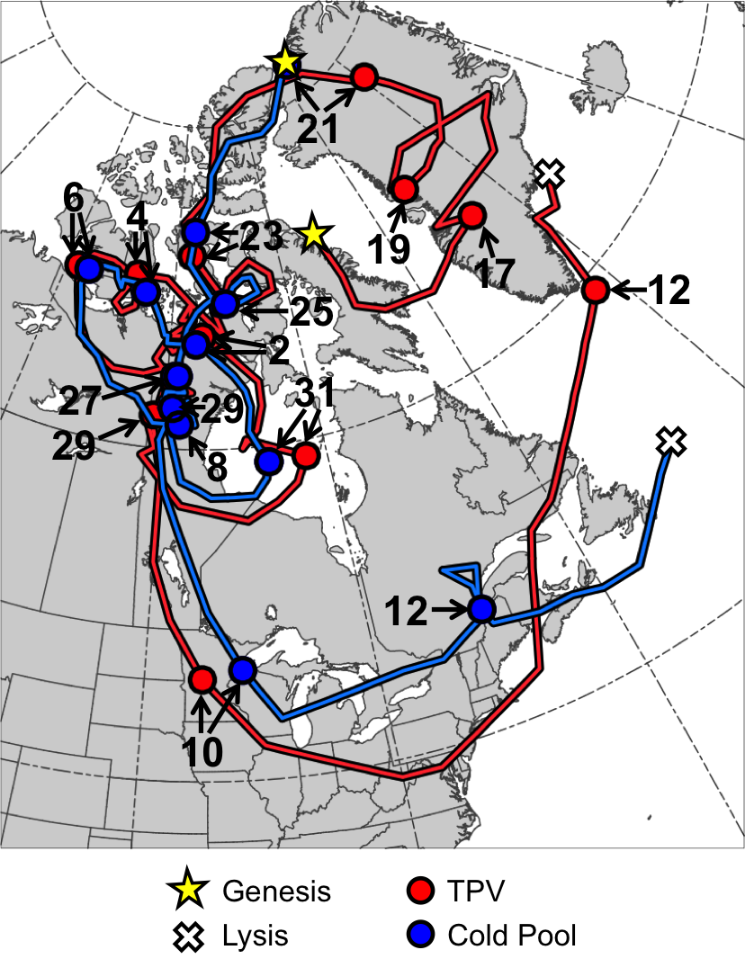

Fig. 4.1. Tracks of TPV (red) from 0600 UTC 15 December 1981 to 0000 UTC 13 January 1982 and cold pool (blue) from 1800 UTC 20 December 1981 to 1800 UTC 13 January 1982 for January 1982 CAO case. Stars denote locations of genesis, crosses denote locations of lysis, and red and blue dots represent 0000 UTC positions of TPV and cold pool, respectively, every 48 h. Numbers pointing toward dots represent dates of the 0000 UTC positions of the TPV and cold pool, such that numbers ≥17 correspond to dates in December 1981 and numbers ≤12 correspond to dates in January 1982.

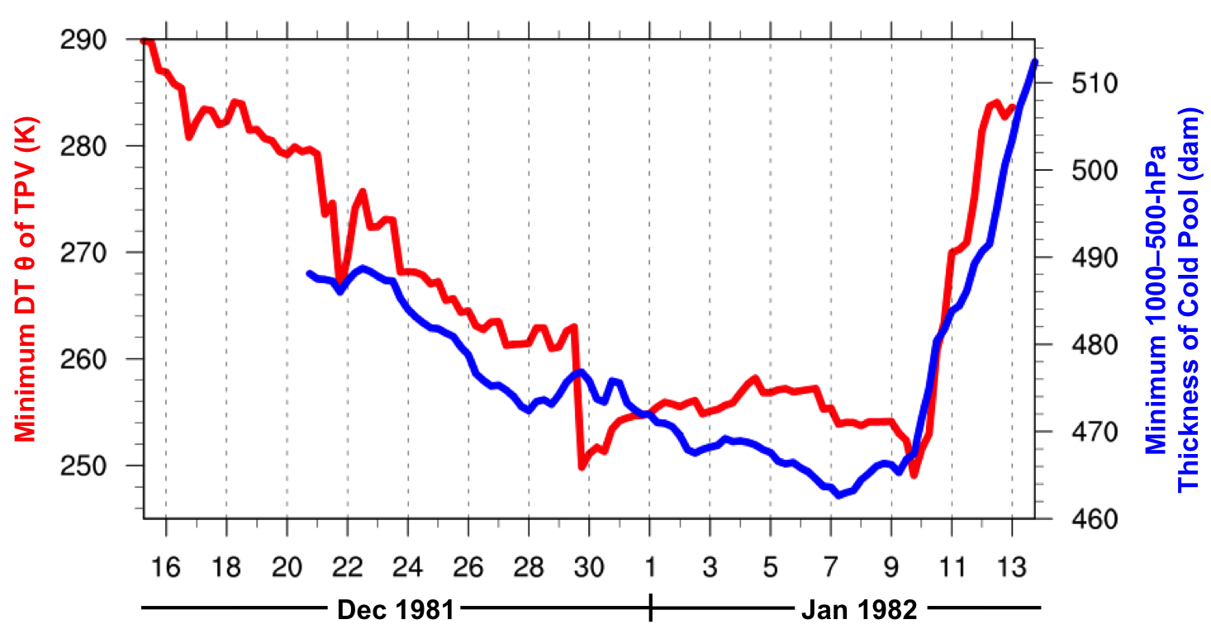

Fig. 4.2. Time series of minimum DT potential temperature (θ) of TPV (K, red) every 6 h from 0600 UTC 15 December 1981 to 0000 UTC 13 January 1982 and minimum 1000–500-hPa thickness of cold pool (dam, blue) every 6 h from 1800 UTC 20 December 1981 to 1800 UTC 13 January 1982 for January 1982 CAO case.
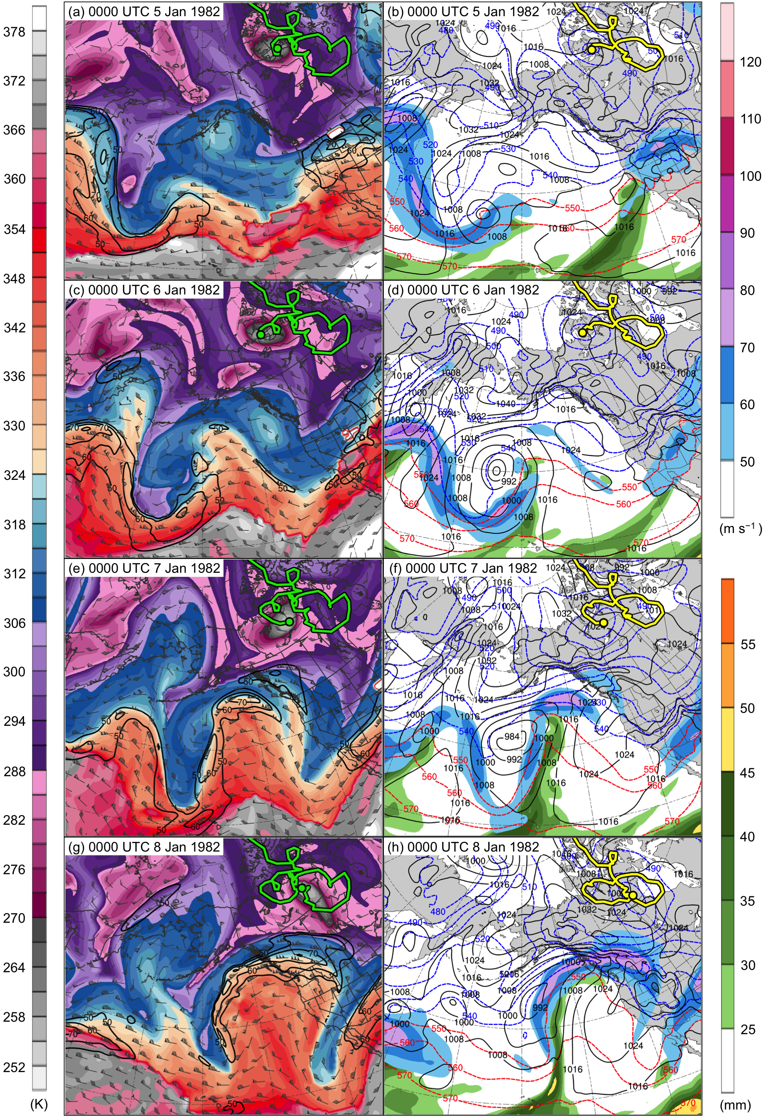

Fig. 4.3. DT (2-PVU surface) potential temperature (K, shaded), wind speed (black contours every 10 m s⁻¹, beginning at 50 m s⁻¹), and wind (m s⁻¹, flags and barbs) at (a) 0000 UTC 5 January, (c) 0000 UTC 6 January, (e) 0000 UTC 7 January, and (g) 0000 UTC 8 January 1982; 250-hPa wind speed (m s⁻¹, shaded), 1000–500-hPa thickness (dashed red and blue contours every 10 dam, contoured red for values >540 dam and blue otherwise), SLP (black contours every 8 hPa), and precipitable water (mm, shaded) at (b) 0000 UTC 5 January, (d) 0000 UTC 6 January, (f) 0000 UTC 7 January, and (h) 0000 UTC 8 January 1982. Green line and dot represent track and position of TPV, respectively, and yellow line and dot represent track and position of cold pool, respectively.
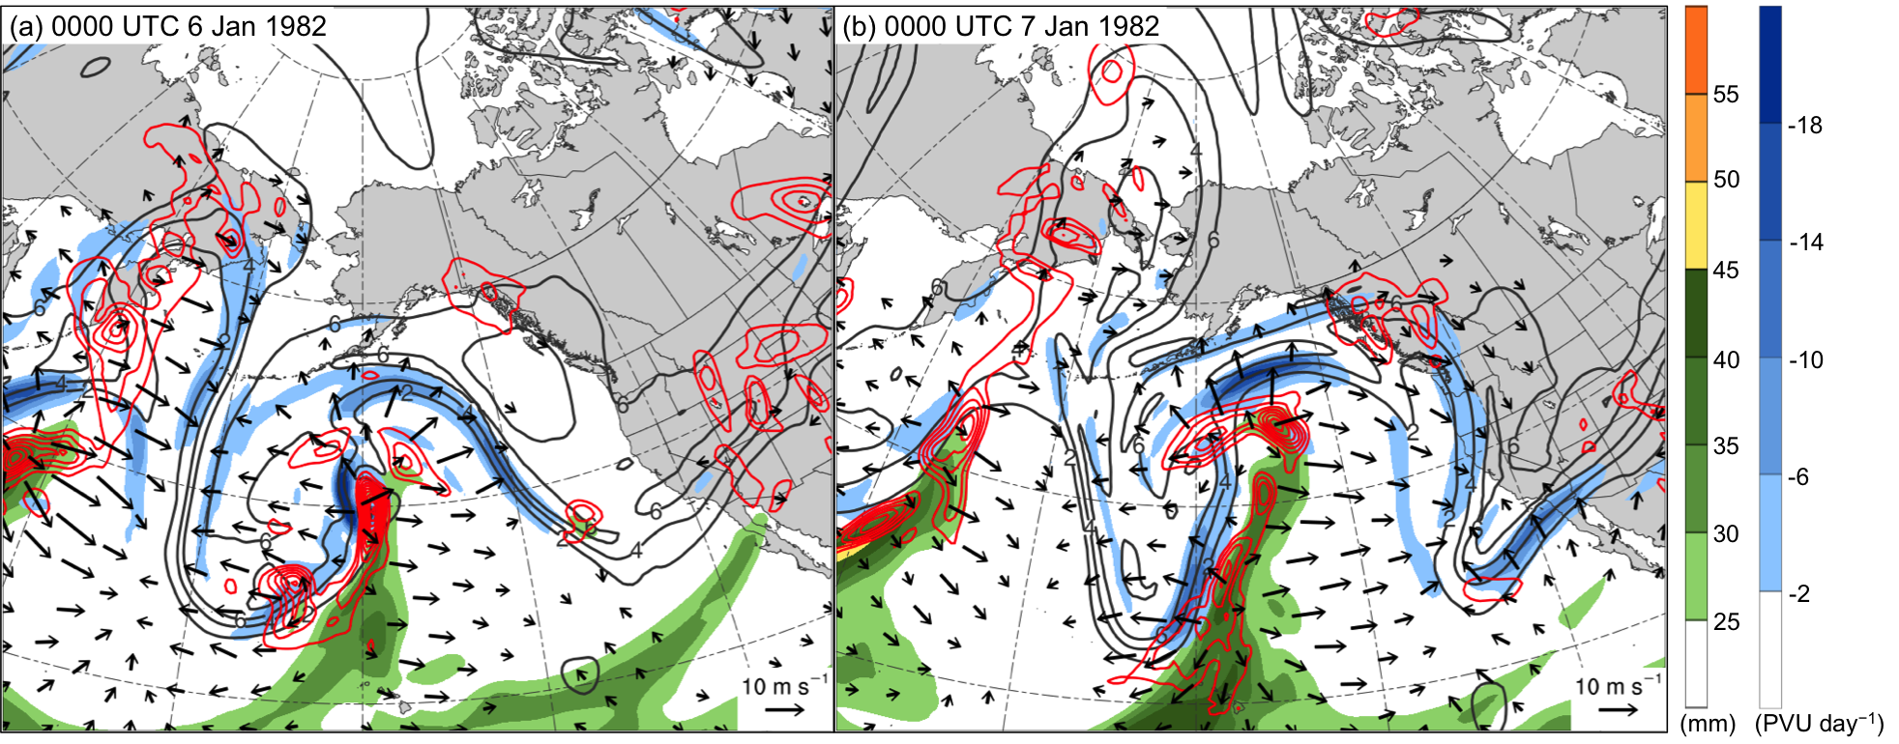

Fig. 4.4. Precipitable water (mm, shaded), 600–400-hPa ascent (red contours every 2.5 × 10⁻³ hPa s⁻¹), and 300–200-hPa PV (PVU, gray) and negative PV advection by the irrotational wind (PVU day⁻¹, shaded) at (a) 0000 UTC 6 January and (b) 0000 UTC 7 January 1982.

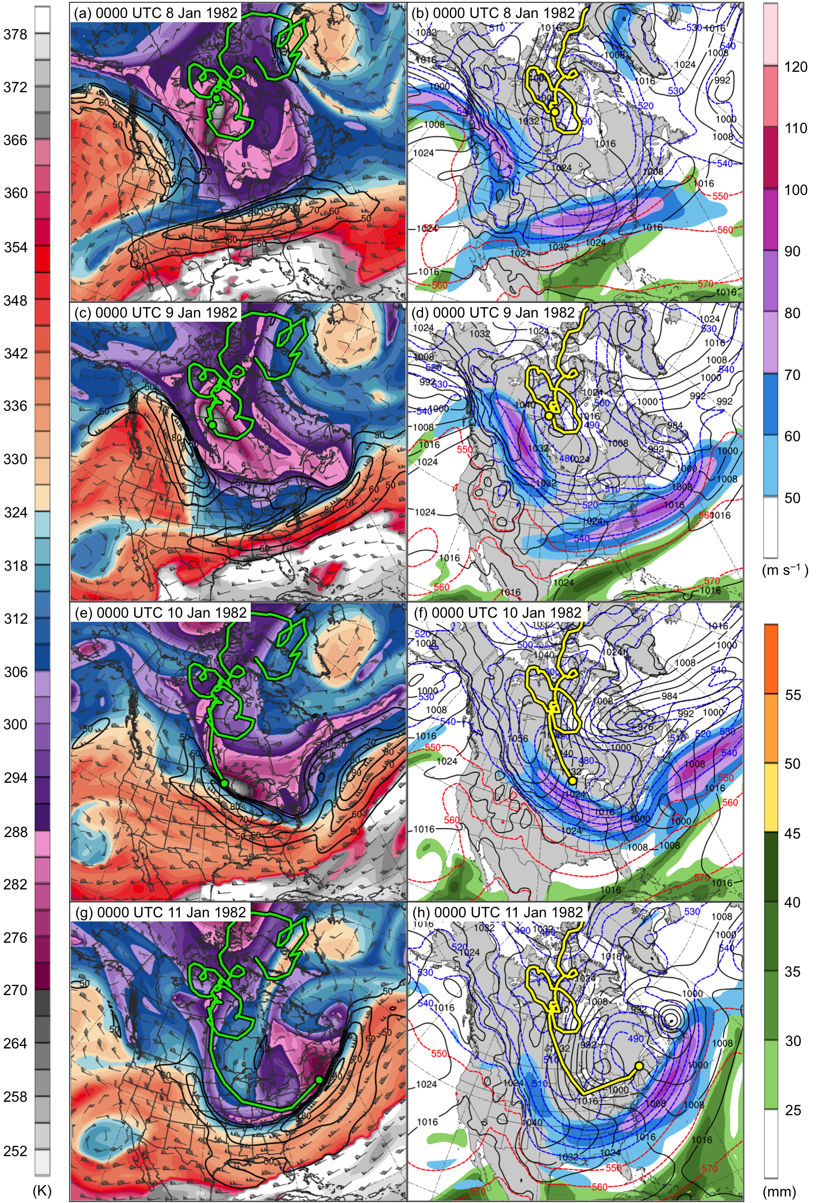

Fig. 4.5. DT (2-PVU surface) potential temperature (K, shaded), wind speed (black contours every 10 m s⁻¹, beginning at 50 m s⁻¹), and wind (m s⁻¹, flags and barbs) at (a) 0000 UTC 8 January, (c) 0000 UTC 9 January, (e) 0000 UTC 10 January, and (g) 0000 UTC 11 January 1982; 250-hPa wind speed (m s⁻¹, shaded), 1000–500-hPa thickness (dashed red and blue contours every 10 dam, contoured red for values >540 dam and blue otherwise), SLP (black contours every 8 hPa), and precipitable water (mm, shaded) at (b) 0000 UTC 8 January, (d) 0000 UTC 9 January, (f) 0000 UTC 10 January, and (h) 0000 UTC 11 January 1982. Green line and dot represent track and position of TPV, respectively, and yellow line and dot represent track and position of cold pool, respectively.
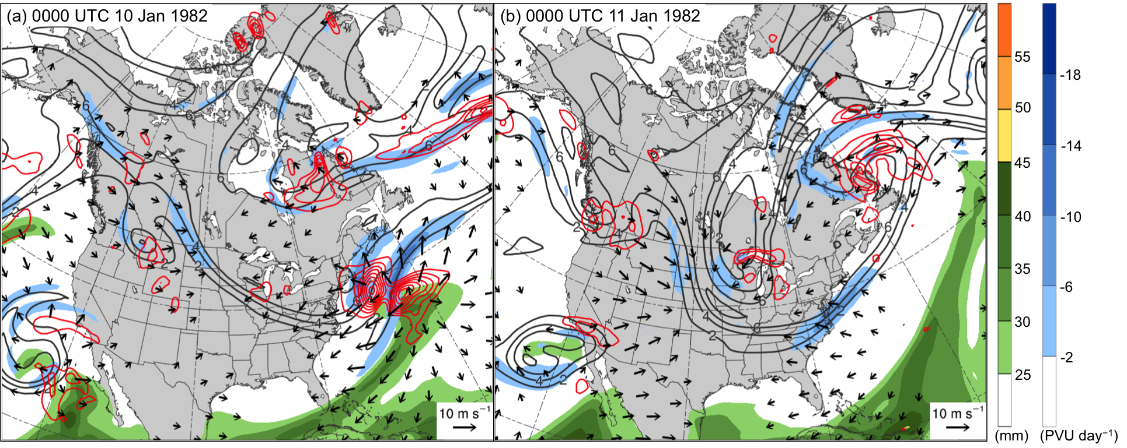

Fig. 4.6. Precipitable water (mm, shaded), 600–400-hPa ascent (red contours every 2.5 × 10⁻³ hPa s⁻¹), and 300–200-hPa PV (PVU, gray) and negative PV advection by the irrotational wind (PVU day⁻¹, shaded) at (a) 0000 UTC 10 January and (b) 0000 UTC 11 January 1982.

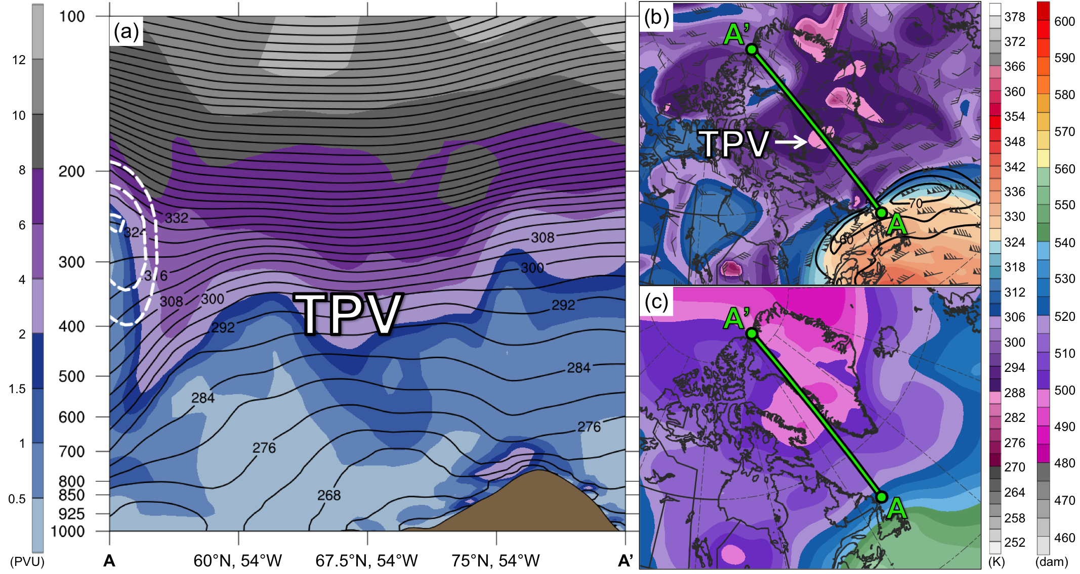

Fig. 4.7. (a) Cross section along line AA’ of PV (PVU, shading), potential temperature (K, black), and wind speed (dashed white contours every 10 m s⁻¹, beginning at 50 m s⁻¹); (b) DT (2-PVU surface) potential temperature (K, shaded), wind speed (black contours every 10 m s⁻¹, beginning at 50 m s⁻¹), and wind (m s⁻¹, flags and barbs); and (c) 1000–500-hPa thickness (dam, shading) at 1200 UTC 16 December 1981. Green line in (b) and (c) represents transect of cross section AA’. Label “TPV” represents location of TPV.
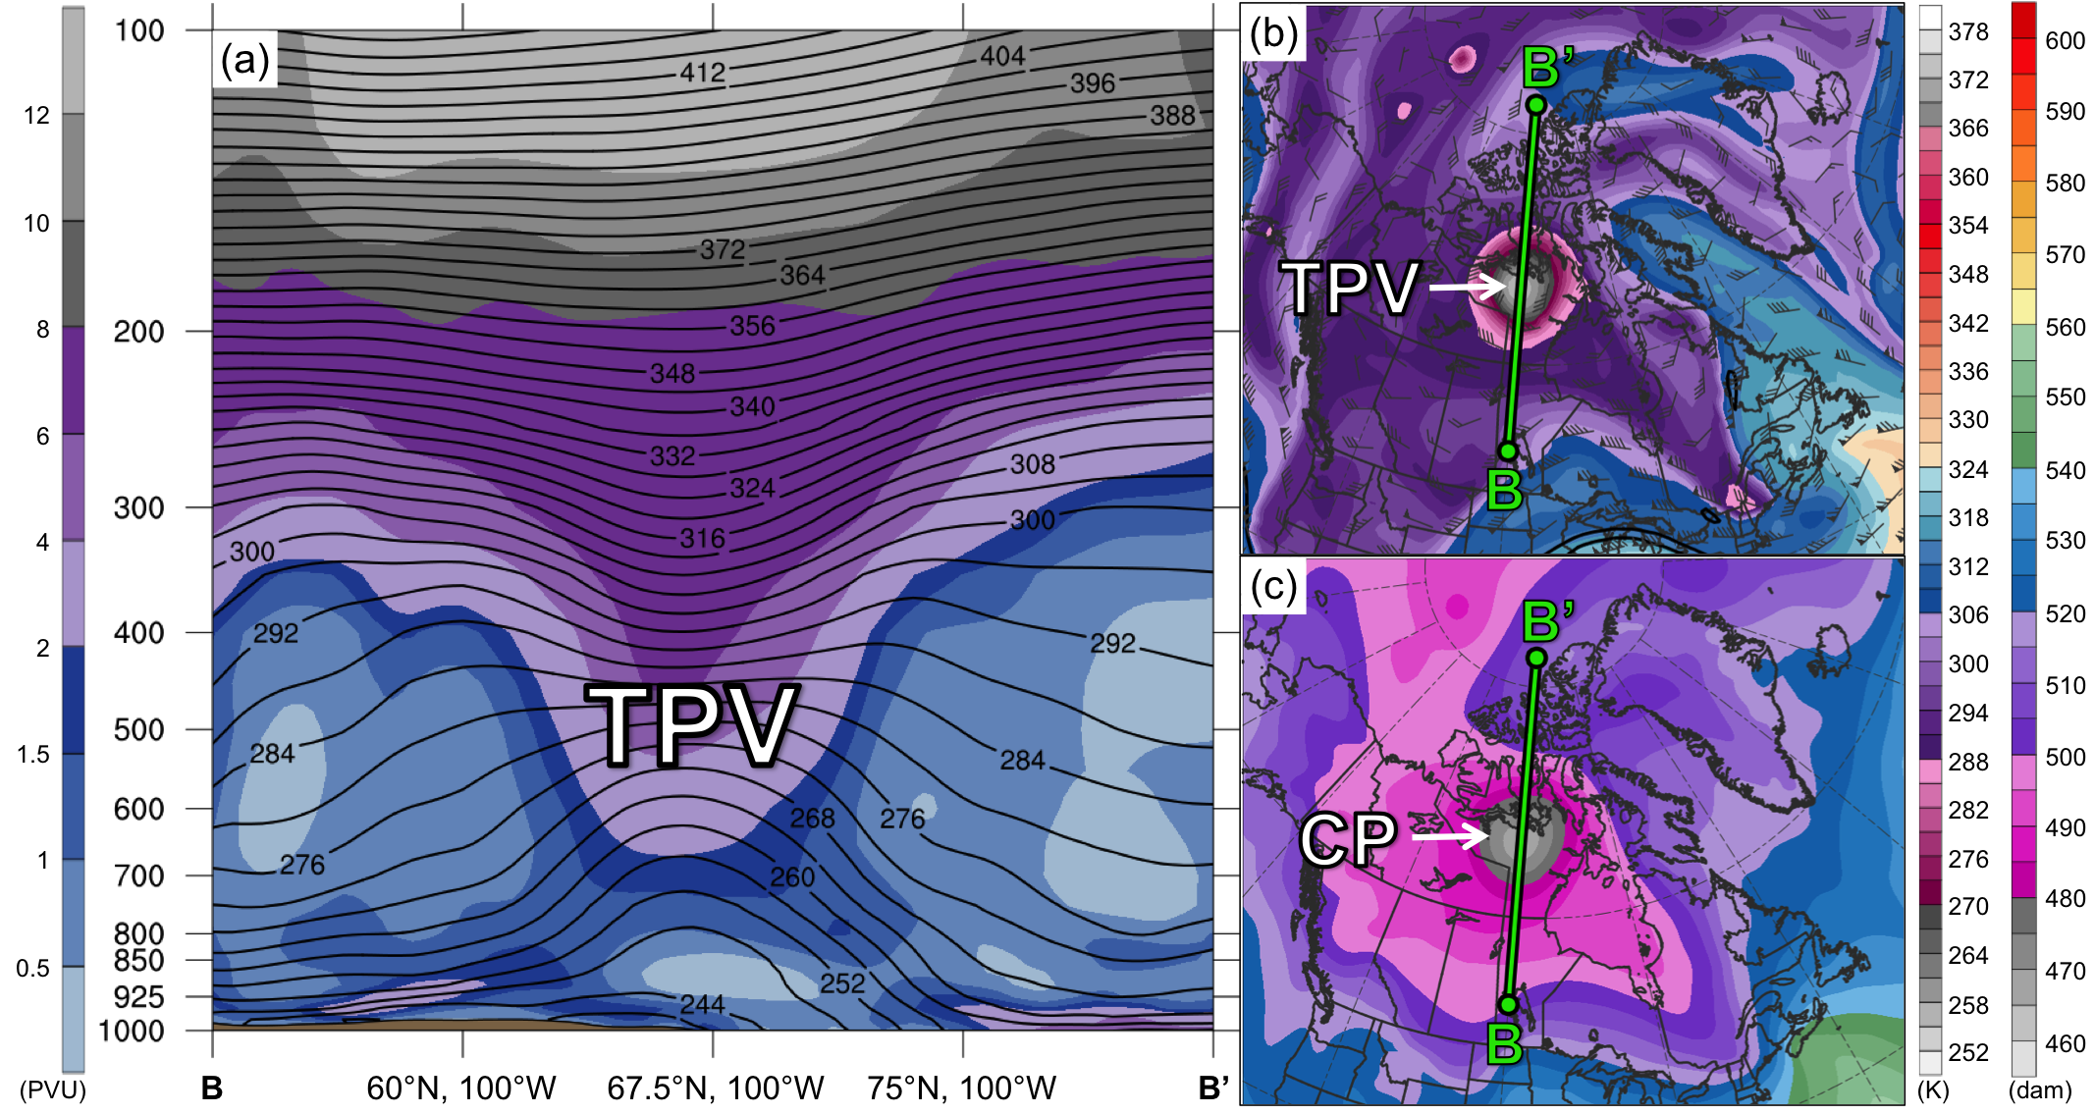

Fig. 4.8. As in Fig. 4.7, but for cross section along line BB’ at 1200 UTC 2 January 1982. Label “CP” represents location of cold pool.

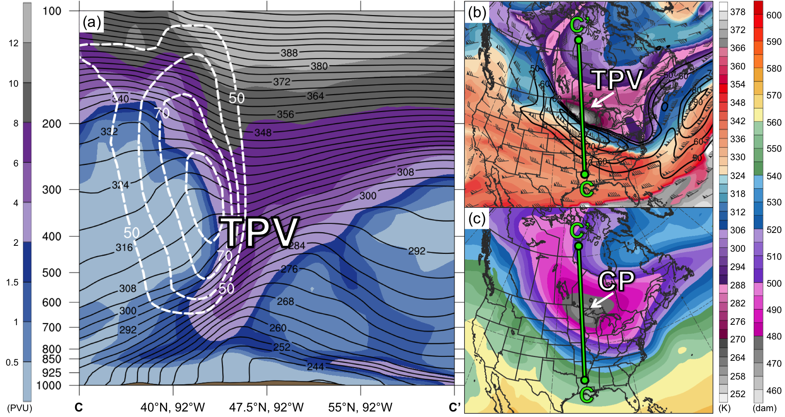

Fig. 4.9. As in Figs. 4.7 and 4.8, but for cross section along line CC’ at 0000 UTC 10 January 1982.

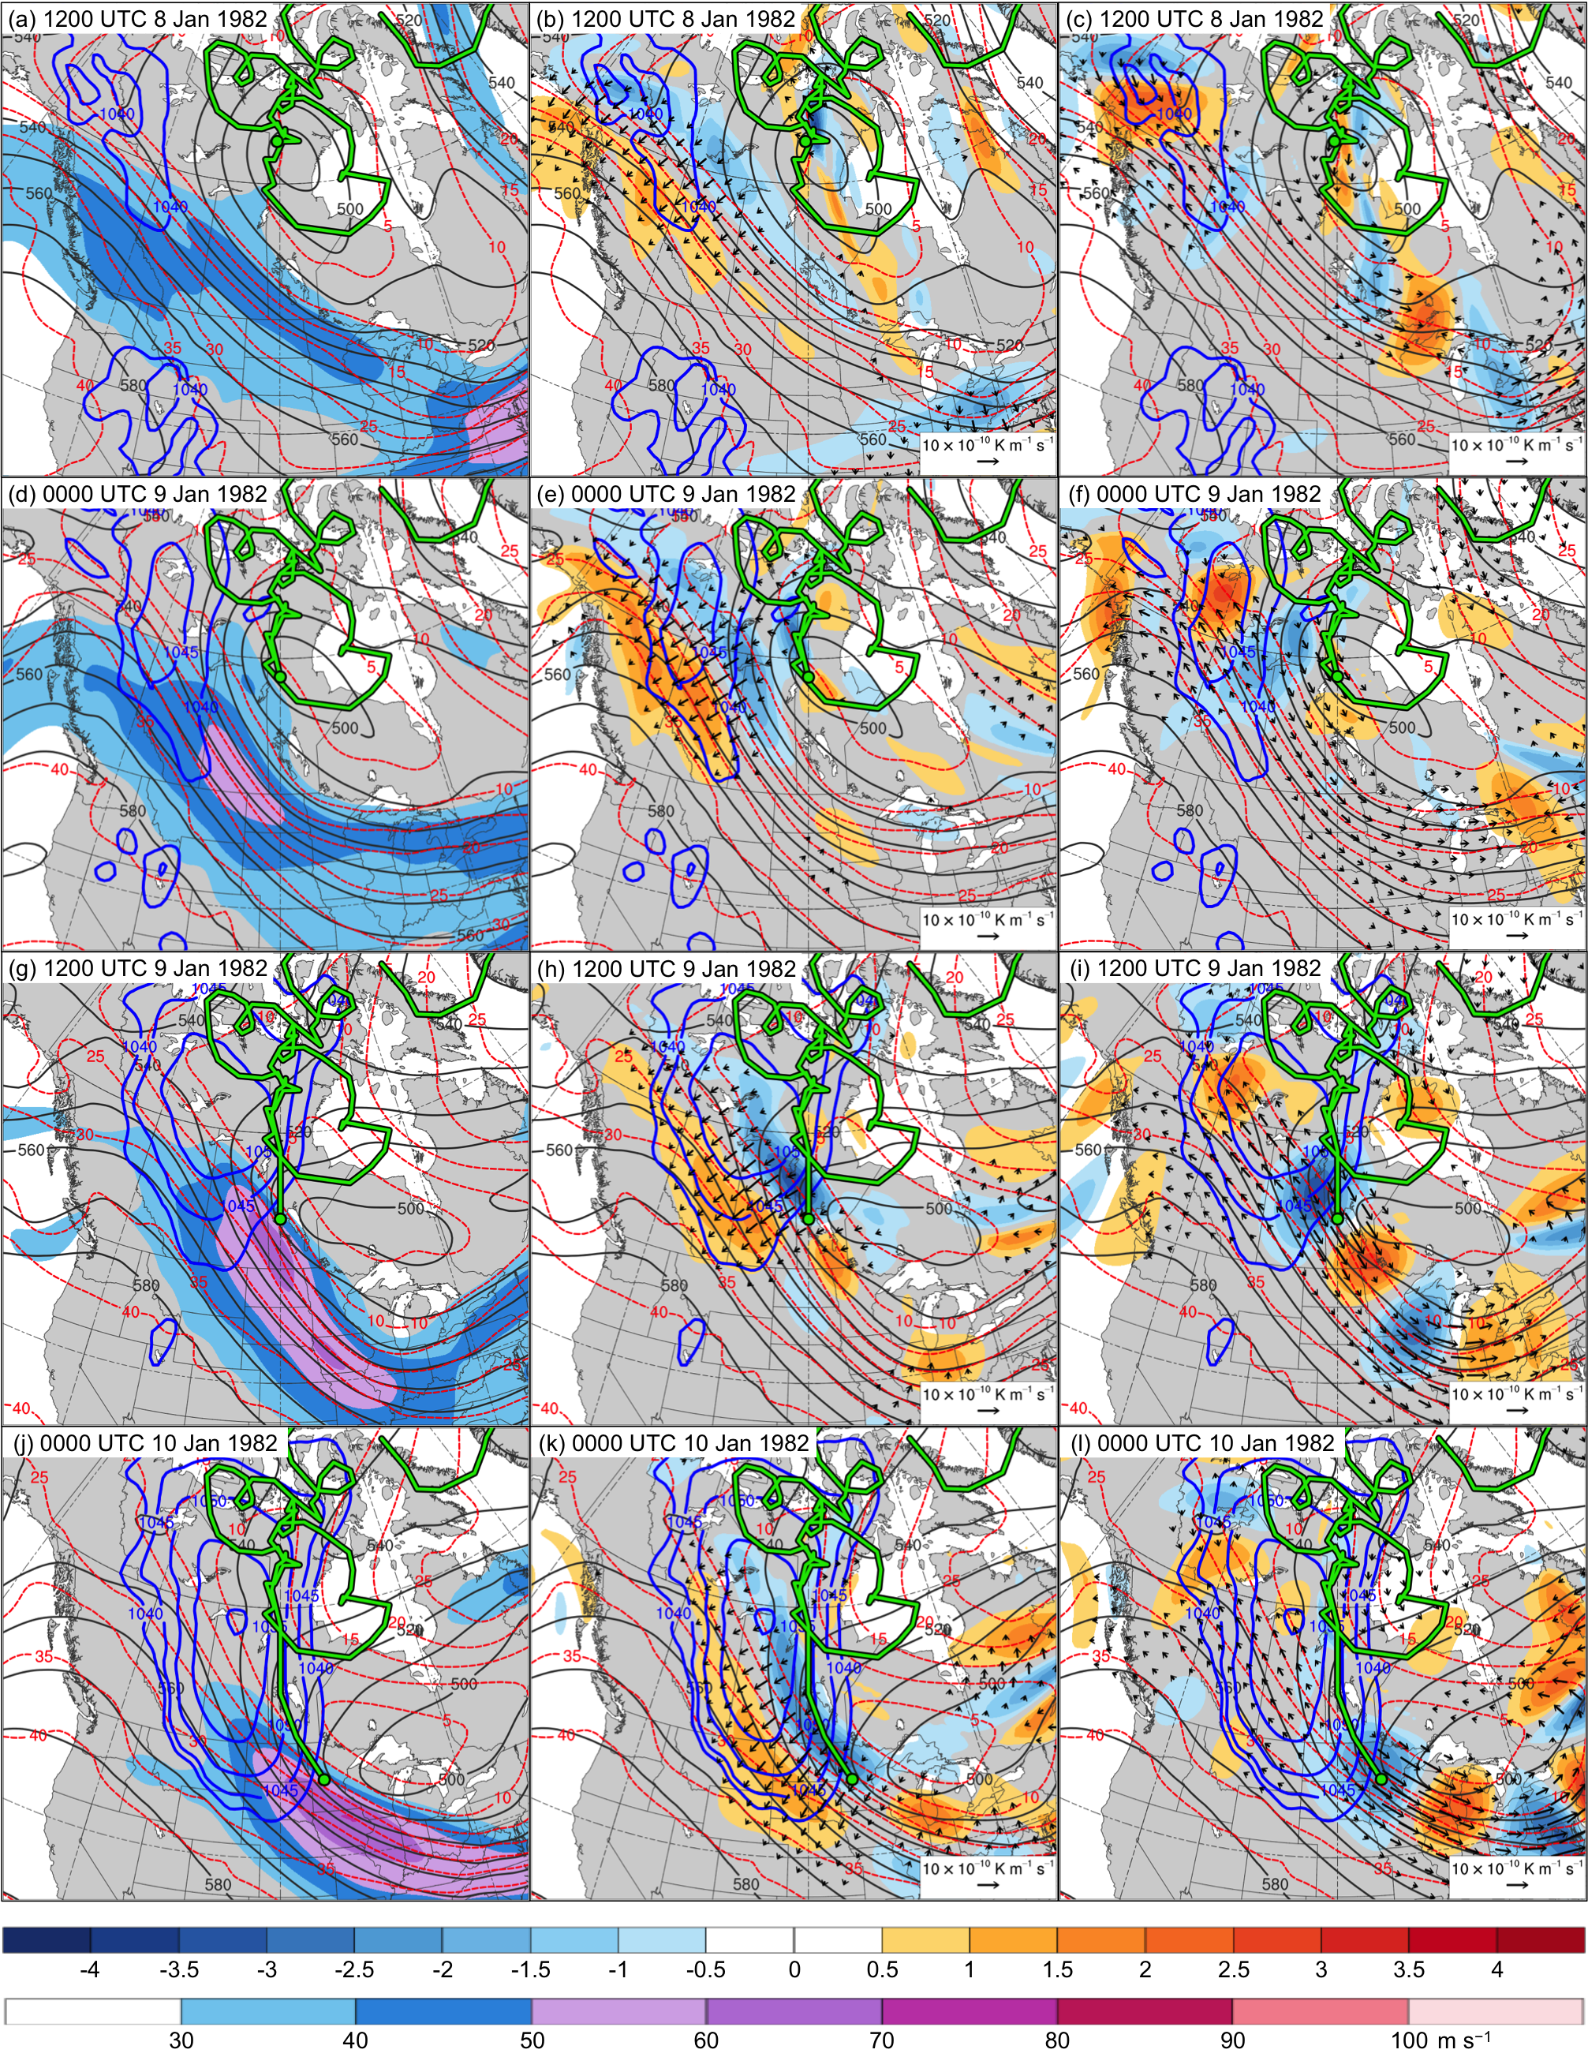

Fig. 4.10. In all panels are SLP (thick blue contours every 5 hPa, beginning at 1040 hPa), and 600–400-hPa geopotential height (dark gray contours every 10 dam) and potential temperature (dashed red contours every 5°C). Also, 600–400-hPa wind speed (m s⁻¹, shaded) at (a) 1200 UTC 8 January, (d) 0000 UTC 9 January, (g) 1200 UTC 9 January, and (j) 0000 UTC 10 January 1982; 600–400-hPa Q_{n} (K m⁻¹ s⁻¹, vectors) and Q_{n} forcing for vertical motion (10⁻¹⁷ Pa⁻¹ s⁻³, shaded) at (b) 1200 UTC 8 January, (e) 0000 UTC 9 January, (h) 1200 UTC 9 January, and (k) 0000 UTC 10 January 1982; and 600–400-hPa Q_{s} (K m⁻¹ s⁻¹, vectors) and Q_{s} forcing for vertical motion (10⁻¹⁷ Pa⁻¹ s⁻³, shaded) at (c) 1200 UTC 8 January, (f) 0000 UTC 9 January, (i) 1200 UTC 9 January, and (l) 0000 UTC 10 January 1982. Green line and dot represent track and position of TPV, respectively.

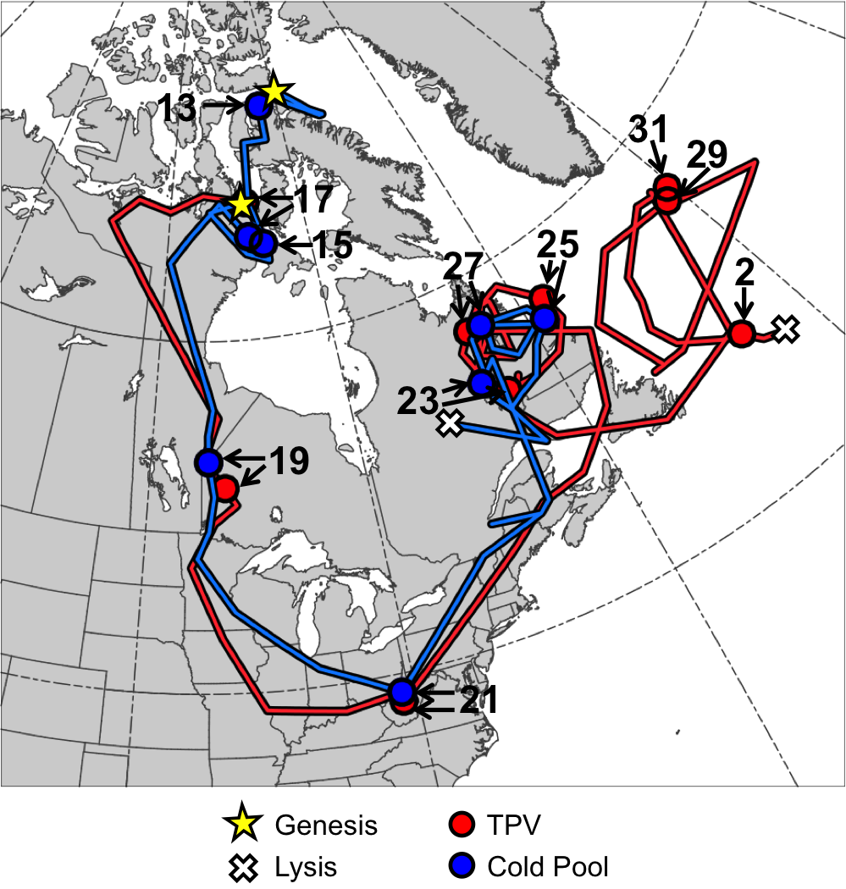

Fig. 4.11. Tracks of TPV (red) from 1800 UTC 16 January to 1200 UTC 2 February 1985 and cold pool (blue) from 1800 UTC 11 January to 0600 UTC 28 January 1985 for January 1985 CAO case. Stars denote locations of genesis, crosses denote locations of lysis, and red and blue dots represent 0000 UTC positions of TPV and cold pool, respectively, every 48 h. Numbers pointing toward dots represent dates of the 0000 UTC positions of the TPV and cold pool, such that numbers ≥13 correspond to dates in January 1985 and the number “2” corresponds to 2 February 1985.

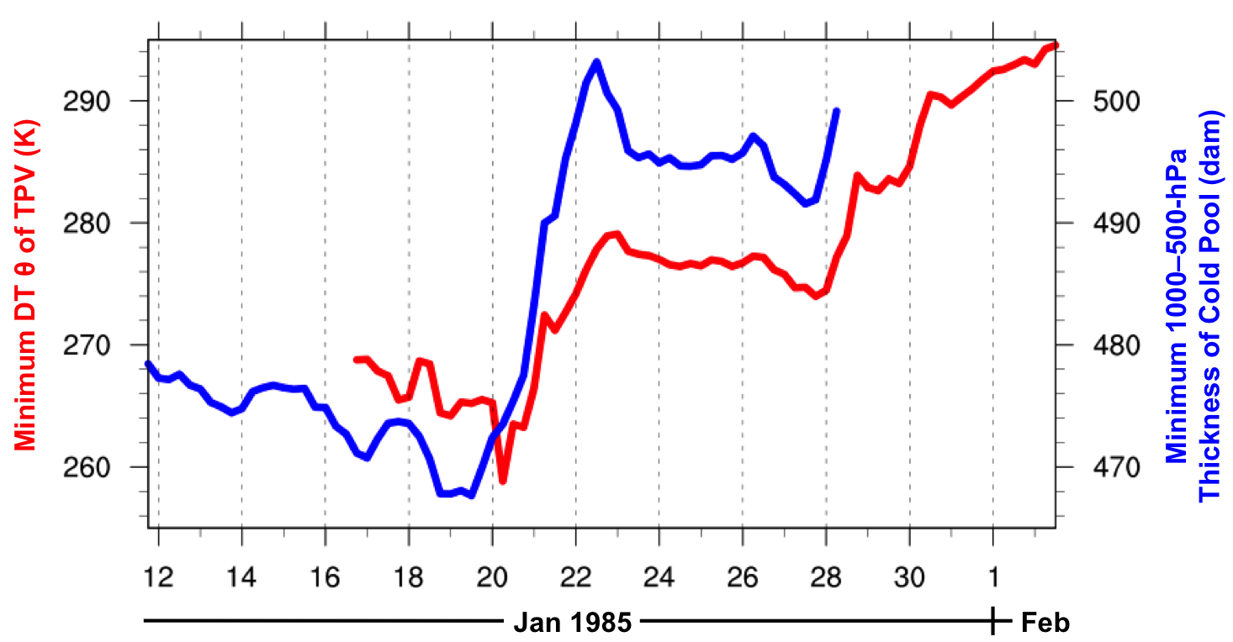

Fig. 4.12. Time series of minimum DT potential temperature (θ) of TPV (K, red) every 6 h from 1800 UTC 16 January to 1200 UTC 2 February 1985 and minimum 1000–500-hPa thickness of cold pool (dam, blue) every 6 h from 1800 UTC 11 January to 0600 UTC 28 January 1985 for January 1985 CAO case.
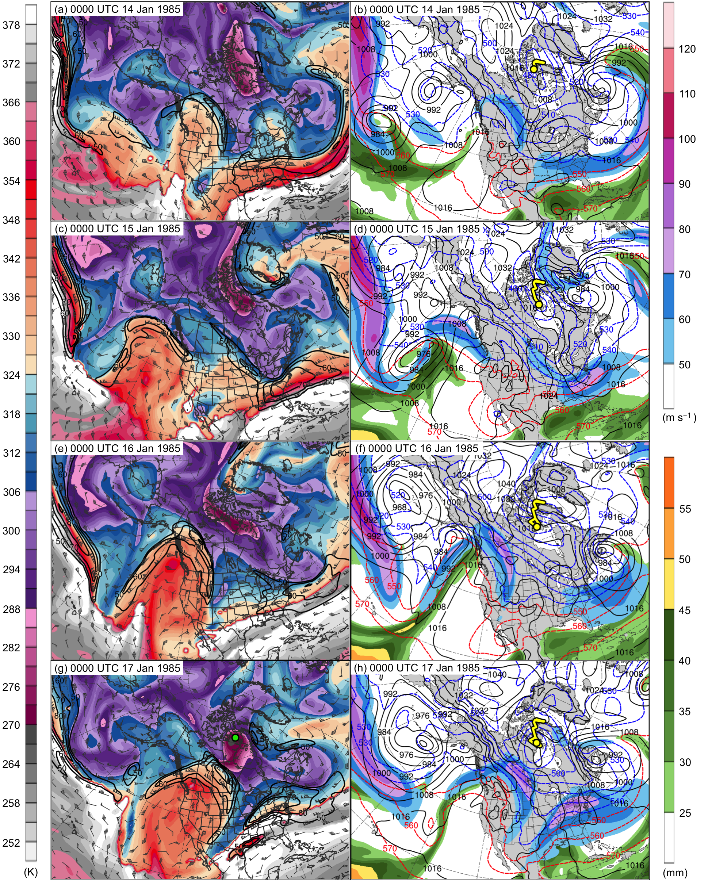

Fig. 4.13. DT (2-PVU surface) potential temperature (K, shaded), wind speed (black contours every 10 m s⁻¹, beginning at 50 m s⁻¹), and wind (m s⁻¹, flags and barbs) at (a) 0000 UTC 14 January, (c) 0000 UTC 15 January, (e) 0000 UTC 16 January, and (g) 0000 UTC 17 January 1985; 250-hPa wind speed (m s⁻¹, shaded), 1000–500-hPa thickness (dashed red and blue contours every 10 dam, contoured red for values >540 dam and blue otherwise), SLP (black contours every 8 hPa), and precipitable water (mm, shaded) at (b) 0000 UTC 14 January, (d) 0000 UTC 15 January, (f) 0000 UTC 16 January, and (h) 0000 UTC 17 January 1985. Green line and dot represent track and position of TPV, respectively, and yellow line and dot represent track and position of cold pool, respectively.

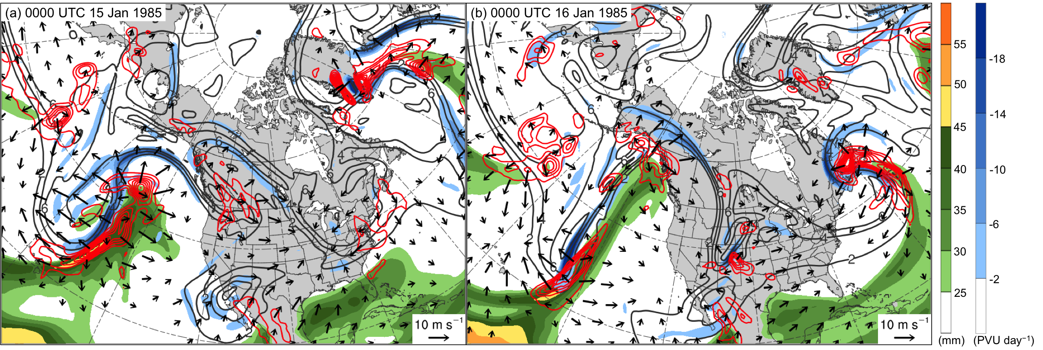

Fig. 4.14. Precipitable water (mm, shaded), 600–400-hPa ascent (red contours every 2.5 × 10⁻³ hPa s⁻¹), and 300–200-hPa PV (PVU, gray) and negative PV advection by the irrotational wind (PVU day⁻¹, shaded) at (a) 0000 UTC 15 January and (b) 0000 UTC 16 January 1985.

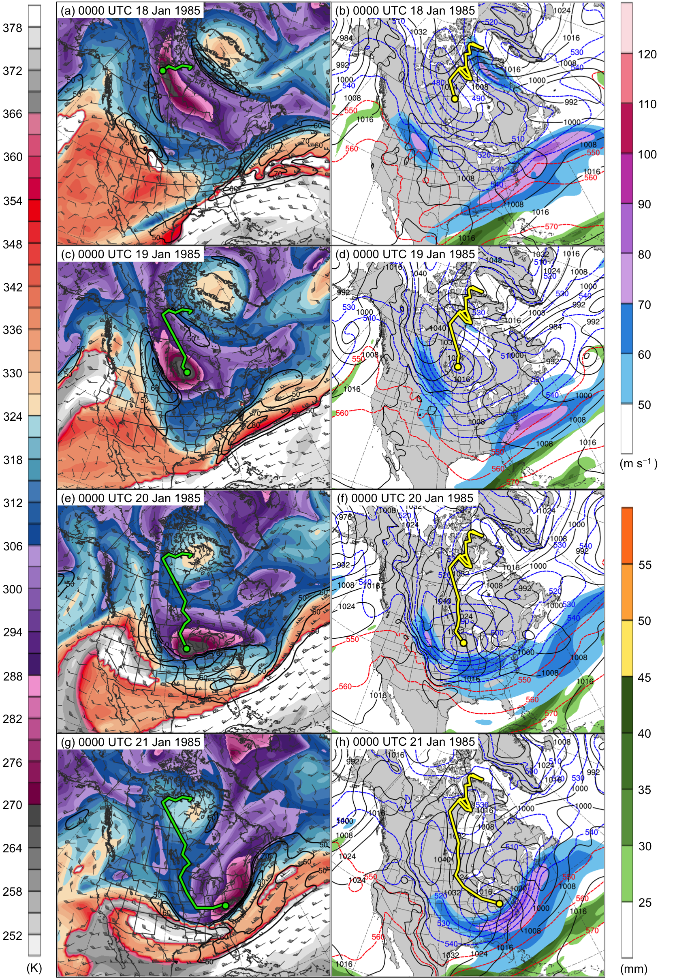

Fig. 4.15. DT (2-PVU surface) potential temperature (K, shaded), wind speed (black contours every 10 m s⁻¹, beginning at 50 m s⁻¹), and wind (m s⁻¹, flags and barbs) at (a) 0000 UTC 18 January, (c) 0000 UTC 19 January, (e) 0000 UTC 20 January, and (g) 0000 UTC 21 January 1985; 250-hPa wind speed (m s⁻¹, shaded), 1000–500-hPa thickness (dashed red and blue contours every 10 dam, contoured red for values >540 dam and blue otherwise), SLP (black contours every 8 hPa), and precipitable water (mm, shaded) at (b) 0000 UTC 18 January, (d) 0000 UTC 19 January, (f) 0000 UTC 20 January, and (h) 0000 UTC 21 January 1985. Green line and dot represent track and position of TPV, respectively, and yellow line and dot represent track and position of cold pool, respectively.
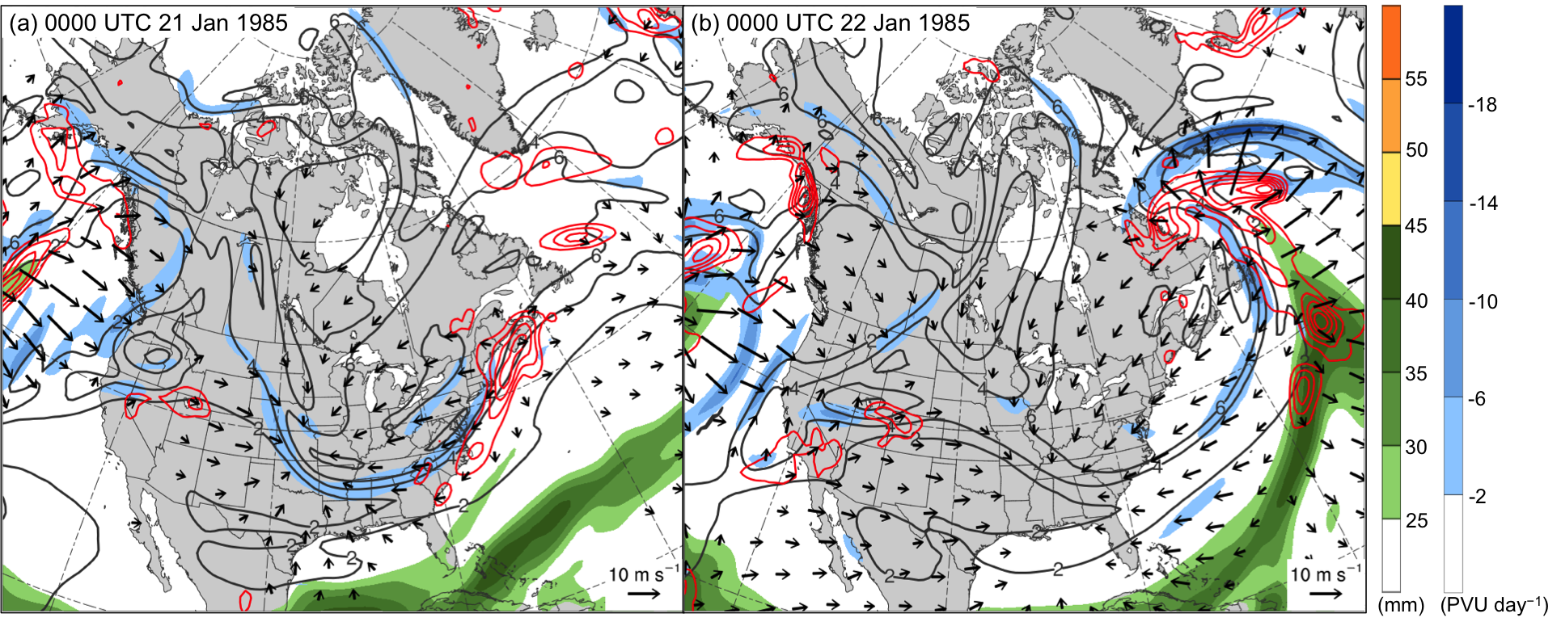

Fig. 4.16. Precipitable water (mm, shaded), 600–400-hPa ascent (red contours every 2.5 × 10⁻³ hPa s⁻¹), and 300–200-hPa PV (PVU, gray) and negative PV advection by the irrotational wind (PVU day⁻¹, shaded) at (a) 0000 UTC 21 January and (b) 0000 UTC 22 January 1985.

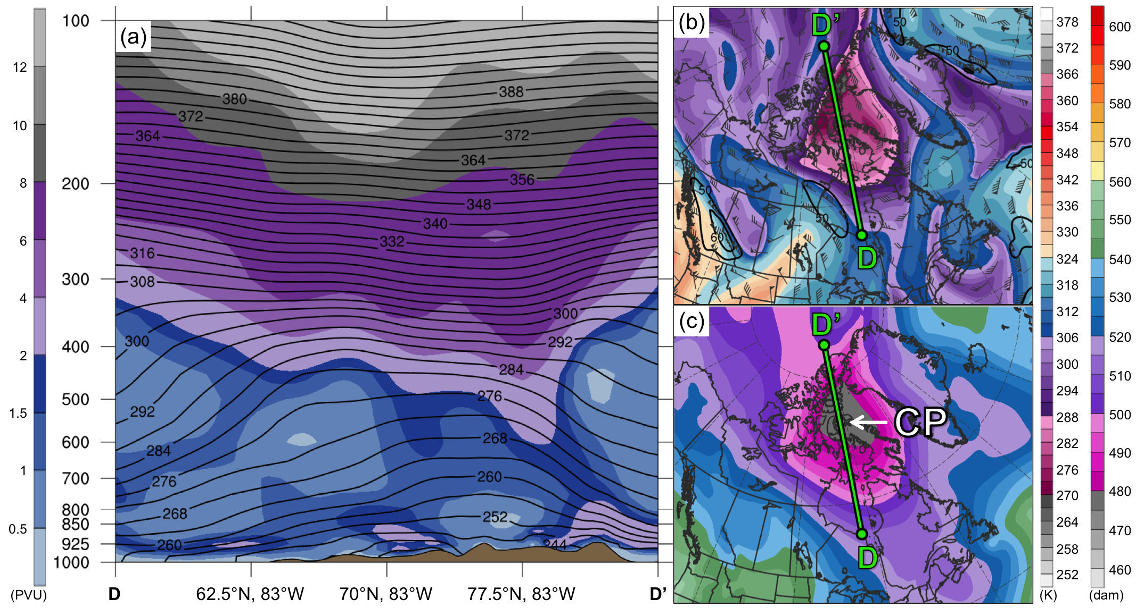

Fig. 4.17. As in Fig. 4.7, but for cross section along line DD’ at 0000 UTC 13 January 1985.

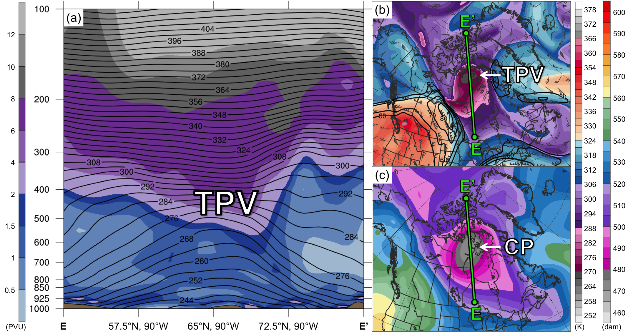

Fig. 4.18. As in Fig. 4.7, but for cross section along line EE’ at 0000 UTC 17 January 1985.

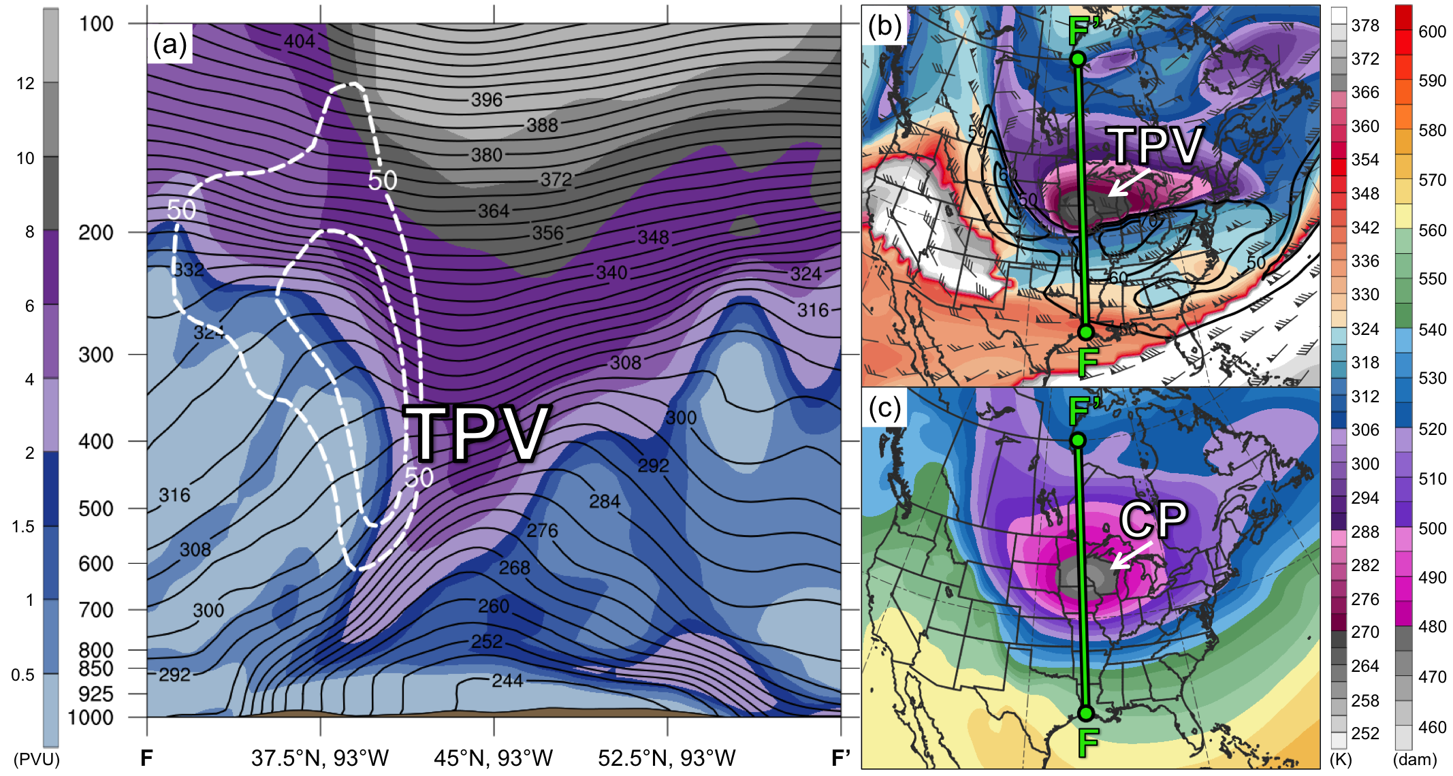

Fig. 4.19. As in Fig. 4.7, but for cross section along line FF’ at 0000 UTC 20 January 1985.

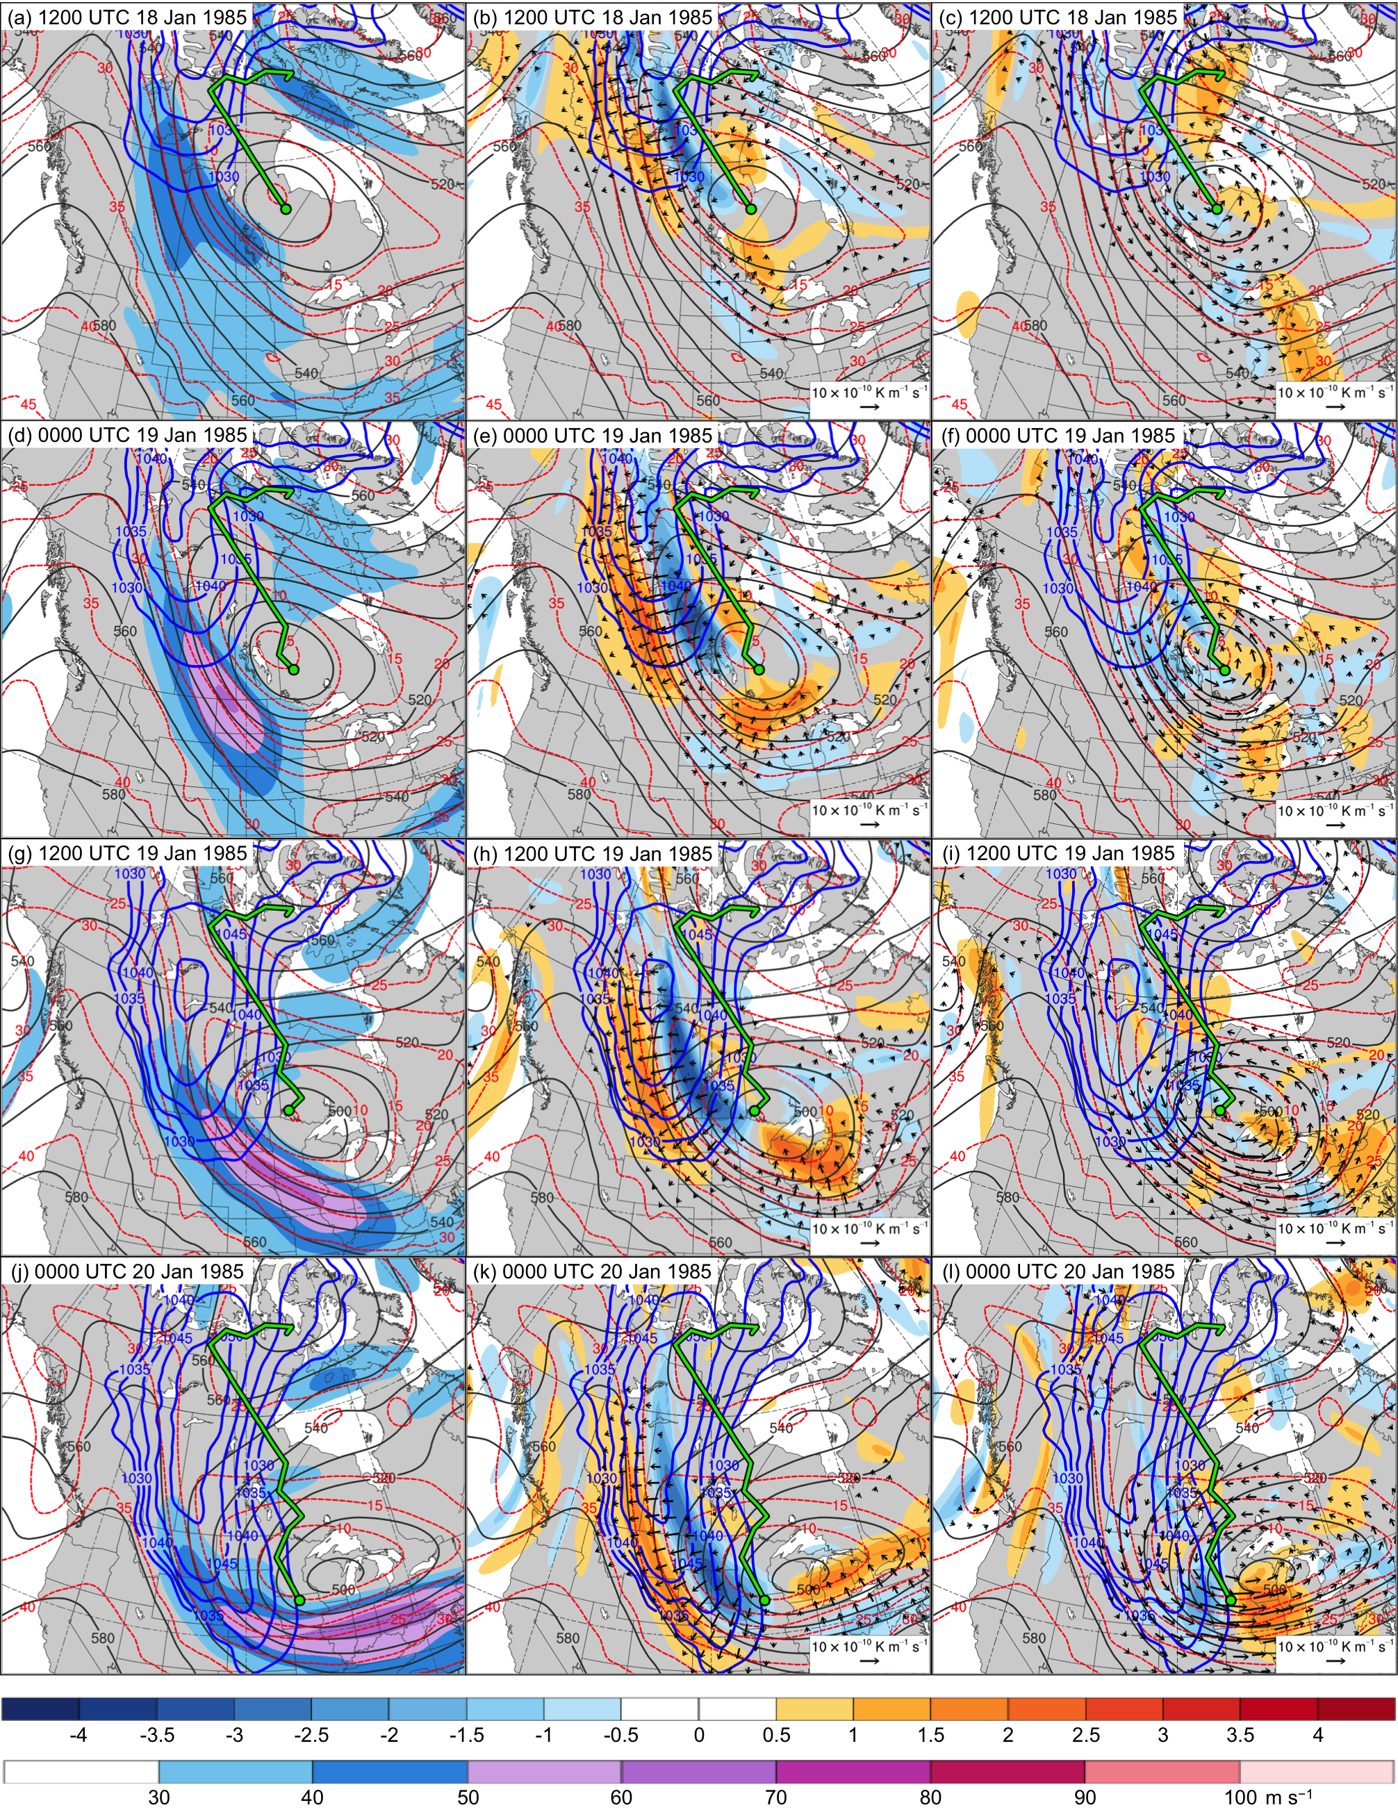

Fig. 4.20. In all panels are SLP (thick blue contours every 5 hPa, beginning at 1030 hPa), and 600–400-hPa geopotential height (dark gray contours every 10 dam) and potential temperature (dashed red contours every 5°C). Also, 600–400-hPa wind speed (m s⁻¹, shaded) at (a) 1200 UTC 18 January, (d) 0000 UTC 19 January, (g) 1200 UTC 19 January, and (j) 0000 UTC 20 January 1985; 600–400-hPa Q_{n} (K m⁻¹ s⁻¹, vectors) and Q_{n} forcing for vertical motion (10⁻¹⁷ Pa⁻¹ s⁻³, shaded) at (b) 1200 UTC 18 January, (e) 0000 UTC 19 January, (h) 1200 UTC 19 January, and (k) 0000 UTC 20 January 1985; and 600–400-hPa Q_{s} (K m⁻¹ s⁻¹, vectors) and Q_{s} forcing for vertical motion (10⁻¹⁷ Pa⁻¹ s⁻³, shaded) at (c) 1200 UTC 18 January, (f) 0000 UTC 19 January, (i) 1200 UTC 19 January, and (l) 0000 UTC 20 January 1985. Green line and dot represent track and position of TPV, respectively.

