1. Introduction
  - Motivation
Tropopause polar vortices (TPVs) are coherent tropopause-based cyclonic vortices that spend at least a portion of their lifetimes in the high latitudes (e.g., Cavallo and Hakim 2009, 2010). TPVs are tropopause-based material features, characterized by a local minimum of potential temperature on the dynamic tropopause (DT) and by a local maximum of pressure on the DT. TPVs represent a subset of coherent tropopause disturbances (CTDs; e.g., Pyle et al. 2004), which are also tropopause-based material features, but are not required to spend at least a portion of their lifetimes in the high latitudes. TPVs are subsynoptic and mesoscale features that may last from days to months (e.g., Hakim and Canavan 2005; Cavallo and Hakim 2012). Also, TPVs often spend much of their lifetimes in the high latitudes, where they may be maintained and intensified via radiative processes (Cavallo and Hakim 2009, 2010, 2012, 2013).
Although TPVs often spend much of their lifetimes in the high latitudes, some TPVs may be extracted from high latitudes in conjunction with high-latitude upper-level ridge amplification (e.g., Hakim et al. 1995, 1996). Once extracted, TPVs may interact with and strengthen midlatitude jet streams (e.g., Pyle et al. 2004), as well as act as precursors to the development of strong extratropical cyclones (ECs; e.g., Hakim et al. 1995, 1996; Bosart et al. 1996). Strong ECs may lead to extreme weather events (EWEs) associated with heavy precipitation and strong winds that can pose significant hazards to life and property. In addition, lower-tropospheric cold pools (hereafter referred to as cold pools) may accompany TPVs as they are transported to middle latitudes and may lead to widespread cold air outbreaks (CAOs; e.g., Shapiro et al. 1987). CAOs are EWEs themselves, posing a hazard to life, infrastructure, and agriculture [e.g., Florida citrus freezes (Rogers and Rohli 1991)].
In view of the hazards CAOs associated with TPVs may pose, the opportunity to improve understanding of the equatorward transport of TPVs to middle latitudes and the role of TPVs in the development of CAOs motivates this research. Although past studies have examined the equatorward transport of TPVs to middle latitudes from a case study perspective (e.g., Hakim et al. 1995, 1996), a climatological analysis of the equatorward transport of TPVs to middle latitudes is lacking. In addition, although past studies have shown that cold pools leading to CAOs may accompany TPVs as they are transported to middle latitudes (e.g., Shapiro et al. 1987), the linkages between TPVs, cold pools, and CAOs have not been explicitly explored. Therefore, the goal of this research is to improve understanding of the equatorward transport of TPVs to middle latitudes and the linkages between TPVs, cold pools, and CAOs.

  - Literature Review
1.2.1 Structure of TPVs

Coherent tropopause-based vortices know as TPVs that are transported to middle latitudes may contribute to the development of EWEs. In order to understand how TPVs contribute to the development of EWEs, it is important to understand the structure of TPVs. Hoskins et al. (1985, section 3) were among the first to conceptualize coherent tropopause-based vortices from a potential vorticity (PV) perspective as upper-level cyclonic PV anomalies (Fig. 1.1). The upper-level cyclonic PV anomaly shown in Fig. 1.1 is associated with anomalously high static stability and cyclonic absolute vorticity relative to its surroundings, and a downward displacement of the tropopause. Furthermore, upward bowing of isentropes in the troposphere beneath the upper-level cyclonic PV anomaly illustrates that upper-level cyclonic PV anomalies are cold core and associated with anomalously cold air within the troposphere beneath them.
Later studies of coherent tropopause-based vortices have referred to these features as CTDs (e.g., Pyle et al. 2004) and TPVs (e.g., Cavallo and Hakim 2009, 2010). CTDs and TPVs are characterized by closed material contours on the DT, such that under adiabatic and frictionless flow, air parcels are trapped within CTDs and TPVs. However, unlike CTDs, TPVs are required to spend at least a portion of their lifetimes in the high latitudes (Cavallo and Hakim 2009, 2010). An example of a CTD studied by Pyle et al. (2004) qualifying as a TPV is shown in Fig 1.2. This TPV, which formed in the Arctic and lasted 17.5 days during November–December 1991 (not shown), is characterized by a local minimum of DT potential temperature (Fig. 1.2a), local maximum of DT pressure (Fig. 1.2b), and local maximum of PV (Fig. 1.2d). In addition, this TPV was located on the edge of a broader cyclonic circulation at 300 hPa (Fig. 1.2c), illustrating that TPVs are subsynoptic scale and mesoscale structures within the broader tropospheric polar vortex, the edge of which is typically located at the core of upper-tropospheric westerly winds (Waugh et al. 2017).
Cavallo and Hakim (2010) composited TPVs located in the Canadian Arctic and created composite west-to-east cross-TPV sections (Fig. 1.3). Anomalies shown in Fig. 1.3 were computed with respect to a west-to-east “background” cross section located over northern Canada near several radiosonde stations. The composite structure of TPVs is similar to the structure of the upper-level cyclonic PV anomaly shown in Hoskins et al. (1985, section 3; Fig. 1.1 in this thesis). Anomalously cold air is located within the TPV and throughout the troposphere beneath the TPV (Fig. 1.3a), anomalously cyclonic flow is located around the TPV (Fig. 1.3b), and anomalously positive PV is located within and above the TPV (Fig. 1.3c). Furthermore, anomalously low relative humidity (RH) air within and above the TPV associated with dry stratospheric air is located above anomalously high RH air beneath the TPV (Fig. 1.3d). Idealized numerical modeling experiments by Cavallo and Hakim (2013) have shown that longwave radiative cooling associated with large-magnitude vertical gradients in water vapor concentration near the tropopause implied by Fig. 1.3d is important for TPV maintenance and intensification.
Cavallo and Hakim (2010) also discussed that a sloping dipole in vertical motion is located about the composite TPV core, with upward vertical motion located downshear of the composite TPV core and downward vertical motion located upshear and partially within the composite TPV core (not shown). Downward vertical motion within the TPV core is suggestive of the production of relative vorticity within the TPV core via vortex stretching. As stated by Cavallo and Hakim (2010), the dipole of vertical motion can be qualitatively explained by geostrophic vorticity advection by the thermal wind. Similar results were found by Hakim (2000) in his zonal composite cross section of “extreme” 500-hPa relative vorticity maxima occurring during the winter of 1988–89.

1.2.2 Climatologies of TPVs

Hakim and Canavan (2005) tracked cyclonic tropopause-based vortices (i.e., CTDs, represented as minima in DT potential temperature) for the 1948–99 period using the 2.5° NCEP–NCAR reanalysis dataset (Kalnay et al. 1996). Kravitz (2007) created a global climatology of CTDs by tracking DT pressure maxima using the NCEP GFS 1.0° final analysis for the 2000–04 period. Figure 1.4 shows the geographical distribution of CTDs tracked by Hakim and Canavan (2005). Regions of high CTD occurrence are located over the Canadian Archipelago, extending southeastward to Hudson Bay and Labrador; over portions of Siberia and northeastern Asia; and on the poleward side of the North Pacific and North Atlantic jet streams. In addition, regions of low CTD occurrence are found over high terrain features including the Rocky Mountains and the Tibetan Plateau. Most of these regions of high and low CTD occurrence are similar to those found by Kravitz (2007, chapter 3, section 3.2.1.1).
Cavallo and Hakim (2012) created TPV climatologies using the Weather Research and Forecasting (WRF) model and NCEP–NCAR reanalysis for winter (December–February) and summer (June–August) for 1990–99. These climatologies indicate that the number of TPVs identified is sensitive to grid resolution, with the higher resolution WRF winter climatology containing 7426 TPVs, but the lower-resolution NCEP–NCAR winter climatology containing only 442 TPVs. The NCEP–NCAR TPV climatologies show that large TPV track densities are located within climatological troughs over northeastern Canada and northern Siberia, which are also regions of high CTD occurrence identified by Hakim and Canavan (2005; Fig. 1.4 in this thesis) and Kravitz (2007, chapter 3, section 3.2.1.1). In addition, a 1948–99 NNRP climatology of TPVs created by Cavallo and Hakim (2009) shows that regions of TPV genesis and lysis are in close proximity, suggesting that TPVs spend the majority of their lifetimes in the same region of the high latitudes.

1.2.3 Equatorward Transport of TPVs and Arctic Air to Middle Latitudes

Although TPVs are most often found in the high latitudes (e.g., Cavallo and Hakim 2009), case study evidence has indicated that TPVs can be transported to middle latitudes, where they may participate in the development of EWEs (e.g., Hakim et al. 1995, 1996; Bosart et al. 1996). Furthermore, case study evidence from Hakim et al. (1995, 1996) and Bosart et al. (1996) has shown that high latitude upper-level ridge amplification can play an important role in the equatorward transport of TPVs. For example, Bosart et al. (1996) showed that the strengthening of the positive Pacific–North American (PNA) pattern (Wallace and Gutzler 1981) during March 1993, associated with ridge amplification over western North America, facilitated the equatorward transport of a high-latitude coherent tropopause-based disturbance (i.e., a TPV) over North America that played an important role in the development of the 1993 Superstorm. Kravitz (2007, chapter 4, section 4.2.1) examined changes in CTD distribution with respect to positive PNA transitions, representing ridge amplification over the eastern North Pacific and western North America. A positive PNA transition was defined as a period in which the PNA increases by at least a +2.0 standard deviation anomaly over seven days. During days 4–7 of the positive PNA transition, regions of anomalously positive CTD frequency extend from northern Canada, Alaska, and the adjacent Arctic to the middle latitudes of eastern North America, suggesting that ridge amplification may play an important role in the equatorward transport of CTDs (i.e., TPVs) from high latitudes to middle latitudes. Although studies such as Bosart et al. (1996) and Kravitz (2007, chapter 4, section 4.2.1) provide evidence of the equatorward transport of TPVs from high latitudes to middle latitudes, a detailed climatological analysis of the equatorward transport of TPVs to middle latitudes is lacking in the literature. Since TPVs transported to middle latitudes may play important roles in the development of EWEs, there is a need for a climatological analysis of the equatorward transport of TPVs to middle latitudes.
High-latitude upper-level ridge amplification is also important for the equatorward transport of arctic air and CAO development. Waugh et al. (2017) noted that large displacements of the tropospheric polar vortex edge, accompanying high-amplitude large-scale waves, are often related to the development of CAOs. They suggest that synoptic-scale disturbances moving equatorward along the tropospheric polar vortex edge may allow for the equatorward transport of cold air. Since TPVs are embedded within the tropospheric polar vortex, these synoptic-scale disturbances moving equatorward along the tropospheric polar vortex edge may include TPVs, suggesting that the equatorward transport of TPVs may be related to the equatorward transport of cold air and the development of CAOs.
As discussed by Namias (1978) for the winter of 1976–77, precursor disturbances over the North Pacific may contribute to the development of highly amplified flow patterns over North America supportive of equatorward surges of arctic air leading to CAO development. Namias explained that anomalous west-to-east SST gradients and associated strengthened baroclinicity over the eastern North Pacific facilitated cyclogenesis and the concomitant development of anomalous southerly flow over the eastern North Pacific. This anomalous southerly flow supported the development of a highly amplified ridge over western North America and highly amplified trough over eastern North America. This highly amplified flow pattern allowed arctic air to be transported equatorward deep into eastern North America, leading to the development of CAOs. Enhanced thermal contrast between arctic air moving off the East Coast of North America and the warm Gulf Stream provided favorable condition for rapidly deepening ECs off the East Coast of North America. These ECs not only helped to reinforce the highly amplified trough over eastern North America, but also helped to create and maintain a persistent 700-hPa cyclone over southeastern Canada. Warm air advection and redistribution of vorticity north and east of this persistent 700-hPa cyclone was believed to force upper-level ridging over the high latitudes, supporting the creation and maintenance of persistent high-latitude blocking. Furthermore, the high-latitude blocking likely reinforced the highly amplified flow pattern and supported recurrent CAOs over eastern North America.
Many studies have also discussed the importance of strong surface anticyclogenesis on the downstream side of amplified ridges for the equatorward transport of arctic air (Dallavalle and Bosart 1975; Colucci and Davenport 1987; Colle and Mass 1995; Jones and Cohen 2011). Jones and Cohen (2011) composited strong surface anticyclones occurring over northwestern North America and showed that a ridge becomes highly amplified over Alaska in the two days prior to the time of maximum sea level pressure (SLP) of the composite surface anticyclone. Jones and Cohen explained that the composite surface anticyclone over northwestern North America rapidly develops in a region of Q-vector forcing for descent and in a region of strong tropospheric subsidence associated with cold air advection and anticyclonic vorticity advection downstream of the ridge. As the composite surface anticyclone strengthens, strengthening cold air advection transports cold air equatorward over North America.

1.2.4 Role of TPVs in the Development of EWEs
1.2.4.1 Role of TPVs in the Development of ECs and Jet Streaks

Hoskins et al. (1985, section 6e) illustrated the dynamical importance of upper-level cyclonic PV anomalies, which may be considered to represent TPVs, on the development of ECs (Fig. 1.5). They showed that when an upper-level cyclonic PV anomaly approaches a lower-tropospheric baroclinic zone, the upper-level cyclonic PV anomaly may induce cyclonic flow in the lower troposphere, which could act to produce a lower-level cyclonic PV anomaly and thus a surface cyclone via warm air advection (Figs. 1.5a,b). The lower-level cyclonic PV anomaly can induce a cyclonic circulation in the upper troposphere that may slow down the propagation of and/or strengthen the upper-level cyclonic PV anomaly via positive PV advection (Fig. 1.5b). The PV anomalies can thus become phased-locked and mutually amplify one another. In addition, if cold tropospheric air associated with the upper-level cyclonic PV anomaly moves over relatively warm lower-level air, static stability may be reduced, supporting enhanced upward vertical motions on the downshear side of the upper-level cyclonic PV anomaly. If sufficient moisture is present, clouds and precipitation may develop within the region of upward vertical motion. Associated latent heat release in the lower to middle troposphere may strengthen the lower-level cyclonic PV anomaly, resulting in a PV tower, which can more readily interact with the upper-level cyclonic PV anomaly than a cyclonic lower-level PV anomaly in a dry atmosphere. Thus, there may be stronger interaction and mutual amplification of the upper-level and lower-level cyclonic PV anomalies and consequently more robust surface cyclogenesis in the presence of moisture and latent heat release compared to in a dry atmosphere.
Takayabu (1991) illustrated via an idealized numerical study that the interaction between upper-level and lower-level cyclonic PV anomalies can lead to the rapid development of surface cyclones. In this idealized numerical study, an initial upper-level cyclonic PV anomaly was placed to the north of an upper-level jet and an initial lower-level cyclonic PV anomaly was placed to the southeast of the upper-level cyclonic PV anomaly. As the upper-level cyclonic PV anomaly interacted with the jet, a jet streak formed. The transverse ageostropic circulation in the entrance region of the jet streak caused the upper-level cyclonic PV anomaly to penetrate downward beneath the jet streak into the lower troposphere. This upper-level cyclonic PV anomaly led to lower-level warm air advection, yielding upward vertical motion and concomitantly the production of cyclonic relative vorticity via vortex stretching at the northern edge of the lower-level cyclonic PV anomaly. The production of cyclonic relative vorticity at the northern edge of the lower-level cyclonic PV anomaly allowed the lower-level cyclonic PV anomaly to move northward and strengthen. As the PV anomalies merged along sloping isentropes, upward vertical motion further intensified, resulting in greater vortex stretching and concomitantly greater production of cyclonic relative vorticity, aiding in the rapid development of the lower-level cyclonic PV anomaly and thus surface cyclone.
Uccellini et al. (1985) diagnosed the role of a polar jet–trough system corresponding to a CTD on the development of the Presidents’ Day Storm of 1979. As the CTD progressed from the Dakotas to off the U.S. East Coast from 18 to 20 February 1979 and interacted with a subtropical jet, rapid cyclogenesis ensued off the U.S. East Coast between 19 and 20 February 1979. Uccellini et al. (1985) found that geostrophic deformation forced subsidence near the polar jet, leading to tropopause folding associated with the CTD. Vertical stretching of stratospheric air that extruded downward within the tropopause fold toward 800 hPa contributed to an increase in absolute vorticity and concomitant rapid surface cyclogenesis near the U.S. East Coast.
Subsequent studies have also documented the important role of CTDs and TPVs on the development of strong ECs. Hakim et al. (1995, 1996) and Bosart et al. (1996) both showed that the interaction of a high-latitude coherent tropopause-based disturbance (i.e., a TPV) with a midlatitude coherent tropopause-based disturbance (i.e., a CTD) was important in the development of the 1978 Cleveland Superbomb and the 1993 Superstorm, respectively. In both cases, confluent flow over western and central North America was important in drawing the TPV and CTD together. Advection of the TPV and CTD by the confluent flow was found to be critical in leading to the explosive development of the 1978 Cleveland Superbomb (Hakim et al. 1996). Bosart et al. (1996) and Dickinson et al. (1997) showed that during the development of the 1993 Superstorm, the approach of the CTD over warm and moist low-level air over the northwestern Gulf of Mexico helped to trigger widespread deep convection. Vertical gradients in diabatic heating in the lower troposphere associated with the deep convection likely led to the production of lower-level PV that aided in the rapid development of the 1993 Superstorm.
In addition, past studies have shown that CTDs and TPVs that interact with the jet stream may lead to the formation and intensification of jet streaks (Cunningham and Keyser 2000; Donnadille et al. 2001a,b; Pyle et al. 2004). Figure 1.6 shows the evolution of the TPV examined by Pyle et al. (2004) that was briefly discussed in section 1.2.1. Between 0000 UTC 30 November and 0000 UTC 1 December 1991, the TPV approached and interacted with a jet stream located on the periphery of an amplifying ridge over western North America, resulting in the intensification of the DT potential temperature gradient and the concomitant formation of a northerly flow jet streak (Figs. 1.6a,b). As the TPV moved southeastward and approached and interacted with a jet streak extending from the southwestern U.S to southeastern Canada between 0000 UTC 1 December and 1200 UTC 2 December 1991, the jet streak strengthened (Figs. 1.6b,c), before weakening by 0000 UTC 4 December 1991 as the TPV weakened and moved downstream over the North Atlantic (Fig. 1.6d). Vertical motion patterns that are part of ageostrophic circulations associated with jet streaks and tropopause folds resulting from ageostrophic circulations associated with jet streaks may play important roles in the development of ECs associated with EWEs (e.g., Uccellini et al. 1985; Uccellini and Kocin 1987; Lackmann et al. 1997). Thus, stronger jet streaks resulting from TPV–jet interactions may supports stronger ageostrophic circulations that may provide enhanced forcing for the development of ECs associated with EWEs.
ECs resulting from TPV–jet interactions also may lead to downstream flow amplification via downstream baroclinic development (e.g., Orlanski and Chang 1993; Chang and Orlanski 1993; Orlanski and Sheldon 1995; Nielsen-Gammon and Lefevre 1996), potentially creating favorable conditions for the development of EWEs. For example, Bosart et al. (2017) found that interactions of polar coherent tropopause-based disturbances (i.e., TPVs) with midlatitude and tropical disturbances and with the North Pacific jet stream led to flow amplification over the North Pacific and subsequent flow amplification over North America via downstream baroclinic development during October 2007. The associated large-scale flow reconfiguration over the North Pacific and North America was important for the development of multiple EWEs over North America during October 2007.

1.2.4.2 Role of TPVs in the Development of CAOs
The composite west-to-east cross-TPV section from Cavallo and Hakim (2010) showed that anomalously cold air is located throughout the depth of the troposphere within and beneath the TPV (Fig. 1.3a), suggesting that TPVs may be associated with cold pools. Defant and Taba (1957) showed that the tropopause height is lowered above “cold polar vortices” and “cold polar outbreaks” when discussing an analysis of tropopause height for 1 January 1956. This analysis, along with the composite west-to-east cross-TPV section, suggests that regions of lowered tropopause associated with TPVs may coincide with cold pools and regions experiencing CAOs.
Shapiro et al. (1987) examined the connection between a “polar vortex” transported equatorward from high latitudes to the U.S. and a widespread CAO over central and eastern North America during January 1985. A cross section transecting this “polar vortex” at 0000 UTC 20 January 1985 (Fig. 1.7) indicates that it is associated with a downward displacement of the tropopause, and thus may be a TPV. In addition, a pool of very cold air is evident within and beneath the “polar vortex,” as illustrated by the widespread region of very low 500-hPa temperatures (Fig. 1.7a) and 850-hPa temperatures (not shown), and significant upward bowing of isentropes (Fig. 1.7b). The cold pool overspread much of the central and eastern U.S., leading to a severe CAO associated with significant socioeconomic impacts including devastation to agriculture over central and southern Florida. The positioning of the cold pool beneath the possible TPV in the Shapiro et al. (1987) study suggests that TPVs may be associated with cold pools that can play important roles in CAO development.
Other studies also point to possible linkages between TPVs, cold pools, and CAOs. Hakim et al. (1995) illustrated that the tracks of the TPV and CTD linked to the development of the 1978 Cleveland Superbomb are similar to the tracks of 1000–500-hPa thickness minima. In addition, as the TPV and associated thickness minimum moved equatorward into the U.S., surface-based arctic air overspread much of the central and eastern U.S. Walsh et al. (2001) performed a backward trajectory analysis to determine the origin of cold air associated with several CAOs impacting different regions of the central and eastern U.S. Trajectories were released 50 hPa above the surface at the location of greatest negative temperature anomaly during the center date of a CAO. These trajectories indicate that the cold air originates mainly over high-latitude regions (Figs. 1.8a–f). These trajectories resemble those of TPVs moving equatorward from regions of high TPV track density over high latitudes (e.g., Cavallo and Hakim 2009). Furthermore, Walsh et al. (2001) pointed out that many of the trajectories may be moving slowly over northwestern Canada, where efficient longwave radiative cooling may diabatically cool the low-level cold air and strengthen the TPVs (e.g., Cavallo and Hakim 2012, 2013). Although the foregoing studies discussed in this section of the thesis together allude to possible linkages between TPVs, cold pools, and CAOs, none of these studies has explicitly examined these linkages, suggesting an opportunity to better understand these linkages.
Cold pools associated with TPVs may also be important from an EC perspective. Sanders and Gyakum (1980) showed that explosively deepening surface cyclones tend to occur in and around the strongest SST gradients associated with the Gulf Stream and Kuroshio currents over the western North Atlantic and western North Pacific, respectively. They noted that cold continental air masses moving over the strong SST gradients associated with the Gulf Stream and Kuroshio currents may allow for strong sensible and latent heat exchange and a resulting reduction of static stability. The reduction of static stability in addition to strong lower-tropospheric baroclinicity associated with strong SST gradients may provide favorable conditions for rapid surface cyclogenesis. Konrad and Colucci (1989) studied 17 strong CAOs over North America and found that rapid surface cyclogenesis tends to follow the strongest CAOs, including the January 1985 CAO studied by Shapiro et al. (1987). Since the January 1985 CAO may be linked to a cold pool associated with a TPV, cold pools associated with TPVs may play important roles in EC development.

  - Research Goals and Thesis Structure

TPVs transported from high latitudes to middle latitudes may play important roles in the development of EWEs. This research expands upon previous work on TPVs and CTDs by focusing on TPVs transported from high latitudes to middle latitudes and that play a role in the development of CAOs. This research especially focuses on examining the linkages between TPVs, cold pools, and CAOs, as these linkages have not been addressed explicitly in previous studies. Therefore, the goals of this research are to improve understanding of: 1) the transport of TPVs and cold pools from high latitudes to middle latitudes by constructing climatologies of TPVs and cold pools transported from high latitudes to middle latitudes; and 2) dynamical linkages between TPVs, cold pools, and CAOs by constructing a climatology of CAOs over the central and eastern U.S. that are linked to cold pools associated with TPVs and by performing case studies of these CAOs.
The organization of the remainder of this thesis is as follows. Data and methodology are described in chapter 2. Climatologies of TPVs, cold pools, and CAOs that are linked to cold pools associated with TPVs are discussed in chapter 3. Case studies and a predictability analysis of TPVs linked to EWEs are discussed in chapter 4. Research results, conclusions, and suggestions for future work are discussed in chapter 5.

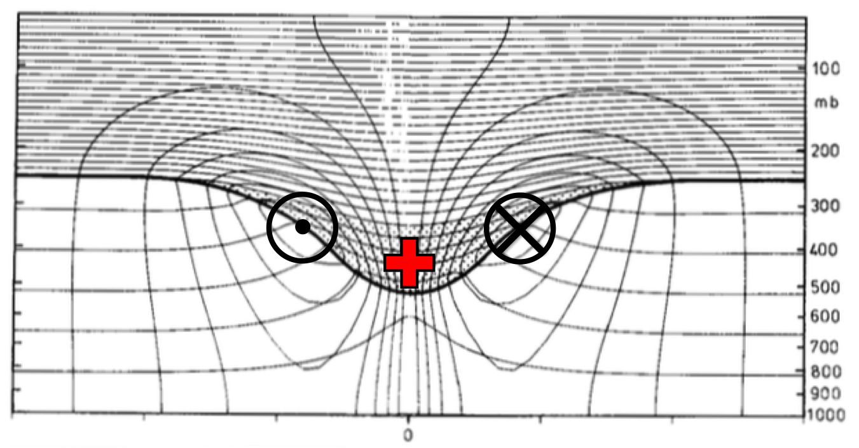
Fig. 1.1. Cross section of circularly symmetric cyclonic flow induced by simple isolated upper-level cyclonic PV anomaly (stippled region and red plus symbol). The thick line represents the tropopause and the solid contours represent potential temperature (every 5 K) and azimuthal wind velocity (every 3 m s⁻¹). Cross symbol represents azimuthal wind velocity directed into cross section and dot symbol represents azimuthal wind velocity directed out of cross section. [Figure 15 and caption adapted from Hoskins et al. (1985, section 3).]
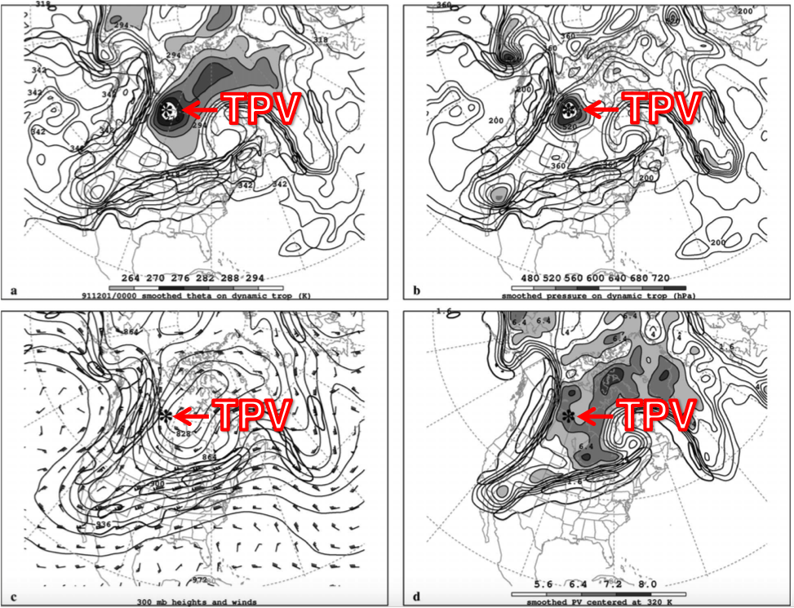
Fig. 1.2. Analyses for 0000 UTC 1 December 1991: (a) DT (1.5-PVU) potential temperature (thin solid; values at and below 342 K contoured at a 6-K interval; shaded as indicated for values below 294 K) and wind speed (thick solid; contoured at a 15 m s⁻¹ interval, starting at 50 m s⁻¹); (b) DT pressure (thin solid; contoured at a 40 hPa interval; shaded as indicated for values greater than 480 hPa) and wind speed [contoured as in (a)]; (c) 300-hPa geopotential height (thin solid; contoured at a 12 dam interval), wind speed [contoured as in (a)], and wind (plotted using standard convention: pennant, full barb, and half barb denote 25, 5, and 2.5 m s⁻¹, respectively); and (d) PV calculated over the 316–324-K layer (thin solid; contoured at a 0.8 PVU interval for values greater than 1.6 PVU; shaded as indicated for values greater than 5.6 PVU) and wind speed at 320 K [contoured as in (a)]. The position of the DT pressure maximum associated with the TPV of interest is marked with an asterisk in each panel. Label “TPV” and arrow point to position of TPV. [Figure 11 and caption adapted from Pyle et al. (2004).]
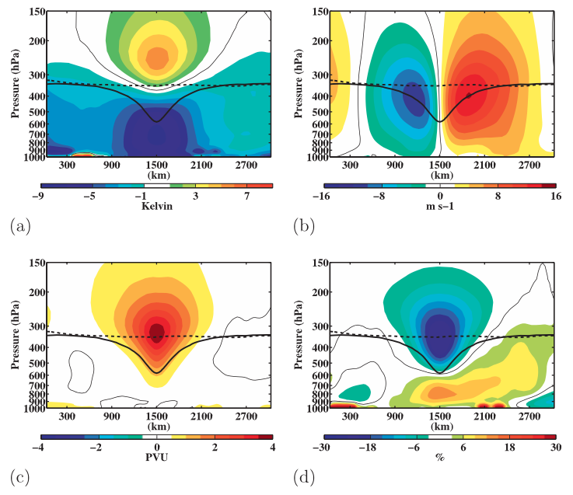
Fig. 1.3. Composite west-to-east cross-TPV section of anomalous (a) temperature (K), (b) v-wind component (m s⁻¹), (c) Ertel PV (PVU), and (d) relative humidity (%). Thick solid black contour is the composite tropopause, thick dashed black contour is the background tropopause, and thin solid contour is the 0 contour. [Figure 9 and adapted caption from Cavallo and Hakim (2010).]
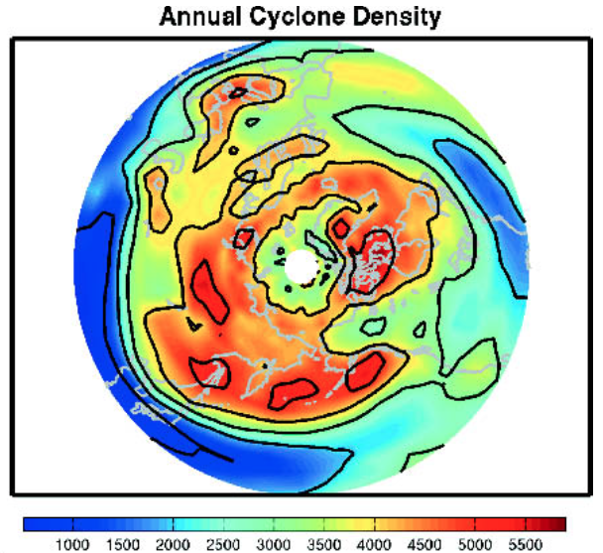
Fig. 1.4. Total number of cyclonic tropopause-based vortex events occurring in a 2.5°–10° latitude–longitude box centered at a point, with a cosine-latitude normalization applied for equal-area weighting [Figure 2 and adapted caption from Hakim and Canavan (2005).]

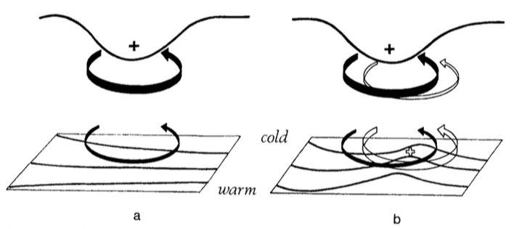
Fig. 1.5. A schematic picture of cyclogenesis associated with the arrival of an upper-level cyclonic PV anomaly over a low-level baroclinic region. In both (a) and (b) solid plus sign indicates location of the upper-level cyclonic PV anomaly, solid black contour at the top represents the tropopause, black contours at the bottom represent isentropes at the ground, thick solid arrow represents the cyclonic circulation induced by the upper-level cyclonic PV anomaly at upper levels, and thin solid arrow represents the cyclonic circulation induced by the upper-level cyclonic PV anomaly at lower levels. In (b), open plus sign represents location of the lower-level cyclonic PV anomaly, thick open arrow represents the cyclonic circulation induced by the lower-level cyclonic PV anomaly at lower levels, and the thin open arrow represents the cyclonic circulation induced by the lower-level cyclonic PV anomaly at upper levels. [Figure 21 and adapted caption from Hoskins et al. (1985, section 6e).]
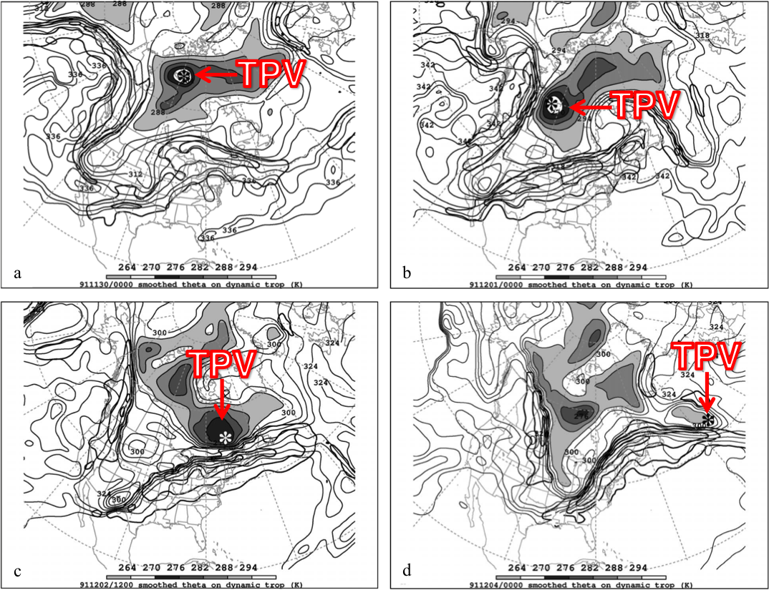
Fig. 1.6. DT (1.5-PVU) potential temperature (thin solid; values at and below 342 K contoured at a 6-K interval; shaded as indicated for values below 294 K) and wind speed (thick solid; contoured at a 15 m s⁻¹ interval, starting at 50 m s⁻¹) valid (a) 0000 UTC 30 November, (b) 0000 UTC 1 December, (c) 1200 UTC 2 December, and (d) 0000 UTC 4 December 1991. The position of the DT pressure maximum associated with the TPV of interest is marked with an asterisk in each panel. Label “TPV” and arrow point to position of TPV. [Figures 10–13 and captions adapted from Pyle et al. (2004).]
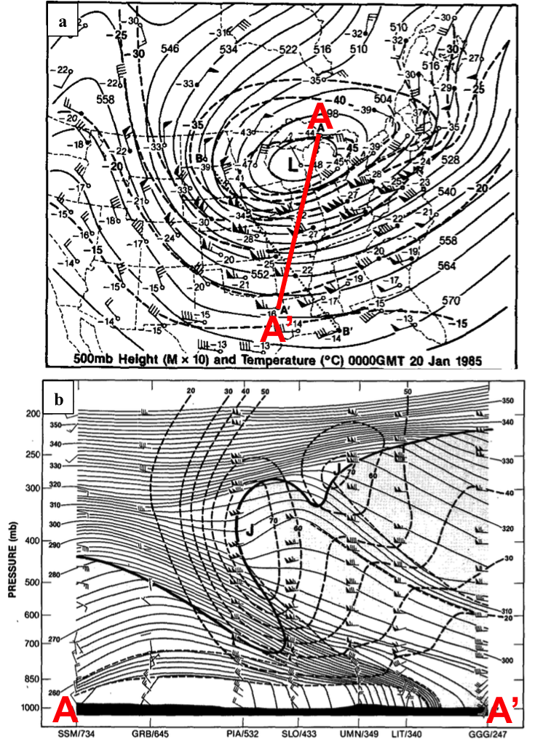
Fig. 1.7. (a) Isopleths showing 500-hPa geopotential height (dam; solid contours) and temperature (°C; dashed contours), and stations showing 500-hPa temperature (°C) and wind (flags and barbs, where flag denotes 25 m s⁻¹, full barb denotes 10 m s⁻¹, and half barb denotes 2.5 m s⁻¹) at 0000 UTC 20 January 1985. Projection line for cross section AA’ is shown by bold red line. (b) Cross section of potential temperature (K, thin solid lines) and wind speed (m s⁻¹, heavy dashed lines) between Sault Sainte Marie, MI and Longview, TX, along the projection line AA’ shown in (a). Heavy solid line is tropopause (10⁻⁷ K s⁻¹ hPa⁻¹ isopleth of PV) and light dashed lines indicate tropospheric frontal and stable layer boundaries. Soundings for stations (labeled at bottom) show wind [units and symbols same as for winds shown in (a)]. Jet cores are marked by “J.” [Figures 8–9 and captions adapted from Shapiro et al. (1987).]
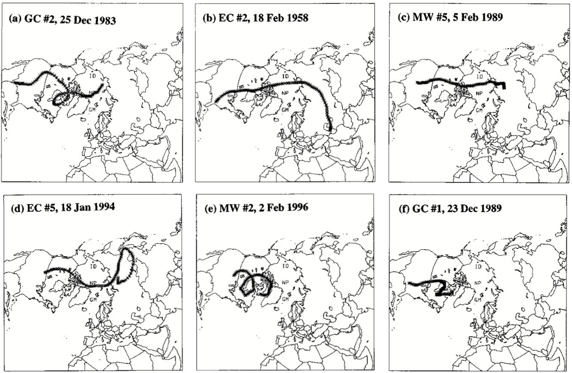

Fig. 1.8. Trajectories of air parcels reaching a point 50 hPa above the surface on center dates of the following major North American cold events from Table 1c of Walsh et al. (2001; not shown): (a) Gulf Coast (GC) #2, 25 December 1983; (b) East Coast (EC) #2, 18 February 1958; (c) Midwest (MW) #5, 5 February 1989; (d) EC #5, 18 January 1994; (e) MW #2, 2 February 1996; (f) GC #1, 23 December 1989. [Figure 5 and caption adapted from Walsh et al. (2001).]

REFERENCES
Bosart, L. F., B. J. Moore, J. M. Cordeira, and H. M. Archambault, 2017: Interactions of
North Pacific tropical, midlatitude, and polar disturbances resulting in linked extreme weather events over North America in October 2007. Mon. Wea. Rev., 145, 1245–1273.

——, G. J. Hakim, K. R. Tyle, M. A. Bedrick, W. E. Bracken, M. J. Dickinson,
and D. M. Schultz, 1996: Large-scale antecedent conditions associated with the
12–14 March 1993 cyclone (“superstorm ‘93”) over eastern North America. Mon.
Wea. Rev., 124, 1865–1891.

Cavallo, S. M., and G. J. Hakim, 2009: Potential vorticity diagnosis of a tropopause polar
cyclone. Mon. Wea. Rev., 137, 1358–1371.

——, and ——, 2010: Composite structure of tropopause polar cyclones. Mon. Wea. Rev., 138,
3840–3857.

——, and ——, 2012: Radiative impact on tropopause polar vortices over the
Arctic. Mon. Wea. Rev., 140, 1683–1702.

——, and ——, 2013: Physical mechanisms of tropopause polar vortex intensity
change. J. Atmos. Sci., 70, 3359–3373.

Chang, E. K. M., and I. Orlanski, 1993: On the dynamics of a storm track. J. Atmos. Sci.,
50, 999–1015.

Colle, B. A., and C. F. Mass, 1995: The structure and evolution of cold surges east of the
Rocky Mountains. Mon. Wea. Rev., 123, 2577– 2610.

Colucci, S. J., and J. C. Davenport, 1987: Rapid surface anticyclogenesis: Synoptic
climatology and attendant large-scale circulation changes. Mon. Wea. Rev., 115, 822–836.

Cunningham, P., and D. Keyser, 2000: Analytical and numerical modelling of jet streaks:
Barotropic dynamics. Quart. J. Roy. Meteor. Soc., 126, 3187–3217.

Dallavalle, J. P., and L. F. Bosart, 1975: A synoptic investigation of anticyclogenesis
accompanying North American polar air outbreaks. Mon. Wea. Rev., 103, 941–957.

Defant, F., and H. Taba, 1957: The threefold structure of the atmosphere and the
characteristics of the tropopause. Tellus, 9, 259–275.

Dickinson, M. J., L. F. Bosart, W. E. Bracken, G. J. Hakim, D. M. Schultz, M. A.
Bedrick, and K. R. Tyle, 1997: The March 1993 Superstorm cyclogenesis: Incipient phase synoptic- and convective-scale flow interaction and model performance. Mon. Wea. Rev., 125, 3041–3072.

Donnadille, J., J.-P. Cammas, P. Mascart, and D. Lambert, 2001a: FASTEX IOP 18: A
very deep tropopause fold. II: Quasi-geostrophic omega diagnoses. Quart. J. Roy. Meteor. Soc., 127, 2269 –2286.

——, ——, ——, ——, and R. Gall, 2001b: FASTEX IOP 18: A very deep tropopause
fold. I: Synoptic description and modelling. Quart. J. Roy. Meteor. Soc., 127, 2247–2268.

Hakim, G. J., 2000: Climatology of coherent structures on the extratropical tropopause.
Mon. Wea. Rev., 128, 385–406.

——, and A. K. Canavan, 2005: Observed cyclone-anticyclone tropopause asymmetries.
J. Atmos. Sci., 62, 231–240.

——, L. F. Bosart, and D. Keyser, 1995: The Ohio Valley wave-merger cyclogenesis
event of 25–26 January 1978. Part I: Multiscale case study. Mon. Wea. Rev., 123, 2663–2692.

——, D. Keyser, and L. F. Bosart, 1996: The Ohio Valley wave-merger cyclogenesis
event of 25–26 January 1978. Part II: Diagnosis using quasigeostrophic potential vorticity inversion. Mon. Wea. Rev., 124, 2176–2205.

Hoskins, B. J., M. E. McIntyre, and A. W. Robertson, 1985: On the use and significance
of isentropic potential vorticity maps. Quart. J. Roy. Meteor. Soc., 111, 877–956.

Jones, J. E. and J. Cohen, 2011: A diagnostic comparison of Alaskan and Siberian
strong anticyclones. J. Climate, 24, 2599–2611.

Kalnay, E., and Coauthors, 1996: The NCEP/NCAR 40-Year Reanalysis Project. Bull.
Amer. Meteor. Soc., 77, 437–472.

Konrad, C. E., and S. J. Colucci, 1989: An examination of extreme cold air outbreaks
over eastern North America. Mon. Wea. Rev., 117, 2687–2700.

Kravitz, J. R., 2007: A study of coherent tropopause disturbances from a climatological
perspective. M.S. thesis, Department of Earth and Atmospheric Sciences,
University at Albany/SUNY, Albany, NY, 191 pp.

Lackmann, G. M., D. Keyser, and L. F. Bosart, 1997: A characteristic life cycle of upper-
tropospheric cyclogenetic precursors during the Experiment on Rapidly
Intensifying Cyclones over the Atlantic (ERICA). Mon. Wea. Rev., 125, 2729–2758.
Namias, J., 1978: Multiple causes of the North American abnormal winter of 1976–77.
Mon. Wea. Rev., 106, 279–295.

Nielsen-Gammon, J. W., and R. J. Lefevre, 1996: Piecewise tendency diagnosis of
dynamical processes governing the development of an upper-tropospheric mobile trough. J. Atmos. Sci., 53, 3120–3142.

Orlanski, I., and E. K. M. Chang, 1993: Ageostrophic geopotential fluxes in downstream and upstream development of baroclinic waves. J. Atmos. Sci., 50, 212–225.

——, and J. P. Sheldon, 1995: Stages in the energetics of baroclinic systems. Tellus,
47A, 605–628.

Pyle, M. E., D. Keyser, and L. F. Bosart, 2004: A diagnostic study of jet streaks:
Kinematic signatures and relationship to coherent tropopause disturbances. Mon. Wea. Rev., 132, 297–319.

Rogers, J. C. and R. V. Rohli, 1991: Florida citrus freezes and polar anticyclones in the
Great Plains. J. Climate, 4, 1103–1113.

Sanders, F., and J. R. Gyakum, 1980: Synoptic-dynamic climatology of the ‘‘bomb.’’
Mon. Wea. Rev., 108, 1589–1606.

Shapiro, M. A., T. Hampel, and A. J. Krueger, 1987: The Arctic tropopause fold. Mon.
Wea. Rev., 115, 444–454.

Takayabu, I., 1991: ‘‘Coupling development’’: An efficient mechanism for the
development of extratropical cyclones. J. Meteor. Soc. Japan, 69, 837–841.

Uccellini, L. W., and P. J. Kocin, 1987: The interaction of jet streak circulations during
heavy snow events along the East Coast of the United States. Wea. Forecasting, 2, 289–308.

——, D. Keyser, K. F. Brill, and C. H. Walsh, 1985: The Presidents’ Day cyclone of 18–
19 February 1979: Influence of upstream trough amplification and associated tropopause folding on rapid cyclogenesis. Mon. Wea. Rev., 113, 962–988.

Wallace, J. M., and D. S. Gutzler, 1981: Teleconnections in the geopotential height field
during the Northern Hemisphere winter. Mon. Wea. Rev., 109, 784–812.

Walsh, J. E., A. S. Phillips, D. H. Portis, and W. L. Chapman, 2001: Extreme cold
outbreaks in the United States and Europe, 1948–99. J. Climate, 14, 2642–2658.

Waugh, D. W., A. H. Sobel, and L. M. Polvani, 2017: What is the polar vortex and how
does it influence weather?. Bull. Amer. M eteor. Soc., 98, 37–44.

