2. Data and Methodology
2.1 TPV and Cold Pool Tracking
The ERA-Interim (ERA-I) reanalysis dataset (Dee et al. 2011) is utilized for this study. The ERA-I fields, which have a native horizontal resolution of ~0.7°, were regridded to a horizontal resolution of 0.5°. TPVs were identified and tracked for the 1979–2015 period poleward of 30°N by utilizing a TPV tracking algorithm developed by Nicholas Szapiro and Steven Cavallo at the University of Oklahoma (https://github.com/nickszap/tpvTrack). This tracking algorithm uses potential temperature, zonal wind, meridional wind, and the vertical component of relative vorticity on the DT (2-PVU surface) as input variables. At each time stamp (6 h interval), the potential temperature field on the DT is segmented into regions associated with potential temperature minima and maxima on the DT. Locations in regions associated with potential temperature minima and maxima on the DT are required to possess positive and negative values of the vertical component of relative vorticity on the DT, respectively. Only regions associated with potential temperature minima on the DT are tracked spatially and temporally with use of the zonal and meridional winds on the DT to create TPV tracks. The location or center of a TPV is defined as the location of the potential temperature minimum on the DT of the TPV. For more detailed information about how TPVs are identified and tracked in the TPV tracking algorithm, see the above link for the TPV tracking algorithm.
As discussed in section 1.2.1, the composite west-to-east cross-TPV section from Cavallo and Hakim (2010) shows that anomalously cold air is located throughout the depth of the troposphere within and beneath the TPV (Fig. 1.3a). Accordingly, 1000–500-hPa thickness minima are considered to be representative of cold pools that may be associated with TPVs. Cold pools were identified and tracked for the 1979–2015 period poleward of 30°N by using the same TPV tracking algorithm discussed above, but with different input variables. Instead of using potential temperature on the DT, the 1000–500-hPa thickness is used. Instead of using zonal and meridional winds on the DT, the 700-hPa zonal and meridional winds are used. Finally, instead of using the vertical component of relative vorticity on the DT, the 1000–500-hPa thermal vorticity, calculated by subtracting the 1000-hPa vertical component of relative vorticity from the 500-hPa vertical component of relativity vorticity, is used. At each time stamp (6 h interval), the 1000–500-hPa thickness field is segmented into regions associated with 1000–500-hPa thickness minima and maxima with use of the sign of the 1000–500-hPa thermal vorticity. Regions associated with 1000–500-hPa thickness minima are tracked spatially and temporally with use of the 700-hPa zonal and meridional winds to create cold pool tracks. The location or center of a cold pool is defined as the location of the 1000–500-hPa thickness minimum of the cold pool.

2.2 TPV and Cold Pool Filtering

Cavallo and Hakim (2009) required that TPVs spend at least 60% of their lifetimes poleward of 65°N. In this study, TPVs are required to spend at least 6 h poleward of 60°N. Cavallo and Hakim imposed a stricter latitude criterion to isolate TPVs from the polar jet stream in order to understand the basic dynamics of TPVs themselves. A less strict latitude criterion is imposed here because the primary interest of this study is on TPVs transported from high latitudes (>60°N) to middle latitudes (30°N–60°N). It is anticipated that TPVs that spend little time in high latitudes and TPVs that spend a majority of their lifetimes in high latitudes may both result in the development of CAOs in middle latitudes. Thus, the use of a less strict latitude criterion allows for the identification of more TPVs that may play an important role in the development of CAOs. Cold pools are also required to spend at least 6 h poleward of 60°N for consistency with the latitude criterion imposed for TPVs. TPVs and cold pools are both required to last at least two days for consistency with the longevity criterion used by Cavallo and Hakim (2009) for TPVs. In addition, since this study focuses on TPVs and cold pools transported from high latitudes to middle latitudes, the focus will be on TPVs and cold pools that move equatorward of 60°N after being located in high latitudes.

2.3 CAO Identification

A regional CAO climatology created by Zachary Murphy, a graduate student at the University at Albany, was utilized for this study. Murphy (2017) used daily minimum temperature data extracted from stations within the National Centers for Environmental Information (NCEI) Global Historical Climatology Network-Daily dataset (Menne et al. 2012). Murphy (2017) extracted daily minimum temperature data from 53 stations evenly distributed throughout the continental U.S., as well as throughout nine climate regions defined by NCEI (Fig. 2.1) for 1948–2015. According to Murphy (2017), a regional CAO is defined to occur within a climate region whenever two or more stations within the climate region experience three or more consecutive days where daily minimum temperatures are less than or equal to the 31-day centered moving average of the 5th percentile minimum temperature for those days and share at least one overlapping day. For this study, only regional CAOs (hereafter referred to as CAOs) occurring in the six climate regions encompassing the central and eastern U.S., i.e., the climate regions east of the black line and labeled in the black box shown in Fig. 2.1, during 1979–2015 are considered.

2.4 Identification of CAOs that are Linked to Cold Pools Associated with TPVs

One of the goals of this study is to determine the linkages between TPVs, cold pools, and CAOs. For this portion of this study, only TPVs and cold pools transported from high latitudes to middle latitudes as described in section 2.2 are considered. In order to investigate the linkages between TPVs, cold pools, and CAOs, CAOs that are linked to cold pools were first determined for each climate region in the central and eastern U.S. for the 1979–2015 period. CAOs that are linked to cold pools were determined for each climate region by requiring that a circle of radius 1500 km surrounding the center of a cold pool must overlap at least one grid point (using a 0.5° grid) of the climate region for at least one time stamp (6 h interval) during a CAO. Figure 2.2a shows a circle of radius 1500 km surrounding the center of a cold pool at 1200 UTC 20 January 1985, a time during which the CAO studied by Shapiro et al. (1987), which was briefly discussed in Section 1.2.4.2, impacted the central and eastern U.S. This CAO was identified to occur in the Central, Northeast, South, and Southeast climate regions during the 19–24 January 1985 period. Also, the cold pool circle intersects at least one grid point in the Central, Northeast, South, and Southeast climate regions at 1200 UTC 20 January 1985 (Fig. 2.2b), so, based on this time stamp alone, all of these climate regions are identified as experiencing a CAO that is linked to a cold pool.
The same cold pool circle radius threshold of 1500 km is used for all cold pools for simplicity and consistency. The choice of a 1500-km radius threshold for the cold pool circle was subjectively chosen based on its general representation of the size of the cold pool shown in Fig. 2.2a as well as other cold pools examined (not shown). Other cold pool circle radius thresholds were tested, including 1250 km and 1750 km, and the sensitivity of the results to the cold pool circle radius threshold will be briefly discussed in chapter 3. There may be situations in which surface-based Arctic air associated with a cold pool spreads beyond the cold pool circle edge. Thus, a larger cold pool circle radius threshold may help avoid “miss” scenarios in which a climate region experiencing a CAO is not identified as experiencing a CAO that is linked to a cold pool because the cold pool circle does not intersect the climate region, but the surface-based Arctic air associated with the cold pool actually impacts the climate region. However, there also may be situations in which surface-based Arctic air associated with a cold pool does not spread far from the cold pool center and/or the cold pool is located too far away from a climate region experiencing a CAO such that the surface-based air associated with the cold pool does not reach the climate region. Thus, a smaller cold pool circle radius threshold may help avoid “false alarm” scenarios in which a climate region is identified as experiencing a CAO that is linked to a cold pool because the cold pool circle intersects the climate region, but the cold pool actually has no impact on the climate region and another feature, e.g., a trough, is causing the CAO in the climate region. An intermediate cold pool circle radius threshold value of 1500 km was thought to be a good compromise, although stricter criteria could be enforced to more precisely determine climate regions experiencing CAOs that are linked to cold pools in different situations.
Once the CAOs that are linked to cold pools were identified for each climate region, cold pools that are associated with TPVs were determined for the 1979–2015 period. In order to determine which cold pools are associated with TPVs, the centers of the cold pools and TPVs were required to be located within a 750-km distance of one another for at least two consecutive days. These criteria help ensure that there is both spatial and temporal overlap between the cold pools and TPVs, and thus help ensure that the cold pools and TPVs are associated with one another. Once it was determined which cold pools are associated with TPVs, a 1979–2015 climatology of CAOs that are linked to cold pools associated with TPVs was determined for each climate region in the central and eastern U.S. Figure 2.3 illustrates that the cold pool linked to the 19–24 January 1985 CAO is also associated with a TPV. At 1200 UTC 20 January 1985, a circle of radius 750 km surrounding the TPV center (TPV shown in Fig. 2.3a) encapsulates the cold pool center (cold pool shown in Fig. 2.3b). In addition, the cold pool center was identified to be located within a 750-km radius circle surrounding the TPV center for at least two consecutive days (not shown). As discussed earlier for this cold pool, the Central, Northeast, South, and Southeast climate regions are identified as experiencing a CAO linked to a cold pool. Given, that this cold pool is associated with a TPV, the Central, Northeast, South, and Southeast climate regions are also identified as experiencing a CAO that is linked to a cold pool associated with a TPV.
Other distance thresholds between the centers of the TPVs and cold pools, such as 500 km and 1000 km, were tested, and the sensitivity of the results to these distance thresholds will be discussed briefly in chapter 3. Too strict of a distance threshold may result in a “miss” scenario in which a cold pool that generally overlaps spatially and temporally with a TPV is not identified to be associated with the TPV because for example, the cold pool and TPV are temporarily spaced too far away from one another at some intermediate time or times. Too relaxed of a distance threshold may result in a “false alarm” scenario in which a cold pool is identified to be associated with a TPV that does not overlap with the cold pool. For example, there may be situations in which there are multiple cold pools and TPVs located near one another, so too relaxed of a distance threshold may falsely associate a cold pool with nearby TPVs that do not overlap with the cold pool.

2.5 Case Studies

Illustrative CAOs that are clearly linked to well-defined cold pools associated with TPVs were chosen as case studies to illustrate important linkages between TPVs, cold pools, and CAOs. These illustrative CAOs are the 9–14 January 1982 CAO and the 19–24 January 1985 CAO. Both CAOs led to significant and widespread societal impacts over the central and eastern U.S.
In addition, TPV–jet interaction is hypothesized to play a role in the development of the CAO in each case. In order to help diagnose the role of TPV–jet interaction on the development of the CAO in each case, the across-isentrope (Q_{n}) and along-isentrope (Q_{s}) components of the Q vector and their associated forcing for vertical motion during TPV–jet interaction are examined. The Q vector is calculated in pressure coordinates using the following equation from Hoskins and Pedder (1980):
$Q=-\left(\frac{∂V_{g}}{∂x} ⋅∇_{p}θ\right)i -\left(\frac{∂V_{g}}{∂y} ⋅∇_{p}θ\right)j$ , (1)
where V_{g} is the geostrophic wind, θ is the potential temperature, and $∇_{p}$ is the horizontal gradient operator along a constant pressure surface. Q vectors are separated into Q_{n} and Q_{s} following Keyser et al. (1992) as follows:
$Q_{n}=\left[Q⋅\left(-\frac{∇θ}{\left|∇θ\right|}\right)\right]\left(-\frac{∇θ}{\left|∇θ\right|}\right)$ (2)
$Q_{s}= \left(\frac{Q⋅\left(k × ∇θ\right)}{\left|∇θ\right|}\right)\left(\frac{k × ∇θ}{\left|∇θ\right|}\right)$. (3)
Q_{n} and Q_{s} describe the rate of change of the magnitude and direction of $∇$θ, respectively (Keyser et al. 1992). Q vector forcing for vertical motion associated with Q_{n} and Q_{s} are calculated using the right-hand side of the Q vector form of the QG omega equation in pressure coordinates from Hoskins and Pedder (1980), given by
$\left(σ∇_{p}^{2}+ f_{0}^{2}\frac{∂^{2}}{{∂p}^{2}}\right)ω = -2h\left(∇_{p}⋅Q\right)$, (4)
with Q replaced by Q_{n} and Q_{s} respectively. In (4), $h= {\left(ρ θ\right)}^{-1}$, where ρ is the density, or equivalently, $h= \frac{R}{p_{o}}{\left(\frac{p_{0}}{p}\right)}^{c_{v}/c_{p}}$, where R is the gas constant for dry air, p is the pressure, p₀ is
1000 hPa, c_{v} is the specific heat of dry air at constant volume, and c_{p} is the specific heat of dry air at constant pressure. Also in (4), f₀ is a constant reference value of the Coriolis parameter, ω is the vertical velocity in pressure coordinates, and $σ=$$-$$h$$\frac{dΘ}{dp}$, where $\frac{dΘ}{dp}$is the vertical derivative of reference potential temperature with respect to pressure, is the static stability parameter. The Q vector components and their associated forcing for vertical motion are calculated every 100 hPa over a layer representative of the TPV in each case.
As discussed in section 1.2.3, surface anticyclones can play an important role in the equatorward transport of Arctic air and thus CAO development. These surface anticyclones may be found in and/or near the left-entrance region of the jet (e.g., Jones and Cohen 2011), and so it is hypothesized that TPV–jet interaction may influence the strength of these surface anticyclones. It is hypothesized that TPV–jet interaction will result in a strengthening of the thermal gradient accompanying the jet, supporting stronger ageostrophic circulations associated with the jet. Thus, Q_{n} and its associated forcing for vertical motion are used to infer changes in the strength of the thermal gradient accompanying the jet and concomitant changes in the structure and magnitude of vertical motion patterns that are part of the ageostrophic circulations associated with the jet during TPV–jet interaction. It is anticipated that there will be Q_{n} forcing for descent in and/or near the left entrance region of the jet associated with the intensification of the thermal gradient accompanying the jet during TPV–jet interaction. In addition, because TPVs are cyclonic vortices that may be accompanied by large curvature in the geostrophic flow, TPVs may alter the orientation of the thermal gradient during TPV–jet interaction. Thus, Q_{s} and its associated forcing for vertical motion are used to infer changes in the direction of the thermal gradient and concomitant changes in the structure and magnitude vertical motion patterns during TPV–jet interaction. Lang and Martin (2010) showed that Q_{s} divergence and thus Q_{s} forcing for descent is expected to be located upshear of an isolated vertical vorticity maximum. It is anticipated that there will also be Q_{s} forcing for descent upshear of the TPV in and/or near the left-entrance region of jet during TPV–jet interaction. The anticipated forcing for descent associated with Q_{n} and Q_{s} in and/or near the left-entrance region of the jet during TPV–jet interaction may provide forcing to strengthen a surface anticyclone that may be located in and/or near the left-entrance region of the jet. Therefore, the strengthening of a surface anticyclone associated with TPV–jet interaction may play a role in the development of the CAO in each case.

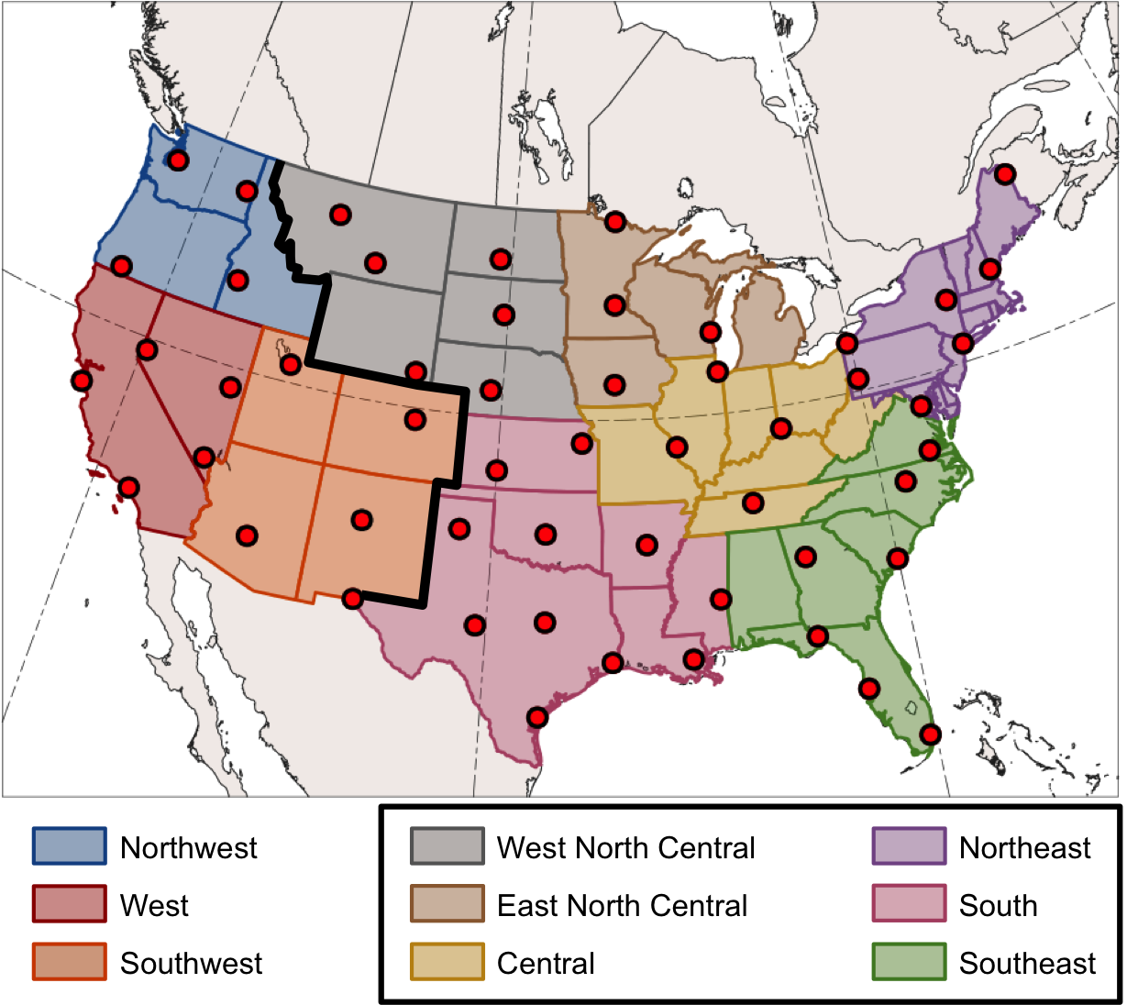
Fig. 2.1. Climate regions and stations (red dots) used in the Murphy (2017) CAO study. Climate regions east of the black line and labeled in the black box are considered for this study.

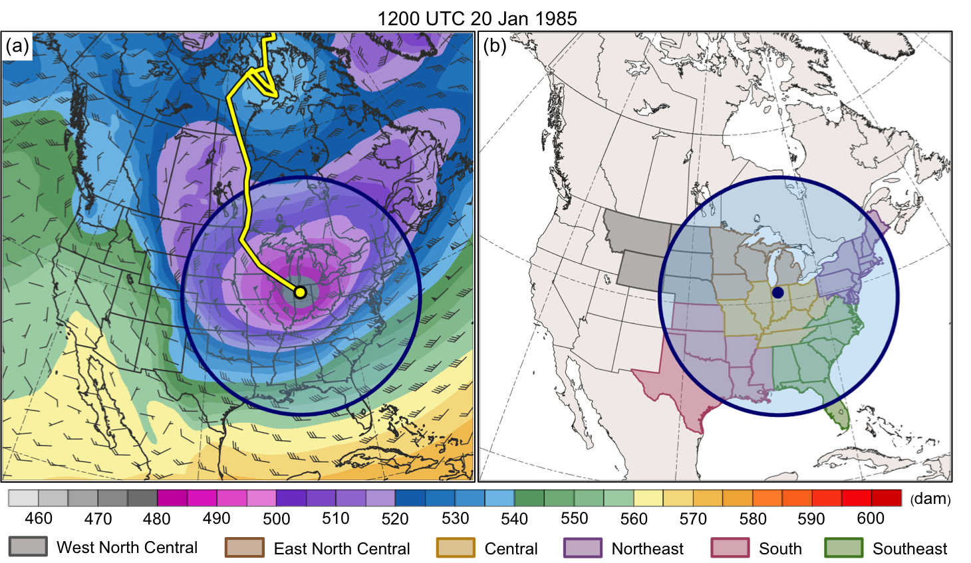
Fig. 2.2. (a) 1000–500-hPa thickness (dam, shading), 700-hPa wind (m s⁻¹, flags and barbs), cold pool track (yellow line), and circle of radius 1500 km (blue circle and shading) surrounding cold pool center (yellow dot) at 1200 UTC 20 January 1985. (b) Climate regions used in this study (colored shaded regions) and same circle as in (a) surrounding cold pool center (blue dot) at 1200 UTC 20 January 1985.

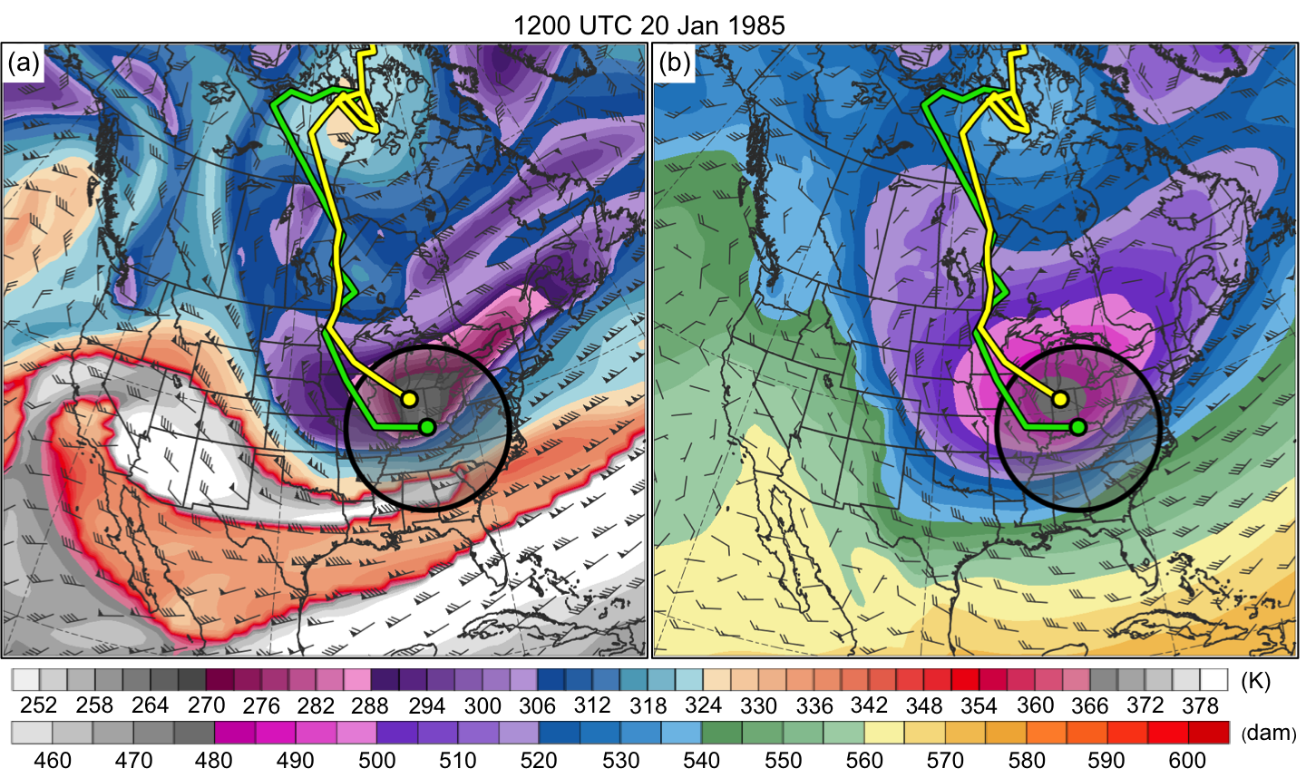
Fig. 2.3. (a) DT (2-PVU surface) potential temperature (K, shaded) and wind (m s⁻¹, flags and barbs), TPV and cold pool tracks (green and yellow lines, respectively), position of TPV center and cold pool center (green and yellow dots, respectively), and circle of radius 750 km (black circle and shading) surrounding TPV center at 1200 UTC 20 January 1985. (b) Same as in (a) except 1000–500-hPa thickness (dam, shading) and 700-hPa wind at 1200 UTC 20 January 1985.

REFERENCES

Cavallo, S. M., and G. J. Hakim, 2009: Potential vorticity diagnosis of a tropopause polar
cyclone. Mon. Wea. Rev., 137, 1358–1371.

——, and ——, 2010: The composite structure of tropopause polar cyclones from a
mesoscale model. Mon. Wea. Rev., 138, 3840–3857.

Dee, D. P., and Coauthors, 2011: The ERA-Interim reanalysis: Configuration and performance
of the data assimilation system. Quart. J. Roy. Meteor. Soc., 137, 553–597.

Hoskins, B. J., and M. A. Pedder, 1980: The diagnosis of middle latitude synoptic development.
Quart. J. Roy. Meteor. Soc., 106, 707–719.

Jones, J. E. and J. Cohen, 2011: A diagnostic comparison of Alaskan and Siberian
strong anticyclones. J. Climate, 24, 2599–2611.

Keyser, D., B. D. Schmidt, and D. G. Duffy, 1992: Quasigeostrophic vertical motions diagnosed
from along- and cross-isentrope components of the Q vector. Mon. Wea. Rev., 120, 731–741.

Lang, A. A., and J. E. Martin, 2010: The influence of rotational frontogenesis and its associated
shearwise vertical motions on the development of an upper-level front. Quart. J. Roy. Meteor. Soc., 136, 239–252.

Menne, M. J., I. Durre, R. S. Vose, B. E. Gleason, and T. G. Houston, 2012: An overview of the
Global Historical Climatology Network-Daily database. J. Atmos. Oceanic Technol., 29,
897–910.

Shapiro, M. A., T. Hampel and A. J. Krueger, 1987: The Arctic tropopause fold. Mon. Wea.
Rev., 115, 444–454.

