3. Climatologies
3.1 Climatology of TPVs

There are a total of 58,563 TPVs during 1979–2015, for an average of ~1,583 TPVs per year. Figure 3.1a shows a track density plot of all TPVs. Regions of high TPV track density are found over northern Canada, the Canadian Archipelago, the Norwegian Seas, and northern Scandinavia extending eastward into northern Siberia and the adjacent Arctic Ocean. A local maximum of TPV track density is also evident over western Alaska and the adjacent Bering Sea. The regions of high TPV track density over the Canadian Archipelago and northern Siberia were also shown in Hakim and Canavan (2005; Fig. 1.4 in this thesis) and Kravitz (2007; their Fig. 3.2) for CTDs and Cavallo and Hakim (2009, 2012) for TPVs. Furthermore, regions of high TPV track density extend equatorward from high latitudes into middle latitudes over central and eastern North America and Siberia and eastern Asia, suggesting that these regions are preferred corridors for the equatorward transport of TPVs. Regions of relatively low TPV track density are found over regions of high terrain, including the Rocky Mountains and the Tibetan Plateau, in agreement with the results of Hakim and Canavan (2005) and Kravitz (2007) for CTDs.
There are a total of 25,085 TPVs transported to middle latitudes (equatorward of 60°N), ~42.8% of all TPVs, during 1979–2015, for an average of ~678 TPVs per year. Figure 3.1b shows a track density plot of TPVs transported to middle latitudes. Well-defined maxima of track density of TPVs transported to middle latitude are located over central Canada and Siberia, with regions of high track density of TPVs transported to middle latitudes extending equatorward over central and eastern North America and Siberia and eastern Asia, again indicating that central and eastern North America and Siberia and eastern Asia are preferred corridors for the equatorward transport of TPVs. To get a better sense of the preferred corridors for the equatorward transport of TPVs, Fig. 3.2 shows the number of instances in which TPVs cross equatorward of 60°N per 10° longitude bin globally. It is clear from Fig. 3.2 that there is a distinct maximum in the number of instances in which TPVs cross equatorward of 60°N over central and eastern North America and a broader maximum in the number of instances in which TPVs cross equatorward of 60°N across much of Siberia and especially eastern Asia, providing further evidence that these regions are indeed preferred corridors for the equatorward transport of TPVs. In addition, Fig. 3.1b suggests that TPVs frequently track near the entrance regions and along the poleward sides of the North Atlantic and North Pacific jet streams, which are also regions of high CTD track density shown by Hakim and Canavan (2005; Fig. 1.4 in this thesis). Fig. 3.1b also shows that regions of relatively low track density of TPVs transported to middle latitudes are found over western North America, and Fig. 3.2 shows that there is a distinct minimum in the number of instances in which TPVs cross equatorward of 60°N over the eastern North Pacific and western North America, likely related to upper-level ridging that often occurs in this region.
Figures 3.3a and 3.3b show the number of TPVs and TPVs transported to middle latitudes (equatorward of 60°N), respectively, per season, normalized to a 91.25-day season. The highest number of TPVs is found during the winter [December, January, and February (DJF)], while the lowest number of TPVs is found during the summer [June, July, and August (JJA)], in agreement with the results of Cavallo and Hakim (2012). There are fairly similar numbers of TPVs during the spring [March, April, and May (MAM)] and autumn [September, October, and November (SON)]. Similar to all TPVs, the highest and lowest number of TPVs transported to middle latitudes is found during the winter and summer, respectively. There is an intermediate number of TPVs transported to middle latitudes during the spring and autumn. Although not shown here, if the number of TPVs transported to middle latitudes per season is divided by the total number of TPVs per season, there is also a slightly higher percentage of TPVs transported to middle latitudes during the winter compared to the summer, suggesting that TPVs are more likely to be transported to middle latitudes during the winter compared to the summer.

3.2 Climatology of Cold Pools

There are a total of 23,045 cold pools during 1979–2015, for an average of ~623 cold pools per year. Figure 3.4a shows a track density plot of all cold pools. Similar to the regions of high TPV track density, there are regions of high cold pool track density over northern Canada, the Canadian Archipelago, and northern Siberia and the adjacent Arctic Ocean. High cold pool track density is also found over northern Greenland and the central Arctic Ocean (Fig. 3.4a), but there is a relative minimum of TPV track density in these same regions compared to surrounding locations like the Canadian Archipelago and northern Siberia (Fig. 3.1a). Similar to regions of high TPV track density, regions of high cold pool track density extend equatorward from high latitudes to middle latitudes over central and eastern North America and Siberia and eastern Asia (Fig. 3.4a), suggesting that these regions are preferred corridors for the equatorward transport of cold pools. Also, similar to regions of relatively low TPV track density, regions of relatively low cold pool track density are located over high terrain features like the Rocky Mountains and the Tibetan Plateau.
There are a total of 8,395 cold pools transported to middle latitudes (equatorward of 60°N), ~36.4% of all cold pools, during 1979–2015, for an average of ~227 cold pools per year. Figure 3.4b shows that there are well-defined maxima of track density of cold pools transported to middle latitude over central and eastern Canada and Siberia and eastern Asia, similar to those of TPVs. However, comparing Fig. 3.4b with Fig. 3.1b shows that these well-defined maxima of track density of cold pools are shifted somewhat eastward from those of TPVs. In addition, there is a distinct maximum in the number of instances in which cold pools cross equatorward of 60°N (Fig. 3.5) over central and eastern North America, similar to that for TPVs (Fig. 3.2), though this maximum for cold pools is shifted somewhat eastward from that for TPVs. There is also a broad maximum in the number of instances in which cold pools cross equatorward of 60°N over much of Siberia (Fig. 3.5), similar to that of TPVs (Fig. 3.2). However, the maximum in the number of instances in which cold pools cross equatorward of 60°N over eastern Asia (Fig. 3.5) is a bit more distinct than that for TPVs (Fig. 3.2), and this maximum for cold pools is also shifted somewhat eastward from that for TPVs over eastern Asia.
The reason for the somewhat eastward shift of the maximum of track density of cold pools transported to middle latitudes over central and eastern Canada and eastern Asia from that of TPVs is not currently clear. It is possible that sometimes there may be a tilted baroclinic structure in the middle-to-upper troposphere such that some upper-level troughs and embedded TPVs may be located somewhat farther west than cold pools. Regardless, as will be illustrated in chapter 4, TPVs and cold pools that are linked can often be vertically aligned or nearly so, suggesting that not all TPVs may be located farther west than cold pools. In addition, like TPVs transported to middle latitudes, Fig. 3.4b suggests that cold pools transported to middle latitudes often track near the entrance regions and along the poleward sides of the North Atlantic and North Pacific jet streams. As cold pools move eastward toward the east coasts of North America and Asia, surface radiative cooling over land may possibly allow the centers of cold pools to remain over land before eventually moving off the coast, where surface heat fluxes over the ocean may weaken cold pools. TPVs moving eastward toward the east coasts of North America and Asia may move more quickly off the east coasts of North America and Asia compared to cold pools as the TPVs interact with the North Atlantic and North Pacific jet streams, respectively. Thus for TPVs and cold pools moving eastward toward the east coasts of North America and Asia, cold pools may possibly remain over land over eastern Canada and eastern Asia longer than TPVs. Thus, a given cold pool may possibly impact more land areas of eastern Canada and eastern Asia compared to a given TPV, possibly contributing to the somewhat eastward shift in the maximum of track density of cold pools transported to middle latitudes over central and eastern Canada and eastern Asia from that of TPVs.
Figure 3.4b also shows that as for TPVs, there is a relative minimum in track density of cold pools transported to middle latitudes over western North America, and Fig. 3.5 shows that as for TPVs, there is a distinct minimum in the number of instances in which cold pools cross equatorward of 60°N over the eastern North Pacific and western North America, likely again related to upper-level ridging that often occurs in this region.
Figures 3.6a and 3.6b show the number of cold pools and cold pools transported to middle latitudes (equatorward of 60°N), respectively, per season, normalized to a 91.25-day season. Perhaps unexpected and contrary to the results for TPVs, the highest numbers of cold pools and cold pools transported to middle latitudes are found during the summer, while the lowest numbers of cold pools and cold pools transported to middle latitudes are found during the winter. However, if considering cold pools transported deep into the middle latitudes (equatorward of 45°N), the highest and lowest numbers of cold pools transported deep into the middle latitudes are found during the winter and summer, respectively (not shown). One possible reason for the higher number of cold pools during the summer compared to the winter is that 1000–500-hPa thickness minima associated with cold pools may be more distinct from the surrounding 1000–500-hPa thickness field during the summer compared to the winter, and thus cold pools may be more identifiable and trackable during the summer compared to the winter. Furthermore, cold pools may be embedded in stronger horizontal thickness gradients during the winter than the summer. Since cold pools that are embedded in strong horizontal thickness gradients may be less identifiable than if they are embedded in weak horizontal thickness gradients, there may be less cold pools identified during the winter than the summer. When considering all cold pools transported equatorward of 60°N, given the higher number of cold pools during the summer compared to the winter, there is also a higher number of cold pools transported equatorward of 60°N during the summer compared to the winter. However, because the polar jet stream is located farther equatorward during the winter compared to the summer (not shown), there are still more cold pools transported deep into the middle latitudes, equatorward of 45°N, during the winter compared to the summer (not shown), regardless of there being a lower total number of cold pools during the winter compared to the summer.
The relatively similar track density patterns of TPVs and cold pools in Fig. 3.1 and Fig 3.4, respectively, and similar longitudinal corridors of maxima in the number of instances in which TPVs and cold pools cross equatorward of 60°N in Fig. 3.2 and Fig. 3.5, respectively, suggest that there are likely linkages between TPVs and cold pools. Given the high track density of TPVs and cold pools transported to middle latitudes and the maximum in the number of instances in which TPVs and cold pools cross equatorward of 60°N over central and eastern North America, a region prone to troughing and CAOs, the linkages between TPVs, cold pools, and CAOs over this region will be examined in detail.
3.3 Climatology of CAOs that are linked to Cold Pools Associated with TPVs

The results in this section will only apply to cold pools and TPVs transported to middle latitudes (equatorward of 60°N). The total number of CAOs for each region over the central and eastern U.S during 1979–2015 is shown in Fig. 3.7a. There is regional variability in the number of CAOs, with the lowest number of CAOs over the East North Central (ENC) region (41) and the highest number of CAOs over the South region (162). Part of this regional variability in the number of CAOs may be due to the methodology used to define CAOs. Because the South region is larger and contains more stations compared to, for example, the ENC region, there may be more opportunity for a CAO to be identified in the South region compared to the ENC region. There also may be additional features, aside from cold pools transported from high latitudes to middle latitudes, that may lead to CAOs in the South region. For example, a midlatitude cutoff low may be associated with sufficiently cold air to lead to a CAO in the South region, but not sufficiently cold air to lead to a CAO in regions to the north.
Figure 3.7a also shows the total number of unique CAOs that are linked to at least one cold pool for each region over the central and eastern U.S during 1979–2015. It is evident that there is a larger number of unique CAOs that are linked to at least one cold pool over the northern regions of the U.S., such as the West North Central (WNC; 84) and Northeast (58) regions, compared to the southern regions of the U.S., such as the South (46) and Southeast (33) regions. Figure 3.7b shows the percentage of unique CAOs that are linked to at least one cold pool for each region over the central and eastern U.S during 1979–2015. It is clear that there is a much higher percentage of unique CAOs that are linked to at least one cold pool in northern regions of the U.S., comprising the WNC (84.8%), ENC (90.2%), and Northeast (86.6%) regions compared to the southern regions of the U.S., comprising the South (28.4%) and Southeast (36.3%) regions. As shown in the track density plot of cold pools transported to middle latitudes (Fig. 3.4b), there is a large meridional gradient in track density of cold pools over southern Canada and the northern U.S., indicating that there are more cold pools that track over and near the northern regions of the U.S. compared to the southern regions of the U.S. Thus, CAOs are more likely to be linked to cold pools over the northern regions of the U.S. compared to the southern regions of the U.S. Although the South region does have more unique CAOs that are linked to at least one cold pool (46) compared to the ENC region (37), the South region has a much lower percentage of unique CAOs that are linked to at least one cold pool (28.4%) compared to the ENC region (90.2%). The higher number of unique CAOs that are linked to at least one cold pool in the South region compared to the ENC region may be related to the South region having a much higher number of CAOs (162) compared to the ENC region (41). Furthermore, cold pools may not need to be associated with as extreme cold air to lead to a CAO in the South region compared to cold pools leading to CAOs in the ENC region.
As discussed in chapter 2, a cold pool circle radius threshold of 1500 km was utilized to determine the number and percentage of unique CAOs that are linked to at least one cold pool. Other cold pool circle radius thresholds, including 1250 km and 1750 km, were tested, and it was found that the sensitivity of the number and percentage of unique CAOs that are linked to at least one cold pool to changes of the cold pool circle radius threshold varies by region. For example, for the ENC region, a 1250-km, 1500-km, and 1750-km cold pool circle radius threshold results in the identification of 34, 37, and 37 unique CAOs that are linked to at least one cold pool, respectively, or 82.9%, 90.2%, and 90.2% of CAOs, respectively. For the South region, a 1250-km, 1500-km, and 1750-km cold pool circle radius threshold results in the identification of 35, 46, and 62 unique CAOs that are linked to at least one cold pool, respectively, or 21.6%, 28.4%, and 38.3% of CAOs, respectively. Thus, the number and percentage of unique CAOs that are linked to at least one cold pool is more sensitive to changes of the cold pool circle radius threshold for the South region compared to the ENC region. Overall, there is greater sensitivity of the number and percentage of unique CAOs that are linked to at least one cold pool to a change in the cold pool circle radius threshold from 1500 km to 1750 km for the southern regions, comprising the South and Southeast regions, compared to the northern regions, comprising the WNC, ENC, and Northeast regions. This greater sensitivity for the southern regions compared to the northern regions may result from the large meridional gradient in the track density of cold pools transported to middle latitudes over southern Canada and the northern U.S. (Fig. 3.4b), such that by increasing the cold pool circle radius threshold from 1500 km to 1750 km, there is a larger increase in the number of CAOs that are identified as linked to cold pools for southern regions compared to northern regions.
Now that the unique CAOs that are linked to at least one cold pool have been determined for each region, the cold pools that are associated with TPVs are identified. It has been found that 6,288 out of the total 8,395 cold pools transported to middle latitudes, or 74.9%, match with at least one TPV transported to middle latitudes. It has also been found that 6,510 out of the total 25,085 TPVs transported to middle latitudes, or 26.0%, match with at least one cold pool transported to middle latitudes. Overall, a large percentage of cold pools transported middle latitudes (74.9%) can be said to be associated with TPVs. A large percentage of TPVs transported to middle latitudes (74%) are not associated with cold pools. A few possible reasons why TPVs may not be associated with cold pools may include TPVs being too small or too weak to be associated with trackable cold pools, TPVs being associated with 1000–500-hPa thickness troughs that are not trackable, and TPVs being associated with cold pools that do not meet the latitude criterion imposed in chapter 2. Now, CAOs that are linked to at least one cold pool associated with TPVs can be determined.
The total number of unique CAOs that are linked to at least one cold pool associated with TPVs for each region over the central and eastern U.S during 1979–2015 is shown in Fig. 3.7a. For all regions, by comparing the total number of unique CAOs that are linked to at least one cold pool to the total number of unique CAOs that are linked to at least one cold pool associated with TPVs in Fig. 3.7a, it evident that a large percentage of the unique CAOs that are linked to at least one cold pool consists of CAOs that are linked to at least one cold pool associated with TPVs. Figure 3.7c shows the percentage of unique CAOs that are linked to at least one cold pool associated with TPVs for each region over the central and eastern U.S during 1979–2015. Similar to unique CAOs that are linked to at least one cold pool, there is a much higher percentage of unique CAOs that are linked to at least one cold pool associated with TPVs over the northern regions of the U.S., comprising the WNC (73.7%), ENC (87.8%), and Northeast (79.1%) regions, compared to the southern regions of the U.S., comprising the South (24.7%) and Southeast (27.5%) regions. As shown in Fig. 3.1b and Fig. 3.4b, there is a large meridional gradient in track density of both TPVs and cold pools transported to middle latitudes, respectively, over southern Canada and the northern U.S., indicating that there are more TPVs and cold pools that track over and near the northern regions of the U.S. compared to the southern regions of the U.S. Thus, CAOs are more likely to be linked to cold pools associated with TPVs over northern regions of the U.S. compared to southern regions of the U.S. Overall, given the high percentage of unique CAOs that are linked to cold pools associated with TPVs over northern regions of the U.S., it is clear that TPVs can play important roles in the development of CAOs.
As discussed in chapter 2, a 750-km distance threshold between the centers of TPVs and cold pools was used to help determine which cold pools are associated with TPVs and thus which CAOs are linked to at least one cold pool associated with TPVs. Other distance thresholds including 500 km and 1000 km were tested, and the sensitivity of the number and percentage of CAOs that are linked to at least one cold pool associated with TPVs to changes of the distance threshold was examined. For the ENC region, a 500-km, 750-km, and 1000-km distance threshold results in the identification of 35, 36, and 36 unique CAOs that are linked to at least one cold pool associated with TPVs, respectively, or 85.4%, 87.8%, and 87.8% of CAOs, respectively. For the South region, a 500-km, 750-km, and 1000-km distance threshold results in the identification of 38, 40, and 41 unique CAOs that are linked to at least one cold pool associated with TPVs, respectively, or 23.5%, 24.7%, and 25.3% of CAOs, respectively. For the WNC region, a 500-km, 750-km, and 1000-km distance threshold results in the identification of 64, 73, and 74 unique CAOs that are linked to at least one cold pool associated with TPVs, respectively, or 64.6%, 73.7%, and 74.7% of CAOs, respectively. Thus in the WNC region, there is notable sensitivity of the number and percentage of CAOs that are linked to at least one cold pool associated with TPVs to a change of the distance threshold from 500 km to 750 km, but like the ENC and South regions as well as all other regions (not discussed), there is small sensitivity to a change of the distance threshold from 750 km to 1000 km. Overall, there is a large percentage of unique CAOs that are linked to at least one cold pool associated with TPVs over northern regions of the U.S., regardless of the exact distance threshold utilized. Thus, again it is clear that TPVs can play important roles in the development of CAOs.
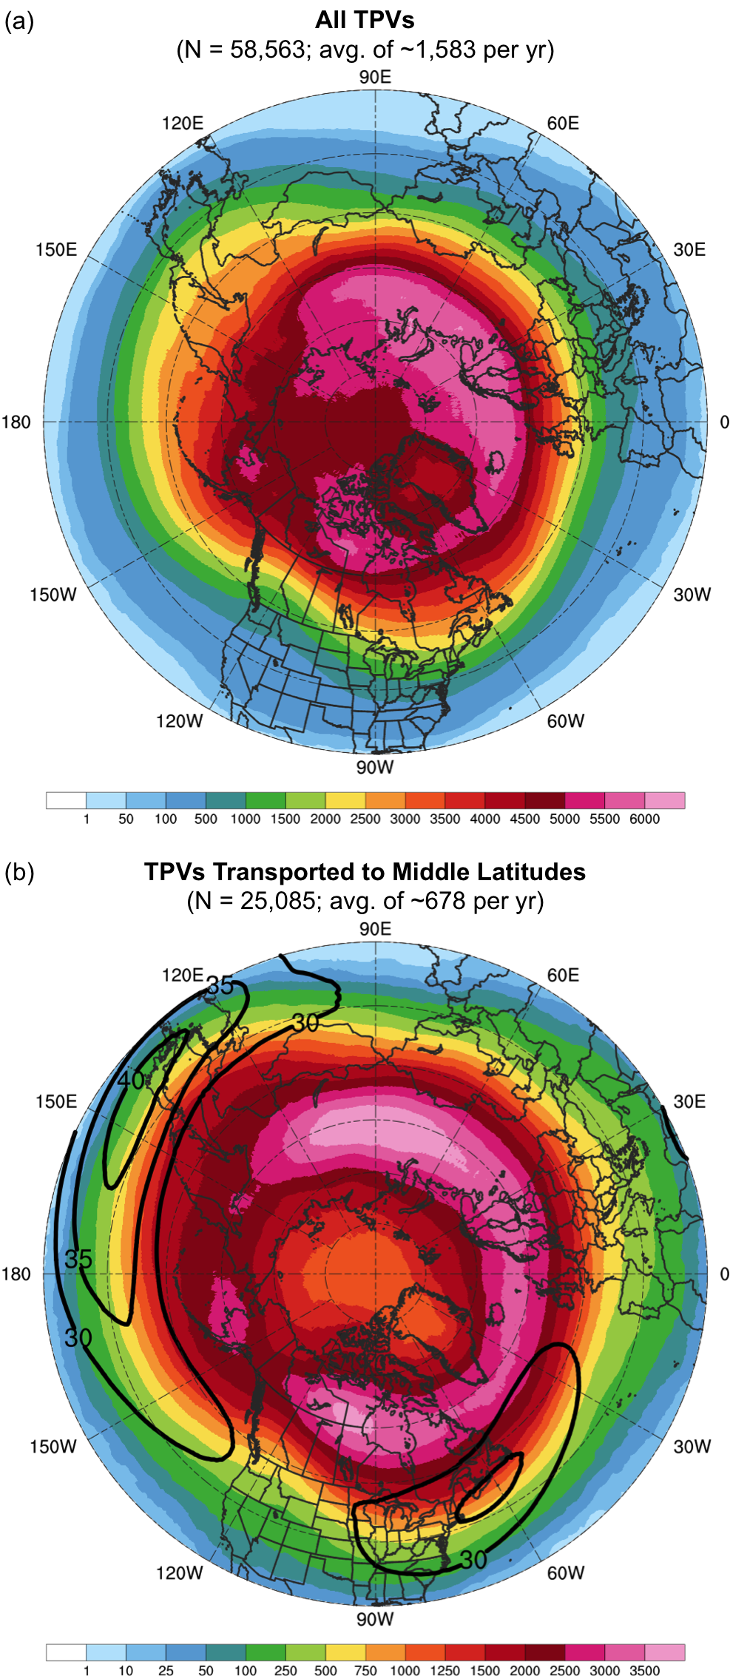
Fig. 3.1. Track density plots showing total number of unique (a) TPVs and (b) TPVs transported to middle latitudes (equatorward of 60°N) within 500 km of each grid point (using a 0.5° grid) during 1979–2015. Also in (b), the 1979–2015 mean DT wind speed (m s⁻¹, black contours).

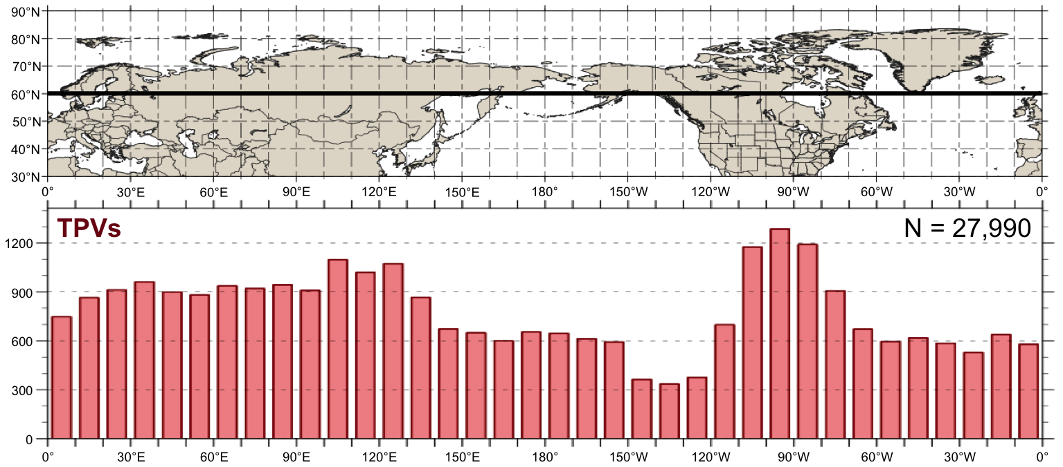
Fig. 3.2. Histogram showing total number of instances in which TPVs cross equatorward of 60°N (black line on map) for each 10° longitude bin globally during 1979–2015. An individual TPV can be counted more than once if it crosses equatorward of 60°N after returning poleward of 60°N.

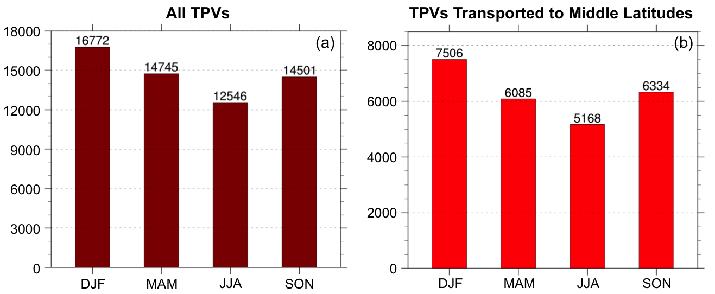
Fig. 3.3. Histograms showing (a) the total number of TPVs per season and (b) the total number of TPVs transported to middle latitudes (equatorward of 60°N) per season, normalized to a 91.25 day season, during 1979–2015.
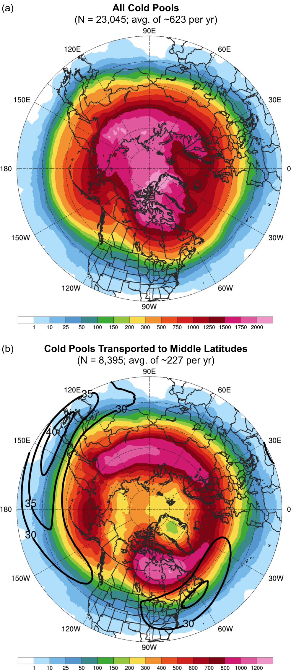
Fig. 3.4. Track density plots showing total number of unique (a) cold pools and (b) cold pools transported to middle latitudes (equatorward of 60°N) within 500 km of each grid point (using a 0.5° grid) during 1979–2015. Also in (b), the 1979–2015 mean DT wind speed (m s⁻¹, black contours).

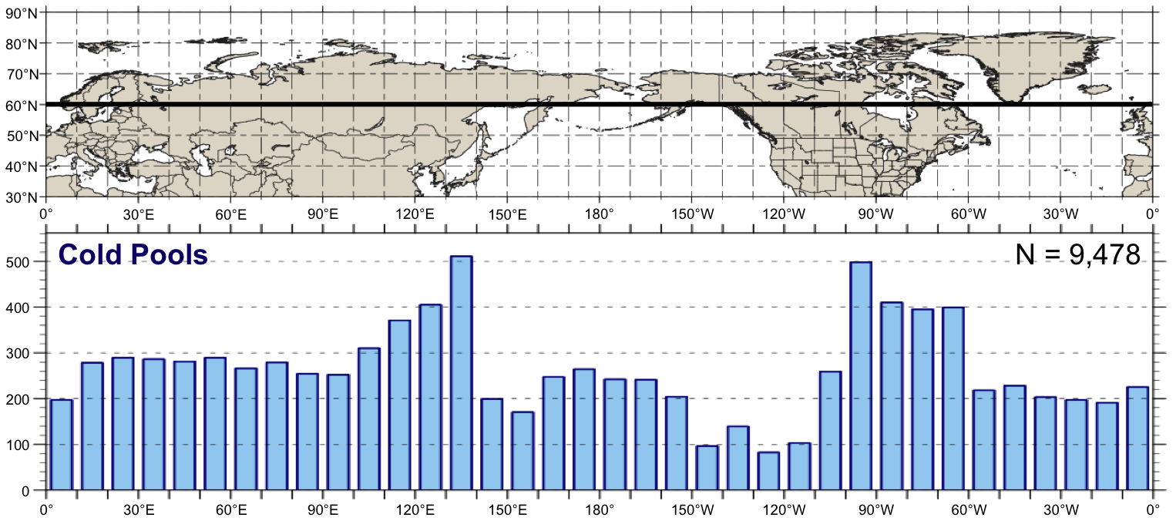
Fig. 3.5. As in Fig. 3.2, but for cold pools.

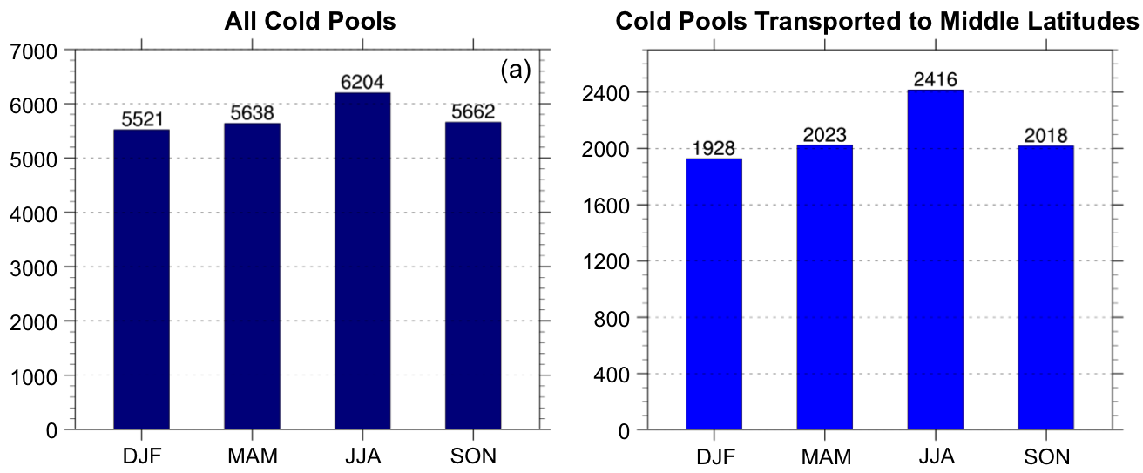
Fig. 3.6. Histograms showing (a) the total number of cold pools per season and (b) the total number of cold pools transported to middle latitudes (equatorward of 60°N) per season, normalized to a 91.25-day season, during 1979–2015.

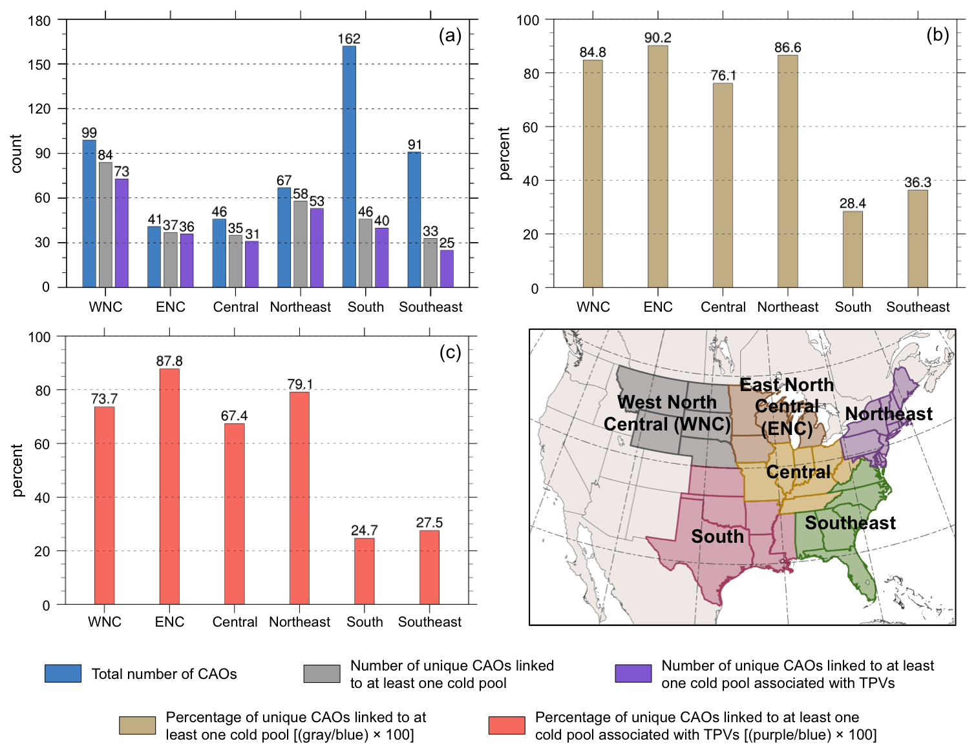

Fig. 3.7. Histograms showing (a) total number of CAOs (blue), number of unique CAOs that are linked to at least one cold pool (gray), and number of unique CAOs that are linked to at least one cold pool associated with TPVs (purple); (b) percentage of unique CAOs that are linked to at least one cold pool (tan); and (c) percentage of unique CAOs that linked to at least one cold pool associated with TPVs (peach) for each NCEI climate region shown in the accompanying map during 1979–2015.

