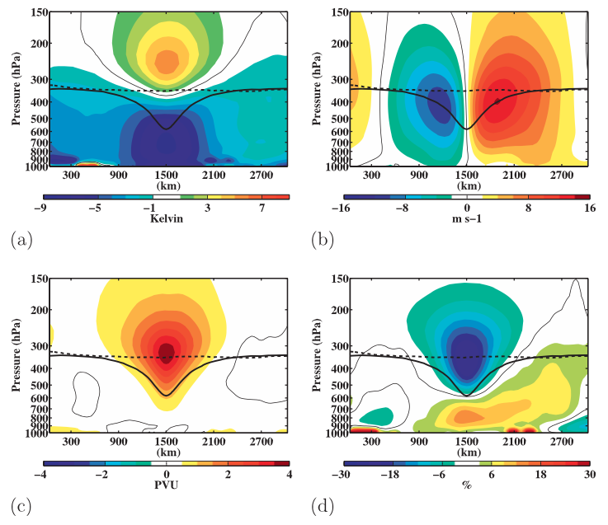
Fig. 1.3. Composite west-to-east cross-TPV section of anomalous (a) temperature (K), (b) v-wind component (m s⁻¹), (c) Ertel PV (PVU), and (d) relative humidity (%). Thick solid black contour is the composite tropopause, thick dashed black contour is the background tropopause, and thin solid contour is the 0 contour. [Figure 9 and adapted caption from Cavallo and Hakim (2010).]

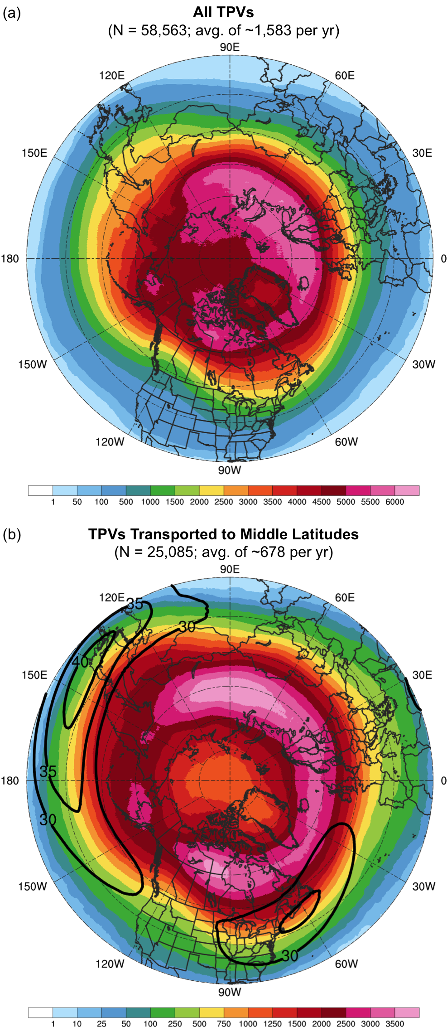
Fig. 3.1. Track density plots showing total number of unique (a) TPVs and (b) TPVs transported to middle latitudes (equatorward of 60°N) within 500 km of each grid point (using a 0.5° grid) during 1979–2015. Also in (b), the 1979–2015 mean DT wind speed (m s⁻¹, black contours).

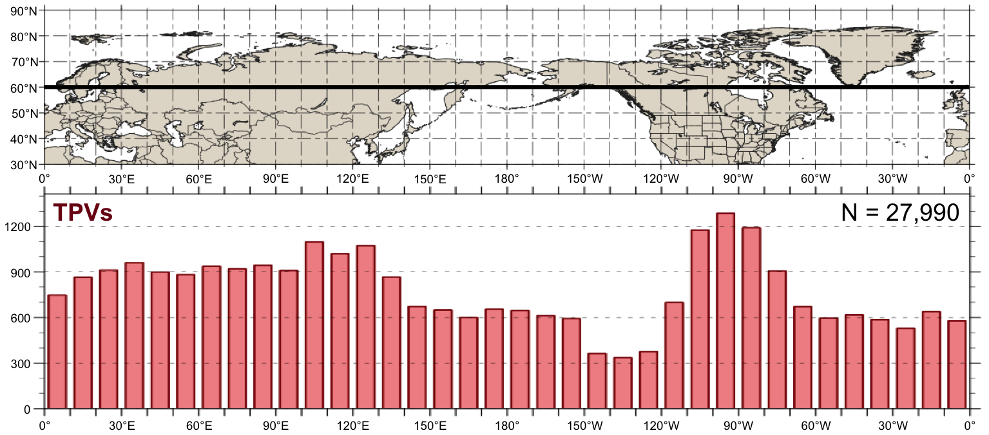
Fig. 3.2. Histogram showing total number of instances in which TPVs cross equatorward of 60°N (black line on map) for each 10° longitude bin globally during 1979–2015. An individual TPV can be counted more than once if it crosses equatorward of 60°N after returning poleward of 60°N.

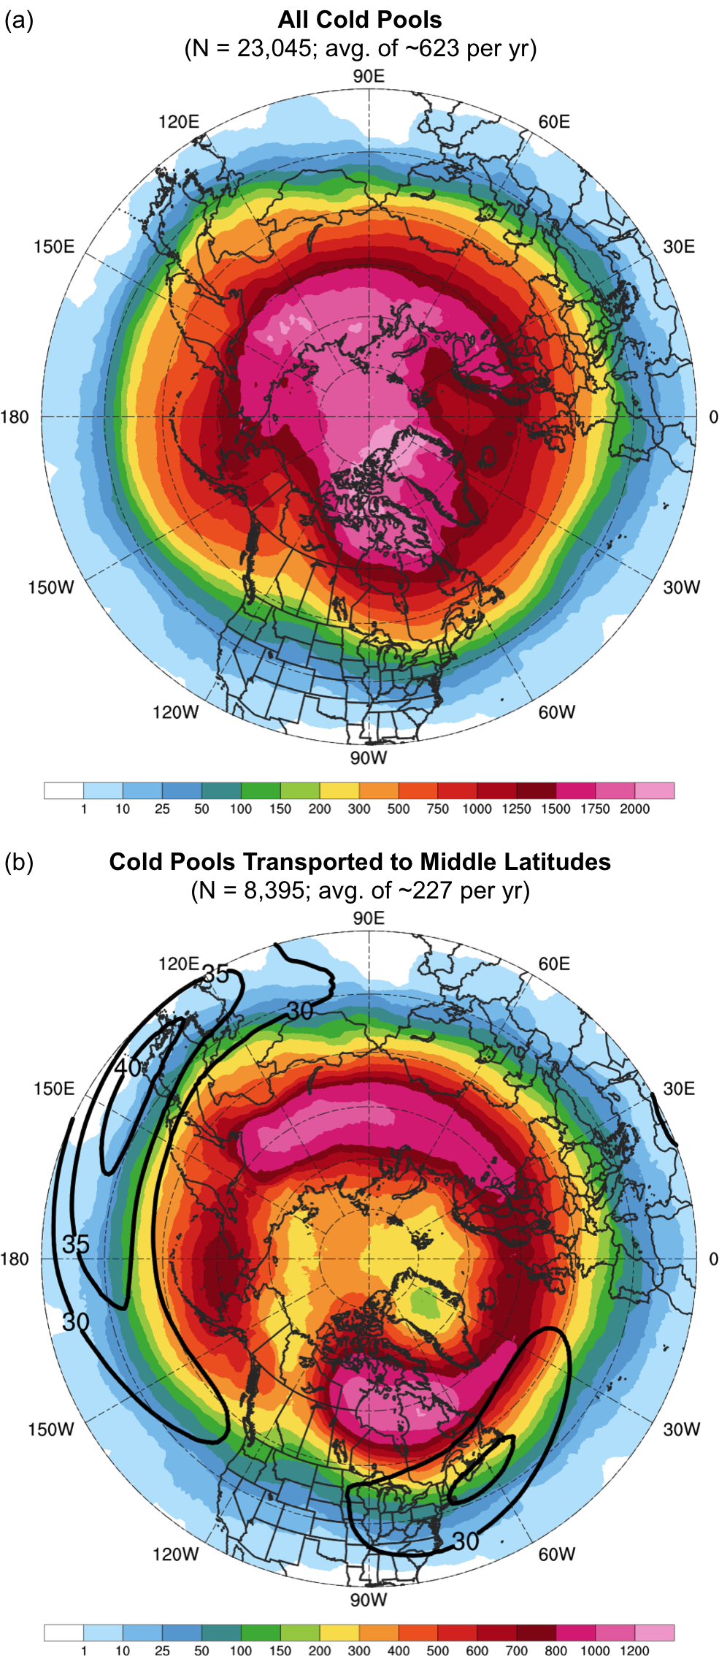
Fig. 3.4. Track density plots showing total number of unique (a) cold pools and (b) cold pools transported to middle latitudes (equatorward of 60°N) within 500 km of each grid point (using a 0.5° grid) during 1979–2015. Also in (b), the 1979–2015 mean DT wind speed (m s⁻¹, black contours).

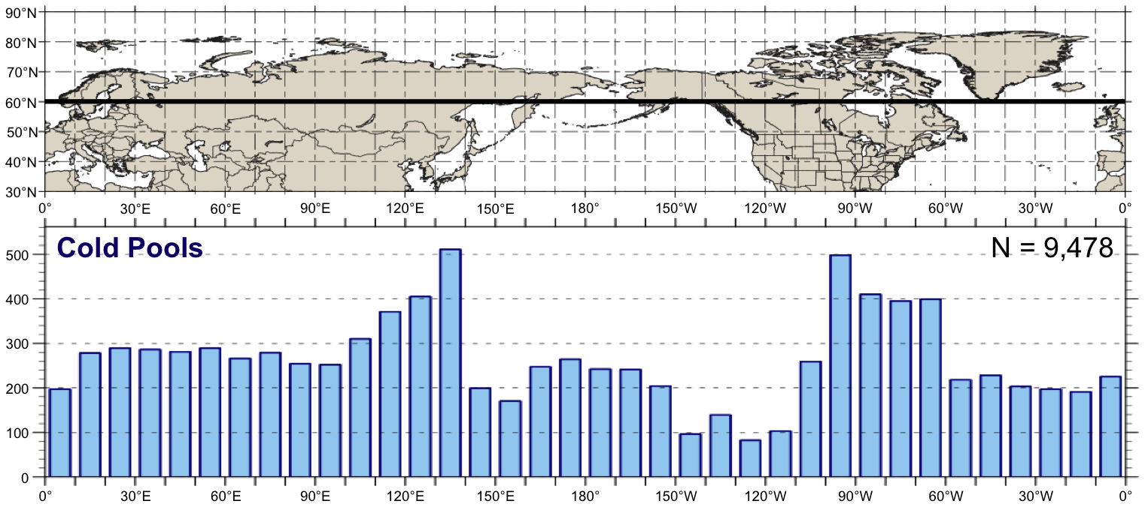

Fig. 3.5. As in Fig. 3.2, but for cold pools.

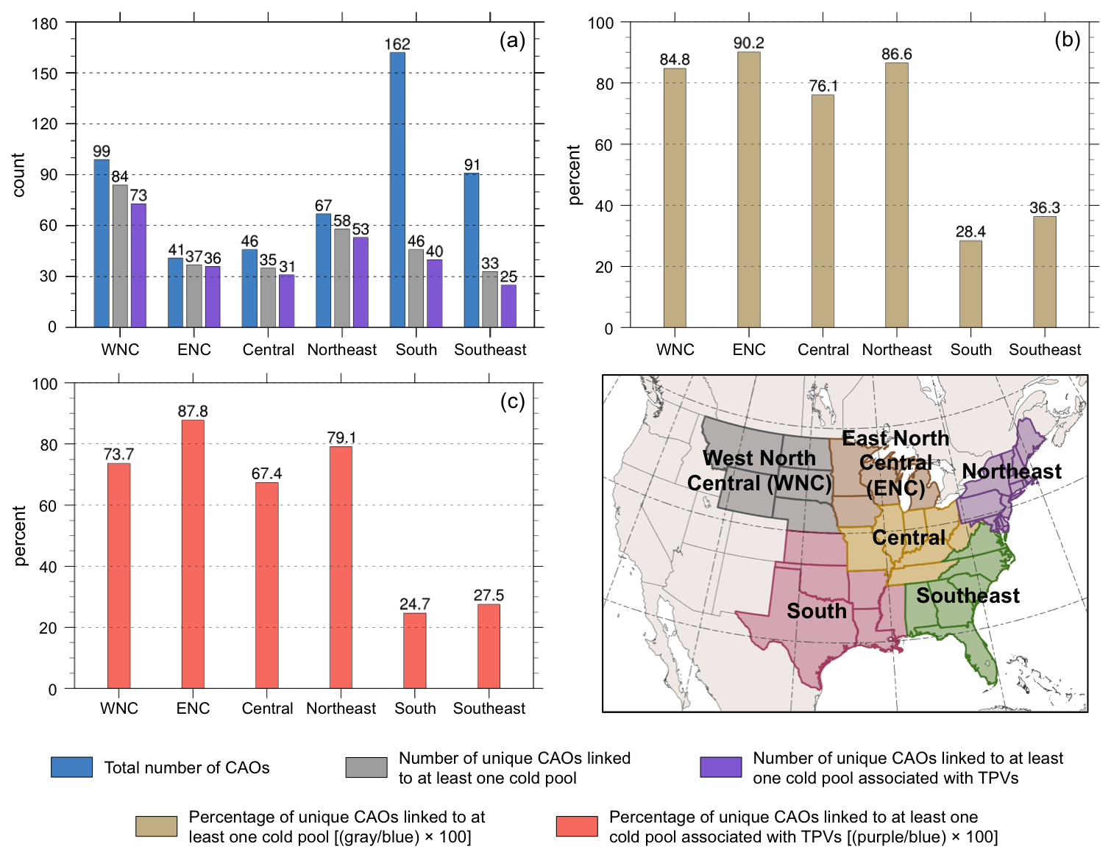
Fig. 3.7. Histograms showing (a) total number of CAOs (blue), number of unique CAOs that are linked to at least one cold pool (gray), and number of unique CAOs that are linked to at least one cold pool associated with TPVs (purple); (b) percentage of unique CAOs that are linked to at least one cold pool (tan); and (c) percentage of unique CAOs that linked to at least one cold pool associated with TPVs (peach) for each NCEI climate region shown in the accompanying map during 1979–2015.

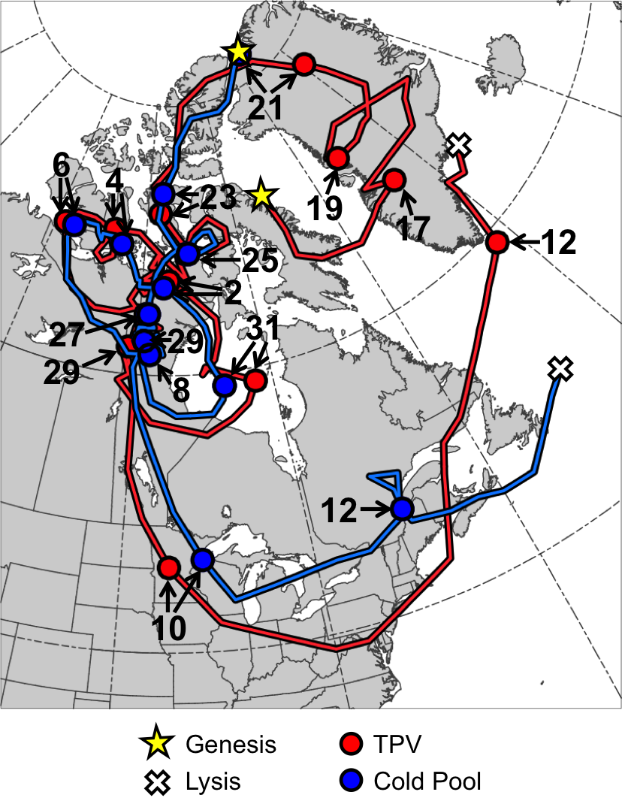
Fig. 4.1. Tracks of TPV (red) from 0600 UTC 15 December 1981 to 0000 UTC 13 January 1982 and cold pool (blue) from 1800 UTC 20 December 1981 to 1800 UTC 13 January 1982 for January 1982 CAO case. Stars denote locations of genesis, crosses denote locations of lysis, and red and blue dots represent 0000 UTC positions of TPV and cold pool, respectively, every 48 h. Numbers pointing toward dots represent dates of the 0000 UTC positions of the TPV and cold pool, such that numbers ≥17 correspond to dates in December 1981 and numbers ≤12 correspond to dates in January 1982.

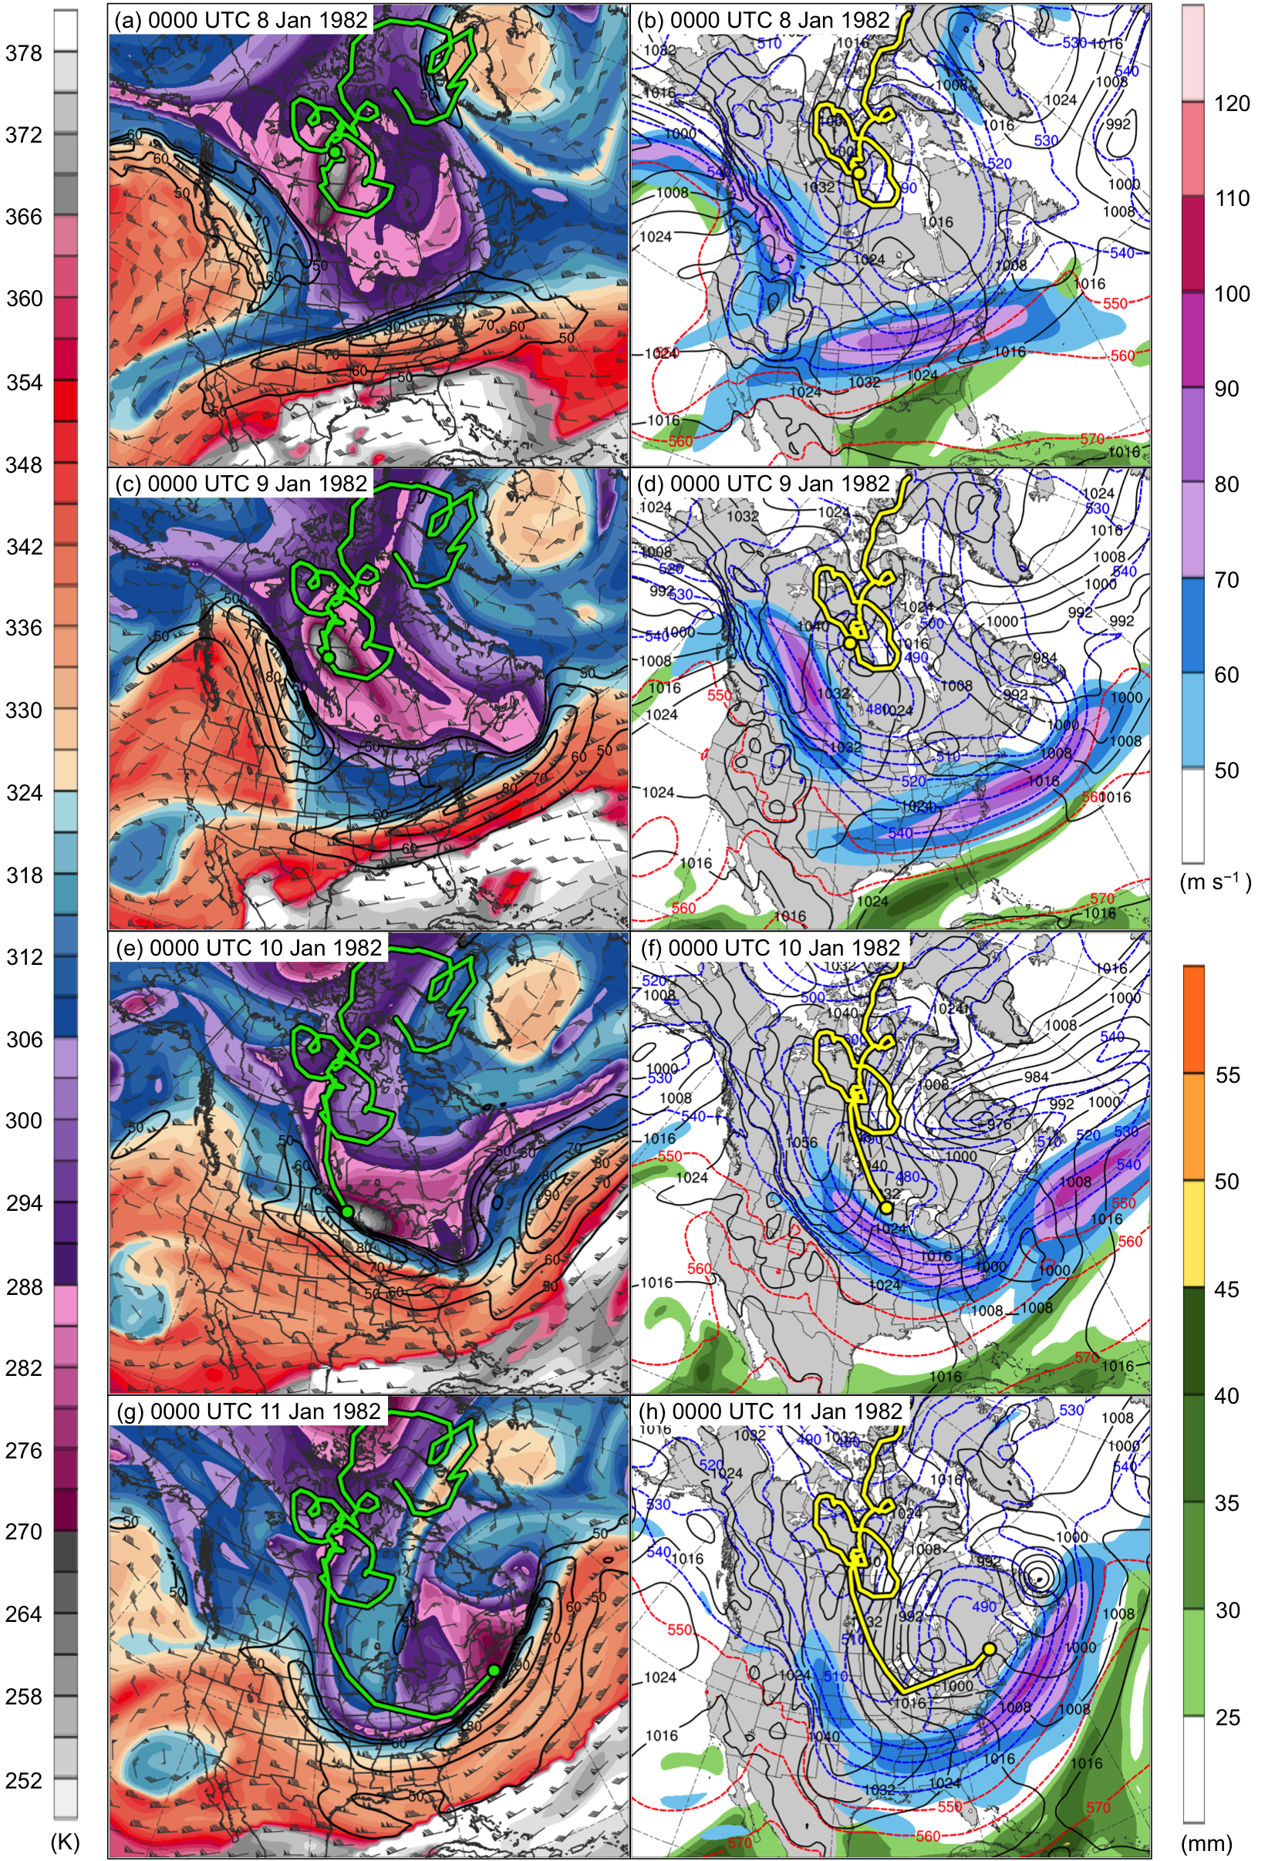
Fig. 4.5. DT (2-PVU surface) potential temperature (K, shaded), wind speed (black contours every 10 m s⁻¹, beginning at 50 m s⁻¹), and wind (m s⁻¹, flags and barbs) at (a) 0000 UTC 8 January, (c) 0000 UTC 9 January, (e) 0000 UTC 10 January, and (g) 0000 UTC 11 January 1982; 250-hPa wind speed (m s⁻¹, shaded), 1000–500-hPa thickness (dashed red and blue contours every 10 dam, contoured red for values >540 dam and blue otherwise), SLP (black contours every 8 hPa), and precipitable water (mm, shaded) at (b) 0000 UTC 8 January, (d) 0000 UTC 9 January, (f) 0000 UTC 10 January, and (h) 0000 UTC 11 January 1982. Green line and dot represent track and position of TPV, respectively, and yellow line and dot represent track and position of cold pool, respectively.

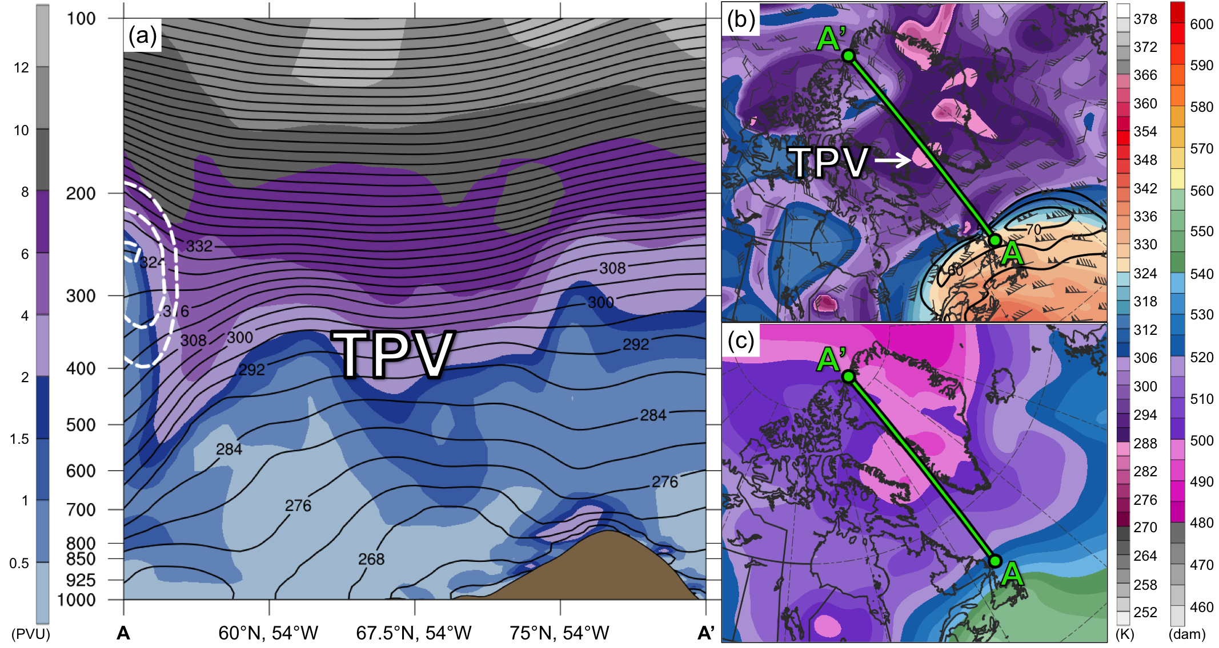
Fig. 4.7. (a) Cross section along line AA’ of PV (PVU, shading), potential temperature (K, black), and wind speed (dashed white contours every 10 m s⁻¹, beginning at 50 m s⁻¹); (b) DT (2-PVU surface) potential temperature (K, shaded), wind speed (black contours every 10 m s⁻¹, beginning at 50 m s⁻¹), and wind (m s⁻¹, flags and barbs); and (c) 1000–500-hPa thickness (dam, shading) at 1200 UTC 16 December 1981. Green line in (b) and (c) represents transect of cross section AA’. Label “TPV” represents location of TPV.

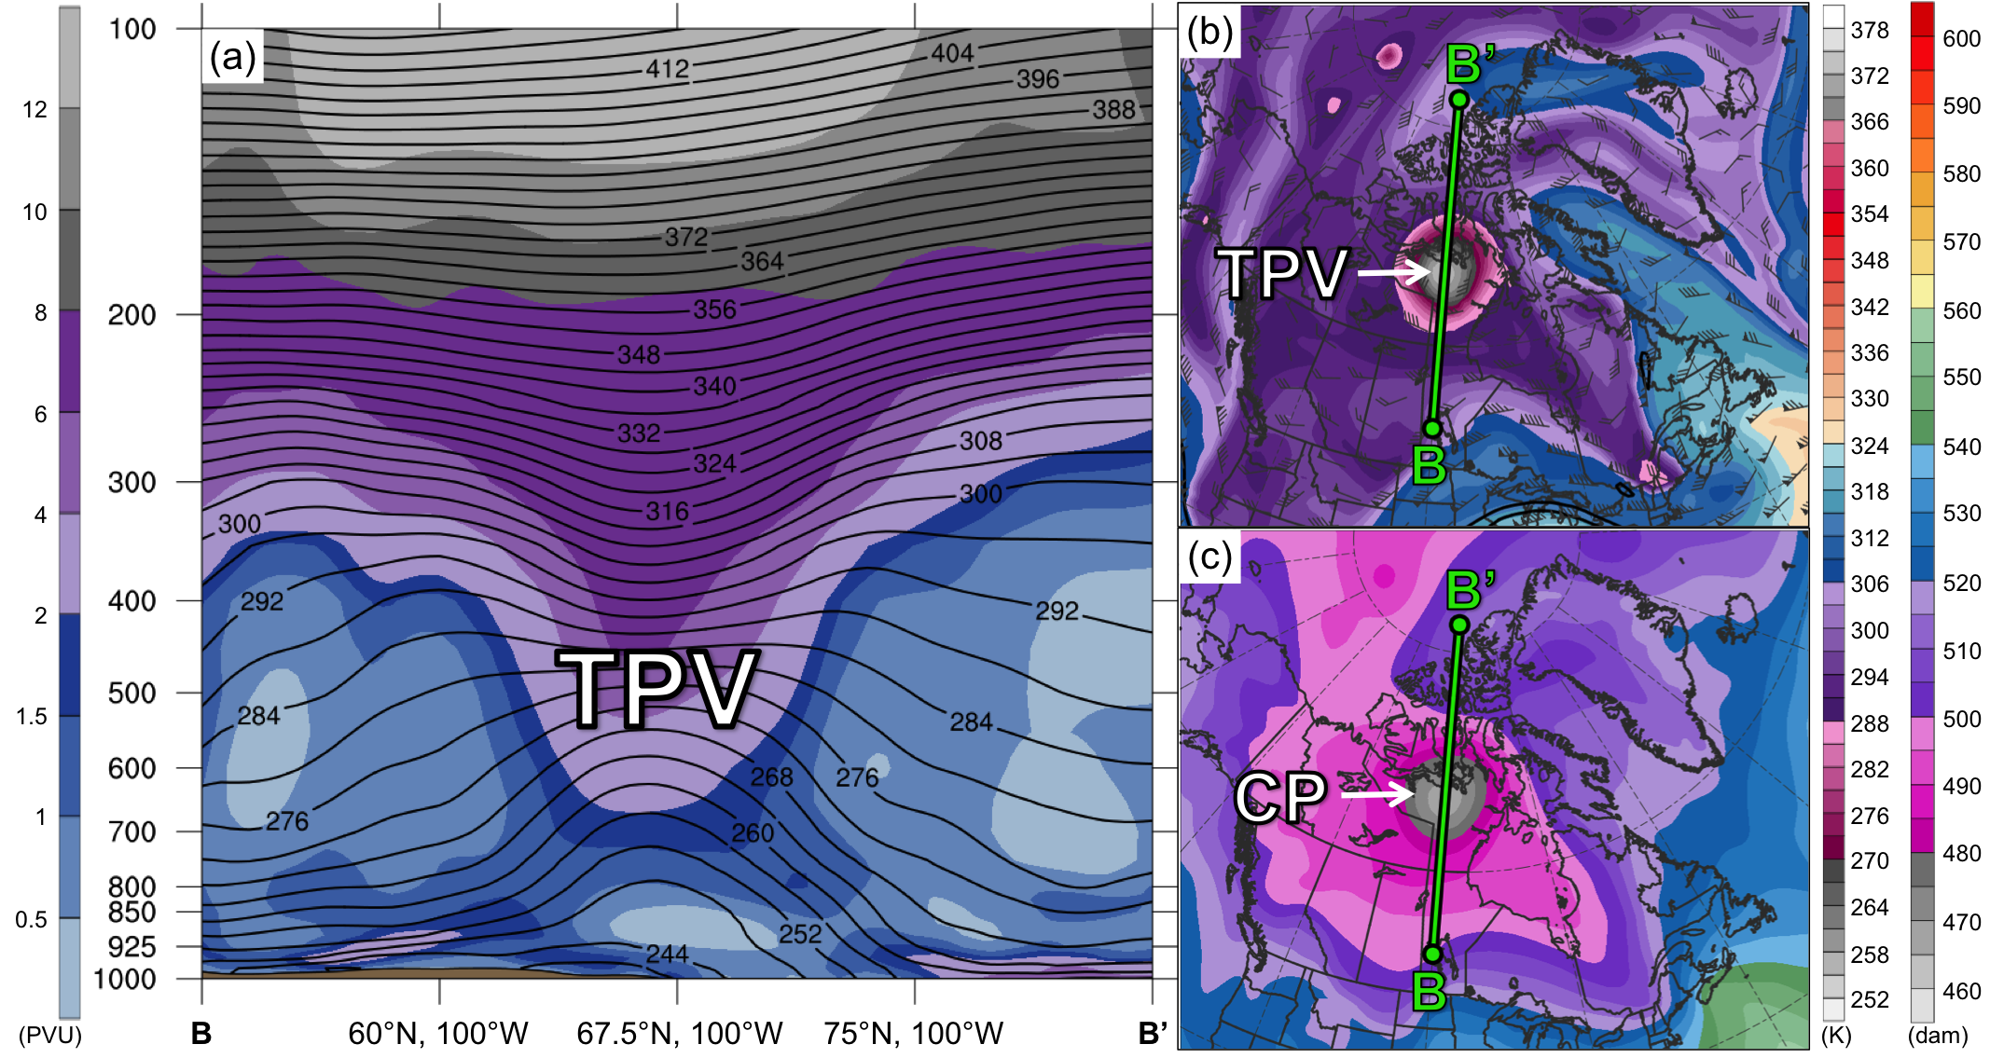
Fig. 4.8. As in Fig. 4.7, but for cross section along line BB’ at 1200 UTC 2 January 1982. Label “CP” represents location of cold pool.

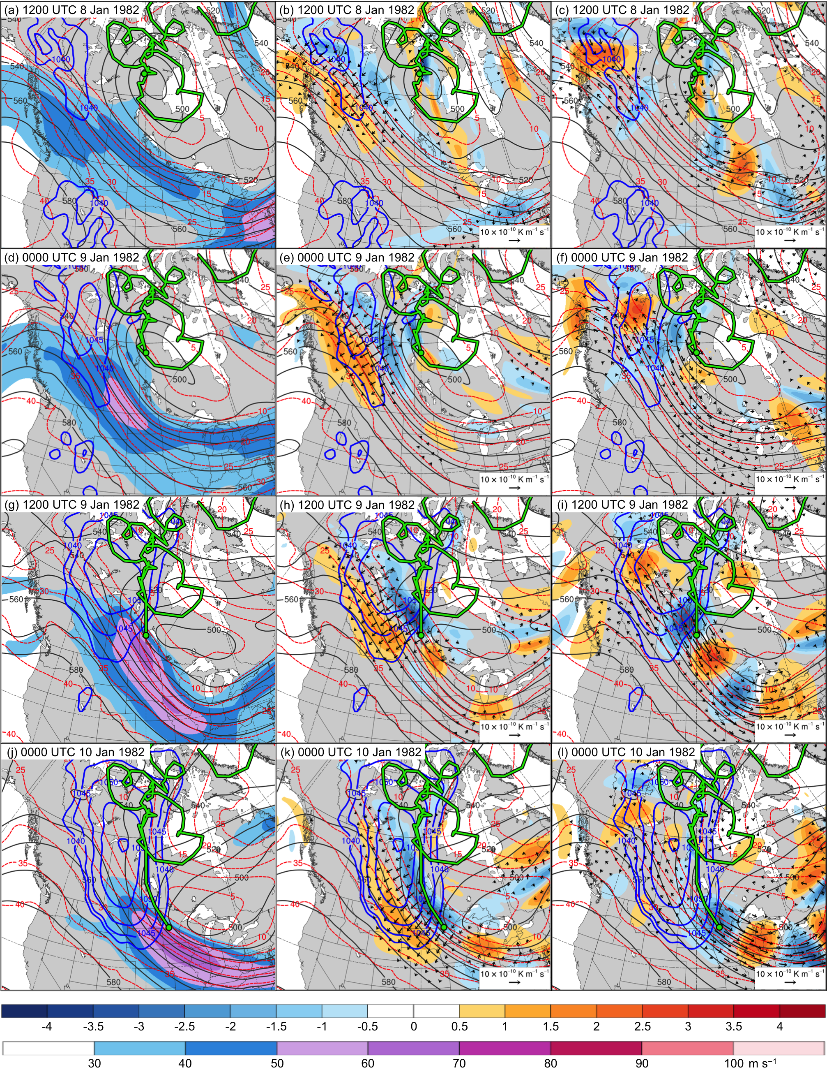
Fig. 4.10. In all panels are SLP (thick blue contours every 5 hPa, beginning at 1040 hPa), and 600–400-hPa geopotential height (dark gray contours every 10 dam) and potential temperature (dashed red contours every 5°C). Also, 600–400-hPa wind speed (m s⁻¹, shaded) at (a) 1200 UTC 8 January, (d) 0000 UTC 9 January, (g) 1200 UTC 9 January, and (j) 0000 UTC 10 January 1982; 600–400-hPa Q_{n} (K m⁻¹ s⁻¹, vectors) and Q_{n} forcing for vertical motion (10⁻¹⁷ Pa⁻¹ s⁻³, shaded) at (b) 1200 UTC 8 January, (e) 0000 UTC 9 January, (h) 1200 UTC 9 January, and (k) 0000 UTC 10 January 1982; and 600–400-hPa Q_{s} (K m⁻¹ s⁻¹, vectors) and Q_{s} forcing for vertical motion (10⁻¹⁷ Pa⁻¹ s⁻³, shaded) at (c) 1200 UTC 8 January, (f) 0000 UTC 9 January, (i) 1200 UTC 9 January, and (l) 0000 UTC 10 January 1982. Green line and dot represent track and position of TPV, respectively.

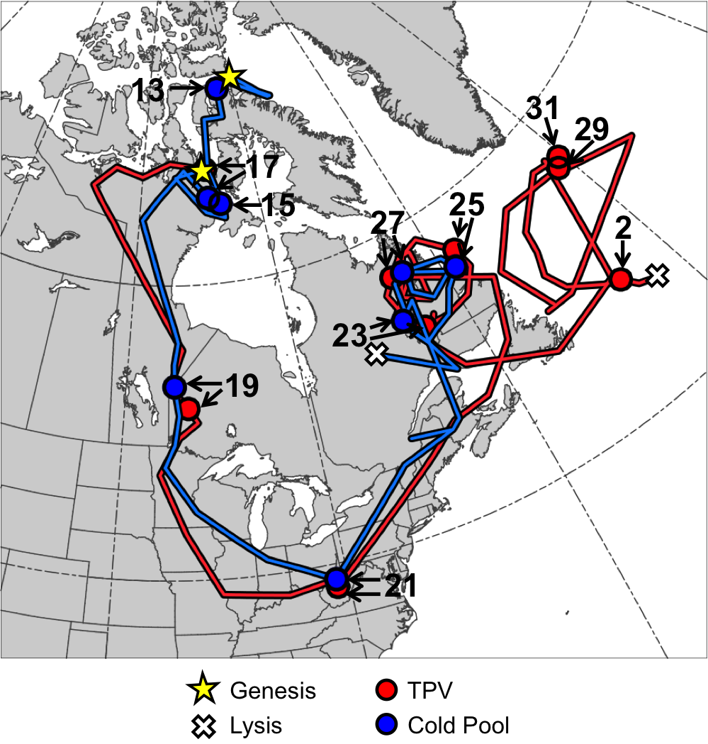
Fig. 4.11. Tracks of TPV (red) from 1800 UTC 16 January to 1200 UTC 2 February 1985 and cold pool (blue) from 1800 UTC 11 January to 0600 UTC 28 January 1985 for January 1985 CAO case. Stars denote locations of genesis, crosses denote locations of lysis, and red and blue dots represent 0000 UTC positions of TPV and cold pool, respectively, every 48 h. Numbers pointing toward dots represent dates of the 0000 UTC positions of the TPV and cold pool, such that numbers ≥13 correspond to dates in January 1985 and the number “2” corresponds to 2 February 1985.

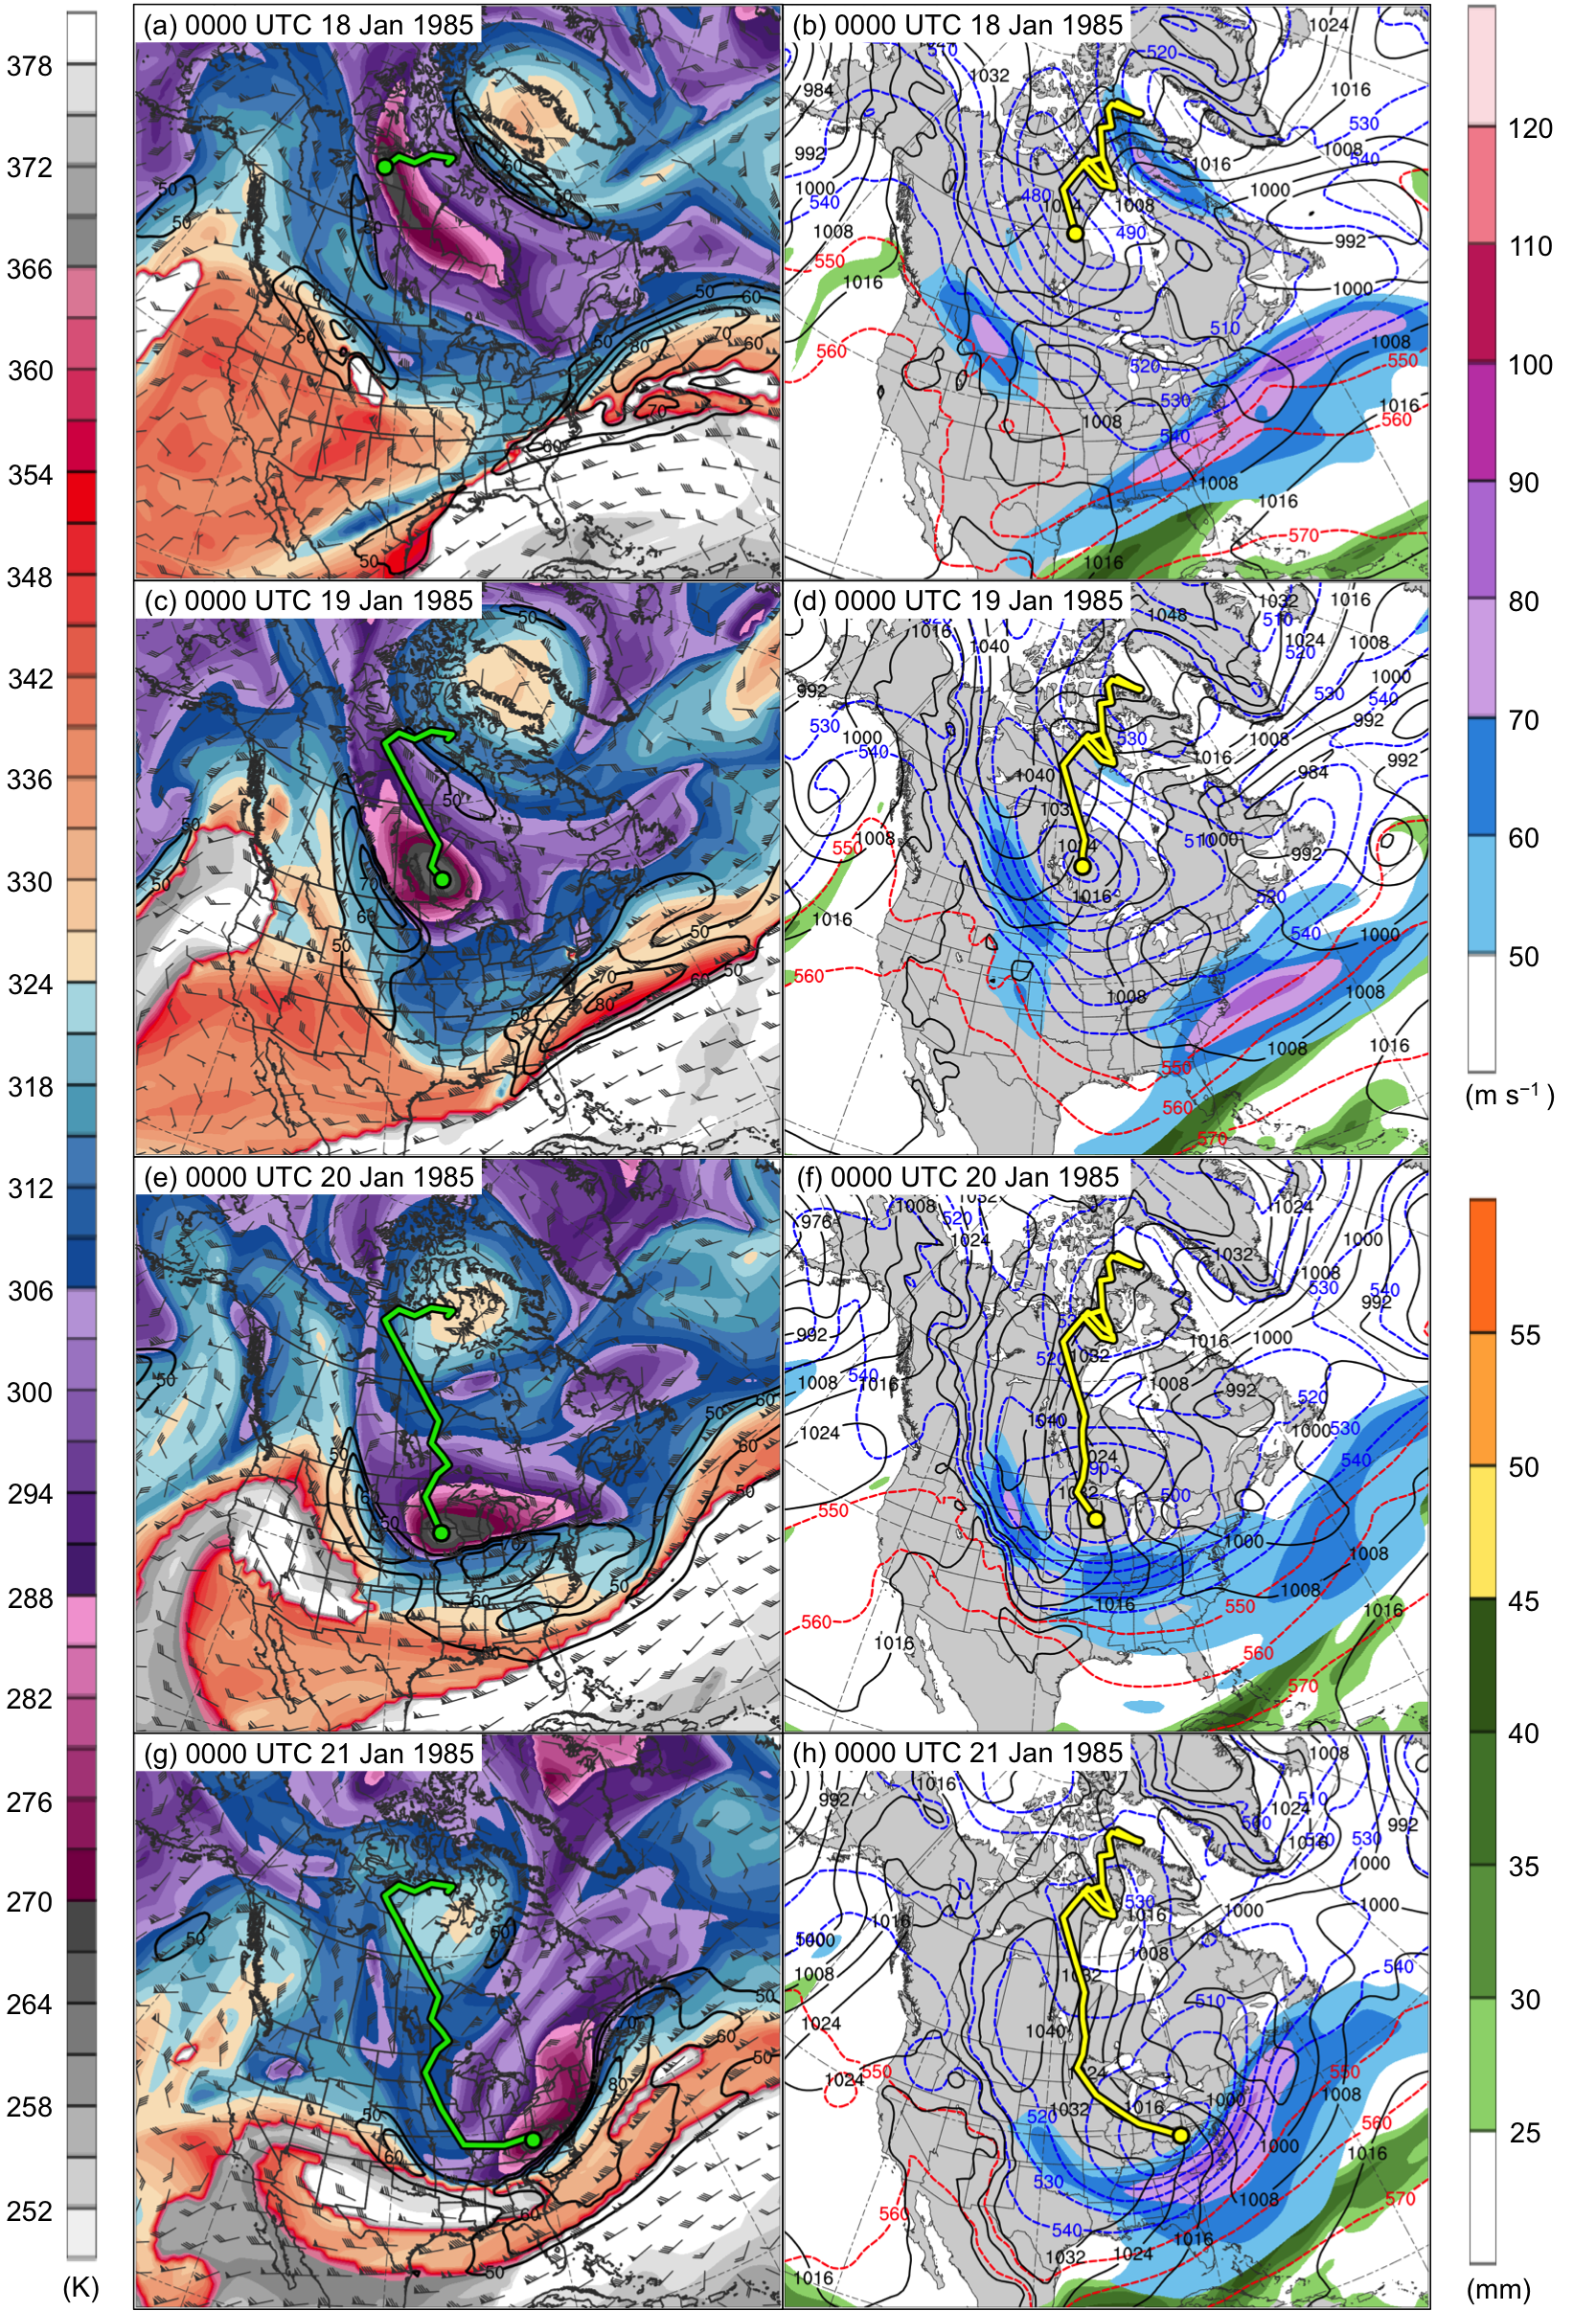
Fig. 4.15. DT (2-PVU surface) potential temperature (K, shaded), wind speed (black contours every 10 m s⁻¹, beginning at 50 m s⁻¹), and wind (m s⁻¹, flags and barbs) at (a) 0000 UTC 18 January, (c) 0000 UTC 19 January, (e) 0000 UTC 20 January, and (g) 0000 UTC 21 January 1985; 250-hPa wind speed (m s⁻¹, shaded), 1000–500-hPa thickness (dashed red and blue contours every 10 dam, contoured red for values >540 dam and blue otherwise), SLP (black contours every 8 hPa), and precipitable water (mm, shaded) at (b) 0000 UTC 18 January, (d) 0000 UTC 19 January, (f) 0000 UTC 20 January, and (h) 0000 UTC 21 January 1985. Green line and dot represent track and position of TPV, respectively, and yellow line and dot represent track and position of cold pool, respectively.
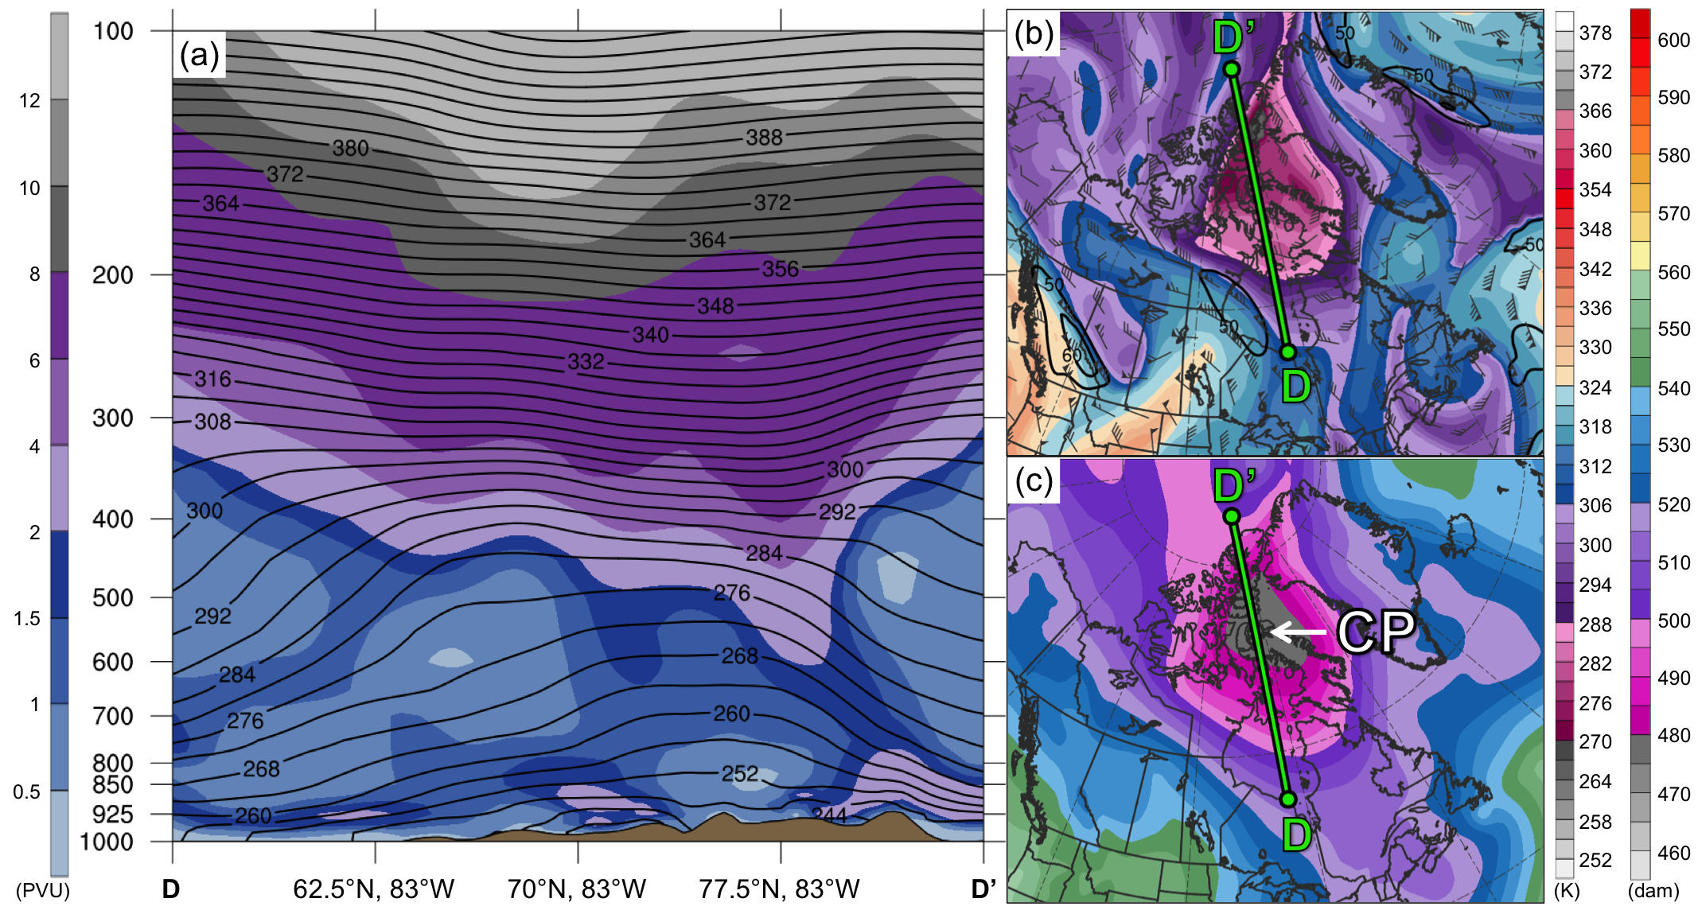
Fig. 4.17. As in Fig. 4.7, but for cross section along line DD’ at 0000 UTC 13 January 1985.

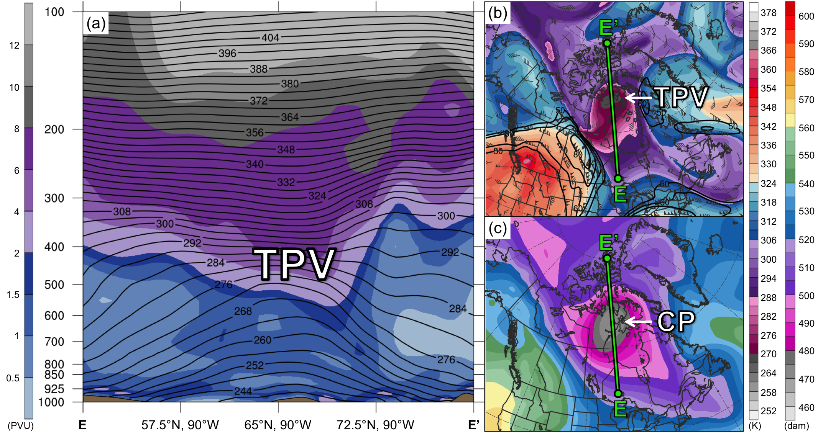
Fig. 4.18. As in Fig. 4.7, but for cross section along line EE’ at 0000 UTC 17 January 1985.

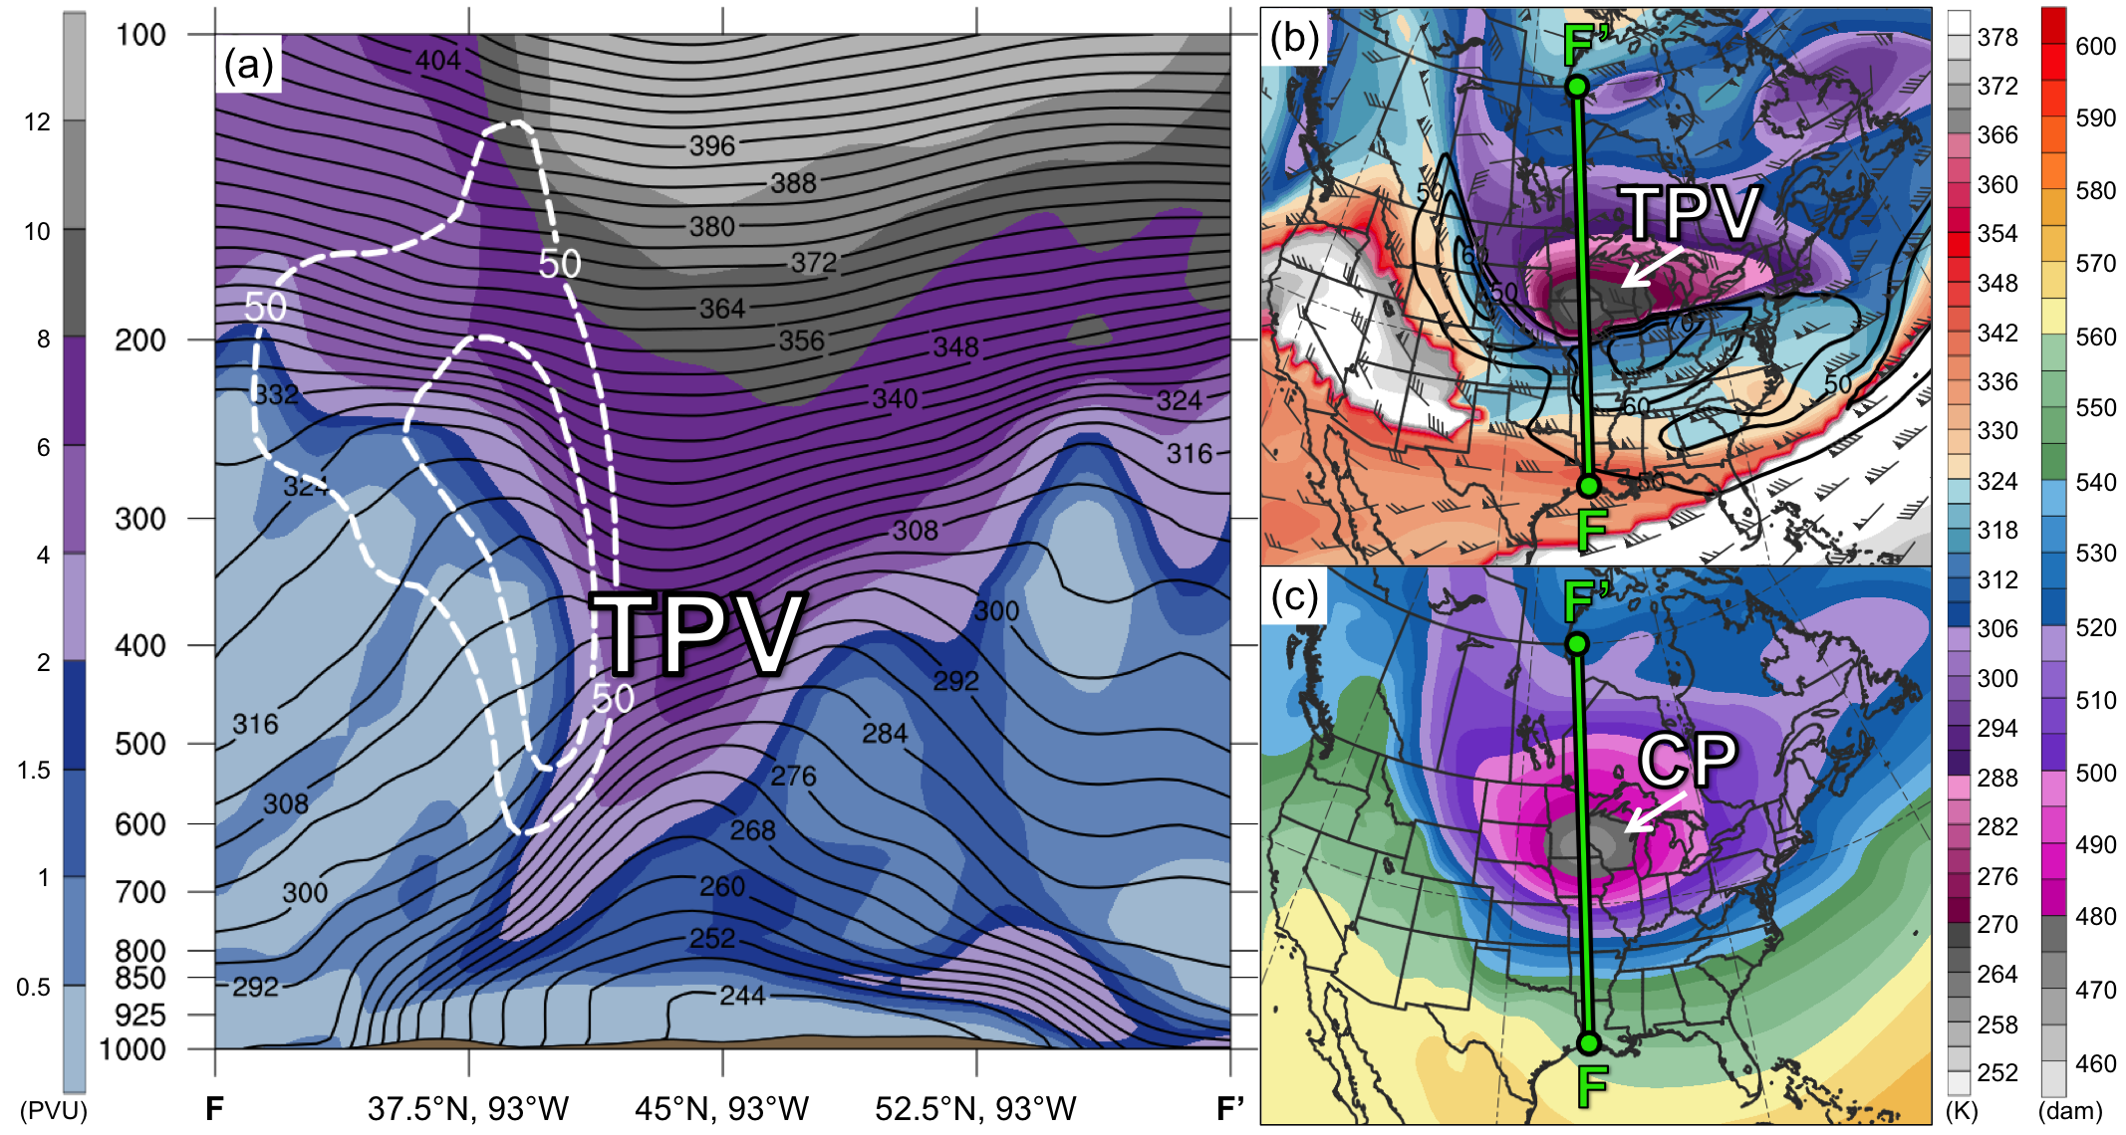
Fig. 4.19. As in Fig. 4.7, but for cross section along line FF’ at 0000 UTC 20 January 1985.

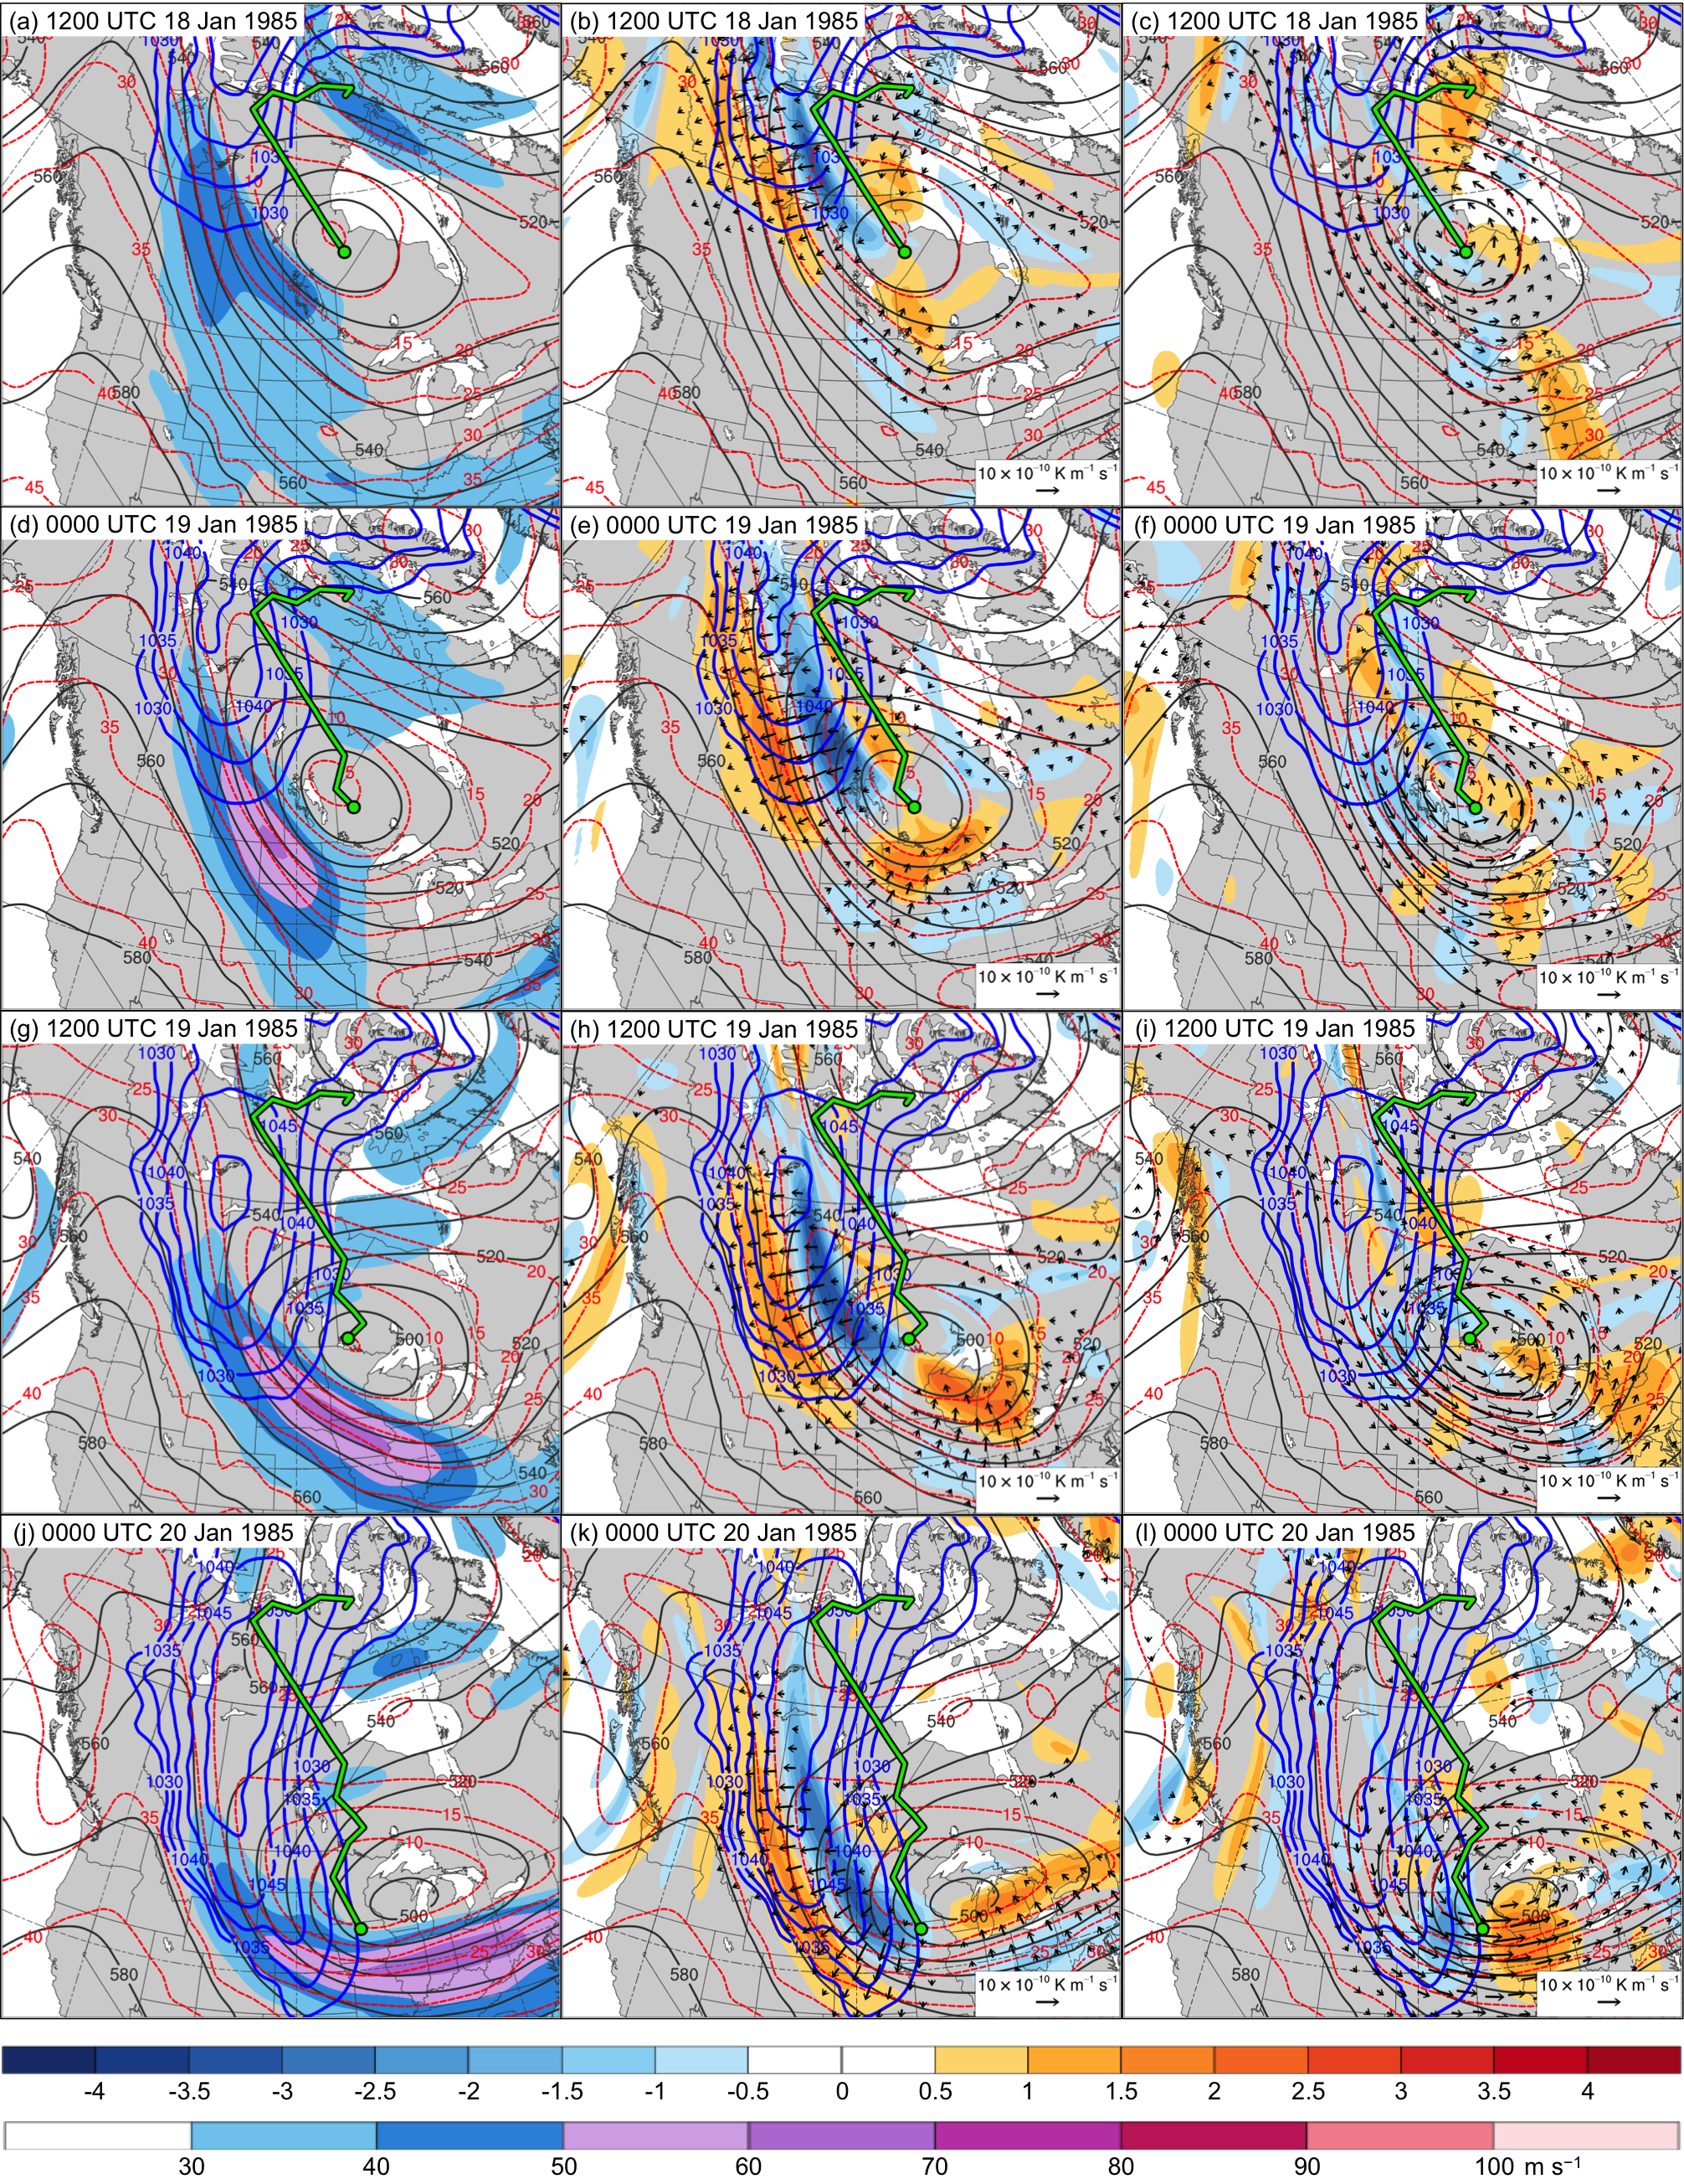
Fig. 4.20. In all panels are SLP (thick blue contours every 5 hPa, beginning at 1030 hPa), and 600–400-hPa geopotential height (dark gray contours every 10 dam) and potential temperature (dashed red contours every 5°C). Also, 600–400-hPa wind speed (m s⁻¹, shaded) at (a) 1200 UTC 18 January, (d) 0000 UTC 19 January, (g) 1200 UTC 19 January, and (j) 0000 UTC 20 January 1985; 600–400-hPa Q_{n} (K m⁻¹ s⁻¹, vectors) and Q_{n} forcing for vertical motion (10⁻¹⁷ Pa⁻¹ s⁻³, shaded) at (b) 1200 UTC 18 January, (e) 0000 UTC 19 January, (h) 1200 UTC 19 January, and (k) 0000 UTC 20 January 1985; and 600–400-hPa Q_{s} (K m⁻¹ s⁻¹, vectors) and Q_{s} forcing for vertical motion (10⁻¹⁷ Pa⁻¹ s⁻³, shaded) at (c) 1200 UTC 18 January, (f) 0000 UTC 19 January, (i) 1200 UTC 19 January, and (l) 0000 UTC 20 January 1985. Green line and dot represent track and position of TPV, respectively.

