LIST OF FIGURES
Figure 3.1. Annual sum of severe reports from 1980–2013 for the Northeast domain (red) and the entire U.S. domain (blue).
Figure 3.2. Annual number of days with at least 1 severe report from 1980–2013 for the Northeast domain (red) and the entire U.S. domain (blue).
Figure 3.3. Annual distribution of reports per severe event from 1980–2013 for the Northeast domain (red) and the entire U.S. domain (blue). The median is plotted with the 25th and 75th percentiles in the whiskers.
Figure 3.4. Annual distribution of POD scores from 1980–2013 for the Northeast domain (red) and the entire U.S. domain (blue). The median is plotted with the 25th and 75th percentiles in the whiskers.
Figure 3.5. Annual number of days with a slight risk outlook covering a portion of the domain from 1980–2013 for the Northeast domain (red) and the entire U.S. domain (blue).
Figure 3.6. Annual distribution of FAR scores from 1980–2013 for the Northeast domain (red) and the entire U.S. domain (blue). The median is plotted with the 25th and 75th percentiles in the whiskers.
Figure 3.7. Annual sums of slight risk convective outlook area from 1980–2013 for the Northeast domain (red) and the entire U.S. domain (blue).
Figure 3.9. Annual frequency of high-impact (blue), type 1 (red), type 2 (green), and good (purple) events from 1980–2013 for the Northeast domain.
Figure 3.10. Percent occurrence of high-impact (blue), type 1 (red), type 2 (green), and good (purple) events per month from 1980–2013 for the Northeast domain.
Figure 3.11. Percent occurrence of high-impact (blue), type 1 (red), type 2 (green), and good (purple) events for northerly, northwesterly, westerly, southwesterly, and southerly 500-hPa flow directions from 1980–2013. Wind values are derived from 1200 UTC CFSR data.
Figure 3.12. Percent of high-impact events classified as type 1 (red) and good (purple) events for northerly, northwesterly, westerly, southwesterly, and southerly 500-hPa flow directions from 1980–2013. Raw numbers of type 1 and good events in each 500-hPa flow category are listed above their respective bars. Wind values are derived from 1200 UTC CFSR data.
Figure 3.13. Phase space diagram of MUCAPE (J kg⁻¹ ) and 1000–500-hPa shear magnitude (kt) for all type 1 (red) and good (purple) events from 1980–2013. High-impact dataset medians of MUCAPE (662 J kg⁻¹) and shear (31 kt) are overlaid as black lines. From the top left going clockwise, quadrants are labeled: Low Shear High MUCAPE (LSHC), High Shear High MUCAPE (HSHC), High Shear Low MUCAPE (HSLC), and Low Shear Low MUCAPE (LSLC). The bold red square and bold purple diamond denote the median MUCAPE and shear values for type 1 and good events respectively. Values are derived from 1800 UTC CFSR data.
Figure 3.14. Number of type 1 and good events binned in each MUCAPE-shear phase space category from 1980–2013. Phase space categories include: Low Shear High MUCAPE (LSHC), High Shear High MUCAPE (HSHC), High Shear Low MUCAPE (HSLC), and Low Shear Low MUCAPE (LSLC). Values are derived from 1800 UTC CFSR data.
Figure 3.15. Same as Fig. 3.14 but for westerly 500-hPa flow cases
Figure 3.16. Same as Fig. 3.14 but for southwesterly 500-hPa flow cases
Figure 3.17. Same as Fig. 3.14 but for northwesterly 500-hPa flow cases
Figure 3.18. Average threat scores of high-impact events occurring under low (< 31 kt) and high (≥ 31 kt) 1000–500-hPa shear. Whiskers are confidence intervals at the 99% level.
Figure 3.19. Northwesterly flow category composite 250-hPa geopotential height (black contours, dam), wind speed (fills, kt), wind barbs (kt), and 500-hPa omega (red dashed contours are negative, red solid contours are positive, contoured every 3×10⁻³ hPa s⁻¹) for good (a) events (N = 20) and type 1 (b) events (N = 29). Heavy red dot represents composite center at point of maximum report density.
Figure 3.20. Northwesterly flow category composite 500-hPa geopotential height (black contours, dam), wind barbs (kt), and 700–500-hPa lapse rate (fills, K km⁻¹), for good (a) events (N = 20) and type 1 (b) events (N = 29). Heavy red dot represents composite center at point of maximum report density.
Figure 3.21. Northwesterly flow category composite mean sea level pressure (black contours, every 2 hPa), 1000–500-hPa thickness (dashed, every 6 dam), and total columnar precipitable water (fills, mm), for good (a) events (N = 20) and type 1 (b) events (N=29). Heavy red dot represents composite center at point of maximum report density.
Figure 3.22. Northwesterly flow category composite MUCAPE (fills, J kg⁻¹), 850–500-hPa lapse rate (black contours, K km⁻¹), and 1000–500-hPa wind shear (barbed, kt), for good (a) events (N = 20) and type 1 (b) events (N=29). Heavy red dot represents composite center at point of maximum report density.
Figure 3.23. As in Fig. 3.19 except for the southwesterly flow category composite for good (a) events (N = 48) and type 1 (b) events (N = 50). Heavy red dot represents composite center at point of maximum report density.

Figure 3.24. As in Fig. 3.20 except for the southwesterly flow category composite for good (a) events (N = 48) and type 1 (b) events (N = 50). Heavy red dot represents composite center at point of maximum report density.

Figure 3.25. As in Fig. 3.21 except for the southwesterly flow category composite for good (a) events (N = 48) and type 1 (b) events (N = 50). Heavy red dot represents composite center at point of maximum report density.

Figure 3.26. As in Fig. 3.22 except for the southwesterly flow category composite for good (a) events (N = 48) and type 1 (b) events (N = 50). Heavy red dot represents composite center at point of maximum report density.

Figure 3.27. As in Fig. 3.19 except for the westerly flow category composite for good (a) events (N = 108) and type 1 (b) events (N = 96). Heavy red dot represents composite center at point of maximum report density.

Figure 3.28. As in Fig. 3.20 except for the westerly flow category composite for good (a) events (N = 108) and type 1 (b) events (N = 96). Heavy red dot represents composite center at point of maximum report density.

Figure 3.29. As in Fig. 3.21 except for the westerly flow category composite for good (a) events (N = 108) and type 1 (b) events (N = 96). Heavy red dot represents composite center at point of maximum report density.

Figure 3.30. As in Fig. 3.22 except for the westerly flow category composite for good (a) events (N = 108) and type 1 (b) events (N = 96). Heavy red dot represents composite center at point of maximum report density.

Figure 3.31. SPC 0600 UTC 18 August 2009 severe wind convective outlook valid 1200 UTC 18 August 2009 to 1200 UTC 19 August 2009.

Figure 3.32. Storm reports valid from 1200 UTC 18 August 2010 to 1200 UTC 19 August 2009. Black circle represents area of interest.

Figure 3.33. Radar reflectivity valid at 2154 UTC 18 August 2009 (source: College of DuPage).

Figure 3.34. 250-hPa geopotential height (black contours, dam), divergence (red contours every 5×10⁻⁵ s⁻¹ starting at 10×10⁻⁵ s⁻¹), wind speed (fills, kt), and wind barbs (kt) at 1600 UTC 18 August 2009 using RUC model analysis data.

Figure 3.35. 500-hPa geopotential height (black contours, dam), relative vorticity (fills, ×10⁻⁵ s⁻¹), and wind barbs (kt) at 1600 UTC 18 August 2009 using RUC model analysis data.

Figure 3.36. SBCAPE (fills, J kg⁻¹), 850–500 lapse rate (black contours every 0.5 K km⁻¹), and 1000–500-hPa shear (barbed, kt) at 1600 UTC 18 August 2009 using RUC model analysis data.

Figure 3.37. Sounding at PIT valid at 1200 UTC 18 August 2009 (source: SPC).

Figure 3.38. Sounding at WAL valid at 1200 UTC 18 August 2009 (source: SPC).

Figure 3.39. DCAPE climatology at WAL. Dark red line represents the maximum 91-day moving average while the thin red line is the daily maximum. Green bolt represents the observed value at 1200 UTC 18 August 2009 (source: SPC).

Figure 3.40. Aircraft sounding and computed parcel path using METAR data valid at 2002 UTC 18 August 2009. Sounding is located at IAD.

Figure 3.41. SPC 0600 UTC 4 May 2010 severe wind convective outlook valid 1200 UTC 4 May 2010 to 1200 UTC 5 May 2010.

Figure 3.42. Storm reports valid 1200 UTC 4 May 2010 to 1200 UTC 5 May 2010. Black circle represents area of interest.

Figure 3.43. Radar reflectivity valid at 1857 UTC 4 May 2010 (source: College of DuPage).

Figure 3.44. As in Fig. 3.34 but for 1400 UTC 4 May 2010.

Figure 3.45. As in Fig. 3.35 but for 1400 UTC 4 May 2010.

Figure 3.46. As in Fig. 3.36 but for 1400 UTC 4 May 2010.

Figure 3.47. Surface equivalent potential temperature (fills, K), MSLP (black contours every 4 hPa), and surface winds (barbed, kt) valid at 1400 UTC 4 May 2010.

Figure 3.48. Sounding at BUF valid at 1200 UTC 4 May 2010 (source: SPC).

Figure 3.49. Sounding at ALB valid at 1200 UTC 4 May 2010 (source: SPC).

Figure 3.50. Visible satellite imagery valid at 1415 UTC 4 May 2010.

Figure 3.51. Meteogram for BDL valid from 0000 UTC 4 May 2010 to 2300 UTC 4 May 2010. Wind speeds are in knots (source: Plymouth State College).

Figure 3.52. Aircraft sounding and computed parcel path using valid METAR data at 1617 UTC 4 May 2010. Sounding is located at BDL.

Figure 3.53. SPC 0600 UTC 4 July 2012 severe wind convective outlook valid 1200 UTC 4 July 2012 to 1200 UTC 5 July 2012.

Figure 3.54. SPC 2000 UTC 4 July 2012 severe wind convective outlook valid 2000 UTC 4 July 2012 to 1200 UTC 5 July 2012.

Figure 3.55. Radar reflectivity valid at 2230 UTC 4 July 2012. Blue circles outline the most prolific severe storms (source: College of DuPage).

Figure 3.56. Radar reflectivity valid at 0230 UTC 5 July 2012. Blue square outlines the area containing the most prolific severe storms (source: College of DuPage).

Figure 3.57. Infrared satellite imagery valid at 2215 UTC 3 July 2012. Magenta circle outlines the developing MCS in Saskatchewan.
Figure 3.58. Infrared satellite imagery valid at 2215 UTC 4 July 2012. Magenta circle outlines the mature MCS over Ontario and the northern Great Lakes.

Figure 3.59. Dynamic tropopause (1.5-PVU surface) potential temperature (shaded, K) and wind barbs (kt), 925–850-hPa layer-averaged cyclonic relative vorticity (black contours, every 0.5 x 10⁻⁴ s⁻¹) at 0000 UTC 4 July 2012. Black circle outlines developing MCS. [Source: Heather Archambault]

Figure 3.60. As in Fig. 3.58 but at 1800 UTC 4 July 2012. Black circle outlines the ridge strengthened by latent heating associated with convection. [Source: Heather Archambault]

Figure 3.61. Infrared satellite imagery valid at 1745 UTC 4 July 2012. Magenta circles outline the incipient convection in Quebec (top) and the remnant MCV over PA (bottom).

Figure 3.62. As in Fig. 3.34 but at 1800 UTC 4 July 2012 using RAP model analysis data.

Figure 3.63. As in Fig. 3.35 but at 1800 UTC 4 July 2012 using RAP model analysis data.

Figure 3.64. As in Fig. 3.36 but at 1800 UTC 4 July 2012 using RAP model analysis data.

Figure 3.65. Sounding from WMW valid at 1200 UTC 4 July 2012 (source: SPC).

Figure 3.66. Sounding from PIT valid at 1200 UTC 4 July 2012 (source: SPC).

Figure 3.67. As in Fig. 3.39 but for PIT. Green bolt represents observed value at 1200 UTC 4 July 2012 (source: SPC).

Figure 3.68. Surface observations valid at 1800 UTC 4 July 2012 (source: Weather Prediction Center).

Figure 3.69. Aircraft sounding and computed parcel path using METAR data valid at 1744 UTC 4 July 2012. Sounding is located at PIT.

Figure 3.70. As in Fig. 3.36 but for 0000 UTC 5 July 2012 using RAP model analysis data.

Figure 3.71. Sounding from PIT valid at 0000 UTC 5 July 2012 (source: SPC).

Figure 3.72. Surface observations valid at 0000 UTC 5 July 2012 (source: UCAR). The black box highlights the thermal boundary between CLE, CAK, YNG, and HZY.

Figure 3.73. SPC 0600 UTC 24 May 2011 severe wind convective outlook valid 1200 UTC 24 May 2011 to 1200 UTC 25 May 2011.

Figure 3.74. Radar reflectivity valid at 2123 UTC 24 May 2011 (source: College of DuPage).

Figure 3.75. As in Fig. 3.34 but at 1200 UTC 24 May 2011.

Figure 3.76. As in Fig. 3.35 but at 1200 UTC 24 May 2011.

Figure 3.77. Sounding at PIT valid at 1200 UTC 24 May 2011 (source: SPC).

Figure 3.78. Sounding at IAD valid at 1200 UTC 24 May 2011 (source: SPC).

Figure 3.79. As in Fig. 3.47 but at 2200 UTC 24 May 2011. The heavy dashed line indicates the position of the cold front.

Figure 3.80. As in Fig. 3.36 but at 2200 UTC 24 May 2011.

Figure 3.81. Radar reflectivity valid at 2354 UTC 23 May 2011 (source: College of DuPage).

Figure 3.82. Infrared satellite imagery valid at 0000 UTC 24 May 2011.

Figure 3.83. Infrared satellite imagery valid at 1215 UTC 24 May 2011.

Figure 3.84. Infrared satellite imagery valid at 1815 UTC 24 May 2011.

Figure 3.85. Surface observations of sky cover valid at 1800 UTC 24 May 2011 (source: Plymouth State College).

Results
  - Severe Weather Skill Scores

The annual sum of severe reports collected by the NWS from 1980–2013 is presented in Fig. 3.1. The trend in annual reporting increases with time for both the national and Northeast domains for reasons hypothesized in chapter 2. Although the smaller Northeast domain exhibits more interannual variability than the CONUS domain, both domains vary considerably after 2005. The more restrictive 1-in (~2.5 cm) severe hail criterion, established 5 January 2010, does not prevent 2011 from having the highest number of severe weather reports of any year in the database for both regions. The annual sum of severe weather days across the study period is pictured in Fig. 3.2. The CONUS and the Northeast exhibit a marginal increase in the annual sum of severe weather days, likely due to the increase in reporting frequency discussed in chapter 2. However, comparing Figs 3.1 and 3.2 suggests the more numerous severe weather days cannot fully explain the rapid increase in annual severe report count.
The increase in severe reports with time, pictured in Fig. 3.1, is reflected in the annual distribution of severe reports per event (Fig. 3.3). An event must have at least 1 severe report occurring within the domain during the 1200–1200 UTC period. Medians for each year are plotted with interquartile ranges in whiskers. The variability of reports per event increases through the study period with the 75th percentile increasing substantially more than the median for both domains. The increasing report count of high-end events implies the reporting trend for prolific severe weather events increases more rapidly than the rest of the event distribution. The upward trend in reports per year and reports per event suggests a temporally dependent threshold, such as that described in chapter 2, is necessary for discriminating high-impact events across both domains.
The annual POD scores for all slight risk events are depicted in Figure 3.4. Yearly medians are plotted with the 25th and 75th percentiles in whiskers. Over the study period, the Northeast displays better median POD scores than the CONUS for all but 3 years suggesting slight risk convective outlooks in the Northeast capture a higher frequency of severe reports than the CONUS. There is no significant trend in POD scores through the study period for either domain. Larger IQRs suggest more POD score variability for the Northeast than the steadier CONUS. The smaller Northeast domain likely has more volatile POD scores since a given slight risk contour centered in the Northeast domain covers a higher percentage of the total domain area than the same slight risk contour in the CONUS domain. Differences in event sample size likely contribute to the relatively higher variability of POD scores in the Northeast as well. The entire CONUS domain has at least 300% more slight risk days than the Northeast domain every year (Fig. 3.5).
The FAR medians and 25th and 75th percentiles are pictured in Fig. 3.6. Both domains show improvement with a downward trend from 1980–2013. The Northeast maintains lower median FAR scores than the CONUS throughout most of the study period. Larger IQRs and higher FAR score variability in the Northeast are evident throughout the study period, likely due to lower event sample size for Northeast events. Fig. 3.7 depicts the cumulative slight risk convective outlook area for each year in the study period. The national slight risk area increases from 1980–1996 and drops precipitously in the latter half of the 1990s. An increase in slight risk area occurs between the turn of the century and 2004 before declining through the end of the study period. These results across the national domain are congruent with Fig. 1.14. The Northeast domain follows a similar, though more varied, trend. The reduction of slight risk outlook size partly contributes to the decline in FAR scores. However, the slight decline in FAR scores in the first half of the study period along with a continued, though muted, decline in the latter half suggests slight risk convective outlook placement has improved throughout the period.
The medians and 25th and 75th percentiles of TS are shown in Fig. 3.8. Similar to the POD and FAR scores, larger volatility is evident in the Northeast TS throughout the study period relative to the CONUS. Additionally, the range between the 75th percentile of TS in the Northeast from the median is higher than the same range for the CONUS domain while both domains have a similar range between their 25th percentile TS and their respective medians for most years in the period. This suggests the upper quartile of events in the Northeast benefit from higher TS than the upper quartile of CONUS events while the lower quartile events have similar TS in both domains. Both threat scores trend up with time, demonstrating gradual improvement in slight risk outlook placement and coverage. Over the 34-year period, the annual median Northeast TS fell below the national median on nine occasions, but remained above the national median for the remaining years of the study period. Therefore, the majority of Northeast slight risk outlooks have higher skill scores than CONUS slight risk outlooks.

  - High-Impact, Low-Predictive Skill Event Climatology

A climatology of high-impact, low-predictive skill severe weather events over the Northeast is constructed using the methods discussed in chapter 2. The annual frequencies of high-impact, type 1, type 2, and good events are shown in Fig. 3.9. Recall high-impact events are defined using a linear regression of the 55th percentile of area impacted by severe weather with a slight risk contour present rather than using the raw 55th percentile for each year. Therefore, the results allow for some variability in the number of high-impact events from year to year instead of tracking events in the upper 45th percentile for a given year. A total of 825 (32%) of 2615 Northeast severe weather events are classified as high-impact events with an annual average of 24 events. A yearly maximum of 44 events occurred in 1994 and a yearly minimum of 10 events occurred in 1984. There is no discernable trend in high-impact events with time, but notable interannual variability exists through the period.
Type 1 (low POD) events composed 224 (27%) of all high-impact events through the period. Slightly more than 25% of high-impact events are classified as type 1 since the lowest 25th percentile POD score for all high-impact events is zero. A maximum of 16 type 1 events occurred in 1980 and a minimum of 1 type 1 event occurred in 2003 with an average of 7 events per year (Fig. 3.9). Type 1 events are a consistent phenomenon with no discernable trend in type 1 event occurrence through the study period. Type 2 (high FAR) events occur less frequently with a total of 42 events from 1980–2013. Before 1996, a total of 32 type 2 events occurred with only 10 events occurring thereafter (Fig. 3.9). An average of 1 type 2 event occurs a year, but type 2 occurrence frequency declines throughout the period with only 5 events occurring in the last decade of the study period. Lastly, 207 high-impact events are classified as good (upper quartile of TS) events with an average of 6 events a year. A maximum of 13 good events occurred in 2002, 2011, and 2012 while a minimum of zero events occurred from 1981–1986. Due in part to the scarcity of good events in the first decade of the study period, there is an upward trend in good event occurrence with time. Of the 9 years having ten or more good events, 8 of them occur in the last decade of the study period. The trend of good events supports the positive TS trend (Fig 3.8) and further suggests slight risk placement and coverage has improved over time.
The monthly frequencies of high impact, type 1, type 2, and good events are presented in Fig. 3.10. High-impact events largely follow the climatology of severe reports in the northeast U.S. (Fig. 1.5) with a peak in the warm season and a minimum in the cool season. 70% of high-impact events occur in June, July, and August (JJA). April, May, and September account for an additional 23% suggesting high-impact events generally occur in boreal spring and summer over the Northeast. To first order, type 1, type 2, and good events follow the high-impact monthly climatology to within a couple percentage points with the exception of type 2 events in May and August. Type 2 events occur more frequently in May and less frequently in August relative to the high-impact event climatology; though, the small sample of type 2 events (N=42) relative to other event categories should be considered. Importantly, the type 1 and good event datasets are similar through all months aside from slight differences including a higher percentage of type 1 events in JJA. The overall likeness of type 1 and good events suggests little seasonal variability in the predictive skill of high impact weather over the Northeast.
The percent occurrence of high-impact, type 1, type 2, and good events by 1200 UTC 500-hPa flow direction is depicted in Fig. 3.11. A total of 7 high-impact events occurred under a variation of easterly flow and are not shown. Most (83%) high-impact events occur under westerly and southwesterly flow regimes while 12% occur under northwesterly flow. Occurrence rates for type 1, type 2, and good events are generally within a few percentage points of the high-impact climatology however, there are some notable differences. Type 2 events did not occur under northerly or southerly flow during the study period. Additionally, type 1 events occur at a higher frequency under northwesterly, northerly, and southerly flow than good events.
To investigate the differences between type 1 and good event flow regimes, Fig. 3.12 illustrates the percentage of high-impact events classified as type 1 or good events for each flow regime. The raw numbers of events are listed above the bars. High-impact events under westerly flow conditions result in the largest number of type 1 and good events. Notably, 24% of high-impact events under westerly flow are type 1 events and 26% of high-impact events under westerly flow are good events. These percentages indicate westerly flow events follow the high-impact event climatology and do not have a higher occurrence rate of poorly (well) forecasted events because both type 1 and good events are defined using the 25th percentile of POD and TS for high-impact events respectively. High-impact events under southwesterly flow have a similar distribution of type 1 and good events, implying southwesterly flow has little impact on the predictive skill of high-impact events.
High-impact events under northwesterly flow compose 12% of all high-impact events, however the occurrence rate of type 1 events per high-impact event is higher than either westerly or southwesterly flow regimes. 31 type 1 events occurred under northwesterly flow, accounting for 33% of all high-impact events under northwesterly flow. Good events compose 21 events representing 22% of all high-impact events under northwesterly flow. The southerly flow regime has similar percentages but sample size is limited as only 17 high-impact events occurred under southerly flow during the study period. High-impact events under northerly flow total 17 but 10 events (58%) are classified as type 1 while only 2 events (12%) are classified as good events. Therefore, type 1 events are most common during high-impact events under northerly flow. Threat scores are calculated for all high-impact events under each flow regime and while northerly and northwesterly flow regimes have the lowest TS, insufficient sample sizes preclude statistical significance. However, the high percentage of type 1 events under northerly flow and the relative rarity of northerly flow severe events suggest forecasting high-impact severe weather under such flow regimes is difficult.
A composite of severe weather parameters of high-impact events is constructed for type 1 and good event categories centered at the point of maximum report density. 93% of high-impact events occur during the warm season (April–September, Fig. 3.10); as a result, cool season (October–March) events are omitted to focus the composites on environments producing the majority of high-impact events. Fig. 3.13 depicts the 1800 UTC MUCAPE and 1000–500-hPa wind shear magnitude for type 1 and good events. Variables are calculated with 0.5° CFSR data using an area average inside a 1.5° × 1.5° box centered on the point of maximum report density. The median MUCAPE (662 J kg⁻¹) and shear magnitude (31 kt) of the entire high-impact dataset are shown in horizontal and vertical black lines, respectively. The high-impact medians segregate the phase space into four quadrants consisting of Low Shear High MUCAPE (LSHC), High Shear High MUCAPE (HSHC), High Shear Low MUCAPE (HSLC), and Low Shear Low MUCAPE (LSLC) events. The median MUCAPE and shear magnitude for type 1 events are 667 J kg⁻¹ and 29 kt respectively. The median MUCAPE and shear magnitude for good events are higher at 691 J kg⁻¹ and 35 kt respectively. Both event types have higher MUCAPE medians than the median for all high-impact events; however, the type 1 shear magnitude median is less than both the good event median shear and the total high-impact event median shear values indicating most type 1 events occur under lower shear conditions.
Fig. 3.14 illustrates the total number of type 1 and good events in each quadrant of the MUCAPE-shear phase space. Good events outnumber type 1 events under HSLC and HSHC conditions while type 1 events outnumber good events under LSLC and LSHC conditions, indicating less than 31 knots of 1000–500-hPa shear (low-shear) conditions are associated with more type 1 events and fewer good events. To further explore the relationship between high-impact event type and the MUCAPE-shear phase space, we segregate events by 1200 UTC 500-hPa flow direction over the point of maximum report density. Fig. 3.15 illustrates the number of type 1 and good events under westerly 500-hPa flow corresponding to each quadrant of the MUCAPE-shear phase space. For westerly flow events, good events outnumber type 1 events when 31 kt or greater of 1000–500-hPa shear (high-shear) is present whereas type 1 events outnumber good events under low-shear conditions. No strong correlation to MUCAPE is found for westerly flow events. Fig. 3.16 is the same as Fig. 3.15, but for southwesterly 500-hPa flow. For events under southwesterly flow regimes, a larger number of good events occur under high-shear conditions than type 1 events. Type 1 events occurred 19 times under LSLC conditions, eclipsing the 5 good events under the same conditions. LSHC conditions have a similar number of type 1 and good events. High-impact events under northwesterly 500-hPa flow have a larger number of type 1 events than good events overall and type 1 events equal or outnumber good events in every category (Fig. 3.17). Similar to other flow regimes, low-shear conditions produce the most type 1 events under northwesterly flow. However, good events under low-shear conditions are more common than good events under high-shear in contrast to the other flow regimes. 16 good events occurred under low-shear conditions while only 4 good events occurred under high-shear conditions.
Analysis suggests type 1 events have a higher rate of occurrence under low-shear conditions than good events. Moreover, average threat scores for all high-impact events are shown in Fig. 3.18. High-impact events under low-shear conditions have a significantly (99% confidence level) lower threat scores than high-impact events under high shear conditions. Additionally, the median TS of low-shear high-impact events is significantly lower (99% confidence level) than the median TS of high-shear high-impact events (not shown). However, only 4 good events occurred under high-shear conditions in northwesterly flow regimes suggesting that while type 1 events are most common under low-shear conditions, high-impact events under northwesterly 500-hPa flow with high deep-layer shear are rarely classified as good events. This suggests high-shear northwesterly flow events are rarely classified as well-forecasted events and forecasting severe weather remains a challenge in such environments. Aside from 1000-500-hPa shear, no other convective parameters were found to be significant in discriminating threat scores of high-impact events in the Northeast.

  - Composite Analysis
    - Northwesterly composite

As discussed in section 3.2, only high-impact type 1 and good events occurring from April–September are included in the event-centered composite calculations. Composite 250-hPa geopotential height and wind are shown in Figs. 3.19a, b. The point of maximum report density for type 1 and good events is found beneath the equatorward exit region of a zonally oriented 50–60-kt upper-level jet streak (Figs. 3.19a, b). The good composite exhibits stronger wind speeds within the jet and a more zonally oriented jet axis than the type 1 composite. Both event centers lie beneath a mean equatorward jet exit region however the weak horizontal wind speed gradient limits the strength of the mean secondary ageostrophic circulation and associated vertical motion over the event centers. The upstream ridge exhibits more pronounced anticyclonic curvature in the type 1 composite than the good composite likely contributing to the reduced ascent at 500 hPa to the west of the event center (Fig. 3.19b). At 500 hPa, a ridge lies upstream of the event centers while a plume of enhanced 700–500-hPa lapse rates advects around the ridge approaching from the west (Figs. 3.20a, b). The good composite depicts stronger 35–40-kt wind speeds and steeper lapse rates upstream of the event center than the type 1 composite. Additionally, the tightened geopotential height gradient and enhanced ascent directly upstream of the event center (Figs. 1.19a and 3.20a) suggest a mean shortwave trough may exist ~1000 km west-northwest of the event center. However, the compositing technique likely dampens the shortwave signal due to variability in the strength and location of the trough relative to the point of maximum report density. The approaching type 1 midlevel ridge displays enhanced anticyclonic curvature relative to the upstream ridge in a similar fashion to the 250-hPa height field. The mean sea level pressure (MSLP) field is relatively diffuse in the type 1 composite depicting westerly geostrophic winds and weak warm air advection over the region (Fig. 3.21b). The good composite displays stronger westerly geostrophic winds over the event center under a similar warm air advection regime (Fig. 3.21a). The good composite also depicts enhanced baroclinicity beneath the upper-level jet, reflected in the stronger 1000–500-hPa thickness gradient, as well as higher thickness values over and upstream of the event center. Additionally, an area of 35–40-mm precipitable water (PW) values lies to the west of the good composite event center ahead of a southwest to northeast oriented surface trough. The enhanced PW zone west of the event center coincides with an area of larger 500–1000 J kg⁻¹ MUCAPE and >6.5 K km⁻¹ 850–500-hPa lapse rates within the good composite (Figs. 3.21a and 3.22a). The type 1 events, by contrast, have weaker lapse rates and between 250–500 J kg⁻¹ of MUCAPE across much of the domain ~1000 km west of the event center (Fig. 3.22b). Additionally, the enhanced baroclinicity and faster flow aloft contribute to higher deep-layer shear values of 35–45 kt to the west-northwest of the event center in the good cases (Figs. 3.22a, b). The steeper lapse rates, accelerated flow aloft, and enhanced instability are likely responsible for the improved forecast performance in the good cases despite the lack of strong synoptic forcing. However, upstream 250–500 J kg⁻¹ 1200 UTC MUCAPE values, >6 K km⁻¹ lapse rates to the west of the event center, and 30–35-kt deep-layer shear to the west-northwest of the event center indicate the more modest convective parameters of the type 1 cases, relative to the good cases, remain supportive of high-impact severe weather in the Northeast.

    - Southwesterly composite

The point of maximum report density for southwesterly flow regimes lies beneath the equatorward jet entrance region of an upper-level jet streak (Figs. 3.23a, b). A 70-kt mean jet maximum north of the event center highlights the good composite whereas a weaker 50-kt jet streak is found to the north of the type 1 event center. The good composite depicts the 50-kt isotach extending into the base of an approaching upper-level trough ~800 km west of the event center while type 1 cases have >50 kt flow restricted to the north of the event center. Good cases have a more amplified 250-hPa trough and a stronger equatorward entrance region over the event center providing favorable deep-layer ascent; type 1 cases have a less amplified trough in a similar location, providing more modest forcing for ascent.
At 500-hPa, the amplified trough axis of the good composite lags the more progressive type 1 trough axis located ~200km further east (Figs. 3.24a, b). Midlevel lapse rates are generally under 6 K km⁻¹ over and upstream of the event center in both composites suggesting advection of steep 700–500-hPa lapse rates is not a prominent process in type 1 or good high-impact events under southwesterly flow. A closed 1008-hPa surface low lies ~350 km west-northwest of the good composite event center (Fig. 3.25a). The surface cyclone is ahead of a 1000–500-hPa thickness trough to the west and is in a favorable position to strengthen under positive 1000–500-hPa thermal vorticity advection by the 1000–500-hPa thermal wind. The thermal trough in the type 1 composite is weaker and more progressive with a broader trough axis ~200 km east of the thermal trough in the good composite (Figs. 25a, b).
Deep-layer shear values southwest of the good composite event center range from 30–35 kt while type 1 events average ~25 kt (Figs. 26a, b). 850–500-hPa lapse rates are weak with slightly stronger lapse rates ~6 K km⁻¹ southwest of the type 1 and good event centers. The good cases depict MUCAPE exceeding 250 J kg⁻¹ over a larger area as well as ~6 K km⁻¹ lapse rates over a broader area upstream of the event center than the type 1 cases; though, MUCAPE at 1200 UTC remains low for both events, suggesting instability develops predominantly in-situ rather than by advection. However, errors in the CFSR MUCAPE field may contribute the low instability depicted in Figs. 26a, b.

    - Westerly composite

The point of maximum report density for westerly flow regimes lies to the south of a zonal jet streak for both composites (Figs. 3.27a, b). On average, the event center does not lie under a prominent jet entrance or exit region, preventing robust conclusions concerning jet forcing over the event center. However, an area of midlevel ascent coincides with a weak upstream trough at 250 hPa ~1000 km west of the event center (Fig. 3.27a). The 60–70-kt jet north of the good composite event center is stronger and elongated relative to the 50–60-kt jet in the type 1 composite. The geopotential height field at 500-hPa depicts a diffuse shortwave trough approaching both event centers from the west-northwest attendant with accelerated flow around the trough axis (Figs. 28a, b). The good cases average wind speeds around 35–40 kt at the trough axis while the type 1 cases average speeds around 30–35 kt in the trough axis. Both composites depict ~6 K km⁻¹ 700–500-hPa lapse rates to the west-southwest of the event center with marginal differences in the location of the lapse rate plume.
Areas of 30–40-mm PW lie around and west of the good composite event center, indicating higher moisture content than type 1 events which average 30–35-mm PW to the south of the event center (Figs. 3.29a, b). A weak 1000–500-hPa thickness ridge approaches the good composite event center from the west and the 564-dam thickness isopleth lies north of the event center. Conversely, the type 1 composite lacks the thickness ridge signature and the 564-dam thickness isopleth lies south of the event center, indicating a cooler airmass over the type 1 event center at 1200 UTC relative to the good composite. Additionally, the meridional thickness gradient to the northwest of the event center is stronger in the good composite, driving stronger flow aloft and contributing to higher vertical wind shear values than the type 1 composite. Figs. 3.30a and 3.30b depicts 35–40 kt of deep-layer shear to the west-northwest of the good composite event center while ~30 kt of shear dominates the area around and west-northwest of the type 1 event center. 500–750 J kg⁻¹ MUCAPE west-southwest of the good composite event center indicate higher instability upstream than the type 1 composite. The area of enhanced instability corresponds with the area of 35–40-mm PW to the west-southwest of the good composite event center (Figs. 3.29a and 3.30a). Type 1 and good event composites have a plume of >6 K km⁻¹ 850–500-hPa lapse rates approaching from the west-southwest, however the differences in strength and spatial extent of the plume are marginal.
In general, the type 1 composites have similar, though less amplified patterns than the good composites. Relative to the type 1 events, good events tend to have stronger flow aloft, steeper lapse rates, and a mean surface trough upstream of the event center under northwesterly flow. Southwesterly good events contained a more amplified upstream trough, faster upper-level winds, a more pronounced thickness ridge over the event center, and a mean closed surface cyclone ~350 km northwest of the event center relative to the type 1 composites. Lastly, good cases under westerly flow exhibit enhanced ascent at 500 hPa in response to a slightly more amplified upper level shortwave trough, faster geostrophic westerly flow at the surface, and enhanced moisture and a thickness ridge approaching the event center from the west.

  - Case Studies
    - 18 August 2009 case study: type 1 LSHC westerly flow event

The 0600 UTC SPC severe wind convective outlook valid 1200 UTC 18 August 2009 to 1200 UTC 19 August 2009 and accompanying storm reports are shown in Figs. 3.31 and 3.32. A 5% severe wind and severe hail (not shown) probability corridor extends up the Ohio River valley into eastern NY encompassing the southeastern Great Lakes region (Fig. 3.31). Severe wind reports number 7 in east and central New York while a large group of wind reports, including 5 severe hail reports and one 77-kt wind report, extend southeast from central PA to portions of MD, DE, NJ, and extreme southern NY (Fig. 3.32). The majority of severe reports occur further downstream and closer to the Atlantic coast than the convective outlook corridor suggests and the severe report coverage area ranks in the top 32nd percentile of all Northeast high-impact events. Fig. 3.33 depicts a radar mosaic at 2154 UTC 18 August while severe storms were ongoing over portions of NY, PA, and MD. Storm initiation occurs ~1600 UTC along the southeast coast of Lake Erie and within the higher terrain of western PA and WV. After convective initiation, storms consolidate into small and broken line segments with bowing elements through the duration of the event.
The synoptic environment at the time of convective initiation is shown in Figs 3.34–3.36. At 250-hPa, a 145-kt jet streak streams across the Great Lakes at the base of an upper-level trough over Ontario. An upper-level ridge axis extends from TN to central PA with an upper-level closed low off the east coast of the Delmarva peninsula (Fig. 3.34). The aggregate synoptic forcing over the southeastern Lake Erie coastline, from the equatorward exit region of the jet to the north and the departing ridge axis over PA to the west, is weak as upper-level divergence is minimal. 500-hPa vorticity suggests the Canadian trough is too far removed from the Northeast to force ascent over the area through vorticity advection aloft; however, a region of enhanced relative vorticity associated with the departing offshore upper-level low provides forcing for descent over NJ, DE and southeastern PA (Fig. 3.35). Wind speeds of 10–25 kt from western VA north to Lake Erie and east across New England provide little deep-layer shear in the wake of the offshore trough. Furthermore, deep-layer shear values are no higher than 20 kt across the entire eastern seaboard with higher shear values remaining over Canada at 1600 UTC (Fig. 3.36). Surface-based CAPE values along the southern Lake Erie coast of 500–1000 J kg⁻¹ indicate the potential for convection and higher CAPE values in excess of 2000 J kg⁻¹ to the southeast provide ample instability for further convective development after initiation. Poor 850–500-hPa lapse rates of ~6 K km⁻¹ or less limit convective potential across much of New England.
Observed 1200 UTC soundings from Pittsburg, PA (PIT) and Wallops Flight Facility (WAL), VA are shown in Figs. 3.37 and 3.38. The PIT sounding is similar to the BUF profile (not shown) and represents the convective initiation environment near Lake Erie at 1200 UTC, depicting a moist profile through the lowest ~400 hPa (Fig. 3.37). Mixed-layer CAPE (MLCAPE) of 1948 J kg⁻¹ suggests potential for strong convection provided diurnal heating forces mixing of the boundary layer during the morning and early afternoon hours. Deep-layer shear is weak at 12 kt; however, stronger shear values exist in the lower levels where observed 700-hPa wind speeds reach 30 kt. Downdraft CAPE (DCAPE) is calculated using the minimum equivalent potential temperature in the lowest 400 hPa and represents the energy available to a saturated downdraft parcel descending to the surface. 510 J kg⁻¹ of DCAPE suggests a reduced threat of strong downdrafts in the vicinity of PIT.
The 1200 UTC profile at WAL is similar to the sounding at Washington Dulles airport (IAD; not shown) and represents the 1200 UTC environment where severe weather occurs later in the day. WAL depicts similar instability to the upstream PIT sounding with 2192 J kg⁻¹ MLCAPE (Fig. 3.38). Shear throughout the depth of the troposphere is weak; wind speeds do not rise above 15 kt below 400 hPa. DCAPE of 1294 J kg⁻¹ is substantially higher than PIT due to an intrusion of dry air around 600-hPa. Fig. 3.39 illustrates the monthly climatology of DCAPE values for WAL soundings. 1294 J kg⁻¹ of DCAPE is above the maximum 90-day moving average for the month of August, suggesting unusually high DCAPE values are in place prior to convective passage. As a result, rain-cooled, saturated parcels around 600-hPa would become strongly negatively buoyant and accelerate toward the ground, providing an enhanced risk of damaging winds at the surface.
As the day progresses, solar insolation heats the surface, leading to a well-mixed boundary layer in the afternoon. An aircraft descending into IAD at 2002 UTC 18 August records an atmospheric temperature profile 30–90 minutes prior to convective passage and an associated severe storm report 80 km to the northeast of the airport (Fig. 3.40). The 1953 UTC IAD surface observation of 36 °C air temperature and 17 °C dewpoint temperature yield a surface-based lifted condensation level height (LCL) of 818 hPa. The dry boundary layer and high LCL heights contribute to the potential of enhanced evaporative cooling of parcels within the approaching storms, increasing the threat for severe wind damage at the surface.

    - 4 May 2010 case study: type 1 HSLC westerly flow event

The 0600 UTC SPC convective outlook valid 1200 UTC 4 May 2010 to 1200 UTC 5 May 2010 and accompanying storm reports are shown in Figs. 3.41 and 3.42. A 5% severe wind and severe hail (not shown) probability corridor covers New England, NY, and portions of northern PA and NJ (Fig. 3.41). 3 severe hail reports occur along with a widespread and prolific windstorm that sweeps east through the Mohawk valley and into New England (Fig. 3.42). The severe report area associated with the storm ranks within the top 25th percentile of all Northeast high-impact events, suggesting the event deserved a higher severe wind threat outlook category than the 5% category issued at 0600 UTC. Furthermore, SPC issued a 15% severe wind outlook over portions of eastern NY, NH, VT, and MA during the 1630 UTC convective outlook update. The radar is depicted in Fig. 3.43 at 1857 UTC 4 May while severe storms are ongoing over eastern NY. Convective initiation occurs at ~1400 UTC along the eastern and southern shores of Lake Erie and Lake Ontario, respectively. Convection grows upscale, forming small lines and bowing segments producing severe wind for the duration of the event (Fig. 3.43).
Strong flow dominates the 250-hPa wind field over the northeast with a 165-kt jet streak spanning WV through New England and Maine (Fig. 3.44). Additionally, an upper-level trough axis exits the Great Lakes region heading towards the Northeast. Despite, the approaching trough, the poleward entrance region of the jet and its concomitant forcing for descent limit upper-level divergence over the eastern Great Lakes (Fig. 3.44). 500-hPa relative vorticity accompanies the prominent 75-kt 500-hPa jet streak stretching across the Northeast (Fig. 3.45). A negatively tilted trough with attendant implied cyclonic vorticity maxima stretches from Ontario to northwestern PA, providing differential cyclonic relative vorticity advection and forcing for ascent over the area of convective initiation.
At the surface, SBCAPE remains below 250 J kg⁻¹ over a large portion of the Northeast with small pockets of 250–500 J kg⁻¹ SBCAPE on the western shore of Lake Ontario and south of Lake Erie (Fig. 3.46). An area of >7 K km⁻¹ 850–500-hPa lapse rates spans the eastern Great Lakes, western NY, and southern Ontario supporting the fledgling convective cells in the area at ~1400 UTC. Deep-layer shear values between 30–35 kt directly surround the southern shore of Lake Ontario. Higher shear values in excess of 50 kt are found downstream across central NY providing convective cells a favorable dynamic environment for upscale growth. Fig. 3.47 depicts the surface equivalent potential temperature and MSLP field at the time of convective initiation over extreme western NY. Low-level baroclinic zones along the boundaries of Lake Ontario and Lake Erie coincide with a weak surface trough extending from southern Quebec toward Lake Ontario, providing a focus for convective initiation. By 1400 UTC, surface equivalent potential temperatures have warmed to 320–330 K across New England and the Northeast coast, increasing instability ahead of the nascent system.
1200 UTC sounding data over Buffalo, NY (BUF) indicates strong, unidirectional tropospheric flow and 37 kt of 0–6-km wind shear, providing favorable dynamic conditions for multicellular storms in the convective initiation environment (Fig. 3.48). An elevated mixed layer (EML) between 600–500 hPa contributes to the 7.2 K km⁻¹ 3–6-km lapse rate and the potential for instability provided sufficient diabatic heating in the boundary layer. Importantly, ~40 kt westerly flow through the elevated mixed layer provides strong lapse rate advection downstream toward New England. Moist low-level conditions favor cloud development, but MLCAPE of 362 J kg⁻¹ suggests minimal potential energy available for convective cells at 1200 UTC and subdued updraft speeds. Sounding data from Albany, NY (ALB) indicates a substantially drier lower troposphere, under similarly strong westerly flow aloft, too stable at the surface to support surface-based convection at 1200 UTC (Fig. 3.49). However, deep-layer shear between 60–70 kt suggests favorable dynamic conditions for upscale growth of convection. Steep low-level lapse rates above the surface inversion indicate the potential for afternoon instability beyond what is implied by the meager 29 J kg⁻¹ of MLCAPE at 1200 UTC. The steep low-level lapse rates within accelerated tropospheric flow enhance the vertical transport of horizontal momentum down to the surface, exacerbating the severe wind theat. Lastly, subtle backing winds ~500 hPa indicate cold air advection aloft and suggest steepening mid-level lapse rates as the day progresses.
Visible satellite imagery at 1415 UTC 4 May depicts a line of incipient convection in extreme western NY ahead of the surface trough (Figs. 3.47 and 3.50). A corridor of clearer skies spanning northern NJ into New England allows substantial diabatic heating through solar insolation ahead of the growing system. The Bradley International Airport (BDL) meteogram valid for 4 May 2010 provides surface observations within the clear sky corridor (Fig. 3.51). Temperatures rise during the morning under calm conditions between 1000–1400 UTC, reaching a peak of 80 °F (~27 °C) at 1800 UTC. Low dew point temperatures through the afternoon ~48 °F (~9 °C) contribute to high cloud bases above 6,500 ft (~2000 m) throughout the day. Gusty conditions starting at 1800 UTC suggest vertical mixing of horizontal momentum under steep low-level lapse rates. A departing aircraft sounding from BDL valid at 1617 UTC depicts nearly dry-adiabatic conditions in the lowest 200-hPa (Fig. 3.52). Surface-based LCL and level of free convection (LFC) heights ~770 hPa is consistent with the large dew point spread in the BDL surface observations. The aircraft samples a well-mixed, dry boundary layer indicating low relative humidity below the cloud base favorable for vertical mixing and enhanced evaporative cooling of descending saturated parcels. The steep low-level lapse rates and dry boundary layer likely contribute to the 38-kt wind gust at BDL, coinciding with convective passage at 2100 UTC (Fig. 3.51).

    - 4 July 2012 case study: type 1 variable shear, high CAPE northwesterly flow event

The 0600 UTC SPC convective outlook valid 1200 UTC 4 July 2012 to 1200 UTC 5 July 2012 and accompanying storm reports are shown in Fig. 3.53. The SEE TEXT region consists of a 5% severe wind and severe hail probability outlook (not shown) spanning the Mississippi River valley east across the entire U.S. east coast. A swath of hail and wind reports blanket central MI and continue across Lake Erie into OH, PA, WV, MD, and VA. A second swath of hail and wind reports span extreme northern NY into VT, NH, MA and ME. The severe report area associated with the event ranks within the top 9th percentile of all Northeast high-impact events, suggesting the event deserves a higher severe weather outlook category than the 5% category issued at 0600Z. Furthermore, SPC issued a 15% severe wind outlook along the southeast shore of Lake Erie into Ohio and extreme northwestern PA during the 1300 UTC convective outlook update. After a moderate expansion of the Lake Erie slight risk east into the D.C. metro area and west across MI during the 1630 UTC convective outlook update, the 2000 UTC update included the storms occurring in northern New England (Fig. 3.54). The first round of severe weather during the event is depicted in Fig. 3.55 as storms progress out of southern Quebec and into northern New England while convective cells are ongoing in southern PA. The cluster of cells in southeast PA track southeast, producing severe hail and wind reports while discreet cells and small lines with bowing segments in New England produce mostly severe wind and a few hail reports. Both groups of storms produce at least one report of ≥ 2-in hail and one ≥ 65-kt wind gust in NY and VT. A secondary round of storms initiates along the southern shore of Lake Erie and grows upscale into small line segments (Fig. 3.56) displaying bowing behavior as convection progresses into southeastern Ohio, southwestern PA, and WV. The evening convection produces severe hail and wind reports as well as one 2-in hail report in Ohio.
The event has origins in the upper Great Plains, Saskatchewan, and Manitoba the day before. Convection initiates ahead of a midlevel trough in British Columbia ~2030 UTC 3 July and grows upscale into a linear MCS system (Fig. 3.57). The system persists over the next 24 hours, crossing ND and into MN and the upper peninsula of Michigan at 2215 UTC 4 July (Fig. 3.58). Tropospheric diabatic heating associated with latent heat release increases potential temperature on the dynamic tropopause (DT) and can have downstream impacts on the mass field. Fig. 3.59 depicts potential temperature and wind on the DT and low-level relative vorticity from the Global Forecast System model (GFS) analysis at 0000 UTC 4 July 2012. A strip of low-level vorticity represents a front over eastern Montana and southern Saskatchewan concomitant with the ongoing MCS system and a ridge of high potential temperature air between 336–348 K on the DT lies to the northeast of the MCS. A trough of potential temperature between 324–330 K on the DT is present east of the aforementioned ridge. Over the next 18 hours, convection strengthens the ridge and raises potential temperature on the DT above and ahead of the MCS system until an area of 348–366 K potential temperature on the DT spans southern Manitoba, Ontario, and the northern Great Lakes (Fig. 3.60). The elevated area of potential temperature on the DT forces a kinematic response in the wind field, producing stronger anticyclonic curvature as well as strengthening wind speeds along the now-enhanced zonal gradient in potential temperature on the DT between the ridge and the trough to the east. The tightened zonal potential temperature gradient increases northerly flow on the eastern side of the ridge, forcing the trough of lower potential temperature on the DT further to the south. The attendant implied quasigeostrophic forcing through differential advection of cyclonic relative vorticity as well as cooler air below the cyclonic PV feature enhance the risk of convection in southern Quebec, eastern Ontario, and the northern Northeast states.
Convective initiation occurs around 1745 UTC over southern Quebec (Fig. 3.61). A northwesterly jet streak over southern Ontario approaches northwestern NY as the jet corridor rounds the base of a 250-hPa trough over southern Quebec at 1800 UTC 4 July (Fig. 3.62). The poleward exit region of the jet streak, along with differential advection of cyclonic relative vorticity on the poleward side of the jet, provide forcing for ascent in extreme southern Quebec. At 500-hPa, a prominent shortwave rotates around the base of the trough, providing deep-layer ascent into southern Quebec and northern New England while enhancing wind speeds to 50 kt in the base of the cyclonic relative vorticity maximum (Fig. 3.63). SBCAPE values swell in excess of 2000 J kg⁻¹ in southern Quebec, northern NY, and northern New England by 1800 UTC (Fig. 3.64). 1000–500-hPa shear between 35–45 kt is supportive of upscale growth of convection and a multicellular storm mode in the region. The 1200 UTC sounding at Maniwaki, QC (WMW) depicts an EML above 500 hPa with a moist boundary layer and 42 kt of 0–6-km shear (Fig. 3.65). The surface inversion prevents any SBCAPE in the morning, but diurnal heating of the boundary layer will result in SBCAPE values well in excess of the 722 J kg⁻¹ MLCAPE calculated at 1200 UTC and similar to those depicted in the RAP analyses at (Fig. 3.64). Notably, the 906 J kg⁻¹ of DCAPE calculated at WMW is in the highest 10th percentile of DCAPE climatologies for radiosonde sites at a similar latitude (e.g. INL, GYX, and CAR).
The severe storms in western PA occur under much more subtle forcing. The upper-level trough, jet, and cyclonic relative vorticity maximum associated with the convection in southern Quebec and northern New England do not provide deep-layer forcing in southwestern PA (Figs. 3.62 and 3.63). The lack of strong forcing allows extended diurnal heating and destabilization before convective initiation ~1930 UTC. The 1200 UTC sounding from PIT displays 1214 J kg⁻¹ MLCAPE, 29 kt of 0–6-km shear and a steep lapse rate above the surface inversion to ~650 hPa (Fig. 3.66). DCAPE, calculated at 1420 J kg⁻¹, is highly anomalous, ranking higher than the 90-day maximum moving average for all months in PIT (Fig. 3.67).
Diurnal heating enhances thermal instability into the afternoon with SBCAPE rising in excess of 3500 J kg⁻¹ around the southern Great Lakes; however, by 1800 UTC, deep-layer shear remains between 20–30 kt across western PA (Fig. 3.64) and does not increase substantially for the duration of the event. Around the time of convective initiation in southern Quebec, remnant clouds from an early-morning MSC persist across western PA (Fig. 3.61). The gradient in insolation associated with the MCS cloud cover as well as the cold pool generated from the early morning convection establish local thermal boundaries in southwest PA. Fig. 3.68 illustrates the thermal gradient present over western PA in the 1800 UTC surface observations. Additionally, a dew point maximum of 75°F (~24°C) in the vicinity of the thermal boundary suggests surface parcels have ample moisture to support strong deep convection. At convective initiation around ~1930 UTC, cells preferentially form along the southern edge of the surface baroclinic zone. A partial profile from an aircraft sounding at PIT illustrates the LCL height and low-level lapse rate before convective initiation (Fig. 3.69). The 1800 UTC surface observation at PIT of 32 °C air temperature and 22 °C dewpoint temperature results in 539 J kg⁻¹ of CAPE below 500 hPa and an LCL height at 827 hPa. The temperature profile is dry adiabatic and well mixed below 800 hPa, supporting acceleration of descending saturated parcels through evaporative cooling.
The second round of storms in OH and PA initiate around 0030 UTC 5 July off the southern shore of Lake Erie. At 0000 UTC, RAP analyses suggest 850–500-hPa lapse rates strengthened to 6.5–7 K km⁻¹ across Lake Erie, western PA, and OH with steeper lapse rates to the west (Fig. 3.70). Deep-layer shear between 10–25 kt dominates the region however SBCAPE remains above 3000 J kg⁻¹ in the RAP analysis. 0000 UTC sounding data from PIT depicts a similarly unstable environment to the model data, indicating 3203 J kg⁻¹ SBCAPE, a 7.5 K km⁻¹ 850–500-hPa lapse rate, and −3 J kg⁻¹ of surface-based convective inhibition. 24 kt of 0–3-km shear provides some support for multicellular convection while 1599 J kg⁻¹ DCAPE suggests anomalously high negative buoyancy available to saturated descending parcels (Fig. 3.71). Upper-level forcing for the second round of convection is lacking; however, similar to earlier convection in southwestern PA, a low-level temperature gradient is evident in the surface observations before convective initiation (Fig. 3.72). The boundary between CLE and HZY, along with the lake-land interface, provides weak low-level forcing for ascent and focus convection in the weakly-inhibited environment. Convection grows upscale after 0200 UTC (Fig. 3.56) and evolves into a bowing line after 0500 UTC propagating into northern WV.

    - 24 May 2011 case study: type 2 HSLC westerly flow event

The 0600 UTC SPC convective outlook valid 1200 UTC 24 May 2011 to 1200 UTC 25 May 2011 and accompanying storm reports are shown in Fig. 3.73. A severe weather outbreak occurs in the central Great Plains along with a series of severe MCSs over TN, KY, NC, and VA. Much of the Northeast is under a slight risk for severe weather with a 15% chance of severe wind and hail (not shown). The day 2 and day 1 SPC convective outlooks at 1730 UTC 23 May and 0600 UTC 24 May respectively, mention a weak shortwave ejecting eastward into the Ohio valley, a cold front advancing into New England, and boundary layer destabilization through diurnal heating ahead of the front as contributing factors for the severe weather theat in the Northeast. However, despite the slight risk outlook ranking in the highest 12th percentile of slight risk area of all slight risk events in the Northeast, only 2 severe reports occur within the Northeast domain. At the peak of the event, storms are small and disorganized; upscale growth is limited, with a couple small, nonsevere line segments in New England and weak cellular systems across NY, PA, and OH (Fig. 3.74).
A 250-hPa jet corridor with winds upward of 90 kt spans OH, PA, NY, and into southern Quebec (Fig. 3.75). Broad cyclonic flow aloft dominates the pattern with a shortwave trough approaching extreme northern ME with attendant upper-level divergence downstream. The diffuse jet lacks strong horizontal wind speed gradients over the Northeast, leading to weak induced secondary ageostrophic circulations. Therefore, upward vertical motion on the equatorward entrance region of the embedded jet streaks is reduced (Fig. 3.75). At 500-hPa, an area of 22×10⁻⁵ s⁻¹ cyclonic relative vorticity approaches ME while disjointed strips of shear vorticity overspread the spine of the Appalachians and west across the southern tier of the Great Lakes (Fig. 3.76). Weakly confluent flow dominates the eastern region of the U.S. with a 50 kt jet maximum over VA, KY, and TN.
The morning sounding at PIT depicts a moist boundary layer and modest MLCAPE of 483 J kg⁻¹ (Fig. 3.77). 34 kt of 0–6-km unidirectional shear, ample low-level moisture and modest midlevel lapse rates indicate the potential for severe convection if more instability can develop into the afternoon. Similar profiles were sampled over BUF and ALB (not shown). The 1200 UTC IAD sounding contains 784 J kg⁻¹ of MLCAPE and 48 kt of 0–6-km shear with higher shear amounts in lower layers (Fig. 3.78). The profile is potentially supportive of severe weather as vertical advection of strong tropospheric flow is enhanced by steep low-level lapse rates provided diurnal heating removes the surface inversion. Drier boundary layer conditions inhibit cloud growth relative to profiles further west and north, decreasing the probability of convective initiation around IAD.
At the peak of the event, a cold front draped across the Northeast and the southern Great Lakes propagates slowly towards the southeast (Fig. 3.79). Ahead of the front, SBCAPE is marginal with values ranging from 500–1000 J kg⁻¹ and higher values in Ohio and Indiana (Fig. 3.80). Midlevel lapse rates between 6–6.5 K km⁻¹ lie ahead of the front and deep-layer shear values range from 20–30 kt in the Northeast with higher values south of MD.
The lack of CAPE and instability is attributable to cloud cover from upstream convection in the Ohio River valley during the previous day. A large MCS moved through the valley with storms spanning from western OH to TN (Fig. 3.81). The system dissipated on the western slopes of the Appalachians during the overnight and early morning hours of 23–24 May. The convection generated substantial cloud cover (Fig. 3.82), which advected towards the Northeast under west-southwesterly flow conditions aloft. By 1215 UTC, clouds blanketed most of the Northeast, preventing strong diurnal heating (Fig. 3.83). The broad cyclonic flow aloft and weak synoptic ascent provide a favorable environment for cloud persistence and, at 1815 UTC, the cloud field remains a robust feature over the northeast U.S. (Fig. 3.84) Surface observations of cloud cover confirm overcast and mostly cloudy conditions persist over the majority of the slight risk region in the Northeast (Fig. 3.85).

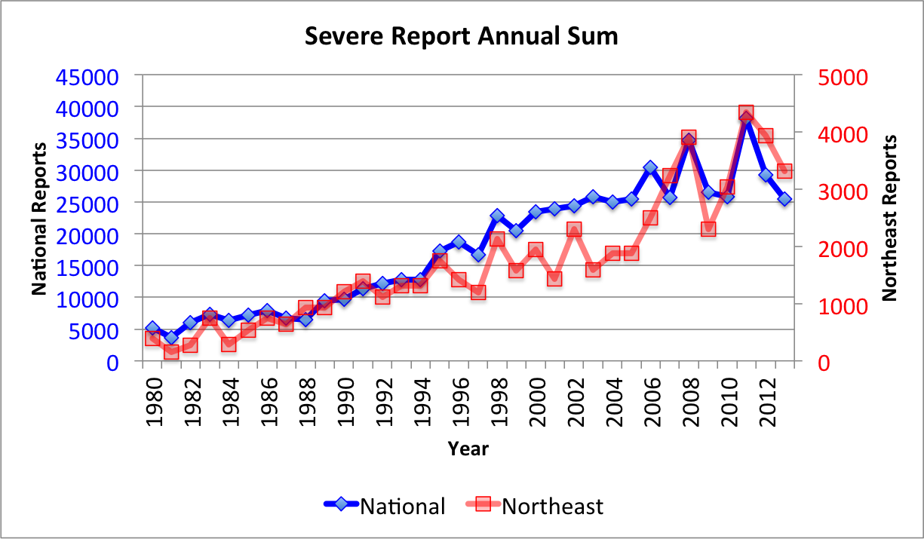
Figure 3.1. Annual sum of severe reports from 1980–2013 for the Northeast domain (red) and the entire U.S. domain (blue).

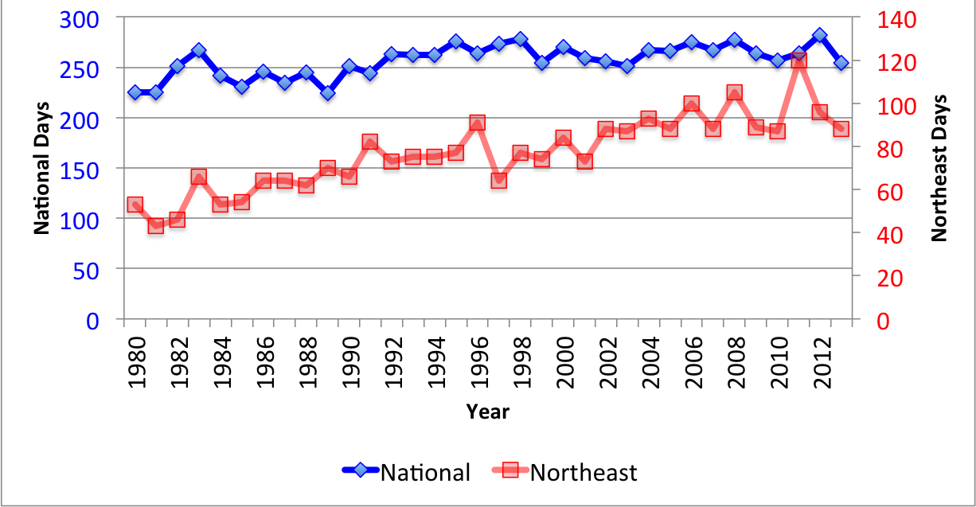
Figure 3.2. . Annual number of days with at least 1 severe report from 1980–2013 for the Northeast domain (red) and the entire U.S. domain (blue).
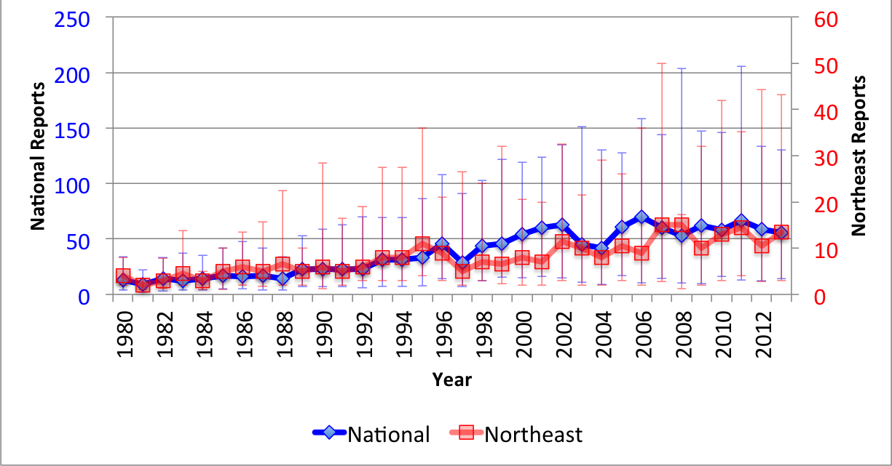
Figure 3.3. Annual distribution of reports per severe event from 1980–2013 for the Northeast domain (red) and the entire U.S. domain (blue). The median is plotted with the 25th and 75th percentiles in the whiskers.

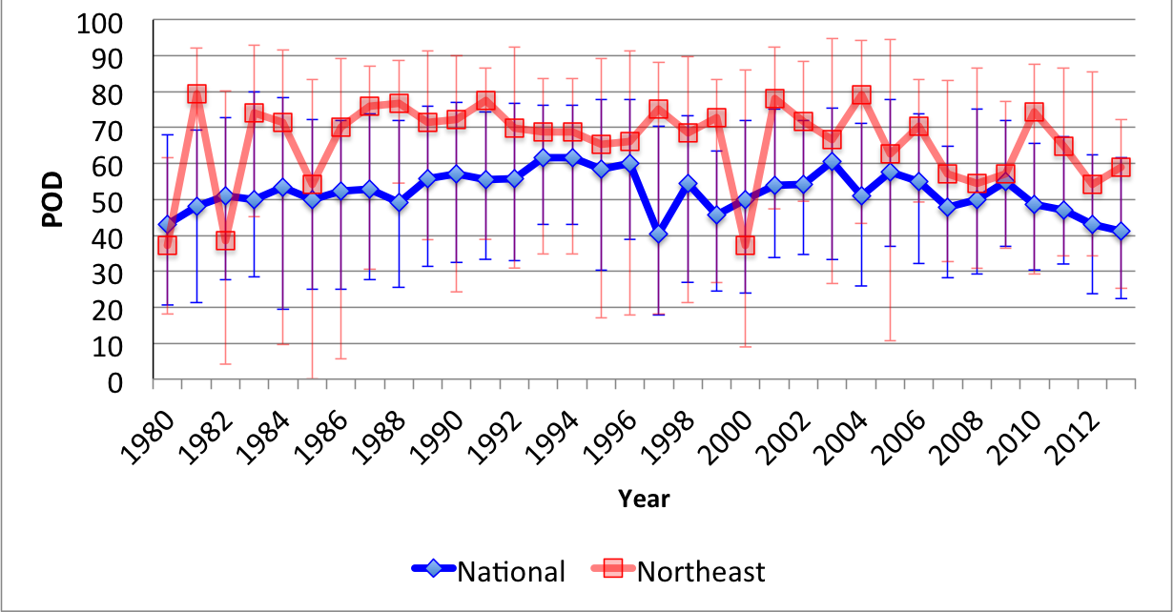
Figure 3.4. Annual distribution of POD scores from 1980–2013 for the Northeast domain (red) and the entire U.S. domain (blue). The median is plotted with the 25th and 75th percentiles in the whiskers.
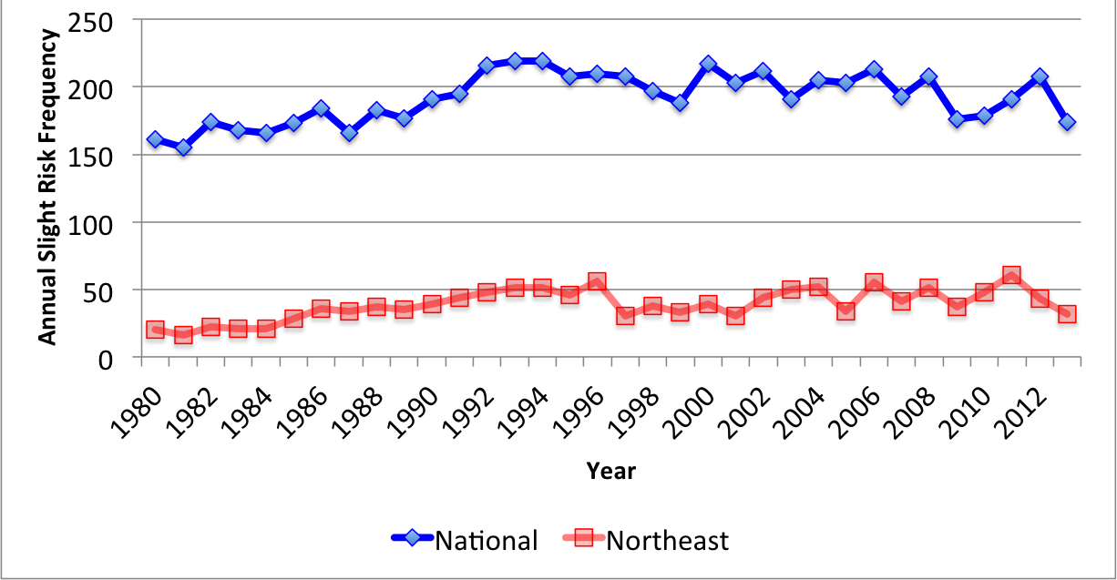
Figure 3.5. Annual number of days with a slight risk outlook covering a portion of the domain from 1980–2013 for the Northeast domain (red) and the entire U.S. domain (blue).

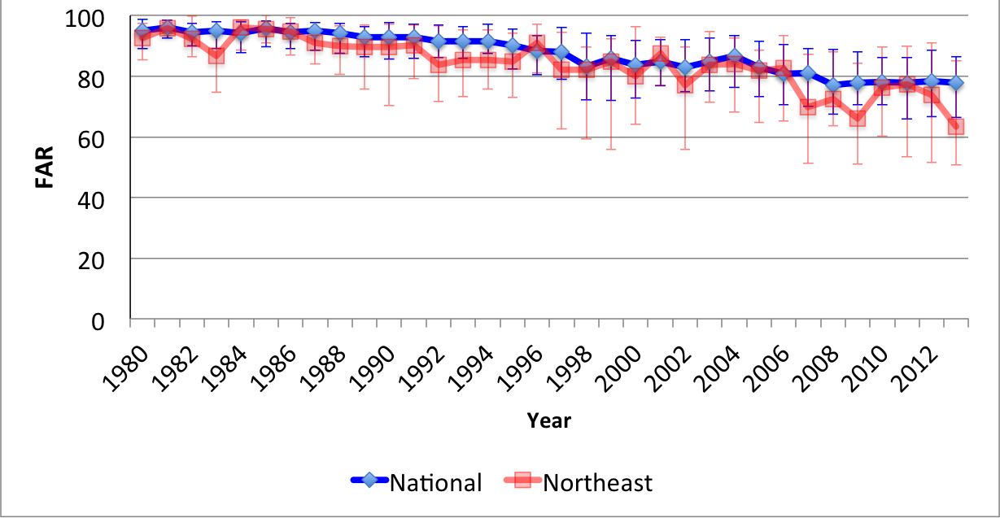
Figure 3.6. Annual distribution of FAR scores from 1980–2013 for the Northeast domain (red) and the entire U.S. domain (blue). The median is plotted with the 25th and 75th percentiles in the whiskers.
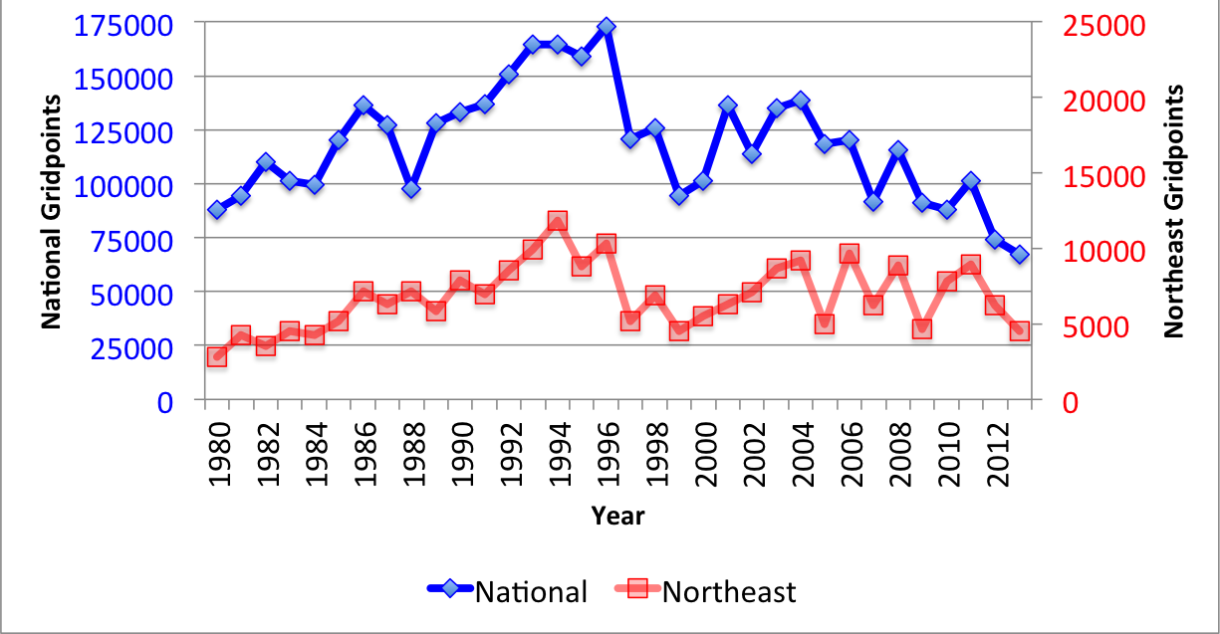
Figure 3.7. Annual sums of slight risk convective outlook area from 1980–2013 for the Northeast domain (red) and the entire U.S. domain (blue).

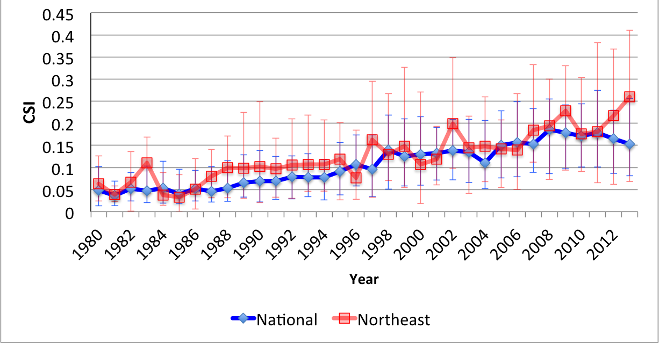
Figure 3.8. Annual distribution of threat scores from 1980–2013 for the Northeast domain (red) and the entire U.S. domain (blue). The median is plotted with the 25th and 75th percentiles in the whiskers.
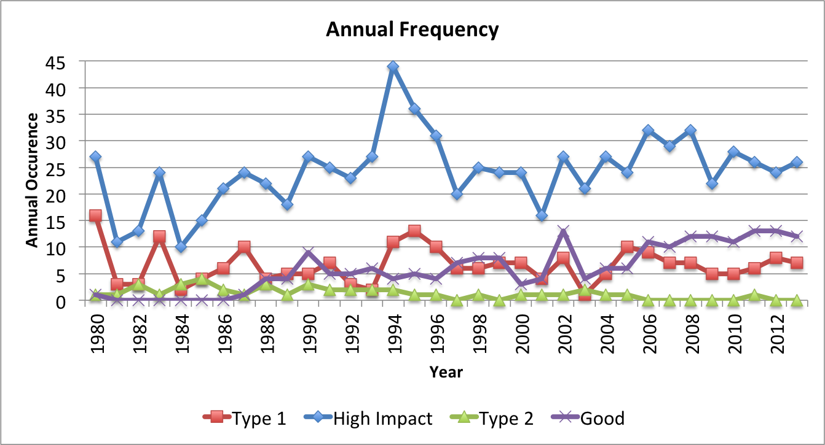
Figure 3.9. Annual frequency of high-impact (blue), type 1 (red), type 2 (green), and good (purple) events from 1980–2013 for the Northeast domain.

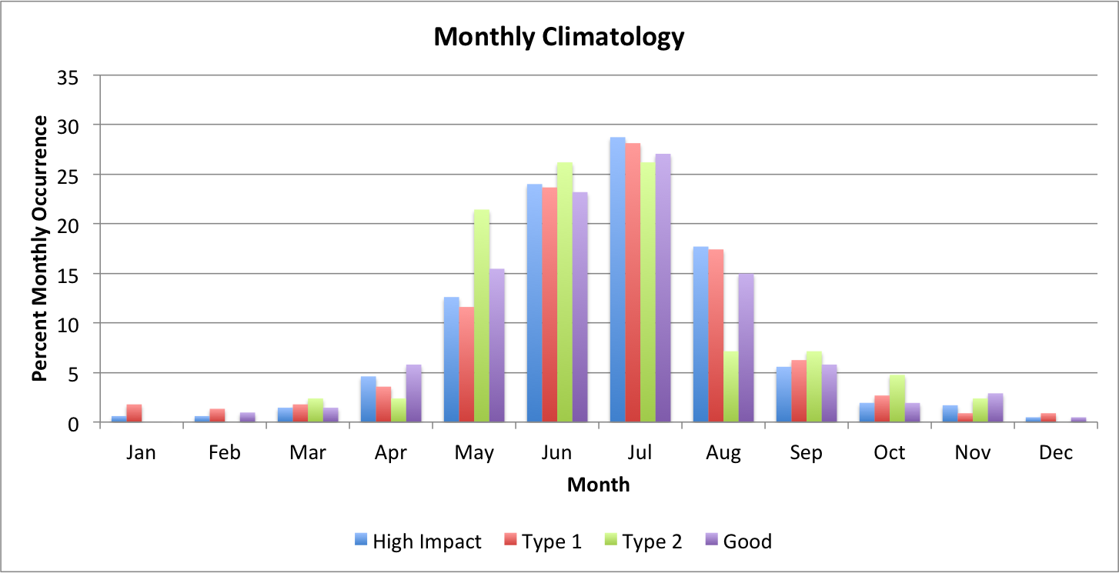
Figure 3.10. Percent occurrence of high-impact (blue), type 1 (red), type 2 (green), and good (purple) events per month from 1980–2013 for the Northeast domain.
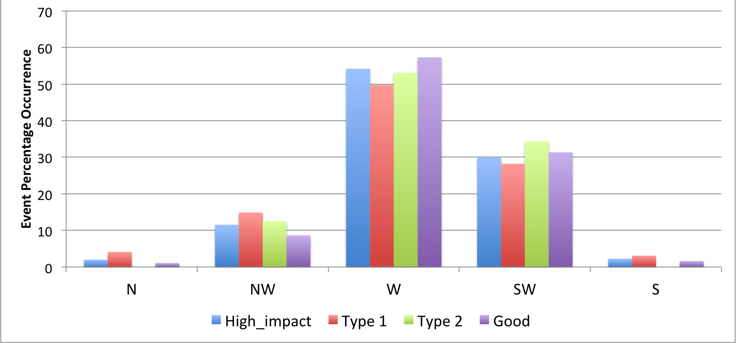
Figure 3.11. Percent occurrence of high-impact (blue), type 1 (red), type 2 (green), and good (purple) events for northerly, northwesterly, westerly, southwesterly, and southerly 500-hPa flow directions from 1980–2013. Wind values are derived from 1200 UTC CFSR data.

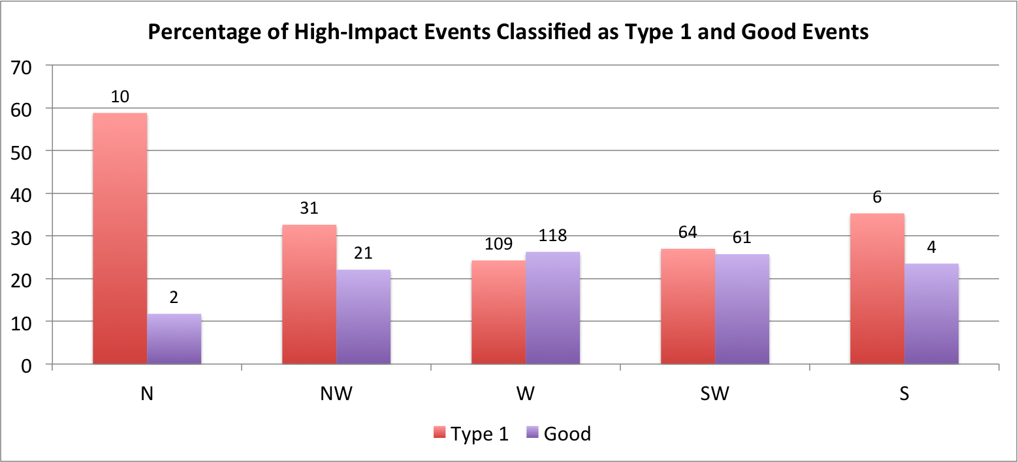
Figure 3.12. Percent of high-impact events classified as type 1 (red) and good (purple) events for northerly, northwesterly, westerly, southwesterly, and southerly 500-hPa flow directions from 1980–2013. Raw numbers of type 1 and good events in each 500-hPa flow category are listed above their respective bars. Wind values are derived from 1200 UTC CFSR data.
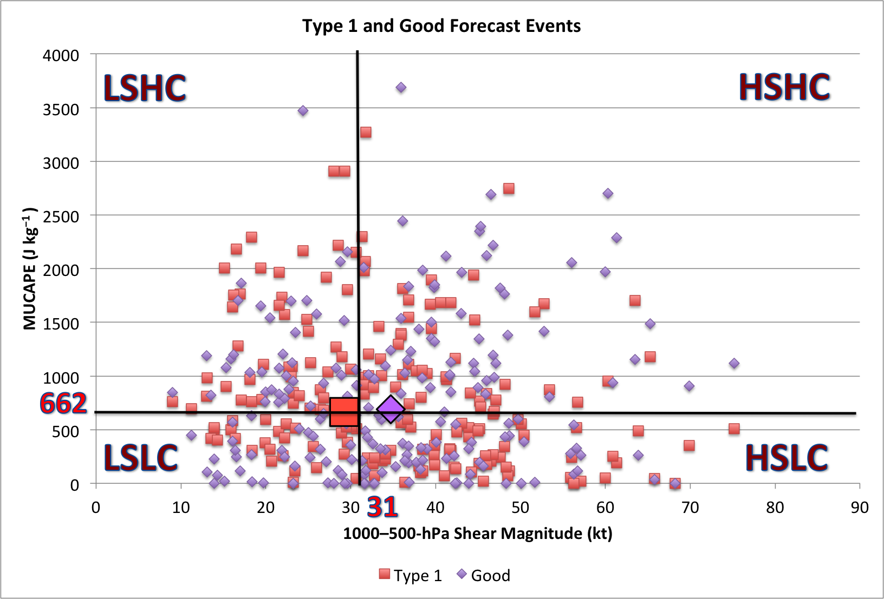
Figure 3.13. Phase space diagram of MUCAPE (J kg⁻¹ ) and 1000–500-hPa shear magnitude (kt) for all type 1 (red) and good (purple) events from 1980–2013. High-impact dataset medians of MUCAPE (662 J kg⁻¹) and shear (31 kt) are overlaid as black lines. From the top left going clockwise, quadrants are labeled: Low Shear High MUCAPE (LSHC), High Shear High MUCAPE (HSHC), High Shear Low MUCAPE (HSLC), and Low Shear Low MUCAPE (LSLC). The bold red square and bold purple diamond denote the median MUCAPE and shear values for type 1 and good events respectively. Values are derived from 1800 UTC CFSR data.

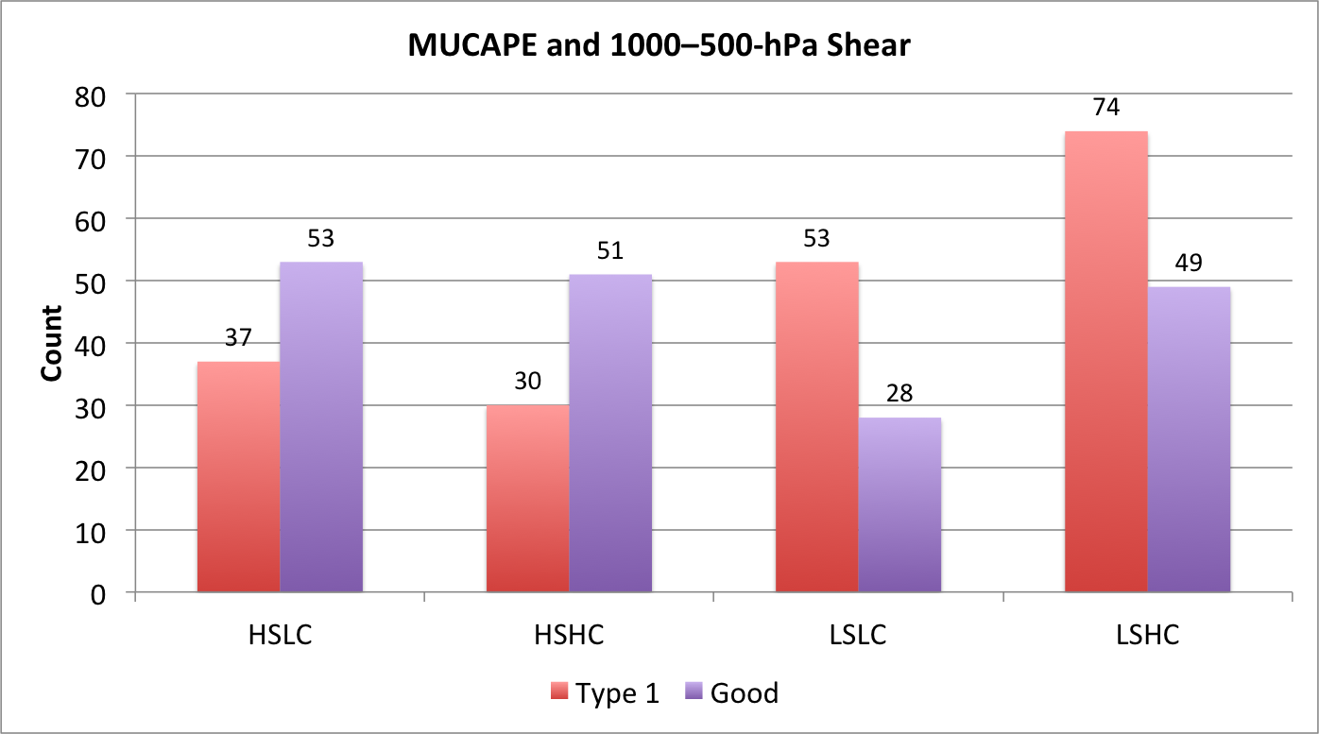
Figure 3.14. Number of type 1 and good events binned in each MUCAPE-shear phase space category from 1980–2013. Phase space categories include: Low Shear High MUCAPE (LSHC), High Shear High MUCAPE (HSHC), High Shear Low MUCAPE (HSLC), and Low Shear Low MUCAPE (LSLC). Values are derived from 1800 UTC CFSR data.
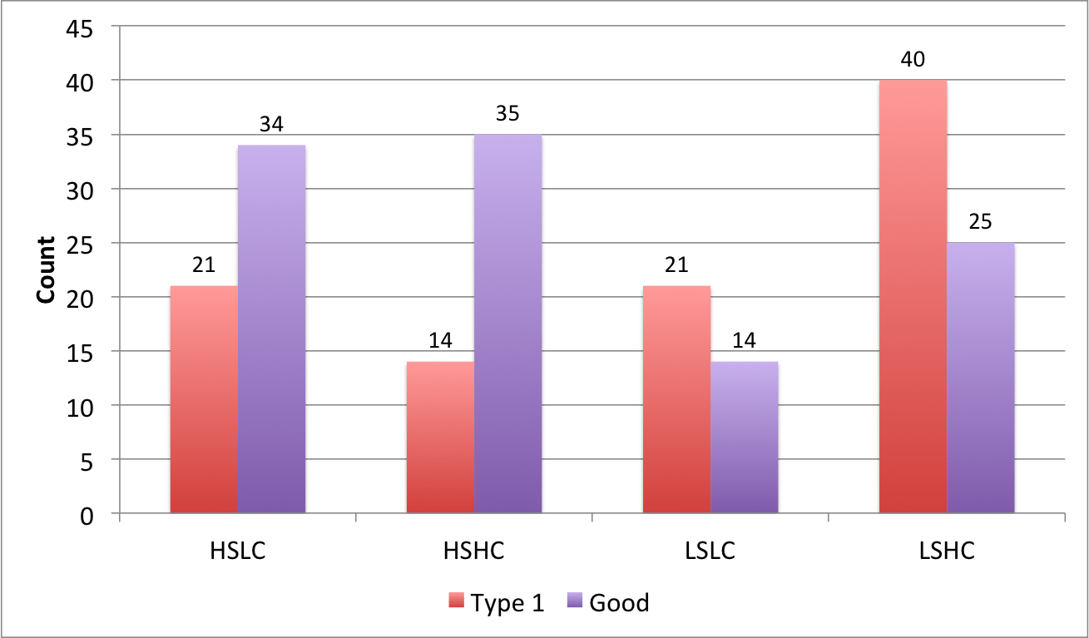
Figure 3.15. Same as Fig. 3.14 but for westerly 500-hPa flow cases

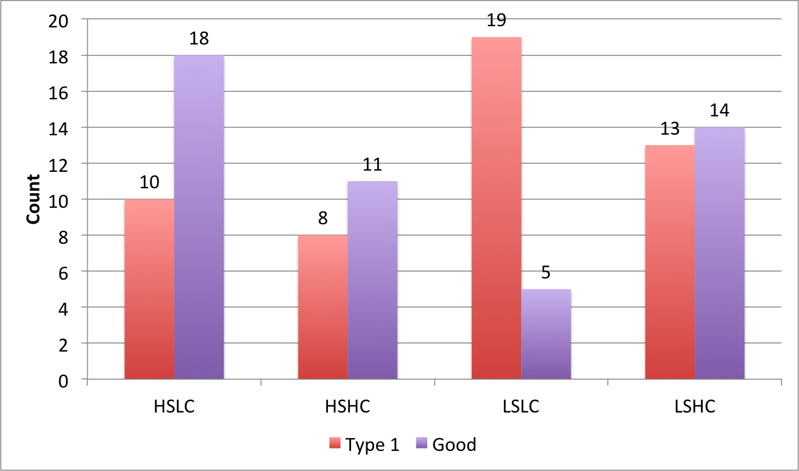
Figure 3.16. Same as Fig. 3.14 but for southwesterly 500-hPa flow cases
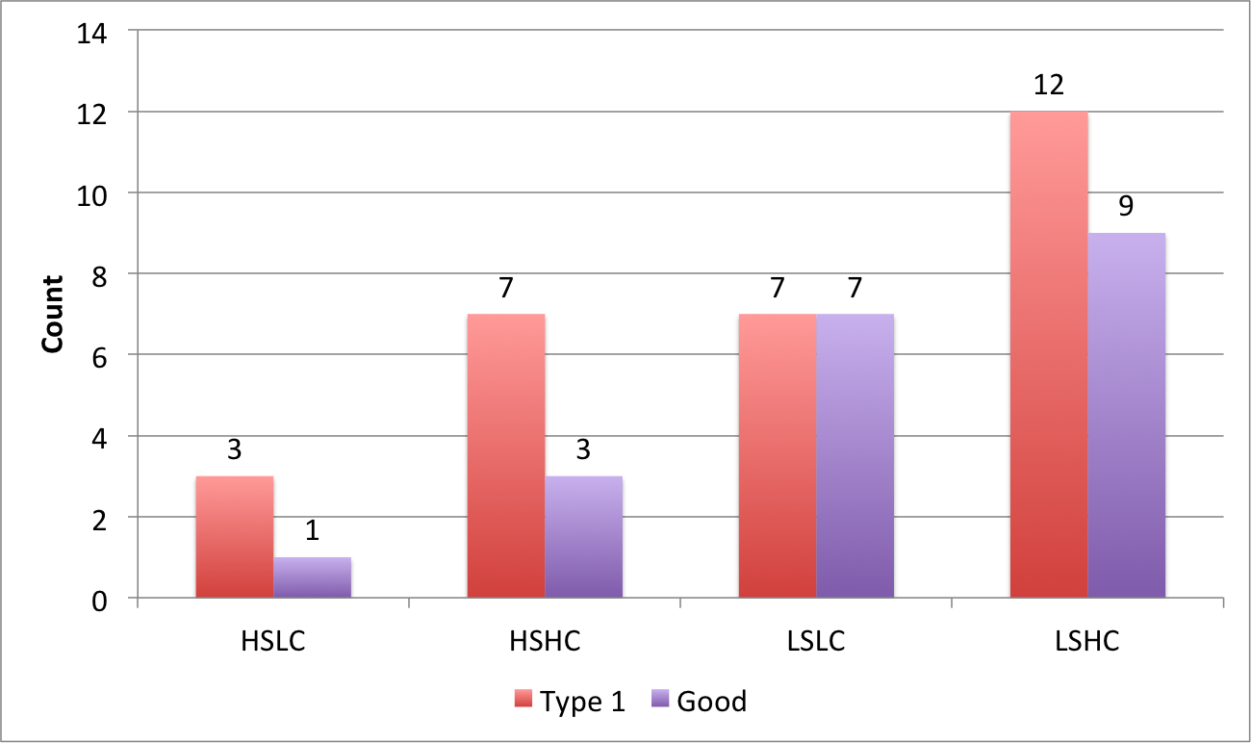
Figure 3.17. Same as Fig. 3.14 but for northwesterly 500-hPa flow cases

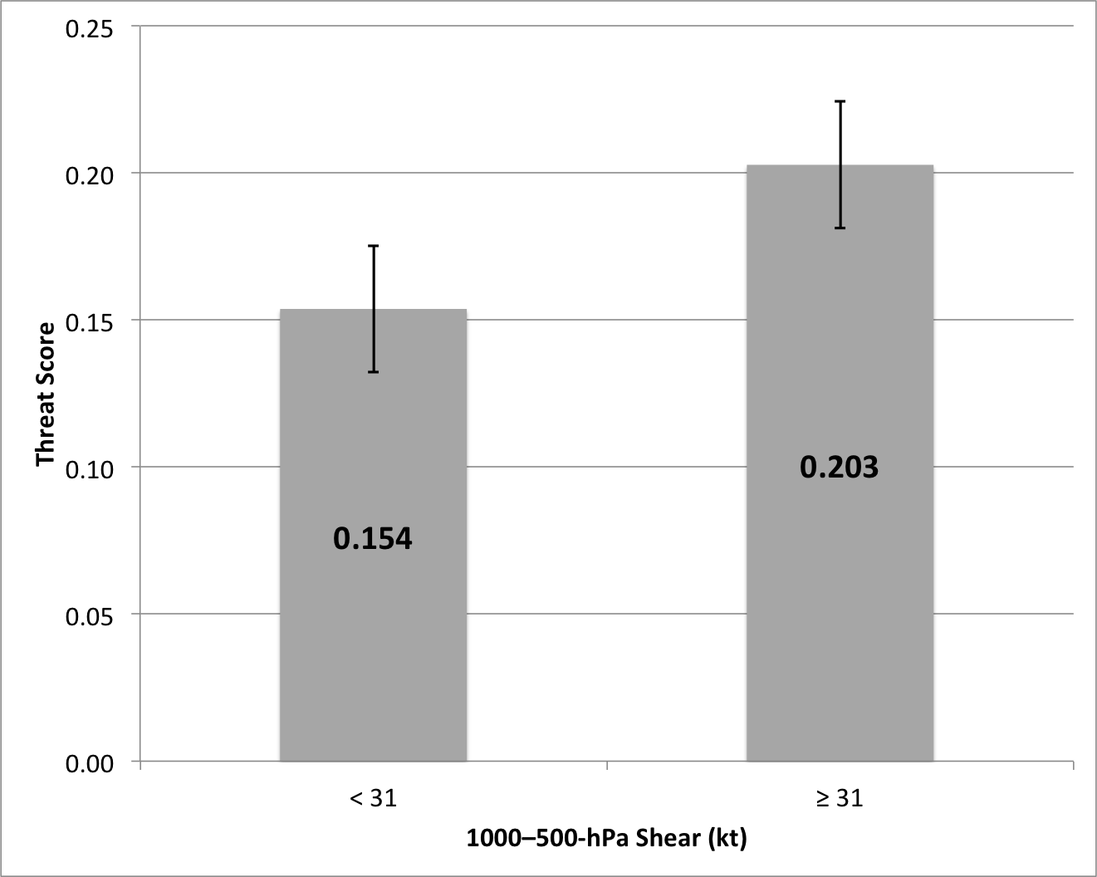
Figure 3.18. Average threat scores of high-impact events occurring under low (< 31 kt) and high (≥ 31 kt) 1000–500-hPa shear. Whiskers are confidence intervals at the 99% level.
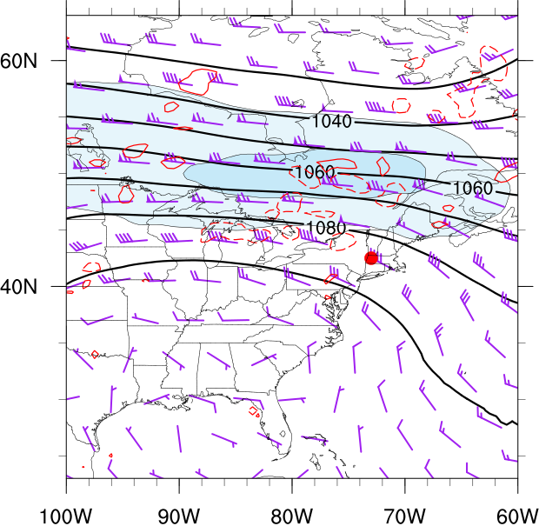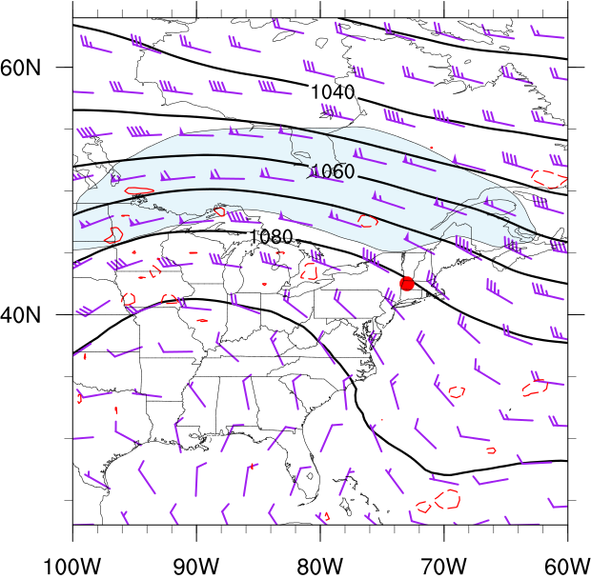
(b)
(a)
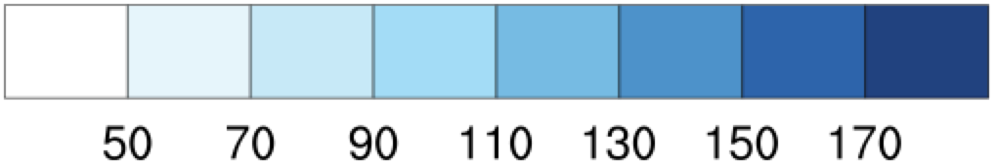
Figure 3.19. Northwesterly flow category composite 250-hPa geopotential height (black contours, dam), wind speed (fills, kt), wind barbs (kt), and 500-hPa omega (red dashed contours are negative, red solid contours are positive, contoured every 3×10⁻³ hPa s⁻¹) for good (a) events (N = 20) and type 1 (b) events (N = 29). Heavy red dot represents composite center at point of maximum report density.

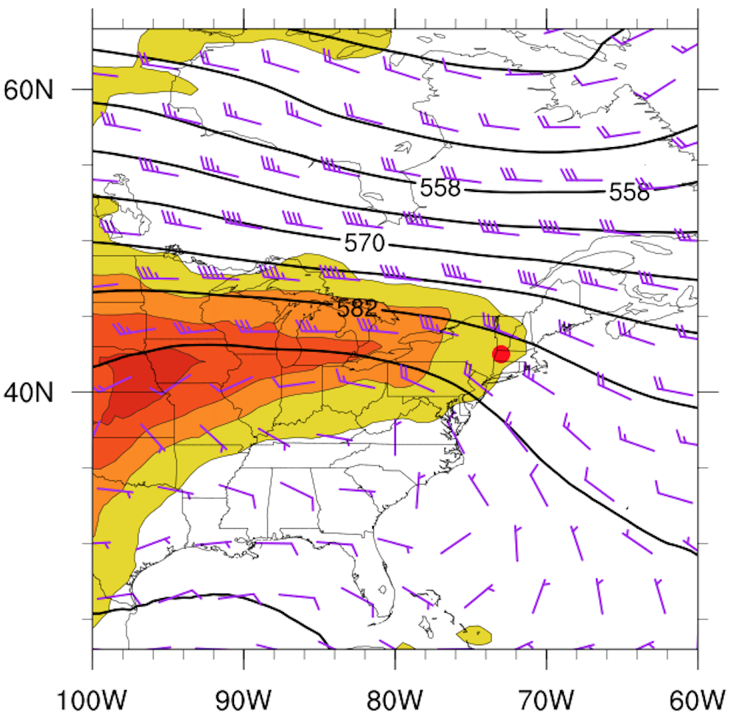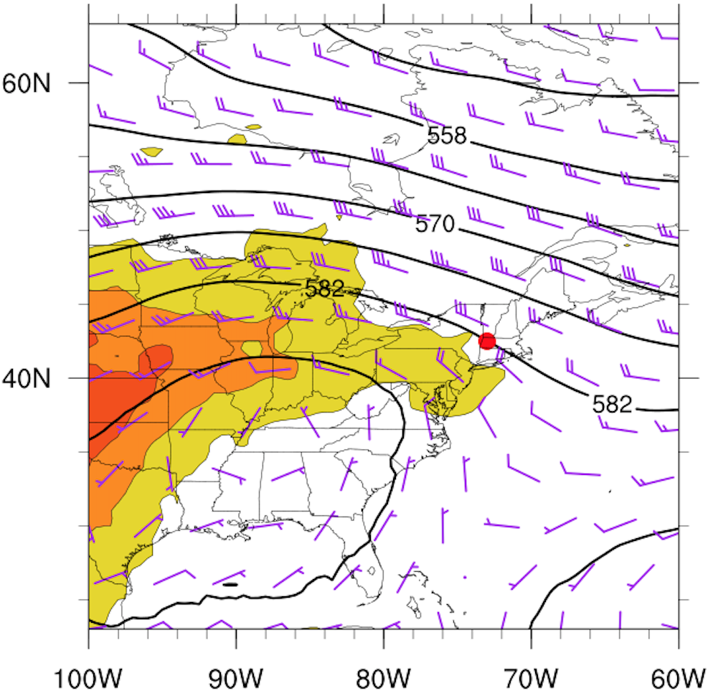
(a)
(b)
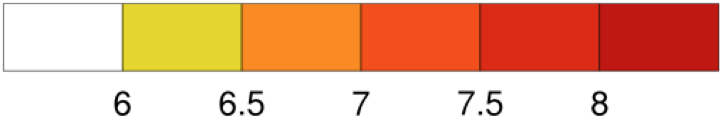
Figure 3.20. Northwesterly flow category composite 500-hPa geopotential height (black contours, dam), wind barbs (kt), and 700–500-hPa lapse rate (fills, K km⁻¹), for good (a) events (N = 20) and type 1 (b) events (N = 29). Heavy red dot represents composite center at point of maximum report density.
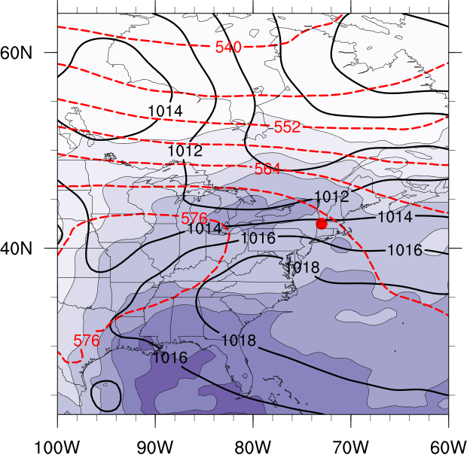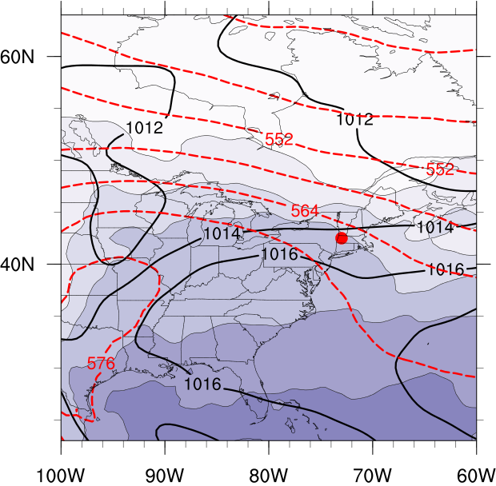
(b)
(a)
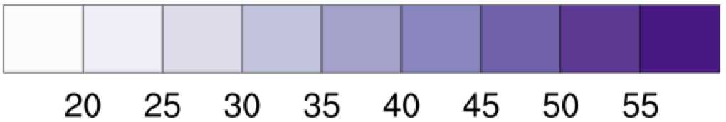
Figure 3.21. Northwesterly flow category composite mean sea level pressure (black contours, every 2 hPa), 1000–500-hPa thickness (dashed, every 6 dam), and total columnar precipitable water (fills, mm), for good (a) events (N = 20) and type 1 (b) events (N=29). Heavy red dot represents composite center at point of maximum report density.

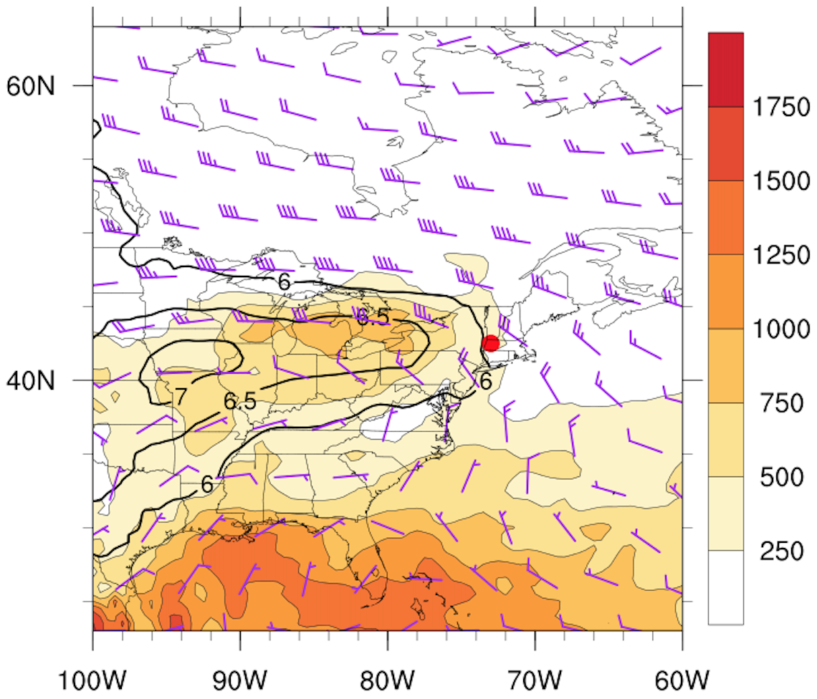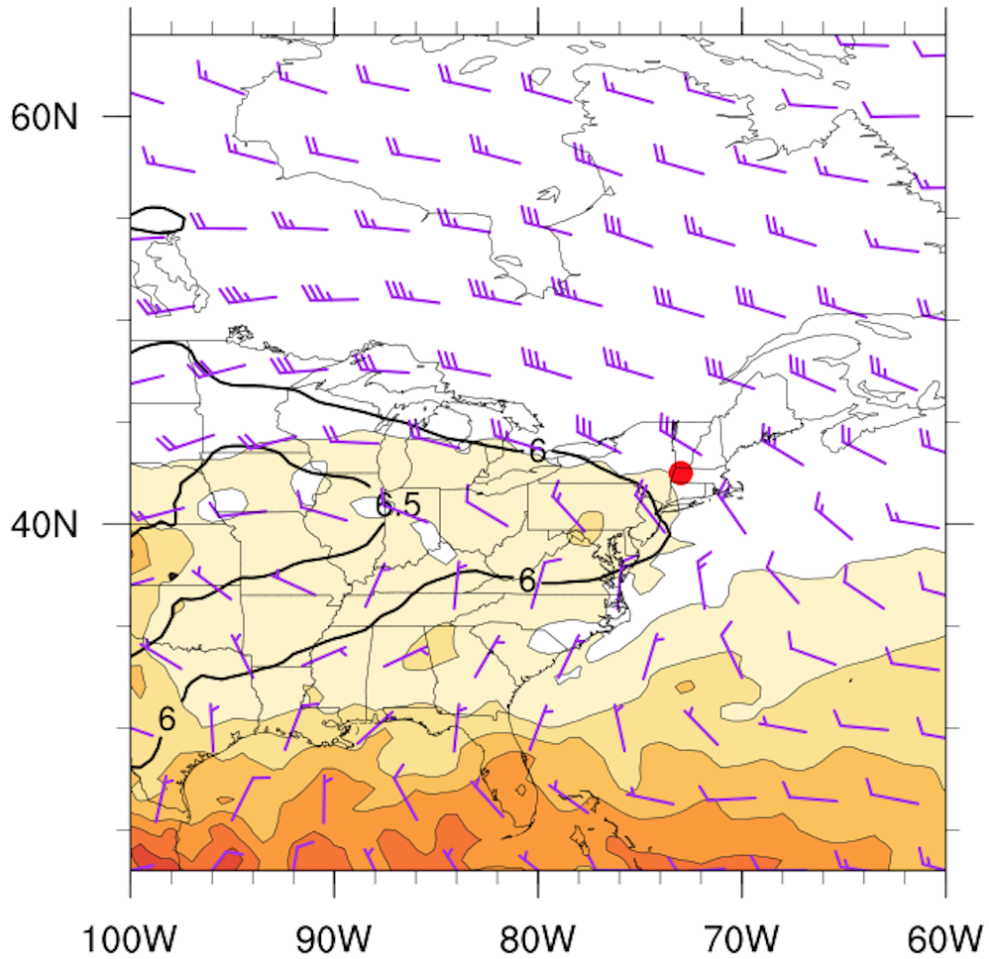
(a)
(b)
Figure 3.22. Northwesterly flow category composite MUCAPE (fills, J kg⁻¹), 850–500-hPa lapse rate (black contours, K km⁻¹), and 1000–500-hPa wind shear (barbed, kt), for good (a) events (N = 20) and type 1 (b) events (N=29). Heavy red dot represents composite center at point of maximum report density.

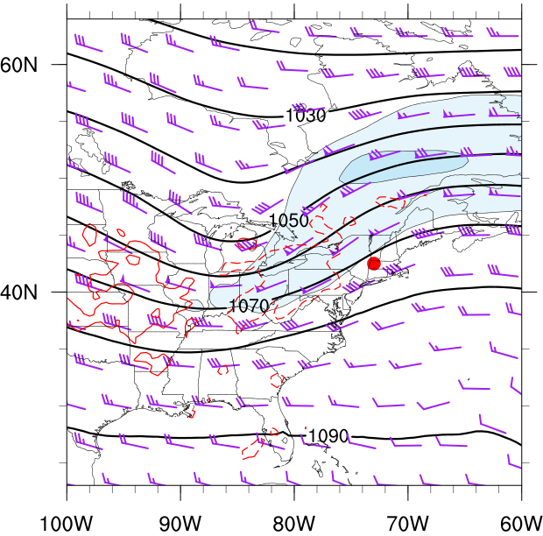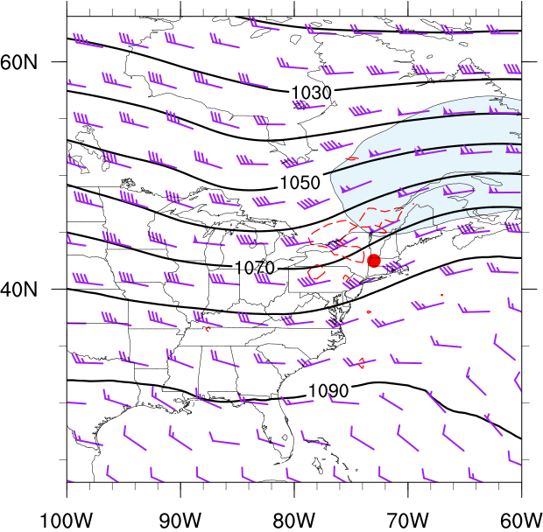
(a)
(b)
Figure 3.23. As in Fig. 3.19 except for the southwesterly flow category composite for good (a) events (N = 48) and type 1 (b) events (N = 50). Heavy red dot represents composite center at point of maximum report density.

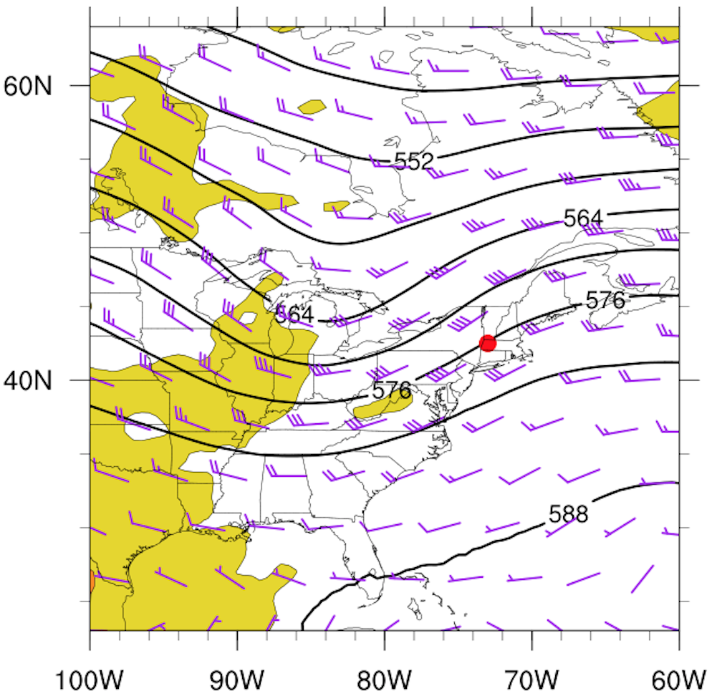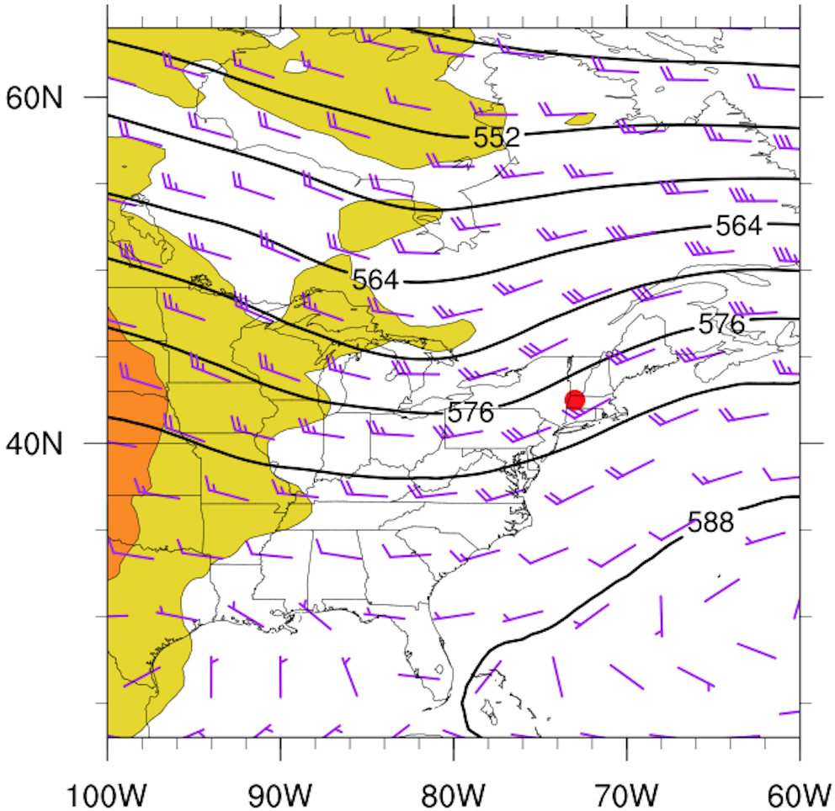
(a)
(b)
Figure 3.24. As in Fig. 3.20 except for the southwesterly flow category composite for good (a) events (N = 48) and type 1 (b) events (N = 50). Heavy red dot represents composite center at point of maximum report density.

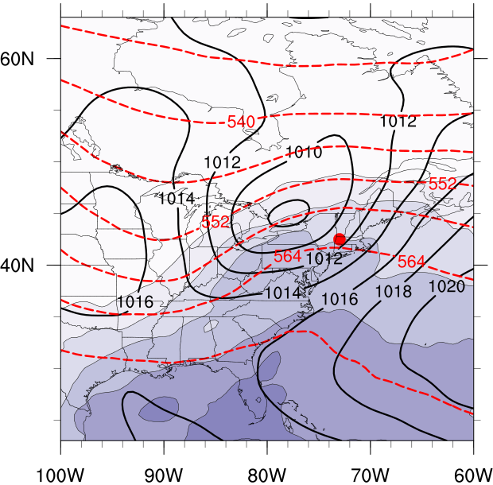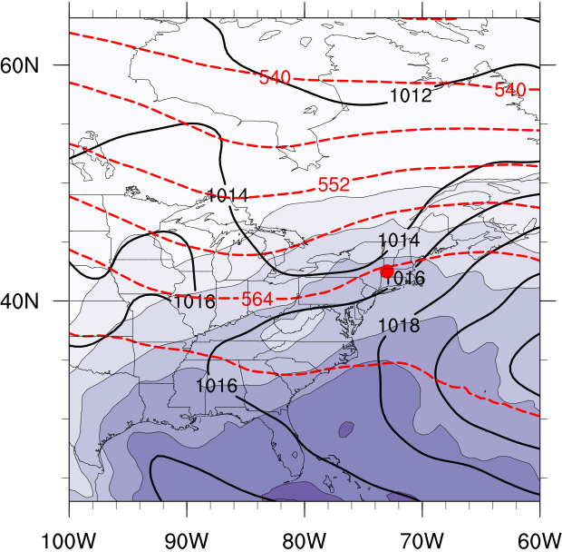
(b)
(a)
(a)
Figure 3.25. As in Fig. 3.21 except for the southwesterly flow category composite for good (a) events (N = 48) and type 1 (b) events (N = 50). Heavy red dot represents composite center at point of maximum report density.

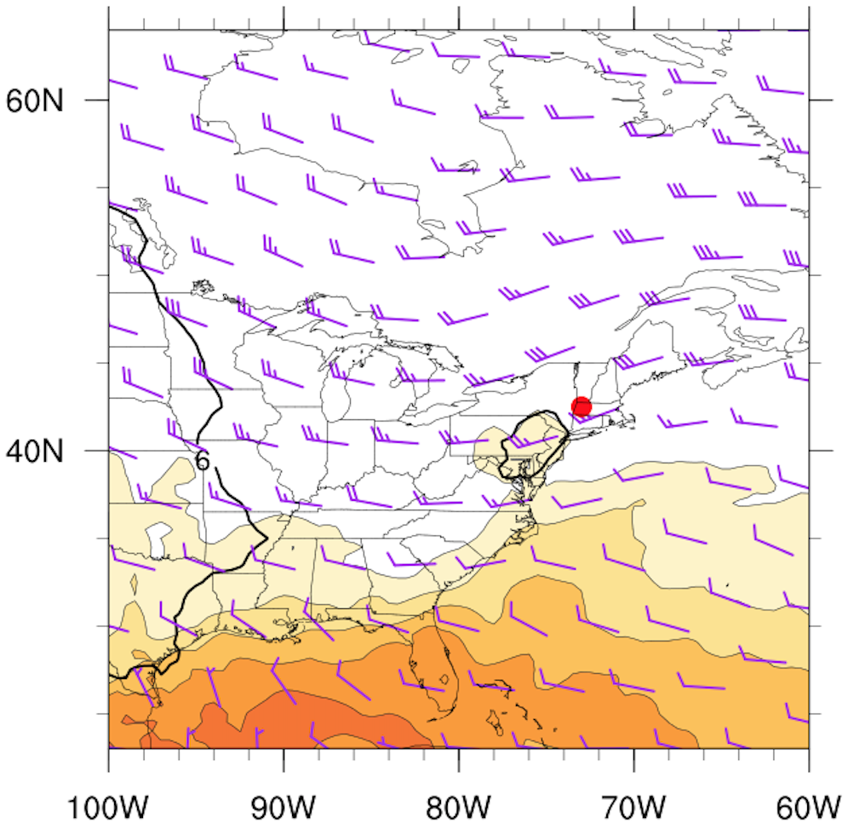
(b)
Figure 3.26. As in Fig. 3.22 except for the southwesterly flow category composite for good (a) events (N = 48) and type 1 (b) events (N = 50). Heavy red dot represents composite center at point of maximum report density.

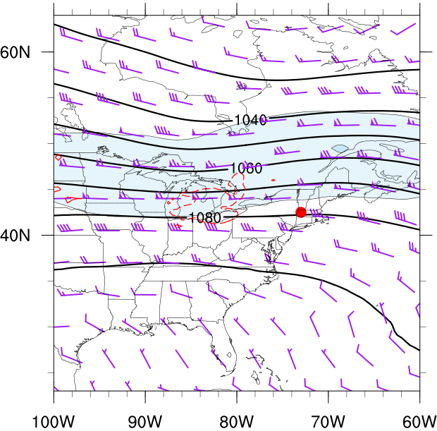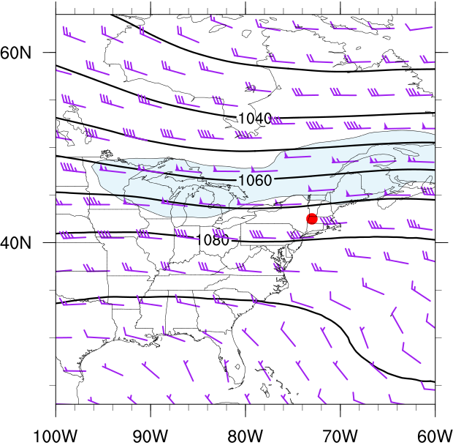
(a)
(b)
Figure 3.27. As in Fig. 3.19 except for the westerly flow category composite for good (a) events (N = 108) and type 1 (b) events (N = 96). Heavy red dot represents composite center at point of maximum report density.

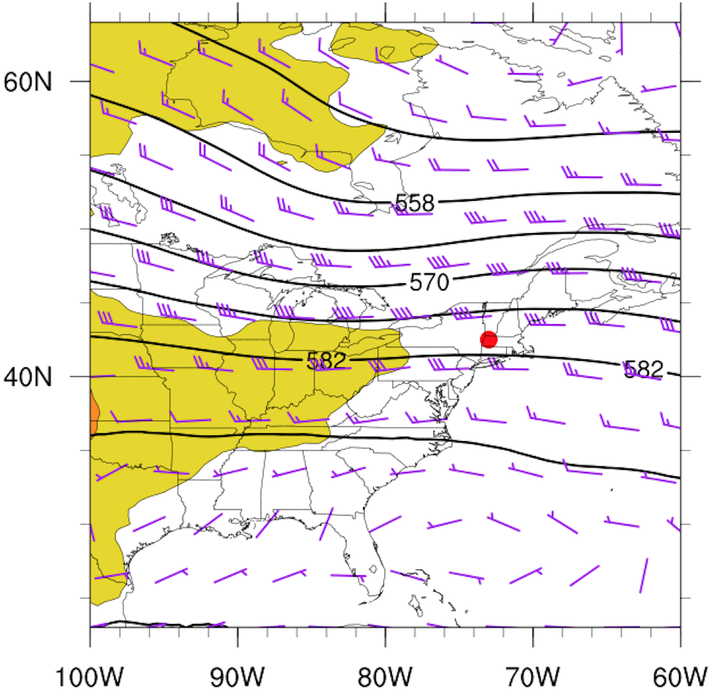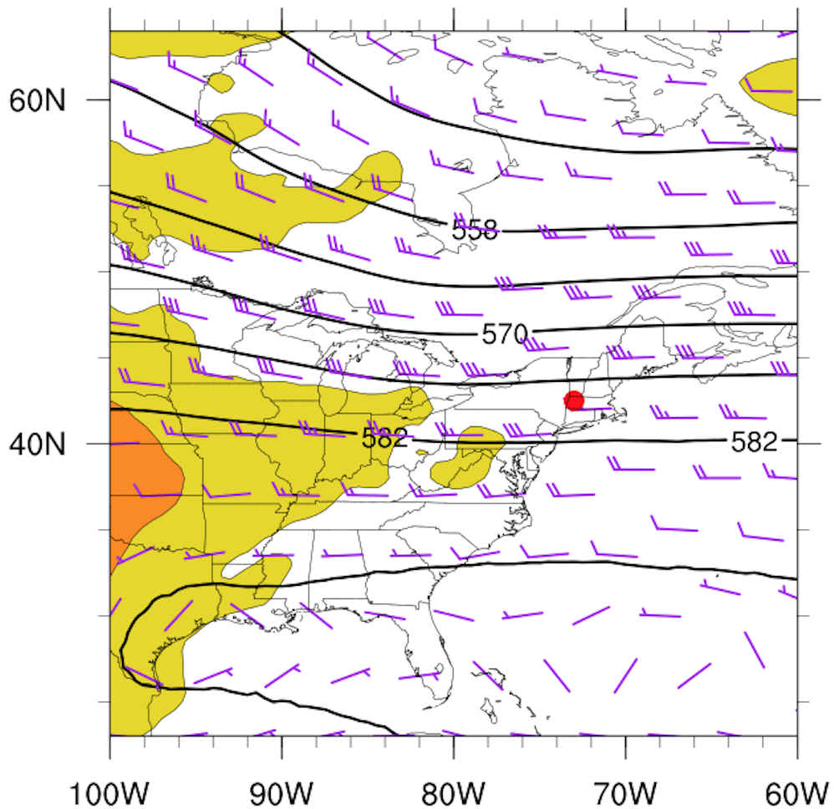
(a)
(b)
Figure 3.28. As in Fig. 3.20 except for the westerly flow category composite for good (a) events (N = 108) and type 1 (b) events (N = 96). Heavy red dot represents composite center at point of maximum report density.

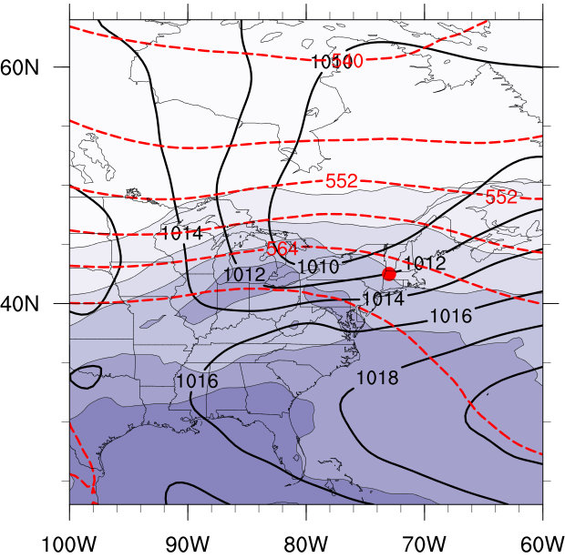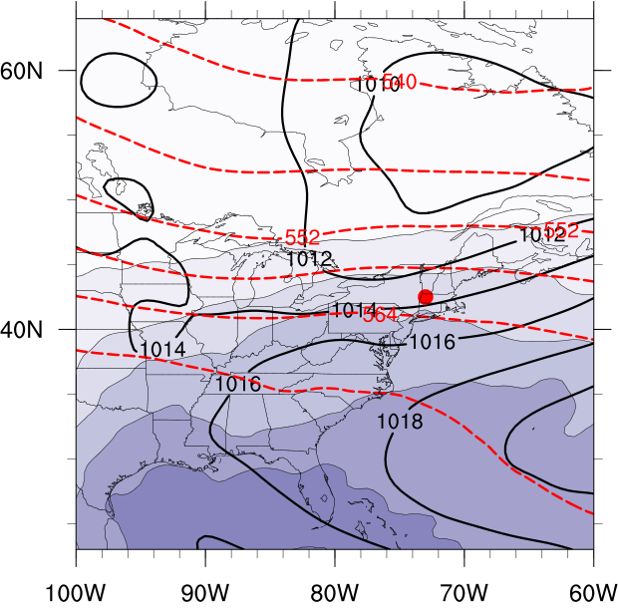
(a)
(b)
(a)
Figure 3.29. As in Fig. 3.21 except for the westerly flow category composite for good (a) events (N = 108) and type 1 (b) events (N = 96). Heavy red dot represents composite center at point of maximum report density.

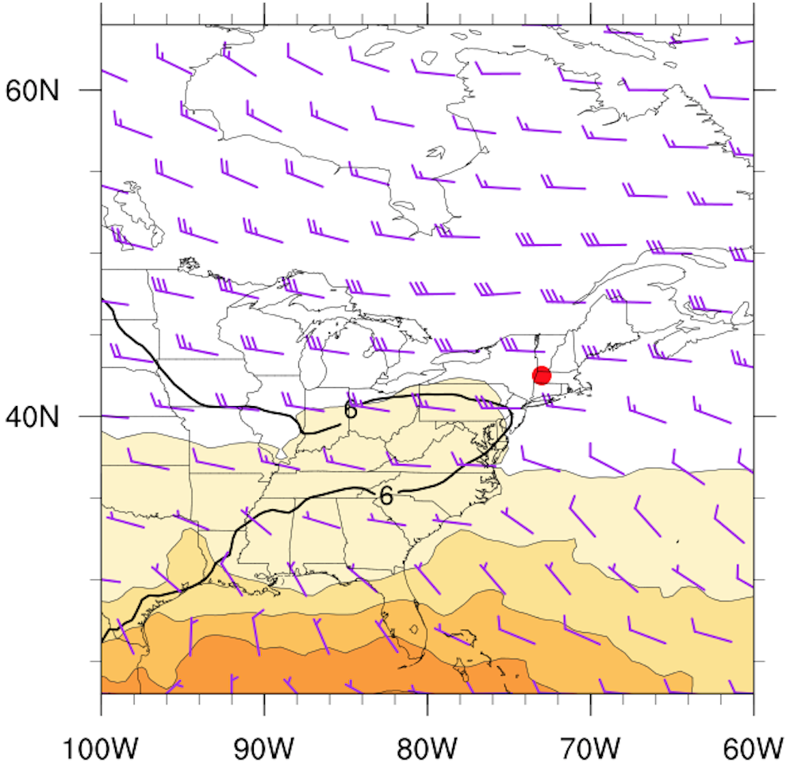
(b)
Figure 3.30. As in Fig. 3.22 except for the westerly flow category composite for good (a) events (N = 108) and type 1 (b) events (N = 96). Heavy red dot represents composite center at point of maximum report density.

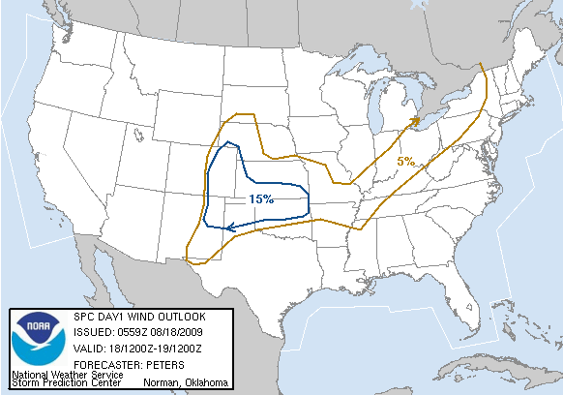
0600 UTC 18 August 2009 Day 1 Convective Outlook
Figure 3.31. SPC 0600 UTC 18 August 2009 severe wind convective outlook valid 1200 UTC 18 August 2009 to 1200 UTC 19 August 2009.

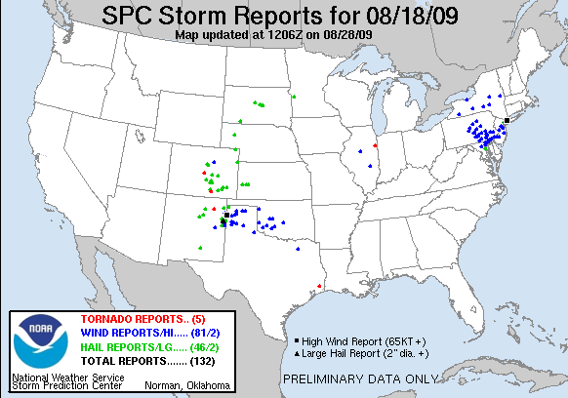
Figure 3.32. Storm reports valid from 1200 UTC 18 August 2010 to 1200 UTC 19 August 2009. Black circle represents area of interest.
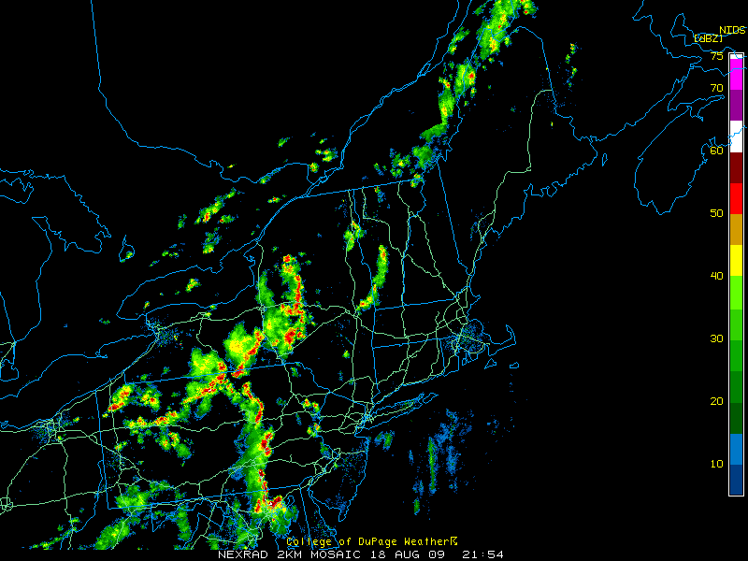
Figure 3.33. Radar reflectivity valid at 2154 UTC 18 August 2009 (source: College of DuPage).

Figure 3.34. 250-hPa geopotential height (black contours, dam), divergence (red contours every 5×10⁻⁵ s⁻¹ starting at 10×10⁻⁵ s⁻¹), wind speed (fills, kt), and wind barbs (kt) at 1600 UTC 18 August 2009 using RUC model analysis data.
Figure 3.35. 500-hPa geopotential height (black contours, dam), relative vorticity (fills, ×10⁻⁵ s⁻¹), and wind barbs (kt) at 1600 UTC 18 August 2009 using RUC model analysis data.

Figure 3.36. SBCAPE (fills, J kg⁻¹), 850–500 lapse rate (black contours every 0.5 K km⁻¹) and 1000–500-hPa shear (barbed, kt) at 1600 UTC 18 August 2009 using RUC model analysis data.
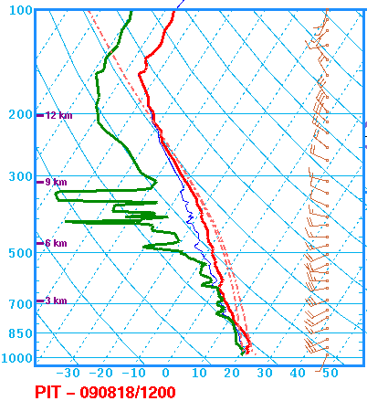
MLCAPE: 1948 J kg⁻¹
0–6-km shear: 12 kt
DCAPE: 510 J kg⁻¹
Figure 3.37. Sounding at PIT valid at 1200 UTC 18 August 2009 (source: SPC).

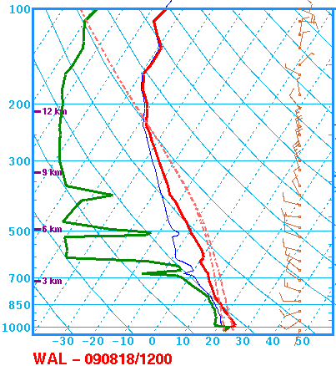
MLCAPE: 2192 J kg⁻¹
0–6-km shear: 12 kt
DCAPE: 1294 J kg⁻¹
Figure 3.38. Sounding at WAL valid at 1200 UTC 18 August 2009 (source: SPC).

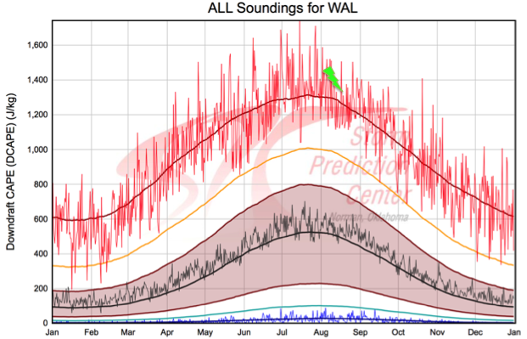
Figure 3.39. DCAPE climatology at WAL. Dark red line represents the maximum 91-day moving average while the thin red line is the daily maximum. Green bolt represents the observed value at 1200 UTC 18 August 2009 (source: SPC).

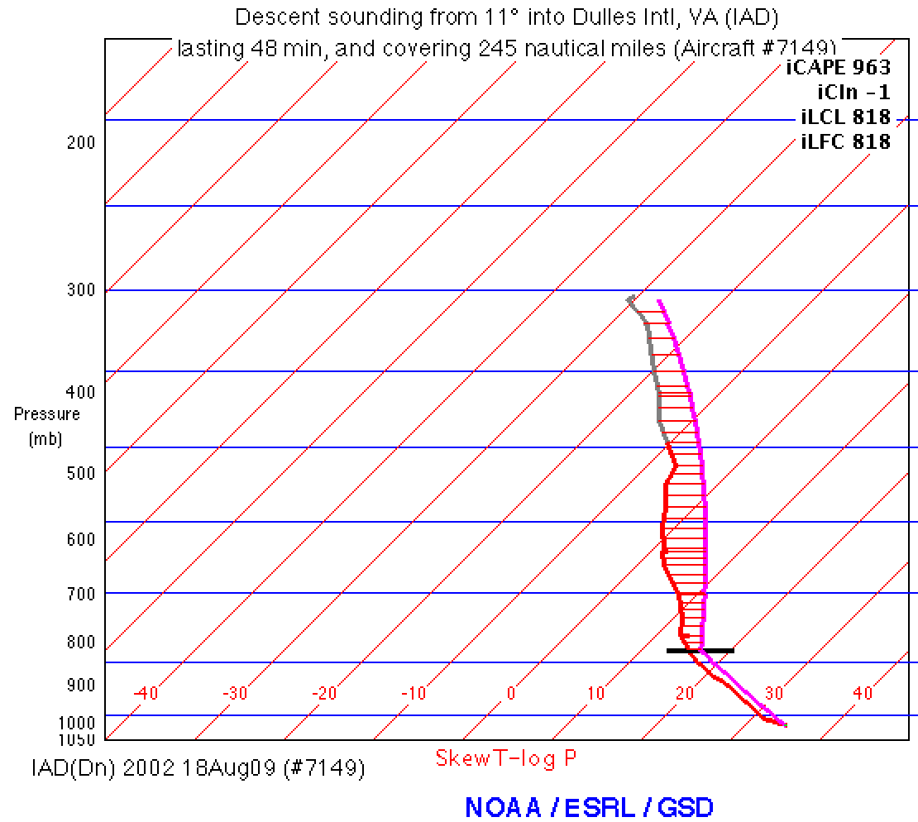
Figure 3.40. Aircraft sounding and computed parcel path using METAR data valid at 2002 UTC 18 August 2009. Sounding is located at IAD.

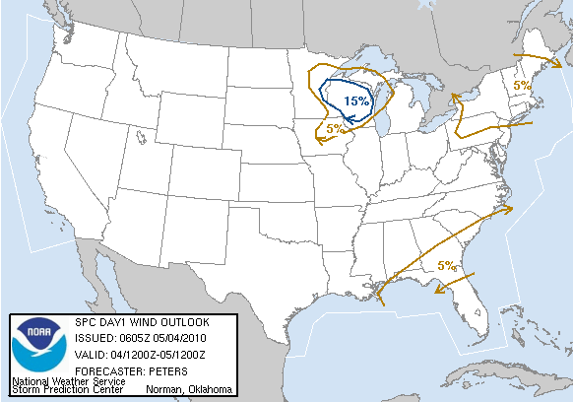
0600 UTC 4 May 2010 Day 1 Convective Outlook
Figure 3.41. SPC 0600 UTC 4 May 2010 severe wind convective outlook valid 1200 UTC 4 May 2010 to 1200 UTC 5 May 2010.

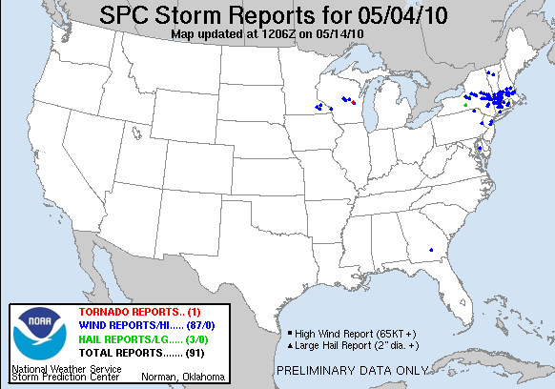
Figure 3.42. Storm reports valid 1200 UTC 4 May 2010 to 1200 UTC 5 May 2010. Black circle represents area of interest.
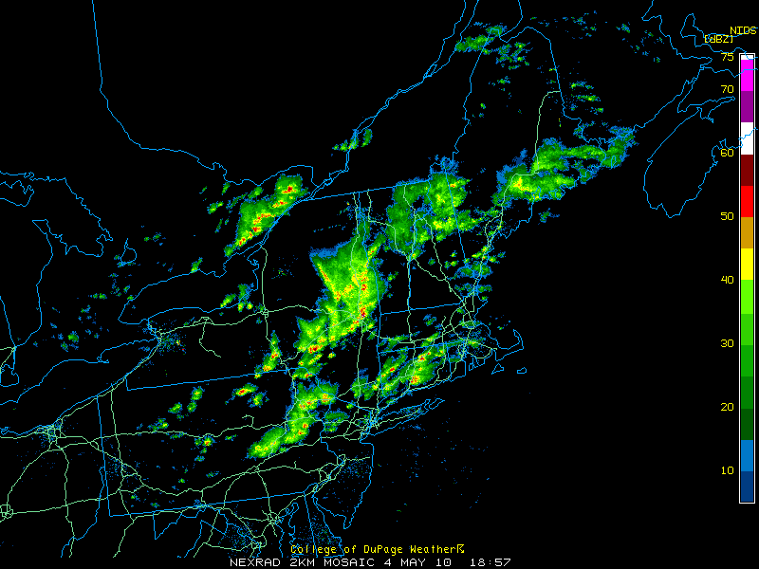
Figure 3.43. Radar reflectivity valid at 1857 UTC 4 May 2010 (source: College of DuPage).

Figure 3.44. As in Fig. 3.34 but for 1400 UTC 4 May 2010.

Figure 3.45. As in Fig. 3.35 but for 1400 UTC 4 May 2010.

Figure 3.46. As in Fig. 3.36 but for 1400 UTC 4 May 2010.

Figure 3.47. Surface equivalent potential temperature (fills, K), MSLP (black contours every 4 hPa), and surface winds (barbed, kt) valid at 1400 UTC 4 May 2010.

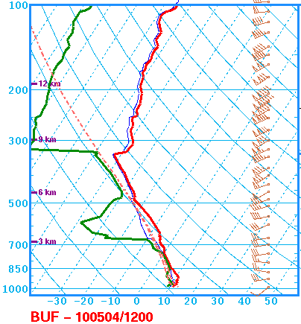
MLCAPE: 362 J kg⁻¹
0–6-km shear: 37 kt
3–6-km LR: 7.2 K km⁻¹
Figure 3.48. Sounding at BUF valid at 1200 UTC 4 May 2010 (source: SPC).

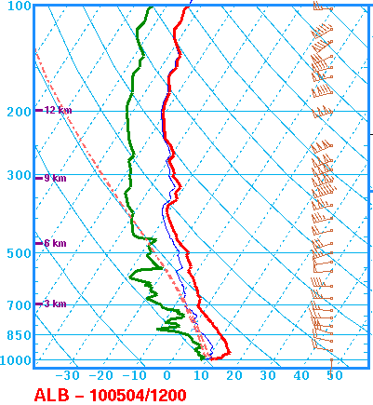
MLCAPE: 29 J kg⁻¹
0–6-km shear: 68 kt
Figure 3.49. Sounding at ALB valid at 1200 UTC 4 May 2010 (source: SPC).

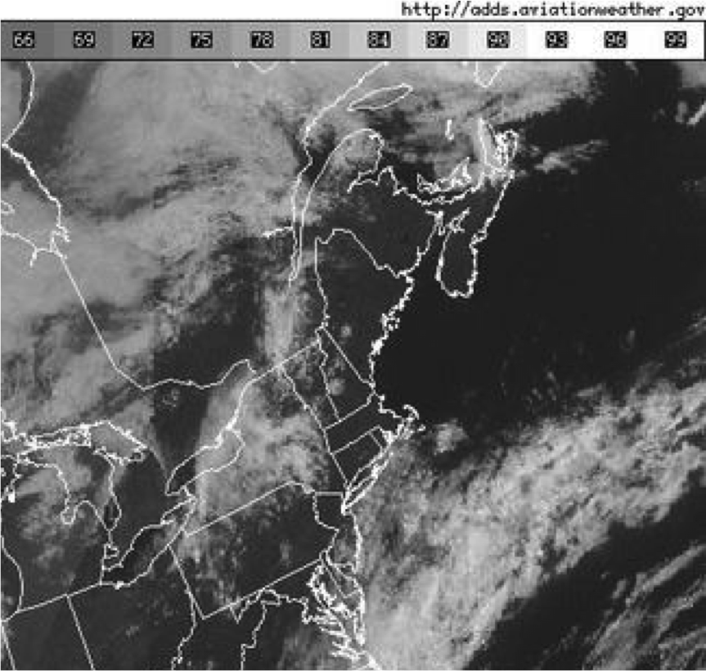
Figure 3.50. Visible satellite imagery valid at 1415 UTC 4 May 2010.

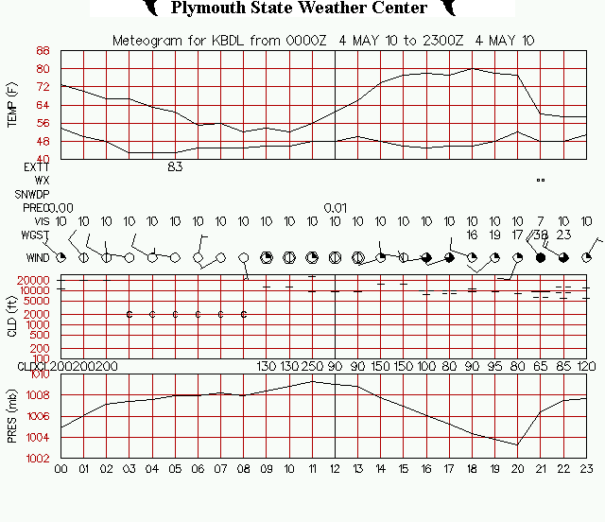
Figure 3.51. Meteogram for BDL valid from 0000 UTC 4 May 2010 to 2300 UTC 4 May 2010. Wind speeds are in knots (source: Plymouth State College).

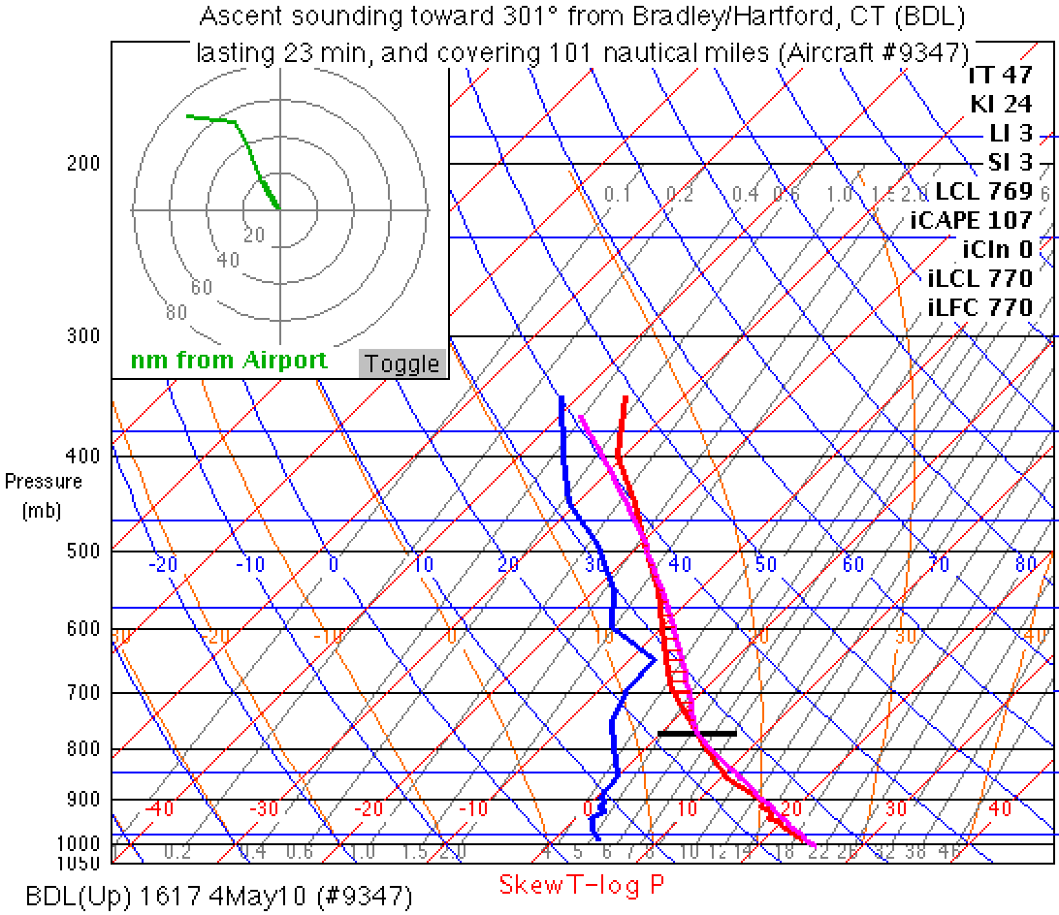
Figure 3.52. Aircraft sounding and computed parcel path using valid METAR data at 1617 UTC 4 May 2010. Sounding is located at BDL.
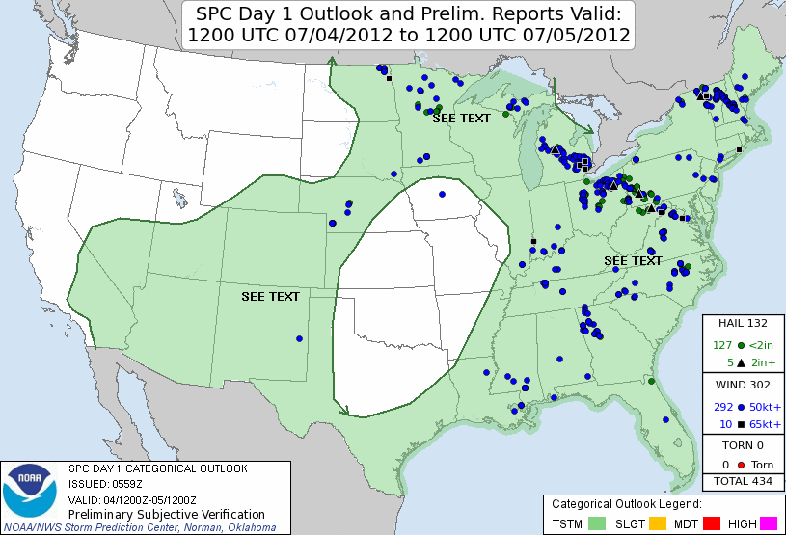
Figure 3.53. SPC 0600 UTC 4 July 2012 severe wind convective outlook valid 1200 UTC 4 July 2012 to 1200 UTC 5 July 2012.

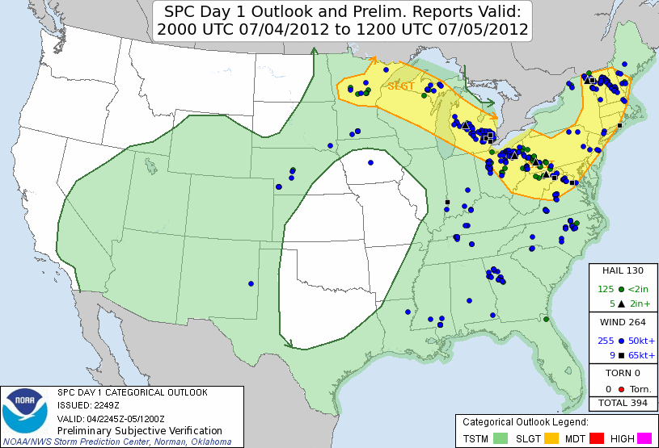
Figure 3.54. SPC 2000 UTC 4 July 2012 severe wind convective outlook valid 2000 UTC 4 July 2012 to 1200 UTC 5 July 2012.

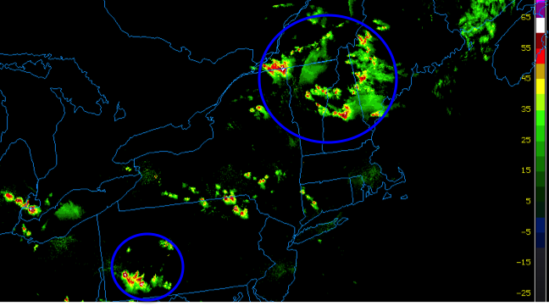
Figure 3.55. Radar reflectivity valid at 2230 UTC 4 July 2012. Blue circles outline the most prolific severe storms (source: College of DuPage).

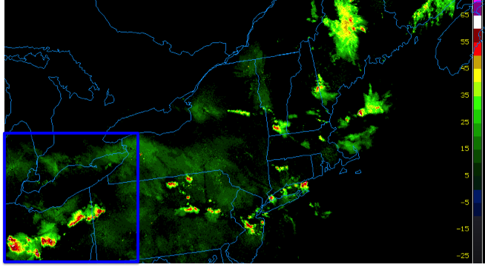
Figure 3.56. Radar reflectivity valid at 0230 UTC 5 July 2012. Blue square outlines the area containing the most prolific severe storms (source: College of DuPage).

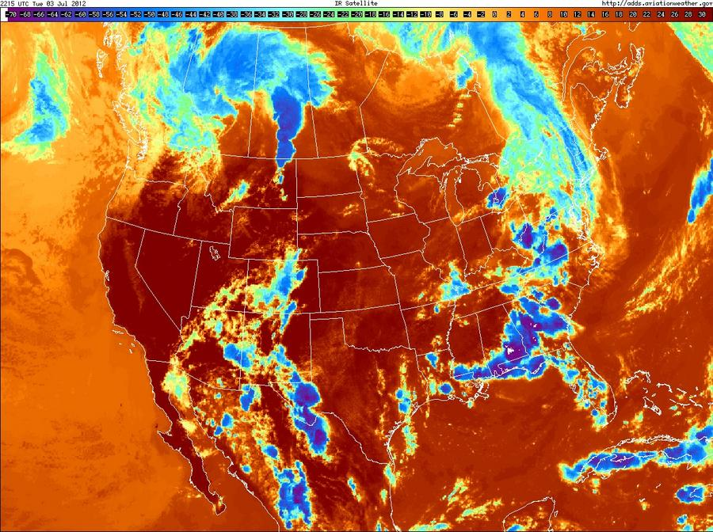
Figure 3.57. Infrared satellite imagery valid at 2215 UTC 3 July 2012. Magenta circle outlines the developing MCS in Saskatchewan.

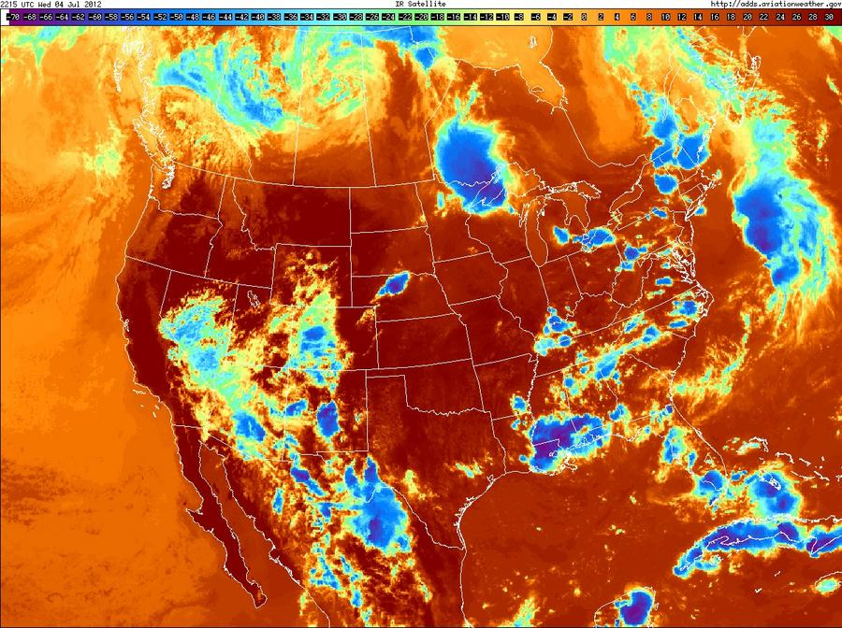
Figure 3.58. Infrared satellite imagery valid at 2215 UTC 4 July 2012. Magenta circle outlines the mature MCS over Ontario and the northern Great Lakes.

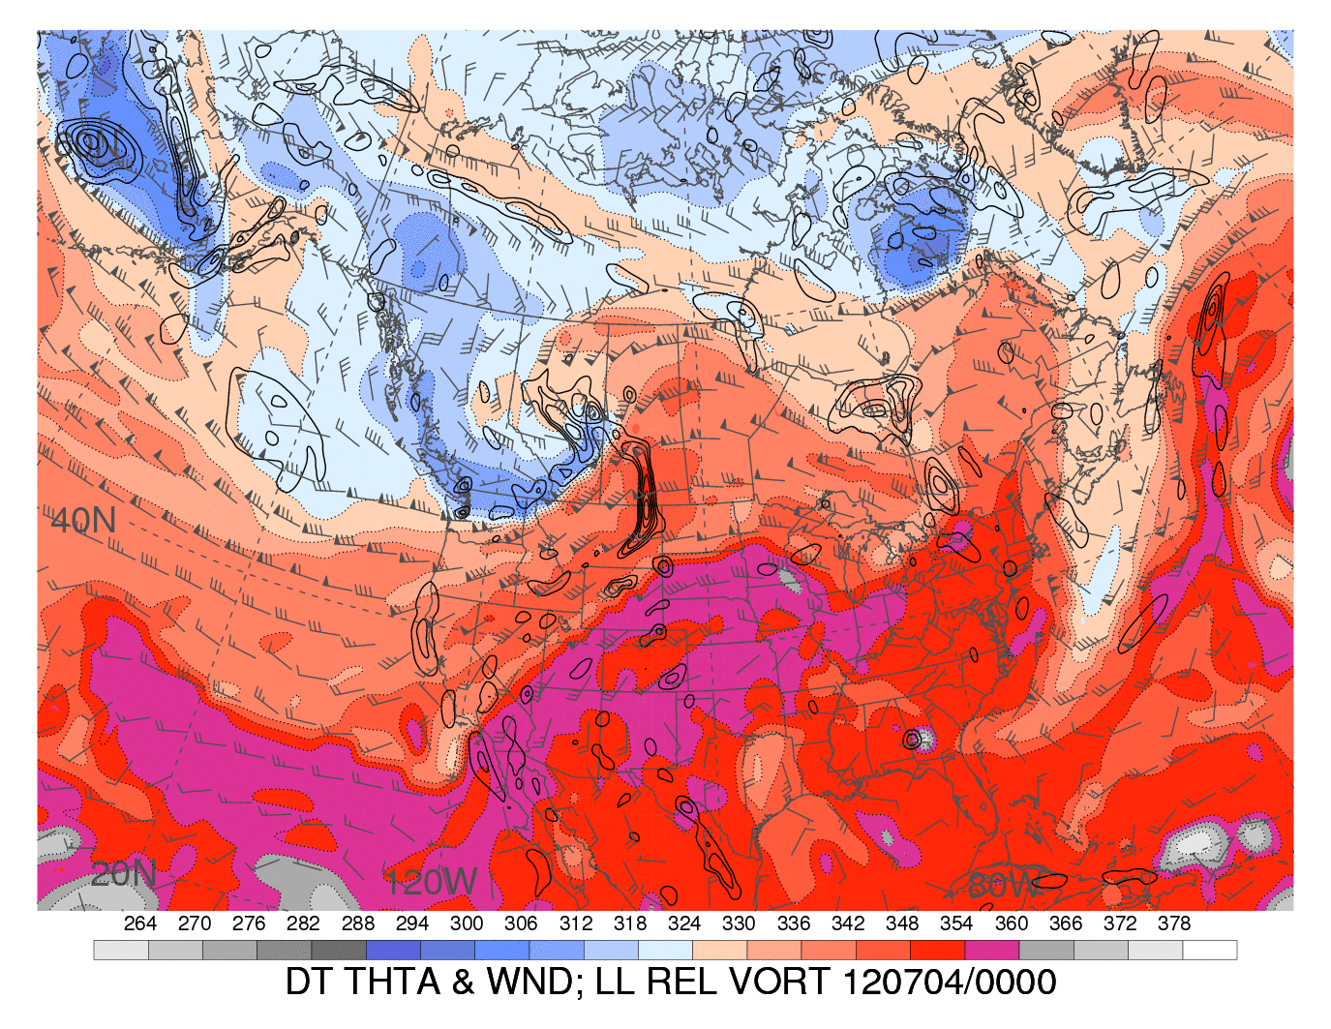
Figure 3.59. Dynamic tropopause (1.5-PVU surface) potential temperature (shaded, K) and wind barbs (kt), 925–850-hPa layer-averaged cyclonic relative vorticity (black contours, every 0.5 x 10⁻⁴ s⁻¹) at 0000 UTC 4 July 2012. Black circle outlines developing MCS. [Source: Heather Archambault]

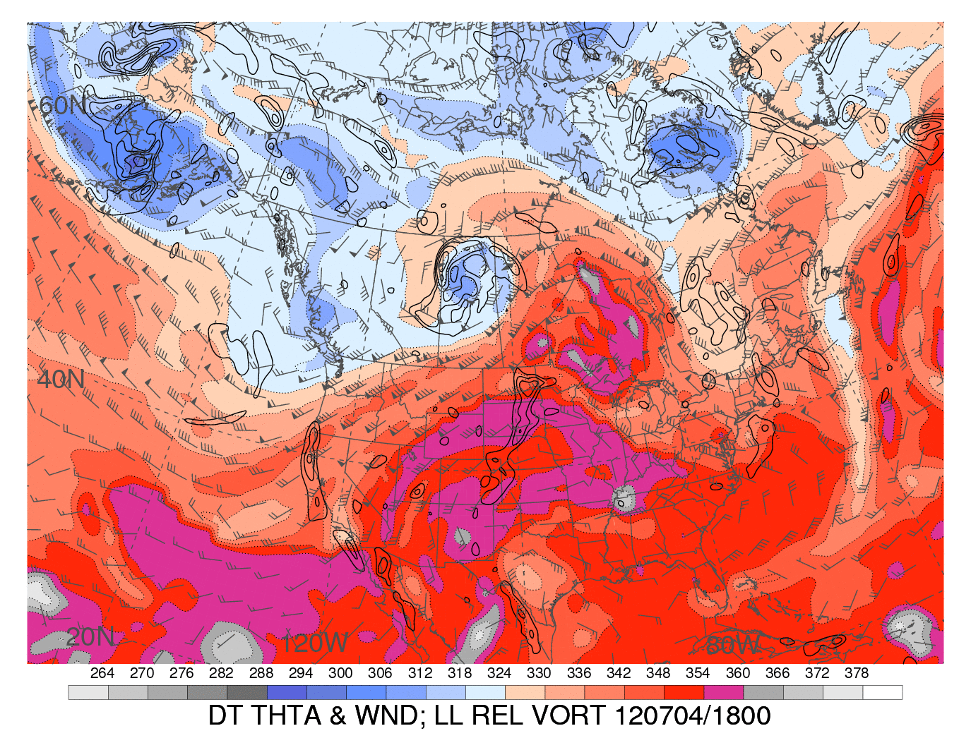
Digging trough
Figure 3.60. As in Fig. 3.58 but at 1800 UTC 4 July 2012. Black circle outlines the ridge strengthened by latent heating associated with convection. [Source: Heather Archambault]
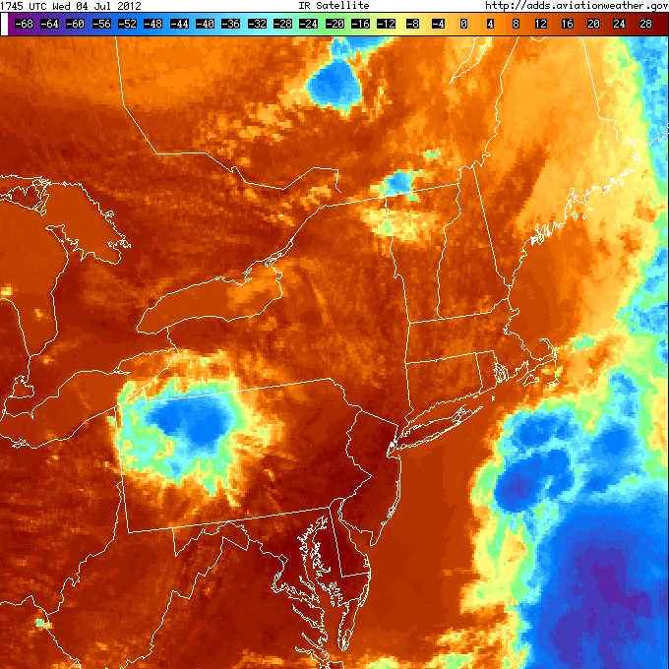
Figure 3.61. Infrared satellite imagery valid at 1745 UTC 4 July 2012. Magenta circles outlines the incipient convection in Quebec (top) and the remnant MCV over PA (bottom).

Figure 3.62. As in Fig. 3.34 but at 1800 UTC 4 July 2012 using RAP model analysis data.
Figure 3.63. As in Fig. 3.35 but at 1800 UTC 4 July 2012.

Figure 3.64. As in Fig. 3.36 but at 1800 UTC 4 July 2012 using RAP model analysis data.

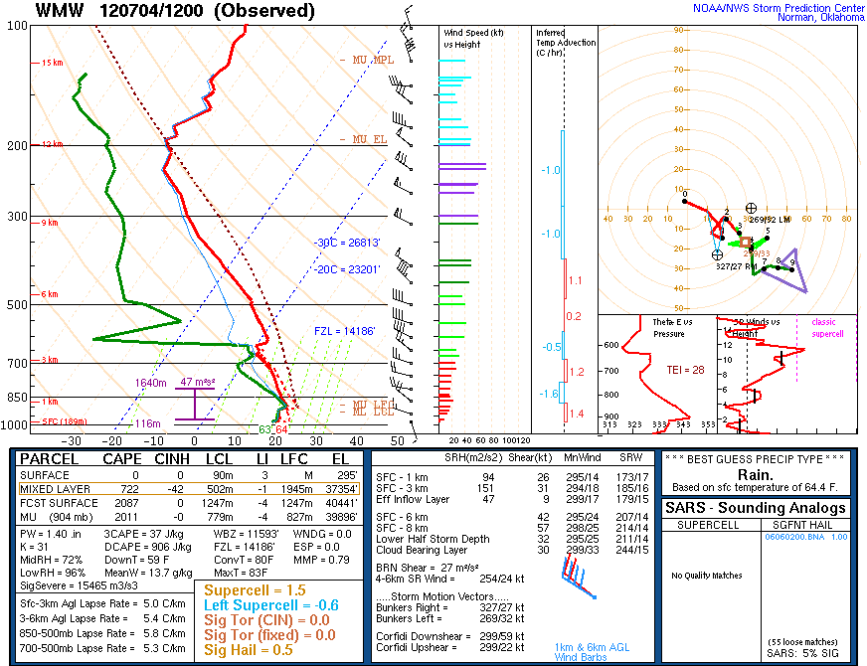
Figure 3.65. Sounding from WMW valid at 1200 UTC 4 July 2012 (source: SPC).

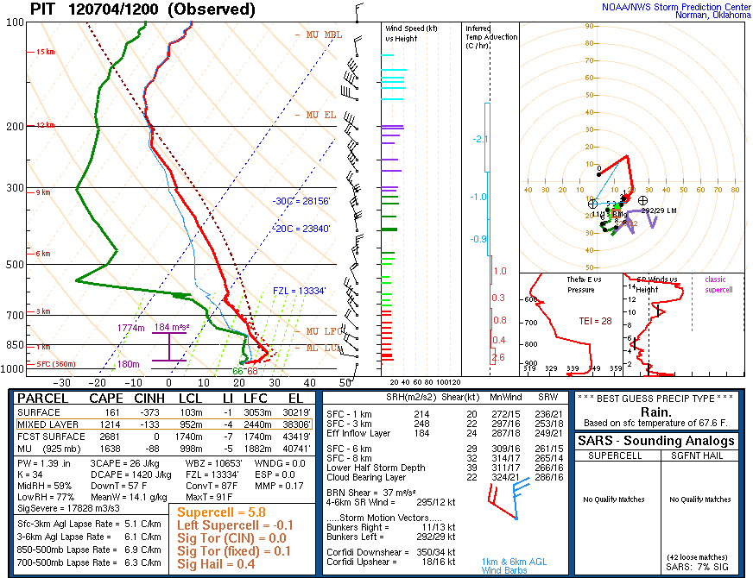
Figure 3.66. Sounding from PIT valid at 1200 UTC 4 July 2012 (source: SPC).
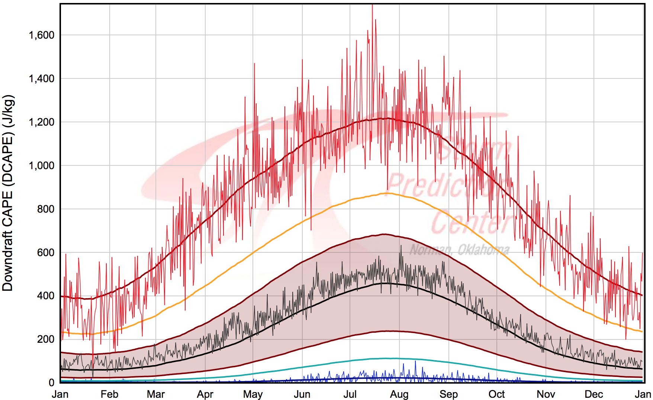
Figure 3.67. As in Fig. 3.39 but for PIT. Green bolt represents observed value at 1200 UTC 4 July 2012 (source: SPC).

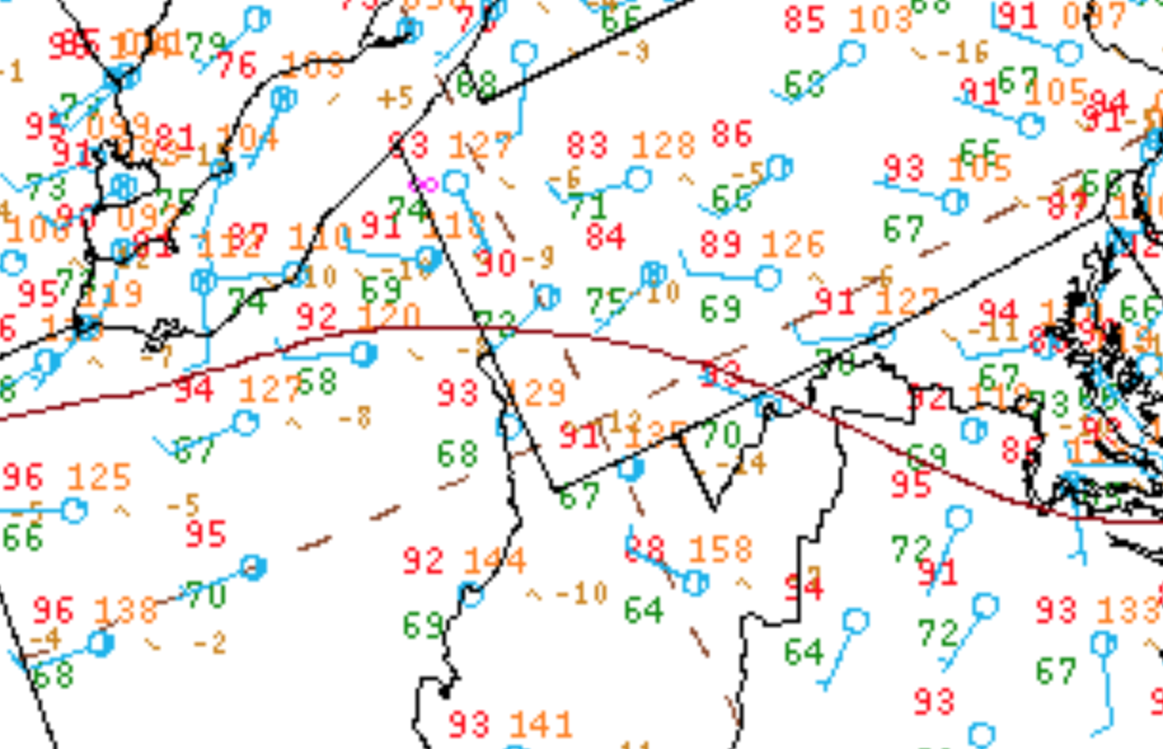
Figure 3.68. Surface observations valid at 1800 UTC 4 July 2012 (source: Weather Prediction Center). Magenta circle denotes area of thermal boundary.

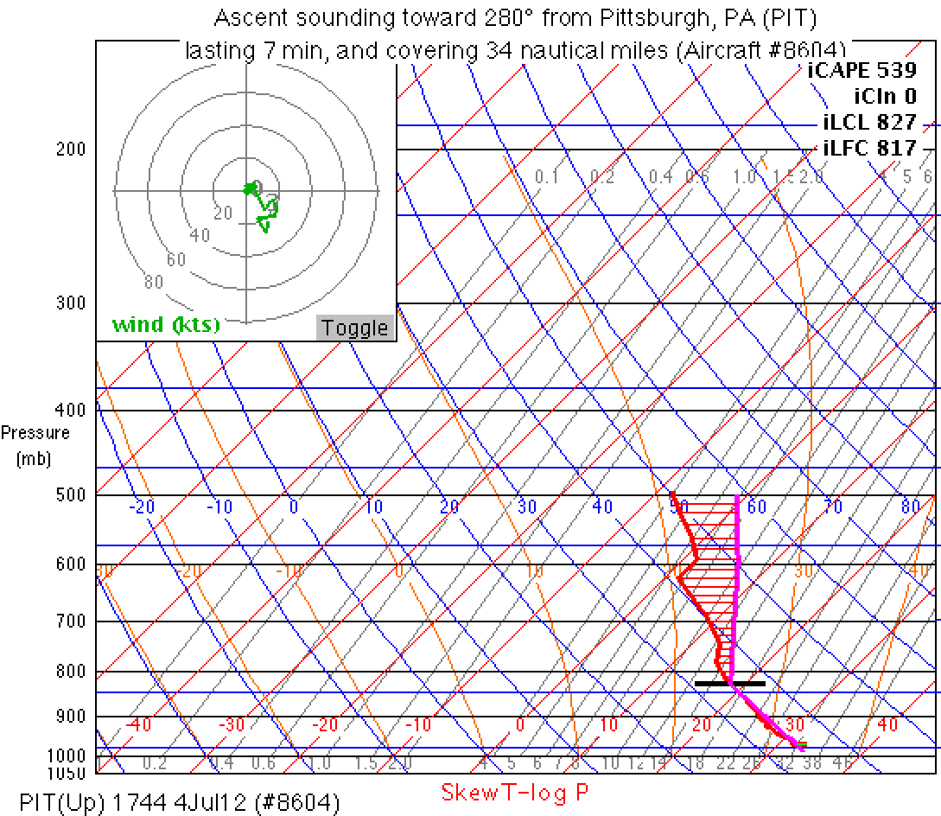
Figure 3.69. Aircraft sounding and computed parcel path using METAR data valid at 1744 UTC 4 July 2012. Sounding is located at PIT.

Figure 3.70. As in Fig. 3.36 but for 0000 UTC 5 July 2012 using RAP model analysis data.

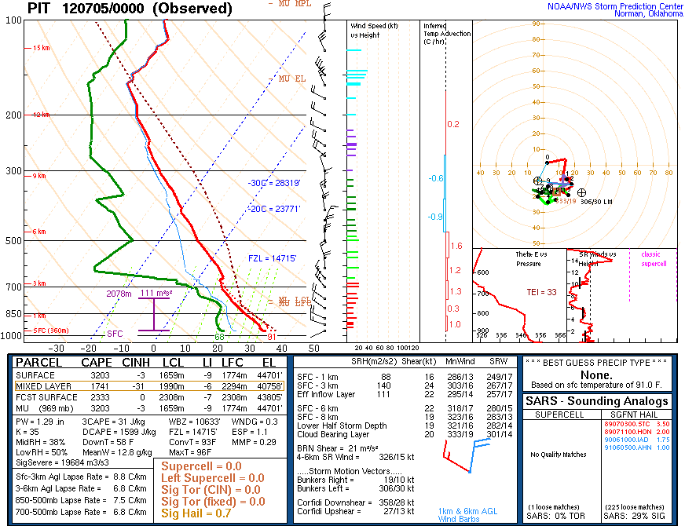
Figure 3.71. Sounding from PIT valid at 0000 UTC 5 July 2012 (source: SPC).

Figure 3.72. Surface observations valid at 0000 UTC 5 July 2012 (source: UCAR). The black box highlights the thermal boundary between CLE, CAK, YNG, and HZY.
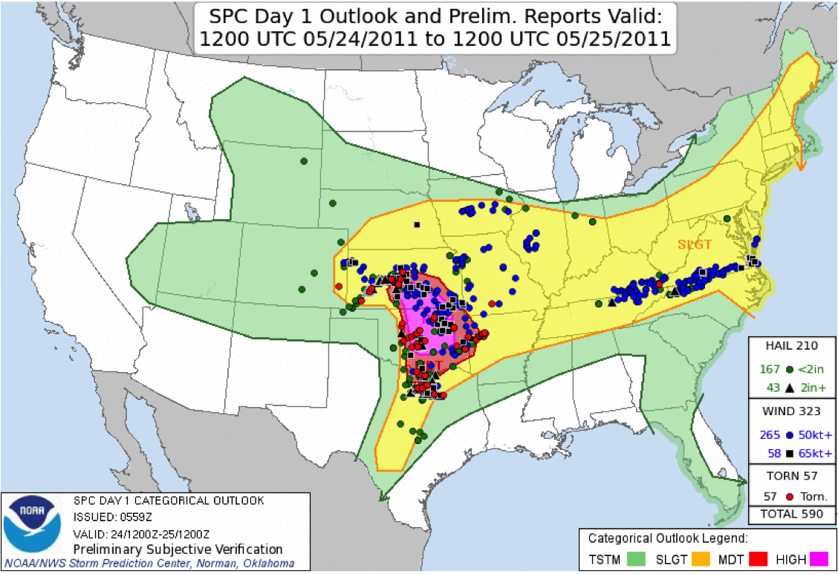
Figure 3.73. SPC 0600 UTC 24 May 2011 severe wind convective outlook valid 1200 UTC 24 May 2011 to 1200 UTC 25 May 2011.

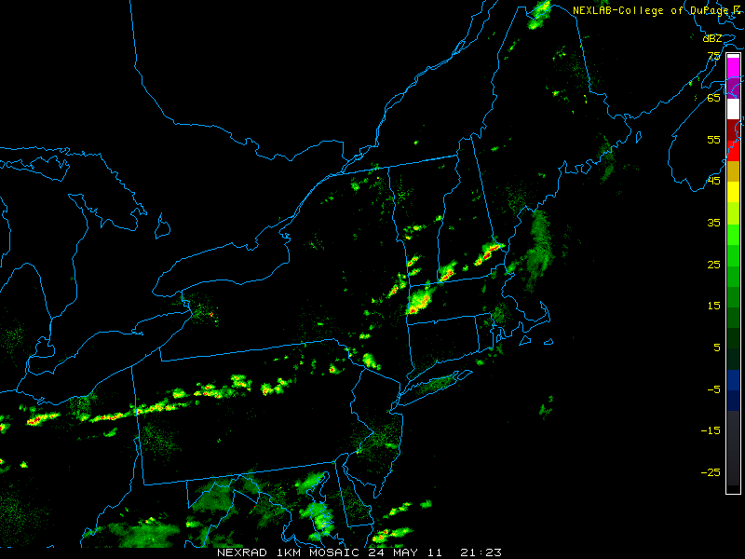
Figure 3.74. Radar reflectivity valid at 2123 UTC 24 May 2011 (source: College of DuPage).

Figure 3.75. As in Fig. 3.34 but at 1200 UTC 24 May 2011.

Figure 3.76. As in Fig. 3.35 but at 1200 UTC 24 May 2011.

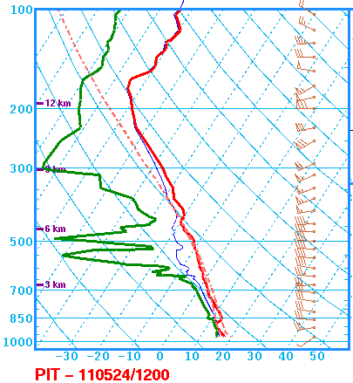
MLCAPE: 482 J kg⁻¹
0–6-km shear: 34 kt
DCAPE: 801 J kg⁻¹
Figure 3.77. Sounding at PIT valid at 1200 UTC 24 May 2011 (source: SPC).

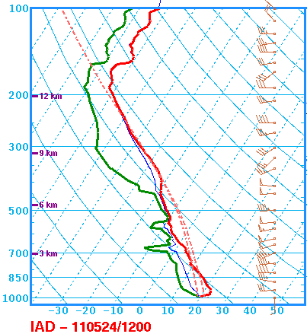
MLCAPE: 784 J kg⁻¹
0–6-km shear: 48 kt
DCAPE: 595 J kg⁻¹
Figure 3.78. Sounding at IAD valid at 1200 UTC 24 May 2011 (source: SPC).

Figure 3.79. As in Fig. 3.47 but at 2200 UTC 24 May 2011. The heavy dashed line indicates the position of the cold front.

Figure 3.80. As in Fig. 3.36 but at 2200 UTC 24 May 2011.

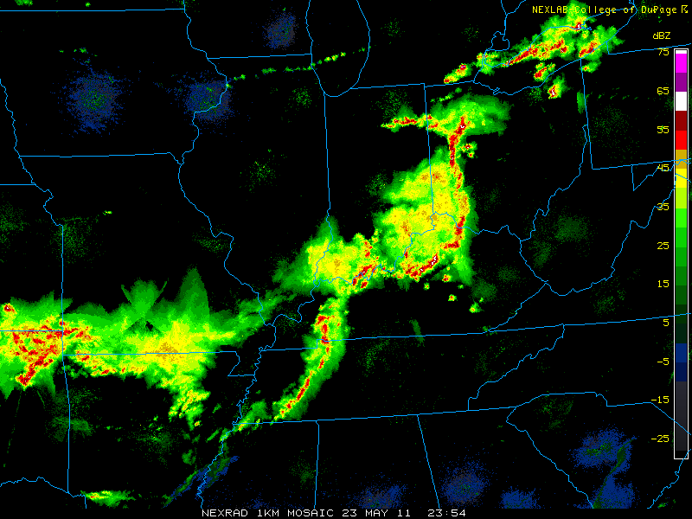
Figure 3.81. Radar reflectivity valid at 2354 UTC 23 May 2011 (source: College of DuPage).

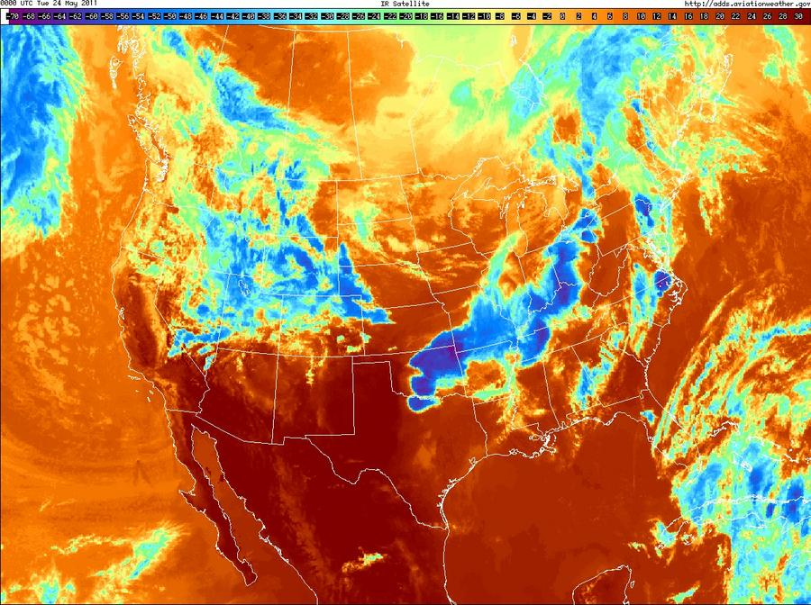
Figure 3.82. Infrared satellite imagery valid at 0000 UTC 24 May 2011.

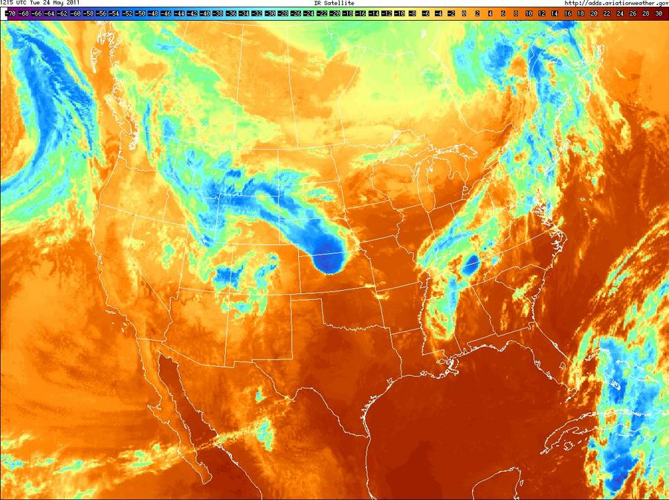
Figure 3.83. Infrared satellite imagery valid at 1215 UTC 24 May 2011.

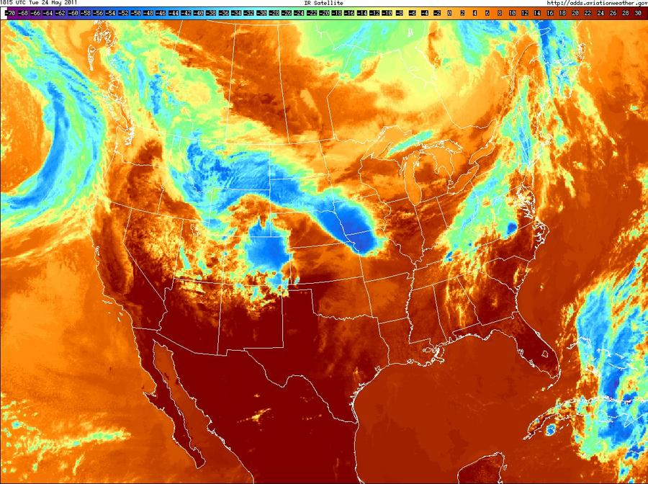
Figure 3.84. Infrared satellite imagery valid at 1815 UTC 24 May 2011.

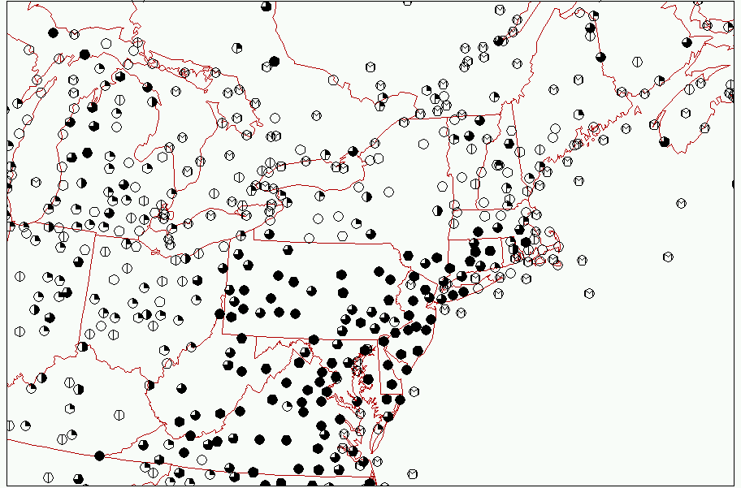
Figure 3.85. Surface observations of sky cover valid at 1800 UTC 24 May 2011 (source: Plymouth State College).

