Saturday, February 26, 2011

Pittsfield meteorologist keeps eye on the sky
By Clarence Fanto, Berkshire Eagle Staff,


Kimberly McMahon works as a meteorologist in her office... (Patrick Dodson / Special to The Eagle)

- PITTSFIELD -- When Kimberly G. McMahon told friends she was studying to become a professional meteorologist, some of them gave her a hard time, but all in good fun.
"'Nice work, a job where you get to be wrong 50 percent of the time,' they told me," McMahon recalled from the Pittsfield home she shares with her husband of less than a year, Shawn.
The couple relocated from Schenectady, N.Y., to the Berkshires so that each could be roughly halfway between their workplaces -- she's less than an hour from the National Weather Service's regional headquarters on the University at Albany (SUNY) campus, and he's about 90 minutes from Hartford, where he works as a mechanical engineer.
"I got the better deal -- it's a little more important that I live closer to the office since I have to get there in all kinds of weather," McMahon said.
Although McMahon, 28, has become immersed in her dream job during this severe winter, the four-year veteran of the job called herself a "late bloomer" in the forecasting world. That's unlike many colleagues, who developed a fascination with weather in elementary school.
"Originally I wanted to be a volcanologist," she said, having been impressed by "Dante's Peak," the 1997 disaster film depicting the impact of a volcano's eruption near a small town in the Pacific Northwest.
McMahon, born Kimberly Sutkevich, is a native of Long Island, N.Y. She earned her meteorology degree at the Departmentof Atmospheric and Environmental Sciences on the SUNY campus, where she studied with Mike Landin, the now semi-retired professor who broadcast detailed forecasts on AMC Northeast Public Radio for 30 years.
"I took his course on severe hazard forecasting," McMahon said.
And how did that go?
"Like every forecaster, you have your ups and downs," she said. "I was only slightly above average."
Professor Vincent Idone, a 35-year veteran of the department who was chairman when McMahon was a student, remembers her as "very motivated, extremely popular with the other students. Her own dedication and motivation and the training she got here made for a good combination."
Before graduating from SUNY in May 2005, McMahon served as a volunteer intern with the National Weather Service. Then she applied for -- and got -- a student temporary position, one notch up from the internship. She said her primary responsibility was launching the upper-air balloon for atmospheric data and training volunteer interns.
After graduation, she worked for the Defense Department at the Army's Dugway Proving Ground in Utah, an area the size of Rhode Island surrounded by mountains on three sides.
"I was a federal civilian employee, working as a meteorologist, setting up observation equipment, launching balloons, forecasting, issuing thunderstorm warnings and doing research," she said. "But it was kind of in the middle of nowhere. Definitely an experience."
When McMahon learned of an opening at the National Weather Service office in Albany, she went after it.
"I was thrilled to get it," she said. "It was like coming home, professionally. Everyone there is very respectful, and it's a great working environment."
In the beginning, McMahon went through rigorous training, especially on the Weather Service's exclusive high-tech software. After exams and certification, she was deemed ready for shifts that rotate every few days.
Her supervisor, Raymond O'Keefe, says she is "on the fast track, very dedicated, conscientious and bright."
Most significantly, he added, she's "a very good forecaster."
Forecaster Brian Montgomery said McMahon is on "a very fast career path."
"She's motivated and proactive," Montgomery said. "Her calmness is always a bonus, and her professionalism shines through. "
But off-duty, McMahon still gets plenty of ribbing from friends who give her a hard time about forecasts that don't quite turn out, or about seemingly never-ending bouts of winter weather.
"They still ask me, ‘Can't you make it stop snowing?' I always tell them: ‘I'm in prediction, not production,' " she said.
McMahon has her priorities in order.
"I know that my co-workers and I feel we don't want to let the public down. We take it to heart if we miss a forecast or we put out a warning for severe weather that doesn't happen. We always try to learn from our mistakes, or if we did a good job, what can we take away from it."
In fact, according to O'Keefe, the Albany forecast office has had a stellar winter, with a 97 percent accuracy rate in predicting 117 winter-weather events in its 19-county, four-state region. That's along with a "false alarm" rate of 23 percent -- out of 149 heavy-snow warnings, 35 didn't pan out.
"It's been one of our best years for predicting winter weather," O'Keefe said.

Tuesday, February 1, 2011
Ross Lazear receives Best of our Blogs honor in the Times Union newspaper:

Historic snow, and a mid-week storm…
January 30, 2011 at 1:11 pm by Ross Lazear
It’s been a remarkably snowy winter for many locales across the northeast U.S. While it has indeed been snowy in the Capital Region, with 34″ of snow falling in January alone in Albany, the truly historic snowfall amounts have fallen farther south and east. New York’s Central Park has officially had its snowiest January in recorded history, with a total of 36″. This breaks the old record of 27.4″, set back in 1925. Though only two inches more than Albany’s total for the month, these snowfall amounts are more uncommon in places farther south and along the coast, like New York.
These amounts get more impressive north and east of the NYC metro area. At Bradley International Airport outside Hartford, Connecticut, a whopping 57″ (nearly five feet!) of snow has fallen in the month of January. Worcester, Mass. has received just under 50″.
The map below, from the National Operational Hydrologic Remote Sensing Center (NOHRSC), shows the current snow depth over southern New England. Note the purples in southern Massachusetts and northeast Connecticut. Over thirty inches of snow are still on the ground in these regions, even after the snow has had time to compact, melt, and sublimate (the act of a solid, in this case ice or snow, changing phase directly into a gas, or water vapor).
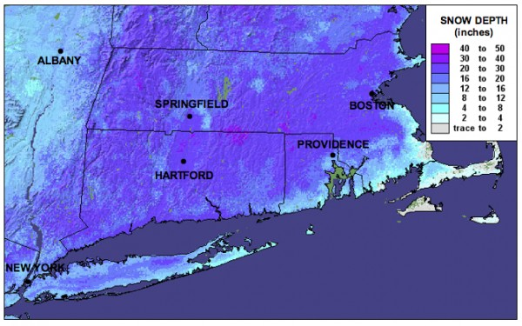
All eyes are on another potential snowstorm mid-week. First, a light to moderate snow event is possible on Tuesday. Then, a major cyclone will develop in the middle of the country, move across the Ohio Valley and toward the mid-Atlantic coast on Wednesday. At this time, it looks like coastal regions to our south may receive a sloppy mix of precipitation, or even all rain. Upstate, however, we may see significant snowfall potentially mixing with, or changing over to sleet. There is still too much uncertainty in the models to pinpoint specific snowfall amounts, or locations where amounts will be hindered due to mixing with sleet or freezing rain. Nonetheless, we could be looking at quite a mess on our hands here in Albany on Wednesday.
Stay tuned . . .

Wednesday, January 26, 2011

Meteorologists Sleepless in Seattle!
January 26, 2011 at 2:19 pm by Chris Thorncroft
At this time of year the American Meteorological Society holds its annual meeting. It’s a huge scientific conference that covers a wide range of topics including severe weather, hurricanes, climate variability and change, water and climate, lightning, clouds and dust to name but a few. There have also been some sessions that discussed how to communicate with society on sensitive and important issues such as climate change and there is also a session today that deals with weather and the energy industry – great stuff!!
This year’s meeting is being held during this week in Seattle and the Department of Atmospheric and Environmental Sciences is well represented by faculty (Lance Bosart and myself), staff and students (including 4 of our bloggers – Ross, Kevin, Heather, and Kyle). The meeting is a great experience for students. Graduate students Heather Archambault, Jay Cordeira and Kyle Griffin are here giving talks on various aspects of weather and climate. Also three of our undergraduate seniors Alicia Bentley, Sarah Ganetis and Larry Gloeckler are attending and benefiting from the experience that includes, in addition to attending the scientific sessions, meeting with professors from other Atmospheric Science Schools in the country. A great benefit when you are thinking of graduate school.
Tonight the AMS hosts its annual award ceremony and we in the Department are very proud that one of our graduate students, Mike Ventrice, will be receiving an award for the best student presentation at the AMS Conference on Hurricanes and Tropical Meteorology that took place in April last year.
This meeting was also a special one for the Department. For the first time we hosted an alumni event. The event attracted more than 75 people including many of our past alumni and friends. It was a particular pleasure to meet up with our alumni, who are now gainfully employed around the country and, in some instances, around the world.
Perhaps I should end by mentioning that the temperature here today is in the 50s! Seattle experiences, what we call, a “maritime climate” that is generally warmer and wetter than the “continental climate” that we experience in Albany – a reminder of England for me!

Monday, January 10, 2010
UAlbany Atmospheric and Environmental Sciences Department Launches Weather Blog
ALBANY, N.Y. (January 10, 2011) -- The University at Albany's Department of Atmospheric and Environmental Sciences (DAES) today launched "Weather and Climate," a blog that will be a leading voice on regional and global weather and weather-related phenomena.
"Weather and Climate," hosted by the Times Union newspaper online, comprises the collective efforts of expert faculty and staff from the department, commenting on weather issues in the region and throughout the world. Topics covered include severe Northeast weather events such as snow storms, floods, hail, and wind storms; high-impact events affecting the U.S., including land-falling hurricanes; and conditions in the Pacific region related to El Nino or La Nina, and what they mean for the planet's weather patterns.
Given its importance to the health of the planet and the vast amount of conflicting information surrounding the issue, climate change will also be addressed by the blog's authors.
"Forecast: a great interactive experience"
"People talk about the weather and climate almost every day of their lives," said Christopher Thorncroft, chairman of DAES, "I am hoping this blog will be able to provide new information for readers about how weather and climate work, how forecasts work -- or don't! -- and, in particular, reasons why high impact events occur. We will also look forward to some lively posts and discussion about climate and climate change and how this is relevant to society."
"Weather is one of the few story lines that affect every one of our readers," said Michael Huber, the Times Union's interactive audience manager. 'We live in a region with dramatic weather changes through all four seasons, and this blog gives our readers an opportunity to join in a conversation with UAlbany’s weather experts. Forecast calls for a great interactive experience."
The audience for the blog, Thorncroft said, is anyone who has an interest in the weather and climate, especially those who want to learn more than they might get from traditional media outlets.
Contributors to "Weather and Climate" include DAES professors Paul Roundy, a climate variability expert; tropical weather and hurricane specialist Chris Thorncroft; climate change expert Mathias Vuille; staff members and meteorologists Ross Lazear and Kevin Tyle; graduate students Heather Archambault, Kyle Griffin and Matt Potter; and retired professor and former broadcast meteorologist Mike Landin.
The authors expect to update the blog at least three or four times per week, Thorncroft said.
The Department of Atmospheric and Environmental Sciences, part of the UAlbany's College of Arts and Sciences, carries out innovative research and provides internationally recognized training for students at the undergraduate and graduate levels.
Department Highlights
One of the most prestigious members of the Department in its early years was the late Bernard Vonnegut who, in addition to working on weather modification, carried out research on electrification of storms, thunderstorms, tornadoes, and aerosols. He published more than 190 papers and reports and received 28 patents.
A major department achievement was the establishment of the National Lightning Detection Network, which started as a mere four-station network in New York in 1982.
Starting in the 1990s, the synoptic-dynamics group, led by Distinguished Professor Lance Bosart, pioneered a collaborative arrangement with the National Weather Service (NWS) in programs called CSTAR (Collaborative Science, Technology, and Applied Research Program) and COMET (Cooperative Meteorological Education and Training). The latter program involved internships for students to work with the regional NWS personnel housed at the University. The cooperation with NWS is one of the features that continues to attract undergraduate and graduate students to the atmospheric science programs at UAlbany today.
Boosted by the arrival of several new faculty over the last 10 years, the Department has been successful at mobilizing funds and carrying out research in a variety of areas of tropical meteorology, including hurricanes, monsoons, intra-seasonal variability, as well as climate variability and change. Hurricane research has received significant funding in recent years, including this year’s NASA supported Genesis and Rapid Intensification Program (GRIP) and NSF supported Pre-Depression Investigation of Cloud-systems in the Tropics (PREDICT), with funding just for these projects amounting to nearly $1 million.
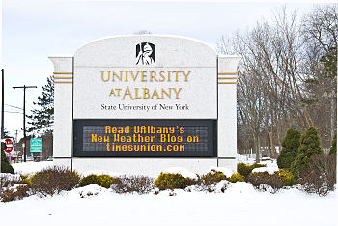
The audience for the new blog is anyone who has an interest in the weather and climate, especially those who want to learn more than they might get from traditional media outlets. (Photo Mark Schmidt)

UCAR Magazine, Monday, November 8, 2010

Hurricanes in the making
Parallel field studies gain the best look yet at incipient tropical cyclones
2 November 2010 • It’s not exactly a moment for celebration, but when a tropical storm is born in the Atlantic, millions of people learn about it quickly. As with any birth, though, a great deal has to happen in just the right way before a tropical storm is christened.
Most tropical storms take shape after spending a few hours to several days as a tropical depression, a quasi-closed circulation whose peak sustained winds haven’t reached the threshold of 63 kilometers per hour (39 miles per hour). For every tropical disturbance that makes it to the depression stage, several more in the Atlantic are snuffed out by wind shear, dry air, and other influences. Both winners and losers in this battle got their six weeks of fame—at least among researchers—in 2010. Aircraft from several agencies spent much of late August and September flying in and around embryonic disturbances, while computer models tracked the circulations and assessed their odds of developing.
Working in tandem, three studies canvassed the tropical Atlantic this year, shown here with their primary funders:
- PREDICT (Pre-depression Investigation of Cloud systems in the Tropics), NSF
- GRIP (Genesis and Rapid Intensification Processes), NASA
- IFEX10 (the 2010 phase of the multiyear Intensity Forecasting Experiment), NOAA
Each project evolved on a separate timeline, with its own goals and instruments, but the three were closely linked. Scientists for each project shared insights and rotated forecasting duties, and the teams synchronized their flight plans with coordination calls twice per day, plus near-continuous exchanges by email.
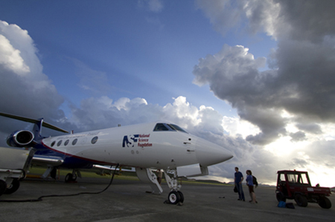
The NSF/NCAR Gulfstream V prepares for an early-morning flight from the St. Croix airport.
“I have never observed such extensive and constructive collaboration between agencies in the planning and carrying out of this kind of field program,” says Edward Zipser (University of Utah). A principal investigator for GRIP, Zipser has nearly five decades of experience in tropical field studies.
The atmosphere itself was also well synchronized with the three studies. With the tropical Atlantic simmering at near-record warmth, and an unusually strong La Niña taking shape, the preconditions were as good as they get. After a quiet start, activity began to bubble toward the end of August. By late September, the projects had gathered exhaustive multiday profiles of the formation of two hurricanes (Earl and Karl), a destructive tropical storm (Matthew), another that was harmless but long-lived (Fiona), and a remnant tropical storm that never revived (Gaston). If analysis goes as well as planned, the results could enhance the ability of forecasters to pick out future hurricanes and weed out doomed systems days in advance.

Nurturing a hurricane-to-be
The problem facing hurricane forecasters and theoreticians alike is aptly stated in the PREDICT project summary: “The formation of tropical cyclones remains one of the great unsolved problems in meteorology.” Once a tropical storm takes shape, track models are increasingly skilled at projecting its path (see related article, inside front cover). The prediction of intensity remains much more difficult, though. That’s especially the case for incipient disturbances that might or might not become tropical cyclones at all.
At the Naval Postgraduate School (NPS), Michael Montgomery, PREDICT’s lead principal investigator, and his research group, including colleague Timothy Dunkerton (NorthWest Research Associates), have spent the last few years grappling with this longtime challenge. Earlier work had made it clear that convection (showers and thunderstorms) is an essential ingredient. Deep layers of moisture are needed in and near the disturbance in order to nourish this convection. And wind shear (the change of winds with height) must be light to keep a system from being torn apart.
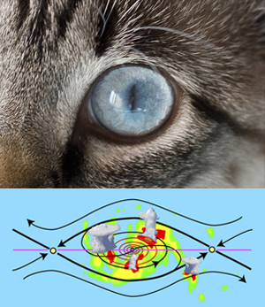
The flow in and near an incipient tropical cyclone resembles a cat’s eye on its side, with air circulating inside a protected region where convection and rotation can consolidate. (Illustration courtesy Michael Bell.)
Around 60 disturbances each year move westward across the tropical Atlantic during a typical hurricane season. Many look promising, but only about 20 percent make the transition to tropical depressions, at which point they’re likely to become tropical storms. Why, then, do so many disturbances fail to develop? Montgomery and colleagues knew that disturbances can take many forms on the larger scale, but they focused on atmospheric waves rolling westward through the Atlantic’s deep tropics.
Like waves atop the sea, these systems travel just north of the richly moist ribbon of air known as the intertropical convergence zone, pulling in an umbilical cord of moisture. When the waves move at the same speed as the encompassing flow, a protected region develops—often called the Kelvin’s cat-eye circulation (see graphic) or nonlinear critical layer—that embraces the formative elements of a tropical cyclone. The metaphor that took hold for Montgomery and Dunkerton was the marsupial pouch in which a young kangaroo develops.
“We think the marsupial pouch provides a focal point or ‘sweet spot’ where favorable conditions could persist for several days and where rotating thunderstorms are most likely to aggregate into a larger-scale storm,” says Montgomery. Not all of his colleagues were enraptured with the analogy, says Montgomery, “but we’re actually proving that it has strong scientific merit.”
In a study reported in the journal Atmospheric Chemistry and Physics, Dunkerton and Montgomery, plus Zhuo Wang (University of Illinois at Urbana-Champaign), found pouches in 55 of 61 tropical storms and hurricanes that had roamed the Atlantic and Pacific between 1998 and 2001. The marsupial hypothesis gained further traction through a Pacific field study called Tropical Cyclone Structure–2008, and NPS’s Mark Boothe and doctoral student Robert LeeJoice applied techniques developed for the Pacific study to identify and track pouches in the output of computer forecast models.
What’s inside the pouch is equally important. For a cyclone to develop, it appears that small pockets of rotation and convection need to coincide, thus strengthening both as well as bolstering the larger disturbance. These processes unfold on too small a scale to be monitored routinely, but PREDICT, IFEX, and GRIP were ideally positioned to take a closer look.

Forecasters on the line
At the PREDICT operations center, located on the north coast of St. Croix, forecasters and researchers huddled each morning to look over the day’s data and make flight plans. Similar scenes unfolded at the Fort Lauderdale International Airport for GRIP, and at MacDill Air Force Base near Tampa for IFEX, whose flights overlapped with routine Air Force and NOAA reconnaissance missions into tropical cyclones.
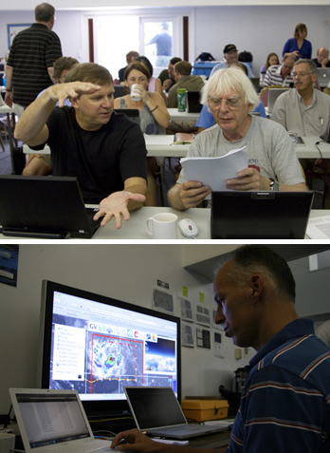
Above: Principal investigators Christopher Velden (University of Wisconsin–Madison) and Roger Smith (University of Munich) discuss tropical cyclone dynamics at the PREDICT operations center
Below: PREDICT nowcaster Derrick Herndon (University of Wisconsin–Madison) keeps an eye on thunderstorms building close to the flight path of the Gulfstream V.
The teams had a wealth of new analysis tools at their disposal. Along with the “pouch products” developed by Boothe and LeeJoice, they drew on more than 250 model runs each day from ensembles developed by Ryan Torn (University at Albany, State University of New York), Sharan Majumdar (University of Miami), and Fuqing Zhang (Pennsylvania State University). Torn’s ensemble employed initial conditions generated with NCAR’s Data Assimilation Research Testbed, then used the Weather Research and Forecasting model to generate PREDICT-specific output, including the probabilities of pouch quantities exceeding relevant thresholds. The pouch products and longer-range forecasts helped PREDICT gain the flight approvals needed from a web of jurisdictions spanning the Caribbean and western Atlantic.
“The forecasts were excellent from day one,” says Albany’s Lance Bosart, who joined other faculty as well as postdoctoral researchers and graduate students in calling the meteorological shots. Sometimes the prediction took patience, as with Hurricane Karl, which took several days to develop. “I was a day too soon in predicting Karl’s formation,” says Bosart. However, he adds, “The track was well forecast, and the storm was well sampled from the pre-genesis period through the Category 3 hurricane stage. We obtained excellent research datasets.”
GRIP benefited from a brand-new observing platform: NASA’s Global Hawk, a remotely piloted vehicle. After tests in the Pacific, the Hawk made its first flight into a hurricane by slicing through Earl on 2 September. With its range of 11,000 nautical miles (20,000 kilometers), the aircraft gathered data continually for up to 13 hours at a stretch, providing a sorely needed look at hurricane evolution on both short and long time scales. The project also tested a system developed at NCAR that will soon allow the Global Hawk to deposit dropsondes (parachute-borne instrument packages) on command. “It’s clear that the Global Hawk will be an amazing tool for studying tropical cyclone formation,” says Albany’s John Molinari.
PREDICT gave the NSF/NCAR Gulfstream V some of the most intensive workouts in its five-year history. Only a year after retiring, veteran NCAR pilot Henry Boynton returned to the skies for PREDICT, accompanied by longtime colleague Lowell Genzlinger. The presence of a second crew headed by pilots Joseph McClain and Stephen Thompson allowed for five consecutive days of G-V coverage on two prolonged systems.
As they circled around and through pouches, the G-V pilots got the kind of customized weather guidance that most commercial pilots only dream of. A group led by Christopher Velden at the Cooperative Institute for Meteorological Satellite Studies (NOAA/University of Wisconsin–Madison) brought real-time, high-frequency satellite data and derived products into a large-format display developed at NCAR that showed the G-V’s flight path (see photo). The mission coordinator and scientist on board the aircraft could see the same real-time display as the forecasting team on the ground, which helped them guide the pilots around thunderstorms and gather prime data while staying safe.
”The combination of real-time satellite products, data displays, and chat communications with the operations center gave us a great capability to adjust our flight patterns on the fly in the dynamic pre-hurricane environment,” says Michael Bell (NPS/NCAR), who served as a principal investigator and a G-V mission scientist.
Students played meaningful roles across the spectrum of field work at PREDICT. “It’s been exciting to apply cutting-edge analysis tools used to understand tropical cyclone formation in an operational setting,“ said Heather Archambault, a graduate student at Albany and a lead forecaster for PREDICT. “This has been one of the best educational experiences I’ve had.”
According to Velden, ”Many times in these high-powered field programs, the students are invited along as a learning experience and end up playing passive onlookers while the mentoring scientists lead the charge. But there was a significant, measurable contribution from the student involvement in PREDICT, from forecasting to decision support to aircraft flight tasks.”

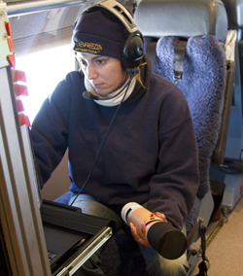

NCAR technician Laura Tudor prepares a dropsonde for launch.

Storm after storm
The PREDICT/GRIP/IFEX trio made the most of the stream of tropical cyclones that traversed the Atlantic this year. A couple of the season’s first hurricanes developed too quickly and too far east for the projects to document, but September brought a rapid-fire string of successful sorties.
Hurricane Earl was a particular success for GRIP’s rapid intensification component, as the system quickly grew to Category 4 intensity just north of the Caribbean before recurving off the U.S. East Coast. NASA’s DC-8 made four flights into Earl over five days, while NOAA’s Gulfstream IV and two P-3 aircraft sampled the storm and its environment with 18 research flights. Another dozen or so flights were deployed by the Air Force’s fleet of C-130 hurricane hunters. “By any measure, this is the best data on rapid intensification ever obtained,” says Zipser. (Earl also gave the PREDICT ground team a jolt of adrenaline as it moved north of St. Croix. The outer bands of the quickly strengthening storm brought debris-tossing gales to the operations center, forcing the staff to seek higher ground for a time in the hurricane-shuttered restaurant of their hotel.)
Along with capturing Hurricane Karl, as noted above, PREDICT gathered ample data on the birth of Tropical Storm Matthew across the southern Caribbean. The prolonged demise of Tropical Storm Gaston provided an equally valuable but much different case. Only a day after being named, Gaston diminished to a remnant low in the tropical Atlantic. At one point the NHC gave the remnants an 80% chance of reviving, but those odds slowly dropped as the system limped into the Caribbean and finally decayed. “Gaston continued to struggle even though it seemed like a viable disturbance for a long time,” says PREDICT PI Christopher Davis (NCAR). “It could teach us a great deal.”
Daily flights during the process made Gaston the most thoroughly observed case of failed tropical cyclogenesis in history, as well as a perfect “null case” for PREDICT: why didn’t the system redevelop?

NASA’s DC-8 shuttled to St. Croix for a flight into the remnants of Tropical Storm Gaston on 7 September. (Photo by John Cowan, NCAR.)
“The depth of the pouch seemed to diminish with time,” according to Montgomery. “There was strong shear from the east, and a lot of dry air was going over it.” If Gaston’s apparent top-down decay is confirmed, it could lend support to the bottom-up development model favored by Montgomery. It’s one facet of a longstanding debate over the vertical sequence of tropical cyclone formation that PREDICT may help settle.
As for forecasting, Montgomery and collaborators would like to see the new pouch-prediction model output added to the arsenal of tools used by NHC forecasters to help save lives and property. This year’s field work could also benefit NOAA’s ten-year Hurricane Forecast Improvement Program, which aims for a 20% improvement by 2013 in the accuracy of NHC’s five-day hurricane track and intensity forecasts. Another goal is to extend hurricane forecasts to seven days.
In order to stimulate progress in long-range prediction, the PREDICT and GRIP teams will need to analyze the data they’ve gathered this year from the difficult-to-observe areas within pouches where the biggest uncertainties lie. “Satellite pictures don’t tell you everything,” Montgomery notes. “The models have a lot of skill at predicting where the pouches are, but they don’t have a lot of skill at predicting what’s going to happen within the pouches. That’s why we’ve been collecting data.” These observations, he adds, should help solve the mystery of why some storms thrive in their protected regions while others struggle to survive.
—Bob Henson

September 3, 2010
Featured Faculty 2010

Ryan Torn Collaborates with NCAR to Develop Numerical Weather Models
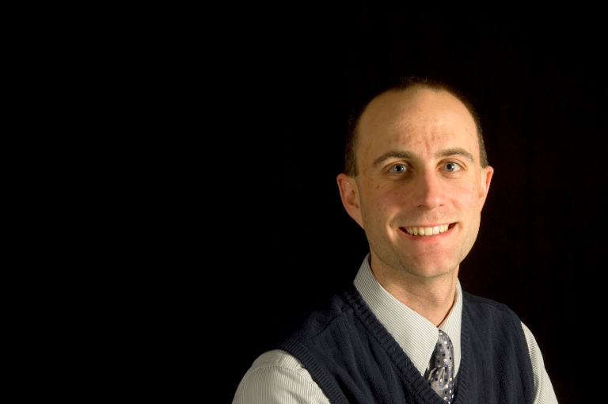
In early August, the National Hurricane Center designated two numerical weather models as semi-operational, meaning that the output from these models would be available to hurricane specialists to make their operational forecasts. This process involved running these computer models over many different hurricanes and many different times, and comparing the model's track and intensity forecast against the best estimates of these quantities. One of the two models is the National Center for Atmospheric Research (NCAR) Advanced Hurricane Weather Research and Forecasting (AHW) model. Over the past two hurricane seasons, the initial conditions for that model have been generated using an advanced technique that combines the information from observations and a previous computer model forecast. The application of this technique to hurricanes has been developed over the past three years by Ryan Torn, Assistant Professor in Atmospheric and Environmental Sciences in collaboration with scientists at NCAR. Current forecasts from this system are available at: http://www.wrf-model.org/plots/realtime_hurricane4km.php
Department of Atmospheric and Environmental Sciences
College Of Arts and Sciences
University At Albany

August 3, 2010
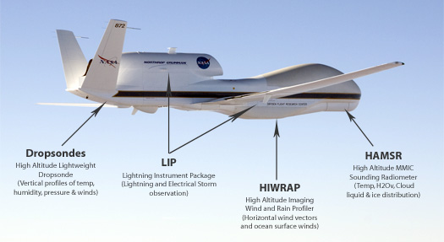
Faculty and Students from DAES participate in two hurricane field campaigns in summer 2010
Four faculty along with their students will be participating in two hurricane field campaigns in August and September this summer. NASA-supported GRIP and NSF supported PREDICT will be working together and with NOAA-supported IFEX (Intensity Forecasting Experiment) to improve our understanding of the nature and causes of hurricanes including their genesis and rapid intensification.
Genesis and Rapid Intensification Processes (GRIP)
The GRIP experiment is a NASA Earth science field experiment in 2010 that will be conducted to better understand how tropical storms form and develop into major hurricanes. NASA plans to use a DC-8 aircraft and the Global Hawk Unmanned Airborne System (see photo above) configured with a suite of in situ and remote sensing instruments that will be used to observe and characterize the life-cycle of hurricanes. The GRIP deployment is planned for 15 August – 30 September 2010 with bases in Ft. Lauderdale, for the DC-8, and at NASA Dryden Flight Research Facility, CA, for the Global Hawk.
Professors John Molinari and Chris Thorncroft are members of the NASA Hurricane Science Team and are involved in this project. John will be one of the Mission Scientists for GRIP, serving for three weeks during the field campaign. This will involve directing the aircraft and sometimes flying (in the DC-8), as well as coordinating with PREDICT and IFEX. Two of John’s students (Leon Nguyen and Diana Thomas) and one of Chris’s students (Matt Janiga) will be based in Ft Lauderdale for two weeks each to help with forecasting and will also likely get a chance to fly missions on the DC-8.
See http://grip.nsstc.nasa.gov for more information.
PRE-Depression Investigation of Cloud-systems in the Tropics (PREDICT)
The PREDICT experiment is a close collaboration between the NSF, NOAA and Naval Postgraduate School in Monterrey, California. The aim of the program is to explore the nature of the precursor disturbances that can become tropical storms (and eventually hurricanes). It will utilize the high endurance NCAR G-V aircraft in collaboration with two NOAA WP-3D aircraft (from IFEX).
Professors Lance Bosart and Ryan Torn are co-PIs on the NSF PREDICT project. Lance will serve as the lead forecaster for PREDICT and will be responsible for scientific mission planning from late August through mid-September when he will be based in the PREDICT operations center in St. Croix, Virgin Islands. Ryan will be running a computer model in the Department that will assimilate the additional data in real-time to assess the impact of this data and to provide guidance for mission planning. Lance has four students who will be contributing to PREDICT. Newly admitted graduate student Kyle Griffin and existing graduate student Jay Cordeira will provide PREDICT forecast support during the second half of August. Existing graduate students Tom Galarneau and Heather Archambault will provide forecast support during the first and second halves of September respectively. They may also have options on PREDICT research flights based out of St Croix, Virgin Islands. A newly admitted student of Chris’s, Jason Dunion, will be a lead forecaster for PREDICT during the second half of August.
See http://met.nps.edu/~mtmontgo/predict.html and http://www.albany.edu/news/campus_news_9949.php for more information.
Video clip: http://www.youtube.com/watch?v=s_V2mKypJ2g

