September 30, 2013

**16th Cyclone Workshop**

The 16th Cyclone Workshop was held at The Chantecler Hotel in Sainte-Adele, Quebec, Canada, on 22-27 September 2013.  Co-organized by current UAlbany DAES Assistant Professor **Kristen Corbosiero**, former DAES post doc **Ron McTaggart-Cowan**, and McGill University Professor **John Gyakum**, the Cyclone Workshop is a forum for presentations and discussions on current research topics in the fields of synoptic, dynamic, mesoscale and tropical meteorology.  Over 100 U.S. and European meteorologists attended the workshop, including 25 UAlbany DAES graduate students, post docs and faculty members.  DAES participants gave talks on a wide variety of topics including the factors influential in the genesis and intensification of tropical cyclones, the interaction between the tropical and extratropical atmospheres, and the structure of midlatitude fronts and snowstorms.  Additional information on The Cyclone Workshop, including the program and links to talks, may be found at <http://www.atmos.albany.edu/facstaff/rmctc/cw16/index.html>.

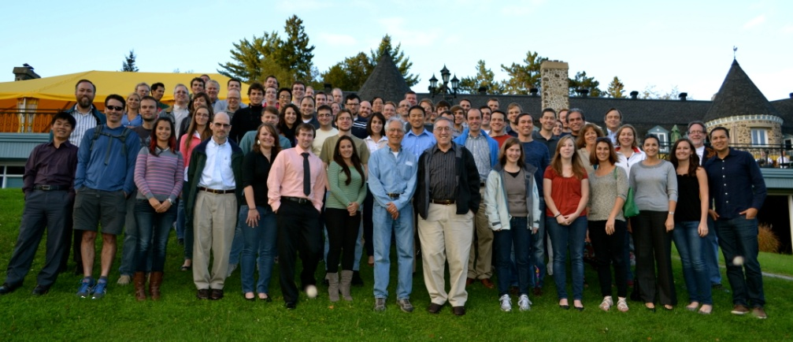

September 9, 2013

**DAES Students Forecast for NASA Hurricane Field Campaign**

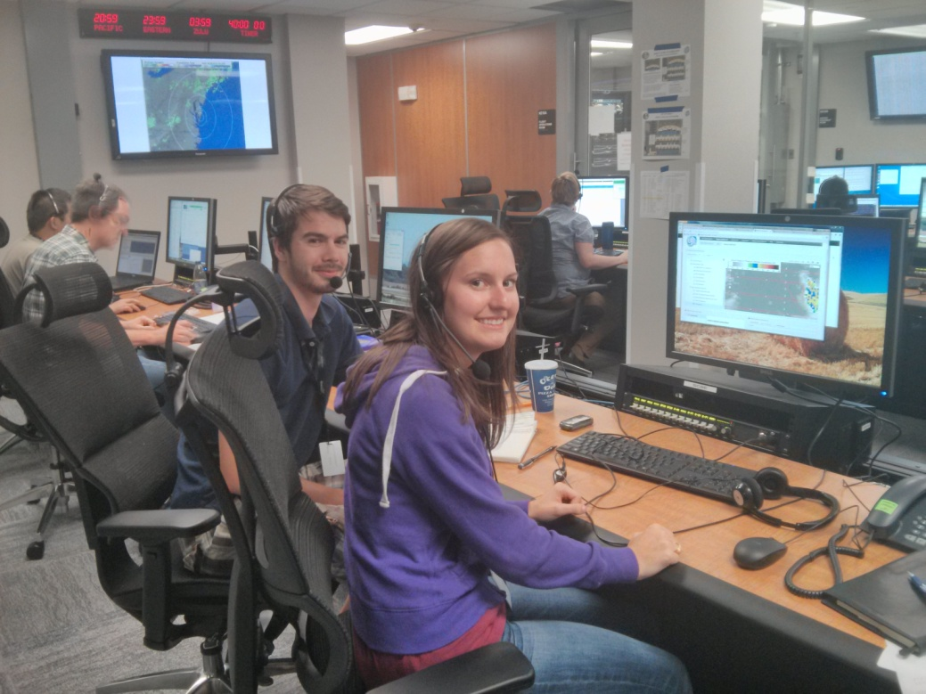

DAES graduate students **Alan Brammer** and **Stephanie Stevenson** are currently working in a weather forecasting team in support of NASA’s HS3 field campaign to observe hurricanes in the Atlantic (<http://www.nasa.gov/mission_pages/hurricanes/missions/hs3/index.html#.Ui37X7wp2qA>).

The HS3 field campaign, based out of Wallops, Virginia is using two unmanned Global Hawks to observe these important weather systems to improve our understanding of how their intensity changes and ultimately to better predict them. **Chip Helms**, another graduate student, is also part of the team and was based in Wallops earlier in the field campaign. The Department has been awarded over $1Million in research funding to participate in this 5-year project (PIs: **Lance Bosart**, **Kristen Corbosiero**, **Jason Dunion**, **John Molinari** and **Chris Thorncroft**).

July 31, 2013

UAlbany Researcher Leads Investigation of Games for Enhanced STEM Education in K-12 Environment

|  |
| --- |
|  |
|  |

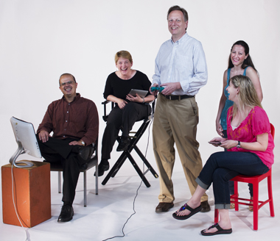

UAlbany educational game researchers share a laugh, left to right, science education specialist Alan Oliveira, geoscientist **Roberta Johnson**, SUNY Games II project director Peter Shea, doctoral student Dima Kasssab, and Assistant Dean of Informatics, Jennifer Goodall. (Photo by Paul Miller)

ALBANY, N.Y. (July 29, 2013) – University at Albany [School of Education](http://www.albany.edu/education/index.php?WT.svl=41449b) Associate Professor Peter Shea is leading a research study investigating the use of games to promote learning. “SUNY Games II” will explore how faculty and students from diverse fields across the SUNY system can develop guided inquiry-based, immersive games to promote enhanced understanding of science, technology, engineering and math (STEM) content in K-12 settings.

The project will foster the research and development of games for learning through the Open SUNY framework, whose goal is to bring all online courses offered at each of SUNY’s 64 campuses onto a shared and comprehensive online environment.

The project is partially funded through a 2013 [SUNY Innovative Instruction Technology Grant](http://www.suny.edu/provost/IITG.cfm) (IITG) and the team has applied for a $1.2 million grant from the National Science Foundation. The team believes that a focus on STEM will address significant state and national challenges and will help position the project for additional external funding, which will be sought in the coming year.

In addition to developing a joint, online academic program that promotes understanding of games for learning, Shea said SUNY Games II will leverage collaborations with area industry. Partners on the SUNY Games II grant include the Troy-based game-design company First Playable and the atmospheric simulation and forecasting company MESO. Shea’s team is also in the process of establishing a working relationship with the Boston-based game developer Turbine Games, a subsidiary of Warner Bros.

Shea serves as principal investigator on the SUNY Games II’s study, which brings together faculty and students from UAlbany and other SUNY institutions representing a wide range of disciplines:

* Shea, Alan Oliveira and Jianwei Zhang, Department of Educational Theory and Practice, UAlbany
* Daniel Goodwin, chair, Department of Art, UAlbany
* Jennifer Goodall and George Berg, College of Computing and Information, UAlbany
* **Roberta Johnson and Mathias Vuille, Department of Atmospheric and Environmental Sciences, UAlbany**
* Bina Ramamurthy, Department of Computer Science and Engineering, University at Buffalo
* James McElwaine, Department of Music, Purchase College
* Edward Bever, College at Old Westbury
* Alexandra Pickett, associate director, SUNY Learning Network
* Kim Scalzo, director, SUNY Center for Professional Development
* Suzanne Hayes, director of instructional technology, Empire State College
* Larry Dugan, director of online learning, Finger Lakes Community College
* Anna Zhou, Shoubang Jian, and Dima Kassab, doctoral students, UAlbany

A nationally recognized expert in online learning, Shea’s research focuses on the development of communities of learners in higher education online environments. He holds joint appointments in the [Department of Educational Theory and Practice](http://www.albany.edu/etap/index.php?WT.svl=41449b) and the [Department of Informatics](http://www.albany.edu/informatics/index.php?WT.svl=41449b) in the [College of Computing and Information](http://www.albany.edu/cci/index.php?WT.svl=41449b).

Shea directs a program of research that has recently attracted more than $2 million in external funding from organizations such as the Alfred P. Sloan Foundation and the U.S. Department of Education. He is the recipient or co-recipient of four national awards including the EDUCAUSE Award for Systemic Improvement in Teaching and Learning and awards from the Sloan Consortium for online and faculty development programs. He is a Sloan-C Fellow in research on online learning and a member of its board of directors.

Prior to joining the University at Albany, Shea was director of the SUNY Learning Network, one of the largest online higher education systems in the United States with annual student enrollments of more than 100,000.

More info: <http://www.albany.edu/news/41449.php?WT.source=RSS&amp;WT.source=PortalAllNews>

July 29, 2013

|  |  |  |  |  |  |  |  |  |  |  |  |  |  |  |  |  |
| --- | --- | --- | --- | --- | --- | --- | --- | --- | --- | --- | --- | --- | --- | --- | --- | --- |
| |  |  |  |  |  |  |  |  |  |  |  |  |  |  |  |  | | --- | --- | --- | --- | --- | --- | --- | --- | --- | --- | --- | --- | --- | --- | --- | --- | | |  |  |  |  |  |  |  |  |  |  |  |  |  |  |  | | --- | --- | --- | --- | --- | --- | --- | --- | --- | --- | --- | --- | --- | --- | --- | | |  | | --- | | [http://ih.constantcontact.com/fs193/1110082448432/img/241.jpg](http://r20.rs6.net/tn.jsp?e=001zdwIo5cGdJiX3ft5d9AMlbZC961jMKm6Bh_M1MlkC04NB3LqTP1MWyurxz1Pf4oI0ltusZaJYEwHLJSakJVr4KIyanPBx8Th_EgAgFtdEaKmE6aUtJ7euwGNvnU1lkua3jhbWK9KuFM=) |      |  | | --- | | *You're invited to our* |      |  | | --- | | Solar Conference & Fundraiser |  |  | | --- | | Please join us while we have Hudson Valley Community College professors and experienced installers demonstrate why solar electricity is a good choice. Meet other local residents who have already installed systems on their own homes, all while supporting a great cause - the troops! Operation Homefront is a nonprofit that supports service member families. The event is free but proceeds from all food purchased will go to support Operation Homefront. |      |  | | --- | | *When* |  |  | | --- | | **SATURDAY August 3rd, 2013** From 11am to 2pm |      |  | | --- | | *Where* |  |  | | --- | | **Century Solar Supply 2600 Sixth Avenue** Troy, NY 12180 |      |  | | --- | | *For more information:* |  |  | | --- | | **Contact Clare at** [**c.gaffey@centurysolarsupply.com**](mailto:c.gaffey@centurysolarsupply.com)  **or by phone at 518-326-3565** [***or click here for the full flyer.***](http://r20.rs6.net/tn.jsp?e=001zdwIo5cGdJhX22oLbCY09n7EIgzPy76RLyl-3PkIV4OHoc0VoxbApF-N_gTmF8Nc35pOmAysaELIuJA9N3QKQagT7V8op8YpnAt57_WSuxENo20tmlJd52QmDqmpTc4oKtyFgBJI5D7VV8GAHnoO7YGUR3hkDKBYzYDQT97gEmeLrQkFTBXqzt0WpW_-13R4jrWuosf-0og=) |  |  | | --- | | http://img.constantcontact.com/letters/images/1101116784221/S.gif |  |  | | --- | | **Food Available by:** |  |  | | --- | | http://ih.constantcontact.com/fs193/1110082448432/img/532.png |  |  | | --- | | http://img.constantcontact.com/letters/images/1101116784221/S.gif | | | |

July 2, 2013

**Forecaster tends to see the big weather picture**

Associate professor looks at patterns a month or so in advance

Claire Hughe, Times Union [Copyright 2013 Times Union. All rights reserved. This material may not be published, broadcast, rewritten or redistributed.](http://www.timesunion.com/business/article/Forecaster-tends-to-see-the-big-weather-picture-4641375.php#license-51d32ff9a5228)

By Claire Hughes

Published 6:38 pm, Monday, July 1, 2013

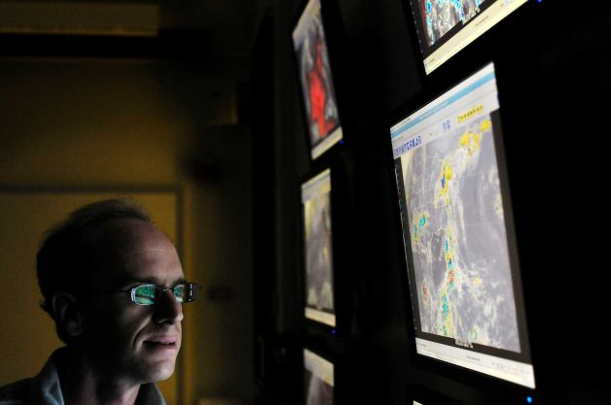

Paul Roundy, an associate professor of atmospheric science at University at Albany, talks about   
satellite images which show infrared radiation Monday, July 1, 2013, during an interview at the   
college in Albany, N.Y. (Paul Buckowski / Times Union)

Anyone who counts on the weather forecast for planning a summer picnic knows getting an accurate prediction for even one day ahead is no sure thing.

[Paul Roundy](http://www.timesunion.com/?controllerName=search&action=search&channel=business&search=1&inlineLink=1&query=%22Paul+Roundy%22) is looking out a good deal further — say, a month at a time. The associate professor in the University at Albany's [Department of Atmospheric and Environmental Sciences](http://www.timesunion.com/?controllerName=search&action=search&channel=business&search=1&inlineLink=1&query=%22Department+of+Atmospheric+and+Environmental+Sciences%22) makes weather predictions from atmospheric waves, created by rain-related tropical heat, that can be as large as Earth itself. He's not trying to determine if, say, it will rain in the middle of a particular afternoon, but what general patterns will persist or change: several weeks that are unseasonably cool, for instance, or a particularly snowy period weeks ahead.

While his forecasts are less specific than what you see in this newspaper for the next 24 hours or week, the general patterns they predict provide the energy industry or large chain stores that sell seasonal supplies with general trends that assist their planning.

"I study these waves in the tropics and how they interact with global atmospheric circulation," Roundy said.

To predict weather in the United States, Roundy analyzes air circulating in the tropics. One of the major systems he tracks is the Madden-Julian oscillation, a tropical pattern he predicts will become as well-known in the future as El Nino, a weather system that it can influence. The MJO can take 40-50 days to play out — 20 days of rain, say, followed by 20 days of dry weather. The number of days is not always the same, Roundy said, but the pattern of a sustained period of rain followed by a similar length of dry weather is typical to MJO.

Roundy analyzes models that show how MJO might move around equatorial regions — bands of precipitation bordered by clear air, moving generally from west to east. He then looks at other overlying weather patterns and statistics, then makes some subjective judgments about how to weigh their worth.

In his office Monday, Roundy showed how even a simple index using some of this data could produce broad but nonetheless useful forecasts. Looking at how the MJO interacts with mid-latitude climates — that includes all of the United States — he predicted it will be unseasonably cool in the central part of the country and moist in the Northeast through the middle of July, followed by a warmer-than-average period at the end of the month.

His likelihood of accuracy with this simple index for this time frame, he said, was perhaps only 60 percent.

"It's better than rolling the dice, but you will be wrong sometimes," he quipped.

Nonetheless, even that degree of accuracy can be useful in some industries, he explained. Someone investing regularly in natural gas heating futures, for instance, will likely come out ahead with a 60 percent chance.

"But if it's a one-off (investment), it's not worth the risk," he said.

Roundy contributes a more sophisticated analysis to the MJO Global Threats Hazards weekly report, which, for example, helped warn the energy industry about extremely unusual weather in March 2012, when temperatures topped 80 degrees.

[*chughes@timesunion.com*](mailto:chughes@timesunion.com) *• 518-454-5417*

**VITALS**

Age: 39

Lives in East Schodack

Married with four children, ages 5, 8, 10, 13

Grew up in southern Idaho

Joined UAlbany seven years ago

Enjoys gardening, running and playing with his kids

Info: <http://www.timesunion.com/business/article/Forecaster-tends-to-see-the-big-weather-picture-4641375.php>

May 21, 2013

UAlbany Researchers Seek to Improve Thunderstorm Forecasting

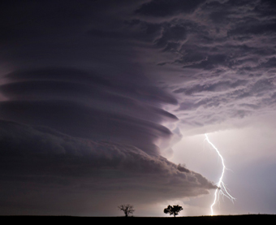

UAlbany researchers are hoping to improve forecasting models for   
thunderstorms, such as supercell events common to the Great Plains region.

ALBANY, N.Y. (May 21, 2013) – University at Albany atmospheric scientists **Lance Bosart** and **Ryan Torn** are part of an elite team of researchers working with the National Center for Atmospheric Research in Boulder, Colorado, to improve the models that forecast thunderstorms.

The Mesoscale Predictability Experiment (MPEX) will be conducted through June 15 and take advantage of the known high frequency of widespread, severe storm outbreaks over the Great Plains region.

From flash flooding to high winds or lightning strikes, thunderstorms hold the potential to devastate communities in mere minutes. While not as large as hurricanes or blizzards, thunderstorms, nonetheless are responsible for several hundred deaths and billions of dollars in property damage each year in the U.S.

“The goal of MPEX is to evaluate whether taking targeted observations of features within the holes of the observation network could influence the development and intensity of thunderstorms and ultimately improve weather forecasts,” said Torn, an assistant professor at UAlbany who examines atmospheric predictability and computer weather models. “We also want to better understand how thunderstorms modify the atmospheric environment they move through.”

The project will include early morning flights with the NSF/NCAR Gulfstream V aircraft to sample the pre-storm atmosphere across Colorado and nearby states. In MPEX, the aircraft will cruise at 40,000 feet for up to six hours, which will enable researchers to thoroughly canvass the entire region where triggers for severe weather lurk. MPEX will also include afternoon launches of weather balloons carrying instrument packages that will profile conditions around thunderstorms as they develop and move east across the Great Plains.

Bosart, a distinguished professor at UAlbany, and Torn will act as operations directors during their month-long stay at NCAR. UAlbany graduate student **Corey Guastini** will also assist in forecasting. After the data collection is complete, Torn will work with UAlbany students in the fall to examine and analyze the information.

“We’ll be evaluating the cases to determine how well we sampled the important regions and trying to understand how errors in atmospheric models grow and evolve to impact thunderstorm forecasts,” said Torn. “We hope to ascertain if examining the thunderstorms in this manner holds the potential to significantly improve the predictability of the more regional aspects of convective weather, and to improve the probability timeframe for these often devastating events.”

In addition to the University at Albany, the project also includes the National Center for Atmospheric Research (NCAR); Colorado State University; Purdue University; the University of Wisconsin–Milwaukee; and NOAA's National Severe Storms Laboratory (NSSL).

Info: <http://www.albany.edu/news/38664.php>

April 26, 2013

UAlbany Advanced Computing System Provides Large-Scale Capacity to Examine Arctic Sea-Ice Variations, Tropical Hurricane Formation

|  |
| --- |
|  |
|  |

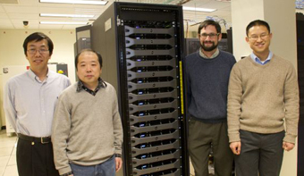

|  |
| --- |
| Liming Zhou, Jiping Liu, Justin Minder, and Brian Tang, Department of Atmospheric and Environmental Sciences Faculty. |

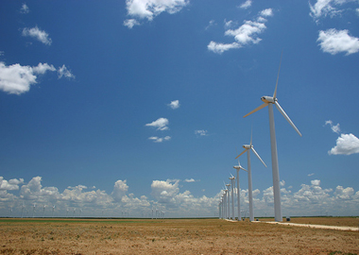

Texas Mill Wind Farm

ALBANY, N.Y. (April 25, 2013) A new, highly sophisticated computing system will allow several new University at Albany Atmospheric Scientists to conduct large-scale research of arctic sea-ice variations, tropical hurricane formations and structure, and boundary layer weather conditions of large operational wind farms.

The computing system, which combines servers and storage into a ‘cluster,’ represents the University’s most powerful and architecturally advanced supercomputer.

UAlbany’s Department of Atmospheric and Environmental Sciences (DAES) and the Office of Information Technology Services ((ITS) acquired the supercomputer, aided in part by a $35,000 grant from the New York State Division of Science, Technology and Innovation (NYSTAR). The cluster provides the department with the computing capability to conduct large-scale atmospheric modeling projects.

UAlbany Atmospheric Sciences faculty members will utilize the cluster for the following research:

Understand how weather and climate works on the scales at which humans and ecosystems are affected - Assistant Professor Justin Minder will use to the cluster for high-resolution simulations of the processes controlling temperatures, winds, rain, and snow on local scales, as well as the processes shaping local response to climate change. The computational power provided by SNOW will allow for detailed simulation of individual cloud features, such as lake-effect snow bands. It will also offer long simulations that characterize the mechanisms of regional climate change such as the effect of snow-loss over mountains on regional weather and hydrology.

Study the impacts of changing polar sea ice on weather and climate, and implement polar sea ice forecasting - Assistant Professor Jiping Liu will utilize the cluster to explore how arctic sea-ice variations impact the weather in high latitudes during winter subsequent to the observed variations.

Investigate the causes of variability in hurricane structure, intensity and frequency using a hierarchy of different modeling approaches - Assistant Professor Brian Tang will use SNOW to run idealized simulations investigating the climatology of tropical disturbances and clusters of convection, and idealized high-resolution hurricane simulations to investigate the dynamics and thermodynamics of tropical cyclones.

Conduct numerical simulations using Weather Research and Forecasting (WRF) models to explore the impact of wind farms on local climates - Associate Professor Liming Zhou will conduct high-resolution modeling using weather and climate prediction models. He will examine the sensitivity of key hydro-climate variables to the presence of large operational wind farms, and monitor the changes in atmospheric boundary layer processes and conditions in the context of land cover use and global warming.

Housed in the University Data Center, the cluster consists of 512 Intel cores with 4 terabytes of RAM, 30 terabytes of scratch disk space and a quad-data-rate Infiniband computational communication backplane. The system can be instantly configured to give individual investigators dedicated, reserved resources or work as one large system.

More Info: <http://www.albany.edu/news/37698.php>

March 18, 2013

Associate Professor Mathias Vuille participated in a meeting organized by the Comunidad Andina (Andean nations of Colombia, Ecuador, Peru and Bolivia) in La Paz, Bolivia between March 13-15. The goal of the meeting was to assess climate change projections elaborated by each country over the past several years within a World Bank funded project to adapt to climate change and glacier retreat. Dr. Vuille was invited as an external project evaluator and gave 4 keynotes on Andean climate, climate change impacts, regional climate change projections and possible adaptation strategies.

February 19, 2013

**UAlbany Research: Tackling Climate Change**

Discover the research of UAlbany's associate professor Mathias Vuille as he ventures into the Andes to study the effects of glacier melt and trains students to tackle this global challenge.

<http://www.albany.edu/news/35590.php?WT.source=home&WT.svl=headline>

<http://www.albany.edu/research/>

January 7, 2013

**PhD Student Nicholas Joseph Schiraldi** wins First Place Poster Award for *“An Operational Approach to Predicting the Global Circulation Impacts of Simultaneous Interaction between the MJO and Equatorial Rossby Waves”* (**N. Schiraldi**, P.E. Roundy, D. Margolin, and L. F. Bosart) at the 2013 American Meteorological Society’s (AMS) Special Symposium on Advancing Weather and Climate Forecasts: Innovative Techniques and Applications.

Friday, December 14, 2012

**UAlbany grant plan gets OK**

**Governor's approval, after earlier objections, frees $35 million that will help start large-scale projects**

**By** [**Scott Waldman**](http://www.timesunion.com/scottwaldman/)

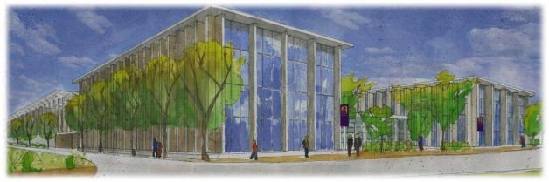

Rendering of proposed E-TECH building at University at Albany. The state University at Albany has proposed a $165 million Emerging Technology and Entreneurship Complex. The new 225,000-square-foot center, which would be located on the west side of campus near the Life Sciences building, would house expanded programs in Atmosphere and Environmental Sciences, biomedical and biotechnology studies, forensic science and cybersecurity, and advanced data and analytics. (University at Albany)

Read more: <http://www.timesunion.com/local/article/UAlbany-grant-plan-gets-OK-4117333.php>

October 31, 2012

**DAES Expertise and Sandy Media Coverage  
  
YNN:** <http://capitalregion.ynn.com/content/capital_tonight/video/609502/climate-change-interview/>

**Science Friday:** <http://www.luisquevedo.org/>  
  
**Times Union:** <http://www.timesunion.com/local/article/The-risk-of-extreme-weather-on-upswing-3998651.php#photo-3673505>  
  
**Times Union**: <http://blog.timesunion.com/weather/>**Register-Star:**  <http://www.registerstar.com/news/>.  
  
**WAMC:** <http://wamc.org/post/damage-widespread-northeast-reflects-historic-storm>.

**Saratoga Wire:** [http://saratogawire.com/article/437/121030-hurricane-sandy-a-bust-for-saratoga/](http://saratogawire.com/article/437/121030-hurricane-sandy-a-bust-for-saratoga/%20%20)   
  
**CBS 6:** <http://www.cbs6albany.com/news/top-stories/stories/ualbany-professor-describes-flight-into-sandy-3899.shtml>   
  
**Times Union:** [http://www.timesunion.com/local/article/UAlbany-researcher-flies-straight-into-Sandy-3990804.php#ixzz2AiXnDFxh](http://www.timesunion.com/local/article/UAlbany-researcher-flies-straight-into-Sandy-3990804.php#ixzz2AiXnDFxh  )   
  
**Times Union:** [http://www.timesunion.com/local/article/Storm-readiness-a-priority-3984339.php#page-1](http://www.timesunion.com/local/article/Storm-readiness-a-priority-3984339.php%23page-1%20)  
 **Times Union:** <http://www.timesunion.com/opinion/article/The-storms-of-New-York-4047064.php#page-1>

Monday, October 23, 2012

**Dr. Roberta Johnson** has been selected as the 2012 recipient of the American Meteorological Society Award for Outstanding Service to Pre-college Teachers. This award recognizes Roberta’s contribution and service to Science education across the country. Dr. Johnson’s dedication to the Science education profession is recognized by this award.

Friday, October 19, 2012

**Winter weather forecasts are out; are we in for big snow?**

Reported by: Nicole Papay

Email: [nicolepapay@fox23news.com](mailto:nicolepapay@fox23news.com)

Last year showed us nature is perfectly fine dumping snow on us in October, so what can we expect this winter? The National Oceanic and Atmospheric Assocation's climate prediction center, AccuWeather, and the Old Farmer's Almanac have all released 2012-2013 winter forecasts.  
  
FOX23 Chief Meteorologist Steve Teeling says the NOAA is giving equal chances for it to be cold or warm, but on average, says the weather will be normal. AccuWeather and the Old Farmer's Almanac have predicted a colder, snowier winter.   
  
But, the local community seems split on whether or not to believe in long-range forecasts.   
  
"I'm not skeptical. I just read each one and say, 'Well, who's going to come in the forefront and be the winner?," said Scarlette Kinley of Albany.  
  
"We hope for the best," said Jodi Modri of Loudonville. "We don't really look into articles or the Farmers' Almanac."  
  
If you follow long-range forecasts, it's important to know how they're built. Typically, the data goes through a computer, which then spits out a base forecast for a meteorologist to analyze.   
  
**Dr. Paul Roundy, an Associate Professor at UAlbany for Atmospheric and Earth Sciences**, said, "Every model that you might find has different biases, different tendencies to be wrong in different ways, so it takes some work to interpret these things."  
  
The Farmer's Almanac is different and makes its forecast secretly. It claims a mathematical, human-calculated formula takes into account sunspots, tides, moon phases and more. To know which forecast to follow, you need to take into account its history.   
  
"Make sure that there's verification data available from past forecasts," said Dr. Roundy. "Don't just trust any one outright. They all follow different techniques and some will have different levels of skill in different scenarios."  
  
Last winter, Farmers' Almanac predicted above-normal precipitation and above-normal temperatures, so less snow than normal. AccuWeather predicted above average snowfall, and NOAA, same as this year, predicted an equal chance for above or below average snowfall.   
  
The Farmers' Almanac seems to win for last winter, so we'll have to wait and see for this year.

**Video**: <http://www.fox23news.com/news/local/story/Winter-weather-forecasts-are-out-are-we-in-for/21zGu7dj6Em-hNV0ia-EFQ.cspx>

Wednesday, October 16, 2012

|  |
| --- |
| **Aiguo Dai Receives 2012 International Surface Water Prize**    http://www.albany.edu/cas/photos/news_event_photos/dai_surface_1.jpghttp://www.albany.edu/cas/photos/news_event_photos/aiguo_2.jpg |
| The **Surface Water Prize** of the 5th Award of the [Prince Sultan Bin Abdulaziz International Prize for Water (PSIPW)](http://www.psipw.org/index.php?option=com_content&view=article&id=98&Itemid=284) was awarded to [Dr. Kevin E. Trenberth](http://www.cgd.ucar.edu/cas/Trenberth/) (left; National Center for Atmospheric Research, USA) and [Dr. Aiguo Dai](http://www.atmos.albany.edu/facstaff/adai/) (right; Department of Atmospheric and Environmental Sciences, University at Albany, SUNY, USA) on September 27, 2012 in Riyadh. The bi-annual PSIPW aims to give recognition to the efforts that scientists, inventors, and research organizations around the world are making in water related fields. PSIPW acknowledges exceptional and innovative work which contributes to the sustainable availability of potable water and the alleviation of the escalating global problem of water scarcity. The award includes a cash prize of half million Riyals (~$133,000).  The prize was awarded to Dr. Trenberth and Dr. Dai for ground-breaking work that provides a powerful estimate of the effects of climate change on the global hydrological cycle, with a clear explanation of the global water budget.  If we are going to talk about hydrology in the 21st century, and the challenges hydrologists face, clearly the overwhelming challenge is to understand hydrologic variability, and the likely impact on hydrology of anticipated climate change. Dr. Kevin Trenberth and Dr. Aiguo Dai have made a unique contribution through the investigation of climate variability and trends in the past, and through the use of models and other creative efforts to reconstruct river discharge into the oceans across the planet for almost 1000 river basins. They use climate models to understand likely changes in the future and the uncertainty associated with those predictions, and explain their findings using such popular indicators as the Palmer drought severity index. As a result, they have provided an exemplary account of the global water budget that is being used in textbooks and encyclopedias.  They have made pioneering contributions to understanding the past with real data, and evaluating the future prospects within the context of what we know of the global climate and hydrology. They have provided a much better understanding of hydrologic responses to climate change, which in turn will provide tremendous guidance for future planning. |

For more information: <http://www.albany.edu/cas/news-dai-surface.shtml>

Monday, October 15, 2012

**DR. LOUIS W. UCCELLINI**, Director, National Centers for Environmental Prediction (NCEP), National Weather Service (NWS) and The National Oceanic and Atmospheric Administration (NOAA), will give a special seminar “Taking Prediction to the Next Level: Expanding Beyond Today’s Weather, Water and Climate Forecasts and Projections” on **Sunday, November 11th at 7:00pm, in the University at Albany, Life Science Research Building, D'Ambra Auditorium.**

**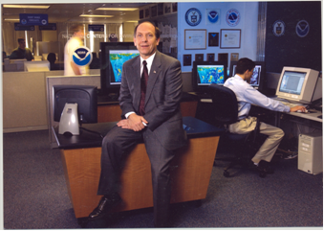 *“NCEP - From the Sun to the Sea:   
Where America’s Climate, Weather, Ocean & Space Weather Services Begin”***

Over the past 60+ years, the research and operational weather enterprise has made revolutionary advances in the prediction of weather. Remarkably, even greater progress has been made in the prediction of extreme weather events including hurricanes, tornado outbreaks, snowstorms, heat waves and heavy rainfall out to 7 days in advance (in some cases). In this presentation, Dr. Louis W. Uccellini, Director of the National Weather Service’s National Centers for Environmental Prediction, will review the advancements that have been made in weather prediction. He will then trace the revolutionary transformation of forecasting from a subjective “art” in the 1940’s to the applied physical science that it is today. Today’s forecast process is based on 1) an integrated global observing system, 2) numerical weather, climate and hydrologic prediction models and 3) the world’s fastest computers. He will also describe how climate, weather and water predictions are being linked to decision makers, including the emergency management, water resource communities, health officials and others, and discuss how these developing requirements are helping to shape a forecast system that can be extended to such areas as water resources and health vectors. The talk will conclude with a summary of the various improvements required to meet the growing demands and increasing expectations placed on the forecast community. Improving the “Earth-System” components of the prediction systems is only one of the challenges. The increasing need for an ensemble model approach to define forecast uncertainty as we push the limits of predictability is another. Finally, as those involved in making critical life-saving decisions (based, in part, on these prediction capabilities) become more dependent on weather forecasts for decision support services, the way forecasts are disseminated in critical life-threatening situations and uncertainty conveyed will also need to be addressed. As will be discussed, the links between science and social sciences and related challenges associated with advancing the use of improved weather forecasts will provide a fundamental basis for taking predictions to the next level.

Thursday, October 4, 2012

**Dr. Paul Roundy Receives AMS Editor’s Award**

Associate Professor **Dr. Paul Roundy** was given a prestigious editors award from the American Meteorological Society for reviews he contributed to the journal Monthly Weather Review. The AMS announcement states that he was chosen for the award "For a large number of prompt and high-quality reviews, and for assistance to the editors in making decisions on controversial papers.*"*

Monday, September 10, 2012

[UAlbany News Center](http://www.albany.edu/news)

News Release iconContact: [Media Relations Office](mailto:mediarelations@uamail.albany.edu) (518) 956-8150

UAlbany Students Join NASA Mission to Discover Why Some Storms Pack a Wallop

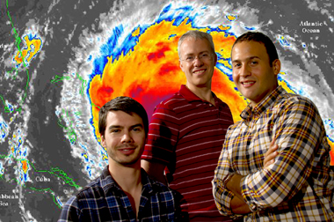

From left, Alan Brammer, Professor Chris Thorncroft, and Mike Ventrice, are involved with the NASA mission. (Photo by Mark Schmidt)

<http://www.albany.edu/news/28428.php>

ALBANY, N.Y. (September 7, 2012) -- Mike Ventrice and Alan Brammer are packing their bags for a “cool” mission at the NASA Wallops Flight Facility in Virginia. The UAlbany doctoral students will forecast when to deploy two unmanned Global Hawk aircraft into developing tropical storms in the Atlantic Ocean basin

|  |
| --- |
|  |
|  |

Along with fellow [Department of Atmospheric and Environmental Sciences](http://www.atmos.albany.edu/) graduate student Jason Dunion, Professor Chris Thorncroft and his UAlbany colleagues John Molinari, Kristen Corbosiero, and Lance Bosart, Ventrice and Brammer will join the $30 million NASA mission, the Hurricane and Severe Storm Sentinel (HS3), specifically targeted to investigate the processes that underlie hurricane formation and intensity change in the Atlantic Ocean.

The mystery surrounding why some storms quickly intensify into dangerous hurricanes remains unsolved, and more advance warning of an approaching storm would help protect people’s lives and property.

“The cool factor comes from the fact that we will be flying two unmanned aircraft to measure hurricanes and their environment – to learn about the birth of hurricanes as well as factors that determine how intense these hurricanes can become and what determines whether a hurricane will intensify rapidly or not,” said Thorncroft, who added UAlbany will be involved in the project in 2013 and 2014 as well.

Of the $30 million obtained by NASA for the project, Thorncroft’s research is funded at $684,488.  DAES colleagues Corbosiero and Molinari obtained an additional $300,000 grant to work on the same project. In addition, graduate student Jason Dunion successfully led a proposal with Lance Bosart (DAES) and Chris Velden of the Space Science and Engineering Center (SSEC) at the University of Wisconsin-Madison that obtained $325,000. In addition to doing his Ph.D. at UAlbany, Dunion also works for the NOAA Hurricane Research Division in Miami and was key to helping coordinate manned NOAA aircraft missions with NASA Global Hawk flights. Dunion is also leading the coordination of the Hurricane Research Division’s daily map discussions that are used for planning NOAA’s field activities during the season.

Lee Harrison of the [Atmospheric Sciences Research Center](http://www.asrc.albany.edu/) (ASRC) is also participating in HS3 - he is carrying out collaborative research (funded by NASA and the Office of Naval Research) with Yankee Environmental systems to develop atmospheric observation instrumentation that will be deployed on the Global Hawks in 2013.

Ventrice, of Patchogue, N.Y., who plans to graduate in December, said, “This field campaign is unique and it is an honor to be part of such an event. UAlbany is one of a few select universities contributing to the field campaign. Albany is developing a number of products to use operationally for forecasting the formation of Atlantic tropical cyclones.”

As part of a small team of two or three forecasters, he and Brammer will be on the lookout for areas where a tropical cyclone may form or intensify.

Brammer, of Macclesfield, England, said, “Making a correct forecast and being able to position the Global Hawk over a developing system for such a long period of time and thus capture those early periods of development will be very useful for trying to understand the cyclogenesis process.”

One of the benefits of the upcoming forecasting mission for NASA is that the planes allow for extended flight times and observations further East than is typically attainable.

“Each Global Hawk can literally fly over the hurricane for 24 hours continuously,” said Molinari. “We have never had anything close to that capability with other aircraft.”

Brammer added that they will be studying the environment surrounding storms as well as the inner dynamics within a storm, to better understand the interaction between storm and environment.

The experience also gives UAlbany students a competitive edge.

“Being a member of a field campaign [like this one] is highly desirable because it shows future employers that you have true experience in the field. Further, it allows you to meet a broad range of professionals who will help you find your career path,” said Ventrice.

Learn more about a major in [atmospheric science](http://www.atmos.albany.edu/). For more UAlbany news, visit the [News Center](http://www.albany.edu/news/index.php?WT.svl=28471t.%20).

Friday, August 31, 2012

**Dr. Ryan Torn Shares “Lessons Learned From Last Summer’s Hurricane Season”**

Professor Ryan Torn examines the latest predictions for Tropical Storm Isaac in his office at UAlbany.

[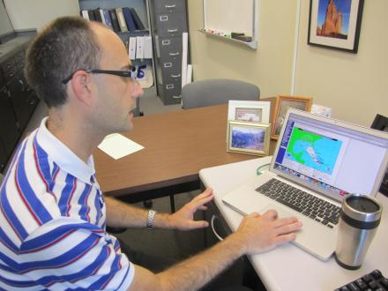](http://mediad.publicbroadcasting.net/p/innovationtrail/files/201208/IMG_1185.JPG)

Credit Marie Cusick / WMHT

Flooding in downtown Binghamton at the convergence of the Susquehanna and Chenango Rivers after Tropical Storm Lee.

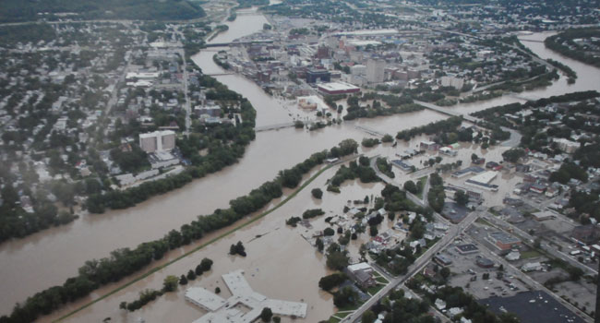

Credit Ed Aswad

A home in the Catskill Mountain town of Prattsville after Tropical Storm Irene

[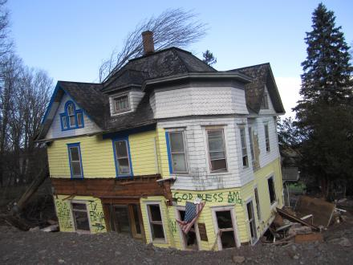](http://mediad.publicbroadcasting.net/p/innovationtrail/files/201208/IMG_0710_0.JPG)

Credit Marie Cusick / WMHT

The Mohawk River floods the Erie Canal outside of Amsterdam.

[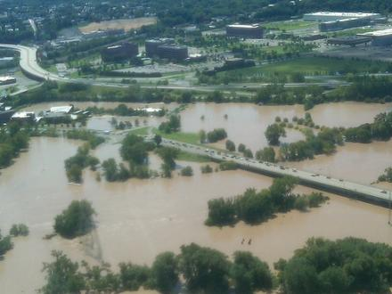](http://mediad.publicbroadcasting.net/p/innovationtrail/files/201208/Photo%20by%20Karen%20DeWitt.jpg)

Credit Karen DeWitt / New York State Public Radio

The Hudson River floods parts of Troy after Irene.

[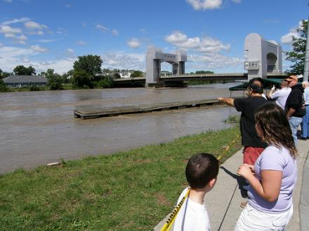](http://mediad.publicbroadcasting.net/p/innovationtrail/files/201208/Troy%202.jpg)

Credit Matt Ryan / WMHT

Flooding from Irene devastates parts of the Schoharie Valley.

[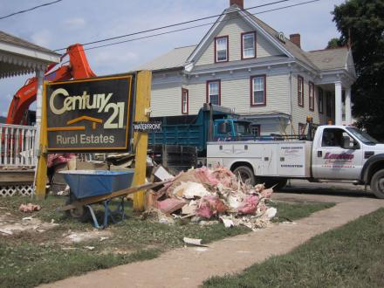](http://mediad.publicbroadcasting.net/p/innovationtrail/files/201208/IMG_0497.JPG)

Credit Marie Cusick / WMHT

A shelter for victims of Tropical Storm Lee in Binghamton.

[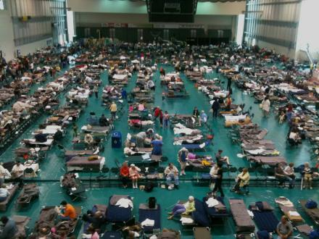](http://mediad.publicbroadcasting.net/p/innovationtrail/files/201208/bushelter.jpg)

Credit Matt Richmond / WSKG

Last summer when Irene and Lee blew through New York, both were classified as tropical storms, not hurricanes. Yet they still managed to cause $1.5 billion in damage across the state. A year later, the cleanup and recovery is far from complete.

So how can these weaker storms still wreak such havoc? And did the classification of the events as tropical storms rather than hurricanes cause some people to let down their guard?

"In hindsight, there were several groups that were trying to communicate that the rainfall was going to be the big issue with this storm, but it didn’t always get into the public perception."

Dr. Ryan Torn is an expert in atmospheric prediction at the University at Albany. He talks about how scientists are getting better at understanding how extreme weather behaves, and why people don't always heed the warnings.

*Note: this interview has been edited for length and clarity*

**Q: What is the most dangerous aspect of a hurricane?**

**A:** It really depends on a number of factors, starting with where you live and the intensity of the hurricane. For a lot of weaker hurricanes, people often let their guard down. They think ‘Oh, the wind is weaker so it must not be that dangerous. I can stay in my house.’ Especially people who are inland.

In a lot of cases in a weaker hurricane, the bigger danger is the rainfall. There can be many inches of rain as we saw last year as we saw last year with Irene. In the stronger storms, if you’re on the coast, there’s a double danger: the wind speed and/or the storm surge.

There’s not a perfect relationship between wind speed and storm surge. You can have weaker storms that can create a huge storm surge, or you can have intense storms that don’t have a big storm surge.

**Q: So a really weak storm that just sits over the land can do a lot more damage than a powerful storm that blows by the coast?**

**A:** Absolutely.

**Q: How have weather modeling and hurricane forecasts improved? What are scientists still struggling to understand?**

**A:** We’ve gotten a lot better at track over the past 20 years. We’re improving track forecasts on the order of a few percent per year. Over time, what used to be two-day track error, is now a three-day track error.

The leading reason we’ve gotten better is that we’ve been making models of the large-scale aspects of the atmosphere. We’re getting really good at taking observations of the oceans with satellites and incorporating those observations into our numerical models.

If we talk about the maximum wind-speed forecast of the hurricane (or intensity) we haven’t gotten really better over the last 20 years.

Hurricanes have these large-scale influences like how much water vapor is in the air, and the difference in wind speed at different levels of the atmosphere (or vertical shear). We’re pretty good at predicting those things. We also have a pretty good idea of what the sea surface temperature looks like.

What we don’t really know too much about are what we call “internal processes.” Hurricanes can go through a lot of natural fluctuations. There’s something called an "eyewall" replacement cycle where the hurricane can actually create a new "eyewall". It’s a really interesting process; the position of the eye (of the hurricane) changes.

In 2005, scientists observed this through aircraft really vividly in Katrina and Rita. We know how the process happens, but we don’t know how it starts yet, or what causes it to start.

**Q: Another thing scientists don’t understand very well is how much rain a hurricane can produce— why is that?**

**A:** One issue is data. Over the ocean there are no rain gauges for us to be measuring. Once a hurricane comes on shore, there are a lot of rainfall measurements.  There have been a lot of studies, especially in the Southeastern United States, about some of the factors that give enhanced rainfall.

But it’s often easier to do hurricane research over the ocean. Land adds a big complication factor. So while you have lots of rain gauge data over land, it’s often hard to pick out how much of that rainfall is coming from a land influence versus the hurricane itself. Rainfall in general is a very hard problem for models. It’s one of the weaker links in numerical models.

In the case of Irene, there was a good sense that there was going to be a lot of rain. No one had a really good feel for what the exact number was going to be, but everyone knew that this was going to be a very large rain event three days out.

In hindsight, there were several groups that were trying to communicate that the rainfall was going to be the big issue with this storm, but it didn’t always get into the public perception.

**Q: Is it difficult sometimes to get weather messages out to the public and make sure people act on the warnings?**

**A:** There’s a whole group of social scientists that are really interested in this problem… giving people raw forecast data and then trying to see how they use that data.

With Irene, forecasters were putting out warnings a few days beforehand saying, ‘Hey, this looks like it’s going to be a lot of rainfall.’ The problem is I think sometimes the public perception is different in that the notion of a storm surge in New York City is a more exciting thing than rainfall over upstate New York.

So that just got a lot of media attention, but I would say the experts had a pretty good handle on this storm.

**Q: Hurricane Irene was downgraded to a tropical storm before it hit New York. Do you think that caused some people to take the threat less seriously?**

**A:** That’s absolutely a fear for forecasters. The category of a storm only describes its wind speed, it doesn’t describe all those other things. It doesn’t describe storm surge or rainfall. People can let their guard down.

This happened in 2008 with Ike in Texas. As it was approaching the Houston area, many people evacuated. Then the storm weakened. The problem was that when it had been stronger, it created a large storm surge over the ocean. Storm surge doesn’t respond to the instantaneous wind, it’s kind of a history of all that sustained wind over many days.

So all of a sudden, there’s this Category 2 storm, and people are thinking they can deal with that. But because it had been so large and so intense for several days before that, it came with a very large storm surge and caught a lot of people by surprise and did a lot of damage.

With Irene people said, ‘Oh, the wind speed is going down. Not a big deal.’ But again, they didn’t take rainfall into account. With weaker storms, the bigger impact is often rainfall, and rainfall will often have a bigger impact over a larger area than wind and storm surge will, which are primarily costal problems.

**Q: Say we’d all listened carefully to the Irene forecasts. Other than evacuating, what can you really do about massive flooding?**

**A:** In this kind of event, not much. In theory, we could have drawn the reservoirs down to a really low level, but you need some time to do that.

I know a couple of days beforehand, they did start opening up reservoirs, but this is just a really extreme event. When you get that much rain over that large of an area, over that amount of time, there’s just not much you can do, except to warn people.

**Q: What role does climate change play in hurricanes?**

**A:** That’s a very hotly debated topic right now. There are lots of things that go into intensity change in hurricanes.

One of the things people readily see is that the intensity of a hurricane is a function of the sea surface temperature. The warmer the sea surface temperature is, typically you’ll get a more intense hurricane.

All other things being equal, with climate change you might expect the sea surface temperatures to get warmer, and you might expect there to be more intense hurricanes.

There was data about five years ago, and several groups published studies showing that the global intensity of hurricanes has increased over past 20 years. They looked at sea surface temperatures and they saw they’d increased at the same time. So they said, ‘Oh there must be a relationship between the two.’ They predicted that hurricane intensity would keep going up.

It turns out that in 2010 and 2011 we’ve observed some of the lowest intensity hurricanes over the past 40 years.

That kind of threw everyone a curveball. There’s no good explanation as to why all of a sudden we’ve gone to a minimum, in terms of intensity. You have to start thinking about some of these other factors—like a difference in wind speed (or wind shear). The more wind shear you have, the harder it is for a hurricane to develop for a variety of physical reasons.

One of the things we don’t really know about going into the future, is how is that distribution of wind shear is going to change. Even if the sea surface temperature warms a lot, if the wind shear changes, we may not get any increase in intensity. It may get harder to make a hurricane, in general.

The scientific consensus seems to be that we should get more intense hurricanes in the future, but we might get fewer of them.

But I would say this is one of the great open questions in the field right now.

**Mapping the threat**

Researchers at the National Center for Atmospheric Research developed this map, which shows how vulnerable different areas are to hurricanes. They cite [a study](http://journals.ametsoc.org/doi/abs/10.1175/1520-0477%282000%29081%3C2065%3ALOLITU%3E2.3.CO%3B2) which shows that more than half of hurricane-related deaths happen in inland counties:

[Hurricane Vulnerability Map by County](http://www.scribd.com/doc/103829380/Hurricane-Vulnerability-Map-by-County)

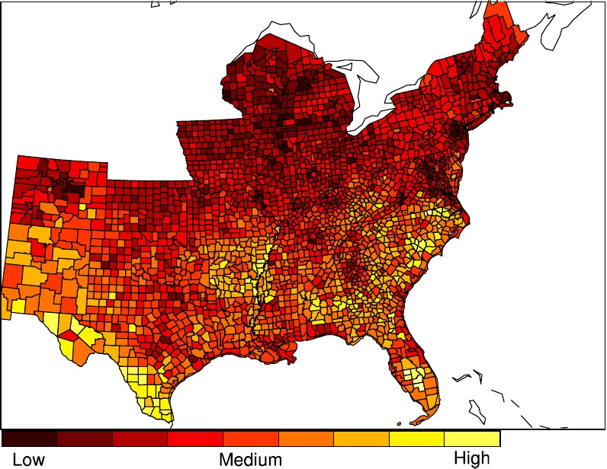

<http://www.innovationtrail.org/post/lessons-last-summers-hurricane-season>

Thursday, August 16, 2012

**Climate Models That Predict More Droughts Win Further Scientific Support**

**By Hristio Boytchev, Published: August 13The Washington Post**

The United States will suffer a series of severe droughts in the next two decades, according to a new [study](http://www.nature.com/nclimate/journal/vaop/ncurrent/full/nclimate1633.html) published in the journal Nature Climate Change. Moreover, global warming will play an increasingly important role in their abundance and severity, claims **Aiguo Dai**, the study’s author and newly appointed **Associate Professor at the University at Albany, Department of Atmospheric and Environmental Sciences** beginning September 1st.

His findings bolster conclusions from climate models used by researchers around the globe that have predicted severe and widespread droughts in coming decades over many land areas. Those models had been questioned because they did not fully reflect actual drought patterns when they were applied to conditions in the past. However, using a statistical method with data about sea surface temperatures, Dai, a climate researcher at the federally funded National Center for Atmospheric Research, found that the model accurately portrayed historic climate events.

“We can now be more confident that the models are correct,” Dai said, “but unfortunately, their predictions are dire.”

In the United States, the main culprit currently is a cold cycle in the surface temperature of the eastern Pacific Ocean. It decreases precipitation, especially over the western part of the country. “We had a similar situation in the Dust Bowl era of the 1930s,” said Dai, who works at the research center’s headquarters in Boulder, Colo.

While current models cannot predict the severity of a drought in a given year, they can assess its probability. “Considering the current trend, I was not surprised by the 2012 drought,” Dai said.

The Pacific cycle is expected to last for the next one or two decades, bringing more aridity. On top of that comes climate change. “Global warming has a subtle effect on drought at the moment,” Dai said, “but by the end of the cold cycle, global warming might take over and continue to cause dryness.”

While the variations in sea temperatures primarily influence precipitation, global warming is expected to bring droughts by increasing evaporation over land. Additionally, Dai predicts more dryness in South America, Southern Europe and Africa.

“The similarity between the observed droughts and the projections from climate models here is striking,” said Peter Cox, a professor of climate system dynamics at Britain’s University of Exeter, who was not involved in Dai’s research. He said he also agrees that the latest models suggest increasing drought to be consistent with man-made climate change.

<http://www.washingtonpost.com/national/health-science/climate-models-that-predict-more-droughts-win-further-scientific-support/2012/08/13/cb4e3108-e16f-11e1-ae7f-d2a13e249eb2_story.html>

Saturday, May 19, 2012

**Class of 2012**

**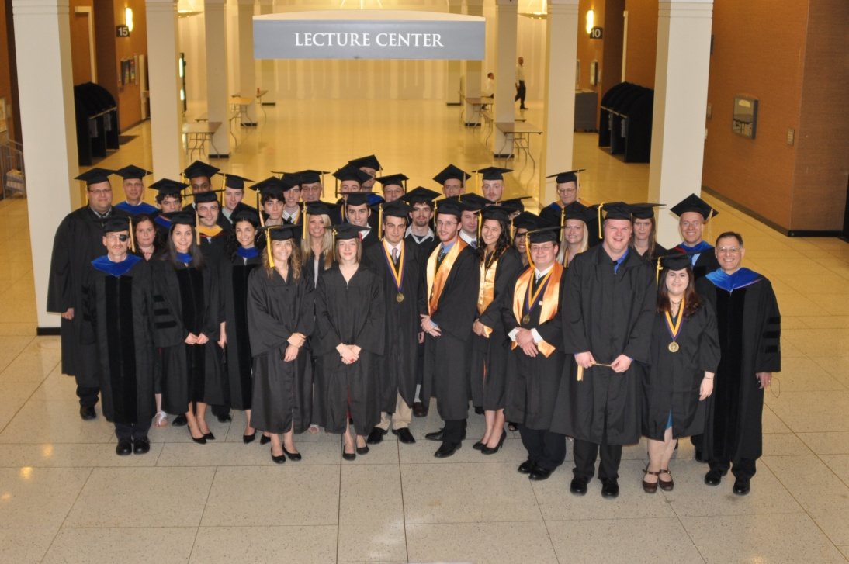**

#### Bachelor of Science in Atmospheric Science

**Hannah E. Attard** *(Magna Cum Laude & Honors Degree)***Kaitlin G. Cooley  
Rachel S. Goldstein** *(Cum Laude)***Timothy W. Humphrey** *(Summa Cum Laude & Honors Degree)***Jason H. Keefer** *(Summa Cum Laude & Honors Degree)***Luigi F. Meccariello  
Adrian N. Mitchell  
Nicholas J. Schiraldi** *(Magna Cum Laude & Honors Degree)* **Marc B. Sedor** *(Cum Laude)***Steven Welch**

**Bachelor of Science in Earth Science  
  
Richard J. Heames  
Tara Laneville  
Kaylee J. Schartner  
Christina M. Torres**

**Bachelor of Arts in Earth and Atmospheric Sciences  
  
Stephen W. Hassard  
Jan C. Nova**

#### Bachelor of Science in Environmental Science

**Chelsea L. Baker**

**Donald B. Bonville**

**Philip J. Canale**

**Jeffrey D. Dzwonkowski** *(Summa Cum Laude)*

**Clare B. Gaffey** *(Magna Cum Laude)*

**Chenyong Han**

**Evan H. Hogan** *(Cum Laude)*

**Lauren R. Holland** *(Summa Cum Laude)*

**Kyle F. Hussey**

**Diane M. Macdowell** *(Cum Laude)*

**Robert J. Moretto** *(Cum Laude)*

**James P. Mulligan**

**Joseph E. Pennisi** *(Magna Cum Laude)***Brian A. Philipps**

**Andrew C. Preston**

**John Puglia**

**Meghan A. Sickles** *(Cum Laude)*

**Zachary M. Smith** *(Magna Cum Laude)*

**Primo R. Stropoli**

**Andrew J. Stummer**

**Laura D. Varble** *(Magna Cum Laude)*

**Danielle E. Wilkens**

**Saturday, May 19, 2012**

Professor and Chair, Chris Thorncroft presented the following student awards at Department of Atmospheric and Environmental Science Recognition Ceremony May 19th:

**Outstanding Student ~ Atmospheric Science Program:**   
Timothy W. Humphrey  
  
**Best Forecaster ~ Atmospheric Science Program:**   
Adrian N. Mitchell  
  
**Outstanding Student ~ Environmental Science Program:**  
Jeffrey D. Dzwonkowski

Friday, March 30, 2012

**Attard, Humphrey and Schiraldi receive   
Presidential Award for Undergraduate Research**

Three Department of Atmospheric and Environmental Sciences students have been named recipients of the 2012 Presidential Award for Undergraduate Research. **Hannah Attard**, **Timothy W. Humphrey** and **Nicholas Schiraldi** will each receive a $100 check in recognition of their success in this important University-wide competition demonstrating outstanding research skills and scholarship.

**Hannah Attard:**

“Large-Scale Precursors to Major Lake-Effect

Snowstorms Lee of Lake Erie”

**Timothy W. Humphrey:**

“Results of a Preliminary Evaluation of CAPE Tendency”

**Nicholas Schiraldi:**

“CFS Reforecast Analysis of Intraseasonal Variability of Tropical/Extratropical Interactions”

March 20, 2012

**Falconer Natural History 2012 Spring Lecture Series Schedule:** <http://www.atmos.albany.edu/daes/falconer.pdf>

February 6, 2012

Mathias Vuille has been invited to serve as a member of the U.S. National Committee (USNC) for the International Union of Quaternary Research (INQUA), for a term ending January 31, 2016. Quaternary research spans the last 2.6 million years of Earth's history. The USNC/INQUA serves as a focal point for U.S. discussion on how to promote the advancement of Quaternary research both in the U.S. and throughout the world.

January 18, 2011

Paul K. Moore graduated with a Bachelor of Science degree in meteorology from the State University of New York (SUNY) College at Oswego in 1985, and went on to receive a Master's degree in atmospheric science from the University at Albany in 1988. His Master's thesis research involved the first in-depth study of cloud-to-ground lightning in lake-effect rain and snowstorms.

The Buffalo Blizzard Book is a fascinating chronicle of the Buffalo region's 200-year battle with its legendary lake-effect blizzards and other monstrous snowstorms.

The saga begins with the tragic consequences of a fierce storm on the eve of the War of 1812, and takes the reader through two centuries of dramatic encounters with Western New York's wild winter weather, including the most recent lake-effect bombardment of December 2010.

Over 50 snowstorms and blizzards are covered in depth, including the long-lasting "Great Christmas Storm" of 1878, the exceptionally destructive "St. Patrick's Day Storm" of 1936, the ferocious "Blizzard of '85," the incredibly devastating "October Surprise" lake-effect storm of 2006, and, of course, Buffalo's unprecedented and incomparable "Blizzard of '77."

The Buffalo Blizzard Book is richly illustrated with over 100 spectacular photographs and prints, and ten informative diagrams. Along with the fast-paced text, they tell the captivating story of winter weather at its very worst…and a community at its very best.

|  |  |
| --- | --- |
|  |  |

<http://www.buffaloblizzardbook.com/>

January 5, 2012

**TEDx Albany-Is Anyone Else Out There?**

John Delano is a Distinguished Teaching Professor in the Department of Atmospheric and Environmental Sciences at the University at Albany (State University of New York), and is the Associate Director of the NASA-funded, multi-institutional New York Center for Astrobiology headquartered at Rensselaer Polytechnic Institute. Professor Delano is the author of 60 scientific publications, and has served on many advisory panels for NASA.  
  
NASA's Astrobiology program is frequently in the news with important discoveries (e.g., discovery of habitable planets orbiting other stars; environments and processes that led to life on Earth; sequencing of DNA that has revealed evolutionary relationships). These discoveries are providing Humanity with a better understanding of the events that have led to life's emergence on this planet and of our context in the galaxy.  
  
In the spirit of ideas worth spreading, TEDx is a program of local, self-organized events that bring people together to share a TED-like experience. At a TEDx event, TEDTalks video and live speakers combine to spark deep discussion and connection in a small group. These local, self-organized events are branded TEDx, where x = independently organized TED event. The TED Conference provides general guidance for the TEDx program, but individual TEDx events are self-organized.\* (\*Subject to certain rules and regulations)

To view Professor Delano’s presentation, please go to NASA’s home page: <http://www.astrobiology.nasa.gov/nai>

November 22, 2011

**Energy Campaign Recap**

The fifth annual Energy Campaign wrapped up on November 13. This year we achieved a 9% reduction in electricity use over our baseline. This represented a 1,095,724 reduction in kilowatt hours and 409 tons of carbon. While we fell a little short of our goal of a 10% reduction, we did improve over last year realizing an additional 20,000 kilowatt hour and 8 ton carbon reduction over last year. The academic buildings garnered a 7% reduction (1% more than last year) and the living residences an 11% reduction (3% less than last year).

A recognition ceremony was added to the campaign to honor those that demonstrated extra effort and commitment to energy conservation. The Best Performer awards, for the largest percent reduction in electricity use from the baseline, went to Freedom Apartments and the Fine Arts building. Empire Commons won the Biggest Impact award for its reduction in kilowatt hours of electricity and carbon emissions. This honor went to the Lecture Centers for the Podium and Arts & Sciences for the Academic Buildings. The Best Quad award went to Colonial Quad, for the largest percent of electricity reduction among the quads. The Most Improved awards went to **Earth Science**, Physics and Business Administration by successfully increasing their electricity reduction over the course of the campaign. The Green Scene award for the academic building most dedicated to creating a culture of sustainability went to the Education building. Lastly, the Honor Roll featured all buildings that had achieved a 10% energy reduction or greater over the campaign. Among the residence areas, this included Empire Commons, Freedom Apartments, and Colonial Quad. Among the academic buildings, the honor went to Arts & Sciences, Business Administration, **Earth Science**, Education, Fine Arts, the Lecture Centers, the PAC, Physics, the Science Library, and the Social Science building.

Congratulations to all our award winners. For more details on the Energy Campaign results go to: http://www.albany.edu/gogreen/4.energycampaign.shtml. A recap of our honorees will be available soon at the recognition page on our website: http://www.albany.edu/gogreen/index.shtml

November 16, 2011

**Physical Controls on Carbon Dioxide Flux to the Atmosphere from a Southern Adirondack Lake**

Matthew Czikowsky, Atmospheric Sciences Research Center, University at Albany

Seasonally-stratified temperate lakes are a source of carbon dioxide to the atmosphere, particularly during autumn overturning as CO2 trapped below the thermocline becomes available to the surface for release to the atmosphere. We made continuous measurements of the vertical profile of pCO2 in a ~600 ha temperate lake (Lake Pleasant, maximum depth ~24 m) in southwestern Adirondack Park, New York from mid-September to mid-October 2010 from a moored pontoon boat. Continuous eddy covariance flux measurements of momentum, sensible and latent heat, and CO2 were made *in situ*, and the water column thermal structure was measured using thermistor chains. The spatial variability (horizontal and vertical) of pCO2 throughout the lake was characterized periodically using a roving profiling system. At the beginning of the study interval, pCO2 at the pontoon boat varied from 500 ppm at the surface to > 3000 ppm below the thermocline. The vertical profile of pCO2 changed markedly during the campaign due to the effects of wind forcing and evaporation (buoyancy), with nearly uniform, high pCO2 throughout the water column at the end of the campaign. The elevated surface water pCO2 increased CO2 emission to the atmosphere.

November 10, 2011

**JOINT COLLOQUIUM SERIES**

**DEPARTMENT OF ATMOSPHERIC & ENVIRONMENTAL SCIENCES & ATMOSPHERIC SCIENCES RESEARCH CENTER**

**Computing and Understanding Forecast Errors in Tropical Cyclone Motion**

**by**

**Thomas Galarneau**

**National Center for Atmospheric Research Boulder, Colorado**

**Monday, Nov. 14, 2011, 4:15 pm**

**Earth Science Room 232**

Previous work has shown that the environment flow is the leading factor that influences tropical cyclone (TC) motion. What exactly is meant by "environment flow" varies greatly among the refereed papers on the subject, but in general it has been suggested that the motion of well-developed TCs can be best approximated by the deep-layer mean wind. Relatively weak TCs may be steered by a lower-tropospheric shallow layer mean wind. How the environment flow is defined may vary greatly from case to case. Typically, the computation of environment flow involves removing the wind field associated with the TC vortex. Since TCs vary in horizontal scale, the computation of the environment wind is sensitive to the radius of TC removal in addition to the vertical depth. How well might the environment flow agree with the actual TC motion when computing the environment flow over a fixed depth and TC removal radius versus a varying depth and radius? Are forecast errors in TC motion primarily due to error in environment wind, or other factors such as errors in vertical depth and/or horizontal structure of the TC? These questions will be addressed in this presentation.

The aim of this presentation is three-fold. First, we will discuss the overall characteristics of TC motion vector errors in the 2011 version of the Advanced Hurricane Weather Research and Forecasting (AHW) model run in real-time, and retrospectively for 2008-2010, at NCAR. Second, we will examine the computation of steering flow and how it is sensitive to the vertical depth and the radius of TC removal. Third, we will examine the TC track forecast busts in AHW for the 2008-2010 retrospective period. Specifically, we will diagnose the sources of error quantitatively in the 24-h AHW forecasts that contributed to large errors in TC motion. We will examine the motion vector errors at 24-h in the AHW forecast because it is (i) relatively certain that the actual position error is small enough that the diagnosis makes sense, and (ii) expected that large errors in TC motion early in the forecast will lead to huge position errors at longer lead times.

# September 23, 2011

**Kerry Emanuel, Breene M. Kerr Professor of Atmospheric Science at MIT,** **will give a special seminar on Black Swan Tropical Cyclones, Sunday, November 6th at 7:00pm, in the University at Albany, Life Science Research Building, D'Ambra Auditorium.**

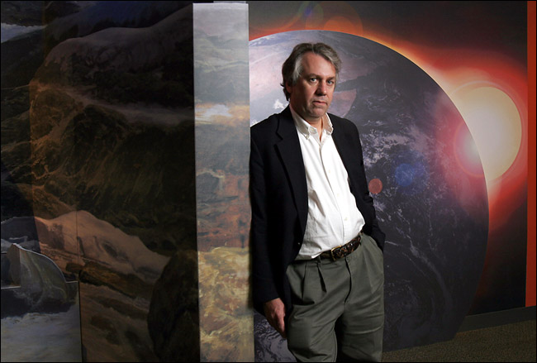Tropical cyclones (a.k.a. “hurricanes”) have no doubt been part of the earth’s climate since the planet formed some 4 billion years ago, but we have only been tracking them with any accuracy for the past 40 years or so. That is enough to give us some idea of their basic climatology…where they typically form and move, and how strong they typically get, but it is not nearly long enough to tell us what the worst possible event is at any given location. But in recent, years, we have developed a technique that allows us to simulate millions of hurricanes in this and possible future climate states that reflect changing climate. When we deploy this technique we see some events that we would not have otherwise thought possible; we have nicknamed these “Black Swan Tropical Cyclones”. In this talk, I will review the basic science of hurricanes as well as our technique for synthesizing large numbers of these storms and use this as background to discuss the rare Black Swans, focusing on their possible impacts on society. ***All are welcome***

# August 22, 2011

The National Center for Atmospheric Research (NCAR) Integrated Science Program (ISP) Summer Colloquium on

**African Weather and Climate: Unique Challenges and Application of New Knowledge   
  
25 July – 5 August 2011, NCAR, Boulder, Colorado**

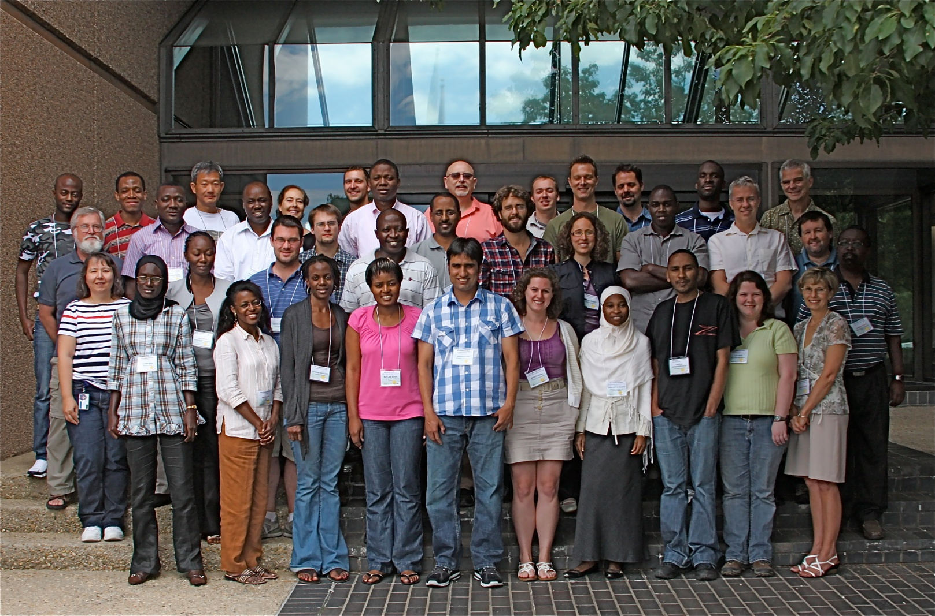  
  
The colloquium aimed to educate and attract graduate students from Africa and the US  (including PhD student Matt Janiga from DAES)  to research with far-reaching consequences and promote their collaboration. The focus was on (i) developing synthesized knowledge on African weather and climate, and (ii) applying modern tools of remote sensing, numerical simulation and prediction, statistical data analysis, and visualization to understand the variability of weather and climate in the African region. Lectures were presented by a core group of instructors, including experts from Africa. Professors Paul Roundy and Chris Thorncroft from the DAES were both invited lecturers. In addition to the lectures students worked in small groups on laboratory exercises and simulations based on case studies. Students also had opportunities to present their research and to identify areas of priority for future collaboration.

# Wednesday, May 25, 2011

Meteorologist Ross Lazear is interviewed by Fox News on the recent tornado activity in the Midwest.   
  
Recipe for Weather Disaster link:

<http://www.clipsyndicate.com/video/playlist/20261/2493444?title=local_news_videos&wpid=9616>

# Saturday, May 14, 2011

Professor and Chair, Christopher Thorncroft presented the following student awards at Department of Atmospheric and Environmental Science Recognition Ceremony, May 14th:

**Atmospheric Science Program Outstanding Students:**   
Alicia Bentley and Sara Ganetis  
**Atmospheric Science Program Best Forecasters:**   
Alicia Bentley and Matthew Corbi  
**Environmental Science Program Outstanding Student:**   
Christopher Ferraro

# Wednesday, May 4, 2011

The Department of Atmospheric and Environmental Science is proud to announce that Thomas J. Galarneau Jr. (PhD ’10) has been selected to receive a 2010-2011 Distinguished Doctoral Dissertation Award for his dissertation: “Tropical Cyclogenesis Associated with Extratropical Precursors in the North Atlantic Basin”.

# Friday, April 29, 2011

DAES PhD student Robert Setzenfand has received a National Science Foundation (NSF) Graduate Research Fellowship, effective Fall 2011. The fellowship provides three years of financial support: a stipend and cost of education allowance, as well as access to the TeraGrid supercomputer. A key component of the application was a proposal to study tropical-extratropical weather interactions.  That proposal was based on recent work by Assistant Professor Paul Roundy and Lynn Gribble Verhagen (MS ‘10).

# Friday, April 8, 2011

Gabriel Susca-Lopata and Alicia Bentley have been named recipients of the Class of 1905 Bazzoni Fellowship Award for 2011.   
  
The Class of 1905 Bazzoni Fellowship was established by Charles Bazzoni in memory of his wife, Edith Vera Bazzoni, both of the Class of 1905. This fellowship is awarded for outstanding achievement in the natural sciences. Each recipient will receive a $1000 fellowship to be used as direct payment toward tuition, books or other educational expenses.

# Wednesday, March 29, 2011

# UAlbany Professor Vuille's Talk on Melting Glaciers in the Andes, March 29, 3rd in Annual Falconer Natural History Spring Lecture Series

|  |
| --- |
| http://www.albany.edu/news/images/meltingglacier%281%29.jpg |
| The effect of glacier retreat in the Andes of Ecuador, Peru and Bolivia will be the subject of a March 29 talk by Professor Mathias Vuille. |

ALBANY, N.Y. (March 14, 2011) -- The Falconer Natural History 2011 Lecture Series continues March 29 at 8 p.m. at the University at Albany John J. Sullivan Auditorium, CESTM building, 251 Fuller Road, Albany. The Tuesday night lectures feature leading scientists on topics ranging from bird migration to melting glaciers, and are free and open to the public.

|  |
| --- |
|  |
|  |

The schedule began on March 15 with Professor Lynn M. Russell of the Scripps Oceanographic Institute's talk on "Can Aerosol Particles Offset Global Warming?", then on March 22 hosted Professor Victor Magaña Rueda of the Universidad Nacional Autónoma de México and his talk on "Urbanization and climate change: the case of central Mexico" on March 22, followed on March 29 by Professor Mathias Vuille of ASRC, addressing "Climate Change in the South American Andes: will the glaciers survive?"

**April 5: Doug Wolfe**, Atmospheric Sciences Research Center, University at Albany, on *Whiteface Mountain - A Natural Laboratory*. The first scientific survey some 175 years ago noted that Whiteface Mountain, with its grand panoramic vistas and unusual flora and fauna, had both tourism and scientific possibilities. ASRC and UAlbany involvement in the past half century will be highlighted.

**April 12: Dr. Judy Shamoun-Baranes**, Institute for Biodiversity and Ecosystem Dynamics, Universiteit van Amsterdam, the Netherlands, on *The intimate relationship between birds and their atmospheric environment*.  Birds are incredibly mobile animals and their ability to fly thousands, even tens of thousands of kilometers a year, is truly spectacular. Yet what happens when birds are trapped in bad weather when flying, or great weather for that matter? Birds, especially migrants, must adapt their behavior to dynamic atmospheric conditions.

**April 19: Spring Break**

**April 26: Deborah Martin** USGS, Denver, Colo., on *Fires, watersheds, and risks: Comparing western and eastern landscapes.* Though wildfires in the western United States are prominently featured in the headlines, fire is also considered one of the major ecological disturbances in eastern ecosystems. Martin will compare the legacy of fire in western and eastern ecosystems and explore the role of fire in future climate scenarios.

Tax-deductible donations to sustain the Natural History Lectures may be made out to the University at Albany Foundation: and mailed to the University at Albany Foundation, UAB 226, 1400 Washington Ave., Albany, N.Y. 12222. Address donations “Attention: Ray Falconer Fund.”

# Monday, March 28, 2011

**Three DAES students receive the Presidential Award for Undergraduate Research.**

1. **Alicia Bentley**: "A Preliminary Climatology of Tropical Moisture Exports in the Southern Hemisphere"

2. **Sara Ganetis**: "Analysis of Banding in 26-27 December 2010 East Coast Blizzard"

3. **Gabriel Susca-Lopata**: "The Role of the Melting Effect in an Oklahoma Winter Storm”

Each student will receive a $100 award, and participate in the 8th Annual Undergraduate Research Conference Saturday, April 2nd and Sunday, April 3rd in the UAlbany Lecture Center. Recipients will do an oral presentation or prepare a poster presentation/art installation piece for the conference.

# Friday, March 4, 2011

University at Albany ATM-BS major, **Sara Ganetis** has been selected to receive the **2011 SUNY Chancellor’s Award for Student Excellence**, and the **2011 Distinguished Scholar-Leader Award**, a President's Award for Leadership.  A ceremony honoring Sara and other recipients of the SUNY Chancellor’s Award for Student Excellence will be held on Tuesday, April 5, 2011 from 3pm-5pm in the Empire State Plaza Convention Center in Albany, NY.  The Distinguished Scholar-Leader Award ceremony will be held at 2:00 p.m. on Sunday, March 20th in the Campus Center Ballroom.

# C:\Documents and Settings\mgm63\Local Settings\Temporary Internet Files\Content.Outlook\TWHM5KOT\Presidents Award for Leadership_2.jpg

# Saturday, February 26, 2011

# hs?hsid=1189619552083_287

**Pittsfield meteorologist keeps eye on the sky**

[By Clarence Fanto, Berkshire Eagle Staff,](mailto:cfanto@yahoo.com?subject=Berkshire%20Eagle%20Online:%20Pittsfield%20meteorologist%20keeps%20eye%20on%20the%20sky)

[](http://www.berkshireeagle.com/portlet/article/html/render_gallery.jsp?articleId=17492698&siteId=101&startImage=1)

Kimberly McMahon works as a meteorologist in her office... (Patrick Dodson / Special to The Eagle)

* PITTSFIELD -- When Kimberly G. McMahon told friends she was studying to become a professional meteorologist, some of them gave her a hard time, but all in good fun.

"'Nice work, a job where you get to be wrong 50 percent of the time,' they told me," McMahon recalled from the Pittsfield home she shares with her husband of less than a year, Shawn.

The couple relocated from Schenectady, N.Y., to the Berkshires so that each could be roughly halfway between their workplaces -- she's less than an hour from the National Weather Service's regional headquarters on the University at Albany (SUNY) campus, and he's about 90 minutes from Hartford, where he works as a mechanical engineer.

"I got the better deal -- it's a little more important that I live closer to the office since I have to get there in all kinds of weather," McMahon said.

Although McMahon, 28, has become immersed in her dream job during this severe winter, the four-year veteran of the job called herself a "late bloomer" in the forecasting world. That's unlike many colleagues, who developed a fascination with weather in elementary school.

"Originally I wanted to be a volcanologist," she said, having been impressed by "Dante's Peak," the 1997 disaster film depicting the impact of a volcano's eruption near a small town in the Pacific Northwest.

McMahon, born Kimberly Sutkevich, is a native of Long Island, N.Y. She earned her meteorology degree at the Departmenthttp://csc.beap.ad.yieldmanager.net/i?bv=1.0.0&bs=(124f5e56n(gid$ddbf9270-443e-11e0-bea3-733f49ada5d2,st$1299009762008944,v$1.0))&t=blank&al=(as$11rsck2hr,aid$aBwrHEwNjeU-,ct$25,at$0)Quantcasthttp://trgca.opt.fimserve.com/fp.gif?pixelid=287-036699&diresu=154d6d5050a9e2293d711e10of Atmospheric and Environmental Sciences on the SUNY campus, where she studied with Mike Landin, the now semi-retired professor who broadcast detailed forecasts on AMC Northeast Public Radio for 30 years.

"I took his course on severe hazard forecasting," McMahon said.

And how did that go?

"Like every forecaster, you have your ups and downs," she said. "I was only slightly above average."

Professor Vincent Idone, a 35-year veteran of the department who was chairman when McMahon was a student, remembers her as "very motivated, extremely popular with the other students. Her own dedication and motivation and the training she got here made for a good combination."

Before graduating from SUNY in May 2005, McMahon served as a volunteer intern with the National Weather Service. Then she applied for -- and got -- a student temporary position, one notch up from the internship. She said her primary responsibility was launching the upper-air balloon for atmospheric data and training volunteer interns.

After graduation, she worked for the Defense Department at the Army's Dugway Proving Ground in Utah, an area the size of Rhode Island surrounded by mountains on three sides.

"I was a federal civilian employee, working as a meteorologist, setting up observation equipment, launching balloons, forecasting, issuing thunderstorm warnings and doing research," she said. "But it was kind of in the middle of nowhere. Definitely an experience."

When McMahon learned of an opening at the National Weather Service office in Albany, she went after it.

"I was thrilled to get it," she said. "It was like coming home, professionally. Everyone there is very respectful, and it's a great working environment."

In the beginning, McMahon went through rigorous training, especially on the Weather Service's exclusive high-tech software. After exams and certification, she was deemed ready for shifts that rotate every few days.

Her supervisor, Raymond O'Keefe, says she is "on the fast track, very dedicated, conscientious and bright."

Most significantly, he added, she's "a very good forecaster."

Forecaster Brian Montgomery said McMahon is on "a very fast career path."

"She's motivated and proactive," Montgomery said. "Her calmness is always a bonus, and her professionalism shines through. "

But off-duty, McMahon still gets plenty of ribbing from friends who give her a hard time about forecasts that don't quite turn out, or about seemingly never-ending bouts of winter weather.

"They still ask me, ‘Can't you make it stop snowing?' I always tell them: ‘I'm in prediction, not production,' " she said.

McMahon has her priorities in order.

"I know that my co-workers and I feel we don't want to let the public down. We take it to heart if we miss a forecast or we put out a warning for severe weather that doesn't happen. We always try to learn from our mistakes, or if we did a good job, what can we take away from it."

In fact, according to O'Keefe, the Albany forecast office has had a stellar winter, with a 97 percent accuracy rate in predicting 117 winter-weather events in its 19-county, four-state region. That's along with a "false alarm" rate of 23 percent -- out of 149 heavy-snow warnings, 35 didn't pan out.

"It's been one of our best years for predicting winter weather," O'Keefe said.

# Tuesday, February 1, 2011

Ross Lazear receives Best of our Blogs honor in the Times Union newspaper:

## [Historic snow, and a mid-week storm…](http://blog.timesunion.com/weather/historic-snow-and-a-mid-week-storm/699/)

January 30, 2011 at 1:11 pm by [Ross Lazear](http://blog.timesunion.com/weather/author/ralazear/)

It’s been a remarkably snowy winter for many locales across the northeast U.S.  While it has indeed been snowy in the Capital Region, with 34″ of snow falling in January alone in Albany, the truly historic snowfall amounts have fallen farther south and east.  New York’s Central Park has officially had its snowiest January in recorded history, with a total of 36″.  This breaks the old record of 27.4″, set back in 1925.  Though only two inches more than Albany’s total for the month, these snowfall amounts are more uncommon in places farther south and along the coast, like New York.

These amounts get more impressive north and east of the NYC metro area.  At Bradley International Airport outside Hartford, Connecticut, a whopping 57″ (nearly five feet!) of snow has fallen in the month of January.  Worcester, Mass. has received just under 50″.

The map below, from the [National Operational Hydrologic Remote Sensing Center (NOHRSC)](http://www.nohrsc.noaa.gov/), shows the current snow depth over southern New England.  Note the purples in southern Massachusetts and northeast Connecticut.  Over thirty inches of snow are still on the ground in these regions, even after the snow has had time to compact, melt, and sublimate (the act of a solid, in this case ice or snow, changing phase directly into a gas, or water vapor).

[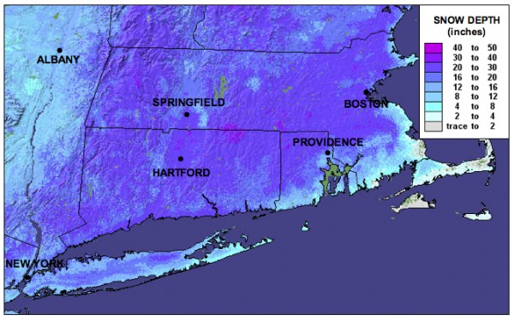](http://blog.timesunion.com/weather/files/2011/01/snowdepth1.jpg)

All eyes are on another potential snowstorm mid-week.  First, a light to moderate snow event is possible on Tuesday.  Then, a major cyclone will develop in the middle of the country, move across the Ohio Valley and toward the mid-Atlantic coast on Wednesday.  At this time, it looks like coastal regions to our south may receive a sloppy mix of precipitation, or even all rain.  Upstate, however, we may see significant snowfall potentially mixing with, or changing over to sleet.  There is still too much uncertainty in the models to pinpoint specific snowfall amounts, or locations where amounts will be hindered due to mixing with sleet or freezing rain.  Nonetheless, we could be looking at quite a mess on our hands here in Albany on Wednesday.

Stay tuned . . .

**Wednesday, January 26, 2011**

## [Meteorologists Sleepless in Seattle!](http://blog.timesunion.com/weather/meteorologists-sleepless-in-seattle/688/)

January 26, 2011 at 2:19 pm by [Chris Thorncroft](http://blog.timesunion.com/weather/author/harmattan/)

[](http://blog.timesunion.com/weather/files/2011/01/137550main_AMS-logo.jpg)At this time of year the [American Meteorological Society](http://www.ametsoc.org/index.html) holds its [annual meeting](http://www.ametsoc.org/meet/annual/). It’s a huge scientific conference that covers a wide range of topics including severe weather, hurricanes, climate variability and change, water and climate, lightning, clouds and dust to name but a few. There have also been some sessions that discussed how to communicate with society on sensitive and important issues such as climate change and there is also a session today that deals with weather and the energy industry – great stuff!!

This year’s meeting is being held during this week in Seattle and the Department of Atmospheric and Environmental Sciences is well represented by faculty (Lance Bosart and myself), staff and students  (including 4 of our bloggers – Ross, Kevin, Heather, and Kyle).  The meeting is a great experience for students. Graduate students Heather Archambault, Jay Cordeira and Kyle Griffin are here giving talks on various aspects of weather and climate. Also three of our undergraduate seniors Alicia Bentley, Sarah Ganetis and Larry Gloeckler are attending and benefiting from the experience that includes, in addition to attending the scientific sessions, meeting with professors from other Atmospheric Science Schools in the country. A great benefit when you are thinking of graduate school.

Tonight the AMS hosts its annual award ceremony and we in the Department are very proud that one of our graduate students, Mike Ventrice, will be receiving an award for the best student presentation at the AMS Conference on Hurricanes and Tropical Meteorology that took place in April last year.

This meeting was also a special one for the Department. For the first time we hosted an alumni event. The event attracted more than 75 people including many of our past alumni and friends. It was a particular pleasure to meet up with our alumni, who are now gainfully employed around the country and, in some instances, around the world.

Perhaps I should end by mentioning that the temperature here today is in the 50s! Seattle experiences, what we call, a “maritime climate” that is generally warmer and wetter than the “continental climate” that we experience in Albany  – a reminder of England for me!

# Monday, January 10, 2010 UAlbany Atmospheric and Environmental Sciences Department Launches Weather Blog

ALBANY, N.Y. (January 10, 2011) -- The University at Albany's [Department of Atmospheric and Environmental Sciences (DAES)](http://www.atmos.albany.edu/) today launched ["Weather and Climate,"](http://blog.timesunion.com/weather) a blog that will be a leading voice on regional and global weather and weather-related phenomena.  
  
"Weather and Climate," hosted by the [Times Union](http://www.timesunion.com) newspaper online, comprises the collective efforts of expert faculty and staff from the department, commenting on weather issues in the region and throughout the world. Topics covered include severe Northeast weather events such as snow storms, floods, hail, and wind storms; high-impact events affecting the U.S., including land-falling hurricanes; and conditions in the Pacific region related to El Nino or La Nina, and what they mean for the planet's weather patterns.   
  
Given its importance to the health of the planet and the vast amount of conflicting information surrounding the issue, climate change will also be addressed by the blog's authors.   
  
**"Forecast: a great interactive experience"**"People talk about the weather and climate almost every day of their lives," said Christopher Thorncroft, chairman of DAES, "I am hoping this blog will be able to provide new information for readers about how weather and climate work, how forecasts work -- or don't! -- and, in particular, reasons why high impact events occur. We will also look forward to some lively posts and discussion about climate and climate change and how this is relevant to society."

"Weather is one of the few story lines that affect every one of our readers," said Michael Huber, the Times Union's interactive audience manager. 'We live in a region with dramatic weather changes through all four seasons, and this blog gives our readers an opportunity to join in a conversation with UAlbany’s weather experts. Forecast calls for a great interactive experience."  
  
The audience for the blog, Thorncroft said, is anyone who has an interest in the weather and climate, especially those who want to learn more than they might get from traditional media outlets.   
  
Contributors to "Weather and Climate" include DAES professors Paul Roundy, a climate variability expert; tropical weather and hurricane specialist Chris Thorncroft; climate change expert Mathias Vuille; staff members and meteorologists Ross Lazear and Kevin Tyle; graduate students Heather Archambault, Kyle Griffin and Matt Potter; and retired professor and former broadcast meteorologist Mike Landin.

|  |
| --- |
| University sign announces new DAES weather blog |
| The audience for the new blog is anyone who has an interest in the weather and climate, especially those who want to learn more than they might get from traditional media outlets. (Photo Mark Schmidt) |

The authors expect to update the blog at least three or four times per week, Thorncroft said.  
   
The Department of Atmospheric and Environmental Sciences, part of the UAlbany's [College of Arts and Sciences](http://www.albany.edu/cas), carries out innovative research and provides internationally recognized training for students at the undergraduate and graduate levels.  
  
**Department Highlights**One of the most prestigious members of the Department in its early years was the late Bernard Vonnegut who, in addition to working on weather modification, carried out research on electrification of storms, thunderstorms, tornadoes, and aerosols. He published more than 190 papers and reports and received 28 patents.  
  
A major department achievement was the establishment of the National Lightning Detection Network, which started as a mere four-station network in New York in 1982.   
  
Starting in the 1990s, the synoptic-dynamics group, led by Distinguished Professor Lance Bosart, pioneered a collaborative arrangement with the [National Weather Service (NWS)](http://weather.gov/) in programs called CSTAR (Collaborative Science, Technology, and Applied Research Program) and COMET (Cooperative Meteorological Education and Training). The latter program involved internships for students to work with the regional NWS personnel housed at the University. The cooperation with NWS is one of the features that continues to attract undergraduate and graduate students to the atmospheric science programs at UAlbany today.   
  
Boosted by the arrival of several new faculty over the last 10 years, the Department has been successful at mobilizing funds and carrying out research in a variety of areas of tropical meteorology, including hurricanes, monsoons, intra-seasonal variability, as well as climate variability and change. Hurricane research has received significant funding in recent years, including this year’s NASA supported Genesis and Rapid Intensification Program (GRIP) and NSF supported Pre-Depression Investigation of Cloud-systems in the Tropics (PREDICT), with funding just for these projects amounting to nearly $1 million.

*UCAR Magazine, Monday, November 8, 2010*

## Hurricanes in the making

Parallel field studies gain the best look yet at incipient tropical cyclones

**2 November 2010  •** It’s not exactly a moment for celebration, but when a tropical storm is born in the Atlantic, millions of people learn about it quickly. As with any birth, though, a great deal has to happen in just the right way before a tropical storm is christened.

Most tropical storms take shape after spending a few hours to several days as a tropical depression, a quasi-closed circulation whose peak sustained winds haven’t reached the threshold of 63 kilometers per hour (39 miles per hour). For every tropical disturbance that makes it to the depression stage, several more in the Atlantic are snuffed out by wind shear, dry air, and other influences. Both winners and losers in this battle got their six weeks of fame—at least among researchers—in 2010. Aircraft from several agencies spent much of late August and September flying in and around embryonic disturbances, while computer models tracked the circulations and assessed their odds of developing.

Working in tandem, three studies canvassed the tropical Atlantic this year, shown here with their primary funders:

* [**PREDICT**](http://www.eol.ucar.edu/projects/predict) (Pre-depression Investigation of Cloud systems in the Tropics), NSF
* [**GRIP**](http://www2.ucar.edu/magazine/features/grip.nsstc.nasa.gov) (Genesis and Rapid Intensification Processes), NASA
* [**IFEX10**](http://www.aoml.noaa.gov/hrd/HFP2010/IFEX.html) (the 2010 phase of the multiyear Intensity Forecasting Experiment), NOAA

Each project evolved on a separate timeline, with its own goals and instruments, but the three were closely linked. Scientists for each project shared insights and rotated forecasting duties, and the teams synchronized their flight plans with coordination calls twice per day, plus near-continuous exchanges by email.

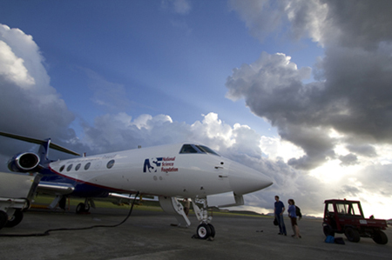

The NSF/NCAR Gulfstream V prepares for an early-morning flight from the St. Croix airport.

“I have never observed such extensive and constructive collaboration between agencies in the planning and carrying out of this kind of field program,” says Edward Zipser (University of Utah). A principal investigator for GRIP, Zipser has nearly five decades of experience in tropical field studies.

The atmosphere itself was also well synchronized with the three studies. With the tropical Atlantic simmering at near-record warmth, and an unusually strong La Niña taking shape, the preconditions were as good as they get. After a quiet start, activity began to bubble toward the end of August. By late September, the projects had gathered exhaustive multiday profiles of the formation of two hurricanes (Earl and Karl), a destructive tropical storm (Matthew), another that was harmless but long-lived (Fiona), and a remnant tropical storm that never revived (Gaston). If analysis goes as well as planned, the results could enhance the ability of forecasters to pick out future hurricanes and weed out doomed systems days in advance.

#### Nurturing a hurricane-to-be

The problem facing hurricane forecasters and theoreticians alike is aptly stated in the PREDICT project summary: “The formation of tropical cyclones remains one of the great unsolved problems in meteorology.” Once a tropical storm takes shape, track models are increasingly skilled at projecting its path (see related article, inside front cover). The prediction of intensity remains much more difficult, though. That’s especially the case for incipient disturbances that might or might not become tropical cyclones at all.

At the Naval Postgraduate School (NPS), Michael Montgomery, PREDICT’s lead principal investigator, and his [research group](http://met.nps.edu/%7Emtmontgo/index.html), including colleague Timothy Dunkerton (NorthWest Research Associates), have spent the last few years grappling with this longtime challenge. Earlier work had made it clear that convection (showers and thunderstorms) is an essential ingredient. Deep layers of moisture are needed in and near the disturbance in order to nourish this convection. And wind shear (the change of winds with height) must be light to keep a system from being torn apart.

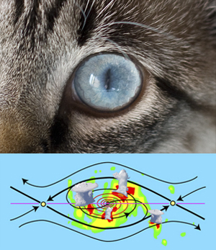

The flow in and near an incipient tropical cyclone resembles a cat’s eye on its side, with air circulating inside a protected region where convection and rotation can consolidate. (Illustration courtesy Michael Bell.)

Around 60 disturbances each year move westward across the tropical Atlantic during a typical hurricane season. Many look promising, but only about 20 percent make the transition to tropical depressions, at which point they’re likely to become tropical storms. Why, then, do so many disturbances fail to develop? Montgomery and colleagues knew that disturbances can take many forms on the larger scale, but they focused on atmospheric waves rolling westward through the Atlantic’s deep tropics.

Like waves atop the sea, these systems travel just north of the richly moist ribbon of air known as the intertropical convergence zone, pulling in an umbilical cord of moisture. When the waves move at the same speed as the encompassing flow, a protected region develops—often called the Kelvin’s cat-eye circulation (see graphic) or nonlinear critical layer—that embraces the formative elements of a tropical cyclone. The metaphor that took hold for Montgomery and Dunkerton was the marsupial pouch in which a young kangaroo develops.

“We think the marsupial pouch provides a focal point or ‘sweet spot’ where favorable conditions could persist for several days and where rotating thunderstorms are most likely to aggregate into a larger-scale storm,” says Montgomery. Not all of his colleagues were enraptured with the analogy, says Montgomery, “but we’re actually proving that it has strong scientific merit.”

In a [study](http://www.atmos-chem-phys-discuss.net/8/11149/2008/acpd-8-11149-2008.html) reported in the journal Atmospheric Chemistry and Physics, Dunkerton and Montgomery, plus Zhuo Wang (University of Illinois at Urbana-Champaign), found pouches in 55 of 61 tropical storms and hurricanes that had roamed the Atlantic and Pacific between 1998 and 2001. The marsupial hypothesis gained further traction through a Pacific field study called Tropical Cyclone Structure–2008, and NPS’s Mark Boothe and doctoral student Robert LeeJoice applied techniques developed for the Pacific study to identify and track pouches in the output of computer forecast models.

What’s inside the pouch is equally important. For a cyclone to develop, it appears that small pockets of rotation and convection need to coincide, thus strengthening both as well as bolstering the larger disturbance. These processes unfold on too small a scale to be monitored routinely, but PREDICT, IFEX, and GRIP were ideally positioned to take a closer look.

#### Forecasters on the line

At the PREDICT operations center, located on the north coast of St. Croix, forecasters and researchers huddled each morning to look over the day’s data and make flight plans. Similar scenes unfolded at the Fort Lauderdale International Airport for GRIP, and at MacDill Air Force Base near Tampa for IFEX, whose flights overlapped with routine Air Force and NOAA reconnaissance missions into tropical cyclones.

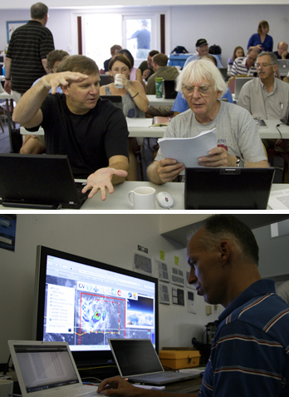

**Above:** Principal investigators Christopher Velden (University of Wisconsin–Madison) and Roger Smith (University of Munich) discuss tropical cyclone dynamics at the PREDICT operations center  
**Below:** PREDICT nowcaster Derrick Herndon (University of Wisconsin–Madison) keeps an eye on thunderstorms building close to the flight path of the Gulfstream V.

The teams had a wealth of new analysis tools at their disposal. Along with the “[pouch products](http://met.nps.edu/%7Emtmontgo/storms2010.html)” developed by Boothe and LeeJoice, they drew on more than 250 model runs each day from ensembles developed by **Ryan Torn** **(University at Albany, State University of New York)**, Sharan Majumdar (University of Miami), and Fuqing Zhang (Pennsylvania State University). [Torn’s ensemble](http://www.atmos.albany.edu/facstaff/torn/predict/) employed initial conditions generated with NCAR’s Data Assimilation Research Testbed, then used the Weather Research and Forecasting model to generate PREDICT-specific output, including the probabilities of pouch quantities exceeding relevant thresholds. The pouch products and longer-range forecasts helped PREDICT gain the flight approvals needed from a web of jurisdictions spanning the Caribbean and western Atlantic.

“The forecasts were excellent from day one,” says **Albany’s Lance Bosart**, who joined other faculty as well as **postdoctoral researchers and graduate students** in calling the meteorological shots. Sometimes the prediction took patience, as with Hurricane Karl, which took several days to develop. “I was a day too soon in predicting Karl’s formation,” says **Bosart**. However, he adds, “The track was well forecast, and the storm was well sampled from the pre-genesis period through the Category 3 hurricane stage. We obtained excellent research datasets.”

GRIP benefited from a brand-new observing platform: NASA’s Global Hawk, a remotely piloted vehicle. After tests in the Pacific, the Hawk made its first flight into a hurricane by slicing through Earl on 2 September. With its range of 11,000 nautical miles (20,000 kilometers), the aircraft gathered data continually for up to 13 hours at a stretch, providing a sorely needed look at hurricane evolution on both short and long time scales. The project also tested a system developed at NCAR that will soon allow the Global Hawk to deposit dropsondes (parachute-borne instrument packages) on command. “It’s clear that the Global Hawk will be an amazing tool for studying tropical cyclone formation,” says Albany’s John Molinari.

PREDICT gave the NSF/NCAR Gulfstream V some of the most intensive workouts in its five-year history. Only a year after retiring, veteran NCAR pilot Henry Boynton returned to the skies for PREDICT, accompanied by longtime colleague Lowell Genzlinger. The presence of a second crew headed by pilots Joseph McClain and Stephen Thompson allowed for five consecutive days of G-V coverage on two prolonged systems.

As they circled around and through pouches, the G-V pilots got the kind of customized weather guidance that most commercial pilots only dream of. A group led by Christopher Velden at the Cooperative Institute for Meteorological Satellite Studies (NOAA/University of Wisconsin–Madison) brought real-time, high-frequency satellite data and derived products into a large-format display developed at NCAR that showed the G-V’s flight path (see photo). The mission coordinator and scientist on board the aircraft could see the same real-time display as the forecasting team on the ground, which helped them guide the pilots around thunderstorms and gather prime data while staying safe.

”The combination of real-time satellite products, data displays, and chat communications with the operations center gave us a great capability to adjust our flight patterns on the fly in the dynamic pre-hurricane environment,” says Michael Bell (NPS/NCAR), who served as a principal investigator and a G-V mission scientist.

Students played meaningful roles across the spectrum of field work at PREDICT. “It’s been exciting to apply cutting-edge analysis tools used to understand tropical cyclone formation in an operational setting,“ said **Heather Archambault, a graduate student at Albany and a lead forecaster for PREDICT**. “This has been one of the best educational experiences I’ve had.”

According to Velden, ”Many times in these high-powered field programs, the students are invited along as a learning experience and end up playing passive onlookers while the mentoring scientists lead the charge. But there was a significant, measurable contribution from the student involvement in PREDICT, from forecasting to decision support to aircraft flight tasks.”

#### NCAR's Laura Tudor and dropsonde

#### NCAR technician Laura Tudor prepares a dropsonde for launch.

#### Storm after storm

The PREDICT/GRIP/IFEX trio made the most of the stream of tropical cyclones that traversed the Atlantic this year. A couple of the season’s first hurricanes developed too quickly and too far east for the projects to document, but September brought a rapid-fire string of successful sorties.

Hurricane Earl was a particular success for GRIP’s rapid intensification component, as the system quickly grew to Category 4 intensity just north of the Caribbean before recurving off the U.S. East Coast. NASA’s DC-8 made four flights into Earl over five days, while NOAA’s Gulfstream IV and two P-3 aircraft sampled the storm and its environment with 18 research flights. Another dozen or so flights were deployed by the Air Force’s fleet of C-130 hurricane hunters. “By any measure, this is the best data on rapid intensification ever obtained,” says Zipser. (Earl also gave the PREDICT ground team a jolt of adrenaline as it moved north of St. Croix. The outer bands of the quickly strengthening storm brought debris-tossing gales to the operations center, forcing the staff to seek higher ground for a time in the hurricane-shuttered restaurant of their hotel.)

Along with capturing Hurricane Karl, as noted above, PREDICT gathered ample data on the birth of Tropical Storm Matthew across the southern Caribbean. The prolonged demise of Tropical Storm Gaston provided an equally valuable but much different case. Only a dayafter being named, Gaston diminished to a remnant low in the tropical Atlantic. At one point the NHC gave the remnants an 80% chance of reviving, but those odds slowly dropped as the system limped into the Caribbean and finally decayed. “Gaston continued to struggle even though it seemed like a viable disturbance for a long time,” says PREDICT PI Christopher Davis (NCAR). “It could teach us a great deal.”

Daily flights during the process made Gaston the most thoroughly observed case of failed tropical cyclogenesis in history, as well as a perfect “null case” for PREDICT: why didn’t the system redevelop?



NASA’s DC-8 shuttled to St. Croix for a flight into the remnants of Tropical Storm Gaston on 7 September. (Photo by John Cowan, NCAR.)

“The depth of the pouch seemed to diminish with time,” according to Montgomery. “There was strong shear from the east, and a lot of dry air was going over it.” If Gaston’s apparent top-down decay is confirmed, it could lend support to the bottom-up development model favored by Montgomery. It’s one facet of a longstanding debate over the vertical sequence of tropical cyclone formation that PREDICT may help settle.

As for forecasting, Montgomery and collaborators would like to see the new pouch-prediction model output added to the arsenal of tools used by NHC forecasters to help save lives and property. This year’s field work could also benefit NOAA’s ten-year [Hurricane Forecast Improvement Program](http://www.hfip.org/), which aims for a 20% improvement by 2013 in the accuracy of NHC’s five-day hurricane track and intensity forecasts. Another goal is to extend hurricane forecasts to seven days.

In order to stimulate progress in long-range prediction, the PREDICT and GRIP teams will need to analyze the data they’ve gathered this year from the difficult-to-observe areas within pouches where the biggest uncertainties lie. “Satellite pictures don’t tell you everything,” Montgomery notes. “The models have a lot of skill at predicting where the pouches are, but they don’t have a lot of skill at predicting what’s going to happen within the pouches. That’s why we’ve been collecting data.” These observations, he adds, should help solve the mystery of why some storms thrive in their protected regions while others struggle to survive.

**—Bob Henson**

*September 3, 2010***Featured Faculty 2010**

|  |
| --- |
|  |
| **Ryan Torn Collaborates with NCAR to Develop Numerical Weather Models** |
|  |
| Prof Torn |
|  |
| In early August, the [National Hurricane Center](http://www.nhc.noaa.gov/) designated two numerical weather models as semi-operational, meaning that the output from these models would be available to hurricane specialists to make their operational forecasts.  This process involved running these computer models over many different hurricanes and many different times, and comparing the model's track and intensity forecast against the best estimates of these quantities.  One of the two models is the [National Center for Atmospheric Research (NCAR)](http://ncar.ucar.edu/) Advanced Hurricane Weather Research and Forecasting (AHW) model.  Over the past two hurricane seasons, the initial conditions for that model have been generated using an advanced technique that combines the information from observations and a previous computer model forecast.  The application of this technique to hurricanes has been developed over the past three years by [Ryan Torn](http://www.atmos.albany.edu/index.php?d=faculty_view&facultyLink=torn), Assistant Professor in [Atmospheric and Environmental Sciences](http://www.atmos.albany.edu/) in collaboration with scientists at NCAR.  Current forecasts from this system are available at: <http://www.wrf-model.org/plots/realtime_hurricane4km.php> |
| [Department of Atmospheric and Environmental Sciences](http://www.atmos.albany.edu/index.php?d=main) |
| [College Of Arts and Sciences](http://www.albany.edu/cas/) |
| [University At Albany](http://www.albany.edu/) |

*August 3, 2010***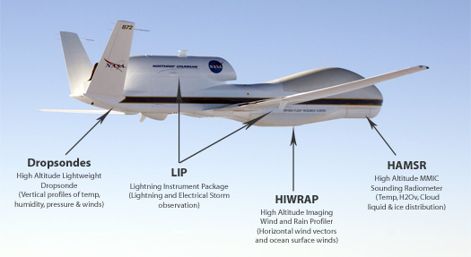**

**Faculty and Students from DAES participate in two hurricane field campaigns in summer 2010**

Four faculty along with their students will be participating in two hurricane field campaigns in August and September this summer. NASA-supported GRIP and NSF supported PREDICT will be working together and with NOAA-supported IFEX (Intensity Forecasting Experiment) to improve our understanding of the nature and causes of hurricanes including their genesis and rapid intensification.

**Genesis and Rapid Intensification Processes (GRIP)**

The GRIP experiment is a NASA Earth science field experiment in 2010 that will be conducted to better understand how tropical storms form and develop into major hurricanes. NASA plans to use a DC-8 aircraft and the Global Hawk Unmanned Airborne System *(see photo above)* configured with a suite of in situ and remote sensing instruments that will be used to observe and characterize the life-cycle of hurricanes. The GRIP deployment is planned for 15 August – 30 September 2010 with bases in Ft. Lauderdale, for the DC-8, and at NASA Dryden Flight Research Facility, CA, for the Global Hawk.

Professors John Molinari and Chris Thorncroft are members of the NASA Hurricane Science Team and are involved in this project. John will be one of the Mission Scientists for GRIP, serving for three weeks during the field campaign. This will involve directing the aircraft and sometimes flying (in the DC-8), as well as coordinating with PREDICT and IFEX. Two of John’s students (Leon Nguyen and Diana Thomas) and one of Chris’s students (Matt Janiga) will be based in Ft Lauderdale for two weeks each to help with forecasting and will also likely get a chance to fly missions on the DC-8.

See <http://grip.nsstc.nasa.gov> for more information.

**PRE-Depression Investigation of Cloud-systems in the Tropics (PREDICT)**

The PREDICT experiment is a close collaboration between the NSF, NOAA and Naval Postgraduate School in Monterrey, California. The aim of the program is to explore the nature of the precursor disturbances that can become tropical storms (and eventually hurricanes). It will utilize the high endurance NCAR G-V aircraft in collaboration with two NOAA WP-3D aircraft (from IFEX).

Professors Lance Bosart and Ryan Torn are co-PIs on the NSF PREDICT project. Lance will serve as the lead forecaster for PREDICT and will be responsible for scientific mission planning from late August through mid-September when he will be based in the PREDICT operations center in St. Croix, Virgin Islands. Ryan will be running a computer model in the Department that will assimilate the additional data in real-time to assess the impact of this data and to provide guidance for mission planning. Lance has four students who will be contributing to PREDICT. Newly admitted graduate student Kyle Griffin and existing graduate student Jay Cordeira will provide PREDICT forecast support during the second half of August. Existing graduate students Tom Galarneau and Heather Archambault will provide forecast support during the first and second halves of September respectively. They may also have options on PREDICT research flights based out of St Croix, Virgin Islands. A newly admitted student of Chris’s, Jason Dunion, will be a lead forecaster for PREDICT during the second half of August.

See <http://met.nps.edu/~mtmontgo/predict.html> and <http://www.albany.edu/news/campus_news_9949.php> for more information.

Video clip: <http://www.youtube.com/watch?v=s_V2mKypJ2g>