

**ATMOSPHERIC SCIENCE PROGRAM**

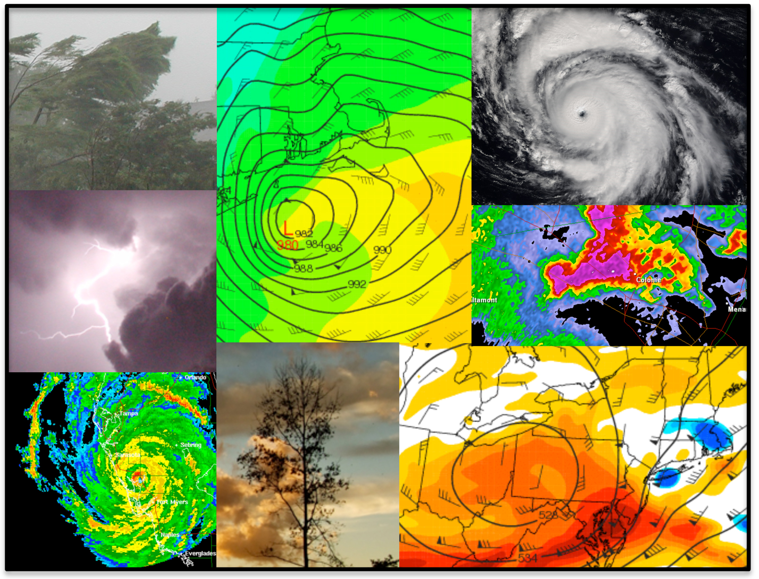

***in the***

**Department of Atmospheric and Environmental Sciences**

**Bachelor of Science Degree in Atmospheric Science**

The Atmospheric Science program at the University at Albany is both nationally and internationally well-renowned. The combination of the Department of Atmospheric and Environmental Sciences (DAES) and the Atmospheric Sciences Research Center (ASRC) gives the University the largest program of education and research in the atmospheric sciences in New York State, and one of the largest in the nation. In addition, the National Weather Service’s regional office is collocated with ASRC on the main campus. This gives students in the department the unique opportunity to work closely with researchers and forecasters in multiple fields of study within the atmospheric sciences.

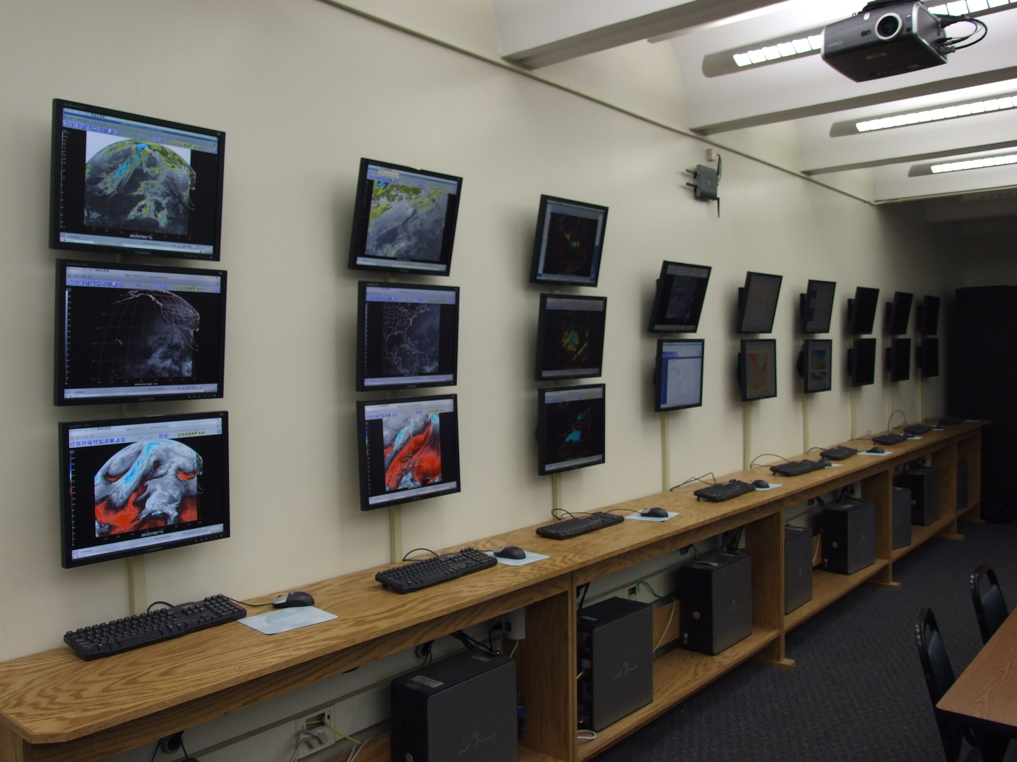The Atmospheric Science department was established in the early 1960s by Vincent Schaefer, the protégé of Nobel Laureate chemist Dr. Irving Langmuir. Inspired by Langmuir, Schaefer, a world-renowned cloud physicist himself, discovered the method of cloud seeding that ushered in the science of weather modification. Thus began a tradition of prominent research in the field that continues today. The current group of scientists covers a broad range of interest in the atmospheric and environmental sciences. Topics of research and study include synoptic-dynamic meteorology, mesoscale meteorology, weather systems, hydrometeorology, short- and medium-range forecasting, hurricanes and tropical meteorology, climate and climate change, cloud and precipitation physics, atmospheric chemistry, air pollution, and bioclimatology. More detail on the specific areas of research of our faculty members can be found beginning on page 6.

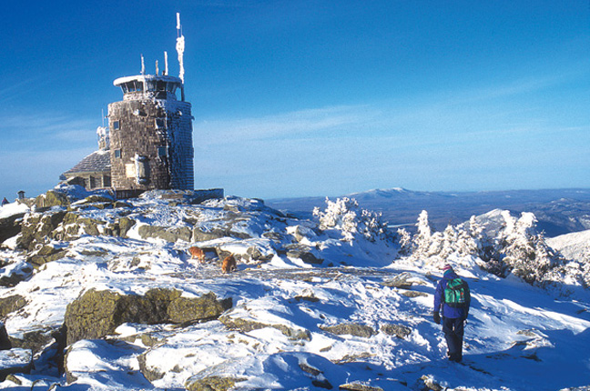Research and teaching facilities are among the most advanced in the nation. The synoptic-dynamic program is supported by a fully equipped electronic map room with satellite, radar, observation, lightning detection, and model forecast data from around the world. This room is used for teaching and for weather discussions, the latter of which occur weekly at both a graduate and undergraduate level. The map room also serves as a lab with many Linux/Windows workstations. Students are free to use the room as a group or individual study area, or to hone their forecasting skills in one of the department’s several forecasting contests.

Atmospheric Science Map Room

In addition to excellent on-campus research laboratories, computer facilities and the map room, we operate several field stations. One such station, operated by ASRC, is atop Whiteface Mountain just north of Lake Placid, NY. This facility provides long-term observation of atmospheric chemical species, cloud properties, acid precipitation, aerosol content and other environmental parameter used in various ongoing projects. The department, along with ASRC, also runs an atmospheric observatory atop Mohawk Tower (Indian Quad), which commands a 360o view of the surrounding area.

Whiteface Observatory operated by ASRC

Photo from www.adirondackexplorer.org

***Requirements for the B.S. Degree in Atmospheric Science***

Students planning to study atmospheric science should have a good academic preparation in physics and mathematics. Core courses related to the study of the atmosphere begin at the beginning of the sophomore year, although students are encouraged to take introductory courses not required for the major during their freshman year. A full list of courses offered in the department appears on Page 4.

The Bachelor of Science (B.S.) in Atmospheric Science course requirements consists of a minimum of 66 credits for the combined major/minor, including:

ATM 209: Weather Workshop

ATM 210/Z: Atmospheric Structure, Thermodynamics and Circulation

ATM 211: Weather Analysis and Forecasting

ATM 315: Environmental Statistics and Computation

ATM 316: Dynamic Meteorology I

ATM 317: Dynamic Meteorology II

ATM 320: Atmospheric Thermodynamics

ATM 321: Physical Meteorology

ATM 350: Meteorological Datasets and Numerical Computation

ATM 418: Dynamic Meteorology III

ATM 419: Numerical Weather Prediction

ATM: *Twelve additional credits of ATM 301 or higher (excluding ATM 304), though no more than six can come from internships or research (ATM 490, 497, 498, 499)*

PHY 140 and 145: Physics I: Mechanics (and lab)

PHY 150: Physics II: Electromagnetism

MAT 111/112/118: Calculus I

MAT 113/119: Calculus II

MAT 214: Calculus III

MAT 311: Ordinary Differential Equations

CHM 120/130: General Chemistry I

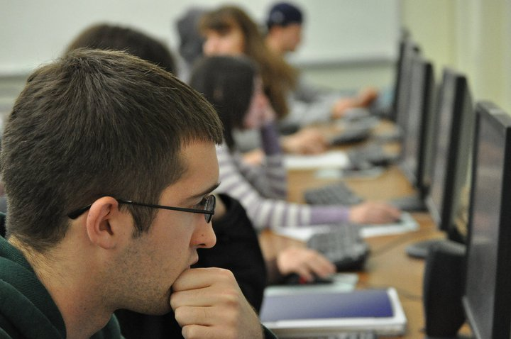 Although no minor is required for those majoring in Atmospheric Science, some students do choose to add an additional minor, or minors. Some common choices are Math, Physics, Chemistry, Computer Science, Sustainability, and Business. In addition, some students choose to pursue a Geographic Information Systems (GIS) certificate through the Department of Geography and Planning, as GIS is viewed as an important software skill for many atmospheric and environmental science jobs.

The department also offers a Bachelor of Science degree in *Environmental Science*. This degree provides an interdisciplinary education while allowing for a concentration in one of three areas: Climate, Geography, or Biology. Additional information on the Environmental Science degree is given in a separate brochure.

Photo by Rihaan Gangat, Class of 2011

***Honors in the major****:* Students with a cumulative Grade Point Average (GPA) of at least 3.25 overall, and a 3.5 GPA in the major at the end of their fourth semester may apply for a B.S. with honors in atmospheric science. To be eligible for a degree with honors, students must also complete a total of 74 credits including two semesters of Undergraduate Research (ATM 499) leading to a significant undergraduate thesis. Further, the above GPAs must be maintained throughout the student’s education. The honors degree represents one of the most challenging programs on this campus; it is designed and intended for only the most exemplary students, but allows students great research opportunities with faculty in our department.

***Typical B.S. Program in Atmospheric Science***

*(Required courses in* ***bold****)*

*Semester I Semester 2*

**MAT 112: Calculus I 4 MAT 113: Calculus II 4**

**PHY 140, 145: Physics I (w/ lab) 4 PHY 150: Physics II 3**

**CHM 120: Chemistry I 4** Elective/Gen-ed *

Elective/University Gen. Ed. Requirement * Elective/Gen-ed *

*Semester 3 Semester 4*

**MAT 214: Calculus III 4 MAT 311: Differential Equations 3**

**ATM 315: Env. Statistics/Comp. 3 ATM 211: Weather Analysis and 4**

**ATM 209: Weather Workshop 1 Forecasting**

**ATM 210/Z: Atmospheric Structure, 3** Elective/Gen-ed *

**Thermodynamics, and** Elective/Gen-ed *

**Circulation** Elective/Gen-ed *

Elective/Gen-ed *

*Semester 5 Semester 6*

**ATM 316: Dynamic Meteorology I 3 ATM 317: Dynamic Meteorology II 3**

**ATM 320: Thermodynamics** 3 **ATM 321: Physical Meteorology 3**

ATM 311: Severe and Hazardous Weather 4 **ATM 350: Meteorological Datasets and 2**

ATM Elective * **Numerical Computation**

Elective/Gen-ed * ATM Elective *

Elective/Gen-ed *

*Semester 7* *Semester 8*

**ATM 418: Dynamic Meteorology III 3 ATM 419: Numerical Weather Pred. 3**

ATM 400: Synoptic Meteorology I 3ATM 401: Synoptic Meteorology II 3

ATM Elective/Gen-ed/Internship * ATM Elective/Gen-ed/Internship *

Elective/Gen-ed * Elective/Gen-ed *

Elective/Gen-ed * Elective/Gen-ed *

***Available Undergraduate Courses in Atmospheric Science***

*“Z” indicates a course that satisfies the “writing intensive” general education requirement*

ATM 100: The Atmosphere (3)

ATM 103: Introduction to Climate Change (3)

ATM 107: The Oceans (3)

ATM 110: Weather and Climate Issues for the 21st Century (3)

ATM 200: Natural Disasters (3)

ATM 209: Weather Workshop (1)

ATM 210/Z: Atmospheric Structure, Thermodynamics, and Circulation (3)

ATM 211: Weather Analysis and Forecasting (4)

ATM 297: Independent Study (1-3)  
ATM 301: Surface Hydrology and Hydrometeorology (3)

ATM 304/Z: Air Quality (3)

ATM 305: Global Physical Climatology (3)

ATM 306: Climate Variability and Change (3)

ATM 307/Z: Atmospheric Chemistry (3)

ATM 311: Severe and Hazardous Weather (4)

ATM 315: Environmental Statistics (3)

ATM 316: Dynamic Meteorology I (3)

*(continued on next page)*

ATM 317: Dynamic Meteorology II (3)

ATM 320: Atmospheric Thermodynamics (3)

ATM 327: Meteorological and Environmental Measurement (3)

ATM 335: Meteorological Remote Sensing (3)

ATM 350: Meteorological Datasets and Numerical Computation (2)

ATM 400: Synoptic Meteorology I (3)

ATM 401: Synoptic Meteorology II (3)

ATM 404: Oceans and Climate (3)

ATM 405: Water and Climate Change (3)

ATM 413: Weather, Climate Change, and Societal Impacts (3)

ATM 414: Air Pollution (3)

ATM 415: Climate Laboratory (3)

ATM 418: Dynamic Meteorology III (3)

ATM 419: Numerical Methods in Atmospheric Science (3)

ATM 421: Tropical Meteorology (3)

ATM 424: Fundamentals of Atmospheric Electricity (3)

ATM 425Y: Physical Meteorology (4)

ATM 480: Special Topics in Atmospheric Science (1-3)

ATM 490-499: Internship, Research, or Independent Study in Atmospheric Science (1-3)

***Undergraduate Internship and Research Opportunities***

***Internships****:* All undergraduate students maintaining a GPA above 2.5 are eligible to participate in an internship at the National Weather Service (NWS) forecast office in Albany. As previously mentioned, the NWS is located on UAlbany’s campus, and only a ten-minute walk from the department. As part of this internship, which is either done during a student’s junior or senior year (or the summer in between), students work closely with each member of the NWS office. Some of the responsibilities include launching weather balloons twice daily, collecting and disseminating atmospheric data, forecasting in the short- and medium-range for the Capital Region and surrounding areas, and even assisting in tornado or high wind damage surveys. By the end of the internship, students are qualified for paid intern positions at the NWS.

Other internship opportunities can be arranged with local groups in the private sector of meteorology, such as AWS Truepower, MESO, and the Department of Environmental Conservation. Additionally, internships are available with the Atmospheric Science Research Center on our campus.

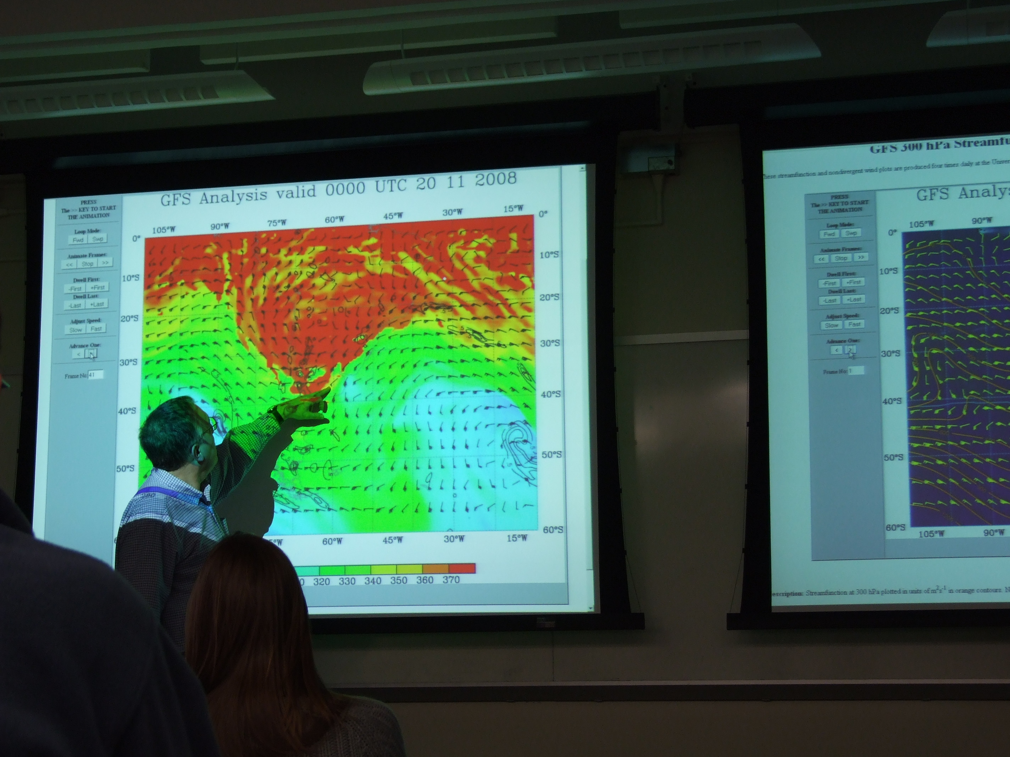***Research***: As previously mentioned, research is a requirement for those students pursuing an Honors degree in the major, but opportunities are also available for non-Honors students to work on research projects with faculty members in our department. In some cases, students present their own research, or research a faculty member’s ongoing work, at local or national conferences. More information on the types of research covered by our faculty can be found beginning on page 6.

There are multiple forecast contests run in our department throughout the year, and students also participate in the national collegiate forecasting contest, *WxChallenge*. These opportunities allow our students to improve their forecasting skills for many different regions. Historically, UAlbany has one of the strongest weather forecasting teams in the country!

***Graduate Program***

Our department also has an active graduate program, offering Ph.D. and M.S. degrees in atmospheric science. This program is viewed to be one of the top atmospheric science graduate departments in the country. A multitude of prominent research in atmospheric science has come from graduate work at UAlbany, and many of our graduates are now employed at some of the top research and teaching facilities in the world.

***Careers***

Many of our undergraduate degree recipients advance to graduate study. Others obtain employment in federal, state and local government agencies, university departments, research laboratories, and private industry. Some of the more common types of employment span the areas of:

-Research

-Teaching

-Governmental regulation

-Air quality monitoring

-Weather forecasting (private sector, and NWS)

-Television broadcasting and broadcast production

-Scientific and engineering consultation

-Solar and wind energy development, and energy forecasting

-Risk management

-Finance/derivatives

-Meteorological instrumentation (development and manufacturing)

-Environmental legislation

-Forensic meteorology

Additionally, an increasing number of graduates are being employed in the private sector via the unique combination of an undergraduate degree in atmospheric science with graduate education in disciplines such as business administration, management and public health.

***Faculty Research Interests***

Members of the Department of Atmospheric and Environmental Sciences are funded externally by agencies such as the National Science Foundation (NSF), the National Aeronautics and Space Administration (NASA), the Office for Naval Research (ONR), the National Oceanic and Atmospheric Administration (NOAA), the Air Force Office for Science Research (AFOSR) and others. Several faculty members have recently served as either an editor or associate editor for some of the premier scientific journals in the field. Special recognition has come to some of our faculty members as winners of prestigious awards from the American Meteorological Society (AMS) in recognition of outstanding achievement in the field. Dr. Daniel Keyser received the *Meisinger Award* (1989) and the *Edward Lorenz Teaching Award* (2014), Dr. Lance Bosart garnered the *Jule G. Charney Award* (1992) and was the inaugural recipient of the *Teaching Excellence Award* (2001), Dr. John Molinari received the *Banner I. Miller* *Award* (1999), and Dr. Robert Fovell won the *Edward Lorenz Teaching Award* (2012). Dr. Bosart, a Distinguised Professor, also is an Affiliate Scientist with the National Center for Atmospheric Research (NCAR) in Boulder, Colorado.

(*continued on next page)*

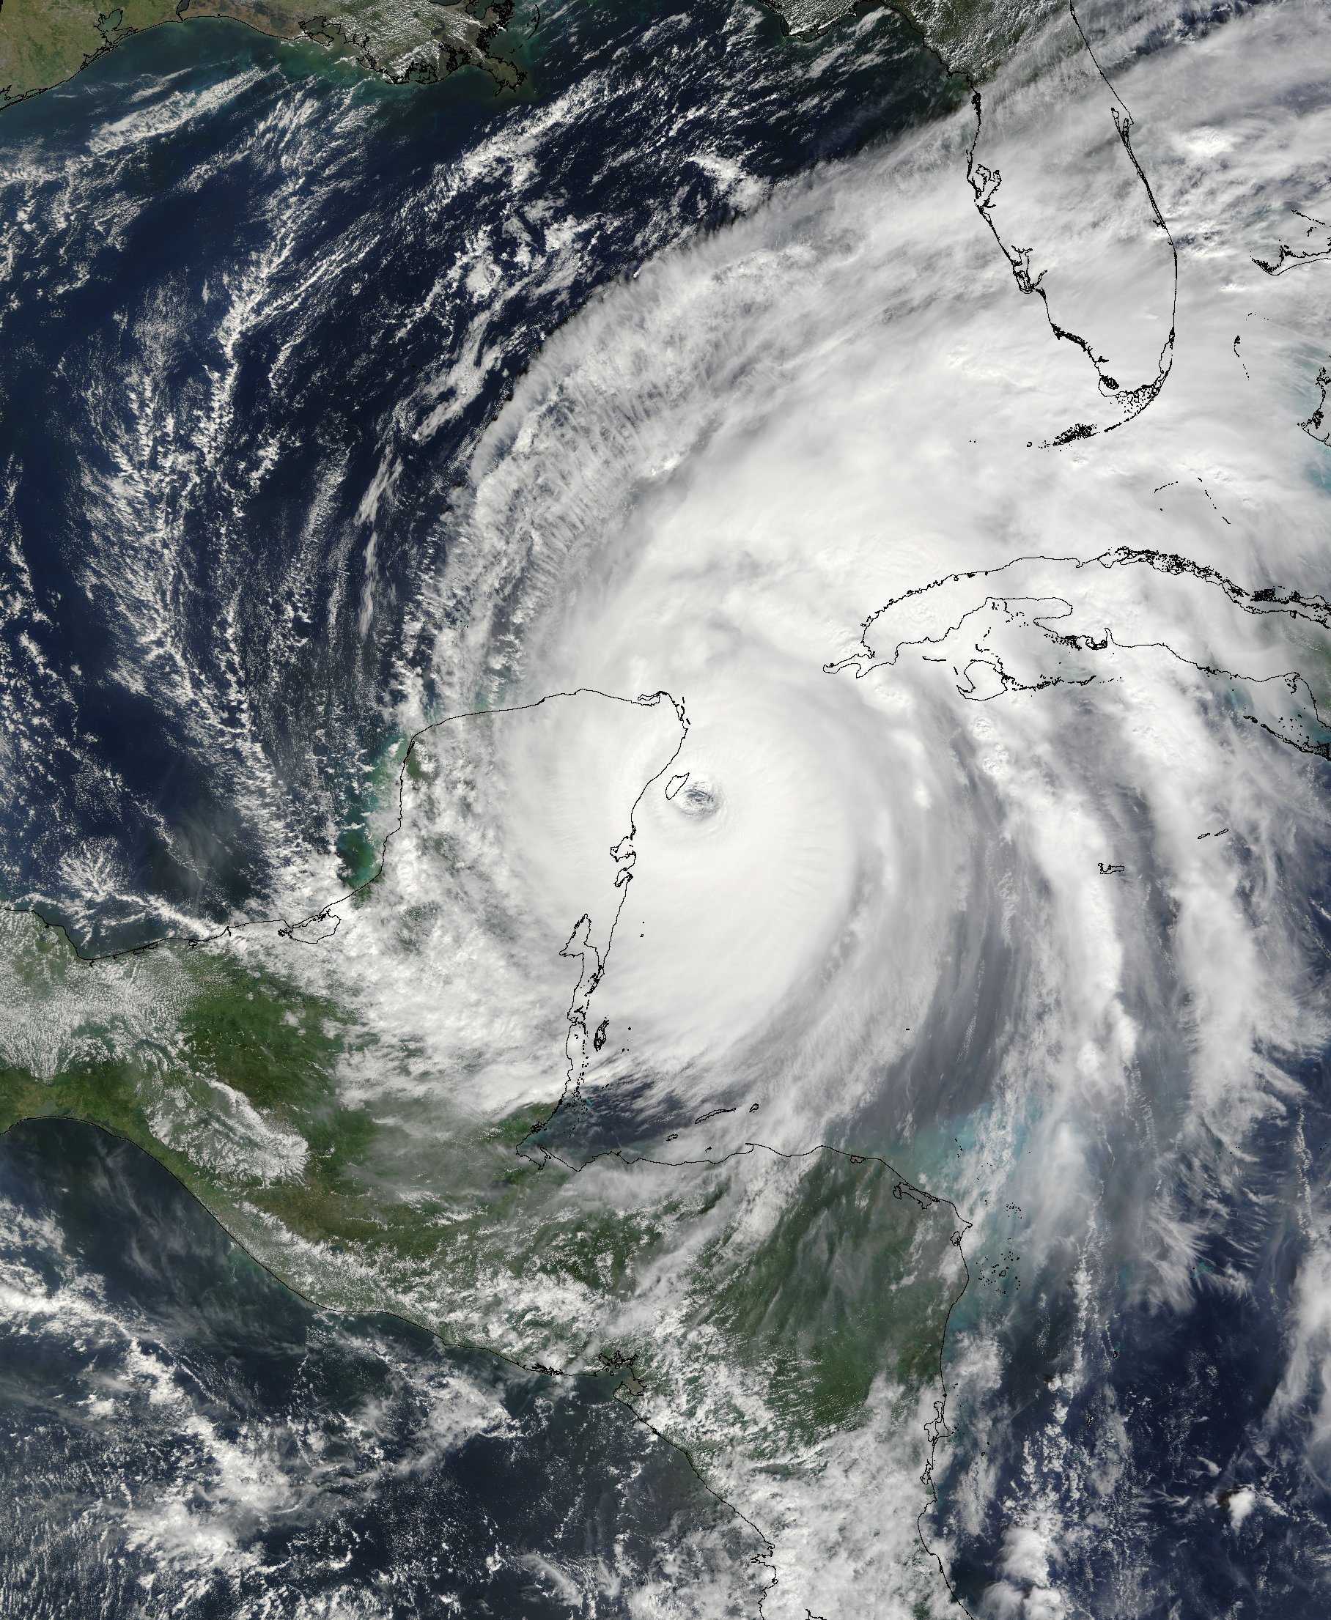***Faculty Research Interests, Continued***

*Synoptic (Weather Systems) and Mesoscale Meteorology, and Hydrometeorology*

Dr. Lance Bosart

Dr. Kristen Corbosiero

Dr. Robert Fovell

Dr. Daniel Keyser

Dr. Andrea Lang

Dr. Justin Minder

Dr. Brian Tang

Dr. Ryan Torn

*Climatology/Climate Change/Paleoclimatology*

Dr. Aiguo Dai

Dr. Oliver Elison Timm

Dr. Jiping Liu

Dr. Brian Rose

Dr. Mathias Vuille

Dr. Liming Zhou

*Hurricanes and/or Tropical Meteorology*

Dr. Lance Bosart

Dr. Kristen Corbosiero

Dr. Robert Fovell

Dr. John Molinari

Dr. Paul Roundy

Dr. Brian Tang

Dr. Christopher Thorncroft

Dr. Ryan Torn

*Physical Meteorology*

Dr. Vince Idone

Dr. Justin Minder

Dr. Junhong Wang

*Atmospheric Chemistry*

Dr. Robert Keesee

***Contact information***

**Department of Atmospheric and Environmental Sciences**

*http://www.atmos.albany.edu*

University at Albany, ES-351

1400 Washington Ave., Albany, NY 12222

Phone: (518)-442-4556

E-mail: *chair@atmos.albany.edu*

**National Weather Service Forecast Office: Albany, New York**

Mr. Raymond O’Keefe, *Meteorologist-in-charge*

Center for Environmental Sciences and Technology Management (CESTM)

251 Fuller Rd., Suite B300, Albany, NY 12203

Phone: (518)-435-9566

E-mail: [*Raymond.Okeefe@noaa.gov*](mailto:Raymond.Okeefe@noaa.gov)

***Department of Atmospheric and Environmental Science Faculty***

**Lance F. Bosart**, Distinguished Professor (Ph.D., MIT)

ES-227, (518)-442-4564

lbosart@albany.edu

**Kristen Corbosiero**, Assistant Professor (Ph.D., Univ. at Albany, SUNY)

ES-321, (518)-442-5852

kcorbosiero@albany.edu

**Aiguo Dai**, Associate Professor (Ph.D., Columbia Univ.)

ES-310, (518)-442-4474

adai@albany.edu

**Oliver Elison Timm**, Associate Professor (Ph.D., Univ. of Kiel, Germany)

ES-316A, (518)-442-3584

oelisontimm@albany.edu

**Robert Fovell**, Professor (Ph.D., Univ. of Illinois)

ES-314

rfovell@albany.edu

**Vincent P. Idone**, Associate Professor (Ph.D., Univ. at Albany, SUNY)

ES-215, (518)-442-4577

vidone@albany.edu

**Roberta M. Johnson**, Clinical Professor (Ph.D., Univ. of California – Los Angeles)

ES-212, (518)-442-4561

rjohnson5@albany.edu

**Robert G. Keesee**, Associate Professor (Ph.D., Univ. of Colorado)

ES-214, (518)-442-4566

rkeesee@albany.edu

**Daniel Keyser**, Professor (Ph.D., Pennsylvania State Univ.)

ES-224, (518)-442-4559

dkeyser@albany.edu

**Michael Landin**, Instructor (M.S., Univ. at Albany, SUNY)

ES-324, (518)-442-4572

mlandin@albany.edu

**Andrea L. Lang**, Assistant Professor (Ph.D., Univ. of Wisconsin)

ES-323, (518)-442-4558

alang@albany.edu

**Ross A. Lazear**, Instructional Support Specialist (M.S., Univ. of Wisconsin)

ES-322, (518)-437-3601

rlazear@albany.edu

**Jiping Liu**, Assistant Professor (Ph.D., Columbia University)

ES-210, (518)-442-4048

jliu26@albany.edu

**Justin R. Minder**, Assistant Professor (Ph.D., Univ. of Washington)

ES-339B, (518)-437-3732

jminder@albany.edu

**John E. Molinari**, Professor (Ph.D., Florida State Univ.)

ES-225, (518)-442-4562

jmolinari@albany.edu

**Brian E. J. Rose**, Assistant Professor (Ph.D., MIT)

ES-315, (518)-442-4477

brose@albany.edu

**Paul E. Roundy**, Associate Professor (Ph.D., Pennsylvania State Univ.)

ES-339A, (518)-442-4476

proundy@albany.edu

**Brian H. Tang**, Assistant Professor (Ph.D., MIT)

ES-324, (518)-442-4572

**Christopher D. Thorncroft**, Professor and Department Chair (Ph.D., Univ. of Reading)

ES-226, (518)-442-4555

cthorncroft@albany.edu

**Ryan Torn**, Associate Professor (Ph.D., Univ. of Washington)

ES-229, (518)-442-4560

rtorn@albany.edu

**Kevin R. Tyle**, Systems Administrator (M.S., Univ. at Albany, SUNY)

ES-235A, (518)-442-4578

ktyle@albany.edu

**Mathias Vuille**, Associate Professor (Ph.D., Univ. of Bern, Switzerland)

ES-311, (518)-442-4472

mvuille@albany.edu

**Junhong (June) Wang**, Research Associate Professor (Ph.D., Columbia University)

ES-339C

jwang20@albany.edu

**Liming Zhou**, Associate Professor (Ph.D., Boston University)

ES-312, (518)-442-4446

lzhou@albany.edu