

**ENVIRONMENTAL SCIENCE PROGRAM**

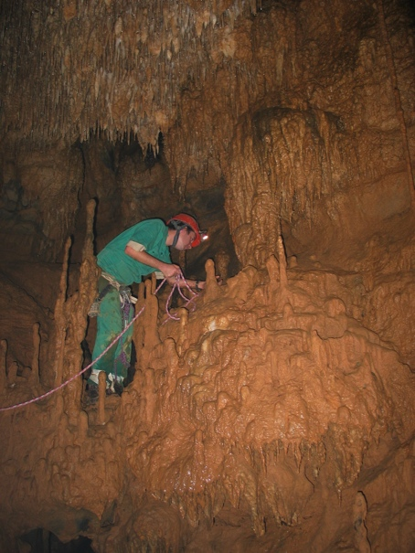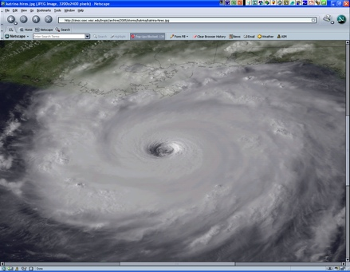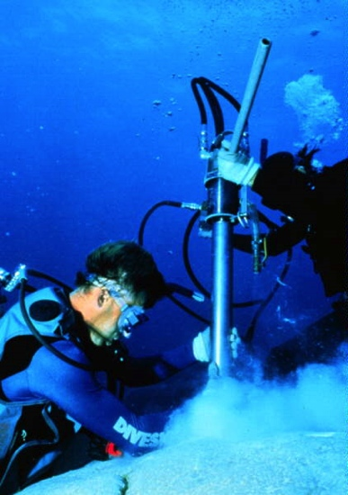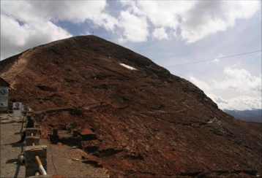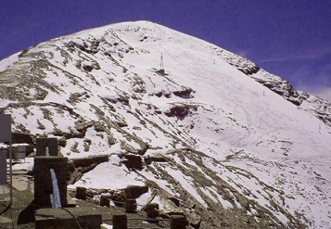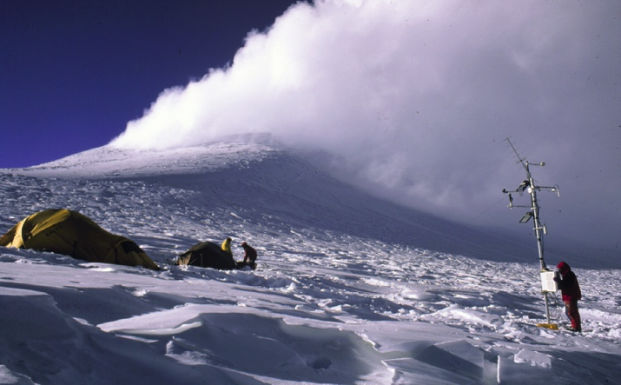

***in the***

**Department of Atmospheric and Environmental Sciences**

**Bachelor of Science Degree in Environmental Science**

Addressing environmental problems from a scientific perspective is becoming ever more import in today’s world. We are faced with an increasing number of environmental challenges such as air pollution, water and soil contamination, climate change, land degradation and loss of biodiversity. Training the next generation of environmental scientists is therefore a mission of critical importance. The B.S. degree in Environmental Science at the University at Albany offers an excellent education and training in these areas and prepares our students for a successful career with governmental or non-governmental organizations, environmental consulting firms or graduate school. Our faculty members are engaged in world-class research relevant to the needs of society and focusing on a wide variety of aspects within the earth system, including research on planetary, atmospheric, hydrologic, cryospheric and terrestrial processes. Our students are also required to take some classes in the Geography and Biology Departments, where they are exposed to biologic and ecologic aspects of environmental science and are trained in computer mapping and Geographic Information Systems (GIS).

The Environmental Science Program at the University at Albany is housed in the Department of Atmospheric and Environmental Sciences. It is one of two undergraduate programs offered by our department, the other one being the B.S. degree in Atmospheric Science. The Department also has an internationally recognized graduate program, offering both Masters and PhDs in Atmospheric Science.

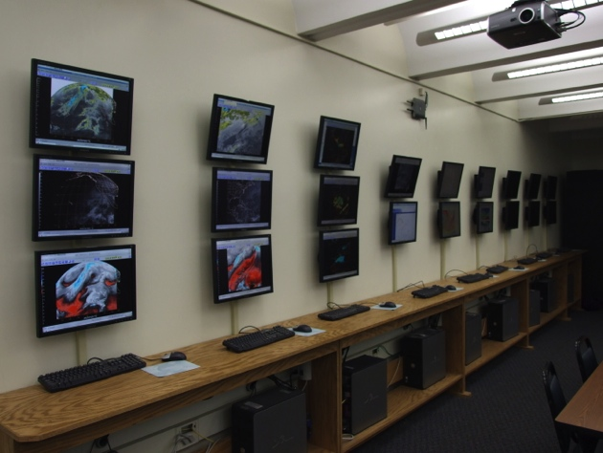Environmental Science Programs around the country vary significantly regarding their main focus and emphasis toward certain aspects of the environment. While some Departments emphasize Environmental Policy, Environmental Health, Environmental Law or Ecology, the strength of our program lies in its core emphasis on the Natural Sciences. Our students are required to take two semesters of calculus, physics and chemistry which give them a very solid foundation to understand and analyze the natural processes that dominate our environment. We also encourage all our Environmental Science students to acquire some working experience by serving as an intern with an environmental consulting firm or a local, state or federal agency. The students earn credit for the internship, but it also gives them a valuable working experience with a potential future employer. Hence our students graduate with a competitive advantage in the job market for all positions that require work experience, a solid scientific background and advanced quantitative skills.

Atmospheric Science Map Room

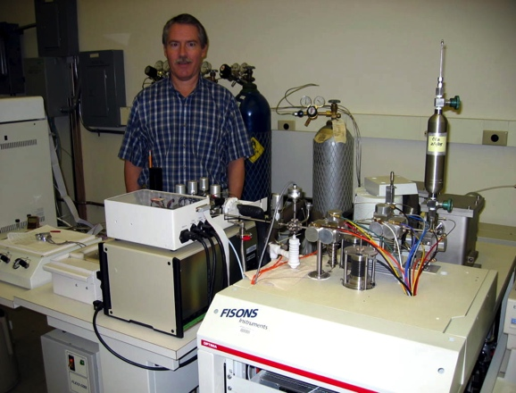Our research and teaching facilities are among the most advanced in the nation. We maintain a fully equipped electronic map room with satellite, radar, observation, lightning detection, and model forecast data from around the world. This room is used for teaching and for weather discussions, but also serves as a lab with many Linux/Windows workstations. Students are encouraged to use the room as a group or individual study area.

We also host a world-class Stable Isotope Ratio Mass Spectrometer (SIRMS) Laboratory where students can perform undergraduate research and learn how to analyze past climate variations using corals, plants, soils, etc.

Research Geochemist Stephen Howe in the SIRMS Lab

***Requirements for the B.S. Degree in Environmental Science***

Students planning to study environmental science should have a good academic preparation in physics, chemistry and mathematics. The core program consists of two semesters of chemistry, mathematics and physics and introductory courses in Environmental and Atmospheric Science, Biology, Geology and Geography. All students have to complete a core program of 45 credits and then select one of three specializations (21 additional credits): Biology, Climate Change, or Geography.Each specialization represents an emphasis within the overall program that would best match a student’s interest and desired career path. For example, those most interested in studying the climate–environment system would opt for the Climate Change specialization, while those seeking careers in land use planning and geographic information systems might opt for the Geography specialization. Correspondingly, students keen on aspects of biological processes and ecology would select the Biology specialization.

**Courses offered:**

**Core (49 credits)**:

**ATM 210: Atmospheric Structure, Thermodynamics, and Circulation**

**ATM/ENV 315: Environmental Statistics**

**ATM/ENV 327: Meteorological and Environmental Measurements**

**BIO 120: General Biology I (+ Lab I)**

**BIO 121: General Biology II (+ Lab II)**

**BIO 320: Ecology**

**CHM 120 or 130 or T CHM 130: General Chemistry I or Advanced General Chemistry I**

**CHM 121 or 131 or T CHM 131: General Chemistry II or Advanced General Chemistry II**

**ENV 105: Introduction to Environmental Science**

**ENV 106: Environmental Science Laboratory**

**ENV 302: Ocean Science**

**ENV 490: Major Topics in Environmental Science**

**GEO 221: Understanding the Earth**

**MAT 111 or 112 or 118 or T MAT 118: Algebra and Calculus II, Calculus I or Honors Calculus I**

**PHY 140 or 141 or T PHY 141: Physics I: Mechanics or Honor Physics I: Mechanics**

**Geography Specialization (**22 credits):

Required courses

**GOG/PLN 220: Introductory Urban Geography**

**GOG 290: Introduction to Cartography**

**GOG 490: Geographic Information Systems (GIS)**

A sample of electives:

**GOG 304: Climatology**

**GOG 330: Principles of Environmental Management**

**GOG 344: World Population**

**GOG 354: Environment & Development**

**GOG 375: Methods of Urban Analysis**

**GOG 414: Computer Mapping**

**GOG 430: Environmental Planning**

**GOG 460: People, Place, and Power**

**GOG 479: Fundamentals of Applied Global Positioning Systems (GPS)**

**GOG 484: Remote Sensing I**

**GOG 485: Remote Sensing II**

**ENV 250: Environmental Sustainability**

**ATM 405: Water and Climate Change**

**ATM 301: Hydrology and Hydrometeorology**

*-continued on next page-*

**Climate Change Specialization (**21 credits):

Required courses:

**ATM 306: Climate Variability and Change**

**ATM 405: Water and Climate Change**

**ATM 415: Climate Laboratory**

**ATM 450: Paleoclimatology**

A sample of electives:

**ATM 301: Hydrology and Hydrometeorology**

**ATM 304: Air Quality**

**ATM 307: Introduction to Atmospheric Chemistry**

**ATM 335: Meteorological Remote Sensing**

**ATM 413: Weather, Climate Change, and Societal Impacts**

**ATM 414: Air Pollution Meteorology**

**RPAD 366: International Environmental Policy**

**RPOS 266: International Political Economic Science**

**Ecosystems Specialization (**22 credits):

Required courses:

**BIO 212: Introductory Genetics**

**BIO 327: Experimental Ecology**

**BIO 402: Evolution**

A sample of electives:

**ANT 418: Culture, Environment, and Health**

**ANT 419: Human Evolutionary and Environmental Physiology**

**ATM 301: Hydrology and Hydrometeorology**

**BIO 308: Parasitic Diseases and Human Welfare**

**BIO 311: World Food Crisis**

**BIO 329: Genetics of Human Disease**

**BIO 343: Evolutionary Biology and Human Health**

**BIO 427: Grazing in Terrestrial Ecosystems**

**ENV 250: Environmental Sustainability**

**HSPH 321: Global Environmental Issues and Their Effect on Human Health**

**HSPH 323: Environmental Laboratory Perspectives in Public Health**

**HSPH 332: Epidemiology and Biostatistics**

**Sustainability Science and Policy (21 credits):**

**Required courses:**

**ATM 304: Air Quality**

**ENV 250: Environmental Sustainability**

**RPOS 399: Selected Topics in Political Science and/or Public Policy**

**A sample of electives:**

**ANT 418: Culture, Environment, and Health**

**ATM 405: Water and Climate Change**

**ATM 413: Weather, Climate, and Societal Impacts**

**BIO 311: World Food Crisis**

**GOG 220: Introductory Urban Geography**

**GOG 344: World Population**

**GOG 430: Environmental Planning**

**GOG 460: People, Place and Power**

**RPAD 366: International Environmental Policy**

**RPOS 266: International Political Economic Science**

**HSPH 321: Global Environmental Issues and Their Effect on Human Health**

**HSPH 323: Environmental Laboratory Perspectives in Public Health**

**HSPH 332: Epidemiology and Biostatistics**

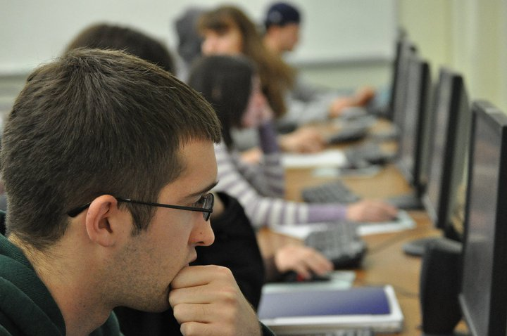The Environmental Science B.S. is a combined major-minor (i.e. has a "built in" minor due to the required foundation coursework). Although no minor is required for those majoring in Environmental Science, some students do choose to add an additional minor, or minors. Some common choices are Geography and Planning, Biology, Atmospheric Science, Business, and Sustainability. Some students also choose to “double major” with any of the aforementioned programs.

The department also offers a Bachelor of Science degree in *Atmospheric* *Science*. This degree provides a more specialized education in meteorology and weather forecasting for students interested in atmospheric processes. Additional information on the Atmospheric Science degree is given in a separate brochure.

**Students hard at work in a DAES classroom**

***Typical B.S. Program in Environmental Science***

*Note that this is an example for the climate change specialization; the required specialization courses (ATM 306, 405, 415, 450) would be different for the other 3 concentrations.****Courses required for this major are shown in bold***

*Semester I Semester 2*

**MAT 112: Calculus I 4 BIO 121: Biology II 3**

**PHY 140: Physics I 3 ENV 106: Env. Science Lab 1**

**CHM 120:** **Chemistry I (+ CHM 124) 4 ENV 105: Intro. Env. Science 3**

**BIO 120: Biology I 3 CHM 121: Chemistry II (+ CHM 125) 4**

University Gen. Ed. Requirement * University Gen. Ed. Requirement *

*Semester 3 Semester 4*

**BIO 201: Biology Lab I 1 BIO 202: Biology Lab II 1**

**BIO 320: Ecology 3 ATM 210: Atmos. Structure/Thermo. 3**

**GEO 221: Understanding the Earth 4** Elective *

University Gen. Ed. Requirement *University Gen. Ed. Requirement *  
University Gen. Ed. Requirement *University Gen. Ed. Requirement *

*Semester 5 Semester 6*

**ENV 302: Ocean Science**  **3** **ENV 327: Meteo./Env. Instrumentation 3**

**ENV 315: Environmental Stat./Comp 3 Specialization elective 3**

**ATM 306: Climate Variability/Change 3** Elective *

**Specialization elective**  *University Gen. Ed. Requirement *

University Gen. Ed. Requirement * University Gen. Ed. Requirement *

*Semester 7* *Semester 8*

**ATM 405: Water and Climate Change 3 ENV 415: Climate Laboratory 3**

**ATM 450: Paleoclimatology 3** **ENV 490: Topics in Env. Science 3**

Elective * **Specialization elective** *

Elective * Elective *

Elective * Elective *

***Undergraduate Internship and Research Opportunities***

***Internships****:* Our Environmental Science students have the possibility to pursue an internship with a local, state or federal government agency or with a private consulting firm. This internship opportunity is open to all junior and senior year students who have a GPA of at least 2.5 in both their major and overall and can be repeated once. These internships provide students with practical work experience in environmental science and allow them to make contacts with potential future employers. It is the student’s responsibility to line up the internship but our faculty regularly help with the search by disseminating information regarding current opportunities to students and by directing students toward useful resources and databases of potential employers.

***Research***: Stimulating and attractive research opportunities exist for our undergraduates. This research, supervised by a department instructor should be done at the beginning of the senior year and can be repeated once for credit (A ENV 498). It requires approval of both the instructor and the chair. In some cases, students work on a faculty member’s ongoing research project, but students are also encouraged to come up with their own ideas. More information on the types of research covered by our faculty can be found beginning on page 7.

***Graduate Program***

Our department does not offer advanced degrees in environmental science but has an active graduate program, offering Ph.D. and M.S. degrees, in atmospheric science. This program is viewed to be one of the top atmospheric science programs in the country. A multitude of prominent research in the field has come from graduate work at UAlbany, and many of our graduates are now employed at the top research and teaching institutions in the world. Several of our environmental science students have applied and been accepted to our atmospheric science graduate program in the past.

***Careers***

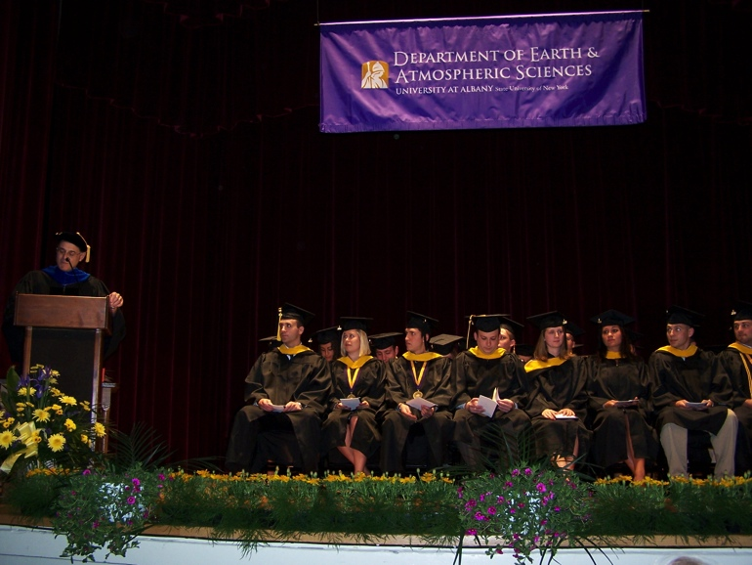Graduates with a B.S. in Environmental Science will be well qualified for a broad range of positions within the highly interdisciplinary field of environmental science. Consulting firms, industry, federal and state government agencies all require employees with this type of training. The demand for individuals with such a degree is anticipated to remain strong as our society attempts to cope with and address a myriad of environmental impacts that are occurring on local, regional, national and global scales. Additionally, graduates with this degree are well prepared to consider advanced degrees in the sciences, or other fields such as business administration (M.B.A.) or law (J.D.). In fact many of our undergraduate degree recipients advance to graduate study.

**DAES Undergraduate Commencement ceremony**

***Our Faculty***

Members of the Department of Atmospheric and Environmental Sciences are funded externally by agencies such as the National Science Foundation (NSF), the National Aeronautics and Space Administration (NASA), the Office for Naval Research (ONR), the National Oceanic and Atmospheric Administration (NOAA), the Air Force Office for Science Research (AFOSR) and others. Research interests of the Faculty teaching in the Environmental Science program include:

*Climatology / Climate Change / Paleoclimatology*

Dr. Aiguo Dai

Dr. Oliver Elison Timm

Dr. Jiping Liu

Dr. Brian Rose

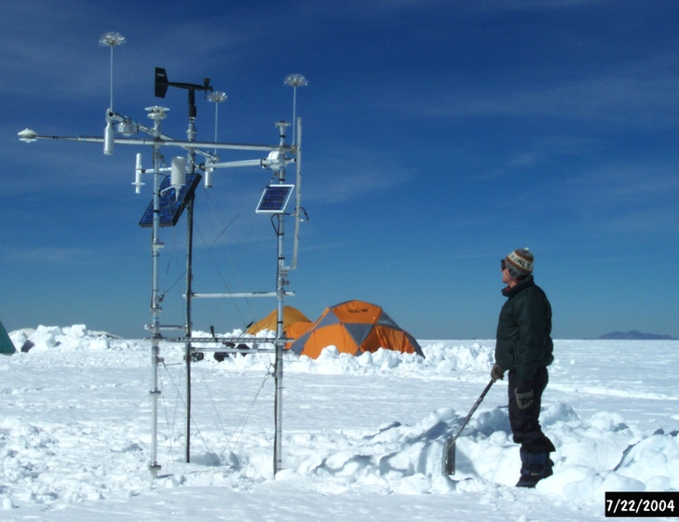Dr. Mathias Vuille

Dr. Liming Zhou

*Tropical Meteorology*

Dr. Paul Roundy

Dr. Brian Tang

Dr. Christopher Thorncroft

Dr. Mathias Vuille

*Physical Meteorology*

Dr. Vince Idone

Dr. Justin Minder

Dr. Junhong Wang

*Atmospheric Chemistry*

Dr. Robert Keesee

**Prof. Vuille working on an automated weather station at 5760 m in the Peruvian Andes**

*Remote Sensing*

Dr. Liming Zhou

*Glaciology and Hydrology*

Dr. Mathias Vuille

*Climate modeling*

Dr. Oliver Elison Timm

Dr. Brian Rose

***Contact information***

**Department of Atmospheric and Environmental Sciences**

*http://www.atmos.albany.edu*

University at Albany, ES-351

1400 Washington Ave., Albany, NY 12222

Phone: (518)-442-4556

E-mail: *chair@atmos.albany.edu*

***Department of Atmospheric and Environmental Science Faculty***

**Lance F. Bosart**, Distinguished Professor (Ph.D., MIT)

ES-227, (518)-442-4564

lbosart@albany.edu

**Kristen Corbosiero**, Assistant Professor (Ph.D., Univ. at Albany, SUNY)

ES-321, (518)-442-5852

kcorbosiero@albany.edu

**Aiguo Dai**, Associate Professor (Ph.D., Columbia Univ.)

ES-310, (518)-442-4474

adai@albany.edu

**Oliver Elison Timm**, Associate Professor (Ph.D., Univ. of Kiel, Germany)

ES-316A, (518)-442-3584

oelisontimm@albany.edu

**Robert Fovell**, Professor (Ph.D., Univ. of Illinois)

ES-314

rfovell@albany.edu

**Vincent P. Idone**, Associate Professor (Ph.D., Univ. at Albany, SUNY)

ES-215, (518)-442-4577

vidone@albany.edu

**Roberta M. Johnson**, Clinical Professor (Ph.D., Univ. of California – Los Angeles)

ES-212, (518)-442-4561

rjohnson5@albany.edu

**Robert G. Keesee**, Associate Professor (Ph.D., Univ. of Colorado)

ES-214, (518)-442-4566

rkeesee@albany.edu

**Daniel Keyser**, Professor (Ph.D., Pennsylvania State Univ.)

ES-224, (518)-442-4559

dkeyser@albany.edu

**Michael Landin**, Instructor (M.S., Univ. at Albany, SUNY)

ES-324, (518)-442-4572

mlandin@albany.edu

**Andrea L. Lang**, Assistant Professor (Ph.D., Univ. of Wisconsin)

ES-323, (518)-442-4558

alang@albany.edu

**Ross A. Lazear**, Instructional Support Specialist (M.S., Univ. of Wisconsin)

ES-322, (518)-437-3601

rlazear@albany.edu

**Jiping Liu**, Assistant Professor (Ph.D., Columbia University)

ES-210, (518)-442-4048

jliu26@albany.edu

**Justin R. Minder**, Assistant Professor (Ph.D., Univ. of Washington)

ES-339B, (518)-437-3732

jminder@albany.edu

**John E. Molinari**, Professor (Ph.D., Florida State Univ.)

ES-225, (518)-442-4562

jmolinari@albany.edu

**Brian E. J. Rose**, Assistant Professor (Ph.D., MIT)

ES-315, (518)-442-4477

brose@albany.edu

**Paul E. Roundy**, Associate Professor (Ph.D., Pennsylvania State Univ.)

ES-339A, (518)-442-4476

proundy@albany.edu

**Brian H. Tang**, Assistant Professor (Ph.D., MIT)

ES-324, (518)-442-4572

**Christopher D. Thorncroft**, Professor and Department Chair (Ph.D., Univ. of Reading)

ES-226, (518)-442-4555

cthorncroft@albany.edu

**Ryan Torn**, Associate Professor (Ph.D., Univ. of Washington)

ES-229, (518)-442-4560

rtorn@albany.edu

**Kevin R. Tyle**, Systems Administrator (M.S., Univ. at Albany, SUNY)

ES-235A, (518)-442-4578

ktyle@albany.edu

**Mathias Vuille**, Associate Professor (Ph.D., Univ. of Bern, Switzerland)

ES-311, (518)-442-4472

mvuille@albany.edu

**Junhong (June) Wang**, Research Associate Professor (Ph.D., Columbia University)

ES-339C

jwang20@albany.edu

**Liming Zhou**, Associate Professor (Ph.D., Boston University)

ES-312, (518)-442-4446

lzhou@albany.edu