Annual Assessment Report for ATM 311
Severe and Hazardous Weather Analysis and Forecasting
Fall 2010

Ross A. Lazear, DAES

Weather forecasting in the Atmospheric Science B.S. degree is initially taught in the final month of ATM 211 (Weather Analysis and Forecasting), typically the second semester of a student’s sophomore year. The following semester, most ATM B.S. majors choose to take ATM 311 (Severe and Hazardous Weather) as an elective. In this course, students are required to participate in two forecasting contests. One contest involves daily forecasting of temperature, probability of precipitation, and precipitation amounts for Albany, NY, during four successive 12-hour periods. Students must forecast at least 80% of all forecast days (Monday through Friday). The other contest is a medium-range forecast contest based on probabilities. For brevity and in order to more closely examine students’ forecast skill, this report will discuss only the former of the two contests. In addition to the two aforementioned contests, it is optional for ATM 311 students to participate in a third contest, referred to as the National Forecast Contest or “Weather Challenge.” Due to the fact that participation in this contest is optional, assessing forecast skill would likely be statistically insignificant on a year-to-year basis, so it will also not be included in this report. The purpose of these three forecast contests as part of ATM 311 is to enable students to hone their forecasting skills for various locations around the country in a competitive, yet fun, environment.
In the 48-hour locally run Albany forecast contest, there are many other competitors forecasting along with the ATM 311 students. This group of forecasters is made up of faculty, staff, graduate students, senior undergraduates, department alumni, and even some National Weather Service forecasters. Because the makeup of this group remains relatively unchanged year-to-year, it allows us to compare students’ forecast accuracy trends both within the semester analyzed and over time.
The Fall 2010 ATM 311 class of 17 students had a similar makeup to recent classes, with approximately 75% atmospheric science majors, and the remainder either majoring in environmental science with an atmospheric science concentration, or minoring in atmospheric science. As will be discussed in further detail, it is clear that the Fall 2010 ATM 311 was superior to recent classes in terms of forecasting skill.
Figure 1 depicts how students in the Fall 2010 ATM 311 class compared to the average forecaster in the contest for each week, and Figure 2 displays the same data but for the Fall 2009 ATM 311 class. Though skill scores for the Fall 2008 class were shown in previous reports, they were calculated using different statistics, and the original data is no longer available. Thus, for consistency in the reporting of the data, the Fall 2008 statistics will not be shown. In order to normalize the data, and because the number of students who forecast every day for a given week changes each week, the data are represented as a percentage of ATM 311 students forecasting better than the average forecaster for a given week. As an example, for week #1, 55% of students in the Fall 2010 ATM 311 class scored better than the average forecaster in the contest. An ideal value is at least 50%, since it implies that students are forecasting on a level comparable with much more experienced forecasters.
As was discussed in last year’s assessment report, the Fall 2009 ATM 311 class (Figure 2) showed a marked improvement in forecast skill during the first four weeks, but suffered a decrease in skill in the middle of the semester. It was hypothesized that the decrease in forecast skill was due to a change of precipitation type forecasting during the change from fall to winter. More emphasis on forecasting was made in last spring’s ATM 211 class, and the results show some improvement from last year. Interestingly, the Fall 2010 class (Figure 1) began with a skill score near 50%, and then slowly declined in skill throughout the duration of the semester. Nonetheless, skill scores overall were higher in the Fall 2010 class, and scored lower than 30% fewer times.
At the University of Washington, Bond and Mass (2009, hereafter BM) performed a study which showed that, in general, forecast skill in a forecasting course improves steadily during the first few weeks, and then gradually plateaus by the middle of the semester. This trend is certainly consistent with results from the 2008 (not shown) and 2009 ATM 311 classes, but not with the most recent class. The Fall 2010 class’s impressive start at the beginning of the semester could simply be a result of their innate forecasting ability, or it could be a direct reflection of improved teaching of forecasting in ATM 211 during the Spring 2010 semester, as well as the introduction of a weekly undergraduate weather discussion often focusing on forecast issues. The slow, but steady decline in forecast skill is potentially due to the change in precipitation type forecasting, or due to students’ time commitment to forecasting decreasing as other academic obligations, such as mid-term exams, begin to take precedence.
Students’ scores can also be broken down by the type of forecast made [i.e., temperature, probability of precipitation (POP), and precipitation amount (PA)]. For the entire Fall 2009 semester, the ATM 311 students’ skill score was only 28% for each forecast type. The Fall 2010 class, however, fared better, with skill scores of 38%, 44%, and 44% for temperature, POP, and PA forecasting, respectively. When analyzing only week #7 and beyond, the data remain approximately the same, except that the skill score for PA decreases from 44% to 33%. The study by BM also separated forecasting skill into temperature and precipitation, and the authors show a lack of increased precipitation forecast skill during the course of a semester. This lack of increased skill is attributed to a change in the nature of precipitation events during the semester to a more convective mode, which is typically much more difficult to predict. As previously discussed, in the fall semester, precipitation type changes from rain to snow, and it is possible that the students need more instruction when it comes to forecasting precipitation amounts during snow events. This issue also occurred in the Fall 2009 ATM 311 class, so I will make it a focus the next time I teach ATM 311.

Reference:
Bond, N. A., and Mass, C. F., 2009: Development of Skill by Students Enrolled in a Weather Forecasting Laboratory. Wea. Forecasting, 24:1141-1148

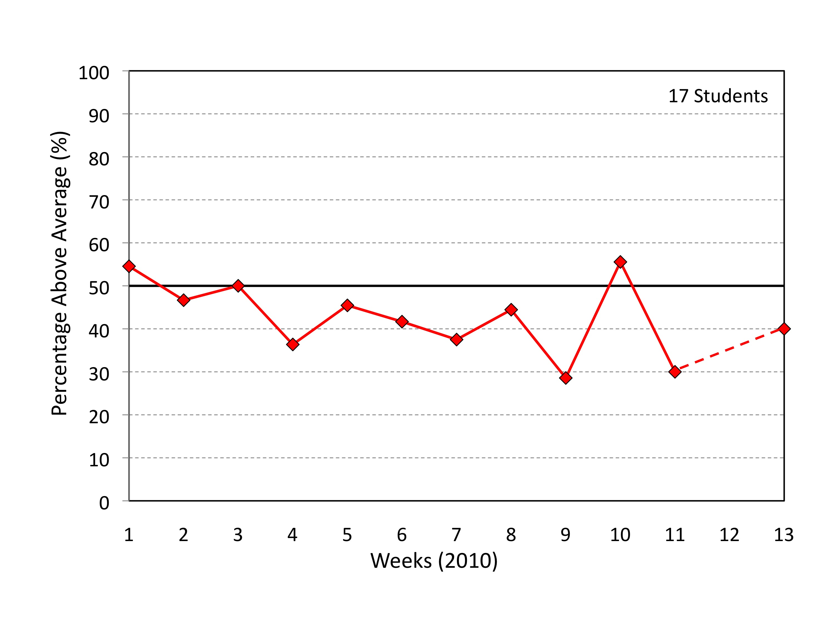
Fig. 1: Percentage, by week, of Fall 2010 ATM 311 students whose forecast skill was above the average skill of every forecaster in the contest. The dashed red line indicates that too few students forecast during week #12 to calculate a skill score.

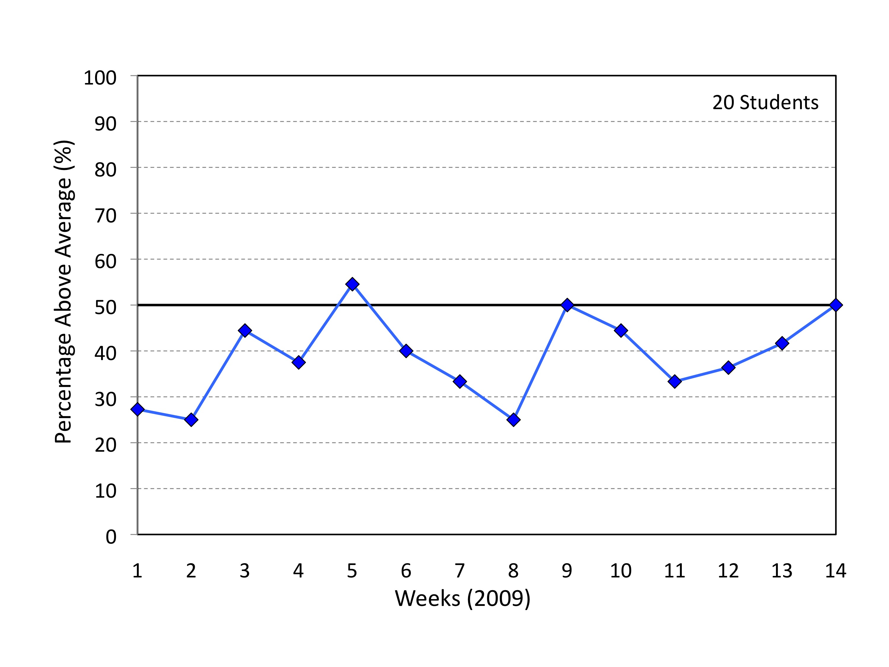
Fig. 2: Percentage, by week, of Fall 2009 ATM 311 students whose forecast skill was above the average skill of every forecaster in the contest.

