Chapter 11
Malevolent Twist: Tornado Science
11.1 Tornado Classifications
11.2 Dissecting the Tornado Vortex: Structure, Wind-Generating Forces, and Spin
How To Identify A Tornado
The “Dynamic Suction Pipe”
Tornadoes and the Conservation of Angular Momentum
Wind Distribution

Storm Physics in Depth:
Why Are Anticyclonic Tornadoes Uncommon?

11.3 Tornado Structure and Wind Speed
Evidence from Doppler Studies
Comparing Two Tornadoes: Dimmitt and Mulhall
The Swirl Ratio
11.4 Tornado Wind Loads and Aerodynamic Forces Causing Structural Failure
Wind Acceleration and Wind Load
How and Why Tornadoes Destroy Houses
Tornado Safety
11.5 Theories of Tornado Formation
Supercell Tornadoes
Cyclic Tornadogenesis
Tornadoes Produced by Bow Echoes
Landspouts
Gustnadoes

Learning Objectives
- Identify the different types of tornado-producing storms and the characteristic intensity of tornadoes produced by each.
- Understand the physical properties of tornadoes and governing forces, including cyclostrophic balance, the conservation of angular momentum, vorticity, circulation, suction vortices, swirl and asymmetric distribution of winds;.
- Describe how Doppler radars have yielded new insights about tornado structure and evolution, including single and multi-vortex tornadoes;
- Define wind load and explain how a tornado’s winds create destructive aerodynamic forces that damage dwellings.
- Explain the core principles associated with tornado formation (tornadogenesis).
Tornadoes strike the United States sporadically and violently. No other location in the world experiences more tornadoes than the central and eastern United States. These intense, vertical vortices produce the strongest of all surface winds. In the most violent tornadoes, wind speeds approach 300 kts (345 mph), far greater than those in a Category 5 hurricane (which can reach 136 kts or 157 mph). But tornadoes are extremely localized storms; the typical tornado track is about 50 meters wide by 2-3 kilometers long. While a single hurricane can adversely impact a 10,000 km² coastal region, less than 1% of the U.S. population will find themselves in the path of a tornado during the course of their lifetime. To understand the relative rarity of tornadoes in any one location, consider the statistics: About 10% of all U.S. thunderstorms each year become severe; but only 10% of the severe storms, or 1% of all thunderstorms, spawn a tornado.
In this chapter, we explore all facets of tornado science. We start by introducing tornado classifications and describing the physical properties of tornadoes. We then discuss the forces that give rise to extreme winds and explore key properties that distinguish large, violent tornadoes from smaller, more transient tornadoes. We show how portable Doppler radars have mapped the internal, three-dimensional structure inside tornadoes. We close by examining how tornadoes damage built structures and looking closely at the enigma of tornadogenesis – the mysterious process by which tornadoes develop within the parent thunderstorm. The next chapter places the devastation wrought by tornadoes and tornado outbreaks in a societal context.
[H1] Tornado Classifications
Scientific Principle 2.28 A tornado is the most intense type of cyclonic vortex, typically less than a half-mile across, and generated within a severe, rotating thunderstorm called a supercell. Its winds, which may top 300 mph, are in a state of cyclostrophic balance.
By definition, a tornado is a violent, small-scale vortex in contact with the surface, spawned from a thunderstorm cloud. Like hurricanes, tornadoes have a vast range of wind intensities, from 60 to 300 kts (69 -345 mph). The weakest tornadoes are very small (just a few meters wide) and short-lived, on the order of minutes. Tornadoes are usually classified in three broad categories:
- Weak tornadoes have winds below 97 kts (112 mph).
- Strong tornadoes have winds that range from 97 to 143 kts (112-165 mph).
- Violent tornadoes – with winds over 143 kts (165 mph) – are also the largest, up to a kilometer or more wide, with tracks that extend 30-40 km (19-25 mi). A long-track, violent tornado can persist an hour or more, destroying many communities across several counties, even multiple states. Only about 10-12 of these “monster” tornadoes occur in the United States during a typical year. While violent tornadoes account for just 1% of all tornadoes, they cause 70% of all tornado fatalities.
Nature produces tornadoes in many ways. The most severe thunderstorms, the supercells, are prolific tornado breeders; they generate 79% of all reported tornadoes and nearly all violent tornadoes. Weaker tornadoes are frequently spawned by especially violent squall-line thunderstorms called bow echoes. In bow echoes, a swath of damaging winds arises from both downbursts and weak tornadoes. This category of storm may account for as many as 18% of all tornadoes. Tropical cyclone remnants also develop tornadoes after landfall, generating 2-3% of annual tornado counts, usually within a two hundred miles of the coastline. Landspouts, a type of weak tornado, originate from isolated convective cells that may not be intense enough to qualify as thunderstorms.
[H1] Dissecting the Tornado Vortex: STRUCTURE, Wind-Generating Forces, and Spin
As we start to look more closely at tornadoes, let’s begin by examining some tornado types.
[H2] How To Identify A Tornado
Tornadoes take on a variety of appearances.
Tornadoes come in an amazing array of shapes, sizes, colors, and configurations. There is no one “prototype” design that applies to all tornadoes. Figure 11.1 illustrates many of the common variations. Panel (A) shows a weak tornado. The main portion of the vortex is rendered visible by water vapor that has condensed into tiny cloud droplets, creating the funnel cloud. The vapor condenses when air rushing into the low-pressure region of the vortex expands adiabatically and cools, lowering the air temperature to its dew point. Portions of the funnel cloud may appear translucent. Dirt lofted from the surface whirls around the base of the tornado. While the larger soil particles are centrifuged outward, fine dusts are lofted halfway up the vortex in a thin, tubular sheath. When illuminated directly by sunlight, the true color of a tornado’s funnel cloud is white, like any other cloud, as Panel (B) shows.
Scientific Principle 3.10 The most common way that air cools to saturation involves the volumetric expansion and adiabatic cooling of a humid air parcel. Adiabatic cooling comes about as an expanding parcel loses internal energy.
Scientific Principle 3.6 The dew point temperature is that temperature at which air must be cooled in order to reach saturation. Dew point temperature is proportional to the amount of vapor mass in the air.
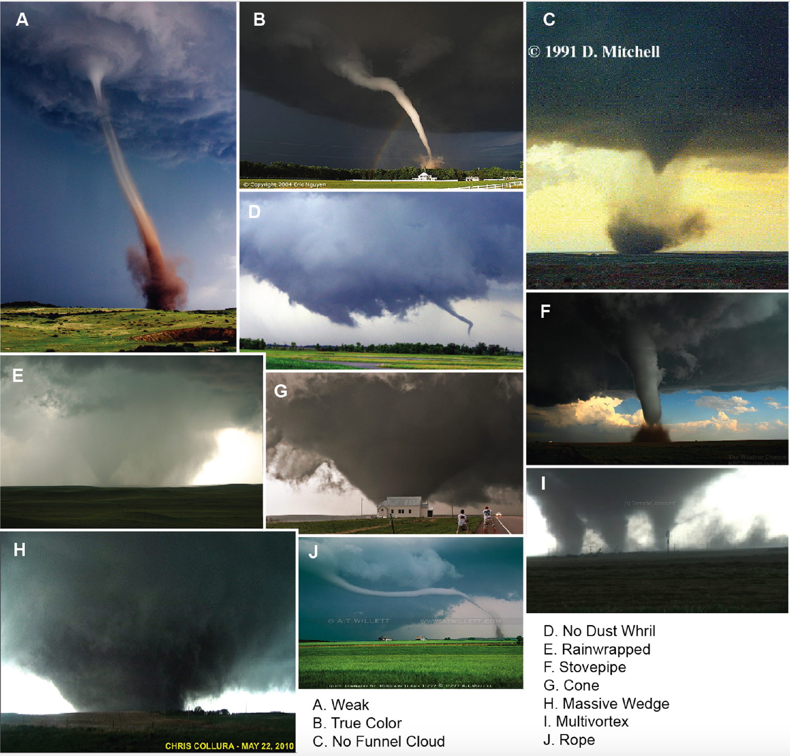
Figure 11.1: The diversity of tornado appearances. Tornadoes may appear as slender as a rope or as a massive funnel more than one kilometer wide. Multiple tornadoes can appear simultaneously, and some are so shrouded in rain that the naked eye cannot detect them.
If the sub-cloud air is especially dry (that is, it has low dew point), or the pressure drop inside the tornado is minimal, a funnel cloud may not develop, as Panel (C) shows. However, a massive dust and debris whirl at the surface implies that the tornado’s wind circulation extends to ground level. Panel (D) shows a funnel cloud pendant from the base of the parent thunderstorm, but there is no dust whirl; in this case, a tornado proper has not yet developed. Panel (E) shows a large, conical tornado that has become rain-wrapped. The tornado is largely obscured by dense rain curtains. Rain-wrapped tornadoes present a hazard to community storm spotters, who may fail to notice these “invisible” tornadoes before they strike a town.
Panels (F) through (J) illustrate additional tornado configurations. Panel (F) displays a classic stovepipe vortex, essentially a wide, straight cylinder between cloud base and surface. Stovepipes tend to be strong tornadoes. They often appear gray or dark blue because they lack direct illumination; the great thickness of overlying storm cloud absorbs and scatters sunlight. Panel (G) shows a classic cone tornado. Cones also tend to be very strong tornadoes.
Panel (H) shows the most dreaded type of tornado, a massive wedge vortex. Often, these violent tornadoes assume a rolling, turbulent, boiling appearance; the classic funnel shape is not present. These most violent of tornadoes, while extremely rare, may be 2-3 kilometers wide (the record for the widest tornado stands at 3.5 kilometers). The lower end of violent tornadoes may devolve into separate suction vortices, becoming a multiple-vortex tornado. The most intense winds on Earth are concentrated at the tip of these miniature vortices, which spin not only about their own axes, but also orbit around the main axis of the parent tornado.
Panel (J) shows a rope tornado. The rope often signals the final, dissipating stage of a tornado. The rope often takes on a highly constricted, sinuous form and a segment of it may even lie horizontal. The rope vortex has been deformed and stretched along the dome of rain-chilled air emanating from the storm, the storm’s downdraft.
The shape, color, and intensity of a tornado can vary considerably throughout its lifetime. For instance, a tornado in its developing stage may have a very narrow funnel. As it matures, the tornado may take on a stovepipe or conical form. Passing over plowed farm fields, the funnel color may change from gray to brown or black, as soil is lofted. Passing over a lake, the funnel may become white or blue as water is ingested. Finally, as a tornado begins dissipating, it will often “rope out.”
[H2] The “Dynamic Suction Pipe”

Tornadic vortices behave like a dynamic suction pipe.

The same set of physical processes governs most types of tornadoes. Like any atmospheric vortex, the swirling wind is established by a balance of wind-generating forces. Curved flow around a large-scale synoptic vortex (such as an extratropical cyclone) is in a state of gradient wind balance (that is, a balance of the pressure gradient, Coriolis and centripetal forces). These large vortices include the effect of Earth’s spin via the Coriolis effect. Tornadic vortices are many orders of magnitude smaller. We can ignore the effect of Earth’s spin at this tiny scale (see “Storm Physics In Depth: Why Are Anticyclonic Tornadoes Uncommon?”).
Scientific Principle 2.3 Differences in atmospheric pressure across a horizontal distance give rise to the pressure gradient force, which accelerates air from high toward low regions of pressure – creating wind.
Scientific Principle 2.5 The Coriolis Effect arises from the spinning Earth; it deflects air that begins to move, to the right, in the Northern Hemisphere.
Scientific Principle 2.17 Extratropical cyclones are large, transient vortices that migrate from west to east across mid latitudes. Air converges in a counterclockwise spiral around these cyclones, which feature low pressure in their core (“L” on a weather map). These systems bring changeable weather (extremes in temperature, precipitation, fair weather) to most mid-latitude locations.
The winds that swirl around a tornado’s low-pressure region are in a state of cyclostrophic balance, as shown in Figure 11.2. The cyclostrophic wind arises when the inward-directed pressure-gradient force is balanced by an outward-directed centrifugal force.
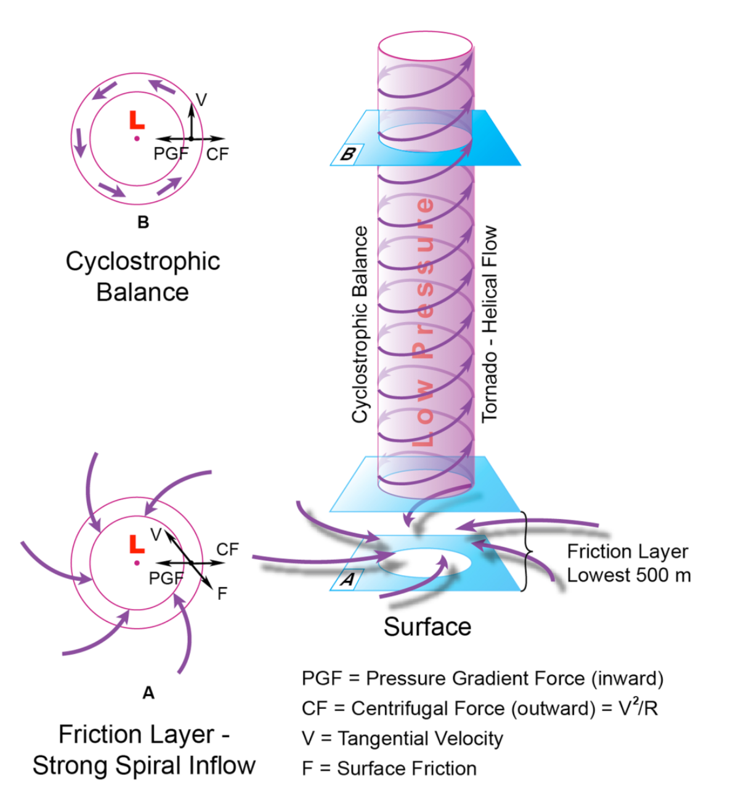
Figure 11.2: Cyclostrophic Balance. In cyclostrophic balance, the inward-directed pressure gradient force is balanced by the outward-directed centrifugal force, producing a swirling cylinder of air around the vortex axis. This balance is disrupted only very close to the surface, when friction with the ground slows the centrifugal force. However, the pressure-gradient force is unaltered. Wind rushes in, creating the equivalent of a giant suction pipe.
When in cyclostrophic balance, air can flow neither toward the central axis of the vortex nor away from it; all flow is confined to a swirling sheath around the vortex axis. However, cyclostrophic balance breaks down at the surface. When the free end of the vortex contacts the ground, friction slows the swirling wind in a shallow layer. As Figure 11.2 shows, centrifugal force is proportional to the velocity squared (V²). At the surface, as the wind slows, the centrifugal force must weaken. But the pressure-gradient force remains unaltered. Air can now rush inward, toward the central axis of the vortex. We can think of a tornado vortex as a kind of dynamic suction pipe. Air swirls around the pipe, but at its base, it can spiral inward, in response to suction. The swirling air enters the vortex interior and rises upward through the pipe from below.
Figure 11.3 illustrates how a tornado is embedded in a larger mesocyclone. Let’s consider a strong or violent tornado, the type that forms in supercell thunderstorms. Recall that supercells have a tall, rotating mesocyclone several kilometers in diameter, embedded inside the main updraft. The base of the mesocyclone, 2-10 km (1.2-6.2 mi) in diameter, extends partially downward below the cloud base, just off the surface. The much smaller tornado (perhaps 500 m in diameter) develops inside the mesocyclone. The rotating winds of the mesocyclone supply angular momentum to the tornado, and the low pressure in its core helps evacuate air from the interior of the tornado vortex. As a dynamic suction pipe, the tornado attempts to fill with air sucked in its base. But as long as the mesocyclone pulls air out of the tornado vortex (at its top), the air never completely fills the tornado and a low-pressure core is maintained. Surface friction also limits the amount of air that can be sucked into the lower end of the tornado. Significant pressure reductions are found inside tornadoes – typically several tens of millibars. The largest pressure deficits are on the order of 100 mb, or about 10% of mean sea-level pressure.
Scientific Principle 2.1 Atmospheric pressure is the weight of the overlying atmospheric gasses, per unit surface area.
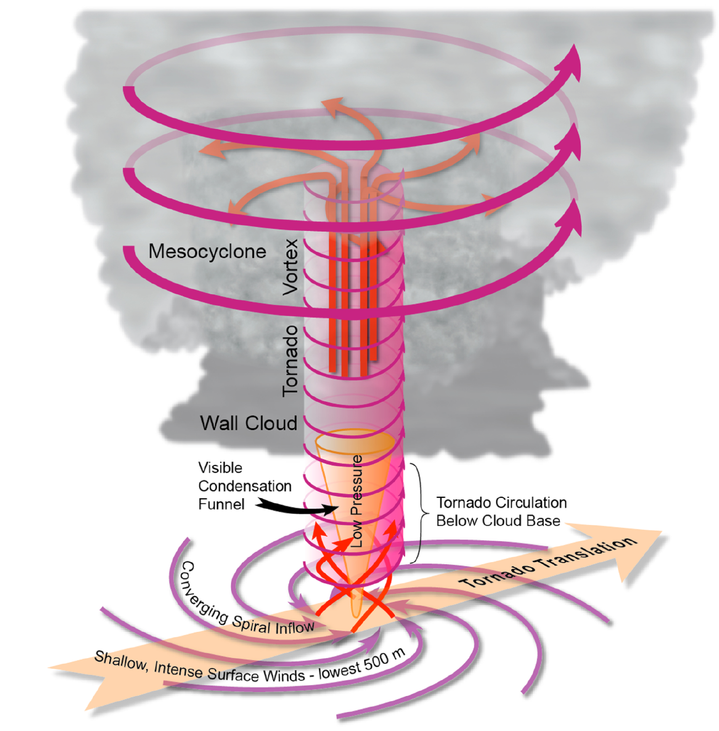
Figure 11.3: The tornado embedded in its parent mesocyclone The mesocyclone is part of a supercell thunderstorm. The low pressure inside the mesocyclone core acts to evacuate the rising, swirling air in the tornado, thus maintaining a low pressure in the tornado vortex and a “suction” that is fed by air entering the tornado vortex at the surface. As long as this dynamic is maintained, the tornado continues to operate.
At the base of the tornado, air converges in a tight spiral in a shallow air layer. In fact, powerful inflow or feeder winds can create considerable damage some distance from the tornado vortex. Note that the funnel cloud, which often tapers toward the surface, is smaller in diameter than the tornado vortex, which occupies a near-vertical cylinder down to the surface. The tornado extends upward some distance inside the larger mesocyclone. The mesocyclone and its tornado translate (move in a straight path) along the ground, often at speeds of 30- 40 kts (35-46 mph), creating a narrow path of destruction as the tornado moves across the landscape.
[begin box]
Storm Physics in Depth
Why Are Anticyclonic Tornadoes Uncommon?

Two important measures of tornado intensity are circulation and vorticity. These concepts explain why all tornadoes need not have winds that swirl in a counterclockwise (cyclonic) direction.
Circulation (C) is a general measure of the size and strength of a vortex. It is proportional to tangential velocity (V) and vortex radius (R):
C = 2πVR
Circulation increases when either the wind speed and/or the vortex radius increases. Vortex size exerts a much greater influence on circulation than radius does. As Table 11.1 shows, the circulation of a small, weak tornado is 1000 times less than that of a typical weak hurricane, but both possess the same wind speed. The circulation of a large, violent tornado is 35 times larger than that of a weak tornado.
The circulation does not indicate how rapidly the vortex winds make a single revolution. The rate of spin is commonly expressed as vorticity, ς, which is calculated as tangential velocity divided by radius (ς =2V/R). As Table 11.1 shows, vorticity is expressed in units of inverse seconds – that is, a vorticity ς = 1/s is interpreted as “one complete revolution per second.” For a given tangential velocity, the smaller the vortex, the larger its vorticity. The table compares the vorticity of a weak tornado, a violent tornado, a weak hurricane, and a strong hurricane. The enormous range in vortex radius is responsible for the wide range of vorticity. The vorticity of a large, strong hurricane is 1000 times smaller than that of the weak tornado. And the vorticity of a dust devil just 10 m (33 ft) across is ten times larger than that of the most violent tornado. You have probably observed dust devils, which are compact swirls of soil, leaves and debris that form over a hot surface, but lack a distinct funnel cloud and last less than a minute.
To summarize: Hurricanes are characterized by very large circulation and small vorticity, while most tornadoes have large vorticity and comparatively small circulation. But what does all this have to do with a tornado’s direction of spin? The vast majority of tornadoes – weak, strong, or violent – spin in a counterclockwise direction; they are cyclonic vortices. But anticyclonic (clockwise-spinning) tornadoes do occur; once thought to be extremely rare, they are being discovered in greater numbers (thanks in large part to recreational and professional storm chasers on the Great Plains). In fact, anticyclonic tornadoes are sometimes paired with cyclonic tornadoes beneath the same supercell. However, most anticyclonic tornadoes are comparatively weak and short-lived compared to their cyclonic counterparts.
It is a common misconception that Earth’s spin, which is counterclockwise, directly influences the direction of tornado spin. Many people mistakenly think that the Coriolis effect controls the spin of a tornado, and even the direction that water swirls down a sink drain. The bottom line is this: The tornado vortex is far too small and short-lived to feel the influence of Earth’s rotation. We can think about a tornado’s spin in terms of vorticity. Knowing Earth’s radius and rotational velocity, we can easily compute Earth’s vorticity at its surface. This works out to 0.00015/s. The vorticity of the smallest tornado is about 3/s. Thus, Earth’s vorticity is only one part in ten thousand of a tornado’s vorticity – far, far too small to directly influence a tornado’s spin.
So why do so many tornadoes spin counterclockwise? Strong and violent supercell-spawned tornadoes are embedded within the mesocyclone, which spins counterclockwise. But the sense of mesocyclone spin is established by airflow that is initially horizontal and characterized by a rapid increase in wind speed with altitude – a property independent of the Earth’s spin.
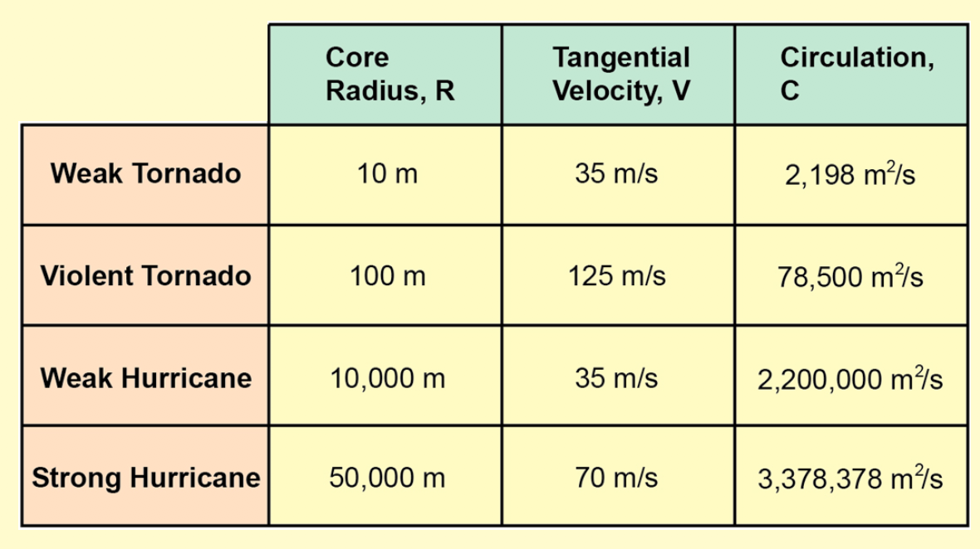
Table 11.1: Circulation and Vorticity of Tornadoes and Hurricanes
[end box]
[H2] Tornadoes and the Conservation of Angular Momentum
When a whirling vortex contracts, it speeds up; when it expands, it slows down
A very important concept in meteorology is the conservation of angular momentum, L. Conservation of angular momentum simply states that the product of the vortex radius, mass and windspeed must remain constant. Angular momentum in any rotating wind system is defined by the following equation:
L = VRm
where V is the wind’s tangential velocity, V (the speed of the swirling wind, or spin); R is the vortex radius; and m is air density (mass). The product of these quantities, L = VRm, is conserved. In other words, if radius (R) decreases (that is, the vortex shrinks or contracts), tangential velocity (V) must increase, to keep angular momentum constant (we ignore variations in mass for the sake of simplicity). If radius increases, spin must decrease. Recent Doppler radar observations show that the radius of tornadoes undergoes pulse-like variations along the track. When the vortex shrinks, wind speeds momentarily increase.
Figure 11.4 illustrates the basic concept of angular momentum. We start with a supercell thunderstorm and its mesocyclone. The mesocyclone has cyclonic (counterclockwise) angular momentum. The embedded tornado has a much smaller radius, perhaps 10-20% the diameter of the mesocyclone. Accordingly, as angular momentum is conserved, cyclonic tornado winds must increase in speed. Some tornadoes break down into two or more suction vortices near the surface. These tiny vortices, perhaps only 10 m across, reflect the final shrinking of the vortex system; the highest tangential winds are thus found within these vortices.
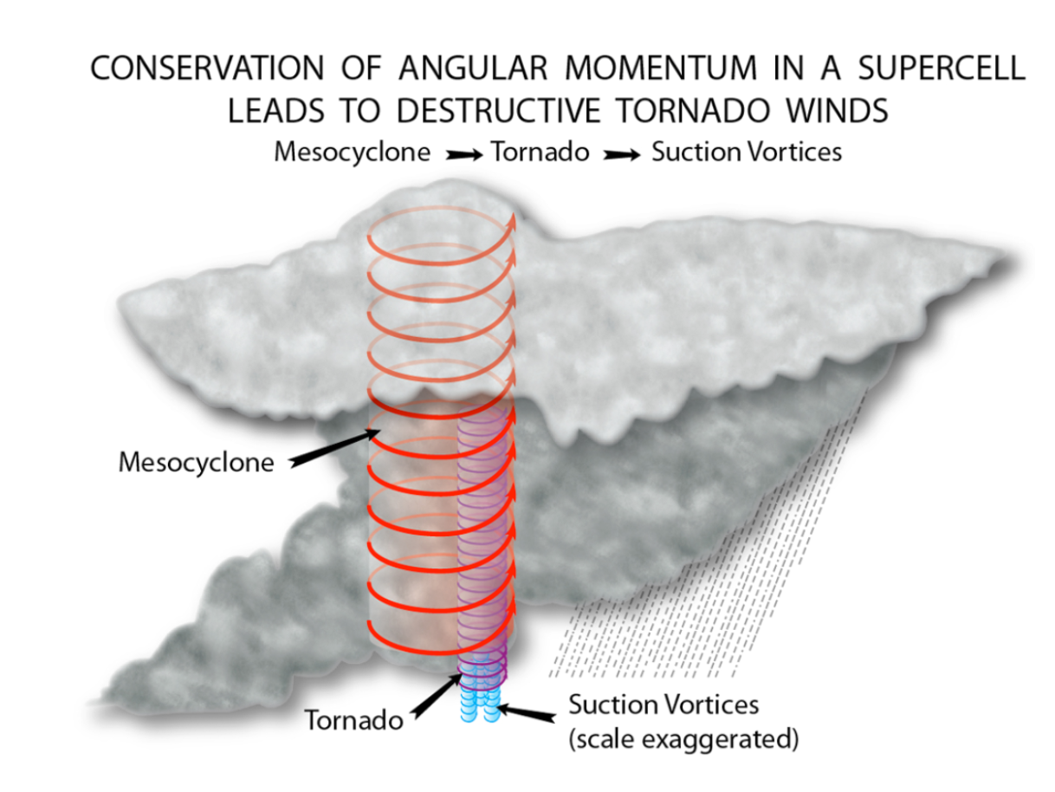
Figure 11.4: Conservation of angular momentum. As we move from the mesocyclone to the tornado there may be a tenfold or greater reduction in radius. Therefore, all else being equal, the tornado’s wind speed must increase to offset the change in size. Likewise, suction vortices are considerably smaller in radius than the tornado, so they must experience a proportional increase in wind speed.
Figure 11.5 quantifies these principles further. From top to bottom, we see the complete hierarchy of vortices that give rise to intense tornadic winds. Tornadoes lie at the base of an energy flow, starting with the large-scale extratropical cyclone (top panel). As the spatial scale shrinks, rotating winds become more sharply focused and intense. Each successive panel shows orders of magnitude reduction or shrinkage in vortex area, with a rise in tangential wind at each step. The extratropical cyclone is a broad vortex, on the order of 1000 km (621 mi). In a mature cyclone, winds spin at 20-30 kts (23-35 mph) around its center at low levels. Within the cyclone’s warm sector, supercell thunderstorms develop. These storm cells each contain a mesocyclone, with a diameter of 10 km (6 mi). While the direction of spin is the same in the cyclone and the mesocyclone (counterclockwise), the winds of the mesocyclone spin at 50-70 kts (58-81 mph). Stepping down further, we arrive at the tornado vortex with a diameter of 1 km (.6 mi) embedded within the mesocyclone, .Winds in a strong tornado circulate counterclockwise in the 150-200 kt (173-230 mph) range. As tornadic winds devolve into 10m-diameter suction vortices (lowest panel), winds approach 300 kts (345 mph). The entire vortical wind system in Figure 11.5 spans six orders of magnitude (a scale factor of 100,000) and the rotating winds have increased from 30 to nearly 300 kts (35 to 345 mph)– a grand example of angular momentum’s conservation.
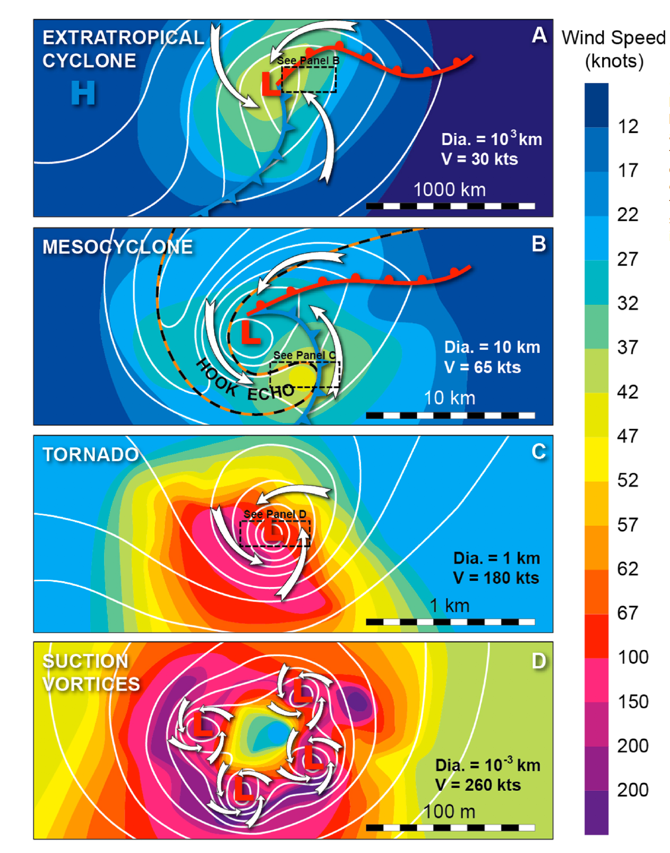
Figure 11.5: Conservation of angular momentum in a hierarchy of atmospheric vortices. We begin with the extratropical cyclone and progress downward in scale through mesocyclone, tornado, and suction vortices. Due to conservation of angular momentum, as the size of the vortex decreases, the speed of the rotating winds in the vortex increases.
[H2] Wind Distribution
Tornadoes have a very concentrated and asymmetric wind distribution.

Generally speaking, tornadoes travel in straight paths because they are embedded in a supercell, which is itself propelled by large-scale winds such as the jet stream. Occasionally, tornado translation slows or becomes erratic, or the tornado becomes stationary. Tornadoes can even make loops; such is the case when the supercell slows or stops moving, and the tornado orbits counterclockwise around its parent mesocyclone.
If a tornado is moving along the ground, the winds that swirl around the vortex (the tangential wind) are not the same on both sides of the tornado track. As the vortex moves in a straight path, the direction and speed of movement must be added to or subtracted from the tangenial wind. Let’s imagine a tornado moving along a straight path, at a brisk speed of 50 kts (58 mph). As Figure 11.6 shows, the tornado is tracking from W-SW to E-NE. If the tornado were stationary, it would have a uniform tangential velocity of 200 kts (230 mph) everywhere around the center. But the entire vortex is moving. On the right side of the tornado path, the speed of the tornado’s movement – its translation speed – adds to the tangential velocity; both the wind direction and the tornado movement act in the same direction. In this case, we add 50 kts + 200 kts to get a total wind of 250 kts (288 mph). To the left of the tornado track, we subtract the translation speed from the tangential wind, because the wind swirls in the opposite direction that the tornado is moving: 200 kts minus 50 kts yields 150 kts (173 mph) total wind to left of track. Thus, the total wind across the tornado varies considerably, amounting to 100 kts difference (250 on the right vs. 150 kts on the left), giving rise to an asymmetric wind field. This large difference occurs over very small distances, on the order of just tens to perhaps a few hundred meters.
The asymmetric wind field explains why the worst tornado damage often appears sporadic and confined to a small area. Homes on one side of a neighborhood street may be devastated, while those on the opposite side may suffer only minor damage. The location of a structure with respect to the tornado track, and distance from the tornado center, greatly determines the damage it receives.
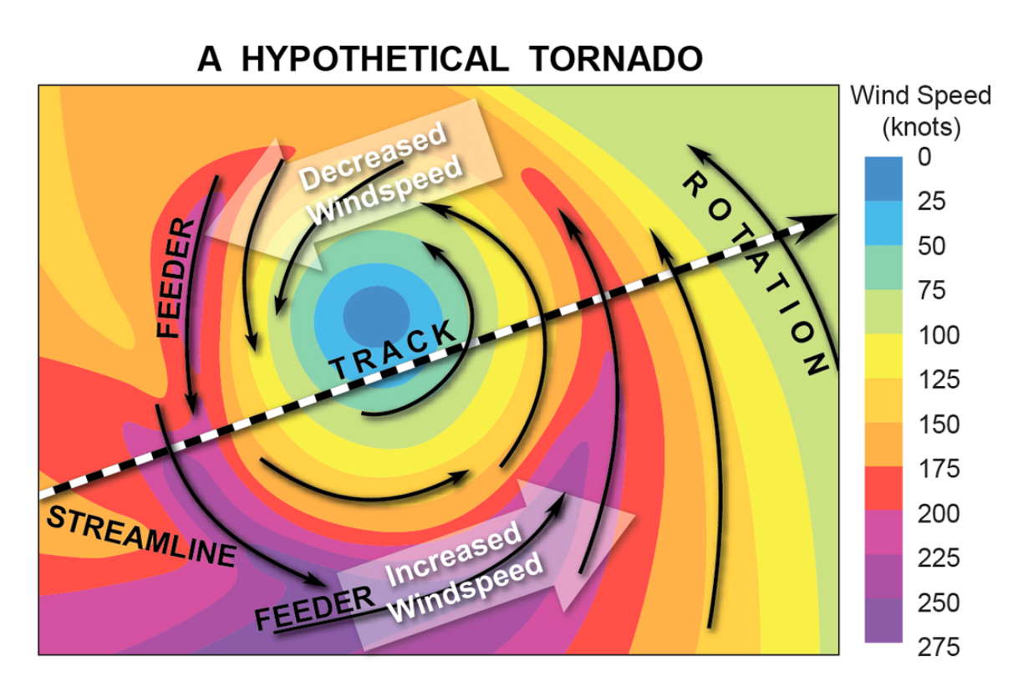
Figure 11.6: Wind asymmetry in a typical tornado. The speed with which a tornado tracks (translational speed) can have significant effect on the wind speeds associated with each side of the tornado. To calculate the differences in wind speed, we add the track speed to the right-side tornado winds and subtract the track speed to the left-side tornado winds.
Another type of wind asymmetry arises from feeder bands. Feeder bands are narrow jet-like ribbons of air that stream into the tornado, along the surface. As Figure 19.6 shows, the strong inflow of air swirling into the vortex is sometimes concentrated in narrow corridors. These feeder bands may be only a few tens of meters wide, and they may contain locally more intense winds than the surrounding vortex.
Figure 11.7 shows a post-tornado damage assessment following a devastating 1979 tornado that occurred in Wichita Falls, Kansas . The assessment is based on aerial surveys and illustrates many of the important concepts we have discussed so far. First, note the very linear and narrow track of damage caused by the tornado. As the tornado approached the small town of Sikes, it changed direction slightly, executing a shallow “S” turn. The path is generally a uniform 500-700 m (1,640-2,300 ft) wide. This tornado was rated as a violent tornado, with winds up to 225 kts (259 mph). There is a very large asymmetry in total wind speed across the path, with the highest winds confined to a very narrow corridor (only about 100-200 m or 328-656 ft wide) to the right of the tornado track. The core of high winds is relatively uniform up to Location A, then becomes sporadic until Location B, at which point the tornado begins to rapidly weaken. To the right of track, particularly in the region of the “S” turn, prominent feeder bands arc inward toward the track’s center from the southwest. Additional feeder bands curve inward from the northeast left of track, just east of Fairway Blvd. The key conclusion here: When a particular tornado is rated as violent, the highest winds occupy only a small percentage of the total path area, typically about 10-20%.
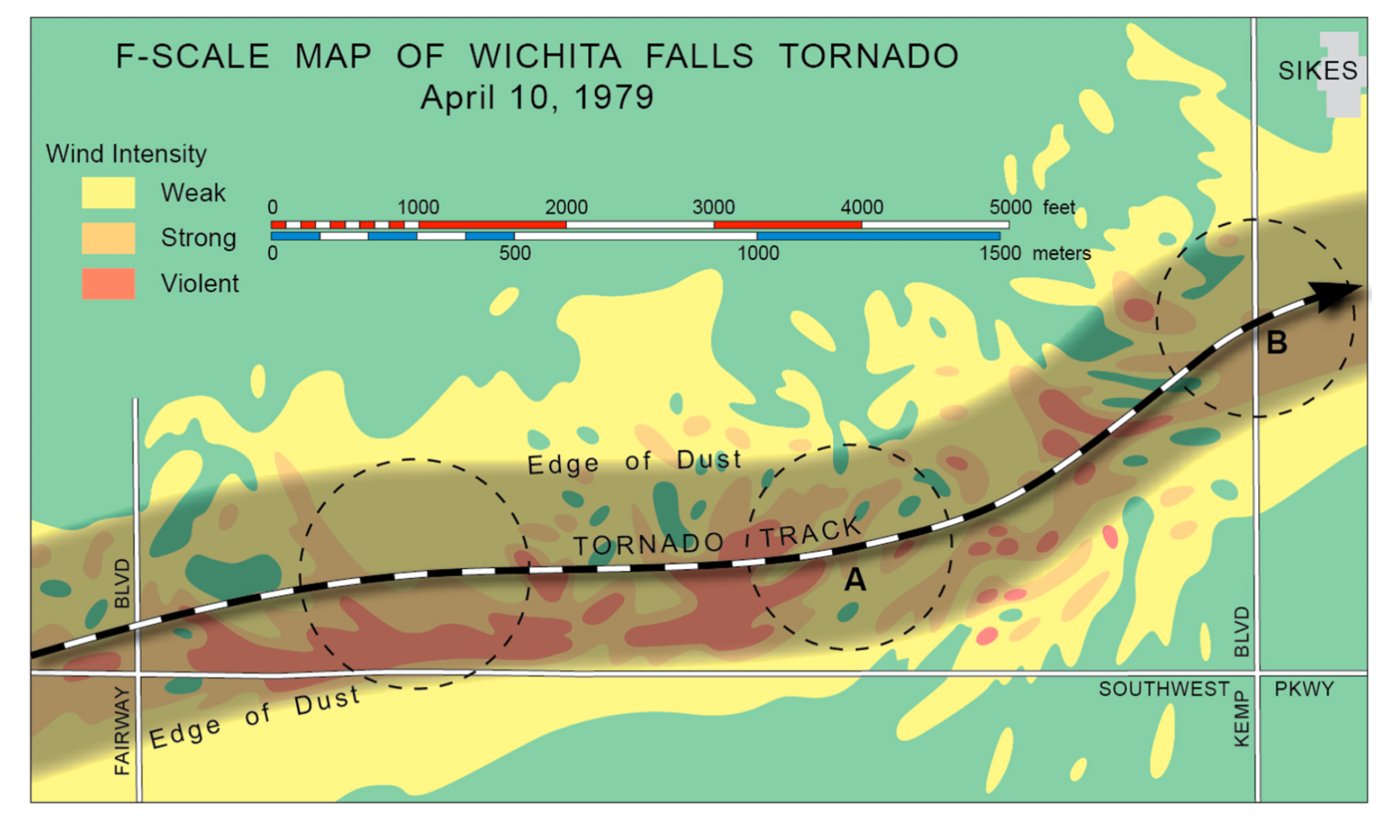
Figure 11.7: Destruction caused by the April 10, 1979 Wichita Falls tornado. The highest winds occur on the right side of the counterclockwise-rotating tornado. With the more rare clockwise-rotating tornado, winds are strongest on the left side.
[H1] Tornado Structure and Wind Speed
Until the late 1980s, meteorologists learned about tornadoes’ internal structure and maximum wind speeds by direct observation, laboratory experiments, and computer simulations. Instruments placed directly in the path of tornadoes experienced a low success rate of collecting data, usually because (1) the tornado missed the instrument, (2) the tornado was too dangerous to safely approach, or (3) the instrument was destroyed. Few, if any, devices can withstand the winds of a violent tornado. But the quest to understand the tornado’s internal air flow continues, because such knowledge provides the engineering insights needed to build windproof dwellings.
The late 1980s saw a breakthrough in tornado observation technology. Doppler radars, which measure wind velocity from a distance, were built small enough to be completely portable. A tornado intercept team could transport the device in a car, or mount it on a small truck, and position the device within one to two kilometers of the tornado. These devices were pioneered by Professor Howard Bluestein and his graduate students at the University of Oklahoma. In the past 15 years, Dr. Joshua Wurman (National Center for Atmospheric Research) has greatly refined portable Doppler techniques using his Doppler on Wheels (DOW). The DOW uses a large radar dish (Figure 11.8) that increases the beam’s resolving power, down to a pixel size of about 60 x 60 m. But progress measuring wind speeds in tornadoes has been slow. Tornadoes remain dangerous and difficult to approach, and the scientific field programs devoted to intensive tornado research are costly. On average, only a small handful of useful portable Doppler tornado datasets are gathered in any given year. Nevertheless, several theories proposing the structure and evolution of tornadoes are finally being verified by these Doppler datasets. Incidentally, the highest ever Doppler-measured wind in a tornado stands at 300 knots (345 mph).
Scientific Principle 4.8 Weather radar is a type of ground-based remote sensing tool. The radar antenna emits rapid, short pulses of microwave energy as it sweeps out an arc through the atmosphere. Precipitation particles (rain drops, snowflakes, hailstones) scatter some of the energy back to the antenna; computers compute the distance to the precipitation and estimate its intensity.
Scientific Principle 4.9 Most radars use the Doppler principle to estimate wind speed and direction, along the radar beam. Pulses of radar energy transmitted at a fixed frequency are phase-shifted toward or away from the radar, based on the horizontal speed of precipitation particles embedded in the moving air.
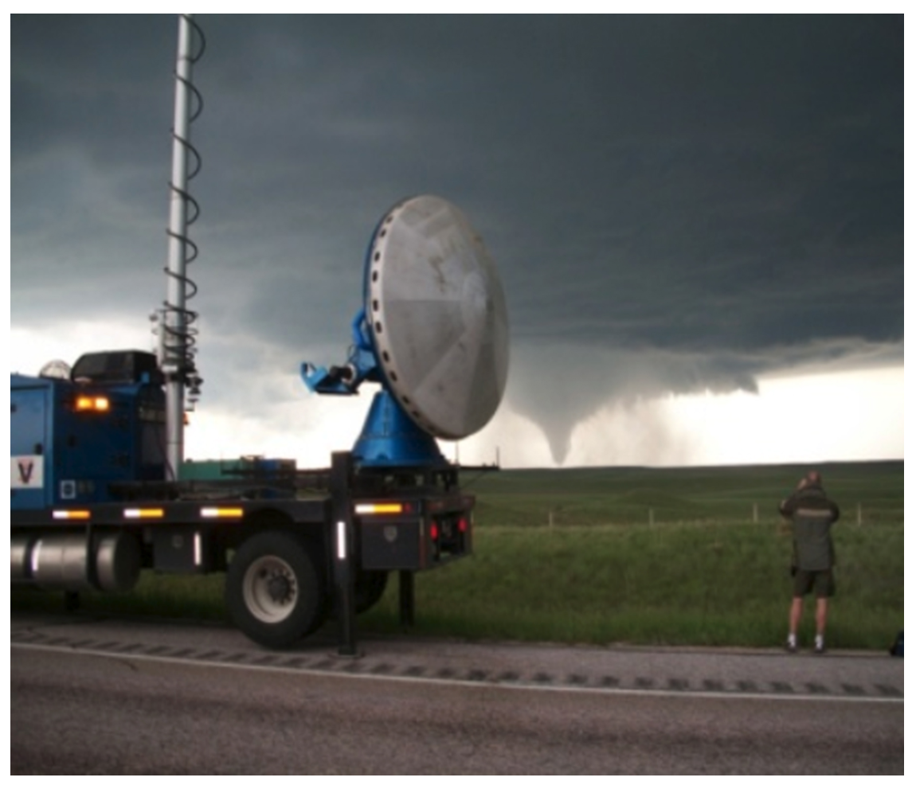
Figure 11.8: Doppler on Wheels (DOW). Scientists now use DOW, with its greater resolving power, to better understand the science of tornadoes. However, it is still difficult and dangerous to position DOW effectively.
[H2] Evidence from Doppler Studies
The tornado’s inner “secrets” are being revealed
Figure 11.9, which depicts a strong to violent tornado, synthesizes much of what we know about the anatomy of a tornado, based on portable Doppler research studies. The tornado is sliced in half, revealing its hollow inner core. Intense tangential winds form a vertical cylinder extending from above the cloud base to the surface. The color scale indicates the relative speed of the tangential wind. To understand the figure properly, you must visualize that the tangential wind comes out of the page on the left side, then enters the page on the right side (note that this movement completes the counterclockwise swirl). Now, imagine the tornado moving in a straight line away from you. This movement makes the total vortex wind stronger on the right side. Note how the tangential winds also decrease with height. Tangential winds are strongest in a shallow ring at the base of the tornado, just above the surface. The entire vortex also widens gradually with height. The overall tornado structure bears an uncanny resemblance to the inner vortex of a hurricane.
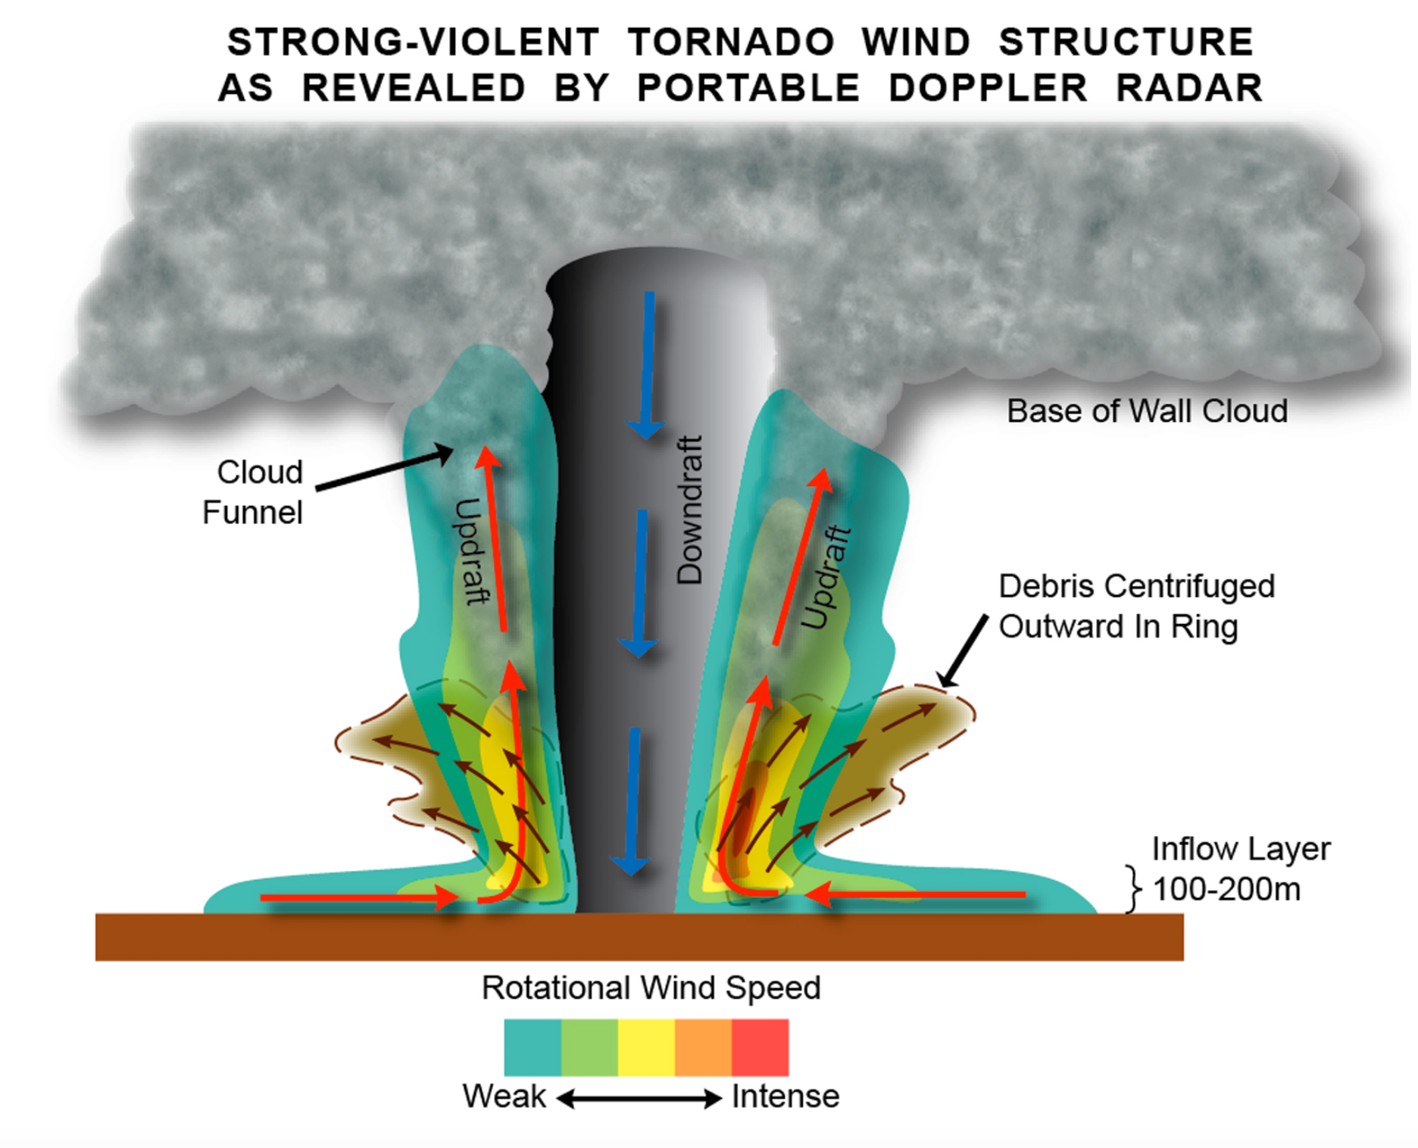
Figure 11.9: Cross-section of a Tornado. Imagine the tornado moving away from you. Winds are strongest near the surface and decrease with altitude. Furthermore, winds are stronger on the right side than the left side due to the storm’s forward movement. Air feeds in near the surface and then flows upward in a clockwise rotation as the mesocyclone draws air out of the tornado at the top.
Superimposed on the rotational or tangential wind is a secondary circulation–a strong, radial air flow moving toward the vortex near its base (red arrows). On each side of the vortex, the inflow penetrates close the to vortex center, where it erupts violently upward as a powerful, ascending jet–the updraft–within the ring of rotating air. The combination of the tangential velocity and strong updraft describes a counterclockwise helical flow, one in which air spirals inward and upward at very high speeds around the vortex core.
The core of a strong-violent tornado contains a central downdraft. Low pressure at the base of the vortex pulls air toward the surface. Air rising in the helix expands adiabatically and cools, and its vapor condenses, forming a cylindrical funnel cloud. But in the core, descending air compresses and warms the air, evaporating cloud droplets and clearing out the core. Any cloud droplets that remain in the core region are centrifuged outward by vortex rotation.
At the base of the tornado vortex is the debris cloud or dust whirl, consisting of soil, bits of vegetation, dust, and the pulverized remnants of structures such as wood panels, tree limbs, bricks, glass, shingles, and wall insulation. Centrifugal force slings the largest pieces outward beyond the radius of maximum tangential winds. Smaller particles remain embedded in the helical walls of the vortex and may ascend to great heights, forming a debris sheath around the tornado.
[H2] Comparing Two Tornadoes: Dimmitt and Mulhall
A contrasting study of a single and multiple-vortex tornado
Figures 11.10 and 11.11 show images of tornado structure from the DOW. Figure 11.10, a plan view or slice through the storm, illustrates a tornado vortex pendant from the hook echo of its parent supercell. This structure typifies weak- to moderate-intensity tornadoes. The tornado has an eyelike structure. Rain (the filament-like region of brown and pink to east of the tornado) is beginning to enshroud the tornado. (In the years before these very high-resolution portable Doppler images, only the general shape of the hook echo was observed; the tornado itself was could not be seen.)
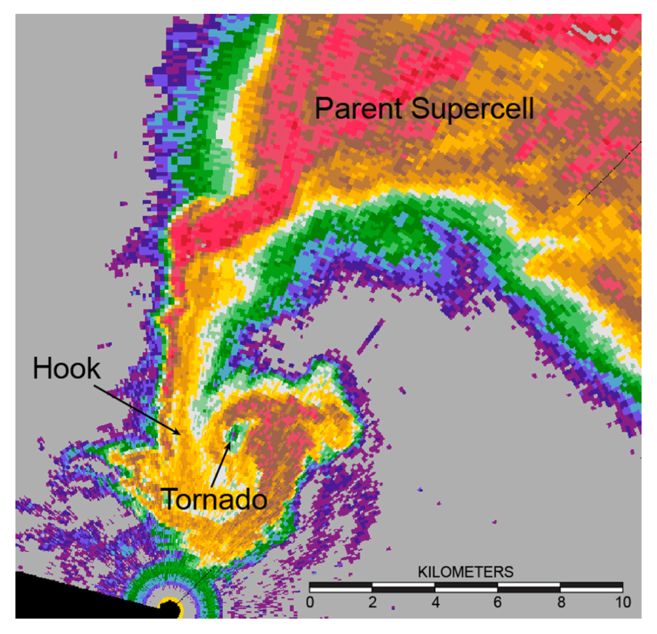
Figure 11. 10: Tornado Embedded in a Hook Echo. This image was captured by a Doppler on Wheels (DOW).
Figure 11.11 captures a strong, mature tornado near Dimmitt, Texas on June 3, 1995. This is a plan view less than 100 m above the surface, a slice through the tornado parallel to the ground. Black “+” marks on the image are spaced at 1-km intervals. The colors indicate the reflectivity or intensity of microwave energy scattered by precipitation and debris orbiting the vortex. Note the tornado’s hollow interior. The core is surrounded by a ring of debris, which is a ring of high tangential velocity. Large raindrops (red colors) spiral around the tornado from the north and east. Tangential winds up to 115 kts (132 mph) were detected in the ring of maximum wind. A downdraft of 50 kts (58 mph) filled the hollow core. Because the DOW samples winds tens of meters above the surface, it is difficult to obtain tornado wind data in the shallow habitation layer, where dwellings are built.
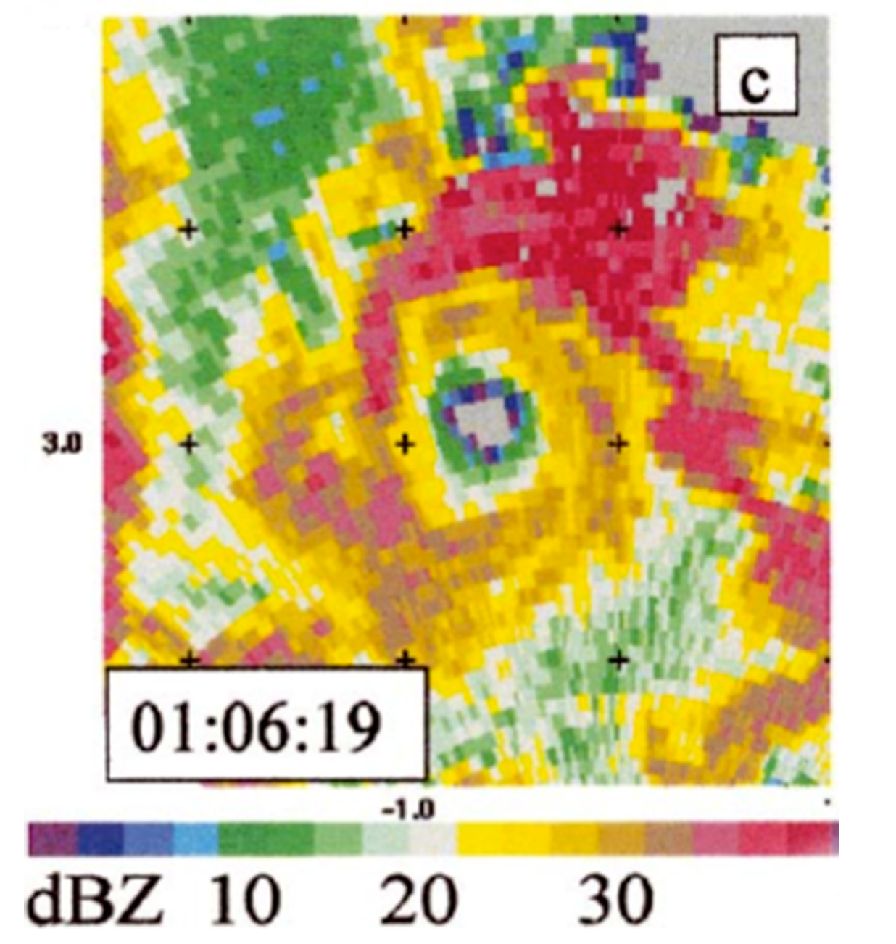
Figure 11.11: Strong Tornado near Dimmitt, Texas, June 1995. This Doppler on Wheels (DOW) image shows a clearly defined hollow core surrounded by a debris field and heavy precipitation (red).
Contrast the strong Dimmitt tornado with the violent tornado that struck Mulhall, Oklahoma in May 1999 (Figure 11.12). The Mulhall tornado had a much more complicated internal structure, with numerous suction vortices embedded in the ring of high wind. This was an exceptionally large, strong tornado, nearly 1.8 km (1.1 mi) wide. DOW winds measured 100 m off the ground revealed peak tangential flow of 190 kts (219 mph). The left panel shows the ring of high Doppler reflectivity, created by swirling debris (the red pixels are pieces of moving debris). The right panel shows Doppler winds. The DOW is located off the panel in the lower-right corner; red colors indicate air moving away from the Doppler radar while blue colors show strong winds approaching the radar.
From this pattern, we can construct a mental image of a giant ring of counterclockwise-swirling air. The small black rings (six of them) on the western side of the vortex are individual suction vortices embedded in the ring of high tangential wind. Each suction vortex contains a core of air spinning 70-80 kts (81-92 mph) faster than the annular, or ring-like, flow (120-140 kts, or 138-161 mph) of the main vortex. Homes and structures subject to passage of a suction spot therefore experienced peak winds of 190- 220 kts (219-253 mph). These suction vortices were several tens of meters in diameter and rotated around the central axis of the tornado at about half the speed of its tangential winds. Updrafts of 70-80 kts (81-92 mph) were observed in the ring of tangential winds and a central downdraft of similar intensity occupied the tornado core.
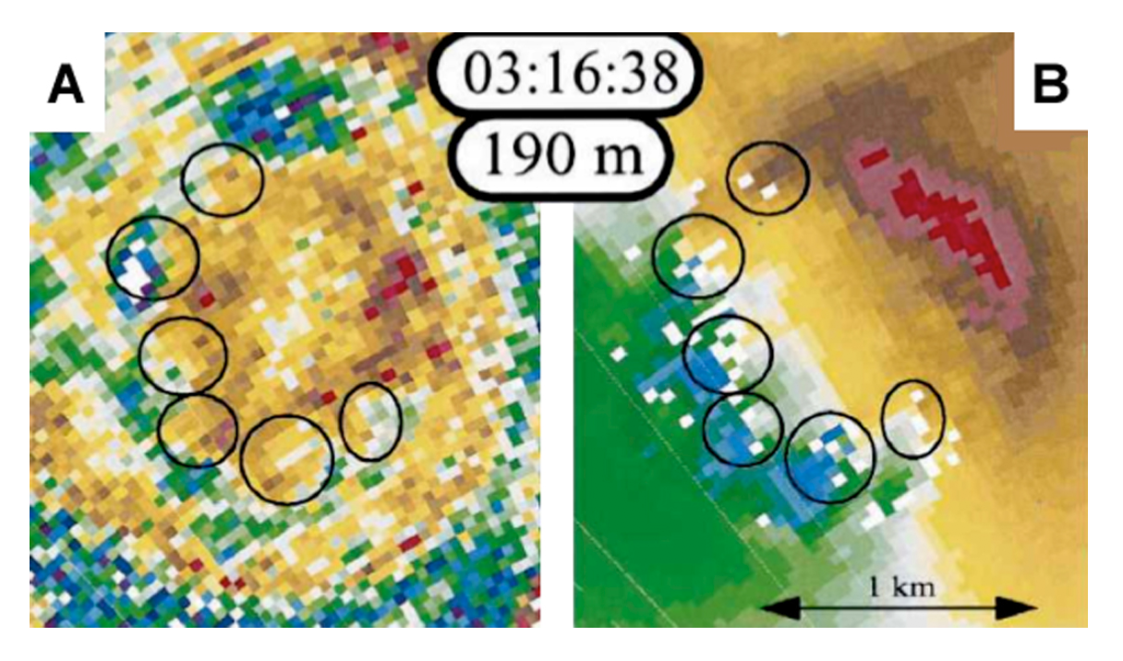
Figure 11.12: Violent Tornado, Mulhall, Oklahoma, May 1999. Panel (A) reveals highly reflective debris (red pixels) embedded in the annulus of the debris field. Panel B) indicates wind speed /direction (red color moving away from the DOW while the blue flow advances toward the observer).
Suction vortices are the deadliest aspect of large, violent tornadoes. As Figure 11.13 shows, homes unlucky enough to be hit by a suction vortex are often completely demolished. The formation, movement, and dissipation of individual suction vortices account for much of the irregularity in a tornado’s damage pattern. As a suction vortex orbits the parent tornado while the tornado translates in a straight line, cycloidal etchings (curved damage streaks) are embedded in the main path (Figure 11.14).
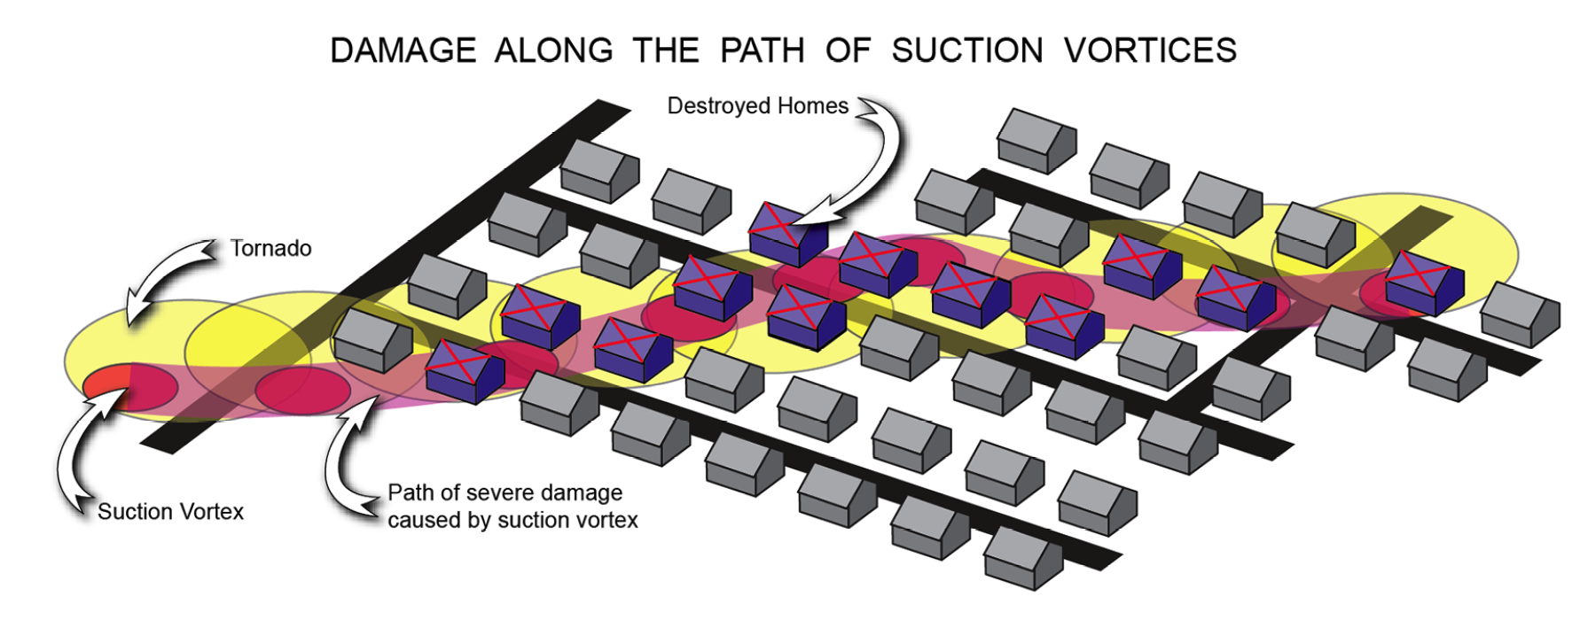
Figure 11.13: Destruction along a Suction Vortex. This diagram shows how homes along the track of suction vortices are far more vulnerable to major destruction.
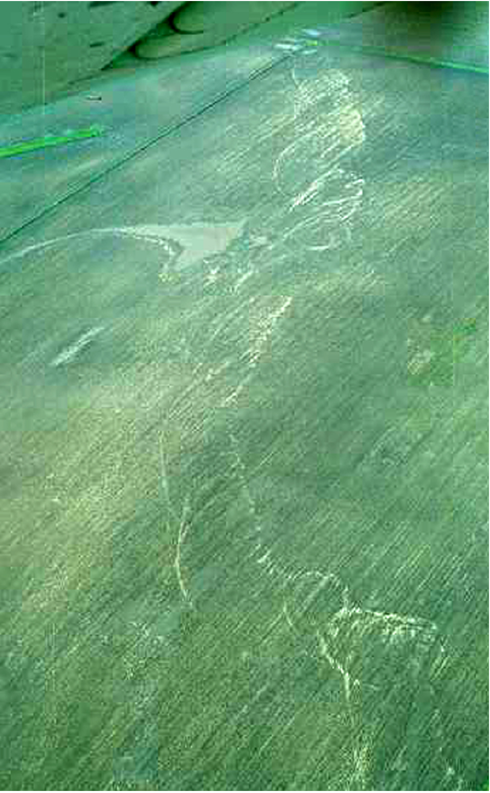
Figure 11.14: Cycloidal Marks (Damage Streaks). This aerial image shows cycloidal marks etched into the landscape as a result of the suction vortex within a tornado.
[H2] The Swirl Ratio
A simple number that predicts whether a single or multiple vortex will form
Laboratory simulations of scaled-down tornado vortices, and the recent DOW observations, confirm that a tornado’s structure is determined by a simple mathematical parameter called the swirl ratio, S. Swirl ratio determines whether a tornado contains a simple, rotating ring of wind (as in the Dimmit tornado) or a large ring containing multiple suction vortices (as in the Mulhall tornado). The swirl ratio is defined as the speed of the tangential wind, Vt, divided by the vortex updraft, w. For S values less than one, the spin is weak compared to the upward motion in the tornado core. This configuration describes the structure of weak tornadoes, shown in Figure 11.15 at the very top. As tangential winds increase relative to upward motion, the tornado undergoes a transition in structure. A central downdraft begins to develop and divide the vortex into two cells. At very high values of S, from 2 to 6, vortex breakdown occurs. The core downdraft penetrates to the surface. At the interface between air descending in the core and the annular updraft, very large horizontal and vertical shears (changes in wind speed and direction) develop. In this region the flow becomes highly unstable, devolving (breaking down) into two or more suction vortices. Vortex breakdown is characteristic of strong-violent tornadoes that contain very strong tangential winds. Look again at the multiple-vortex tornado in Figure 11.1(H). Each suction vortex is just meters wide and only a few tens of meters tall. But the total vortex winds (suction vortex wind + parent tornado wind) add up to the most extreme wind velocities in a confined space on Earth.
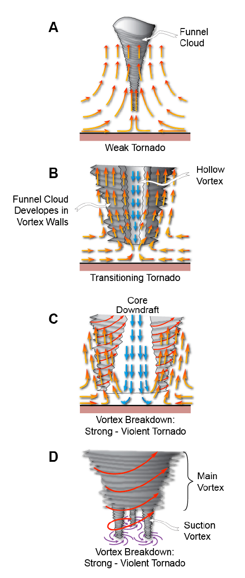
Figure 11.15: The Transition from a Weak Tornado to a Strong, Violent Tornado. Panel (A) shows a weak tornado. In (B), a central downdraft begins to divide the vortex into two parts. Shearing increases both horizontally and vertically as the vortex divides (C). As the process continues, multiple suction vortices form (D).
[H1] Tornado Wind Loads and Aerodynamic Forces Causing Structural Failure
The most violent tornadoes create widespread destruction of brick and mortar structures, heavy vehicles, and engineered structures such as schools. Witness the aftermath of violent tornadoes in Greensburg, Kansas in 2007 (Figure 11.16) and Joplin, Missouri in 2011 (Figure 11.17). In both cases, near-total destruction resulted from winds that approached 210 kts (242 mph) across a wide path (2.7 km in the case of Greensburg). Trees were completely denuded of all limbs, vegetation, and bark. Sheet metal from roofs was twisted around tree trunks. Pavement was lifted from roadbeds. Entire neighborhoods were rendered unrecognizable.
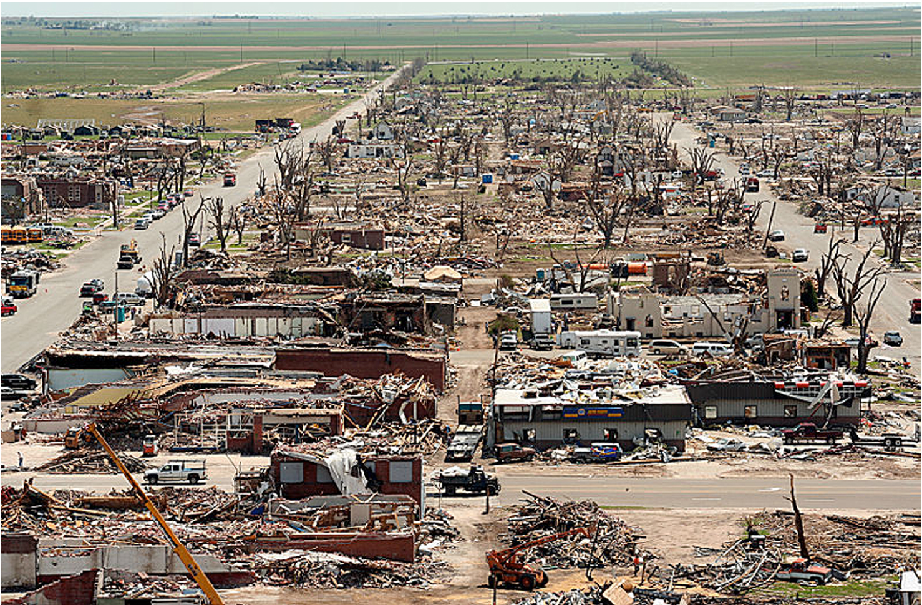
Figure 11.16: Aftermath of a Devastating Tornado in Greensburg, Kansas, 2007.
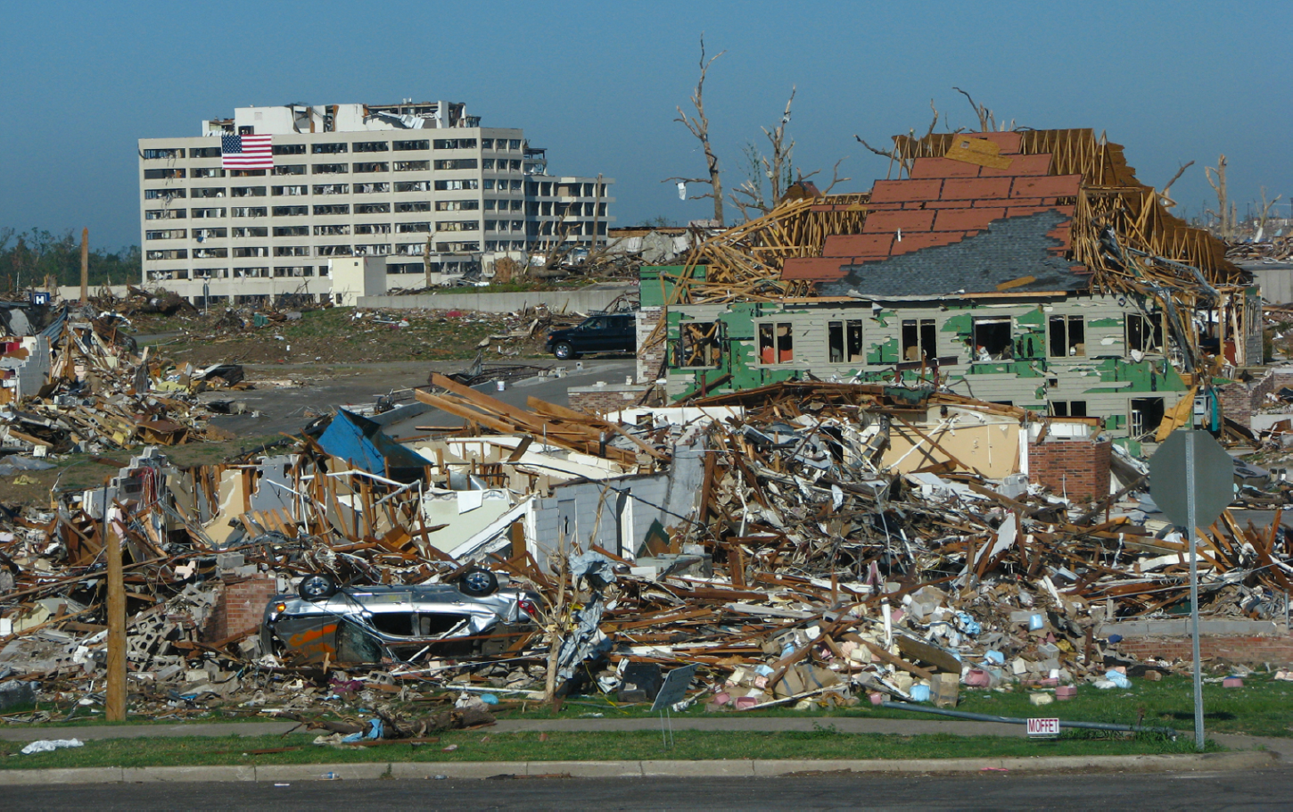
Figure 11.17: Post-Tornado Joplin, Missouri, 2011. Even large structures like the hospital in the background (white building) were severely damaged.
(Courtesy of Carol Rabenhorst)
[H2] Wind Acceleration and Wind Load
Forces exerted on structures depend on wind speed, structural shape and surface area
Because tornadoes are typically small and travel quickly, structures are exposed to peak winds for only seconds. However, the rate of change of the wind speed, or wind acceleration, is likely to approach 5 Gs (five times the acceleration of gravity) when an intense suction vortex strikes a structure. The force per unit area, or wind load, exerted by tornadic winds varies with the square of wind speed. So a doubling of wind speed (between a weak and strong tornado, or between a strong and violent tornado) leads to a quadrupling of force. The force exerted on structures by a high-end violent tornado is fifteen to twenty times larger than the wind load exerted by a weak tornado. There are some studies that suggest that the relationship may be even larger, with wind pressure forces varying according to the cube of wind speed.
Peak tangential winds are not the only measure of a tornado’s ability to destroy. The updraft is also critical. An updraft of 80-90 kts (92-104 mph) lofts heavy structures or pieces of debris, which tangential winds then readily accelerate. In fact, the simple sum of a 100-kt updraft operating in tandem with 200-kt tangential wind yields a total (helical) wind of 225 kts (259 mph). Additionally, the duration of high wind is also important. In very large tornadoes, or those that translate slowly, structures are subject to long-duration winds (perhaps a minute or more). These winds can cause structures to vibrate in a manner that contributes to their destruction.
Abrupt changes in wind direction are also significant. Winds from different directions exert stress on structures from multiple angles. Many structures have a weak wall. If that wall experiences direct onslaught from the highest wind, the entire structure succumbs as the weak wall fails. A common example of a weak wall is the front of a house with a large picture window, an entrance door, and a garage door. All of these portals are relatively frail and easily compromised by the wind.
[H2] How and Why Tornadoes Destroy Houses
The key to a home’s survival is to keep the roof on!
Figure 11.18 shows what typically happens when a wood-frame-and-siding house is subject to high wind loads. If the front wall of the house lies just to the right of the tornado path and is subject to peak winds, glass windows and doors are blown inward. High-speed air rushes inside the house, instantaneously raising the internal pressure. Moreover, wind flowing around the sides and back wall of the house creates a pressure reduction along the external surfaces. Consequently, these remaining walls (sides and back) are pushed outward, along a pressure gradient between inside and outside. A pitched roof exacerbates home damage. Roofs are designed with a pitch so that they easily shed rainwater, but this pitch makes them vulnerable to high wind. As wind flows over the rooftop, an aerodynamic lift force develops, similar to air flowing over the curved upper surface of an airplane wing. Consequently, the roof or large portions thereof may peel away. With the roof detached, free-standing walls loose their support and more easily fall outward. Large eaves or roof overhangs allow the wind to more effectively build wind pressure beneath roof edges, increasing the upward lift force.
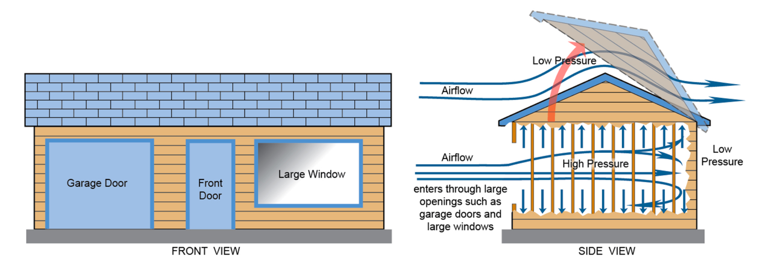
Figure 11.18: Aerodynamic wind forces on a home. When wood-framed homes are exposed to strong tornadic winds, such as those found in the right side of the tornado, the structure is often destroyed. Winds penetrate the structure through weak zones such as large windows and garage doors. Wind going around and over the house creates low pressure above and behind the structure. As a result the home “explodes” outward, destroying the structure.
As the roof lifts off and external walls fall outward, it appears that the house explodes. For decades, such explosions were wrongly attributed to the pressure drop inside the tornado’s core. Homeowners in the path of a tornado were encouraged to open one or more windows to “ventilate” the home prior to vortex passage. However, we now know that this logic is faulty. Tornadoes do indeed have reduced core pressure; however, the shroud of whirling debris that strikes the home before the core arrives more than adequately eliminates pressure differentials, by poking numerous holes through windows, doors, and walls. Much of the damage rendered to homes and buildings comes from the tremendous impact of wind-borne debris: pieces of 2” x 4” lumber, bricks, metal signs, tree limbs, glass shards, plywood, and various other dense objects hurled at a speed of several hundred knots.
Homes not built according to strict code often succumb through loss of the roof. Figure 11.19(A) shows the major design elements that buttress and secure a roof to the walls of a typical wood-frame home. Diagonal roof trusses are attached to the horizontal top plate that overlies vertical wall studs. In Figure 19.19(B), a low-budget method of attachment utilizes three toe nails–that is, nails driven in diagonally, to connect the top plate and truss. This is not a very secure method of attachment. The upward lift force and/or torque (twising force) exerted between roof and walls by the wind can easily wrench trusses free from the top plate. The preferred method is to more strongly secure the top plate and trusses with pre-formed metal plates, as shown in Figure 19.19(C). Each precisely shaped plate secures the stud and truss in multiple locations, greatly increasing the attachment surface area. The plate also resists bending and twisting by wind forces. In houses that use this method, the roof is more likely to remain attached to the house–and as the saying goes, “If you save the roof, you save the home.”
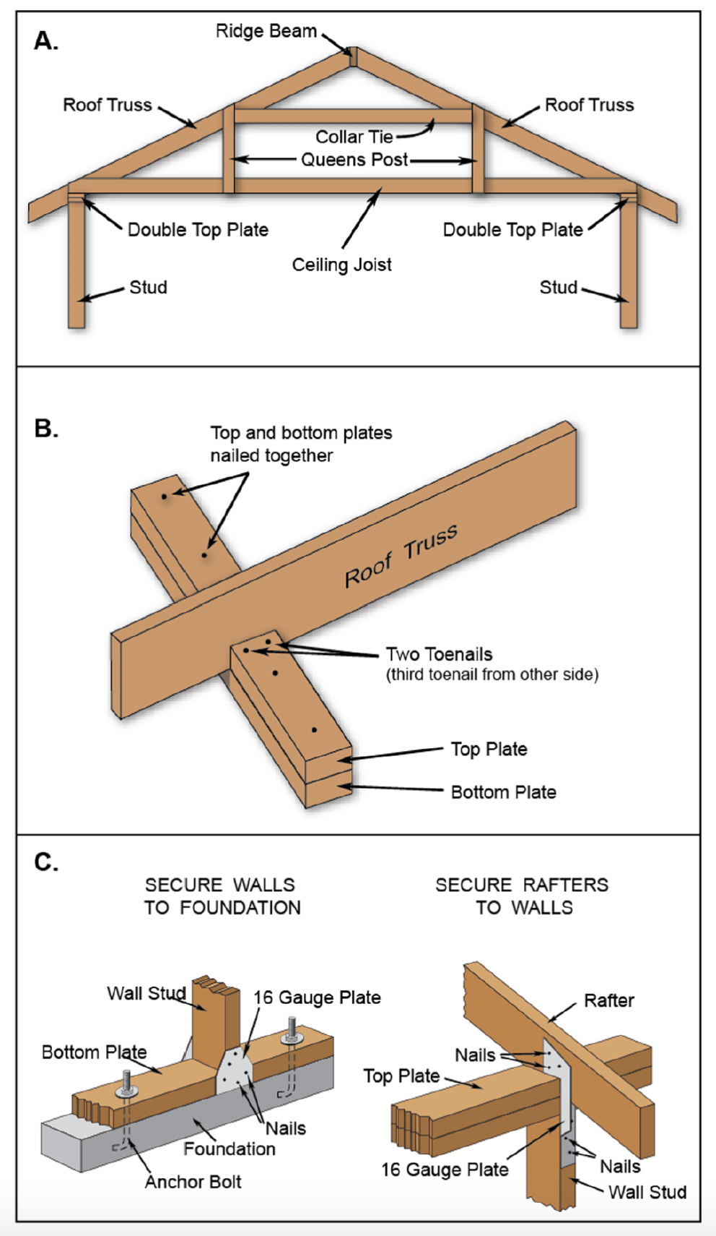
Figure 11.19: Building to Protect the Roof. Panel (A) illustrates a typical roof truss in a wood-frame house. Panel (B) shows how trusses of low-budget houses are often attached to the top wall plate with toe nailing, a technique that gives the roof little ability to resist being wrenched loose in tornado-strength winds. Panel (C) depicts a much stronger method of attaching both roof trusses and the wall studs. A few extra dollars spent on these construction techniques increases the odds that the roof will stay attached to the house, thereby greatly increasing the likelihood that the house will remain intact.
Figure 11.19(C) also illustrates the importance of securely attaching the house’s walls to its foundation. Low-budget methods may rely on friction and gravity (weight of the home) to do the trick. Without metal plates and anchor bolts, the entire home can literally be shoved off its foundation slab by a tornado’s winds. In fact, this type of destruction happens so often that damage-assessment teams call these homes “sliders.”
Mobile (or manufactured) homes are especially dangerous places during a tornado. The tornado fatality rate is considerably higher in manufactured homes than in permanent homes; in fact, mobile homes dominate the tornado fatality statistics for all structures. According to tornado researchers Kevin Simmons and Daniel Sutter, mobile homes, permanent homes, automobiles and buildings account for 43%, 31%, 9% and 5%, of national tornado fatalities respectively. In the Southeast, mobile homes account for 58% of tornado deaths.
Mobile homes are very lightweight and constructed of comparatively flimsy materials. They have a very large ratio of surface area to weight, and they are easily tumbled or rendered airborne. Windborne debris easily penetrates their thin walls and roofs.
Some mobile-home owners secure their homes to the ground using metal tie-down straps, usually one on each end. These straps encircle the home and attach to metal shafts augured into the ground. But these straps provide a false sense of security and are not effective at winds above 60-70 kts (69-81 mph). They cannot protect a mobile home from the impact of wind-borne debris. Damage surveys reveal that straps are often severely rusted at ground level and therefore snap at low wind speeds.
[H2] Tornado Safety
Lacking a basement, put as many walls as possible between you and the tornado
There are some simple, common-sense rules regarding tornado safety. For permanent homes with a basement or storm cellar, relocate there, preferably beneath a heavy workbench or beneath the staircase. If there is no basement, put as many walls between you and the tornado as possible. Seek shelter in an interior closet or in a bathroom, climbing into the tub or shower stall. If you live in a tornado-prone area, consider constructing a tornado safe room, which is a small, above-ground, structurally reinforced room in the center of the house.
If you are in a public building, such as a school or airport terminal, move away from plate-glass windows. Seek an interior hallway, crouching low and protecting your head and neck with hands. Move out of large, open spaces such as gymnasiums that have large-span, flat roofs (these are flimsy and readily collapse). If you are in a mobile home, get out – either to a community storm shelter or into a low ditch. Cars or trucks are death traps, easily flipped or rendered airborne; never try to out-drive a tornado. Leave the vehicle and crouch in a low ditch. Finally, never seek shelter under a highway overpass. This has proven to be a fatal mistake; the tornado’s winds accelerate substantially while passing through the narrow passage between bridge deck and ground.
[H1] Theories of Tornado Formation
For years, the public has been sold a gross oversimplification about how tornadoes form–specifically, “cold and warm air masses collide over the Great Plains, leading to severe storms and twisters.” If the process were this simple, we’d have tornado outbreaks during all hours of the day, every day of the year! Cold and warm masses continuously interact along fronts, but many of these interactions do not produce severe thunderstorms. In fact, the complete process by which tornadoes develop within thunderstorms – termed tornadogenesis - remains one of the most elusive questions in meteorology – but new insights are filling in knowledge.
For strong and violent tornadoes, the first step requires formation of a supercell thunderstorm. But tornadogenesis occurs on smaller space and time scales than the larger supercell. While a supercell may take one to two hours to mature, encompassing a region of several hundred square kilometers, the tornado develops in just minutes, on scales of one km² or less. Tornadogenesis is a very focused, small-scale process. There are subtle differences between supercells that do not create tornadoes and those that do; and in fact the majority of supercells (70-75%) fail to spawn tornadoes. In the past several decades, scientists have identified many ways that tornadoes develop, both within supercells and in other types of storm cells. In this section, we review the important principles, starting with the genesis of strong and violent tornadoes.
[H2] Supercell Tornadoes
Supercells generate many of the strong tornadoes, and all violent tornadoes, over the U.S.
A defining characteristic of a supercell, and the key to its severity and longevity, is its rotating or helical updraft, the mesocyclone (“meso”), located in the storm’s mid-levels (2-6 km, or 1.2-3.7 mi) and southwest quadrant. Most mesos do not produce tornadoes, and some of the most intense mesos ever documented on Doppler radar failed to create a tornado. A tornado is more likely when the mid-level mesocyclone builds down to the surface. The mechanism that produces the low-level meso differs from genesis of the mid-level meso. To understand how a low-level meso develops, we must first look at a basic mechanism: the storm manufactures its own horizontal spin in the lowest one kilometer of the storm, which then becomes tilted into the vertical.
[H3] Tilting horizontal spin to vertical. As Figure 11.20 shows, horizontal vortex tubes can develop in two ways beneath a supercell. First, the mesocyclone aloft can induce a powerful inflow of air just above the surface, through its suction effect. This establishes a strong vertical shear, in which winds increase speed rapidly with altitude (this is a different source of wind shear than the deeper, environmental winds that initially create the mesocyclone). This streaming air will overturn or tumble along a horizontal axis. Imagine holding up one palm, placing a pencil on that palm, and then moving the other palm across the pencil, mimicking strong winds blowing above the surface. The pencil rolls over and over. Second, there is often a boundary or front separating cold, rain-cooled air (the forward flank downdraft) from warm inflow air feeding into the base of the updraft. Along this boundary, buoyant warm air rises on one side; meanwhile dense, cold air sinks on the other side of the boundary. The rising and sinking create an overturning motion along the boundary. A horizontal vortex tube will develop along the length of this downdraft boundary, just above the surface. This process can take up to an hour or so to create horizontal spin.
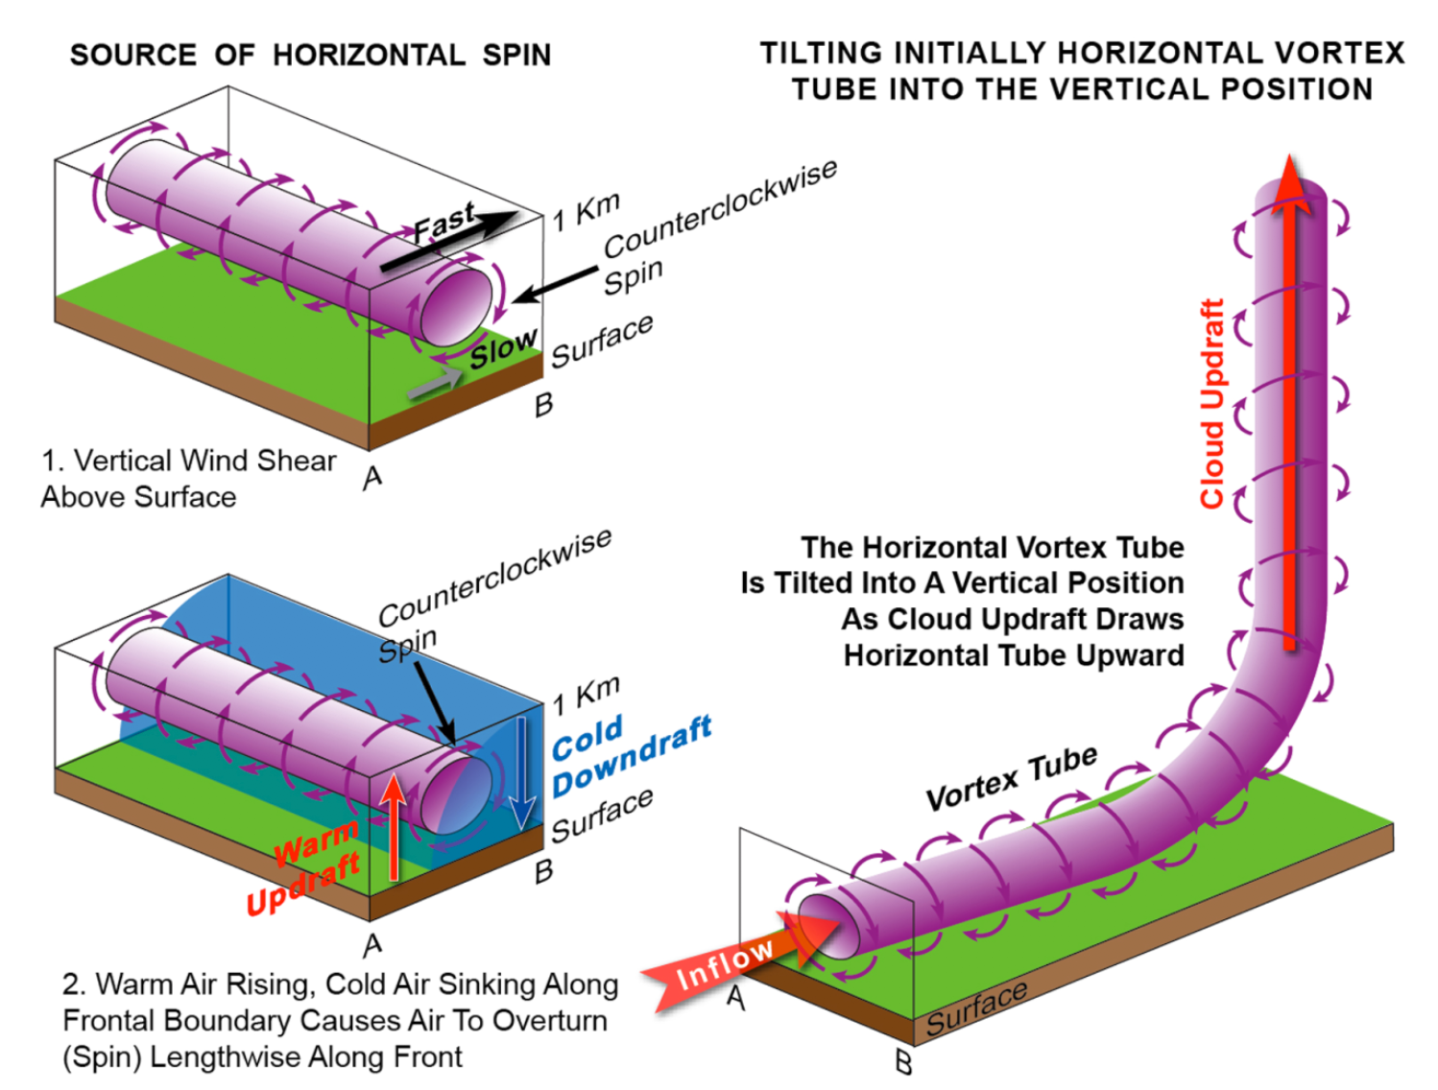
Figure 11.20: Tilting Storm-Generated Horizontal Spin to Vertical. Horizontal rotating vortices can result from two different processes. (A) Vertical wind shear is caused by two different wind speeds,(slow near the surface and fast at higher levels above the surface. (B) The second method is common along small-scale fronts beneath the supercell, where warm air rising in updrafts meets downdrafts of cold subsiding air. (C?) This diagrams illustrates how a horizontal vortex tube is tilted upward into a vertical position, resulting in the formation of a low-level mesocyclone in a supercell. Tilting occurs when strong ground flow into the mesocyclone draws the horizontal vortex tube inward towards the storm’s center. As the inward flow turns abruptly upward, the horizontal vortex tube is lifted into a vertical position.

The updraft of the supercell features a region of low pressure near the surface, and air streams inward to fill the low. Some of the air streams parallel to and through the vortex tubes, drawing them inward toward the low. As the inflow turns abruptly upward, entering the base of the updraft, the orientation of the tubes changes from horizontal to vertical. As the vortex tubes ascend, they consolidate, coalescing into a low-level mesocyclone. Figure 11.21 is a three-dimensional rendering of the process. You will note that the sense of spin initially present in the horizontal vortex tubes is preserved as they are tilted. As the tubes lift, they spin counterclockwise, the same direction as the supercell’s mid-level meso. Formation of a low-level meso is a critical early step that may lead to tornadogenesis.
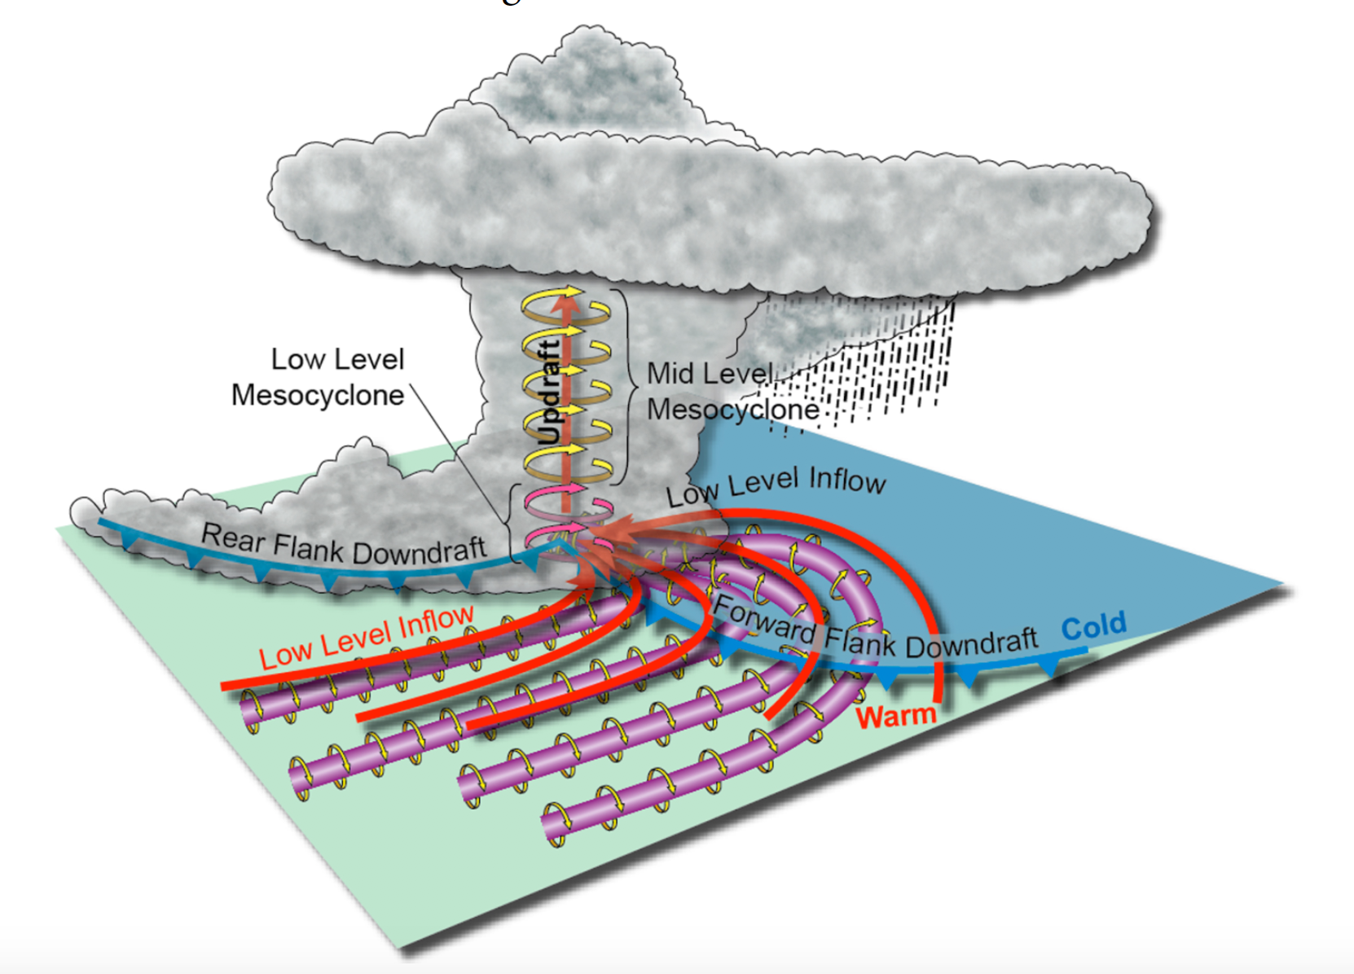
Figure 11.21. Formation of the low-level mesocyclone. This illustration applies the principles in Figure 11.20 to a 3D supercell. Notice how the horizontal vortex tubes are drawn into the mesocyclone and raised into a vertical position. The strong updraft at the core of the mesocyclone strengthens the vertical vortex tube.
[H3] Influence of the rear flank downdraft. A second important step comes next. In tornadic supercells, one to two hours after the supercell forms, a new downdraft develops. This spiral downdraft, which forms along the southwestern flank of the supercell and wraps around the mesocyclone, is called the rear flank downdraft (Figure 11.22). This downdraft divides the mesocyclone so that it is composed of downdraft and updraft in roughly equal parts (note the horseshoe-shaped warm and cold regions in the figure, both inside the meso). At the boundary between the updraft and downdraft, there are very exceptionally strong shears (rapid changes in vertical and horizontal air motion). Air spirals up into the updraft portion of the low-level meso (red arrows) (Figure 11.23). Meanwhile, the rear flank downdraft spirals downward in a counterclockwise manner, wrapping around the low-level meso (solid blue arrows). When the tornado does form, it often does so near the center of the divided mesocyclone, indicated by the “T” inside a small circle on the diagram.
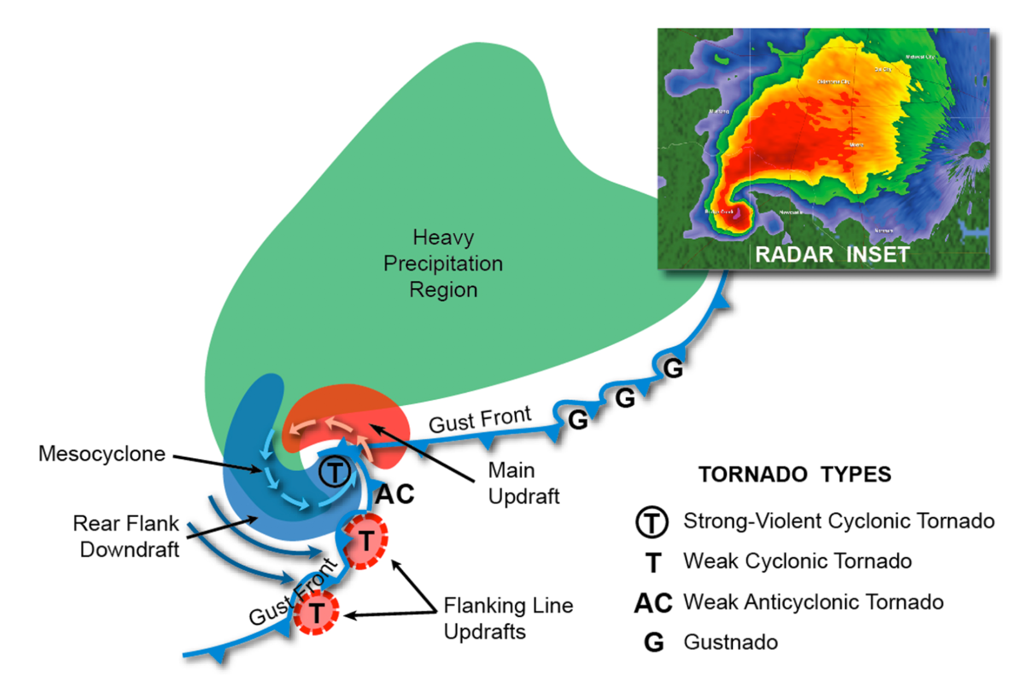
Figure 11.22: The divided, low-level mesocyclone. Within the mesocyclone are strong areas of updrafts and downdrafts that produce violent shearing effects near the center. This is the likely location for the birth of a strong or violent supercell tornado (indicated by the letter “T” inside the circle).
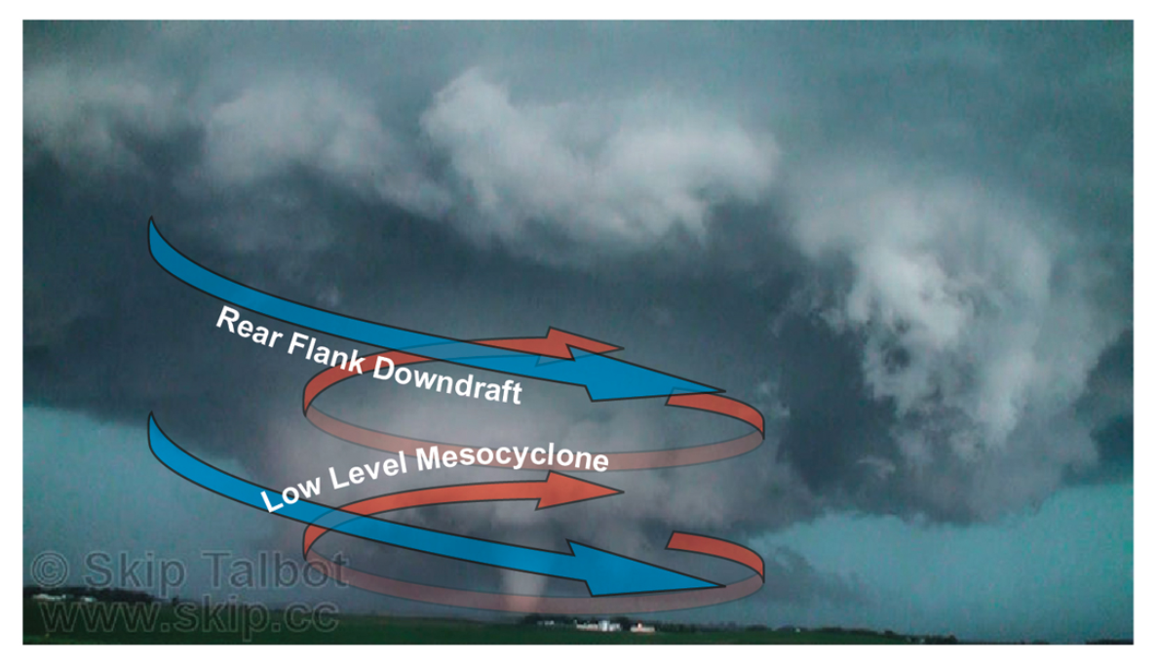
Figure 11.23. Major supercell wind currents giving rise to tornado formation. The storm’s rear flank downdraft (blue arrows) wrap around the tightly spiraling mesocyclone updraft (red arrows), giving rise to very strong wind shears.
[H3] Development of the tornado. Within this highly dynamic region of the supercell, there are two major modes by which the tornado develops. Starting in the 1970s, meteorologists noted that some tornadoes first developed in mid-levels of the mesocyclone, near its center, building downward. The signature of the nascent tornado could be identified aloft on Doppler radar up to 15-20 minutes prior to touchdown. A theory called the dynamic pipe effect explains how these tornadoes build downward. Figures 11.24 and 11.25 illustrate progressive, downward growth of the tornado vortex, as cyclostrophic balance becomes established at progressively lower and lower levels. As each new layer of spinning pipe is added to the lower end, the pipe extends down to the surface. Then surface friction establishes strong inflow of air into the tornado’s base.
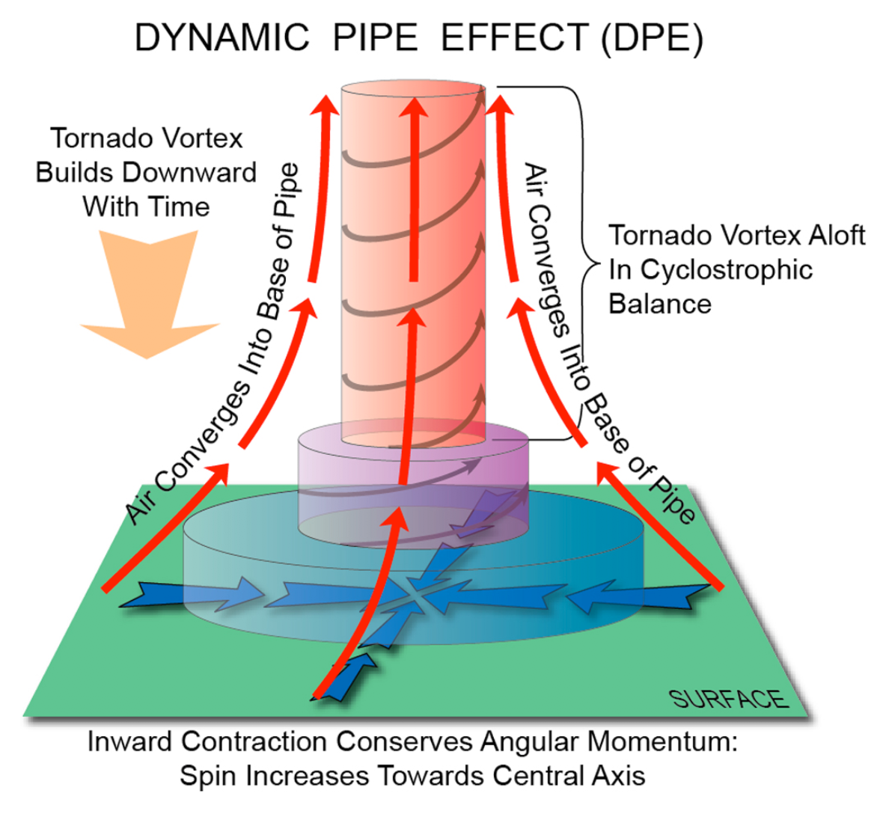
Figure 11.24. How a tornado aloft can progressively extend downward to the surface. As warm air is drawn in at the surface and is caught up in the strong vertical updraft found at the center of the tornado aloft, the flow spirals tighter, drawing the tornado downward towards the surface.
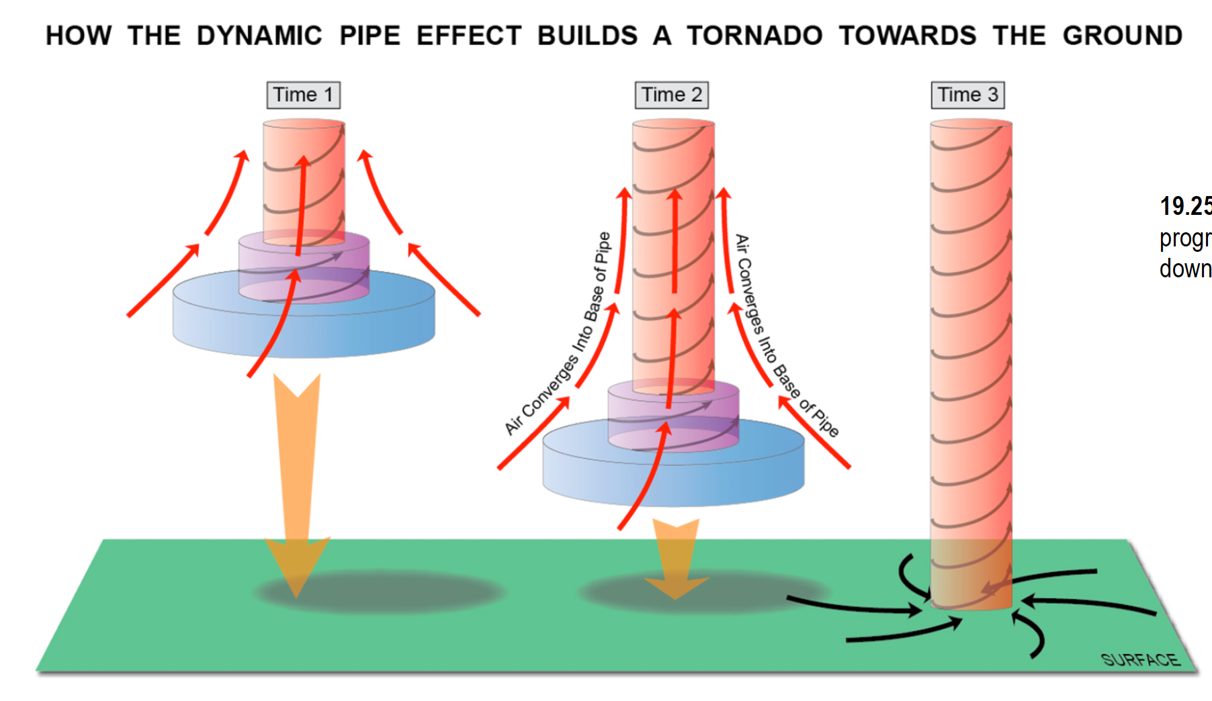
Figure 11.25: The Stepwise Progression of a Tornado Being Drawn Downward Towards the Surface.
But in the late 1980s and 1990s, tornado field programs revealed that not all tornadoes develop in this top-down manner. Many form from the bottom up, starting very near the surface. The dynamic pipe effect does not apply in this situation. So meteorologists have sought a mechanism by which intense vertical spin can be created at the surface. A basic principle, first recognized in the mid-1980s, requires a downdraft for this type of tornadogenesis. As Figure 11.25 illustrates, when horizontal vortex tubes are tipped into the vertical by an updraft, vertical spin cannot develop at the surface because the updraft transports the spinning tube upward, away from the ground (top panel, Times 1 through 3). However, if a downdraft does the tipping, horizontal spin is transported toward the ground (bottom panel, Times 4 and 5). The rear flank downdraft, which is part of the divided mesoscylone, provides the needed mechanism. Then, as newly tilted vortex tubes are drawn into the adjacent updraft, they are stretched vertically. The stretching is critical, as it contracts these tubes. Conservation of angular momentum requires that they spin up rapidly to tornadic intensity, as Figure 11.26 shows.
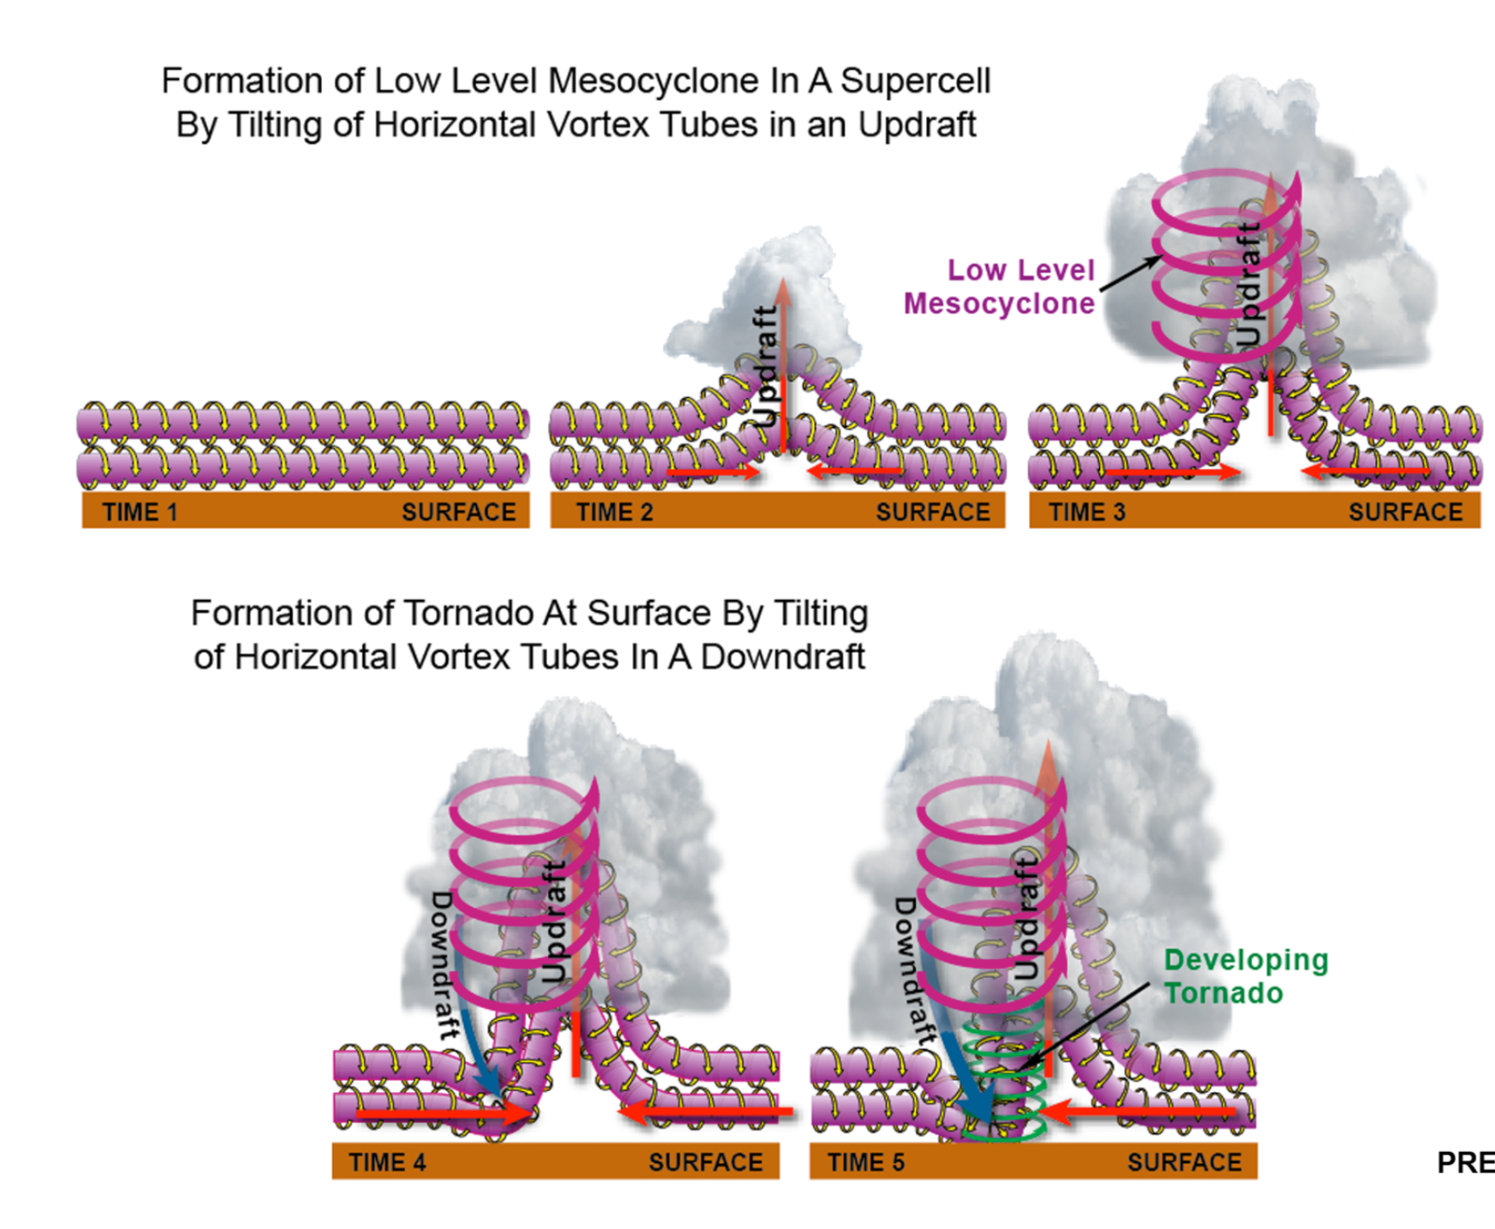
Figure 11.26: The Stepwise Progression of Horizontal Vortex Tubes Being Drawn Upward into a Vertical Position. In Time 4 and 5 a vigorous downdraft tilts horizontal spin vertically and downward towards the surface. Additionally, stretching of the vortex in the adjacent updraft accelerates the wind speeds.
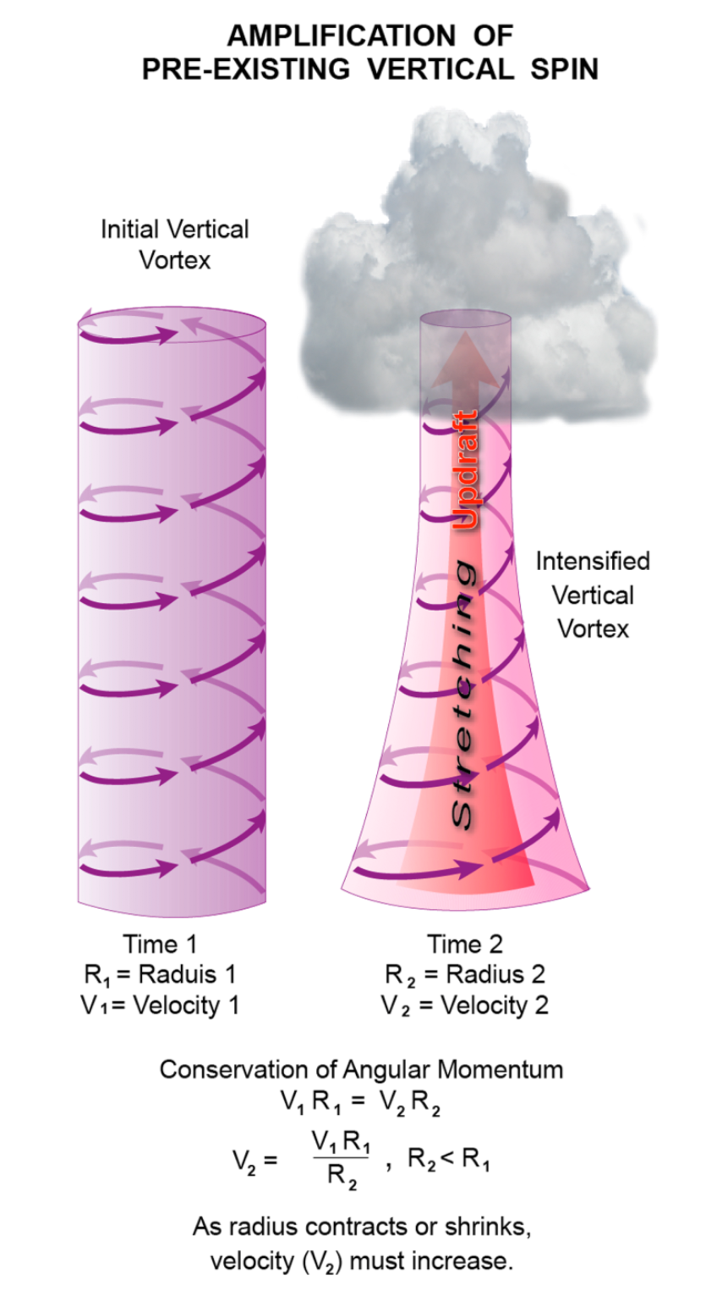
Figure 11.27: Final spin-up of the tornado. This diagram illustrates how stretching the vortex tube causes the wind speed to accelerate through the conservation of angular momentum.
Computer simulations and observations both show that air enters the tornado from the supercell’s downdraft region. It is somewhat ironic that tornadogenesis occurs when the supercell is transitioning from updraft-dominant to downdraft-dominant, which often marks the beginning of the storm’s demise. Ultimately, tornadogenesis involving the downdraft is a self-limiting process. The downdraft air, being relatively cool and dense, wraps around the mesocyclone, much in the way that a cold front eventually occludes an extratropical cyclone. After about 20-30 minutes, the supercell updraft is cut off from its source of warm, buoyant inflow. As the updraft weakens, so does the mesocyclone. The tornado’s low-pressure core begins to fill with air, and it dissipates.
In short, most scientists believe that the rear flank downdraft plays a critical role in the formation of strong and violent tornadoes. However, forecasters cannot yet discriminate supercells that will become tornadic from those that will not. There seems to be a random element to tornadogenesis. Supercells often do not form, mature, and decay in isolation, but frequently interact with other storm cells. As they move, supercells pass across localized gradients in air stability and wind shear, encountering various air boundaries. All of these processes influence tornadogenesis in both constructive and destructive ways, but we do not yet have the technology to measure these variations. Finally, it has been suggested that tornadogenesis is a fragile process, requiring an optimum set of conditions. For instance, the air in the rear flank downdraft must not be too cold. Periodic surges in the downdraft may also be important, but they must not be too strong. The temperature of the downdraft air is also critical; too cold, and the dense air resists upward lifting and stretching inside the updraft. All of these conditions help explain the relatively scarcity of tornadoes as a severe local weather phenomenon.
[H2] Cyclic Tornadogenesis
Some supercells generate a sequence of tornadoes, one after another
Supercells can be very long-lived, producing severe weather for many hours along a track that extends hundreds of kilometers. Long-lived supercells often produce multiple tornadoes, in cycles that last 30 minutes to an hour. The succession (serial generation) of tornadoes can sometimes leave a long path of damage that is mistakenly attributed to a single, long-lived tornado.
Figure 11.28 illustrates the processes of cyclic tornadogenesis, in which a series of tornadoes are spawned. In our example, the same supercell tracking from southwest to northeast produces a series of three tornadoes. There is a brief gap in tornado-path coverage between each successive tornado. At Time 1, the entire supercell is not illustrated, just the mesocyclone and associated small-scale fronts or air-mass boundaries associated with the rear flank and forward flank downdrafts; the larger region of heavy precipitation (rain and hail) has been omitted for clarity. By Time 2, the first tornado forms within the mesocyclone. This tornado intensifies and widens as it tracks northeast. At Time 3, the tornado has matured, but the rear flank downdraft begins wrapping around the mesocyclone. At Time 4, the downdraft occludes the updraft, and the tornado weakens. However, intense uplift of air along the leading edge of the rear flank downdraft leads to formation of a new low-level mesocyclone, to the east of the original meso. By Time 5, this new meso has intensified while the original meso dissipates. Henceforth, a new tornado develops within the second meso, and the cycle repeats itself.
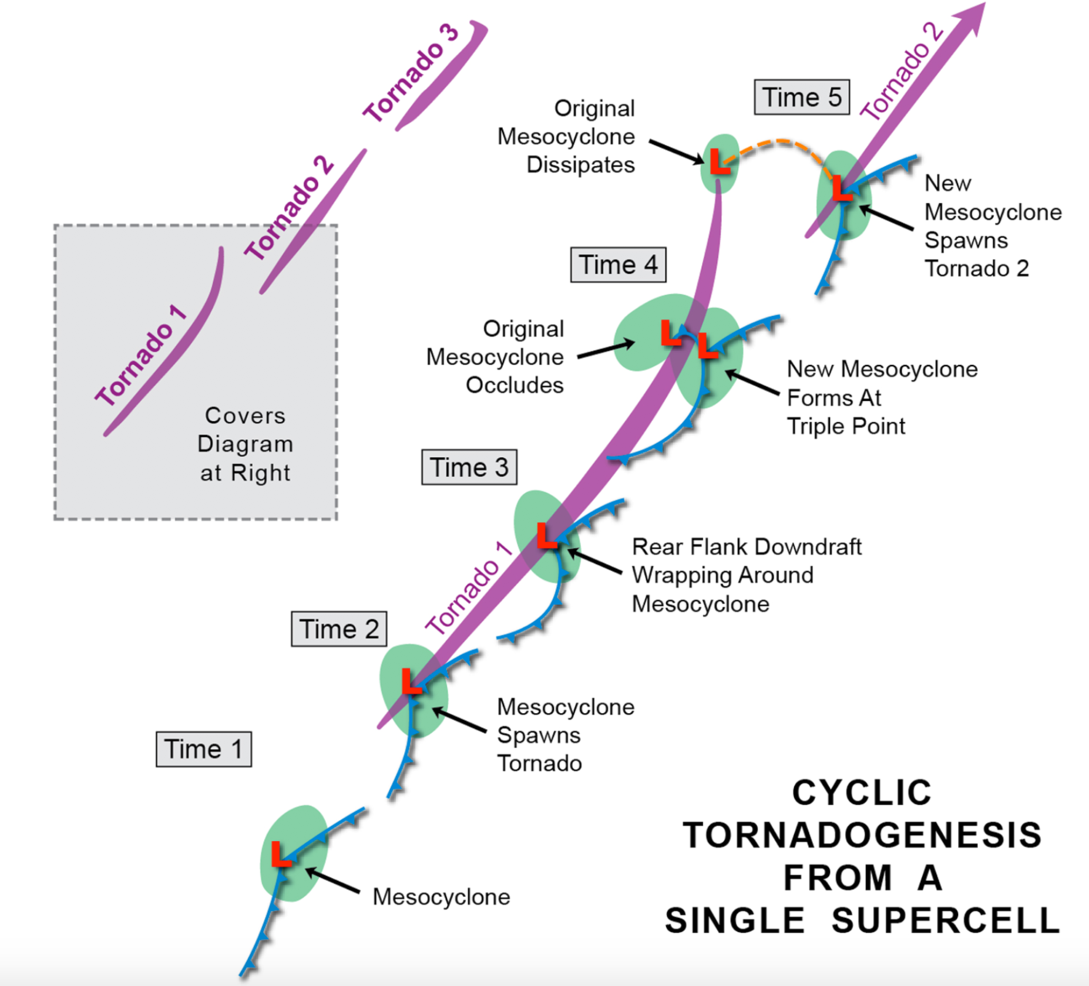
Figure 11.28: Cyclic Tornadogenesis. A supercell has the potential to produce a series of successive tornadoes that can span many tens or even hundreds of kilometers. At Time 1, a mesocyclone forms. At Time 2 a tornado is spawned as the meso intensifies. At Time 3 the tornado intensifies. At Time 4 the strong rear flank downdraft occludes the updraft and thereby weakens the tornado. A new mesocyclone forms to the right of the old dissipating meso. At Time 5 a new tornado is generated in the second mesocyclone and the cycle repeats itself.
[H2] Tornadoes Produced by Bow Echoes
Recall that a bow echo is a fast-moving, bow- or arc-shaped line of intense thunderstorms that produces devastating, localized streaks of wind damage called downbursts. Bow echoes also generate tornadoes. Figure 19.29 shows a post-storm damage survey of a bow echo that travelled from west to east near Springfield, Illinois in August 1977. The burst-like streaks of wind damage are shown by the blue patches and arrows; each fan-shaped region is an individual downburst. Downbursts contain straight-line or divergent wind that is non-rotary in nature, and the winds can approach or exceed 100 kts (115 mph), the same intensity as weak tornadoes. Microbursts are small versions of downbursts. In the figure, note that this bow echo generated a series of 10 downbursts and 17 smaller, embedded microbursts. It is not uncommon for a single bow echo to generate a mixture of downbursts and tornadoes.
The damage survey reveals narrow, linear swaths (colored red) marking the tracks of tornadoes. This bow echo produced a total of 18 tornadoes. Many of the tornadoes occurred south of the main downburst corridor (numbers 1, 4, 6, 8, 10, 11, 14, 15, and 16), and were likely generated by small mesocyclones (weaker and shorter lived than a supercell meso) along the forward edge of the bow echo. The remainder developed within and along the axis of downburst activity, particularly at the interface of downbursts and microbursts. These tornadoes were smaller, weaker, and shorter-lived than the others.
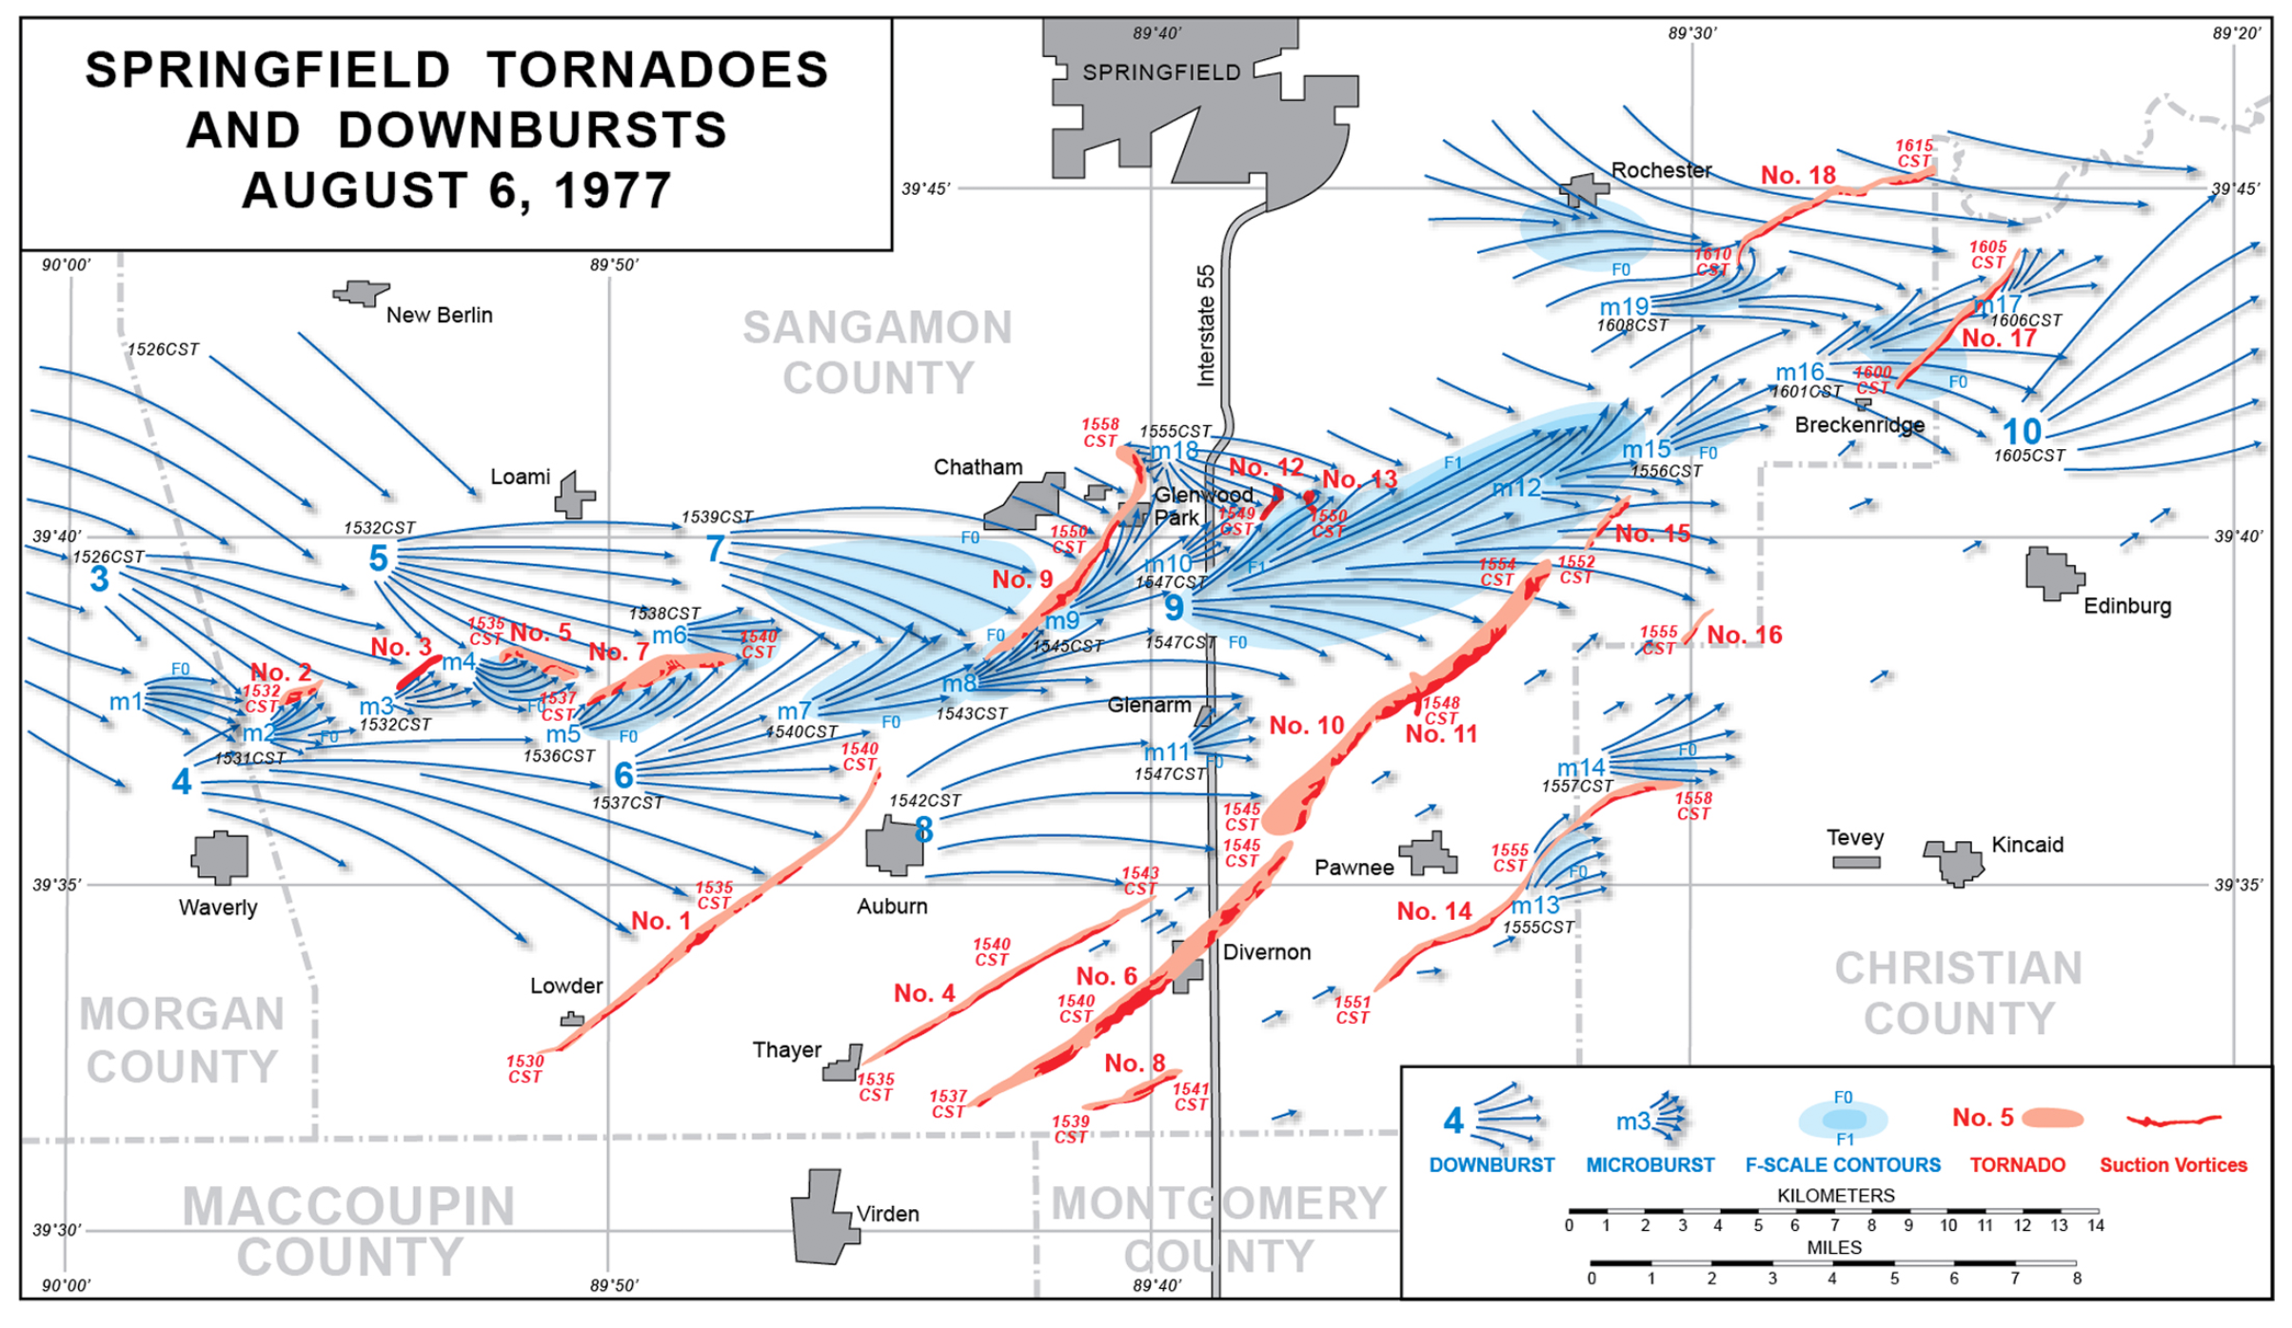
Figure 11.29: Damage from a Bow Echo, Near Springfield, Illinois, August 1977. This bow echo traveled from west to east. The post-damage survey shows how a single bow echo storm complex can generate numerous tornadoes and a series of strong downbursts.
Figure 11.30 shows where tornadoes commonly develop within bow echoes. In this plan view, green shading indicates the region of heavy rain, and the most intense convective cells are located along the storm’s leading edge. The system is moving quickly toward the east-southeast. The heavy blue arrows denote the fan-like sweep of downdraft air flowing through the bow echo, creating a blast of strong, rain-cooled wind at the surface. The leading edge of this massive downdraft is the gust front. Behind the gust front are small pockets of intense wind; these are the individual downbursts and microbursts. The small tornadoes that develop from very small and shallow vortices, smaller than a supercell’s mesocyclone, along the bow echo’s leading edge. These tornadoes are indicated by bold “Ts.” Their hypothesized formation involves very strong wind shears and tilting of vortex tubes, but from mechanisms that may differ from the formation of supercell tornadoes.
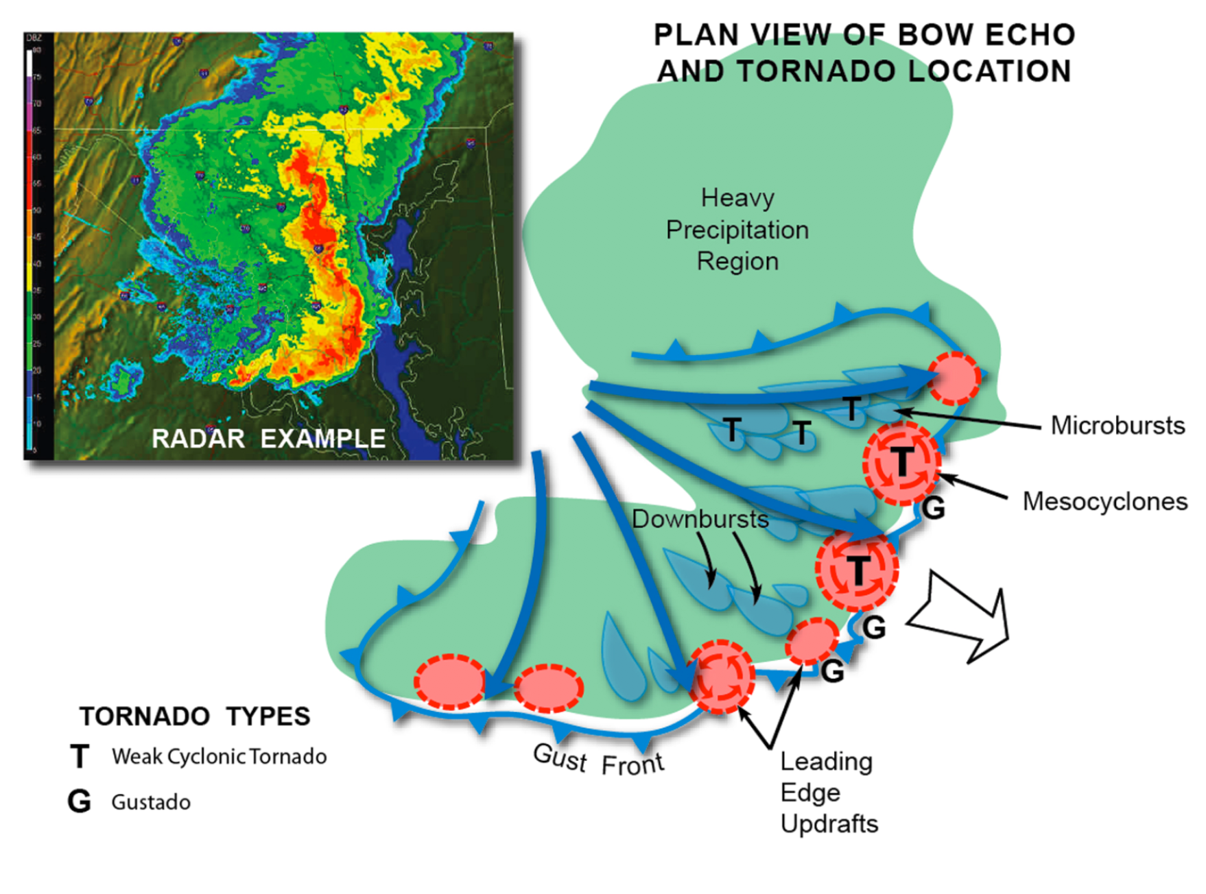
Figure 11.30: A Bow Echo with embedded Tornadoes, and Downbursts. Bow echoes are often associated with tornadoes and downbursts, which are usually fast-moving features. Cold downdrafts of air spread outward toward the leading edge of the gust front. Downbursts and microbursts are embedded behind the gust front. Tornadoes can form along the edge of the bow echo, where they are embedded in small mesocyclones called misocyclones.
[H2] Landspouts
Weak, tornadic-like vortices can develop over land, similar to the way a waterspout forms
Waterspouts are weak vortices, pendant from convective clouds, over warm bodies of water. The clouds need not be thunderstorms. Storm chasers along the Great Plains have long recognized a weak, short-lived type of tornado that develops from the base of towering cumulus clouds, some of which lack lightning and thunder. Figure 11.31 shows an example. Here we see two of these vortices lofting soil and dust in Washington State. These tornadoes lack well-defined funnel clouds (the air beneath the cloud base is too dry to support condensation) and there is no visible wall cloud, rainfall, or lightning. Often, a cluster or line of these tornadoes will develop simultaneously, spaced a few kilometers apart, from a row of towering cumulus clouds. They are most common just east of the Colorado Rockies, in the Boulder-Denver area, along the I-25 corridor. There, a large, terrain-induced wind circulation called the Denver Cyclone develops during the warm season. These tornadoes are called landspouts, because they are thought to develop in a similar manner to waterspouts.
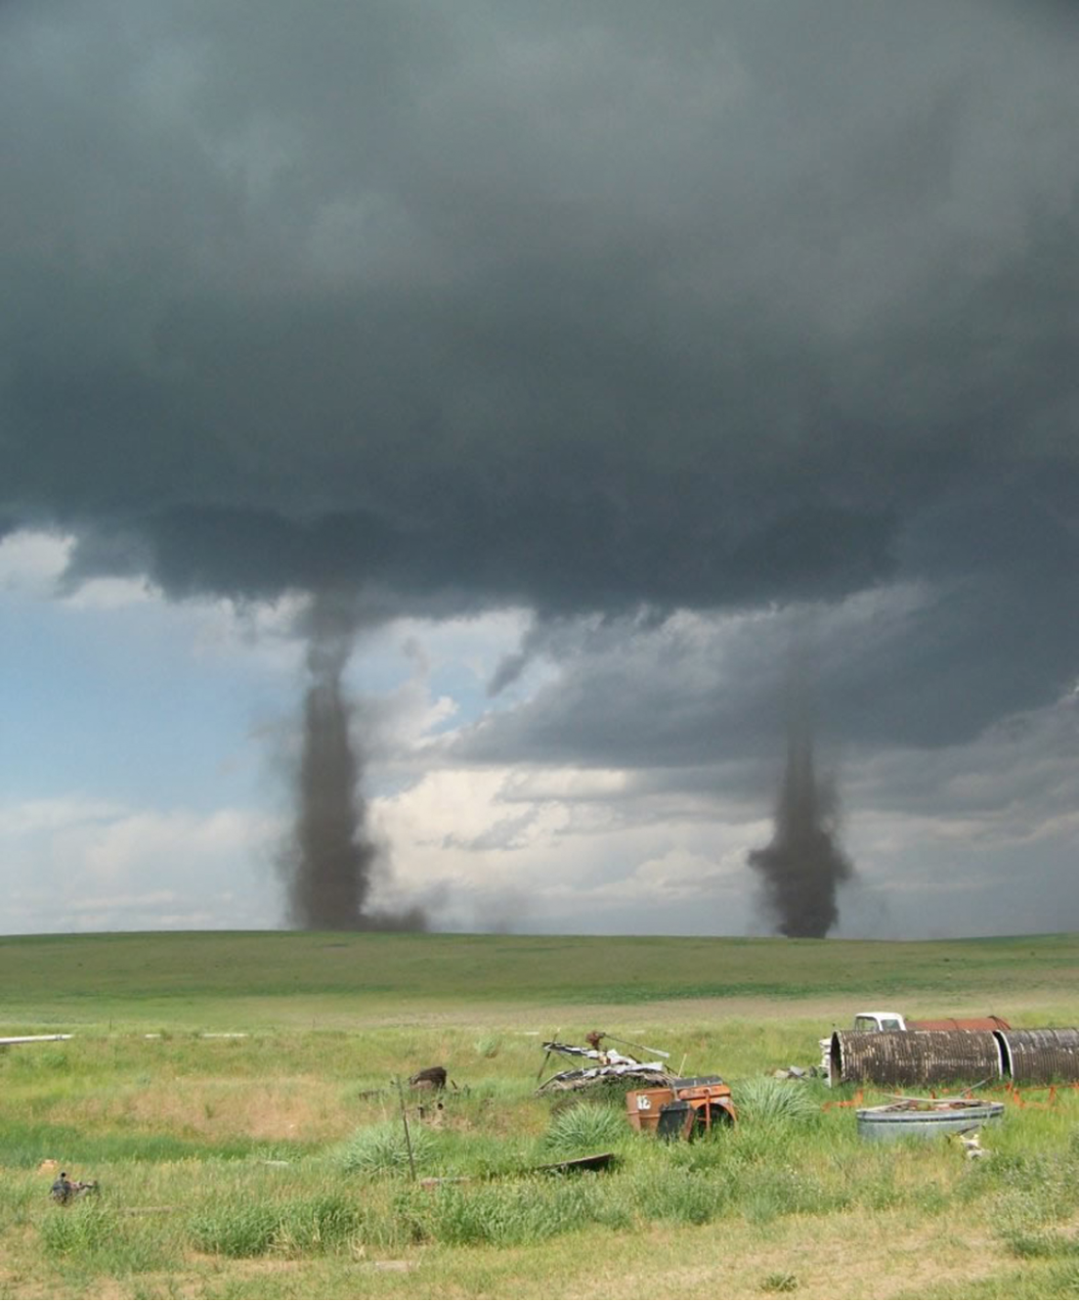
Figure 11.31: Landspouts. Landspouts (weak tornadoes) lack a well-defined funnel. While landspouts can form most anywhere, they are particularly common along the Front Range in the Boulder/Denver region of Colorado.
Figure 11.32 shows a plan view of typical meteorological features that generate landspouts. The process starts with a wind-shift zone across which horizontal wind shear is present. Air on the southeast side of the boundary has a southerly component, while air on the west side has a northerly component. The sense of horizontal shear imparts small regions of counterclockwise spin along the boundary. These individual regions, often less than 1-2 km (.6-1.2 mi) across, are called misocyclones, and they lie very close to the ground. When isolated convective cells develop atop misocyclones, cloud updrafts stretch each misocyclone vortex into a tighter, faster spinning vortex, turning the misocyclone into a landspout. This process is identical to that illustrated in Figure 11.26, involving conservation of angular momentum. Small pockets of heavy rain may fall from individual cloud cells (shown by the green regions).
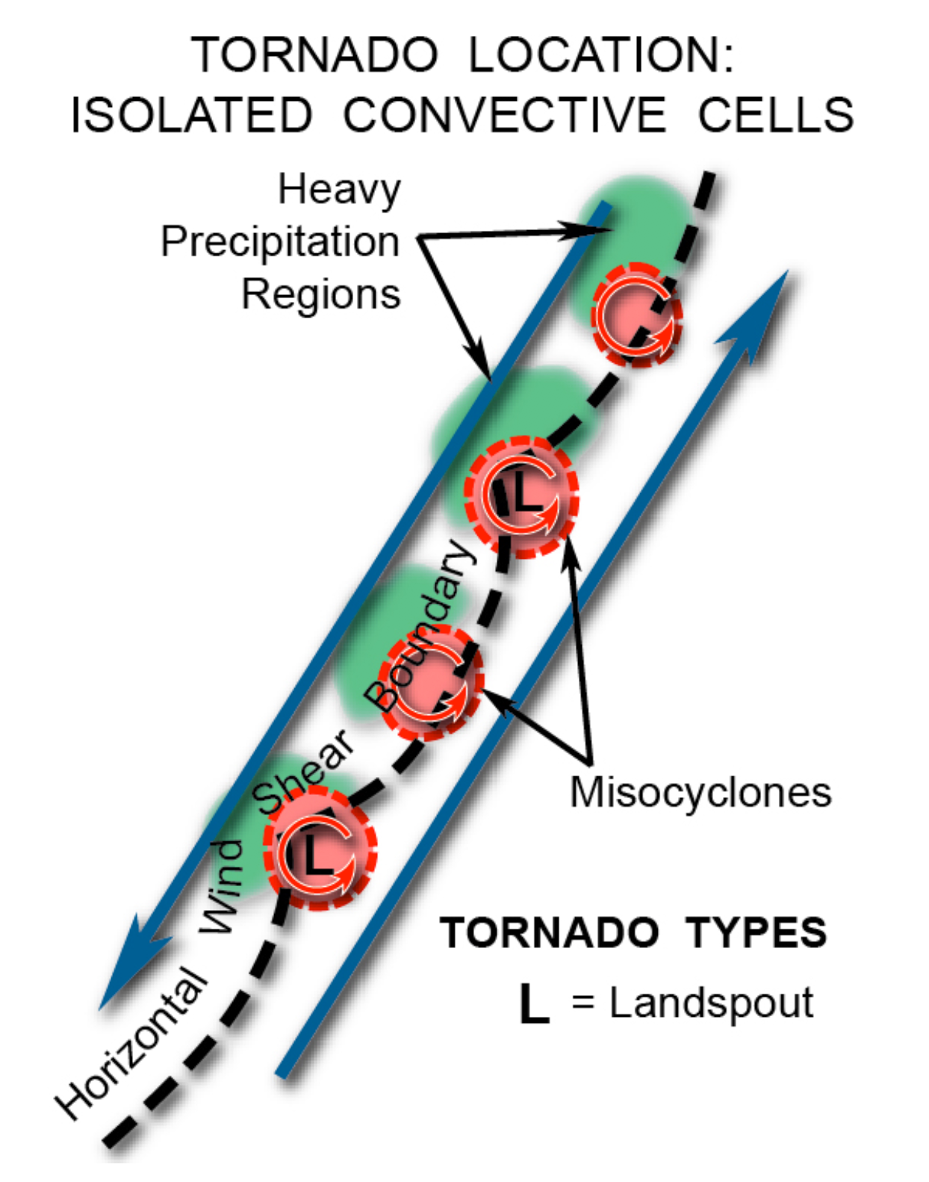
Figure 11.32: The Formation of Landspouts. Opposing horizontal wind shear forms misocyclones. When isolated convective cells stretch these small vertical vortices, landspouts are formed.
Figure 11.33 illustrates the three-dimensional evolution of a landspout-bearing cloud line. Panel (A) shows the wind-shift zone, with opposing surface winds on either side. The leading edge of this boundary often becomes distorted into a series of wavelike undulations. Between the lobes and clefts, small counterclockwise vortices develop. These are the misocyclones. In Panel (B), cumulus clouds containing updrafts begin forming along the zone. Individual misocyclones often merge and coalesce, intensifying, and cloud updrafts amplify spin by vortex stretching. In Panel (C), as convective clouds grow upward, misocyclones spin up to near-tornadic intensity. Further merger or consolidation of vortices may occur at this time. Panel (D) illustrates a mature convective cloud, which deposits a heavy rain shower west of the updraft region. A cool downdraft accompanies the shower. When the downdraft reaches the surface, it wraps around the tornado. The convergence of dense air spiraling inward provides a final, brief period of vortex contraction, reaching maximum intensity. Finally, in Panel (E), downdraft dominates the cloud. It completely wraps around the tornado, often distorting it into a horizontal rope-like shape. This is the tornado’s dissipating phase. The total process from updraft formation to development and dissipation of the tornado is often no longer than 15-20 minutes.
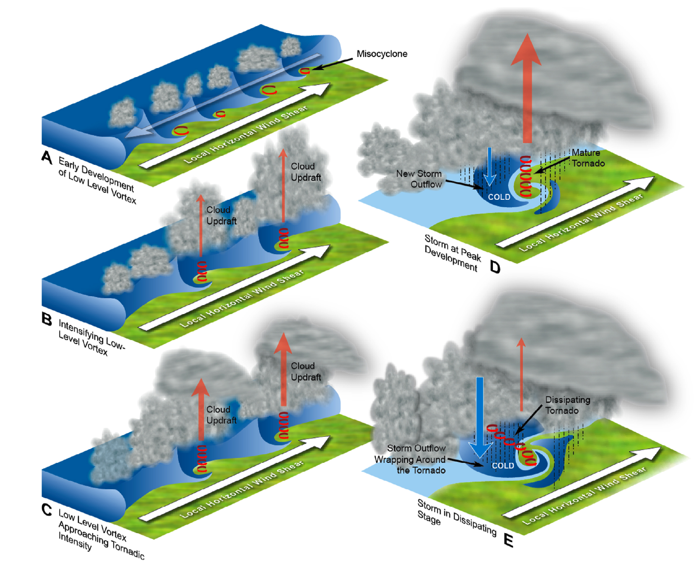
Figure 11.33: Formation of Landspouts: A 3D View. Panel (A) shows how opposing winds cause undulations and horizontal shear along the cold/warm air boundary, setting in motion the rotating cylinders of air. Panel (B) depicts local cumulus cells stretching the vortex cylinders. In panel (C) the vortices continue to be stretched and their wind speeds accelerate. Panel (D) shows how cold downdrafts begin to encircle the vortices and cut off the energy inflow. Panel (E) shows the landspout in its final phase of dissipation.
[H2] Gustnadoes
Weak, tornado-like vortices lacking a funnel cloud can form just ahead of a thunderstorm
A final tornado variant is the gustnado, shown in Figure 11.34. A gustnado is a very brief, weak tornado that sometimes develops along gust fronts associated with thunderstorms and heavy rain showers. Often, all that is visible is a tiny dust whirl at the surface, along the edge of the storm cloud, in front of an opaque rain curtain. Sometimes several whirls are observed along a single gust front. There is often no funnel cloud. Gustnadoes represent the weakest end of the tornado spectrum. The maximum swirling wind speeds in most gustnadoes usually lies below 50-60 kts (58-69 mph). Many thousand gustnadoes probably occur every year in the United States, and many are never observed. Meteorologists disagree on whether to classify them as tornadoes, and they are not officially logged in the U.S. tornado database. They form in a manner analogous to Panel A in Figure 11.32. Gustnadoes form within the lobes and clefts of the gust front when part of the outflow becomes distorted or surges ahead. The rain-cooled, chilly downdraft air at the gust front is dense, hugging the ground; it resists vertical lifting and stretching if updrafts are present above. Therefore, gustnadoes rarely amplify to strong tornadic intensity.
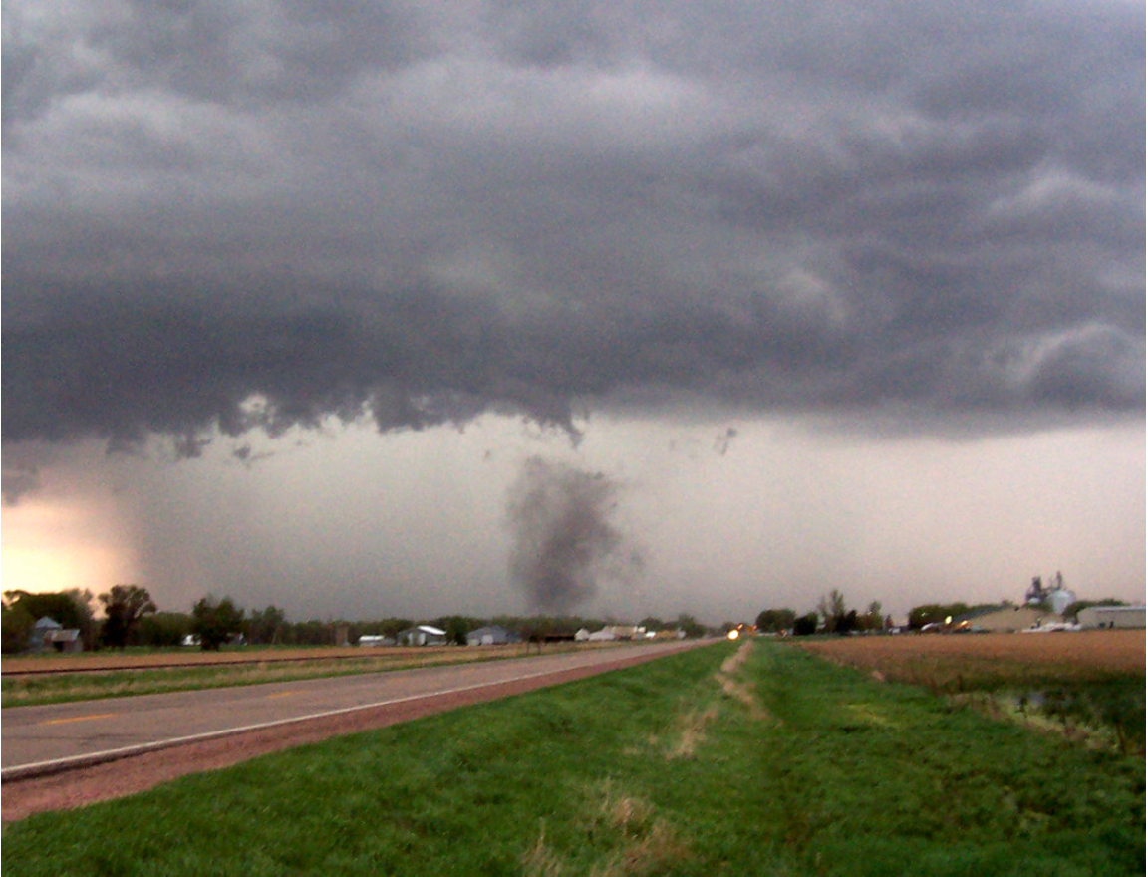
Figure 11.34: Gustnado. A gustnado is a very weak, short-lived tornado that originates along a gust front. Lacking significant water content, and lacking dust and debris from the surface, gustnadoes are often quite transparent and discontinuous looking.
Key Terms
anticyclonic tornado
bow echo
centrifugal force
circulation
cone tornado
conservation of angular momentum
cyclic tornadogenesis
cycloidal etching
cyclostrophic balance
cyclostrophic wind
debris cloud
Doppler on Wheels
downburst
dynamic pipe effect
dynamic suction pipe
feeder winds
forward flank downdraft
funnel cloud
gustnado
helical flow
landspout
mesocyclone
microburst
misocyclone
multi-vortex tornado
rain-wrapped tornado
rear flank downdraft
rope tornado
secondary circulation
stovepipe tornado
strong tornado
supercell
swirl ratio
tangential velocity
tornadogenesis
violent tornado
vortex breakdown
vortex tube
vorticity
weak tornado
wedge tornado
wind load

Summary of Learning Objectives
11.1 Tornado Classifications

L11.1 Identify the different types of tornado-producing storms and the characteristic intensity of tornadoes produced by each.
• Tornadoes are very rare severe local storms; fewer than 1% of all thunderstorms during the year in the U.S. spawn a tornado;
• Tornadoes can be broadly classified as weak (winds < 111 mph), strong (111-165 mph) and violent (winds between 166-200+ mph). Severe supercell thunderstorms spawn most of the strong and violent tornadoes, while weaker tornadoes are generated both by supercells and also by bow echoes. While violent tornadoes account for 1% of all U.S. annual tornadoes, they produce 70% of all tornado fatalities;
• The tornado, which is a tubular, low pressure vortex of wind in contact with the surface, develops a funnel cloud when humid air expands and cools adiabatically inside the tornado core, to the dew-point temperature of the air
11.2 Dissecting the Tornado Vortex: Structure, Wind-Generating Forces, and Spin

L11.2 Understand the physical properties of tornadoes and governing forces, including cyclostrophic balance, the conservation of angular momentum, vorticity, circulation, suction vortices, swirl and asymmetric distribution of winds

• The swirling wind in a tornado vortex arises from cyclostrophic balance, in which the inward-directed pressure gradient force is balanced by the outward- directed centrifugal force;
• Tornadoes behave like a dynamic suction pipe: Air can only enter the vortex tube at its lower end, at the surface. This generates a shallow layer of intense inflow or feeder winds converging in a spiral beneath the tornado;
• Strong and violent tornadoes are embedded in a larger vortex contained inside the supercell, called the mesocyclone. Low pressure in the mesocyclone helps remove air that flows into the base of the tornado, and supplies angular momentum that helps spin up the tornado;
• Tornado formation and maintenance are predicated upon the conservation of angular momentum, which is the product of a tangential velocity, vortex radius and air density. Tangential velocity is the speed of the swirling wind. As a mesocyclone contracts (decreases in radius), tangential winds must increase to maintain constant angular momentum. The base of large, strong tornadoes may devolve into numerous suction vortices; their very small radius requires that tangential velocity increase further, creating the fastest, localized winds inside the tornado;
11.3 Tornado Structure and Wind Speed

L11.3 Describe how Doppler radars have yielded new insights about tornado structure and evolution, including single and multi-vortex tornadoes
• Portable research Doppler radars have enabled scientists to study the 3D airflow inside both weak and violent tornadoes. In addition to the swirling wind, tornados also feature strong inflow of air into their base, and a powerful updraft within the vortex ring. Large, strong/violent tornadoes contain rapidly sinking air in a clear “eye”;
• Tornadoes move along the ground, or translate, in a relatively straight path. This translation speed must be added to the tangential wind on the right side of the tornado track, and subtracted from the left side. This creates an asymmetrical pattern of wind damage across the tornado. Much higher winds usually prevail on the right side of track, creating an uneven damage pattern as the tornado moves along the ground;
• Anticyclonic (clockwise spinning tornadoes) do occur in the northern hemisphere, but they are few in number compared to cyclonic (counterclockwise) tornadoes. The direction of a tornado’s spin is not determined by the sense of the Earth’s rotation, as the Earth’s spin represents only 1 part in 10,000 of a tornado’s spin
• Suction vortices develop in strong/violent tornadoes at high swirl ratio (i.e. the tangential velocity greatly exceeds the updraft speed), at which point the vortex breaks down or devolves into several smaller sub- vortices. As a tornado translates, individual suction vortices may orbit the tornado’s axis, leaving cycloidal marks or etchings in the damage swath;
11.4 Tornado Wind Loads and Aerodynamic Forces Causing Structural Failure

L11.4 Define wind load and explain how a tornado’s winds create destructive aerodynamic forces that damage dwellings.
• The wind load in a tornado is the pressure or force exerted by the wind on structures, which varies with the square of the tornado’s wind speed. As wind flows over and around a dwelling, aerodynamic forces cause the roof to lift upward and the walls to move outward. Additionally, debris tossed at high velocity by the tornado’s winds destroys walls, windows and doors;
• Mobile homes are easily damaged by tornado winds, because their thin walls are easily penetrated by debris, and their high surface area to weight ratio makes them susceptible to rolling

11.5 Theories of Tornado Formation

L11.5 Explain the core principles associated with tornado formation (tornadogenesis).
• Tornadogenesis describes the process of tornado formation within thunderstorms. The majority of supercell thunderstorms do not produce tornadoes. Those that do form develop within the supercell’s mesocyclone, as it interacts with a cool downdraft of air that wraps around the mesocyclone late in the supercell’s lifetime;
• Several dynamic principles help form tornadoes at the surface: (1) horizontal vortex tubes above the surface are tilted into the vertical by the downdraft; (2) once tilted by the downdraft, the vertical tubes are stretched in the adjacent updraft (divided mesocyclone); (3) by conservation of angular momentum, as a vortex tube stretches and its radius decreases, tangential winds increase to tornadic intensity;
• Cyclic or serial tornadogenesis is the process by which a single supercell, lasting many hours, produces a succession of tornadoes;
• Landspouts are a type of weak tornado that form in an analogous manner to waterspouts. Small vertical circulations called misocyclones develop close to the surface when horizontal wind shear along an air mass boundary spins up and consolidates. When the updraft of a growing storm cloud becomes co-located with a misocyclone, it is stretched vertically, intensifying to tornadic wind speed. Landspouts are common in High Plains thunderstorms, particularly along Colorado’s Front Range;

