Chapter 2

A Meteorological Primer, Part I: Pressure and Wind Relationships
2.1 Sea-level atmospheric pressure is the weight of the overlying air column
2.2 The pressure gradient is the “motor” that generates wind
2.3 But there’s a twist: Earth spins, so we must introduce the Coriolis effect
2.4 The Relationship between Pressure Gradient and Temperature Variations
2.5 Global Atmopsheric Circulation: A Giant Atmospheric Heat Engine
Circulation Features in the Tropics
Circulation Features in the Subtropics
Circulation Features in the Mid-Latitudes
Circulation Features in Polar Latitudes
2.6 Wind Systems Associated with Extratropical Cyclones and Anticyclones
The Forces Behind the Wind
Extratropical cyclones and anticylones are created beneath waves in the polar jet stream
Changeable daily weather in mid-latitudes is tied to the formation and movement of cyclones and
anticyclones
A Comparison of Winds in Atmospheric Vortices of All Sizes
2.7 Small-Scale Wind Circulation Systems
Understanding the sea breeze is … a breeze!
The air goes up the mountain
The Nocturnal Low-Level Jet: Moisture Pipeline Over the Great Plains
A Potpourri of Other Regional Circulations

Learning Objectives
1. Define atmospheric pressure and explain how pressure changes with altitude.
2. Understand how the pressure gradient force creates wind, and determine wind strength by examining the spacing of isobars on a surface weather map.
3. Explain how the geostrophic wind, which blows parallel to isobars, is created by a balance between the pressure gradient force and the Coriolis effect.
4. Describe how horizontal variations in air temperature create a pressure gradient and geostrophic wind.
5. List the principal features of general atmospheric circulation, and discuss how global air circulation is driven by the movement of excess heat energy from the equator toward the poles.
6. Discuss how the types of wind forces differ among extratropical cyclones, hurricanes, and tornadoes.
7. Describe the origins and geographical distribution of various regional-scale wind circulations, including the sea breeze, mountain-valley circulation, nocturnal low-level jet, North American Monsoon, and mountain winds (Santa Ana and Chinook).

Much of the destruction caused by severe storms arises from strong winds blowing around atmospheric vortices. For example, tornado winds are highly localized and may approach 250 mph. The circulation of air around hurricanes is about 1000 times larger than that in a tornado, and extreme winds in the hurricane’s core may exceed 150 mph, with higher gusts. And the everyday, extratropical variety of cyclone, which brings changeable weather to many parts of North America, may contain winds approaching 60-70 mph. Tornadoes inflict damage to engineered structures that is highly localized and often near-total, while much larger extratropical cyclones and hurricanes down tree limbs and create power outages across widespread areas. In both cases, intense winds arise from atmospheric forces that combine in predictable ways.
In this chapter, we introduce these forces and the types of weather systems that produce strong winds. As you begin reading, keep the following key point in mind: Wind (the movement of air) arises from differences in atmospheric pressure across some unit of distance. Over a pressure gradient – that is, a change in surface pressure over a specified distance -- air will accelerate from a region of high pressure toward an area of low pressure. A wind is born!
To set the stage for our study of wind, let’s begin with some important definitions. Cells of low pressure, around which winds spiral counterclockwise, are the common extratropical cyclones that move from west to east across North America. Some 50-70 of these storms, which can produce destructive winds across large areas, may impact any given U.S. region in the course of a year. Hurricanes are a type of cyclone that form in the tropics. Embedded within these cyclones, particularly those in the mid-latitudes, are intense thunderstorms that spawn tornadoes. Tornadoes are very small-scale cyclones that create narrow corridors (typically a few kilometers long by a few hundred meters wide) of extreme wind destruction.
Now, let’s examine the basics of atmospheric pressure and winds.
2.1 Sea-level atmospheric pressure is the weight of the overlying air column.
Atmospheric pressure is the weight of the overlying atmosphere, per unit area. The concept of atmospheric pressure is quite simple, as Figure 2.1 shows. Air is composed of a mixture of gases, mostly nitrogen (78%) and oxygen (21%). Although invisible, air has mass. If you designed a scale to measure the weight of a 1-inch-by-1-inch vertical column of Earth’s atmosphere, extending from surface to space, you will find that it weighs 14.7 pounds per square inch (psi) at sea level. The metric unit of atmospheric pressure is the Pascal (Pa), and 14.7 psi equals 1013 hPa (hectopascals). American meteorologists commonly use a unit called the millibar (mb), equating 1 mb with 1 hPa, or 1 mb = 1hPa. So we can “daisy chain” all of our equivalent sea-level pressure units together in the following manner:
14.7 psi = 1013 hPa = 1013 mb = 29.92 in hg.
The gases that compose the atmosphere are compressible. That is, they can be compressed. Molecules become squeezed together close to Earth’s surface, due to the weight of the overlying air column. If we were to take a balloon ride upward through the atmosphere, we would discover that pressure decreases with altitude. But it does not decrease in a steady manner. Instead, the pressure decreases exponentially with height. (An exponential change is one in which the change is proportional to the amount of a substance.) Near Earth’s surface, where the pressure is largest, the decrease with an incremental change in altitude is rapid. Halfway up the troposphere – say, at a level of about 18,000 feet – atmospheric pressure is about 500 mb, or about half of what it is at sea level. Here, the decrease in air pressure with altitude is much smaller. Figure 2.2 illustrates the exponential drop in pressure with altitude.
A measurement closely related to air pressure is air density. Density is the ratio of mass to volume. Because air molecules are squeezed close together at sea level, air density is largest at sea level. Density drops off with height in a very similar manner to pressure – that is, it follows an exponential decrease.
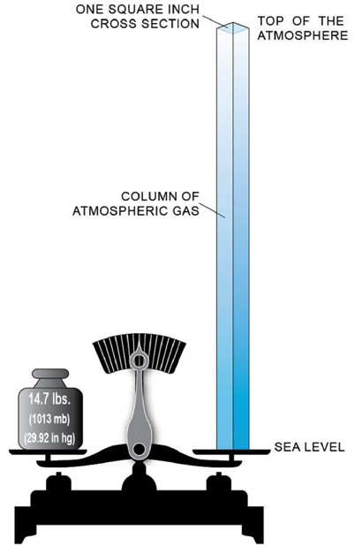
Figure 2.1: Atmospheric pressure is the accumulated weight of the atmosphere. We seldom think of atmospheric (air) pressure unless we are changing altitude rapidly (taking off or landing in an airplane, for example). However, air does have weight. The average weight of a one-square-inch column of air measured from the top of the atmosphere to sea level weighs 14.7 pounds (1013 hPa or 1013 mb or 29.92 in. hg).
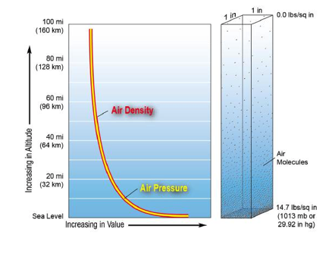
Figure 2.2: The atmosphere is a compressible gas. It is densest at Earth’s surface and thins with increasing altitude. This graph illustrates how air density and air pressure change exponentially in a one-to-one correlation with change in altitude.

2.2 The pressure gradient is the “motor” that generates wind.
Substances tend to move from regions of high concentration to regions of low concentration. Think about what happens when you add a drop of dye into a tank of still water, or a smokestack releases pollutants into still air. Those heavy concentrations are soon dispersed. A similar process is at work with variations in atmospheric pressure at Earth’s surface, or any level in the atmosphere for that matter. Air will flow freely from a region of high pressure toward a region of low pressure. Nature likes to even out, or equilibrate, these regions of uneven pressure.
An important force arises between areas of unequal pressure, called the pressure gradient force. This force accelerates the movement of air from high pressure to low pressure. Air that is moving is simply the wind. The wind, in turn, exerts a stress or force of its own on structures, such as the leaves of a tree, or a flag on a flagpole.
Figure 2.3 illustrates the pressure gradient force. Imagine two hollow boxes separated by a partition. The partition has an aperture opened and closed by a sliding door. On the left side, we allow air pressure to build to a higher value than on the right side. The difference in pressure, or ΔP, is 6 mb. Now we quickly slide open the aperture. Air will immediately flow from the high-pressure side to the low-pressure side. Now let’s increase the size or magnitude of the pressure difference, such that the ΔP = 14 mb. When we slide open the aperture, air will flow more vigorously from high pressure to low pressure. We expect a stronger wind will flow through the aperture in the second example.
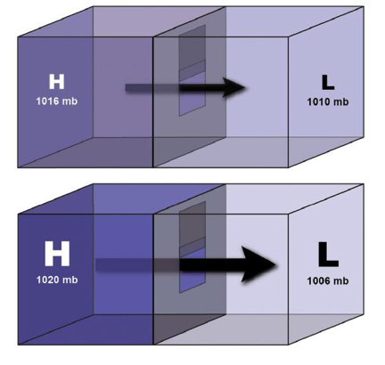
Figure 2.3: An illustration of the pressure gradient. In nature, pressure differences within the atmosphere try to equilibrate by moving air from areas of high pressure to areas of low pressure. We know these air movements as wind. As illustrated here, the greater the pressure difference over distance (pressure gradient), the stronger the wind.
From this simple illustration, let’s jump to a surface weather map, as shown in Figure 2.4. We know that the magnitude of the pressure gradient force (and strength of the wind) is proportional to the size of the pressure difference, ΔP. A larger difference in pressure will generate stronger winds. But the pressure gradient is related to both the difference in air pressure and the distance over which this difference is measured. By definition, the pressure gradient is equal to ΔP/ΔX, where ΔP = difference in pressure and ΔX = increment of distance. We can
assess the strength of the pressure gradient by examining the isobars – lines of constant pressure – drawn on a weather map. In Figure 2.4, we see a region of high pressure, 1020 mb, separated from a region of low pressure, 976 mb. The area of low pressure is in fact an intense extratropical cyclone over the Great Lakes during the fall. This particular storm had such an intense pressure gradient that it produced widespread wind damage within a few hundred miles of the storm’s center.
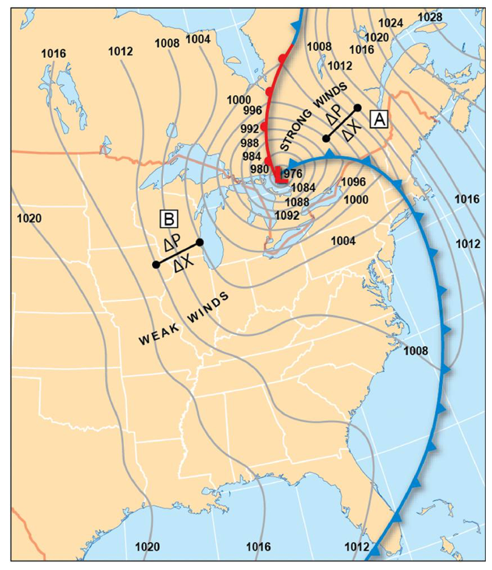
Figure 2.4: This map displays isobars distributed around a low-pressure system. The areas with higher pressure gradients are indicated by closely spaced isobars. Where isobars have greater separation the pressure gradient will be less. The relative strength of wind depends on the pressure gradient. The higher the gradient, the stronger the wind. By definition, the pressure gradient is equal to ΔP/ΔX, where ΔP = difference in pressure and ΔX = increment of distance.
Let’s examine the pressure gradient at a couple of locations. For a given difference in pressure, ΔP, a large increment of distance, ΔX, gives rise to a small overall pressure gradient. If the two regions are separated by a small increment of distance, the gradient will be large. To avoid doing this type of mental math, we can simply count the number of isobars between adjacent regions of high and low pressure. By convention, isobars on weather charts are spaced every 4 mb. If the isobars are close together, such that a large number of isobars lie between the region of high pressure and low pressure, the pressure gradient is large, and the wind will blow strongly, as in Region A in Figure 2.4. If, on the other hand, the isobars are spaced far apart over the same distance, both the pressure gradient and the wind are much weaker (Region B). In Figure 2.4, very strong northeasterly winds (winds that blow from the northeast) are flowing into the storm north of the Great Lakes. However, to the west of the storm, and farther from its center, much slower winds blow from the west (westerly winds).

2.3 But there’s a twist: Earth spins, so we must introduce the Coriolis effect.
You should now be able to examine any standard chart of surface pressure and (a) identify regions of high and low pressure, and (b) estimate the relative strength of the wind at any location on the map. However, there’s more to the story about wind. Until now, we’ve neglected another important effect, one that determines the direction in which winds blow. Winds in the northern hemisphere circulate clockwise around regions of high pressure, and counterclockwise around regions of low pressure. This important effect is called the Coriolis effect, and it arises from the rotation of Earth.
The Coriolis effect causes moving air to deflect to the right of its path in the northern hemisphere (and to the left in the southern hemisphere). The Coriolis effect arises only when the pressure gradient accelerates the air; it has no influence on air that is perfectly still. The Coriolis effect explains why air does not flow straight outward from the center of high-pressure cells, likes spokes on a wheel, but rather circulates clockwise around the high-pressure cell. Similarly, air circulates counterclockwise around a low cell, rather than flowing straight inward from all directions.
The winds through the deep atmosphere arise from a balance between the pressure gradient force and the Coriolis effect. This state of balance gives rise to the geostrophic wind. Figure 2.5 illustrates the geostrophic wind, with arrows that show the size and direction of the pressure gradient force, Coriolis effect, and the resultant wind; such arrows expressing both magnitude and direction are called vectors. In Figure 2.5, you will note that the pressure gradient force is directed from the region of high pressure toward low pressure, along the pressure gradient. Because the geostrophic wind is a state of balance, the Coriolis effect must equal the pressure gradient force, operating in an opposite manner. The geostrophic wind, then, does not blow directly from high to low pressure, but is instead oriented parallel to the isobars, with high pressure located to the right (facing the direction from which the wind blows) and low pressure on the left.
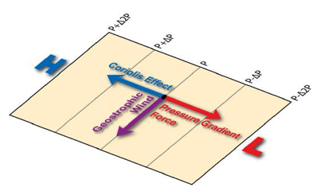
Figure 2.5: The Geostrophic (Earth-Turning) Wind. Geostrophic winds are the result of the interaction between the Coriolis effect and the pressure gradient force. Air wants to move from high to low pressure. However, due to Earth’s rotation, the Coriolis effect causes the wind to be deflected to the right in the northern hemisphere (pictured here) and to the left in the southern hemisphere.
It’s useful to make a few more points about the Coriolis effect. The effect increases in proportion to the magnitude of the pressure gradient force. When the wind blows strong (that is, when the pressure gradient force is large), the Coriolis effect is also large. Also, the magnitude of the Coriolis effect varies with latitude across the globe. This effect arises because of Earth’s spin about its axis. Earth’s spin is maximum at the poles, and zero along the equator. The Coriolis effect therefore vanishes at 0 latitude – in the tropics. The tropics are the one place on Earth where wind does indeed blow in nearly a straight path from high pressure toward low pressure. Finally, the Coriolis effect comes into play only when the pressure gradient operates over fairly large distances and over a long time, typically in excess of several hundred kilometers and several hours. Thus, many small-scale, short-lived wind circulations and vortices – such as tornadoes – are not directly influenced by the Coriolis effect.

2.4 Horizontal Variations in Air Temperature Give Rise To A Pressure Gradient
Now we arrive at a very important concept in introductory meteorology, one that will enable you to understand how horizontal variations in air temperature give rise to a horizontal gradient in air pressure. Examine Figure 2.6, which portrays three vertically tall columns of atmosphere, extending from the surface to the 500 mb level (18,000 ft). All three air columns contain the same mass of air and therefore exert the same pressure on the surface (Panel A). Now, let’s uniformly cool the air inside the left-hand column by several degrees, and warm the air inside the right-hand column. Like most substances, air contracts when it is cooled, and expands when it is heated. So the cold column shortens, and the warm column lengthens, relative to the middle column with no temperature change (Panel B). Here is another way to think about these changes: In the warm column, air molecules spread apart. The air in the column becomes less dense. The column must get taller (deeper), in order to achieve the same weight (surface pressure). In the cold air column, air molecules move closer together. The air in the column is more dense. The column height decreases to achieve the same surface pressure.
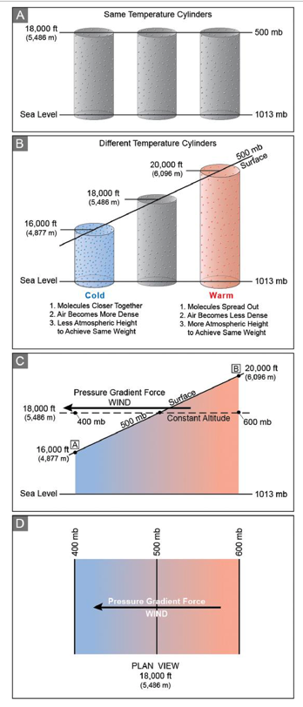
Figure 2.6: How air mass temperature variations give rise to a pressure gradient. Panel A illustrates three identical columns of air – same volume, temperature, and pressure. Panel B shows what happens when one column of air (left) is cooled, one (center) remains unchanged, and the third (right) is warmed. The cool air contracts as the molecules move closer together. The warm air expands as the molecules move farther apart. The diagonal line represents the point where the air is at a constant pressure. Of course, air in the atmosphere is not restricted to columns, but rather is continuous. As temperatures vary from place to place (Panel C) the level of equal air pressure changes altitude in concert with air temperature. Panel D is a plan view of the plane represented by the dashed line in Panel C. Notice that with constant altitude, air pressure changes in response to air temperature.
Now let’s tie all this into the concept of the pressure gradient. Panel B shows something interesting that happens to the 500 mb pressure level. We can think of this level as a two-dimensional surface. In the middle column, the height of the 500 mb pressure level lies at 5,486 m (18,000 ft). But above the warm column, the 500 mb pressure level is pushed upward to 6,046 m (20,000 ft). Over the cold column, the 500 mb pressure level has dropped to 4,877 m (16,000 ft). The 500 mb pressure surface takes on a slope, tilting downward toward the cold-air column.
In Panel C, we’ve left the sloping 500 mb pressure surface in place, but we’ve taken away the air columns. We’ve added another surface, a surface of constant altitude, that cuts across all air columns at exactly 5,486 m (18,000 ft). Notice that the surface of constant pressure and surface of constant altitude do not coincide; rather, the constant-altitude surface cuts through the plane of constant pressure. Along the constant-altitude surface, the air must accelerate horizontally, because a pressure gradient lies along it. At Point A on the constant-altitude plane, the pressure is lower than 500 mb (it is 400 mb, to be exact). At Point B, the pressure is higher than 500 mb (it is 600 mb, to be exact).
Exactly at the plane’s mid-section, the pressure is 500 mb. So along the horizontal plane, there exists a pressure gradient force, and the air accelerates from right to left, from high (600 mb) to low (400 mb) pressure. The plan view at the bottom of Panel D shows the pressure gradient, and the pressure gradient force, directed from high pressure toward low pressure. The Coriolis effect must balance this force and deflect the flowing air to its right. The wind on the constant-altitude surface will turn into the page, and is in fact a geostrophic wind. And this geostrophic wind has developed simply because adjacent air columns have heated and cooled! In other words, you can now see that a horizontal gradient in temperature generates a horizontal pressure gradient.
You are now armed with some very powerful concepts in meteorology, and you are ready to apply this knowledge to learn how Earth’s general atmospheric circulation arises.

2.5 Global Atmospheric Circulation: A Giant Atmospheric Heat Engine
The Earth is in a state of radiative imbalance, with a surplus of solar radiation in the tropics, and minimal solar radiation at the poles. You might ask why the tropics do not steadily get hotter and hotter, and the poles colder and colder. The answer lies in the fact that Earth’s atmosphere (and oceans) continuously transport heat energy from the equator toward the poles. Nature attempts to constantly equilibrate this imbalanced state, to even out the excesses and deficits of temperature. The simplest picture we can portray of the atmospheric general circulation is this: Hot air over tropical oceans and land masses rises into the upper troposphere, then moves poleward at high altitude. There is a return flow of cool air from the polar regions advancing toward the tropics. When a fluid such as air moves excess heat vertically upward, the process is called convection. At the hemispheric scale, one can imagine the need for a giant, overturning air cell acting as a heat pump for the entire planet (Figure 2.7).
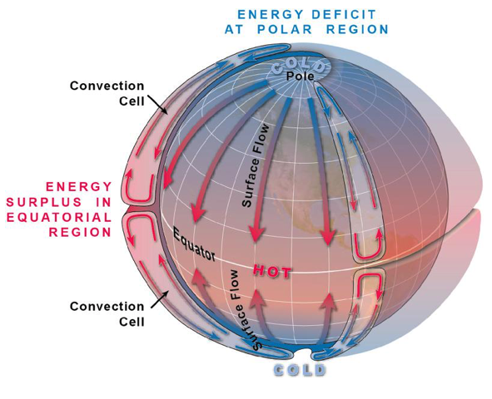
Figure 2.7. The radiation imbalance across Earth. Earth is constantly attempting to equilibrate imbalances. Heat from the tropics is moved poleward and cold air at the poles moves towards the tropics. Without this natural adjustment, the zone of habitation would be greatly restricted because the tropics would heat dramatically and the polar regions would move severe cold significantly towards the tropics.
Figure 2.8 illustrates the atmospheric heat engine in more detail. In each hemisphere, there is a very broad temperature contrast between the tropics and the pole. The heated air column over the equator is deeper than the cold air column over the pole (as we discussed in Section 2.4). As in Figure 2.6, we see how the 500 mb pressure surface slopes (arcs) downward from the equator toward the pole. If we choose a surface of constant altitude -- say, at 4,877m (16,000 ft) -- the pressure on this surface over the equator (Point A) is higher than 500 mb, and that over the pole (Point B) is exactly 500 mb. Along this surface, there is a horizontal pressure gradient force directed from high pressure over the equator, toward the north pole, at high altitudes. The air over the tropics accelerates towards the pole. The wind moves excess heat from the equator, and this general atmospheric circulation attempts to even out temperature across all latitudes.
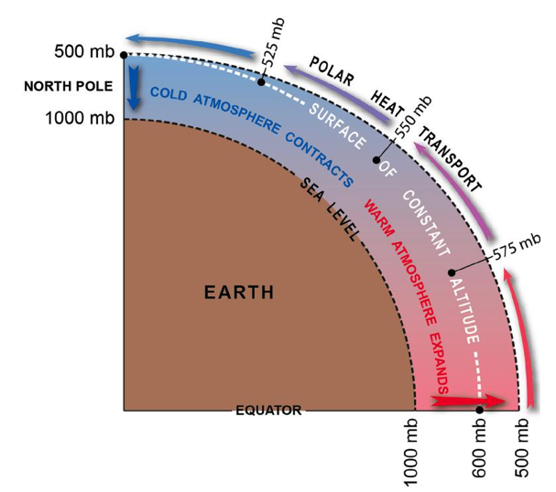
Figure 2.8: This diagram demonstrates the cause of air movement from the tropics towards the poles. Notice that at a constant altitude, the air pressure decreases going poleward, even though air pressure remains constant at the surface. This occurs because the weight of the atmosphere on average is uniform around the world. However, contracting air at the poles and expanded air at the equator create different pressures at a constant altitude.
Now, this is a highly simplified model of how Earth balances its uneven heat distribution. The reality is more complicated. First, as Figure 2.9 shows, the general circulation actually consists of three separate overturning cells or “heat pumps” in each hemisphere. The largest one over the tropics is called the Hadley Cell; the one over the middle latitudes is the Ferrel Cell, and the high-latitude circulation is called the Polar Cell. All three work like individual cogs or gears in the global atmospheric heat engine. But let’s not forget that Earth is also rotating, so we must consider the Coriolis effect. Coriolis deflects the poleward flow of air at high levels toward the right, creating a westerly current of air over mid-latitudes. Conversely, the low-level return flow of polar air flowing back toward the equator is also deflected to the right, causing easterly winds to stream from the east across the tropics.
Figure 2.10 portrays the observed general circulation with all its nuances. This is a busy figure so we’ll break it down into several geographic regions, starting with the tropics (20 N to 20 S). Throughout this discussion, keep in mind the two guiding principles: (1) equatorial heat must be moved poleward, through a series of stepwise circulations; and (2) the Coriolis effect deflects air streaming north or south into westerly and easterly flows, respectively. In the following discussion, we describe features in the northern hemisphere, but the same reasoning applies to understand circulation patterns that develop across the southern hemisphere (where the Coriolis effect deflects air to the left).
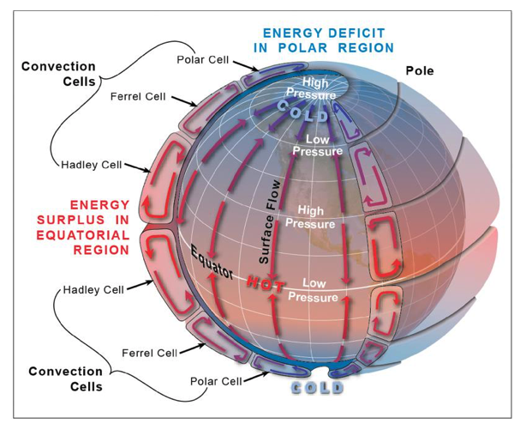
Figure 2.9: The Earth’s atmospheric circulation system is composed of three convection cells in each hemisphere. Alternating high- and low-pressure regions mark the boundary of the cells. Beginning at the equator there is a region of low pressure. Then, moving poleward, a high-pressure region, a low-pressure region, and finally a high-pressure region at the poles.
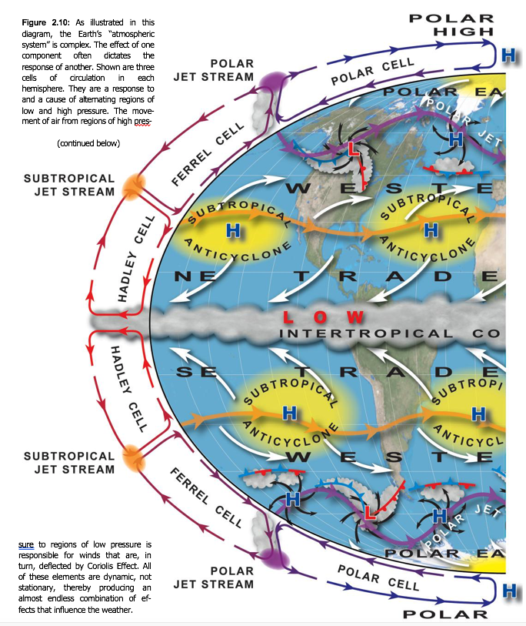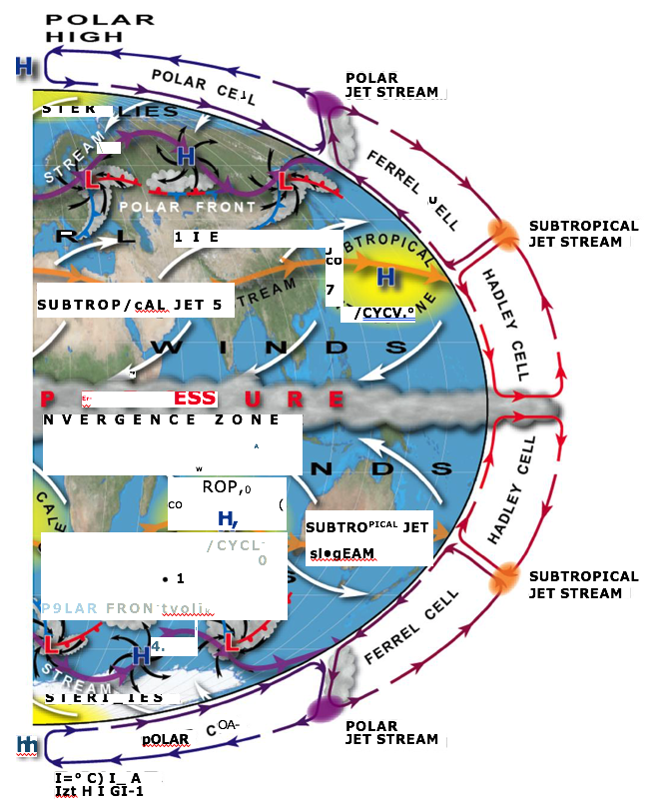
Figure 2.10: As illustrated in this diagram, Earth’s atmospheric system is complex. The effect of one component often dictates the response of another. Shown are three cells of circulation in each hemisphere. They are a response to and a cause of alternating regions of low and high pressure. The movement of air from regions of high pressure to regions of low pressure is responsible for winds that are, in turn, deflected by the Coriolis effect. All of these elements are dynamic, not stationary, thereby producing an almost endless combination of effects that influence the weather.

Circulation Features in the Tropics
The Hadley Cell (one on either side of the equator) is often referred to as the “firebox of the tropics.” Within this firebox, warm air over the low latitudes ascends in giant rain clouds. The air cools as it rises, and upon encountering the stratosphere (at about 16 km [10 mi] altitude), it flows laterally toward the pole. The air at high altitude radiates some of its heat energy to space. This increases its density, causing it to sink back toward the surface around 30 N. Along the equator, there is a persistent band of deep rain clouds. On either side of the equator, trade winds at the surface converge from both hemispheres. When air converges, it is forced to ascend and cool. Moisture in the ascending air condenses into deep rain clouds all around the equator; this area spanning the equator is termed the intertropical convergence zone (ITCZ). As air rises from the surface, pockets of low pressure are created within the ITCZ. Some of these pockets develop into large cloud clusters containing intense tropical thunderstorms. Because the humidity content of warm, tropical air is very high (from the evaporation of warm sea water), these tropical clouds frequently generate torrential downpours and localized flash flooding. Occasionally, during the summer and fall months, cloud clusters near the equator may intensify into highly destructive tropical cyclones (a general term that includes hurricanes) that move toward the west and north, sometimes threatening the United States.

Circulation Features in the Subtropics
The subtropical latitudes are centered at about 30 N and 30 S. High-altitude air on the northern edge of the Hadley Cell sinks over these latitudes. As the air piles up at the surface, high pressure develops. The mass of air is forced to diverge, or spread apart, across the surface in all directions. These large, elongated cells of high pressure are called subtropical anticyclones (STACs) and they are permanent features at this latitude. An anticyclone is a high-pressure cell in which air spirals clockwise outward from the center of the high. The Coriolis effect deflects air flowing southward out of the STAC toward the west, creating a belt of northeasterly trade winds. Air streaming northward from the STAC is deflected toward the east, giving rise to a belt of mid-latitude westerlies. Some of the air at high altitude flowing northward out of the Hadley Cell is deflected to the east by the Coriolis effect. This narrow belt of fast westerly winds in the upper troposphere is called the subtropical jet stream, with winds of 65-87 kts (75-100 mph) in its core.

Circulation Features in the Mid-Latitudes
The mid-latitude belt extends from roughly 40-60 N and S. Westerly flow prevails at all levels in this belt. Most of the continental United States lies within this belt. Along its southern border, warm and humid air masses arrive from the south as air streams northward out of the STAC. Along the northern part of the mid-latitudes, polar easterlies move cold and dry air southward from the north pole. Thus, the mid-latitudes are a location in which warm and cold air masses repeatedly clash. The convergence of disparate air masses creates a deep, narrow zone of strong temperature contrasts (a strong temperature gradient) called the polar front. Air along the polar front is in a constant state of being mixed. Large vortices, spanning 1000 km (620 mi) or more, constantly form and decay along the polar front. These vortices include mid-latitude cyclones and anticyclones. These cyclones and anticyclones migrate along the polar front, swept toward the east by the mid-latitude westerly air currents. They have a lifetime of a few days, and as they cross any given location, they bring changeable weather conditions. In fact, these traveling disturbances are responsible for much of the daily weather variation and storminess across the United States.
Extratropical cyclones, also called mid-latitude cyclones, are very different than hurricanes, which are their tropical latitude, cyclonic counterparts. These cyclones are called extratropical because they form outside the tropical belt. Within an extratropical cyclone, air spirals inward toward the center of low pressure in a counterclockwise manner. As the air converges, it is forced to ascend. As air ascends, it cools and the water vapor condenses into clouds and precipitation. Thus, extratropical cyclones are associated with disturbed weather, including clouds and precipitation. Extratropical cyclones may generate various forms of severe weather, such as violent thunderstorms (during the warm months), heavy snow and ice (during the cold months), and widespread strong winds (if the pressure gradient is especially large). The most severe weather is often concentrated along one or more fronts associated with the cyclone. In Figure 2.10, note how each extratropical cyclone tends to distort the polar front into a wave-like shape, causing the polar front to become fragmented as it encircles the northern hemisphere.
Extratropical anticyclones, in contrast, are characterized by divergence at the surface caused as air sinks from aloft. When air descends, it warms and any cloud or precipitation evaporates. The skies clear and fair weather prevails. At any given location in the United States, the repeated passage of cyclones and anticyclones brings days of fair weather and foul through the course of the year.
There is one other crucial general circulation feature of the mid-latitudes, the polar jet stream. Like the subtropical jet stream, the polar jet is a narrow, high latitude “river” of air that blows from west to east. It develops as a consequence of the intense temperature gradient along the polar front combined with the Coriolis effect. The polar jet (and polar front) are strongest during winter, when winds in the core of the polar jet can approach 174 kts (200 mph). The polar jet develops a series of meanders (or waves) that oscillate north-south and move through the jet stream from west to east. Figure 2.11 illustrates a top-down view of the northern hemisphere, showing the typical configuration of these waves, which can number from three to six. Note that extratropical cyclones and anticyclones are associated with waves in the polar jet. In fact, the low- and high-pressure cores in these vortices are created and maintained by changes in the direction and speed of airflow in the jet stream’s waves.
The polar front and polar jet migrate north during the northern hemisphere summer, and south during winter. These wind patterns shift along with the rest of Earth’s general atmospheric circulation, which in turn follows the Sun’s wander across the equator through the seasons. During the winter, the core of the polar jet lies across the southern and central United States. Vigorous cyclones and anticyclones develop in the strong polar jet’s meanders and sweep from west to east across the country. During the summer, the polar jet weakens and moves north, across the northern Plains, Great Lakes, and southern Canada. Cyclones and anticyclones develop less frequently and are not as strong. Additionally, the subtropical anticyclone in the north Atlantic strengthens and moves north. This feature, often called the Bermuda High, ushers in a hot, humid, tropical airflow across much of the eastern two-thirds of the United States. Heat waves are common. Of all the severe weather hazards affecting the United States, heat waves lead to the largest average annual loss of life.
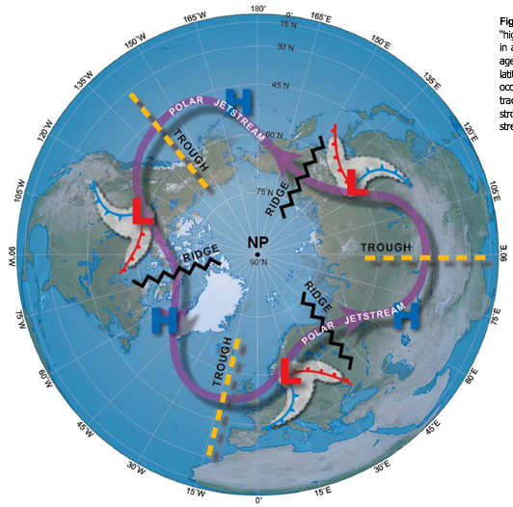
Figure 2.11: A view of the polar jet stream. The polar jet stream is a high-speed “river of air.” It undulates in a serpentine motion and on average is centered about 50 degrees latitude. The polar jet stream influences much of the weather that occurs in the mid-latitudes as well as the tracks of storm systems.

Circulation Features in Polar Latitudes
Finally, we arrive at latitudes north of 60. The planet’s coldest air masses straddle the northern hemisphere’s cap, chilled by outgoing long-wave radiation and sustained contact with snow and ice. Air sinks over the polar region and is very dry (because cold air contains very little water vapor). As a permanent high-pressure cell builds over the polar regions, air at its center diverges outward then becomes deflected into a large clockwise spiral. This flow pattern is known as the polar easterlies. During the northern hemisphere winter, extremely frigid air masses break free from the polar latitudes and surge south across the United States as part of an extratropical anticyclone. This process ushers in arctic air outbreaks. Extremely low temperatures often lead to widespread loss of crops and livestock, damage critical infrastructure such as water mains, and claim numerous human lives.

2.6 Giant Wind-Producing Systems, Called Extratropical Cyclones and Anticyclones, Are Generated By Waves In The Jet Stream
Overall, the atmospheric heat engine accomplishes roughly two-thirds to three-quarters of the required heat export from the tropics; the remainder is handled by surface ocean currents. The amount of energy involved in this atmospheric transfer is impressive indeed, approximately 5 petawatts of power. A petawatt is a quadrillion (10¹⁵) watts (the humble light bulb burns at a steady 60 watts) and this is the energy being processed every second! So, in the grandest sense, the role of large atmospheric vortices such as extratropical cyclones is to transport heat. The severe weather that they sometimes generate is a byproduct of this heat-transfer process.
Before we continue, let’s take a moment to review some key phenomena. A large low-pressure cell at the surface is called a cyclone and features a counterclockwise, inward spiral of air. A large high-pressure cell at the surface is called an anticyclone and features clockwise, outward spiral of air.

The Forces Behind the Wind
You now understand that wind is created because various forces act upon the air, first setting the air in motion (pressure gradient force) and then deflecting the direction that the wind blows (Coriolis effect). This balanced state – the geostrophic wind – strictly applies to winds blowing in a straight path at high altitudes. For winds that flow in curved paths (such as air circulating around a vortex), and for winds that blow across Earth’s surface, there are a few additional forces to consider.
Figure 2.12 presents a colorful depiction of the various types of wind and the forces acting in balance. Panel A is the pure geostrophic wind. Panel B shows a different balance of forces when air circulates around a vortex, such as an extratropical cyclone. In addition to the pressure gradient (red) and Coriolis effect (blue), we must include a force that keeps the air spinning in a curved path – the centripetal force (yellow). To understand this force, imagine twirling a rock attached to the end of a string. To keep the rock moving in a circle, your arm must exert part of the force as an inward-directed pull. If you eliminate the inward pull by letting go of the string, the rock flies off in a straight direction. Around a low-pressure vortex, both the centripetal force and pressure gradient force are directed inward; both must be balanced by the Coriolis effect. The resulting circular wind is called the gradient wind. The gradient wind blows parallel to curved isobars around a vortex; counterclockwise around a large, low-pressure vortex (cyclone); and clockwise around a large, high-pressure vortex (anticyclone).
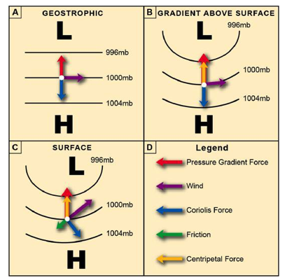
Figure 2.12: Illustrated are the various forces that create wind. Panel A present the forces that influence geostrophic wind. Panel B depicts the forces at work in regions of curved airflow. Panel C shows the impact of friction on a surface wind.
Panel C illustrates the most complicated type of wind – that of a large vortex at the surface. Our force balance retains all of the elements as described for the gradient wind. But now we must add a fourth force, friction (green). Friction slows the air in immediate contact with the surface. Friction acts in the opposite direction of the wind (purple). However, as the wind slows, the Coriolis effect becomes smaller (recall from Section 2.3 that the magnitude of the Coriolis effect is proportional to wind speed). The smaller Coriolis effect allows the combination of pressure gradient and centripetal forces – both of which are directed inward -- to exert a stronger influence. The stronger inward pull causes the wind direction to cross isobars, at an angle, from high pressure toward low pressure. In the case of the extratropical cyclone shown in Panel C, the surface wind blows counterclockwise and inward, an inflowing spiral around the entire vortex (Figure 2.13). Note that the Coriolis effect (blue arrow) always remains perpendicular to the observed wind (purple).
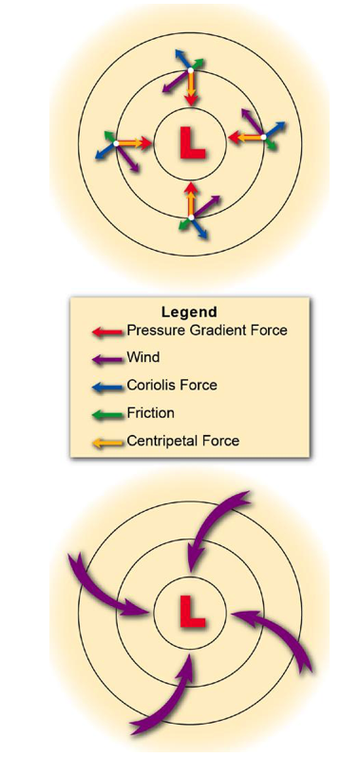
Figure 2.13: The top diagram depicts the various forces that work in concert to create surface winds around cyclones (purple arrows). Pressure gradient force is generated by differences in pressure, with air moving from higher to lower pressure. Centripetal force maintains flow in a curved path. Coriolis effect is a product of Earth’s rotation on its axis. Friction force opposes the forward movement of the wind. The combined effect of these forces causes the winds to move inward and counterclockwise (northern hemisphere as illustrated in the lower diagram) or clockwise (southern hemisphere).

Extratropical cyclones and anticyclones are created beneath waves in the polar jet stream.
Now that we have learned about the forces balancing different types of wind, let’s examine another key concept. We can study the location and intensity of cyclones and anticyclones on a surface weather map. But these weather systems are inherently three-dimensional. Their vortices extend upward through the depth of the troposphere (16 km [10 mi]). In fact, their circulations are connected at high levels to meanders in the polar jet stream. Cyclones and anticyclones develop and are maintained by changes in the speed and direction of wind as it flows through the jet stream. The meanders in the jet stream move from west to east, so they move the cyclones and anticyclones along with them. Let’s explore the vital connection between pressure at the surface, and the twists and turns of air streaming along at 10,670 m [35,000 ft].
Figure 2.14 illustrates a set of meanders in the westerly jet stream. Where the jet stream dips to the south and the airflow curves counterclockwise, the region is called a trough. Within the trough, the deep cold air mass dips down from Canada and the Arctic. When the jet arcs northward, such that that the curved airflow is clockwise, the region is called a ridge. A deep warm air mass from the tropics intrudes northward inside a ridge.
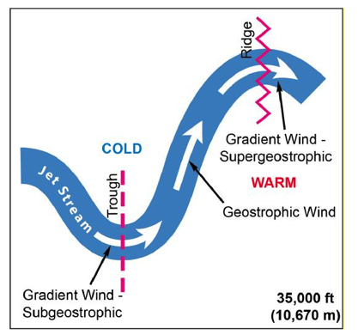
Figure 2.14: Ridges and troughs in the jet stream. In the northern hemisphere, troughs are places along the jet stream where the wind turns in a counterclockwise direction. Ridges are located where the wind turns in a clockwise direction.
Now let’s think about the type of wind balance that must operate inside these meanders. In the straight section of airflow connecting the trough and ridge, the wind is purely geostrophic. In the base of the trough, where the flow curves, we must have a gradient wind. Likewise, in the crest of the ridge, the curved flow is also gradient. But there’s an additional detail: The gradient wind inside the trough is weaker than the geostrophic wind, and the gradient wind inside the ridge blows stronger than the geostrophic wind. You can see this difference by noting the length of the white arrows in each region. The wind in the trough is called subgeostrophic; that in the ridge, supergeostrophic.
In Section 2.5, we saw how deep, vertical air columns with different temperatures experience changes in pressure. The pressure near the surface can also be changed by physically adding air to or removing air from inside the air column. If air is allowed to exit the top of a tall air column, the surface pressure will drop (the weight of the overlying air decreases). If air is added to the top of the column, the surface air pressure must rise.
Figure 2.15 shows a trough and ridge in the polar jet. Imagine that these meanders represent the lanes of a superhighway. High-speed packets of air flow along the jet like cars on the road. Just before entering the curve of the trough, there is a construction zone, and cars abruptly slow. The slow traffic moving through the trough is subgeostrophic. Coming out of the bend, traffic speeds up to geostrophic speeds. The traffic (air packets) diverge, or spread apart, in the straightaway. Traffic continues to accelerate through the curve into the ridge, reaching supergeostrophic speeds. But coming around the bend in the ridge, we see brake lights once again – perhaps due to an accident. Traffic abruptly slows going into the next straightaway. Cars (air packets) squeeze together; we say that the flow converges in this region.
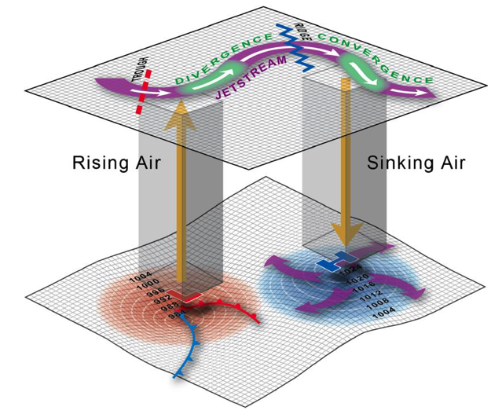
Figure 2.15: Important 3D airflow relationships in the mid-latitude atmosphere. In the upper part of the troposphere the jet stream, troughs and ridges are linked with events taking place at the surface. Wind coming out of a trough will speed up, creating lower pressure that draws air upward from the surface, creating a region of low pressure. Where convergence occurs at the ridge, air accumulates and pressure increases. Some of the air is forced downward contributing to a region of high pressure at the surface.
So, along the meandering jet stream, there is a region where the airflow diverges (speeds up) between the trough and the ridge, and converges (slows down) between ridge and trough. These are two-dimensional changes in airflow, but recall that the atmosphere is three-dimensional. Where the airflow diverges aloft, air in a vertical column beneath will rise upward, ascending to fill the void. The rising air will create a large region of low pressure at the surface, which in turn develops into an extratropical cyclone. Where the airflow aloft converges, air in a vertical column will be forced to sink downward, removing the buildup of air. The sinking air generates a large region of surface high pressure, developing a surface anticyclone. In this way, air inside the jet stream is connected to patterns of surface pressure – the extratropical cyclones and anticyclones. Knowing what is happening at jet-stream level is critical to predicting how daily weather will evolve in any part of North America.
Changeable daily weather in mid-latitudes is tied to the formation and movement of cyclones and anticyclones.
Extratropical cyclones and anticyclones are associated with significant changes in everyday weather – including the arrival and departure of many types of severe storms and other weather hazards. With the help of Figure 2.16, let’s briefly examine the characteristic weather changes caused when a cyclone-anticyclone pair passes through a location (labeled “A”).
The first thing you will notice is two large, contrasting air masses: (1) a very cold and dry polar air mass, originating from northern Canada (blue), and (2) a warm, humid air mass sitting over the subtropics (red). At 30 N, a subtropical anticyclone (red H, with central pressure of 1013 mb) is embedded in this air mass; its clockwise circulation sweeps warm and humid air northward, on its western side. Farther north, cold polar air circulates southward in the clockwise outflow of an extratropical anticyclone (blue H, located at 50 N, with central pressure of 1013 mb). But while the subtropical anticyclone remains stationary at 30 N, the extratropical anticyclone is on the move, headed east, because it’s embedded within the upper level jet stream (not shown).
The polar front lies along the border of these two contrasting air masses, spanning a latitude of 35-50 N. However, an extratropical cyclone (area of low pressure, shown by the red L, with minimum central pressure of 988 mb) develops along the polar front, at 40 N. Above and just to the west of the cyclone lies a trough in the jet stream, and the region of low pressure is maintained by rising air “filling the void” aloft. The cyclone tracks toward the east, in tandem with the extratropical anticyclone. The anticyclone to the north feeds its cold air southward into the cyclone, and the subtropical cyclone circulates warm air northward. The cyclone’s counterclockwise inflow helps to draw these contrasting air masses together. The cyclone’s circulation distorts the polar front into a wave-like configuration. A cold front develops where the cold and dry air advances toward the east around the low; this dense, chilly air undercuts and lifts warm air to the south of the low. A warm front forms along the polar front, close to the center of the low, where a warm, southerly flow of air runs up and over cooler air to the north and east. Along both of these fronts, moist air is forced to ascend. The air cools as it rises, the moisture condenses, and extensive clouds and precipitation develop. Showery rain clouds and thunderstorms also erupt in the warm, tropical air mass, between the subtropical anticyclone and extratropical cyclone.
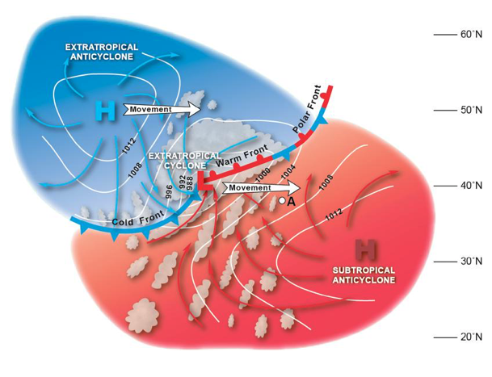
Figure 2.16: The structure of cyclones and anticyclones, which form an interacting wind system. Extratropical anticyclones feed cold dry air towards warm moist air driven by subtropical anticyclones. When these air masses clash, the warm moist air is shoved upward as the cold dry air advances. A region of low pressure forms and feeds into this region in a counterclockwise direction (northern hemisphere). The unstable warm air rises, cools, and condenses to form clouds, often accompanied by precipitation.
The extratropical cyclone features a region of extensive cloud cover, and heavy precipitation falls along its fronts, and over the center of low pressure. In the cool season (November through March), air mass temperatures < 0 C (32 F) often support the development of heavy snow and ice. During the spring and early summer, extratropical cyclones are notorious for producing bands of severe thunderstorms. These thunderstorm cells, in turn, produce damaging wind gusts, flash floods, large hail, and tornadoes. If the pressure gradient between the extratropical cyclone and anticyclone is intense, damaging winds develop to the north and west of the cyclone.
Figure 2.16 shows how an extratropical cyclone and one or more anticyclones “team up” to generate various forms of severe and hazardous weather. The most intense weather generally develops where warm and cold air masses are forced together, along one or more fronts. You will note that the extratropical anticyclone contains few if any clouds within its core. As the air descends into it from jet-stream level, the air warms and dries. Any clouds and precipitation tend to evaporate into the warm and dry air. Extratropical anticyclones, therefore, are generally associated with fair and slowly changing weather.
However, there are exceptions. During the middle of winter, these anticyclones can circulate extremely frigid air southward, along with gusty winds. The resulting arctic air outbreak and associated sub-zero wind chills pose a serious weather hazard in their own right. And, during summer, the hot, humid air mass circulated northward by persistent subtropical anticyclones leads to extended heat waves. Anticyclones also create a number of other localized weather hazards, including damaging Santa Ana and Chinook winds across the mountains of western North America, dense fog, localized severe thunderstorms and flash floods, and localized lake-effect snow across the Great Lakes.
Table 2.1 presents a concise summary of the characteristics of extratropical cyclones and anticyclones. In mid-latitudes, they are key players in severe weather, and much of this textbook will explore the widespread and localized weather hazards contained within them.

A Comparison of Winds in Atmospheric Vortices of All Sizes
Thus far, we’ve studied several types of winds, based on different forces acting in balance: geostrophic, gradient, and friction. Figure 2.17, panel A, summarizes how these various force balances come into play within the mid-latitude circulation system (jet-stream trough and ridge, extratropical cyclone and anticyclone). The particular type of wind depends on (1) the presence of straight vs. curved airflow, and (2) whether the wind occurs close to the surface.
In comparison, Figure 2.17, Panel B, shows the various types of winds contained within a mature hurricane. While we haven’t yet discussed tropical cyclones in detail, the hurricane is a type of cyclone, but smaller in diameter than the typical extratropical cyclone. A hurricane contains a broad region of gradient winds circulating around low pressure, and the frictional wind at the surface. In the upper levels, the airflow actually reverses direction, spiraling outward from the storm’s top, in a gradient wind around high pressure. The inner core of the hurricane contains a special type of wind, called the cyclostrophic wind, which represents a balance between the inward-directed pressure gradient force and outward-directed centrifugal force. At the very small scale of the hurricane’s inner core (~20-30 km), the Coriolis effect is negligibly small and is not included in the force balance.
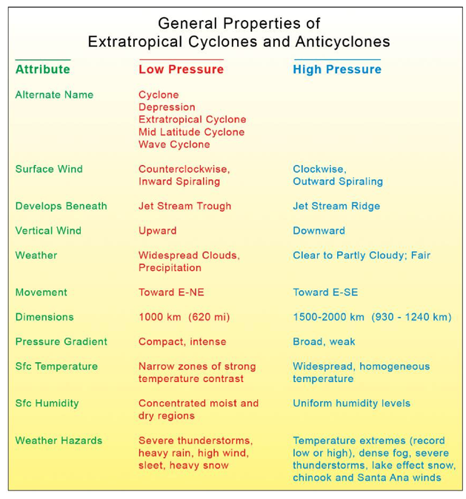
Table 2.1: A summary of general properties associated with extratropical cyclones and anticyclones. Many of these characteristics help to understand what to expect when these different systems pass over a geographic region.
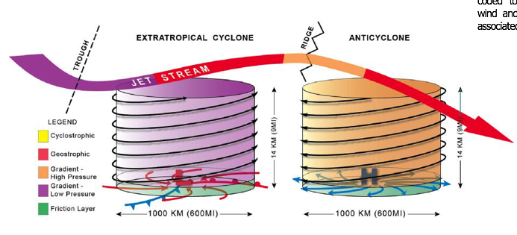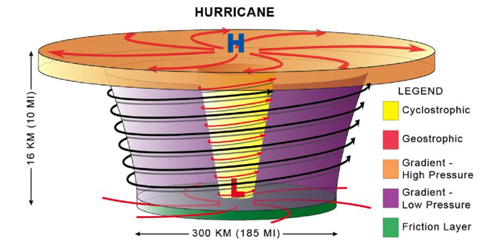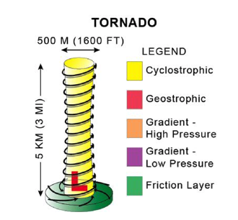
Figure 2.17: (A) A three-dimensional comparison of an extratropical cyclone and an anticyclone. They are color-coded to reflect the various wind and pressure conditions associated with each. (B) The various winds and pressures found within a hurricane. (C) Due to the small geographic scale of a tornado, there are no geostrophic winds associated with this kind of storm. Furthermore, the scale prevents the development of gradient high or low pressures. However, the central core of the tornado has cyclostrophic flow.
A tornado is an intense cyclonic vortex, much smaller in scale than a hurricane – a tall, narrow tube of violently spinning air, typically only 500 m across. The most intense tornadoes are generated within severe thunderstorm cells, which, in turn, are found within the broader circulation of an extratropical cyclone. As you might surmise, tornadoes are so small that they, too, do not directly “feel” the effect of Earth’s spin, so there is no Coriolis effect. Tornadoes,
like the very inner core of hurricanes, are in a state of cyclostrophic balance (except at the surface, where friction must be included).

2.7 Many Small-Scale Wind Circulation Systems Are Associated With The Generation of Severe Storms and High Impact Weather
Figure 2.18 shows the geographic distribution of several types of wind circulations, tied to terrain, across the United States. One caution, however: These circulations do not occur simultaneously all the time. The two most widely distributed wind patterns include the coastal sea breeze, stretching from the Gulf Coast to New England (green shading), and the mountain-valley circulations (MVCs, pink shaded regions), which are generated along elevated terrain – including the Appalachians in the east, and numerous mountain ranges of the western United States. Both of these wind patterns are fairly localized and are driven by solar heating during the late morning and afternoon hours. They are also quite shallow, confined to the lowest 2-3 km of the troposphere.
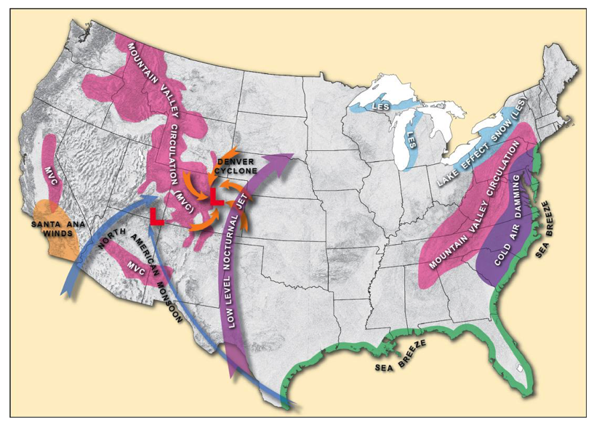
Figure 2.18: A variety of wind patterns contribute to meteorological phenomena that can bring about hazardous weather. While the distribution shown on the map is general, these conditions are not restricted to these areas alone. Rather, they are widely distributed throughout the United States.

Understanding the sea breeze is … a breeze!
The sea breeze, shown in Figure 2.19 (top), develops during the daytime, particularly in the warm season, because the land mass adjacent to the ocean warms to a greater degree than the water. Water has a very high heat capacity, meaning it can absorb a tremendous amount of solar energy, though a deep layer of water, but experience very little temperature change. Nor does it cool quickly as heat is radiated. In contrast, land surfaces -- including soil, sand, and vegetation – absorb solar energy in the uppermost 1-2 mm and don’t conduct heat through a deep layer. The “skin” of the land surface thus experiences a large, rapid rise in temperature. As the land quickly warms, so does the overlying air, and the air density decreases. In response, low pressure develops in the lowest 100 m of atmosphere. Air flows onshore, from the cooler ocean surface toward land, to fill this void. This generates a breeze along the coast. The inrush of cool air behaves like a cold front, lifting the air ahead of it. The rising air flows back toward the ocean, where it subsides – creating a closed, fairly shallow loop of overturning air along the coast. Clouds tend to form in the rising air, on the land side.
Figure 2.20 shows a weather-satellite view of clouds developing along the inland side of the sea breeze. On hot summer days, lines of thunderstorms frequently erupt along the edge of the sea breeze, just a few kilometers inland of the ocean. Occasionally, these thunderstorms may become severe. At night, the direction of airflow along the coast reverses: The land surface cools faster than the ocean, which remains warm. The resulting land breeze blows from land out over the water. Lines of clouds and thunderstorms often develop in the early morning hours, offshore, as humid ocean air is lifted along the land-breeze front.
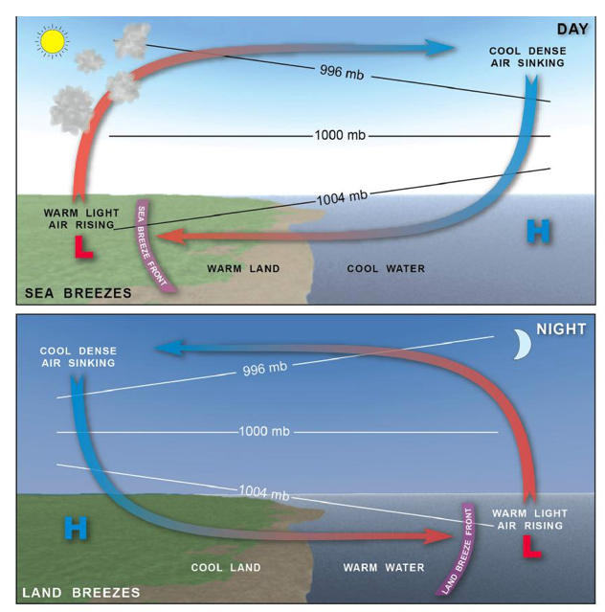
Figure 2.19: Formation of the sea breeze. Sea breezes occur during the day when water temperatures are cooler than land temperatures. High pressure develops over the water and a low pressure forms over the land. The air moving from high to low pressure creates the sea breeze. At night, relative temperature differences reverse over the land and water, causing the wind to blow from the land out over the water.
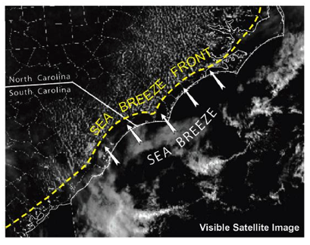
Figure 2.20: How thunderstorms are connected to the sea breeze. As sea breezes blow onto the land they carry moist air inland. As the moist air encounters the warmer temperatures over the land, the air becomes lighter. Subsequently, the air rises and cools, bringing about the formation of clouds and often local thunderstorms.

The air goes up the mountain.
Mountain-valley circulations are quite widespread across higher terrain but often localized to the taller peaks. Valley breezes blow upslope during the day, and air flows downslope at night. During the day, the land surface on a hill slope warms more quickly than the valley, because the slope receives the Sun’s rays more directly, particularly in the morning hours. The warm hill slope heats the overlying air. A small region of lowered density and decreased pressure develops over the hill slope. Air rises up from the valley floor to fill the void. As air is drawn out of the valley bottom, eventually it will converge and sink back down over the valley center, but at a higher altitude. The overturning of air due to terrain generates the shallow-circulation cells shown in the top panel of Figure 2.21. But as in the case of the sea breeze, warm and humid air forced to ascend will form deep clouds along the ridge tops. On hot summer days, afternoon thunderstorms frequently develop along the ridges of the Appalachians and the Rockies. At times, these storms reach severe levels. At night, the circulation pattern reverses: Hill slopes cool quickly by radiating heat to space. This chills the overlying air, which becomes dense and flows down into the valley bottom.
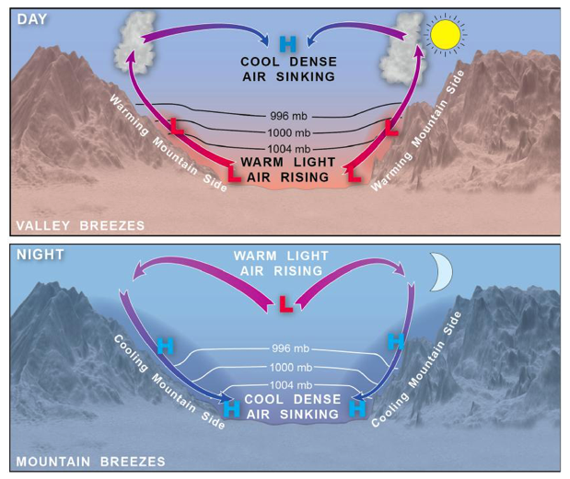
Figure 2.21: The local mountain-valley wind circulation. Similar mechanics that form sea and land breezes are also at work in the valley and mountain breezes of the mountain-valley circulation. During the day, the valley surface heats up, transferring the warmth to the air. The warm air then rises up the valley wall creating a valley breeze. At night air in direct contact with rapidly cooling mountain slopes becomes dense, and under the pull of gravity flows down the hill slopes into the valley, creating a mountain breeze.

Figure 2.22 shows the combined effects of the sea breeze and the valley breeze along the mountain slopes of the big island of Hawaii. Warm, humid air over the land is forced upward along the inward-moving sea breeze front, augmented by a valley wind flowing up the mountain slope. Deep clouds in these circulations can produce heavy rain showers; they are a frequent, almost daily, occurrence just inland and along the hill slopes of Hawaii.
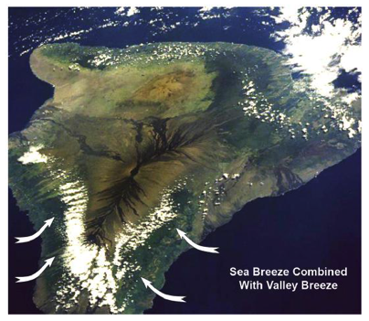
Figure 2.22: The image shows the sea breeze and mountain-valley breeze joining forces. Shown is a satellite image of the Big Island of Hawaii. The clouds (next to arrows) reveal the combined effect of sea breezes and valley breezes as moist air is carried inland and then up the mountain, where the air cools and condenses.

The Nocturnal Low-Level Jet: Pumping Gulf Moisture Over the Great Plains
In Figure 2.18, a narrow swath of wind is shown sweeping inland off the Gulf of Mexico (purple arrow), moving from south to north over the central Plains. This corridor of moist air is a frequent nighttime feature over the Plains, east of the Rockies. In the warm season, it helps fuel enormous complexes of nocturnal thunderstorms that deliver much of the annual rainfall to the Great Plains. At times the rainfall is so heavy that these cloud systems generate extensive flooding. The nocturnal low-level jet develops as consequence of temperature differences along the Rocky Mountains and Great Plains (Figure 2.23). At night, air over mountain slopes cools and drains eastward onto the Plains. Further east, the air above the surface remains relatively warm. A large horizontal gradient in temperature above the surface becomes established. The temperature gradient creates a horizontal pressure gradient (as described in Section 2.4). The pressure gradient, in turn, causes air to accelerate toward the Rockies at low levels, but the air becomes deflected to the right by the Coriolis effect. During the nighttime hours, a narrow, low-altitude ribbon of fast air streams northward from the Gulf of Mexico, across the Plains. Within this ribbon, large nighttime complexes of thunderstorms erupt. One such complex is shown in Figure 2.24, which depicts a satellite image of an enormous nocturnal thunderstorm clustered over the heart of the Plains. The colors indicate the height of the clouds, with red hues showing extremely deep thunderstorms.
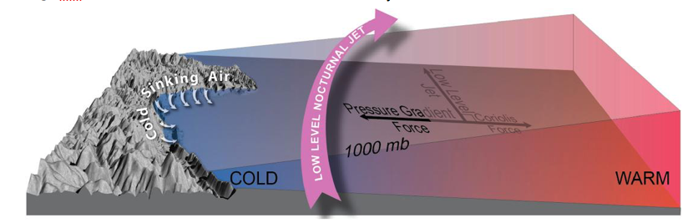
Figure 2.23: Formation of the nocturnal low-level jet. This wind system forms when cold mountain air flows eastward out of the mountains at night. This creates a lens of cold air that warmer air existing east on the plains rides upon. The result is a horizontal pressure gradient that accelerates a stream of air towards the Rockies. The Coriolis effect deflects the wind to the east, as illustrated in the figure.
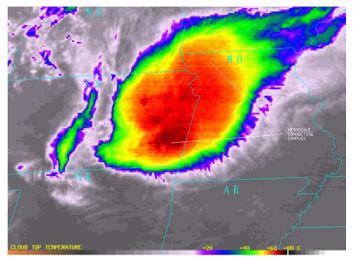
Figure 2.24: An example of how nighttime thunderstorms over the Plains feed off Gulf moisture. The nocturnal low-level jet is a low- altitude ribbon of fast air that streams northward from the Gulf of Mexico, across the Plains. Within this ribbon, large nighttime complexes of thunderstorms erupt. One such complex is shown in the image.

A Potpourri of Other Regional Circulations
Figure 2.18 shows a few additional types of wind circulations, each of which creates storminess and other types of weather hazards. The purple shaded region east of the Appalachians identifies the zone of cold air damming. This phenomenon occurs when cold, dense air from eastern Canada and New England moves south but becomes trapped up against the high terrain, just above the surface. Moist air flowing off the Atlantic (often pulled westward by passing extratropical cyclones) flows up and over the cold “wedge”, generating widespread layers of thick cloud, heavy snow, and ice storms.
To the northwest of the Appalachians, the light blue shaded regions denote areas that are frequently impacted by lake-effect snows. These heavy snows, which tend to be highly localized along the lee shores of the Great Lakes, occur when cold winds blow from the west-northwest, under the influence of a strong anticyclone over the northern Plains. As the cold air moves over the relatively warmer water surface, the air warms and moistens. This makes the air mass unstable. The air ascends into clouds that produce heavy snow showers.
Further west, along the Front Range of the Rockies across Wyoming and Colorado, cold air damming also occasionally develops during the winter months. Uplift of warm, humid Gulf air over the dome of cold air can produce extremely heavy snows. During the warm months, a different type of mountain-circulation feature, called the Denver Cyclone, spins up. The cyclone is a small, shallow vortex created by southeasterly winds interacting with the complex terrain in the Denver region. Convergence of unstable air into the vortex during the summer months triggers severe thunderstorms, and the cyclone is a notorious breeding ground for a certain type of weak tornado.
Moving to the southwestern United States, there are two regional wind patterns of interest. The first is a large, persistent circulation that develops across Arizona, Nevada, Utah, Colorado, and New Mexico during the summer months. This is called the North American Monsoon. Because the landmass over the desert of the southwest becomes intensely heated, a large low-pressure cell forms in the Four Corners region. The low pulls in plumes of moisture from the Gulf of California and Gulf of Mexico. As moist, heated air is forced to rise above the low-pressure area, widespread clusters of afternoon and evening thunderstorms develop on a near-daily basis. These storms frequently attain severe levels, producing damaging winds, haboobs (desert dust storms), and torrential rains that lead to flash flooding.
Finally, two specific types of windstorms develop in connection with high terrain. These windstorms have no connection to cloud systems, such as thunderstorms or cyclones. The first of these is the Santa Ana wind, which blows from east to west across southern California during the fall months. These strong winds, which often develop on otherwise sunny, fair weather days, are created when a strong anticyclone becomes situated over the Four Corners region. The strong outflow of wind, flowing west, gets funneled through narrow mountain gaps and warms as it descends toward the California coast. These hot winds frequently fan widespread fires across the Los Angeles basin. The Chinook wind is an intense local windstorm that develops along the lee side of mountain ranges in the western United States and Canada – including the Pacific Northwest, Canadian Rockies, and the Rocky Mountain Front Range. The Chinook wind is created by the strong pressure gradient of an anticyclone, with winds accelerating through narrow mountain passages and blowing downslope. As the air sinks it warms, leading to a rapid rise in temperature and onset of strong, gusty winds – in some cases, strong enough to inflict localized damage.

Summary of Learning Objectives

2.1 Sea-level atmospheric pressure is the weight of the overlying air column.
LO 1. Define atmospheric pressure and explain how pressure changes with altitude.
- Atmospheric pressure is the weight of the overlying atmosphere, per unit area. At sea level, the atmospheric pressure is 1013 mb (14.7 pounds per square inch, or 29.92 inches of mercury).
- Pressure (and air density) decrease exponentially with increasing altitude.

2.2 The pressure gradient is the “motor” that generates wind.
LO 2. Understand how the pressure gradient force creates wind, and determine wind strength by examining the spacing of isobars on a surface weather map.
- The pressure gradient force, which is related to the pressure difference between two locations at Earth’s surface, sets the air into horizontal motion, creating wind.
- On a surface weather map, the larger the pressure gradient (isobars more closely spaced together between a region of high pressure and a region of lower pressure), the faster the wind.

2.3 But there’s a twist: Earth spins, so we must introduce the Coriolis effect.
LO 3. Explain how the geostrophic wind, which blows parallel to isobars, is created by a balance between the pressure gradient force and the Coriolis effect.
- On the rotating Earth, the Coriolis effect balances the pressure gradient force and gives rise to the geostrophic wind. Because the geostrophic wind is a state of balance, it does not blow from directly from high to low pressure. Rather, it is oriented parallel to the isobars.
- The Coriolis effect in the northern hemisphere deflects air (set in motion by the pressure gradient) to the right of its path. The deflection effect is proportional to wind speed, is maximum at the poles, and vanishes at the equator.

2.4 The Relationship Between Pressure Gradient and Temperature Variations
LO 4. Describe how horizontal variations in air temperature create a pressure gradient and geostrophic wind.
- Horizontal variations in air-mass temperature create a horizontal pressure gradient force, accelerating the wind from a warm column of air toward a cold column of air. Coriolis effect balances the pressure gradient force. The wind on the constant-altitude surface is thus a geostrophic wind.

2.5 Global Atmospheric Circulation: A Giant Atmospheric Heat Engine
LO 5. List the principal features of general atmospheric circulation, and discuss how global air circulation is driven by the movement of excess heat energy from the equator toward the poles.
- The general atmospheric circulation, in the simplest sense, operates as a giant convective (overturning) air cell to move excess heat energy from the tropics towards the poles.
- The observed general atmospheric circulation in the tropics includes the Hadley cell, intertropical convergence zone (ITCZ), and sometimes tropical cyclones. Features of atmospheric circulation in the subtropics include the subtropical jet stream, subtropical anticyclones, and easterly trade winds. In the polar regions, surface high pressure generates polar easterlies.
- In mid-latitudes, the polar front denotes the zone of contrast between tropical and polar air masses. Above this front, a polar jet stream containing intense westerly winds undulates around the mid-latitudes. Extratropical cyclones and anticyclones occur in the mid-latitudes.
- Waves in the polar jet stream (troughs and ridges) contain regions of curved airflow. The curved flow induces rising air downstream of a trough, and sinking air downstream of a ridge. Areas of surface low pressure and high pressure develop beneath these regions, respectively.

2.6 Wind Systems Associated with Extratropical Cyclones and Anticyclones
LO 6. Discuss how the types of wind forces differ among extratropical cyclones, hurricanes, and tornadoes.
- A large low-pressure cell at the surface is called a cyclone and features a counterclockwise, inward spiral of air. A large high-pressure cell at the surface is called an anticyclone and features clockwise, outward spiral of air.
- Around cyclones and anticyclones, the wind is in gradient balance, which is a three-way force balance involving the pressure gradient force, Coriolis effect, and centripetal force. At the surface, a fourth force, friction, is also included.
- Extratropical cyclones and anticyclones form along the polar front, beneath troughs and ridges in the polar jet stream, and move from west to east across the mid-latitudes. These vortices are responsible for the day-today weather variations (alternating periods of storminess and fair weather) and frequently contain smaller, embedded regions of severe and hazardous weather.
- Extratropical cyclones feature ascending air in their core. As the air ascends and cools, water vapor condenses into various forms of cloud and precipitation. Extratropical anticyclones contains air that sinks down their center, warming and drying as it does so, leading to clear skies and fair weather.
- Outbreaks of severe local storms – including summertime thunderstorms containing damaging wind, torrential rain, large hail, and tornadoes – frequently concentrate along the fronts (warm front and cold front) contained in extratropical cyclones. During the winter months, extensive regions of heavy snowfall, ice, and strong winds develop and move across the United States within extratropical cyclones;
- Extratropical anticyclones are most often associated with extremes in air mass temperature, creating hazardous weather during both the winter (arctic air outbreak) and summer (heat waves).
- Extratropical anticyclones are also sometimes associated with weather hazards. These include localized regions of severe thunderstorms and flash flooding, heavy lake-effect snows, and damaging wind storms down steep mountain slopes (Santa Ana and Chinook winds).
- Hurricanes and tornadoes are the most intense forms of low-pressure cyclones. The most intense winds in these vortices are called cyclostrophic winds and they are created by a balance of pressure gradient and centrifugal forces.

2.7 Small-Scale Wind Circulation Systems
LO 7. Describe the origins and geographical distribution of various regional-scale wind circulations, including the sea breeze, mountain-valley circulation, nocturnal low-level jet, North American Monsoon, and mountain winds (Santa Ana and Chinook).
- Across the continental United States, regional wind circulation patterns occur in geographically preferred regions. Many of these circulations, including the sea breeze, North American monsoon, and mountain-valley circulation, are quite shallow and are driven when the surface is heated by the afternoon Sun. These circulations can generate thunderstorms, some of which reach severe levels.
List of Key Scientific Principles Covered In This Chapter
Note to the student: Many of these “first principles” will be called out in later chapters, as a reminder of an important physical process or definition, to aid in your understanding of more advanced material.

2.1 Atmospheric pressure is the weight of the overlying atmospheric gasses, per unit surface area.

2.2 Pressure decreases rapidly with altitude in the lowermost atmosphere, and less rapidly at higher levels (this variation describes an exponential decrease with height).

2.3 Differences in atmospheric pressure across a horizontal distance give rise to the pressure gradient force, which accelerates air from high toward low regions of pressure – creating wind.

2.4 On a surface weather chart, isobars are drawn as contour lines of constant pressure, typically spaced every 4 mb. The more closely spaced the isobars, the stronger the wind.

2.5 The Coriolis Effect arises from the spinning Earth; it deflects air that begins to move, to the right, in the Northern Hemisphere.

2.6 The geostrophic wind is a balanced state between the pressure gradient force and Coriolis effect; this wind moves at constant speed, in a straight path, above the surface.

2.7 Horizontal variations in atmospheric temperature, over long distances, give rise to a horizontal pressure gradient force (low pressure is associated with warm air, high pressure with cold, dense air).

2.8 A system of global atmospheric winds, called the atmospheric general circulation, arises from a strong imbalance in radiational heating between the equator and poles. There are several components to the general circulation, in the tropics, mid-latitudes and polar regions.

2.9 The tropical Hadley cells circulate warm, equatorial air toward the higher latitudes; these cells give rise to tropical easterly winds (trade winds), the ITCZ, subtropical anticyclones, and the subtropical jet stream.

2.10 The Intertropical Convergence Zone (ITCZ) is where easterly trade winds from each hemisphere converge, near the equator, causing air to rise. This forms a nearly continuous belt of showers and thunderstorms, often organized into large clusters of storms.

2.11 Subtropical anticyclones (high pressure cells) are situated near 30 N and S; these cells are formed by air descending on the periphery of the Hadley cells. As the air descends, it warms and dries, creating large cloud-free zones.

2.12 The subtropical jet stream forms in in the upper atmosphere, in each hemisphere; it forms when poleward-moving air, exiting the Hadley cell, becomes deflected toward the east by the Coriolis Effect.

2.13 Mid latitude circulation features of the atmospheric general circulation include: The polar front, polar jet stream, extratropical cyclones and anticyclones.

2.14 The polar front is a deep, wave-like discontinuity between tropical and polar air masses, lying across the mid latitudes. Extratropical cyclones frequently develop from waves along this boundary.

2.15 The polar jet stream develops along the polar front, at high altitudes. It is maintained by the strong north-south temperature gradient across the polar front. The polar jet constantly develops large meanders (Rossby waves) that are inherently unstable, tied to formation of extratropical cyclones and anticyclones near the surface.

2.16 The upper-atmosphere polar vortex and band of deep, polar easterlies are found above the Arctic Circle in each hemisphere.

2.17 Extratropical cyclones and anticyclones are large, transient vortices that migrate from west to east across mid latitudes. Air converges in a counterclockwise spiral around these cyclones, which feature low pressure in their core (“L” on a weather map). Air diverges in a clockwise spiral around anticyclones, with high pressure in the core (“H” on a weather map). These systems bring changeable weather (extremes in temperature, precipitation, fair weather) to most mid-latitude locations.

2.18 Around extratropical cyclones and anticyclones, a type of circular wind called the gradient wind develops as a consequence of the pressure gradient, Coriolis effect and centripetal (inward-directed) force.

2.19 Near the surface, the friction force slows the wind and creates an imbalanced flow in the gradient wind, causing air to spiral inward toward the center of an extratropical cyclone, and away from the center of an extratropical anticyclone.

2.20 The principle of mass conservation requires that air that spirals inward toward the center of an extratropical cyclone to rise, and air that spirals outward in an extratropical cyclone to draw down air from above.

2.21 The meanders in the jet stream, called Rossby waves, take the form of troughs (equatorward-curved segments) and ridges (poleward-curved segments). Cold, polar air moves south in a trough, while warm, tropical air moves north in a ridge.

2.22 Air flowing through a trough in the jet stream is subgeostrophic (slower than geostrophic). As the air moves away from the trough it accelerates (diverges); this effect draws up air from the surface (via the principle of mass conservation), leading to the development of a large region of low pressure, and subsequent formation of an extratropical cyclone.

2.23 Air rising in the core of an extratropical cyclone cools and becomes saturated, leading to widespread cloud cover and precipitation (i.e. a storm) within the cyclone.

2.24 Air flowing through a ridge in the jet stream is supergeostrophic (faster than geostrophic). As the air moves away from the ridge it deaccelerates (converges); this effect causes air to descend toward the surface (via the principle of mass conservation), leading to the development of a large region of high pressure, and subsequent formation of an extratropical anticyclone.

2.25 Air sinking in the core of an extratropical anticyclone warms and becomes unsaturated, leading to widespread fair weather and generally clear skies.

2.26 In an extratropical cyclone, fronts develop in the lower atmosphere where contrasting air masses (i.e. tropical and polar) are drawn together. The warm, buoyant air is forced to ascend vigorously along fronts, developing bands of deep cloud, heavy precipitation, and sometimes severe weather.

2.27 A tropical cyclone (hurricane in the Atlantic, typhoon in the Pacific) is an intense cyclonic vortex in the tropics, with a compact, inner core of extremely low pressure. Very strong winds around the low are in a state of cyclostrophic balance between the pressure gradient force and outward-directed centrifugal force.

2.28 A tornado is the most intense type of cyclonic vortex, typically less than a half-mile across, and generated within a severe, rotating thunderstorm called a supercell. Its winds, which may top 300 mph, are in a state of cyclostrophic balance.

2.29 Regional and local wind systems are driven by uneven heating of the atmosphere. These winds include the sea breeze, mountain/valley breeze, nocturnal low-level jet, and North American Monsoon. Under certain conditions, thunderstorms develop along a narrow zone of rising air in each case.

2.30 The sea breeze develops between heated land and cooler, adjacent ocean water during the daytime. It is a shallow circulation cell with rising air over the land, and sinking air over the ocean.

2.31 The mountain/valley breeze is created by strong heating of sloped, elevated terrain during daytime. Air rises from the valley floor, up the mountain, creating a steady wind. At night, the elevated land cools more strongly than the surrounding air, causing a cold, dense air flow to settle into the valley floor.

2.32 The nocturnal low level jet is a wind current of the Great Plains. It is a narrow, elongated ribbon of air that blows moist, unstable air from the Gulf of Mexico northward over the Plains – leading to large complexes of heavily-raining thunderstorms, and frequent severe weather.

2.33 The North American summer monsoon is a seasonal (summertime) wind pattern that develops over the U.S. Desert Southwest and adjoining portions of northern Mexico. The large expanse of exceptionally hot air develops a zone of low pressure, which accelerates airflow from the Gulf of California northward. Late afternoon and evening thunderstorms blossom in this unstable air mass across Arizona, New Mexico, Utah, Nevada and Southern California from June through September.

Key Terms
anticyclone
atmospheric pressure
centrifugal force
centripetal force
Chinook
cold air damming
cold front
convection
convergence
Coriolis effect
cyclone
cyclostrophic wind
Denver Cyclone
density
divergence
extratropical anticyclone
extratropical cyclone
friction
general atmospheric circulation
geostrophic wind
gradient wind
haboob
Hadley cell
hurricane
intertropical convergence zone (ITCZ)
isobars
lake-effect snows
land breeze
millibar
mountain-valley circulation
nocturnal low-level jet
North American Monsoon
polar easterlies
polar front
polar jet stream
pressure gradient
pressure gradient force
ridge
Santa Ana wind
sea breeze
subgeostrophic wind
subtropical anticyclone
subtropical jet stream
supergeostrophic wind
tornado
trade winds
trough
vectors
warm front

