Chapter 3

A Meteorological Primer, Part II: Moisture and Precipitation in Storms
3.1 Common Measures of Atmospheric Humidity: Dew Point Temperature and Relative Humidity
The Vertical and Horizontal Variation of Atmospheric Moisture
Dew Point Temperature Relates Directly to the Air’s Moisture Content
Relative Humidity: An Imperfect Measure of Water Vapor
3.2 How Air Becomes Saturated
3.3 Growth of Cloud Droplets and Rain in Clouds
3.4 Growth of Ice Crystals and Snow in Clouds
3.5 Atmospheric Stability and the Formation of Thunderstorms and Layer Clouds
3.6 Common Precipitation Types in Summer and Winter Settings
Precipitation Associated with Extratropical Cyclones
Precipitation Associated with Summertime Convective Storms
Learning Objectives
1. Distinguish among humidity, dew point temperature, and relative humidity, and describe how these values typically vary with time of day, by season, and across geographic regions.
2. Discuss two ways in which air becomes saturated and describe adiabatic cooling of air.
3. Explain how supersaturation, cloud condensation nuclei, and collision-coalescence lead to growth of cloud droplets.
4. Define supercooled water and explain how it relates to the formation of small ice crystals in subfreezing clouds; distinguish between vapor deposition and riming.
5. Explain why an unstable air mass leads to rapid growth of the deep convective clouds associated with heavy rain showers and hail.
6. Describe how regions of precipitation are developed and arranged in a typical extratropical cyclone (cool-season weather pattern) and during the summer months.

In Chapter 2, we examined the forces that give rise to moving air (wind) on Earth, including local breezes, cyclones, anticyclones, and jet streams. Except in desert settings, most air masses on Earth contain some degree of moisture, in the form of water vapor. Additionally, layers and billows of clouds – some of which become quite extensive – frequently develop in association with cyclonic storms. Many kinds of precipitation, including rain, snow, and hail, develop from persistent zones of cloudiness. The connection between extreme precipitation and storm hazards takes many forms: Rapid accumulation of rain causes flash floods; heavy snow and ice can paralyze entire states; and large hailstones heavily damage crops and property.

In this chapter, we focus on the processes and mechanisms that create precipitation. First we look at a few ways that water vapor is measured in the atmosphere. We then examine the processes that form clouds. From clouds we discuss formation of rain drops and frozen precipitation such as snow. We discuss the vital concept of atmospheric stability and what this means for the growth of deep, vertical clouds called convective clouds, which include thunderstorms. Finally, we distinguish between processes leading to horizontal layers of precipitating cloud, called stratiform precipitation, from the more intense and localized convective showers and thunderstorms.

[H1] Common Measures of Atmospheric Humidity: Dew point Temperature and Relative Humidity

Most of us are familiar with the concept of atmospheric humidity. Think about the oppressive, clinging stickiness of the air on a hot, humid summer day … or the skin-chapping dryness of a cold winter wind. The simple idea of changeable moisture content in the air has surprisingly large effects on our daily lives.

[H2] The Vertical and Horizontal Variation of Atmospheric Moisture

There are many scientific measures of water vapor, all of which can be loosely categorized as measures of the air’s humidity (water vapor content). Water vapor is a trace gas (at atmospheric constituent present in minute quantities), derived from the evaporation of surface water from oceans, lakes, inland seas, and other bodies of water. Water vapor tends to be most concentrated close to Earth’s surface, decreasing with height through the troposphere. Water vapor concentrations may range from 10-20 parts per thousand (ppt) near the surface and over large water bodies, and can comprise up to 3% of the air’s total mass over warm tropical seas and rain forests. Many miles above the surface, the concentration of water vapor drops to parts per million – values so small they are difficult to measure. Water vapor content can also be expressed as a gas concentration—for example, 16 grams of water per kilogram of dry air.

As Figure 3.1 shows, the amount of water vapor in the atmosphere varies greatly across North America. This image is a color-enhanced satellite view of mid-tropospheric water vapor, in the 3-8 km (2-5 mi) altitude range. Regions of air that are saturated contain the maximum amount of water vapor for a given temperature and are light blue. Very dry (low humidity) areas are orange or red.

The gradient (rate of change with distance) of water vapor across a region can be quite dramatic, as in location AA’. This zone denotes a weather front, across which air-mass properties (temperature, humidity, and winds) vary markedly over a short distance. In fact, water vapor is a remarkable tracer of motion in the atmosphere. For instance, note the large cyclone at location B. Its giant, counterclockwise swirl is readily apparent by wisps of humid and dry air converging into the low-pressure center. This area of low pressure, called an extratropical cyclone (Chapter 2), draws in a narrow corridor of very humid air from the south (labeled “C”).
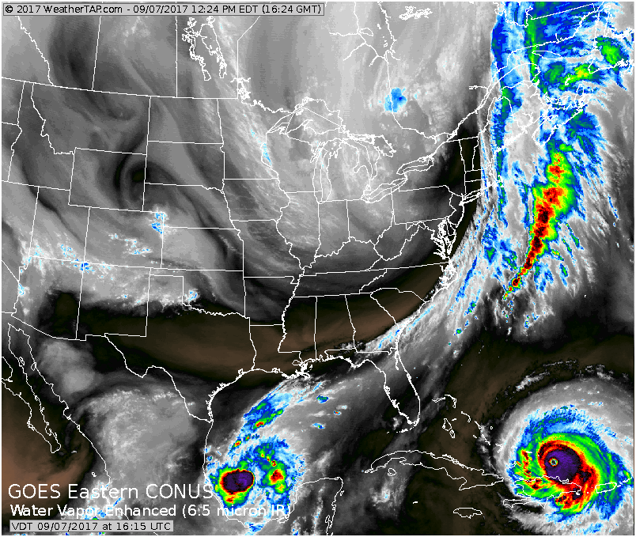
Figure 3.1 Atmospheric Water Vapor Across North America
False-color water vapor imagery, obtained from a weather satellite, depicts the large variation of humidity (atmospheric moisture) in the upper atmosphere across the United States on a typical day.

[H2] Dew Point Temperature Relates Directly to the Air’s Moisture Content

As air cools, dew, fog and clouds can form – as commonly observed before sunrise on an autumn night. When the air cools, water vapor molecules slow down (they lose kinetic energy) and are more likely to clump – or condense – into liquid droplets. This condensation occurs either on (1) grassy surfaces, forming dew, or (2) around microscopic dirt particles in the air, forming fog or cloud. The dew point is the temperature to which the air must cool for the first traces of condensed water to appear.

The drier the air, the more the air must cool to reach the point of saturation. Saturation is a requirement for condensation and formation of liquid water droplets. When air is saturated, the rate of condensation exceeds evaporation, and liquid droplets begin growing. Dry air with a dew point temperature of, say, 35° F (2° C) will require more cooling to cause saturation than air with a dew point temperature of 70° F (21° C).

For example, morning fog rarely forms during the early summer months. Let’s say the dew point temperature at sunset is 65° F (18° C). During the short nights of mid-summer, the air simply cannot cool sufficiently to reach the dew point temperature. But on a mid-autumn night, starting again at 65° F (18° C), additional cooling hours afforded by the longer night allows the air to reach its dew point temperature – and a fogbank or dew-covered grass develops.

Another way of expressing the relationship between dew point temperature and humidity is to state that the dew point temperature is proportional to (varies directly with) the air’s moisture content.

Dew point temperature varies considerably across the United States from season to season, and with geographic location on any given day. Figure 3.2 provides maps showing characteristic dew point temperature values for mid-summer and mid-winter across the continental United States.
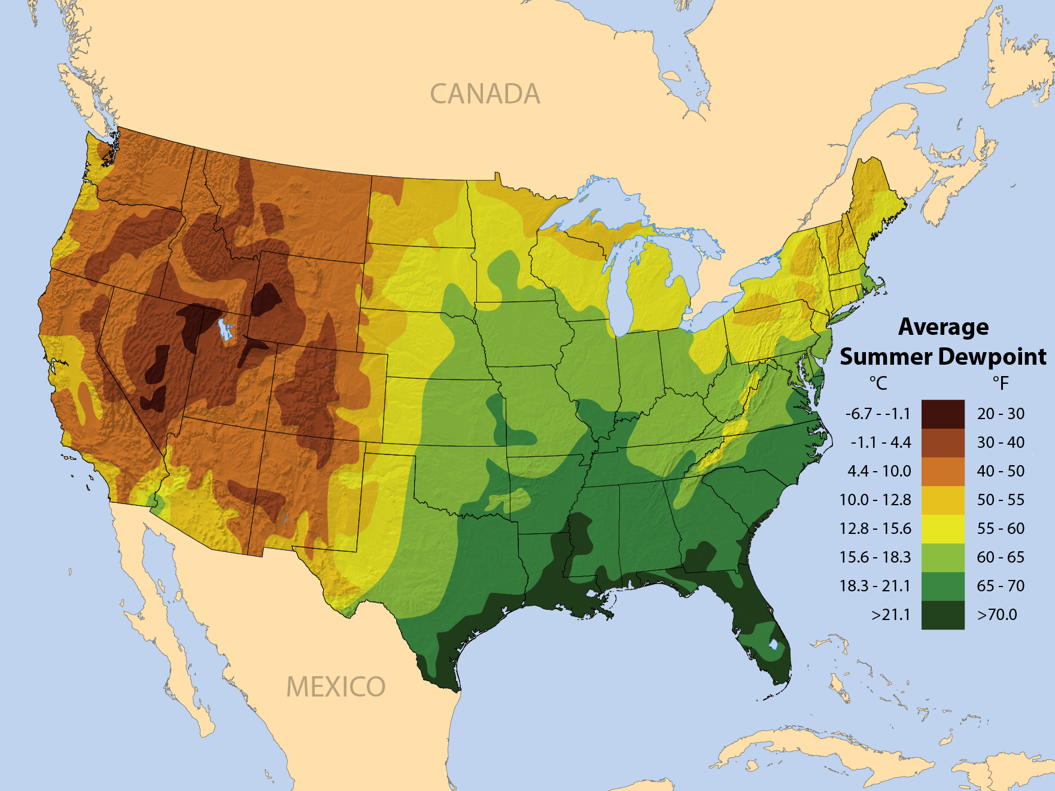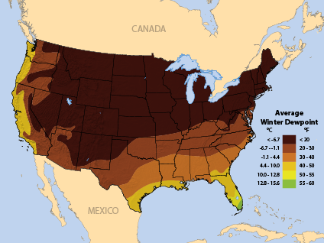
Figure 3.2 Seasonal Variation in Dew Point Temperatures
This figure shows spatial variation of surface dew point temperatures across the United States during (a) summertime (July) and (b) wintertime (January) .

These maps portray the average distribution of dew point temperature over many weeks. Daily, and even hourly, values depart from these averages, due to migrating weather systems such as extratropical cyclones, fronts, and high-pressure cells. Looking first at summer (Figure 3.2a), we note very high dew point values, approaching 70-75° F (21-24° C), along the Gulf Coast region and southeastern United States. These high values are due to intense evaporation off the very warm Gulf of Mexico and Caribbean Sea.

Dew points generally decrease poleward and westward across the continental United States, for two reasons: (1) increasing distance from the oceanic moisture source, and (2) progressively cooler temperatures at higher latitudes. Dew point temperature tends to decrease as air temperature decreases, for the simple reason that there is less heat energy to supply vapor molecules with the kinetic energy they need to remain in the gaseous state.

Note also a significant reduction in summertime dew point values over the intermountain west. The high elevations and sparse vegetation contribute to low moisture content of the air, even in summer. Recall that water vapor decreases as altitude increases. In the desert southwest, where fewer trees grow and grasslands are sparse, there is less transpiration of water vapor into the air. Transpiration is caused by plant roots that draw soil moisture through vascular stems. The moisture then diffuses through small pores in the leaves.

Average dew point temperature during wintertime (Figure 3.2b) reflects a decrease in moisture values everywhere. We expect lower moisture because air temperatures are much lower countrywide during the cold season. The highest wintertime values are found along the Gulf Coast, where the Gulf of Mexico has cooled significantly since summer but nonetheless remains a source of evaporating water. Extremely low dew point values are found over the high-elevation, chilly air of the western United States.

Dew point temperature also exhibits significant day-to-day variability, caused by migrating extratropical cyclones and anticyclones in the mid-latitude westerlies (Chapter 2). Figure 3.3 illustrates the striking contrast in dew point temperature across a typical springtime extratropical cyclone. Within these large storms, a converging, clockwise spiral of low-level wind brings dissimilar air masses into close proximity. Humid air streams north from the Gulf of Mexico, while very dry air circulates south out of Canada. There is a 40-50° F (4-10° C) variation in dew point temperature across the storm system, leading to very changeable weather conditions as the storm system moves through.
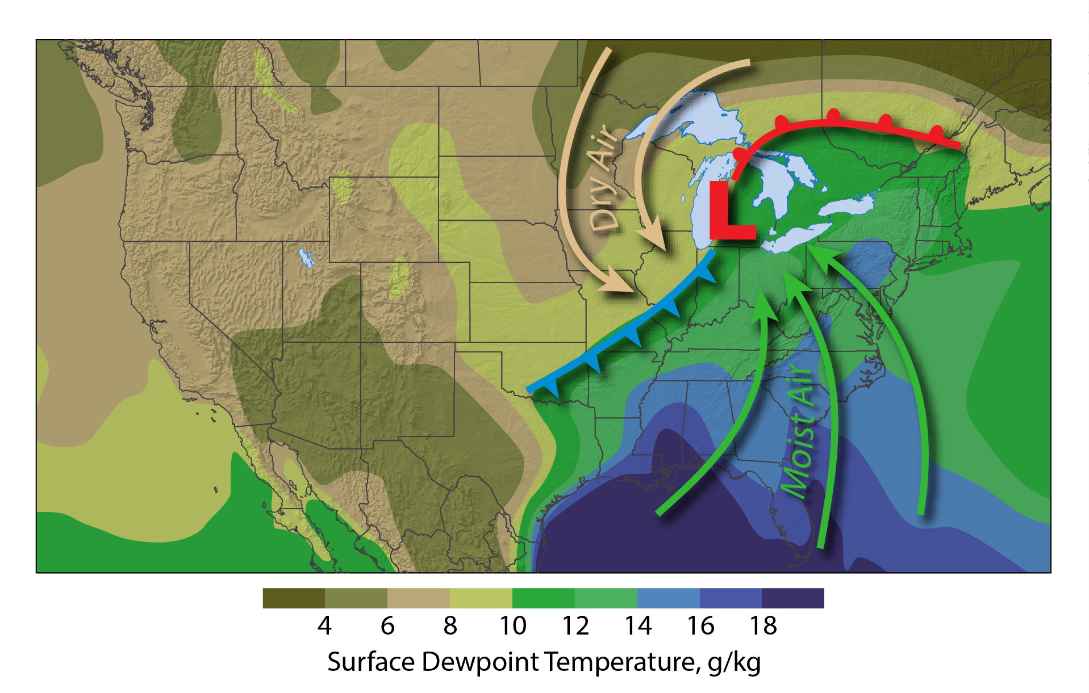
Figure 3.3 Surface Dew Point Temperature Variations Across a Typical Extratropical Cyclone. This figure shows the moist and dry sides of a typical low pressure system over the United States. Warm, humid air is circulated north by southerly winds on the east side of the system, while cold and dry air of Canadian origin circulates toward the south on the west side.

Dew point temperature directly affects how we feel in the outdoors. During the hot days of summer, high temperature is exacerbated by the presence of high-humidity (high-dew point) air. As the dew point temperature climbs above 70° F (21° C), the air feels quite heavy and oppressive. This perception stems from the body’s inability to efficiently cool on very hot, humid days. Efficient cooling is reduced because evaporation from skin is curtailed when the vapor content of the surrounding air is already high – there is less room in the air for additional vapor. Evaporation is a cooling process (heat is extracted from skin to vaporize liquid water), so when evaporation rates are slowed, our bodies cannot shed their metabolic heat, and we become in danger of overheating.

[H2] Relative Humidity: An Imperfect Measure of Water Vapor

Another measure of the air’s water vapor is relative humidity. The definition hinges on the word relative: Relative humidity expresses the ratio of the air’s actual humidity to the maximum amount of humidity that completely saturates the air at the given temperature. In other words, it’s a percentage showing how close the air comes to achieving saturation. It says nothing about the actual, physical amount of water vapor present!

The problem is that this percentage is a function both of the ambient air’s moisture content and its temperature. The higher the air temperature, the higher the saturation value of humidity. So if the temperature of a moist blob of air changes, so will its relative humidity, even though we have not changed the air’s actual moisture content. For water vapor content to remain constant when temperature is raised, relative humidity must decrease. When the air cools, relative humidity must increase for water vapor to remain constant.

As Figure 3.4 shows, relative humidity commonly undergoes cyclic changes through the course of the day. The true moisture content of the air – expressed by the dew point - remains constant (green curve). In the afternoon, as temperature (red curve) rises, relative humidity (blue curve) must decrease. During the early morning hours, normally the coolest time of day, relative humidity must increase. Yet the physical amount of water vapor in the air has not changed at all.
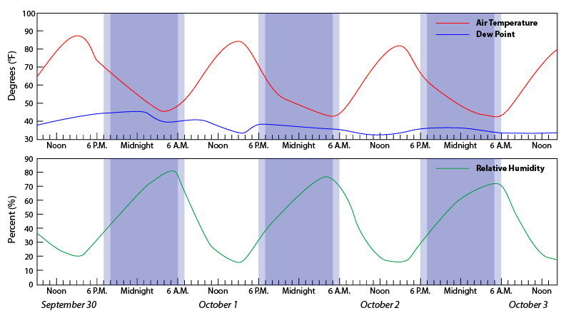
Figure 3.4 Relative Humidity Throughout the Course of a Day
The diurnal (daily) variation of relative humidity, compared to constant dew point temperature, illustrates how relative humidity is inversely related to air temperature.

Many meteorologists consider relative humidity to be a “second tier” measure of air’s vapor content, because relative humidity is not an unambiguous measure of humidity. Temperature changes throughout the day profoundly affect the value of relative humidity. If the ambient humidity varies as well (often the case), there is no way of telling whether moisture, or temperature, or both, caused the observed change in relative humidity.

[H1] 3.2 How Air Becomes Saturated

There are two ways that air achieves supersaturation (relative humidity exceeding 100%). When air becomes supersaturated, condensation of vapor exceeds the rate of evaporation on surfaces, enabling small droplets to begin growing. Supersaturation can occur in one of two ways: (1) Air temperature remains constant, but humidity increases, or (2) Humidity remains constant, but the air cools until it reaches its dew point temperature. The first process sometimes occurs over very wet land surfaces or over bodies of water, where the source of moisture is essentially unlimited, and other processes facilitate vigorous evaporation into the air. But the much more common process involves cooling air.

You may implicitly understand that rising air cools, but you may not understand the exact reason why. Air cools as it rises not because rising blobs of air encounter cooler air aloft; rather, the blobs expand as they rise, due to lower atmospheric pressure. Visualize how a helium-filled balloon must get larger as it ascends, expanding into the thinner air. For a rising air bubble to expand, it must work on its surroundings, pushing the surrounding air outward. The work depletes some of the bubble’s internal energy, and the air temperature inside the bubble falls (temperature is a measure of the average kinetic energy of the gas molecules, which must be slowing down as they lose internal energy). You can experience this type of cooling by letting the air out of a tire; the air stream will feel very cool against your hand, because the air expands in volume as it escapes.

Adiabatic cooling is the expansion and cooling of air, under lower pressure aloft. The term derives from the laws of thermodynamics, which state that the bubble of rising air remains a closed system and has no heat exchange with its surroundings; all temperature changes must come from changes in the bubble’s own internal energy. It turns out that rising, unsaturated blobs of air cool adiabatically at a constant rate, which is -10° C/km (-18° F/3300 ft) of ascent.

Let’s say that a rising blob of air initially has a surface temperature of 90° F (32° C) and a dew point temperature of 63° F (17° C). This is a fairly moist, but unsaturated, air bubble. Now, the air is allowed to ascend freely. It immediately encounters reduced air pressure aloft and begins expanding, cooling adiabatically. At a rate of -10° C/km, the air chills to 72° F (22° C) after the first kilometer of ascent. After another half a kilometer, it has chilled a further 5° C (41° F), but then its internal temperature equals the dew point temperature, 63° F (17° C). At this point, the air bubble has cooled to the point of saturation. With the slightest additional bit of cooling, condensation begins exceeding evaporation, and water vapor molecules cling to form the first liquid cloud droplets. Voilà, a cloud appears! This process is illustrated in Figure 3.5.
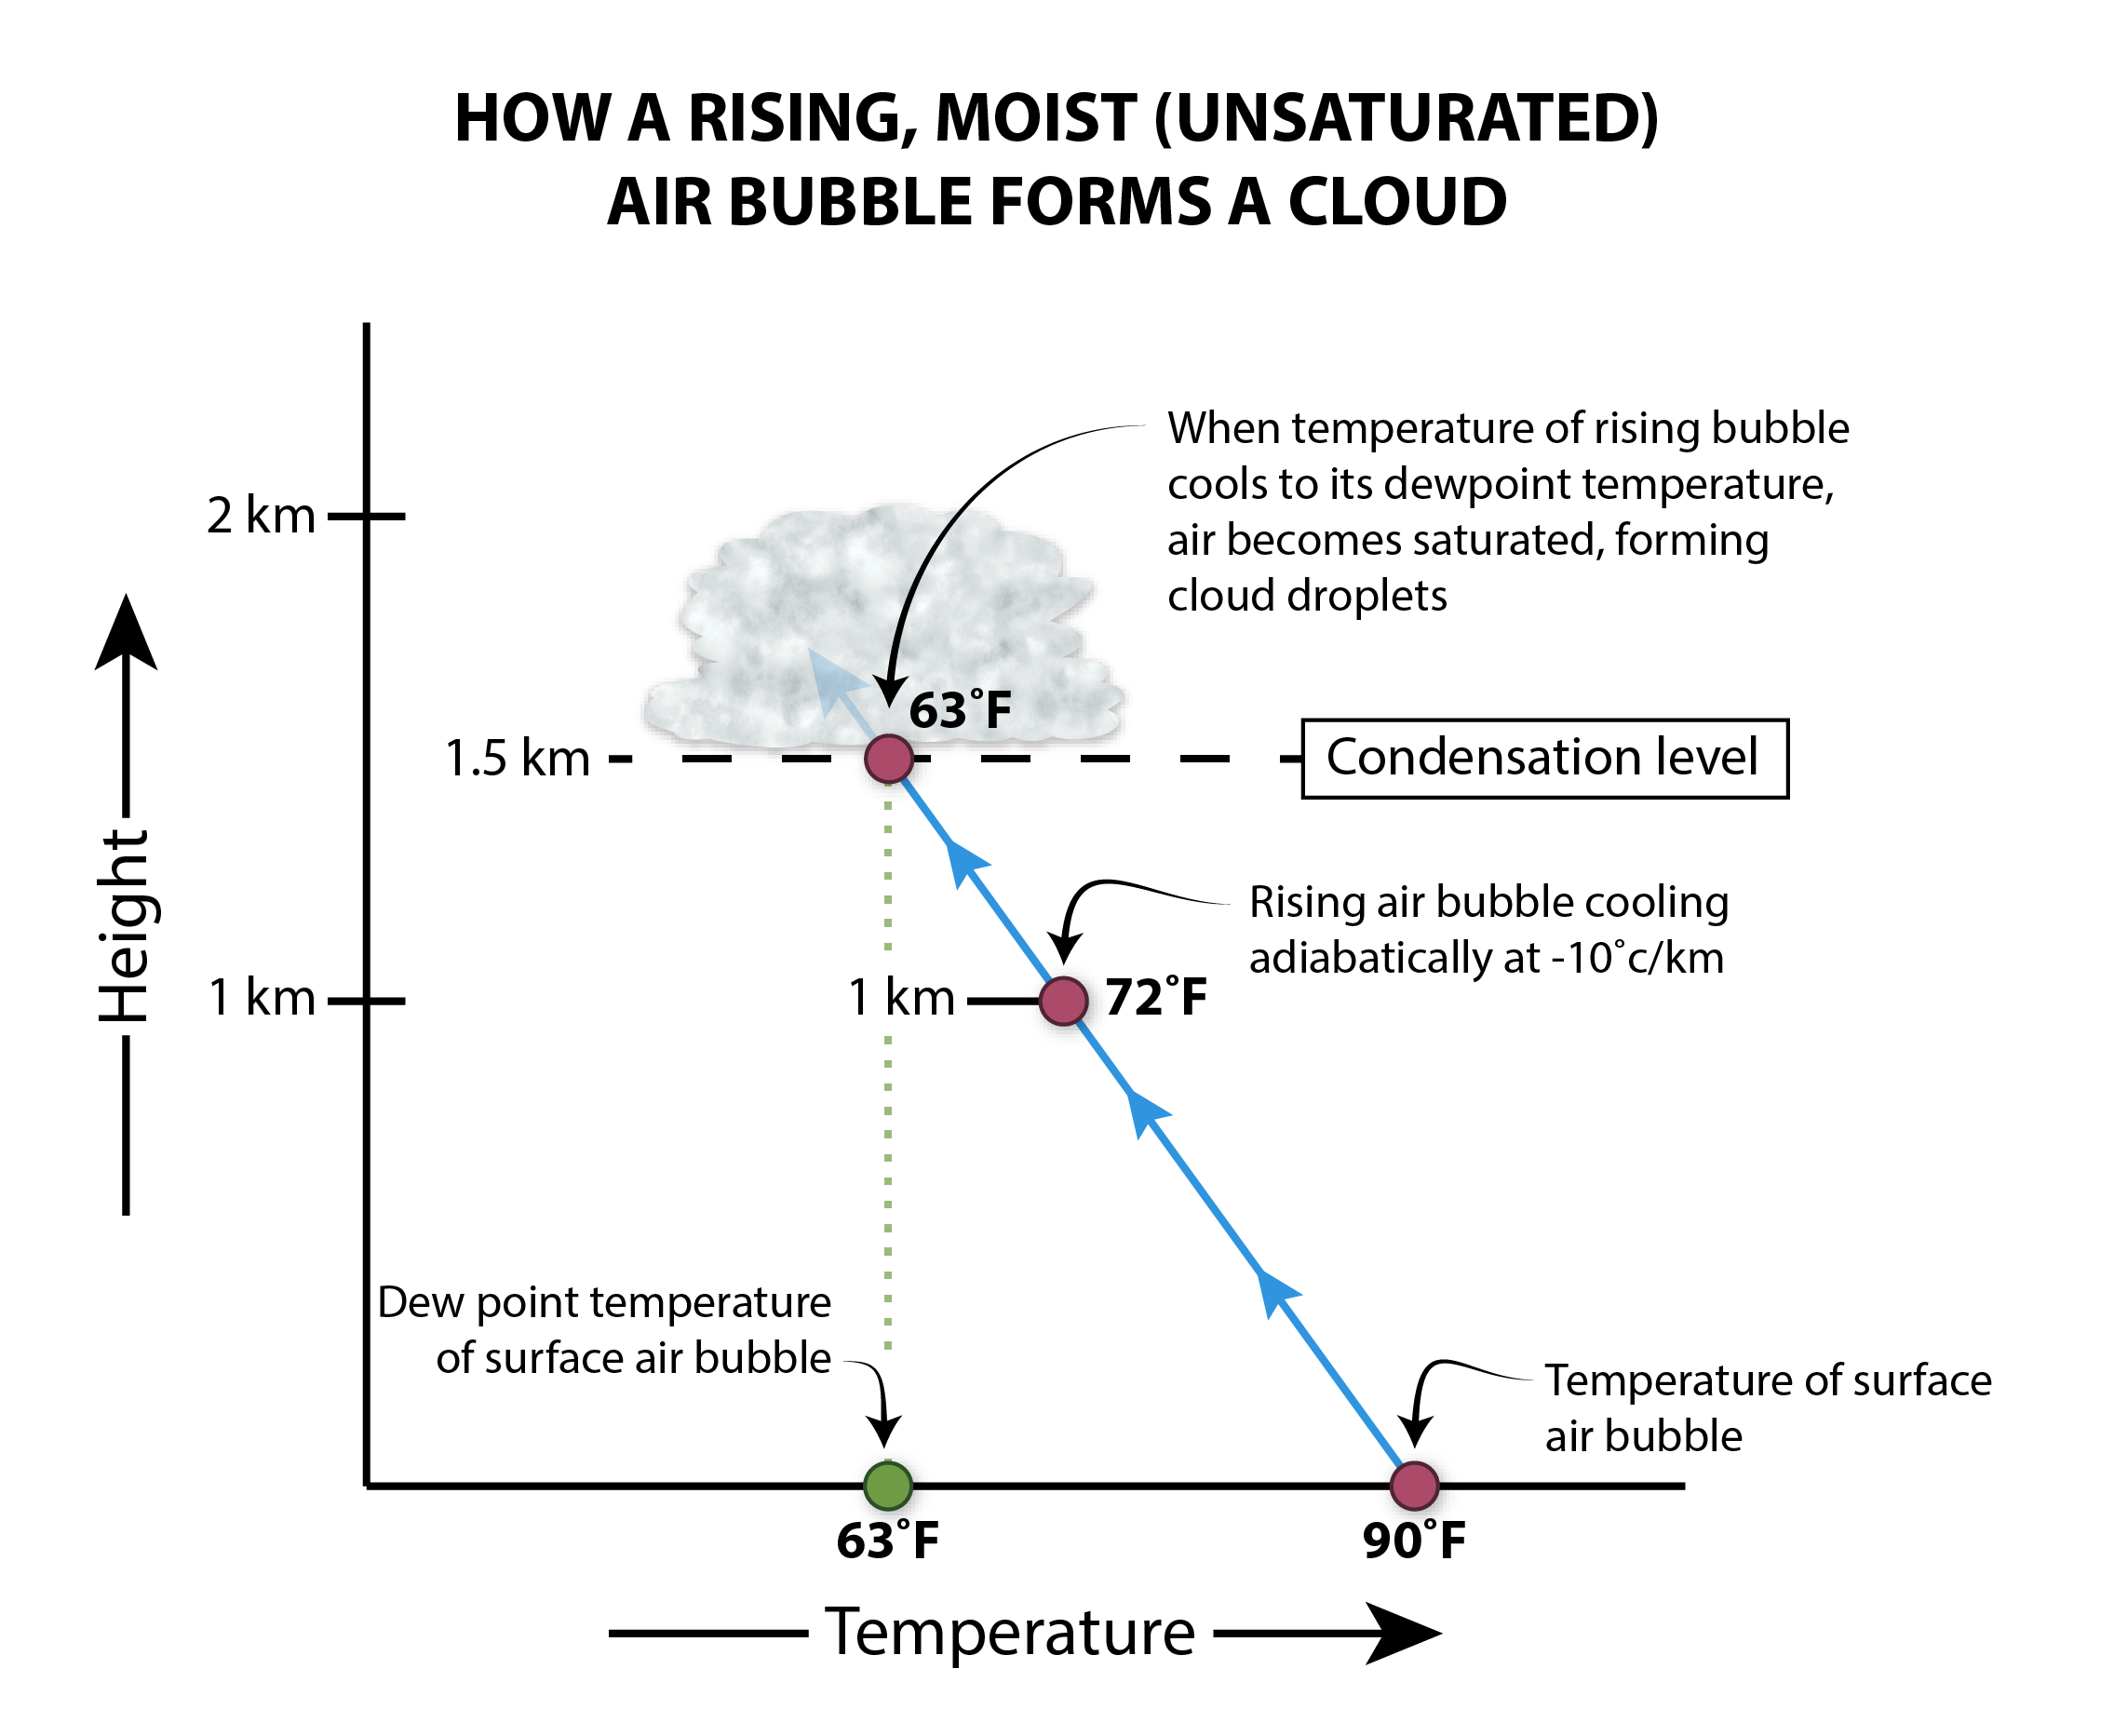
Figure 3.5 The Formation of a Cloud.
The figure shows the key processes leading to formation of a cloud, following ascent of initially unsaturated air that cools adiabatically to its dew point temperature.

Air is commonly lifted and undergoes adiabatic cooling by four processes, as shown in Figure 3.6. These include: (1) free ascent of buoyant air blobs called thermals; (2) forced ascent of air up the side of a hill or mountain, or orographic lifting; (3) lifting of air along frontal boundaries, such as when a cold, dense air mass wedges beneath a warm, less-dense air mass (frontal uplift); and (4) convergence of air into a low-pressure system (extratropical cyclone) near the ground. Convergence in this context refers to airstreams that swirl inward toward a more compact spiral. The air in the center begins flowing upward, away from the ground.
Figure 3.6. Adiabatic Cooling Processes
Air is lifted in the atmosphere in the four ways illustrated here, producing adiabatic cooling that leads to saturated air and cloud formation.

Thermals frequently develop when surface air is much warmer than the cooler air aloft. Small regions of ground heat to higher temperatures than others, enabling some bubbles of air to develop slightly warmer temperatures. Through the principle of buoyancy, these blobs begin ascending, like bubbles rising in a lava lamp. As a result of adiabatic cooling and condensation, puffy cumulus clouds develop atop each thermal. The upward transfer of warm, moist air is called convection. If the thermals become especially strong and rise to great heights, deep convective clouds called cumulonimbus develop. The cumulonimbus is also known as a thunderstorm cloud (Figure 3.7), and it is the harbinger of severe local storms.
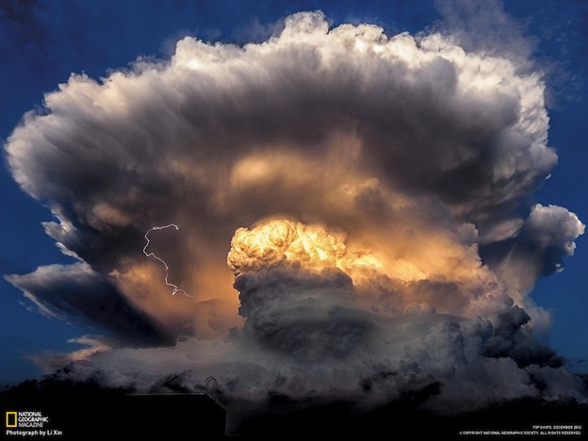
Figure 3.7. Cumulonimbus Cloud
The lower portion of the cloud is composed of liquid water, the uppermost portion of ice particles. The mid-regions feature a mixture of supercooled water and ice particles. This photo was taken from a distance on a hot summer day.

Orographic lifting or ascent commonly occurs along the Appalachians and mountains of the western U.S. coast. In both locations, moist airflow flowing [?] off the ocean often leads to saturated air and extensive cloud formation. These clouds often generate very heavy precipitation (both rain and snow), which may create flash floods and blizzards.

Frontal uplift takes two forms. The first occurs when cold air wedges beneath warmer, more humid air, which occurs along a cold front. The second form occurs when warm, humid air glides gently atop a colder air mass hugging the surface, establishing a warm front. As Figure 3.8 shows, both cold fronts and warm fronts commonly develop in association with extratropical cyclones across the United States. The converging, clockwise spiral of wind brings dissimilar air masses into abrupt opposition. Cold, dry air circulates south out of Canada, while warm, humid air is drawn northward out of the Gulf of Mexico or western Atlantic. Especially large gradients of temperature and dew point become established across the cold front and warm front (Figure 3.9). Fronts are the location of very active kinds of weather, given that humid air is forced to rise along these narrow zones.
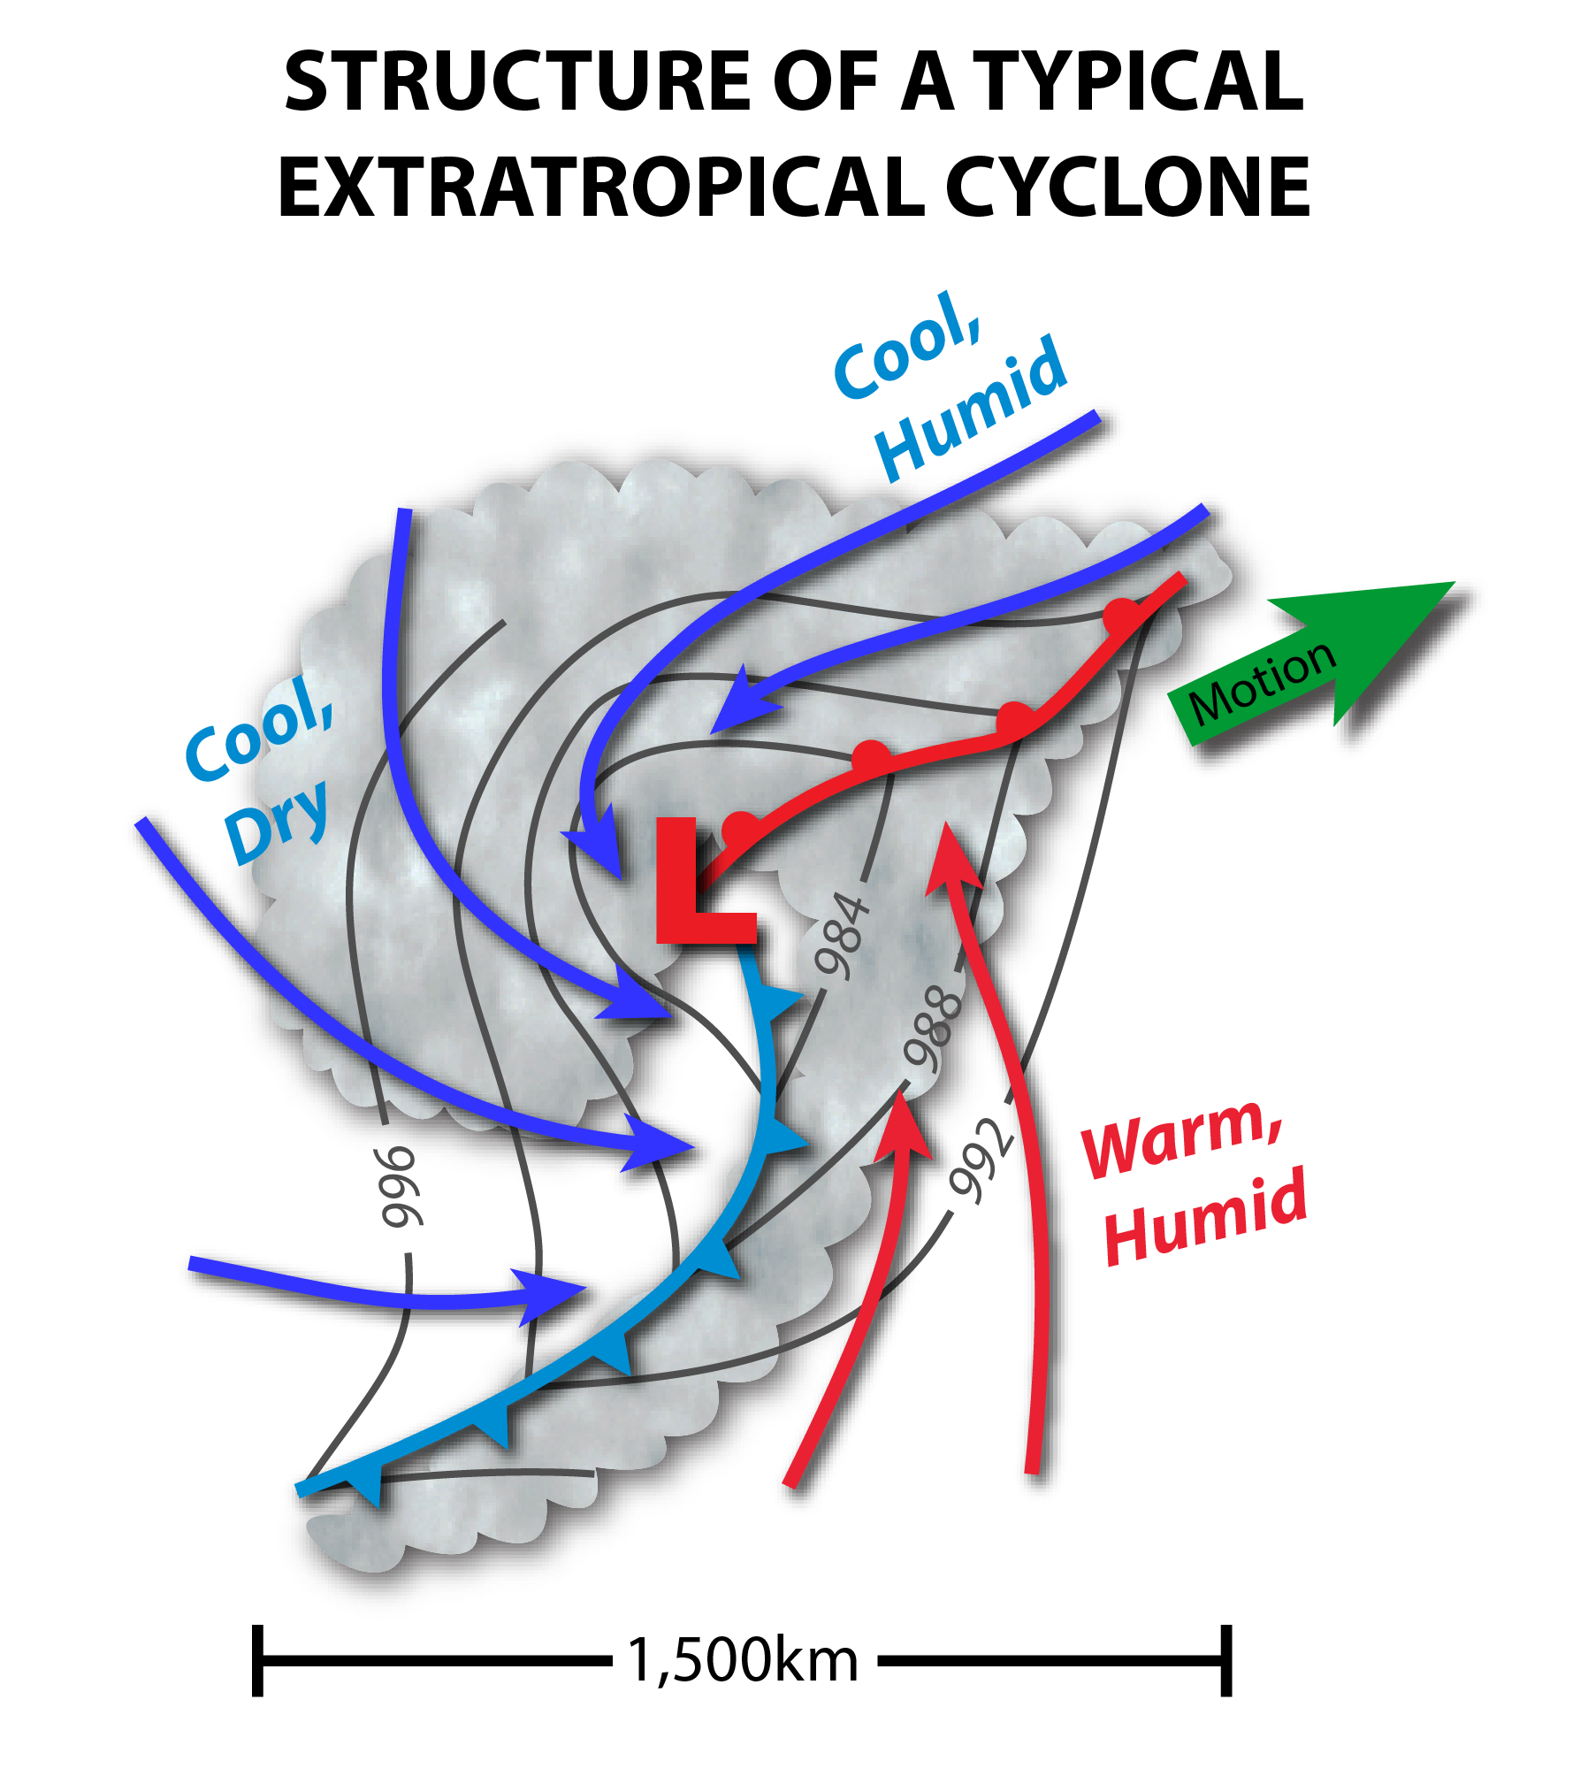
Figure 3.8 General Structure of an Extratropical Cyclone.
This schematic weather map illustrates the general structure of an extratropical cyclone, with types of air masses and frontal structures labeled. Arrows indicate airflow, and solid thin lines denote isobars (lines of constant pressure).
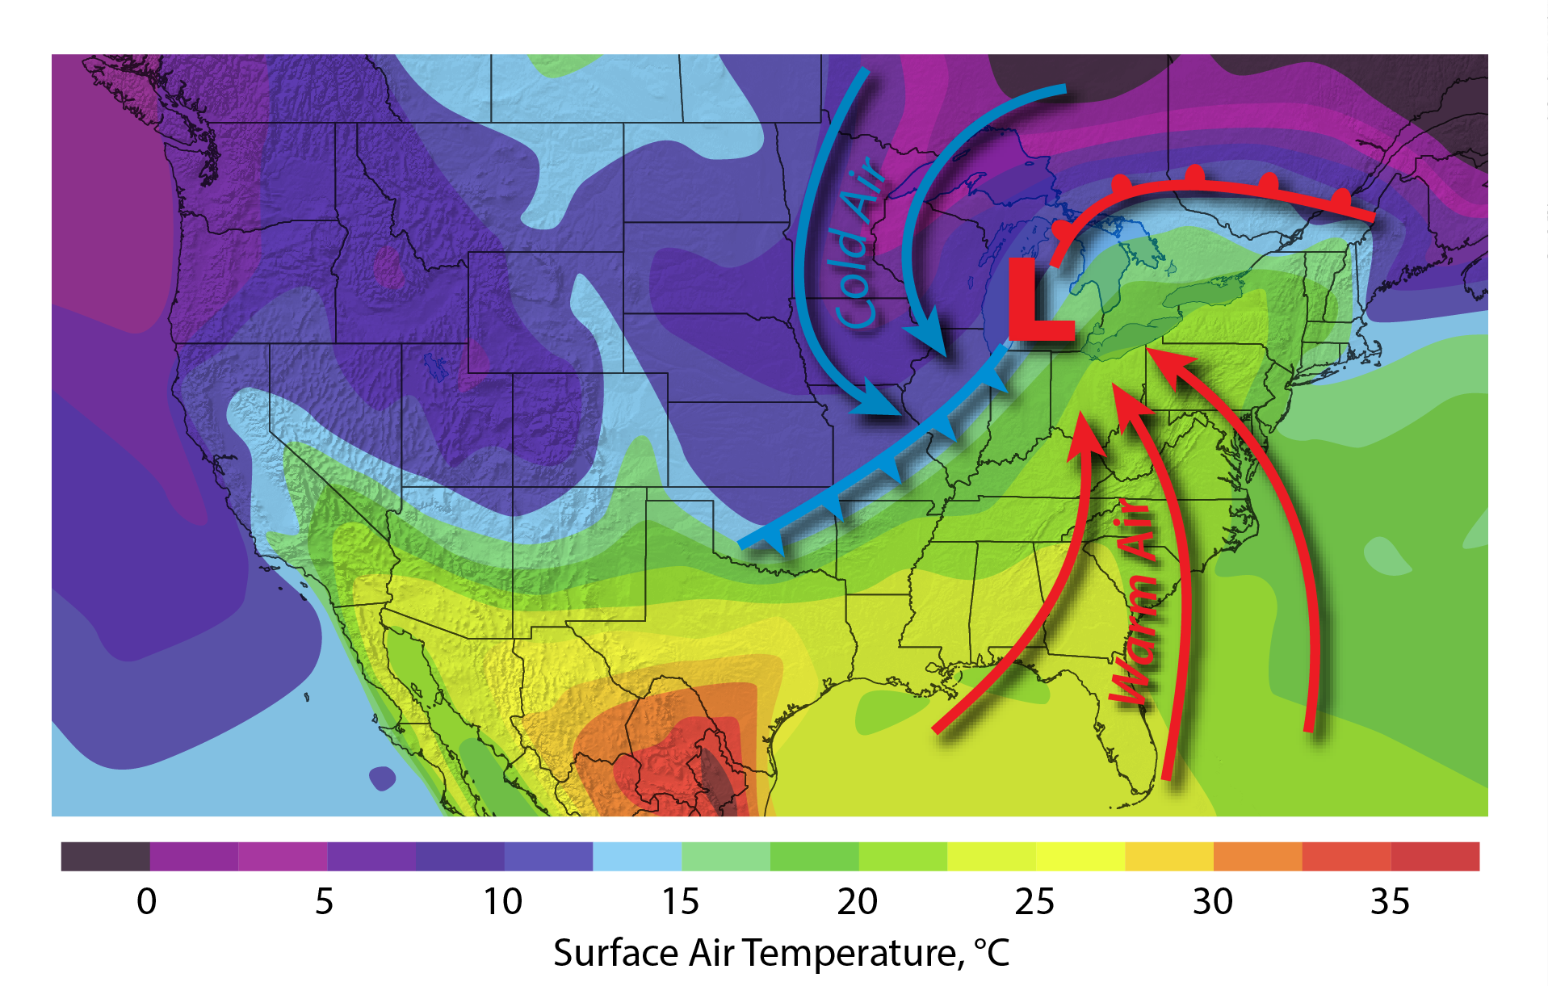
Figure 3.9 Surface Temperature Variations Across a Typical Extratropical Cyclone. Compare this figure with the dew point temperature variations in Figure 3.3. The contrasting temperature and humidity values derive from the different air-mass source regions.

The uplift of air occurs along a narrow zone ahead of an advancing cold front, and it is often quite vigorous. This air develops into a narrow band of convective showers and sometimes thunderstorms. North of the storm’s warm front, clouds and precipitation become more widespread, because the uplift of air is more gradual and spread out over a large, gently sloping region. Figure 3.10 depicts a weather radar view of a springtime extratropical cyclone; the figure shows the locations of the cold-front and warm-front rainbands.
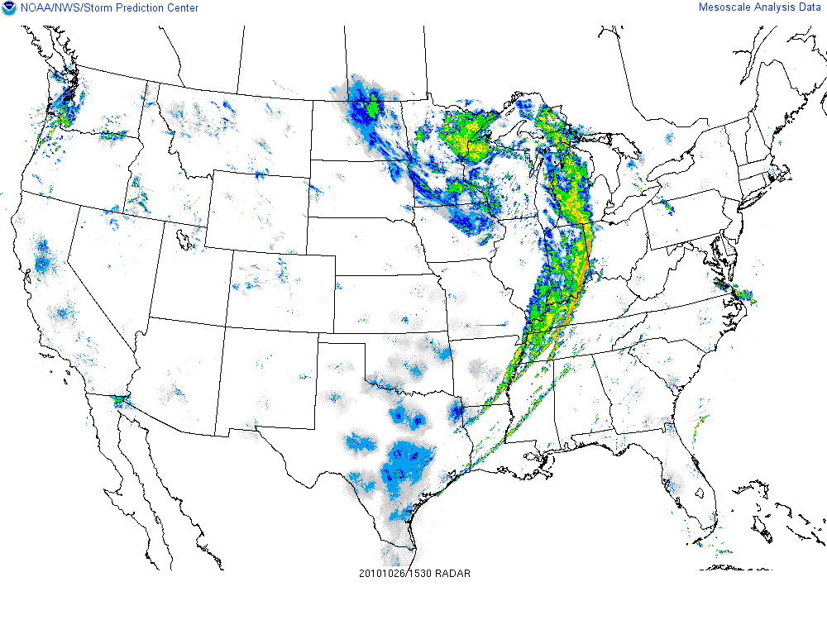
Figure 3.10. Precipitation in a Mature Extratropical Cyclone
This weather radar shows a broad view of the precipitation structure (rain location and intensity) in a mature extratropical cyclone. Blue and green denote light rain; yellow shows moderate rain; red indicates heavy rain.

The convergence of inward-streaming air masses helps to focus uplift of air, along with cloud formation and precipitation, near the center of an extratropical cyclone. This broad shield of heavy weather is termed the comma head when viewed from the perspective of a weather satellite (Figure 3.11).
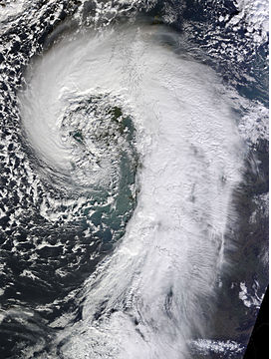
Figure 3.11. Comma Head.
This satellite view of a mature extratropical cyclone reveals the comma shape of the cloud-top structure. It also identifies temperature (cold clouds are illustrated in red).

Finally, convergence is the main reason why tropical cyclones of low-latitude origin form concentric rings and spiral bands of heavy convective showers. Lacking fronts (there is no source of cold air in the tropics – the air mass is uniformly warm and humid), intense convergence of humid air supplies the vigorous uplift and cooling of air that develops a tropical cyclone’s torrential rains.

[H1] 3.3 Growth of Cloud Droplets and Rain in Clouds

Clouds are formed from cloud droplets, which are the tiniest forms of liquid water in the atmosphere, with diameters measured in the micron (millionth of a meter) range. A microscope is needed to see cloud droplets. For cloud droplets to form, moist air must first cool enough to become slightly supersaturated. In addition, tiny particles called aerosols must be present; these act as nuclei (centers) around which water vapor molecules condense into spherical droplets. These aerosols, called cloud condensation nuclei (CCN), consist of dust grains, which might be derived from wind-swept soil particles or ashes from volcanic eruptions and wildfires. Additionally, sea salt particles lofted by breaking waves and chemical emissions from oceanic plankton can nucleate cloud droplets. Anthropogenic aerosols (pollutants) deriving from industrial emissions, biomass burning, and agricultural practices can also serve as cloud droplet nuclei.

The difference in volume between a cloud droplet and a raindrop is a millionfold or more. Raindrop diameters range from 1 to 6 mm. The growth of cloud droplets to raindrop size, through condensation of water vapor, takes many hours, in contrast to convective rain showers, which are often generated in as little as 15-20 minutes! What process can vastly speed up this rate of droplet growth?

Warm clouds (those above freezing temperature) undergo a kind of chain reaction, whereby the rate of droplet growth grows exponentially. The process is based on a distribution of cloud droplet sizes – that is, many small droplets mixed in with several larger ones. This size variation occurs naturally, as a result of different sizes of CCN. The larger droplets through the cloud slightly faster than the small droplets. As a result, the larger droplets overtake and stick to the small droplets (Figure 3.12). As these big droplets, called collector drops, rapidly overtake small droplets in their path, their mass (volume) rapidly increases to raindrop size. This process is the essence of the chain reaction-type growth.
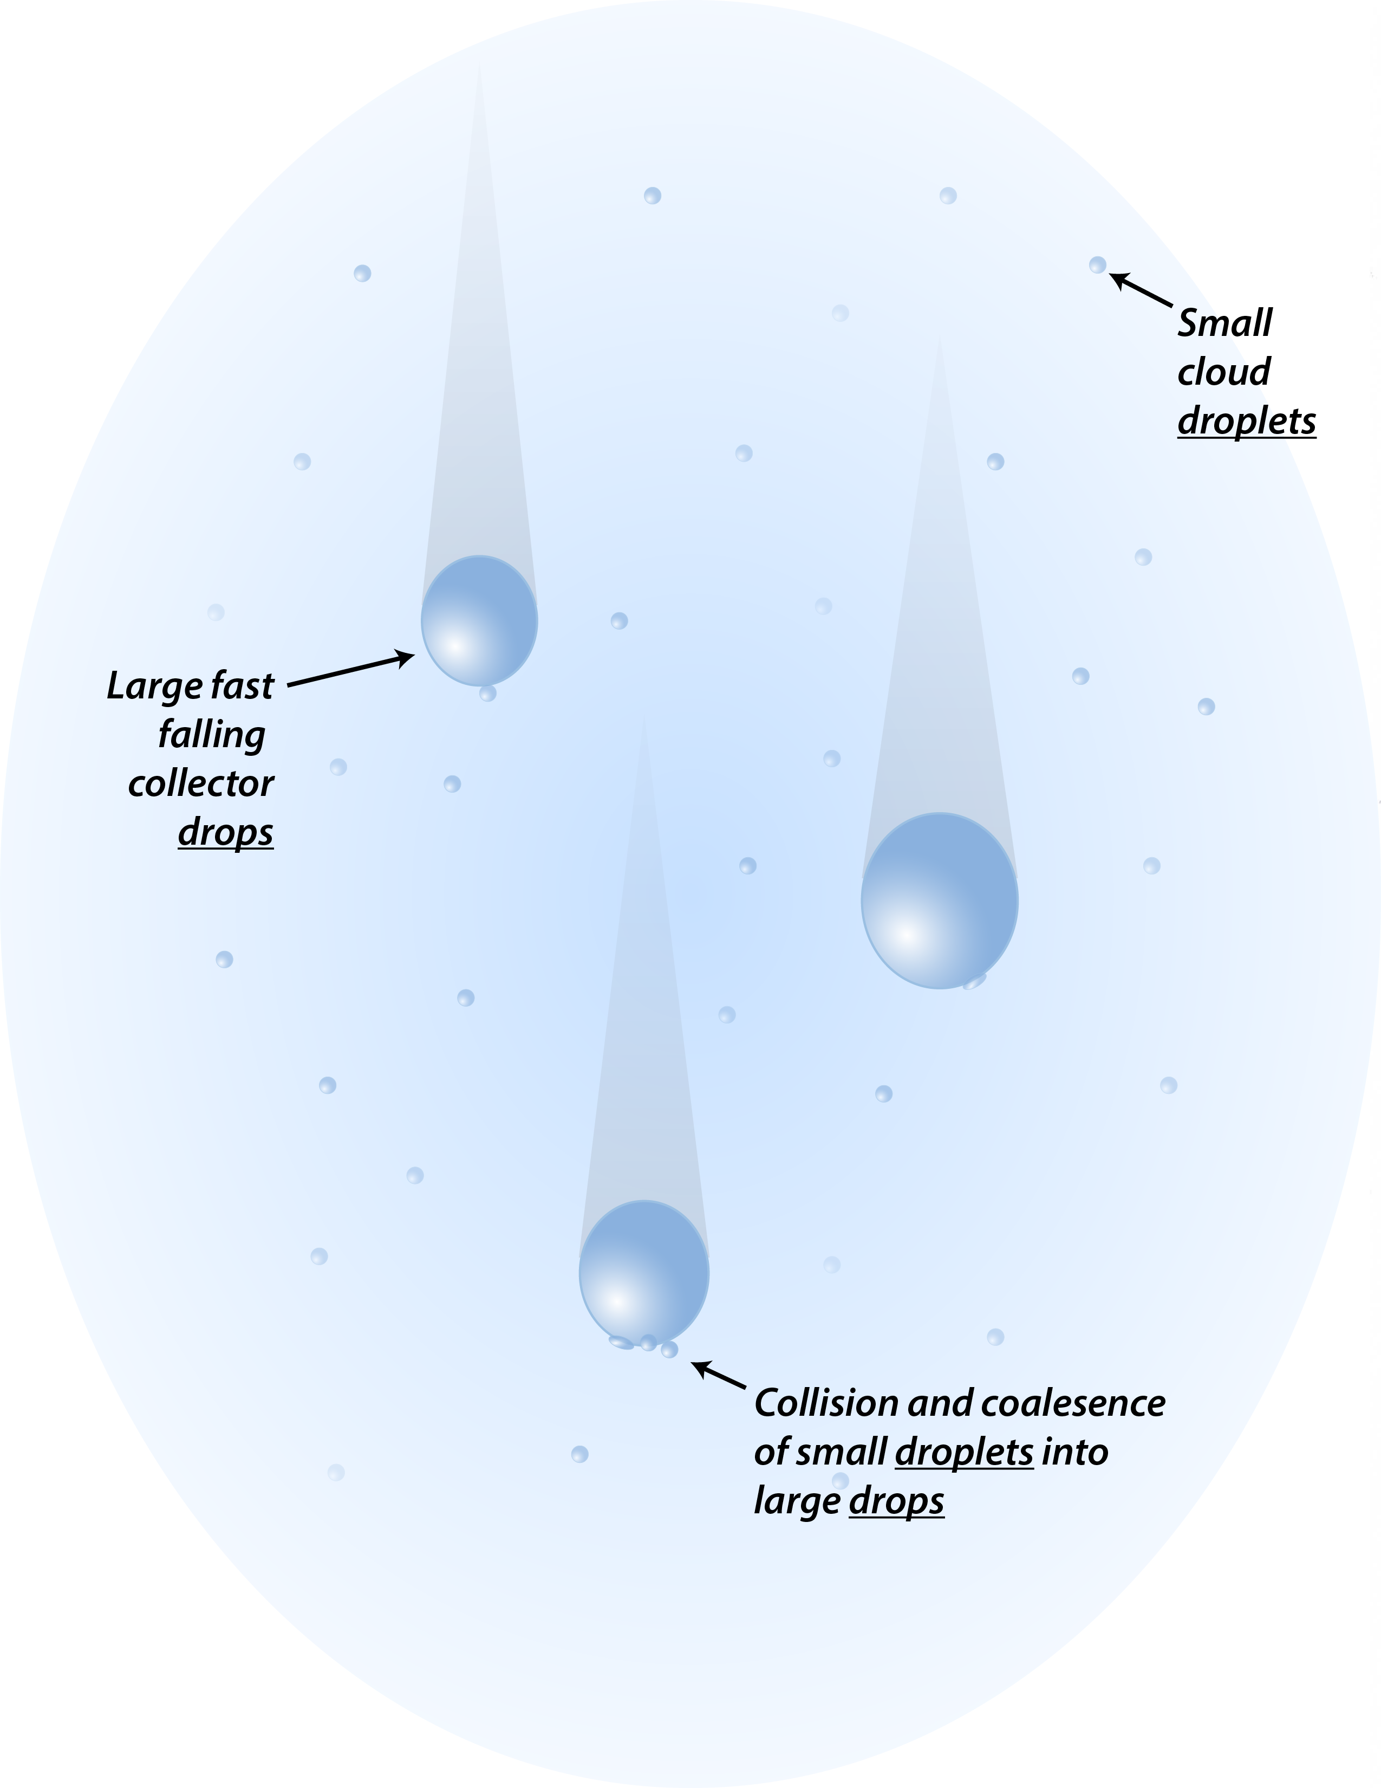
Figure 3.12 Collision-Coalescence
The process of collision-coalescence is based on large falling cloud droplets overtaking and sticking to many smaller cloud droplets. The larger droplet grows at an exponential rate, quickly reaching raindrop size.

The chain reaction continues even after falling raindrops have formed. When the diameter of falling raindrops grows larger than 2-3 mm, their (relatively) large size makes them unstable as they are buffeted by air turbulence. Big raindrops vibrate and deform into shapes that resemble inverted hamburger buns, and their wobbling becomes so intense that they disintegrate into many smaller raindrops. The cascade of smaller drops thus released grows through continued collisions with smaller drops and cloud droplets.

This whole process, summarized in Figure 3.12, is called collision-coalescence (coalescence means “sticking together”), and the process is inherently unstable, leading to rapid generation of moderate to heavy rain showers in just a few tens of minutes. This process occurs as long as there is a steady supply of rising, humid air within the cloud – in other words, a continued supply of moisture that quickly cools to supersaturation. During the summer months, when the air mass is very humid and unstable (discussed later in this chapter), cumulonimbus clouds develop and generate torrential rain, partly through the collision-coalescence process (there are additional mechanisms at play, which we discuss next). These deep convective clouds are notorious for manufacturing heavy rain at the rate of several inches per hour, leading to flash floods – the number-one cause of U.S. storm fatalities.

[H1] 3.4 Growth of Ice Crystals and Snow in Clouds

The processes just described account for precipitation in warm, low-altitude clouds. What about deeper clouds, extending many miles (kilometers) above Earth’s surface, where temperatures are well below freezing? The formation of precipitation at subfreezing temperatures has a few surprising aspects. First, liquid cloud water will not spontaneously freeze to form ice crystals as the temperature falls below 32° F (0° C). Water may exist in a supercooled state, remaining liquid all the way down to -40° F (-40° C). Freezing of water in the atmosphere requires the presence of microscopic freezing nuclei – aerosol particles that mimic the crystalline, lattice-like configuration of frozen water. Many of these aerosols are not “activated” until temperatures fall considerably below freezing.

Clouds between the temperature of 0° C (32° F) and -20° C (-4° F) contain a mixture of ice crystals and supercooled liquid water drops. In this mixed phase condition, the tiny ice crystals tend to grow at the expense of the liquid water droplets. Vapor deposition is the process by which water vapor molecules evaporate from the surface of cloud droplets and deposit directly onto either ice nuclei or any pre-existing ice crystals. Through this process small snowflakes build up mass until they become heavy enough to fall out of the cloud. Collisions among small snowflakes enables them to stick together, forming even larger flakes in a process is called aggregation. During the cold winter months, aggregation is responsible for the large flakes of a heavy snowfall. At other times of the year, the flakes completely melt as they descend into air above freezing air near the ground, striking the ground as raindrops.

When supercooled water abounds in the presence of ice crystals, the supercooled drops may immediately freeze upon contacting an ice crystal. This process, called riming, rapidly builds growing shells of frozen water, to the point where small, spherical graupel particles consisting of opaque, mushy ice develop. Riming is more common during the summer months, high up in cumulonimbus clouds, where powerful updrafts acting on very humid air deliver large quantities of supercooled water into the mixed-phase region of the cloud (0° to -20° C [32° to -4° F]).

Graupel particles serve as the building blocks of larger hailstones. The formation of hail occurs by continuous accumulation of supercooled water onto a growing, frozen sphere that remains suspended in the cloud updraft. The stronger the updraft, the longer the stones remain suspended and the larger they can grow, sometimes to the size of softballs. It may seem paradoxical that the largest pieces of precipitating ice that fall from clouds occur during the warmest season of the year! But the intense updrafts necessary to levitate large stones occur only during summer, when the air is very unstable and strongly buoyant (discussed later in this chapter).

Figure 3.13 summarizes the processes of cold-cloud precipitation formation, including vapor deposition, aggregation, and riming. It’s important to recognize that a significant fraction of rain in the mid-latitudes reaches the surface via these cold-cloud processes, with subsequent melting of frozen precipitation into liquid drops close to the surface. This is even the case for summer thunderstorms. High up in the frozen reaches of cumulonimbus clouds, a veritable blizzard of heavy snow rages even when surface temperatures exceed 90° F (32° C)!
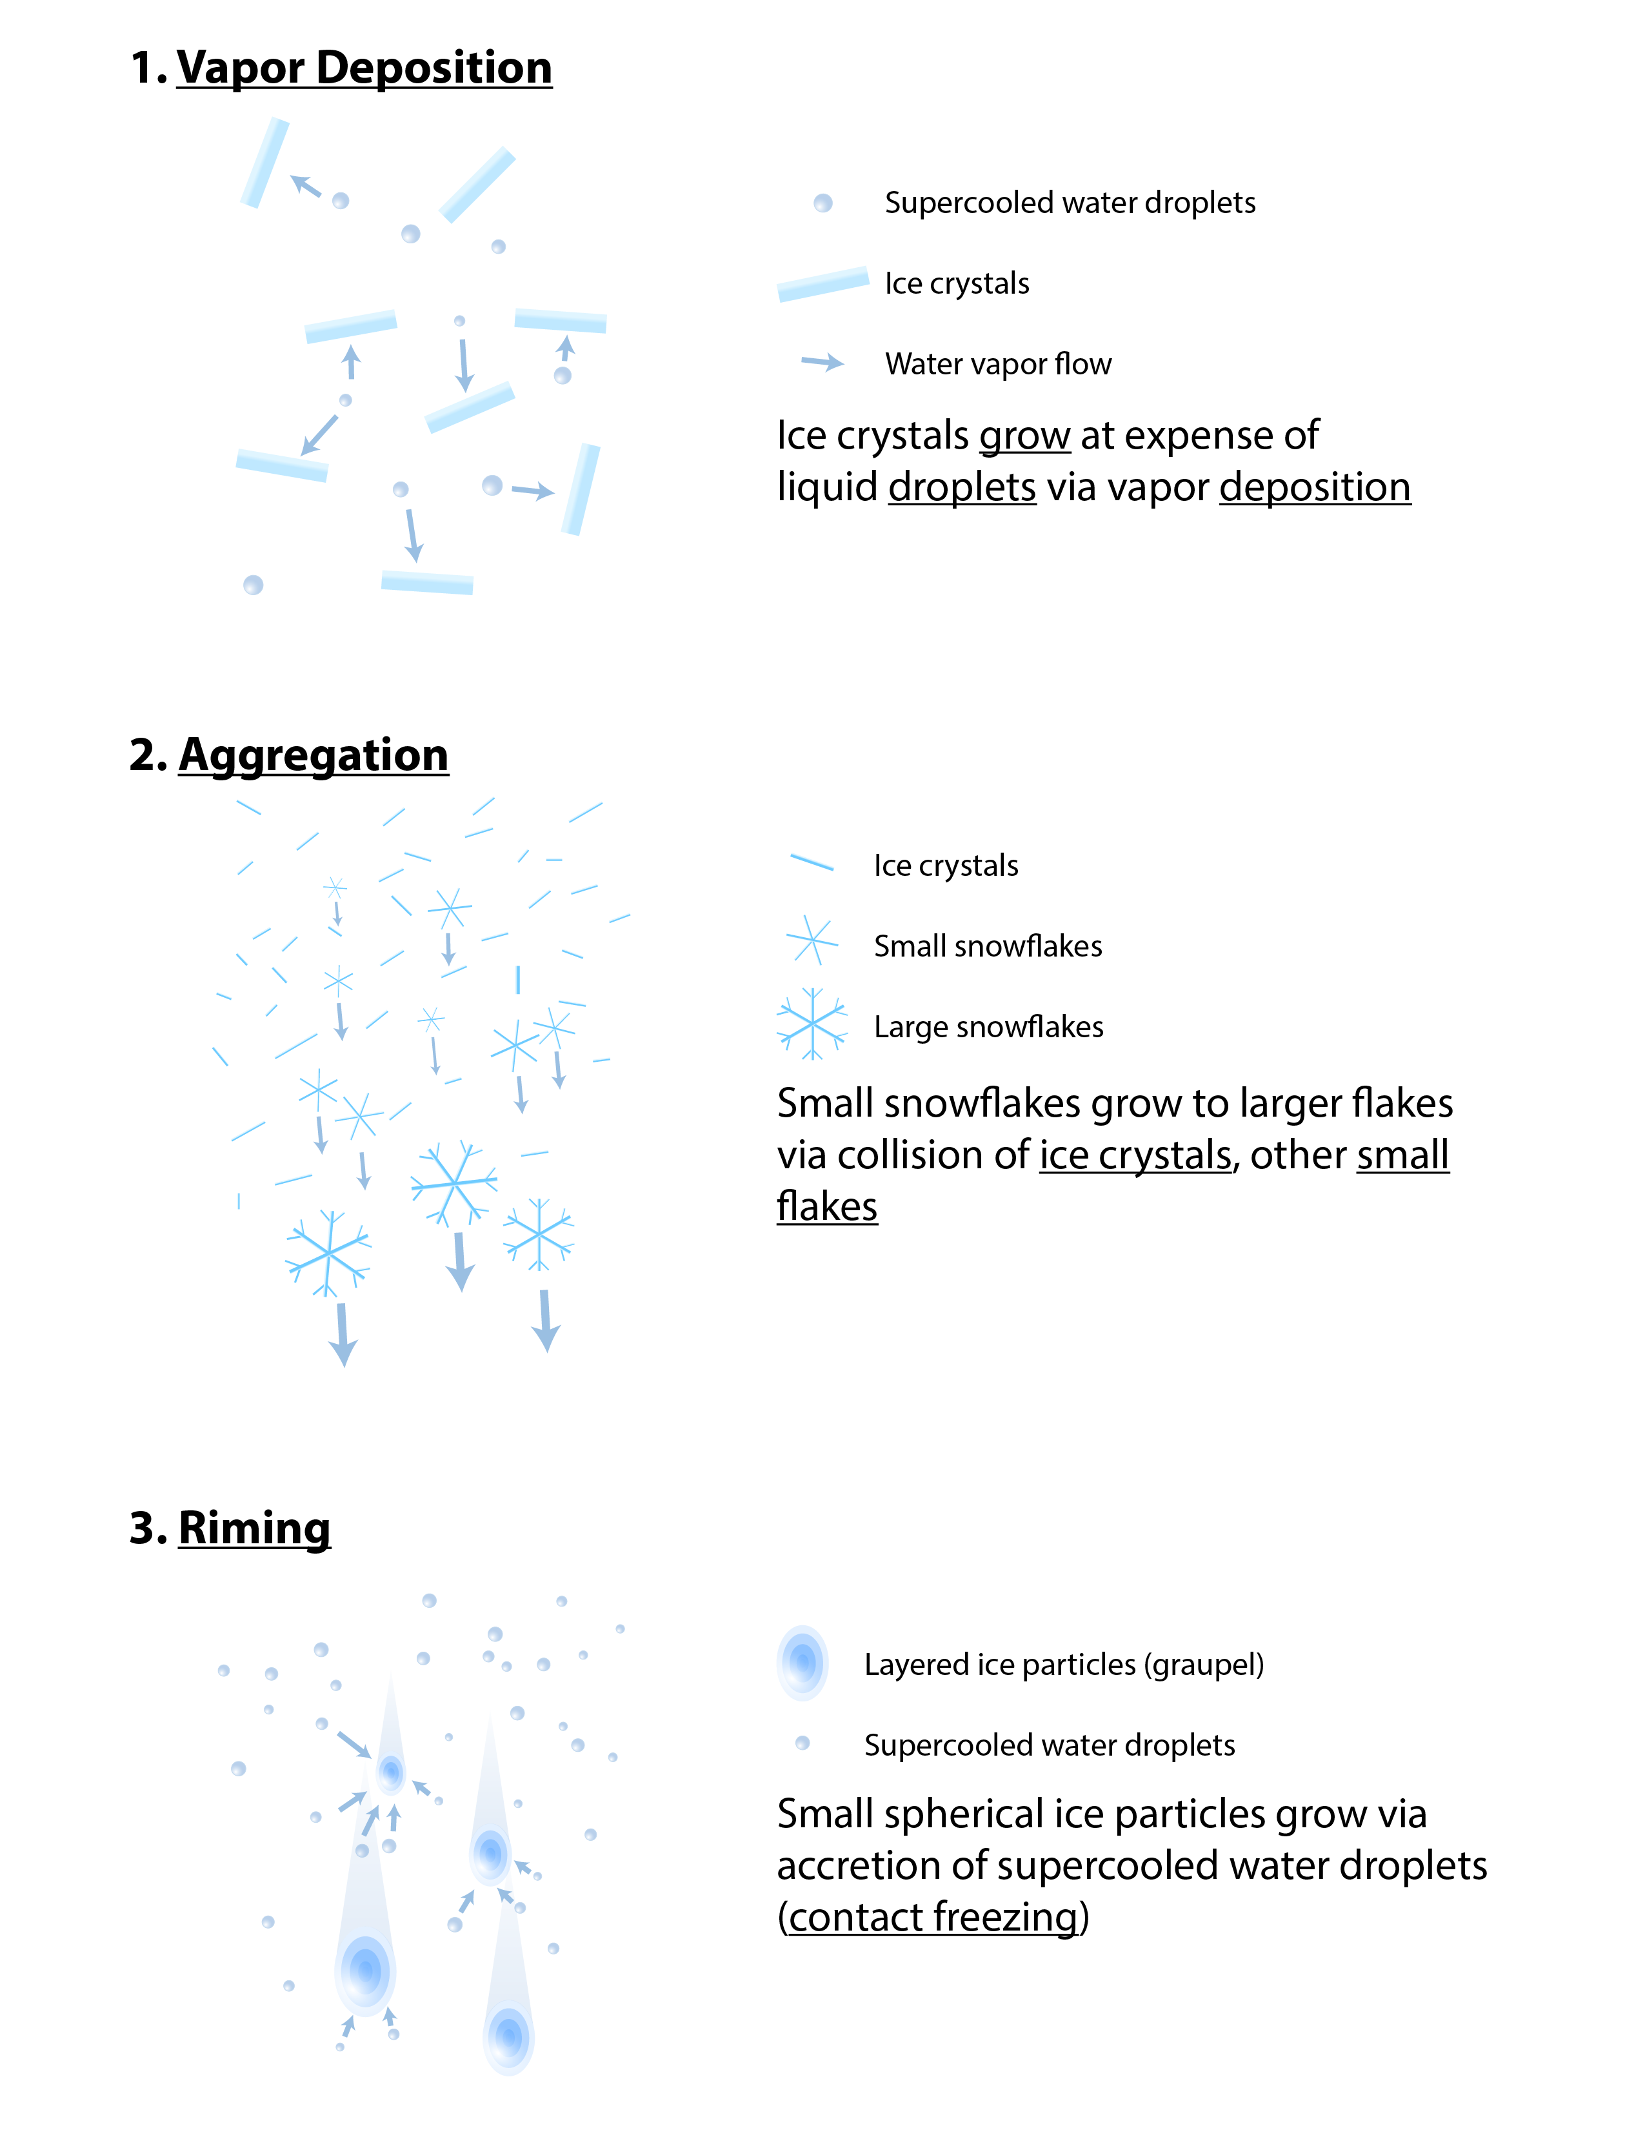
Figure 3.13. Cold-Cloud Precipitation Formation
Frozen precipitation can grow in clouds through a number of processes, including (a) vapor deposition, (b) aggregation, and (c) riming.

The mixture of supercooled water drops, ice crystals, and graupel in warm-season convective clouds leads to cloud electrification and lightning. More detailed discussion of lightning appears in a later chapter, but cloud and precipitation particles become electrically polarized depending on their phase (liquid vs. ice) and size. Cloud updrafts and downdrafts re-distribute or sort these particles by size, leading to opposing charge centers within different regions of the cloud. The process is akin to charging a battery. When the voltage (difference in charge) between negative and positive regions becomes large enough, an electrical discharge (in this case, lightning) restores electrical equilibrium within the cloud (or between cloud and ground).

[H1] 3.5 Atmospheric Stability and the Formation of Thunderstorms and Layer Clouds

Everyone knows that a hot summer day frequently breeds afternoon and evening thunderstorms. Inherently, we understand that the intense summer Sun strongly heats the surface, causing thermals of moist air to rise and condense into thunderclouds. Convection is the process by which excess heat energy is moved upward through the atmosphere, into the cold upper layers. Convection occurs spontaneously, as long as the atmosphere is unstable – but what exactly does unstable mean?

An unstable atmosphere is one in which rising air cools at a slower rate than the surrounding atmosphere. The large-scale layer of air extending many miles (kilometers) above the surface normally experiences a decrease in temperature with altitude; this lapse rate, on average, is around -6.5° C/km (-20° F/3300 ft). But recall that rising bubbles of warm, humid air cool as they expand. This is adiabatic cooling, which occurs at a constant rate of -10° C/km (-14° F/3300 ft). As long as the rate of cooling in rising air is less than that of the surrounding air, the blob of air will remain warmer than its surroundings. The blob will remain buoyant and will continue to ascend. This condition is the hallmark of an unstable atmosphere. If the atmosphere is unstable through a great depth, up to around 50,000 feet (15 km), a deep thundercloud will develop.

Figure 3.14 shows how we can assess the degree of instability by comparing two rates of temperature change – that of the average environment, and that of a bubble of air rising through the larger environment – by comparing the slopes (mathematically defined as the “rise over the run”) of the two lines representing these processes.
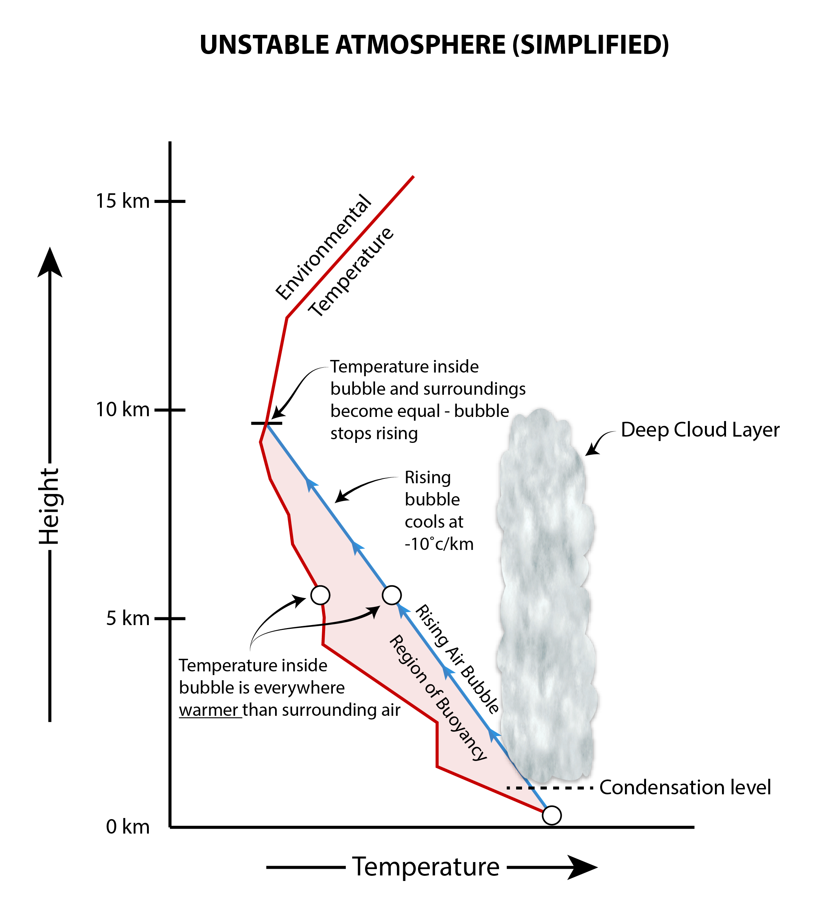
Figure 3.14 Unstable Atmosphere
These illustrations compare (a) environmental temperature decreasing at a characteristic lapse rate and. (b) temperature in a rising bubble of air cooling adiabatically. As long as the temperature inside the blob remains warmer than its environment, the bubble is buoyant and continues to rise. Under these conditions the atmosphere is unstable.

The slope of the line representing the environmental lapse rate can be altered in two ways. Either the surface layer can warm up, or the upper atmosphere can cool. In both cases, the slope of the line gets steeper, but the adiabatically cooling (rising) thermal always follows the same path. The lower atmosphere commonly heats up over the course of a summer afternoon, and the upper atmosphere will cool if winds aloft move colder air over the region. Under these conditions, the atmosphere will become more unstable, as Figure 3.15 shows.
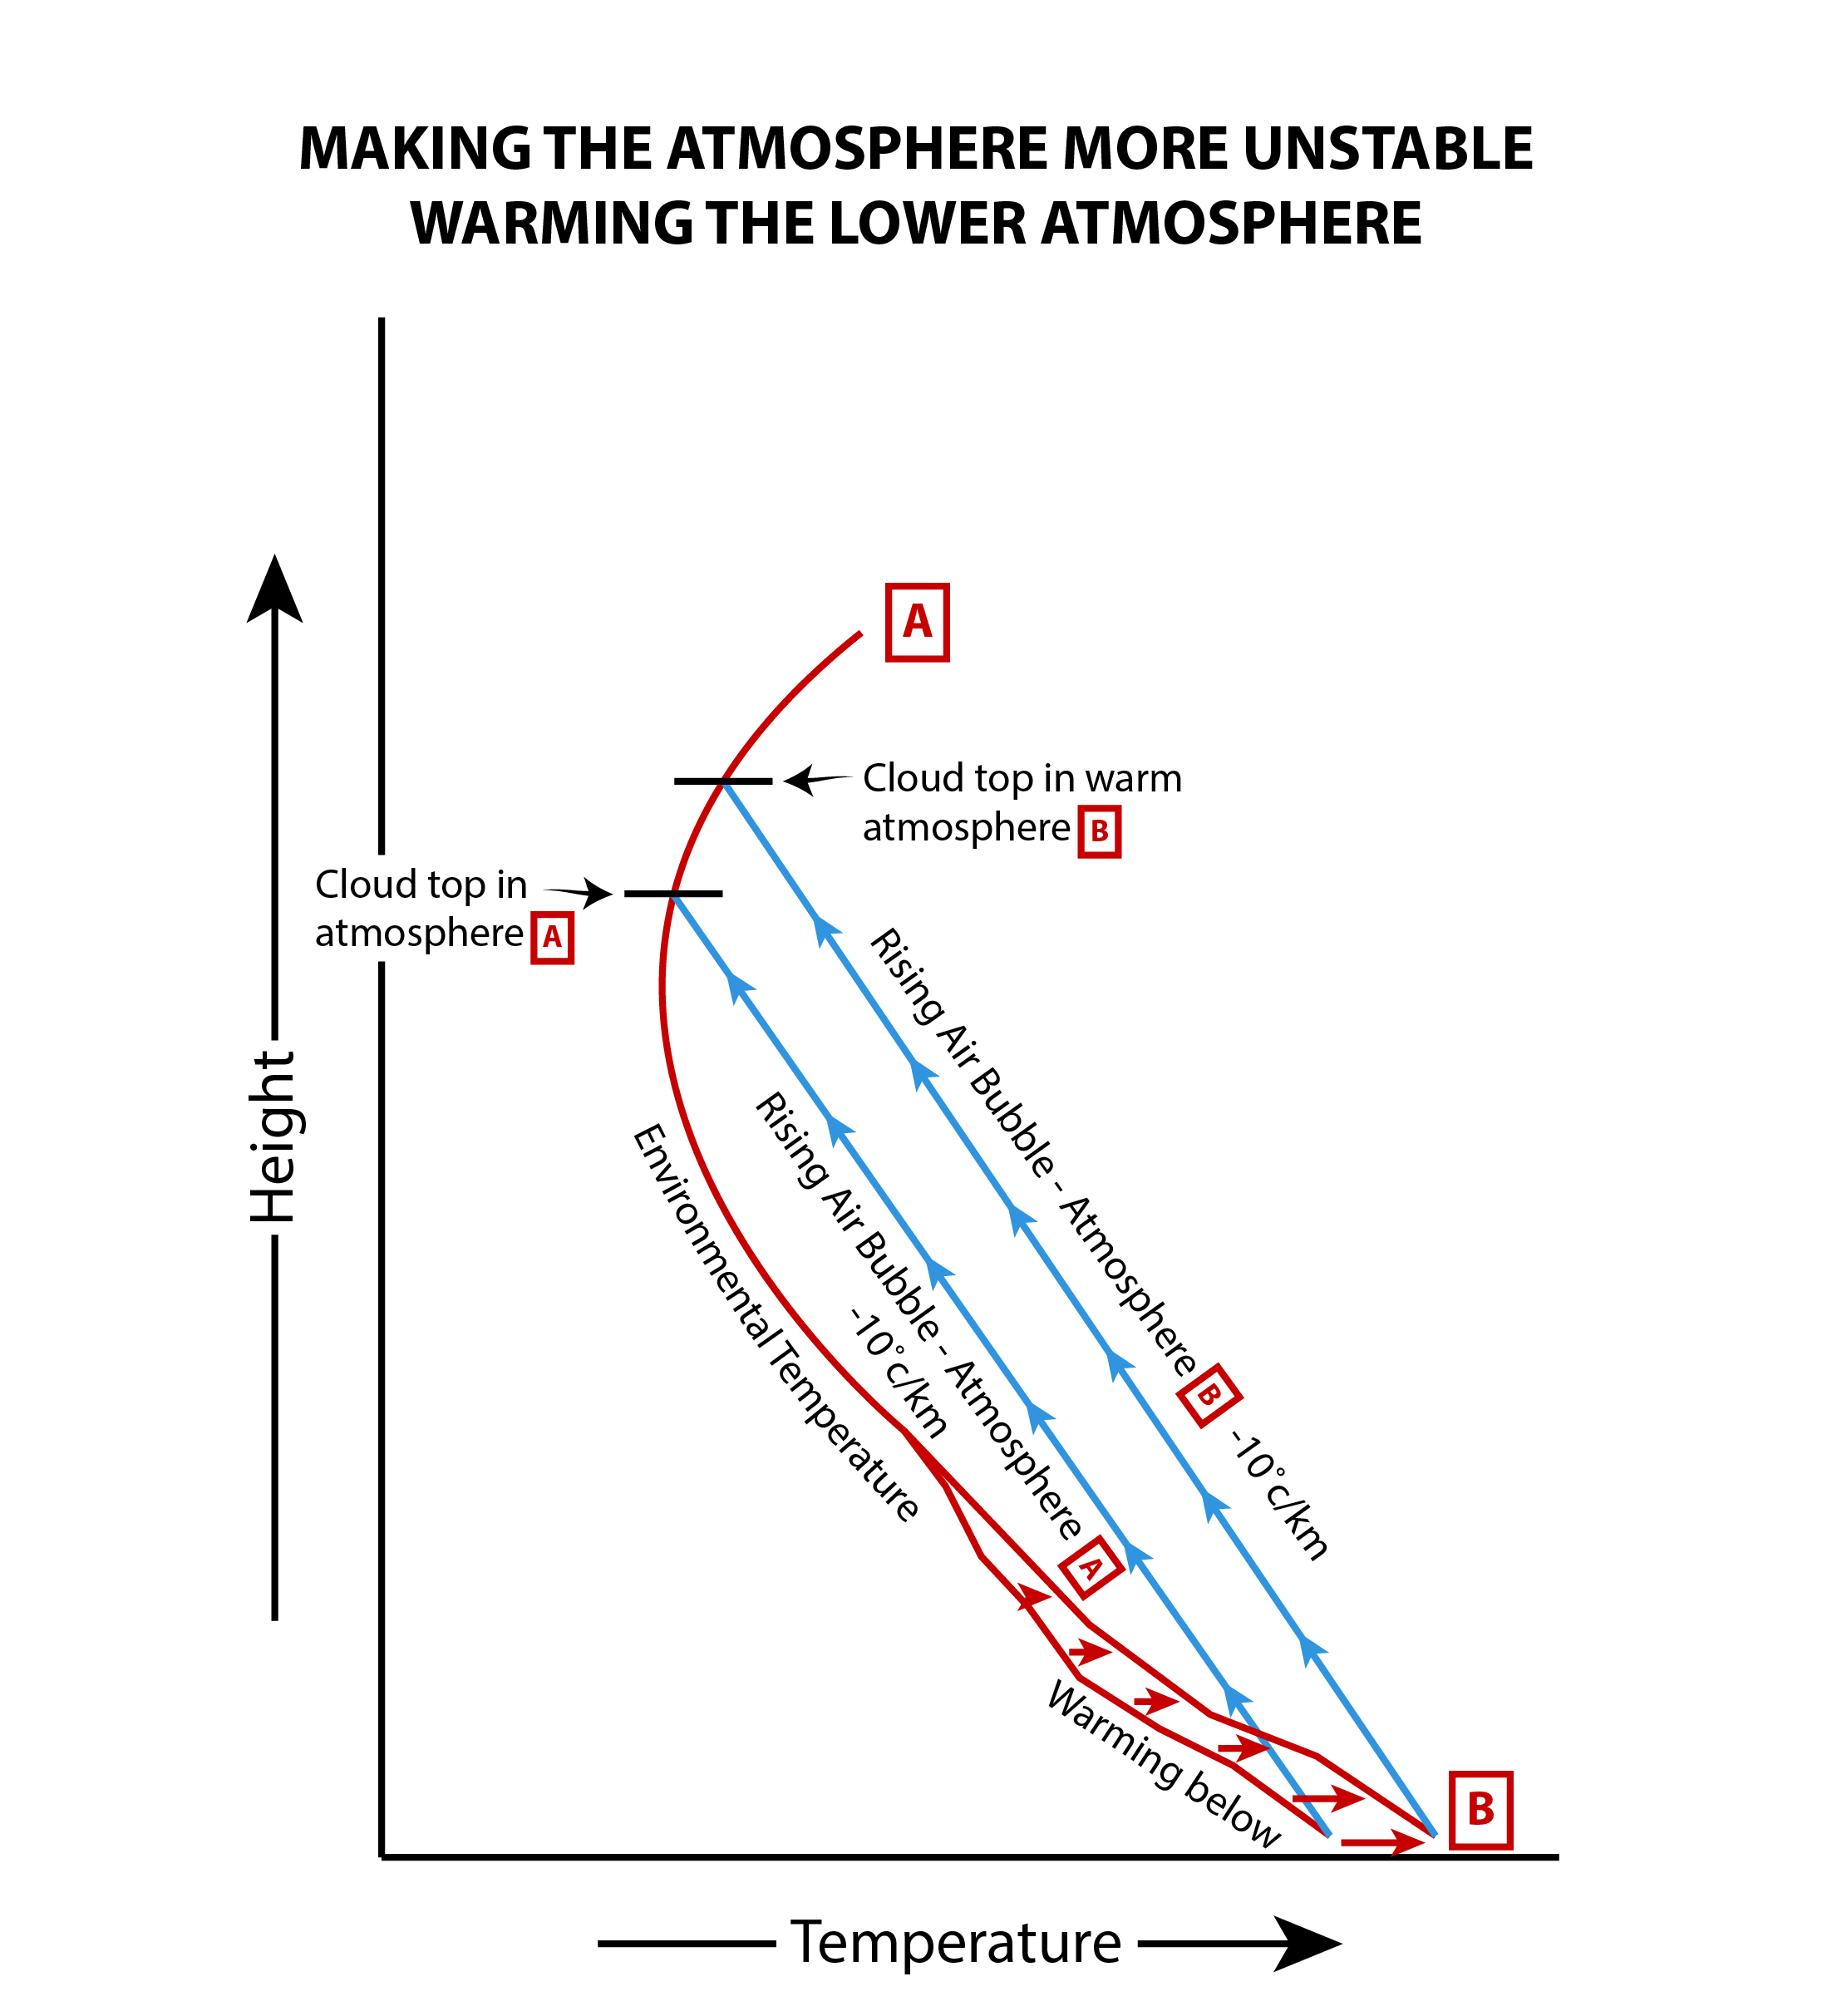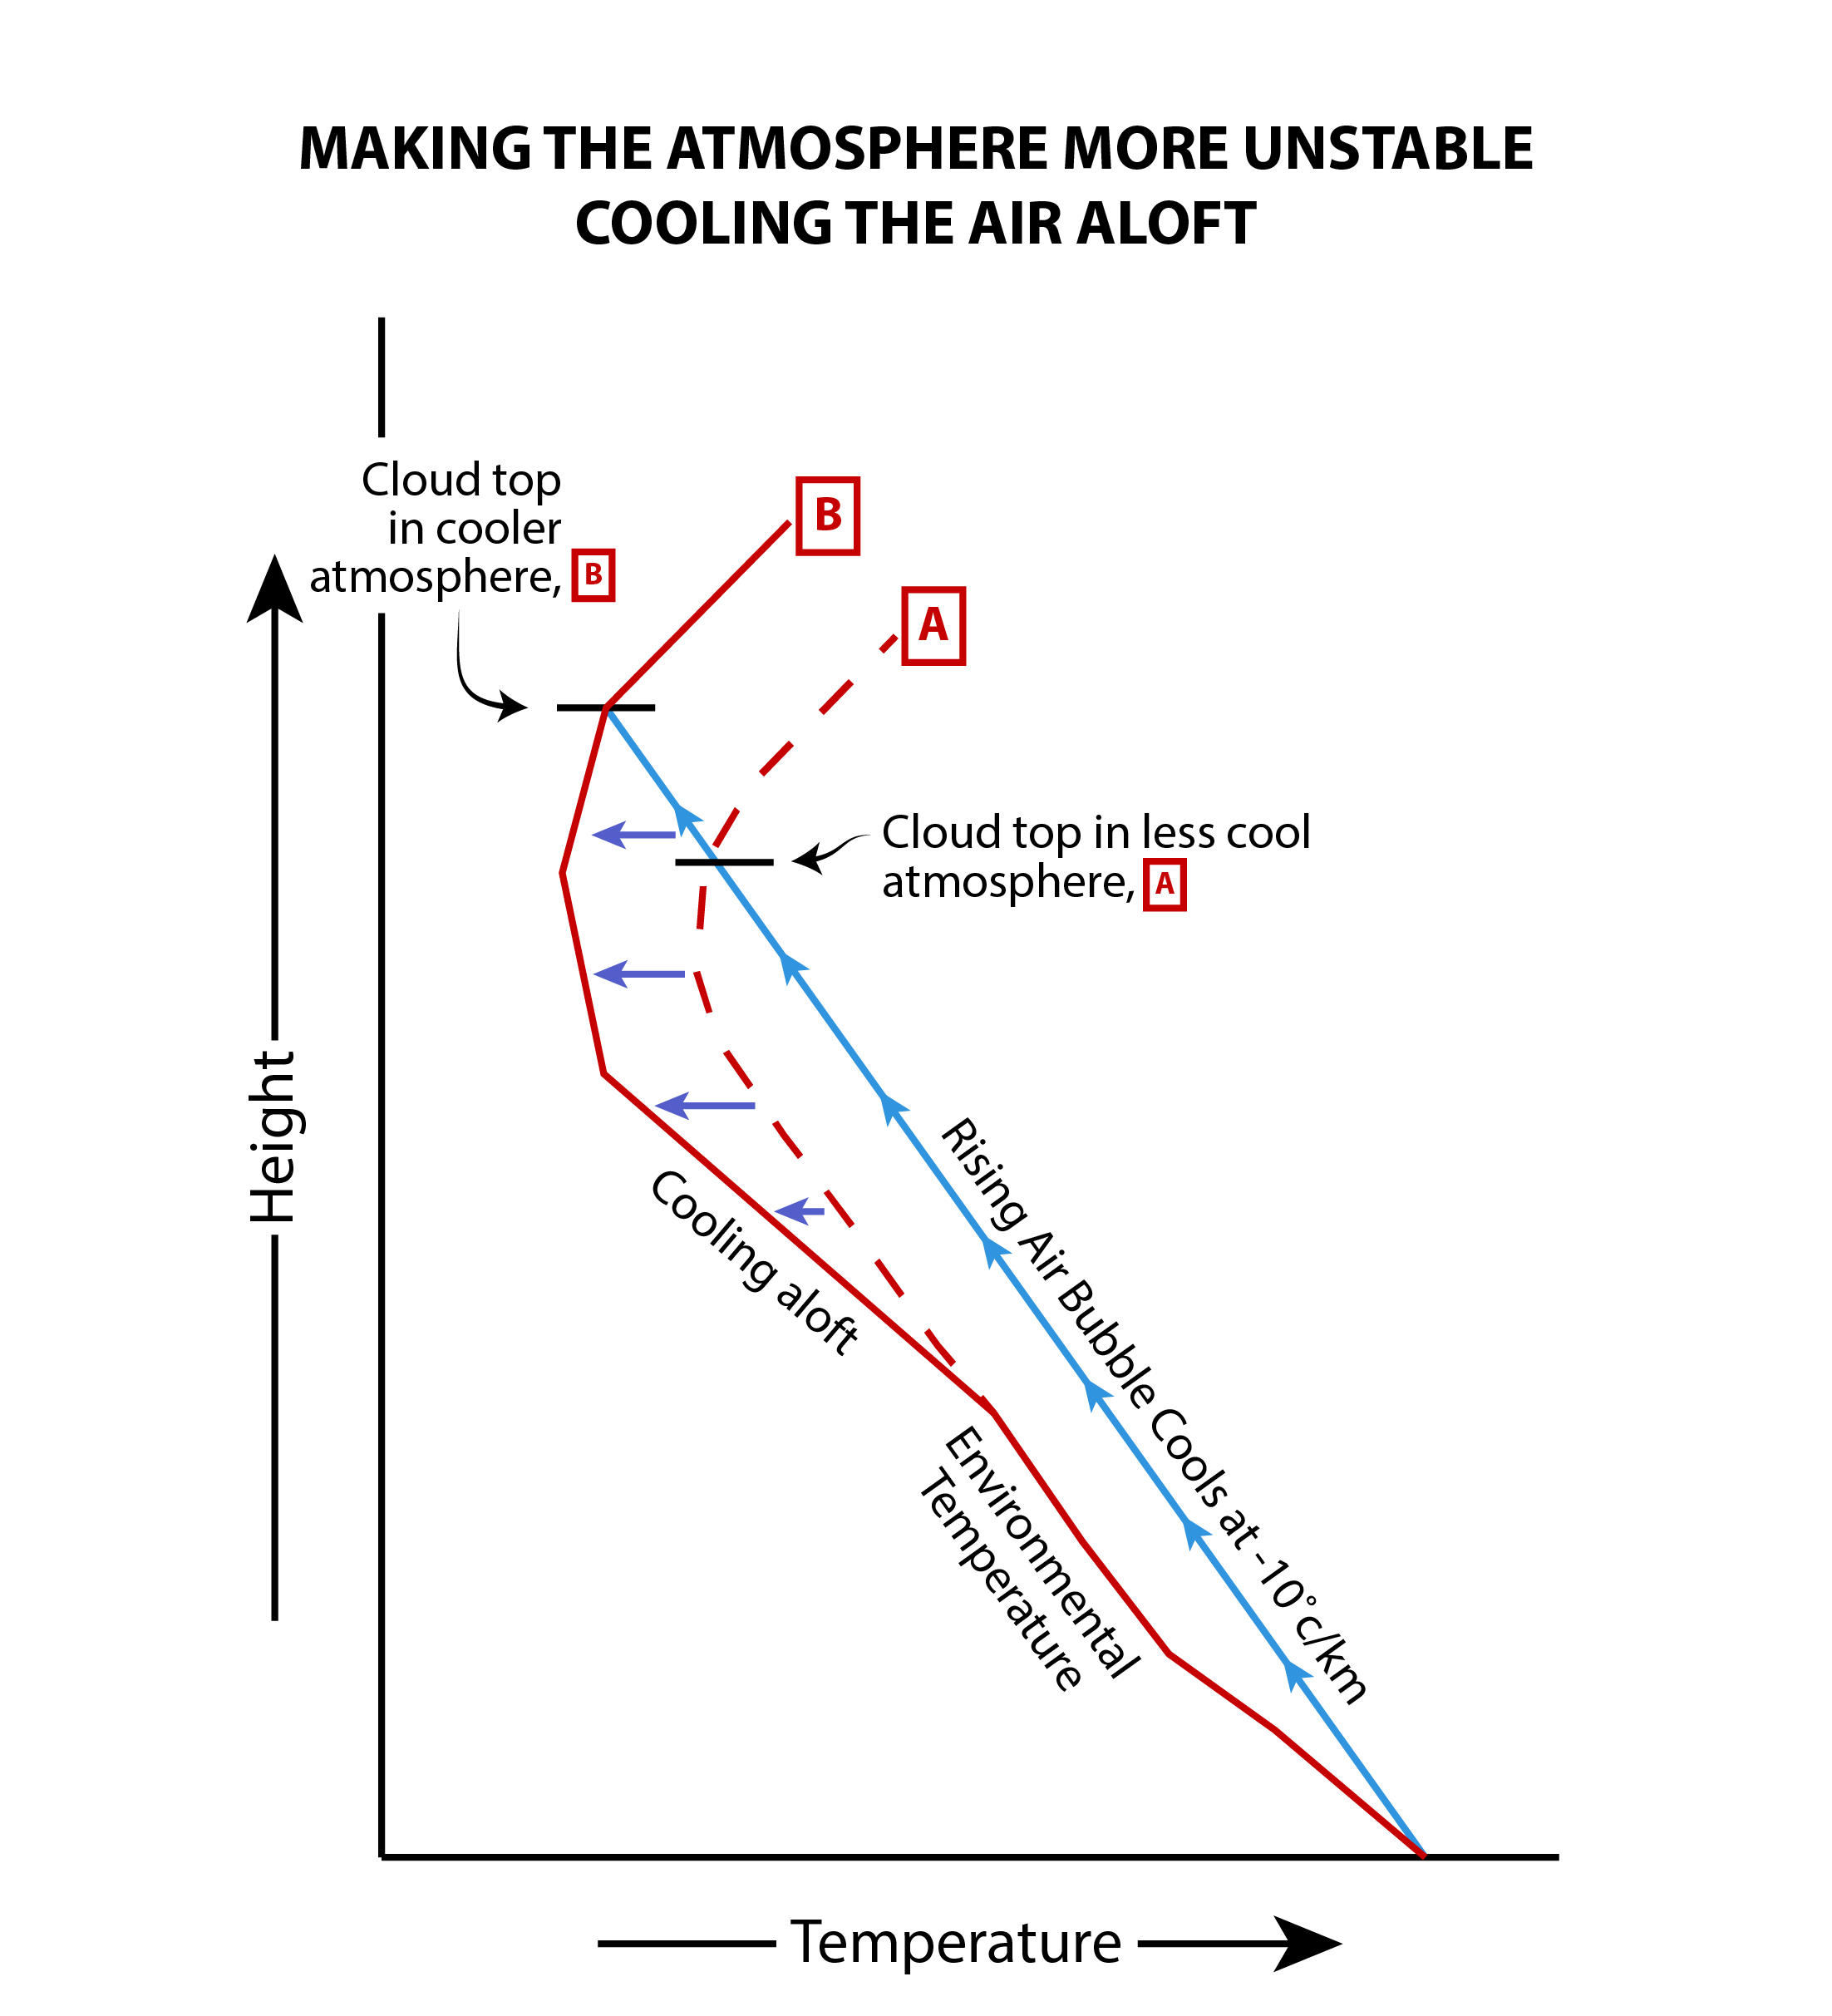
Figure 3.15. Common Processes That Lead to an Unstable Atmosphere
(a) Strong warming of the surface. (b) Cooling of the upper atmosphere.

What happens if instead the surface cools, which normally occurs overnight? The slope of the environmental lapse rate becomes less steep. Now, rising bubbles arrive at upper levels cooler than their surroundings. The bubbles are colder and denser, and thus sink back to the surface. This is a stable atmosphere. In a stable atmosphere, air cannot rise very far on its own, if at all; there is zero buoyancy. A stable air mass cannot develop deep clouds. This is not the same as saying no clouds; cool but nearly saturated air can be forced to ascend the short distance needed to saturate the air and form shallow layer clouds (by orographic lifting, frontal lifting, or convergence). This is a common situation during the cool season, particularly during the winter months. Figure 3.16 illustrates the temperature profiles for a stable atmosphere and the formation of horizontal layer clouds.
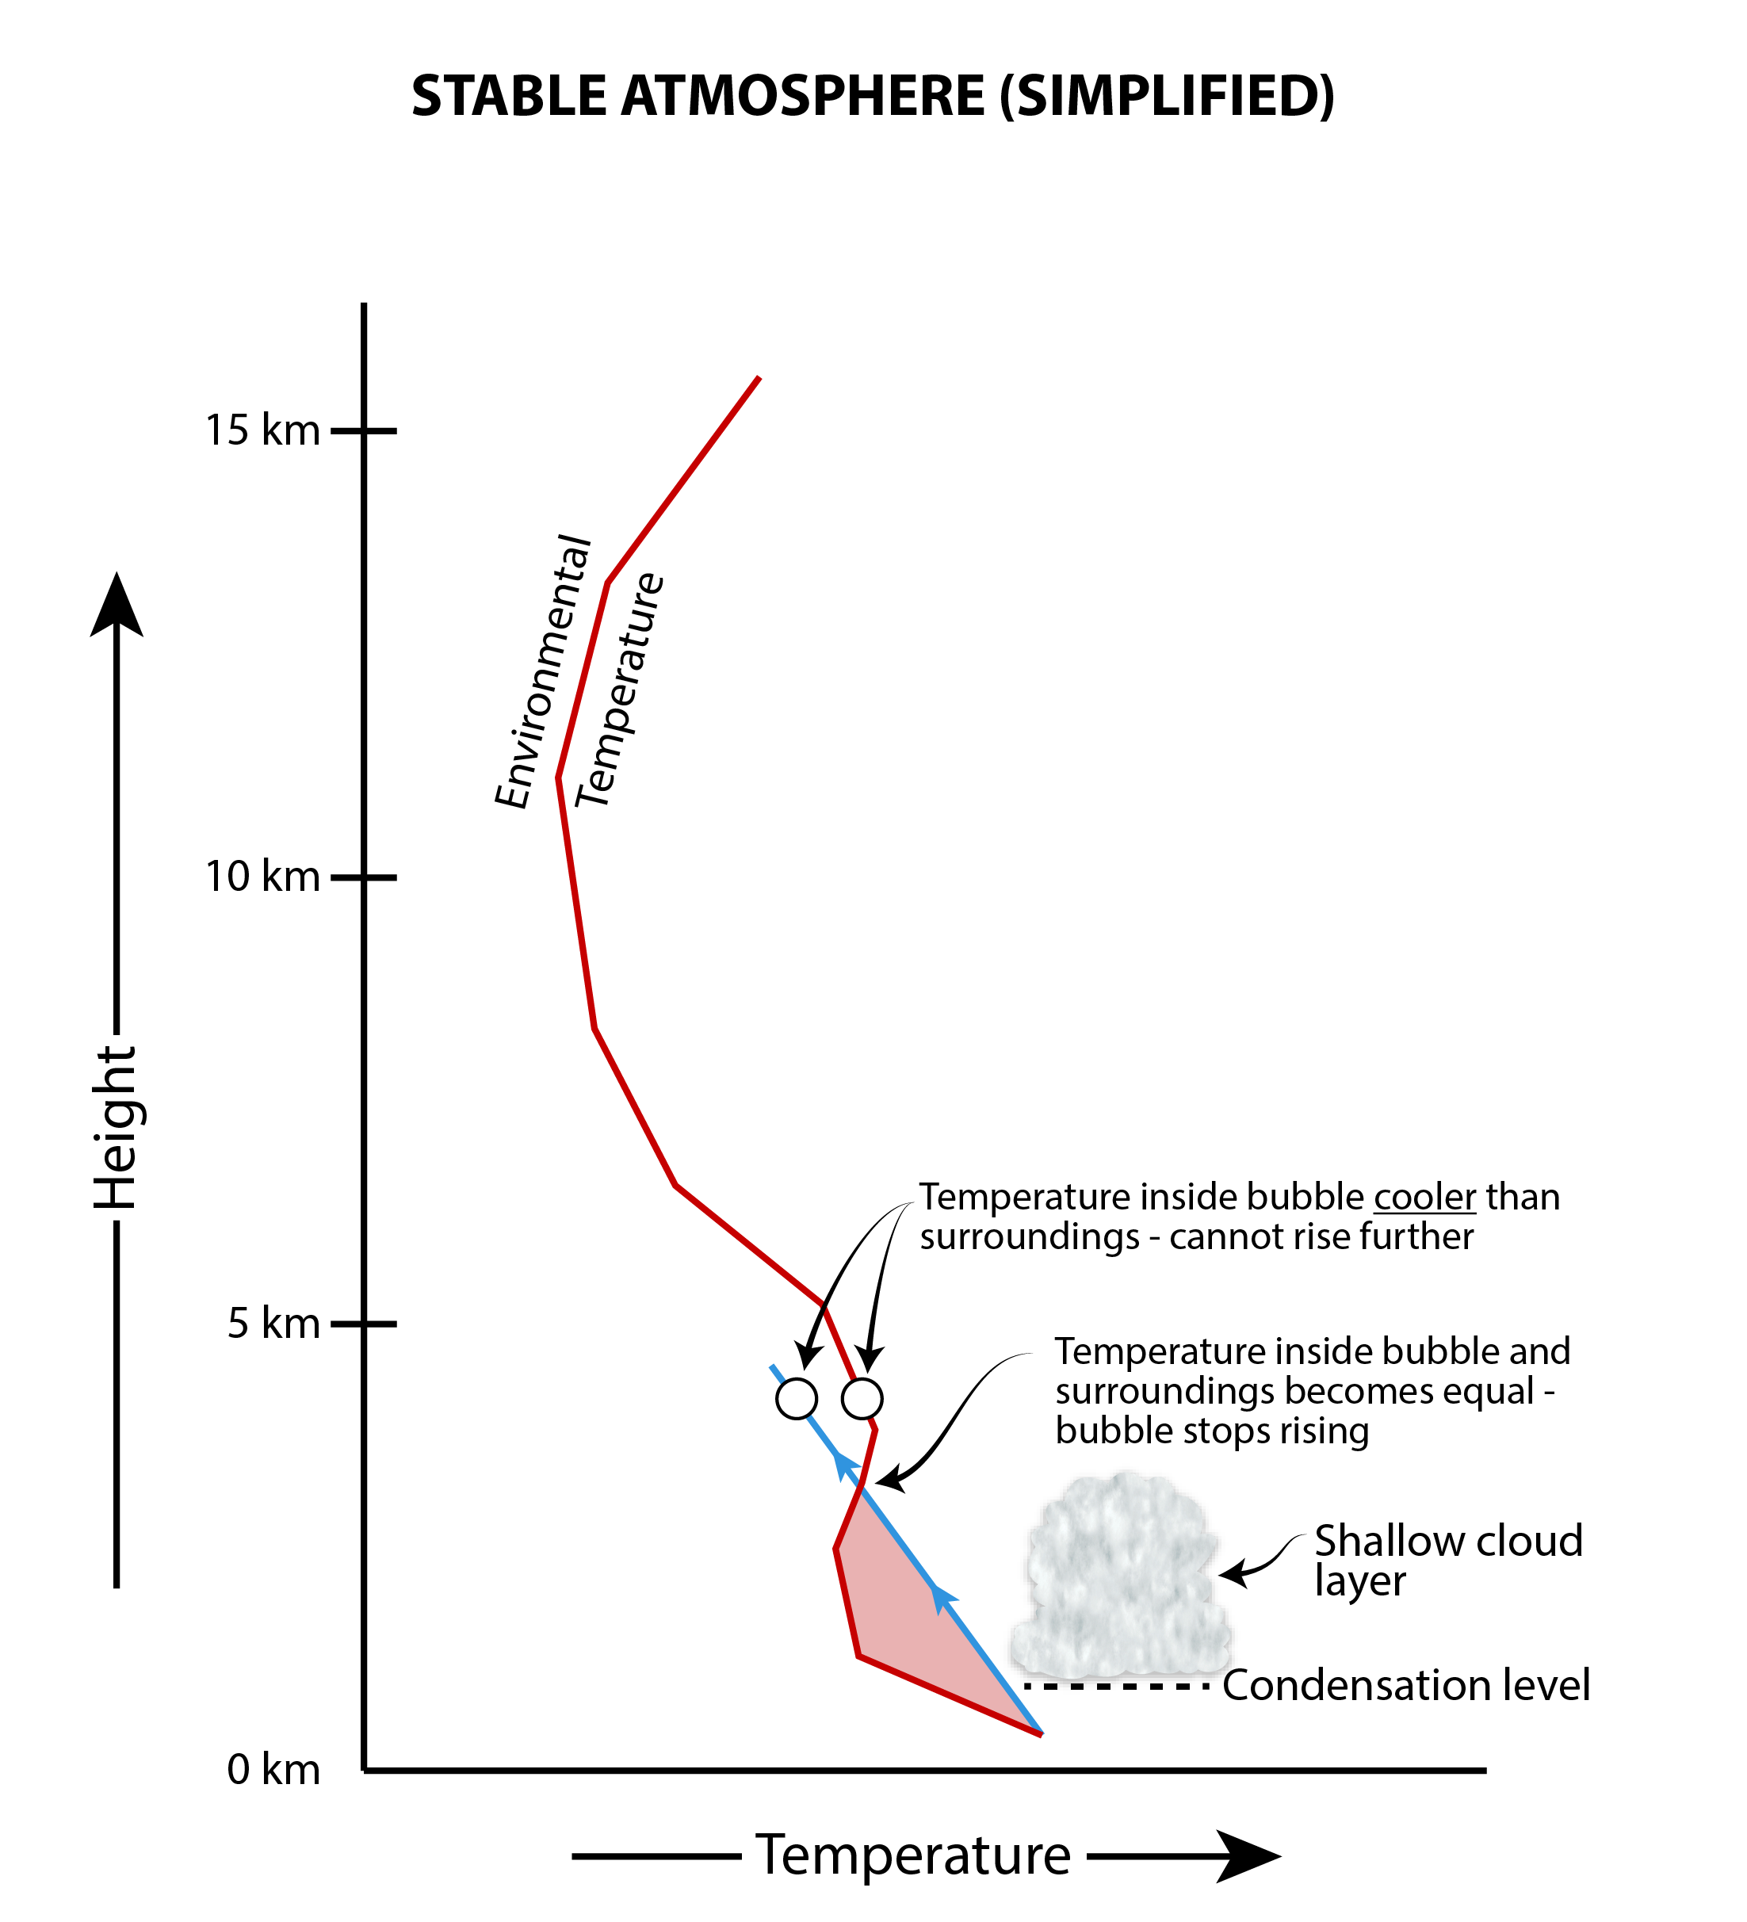
Figure 3.16. Stable Atmosphere
These illustrations compare (a) environmental temperature decreasing at a characteristic lapse rate, and (b) temperature in a rising bubble of air cooling adiabatically at various altitudes. When the temperature inside the blob becomes cooler than its environment, the bubble sinks back toward the surface, inhibiting deep cloud growth. Under these conditions the atmosphere is stable.

For the sake of simplicity, the diagrams in Figures 3.14 through 3.16 omit part of the more complete story, which we cannot ignore. When water vapor condenses to form rain, heat energy is released during the water’s phase change. Rapidly vibrating water vapor molecules possess kinetic energy, a form of heat. When the air containing the vapor cools, vapor molecules lose heat and slow down, enabling them to coalesce into liquid drops. The heat that escapes into the surrounding air is termed latent heat. The heat is “hidden” or latent, not becoming manifest until the water changes phase. As Figure 3.17 shows, there are six forms of latent heat, because water can undergo a total of six phase changes.
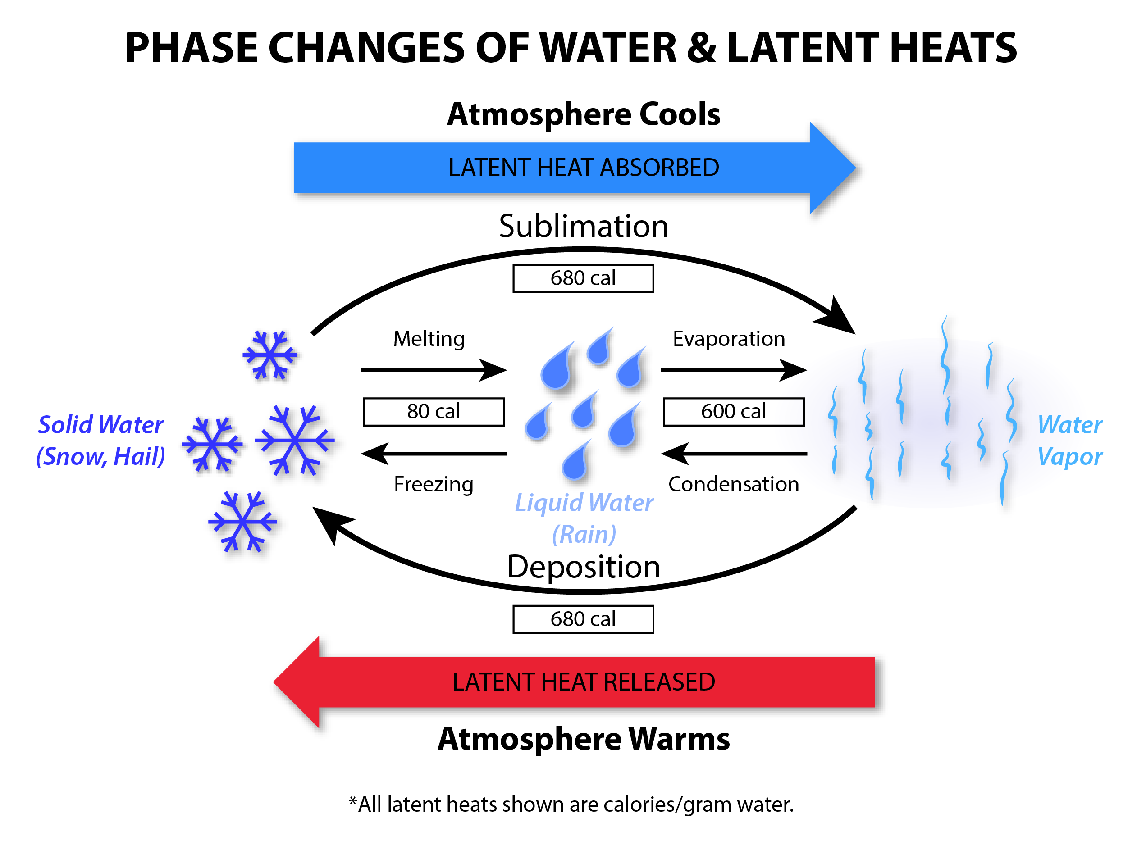
Figure 3.17. Six Forms of Latent Heat
This figure shows the latent heat associated with the six phases changes of water. Heat is absorbed (the air cools) when ice melts and liquid water evaporates. Heat is released (the air warms) when vapor condenses and liquid water freezes.

Both the condensation of vapor into liquid, and freezing of liquid into ice, are associated with the release of latent heat. This heat warms the rising bubbles of air, such that the adiabatic rate of cooling (due to expansion of air) must be reduced. For a bubble of rising air, the adiabatic lapse rate reduces to approximately -6° C/km (-11° F/3300 ft). In other words, some of the adiabatic cooling is offset by the steady release of latent heat.

So, it’s a simple matter to re-assess the definition of an unstable atmosphere, accounting for this more complete understanding of the processes involved. Figure 3.18 illustrates a deep, unstable atmosphere allowing for the release of latent heat inside the growing convective cloud. Figure 3.19 diagrams the process for a stable air mass and layered clouds.
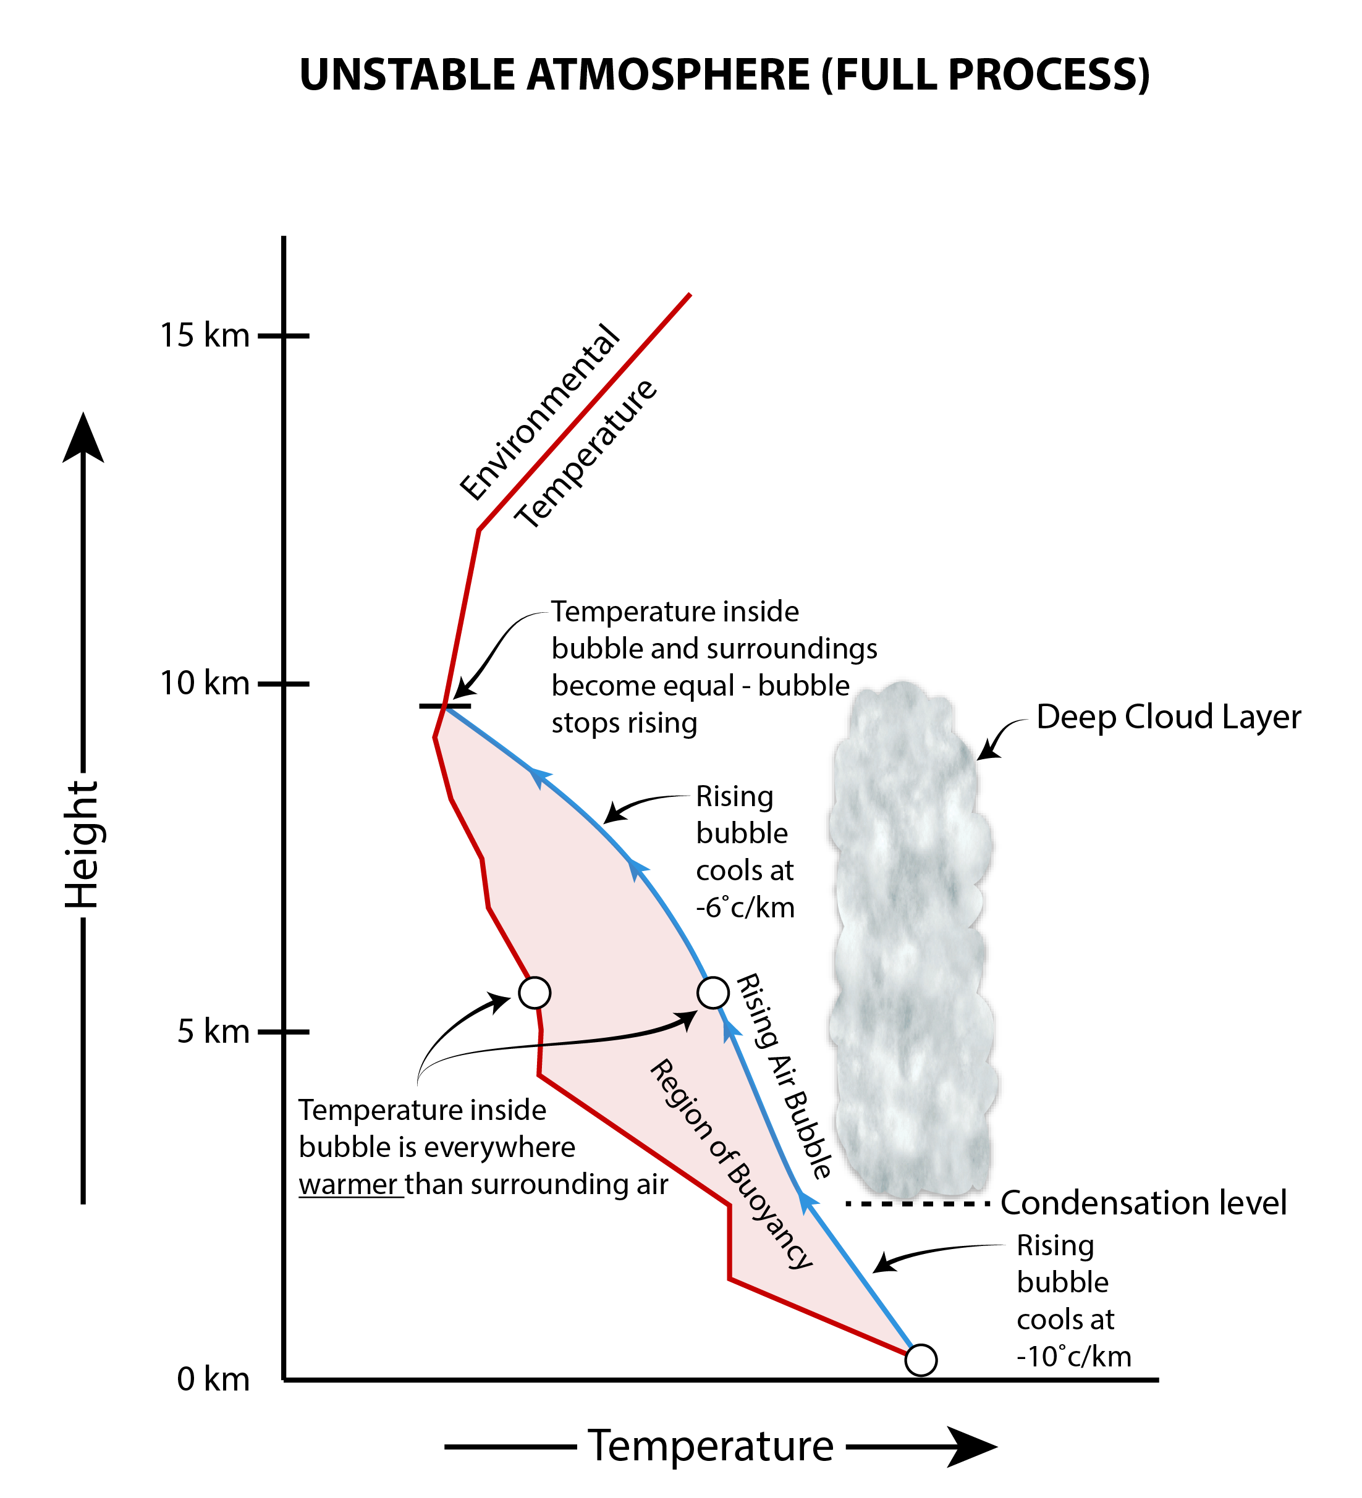
Figure 3.18. Latent Heat and Deep Cloud Formation in an Unstable Atmosphere
This figure shows the processes leading to deep cloud formation in an unstable atmosphere, taking into account the release of latent heat during condensation.
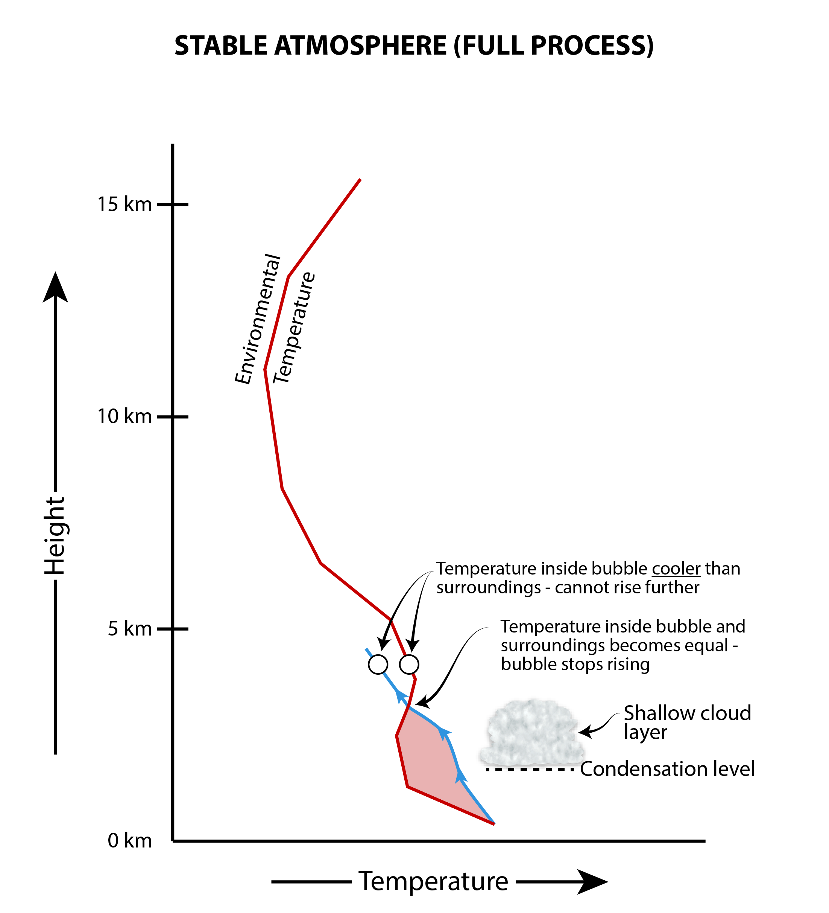
Figure 3.19. Latent Heat and Shallow Cloud Formation in a Stable Atmosphere
This figure shows the processes leading to shallow cloud formation in a stable atmosphere, taking into account the release of latent heat during condensation.

To summarize, the summer months frequently develop an unstable atmosphere, one that enables formation of deep cumulonimbus clouds and severe local storms. The winter months, in contrast, feature a stable atmosphere permitting only shallow clouds. Rain or snow falls from widespread layer clouds called nimbostratus. Compared to thunderstorms, the vertical currents in nimbostratus are very gentle.

[H1] 3.6 Common Precipitation Types in Summer and Winter Settings

In this section, we examine common types of precipitation during the warm and cool seasons across the United States and their association with typical weather systems. We discuss general precipitation patterns, which can develop into the severe local storms discussed throughout this text.

[H2] Precipitation Associated with Extratropical Cyclones

Figure 3.20 presents a conceptual model of an extratropical cyclone (XTC), during the November-December timeframe in the United States. Recall that these large regions of low pressure are associated with widespread uplift of air and weather fronts. Clouds and precipitation develop along the fronts and near the center of the XTC, where air rises most vigorously. This air is cooled to its dew point temperature, leading to saturation, cloud development, and the formation of both liquid and solid precipitation.
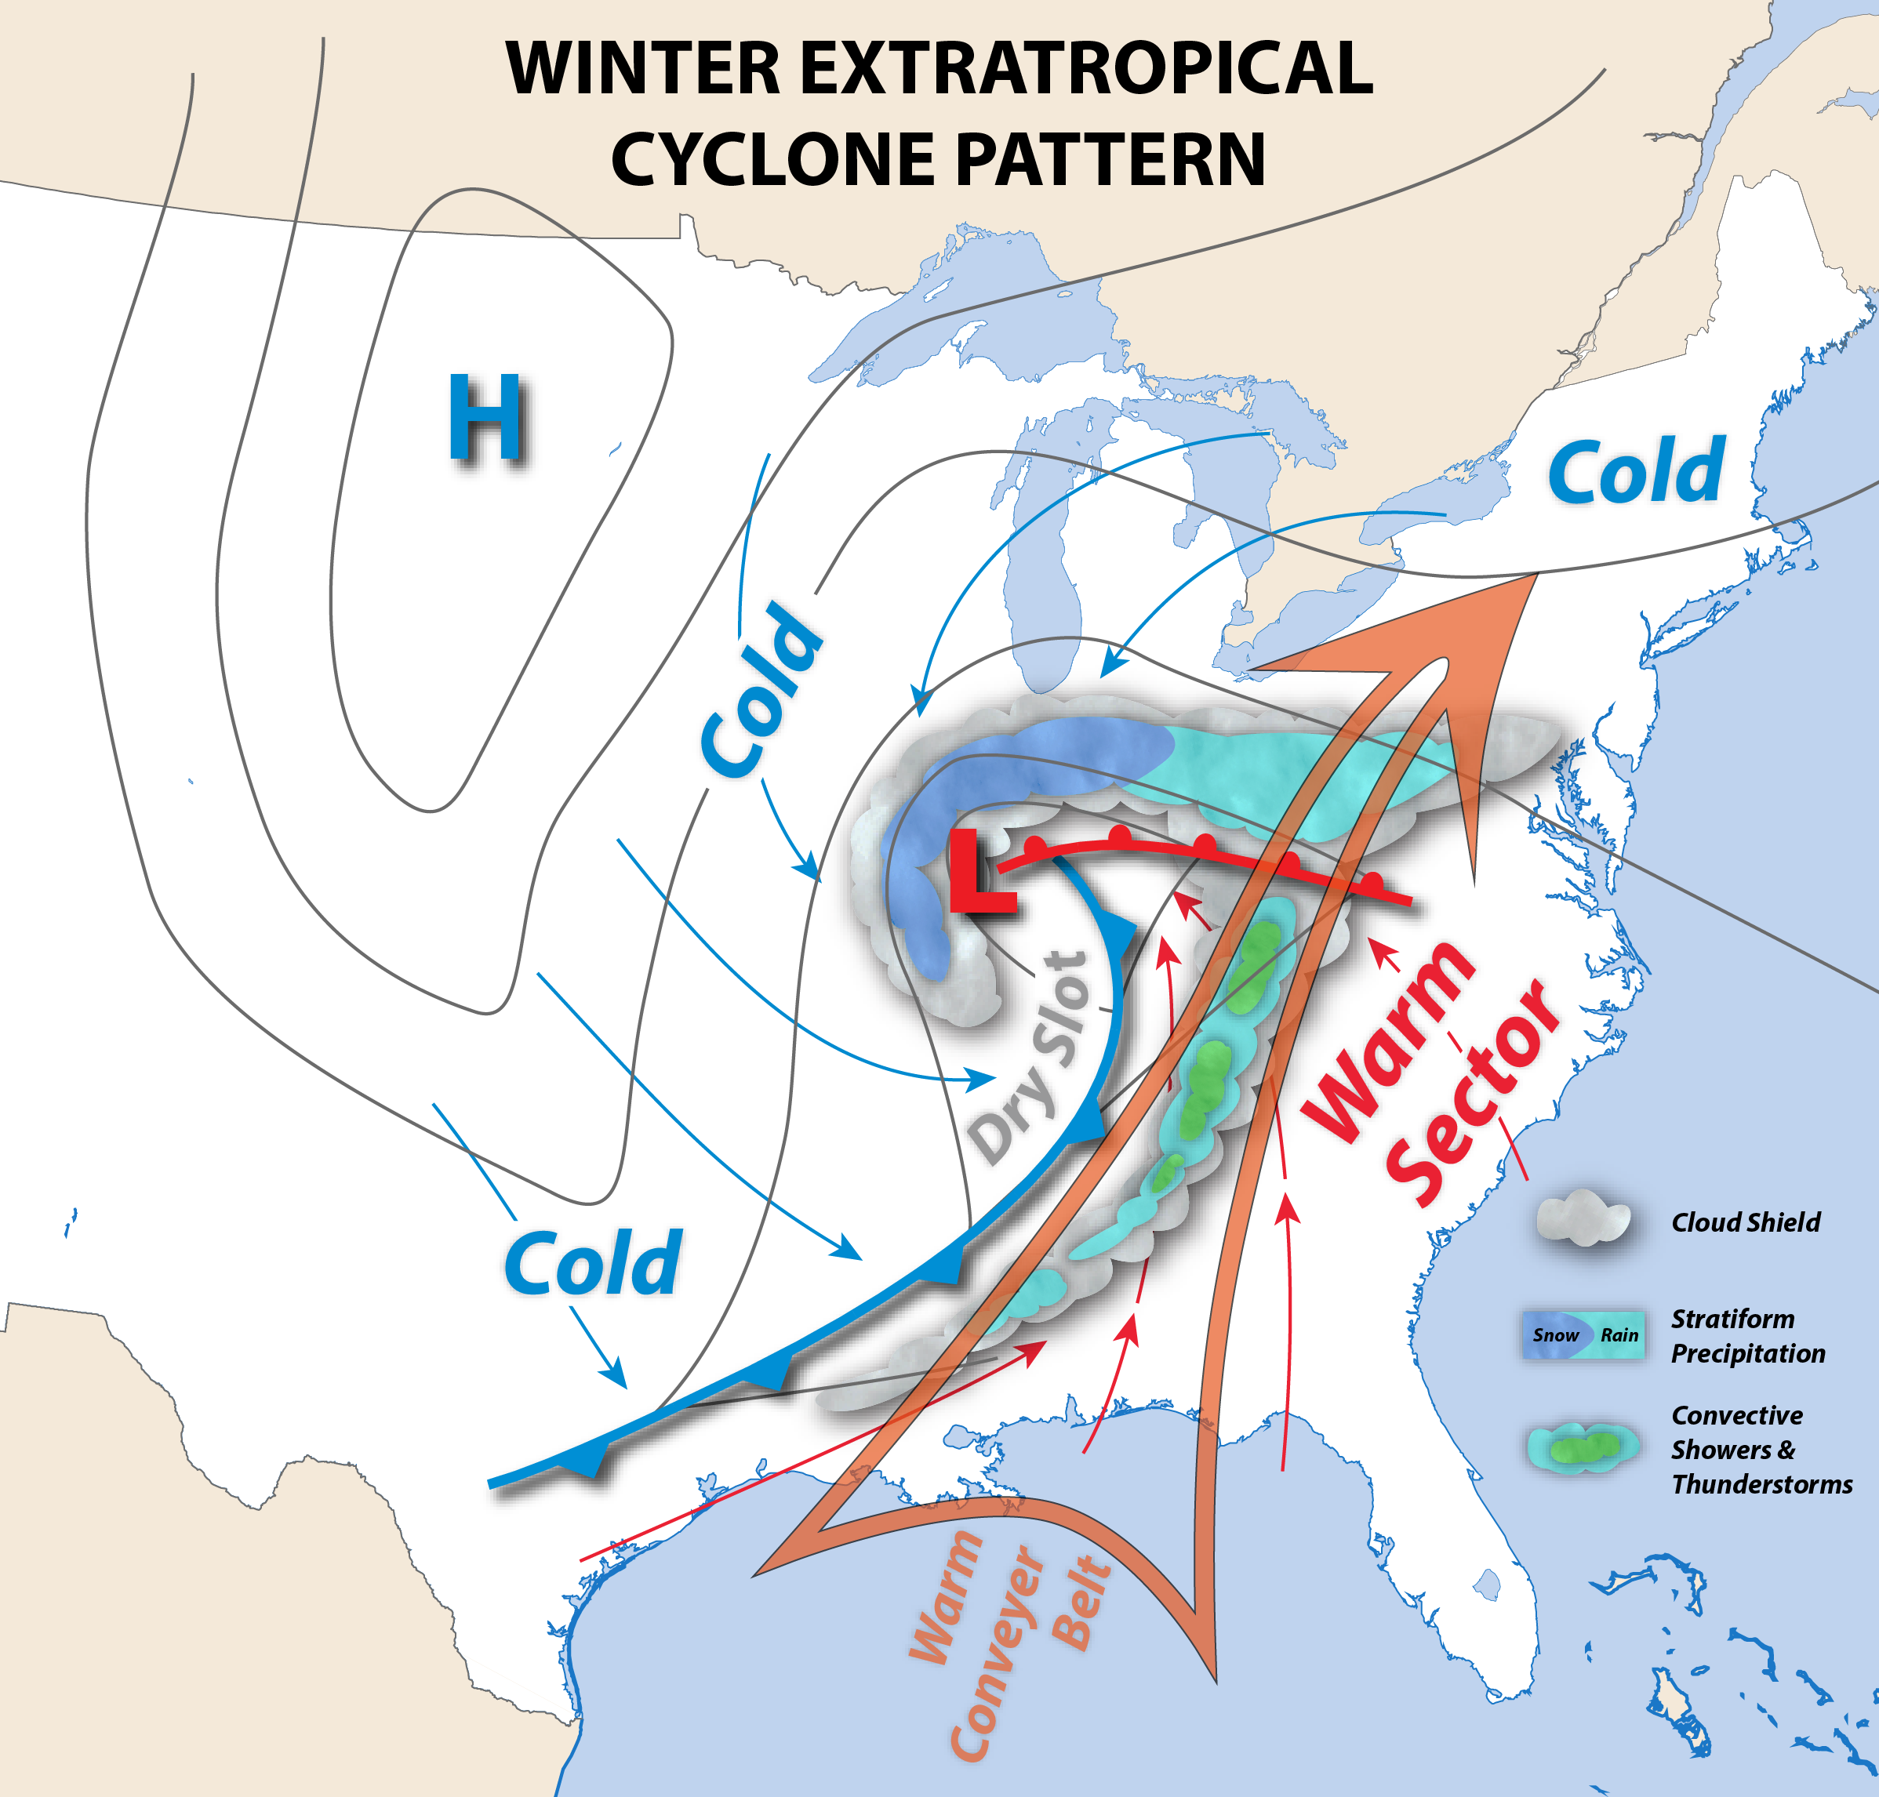
Figure 3.20. Key Features of a Mature Extratropical Cyclone During the Late Fall or Early Spring.
Thin arrows represent general airflow.. Thick arrows show the warm conveyor belt and dry slot. The cold front and warm front are also indicated, along with general regions of precipitation.

The triangular-shaped region on the south and east side of the XTC is the warm sector. Within the warm sector, low-level airflow streams from the south, causing temperatures and humidity to rise. The warm, humid air mass comes from tropical latitudes. Because the air warms strongly at low levels, the atmosphere becomes unstable. The warm sector is thus conducive to convective showers and thunderstorms. The showers and storms may organize into one or more bands in which rainfall is enhanced. A particularly prominent and intense band develops along the cold front. The cold frontal band may develop along the front, immediately behind the front, or up to several hundred miles (kilometers) in advance of the front. Heavy rain sometimes develops along a narrow corridor of strong, low-level southerly flow, called a warm conveyor belt. Very humid air in this corridor can generate prolonged heavy rain and flash flooding.

Figure 3.21 shows examples of these rain patterns using weather radar images. If surface temperatures fall below freezing (for example, in January-February), heavy snow showers develop along the cold front, leading to snow squalls. During the spring, the warm sector becomes a place where violent weather is born. Severe thunderstorms may develop, accompanied by large hail, high winds, and tornado outbreaks.
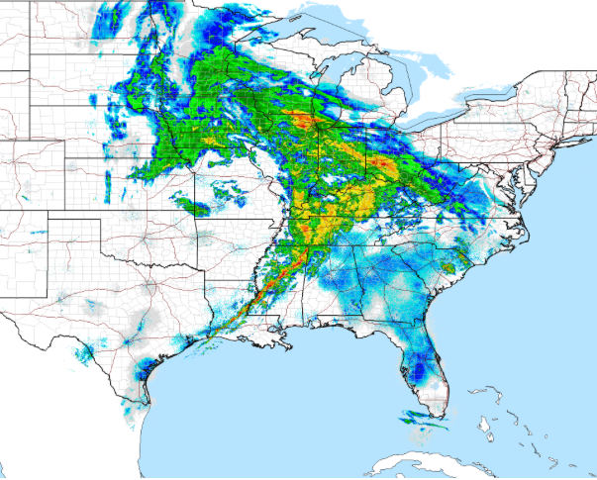
Figure 3.21 Rain Patterns in and Around an Extratropical Cyclone
Banded, heavy precipitation structures are found in various locations in and around an extratropical cyclone, as this weather radar image illustrates.

Another significant region of precipitation lies along and north of the warm front. Along this front, air from the warm sector glides above a layer of colder, denser air north of the front. The cold and humid air mass approaches the center of the XTC as a low-level, easterly air current. Because cool surface air lies beneath warm air aloft, the atmosphere is stable and resists the strong, buoyant air motions associated with convective storms. However, the forced ascent of air up the incline or “wedge” of cold air does lift the air until it cools to saturation. Horizontally extensive layers of nimbostratus cloud develop along and north of the warm front. Widespread gentle to moderate precipitation, called stratiform precipitation, falls from these clouds. This type of rain is unlikely to lead to flooding. During winter, with subfreezing air beneath the cloud deck, various forms of frozen precipitation develop, including snow, sleet, and freezing rain. Extensive layers of non-precipitating cloud often extend far to the north and east of the stratiform precipitation shield, leading to overcast sky conditions many hours before the precipitation’s arrival. Figure 3.22 shows a radar depiction of stratiform rain contained within a larger XTC.
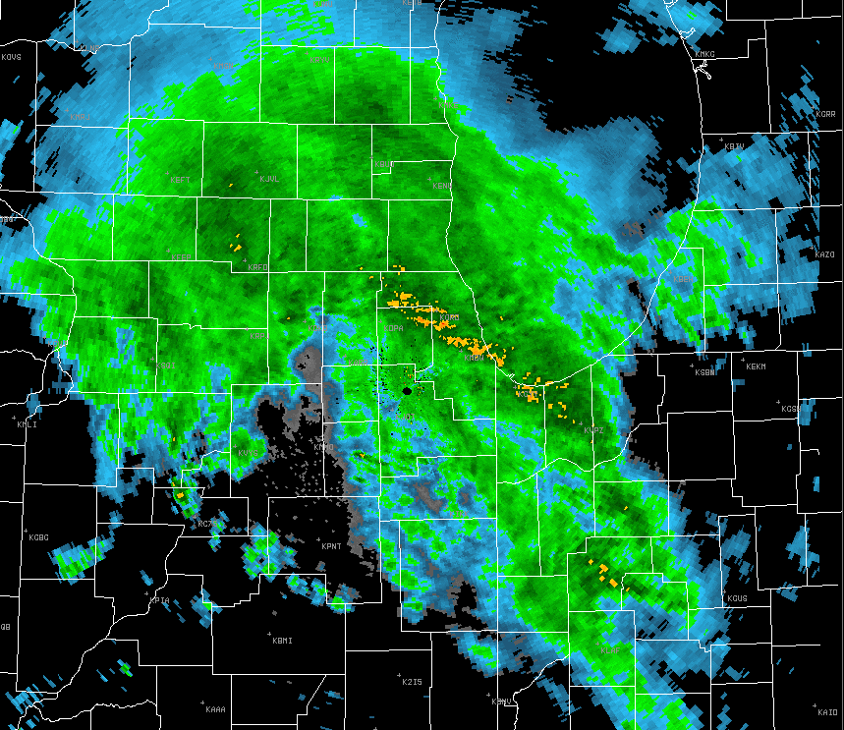
Figure 3.22 Stratiform Rain in an Extratropical Cyclone
This radar image shows extensive stratiform rain in an extratropical cyclone along with some banding due to heavier (convective) clouds.

Wrap-around cloud[s?] and precipitation usually extend to the north and west on the cold-air side of the XTC. Here, cold, dry, low-level winds stream down from the north. This air near the surface is often too dry to support precipitation, but residual moisture entering the storm from aloft, and from the east, is sufficient to saturate the cold air. In subfreezing conditions, one or more bands of heavy snow develop about 150-200 miles to the north and west of the XTC center.

At times, banded precipitation also develops within the large mass of stratiform precipitation. These narrow bands arise if small pockets of mildly unstable air develop, and they can lead to brief periods of heavier precipitation. The embedded bands are most often arranged parallel to the main warm front.

As Figure 3.20 shows, a cloud-free zone called the dry slot often develops behind the cold front and comma head cloud structure. The dry slot is caused by very dry air sinking and warming adiabatically from high altitudes. The warm, dry air strongly suppresses any tendency for uplift, cooling, and saturation. At the surface, immediately after the cold front passes, rain tapers, clouds clear, and the winds kick in from the west-northwest. The air also abruptly cools and dries as Canadian air begins to arrive from the northwest.

[H2] Precipitation Associated with Summertime Convective Storms

During the summer months in the United States, the polar jet stream weakens and retreats to the north, over southern Canada. Extratropical cyclones are fewer in number and not as intense as during the cool season, and they track along the northern tier of the United States, impacting the Upper Midwest, Great Lakes, and New England. Much of eastern United States comes under the influence of a broad dome of high pressure called the Bermuda High, which also extends across the entire western and central Atlantic at low latitudes (Figure 3.23).

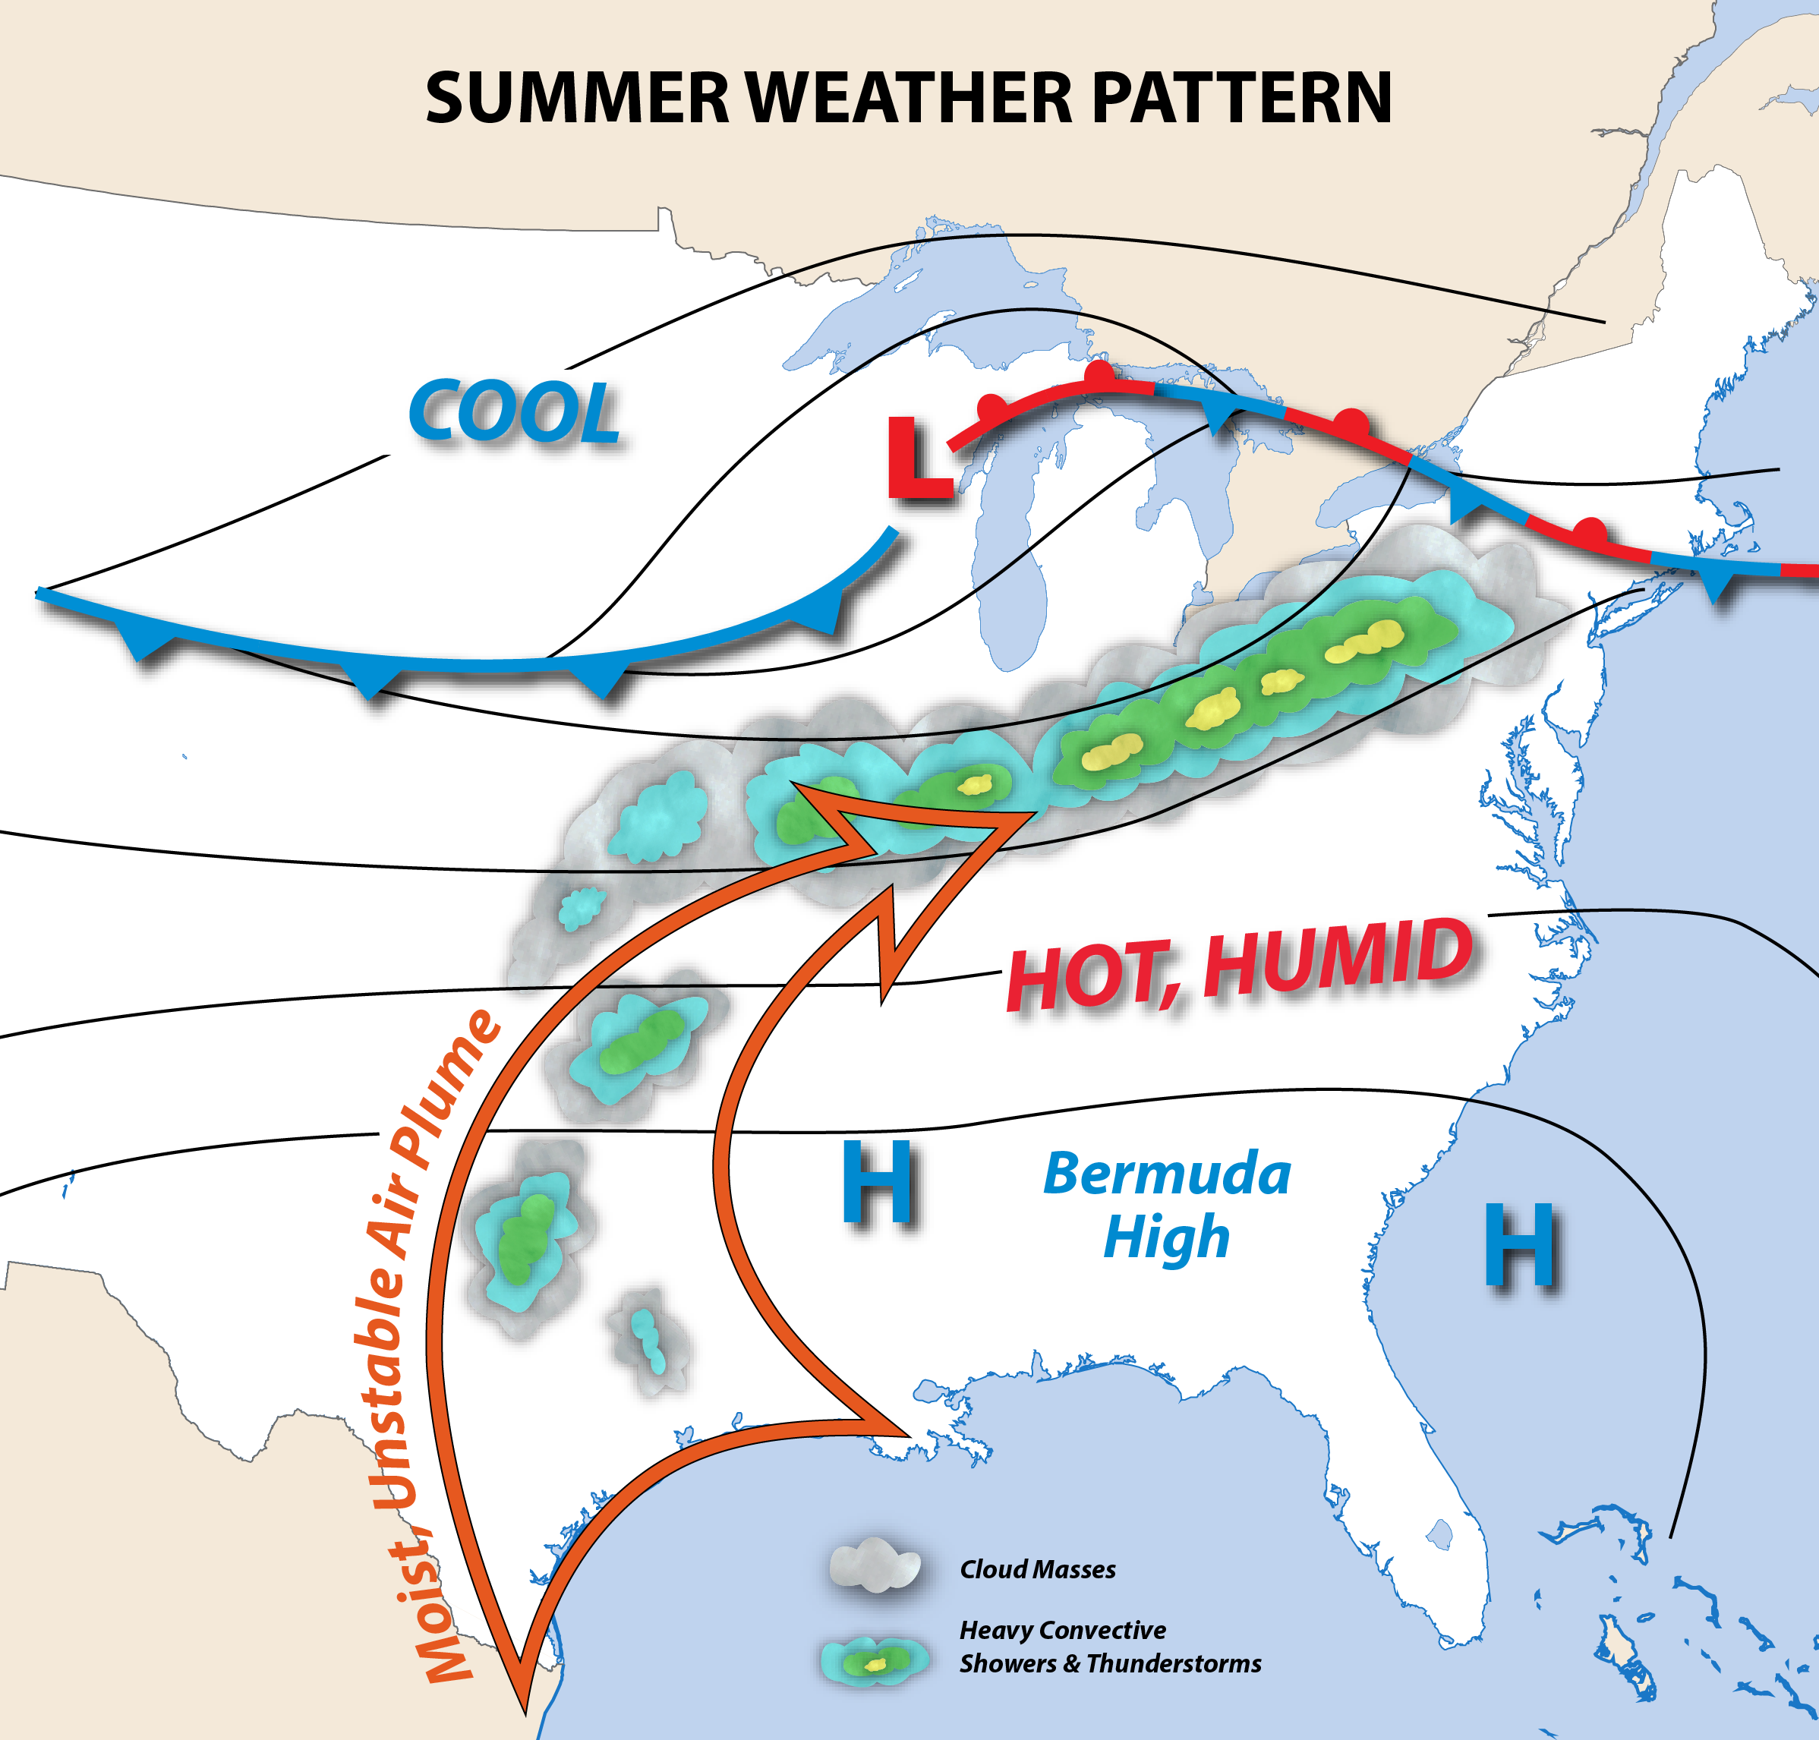
Figure 3.23 Principal Summertime U.S. Surface Weather Systems
This schematic illustrates principal surface weather systems on a typical June or July day across the United States, including the large Bermuda High and weak extratropical cyclones moving west to east across southern Canada.

Within the core of this high-pressure cell, air sinks for many miles, leading to a dry, warm, and stable air mass across its center. But on the western edge of the Bermuda High, low-level air spirals outward toward the north and west. The lower levels of this southerly current are warmed and humidified by the Caribbean Sea and Gulf of Mexico, while the hot land surface further heats the air. A strongly unstable air mass develops over the entire central and eastern United States. Localized, heavy convective showers and thunderstorms become the prevailing weather maker, leading to a hit-or-miss variety of rain (Figure 3.24).
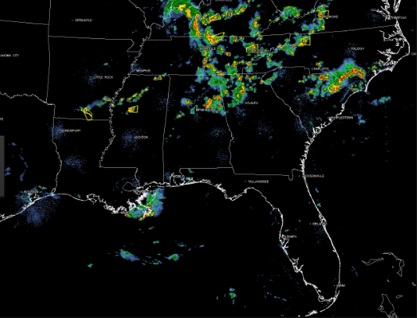
Figure 3.24 Convective Shower and Thunderstorm Activity Across the United States on a Typical Summer Day
Contrast this figure with Figure 3.22, which shows typical precipitation patterns associated with a cool-season weather system.

Prospects for stratiform rain are greater along the northern tier of the United States, associated with the passage of multiple, weak XTC. Infrequently, the cold front from one of these XTC will extend southward into the central Plains and Mid-Atlantic, triggering a narrow band of strong or even severe thunderstorms.

Summertime thunderstorms can still organize into intense clusters and lines by other processes. The largest of these systems produces copious rain and flooding across the Midwest and Ohio Valley, especially at night. This type of storm, called a Mesoscale Convective Complex, is illustrated in Figure 3.25. Another type of especially violent convective storm system called a derecho (Figure 3.26) commonly develops east of the Rockies, bringing widespread wind damage across regions up to 1000 miles (1,610 km) long.
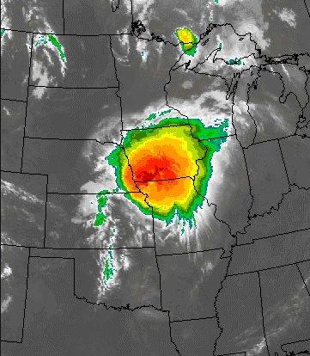
Figure 3.25 Mesoscale Convective Complex (MCC)
This satellite image shows a typical Midwestern Mesoscale Convective Complex (MCC). This enormous aggregate of thunderstorms frequently produces widespread flooding and other forms of severe weather during the summer.
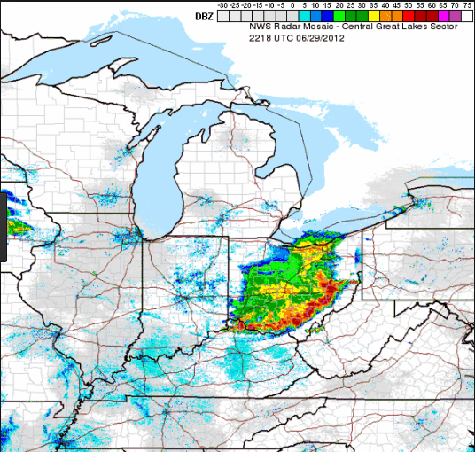
Figure 3.26 Derecho
This radar image shows a rapidly moving derecho on June 30, 2012 which produced widespread severe wind damage along a 1000-mile long corridor, knocking out power to nearly 9 million customers.

In the western United States, summertime convective storms are more limited, given the lower prevailing dew point values. But the high, mountainous terrain triggers afternoon thunderstorm growth, as heated surface air rises along mountain slopes. This orographic convection (or mountain-induced convection) leads to spotty rain. Occasionally severe thunderstorms erupt along Colorado’s Front Range and the U.S. Southwest, associated with a monsoon rain pattern that develops from June through August. Figure 3.27 provides a radar snapshot of orographic summer rains.
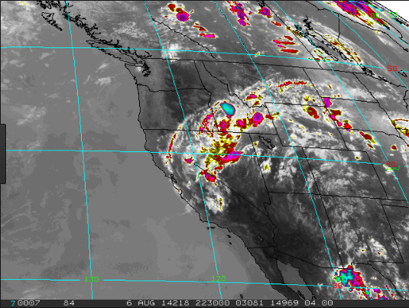
Figure 3.27 Orographic Summer Rains
This satellite image shows numerous thunderstorm cells dotting the mountainous landscape of the western United States. Many of the storms are tied to mountain slopes, where prevailing winds force warm and humid air to rise.

[H1] Chapter Summary

Common Measures of Atmospheric Humidity: Dew Point Temperature and Relative Humidity

LO3.1 Distinguish among humidity, dew point temperature, and relative humidity, and describe how these values typically vary with time of day, by season, and across geographic regions.

- Humidity refers to any measure of atmospheric water vapor content. Dew point temperature describes the degree of cooling needed to fully saturate the air. Relative humidity is a ratio that reflects the percentage saturation of air, for a given temperature and water vapor content.
- Dew point temperatures are uniformly higher across the United States during summer than they are during winter. Within each season, the dew point tends to be lower (drier air) over the continental interior, away from oceans, and at high altitude.
- Relative humidity varies strongly with air temperature, being lowest during the afternoon and highest during early morning, as long as water-vapor content is held constant.

How Air Becomes Saturated

LO3.2 Discuss two ways in which air becomes saturated and describe adiabatic cooling of air.

- Air can be saturated by increasing the evaporation rate at constant temperature, or b cooling the air at constant dew point temperature.
- Air most commonly cools to saturation by rising and undergoing an adiabatic expansion.
- During an adiabatic expansion, the internal energy and hence temperature of the air decreases, cooling at a rate of -10° C/km of ascent.
- Air rises by four main mechanisms: (1) flowing up a mountain slope, (2) lifting along a front, (3) converging and rising into a low-pressure center, and (4) rising freely due to its internal buoyancy.

Growth of Cloud Droplets and Formation of Rain

LO3.3 Explain how supersaturation, cloud condensation nuclei, and collision-coalescence lead to growth of cloud droplets.

- Condensation of cloud water involves the aggregation of water vapor molecules around a microscopic condensation nucleus suspended in air, often a grain of dust or an ash particle.
- Condensation also requires that the air be cooled to the point of slight supersaturation.
- Raindrops are over a million times more massive than cloud droplets, and require an efficient growth process occurring in as little as 15-20 minutes.
- The process of collision-coalescence enables an exponentially increasing rate of cloud droplet growth to the size of raindrops.

3.4 Growth of Ice Crystals and Snow in Clouds

LO3.4 Define supercooled water and explain how it relates to the formation of small ice crystals in subfreezing clouds; distinguish between vapor deposition and riming.

- Liquid cloud droplets do not spontaneously freeze. Rather, they remain as supercooled liquid droplets and require a microscopic ice nucleus upon which to freeze into ice crystals.
- Small ice crystals grow by direct deposition of vapor, at the expense of liquid water droplets in a cloud. Ice crystals, in turn, aggregate into larger crystal clumps called snowflakes.
- Small supercooled water drops in a cloud may spontaneously freeze into large ice particles upon colliding with an ice crystal, a process called riming.

3.5 Atmospheric Stability and the Formation of Thunderstorms and Layer Clouds

LO3.5 Explain why an unstable air mass leads to rapid growth of the deep convective clouds associated with heavy rain showers and hail.

- An unstable air mass, typical of summertime, occurs when a rising bubble of air cools at a slower rate than the surrounding air, such that the bubble remains buoyant.
- An unstable air mass permits growth of convective clouds to deep altitudes, forming thunderstorm (cumulonimbus) clouds.
- The large amounts of humid air entering into a thunderstorm cloud permit large amounts of condensed water to form, leading to heavy but localized rain showers.
- A stable air mass is one that suppresses deeply rising air. In a stable atmosphere, cloud formation requires air to be forcefully lifted upward a short distance, resulting in thin but widespread stratiform clouds.

3.6 Common Precipitation Types in Summer and Winter Settings

LO3.6 Describe how regions of precipitation are developed and arranged in a typical extratropical cyclone (cool-season weather pattern) and during the summer months.

- During the winter months, extratropical cyclones create widespread, forced uplift of relatively stable but moist air, leading to extensive layer clouds and regions of precipitation (including snow and ice when the surface air is below freezing).
- The warm sector of an extratropical cyclone may feature unstable air, with bands of convective showers and thunderstorms, particularly during the spring months – leading to outbreaks of severe weather (for example, tornadoes).
- The summertime weather pattern over the eastern United States is mainly dominated by the large Bermuda High, featuring unstable air with hit-or-miss, heavy convective rains. The mountainous West also features an unstable air mass with thunderstorms controlled by warm air rising up steep mountain slopes.
List of Key Scientific Principles Covered In This Chapter
Note to the student: Many of these “first principles” will be called out in later chapters, as a reminder of an important physical process or definition, to aid in your understanding of more advanced material.

3.1 Atmospheric humidity is any measure of the amount, concentration, ratio or percentage of water vapor in the air.

3.2 Evaporation is a change in phase of water from liquid to vapor, requiring the input of heat (latent heat of evaporation) from a free water surface, or the air. Evaporation varies as a function of temperature, in an exponential manner i.e. warmer temperatures can evaporate vastly larger amounts of vapor than cooler air.

3.3 Transpiration is the diffusion of water vapor into the air from small openings in leaf surfaces from grass, trees, corn stalks, etc.

3.4 Air becomes saturated when the maximum amount of water evaporates into the air, from a free water surface; any further increase in vapor mass will lead to condensation.

3.5 Air can become saturated in two ways: (1) cool the air, while holding the amount of water vapor constant; and (2) evaporate additional vapor into the air, while holding air temperature constant.

3.6 The dew point temperature is that temperature at which air must be cooled in order to reach saturation. Dew point temperature is proportional to the amount of vapor mass in the air.

3.7 The dew point temperature commonly decreases with increasing latitude and altitude across the U.S., and reaches higher values during the summer than during winter. It is largest along the Gulf Coast states during summer, and lowest at high elevations in the Desert Southwest during winter.

3.8 The relative humidity is a percentage expressing how close the air is to saturation. It is the ratio of the amount of vapor in the air, to the maximum amount of vapor if the air were saturated. Relative humidity depends on both vapor content and air temperature.

3.9 Throughout a 24-hr period, relative humidity varies strongly with the change in air temperature (assuming constant values of vapor content); it reaches its highest value in the early morning, when the air is coolest, and its lowest value during the late afternoon during high temperature.

3.10 The most common way that air cools to saturation involves the ascent, expansion and adiabatic cooling of a humid air parcel. Adiabatic cooling comes about as an expanding parcel loses internal energy. The parcel cools at a rate of 10 C/km of ascent (as long as it remains unsaturated).

3.11 Four ways that moist air can be lifted to saturation include isolated rising bubbles or thermals, orographic lift (forced ascent up a mountain slope), frontal uplift, and convergence of air into a region of low pressure.

3.12 Air that has been lifted becomes slightly supersaturated before the first condensed cloud droplets form, on the order of 100.1% to 100.5%.

3.13 Condensation describes the phase change of water vapor, in supersaturated air, to liquid cloud droplets. The surrounding air is warmed by the release of latent heat of condensation.

3.14 The formation of microscopic cloud (or fog) droplets requires a slight amount of supersaturation and the presence of cloud condensation nuclei, which serve as tiny “staring points” upon which a small sphere of liquid water can condense.

3.15 Growth of microscopic cloud droplets to macroscopic, precipitating size occurs rapidly by a chain-reaction (unstable) type of process within the cloud, termed collision-coalescence (warm cloud process).

3.16 Cloud droplets and rain drops commonly exist in a supercooled state, remaining liquid down to temperatures of -40 C.

3.17 Between temperatures of 0 C and -40 C, thick clouds contain a mixture of liquid (supercooled) and frozen forms of precipitation; the layer is termed the mixed-phase region and it plays a critical role in the electrification of thunderclouds and formation of hail inside thunderstorms.

3.18 In the very cold, upper regions of a summertime thundercloud, or in the shallow, layered clouds of winter, microscopic ice crystals in sub-freezing air develop when vapor deposits directly onto microscopic ice condensation nuclei. This process is termed vapor deposition.

3.19 Snowflakes in a sub-freezing cloud commonly develop when ice crystals aggregate or clump together, while being jostled by turbulent air motions, settling through the cloud or being lifted by rising air.

3.20 When a mixed phase region of the cloud contains abundant supercooled water, small, conical ice particles called graupel develop from a process called riming (accretion and instant freezing of liquid water onto a tiny ice grain). Continued growth of graupel to hailstones occurs when a strong cloud updraft levitates ice particles within the mixed phase region for long periods of time.

3.21 The cold cloud processes in subfreezing clouds, described by vapor deposition, aggregation and riming, lead to a significant production of rain in cloud systems during both summer and winter; the rain forms as descending ice particles (crystals, snowflakes, graupel, hail) melt upon encountering a warm air layer above the surface.

3.22 Air mass stability describes the tendency for a deep air mass to spontaneously “overturn” – that is, the tendency for parcels of warm air to rise away from the surface, and keep rising, through a deep layer.

3.23 An unstable atmosphere is one in which parcels of warm air can rise to high levels, promoting the formation of convective showers and thunderstorms.

3.24 Convection describes vertical currents of air, in which a buoyant thermal or updraft rises through a deep layer, and a downdraft of cooler air sinks back toward the surface. A thunderstorm or cumulonimbus cloud is the deepest, most vigorous form of convection in an unstable atmosphere.

3.25 Convective rain describes heavy showers, or cloudbursts, generated by deep convective clouds and thunderstorms. This type of rain tends to be spotty (isolated) and intense, lasting only for brief periods (tens of minutes), and characteristic of summertime weather systems across the U.S.

3.26 A stable atmosphere is one in which surface-based air parcels lack buoyancy to rise spontaneously; moist parcels may be forced upward, for short distances, reach saturation and form extensive layers of shallow cloud.

3.27 Stratiform precipitation describes rain or snow falling from stable, horizontally-oriented cloud layers (nimbostratus) that cover widespread areas. The precipitation tends to be moderate or light, and often persists for many hours.

3.28 Atmospheric stability is assessed from weather balloon data. The vertical change of air temperature, called the atmospheric lapse rate, is compared to the adiabatic lapse rate of a rising air parcel, at many levels.

3.29 To more completely describe whether a rising air parcel is stable or unstable, the adiabatic lapse rate must be adjusted once the parcel achieves saturation. Above the saturation level, the adiabatic lapse rate changes to -6 C/km (on average), because the cooling due to expansion is partly compensated by the release of latent heat of condensation.

3.30 The atmosphere commonly destabilizes (becomes more unstable through a deep air layer) from two processes: (1) strong surface heating from the Sun (mid-late afternoon) or arrival of a warm air mass near the surface; and/or (2) strong cooling or arrival of a cold air mass in the upper air layers.

3.31 During the cool season (October through April), extratropical cyclones are the dominant precipitation-producing weather systems over much of the U.S. These large, traveling storms in a stable atmosphere create regions of stratiform precipitation, often heaviest along fronts.

3.32 Cloud and precipitation features of a typical extratropical cyclone, as seen from satellite or weather radar, include the comma head, cold frontal rainband, dry slot, and warm frontal rain shield. Heavy rain and/or thunderstorms occasionally develops in the more unstable warm sector of the storm system, ahead of the cold front, and fed by a deep river of moist air termed the warm conveyor belt.

3.33 During the warm season (May through September), summertime precipitation-generating weather systems are more convective in nature, developing in an unstable atmosphere. The Bermuda High, a subtropical anticyclone located across the Atlantic Ocean, pumps high-dewpoint air across the eastern two thirds of the U.S.

3.34 Convective, flash-flood generating complexes of summertime include mesoscale convective complexes (MCCs), derechos, squall lines and clusters of orographic thunderstorms; many of these systems also generate other forms of severe weather including tornadoes, damaging wind gusts and large hail.

[H1] Chapter Terms
adiabatic cooling
aerosols
aggregation
Bermuda High
cloud condensation nuclei
cloud droplets
cold front
collector drops
collision-coalescence
comma head
condensation
convection
convergence
cumulonimbus
dew point
dry slot
evaporation
frontal uplift
graupel
humidity
lapse rate
latent heat
mixed phase
nimbostratus
orographic convection
orographic lifting
phase change
relative humidity
riming
saturation
stable atmosphere
stratiform precipitation
supercooled water
supersaturation
transpiration
unstable atmosphere
vapor deposition
warm conveyor belt
warm sector
warm front

