Chapter 8
Landfalling Hurricanes: Coastal and Inland Devastation
8.1 Hurricanes Weaken In A Characteristic Manner Moving Into Higher Latitudes and Over Land, While Producing Several Mechanisms of Coastal and Inland Damage

Hurricanes weaken over land not because of friction, but loss of their oceanic heat source
A hurricane unleashes an arsenal of destructive elements along the immediate coastline, and sometimes further inland
8.2 One of the Most Deadly and Destructive Elements in a Landfalling Hurricane Is The Storm Surge
Meteorologists and hydrologists make a careful distinction between storm surge and storm tide
Barrier islands and beach heads are particularly susceptible to the storm tide
The storm surge is created as the swirling mound of water beneath a hurricane’s eye encounters shallow coastal water
Inlets and bays locally amplify the storm tide
Integrated Kinetic Energy (IKE) is a better predictor of surge height than wind speed alone
8.3 Hurricane Wind Damage Has Several Aspects, Including a Sustained Wind Component, and Periodic Gusts to Higher Wind Speed.

Major determinants of widespread damage include wind asymmetry across the vortex, and the size of the vortex at landfall
It is important to distinguish between a hurricane’s maximum sustained wind (MSW) and gust factor
The wind interacts with structures in a complex manner, setting up powerful aerodynamic forces
As a hurricane weakens, its winds decay at an exponential rate, but the size of the wind field expands
Downbursts, mini-swirls, and wind streaks are all forms of localized, destructive winds spawned by hurricanes
8.4 Freshwater Flooding Is One Of the Most Deadly Aspects of A Landfalling Tropical Cyclone

The Heavy Rain From Tropical Cyclones At Landfall Ranks As Some of the Most Devastating Across Broad Regions of the United States

8.5 Tropical Cyclones Entering Their Post-Tropical Phase Can Still Create Devastating Inland Impacts
A hybrid vortex is one which feeds off both tropical and extratropical energy sources

Hurricane Hazel morphed into a powerful hybrid cyclone, which rejuvenated over the northeastern United States

Extremely heavy rainfall far inland is commonly generated by hybrid cyclones, particularly over the Appalachians
Following landfall of a weakening tropical cyclone, numerous tornadoes may develop inland
Storm Study In Depth: Hurricane Katrina – Anatomy of the Great Flood
Storm Study In Depth: Hurricane Sandy – Diverse Impacts From a Hybrid Super-Storm

Learning Objectives
  - Understand the processes by which hurricanes weaken over land. What set of hazards attend hurricanes making landfall along the immediate coast? What hazards unfold once the hurricane is deep inland?
  - Describe formation of the storm surge, its asymmetry and the manner in which it is compounded by tidal variations;
  - Distinguish between maximum sustained wind and gust factor. Describe how structures succumb to aerodynamic forces in high wind. Explain the rate at which hurricane winds decay once the storm is inland, and how the areal coverage of damaging wind changes with time. Identify several factors lead to concentrated pockets of extreme wind damage;
  - Explain why hurricanes are capable of exceptionally heavy rainfall, in terms of storm motion, cell training, interactions with mid-latitude weather systems, and orography. What two scenarios explain how heavy rain is distributed with respect to storm track?
  - Define and give examples of the following: Post- tropical cyclone, tropical remnant, extratropical transition, hybrid cyclone, rejuvenated storm. Discuss how inland flooding and tornadic activity is sometimes enhanced inland of the coast.
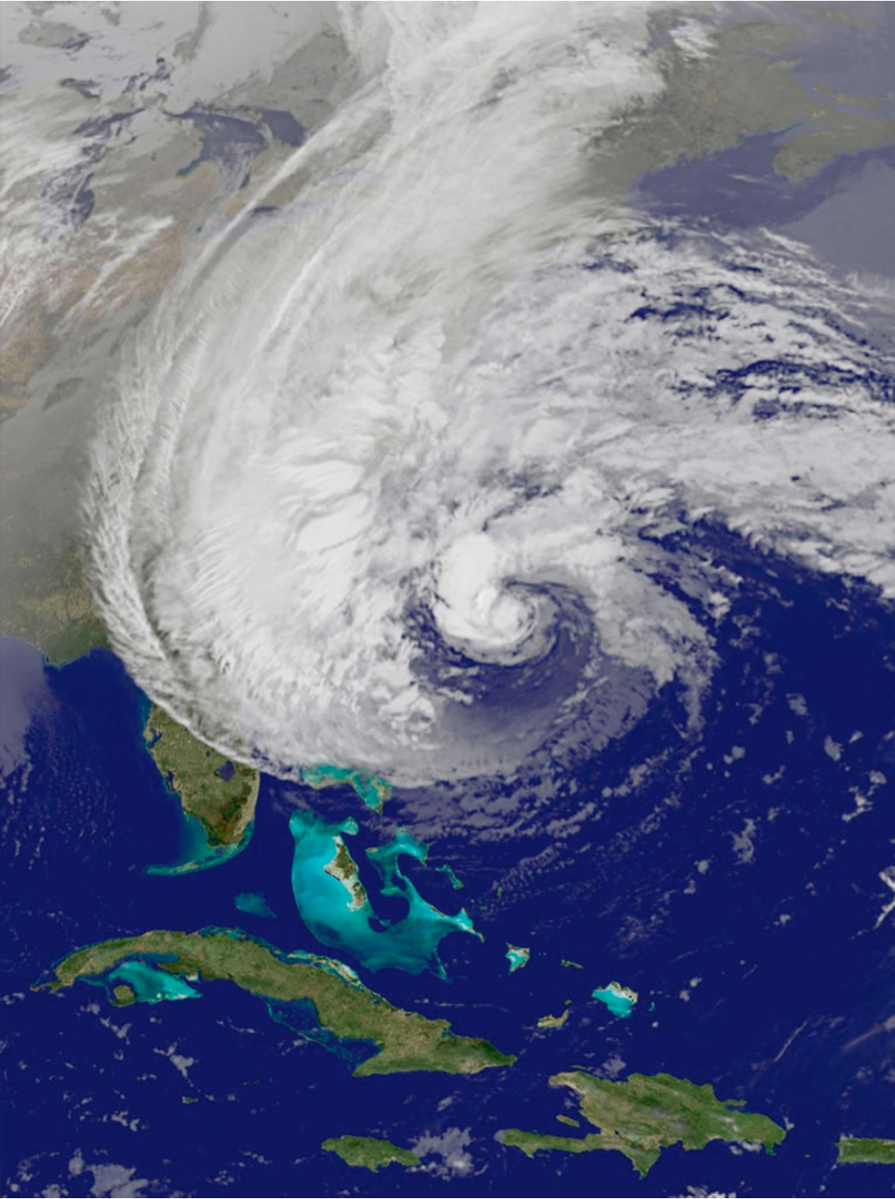
Figure 8.1. Hurricane Sandy viewed from satellite, October 28, 2012. Note the enormous size of the vortex. The hurricane was in the process of morphing into an extratropical cyclone prior to landfall over New Jersey.
It was a storm of epic proportions, striking very late during 2012’s Atlantic hurricane season. On October 29, Superstorm Sandy began to ravage the mid-Atlantic, Northeast, and Ohio Valley. Lower Manhattan was submerged by a 14-foot storm tide, and a massive power outage darkened much of the New York City. Jumbled heaps of debris, sodden with mud and mold, were all that remained of beachfront homes in dozens of coastal towns along the New Jersey and Long Island shores. Fires sprouted out of dark flood waters, fueled by ruptured natural gas mains. Nearly 9 million power outages enveloped a massive region bounded by Virginia, Ontario, Ohio, and Michigan. Hundreds of displaced residents remained homeless as winter arrived. In all, 24 states experienced direct impacts from this single, incredibly destructive hurricane.
In the warm waters south of Cuba, Sandy quickly incubated into a strong Category 2 hurricane. The storm moved north, toward the East Coast of the United States, and underwent a remarkable metamorphosis. It became part nor’easter, part tropical cyclone. The system expanded to three times its initial diameter, becoming the largest Atlantic cyclone ever observed. Approaching land, Sandy began to tap an additional energy source, a strong vortex in the mid-latitude jet stream. The vortex propelled an unseasonably cold air mass into Sandy, which wrapped around the storm’s tropical core. Even more remarkably, this massive hybrid-type storm made an unprecedented turn toward the west, plowing straight into the New Jersey shore.
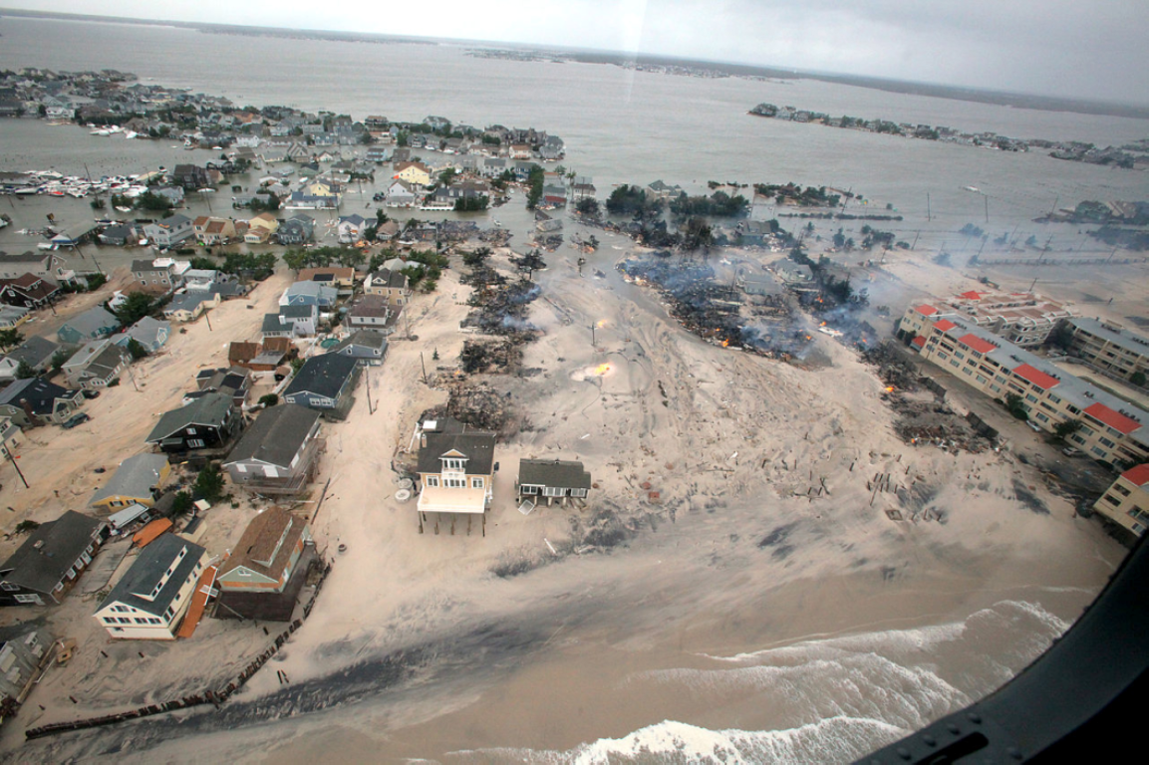
Figure 8.2. Catastrophe visits the East Coast. This areal view graphically portrays the immense devastation wrought by Hurricane Sandy along the New Jersey shoreline. The storm surge completely flooded this township and deposited thick layers of sand throughout streets and yards.
We’ll revisit Hurricane Sandy’s impacts in the “Storm Study in Depth” at the end of this chapter. In the meantime, our primary objective is to describe the physical impacts of tropical cyclones,during landfall. In this chapter, we also describe why some tropical cyclones remain capable of producing violent weather days after landfall, even those remnants that have traveled hundreds of miles inland. Some of the greatest U.S. weather disasters in history have arisen from this special category of inland storm that transitions from a purely tropical to extratropical system.
Scientific Principle 2.27 A tropical cyclone (hurricane in the Atlantic, typhoon in the Pacific) is an intense cyclonic vortex in the tropics, with a compact, inner core of extremely low pressure. Very strong winds around the low are in a state of cyclostrophic balance between the pressure gradient force and outward-directed centrifugal force.
Hurricanes, an intense type of tropical cyclone, are the deadliest and costliest natural disaster facing the United States. Hurricanes Sandy (2005) and Sandy (2012) are the two costliest natural disasters to ever strike the U.S. And the nation may be more vulnerable than ever to future hurricane catastrophes. The U.S. coastline, from Texas to Maine, has undergone phenomenal growth of infrastructure, property, and population. We have entered the era of hurricanes that do $100 billion in damage. Hurricane Katrina’s (2005) death toll exceeded 1,800, a loss of life not seen since the Galveston Hurricane more than a century earlier. More than ever, it is important to cultivate a scientifically accurate understanding of hurricane impacts. By reading this chapter, you will take a giant step toward gaining this crucial understanding.
8.1 Hurricanes Weaken In A Characteristic Manner Moving Into Higher Latitudes and Over Land, While Producing Several Mechanisms of Coastal and Inland Damage
We have discussed hurricanes at several points in this book, but before proceeding let’s provide a quick review of the processes and terminology related to hurricanes. Tropical cyclones are large, cyclonic vortices containing a warm, inner core. Winds converge into a tight, counterclockwise spiral as air streams into the central region of low pressure. Two common types of tropical cyclones are tropical storms (winds > 35 kts or 40 mph) and hurricanes (winds > 65 kts or 74 mph). A circular eyewall is comprises of a central ring of intense thunderstorms, 10-50 km (6-31 mi) in diameter. The eyewall coincides with an annular (ring-shaped) radius of maximum wind. Heavy bands of rain are arranged in spiral arms surrounding the eyewall. The strongest winds are found in the storm’s right hemisphere or semicircle (with respect to storm storm track). As the storm approaches land, winds on the right side push a massive mound of seawater toward shore, called the storm surge.
In the United States, hurricanes are ranked according to the Saffir - Simpson Intensity Scale, which is based on the maximum sustained wind (MSW, a one-minute averaged wind near the surface). Category 1 hurricanes have winds exceeding 65 kts (74 mph), while Cat 5 storms have winds that exceed 135 kts (155 mph).

Hurricanes weaken over land not because of friction, but loss of their oceanic heat source
Hurricanes extract huge amounts of heat energy from warm ocean water, through the process of evaporation and transfer of sensible heat. Evaporation is critical, since the formation of water extracts ocean heat.
Scientific Principle 3.2 Evaporation is a change in phase of water from liquid to vapor, requiring the input of heat (latent heat of evaporation) from a free water surface, or the air. Evaporation varies as a function of temperature, in an exponential manner i.e. warmer temperatures can evaporate vastly larger amounts of vapor than cooler air.
When the vapor later condenses in eyewall thunderclouds, the heat is released into the atmosphere – powering the hurricane.
Scientific Principle 3.13 Condensation describes the phase change of water vapor, in supersaturated air, to liquid cloud droplets. The surrounding air is warmed by the release of latent heat of condensation.
As a hurricane moves onto land, these energy sources are left behind. Many people incorrectly assume that hurricanes weaken as a result of increased land friction, which slows the wind. While this phenomenon does occur in the lowest few thousand feet above the ground, there is a more important reason why hurricanes weaken. The storm’s deeper vortex, which extends to 50,000 or more feet – its “heat engine” – begins running low on fuel. Without continued supply of latent and sensible heat derived from the ocean, the giant convective clouds in the eyewall diminish. Essentially, the storm’s deep warm core rapidly cools.
Scientific Principle 3.24 Convection describes vertical currents of air, in which a buoyant thermal or updraft rises through a deep layer, and a downdraft of cooler air sinks back toward the surface. A thunderstorm or cumulonimbus cloud is the deepest, most vigorous form of convection in an unstable atmosphere.
Additionally, as the hurricane approaches land, dry air masses from the interior continent get swept into the storm. Dry air evaporates thunderstorm clouds in the eyewall and rain bands, creating cold downdrafts near the storm center. These downdrafts suppress upward motions that sustain cloud updrafts. A hurricane moving northward, into mid-latitudes, also begins to encounter increasingly stiff westerly winds. This wind shear, or change in wind direction and/or speed with altitude, disrupts the vertical integrity of the eyewall and vortex. The top portion of the storm may literally become displaced (sheared) from the bottom half, leading to rapid weakening.
Finally, a hurricane moving north toward the U.S. mainland may encounter cooler ocean temperatures, a feature of higher latitudes. In these cooler waters, the transfer of latent and sensible heat is greatly diminished, which can reduce the hurricane’s intensity by one or two categories in the hours just before landfall.
A hurricane unleashes an arsenal of destructive elements along the immediate coastline, and sometimes further inland
Hurricanes unleash a powerful triad of damaging effects along the immediate shoreline: storm surge, sustained high winds, and heavy rainfall. Figure 8.3 compares the causes of U.S. hurricane fatalities between 1970 and 1999, both along the coast and farther inland. The number-one killer is freshwater flooding caused by heavy rains. This is a notable exception compared to many other parts of the world, where storm surge is generally the number-one cause of death in these storms. For instance, individual storms in the Indian Ocean have drowned up to 500,000 people in the space of a few hours.
Further inland, the remnants of hurricanes can remain strong and devastating, sometimes days after the storm makes landfall. Most often, the lingering effects occur because the remnant vortex combines with a mid-latitude weather system, such as a front, a low-pressure center, or a disturbance in the jet stream.
Scientific Principle 2.15 The polar jet stream develops along the polar front, at high altitudes. It is maintained by the strong north-south temperature gradient across the polar front. The polar jet constantly develops large meanders (Rossby waves) that are inherently unstable, tied to formation of extratropical cyclones and anticyclones near the surface.
In all of the cases, the storm acquires a new source of energy. While storm winds typically weaken by 50% or more in the first 24 hours after landfall, on rare occasions hurricane-force winds have been maintained nearly 800 km (500 miles) inland. More commonly, freshwater flooding continues to be a major concern, and can even intensify when tropical remnants interact with mountainous terrain such as the Appalachians. Flash floods, extensive river flooding, mudslides, and debris flows are all consequences of this excessive, persistent rain. Finally, swarms of tornadoes sometimes break out ahead of and to the right of the storm’s center, even as the tropical system weakens over land! In the sections that follow, we explore the manner in which hurricanes create all of these devastating effects.
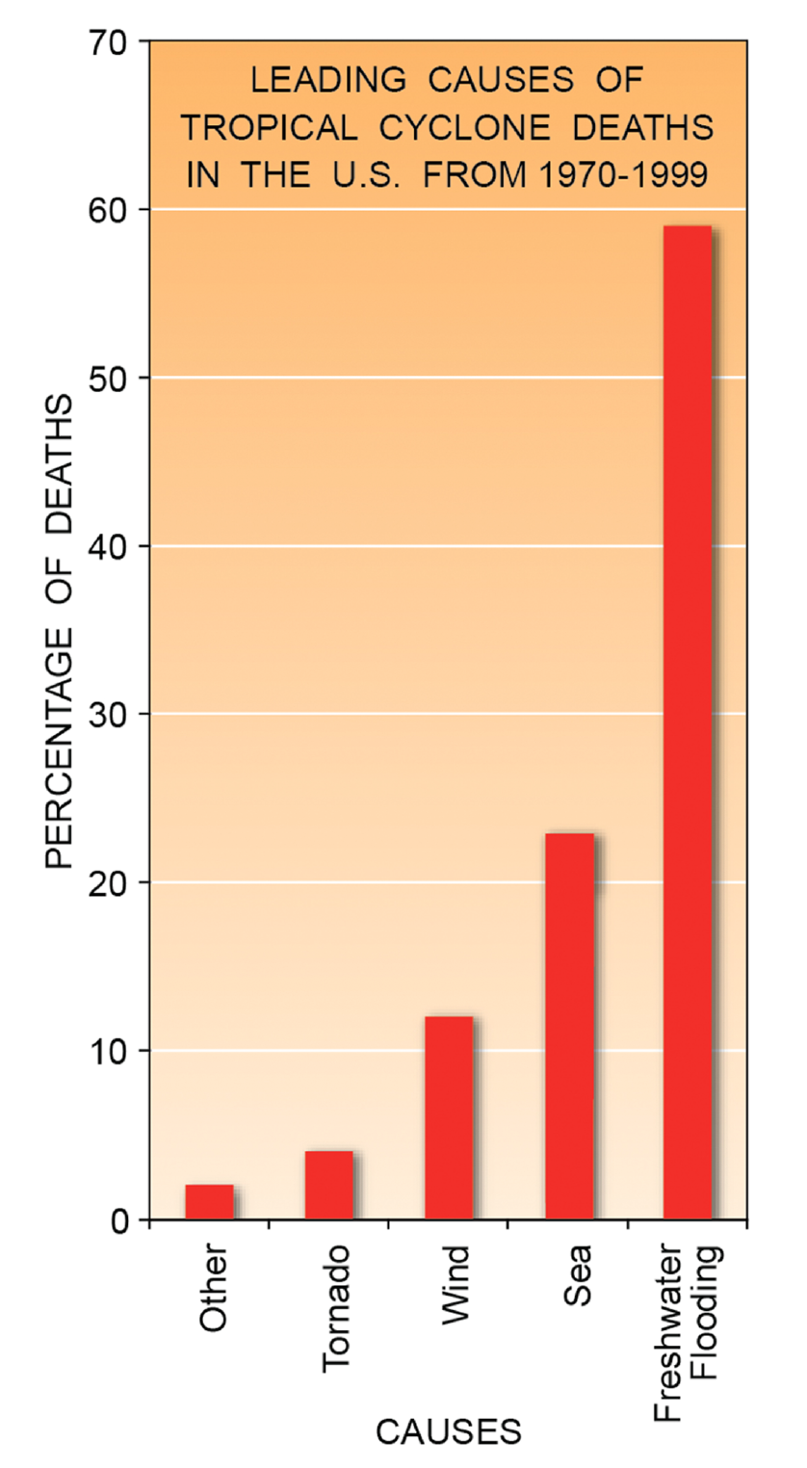
Figure 8.3. Principal causes of death in United States tropical cyclones (both tropical storms and hurricanes). The overwhelming majority these deaths come about from freshwater flooding, produced by heavy rain. Outside the United States, storm surge is the predominant cause of death from tropical cyclones.
8.2 One of the Most Deadly and Destructive Elements in a Landfalling Hurricane Is The Storm Surge
The effects of a landfalling hurricane are all too familiar, particularly in the past decade when the United States was dealt a severe double-blow (no pun intended) by Hurricanes Katrina (2005) and Sandy (2012). A massive storm tide (a more precise term describing the surge) over 25 feet high swamped the Louisiana and Mississippi coasts during Katrina, and a tide of up to 14 feet inundated densely populated regions of New York City and northern New Jersey during Sandy. In the section that follows, we describe how the storm tide develops, and the manner in which is becomes amplified by a region’s specific geography.
Meteorologists and hydrologists make a careful distinction between storm surge and storm tide
Historically, the Galveston Hurricane’s (1900) storm tide led to the greatest loss of life of any U.S. hurricane. Estimates range from 6,000-12,000 deaths. It was likely a Cat 4 (126 kts / 145 mph sustained winds) at landfall. In fact, the Galveston hurricane was the deadliest natural disaster ever to strike the United States. The city of Galveston, built on a sandbar in shallow Gulf of Mexico water, was extremely susceptible to inundation by storm surge. Lives were lost when people drowned in saltwater, were crushed by a wave of debris swept inland, or trapped under mounds of debris left in the wake of the surge.
Figure 8.4 illustrates the manner in which the sea during a hurricane inundates land. The bottom of the diagram shows mean (average) sea level and the normal tidal range. In the hours before landfall, wind-whipped waves relentlessly pound the shore, gradually increasing in height. But as the hurricane’s eyewall moves onshore, a much greater mound of water, the storm tide, swiftly overwhelms the shoreline. The tide does not crash onto the shore in the manner of an enormous wave; rather, think of it as a swiftly flowing current backed by many miles of high water.
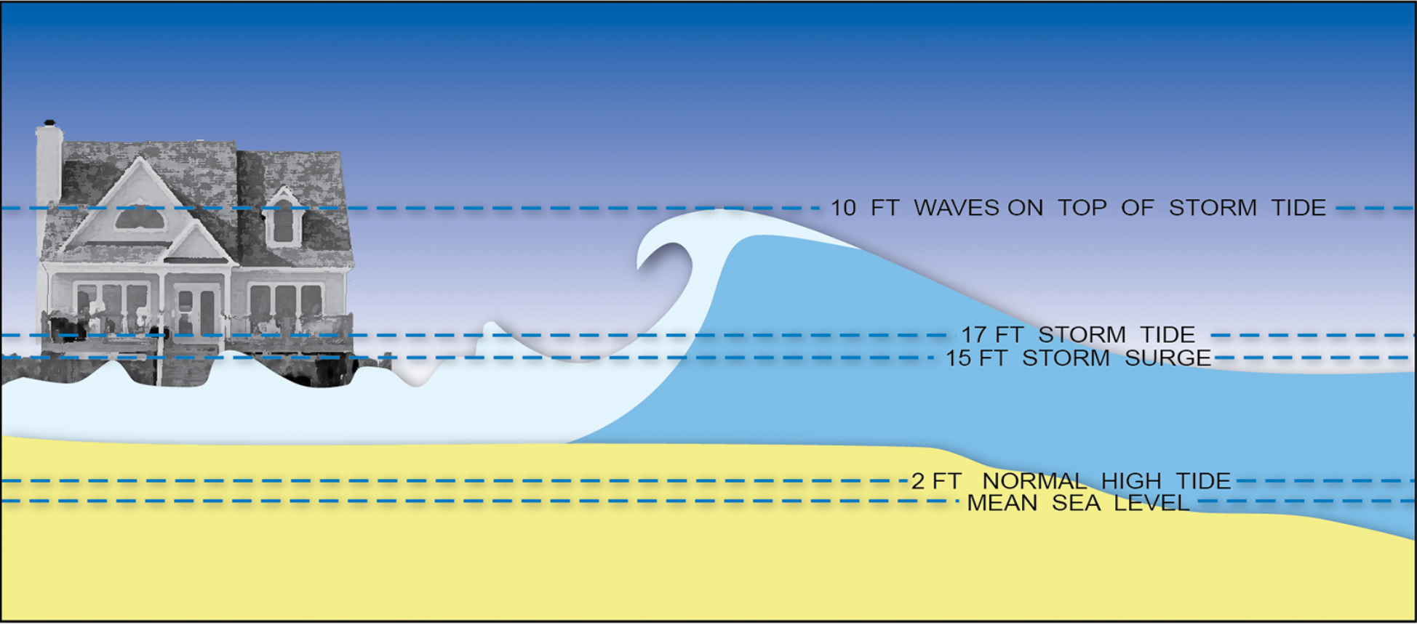
Figure 8.4. The difference between storm surge and storm tide. Storm tide reflects the superposition of lunar tide and storm surge. These two agents build a mound of seawater above mean sea level. The storm tide maintains its elevated form over many hours as a hurricane approaches shore. Individual, transient waves – driven by wind gusts – add further height to the water level.
A storm surge will coincide with a phase of astronomical low or high tide. If the surge arrives during high tide, the water flowing inland rises further. It’s bad luck when this happens. The sum of the storm surge and astronomical low or high tide is termed the storm tide. The distinction between storm tide and storm surge is not often made in media reports, leading to confusion. For instance, during Hurricane Sandy’s assault on New York City, a total storm tide of 14 feet, recorded at The Battery, reflected a 5-foot high tide combined with a 9-foot storm surge. On top of the storm tide, which is sustained for several hours, individual wind-generated waves form and dissipate on short time scales. The inland reach of these waves is significantly extended by the elevated ocean water surface.
The sea has great destructive potential. Seawater has a density close to 1000 kg/m³ (roughly 2200 lbs/yard³). As the storm tide flows inland at tens of knots, think of the enormous energy involved. Very few structures, short of a steel-reinforced concrete bunker, can stand up to this type of tremendous force. Deep vertical pilings used to anchor structures, such as piers and homes, are undermined by the swirling force of rapidly flowing water. When pilings lose their sandy support, all but the most deeply anchored structures fail.
It’s not just water that causes damage. The debris transported by the water compounds the surge’s battering effect. Pieces of homes and buildings, including foundation materials, lumber, tree trunks, cars, and boats, mix into and are flushed inland in turbulent storm tide waters. At times, the storm tide builds into an enormous battering ram of churning water, beach sand, and solid objects. Few structures survive this assault. People caught in the surging water experience great bodily trauma, get dragged and pummeled by turbulent waters, get pinned and entrapped by debris, and invariably succumb to saltwater drowning.
Barrier islands and beach heads are particularly susceptible to the storm tide
Barrier islands are quite vulnerable to the effects of storm tide. Storm tides can breach these low-lying, narrow strips of sand and vegetation completely in one or more locations. New inlets or channels can be created where a barrier island is close to the mainland. Sinepuxent Inlet, south of Ocean City, Maryland, was created in this manner by the Chesapeake and Potomac hurricane of 1933 (Figure 8.5). Additionally, barrier islands can be very difficult to evacuate swiftly, particularly when they are choked by large numbers of summertime tourists. Often only one or two causeways connect these densely populated strips with the mainland. If evacuation is not done with sufficient lead time and in stages, pandemonium and gridlock ensue.
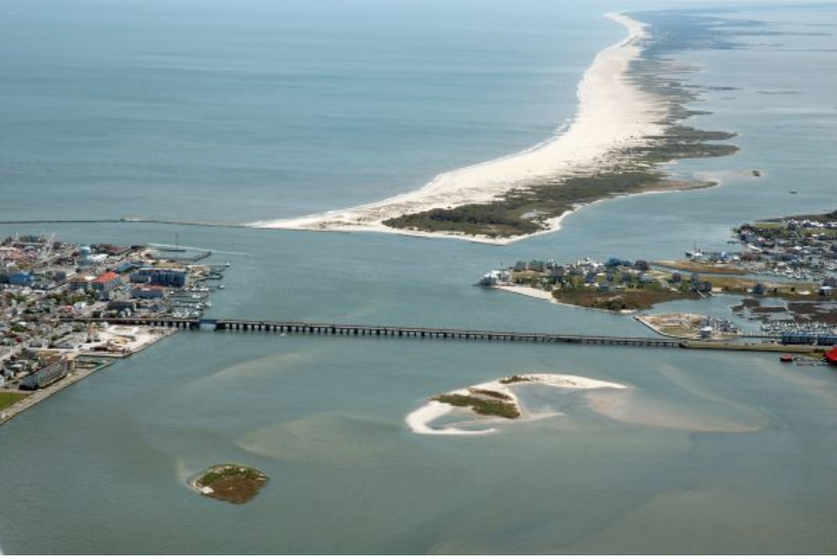
Figure 8.5. Hurricanes have the power to completely alter landforms. A powerful hurricane in 1933 created this inlet on the south end of Ocean City, Maryland.
Along mainland beaches, wave action removes sand from dunes protecting inland areas from inundation. The effective narrowing of beaches by the cumulative action of intense storms is an ongoing challenge faced by municipalities wishing to preserve their shoreline. Countless millions of dollars are spent each year to replenish the sand lost to storms, either by importing sand or dredging it from offshore. Human alteration of the coastline has exacerbated the damage caused by storm tide. In some locations, dunes are removed, or their vegetation removed, to facilitate beach access or shoreline view, and to build beachfront property. Dunes and coastal marshlands provide a natural barrier against the onslaught of storm tide, and greatly diminish wave energy.
The storm surge is created as the swirling mound of water beneath a hurricane’s eye encounters shallow coastal water
How is a storm surge created? The surge is highly asymmetric, occurring just in the hurricane’s right-front quadrant (Figure 8.6). On this side of the storm, sustained winds constantly push water toward the shore (letter C). On the storm’s left side, winds push water away from the shoreline, out to sea, causing a coastal recession. These effects are strongest at the storm’s radius of maximum wind (RMW), as shown on the diagram. Two other important factors contribute to the total surge height (letter D). The first is the oft-quoted inverted barometer effect, or upward suction from low pressure in the storm’s eye (letter A). This effect does cause the sea surface to dome slightly upward. The effect is symmetric across the eye, and largely within the RMW. However, it does not account for more than about 10-20% of total surge height; in the worst-case scenario of a 9 m (30-ft) surge, about 1-2 m (3-6 ft) can be attributed to this inverted barometer effect.
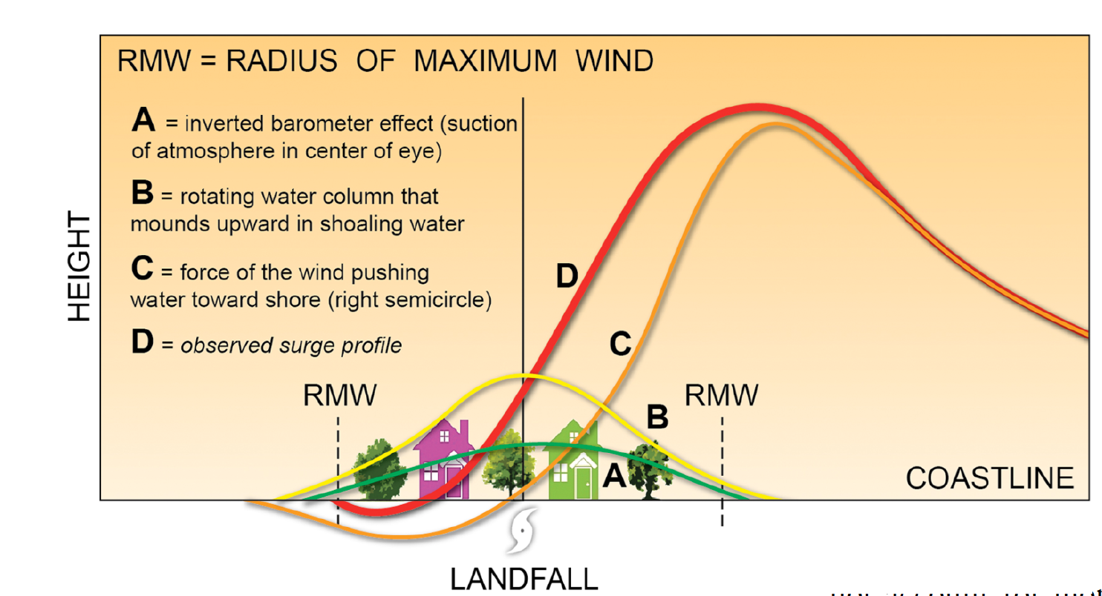
Figure 8.6. An illustration of the strongly asymmetric storm surge. A large surge is raised to the right of the storm’s center (the hurricane is shown approaching the shoreline, as if moving from the reader, toward the page). Multiple processes contribute to the total surge height (D) – including the force of the wind (C) , the “inverted barometer” effect (A), and a dynamic process due to the swirling column of ocean water as it enters shallow water (B)
The second process, shown by letter B, is a dynamic process that occurs only when the hurricane moves into shallow water. The details are shown in Figure 8.7. In the top panel, a hurricane over deep ocean generates an inward spiral of wind. This wind energy sets the underlying water in motion, creating an inward spiraling water column perhaps 100 m (330 ft) deep. As the water converges inward, it is forced to descend. In deep water, the sinking current can flow away at depth, spreading away from the storm.
In the bottom panel, suppose now the hurricane moves over shallow seafloor. The descending, swirling water column can no longer flow away, because it is restricted by friction along the sea floor. But winds continuously push the water inward toward the storm’s center. Consequently, a mound of water rapidly builds upward. This dynamic process only operates as the storm nears land, as the seafloor rapidly rises toward shore. It is also symmetric and largely confined to the RMW.
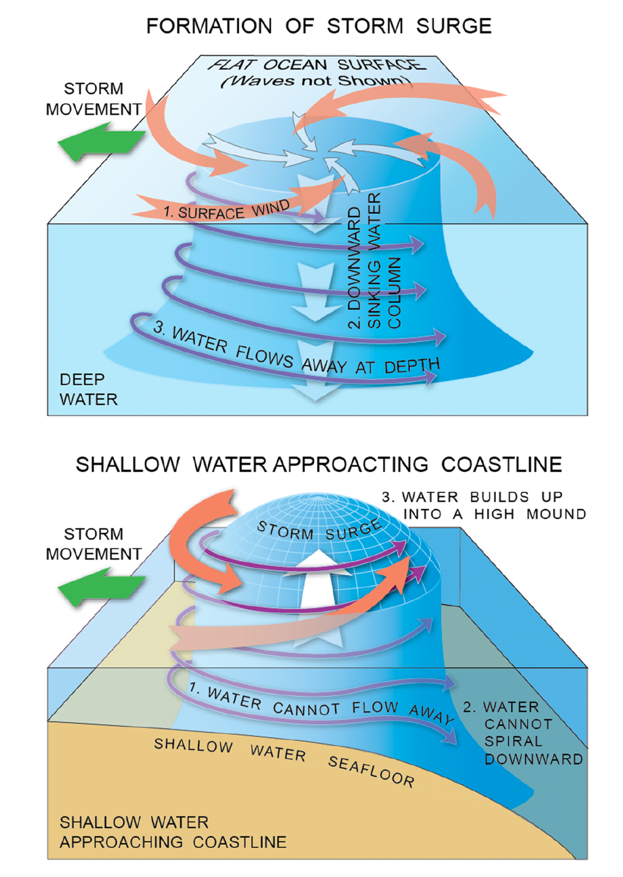
Figure 8.7. The dynamic process giving rise to storm surge. This involves a rotating water column beneath the eye. In open ocean, at great depth, the water can spiral away. When water becomes shallow, outflow at its bottom is restricted, causing the water spiral to build upward.

Inlets and bays locally amplify the storm tide
Hurricane Carla was a Category 5 storm that made landfall along the Texas coast in September, 1961 (Figure 8.8A). The coastal geometry, including the location and size of inlets, bays, and sounds, greatly influenced local surge heights. As Figure 8.8B shows, the storm came inland near Corpus Christi, in the vicinity of Porto Lavaca. Surge heights to the left of track were in the 1-3 m (4 to 8 ft) range, while those on the right side exceeded 3 m (10 feet). This is a general reflection of the storm surge’s cross-track asymmetry. But note that the very highest surge developed within deep coastal indentations, including Porto Lavaca’s bay (surge = 6 to 7 m, or 20 to 22 ft) and Galveston Bay (surge = 5 to 6 m, or 16 to 18 ft). When the surge enters these narrow channels and bays, wave energy becomes greatly amplified, causing water levels to rise further, concentrating the worst damage over small regions.
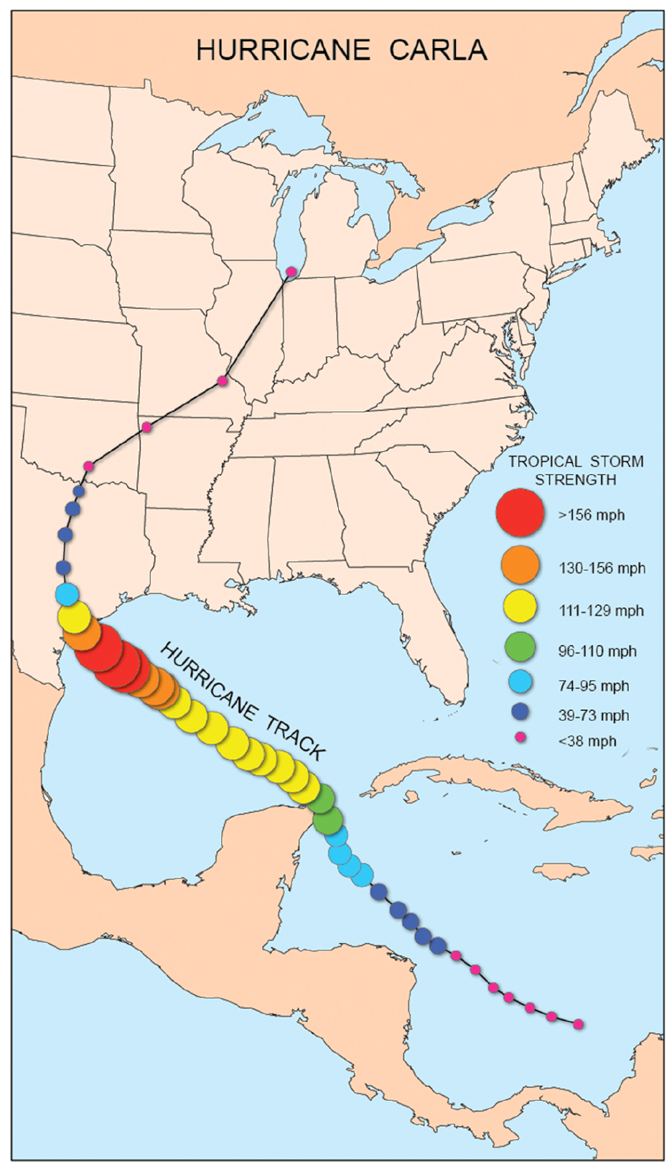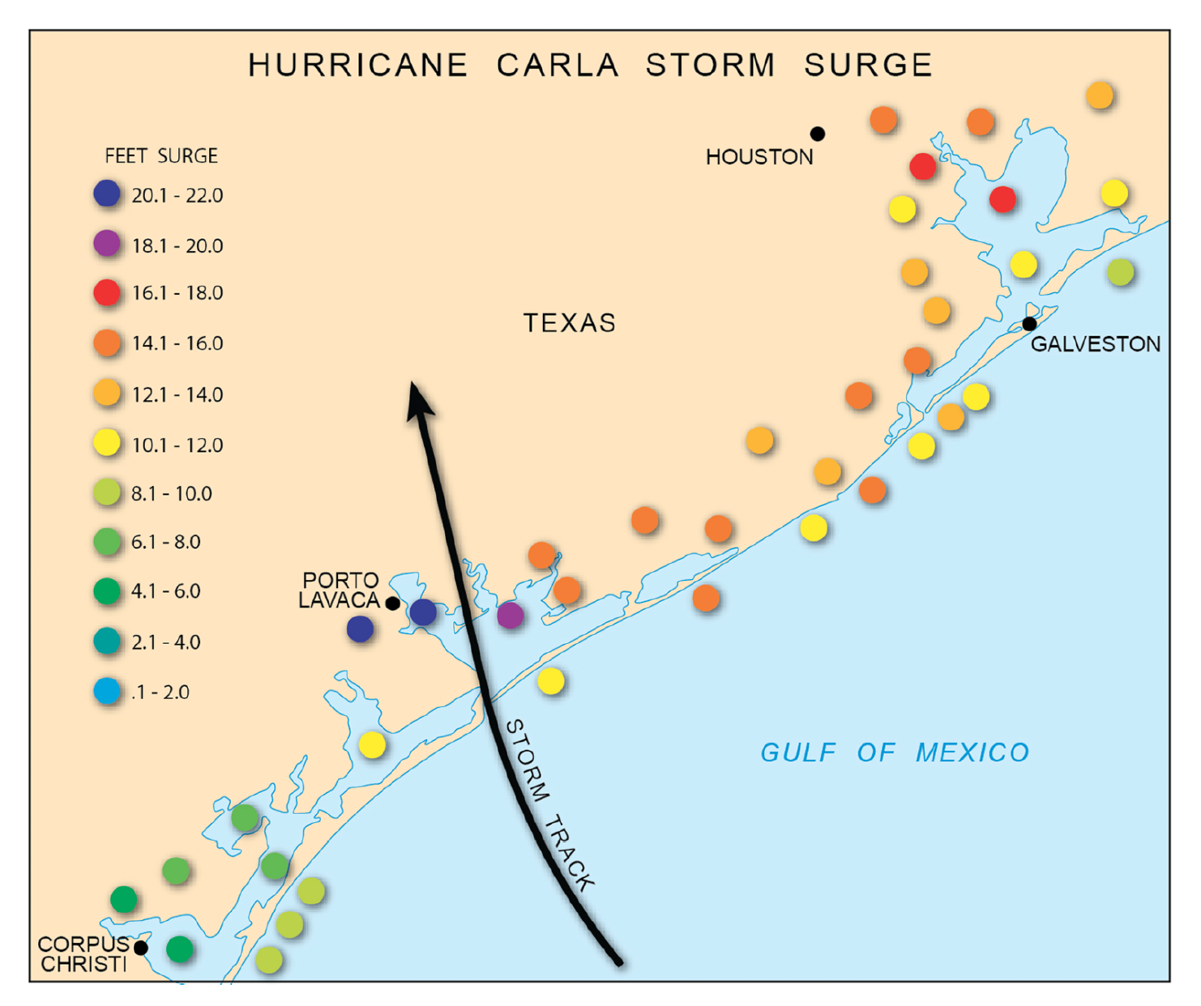
Figure 8.8(A). Local variations in Hurricane Carla’s storm tide. This hurricane, a Category 5 storm in the Gulf of Mexico, struck the Texas coastline as a Category 4 storm. (B). Hurricane Carla raised a tremendously high tide to the right of its track. The highest water levels, up to 6 m (18 ft) developed as the tide became amplified within narrow embayments and inlets along the Texas shoreline.
One of the most dramatic examples of surge amplification in a bay occurred in September 2003 after Hurricane Isabel made landfall in the Mid-Atlantic. The Chesapeake Bay is an exceptionally long, straight, and shallow water body extending north from Norfolk, Virginia to the Susquehanna River, near the Maryland- Pennsylvania border. Isabel followed a highly atypical track; instead of re-curving offshore, away from the coastline, the storm barreled straight inland toward the northwest, crossing the Appalachian Mountains into Ohio (Figure 8.9A).
The storm reached the North Carolina Outer Banks as a Category 2 storm, then began weakening as it moved inland. The core of the system’s highest wind remained south of the Chesapeake Bay, but the winds blew from the east-southeast for several hours, at a sustained speed of 35-43 kts (40-50 mph). The sustained winds pushed a mound of water straight up the Bay. As the storm tide entered the Bay’s narrow northern portion, the tide became amplified, such that the deepest inundation occurred in the Bay’s upper reaches (Figure 8.9B). The flood hit Baltimore’s Inner Harbor and Annapolis, Maryland with a storm tide exceeding 2 m (7 ft). Given the proper wind direction, the Chesapeake Bay can act as a giant funnel, concentrating the storm tide in its upper reaches, and even relatively protected regions such as Baltimore and Annapolis - far inland from the Atlantic shoreline - experienced a devastating flood.
This scenario underscores the importance of wind fetch – the distance over which wind blows across the water. The longer the fetch, the greater the duration over which the wind’s energy is imparted into the ocean, increasing the height of the waves and storm surge. This duration factor leads to what's termed a fully-developed sea. This crucial concept is now embodied in a better understanding of why weak, but large, hurricanes can develop uncharacteristically large storm tides. This effect is explained in the next section.
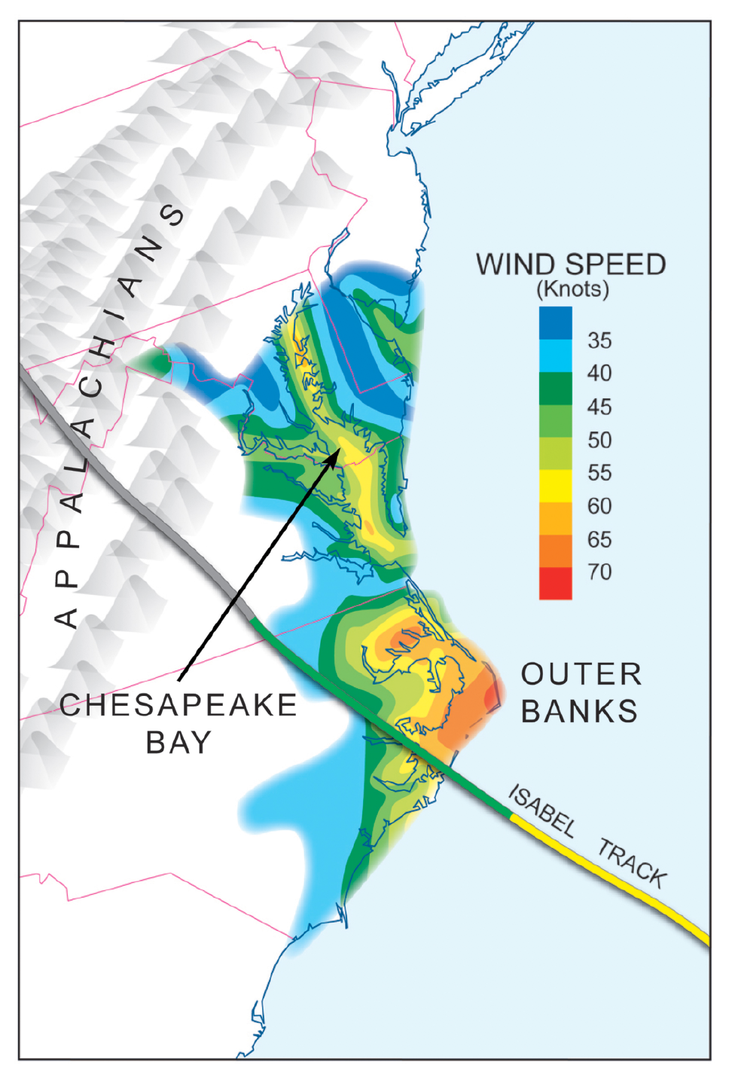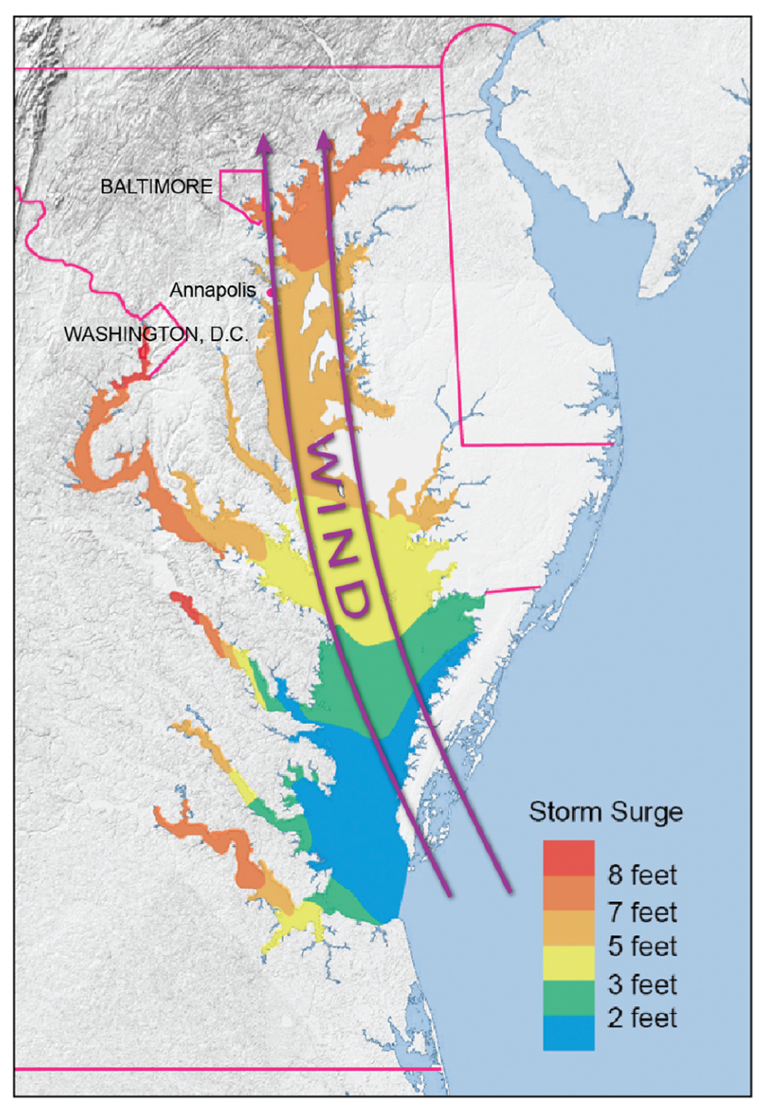
Figure 8.9(A). Hurricane Isabel’s impressive storm tide on the Chesapeake Bay. Hurricane Isabel (2003) took an unusual, “inside” track into the Appalachian Mountains instead of re-curving along the coastline. As a result, strong winds from the south blew along the long axis of the Chesapeake Bay, pushing water into a surge that moved up the bay toward its northern terminus. (B). An unusual “Bay Surge” in which the highest storm tide developed at the Chesapeake Bay’s headwaters near Annapolis and Baltimore, Maryland.
Integrated Kinetic Energy (IKE) is a better predictor of surge height than wind speed alone
Recent experience with several landfalling hurricanes suggests that a storm’s intensity (maximum sustained wind) is not the only factor in establishing surge height. Historically, large diameter storms (compared to historical averages) such as Ike (2008) have created storm surge that is significantly higher than one would predict from wind speed alone. Figure 8.10A compares the surge raised by Ike at landfall, as a Category 2 storm, vs. Hurricane Charley (2004), which struck Florida as a Category 4 system. Charley was a much more compact storm than Ike (Figure 8.10B).
Why was Ike’s surge so much higher than Charley’s surge? An important factor is the total water area over which high winds blow. As more wind energy is transferred into the ocean, the greater the water mound set into motion. The combined effects of wind speed and wind area are captured in a metric called integrated kinetic energy (IKE). In this metric, kinetic energy (proportional to wind speed squared, or V²) is summed over the total area over which winds are sustained at a threshold speed. The larger the storm’s diameter, the larger the fetch; the larger fetch translates into more complete energy transfer between wind and sea, leading to a fully-developed sea state – manifest by a higher surge. The IKE of several hurricanes from the past 50 years is shown in Figure 8.11. By this measure, Hurricane Ike was a much more potent surge generator than Hurricane Charley. Ike’s IKE (which is calculated in terajoules) was seven times larger than Charley’s, even though Ike’s maximum winds at landfall were 25% weaker. Storm diameter, as it turns out, is an important and (until recently) undervalued determinant of a storm’s surge-generating potential.
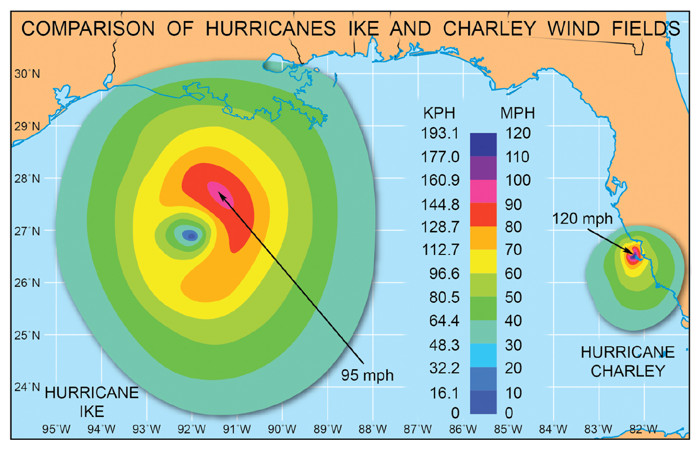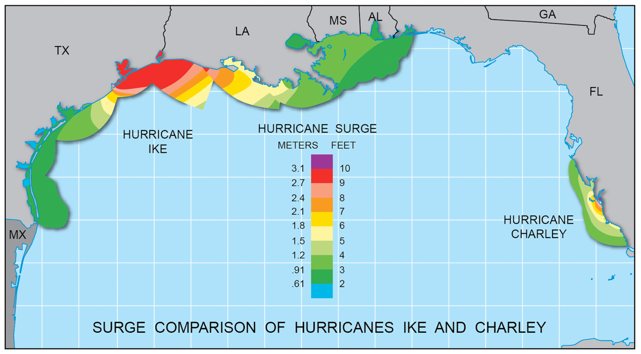
Figure 8.10(A). Comparison of the wind field between Hurricanes Ike and Charley. Hurricane Ike’s vortex dwarfed that of Charley, but Ike was a significantly weaker storm. (B). Not only was the total coastal extent of Ike’s storm surge much greater than Charley’s, this weaker storm (Ike) paradoxically generated a significantly higher storm surge than Charley did.
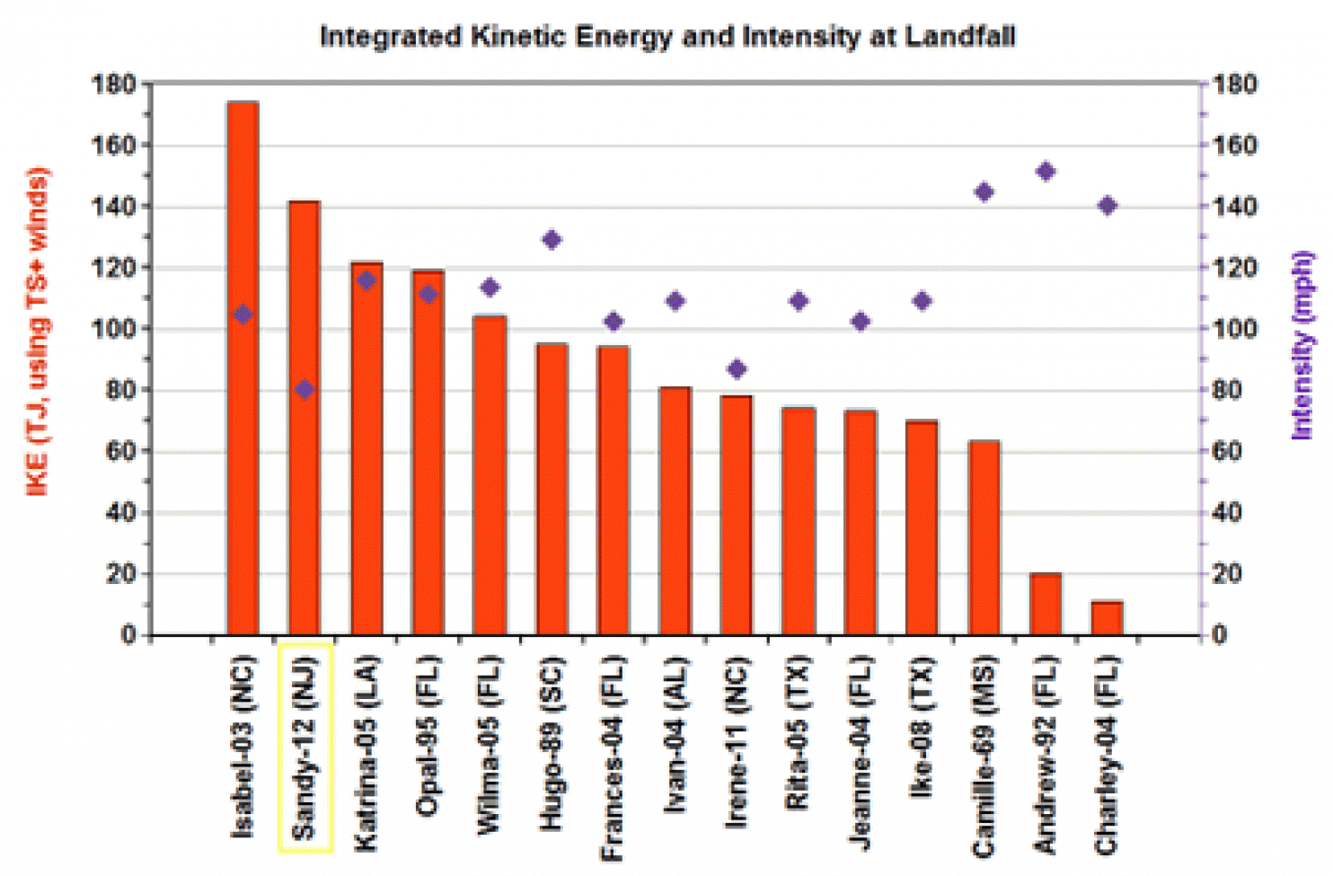
Figure 8.11. Integrated Kinetic Energy (IKE) values of several hurricanes. This important measure of a hurricane’s ability to create storm takes into account not just the maximum wind but also the total sea-surface area of hurricane-force winds.

8.3 Hurricane wind damage has several aspects, including a sustained wind component, and periodic gusts to higher wind speed.
In this section, we examine damage created by a hurricane’s wind. These winds are generated by a large spiral inflow of air, in response to the extreme pressure gradient between the storm’s center and its surroundings. In addition to these large-scale winds, various smaller-scale wind processes lead to localized pockets of more extreme wind damage – such that the extent of wind damage reflects considerable horizontal variation.
Scientific Principle 2.3 Differences in atmospheric pressure across a horizontal distance give rise to the pressure gradient force, which accelerates air from high toward low regions of pressure – creating wind.
Scientific Principle 2.4 On a surface weather chart, isobars are drawn as contour lines of constant pressure, typically spaced every 4 mb. The more closely spaced the isobars, the stronger the wind.

Major determinants of widespread damage include wind asymmetry across the vortex, and the size of the vortex at landfall
Sustained wind speeds in the hurricane vortex increase from the storm’s periphery to the radius of maximum wind, just outside the eye. The wind speed increases more rapidly with radial distance as we approach the storm’s core. As Figure 8.12 shows, the ring of high-speed wind, which we know as the radius of maximum wind (RMW), coincides with the eyewall. The graph in Figure 8.12 is called a time series; this type of graph is created when an anemometer records wind speed every few seconds as the storm moves through. Wind speed is plotted in red, wind direction in green. You will note a great deal of gustiness, with large changes in wind speed from minute to minute. But in the background is the maximum sustained wind, which is a kind of average wind speed, shown by the solid black curve. Winds become nearly calm in the center of the hurricane eye. Note how the wind speed increases in inverse relation to the surface pressure (blue curve) – and how rapidly both pressure and wind change very close to the eye.
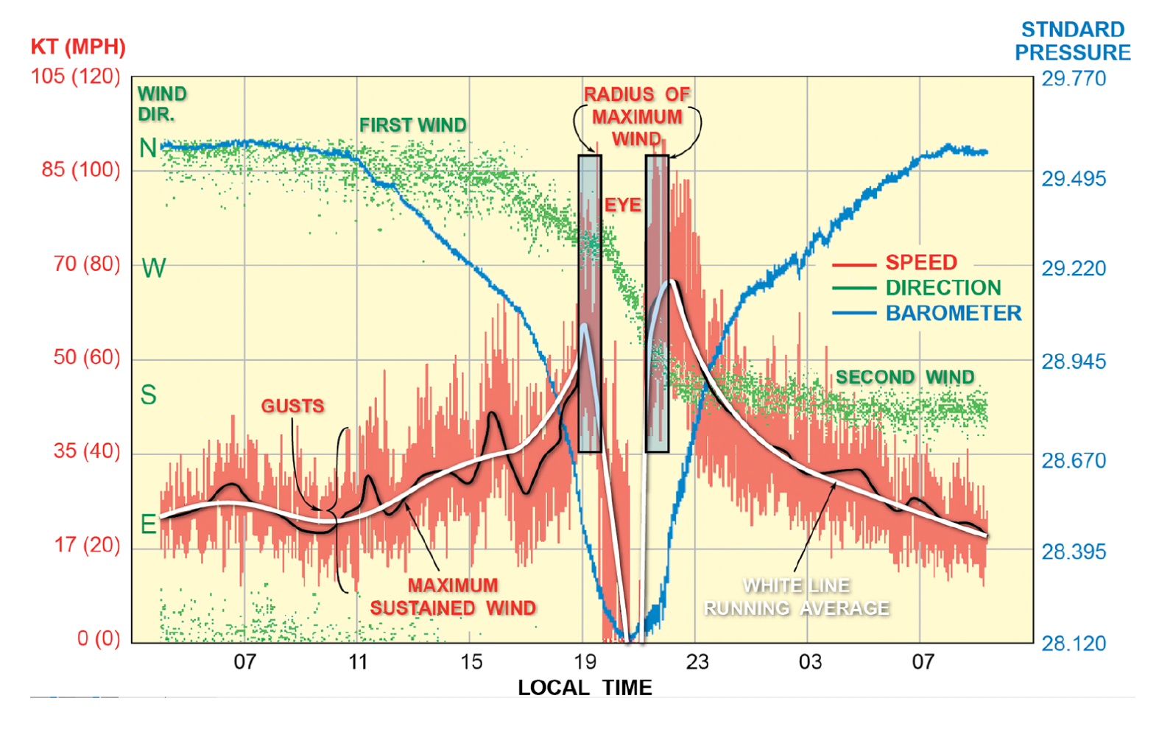
Figure 8.12. Time series tracing of the minute-by-minute variation of a hurricane’s wind and pressure, as it moves over a fixed observing site.
The wind field surrounding a hurricane is highly asymmetric, due to the storm’s forward motion. The basis for this asymmetry was discussed in Chapter 5. In a moving storm, the sustained wind is stronger in the right semicircle. Figure 8.13 shows a real-world example for Hurricane Daniel (2000). Across the storm, there is often a substantial difference in the speed between right and left side (with respect to the storm track), and this difference increases as the storm moves faster. The difference can amount to 50-60 kts. Because the storm surge is primarily generated by wind, the surge is also maximized to the right-of-track.
During landfall, the extent, duration and severity of wind damage are controlled by three factors: maximum sustained wind (a function of a storm’s minimum central pressure), vortex size, and the storm’s speed of movement. Hurricane Andrew (1992) was an extremely intense system (Category 5) but also very compact, and moving very rapidly. It created a small region of near-total devastation, along its northern eyewall, in Dade County, Florida. Analysis of barometric pressure revealed an amazingly large pressure gradient, approaching 4-5 mb/km, along its northern fringe. Damage was confined to a small area, and the duration of extreme wind was on the order of only two to three hours. In this situation, the storm’s rapid movement and small size lead to brief duration of intense winds, over a small region. But the storm’s rapid movement increased the cross-vortex wind asymmetry, further increasing the wind speeds to right-of-track (in the direction north of center). Peak wind gusts exceeded 174 kts (200 mph), and even well-engineered structures were heavily damaged. These gusts are comparable to a strong tornado! Because of the extreme wind damage, Hurricane Andrew in 1992 became the costliest U.S. natural disaster.
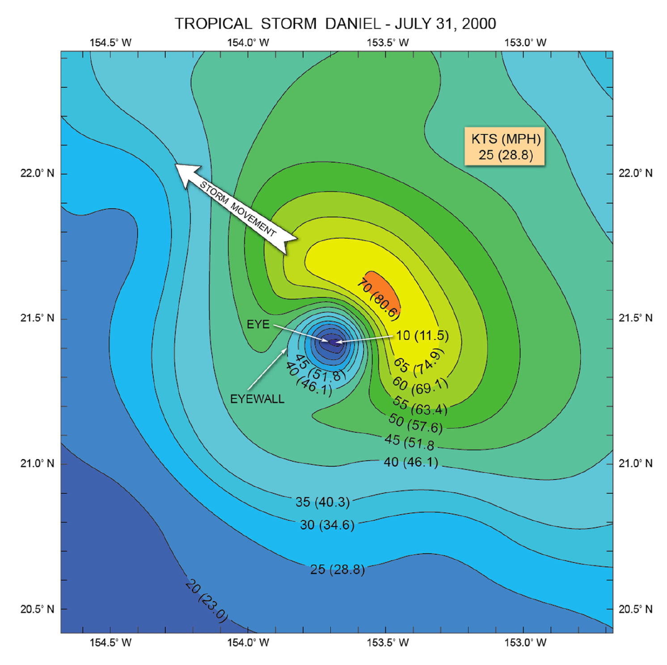
Figure 8.13. Unequal distribution of sustained surface winds in Hurricane Daniel. This type of wind asymmetry, in which the stronger wind is aligned to the right of storm center, is typical of a moving hurricane.
Contrast Andrew with a very large and slower-moving storm such as Hurricane Sandy (2012). Maximum wind gusts at landfall during Sandy were in the 70-77 kt (80-90 mph) range – half that of Hurricane Andrew. However, the massive size of Sandy’s wind field meant that damaging winds were sustained for many hours. Property devastation is also a function of population density and the prevailing type of dwelling. Like Andrew, Sandy struck a very densely populated region with exceedingly high property values. The price tags for Andrew and Sandy (considering the effect of both the wind and surge) ran into to tens of billions of dollars.
It is important to distinguish between a hurricane’s maximum sustained wind (MSW) and gust factor
Figure 8.14 makes a critical distinction between maximum sustained wind (MSW – solid black line) and hurricane wind gusts (irregular red tracing). The MSW is a one-minute average wind near the surface; it is the standard by which hurricane intensity is assessed in the United States. Superimposed on the sustained wind are instantaneous wind gusts, or brief excursions of wind speed above and below the MSW. Wind gusts are created by two processes: (1) the turbulent motion of the airflow as it interacts with the surface, and (2) internal instability within the airflow. Think of eddies and ripples in a flowing stream – these are analogous to gusts, while the steady current is analogous to the maximum sustained wind.
While the MSW is an averaged value, the gust factor describes the instantaneous variation of wind, with a time scale of seconds to tens of seconds, expressed as a percentage wind speed beyond the MSW. Air turbulence and gust factor are closely related to the degree of surface roughness. Over open ocean, gusts commonly exceed the MSW by 20%-30%. While we commonly regard the ocean surface as smooth, bear in mind that it becomes deeply undulating in the presence of storm waves. The waves disrupt the wind field, breaking it into numerous swirls and eddies. Land surface, in contrast, features forest cover, suburban sprawl, urban landscape, and uneven terrain. This type of surface creates greater turbulence than over disturbed ocean, and gust factor rises to 40%-50% in excess of MSW. In mountainous terrain, gust factors approaching 100% have been demonstrated. The next section explains why knowledge of expected gust factor, in addition to the MSW, are critical design elements in building structures to withstand high wind.
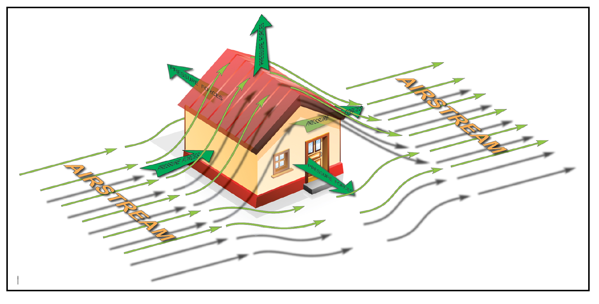
Figure 8.14. This schematic illustrates a structure’s vulnerability to the wind and resulting aerodynamic forces that lift off the roof and pull the sidewalls outward.
The wind interacts with structures in a complex manner, setting up powerful aerodynamic forces
The sustained winds exert a force on structures, such as the walls of dwellings, proportional to wind speed cubed (V³) multiplied by surface area. For the same area, if sustained wind doubles (as it does between a Category 1 and Category 5 hurricane), the damage forces increase by a factor of nine!
Wind-tunnel studies have demonstrated that homes with gabled (pitched) roofs generate aerodynamic lifting forces as high winds flow over them (Figure 8.14), similar to way that lift is generated when air flows over a curved airplane wing. If the roof is not securely anchored to the walls, sections of the roof, or the entire roof, peel away. With the roof gone, walls lose structural support and collapse outward. This process is enhanced by regions of low pressure that form along the sides of the house as wind streams by – a type of suction force acting to pull the side walls and downwind wall outward. The integrity of walls is also compromised by airborne debris – essentially airborne missiles. Walls are more easily breached in their weaker areas, including large panel windows and garage doors. Eaves or roof overhangs tend to “catch” the wind, causing high pressure to build beneath the roof edges. These forces act in concert with the upward sucking force along the roof, leading to its destruction.
Structural failure is greatly enhanced by transient, buffeting forces that arise from wind gusts. The repeated, on-off “hammering” of a structure by the wind can create a process called resonance. During resonance, the structure’s natural frequency of vibration is excited by rapid, cyclic variations in wind speed. The structural vibrations rapidly amplify, to the point where the structure literally shakes itself apart. (A simple analogy to resonance occurs when an adult pushes a child on a swing, with each push precisely timed to the arrival of the child).
Another important damage process is related to the shift in wind direction, as shown in Figure 8.12. The initial hurricane wind to be experienced, as the eye approaches, is termed the first wind. As the eye crosses, the wind direction must shift by 180 degrees. The resurgence in wind speed, on the other side of the eye, is termed the second wind. This simple distinction is more than academic. The first wind places high wind loads on structures for several hours. Once the eye passes, extreme forces ramp up for several more hours, but from the opposite direction. The back-and-forth wind loading contributes to structural failure.
Finally, it is worth noting the fate of trees in sustained high wind. Much of the damage to dwellings and vehicles comes from falling limbs or uprooted trees. Most utility damage, which can lead to multi-day power outages, arises from limbs and trees falling on power lines. Removing tree debris from roads delays initial utility access and repair. Soils anchor tree root systems, but these root systems often become saturated and loosened in the heavy rain that accompanies hurricanes, making trees more susceptible to windfall. Furthermore, many hurricanes strike during the late summer and early fall, when trees are in full foliage. Each individual leaf acts as a tiny “sail” that catches the wind, exponentially multiplying the total wind force in the tree crown. For all these reasons, widespread loss of tree cover and extensive power disruptions are a common outcome of hurricane winds at landfall.
As a hurricane weakens, its winds decay at an exponential rate, but the size of the wind field expands
As the hurricane “engine” begins running out of fuel at landfall, the sustained wind spins down in a predictable manner. Figure 8.15 shows the rate at which winds decay, for storms of varying intensity. This decay is often exponential, meaning the initial rate of decay is very rapid, followed by a progressively slower weakening. In the first 12 hours, stronger hurricanes experience larger wind reductions than weaker systems. At the end of the first 12 hours, all categories have weakened to 50% of their pre-landfall value. By 36 hours, weakening is nearly complete.
An example of Hurricane Hugo’s (1989) wind decay is shown in Figures 8.16A and B as the storm crossed into South Carolina. Hugo made landfall as a powerful, compact Category 4 storm near Charleston. Shown in the diagram are contours of maximum sustained wind. Following the track inland, note the small, intense region of 104+ kts (120+ mph) winds to the right of track, along the immediate coast. Winds rapidly diminished as the storm moved inland. Some 80 km (50 mi) inland, sustained winds in the right semicircle were down to 78 kts (90 mph), with minimal hurricane intensity (65 kts, or 75 mph) on the left side. After another 80 km (50 mi), the post-tropical system encountered the Appalachian Mountains, which disrupted and weakened the winds further.
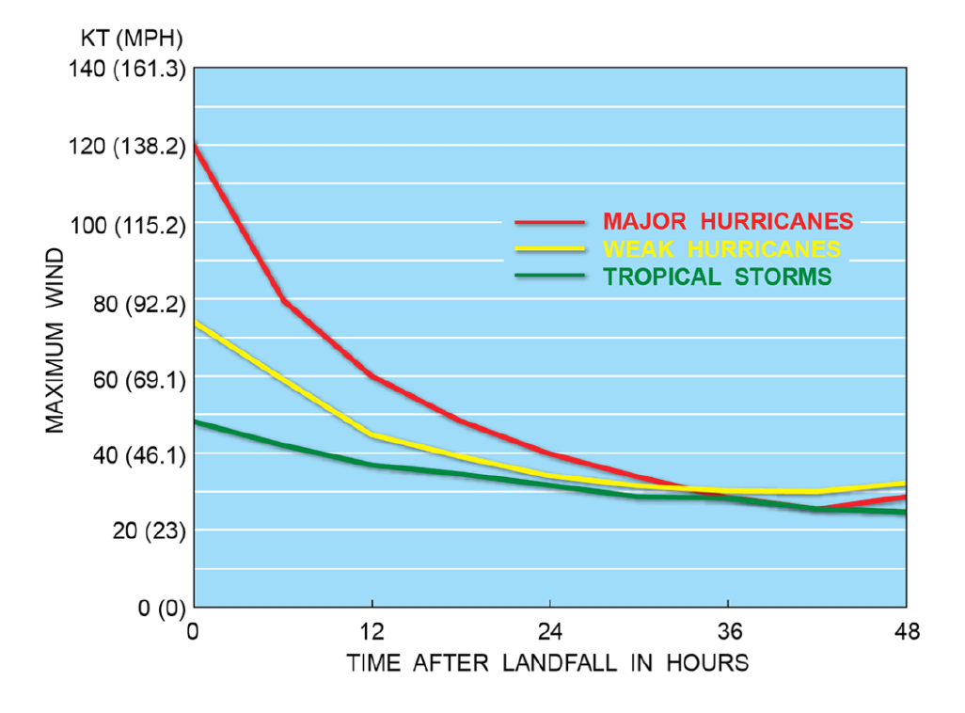
Figure 8.15. Decay of maximum sustained wind in hurricanes of varying intensities. For most storms, the process takes about 24 hours for winds to diminish below tropical storm strength.
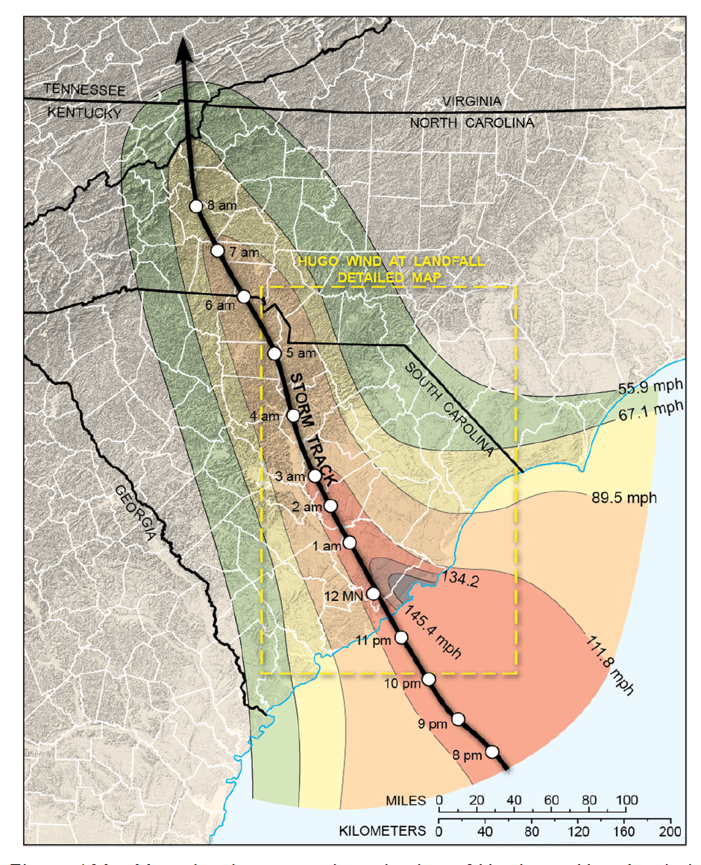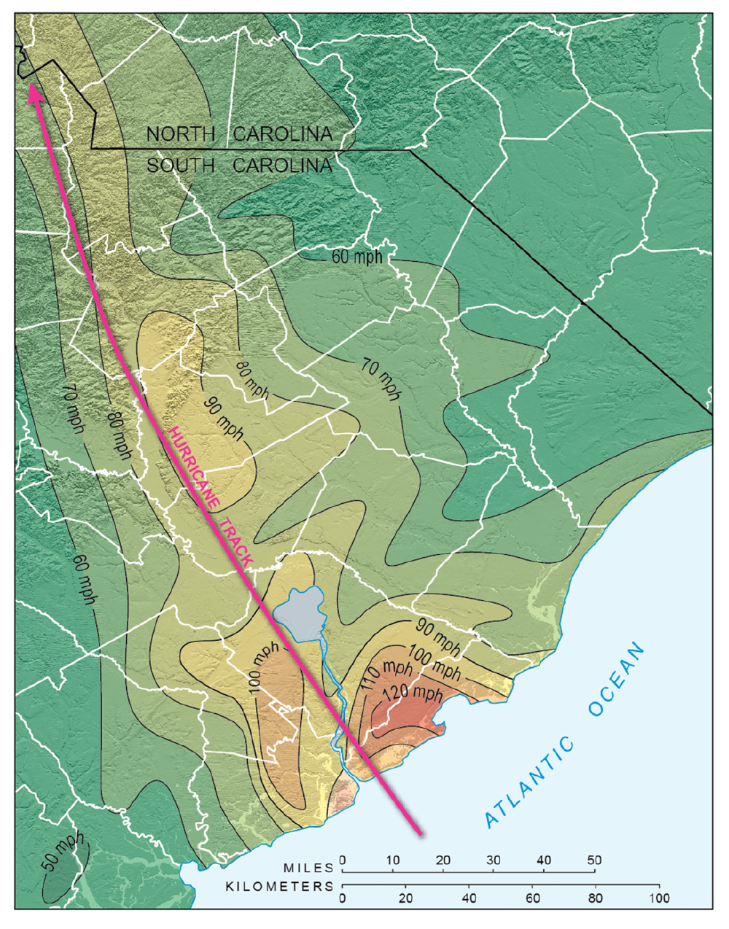
Figure 8.16(A). Map showing general weakening of Hurricane Hugo’s winds at landfall. Weakening became especially rapid once the storm vortex began interacting with elevated terrain. (B). Detailed wind analysis during Hurricane Hugo’s landfall over South Carolina. The strongest winds, as expected, are found to the right of track, but quickly decay inland.
The rapid “spin down” of the vortex occurs as the entire wind field expands. Hurricane Irene (2011) illustrates this common behavior (Figure 8.17). Irene was a strong Category 3 system in the Caribbean. The storm began steady weakening as it approached the United States, and was down to Category 1 at landfall in the Outer Banks. But note how the width of both the hurricane-force and tropical storm-force winds expanded, covering more area with time (red and orange shaded regions, respectively).
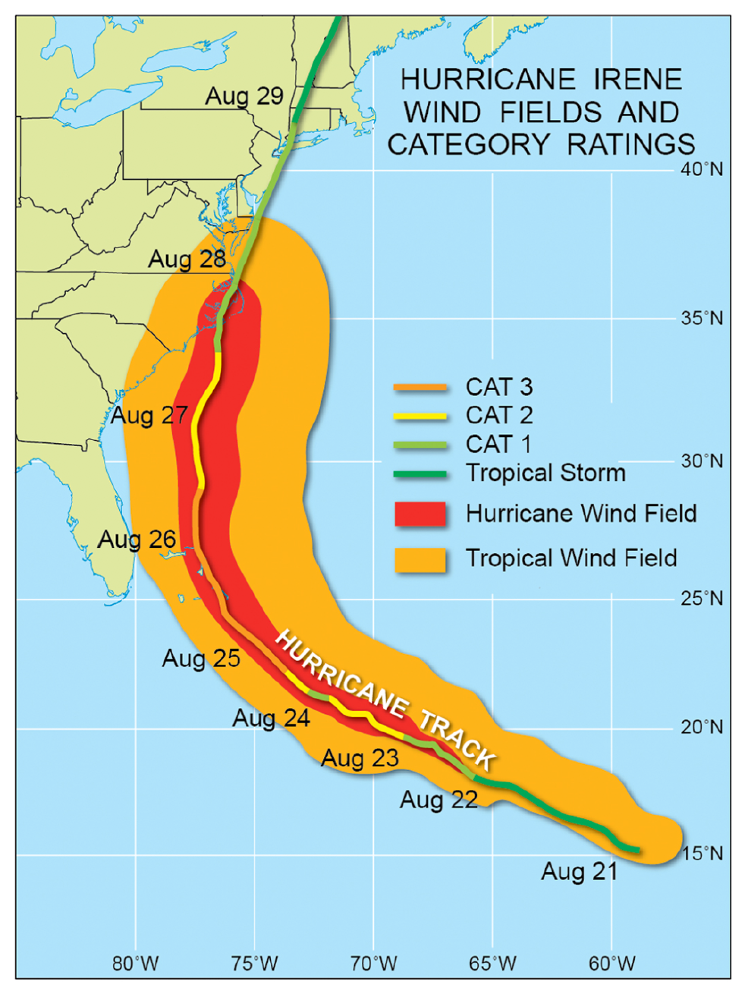
Figure 8.17. Changes in the wind distribution as a hurricane weakens. As is commonly observed, the footprint of both tropical-storm and hurricane-force winds expands as the storm moves into higher latitudes and weakens.
It is tempting to ascribe this expansion to conservation of angular momentum This principle of physics states that when the winds in a vortex weaken, the vortex expands in size (conversely, an initially large vortex, when contracting, experiences an increase in its wind speed). However, detailed studies reveal that the process is more complicated than this. Figure 8.18 shows how the hurricane’s wind profile (the variation of wind speed with storm radius) changes during weakening. In this example, a Category 1 hurricane weakens to a tropical storm. The winds along the RMW have died down. But the RMW itself has expanded by nearly 100 km (62 mi). Additionally, the ring of tropical storm force winds has enlarged by nearly 300 km (186 mi). A simple analogy of hurricane winds during weakening is to envision a steep mound of rotating sand that is collapsing: the pointed peak flattens, while the diameter of the sandpile increases.
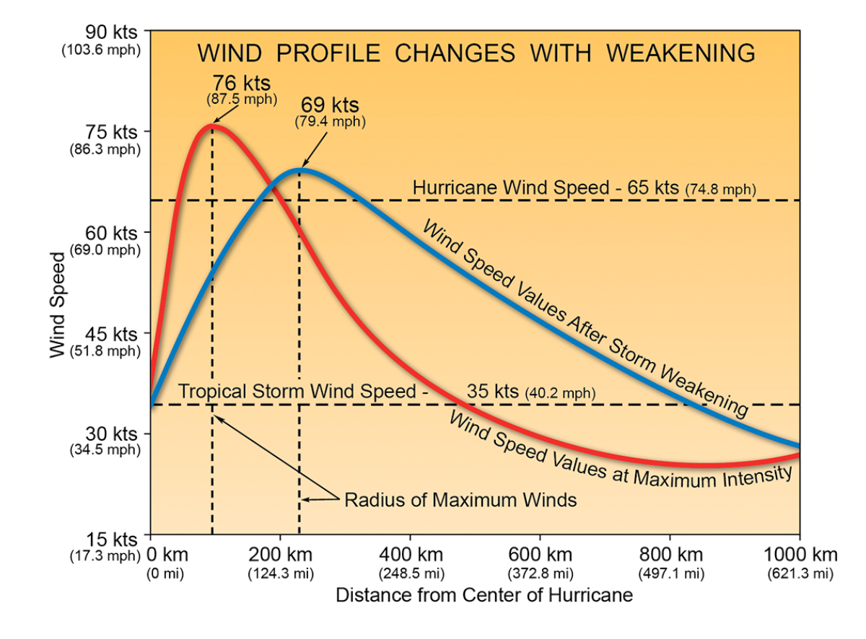
Figure 8.18. How the wind distribution across a hurricane changes during weakening. The wind profile, or strength of the storm’s wind as a function of radius, undergoes significant change in a weakening hurricane. Notably, the radius of maximum wind near the center weakens and expands, while wind speeds actually increase at larger distances from the storm center.
Sometimes during landfall a storm interacts with a nearby high-pressure cell, causing the pressure gradient to intensify on one side of the storm. This can maintain strong, sustained winds for many hours after landfall, while the storm itself undergoes weakening. Such an event occurred when Hurricane Isabel (2003) moved into the Mid-Atlantic, as shown in Figure 8.19.
Scientific Principle 2.17 Extratropical anticyclones (high pressure cells) are large, transient vortices that migrate from west to east across mid latitudes. Air diverges in a clockwise spiral around anticyclones, with high pressure in the core (“H” on a weather map).
Prior to Isabel’s arrival, a strong fair-weather anticyclone became established over New England. Isabel moved inland to the south of this weather system. The pressure gradient between the storm and the anticyclone strengthened. This interaction enhanced the winds on the northern side of the storm, over the densely populated Northern Virginia-Washington-Baltimore region. Several million power outages resulted from Isabel’s passage, even while the hurricane was rapidly weakening to a tropical storm.
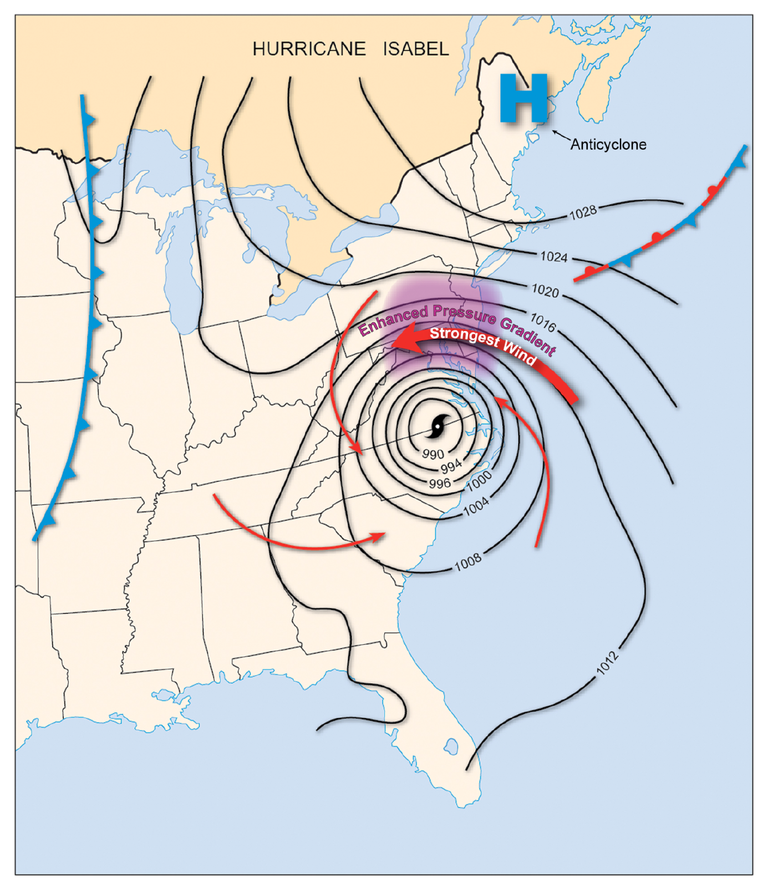
Figure 8.19. Hurricane Isabel’s interaction with a strong ridge of high pressure over New England. The inland ridge of high pressure over New England enhanced the pressure gradient along the north side of the storm, maintaining strong winds over the Mid Atlantic even after landfall.
Downbursts, mini-swirls, and wind streaks are all forms of localized, destructive winds spawned by hurricanes
When conducting post-landfall hurricane damage surveys, researchers have long noted small, intense pockets of wind damage. This was especially true over south Florida in the aftermath of Hurricane Andrew. Numerous processes, including those common to severe thunderstorms, are responsible for generating the most extreme winds.
Hurricane Andrew was an exceptionally compact Category 5 storm that struck in 1992 (Figure 8.20). Tropical storm force winds extended less than 145 km (90 mi) from the storm’s center, making this system among the smallest to ever strike the United States. But for several hours, sustained winds of 130-136 kts (150-157 mph) hammered the coastline along Biscayne Bay and Dade County, just 40 km (25 mi) south of Miami. Andrew received a pre-landfall energy boost from the warm Gulf Stream, and the storm weakened only slightly as it rapidly crossed the Florida peninsula. Arrested weakening was the result of south Florida’s unique land surface – which is actually quite waterlogged, with a large inland body of warm water (the swampy Everglades) and myriad lakes.
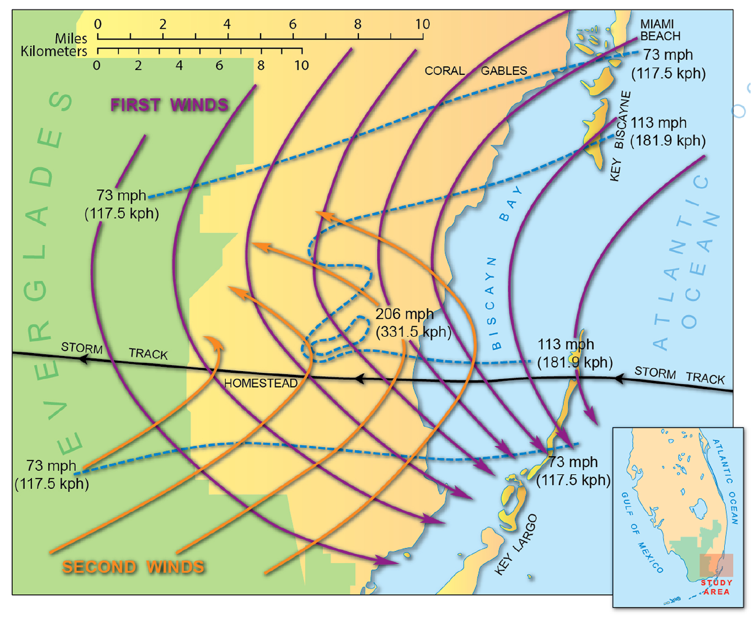
Figure 8.20. Wind analysis of Hurricane Andrew (1992) over southern Florida. The wind field in this storm was unusually intense and compact. The strongest winds were confined to a 16 km (10 mi)-wide strip just north of the eye.
In post-storm damage surveys, investigators discovered a pocket of extreme winds approaching 183 kts (210 mph) along the northern eyewall, in the vicinity of Homestead, Florida. Damage was near-total (Figure 8.21), with loss of 63,000 homes, 101,000 damaged homes, and a $27 billion price tag (1992 dollars). This single storm became the costliest U.S. natural disaster up until the time.
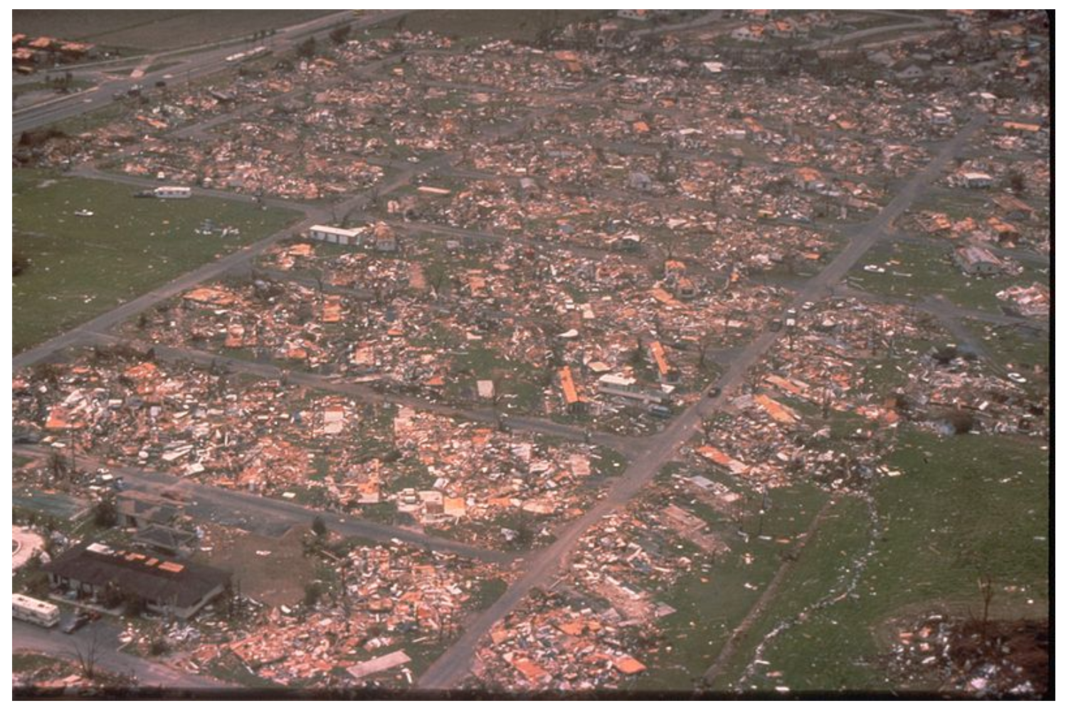
Figure 8.21. Landscape of devastation across south Florida in the wake of Hurricane Andrew. Viewing the total destruction of this Florida subdivision from helicopter, one might surmise such damage arose from a strong tornado, rather than Category 5 Hurricane Andrew.
A narrow, 5 m (16 ft) storm tide impacted Florida’s east coast, and up to 36 cm (14 in) of rain fell over the Everglades. But Andrew, metaphorically speaking, seemed to behave more like a monstrous tornado, tens of miles in diameter, sweeping across the southern tip of Florida. As Figure 8.20 shows, the highest winds were contained within 10 km (6 mi) of the storm’s center, on the storm’s right side.
Figure 8.22 shows an example of downburst winds during the landfall of Hurricane Carla over the Texas coast (September, 1961). A downburst is a small-scale (3-5 km, or 5-8 mi- wide), rapidly descending air mass that blasts outward upon striking the ground. They are the most common agent of wind damage in severe thunderstorms everywhere in the United States. When downbursts occur in hurricanes, they are generated by severe thunderstorm cells embedded in the storm’s eyewall or rain bands.
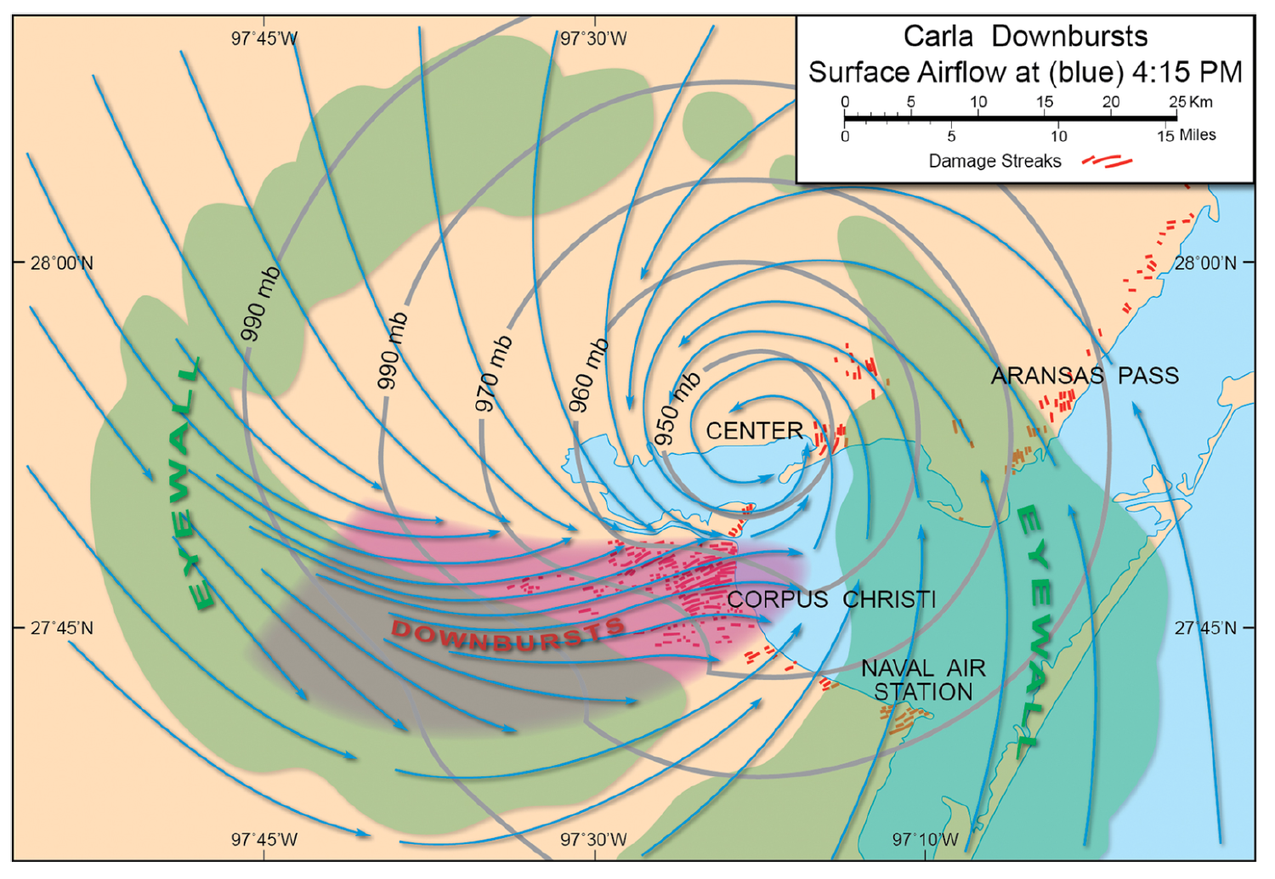
Figure 8.22. Wind damage map in the aftermath of Hurricane Carla, revealing embedded downburst damage. Most commonly observed in severe thunderstorms, downbursts are occasionally generated by hurricanes within the eyewall and rain-band regions. These violent outbursts of wind create localized pockets of intense wind damage.
Mini- swirls (Figure 8.23) are a small type of intense vortex just 30-60 m (99-197 ft) in diameter within the hurricane eyewall. They are generated by rapidly moving wind currents that slip past one another, creating turbulent flow (eddies). This slippage is called horizontal wind shear. Imagine holding your hands vertically in front of you, with a pencil upright in between. Move one hand past the other. This shearing motion causes the pencil to spin, in the manner of a mini-swirl. Mini-swirls create corridors of extreme wind damage within, and adding to, the overall high-speed flow of the sustained wind.
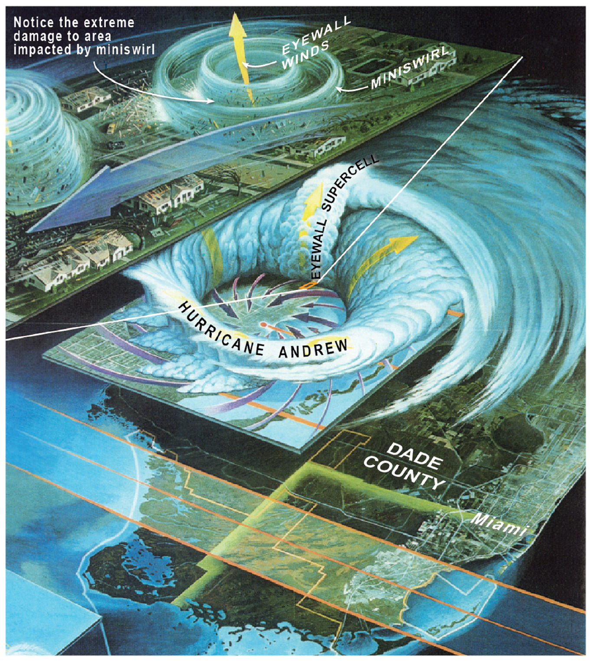
Figure 8.23. Mini-swirls, which were discovered in the aftermath of Hurricane Andrew, are likened to a “vortex within a vortex.” These small, intense vortices in the eyewall create corridors of extreme wind devastation.
Finally, Doppler radar studies in landfalling hurricanes have identified a novel type of wind damage, called wind streaks (Figure 8.24A).
Scientific Principle 4.9 Most radars use the Doppler principle to estimate wind speed and direction, along the radar beam. Pulses of radar energy transmitted at a fixed frequency are phase-shifted toward or away from the radar, based on the horizontal speed of precipitation particles embedded in the moving air.
Wind streaks are are narrow linear swaths or “fingers” of wind devastation. Wind streaks are predicated on the slowing of winds near the surface. When winds rapidly increase with altitude, the result is a vertical wind shear. As Figure 8.24B illustrates, when faster airflow aloft slips over slower air at the surface, the wind “trips” over itself and vortex tubes or rollers are created. Back to the hands and pencil, imagine your hands now horizontal, with the pencil lying in between. Move the top hand only and observe the pencil spin. The tubes develop as closely arrayed, parallel rolls, oriented in the same direction as the airflow. Between rolls that have opposing spin, high-velocity air is dragged downward to the surface. The result is a narrow blast of high wind along the ground. Such narrow strips of high wind, tens of meters wide and spaced a few hundred meters apart create, are the hallmark of wind streaks.
Finally, we note that tornadoes are yet another hallmark of hurricanes that make landfall. Tornadoes embedded in hurricanes create narrow swaths of enhanced wind damage, within the larger envelope of the hurricane’s sustained winds.
Scientific Principle 2.28 A tornado is the most intense type of cyclonic vortex, typically less than a half-mile across, and generated within a severe, rotating thunderstorm called a supercell. Its winds, which may top 300 mph, are in a state of cyclostrophic balance.
However, tornadoes are more likely to form a distance inland from the coast. Accordingly, we discuss them below in Section 8.5, which treats the inland hazards of tropical cyclones. Table 8.1 summarizes the various types of small-scale wind damage processes in landfalling hurricanes (downbursts, mini-swirls, wind streaks and tornadoes).
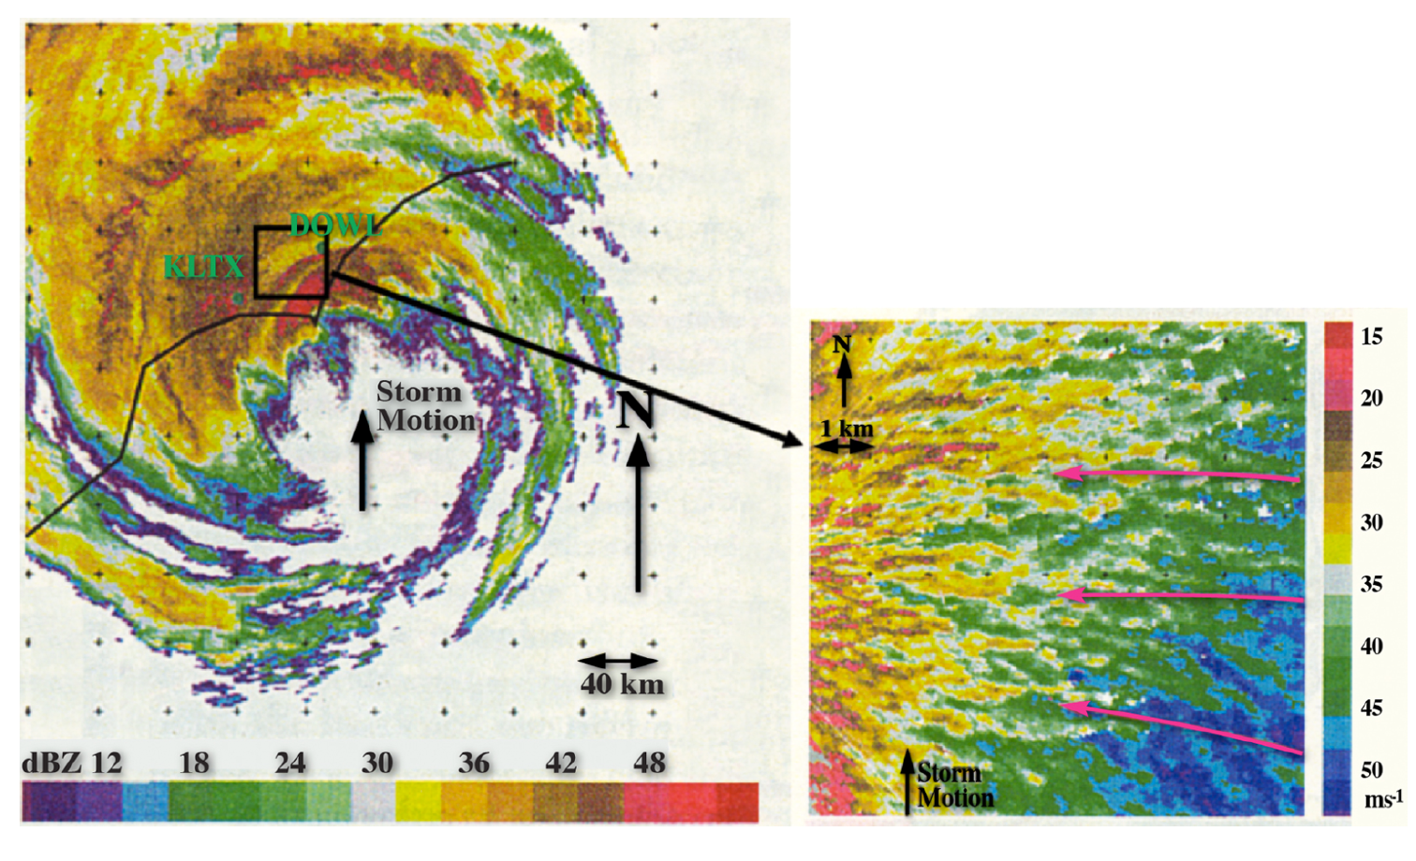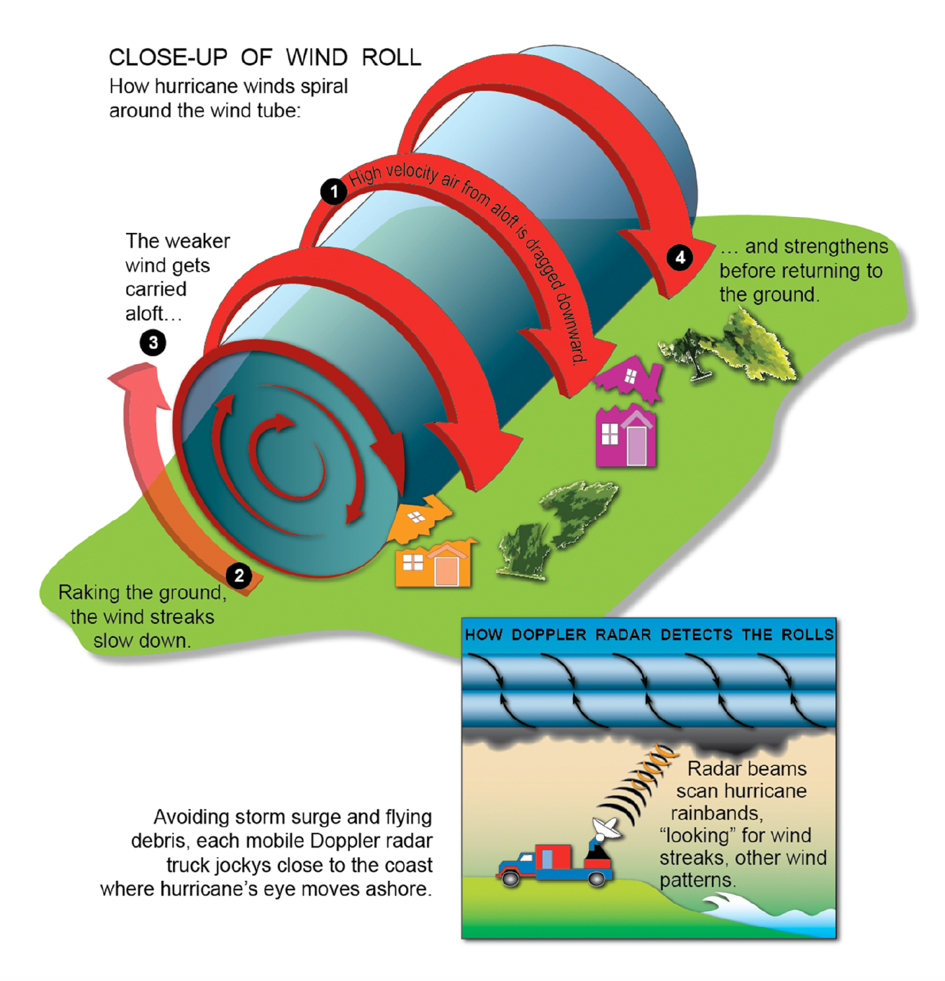
Figure 8.24(A). Schematic showing the formation of wind streaks above the surface in a landfalling hurricane. Wind streaks were first identified by mobile Doppler radars positioned along the coast. As shown in the inset, the corridors are less than 1 km wide and arrayed in parallel rows, in the direction of eyewall winds. (B). Wind streaks are aligned parallel to horizontal, rolling tubes of air above the surface. The tubes drag high velocity air aloft (freed from the effect of surface friction) down to the surface.
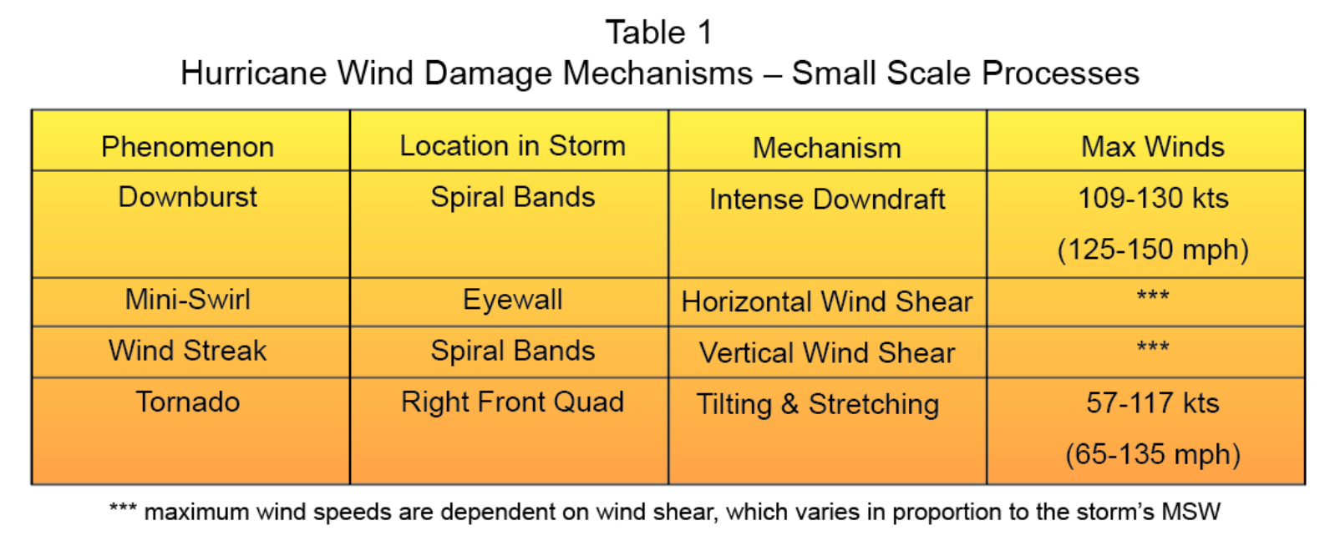
Table 8.1. This table summarizes the various types of small-scale winds in hurricanes, along the coast at landfall. While tornadoes are a small-scale extreme wind, they develop further inland.
8.4 Freshwater Flooding Is One Of the Most Deadly Aspects of A Landfalling Tropical Cyclone
Flooding from heavy rain is the number-one cause of hurricane-related deaths in the United States. Like surge and high wind, the mechanism depends on many details – meteorological, hydrological and geographical. Landfalling hurricanes commonly produce 15-30 cm (6-12 in) of heavy rain along the coast, sometimes much more, leading to flash flooding and river floods.

The Heavy Rain From Tropical Cyclones At Landfall Ranks As Some of the Most Devastating Across Broad Regions of the United States
Tropical cyclones, including both hurricanes and tropical storms, are among Earth’s most efficient rain-producers. They process copious amounts of water vapor into heavy showers. The heaviest rain falls from intense convective cells in the eyewall spiral bands. Between these cells, thick layers of sheet-like cloud (stratiform cloud) generate more widespread, steady rain.
Scientific Principle 3.25 Convective rain describes heavy showers, or cloudbursts, generated by deep convective clouds and thunderstorms. This type of rain tends to be spotty (isolated) and intense, lasting only for brief periods (tens of minutes), and characteristic of summertime weather systems across the U.S.
Scientific Principle 3.27 Stratiform precipitation describes rain or snow falling from stable, horizontally-oriented cloud layers (nimbostratus) that cover widespread areas. The precipitation tends to be moderate or light, and often persists for many hours.
Wind blows the rain horizontally. Salty ocean spray and heavy rain mix above the ocean. At times, it is nearly impossible to separate ocean from sky.
Figure 8.25 shows the remarkable rain totals created by tropical cyclones and their post-tropical remnants in each of the states. Every U.S. state, at some point since the start of records (1962), has received some amount of tropical cyclone rainfall. As you might expect, the Gulf Coast and Mid-Atlantic states are the rainfall heavy hitters, lead by Texas (122 cm or 48 in from Tropical Storm Amelia in 1978), followed by Florida (98 cm or 38.5 in from Hurricane Georges in 1998) and Alabama (96 cm or 38.8 in from Tropical Storm Danny in 1997).
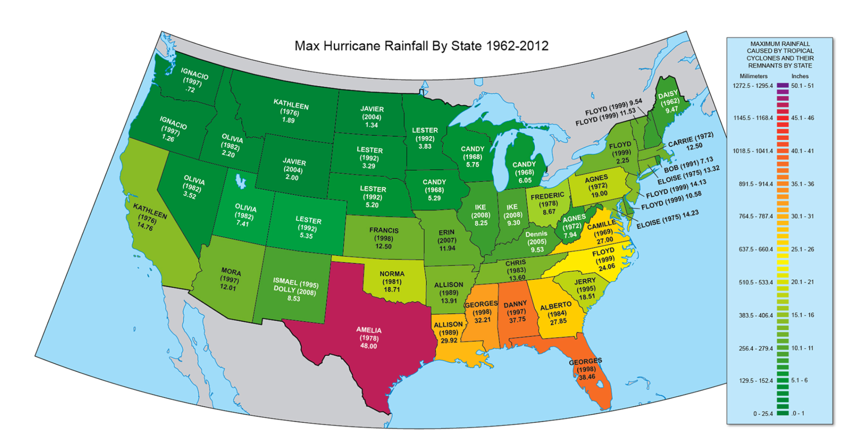
Figure 7.25. State-by-state tally of record tropical cyclone rainfall. Tropical storms, rather than hurricanes, sometimes produce the highest rain totals.
Surprisingly, the amount of rain delivered by a tropical cyclone correlates poorly with its intensity as measured by the MSW. A humble tropical storm can deliver heavier rain than a Category 2 hurricane. Rain accumulation depends on several factors besides vortex strength. One of the most important is the speed at which the storm moves. A slow-moving or stationary hurricane localizes all its rain to one spot. Tropical cyclones, striking the United States in late summer and early fall, often encounter quiescent (inactive) steering winds. That is, there is no fast jet stream over the southern United States; the jet, if present at all, is located over Canada. Many a tropical cyclone has languished for days along the Gulf Coast states, resulting in rain totals measured in feet, not inches!
Another reason for heavy rain is the repeated passage of individual rain-producing thunderstorm cells over the same location. This is process is called cell training and is illustrated in Figure 8.26. The diagram shows a tropical cyclone tracking slowly W-NW across the Gulf Coast. Large amounts of Gulf moisture enter the storm. Heavy rain showers form in rain-band cells (dark green circular regions). One of these bands is oriented east-west across Location A. Winds entering the storm from the east blow parallel to this band. The rain cells, moving with the wind, pass repeatedly over the same location. As long as the spiral band remains stationary, each cell delivers its “cargo” of heavy rain, analogous to a freight train passing overhead. The smaller inset diagram shows how quickly the rain adds up. A sequence of 5-6 rain cells can easily deliver 13-26 cm (5-10 in) of rain in just a few hours.
Finally, tropical cyclones import a tremendous amount of water vapor over land. This moisture converges near the storm’s center as the airflow spirals inward, where it is forced to ascend. Even though the wind vortex may be weakening, the shear amount of water vapor available to condense into rain is vast; rain production remains a very efficient and widespread process, sometimes persisting over several days of the weakening process.
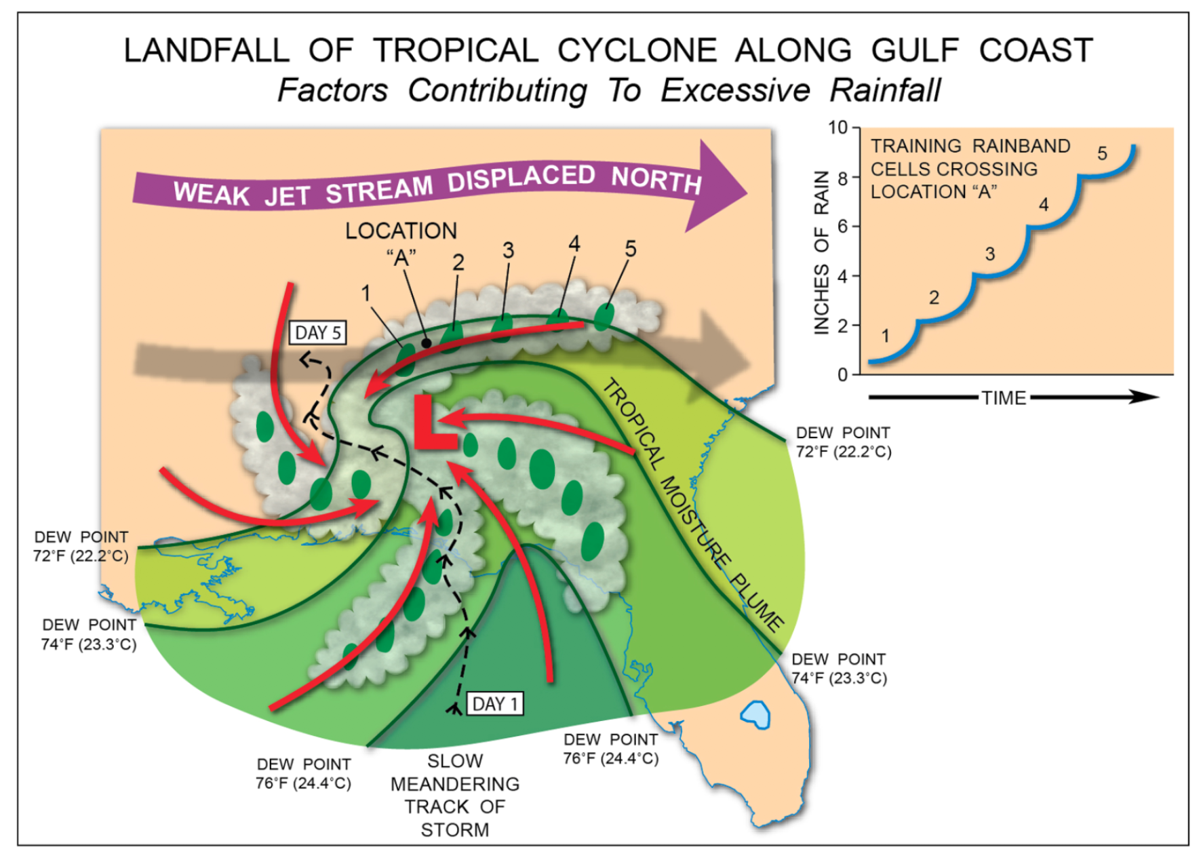
Figure 8.26. The diagram shows the various mechanisms leading to heavy rainfall during a landfalling tropical cyclone. These process include slow storm motion, high moisture content in the air, and cell training within rain bands.
Meteorologists use a simple equation to help predict total rain along the coastline, based on (1) the storm’s average rain rate (the one factor that varies with storm intensity), (2) storm size, and (3) speed of storm movement:
Total Rain = (Rain Rate X Storm Diameter) / Storm Speed
Consider two quick examples. Storm A produces rain at 5 cm (2 in) per hour. It is compact, only 200 km (124 mi) in diameter. It also moves rapidly, at 30 kts (35 mph). Total rain for any location beneath the storm works out to 18 cm (7 inches). Storm B is larger but weaker, moves at 15 kts (17 mph), with an average rain rate of 3 cm (1 inch) per hour. These numbers yield 68 cm (27 in) of rain. This is an extreme value, but not without precedent along the Gulf Coast.
Let’s look at some examples of coastal flooding during extreme events tropical cyclone landfalls. Figure 8.27 shows rain accumulations for Tropical Storm Allison (2001), Hurricane David (1979), and Tropical Storm Fay (2008). Allison struck Texas as a tropical storm, weakening to a tropical depression. The system meandered for days along the Gulf Coast, even executing a 360 degree loop! A total of 51-64 cm (20-25 in) rain fell across southern Louisiana. Note the pocket of 89 cm (35 in) of rain over extreme southeastern Texas. That is almost three feet of rain.
Hurricane David’s rain footprint was more extensive, stretching from Florida to Maine. The storm hit the United States as a Category 2, having weakened considerably from Category 5 status over the Caribbean. Compared to Allison, this system was on the move. Up to 18-25 cm (7-10 in) of rain fell over the eastern Carolinas. There were isolated pockets of up to 38-51 cm (15-20 in) of rain, probably from cell training in spiral rain bands.
Finally, Tropical Storm Fay produced the most widespread hurricane flood in Florida’s history. The storm traced a path along Florida’s peninsula, then the panhandle, blanketing the entire state with heavy rain. During its slow zigzag, Fay made four consecutive landfalls over Florida! As much as 50% of the state received 25-38 cm (10-15 in) of rain with extreme values exceeding 64 cm (25 in). Note that Fay’s moisture extended as far north as the Smoky Mountains, where uplift of air along mountain slopes wrung out an additional 25-38 cm (10-15 in) across high terrain. The enhancement of rain over steep mountain slopes is termed orographic rainfall and is discussed in the next section.
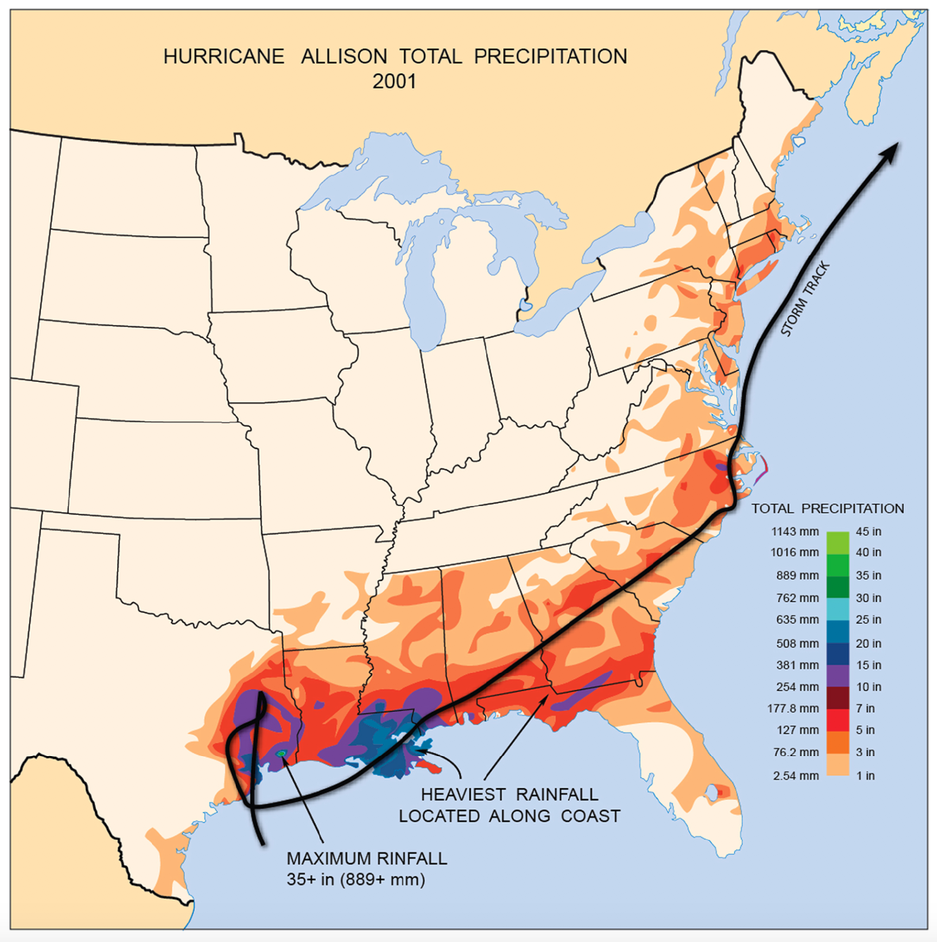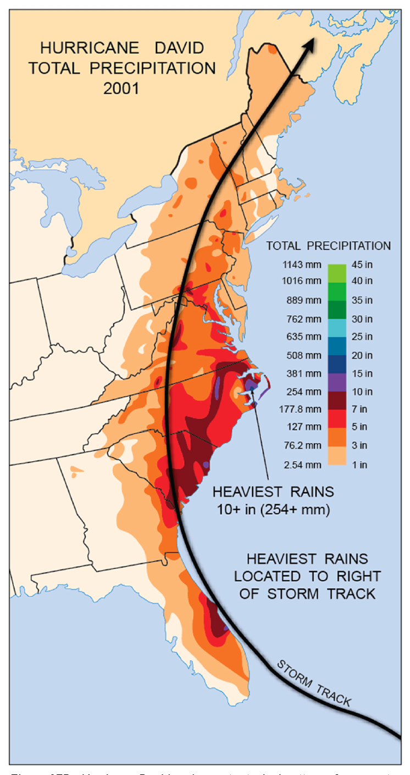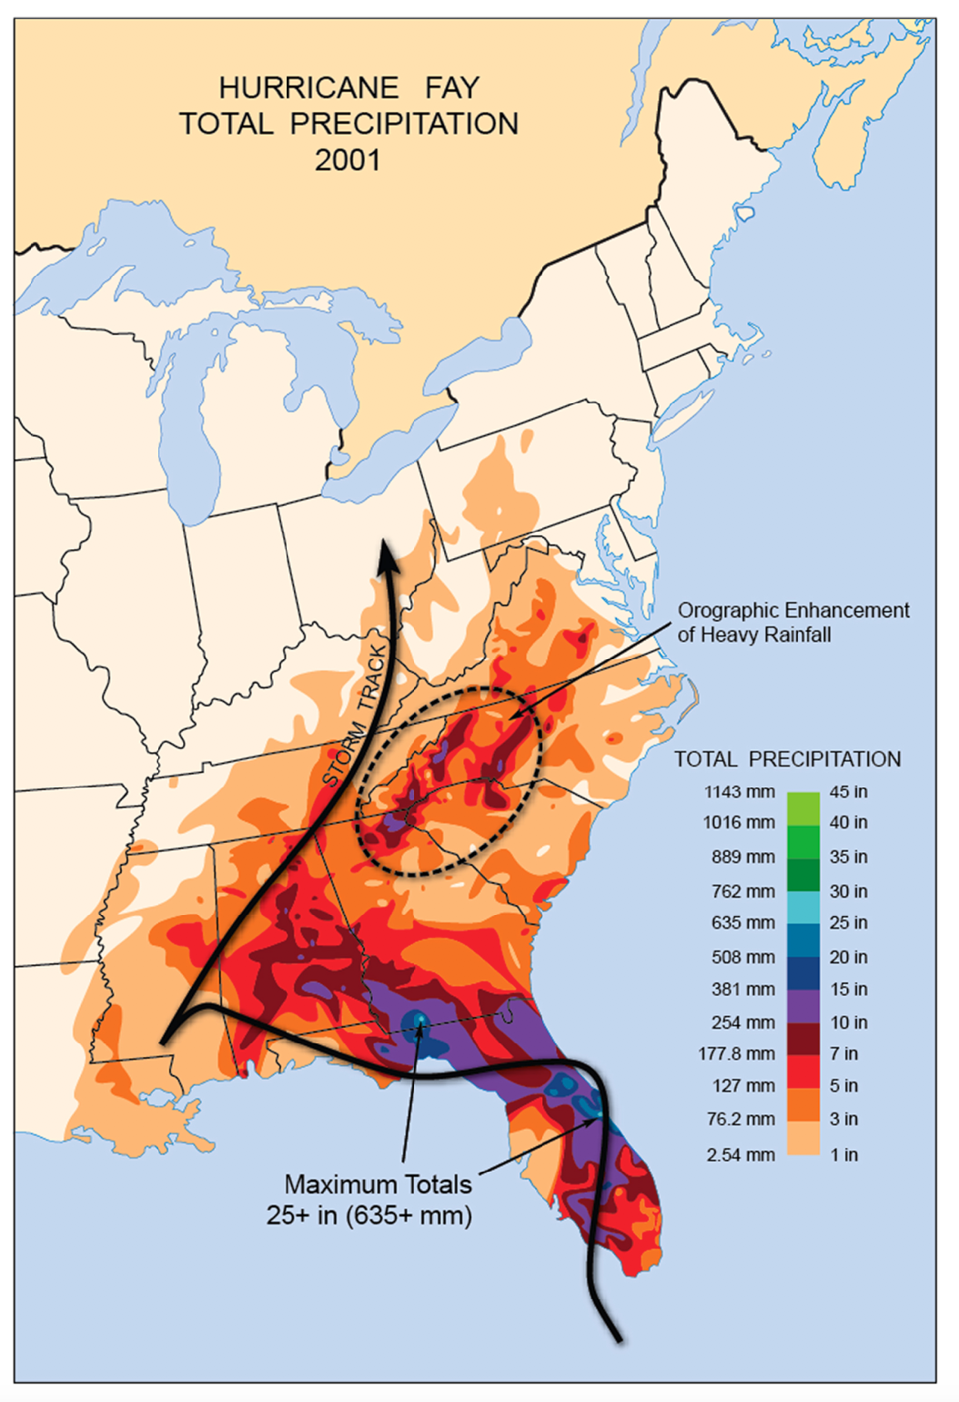
Figure 8.27(A). Rain accumulation maps from several notable United States landfalling tropical cyclones. Heavy rains fell along the Gulf Coast from Tropical Storm Allison, due mainly to the storm’s slow motion and looping track. (B). Hurricane David underwent a typical pattern of re-curvature along the East Coast, producing a long arc of heavy rain from Florida to New England. (C). Hurricane Fay inundated the entire state of Florida before tracking into the Ohio Valley. The storm was also responsible for heavy rainfall in the southern Appalachians.

8.5 Tropical Cyclones Entering Their Post-Tropical Phase Can Still Create Devastating Inland Impacts
Post-tropical remnants of a tropical cyclone can remain destructive far inland when there is an additional source of energy fueling the vortex. The same energy sources that power extratropical cyclones – strong temperature gradients and dynamic waves in the jet stream – can combine with and sustain remnant tropical systems.
Scientific Principle 2.17 Extratropical cyclones are large, transient vortices that migrate from west to east across mid latitudes. Air converges in a counterclockwise spiral around these cyclones, which feature low pressure in their core (“L” on a weather map). These systems bring changeable weather (extremes in temperature, precipitation, fair weather) to most mid-latitude locations.
The post-tropical system undergoes significant changes, appearing more and more extratropical over time. For a while, it may become a type of “hybrid” storm – possessing characteristics of both a tropical and extratropical vortex.
This section is about tropical cyclones that move inland, then catch their “second wind,” both figuratively and literally. These hurricane remnants continue to produce hazardous weather, sometimes days after landfall. Historically this phenomenon has happened in many locations east of the Rockies, but most commonly in the Mid-Atlantic and Northeast. The biggest concern of post-tropical cyclone remnants is heavy rain, leading to flash floods, river floods, mudslides, and debris flows. Tornado outbreaks are also fairly common. Much less frequently, intense hurricane-force winds can be maintained far inland. Even heavy snowfall has occurred -- for instance, after the landfall of Hurricane Sandy (2012). Several U.S. weather catastrophes have unfolded during the inland phase; examples are shown in Table 8.2.
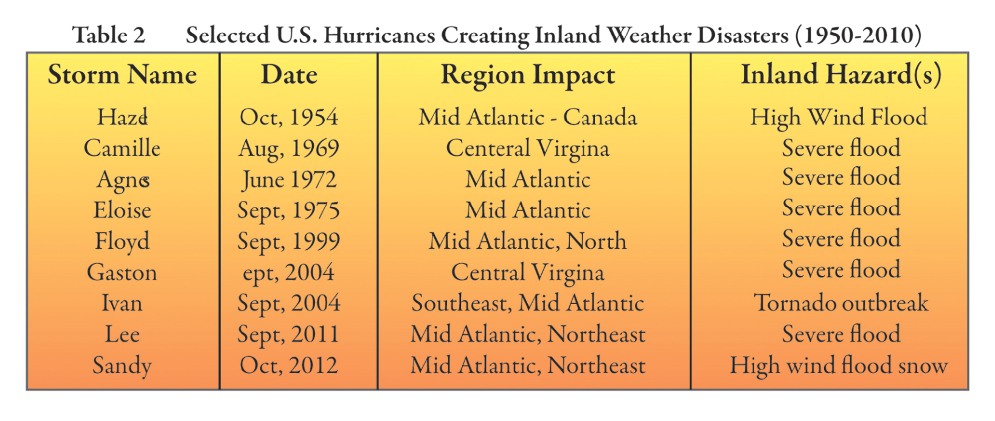
Table 8.2. This table shows inland weather hazards generated by selected post-tropical cyclone remnants during the past 60 years.
A hybrid vortex is one which feeds off both tropical and extratropical energy sources
In 2010, the National Hurricane Center introduced new terminology to describe tropical cyclone remnants – the so-called post-tropical cyclone phase. Post-tropical cyclones are hurricanes or tropical cyclones that have weakened, over land or ocean, and lose key structural attributes including the eye and eyewall. The storm’s central warm core will be in the process of cooling. But a weakened vortex of wind remains, typically larger diameter than as a purely tropical system, and one or more spiral rain bands still show up on radar and satellite imagery. Moreover, these post-tropical cyclones may continue to produce heavy rain and high wind.
Post-tropical cyclones that weaken further - to the point where winds have dropped below 34 kts (39 mph) - are referred to as remnant lows. Aside from continued moderate-heavy rain, their severe effects are limited.
A post-tropical cyclone that morphs into a mid-latitude cyclone, is referred to as a hybrid cyclone. The process by which a tropical cyclone fully transforms into an extratropical cyclone is termed extratropical transition (ET). Just like ordinary extratropical cyclones, these systems have acquired fronts and derive their principal energy from thermal gradients. They become fully coupled to the westerly jet stream aloft. This process is illustrated in Figure 8.28.
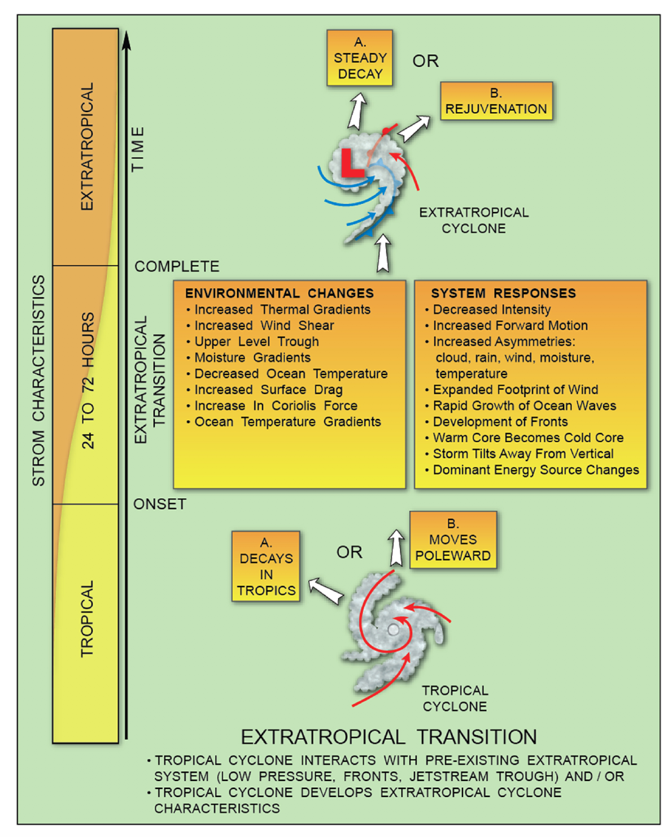
Figure 8.28. This figure summarizes the different fates of hurricanes in their post-tropical phase, including the complex process of extratropical transition.
As a tropical cyclone moves poleward, it encounters a number of changes in its atmospheric and oceanic environment. The Coriolis effect (Earth’s spin) becomes stronger, changing the tropical cyclone’s wind balance.
Scientific Principle 2.5 The Coriolis Effect arises from the spinning Earth; it deflects air that begins to move, to the right, in the Northern Hemisphere.
Cooler ocean temperatures diminish the supply of sensible and latent heat streaming into the tropical cyclone. At the same time, the storm begins to interact with the strong temperature and humidity gradients typical of the mid-latitude atmosphere. Vertical wind shear increases as the hurricane moves into the domain of the westerly jet-stream. A trough in the jet stream may merge with the tropical cyclone. One or more fronts near the surface may become incorporated into the storm’s circulation. Both of these interactions increase the uplift of air, escalating the storm’s rainfall.
In response to these effects, the post-tropical storm undergoes significant changes. The storm accelerates once it becomes embedded in the faster flow. As a storm’s forward speed increases, winds around the vortex become highly asymmetric, blowing more strongly to right of center. Meantime, the heavy rain often shifts to left of track. The storm’s cloud and precipitation shield become elongated in the downstream direction. What results is a highly asymmetric, distorted, and often expanded weather system that, while weaker, is still capable of producing destructive weather for several days. Figure 8.29 shows an example, from the satellite perspective, how the physical attributes of a tropical cyclone change during ET. During ET, the hybrid system can remain steady-state for days or slowly decay.
Rarely, a hybrid cyclone can undergo a brief period of re-intensification or rejuvenation. Rejuvenation requires an extremely favorable merger between the tropical cyclone and a vigorous jet stream trough. Let’s now look at a remarkable example of rejuvenation: Hurricane Hazel, during October, 1954.
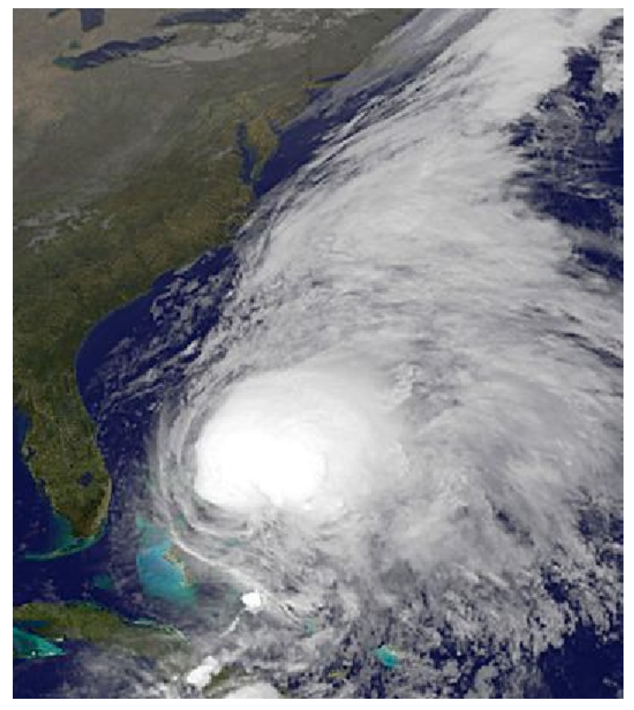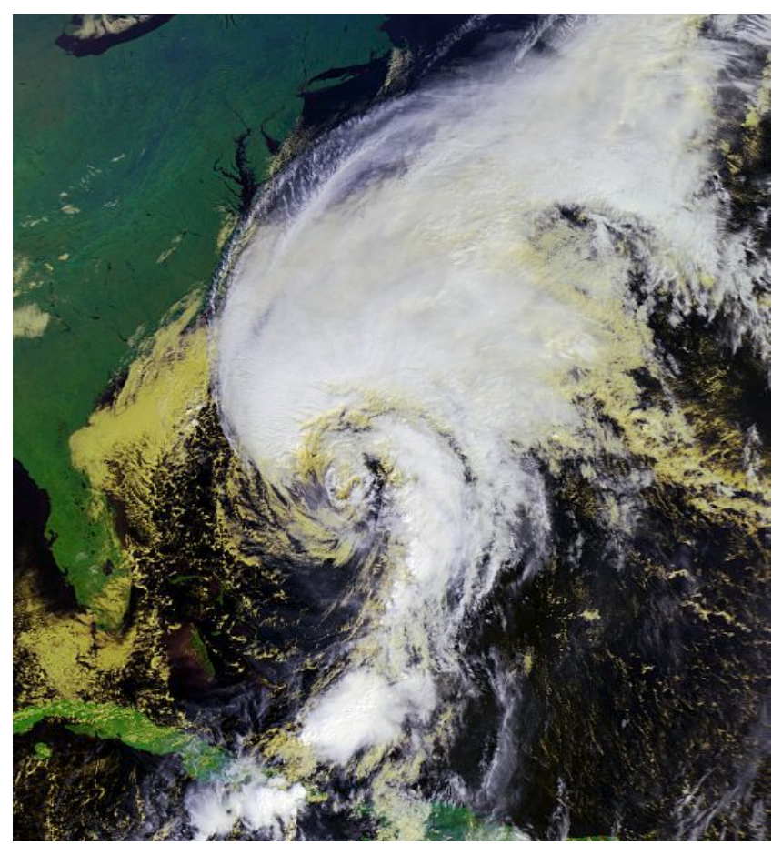
Figure 8.29(A). Satellite view showing Hurricane Noel (2007) before extratropical transition. Note the symmetric, near-circular mass of tropical thunderstorms clustered near the storm’s center. A visible eye, however, remains obscured by high cloud. (B). Hurricane Noel during extratropical transition. The storm takes on the appearance of a classic mid-latitude cyclone, with its distinct comma shape. Clear, dry air intrudes from the southwest and the cloud shield acquires an asymmetric shape as jet-stream winds spread the storm’s moisture toward the northeast.

Hurricane Hazel morphed into a powerful hybrid cyclone, which rejuvenated over the northeastern United States
Hurricane Hazel’s (1954) transformation from hurricane to a powerful extratropical storm offers a rare glimpse into the rejuvenation process. As shown in Figure 8.30A, Hazel made landfall along the Carolina coast as a Category 4 hurricane on the evening of October 15, 1954. As the storm moved toward the north, an unseasonably cold and vigorous trough in the jet stream approached the East Coast (Figure 8.30B).
Scientific Principle 2.21 The meanders in the jet stream, called Rossby waves, take the form of troughs (equatorward-curved segments) and ridges (poleward-curved segments). Cold, polar air moves south in a trough, while warm, tropical air moves north in a ridge.
The trough helped generate an ordinary extratropical cyclone north of the Great Lakes. A cold front trailed southward from this storm. Hazel rapidly merged with this cold front over the Mid-Atlantic states.
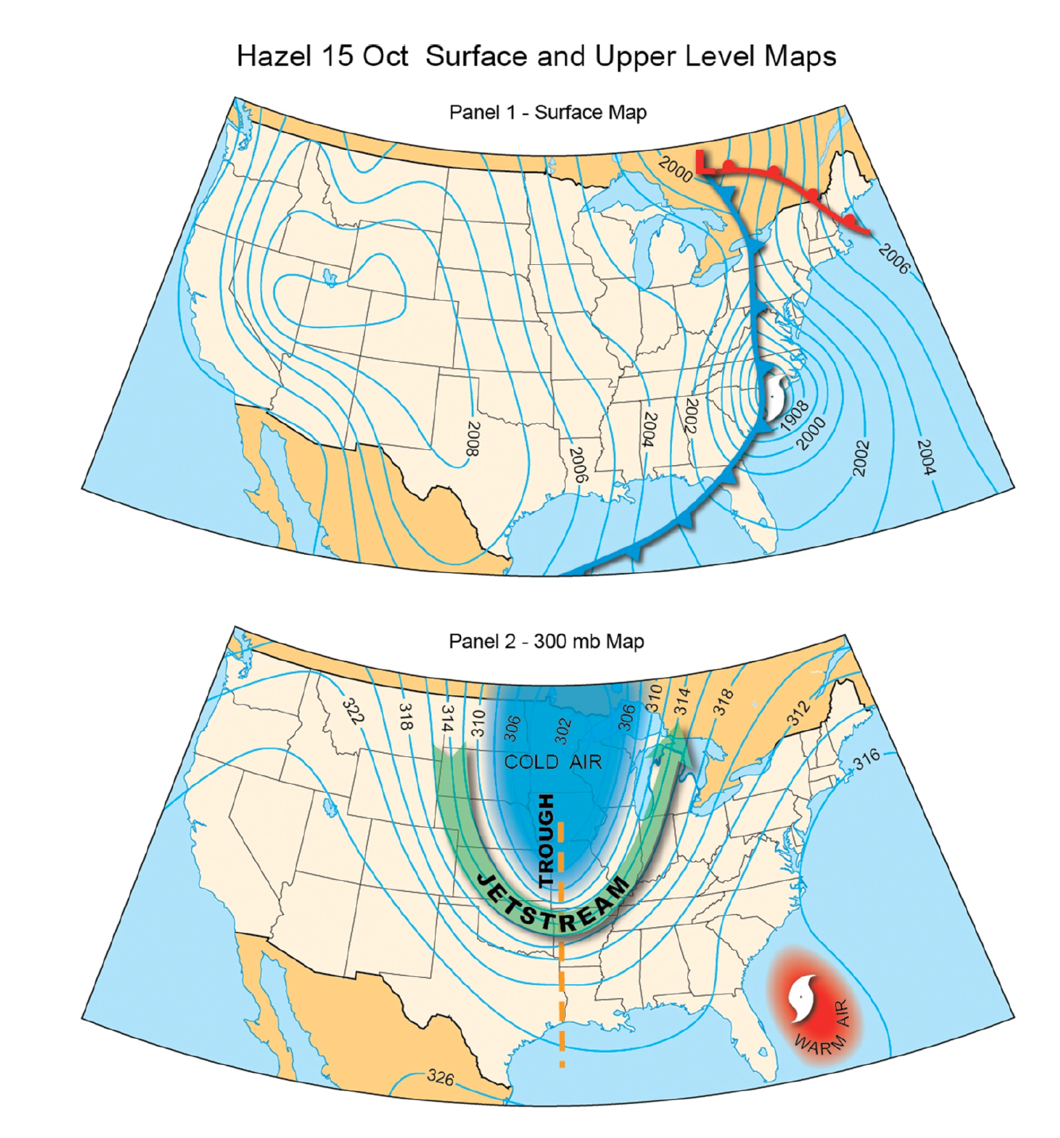
Figure 8.30(A). Interaction of Hurricane Hazel with a strong cold front and upper-level jet stream trough set the stage for rejuvenation over land. This is the initial phase of the interaction on October 15. (B). Interaction of Hurricane Hazel with a strong cold front and upper-level jet-stream trough. This is the initial phase of the interaction.
By midnight on the 16th, Hazel’s tropical vortex combined with the Great Lakes cyclone (Figure 8.31A). The combined system moved over Toronto, Canada, where it led to considerable damage and loss of life. You will note from the appearance of isobars that this hybrid system was just as intense as the hurricane phase in the Carolinas! The strong jet-stream trough (Figure 8.31B) played a significant role in maintaining Hazel’s intensity. In fact, an enormous reservoir of potential energy was generated as cold, arctic air became juxtaposed against warm, tropical air. This generated an intense thermal gradient and reservoir of potential energy. As cold air sank and warm air ascended, a tremendous amount of kinetic energy was created, on the order of one petajoule (one quadrillion joules). This energy is equivalent to the detonation of two atomic bombs. This extra energy counteracted spin-down of the tropical vortex as it left behind its oceanic heat source. As a result, hurricane-force winds were maintained for hundreds of miles inland.
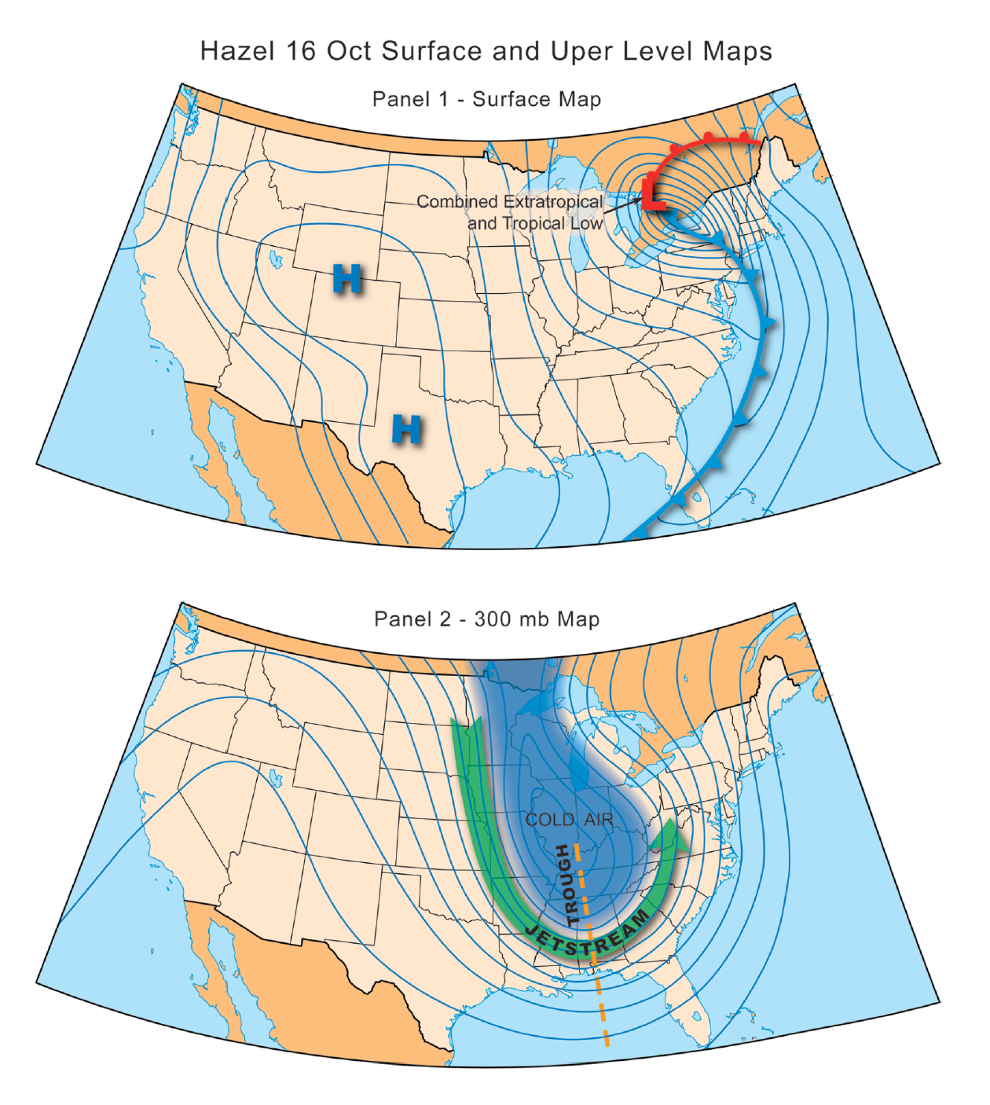
Figure 8.31(A). (B). Interaction of Hurricane Hazel with a strong cold front and upper-level jet stream trough: The post-tropical cyclone and extratropical cyclone have merged into a giant hybrid vortex. (B). The intensified trough at jet stream level, with extremely cold air circulating far to the south,
Because the storm was embedded in fast jet-stream winds, it zipped northward at speeds of 43-48 kts (50- 55 mph). Within 24 hours of landfall in the Carolinas, Hazel traveled all the way to southeastern Canada. Sustained winds near 70 kts (81 mph) were experienced In Norfolk, Virginia and Washington, DC, with gusts approaching 87 kts (100 mph). Winds gusted to 78 kts (90 mph) in New York. As Figure 8.32 shows, these high winds were generated along the right side of the storm’s track. Note the steady progression of the 50 kt (58 mph) isotach up the East Coast. The storm’s fast movement contributed to these exceptionally strong inland winds.
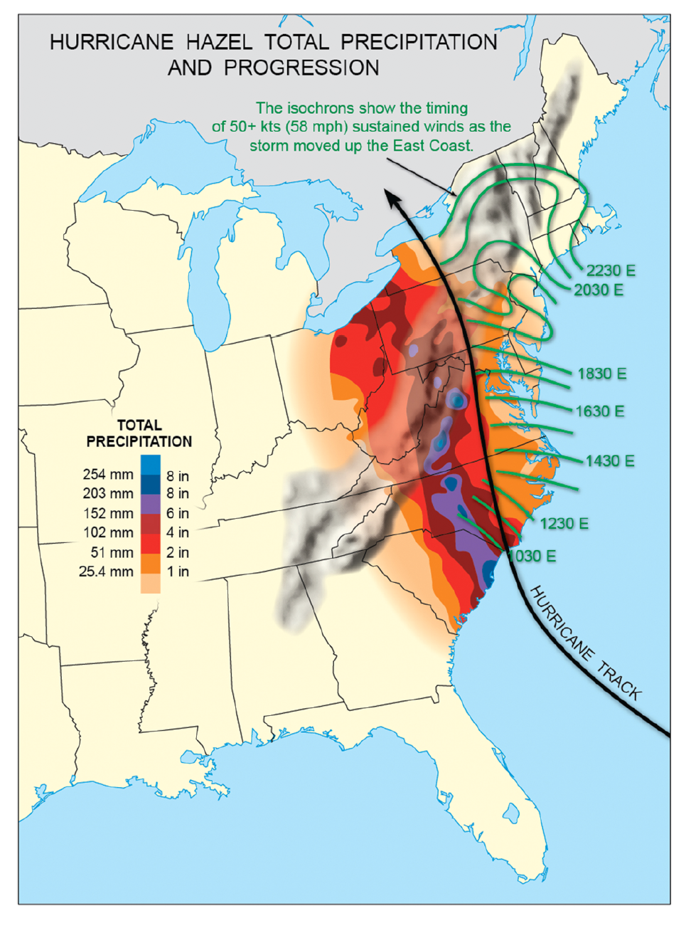
Figure 8.32. The devastating inland effects of Hurricane Hazel’s extratropical transition and rejuvenation. A swath of heavy rain developed to left of track along the Appalachians, while sustained 50+ kt (58+ mph) winds rapidly swept northward up the East Coast, on the right side of the system.
A swath of heavy rain fell to the left of track, along the Appalachians (Figure 8.31). Overall, 10-15 cm (4-6 in) of rain fell, with isolated pockets exceeding 15 cm (6 in). The storm’s rapid movement limited total rain accumulation.

Extremely heavy rainfall far inland is commonly generated by hybrid cyclones, particularly over the Appalachians
Some of the greatest flood disasters in the history of the Mid-Atlantic and New England have unfolded when post-tropical cyclones and their hybrids interact with mountainous terrain and pre-existing fronts. Disastrous floods ensue, including flash floods and river floods. Mudslides and debris flows along mountain slopes may also result.
Hurricane Floyd (1999; Figure 8.33) generated exceptionally heavy rains during its extratropical transition. Floyd struck the Carolinas on September 16 as a strong Category 2 hurricane. As Figure 8.34 shows, the storm tracked northeastward along the Outer Banks and Delmarva Peninsula. An elongated swath of exceptionally heavy rain, 18-25 cm (7-10 in), fell from North Carolina through Maine, impacting 13 states. Maximum amounts of rainfall (38-51 cm or 15-20 in) accumulated over portions of eastern Virginia and North Carolina. These rains generated widespread river flooding across eastern North Carolina, where several major rivers exceeded 500-year flood levels, cresting 6-7 m (20 to 23 ft) above flood stage. Floodwaters were heavily contaminated with pesticides, fertilizer, and hog waste across this largely agricultural region. Damage to dwellings from the storm’s effects was extensive – nearly 75,000 homes – forcing 10,000 people into temporary shelter, with total economic losses approaching $5 billion. We should note that Floyd’s flood was “preconditioned” by the arrival of Tropical Storm Dennis, which only a week earlier deposited 18- 25 cm (7-10 in) of rain across eastern North Carolina.
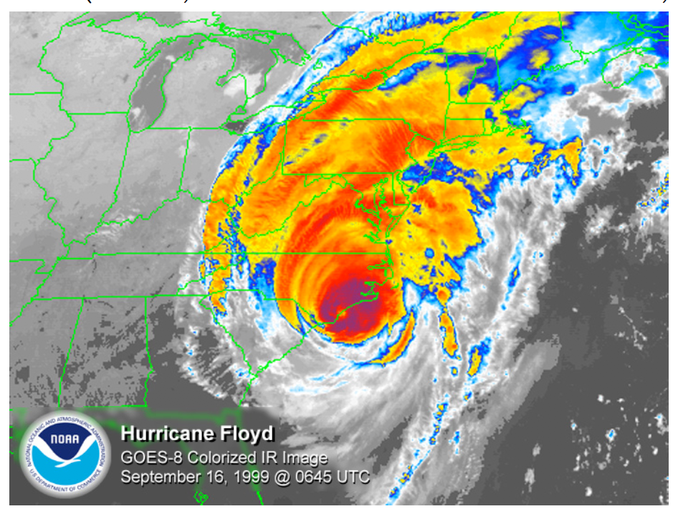
Figure 8.33. False-color infrared satellite image of Hurricane Floyd (1999) during its extratropical transition phase
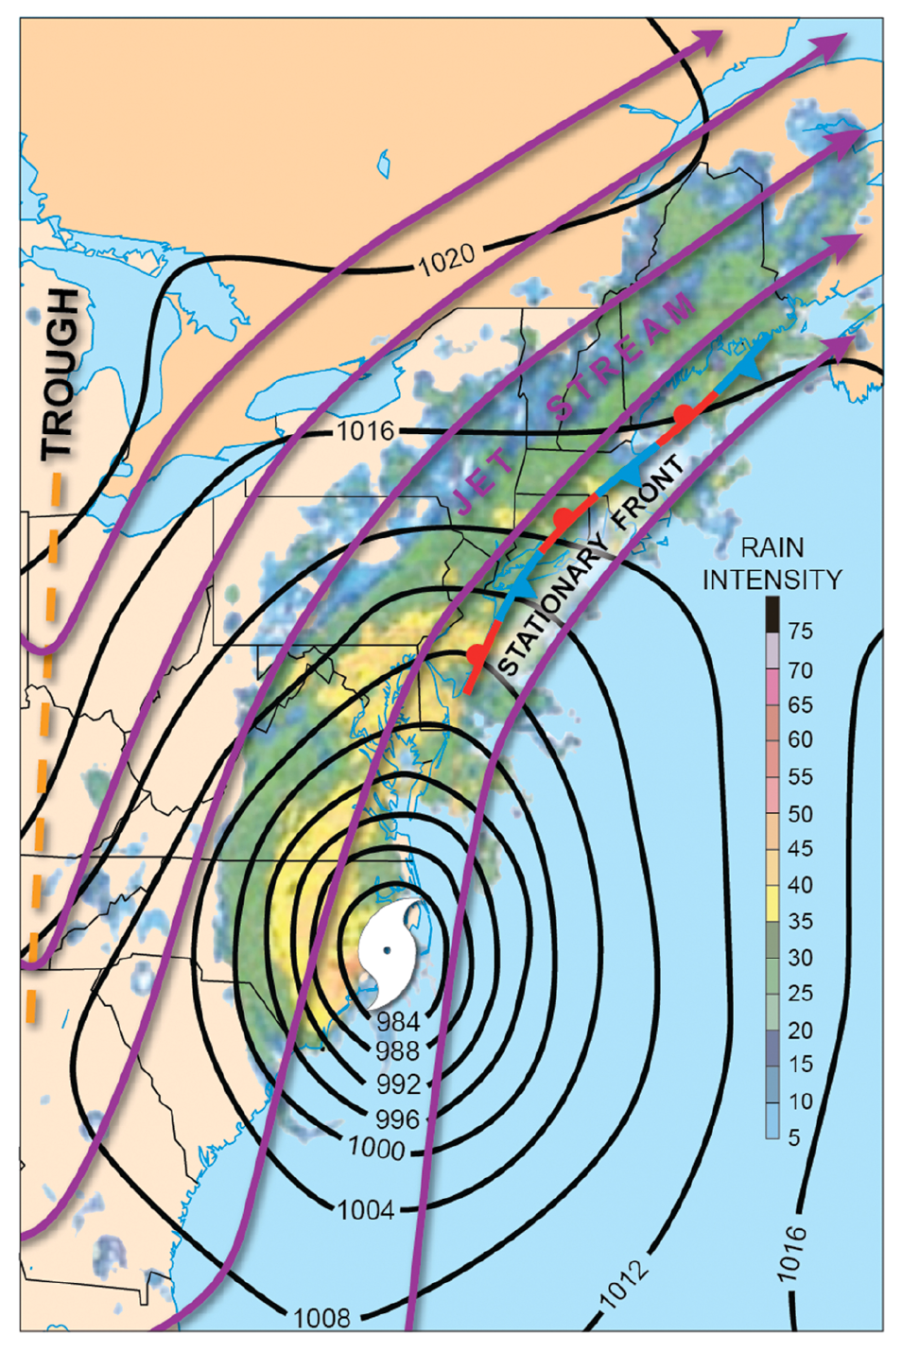
Figure 8.34. This figure shows the various mid-latitude weather elements that hastened the extratropical transition of Hurricane Floyd over the Mid-Atlantic. Floyd became embedded in an upper-level trough and strong jet-stream flow. Note the extension of heavy rain up the East Coast, hundreds of miles ahead of the main storm, along a newly-developed coastal front.
As in the case of Hazel, the location of inland, heavy rain was along Floyd’s left side. Nearly half of all landfalling tropical cyclones have a left-of-center (LOC) rain distribution. Figure 8.35A shows how LOC heavy rain is produced. The key aspect is interaction between the tropical cyclone and a jet-stream trough, located upwind of the storm. Timing is everything. When the trough captures a tropical cyclone, copious water vapor condenses in the trough’s vigorously ascending air. A steady supply of low-level tropical moisture enters the storm from the south and east (green arrow). These weather systems are optimized, heavy-rain-generating machines. If a decaying tropical cyclone interacts with a ridge downwind in the jet stream, heavy rain generation shifts to right-of-center (ROC; see Figure 8.35B).
Finally, heavy rains can be generated when post-tropical remnants interact with mountainous terrain. In this situation, there is enhanced uplift of moisture-laden air along mountain slopes. This interaction can also involve capture of the remnant by a mid-latitude weather system, in the manner of Floyd. Figure 8.36 shows examples of orographic rain enhancement in Hurricanes Agnes (1972) and Eloise (1975). These two storms produced the floods of record in Pennsylvania and Maryland, respectively. The flood of record is the greatest historical flood in a given state. Agnes struck the Florida panhandle as a Category 1 storm, Eloise as a Category 3. Curiously, both systems followed an identical inland track and produced the heaviest rain over northern Virginia, Maryland, and Pennsylvania, far from landfall.
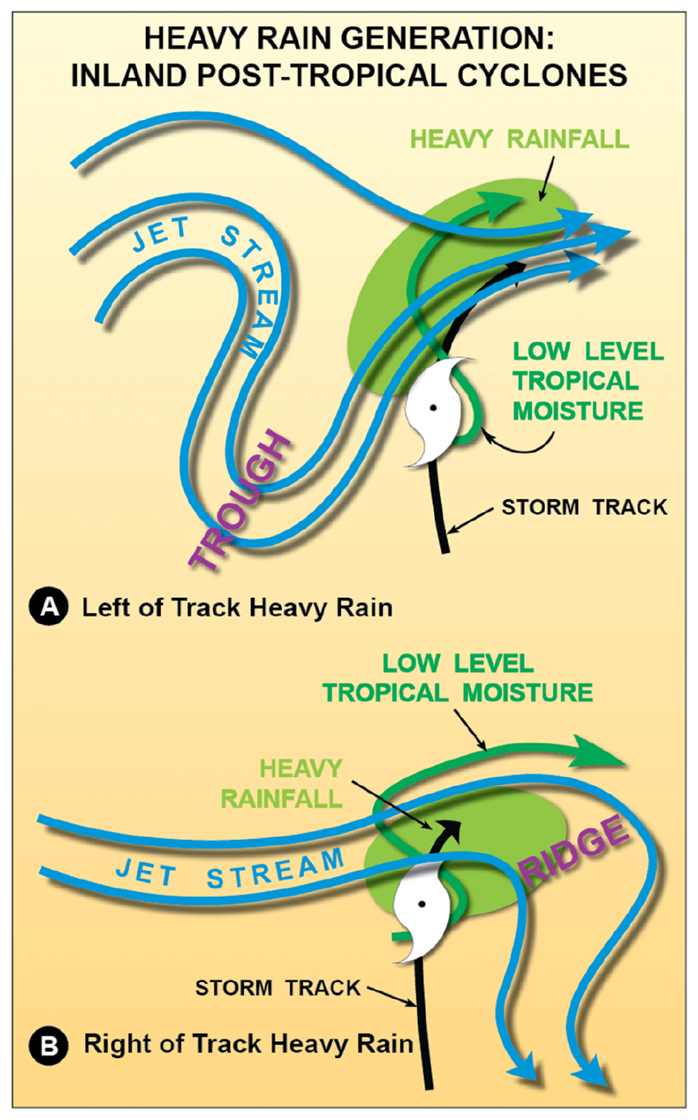
Figure 8.35. Heavy rain distribution during the hybrid phase of an inland, post-tropical cyclone. These models illustrate how the region of heavy rain formation shifts either left of track or right of the storm’s track, depending on the nature of the jet-stream interaction. Both types occur in roughly equal proportion.
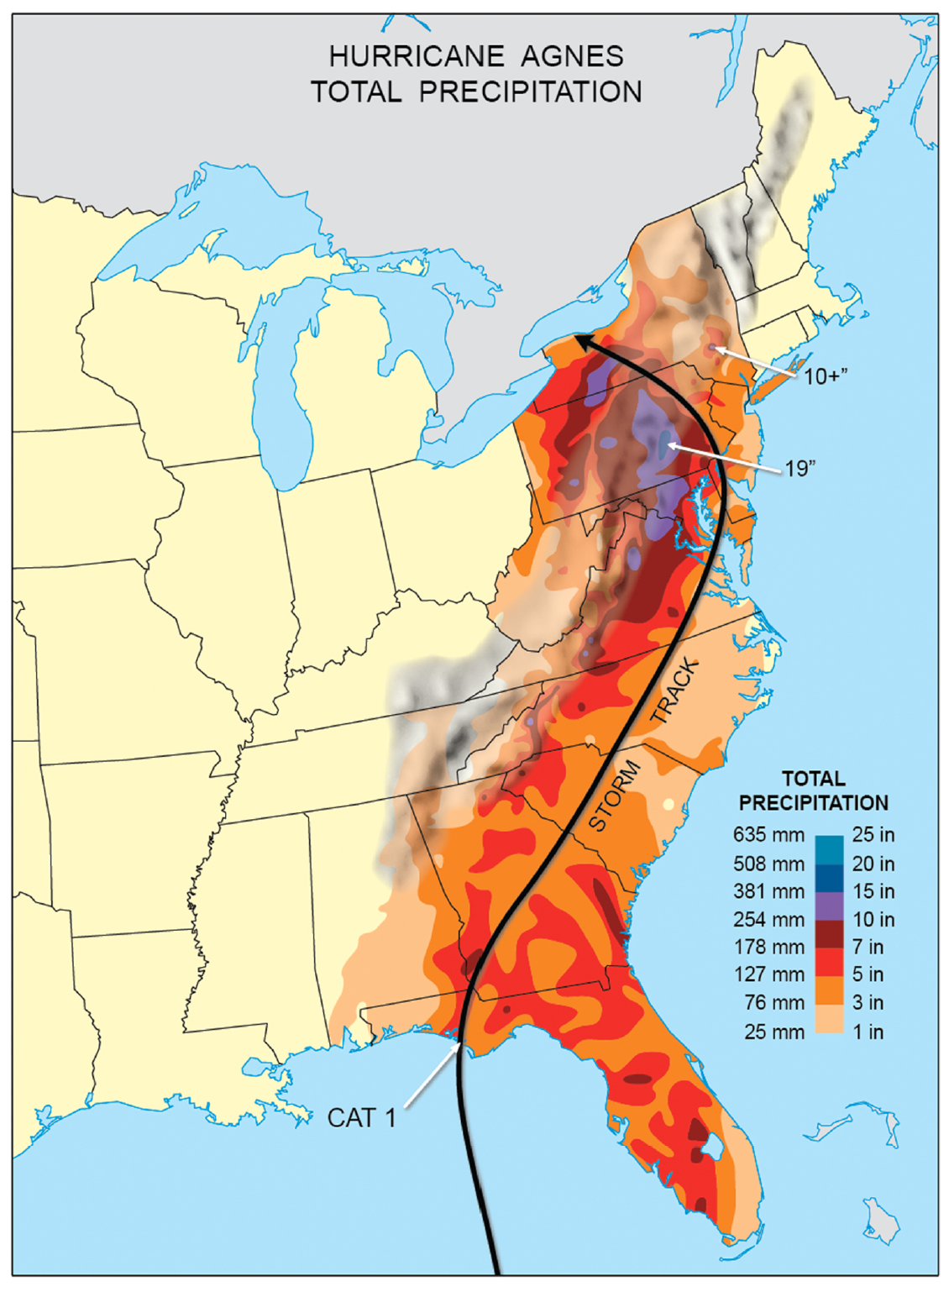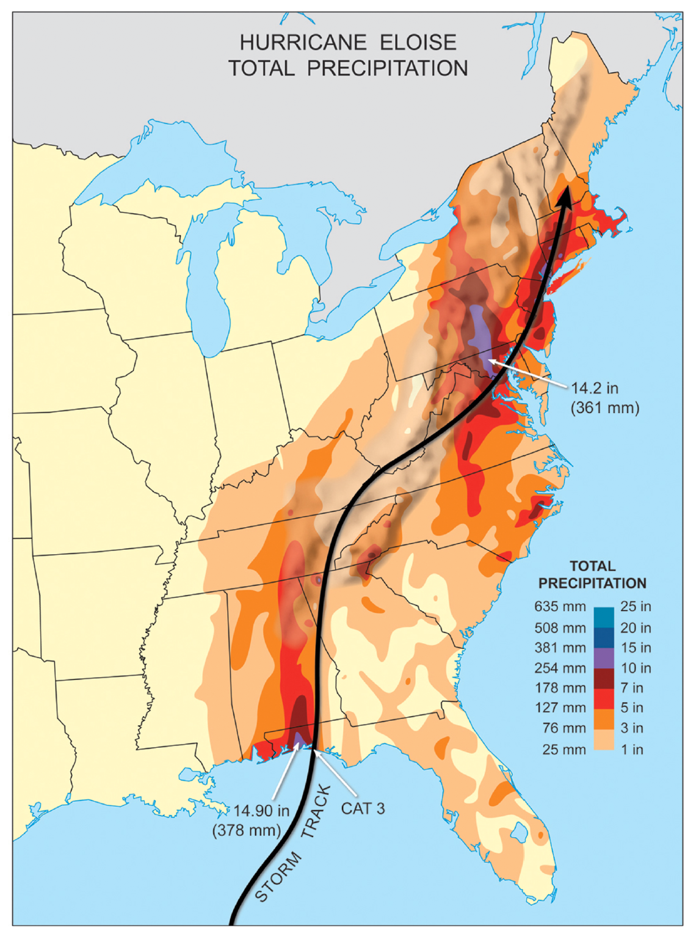
Figure 8.36(A). Although making landfall in Florida, the remnants of Hurricane Agnes did not produce devastating rain until hundreds of miles north. There, rich tropical moisture combined with mid-latitude weather systems over steep terrain to produce Pennsylvania’s historical flood of record. (B). Bearing an uncanny resemblance to Hurricane Agnes, Hurricane Eloise made landfall over Florida and disgorged heavy rainfall several days later over the Maryland- Pennsylvania mountains.
In Agnes (Figure 8.36A), the forced ascent of humid, tropical air up east- and south-facing slopes of the Appalachians produced incredibly heavy rainfall over several days. The heavy rain was also left-of-center, implying (correctly) that a mid-latitude trough enhanced the uplift of moist air. A weather front parallel to the Appalachians, and along the storm’s northward track, further enhanced rain production over Virginia and Maryland. When Agnes’ post-tropical vortex moved off the North Carolina Outer Banks, a second vortex developed over the Appalachians and tracked northward, creating two rain-generating systems operating in tandem! The inland vortex eventually slowed, becoming nearly stationary over western Pennsylvania. The slow movement contributed to very heavy rain accumulations across Pennsylvania.
Hurricane Eloise (Figure 8.36B) took a track very similar to Agnes, but Eloise struck Florida as a Category 3. Major flooding once again ensued in the central and northern Appalachians, days after landfall, producing Maryland’s flood of record.
Following landfall of a weakening tropical cyclone, numerous tornadoes may develop inland,
In addition to heavy rain, hurricanes sometimes play a final destructive card after landfall. When a tropical cyclone forms a tornado, the parent storm’s spin is focused down to very small time and space scales. A tornado is a type of severe local storm. However, there are a few “twists” involved in the process. First, the tornadoes are most likely to occur only when a tropical cyclone weakens over land. Second, the spin actually arises from horizontal twisting of air. Third, tropical cyclone-spawned tornadoes are among the weakest of all tornado intensity categories, with winds that rarely exceed 135 mph – more commonly 65-110 mph.
To understand the process that creates these tornadoes, examine Figure 8.37. Surface friction causes winds in the lowest mile of the hurricane to slow down. As in the case of wind streak formation, friction creates a vertical wind shear. Air within this layer begins to “tumble” over itself, forming long, horizontal “rollers” above and parallel to the ground. Rain bands in tropical cyclones contain convective cells with updrafts. (Updrafts are narrow currents of rapidly rising air.) As vortex loops are drawn into an updraft, they tilt from horizontal to vertical. The updraft then stretches the vortex tubes vertically, such that they contract, intensifying their spin (think the ice skater effect, recalling conservation of angular momentum). In this manner, one or more tornadoes are created within the spiral rain bands of a landfalling tropical cyclone. But over open water, there is not enough surface friction to slow down the air and get it to “tumble.”
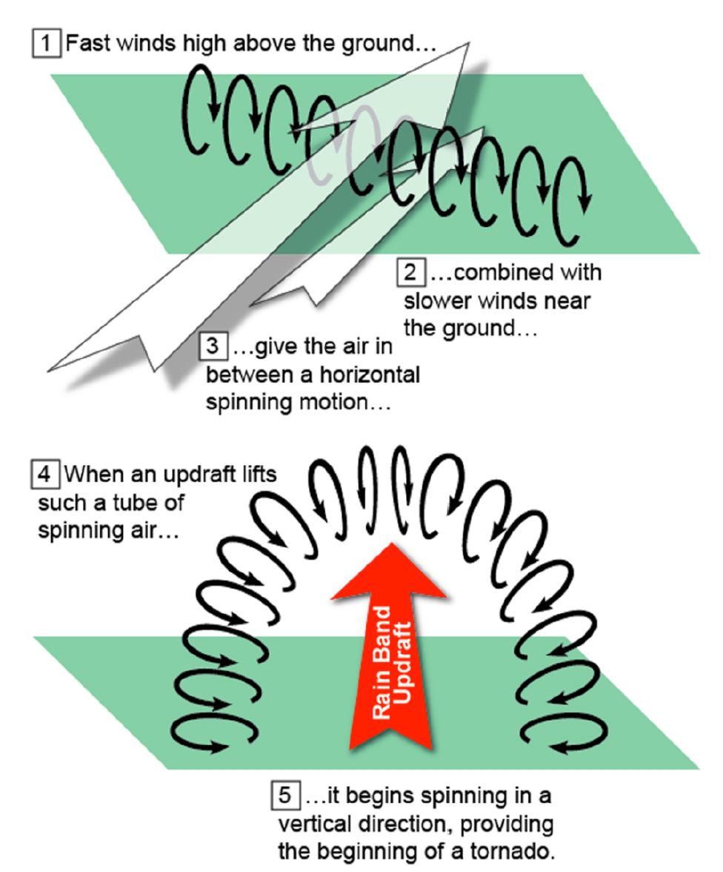
Figure 8.37. This figure shows tornadoes in tropical cyclone rain bands acquire their “twist.” The spin starts in the horizontal plane, as fast winds aloft overtake air slowed at the surface by friction. This process imparts a rolling motion to the air. Later, updrafts in rain-band convective cells draw up loops of spin, tilting horizontally rotating air to the vertical. Stretching of air in the updraft amplifies the vortex into a weak tornado.
Figure 8.38 shows the typical distribution of tornadoes within a landfalling tropical cyclone. The distribution is asymmetric, with most tornadoes developing in the storm’s right front quadrant and within a 400 km (249 mi) radius of the storm’s center.
Figure 8.39 shows the location of all hurricane-produced tornadoes over the United States for a 60-year period. These data are stratified according to Fujita or F scale wind intensity, which ranks tornadic wind speed on a scale from F0 (weak tornado) to F6 (violent tornado). Most tropical cyclone-spawned tornadoes are weak F0-F1 category (winds to 96 kts or 110 mph), and occur within a few hundred kilometers of the coastline; 63% of all these tornadoes form within 161 km (100 mi) of the coast, and an additional 25% within 322 km (200 mi) of the coastline. Figure 8.40 presents a histogram (frequency distribution) of tropical cyclone tornado intensity, based on this 60-year climatology. Note that about only 15% of these tornadoes exceed F1 intensity.
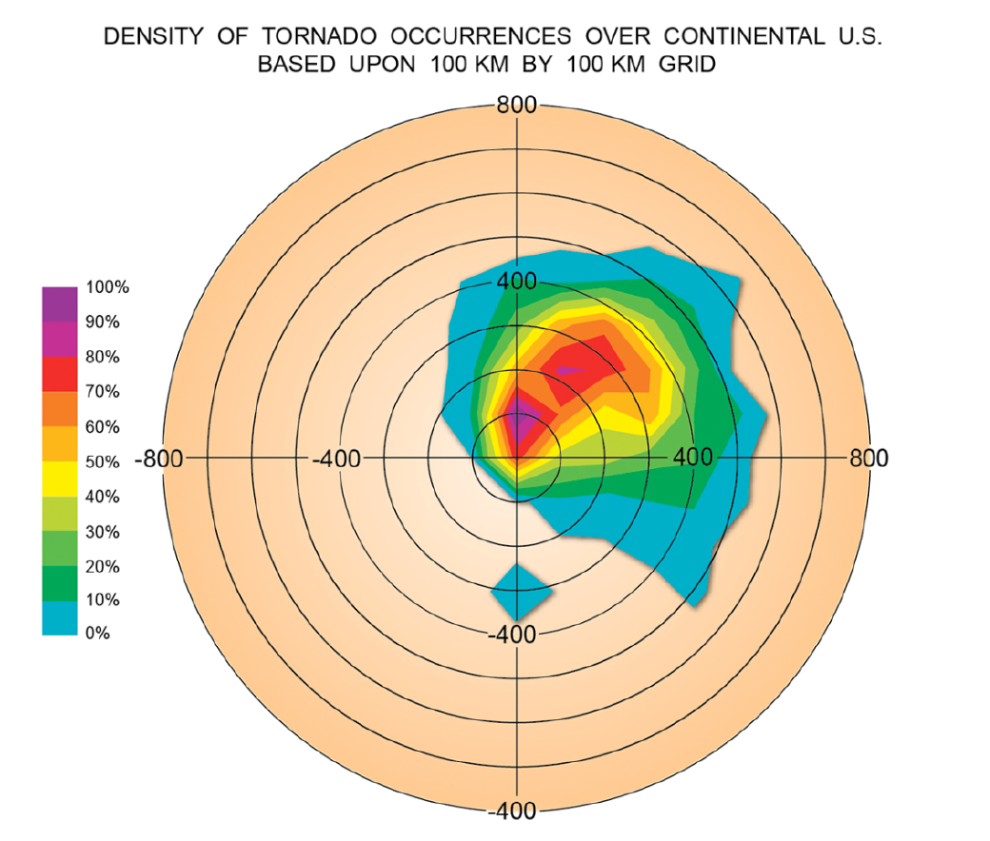
Figure 8.38. Location of tropical cyclone tornadoes after landfall. Most of these tornadoes, while characteristically weak, tend to cluster in the northeast quadrant of post-landfalling storms.
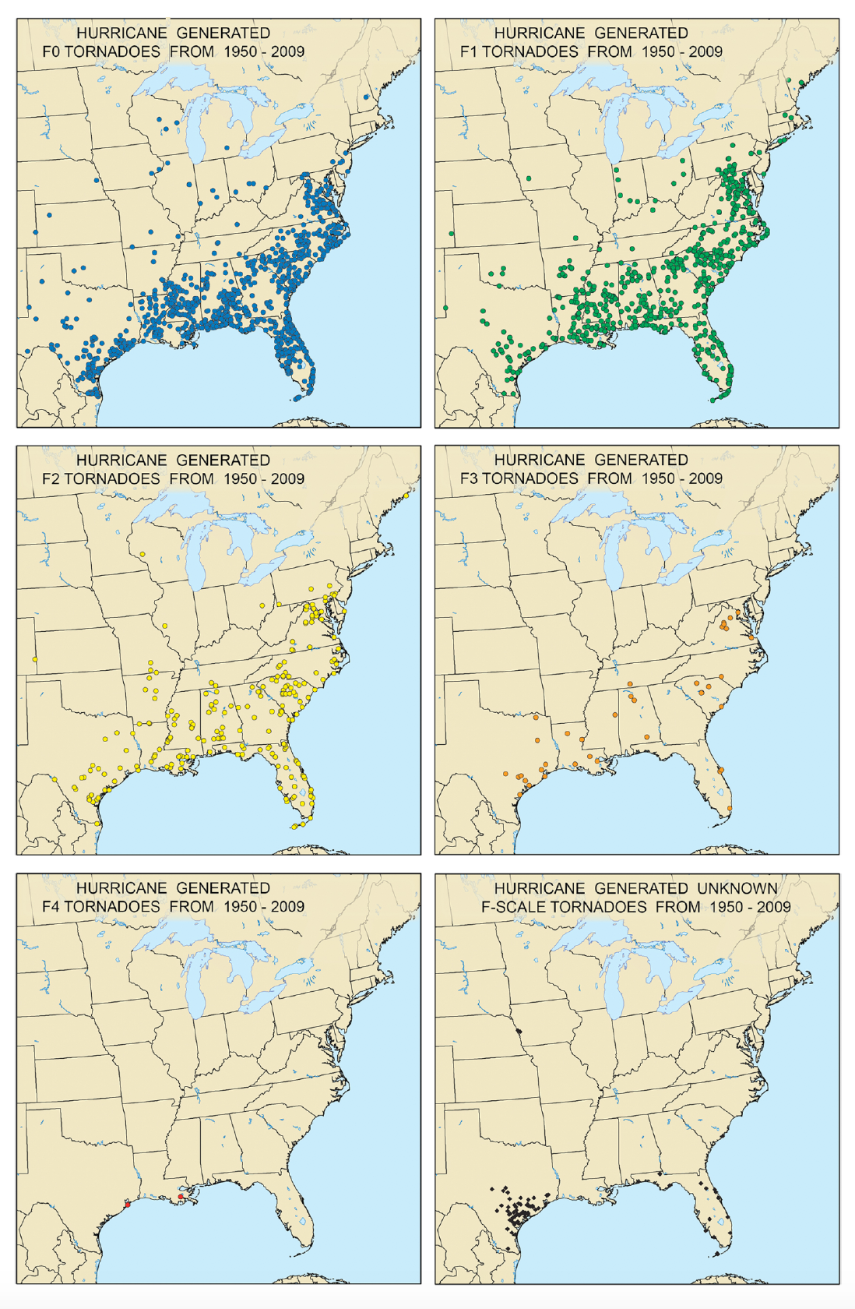
Figure 8.39. Breakdown of tropical cyclone tornadoes from 60 years of data, by intensity (colors) and location relative to the coastline. The great majority of these tornadoes are considered weak and short- lived, and most occur within 322 km (200 mi) of the coast.
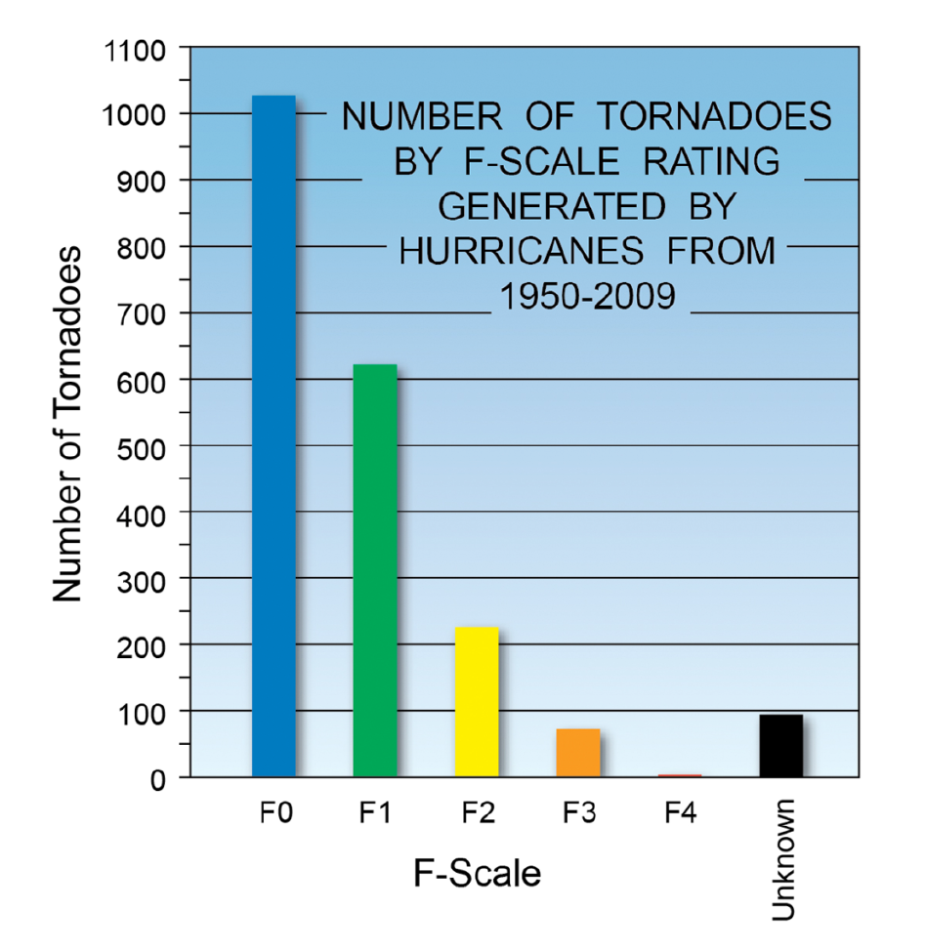
Figure 8.40. Frequency distribution of tropical cyclone-spawned tornadoes in the 60-year study shown in Figure 8.39.
Until 2004, the greatest number of tornadoes for any U.S. hurricane stood at 115, spawned by Hurricane Beulah (1967) across Texas. Beulah’s record number of tornadoes was beaten by Hurricane Ivan in 2004 as it tracked across the Southeast and Mid-Atlantic. Ivan created pockets of numerous tornadoes (called tornado swarms) over a four-day period, as Figure 8.41 shows. Ivan came ashore as Category 3 in Alabama. The storm generated 117 tornadoes over land, including a swarm of 40 tornadoes over northern Virginia on September 17. A small number of these tornadoes were rated as F2-F3 (winds up to 143 kts or 165 mph). On each day, tornadoes tended to cluster during the afternoon – the time of maximum solar heating, when the atmosphere is most unstable (i.e. warm surface air will rise through a deep layer, forming thunderstorms). This makes sense, since strong convective updrafts are needed to tilt horizontal vortex tubes into the vertically spinning tornadoes.
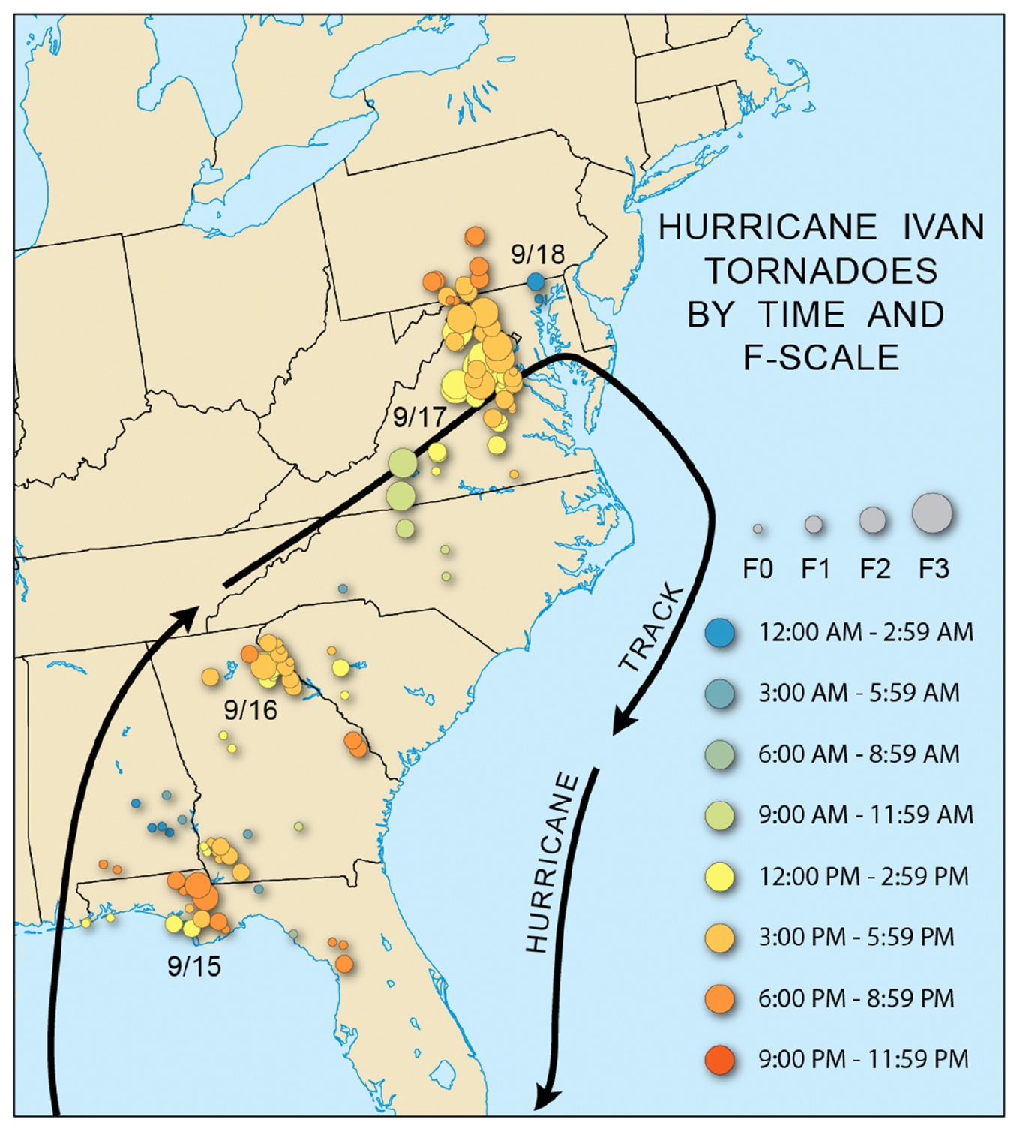
Figure 8.41. Hurricane Ivan (2004) was the most prolific inland-tornado-producing hurricane in U.S. history. Several tornado outbreaks were generated along Ivan’s multi-day path through the Southeast and Mid-Atlantic. Outbreaks clustered in the afternoon hours, when the atmosphere was most unstable from solar heating.
Key Terms
cell training
downburst
extratropical transition (ET)
eyewall
fetch
first wind
flood of record
gust factor
horizontal wind shear
hurricane
hybrid cyclone
integrated kinetic energy (IKE)
inverted barometer effect
maximum sustained wind (MSW)
mini-swirl
post-tropical cyclone
radius of maximum wind
rejuvenation
remnant low
resonance
Saffir-Simpson scale
second wind
shelf water
steering wind
storm surge
storm tide
tornado swarm
tropical cyclone
tropical storm
vertical wind shear
wave setup
wing gusts
wind profile
wind shear
wind streak

Summary
8.1 Hurricanes Weaken In A Characteristic Manner Moving Into Higher Latitudes and Over Land, While Producing Several Mechanisms of Coastal and Inland Damage
LO 1 Understand the processes by which hurricanes weaken over land. What set of hazards attend hurricanes making landfall along the immediate coast? What hazards unfold once the hurricane is deep inland?
• Hurricanes moving over land weaken primarily through loss of sensible and latent heat release, as the circulation moves away from the ocean heat source. Additional factors include wind shear, which disrupts the vortex; ingestion of dry air; and movement over cool, coastal shelf water.
• Along the immediate coast, the principal hurricane hazards are heavy rain, high wind and storm surge. Freshwater flooding accounts for most U.S. hurricane fatalities.
• Inland hazards often continue in the hurricane’s post-tropical phase, sometimes hundreds of miles inland. These effects including flooding from heavy rainfall and swarms of tornadoes
8.2 One of the Most Deadly and Destructive Elements in a Landfalling Hurricane Is The Storm Surge

LO 2 Describe formation of the storm surge, its asymmetry and the manner in which it is compounded by tidal variations
• Storm surge refers to the wind-induced rise of ocean water, building in height as the storm moves over shallow water. Storm surge height is greatest in the storm’s right semicircle.
• Storm tide combines the storm surge with tidal variations along the coast. Surge is enhanced during high tide, and its impact is reduced during low tide.
• Inlets and embayments along the coast enhance the height of storm surge by funneling and concentrating the wave energy.
• Integrated kinetic energy (IKE) combines the effects of the storm’s maximum sustained wind and areal footprint of wind on the ocean. Total water area set into motion by storm wind is an important factor in determining surge height, independent of wind speed.
8.3 Hurricane Wind Damage Has Several Aspects, Including a Sustained Wind Component, and Periodic Gusts to Higher Wind Speed
LO 3 Distinguish between maximum sustained wind and gust factor. Describe how structures succumb to aerodynamic forces in high wind. Explain the rate at which hurricane winds decay once the storm is inland, and how the areal coverage of damaging wind changes with time. Identify several factors lead to concentrated pockets of extreme wind damage
• A hurricane’s maximum sustained wind (MSW) is the one-minute averaged wind just above the surface. MSW varies inversely with the minimum central pressure. MSW ramps up exponentially between the outer edges of the storm and the eyewall.
• MSW is not evenly distributed around the storm, but is maximized in the right semicircle, where the swirling wind and storm motion act in the same direction.
• Gust factor relates to the degree of turbulence in the airflow, with gusts exceeding MSW values by 20- 30% over open water, and 40-50% over land.
• Aerodynamic forces due to wind impinging on structures are substantial, varying with the square of wind speed. Repeated buffeting of structures by gusts can lead to failure due to resonance effects. Shift in wind direction between the storm’s first and second wind (crossing the eye) adds a further damage mechanism.
• The storm’s MSW typically decays to 50% of the over-ocean value within 12 hours of landfall, with continued exponential decay through 24 hours. The decay is often associated with an expansion of the storm’s wind field. The expansion shifts the radius of maximum winds outward and may result in higher wind speeds at large distances from the center.
• Downbursts within a hurricane’s eyewall and rain bands are created by small pockets of rapidly descending air (intense downdrafts). They create localized (3-5 km or 5-8 mi-wide) pockets of fan-shaped damage at the surface;
• Mini-swirls are intense vortices embedded in the eyewall winds at the surface, only a few 10s of meters across, creating streaks or swaths of enhanced wind damage.
• Wind-streaks arise from abrupt decrease in wind speed at the surface over land due to friction. Horizontal vortices or “rollers” created by this wind shear transport high-velocity airflow to the surface, creating narrow swaths of enhanced wind damage just tens of meters wide.
8.4 Freshwater Flooding Is One Of the Most Deadly Aspects of A Landfalling Tropical Cyclone
LO 4 Explain why hurricanes are capable of exceptionally heavy rainfall, in terms of storm motion, cell training, interactions with mid-latitude weather systems, and orography. What two scenarios explain how heavy rain is distributed with respect to storm track?
• Tropical cyclones at landfall are very efficient rain producers, characteristically producing 15-30 cm (6-12 in) of rain, sometimes much more. Rain efficiency arises from slow movement of the storm, training of convective rain cells within rain bands, and high moisture content of tropical air feeding the storm.
• Total rain production in a tropical cyclone along the coast is proportional to the storm’s average rain rate and storm diameter, and inversely related to storm speed. Because so many factors influence rain production, total rain is often not well correlated with a tropical cyclone’s wind intensity at landfall.
8.5 Tropical Cyclones Entering Their Post-Tropical Phase Can Still Create Devastating Inland Impacts
LO 5 Define and give examples of the following: Post- tropical cyclone, tropical remnant, extratropical transition, hybrid cyclone, rejuvenated storm. Discuss how inland flooding and tornadic activity is sometimes enhanced inland of the coast.
• A weakening tropical cyclone over land becomes post-tropical when it loses key defining attributes such as its eyewall and warm core, and may further degrade to a remnant low (winds below 34 kts or 39 mph).
• Post-tropical systems may combine with one or more mid-latitude weather systems and begin to acquire extratropical characteristics. During this process, called extratropical transition, the system becomes a hybrid cyclone. If the hybrid acquires a cold central core and fronts, it completes its transition into an extratropical cyclone. Additional energy acquired from mid-latitude weather systems may enable the hybrid storm to briefly rejuvenate, with continued production of severe weather – including high, sustained winds – far inland.
• During extratropical transition, extremely heavy rainfall - leading to flash floods, river floods, mudslide and debris flows - can continue inland over mountainous terrain. Flood catastrophes of this sort have included Camille (1969), Agnes (1972), Eloise (1975) and Lee (2011).
• Generation of heavy rain during extratropical transition shifts to left-of-center when the post- tropical vortex interacts with a jet stream trough located upstream. A right-of-center distribution unfolds when the system interacts with a jet stream ridge downwind.
• Hurricane tornadoes develop over land, paradoxically during the period when the parent storm is weakening. Land friction slows winds in the lowest 1 km (3300 ft), creating horizontal vortex tubes. Updrafts in rain band convective cells draw up vortex tubes, tilting them into the vertical, and amplifying their spin through vertical stretching. Tornadoes created in this manner are typically weak and short- lived.
• Hurricane tornadoes tend to concentrate in the storm’s right front quadrant and cluster in the afternoon hours, when solar heating and thus air mass instability is strongest.
Storm Study In Depth: Hurricane Katrina – Anatomy of the Great Flood
Hurricane Katrina marked the first time the United States crossed the $100 billion disaster threshold. It was also the first time in 77 years that fatalities from a single storm (1833 deaths) surpassed the 1000-death mark. In many ways, we have made remarkable progress in terms of predicting storm track and landfall location, in some cases up to 7-10 days in advance. But our nation’s exponential growth of population and property in low-lying, extremely vulnerable locations such as the Gulf Coast (Figure 1) and New York Harbor have rendered our nation more susceptible than ever to catastrophic hurricane death tolls, once thought to be a relic of centuries past.
Katrina attained rare Category 5 status in the Gulf of Mexico and maintained this intensity up until 24 hours from landfall. As Figure 2 shows, the center passed very close to downtown New Orleans, but the city was spared the highest winds and surge, which were located in the storm’s right semicircle. A massive storm surge, in the range of 7 to 8 m (23 to 26 ft) obliterated sections of the Mississippi coastline. Portions of the coastline were inundated to a distance of 10-19 km (6- 12 mi) inland. New Orleans and surrounding parishes, which sit 1-2 m (3-7 ft) below mean sea level, was 80% submerged from a combination of ocean and lake water. For years, it was thought that an extensive system of levees and pumps would protect the city from a storm of up to Category 3 intensity. As Figure 2 shows, Katrina was rapidly weakening as it moved north across Louisiana, and could be properly characterized as a system transitioning from Category 3 to Category 2 as it passed the city. In spite of this weakening, 53 levees in and around New Orleans were breached or overtopped during a 6-8 hour period. The failure of the city’s defenses – which can be partly traced to inadequate design and construction - is the worst civil engineering disaster in U.S. history.
Figure 2 shows that Katrina’s great flood unfolded in two parts. The first came in the early hours of August 29 as the storm approached Lake Borgne. While still a Category 3 storm, high winds from the east – the storm’s First Wind – built a high storm surge in the progressively narrowing Mississippi Sound. This surge flowed westward through Lake Borgne and a portion entered the Industrial Canal, a straight channel created as a shortcut connecting New Orleans to the Gulf of Mexico (Figure 2). The Canal funneled and concentrated the surge further, amplifying it by 20% and propelling it rapidly westward at high speed into the city. Figure 3 shows the arrival of this surge at the Industrial Canal’s mouth around 7 am. Levees along the Canal protecting the city’s western boroughs failed and Gulf saltwater began pouring into the city.
Figure 1. Doomsday in New Orleans, early September 2005 – a great flood at the hands of Hurricane Katrina and a failed defense system
Figure 2. Schematic showing the timing and direction of Katrina’s assault on New Orleans, compared to the track and intensity of the storm. The Great Flood unfolded in several stages, from multiple directions.
Figure 3. Sequence of the Great Flood’s three stages, and location of principal levee failures.
Throughout the morning, Katrina continued to move rapidly northward. By noon, the center passed to the northeast of New Orleans and the storm weakened to Category 2. A strong, sustained wind from the north-northwest – the storm’s second wind – set up a southward-flowing surge across Lake Pontchartrain. Surge and storm waves exerted tremendous pressure along the southern wall of the lake, blowing out several levees along canals connecting the lake with the city’s northern boroughs. These included the 17th Street and London Avenue canals. These levees succumbed between 10-11 a.m.
Amidst the chaos of the storm – including the high wind and heavy rain, power outages, impassable roads, and communication system failures – authorities were slow to realize when and where the breaches occurred. But throughout the afternoon, the central city’s vast bowl was filling with water. This third stage continued into the evening of August 29th. The floodwaters derived from the Gulf via the Industrial Canal breach and Lake Pontchartrain. It took nearly two months to pump out the city; the city’s defenses were optimized to prevent water from entering the city, not removing a massive volume of water. The nightmare, worst-case scenario that scientists and engineers had predicted for decades had finally unfolded. And once again, this grand, historical city – dry and in the midst of recovery – lies vulnerable to another Great Flood.

Storm Study In Depth: Hurricane Sandy – Diverse Impacts From a Hybrid Super-Storm
Hurricane Sandy was a meteorological surprise with so many bizarre twists that many scientists (including the authors of this text) were left shaking their heads in disbelief. Like Katrina, this system garnered “superstorm” status in terms of its size, power, impacts, and price tag approaching $100 billion. Like many of the large storms before it, Sandy underscores the vulnerability of low-lying, densely populated regions including New York Harbor. It also foretells a new era of extreme devastation from natural hazards such as hurricanes. This hazard exists despite the nation’s technological prowess and the fact that the United States has arguably done the most of any nation to advance the science of hurricane behavior and prediction.
Medium-range (7-10 day) weather prediction has improved markedly in the past 10-15 years. As Figure 1 shows, some of the forecast models were portraying an ominous (and largely accurate) scenario as many as eight days in advance of Sandy’s landfall. The models were also suggesting two very uncommon characteristics for a hurricane off the East Coast. The first: The tropical cyclone would combine with a deep, cold mid-latitude trough in the jet stream, creating an enormous hybrid cyclone – the largest ever documented in the western Atlantic - with a blend of hurricane and nor’easter characteristics. Second: The huge vortex would turn due westward, straight into the New Jersey shoreline. Such a sharp, left-hand turn is unprecedented in all hurricane tracks documented since the mid-1800s, and presented a forecast dilemma, as not all of the forecast models predicted this “left hook.” The bizarre turn was due to a highly anomalous jet stream track, with large distortions (troughs and ridges) across the eastern United States, Canada and Greenland. A massive ridge of high pressure sat south of Greenland, blocking northward progress of the storm. Meanwhile, an unseasonably intense trough of low pressure over the eastern U.S. would act to pull the storm westward, directly into the East Coast.
Figure 1. This ECMWF model forecast, made 8 days before Superstorm Sandy hit, is among the most ominous that this generation of meteorologists has ever witnessed. The sheer size and power (note the spacing of isobars) of this hybrid storm completely overwhelms the Eastern Seaboard. The ECMWF overestimated the actual intensity of Sandy by about 10 mb. Color scale indicates vortex wind speed at 1500 m (5,000 ft) in knots. The inner core features forecast maximum winds of up to 90 kts (104 mph).
Figure 2 traces the evolution of this superstorm from its purely tropical beginnings to a massive hybrid system off the Mid-Atlantic coastline. The hurricane developed unusually late in the Atlantic hurricane season (the last week of October) and reached near-Category 3 status before weakening over Cuba. Once north of the islands of the Caribbean, the storm encountered a series of upper-level troughs in the westerly flow. A particularly potent vortex lay over the southeastern United States and contained a core of very cold Canadian air. This vortex entrained Sandy into its periphery and began circulating a tongue of cold air around the system’s warm tropical core. The strong thermal gradient thus created enhanced the storm’s kinetic energy and caused the vortex to expand. A large-diameter ring of high wind developed on the storm’s southwest side, at large distance from the center, and to the left-of-track. In essence, this tossed the textbook notion that a hurricane’s strongest winds occur in the right semicircle, “to the wind”! The inner core still retained tropical characteristics, including a warm central eye and ring of eyewall thunderstorms.
Figure 2. The life and times of Superstorm Sandy. Shown here is the complex evolution of a cyclonic vortex through several different configurations, including hurricane, hybrid vortex, and massive nor’easter.
While just a few hundred miles off the coast of New Jersey and New York, Sandy was morphing from this hybrid configuration into a full-scale nor’easter, complete with warm and cold fronts and a massive precipitation shield. In fact, the storm made landfall as an extratropical cyclone. This created a novel dilemma for forecasters: Should they use hurricane warnings, which convey a heightened level of seriousness for emergency planners, or should they instead issue separate gale warnings, flood warnings, and coastal flood warnings under the guise of the more technically correct (and powerful) nor’easter? This was not an easy decision. Ultimately, the hurricane warnings were dropped, and this action did create confusion among those making preparations for Sandy’s impacts. Since then, however, the National Weather Service has made a policy decision to stick with hurricane warnings should a powerful hybrid system again threaten the coast.
Figure 3 illustrates the great diversity of oceanic and sensible weather impacts during Sandy’s transit from New Jersey to Ontario. Highest sustained winds with gusts to 70-78 kts (81-90 mph) occurred to the right of track, along the New Jersey shoreline and Long Island (panel A). Heavy rain was concentrated left of track, consistent with our model of extratropical transition involving a jet -stream trough located upstream (panel B). Panel C shows the height of the storm surge. Note the high values over a large stretch of coastline to the right of track. Surge was particularly focused in narrow inlets including New York Harbor, Long Island Sound and the Gulf of Maine. For decades, hurricane scientists and emergency planners had noted the unique vulnerability of New York Harbor to hurricane storm surge, given its funnel-shaped geometry that causes the surge to concentrate and build in amplitude. Population density is very high in the lowlands surrounding the Harbor. Note also the unusual occurrence of lake-effect surge. So massive was the strong wind field of this storm, that waves of up to 8 m (26 ft) were raised along the lee shores of the Great Lakes, hundreds of miles from the
Panel C reveals another bizarre impact: an inverted temperature gradient across the Northeast and Mid-Atlantic. Instead of warm temperatures to the south and colder conditions to the north, Sandy’s circulation drew unseasonably cold air from Canada across the central Appalachians. Meanwhile, an influx of warm air from the Atlantic’s Gulf Stream was circulated over New England. While New York and Maine enjoyed high temps in the mid-60s to near 70 F, portions of West Virginia were plunged below freezing. This set up the Central Appalachians for perhaps Sandy’s most bizarre twist of all: Heavy, wet snow, accumulating to nearly 1 m (3 ft) in spots (panel D), from moisture of hurricane origin!
Compared to Katrina, Sandy’s death toll was much lower (around 150 direct fatalities in the United States), but the property damage was exceptionally large, given the high density of beachfront properties and seaside communities, infrastructure and population of New York City. Both of these storms were essentially “worst case scenarios” for two of the most hurricane-vulnerable regions in the United States.
Figure 3. Superstorm Sandy was a multi-faceted storm in terms of weather and water impacts – combining high wind, heavy rain, bizarre temperature fluctuations, heavy snow, destructive coastal storm surge, and high waves across the Great Lakes.

Figure References
Figure 1 NASA
Figure 2
Figure 3
Figure 4
Figure 5
Figure 6 After Simpson and Riehl, The Hurricane and Its Impacts
Figure 7 Original
Figure 8 After Simpson and Riehl, The Hurricane and Its Impacts
Figure 9 Original
Figure 10
Figure 11 After Powell and Reinhold, 2007: Tropical Cyclone Destructive Potential By Integrated Kinetic Energy, BAMS XX:513-526
Figure 12
Figure 13 NOAA HRD Figure 14 Original
Figure 15 After Kerry Emanuel, Divine Wind
Figure 16 After Powell et al., 1991: The Landfall of Hurricane Hugo in the Carolinas: Surface Wind Distribution, Weather and Forecasting, 6: 379-399.
Figure 17 After NOAA HPC Figure 18 Original
Figure 19 Original
Figure 20 After Wakimoto and Black, 1994: Damage Survey of Hurricane Andrew and Its Relationship to the Eyewall, BAMS: 75:189-200.
Figure 21 FEMA
Figure 22 After Fujita, XXXX:
Figure 23 After Miami Herald Figure 24A
Figure 24B After USA Today
Figure 25 After David Roth, NOAA HPC Figure 26 Original
Figure 27 After David Roth, NOAA HPC Figure 28 Original
Figure 29 NASA
Figure 30 After Palmen, 1958:
Figure 31 After Palmen, 1958:
Figure 32 After Paul Kocin, NOAA HPC and XX Figure 33 NOAA
Figure 34 After Atallah and Bosart, 2003: The Extratropical Transition and Precipitation Distribution of Hurricane Floyd (1999), Monthly Weather Review, 131:1063-1981
Figure 35 After Atallah et al., 2007: Precipitation Distribution Associated With Landfalling Tropical Cyclones Over The Eastern United States, Monthly Weather Review, 135:2185-2206
Figure 36 After David Roth, NOAA HPC
Figure 37 After Jack Williams, USA Today Weather Book
Figure 38 After Schultz and Cecil, 2009: Tropical Cyclone Tornadoes, 1950-2007, Monthly Weather Review, 137:3471-3484
Figure 39 After Schultz and Cecil, 2009: Tropical Cyclone Tornadoes, 1950-2007, Monthly Weather Review, 137:3471-3484
Figure 40 Original figure, based on data provided by Lori Schultz
Figure 41 Original figure, based on data provided by Lori Schultz
Katrina Box, Figure 1
Katrina Box, Figure 2 Original figure Katrina Box, Figure 3 Time
Sandy Box, Figure 1Weatherbell Analytics Sandy Box, Figure 2Original figure
Sandy Box, Figure 3Original figure

