ATM 311

Severe Weather Project

Assigned: Tuesday, November 13

Due: Thursday, December 6

On the course website, you will find the following gridded plots of NAM initialization for 12Z Day 1, and 00Z Day 2:

300-mb geopotential height (dam) and wind (kt)

500-mb abs. vorticity (s-1 x 10-5), geo. height (dam), and wind (kt)

700-mb RH, temp. (°C), geo. height (dam), and wind (kt)

850-mb temp. (°C), geo. height (dam), and wind (kt)

You will also find plots of stability/severe weather indices for:

12Z Day 1 and 00Z Day 2

where (**Upper Left**-Lifted Index; **UR**-BRN, **LL**-SWEAT, **LR**-TT)

and CAPE (+) / CINH (-) for:

12Z Day 1 and 00Z Day 2

*Note that the above plots are directly from the 12Z and 00Z RAOB*

Also on the course website are two pdf files, each containing observed soundings, hodographs, and severe weather indices/variables from 12Z Day 1 and 00Z Day 2 for most of the upper air sites across the U.S. *Note that the SPC uses virtual temperature to calculate variables like CAPE, CINH, LI, etc. Note also that the SPC displays the “BRN shear”, which is the denominator of the BRN.*

You have been given two copies each of:

12Z Day 1 surface analysis

00Z Day 2 surface analysis

You have also been given one blank map.

**For the surface analysis**,

1) Contour the sea level pressure every 4 mb, in multiples of 4 (1000, 1004, etc.).

2) Draw in the positions of the fronts and dryline(s), using appropriate color

After completing the above, create the following:

* On the blank map, a severe weather outlook for the United States for approx. 2200 UTC Day 1 through 0600 UTC Day 2, similar to what the Storm Prediction Center creates. You’ll contour the following risk regions:

* General non-severe thunderstorms (light green)

* Marginal (dark green)

* Slight (yellow)

* Enhanced (orange)

* Moderate (red)

* High (pink/magenta)

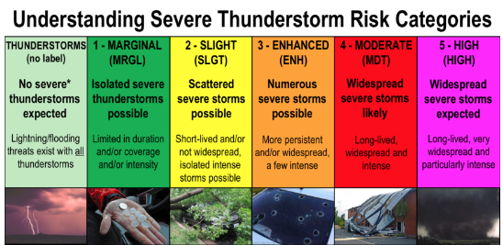

* A 3-5 page paper describing the potential for severe weather on this particular day. Be sure to specifically refer to the maps you have analyzed. You’ll want to make sure and describe:

* Upper level flow and forcing mechanisms (remember that these result in the development of surface lows, which perturb airmasses and result in frontal boundaries)

* Lower level flow and forcing mechanisms

* Frontal positions and other surface-based boundaries (these force surface-based ascent)

* If the upper and lower level flow create the potential for severe weather (e.g., a loaded gun sounding), and if so, where?

* Specific soundings that show the potential for severe weather, or lack of severe weather. Soundings are given on the course website.

* How the day progressed (from 1200 UTC Day 1 to 0000 UTC Day 2)

* What variables/parameters/patterns play an important role in determining highest severe weather risk areas?

* What variables/parameters/patterns prevent severe weather from occurring in the lower risk areas?

* Are there certain regions, where the setup is more conducive for tornadoes? Large hail? High winds? Why?