A Dynamically Based Climatology of Subtropical Cyclones
that Undergo Tropical Transition in the North Atlantic Basin

Alicia M. Bentley, Daniel Keyser, and Lance F. Bosart

Department of Atmospheric and Environmental Sciences, University at Albany,
State University of New York, Albany, New York

Submitted to
Monthly Weather Review
16 July 2015

Revision submitted to

Monthly Weather Review
22 February 2016

ABSTRACT
Subtropical cyclones (STCs) derive a considerable portion of their energy from baroclinic and diabatic processes. The opportunity to investigate the roles of baroclinic and diabatic processes during the evolution of STCs from a potential vorticity (PV) perspective motivates this study. The roles of baroclinic and diabatic processes during the evolution of STCs are determined by calculating three PV metrics from the 0.5° NCEP Climate Forecast System Reanalysis dataset. The three PV metrics quantify the relative contributions of lower-tropospheric baroclinic processes, midtropospheric latent heat release, and upper-tropospheric dynamical processes during the evolution of individual cyclones. An evaluation of the three PV metrics, as well as the sign of the upper-tropospheric thermal vorticity, during the evolution of individual cyclones is used to devise an objective STC identification technique and construct a 1979–2010 climatology of North Atlantic (NATL) STCs that undergo tropical transition.
An investigation of the intraseasonal variability associated with the location and frequency of STCs identified in the 1979–2010 climatology shows that STCs typically form over the southern Gulf of Mexico and western NATL during April–June, over the northern Gulf of Mexico and western NATL during July–September, and over the western, central, and eastern NATL during October–December. STC formation occurs most frequently during September, when baroclinic and convectively driven forcings overlap across portions of the NATL. The frequency of STC formation is sensitive to the phase of ENSO and is maximized during periods of anomalously low SSTs in the eastern equatorial Pacific.

- Introduction
The National Hurricane Center (NHC) online glossary defines a subtropical cyclone (STC) as a “non-frontal low-pressure system that has characteristics of both tropical and extratropical cyclones…. Unlike tropical cyclones, subtropical cyclones derive a significant portion of their energy from baroclinic sources, and are generally cold-core in the upper troposphere, often associated with an upper-level low or trough” (OFCM 2015). The NHC STC definition emphasizes the hybrid nature of STCs and suggests that both baroclinic and diabatic processes can contribute to STC formation. The hybrid nature of STCs, emphasized in the NHC STC definition, makes them likely candidates to become tropical cyclones (TCs) via the tropical transition (TT) process (Davis and Bosart 2003, 2004), during which cold-core oceanic cyclones transition into warm-core TCs in the presence of an upper-tropospheric disturbance. Operational forecasters began documenting the transition of STCs into TCs in the presence of an upper-tropospheric disturbance in the early 1950s (e.g., Moore and Davis 1951; Simpson 1952). The tendency for STCs to form and rapidly undergo TT close to land (e.g., Bermuda, the east coast of North America, and the west coast of Europe), as well as over the central North Atlantic (NATL), is well documented (Table 1). Such rapidly transitioning STCs can pose a considerable threat to lives and property, and can create potential challenges for operational forecasters and emergency managers.
Despite the existence of an STC definition in the NHC online glossary and numerous examples of NATL STCs transitioning into NATL TCs, the real-time identification of NATL STCs has been described as highly subjective by González-Alemán et al. (2015). The first long-term (1951–2000) NATL STC climatology, constructed by Roth (2002), emphasized the use of satellite observations in STC identification and highlighted the lack of an objective NATL STC identification technique. Guishard et al. (2009) addressed the need for an objective NATL STC identification technique by developing a quantitative definition of STCs in terms of their location of formation, hybrid synoptic structure, and near-surface wind speed. NATL STCs forming during 1957–2002 were identified by Guishard et al. (2009) by applying a set of objective criteria to oceanic cyclones within the 1.25° European Centre for Medium-Range Weather Forecasts (ECMWF) Re-Analysis (ERA-40) dataset (Uppala et al. 2005). In their study, NATL STCs are required to form between 20°N and 40°N, exhibit hybrid structure within the Hart (2003) cyclone phase space (CPS) for ≥36 h, attain gale-force winds (17 m s⁻¹) at 925 hPa while exhibiting hybrid structure, and be identified within 24 h of becoming purely cold or warm core. The overlap between the NATL STCs identified by Guishard et al. (2009) and NATL STCs identified in the version of the NHC Hurricane Database (HURDAT) (Jarvinen et al. 1984) valid at the time Guishard et al. (2009) was published is extensive, but not complete. According to González-Alemán et al. (2015), this incomplete overlap is attributable to the different techniques and criteria used for STC identification by Guishard et al. (2009) and NHC during 1957–2002. The Hart (2003) CPS, utilized by Guishard et al. (2009) to detect the hybrid structure of STCs, has been utilized by NHC to detect the hybrid structure of STCs during the last decade and represents an important tool for modern-day STC identification.
The work of Guishard et al. (2009) motivated subsequent research on STC formation in the South Atlantic basin. Evans and Braun (2012) identified South Atlantic STCs forming during 1957–2007 by applying a set of objective criteria similar to those used by Guishard et al. (2009) to oceanic cyclones within the 1.25° ERA-40 dataset. A subsequent study by Gozzo et al. (2014) identified South Atlantic STCs forming during 1979–2011 by applying a set of objective criteria that are similar to, but less restrictive than, the set of objective criteria used by Evans and Braun (2012) [i.e., relaxation of the hybrid structure requirement within the Hart (2003) CPS, no gale-force wind requirement] to oceanic cyclones within the 1.5° Interim ECMWF Re-Analysis dataset (Dee et al. 2011) and the 2.5° NCEP–NCAR reanalysis dataset (Kalnay et al. 1996). The STC climatologies of Guishard et al. (2009), Evans and Braun (2012), and Gozzo et al. (2014) were constructed using objective STC identification techniques that consider the geographical, structural, and dynamical characteristics of STCs. The opportunity to develop a complementary objective STC identification technique that considers the roles of baroclinic and diabatic processes during the evolution of STCs from a potential vorticity (PV) perspective motivates the present study.
The development of a complementary objective STC identification technique that considers baroclinic and diabatic processes from a PV perspective may provide further insight into the structure and evolution of NATL STCs. Davis (2010) developed a methodology for quantifying the relative contributions of lower-tropospheric baroclinic processes and midtropospheric latent heat release during the evolution of individual cyclones in terms of two PV metrics. The present study extends the work of Davis (2010) by quantifying the relative contribution of upper-tropospheric dynamical processes during the evolution of individual cyclones in terms of a third PV metric and by characterizing the upper-tropospheric thermal structure directly over and surrounding an individual cyclone in terms of the sign of the upper-tropospheric thermal vorticity. An evaluation of the three PV metrics during the evolution of individual cyclones will be used to investigate the roles of baroclinic and diabatic processes within the 0.5° NCEP Climate Forecast System Reanalysis (CFSR) dataset (Saha et al. 2010). An objective STC identification technique based on the three PV metrics and the sign of the upper-tropospheric thermal vorticity will be devised and applied to candidate STCs included in the global climatology of baroclinically influenced tropical cyclogenesis created by McTaggart-Cowan et al. (2013) in order to construct a 1979–2010 climatology of NATL STCs that undergo TT. The intraseasonal variability associated with the location and frequency of NATL STC formation will be compared with that of NATL TC formation. The present study seeks to illustrate the effectiveness of the devised objective STC identification technique in identifying NATL STC formation in the presence of an upper-tropospheric disturbance, as well as provide a foundation for documenting the structure, motion, and evolution of the upper-tropospheric features linked to NATL STC formation in subsequent studies.
The remainder of this paper is organized as follows. The data and methodology used to devise the proposed objective STC identification technique are described in section 2. An example of the application of the proposed objective STC identification technique for the case of STC Sean (Avila and Stewart 2013), which formed in the presence of an upper-tropospheric disturbance ~700 km southwest of Bermuda in November 2011, is also described. Section 3 contains a 1979–2010 climatology of NATL STCs that undergo TT constructed using the proposed objective STC identification technique, and a comparison of the intraseasonal variability associated with the location and frequency of NATL STC formation with that of NATL TCs. Results of this study are discussed and conclusions are presented in section 4.

- Data and methodology
a. Candidate STCs
A list of 460 cyclones that occurred over the NATL during 1979–2010 was compiled from the global climatology of baroclinically influenced tropical cyclogenesis created by McTaggart-Cowan et al. (2013), and the cyclones in this list were considered potential candidates for STC identification. The 1979–2010 period was chosen to coincide with the portion of the McTaggart-Cowan et al. (2013) study covered by the NCEP CFSR dataset, which is available with 0.5° horizontal grid spacing and 6-h temporal resolution. NATL cyclone tracks were obtained from the v03r03 edition of the International Best Track Archive for Climate Stewardship (IBTrACS) dataset (Knapp et al. 2010). Cyclone classification information (i.e., whether a cyclone was classified as a TC, STC, extratropical cyclone, or disturbance) was also obtained from the IBTrACS dataset along each NATL cyclone track. NATL cyclone tracks were extended backward 36 h from their first IBTrACS position using a reverse steering flow calculation described in McTaggart-Cowan et al. (2008).
McTaggart-Cowan et al. (2013) categorized tropical cyclogenesis into one of five development pathways based on two external forcings in the near-TC environment prior to TC formation: 1) QG forcing for ascent, Q, determined by the convergence of the 400–200-hPa layer-averaged Q vector within 6° of the cyclone center, and 2) lower-tropospheric baroclinicity, Th, determined by asymmetries in the 1000–700-hPa thickness field within 10° of the cyclone center. The five development pathways identified in McTaggart-Cowan et al. (2013) comprise: 1) Strong TT, 2) Weak TT, 3) Trough Induced, 4) Low-level Baroclinic, and 5) Nonbaroclinic. The relative magnitudes of Q and Th associated with each development pathway, as well as a brief description of each development pathway, are given in Table 2.
In order to focus on NATL STCs with the potential to undergo TT, only cyclones that formed in the presence of an upper-tropospheric disturbance and were classified as TCs in the IBTrACS dataset during their life cycle were considered candidates for STC identification, restricting the development pathways considered to those with “high” values of QG forcing for ascent in Table 2: Strong TT, Weak TT, and Trough Induced. Of the 460 cyclones included in McTaggart-Cowan et al. (2013) that occurred over the NATL during 1979–2010, 214 cyclones formed in the presence of an upper-tropospheric disturbance, were classified as TCs in the IBTrACS dataset during their life cycle, and were considered candidates for STC identification [Strong TT (N = 56), Weak TT (N = 122), Trough Induced (N = 36)]. A track map of the 214 cyclones that were considered candidates for STC identification is shown in Fig. 1.

b. Adapted Davis (2010) methodology
The Davis (2010) methodology for STC identification is based on the concept of Ertel PV and formulated in terms of two PV metrics that quantify the relative contributions of lower-tropospheric baroclinic processes and midtropospheric latent heat release, respectively, during the evolution of individual cyclones. These two PV metrics are used to distinguish between cyclone types within an idealized numerical simulation and are analogous to the structural and dynamical metrics defining the Hart (2003) CPS utilized for STC identification by Guishard et al. (2009), Evans and Braun (2012), Gozzo et al. (2014), González-Alemán et al. (2015), and NHC. The Hart (2003) CPS describes cyclone structure in terms the lower-tropospheric storm-motion-relative thickness asymmetry and the vertical derivative of the horizontal height gradient (i.e., the scaled thermal wind magnitude). In contrast to the Hart (2003) CPS, the Davis (2010) methodology for STC identification describes cyclone structure in terms of the near-surface potential temperature anomaly difference across the cyclone center, represented as the near-surface PV anomaly, and the lower-tropospheric PV anomaly. The advantage of casting the near-surface potential temperature anomaly difference across the cyclone center in terms of PV is that the influences of lower-tropospheric baroclinic processes and midtropospheric latent heat release on cyclone structure can be directly compared.
The transition from identifying STCs within an idealized numerical simulation to the 0.5° NCEP CFSR dataset requires adapting the original Davis (2010) methodology to apply to a latitude–longitude grid and utilizing time means instead of zonal means of potential temperature and Ertel PV. All PV metrics considered in the present study are calculated in a 6° box centered over the surface cyclone, shown schematically in Fig. 2. A 6° box was determined to be small enough to capture the relative contributions of lower-tropospheric baroclinic processes and midtropospheric latent heat release associated with the cyclone, but large enough for the calculated PV metrics to be stable. All variables used to calculate the PV metrics considered in the present study are described in Table 3 for ease of reference.
The first PV metric in the Davis (2010) methodology, PV1, represents lower-tropospheric baroclinic processes in terms of the near-surface potential temperature anomaly:
PV1 $=gηG/∆p_{1}$, (1)
where
$$G={(G_{x}^{2}+G_{y}^{2})}^{1/2},$$
$$G_{x}=\frac{1}{L_{xc(6)}}\int_{-\frac{L_{y(6)}}{2}}^{\frac{L_{y(6)}}{2}}{θ^{'}dy|_{\begin{aligned} \\ x=\frac{L_{x(6)}}{2}\end{aligned}}-\frac{1}{L_{xc(6)}}\int_{-\frac{L_{y(6)}}{2}}^{\frac{L_{y(6)}}{2}}{θ^{'}dy|_{\begin{aligned} \\ x=-\frac{L_{x(6)}}{2}\end{aligned}} ,}} \\ G_{y}=\frac{1}{L_{y(6)}}\int_{-\frac{L_{xn(6)}}{2}}^{\frac{L_{xn(6)}}{2}}{θ^{'}dx|_{\begin{aligned} \\ y=\frac{L_{y(6)}}{2}\end{aligned}}-\frac{1}{L_{y(6)}}\int_{-\frac{L_{xs(6)}}{2}}^{\frac{L_{xs(6)}}{2}}{θ^{'}dx|_{\begin{aligned} \\ y=-\frac{L_{y(6)}}{2}\end{aligned}}}} ,$$$g$ is gravity, $η$ is the 925–850-hPa layer-averaged absolute vorticity, and $θ^{'}$ is the potential temperature anomaly calculated at an individual grid point from an 11-day centered mean (Table 3). The potential temperature anomaly differences across the 6° box, $G_{x}$ and $G_{y},$ are averaged between 925 hPa and 850 hPa prior to computing $G.$ The horizontal lengths, $L_{y(6)}$ and $L_{x(6)}$, are the length of 6° of latitude and the longitudinal length of the 6° box as a function of latitude, respectively. The horizontal lengths, $L_{xn(6)},$ $L_{xc(6)},$ and $L_{xs(6)}$, represent the lengths of the northern edge, center, and southern edge of the 6° box, respectively. The vertical scale, $∆p_{1}$, is equal to 425 hPa, which matches the vertical integration of the lower-tropospheric PV anomaly (see below).
The second PV metric in the Davis (2010) methodology, PV2, represents midtropospheric latent heat release (i.e., diabatic processes) in terms of the lower-tropospheric PV anomaly:
PV2 $=\frac{\int_{-\frac{L_{x(6)}}{2}}^{\frac{L_{x(6)}}{2}}{dx\int_{-\frac{L_{y(6)}}{2}}^{\frac{L_{y}(6)}{2}}{dy }\int_{500 hPa}^{925 hPa}{q^{'}dp }}}{L_{xc(6)}L_{y(6)}{∆p}_{2}} ,$ (2)
where $q$ is the Ertel PV formulated in isobaric coordinates, the superscript prime symbol denotes the anomaly calculated at an individual grid point from an 11-day centered mean, and $∆p_{2}$ is equal to 425 hPa (Table 3).
For the purposes of the present study, the authors introduce two additional metrics used to evaluate upper-tropospheric dynamical processes and upper-tropospheric thermal structure (i.e., cold core vs. warm core) above the surface cyclone, respectively. The first additional metric, PV3, represents upper-tropospheric dynamical processes in terms of the upper-tropospheric PV anomaly:
PV3 $=\frac{\int_{-\frac{L_{x(6)}}{2}}^{\frac{L_{x(6)}}{2}}{dx\int_{-\frac{L_{y(6)}}{2}}^{\frac{L_{y(6)}}{2}}{dy }\int_{200 hPa}^{500 hPa}{q^{'}dp }}}{L_{xc(6)}L_{y(6)}{∆p}_{3}} ,$ (3)
where $∆p_{3}$ is equal to 300 hPa (Table 3). The second additional metric, ζ_{T}, represents upper-tropospheric thermal structure in terms of the upper-tropospheric thermal vorticity:
ζ_{T} $=\frac{\int_{-\frac{L_{x(12)}}{2}}^{\frac{L_{x(12)}}{2}}{dx\int_{-\frac{L_{y\left(12\right)}}{2}}^{\frac{L_{y\left(12\right)}}{2}}{(ζ_{g200}-ζ_{g500})}dy}}{L_{xc(12)}L_{y(12)}} ,$ (4)
where the horizontal lengths, $L_{y(12)},$ $L_{x(12)},$ and $L_{xc(12)}$, are the length of 12° of latitude, the longitudinal length of a 12° box as a function of latitude, and the length of the center of the 12° box, respectively (Table 3). As will be shown in section 2d, an STC forming in the presence of an upper-tropospheric disturbance may attain negative upper-tropospheric thermal vorticity values directly over the cyclone during its life cycle. This region of negative upper-tropospheric thermal vorticity values is typically surrounded by a broad region of positive upper-tropospheric thermal vorticity values, indicating that the smaller warm-core STC is embedded within a larger cold-core upper-tropospheric low or trough. A 6° box used to calculate ζ_{T} fails to capture the region of positive upper-tropospheric thermal vorticity values surrounding the cyclone, providing an inaccurate representation of the upper-tropospheric thermal structure within which the cyclone is embedded. A 12° box was determined to be large enough to capture the upper-tropospheric thermal structure directly over and surrounding the cyclone and for the calculated values of ζ_{T} to be stable. The calculated values of ζ_{T} were determined to be relatively insensitive to varying the size of the box between 10° and 14°.
A schematic representation of the regions over which PV1, PV2, PV3, and ζ_{T} are calculated is shown in Fig. 2. STCs forming in the presence of an upper-tropospheric disturbance are associated with characteristic features and processes that can be identified and quantified within these regions. An upper-tropospheric disturbance located over and in the vicinity of the surface cyclone, represented by Q in McTaggart-Cowan et al. (2013), would be represented by PV3 and ζ_{T} in the present study. An intrusion of relatively cold upper-tropospheric air accompanying this upper-tropospheric disturbance is likely to steepen lapse rates beneath the disturbance and facilitate the development of deep convection, which serves as a catalyst for STC formation. Midtropospheric latent heat release, occurring within regions of deep convection beneath the upper-tropospheric disturbance, would be represented by PV2 in the present study. Lower-tropospheric baroclinicity, represented by Th in McTaggart-Cowan et al. (2013), would be represented by PV1 in the present study. The values of PV1, PV2, PV3, and ζ_{T} are smoothed using a 1–2–1 temporal filter prior to STC identification.

c. STC identification
In order to determine the time and location of STC formation within the subset of 214 cyclones that formed in the presence of an upper-tropospheric disturbance and were classified as TCs in the IBTrACS dataset during their life cycle, an objective identification technique for detecting STC formation was devised, incorporating PV2, PV3, and ζ_{T}, and applied to the 0.5° NCEP CFSR dataset. PV1, which represents lower-tropospheric baroclinic processes, was not included in the objective identification technique due to the range of lower-tropospheric potential temperature gradients associated with the 214 cyclones that formed in the presence of an upper-tropospheric disturbance (Table 2). Nevertheless, PV1 is retained to diagnose lower-tropospheric baroclinic processes during the evolution of STC Sean (2011) in section 2d and at the time of STC formation in the 1979–2010 climatology of NATL STCs that undergo TT contained in section 3c.
STC formation was identified the first time (t = t₀) at which the following criteria were met:

1) PV3 > 0 and PV2 > 0 at t = t₀: There is a positive upper-tropospheric PV anomaly (e.g., representing an upper-tropospheric low or trough) and positive lower-tropospheric PV anomaly (e.g., representing a PV tower) over the cyclone

2) d(PV3)/dt < 0 at t = t₀ + 6 h and t₀ + 12 h: The upper-tropospheric PV anomaly begins to be eroded by midtropospheric latent heat release

3) d(PV3)/dt < d(PV2)/dt at t = t₀ + 6 h and t₀ + 12 h: The time rate of change of the value of the upper-tropospheric PV anomaly is less than the time rate of change of the value of the lower-tropospheric PV anomaly

4) ζ_{T} > 0 at t = t₀: The upper-tropospheric thermal structure within which the cyclone is embedded is cold core

5) The previous four criteria are met < 3 days after the first IBTrACS position

The criteria for STC identification stated above are designed to capture the characteristic features and processes associated with STC formation discussed in section 2b. It is important to note that not all of the criteria stated above are unique to STCs. For example, TCs would also be associated with a positive lower-tropospheric PV anomaly over the cyclone (i.e., PV2 > 0 at t = t₀), indicative of midtropospheric latent heat release and the diabatic redistribution of PV in the vertical (e.g., Hoskins et al. 1985, section 7; Davis and Emanuel 1991; Raymond 1992; Stoelinga 1996; Čampa and Wernli 2012). The criteria requiring the presence of a cold-core upper-tropospheric low or trough directly over and surrounding the cyclone (i.e., PV3 > 0 and ζ_{T} > 0 at t = t₀) are designed to differentiate between STCs forming in the presence of an upper-tropospheric disturbance from the TCs that compose the bulk of the IBTrACS dataset.

d. Case study: STC Sean (2011)
An example of the application of the objective identification technique for detecting STC formation is shown in Fig. 3 for the case of STC Sean (Avila and Stewart 2013), which formed in the presence of an upper-tropospheric disturbance ~700 km southwest of Bermuda in November 2011. Although it formed outside the 1979–2010 period considered in the present study, STC Sean was selected as an illustrative case of a NATL STC that rapidly underwent TT. Sean is noteworthy for also undergoing extratropical transition (ET) (e.g., Klein et al. 2000; Hart and Evans 2001; Jones et al. 2003; Harr and Archambault 2015) during its life cycle. The progression of Sean through a variety of phases renders it well suited for illustrating 1) the ability of the adapted Davis (2010) methodology to summarize the life cycle of an individual cyclone, and 2) the application of the objective identification technique for detecting STC formation. The life cycle of Sean is presented in Figs. 4–6, which are discussed in the remainder of this section. Figure 4 illustrates the mean sea level pressure (MSLP) field associated with Sean, as well as regions of convective activity using satellite-derived infrared (IR) brightness temperature data obtained from the NCEP/CPC 4-km global (60°N–60°S) IR dataset (Janowiak et al. 2001; CPC 2012). Figure 5 illustrates the fields used to calculate PV1 and PV2, whereas Fig. 6 illustrates the fields used to calculate PV3 and ζ_{T}.
Sean was originally classified as an extratropical cyclone by NHC at 0000 UTC 6 November 2011. Due to the use of a 1–2–1 temporal filter to smooth the values of PV1, PV2, PV3, and ζ_{T} prior to STC identification (section 2b), the first time period when the values of PV1, PV2, PV3, and ζ_{T} may be analyzed is 0600 UTC 6 November (Fig. 3). Convective activity was primarily located to the northeast of the center of Sean at 0600 UTC 6 November (Fig. 4a), collocated with a moderate gradient in 925–850-hPa layer-averaged potential temperature values (Fig. 5a). A weak gradient in 925–850-hPa layer-averaged potential temperature values existed across the center of Sean at this time (Fig. 5a), corresponding to a relatively low value of PV1 (Fig. 3). A broad region of positive 925–500-hPa layer-averaged PV values was located near the center of Sean at 0600 UTC 6 November (Fig. 5a), corresponding to a positive value of PV2 (Fig. 3). A region of 500–200-hPa layer-averaged PV values >2 PVU, associated with the northern portion of a 200-hPa trough axis, was positioned to the north of the center of Sean at this time (Fig. 6a), corresponding to a positive value of PV3 (Fig. 3). A region of negative 500–200-hPa thermal vorticity values, associated with a broad ridge in the 500–200-hPa thickness field, was located over and in the vicinity of the center of Sean at 0600 UTC 6 November (Fig. 6a), corresponding to a negative value of ζ_{T} (Fig. 3).
The objective identification technique indicates that Sean became an STC at 1200 UTC 7 November, 6 h (18 h) prior to when it was classified as a low (STC) by NHC (Fig. 3). Convective activity moved closer to the center of Sean between 0600 UTC 6 November and 1200 UTC 7 November as the cyclone became increasingly organized (Figs. 4a,b). The gradient in 925–850-hPa layer-averaged potential temperature values across the center of Sean weakened slightly between 0600 UTC 6 November and 1200 UTC 7 November (Figs. 5a,b), corresponding to a slight reduction in the value of PV1 during this period (Fig. 3). Values of 925–500-hPa layer-averaged PV near the center of Sean were comparable at 0600 UTC 6 November and 1200 UTC 7 November (Figs. 5a,b), corresponding to an almost unchanged value of PV2 (Fig. 3). A region of 500–200-hPa layer-averaged PV values >2 PVU moved over the center of Sean between 0600 UTC 6 November and 1200 UTC 7 November as the 200-hPa trough axis rotated counterclockwise and moved southward (Figs. 6a,b), resulting in an increase in the value of PV3 (Fig. 3). The region of negative 500–200-hPa thermal vorticity values located over and in the vicinity of the center of Sean at 0600 UTC 6 November (Fig. 6a) became more localized near the cyclone center and was nearly surrounded by a region of positive 500–200-hPa thermal vorticity values at 1200 UTC 7 November (Fig. 6b). The 500–200-hPa thermal vorticity distribution and associated 500–200-hPa thickness distribution at 1200 UTC 7 November (Fig. 6b) are consistent with the marginally positive value of ζ_{T} shown in Fig. 3 at this time, indicating that the upper-tropospheric thermal structure within which the cyclone is embedded was slightly cold core. The marginally positive value of ζ_{T} at 1200 UTC 7 November, the positive values of PV3 and PV2, and the decrease (increase) in the value of PV3 (PV2) over the following 12 h (Fig. 3), satisfy the criteria for detecting STC formation.
Sean underwent TT and was classified as a tropical storm by NHC at 1800 UTC 8 November (Fig. 3). Sean deepened over the following 42 h (Figs. 4b,c), attaining its minimum central pressure of 982 hPa at 1200 UTC 10 November (Fig. 3). The gradient in 925–850-hPa layer-averaged potential temperature values across the center of Sean remained relatively weak between 1200 UTC 7 November and 1200 UTC 10 November (Figs. 5b,c), with the increase in PV1 (Fig. 3) attributed to an increase in 925–850-hPa layer-averaged absolute vorticity values near the center of Sean (not shown). An increase in 925–500-hPa layer-averaged PV values near the center of Sean between 1200 UTC 7 November and 1200 UTC 10 November (Figs. 5b,c) was likely associated with deep convection occurring over the cyclone center (Fig. 4c) and the diabatic redistribution of PV in the vertical. The counterclockwise rotation and movement of the 200-hPa trough axis to the southeast of the center of Sean between 1200 UTC 7 November and 1200 UTC 10 November (Figs. 6b,c), as well as the diabatic redistribution of PV in the vertical associated with deep convection over the cyclone center (Fig. 4c), resulted in a reduction in 500–200-hPa layer-averaged PV values and 500–200-hPa thermal vorticity values over and in the vicinity of the cyclone center (Figs. 6b,c) and corresponds to a decrease in the values of PV3 and ζ_{T} (Fig. 3). The earlier (later) peak observed in the values of PV3 (ζ_{T}) in Fig. 3 between 1200 UTC 7 November and 1200 UTC 10 November is consistent with the movement of the 200-hPa trough axis to the southeast of the cyclone center during this period (Figs. 6b,c). A local maximum in 500–200-hPa thickness values was located over the center of Sean at 1200 UTC 10 November (Fig. 6c), consistent with the structure of a warm-core TC.
NHC reclassified Sean as an extratropical cyclone at 0000 UTC 12 November (Fig. 3). A strong gradient in 925–850-hPa layer-averaged potential temperature values approached the center of Sean from the west between 1200 UTC 10 November and 0000 UTC 12 November (Figs. 5c,d), corresponding to a large increase in the value of PV1 (Fig. 3). Values of 925–500-hPa layer-averaged PV decreased near the center of Sean between 1200 UTC 10 November and 0000 UTC 12 November (Figs. 5c,d) as the cyclone weakened and deep convection moved away from the cyclone center (Figs. 4c,d), corresponding to a decrease in the value of PV2 (Fig. 3). Values of 500–200-hPa layer-averaged PV also decreased near the center of Sean during this period (Figs. 6c,d), corresponding to a decrease in the value of PV3 (Fig. 3). A region of negative 500–200-hPa thermal vorticity values, associated with a ridge in the 500–200-hPa thickness field, persisted over and in the vicinity of the center of Sean between 1200 UTC 10 November and 0000 UTC 12 November (Figs. 6c,d), maintaining a negative value of ζ_{T} (Fig. 3).
Figure 3 reveals that the adapted Davis (2010) methodology is capable of representing the contributions of lower-tropospheric baroclinic processes, midtropospheric latent heat release, and upper-tropospheric dynamical processes, as well as changes in upper-tropospheric thermal structure, during the evolution of an individual cyclone. This representation summarizes Sean’s life cycle and illustrates the various processes associated with its TT and ET. Figure 3 also reveals that the objective identification technique for detecting STC formation devised in the present study is capable of identifying STC Sean 18 h prior to NHC based solely on the contributions of midtropospheric latent heat release and upper-tropospheric dynamical processes, as well as upper-tropospheric thermal structure, during Sean’s evolution. According to Avila and Stewart (2013), NHC classified Sean as an STC at 0600 UTC 8 November as the cyclone center became vertically aligned with the upper-tropospheric disturbance. Figure 3 suggests that the cyclone center became vertically aligned with the upper-tropospheric disturbance at 1200 UTC 7 November, or the time of STC identification in the present study. This result is encouraging and suggests that the objective STC identification technique devised in the present study is effective in identifying NATL STC formation in the presence of an upper-tropospheric disturbance.

3. Climatology of NATL STCs that undergo TT
a. Comparison with IBTrACS
The objective identification technique for detecting STC formation applied to STC Sean (2011) was subsequently applied to the 214 cyclones that formed in the presence of an upper-tropospheric disturbance, were classified as TCs in the IBTrACS dataset during their life cycle, and were considered candidates for STC identification (section 2a) using the 0.5° NCEP CFSR dataset. Of the 214 cyclones, 62 were identified as STCs using the objective identification technique. A total of 16 of the 62 identified STCs in the present study were classified as STCs that undergo TT in the IBTrACS dataset, with 2 identified STCs classified as extratropical cyclones that undergo TT and 44 identified STCs exclusively classified as TCs. The mean difference in time between STC formation in the present study and STC formation in the IBTrACS dataset is ~24.8 h, with a standard deviation of ~15.2 h and a range of 0–60 h. The 62 identified STCs were primarily classified by McTaggart-Cowan et al. (2013) as Strong TT (N = 30) and Weak TT (N = 28), with a small subset classified as Trough Induced (N = 4).

b. Locations of STC formation
Figure 7 illustrates the intraseasonal variability associated with the location of STC formation in the NATL basin during 1979–2010. STC formation primarily occurs over the southern Gulf of Mexico and western NATL during April–June, coinciding with the highest mean sea surface temperatures (SSTs) poleward of 20°N in the NATL basin during this period. An intrusion of relatively cold upper-tropospheric air accompanying an upper-tropospheric disturbance moving over the southern Gulf of Mexico and western NATL during April–June (Nieto et al. 2005; Wernli and Sprenger 2007) is likely to steepen lapse rates beneath the disturbance and facilitate the development of deep convection, which serves as a catalyst for STC formation. STC formation primarily occurs over the northern Gulf of Mexico and western NATL during July–September, with several cases of STC formation occurring over the central and eastern NATL during this period. STC formation occurring over the NATL during July–September is likely associated with the observed increase in mean SSTs relative to April–June (Fig. 7), as well as the increasingly frequent intrusion of upper-tropospheric disturbances into the NATL basin (Nieto et al. 2005; Wernli and Sprenger 2007). STC formation continues to occur over the western, central, and eastern NATL during October–December as mean SSTs decrease relative to July–September (Fig. 7) and upper-tropospheric disturbances continue to intrude into these regions from the midlatitudes (Nieto et al. 2005; Wernli and Sprenger 2007). The relatively high frequency of STC formation between 20°N and 40°N (Fig. 7) suggests the importance of baroclinic and convectively driven forcings during STC formation and supports the latitudinal restriction imposed by Guishard et al. (2009) on STC identification.
Figure 7 also illustrates that STC formation occurs more frequently over the western NATL than over the eastern NATL during April–December. Guishard et al. (2009) identified a similar spatial distribution in STC formation during January–December (their Fig. 5), attributing the higher frequency of STC formation over the western NATL to the recurrent overlap of relatively high SSTs and lower-tropospheric baroclinicity in that portion of the basin. Figure 7 further illustrates the potential for STC formation to occur over SSTs that are lower than the 26.5°C threshold deemed necessary for TC formation in the seminal works of Palmén (1948) and Gray (1968), particularly over the eastern NATL, which is consistent with the results of González-Alemán et al. (2015). A complementary examination reveals that STC formation can occur over SSTs ranging from ~20.0°C to ~30.0°C (Fig. 8). A mean SST value of 26.6°C and standard deviation of 2.2°C calculated in the present study may be compared to a mean SST value of 24.6°C and standard deviation of 3.4°C calculated by Guishard et al. (2009), where the respective means agree within one standard deviation. The lower mean SST value calculated by Guishard et al. (2009) is likely associated with the cool season (January–March) STCs identified in their study that did not undergo TT and were not included in the list of 460 potential candidates for STC identification obtained from McTaggart-Cowan et al. (2013). Figure 8 reveals that STCs classified as Strong TT by McTaggart-Cowan et al. (2013) typically form over lower SSTs than STCs classified as Weak TT or Trough Induced, with mean SST values of 25.1°C, 28.0°C, and 28.2°C, respectively. These results are consistent with the results of McTaggart-Cowan et al. (2015), who found that TCs classified as Strong TT typically form over lower SSTs than TCs classified as Weak TT or Trough Induced. An examination of the locations of STC formation separated by development pathway (Fig. 9) indicates that STCs classified as Strong TT typically form at higher latitudes than STCs classified as Weak TT or Trough Induced, forming at an average latitude of 30.3°N, 25.9°N, and 21.8°N, respectively.
The intraseasonal variability associated with the location of NATL STC formation is similar, but not identical, to the intraseasonal variability associated with the locations of NATL TC formation. Figure 10 compares the intraseasonal variability associated with the location of STC formation and TC formation in the NATL basin during April–June, July–September, and October–December 1979–2010. Locations of STC formation correspond to those shown in Fig. 7. Locations of TC formation are identified as the first position of a TC in the IBTrACS dataset, with TCs defined as NATL cyclones included in McTaggart-Cowan et al. (2013) that were not identified as STCs that undergo TT in the present study or exclusively classified as STCs in the IBTrACS dataset.
Similar to STC formation, a few cases of TC formation occur over the western NATL during April–June (Fig. 10a). In contrast to STC formation, TC formation frequently occurs over the eastern Gulf of Mexico and western Caribbean during April–June, primarily over regions with mean SSTs ≥26.5°C. TC formation occurs more frequently over the western NATL during July–September than during April–June, in a region also characterized by an increase in the frequency of STC formation (Figs. 10a,b). In contrast to STC formation, TC formation preferentially occurs over the Gulf of Mexico, western Caribbean Sea, and main development region [MDR (10°–20°N; 20°–80°W), e.g., Goldenberg and Shapiro 1996; Landsea et al. 1998; Goldenberg et al. 2001] during July–September. A larger number of TCs form in the MDR during July–September than during April–June, with this difference attributed to increased African easterly wave (AEW) activity during July–September (e.g., Hopsch et al. 2007; McTaggart-Cowan et al. 2008, 2013). The absence of STCs forming and undergoing TT over the western Caribbean Sea and MDR during July–September is likely associated with the lack of upper-tropospheric disturbances intruding into these regions from the midlatitudes during this period (e.g., Wernli and Sprenger 2007), which provide the necessary baroclinic forcing for TT to occur.
Figure 10c reveals a noticeable separation between the locations of STC formation and TC formation during October–December across the NATL basin. STC formation primarily occurs poleward of ~20°N during October–December, over the western, central, and eastern NATL, while TC formation primarily occurs equatorward of ~25°N, over the Caribbean Sea and western MDR. Fewer TCs form over the central and eastern MDR during October–December than during July–September, with this difference attributed to decreased AEW activity during October–December (e.g., Hopsch et al. 2007; McTaggart-Cowan et al. 2008, 2013). The noticeable separation between the locations of STC formation and TC formation in the NATL basin during October–December (Fig. 10c) suggests that the objective identification technique for detecting STC formation devised in the present study is capable of distinguishing between STCs and TCs without imposing a latitudinal restriction on the location of STC formation.

c. Seasonal distribution of STC formation
Intraseasonal variability is associated with the frequency of NATL STC formation, as well as with the location of NATL STC formation. Figure 11 bins the 62 STCs identified in the present study by the month during which they formed. STC formation occurs most frequently in September, with a secondary peak in June. These frequency maxima are associated with the seasonal alignment of relatively high SSTs with intrusions of relatively cold upper-tropospheric air accompanying an upper-tropospheric disturbance into the subtropics. A relative minimum in the frequency of STC formation is observed in July, likely associated with the reduced depth of upper-tropospheric disturbances over the NATL during mid-summer (Wernli and Sprenger 2007) and the inability of these disturbances to facilitate the development of deep convection necessary for STC formation to occur (González-Alemán et al. 2015). The results of the present study are similar to those of Guishard et al. (2009), who found that NATL STC formation occurs relatively frequently in June, September, and October, with a relative minimum in the frequency of STC formation in July (their Fig. 6). It is important to note that the seasonal distribution of NATL STC formation found in the present study is not typical of STC formation in the eastern NATL, which occurs most frequently in March and October and almost exclusively during the cool-season (González-Alemán et al. 2015; their Fig. 2b).
STCs classified as Strong TT by McTaggart-Cowan et al. (2013) typically form during April–May and October–December (Fig. 11). The formation of STCs classified as Strong TT during the shoulder seasons is consistent with the brief description of the Strong TT development pathway given in Table 2, which indicates that STCs classified as Strong TT form in the presence of strong lower-tropospheric thermal gradients. STCs classified as Weak TT by McTaggart-Cowan et al. (2013) almost always form during June–September, whereas the four STCs classified as Trough Induced form during July–September (Fig. 11). The formation of STCs classified as Weak TT and Trough Induced during summer and early fall is consistent with the brief descriptions of the Weak TT and Trough Induced development pathways given in Table 2, which indicate that STCs classified as Weak TT (Trough Induced) form in the presence of moderate (without appreciable) lower-tropospheric thermal gradients.
The brief descriptions of the Strong TT, Weak TT, and Trough Induced development pathways given in Table 2 are supported by the mean values of PV1, PV2, and PV3 at the time of STC formation given in Table 4. STCs classified as Strong TT display the highest mean values of PV1, PV2, and PV3 at the time of STC formation of the three development pathways considered in the present study, indicating that STCs classified as Strong TT are associated with significant contributions from lower-tropospheric baroclinic processes (i.e., strong lower-tropospheric thermal gradients), midtropospheric latent heat release (i.e., enhanced deep convection), and upper-tropospheric dynamical processes (i.e., an upper-tropospheric disturbance). STCs classified as Trough Induced display the lowest mean values of PV1, PV2, and PV3 at the time of STC formation. STCs classified as Weak TT display mean values of PV1, PV2, and PV3 at the time of STC formation that are lower (higher) than those classified as Strong TT (Trough Induced). The foregoing comparison of the mean values of PV1, PV2, and PV3 at the time of STC formation (Table 4) supports the relative magnitudes of Q and Th associated with the Strong TT, Weak TT, and Trough Induced development pathways and confirms the validity of the brief descriptions of these pathways in Table 2. This comparison also suggests that the adapted Davis (2010) methodology is capable of representing the relative contributions of lower-tropospheric baroclinic processes, midtropospheric latent heat release, and upper-tropospheric dynamical processes at the time of STC formation.
The intraseasonal variability associated with the frequency of NATL STC formation is similar, but not identical, to the intraseasonal variability associated with the frequency of NATL TC formation. Figure 12 compares the intraseasonal variability associated with the frequency of STC and TC formation, binning STCs and TCs by the month during which they formed. The month during which STC and TC formation occurred is determined by applying the same methodology used to create Fig. 10. Similar to STC formation, TC formation occurs most frequently in September (Fig. 12). This result is attributed to the occurrence of a maximum in AEW activity during September that declines during the latter portion of the TC season (e.g., Hopsch et al. 2007; McTaggart-Cowan et al. 2008, 2013). In contrast to STC formation, TC formation does not display a secondary peak in frequency in June. Figure 12 reveals that STCs that undergo TT account for a large percentage of NATL TCs that form during April (~66.7%), a small percentage of NATL TCs that form during August (~9.1%), and a moderate percentage of NATL TCs that form during November and December (~33.3%). These results are consistent with the portion of the NHC STC definition (section 1) stating that, unlike TCs, STCs derive a significant portion of their energy from baroclinic sources, which are maximized over relatively high SSTs in the NATL basin during the shoulder seasons.

d. STC formation and El Niño–Southern Oscillation
Previous studies have established that the frequency of NATL TC formation is sensitive to the phase of the El Niño–Southern Oscillation (ENSO) (e.g., Gray 1984a,b; Goldenberg and Shapiro 1996; Klotzbach 2011; Patricola et al. 2014). Goldenberg and Shapiro (1996) determined that anomalously high SSTs in the eastern Pacific basin, specifically in the Niño-1+2 region (0°N–10°S, 90°W–80°W), were correlated with periods of reduced NATL TC activity. An examination of monthly Niño-1+2 SST anomalies (ESRL 2011) at the time of STC formation reveals similar results, with 30 STCs forming when Niño-1+2 SST anomalies were low (<−0.5°C), 26 STCs forming when Niño-1+2 SST anomalies were neutral (−0.5°C–0.5°C), and 6 STCs forming when Niño-1+2 SST anomalies were high (>0.5°C) (Table 5). The 95% confidence interval for the number of STCs included in each ENSO state was determined using bootstrap random resampling tests (e.g., Wilks 2006, section 5.3.4). These tests were used to construct new STC climatologies, equal in size to the original STC climatology, by randomly drawing a new set of STCs with replacement from the original STC climatology. Niño-1+2 SST anomalies associated with STCs included in each new STC climatology were binned according to ENSO state. Ten thousand iterations of the bootstrap random resampling test were used.
The three ENSO states considered in Table 5 do not necessarily occur with the same frequency and are not necessarily evenly distributed throughout the year. It is possible that differences in ENSO state could yield different STC counts even if there were no systematic dependence of STC formation on ENSO state. Therefore, it is important to normalize the distribution of STCs across ENSO states by the amount of time spent in each ENSO state, weighted by the seasonal distribution of STC formation. In order to determine the probability that STC formation will occur in a given month for a particular ENSO state, the occurrence of each ENSO state during 1979–2010 was (1) weighted by the fraction of STCs that form during each month divided by the total number of STCs in the climatology, (2) multiplied by the number of STCs forming in that ENSO state, and (3) divided by the number of months during 1979–2010. Figure 13, which displays the result as the probability that STC formation will occur in a given month for a particular ENSO state, indicates that STCs are approximately three times as likely to form when Nino-1+2 SST anomalies are low than when they are high. Although not shown, it is likely that the probability that STC formation will occur in a particular ENSO state would fluctuate throughout the year, and it is also likely that STCs may preferentially form over certain portions of the NATL basin during various ENSO states.

d. Caveats
It is important to note that while similar intraseasonal variability is associated with the location and frequency of NATL STC formation identified by Guishard et al. (2009) and in the present study, there is a discrepancy in the number of STCs identified annually. Approximately 4 STCs are identified annually in the 1957–2002 STC climatology constructed by Guishard et al. (2009) (January–December), while ~2 STCs are identified annually in the 1979–2010 STC climatology constructed in the present study (April–December). This discrepancy may be partially explained by considering the STCs identified during January–March by Guishard et al. (2009) that do not undergo TT and were not included in the list of potential candidates for STC identification compiled in the present study from the global climatology of baroclinically influenced tropical cyclogenesis created by McTaggart-Cowan et al. (2013) (section 2a). The number of STCs identified annually in each climatology during the period of overlap (April–December 1979–2002) is somewhat more comparable, with ~3.5 STCs identified in Guishard et al. (2009) and ~1.8 STCs identified in the present study. It is also likely that not all NATL STCs that underwent TT during 1979–2010 were considered for identification in the present study. The global climatology of baroclinically influenced tropical cyclogenesis constructed by McTaggart-Cowan et al. (2013) excludes cyclones whose initial development stages are not included in the IBTrACS dataset [i.e., cyclones with winds exceeding the 34 kt (~17 m s⁻¹) tropical storm threshold at their first IBTrACS position]. It is possible that some cyclones excluded from McTaggart-Cowan et al. (2013) were STCs with winds exceeding 34 kt or STCs that transitioned into TCs with winds exceeding 34 kt before being included in the IBTrACS dataset. Despite limitations associated with the list of potential candidates for STC identification compiled from McTaggart-Cowan et al. (2013), similarities in the intraseasonal variability associated with the location and frequency of NATL STC formation identified by Guishard et al. (2009) and the present study suggest that the objective STC identification technique presented in section 2c is effective in identifying NATL STC formation in the presence of an upper-tropospheric disturbance.

4. Discussion and conclusions
The NHC STC definition, cited in section 1, suggests that both baroclinic and diabatic processes contribute to STC formation. The 1979–2010 NATL STC climatology constructed in the present study differs from previous STC climatologies (e.g., Guishard et al. 2009) by
considering baroclinic and diabatic processes in accordance with the NHC STC definition and identifying only NATL STCs that undergo TT. In the present study, the adapted Davis (2010) methodology for STC identification is used to quantify the changing contributions of lower-tropospheric baroclinic processes, midtropospheric latent heat release, and upper-tropospheric dynamical processes, as well as changes in upper-tropospheric thermal structure, during the evolution of individual cyclones, and has been shown to be effective in identifying NATL STC formation in the presence of an upper-tropospheric disturbance.
The results of the present study demonstrate that considerable intraseasonal variability is associated with the location and frequency of NATL STC formation. STC formation occurs more frequently over the western NATL than over the eastern NATL during April–December. Guishard et al. (2009) identified a similar spatial distribution in STC formation during January–December, attributing the higher frequency of STC formation in the western NATL to the recurrent overlap of relatively high SSTs and lower-tropospheric baroclinicity in that portion of the basin. In the present study, STC formation primarily occurs over the southern Gulf of Mexico and western NATL during April–June, coinciding with the highest mean SSTs poleward of 20°N in the NATL basin during this period. STC formation primarily occurs over the northern Gulf of Mexico and western NATL during July–September, with several cases of STC formation also occurring over the central and eastern NATL. STC formation occurring over the NATL during July–September is likely associated with the observed increase in mean SSTs relative to April–June, as well as the increasingly frequent intrusion of upper-tropospheric disturbances into the NATL basin, causing the region to become favorable for the development of deep convection. STC formation continues to occur over the western, central, and eastern NATL during October–December as mean SSTs remain relatively high and upper-tropospheric disturbances continue to intrude into these regions from the midlatitudes. In contrast to NATL STC formation, NATL TC formation frequently occurs over the eastern Gulf of Mexico and western Caribbean Sea during April–June, and the Gulf of Mexico, western Caribbean Sea, and MDR during July–September. A large number of TCs forming in the MDR during July–September is attributed to the occurrence of a maximum in AEW activity during this period. TC formation primarily occurs equatorward of ~25°N during October–December, while STC formation primarily occurs poleward of ~20°N.
NATL STC formation occurs most frequently in September, with a secondary peak in June. These results are similar to those of Guishard et al. (2009), who found that STC formation occurs relatively frequently in June, September, and October. STCs classified as Strong TT by McTaggart-Cowan et al. (2013) typically form during the shoulder seasons, whereas STCs classified as Weak TT and Trough Induced almost always form during the summer and early fall. Similar to NATL STC formation, NATL TC formation occurs most frequently in September, during the seasonal maximum in AEW activity. The frequency of NATL STC formation is sensitive to the phase of ENSO, preferentially occurring during periods of anomalously low SSTs in the Niño-1+2 region of the eastern equatorial Pacific.
The dynamically based documentation of the life cycle of STC Sean (2011) and the 1979–2010 climatology of NATL STCs that undergo TT presented in this study provide a foundation on which to investigate the role of upper-tropospheric features in NATL STC formation. The authors hypothesize that NATL STC formation may preferentially occur in association with upper-tropospheric features (e.g., PV streamers) injected into the subtropics during midlatitude anticyclonic wave breaking events (e.g., Galarneau et al. 2015; Zhang et al. 2016). A cyclone-relative composite analysis, performed on subjectively constructed clusters of NATL STCs forming in association with similar upper-tropospheric features, may be used to document the structure, motion, and evolution of the upper-tropospheric features linked to NATL STC formation. The envisioned cyclone-relative composite analysis could provide further insight into the preferential pathways for NATL STC formation and TT.

Acknowledgments. The authors are grateful to four anonymous reviewers whose specific and thoughtful suggestions greatly improved this paper. The authors thank Drs. Kristen Corbosiero (University at Albany), Chris Davis (National Center for Atmospheric Research), Kyle MacRitchie (formerly University at Albany), Ron McTaggart-Cowan (Environment Canada), Paul Roundy (University at Albany), and Ryan Torn (University at Albany) for helpful discussions and research assistance. This research was funded by NSF Grants AGS-0935830 and AGS-1355960.

REFERENCES
Abraham, J., J. W. Strapp, C. Fogarty, and M. Wolde, 2004: Extratropical transition of Hurricane Michael: An aircraft investigation. Bull. Amer. Meteor. Soc., 85, 1323–1339.
Avila, L. A., 1991: Atlantic tropical systems of 1990. Mon. Wea. Rev., 119, 2027–2033.
Avila, L. A., and S. R. Stewart, 2013: Atlantic hurricane season of 2011. Mon. Wea. Rev., 141, 2577–2596.
Beven, J. L., II, 2012: Tropical cyclone report: Tropical Storm Beryl, 26–30 May 2012. National Hurricane Center, 22 pp.
Beven, J. L., II, S. R. Stewart, M. B. Lawrence, L. A. Avila, J. L. Franklin, and R. J. Pasch, 2003: Atlantic hurricane season of 2001. Mon. Wea. Rev., 131, 1454–1484.
Beven, J. L., II, and Coauthors, 2008: Atlantic hurricane season of 2005. Mon. Wea. Rev., 136, 1109–1173.
Čampa, J., and H. Wernli, 2012: A PV perspective on the vertical structure of mature midlatitude cyclones in the Northern Hemisphere. J. Atmos. Sci., 69, 725–740.
Cordeira, J. M., and L. F. Bosart, 2010: The antecedent large-scale conditions of the “Perfect Storms” of late October and early November 1991. Mon. Wea. Rev., 138, 2546–2569.
Cordeira, J. M., and L. F. Bosart, 2011: Cyclone interactions and evolutions during the “Perfect Storms” of late October and early November 1991. Mon. Wea. Rev., 139, 1683–1707.
CPC, 2012: CPC 4-km global IR dataset. CPC, accessed 24 November 2015. [Available online at ftp://disc2.nascom.nasa.gov/data/s4pa/TRMM_ANCILLARY/MERG/.]
Davis, C. A., 2010: Simulations of subtropical cyclones in a baroclinic channel model.
J. Atmos. Sci., 67, 2871–2892.
Davis, C. A., and K. A. Emanuel, 1991: Potential vorticity diagnostics of cyclogenesis. Mon. Wea. Rev., 119, 1929–1953.
Davis, C. A., and L. F. Bosart, 2003: Baroclinically induced tropical cyclogenesis. Mon. Wea. Rev., 131, 2730–2747.
Davis, C. A., and L. F. Bosart, 2004: The TT problem. Bull. Amer. Meteor. Soc., 85, 1657–1662.
Dee, D. P., and Coauthors, 2011: The ERA-Interim reanalysis: Configuration and performance of the data assimilation system. Quart. J. Roy. Meteor. Soc., 137, 553–597.
ESRL, 2011: Monthly Niño 1+2 SST index. ESRL, accessed 28 May 2015. [Available online at http://www.esrl.noaa.gov/psd/gcos_wgsp/Timeseries/Nino12/.]
Evans, J. L., and M. P. Guishard, 2009: Atlantic subtropical storms. Part I: Diagnostic criteria and composite analysis. Mon. Wea. Rev., 137, 2065–2080.
Evans, J. L., and A. Braun, 2012: A climatology of subtropical cyclones in the South Atlantic. J. Climate, 25, 7328–7340.
Fogarty, C. T., R. J. Greatbatch, and H. Ritchie, 2007: The use of a vortex insertion technique to simulate the extratropical transition of Hurricane Michael (2000). Wea. Forecasting, 22, 480–500.
Franklin, J. L., L. A. Avila, J. L. Beven, M. B. Lawrence, R. J. Pasch, and S. R. Stewart, 2001: Atlantic hurricane season of 2000. Mon. Wea. Rev., 129, 3037–3056.
Franklin, J. L., R. J. Pasch, L. A. Avila, J. L. Beven II, M. B. Lawrence, S. R. Stewart, E. S. Blake, 2006: Atlantic hurricane season of 2004. Mon. Wea. Rev., 134, 981–1025.
Galarneau, T. J., Jr., R. McTaggart-Cowan, L. F. Bosart, and C. A. Davis, 2015: Development of North Atlantic tropical disturbances near upper-level potential vorticity streamers. J. Atmos. Sci., 72, 572–597.
Goldenberg, S. B., and L. J. Shapiro, 1996: Physical mechanisms for the association of El Niño and West African rainfall with Atlantic major hurricane activity. J. Climate, 9, 1169–1187.
Goldenberg, S. B., C. W. Landsea, A. M. Mestas-Nuñez, and W. M. Gray, 2001: The recent increase in Atlantic hurricane activity: Causes and implications. Science, 293, 474–479.
González-Alemán, J. J., F. Valero, F. Martín-León, and J. L. Evans, 2015: Classification and synoptic analysis of subtropical cyclones within the northeastern Atlantic Ocean. J. Climate, 28, 3331–3352.
Gozzo, L. F., R. P. da Rocha, M. S. Reboita, and S. Sugahara, 2014: Subtropical cyclones over the southwestern South Atlantic: Climatological aspects and case study. J. Climate, 27, 8543–8562.
Gray, W. M., 1968: Global view of the origin of tropical disturbances and storms. Mon. Wea. Rev., 96, 669–700.
Gray, W. M., 1984a: Atlantic seasonal hurricane frequency. Part I: El Niño and 30-mb quasi-
biennial oscillation influences. Mon. Wea. Rev., 112, 1649–1668.
Gray, W. M., 1984b: Atlantic seasonal hurricane frequency. Part II: Forecasting its variability. Mon. Wea. Rev., 112, 1669–1683.
Guishard, M. P., J. L. Evans, and R. E. Hart, 2009: Atlantic subtropical storms. Part II: Climatology. J. Climate, 22, 3574–3594.
Guishard, M. P., E. A. Nelson, J. L. Evans, R. E. Hart, and D. G. O'Connell, 2007: Bermuda subtropical storms. Meteor. Atmos. Phys., 97, 239–253.
Harr, P. A., and H. M. Archambault, 2015: Dynamics, predictability, and high-impact weather associated with the extratropical transition of tropical cyclones. Dynamics and Predictability of Large-Scale, High-Impact Weather and Climate Events, J. Li, R. Swinbank, H. Volkert, and R. Grotjahn, Eds., Cambridge University Press, in press.
Hart, R. E., 2003: A cyclone phase space derived from thermal wind and thermal asymmetry. Mon. Wea. Rev., 131, 585–616.
Hart, R. E., and J. L. Evans, 2001: A climatology of the extratropical transition of Atlantic tropical cyclones. J. Climate, 14, 546–564.
Hopsch, S. B., C. D. Thorncroft, K. Hodges, and A. Aiyyer, 2007: West African storm tracks and their relationship to Atlantic tropical cyclones. J. Climate, 20, 2468–2483.
Hoskins, B. J., M. E. McIntyre, and A. W. Robinson, 1985: On the use and significance of isentropic potential vorticity maps. Quart. J. Roy. Meteor. Soc., 111, 877–946.
Hulme, A. L., and J. E. Martin, 2009a: Synoptic- and frontal-scale influences on tropical transition events in the Atlantic basin. Part I: A six-case survey. Mon. Wea. Rev., 137, 3605–3625.
Hulme, A. L., and J. E. Martin, 2009b: Synoptic- and frontal-scale influences on tropical transition events in the Atlantic basin. Part II: Tropical transition of Hurricane Karen. Mon. Wea. Rev., 137, 3626–3650.
Janowiak, J. E., R. J. Joyce, and Y. Yarosh, 2001: A real-time global half-hourly pixel-resolution infrared dataset and its applications. Bull. Amer. Meteor. Soc., 82, 205–217.
Jarvinen, B. R., C. J. Neumann, and M. A. S. Davis, 1984: A tropical cyclone data tape for the North Atlantic Basin, 1886–1983: Contents, limitations, and uses. NOAA Tech. Memo. NWS NHC 22, 21 pp.
Jones, S. C., and Coauthors, 2003: The extratropical transition of tropical cyclones: Forecast challenges, current understanding, and future directions. Wea. Forecasting, 18, 1052–1092.
Kalnay, E., and Coauthors, 1996: The NCEP/NCAR 40-Year Reanalysis Project. Bull. Amer. Meteor. Soc., 77, 437–471.
Klein, P. M., P. A. Harr, and R. L. Elsberry, 2000: Extratropical transition of western North Pacific tropical cyclones: An overview and conceptual model of the transformation stage. Wea. Forecasting, 15, 373–395.
Klotzbach, P. J., 2011: The Influence of El Niño–Southern Oscillation and the Atlantic multidecadal oscillation on Caribbean tropical cyclone activity. J. Climate, 24, 721–731.
Knapp, K. R., M. C. Kruk, D. H. Levinson, H. J. Diamond, and C. J. Neumann, 2010: The International Best Track Archive for Climate Stewardship (IBTrACS): Unifying tropical cyclone data. Bull. Amer. Meteor. Soc., 91, 363–376.
Kong, K.-Y., 2002: Understanding the genesis of Hurricane Vince through the surface pressure tendency equation. Preprints, 27th Conf. on Hurricanes and Tropical Meteorology, Monterey, CA, Amer. Meteor. Soc., 9B.4. [Available online at https://ams.confex.com/ams/pdfpapers/108938.pdf.]
Landsea, C., G. D. Bell, W. Gray, and S. B. Goldenberg, 1998: The extremely active 1995 Atlantic hurricane season: Environmental conditions and verification of seasonal forecasts. Mon. Wea. Rev., 126, 1174–1193.
Lawrence, M. B., and J. M. Pelissier, 1981: Atlantic hurricane season of 1980. Mon. Wea. Rev., 109, 1567–1582.
Mauk, R. G., and J. S. Hobgood, 2012: Tropical cyclone formation in environments with cool SST and high wind shear over the northeastern Atlantic Ocean. Wea. Forecasting, 27, 1433–1448.
Mayfield, M., and M. B. Lawrence, 1991: Atlantic hurricane season of 1990. Mon. Wea. Rev., 119, 2014–2026.
McTaggart-Cowan, R., G. D. Deane, L. F. Bosart, C. A. Davis, and T. J. Galarneau Jr., 2008: Climatology of tropical cyclogenesis in the North Atlantic (1948−2004). Mon. Wea. Rev., 136, 1284–1304.
McTaggart-Cowan, R., T. J. Galarneau Jr., L. F. Bosart, R. W. Moore, and O. Martius, 2013: A global climatology of baroclinically influenced tropical cyclogenesis. Mon. Wea. Rev., 141, 1963–1989.
McTaggart-Cowan, R., E. L. Davis, J. G. Fairman Jr., T. J. Galarneau Jr., D. M. Schultz, 2015: Revisiting the 26.5C sea surface temperature threshold for tropical cyclogenesis. Bull. Amer. Meteor. Soc., 96, 1929–1943.
Moore, P. L., and W. R. Davis, 1951: A preseason hurricane of subtropical origin. Mon. Wea. Rev., 79, 189–195.
Nieto, R., and Coauthors, 2005: Climatological features of cutoff low systems in the Northern Hemisphere. J. Climate, 18, 3085–3103.
OFCM, cited 2015: National Hurricane Operations Plan (NHOP). Office of the Federal Coordinator for Meteorological Research. [Available online at http://www.ofcm.gov/nhop/15/pdf/FCM-P12-2015.pdf.]
Palmén, E., 1948: On the formation and structure of tropical cyclones. Geophysica, 3, 26–38.
Pasch, R. J., and L. A. Avila, 1992: Atlantic hurricane season of 1991. Mon. Wea. Rev., 120, 2671–2687.
Patricola, C. M., R. Saravanan, and P. Chang, 2014: The impact of El Niño–Southern Oscillation and Atlantic meridional mode on seasonal Atlantic tropical cyclone activity. J. Climate, 27, 5311–5328.
Raymond, D. J., 1992: Nonlinear balance and potential-vorticity thinking at large Rossby number. Quart. J. Roy. Meteor. Soc., 118, 987–1015.
Roth, D. M., 2002: A fifty year history of subtropical cyclones. Preprints, 25th Conf. on Hurricanes and Tropical Meteorology, San Diego, CA, Amer. Meteor. Soc., P1.43. [Available online at http://ams.confex.com/ams/pdfpapers/37402.pdf.]
Saha, S., and Coauthors, 2010: The NCEP Climate Forecast System Reanalysis. Bull. Amer. Meteor. Soc., 91, 1015–1057.
Simpson, R. H., 1952: Evolution of the Kona storm, a subtropical cyclone. J. Meteor., 9, 24–35.
Stoelinga, M. T., 1996: A potential vorticity-based study of the role of diabatic heating and friction in a numerically simulated baroclinic cyclone. Mon. Wea. Rev., 124, 849–874.
Tapiador, F. J., M. A. Gaertner, R. Romera, and M. Castro, 2007: A multisource analysis of Hurricane Vince. Bull. Amer. Meteor. Soc., 88, 1027–1032.
Uppala, S. M., and Coauthors, 2005: The ERA-40 re-analysis. Quart. J. Roy. Meteor. Soc., 131, 2961–3012.
Vaquero, J. M., R. García-Herrera, D. Wheeler, M. Chenoweth, and C. J. Mock, 2008: A historical analog of 2005 Hurricane Vince. Bull. Amer. Meteor. Soc., 89, 191–201.
Wernli, H., and M. Sprenger, 2007: Identification and ERA-15 climatology of potential vorticity streamers and cutoffs near the extratropical tropopause. J. Atmos. Sci., 64, 1569–1586.
Wilks, D. S., 2006: Statistical Methods in the Atmospheric Sciences. 2nd ed. Academic Press, 627 pp.
Zhang, G., Z. Wang, T. J. Dunkerton, M. S. Peng, and G. Magnusdottir, 2016: Extratropical
impacts on Atlantic tropical cyclone activity. J. Atmos. Sci., in press.

TABLES

TABLE 1. Examples of STCs that have formed and rapidly undergone TT in the NATL basin. STCs are separated into regions according to their location of formation. The month and year listed for each STC indicates when TT occurred, according to NHC. Applicable references are given for each STC.
Region | Name | References
Bermuda | Grace (October 1991)  Karen (October 2001)  Sean (November 2011) | Pasch and Avila (1992),  Cordeira and Bosart (2010, 2011)  Beven et al. (2003),  Guishard et al. (2007),  Evans and Guishard (2009),  Hulme and Martin (2009a,b)  Avila and Stewart (2013)
East coast of North America | Bertha (July 1990)  “Perfect Storm” (November 1991)  Michael (October 2000)  Beryl (May 2012) | Mayfield and Lawrence (1991)  Pasch and Avila (1992),  Cordeira and Bosart (2010, 2011)  Franklin et al. (2001),  Abraham et al. (2004),  Fogarty et al. (2007),  Hulme and Martin (2009a)  Beven (2012)
West coast of Europe | Edouard (August 1990)  Vince (October 2005)  Delta (November 2005) | Mayfield and Lawrence (1991)  Kong (2006), Tapiador et al. (2007),  Beven et al. (2008),  Vaquero et al. (2008),  Mauk and Hobgood (2012)  Beven et al. (2008),  Mauk and Hobgood (2012)
Central NATL | Karl (November 1980)  Lili (October 1990)  Noel (November 2001)  Otto (November 2004) | Lawrence and Pellissier (1981)  Avila (1991),  Mayfield and Lawrence (1991)  Beven et al. (2003)  Franklin et al. (2006)

TABLE 2. Description of TC development pathways identified in McTaggart-Cowan et al. (2013). The relative magnitudes of the two external forcings, Q and Th (defined in section 2a), associated with each development pathway are given in the second and third columns, respectively. [Adapted from Table 2 in McTaggart-Cowan et al. (2013).]
 | External Forcings
Development Pathway | Q | Th | Brief Description
Strong TT | High | High | Upper-level disturbance with strong  lower-level thermal gradients
Weak TT | High | Medium | Upper-level disturbance with moderate  lower-level thermal gradients
Trough Induced | High | Low | Upper-level disturbance without appreciable lower-level thermal gradients
Low-level Baroclinic | Low | High | Strong lower-level thermal gradients without  an upper-level disturbance
Nonbaroclinic | Low | Low | No appreciable baroclinic influences

TABLE 3. Descriptions of the variables used to calculate PV1, PV2, PV3, and ζ_{T} (section 2b).
Variable | Description
g  G_{x}  G_{y}  G  L_{x(6)}  L_{x(12)}  L_{xc(6)}  L_{xc(12)}  L_{xn(6)}  L_{xs(6)}  L_{y(6)}  L_{y(12)}  q′  Δp₁  Δp₂  Δp₃  η  θ′ | gravity  zonal potential temperature anomaly difference across the 6° box  meridional potential temperature anomaly difference across the 6° box  magnitude of the potential temperature anomaly difference across the  6° box  longitudinal length of the 6° box as a function of latitude  longitudinal length of the 12° box as a function of latitude  longitudinal length of the center of the 6° box  longitudinal length of the center of the 12° box  longitudinal length of the northern edge of the 6° box  longitudinal length of the southern edge of the 6° box  length of 6° of latitude  length of 12° of latitude  Ertel PV anomaly calculated at an individual grid point from an  11-day centered mean  vertical scale of 425 hPa  vertical scale of 425 hPa  vertical scale of 300 hPa  925–850-hPa layer-averaged absolute vorticity  potential temperature anomaly calculated at an individual grid point  from an 11-day centered mean

TABLE 4. Means and standard deviations of PV1, PV2, and PV3 at the time of STC formation (t = t₀).
 |  | PV1 (10⁻³ PVU) | PV2 (10⁻³ PVU) | PV3 (10⁻³ PVU)
Strong TT  (N = 30) | Mean | 37.4 | 103.7 | 307.2
 | Std dev | 28.5 | 61.0 | 232.5
Weak TT  (N = 28) | Mean | 14.1 | 63.9 | 82.7
 | Std dev | 7.2 | 37.9 | 55.9
Trough Induced  (N = 4) | Mean | 8.3 | 58.0 | 43.3
 | Std dev | 4.5 | 28.5 | 63.1

TABLE 5. Number of STCs forming during 1979–2010 when Niño-1+2 SST anomalies were low (<−0.5°C), neutral (−0.5°C–0.5°C), and high (>0.5°C), and the 95% confidence interval for the number of STCs included in each bin. The 95% confidence interval associated with each bin was constructed using bootstrap random resampling tests described in section 3.
Niño-1+2 SST anomalies | Number of STCs | 95% confidence interval
Low (<−0.5°C) | 30 | 22–38
Neutral (−0.5°C–0.5°C) | 26 | 18–34
High (>0.5°C) | 6 | 2–11

FIGURE CAPTIONS
FIG. 1. Track map of the 214 cyclones that formed in the presence of an upper-tropospheric disturbance in the NATL basin during 1979–2010 (McTaggart-Cowan et al. 2013), were classified as TCs in the IBTrACS dataset during their life cycle, and were considered candidates for STC identification. The color of each cyclone track represents the development pathway associated with cyclone formation, according to the legend. A brief description of each development pathway is given in Table 2.

FIG. 2. Schematic representation of the regions over which PV1, PV2, PV3, and ζ_{T} are calculated. All calculations are centered over the surface cyclone (red “L”). A region of latent heat release is denoted by a cloud.

FIG. 3. Graphical representation of PV1, PV2, PV3, ζ_{T}, and MSLP during the evolution of STC Sean from 0600 UTC 6 November through 1200 UTC 12 November 2011. The white, green, blue, and pink regions of the graph denote the time periods when NHC classified Sean as an extratropical cyclone, a low, a subtropical storm, and a tropical storm, respectively. The magenta line denotes the time when the objective identification technique indicated STC formation had occurred.

FIG. 4. Analyses showing MSLP (green contours, hPa), IR brightness temperature (shaded, °C), and the 26.5°C and 22.0°C isotherms in the SST field (red contours) for STC Sean at (a) 0600 UTC 6 November, (b) 1200 UTC 7 November, (c) 1200 UTC 10 November, and (d) 0000 UTC 12 November 2011. The pink dot in each panel denotes the location of the cyclone center.

FIG. 5. Analyses depicting the fields used to calculate PV1 and PV2 for STC Sean at (a) 0600 UTC 6 November, (b) 1200 UTC 7 November, (c) 1200 UTC 10 November, and (d) 0000 UTC 12 November 2011. Analyses show 925–850-hPa layer-averaged potential temperature (black contours, K) (used to calculate PV1) and 925–500-hPa layer-averaged PV (shaded, PVU) (used to calculate PV2). The pink dot in each panel denotes the location of the cyclone center. The red box denotes the region within which PV1 and PV2 are calculated.

FIG. 6. Analyses depicting the fields used to calculate PV3 and ζ_{T} for STC Sean at (a) 0600 UTC 6 November, (b) 1200 UTC 7 November, (c) 1200 UTC 10 November, and (d) 0000 UTC 12 November 2011. Analyses show 500–200-hPa layer-averaged PV (shaded, PVU) (used to calculate PV3) and 500–200-hPa thermal vorticity [solid (dashed) black contours, 10⁻⁵ s⁻¹ (−10⁻⁵ s⁻¹)] (used to calculate ζ_{T}). The pink dot in each panel denotes the location of the cyclone center. The red box denotes the region within which PV3 is calculated. The dark blue box denotes the region within which ζ_{T} is calculated. The thick dashed black line in (b) denotes the location of the 200-hPa trough axis discussed in section 2d.

FIG. 7. Locations of STC formation in the NATL basin during 1979–2010. The color of each dot represents the month STC formation occurred, according to the legend. The solid red (black) line denotes the location of the 26.5°C (22.0°C) isotherm in the 1979–2010 mean SST field during April–June. The long dashed red (black) line denotes the location of the 26.5°C (22.0°C) isotherm in the 1979–2010 mean SST field during July–September. The short dashed red (black) line denotes the location of the 26.5°C (22.0°C) isotherm in the 1979–2010 mean SST field during October–December.

FIG. 8. Frequency distribution of STC formation in the NATL basin during 1979–2010 binned by SST (°C). SSTs are binned at 1°C intervals beginning at the given integer value (e.g., the 20°C bin contains all STCs forming over SSTs ≥20°C and <21°C). Red, blue, and green regions represent the number of STCs classified as Strong TT, Weak TT, and Trough Induced, respectively, in McTaggart-Cowan et al. (2013).

FIG. 9. As in Fig. 7, except the color of each dot represents the McTaggart-Cowan et al. (2013) development pathway associated with STC formation, according to the legend.

FIG. 10. Locations of STC formation and TC formation in the NATL basin during a) April–June, b) July–September, and c) October–December 1979–2010. A red dot denotes the location of STC formation, whereas a blue dot denotes the location of TC formation. The solid red (black) line denotes the location of the 26.5°C (22.0°C) isotherm in the 1979–2010 mean SST field during a) April–June, b) July–September, and c) October–December.

FIG. 11. Frequency distribution of STC formation in the NATL basin during 1979–2010 binned by month (April–December). Red, blue, and green regions represent the number of STCs classified as Strong TT, Weak TT, and Trough Induced, respectively, in McTaggart-Cowan et al. (2013).

FIG. 12. Frequency distribution of STC formation and TC formation in the NATL basin during 1979–2010 binned by month (April–December). Red and blue regions represent the number of STCs and TCs forming each month, respectively.

FIG. 13. The probability (%) of STC formation occurring in a given month when Niño-1+2 SST anomalies are low (<−0.5°C), neutral (−0.5°C–0.5°C), and high (>0.5°C). The 95% confidence interval for each bin is shown using a black line segment.

FIGURES

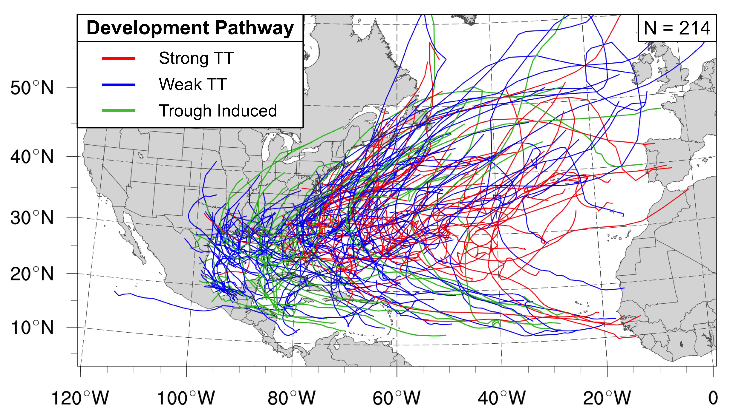

FIG. 1. Track map of the 214 cyclones that formed in the presence of an upper-tropospheric disturbance in the NATL basin during 1979–2010 (McTaggart-Cowan et al. 2013), were classified as TCs in the IBTrACS dataset during their life cycle, and were considered candidates for STC identification. The color of each cyclone track represents the development pathway associated with cyclone formation, according to the legend. A brief description of each development pathway is given in Table 2.

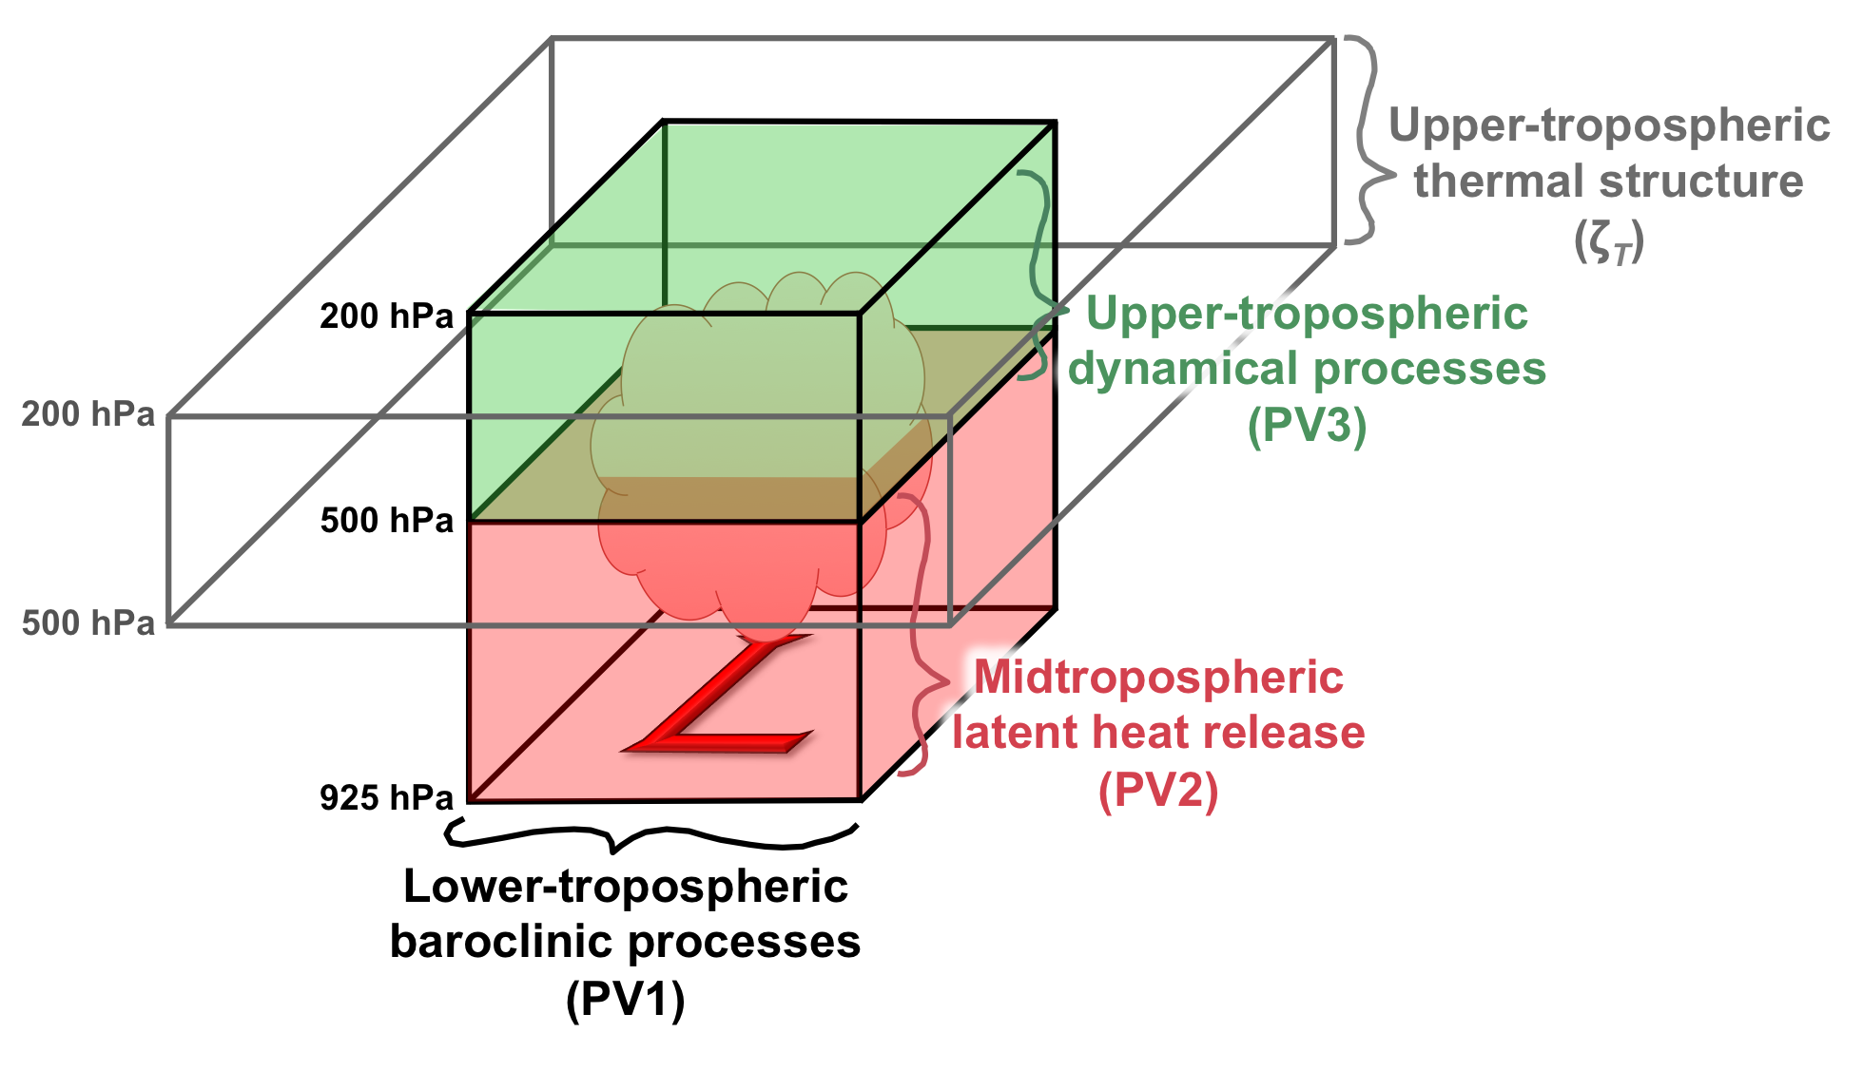
FIG. 2. Schematic representation of the regions over which PV1, PV2, PV3, and ζ_{T} are calculated. All calculations are centered over the surface cyclone (red “L”). A region of latent heat release is denoted by a cloud.

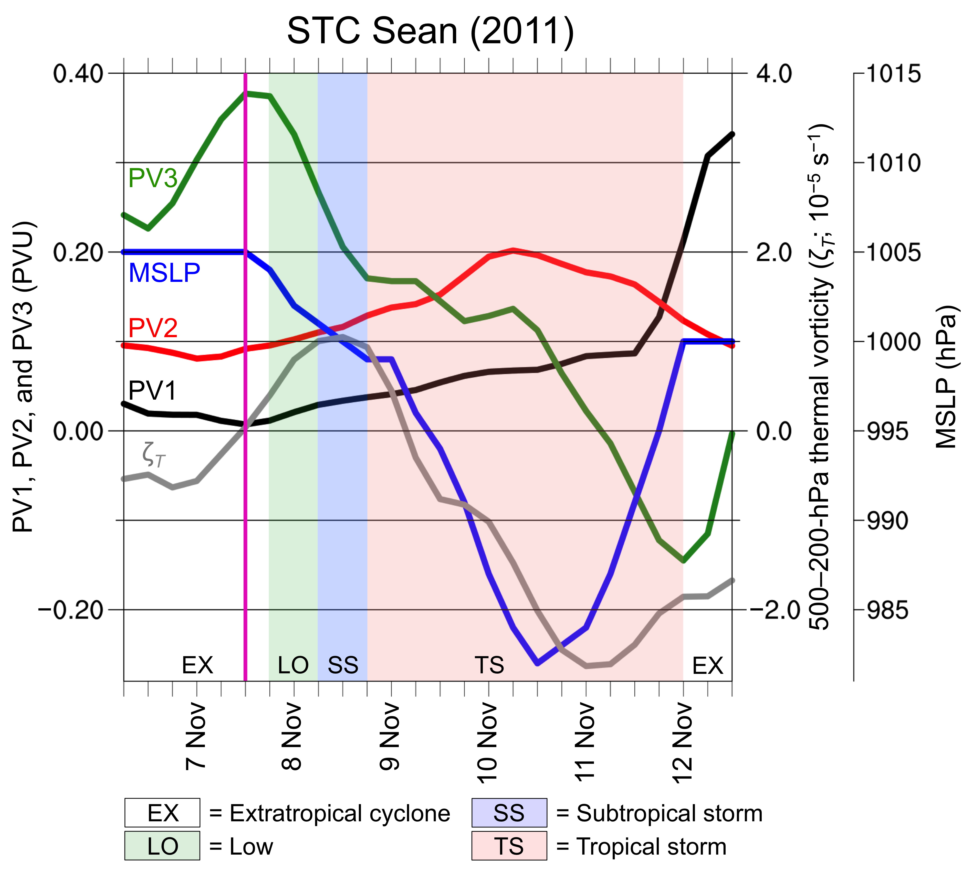

FIG. 3. Graphical representation of PV1, PV2, PV3, ζ_{T}, and MSLP during the evolution of STC Sean from 0600 UTC 6 November through 1200 UTC 12 November 2011. The white, green, blue, and pink regions of the graph denote the time periods when NHC classified Sean as an extratropical cyclone, a low, a subtropical storm, and a tropical storm, respectively. The magenta line denotes the time when the objective identification technique indicated STC formation had occurred.

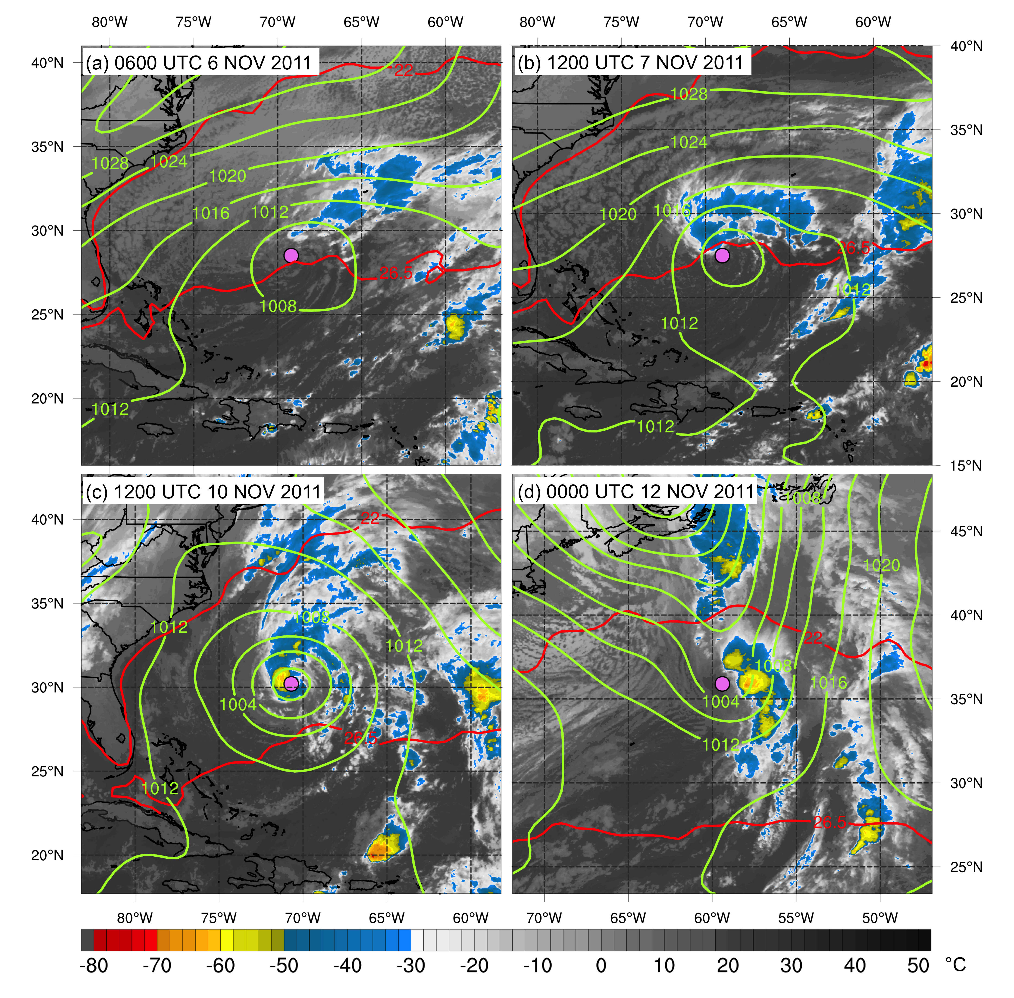
FIG. 4. Analyses showing MSLP (green contours, hPa), IR brightness temperature (shaded, °C), and the 26.5°C and 22.0°C isotherms in the SST field (red contours) for STC Sean at (a) 0600 UTC 6 November, (b) 1200 UTC 7 November, (c) 1200 UTC 10 November, and (d) 0000 UTC 12 November 2011. The pink dot in each panel denotes the location of the cyclone center.

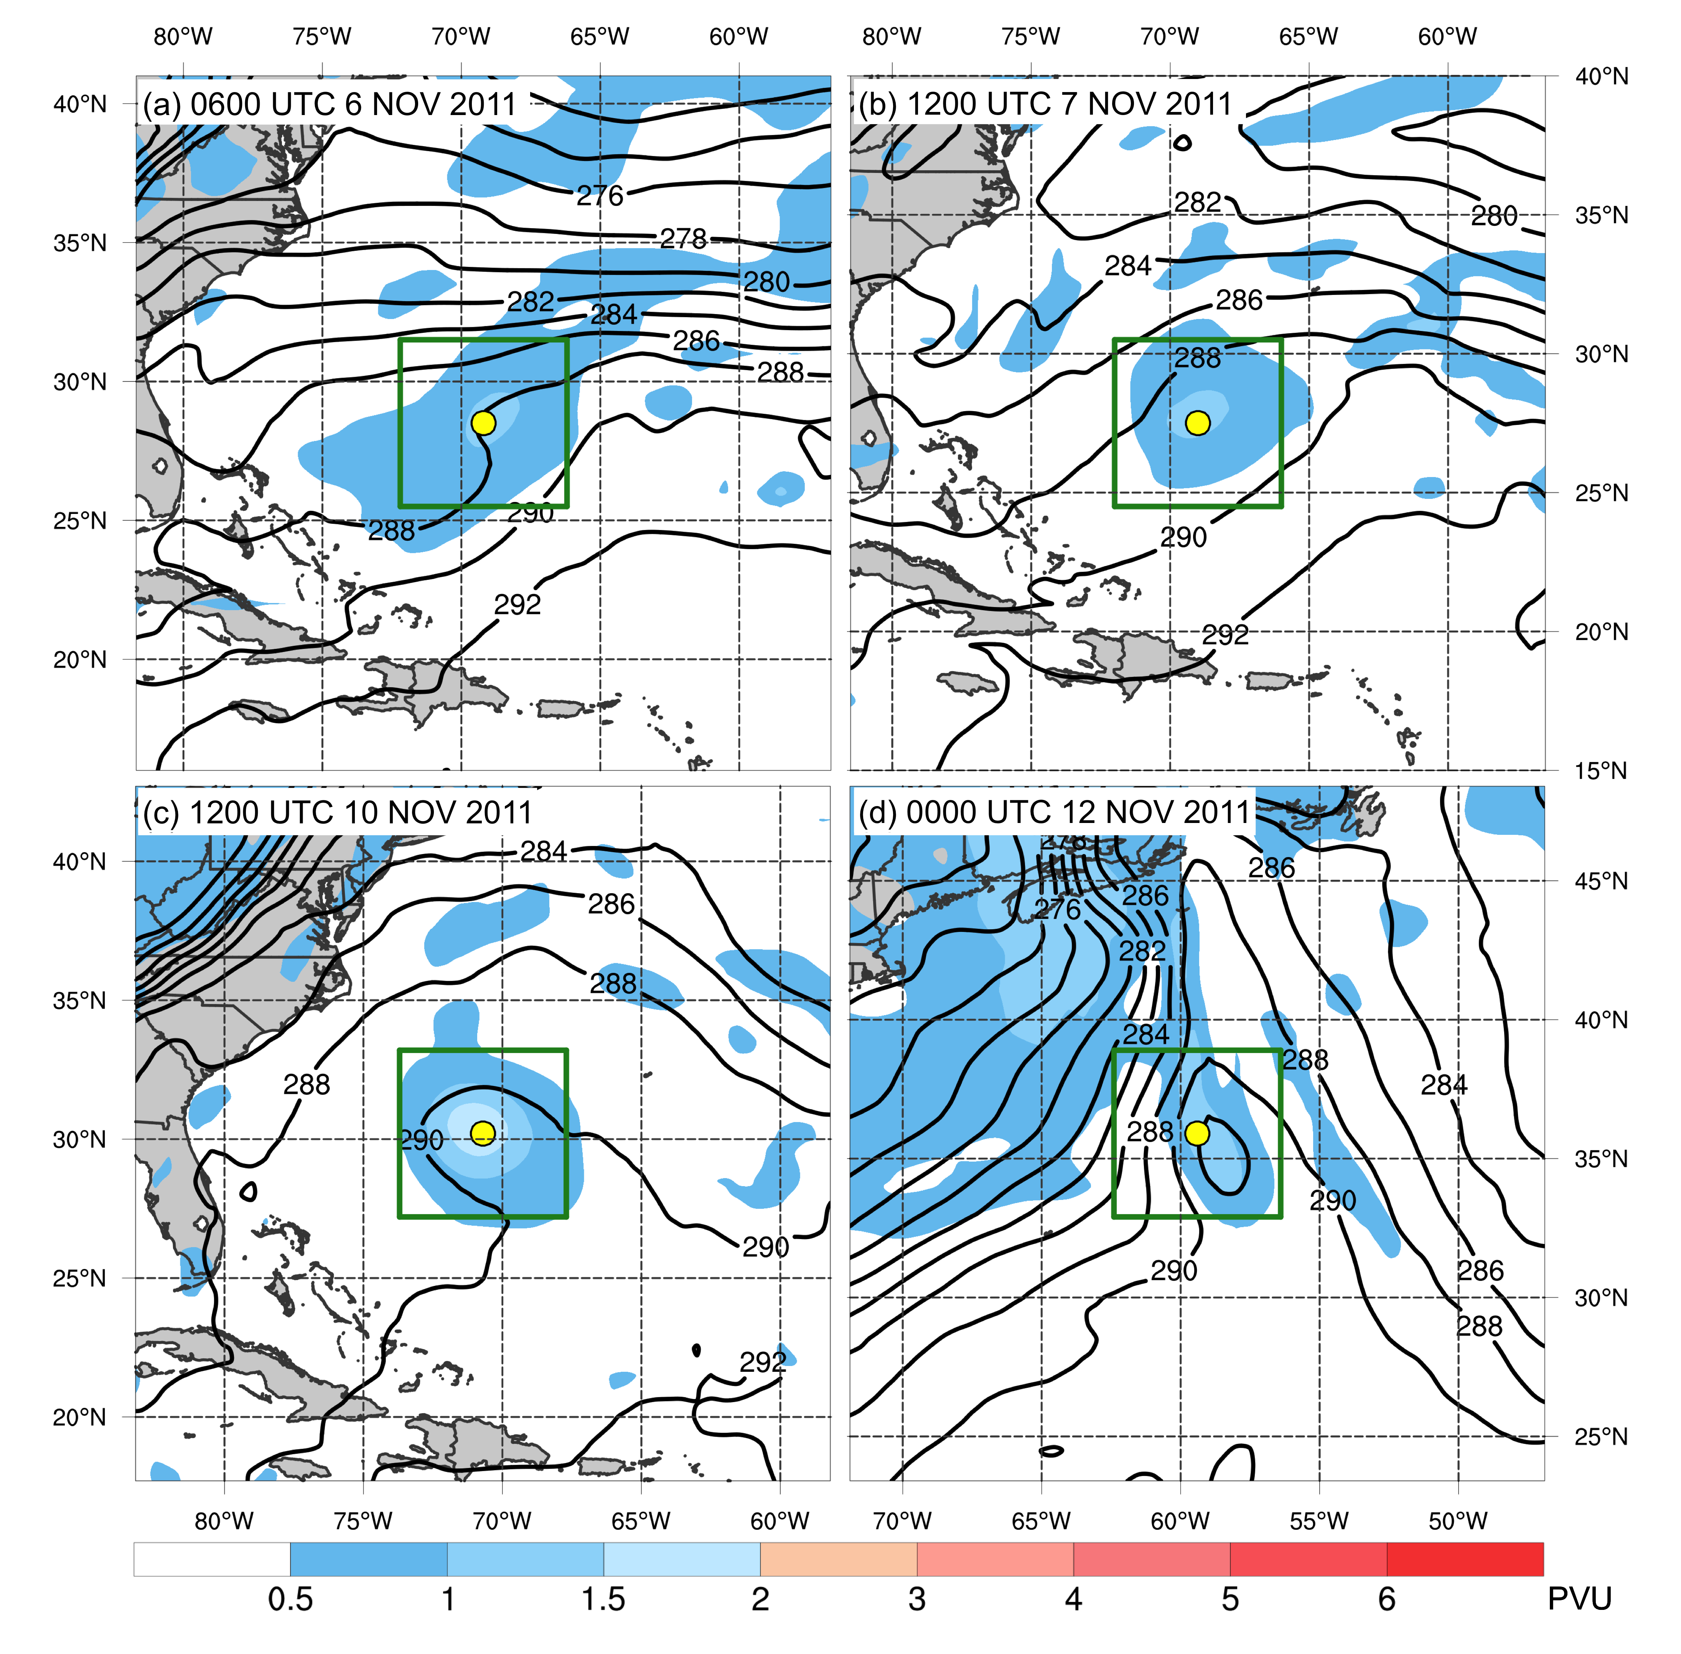
FIG. 5. Analyses depicting the fields used to calculate PV1 and PV2 for STC Sean at (a) 0600 UTC 6 November, (b) 1200 UTC 7 November, (c) 1200 UTC 10 November, and (d) 0000 UTC 12 November 2011. Analyses show 925–850-hPa layer-averaged potential temperature (black contours, K) (used to calculate PV1) and 925–500-hPa layer-averaged PV (shaded, PVU) (used to calculate PV2). The yellow dot in each panel denotes the location of the cyclone center. The green box denotes the region within which PV1 and PV2 are calculated.

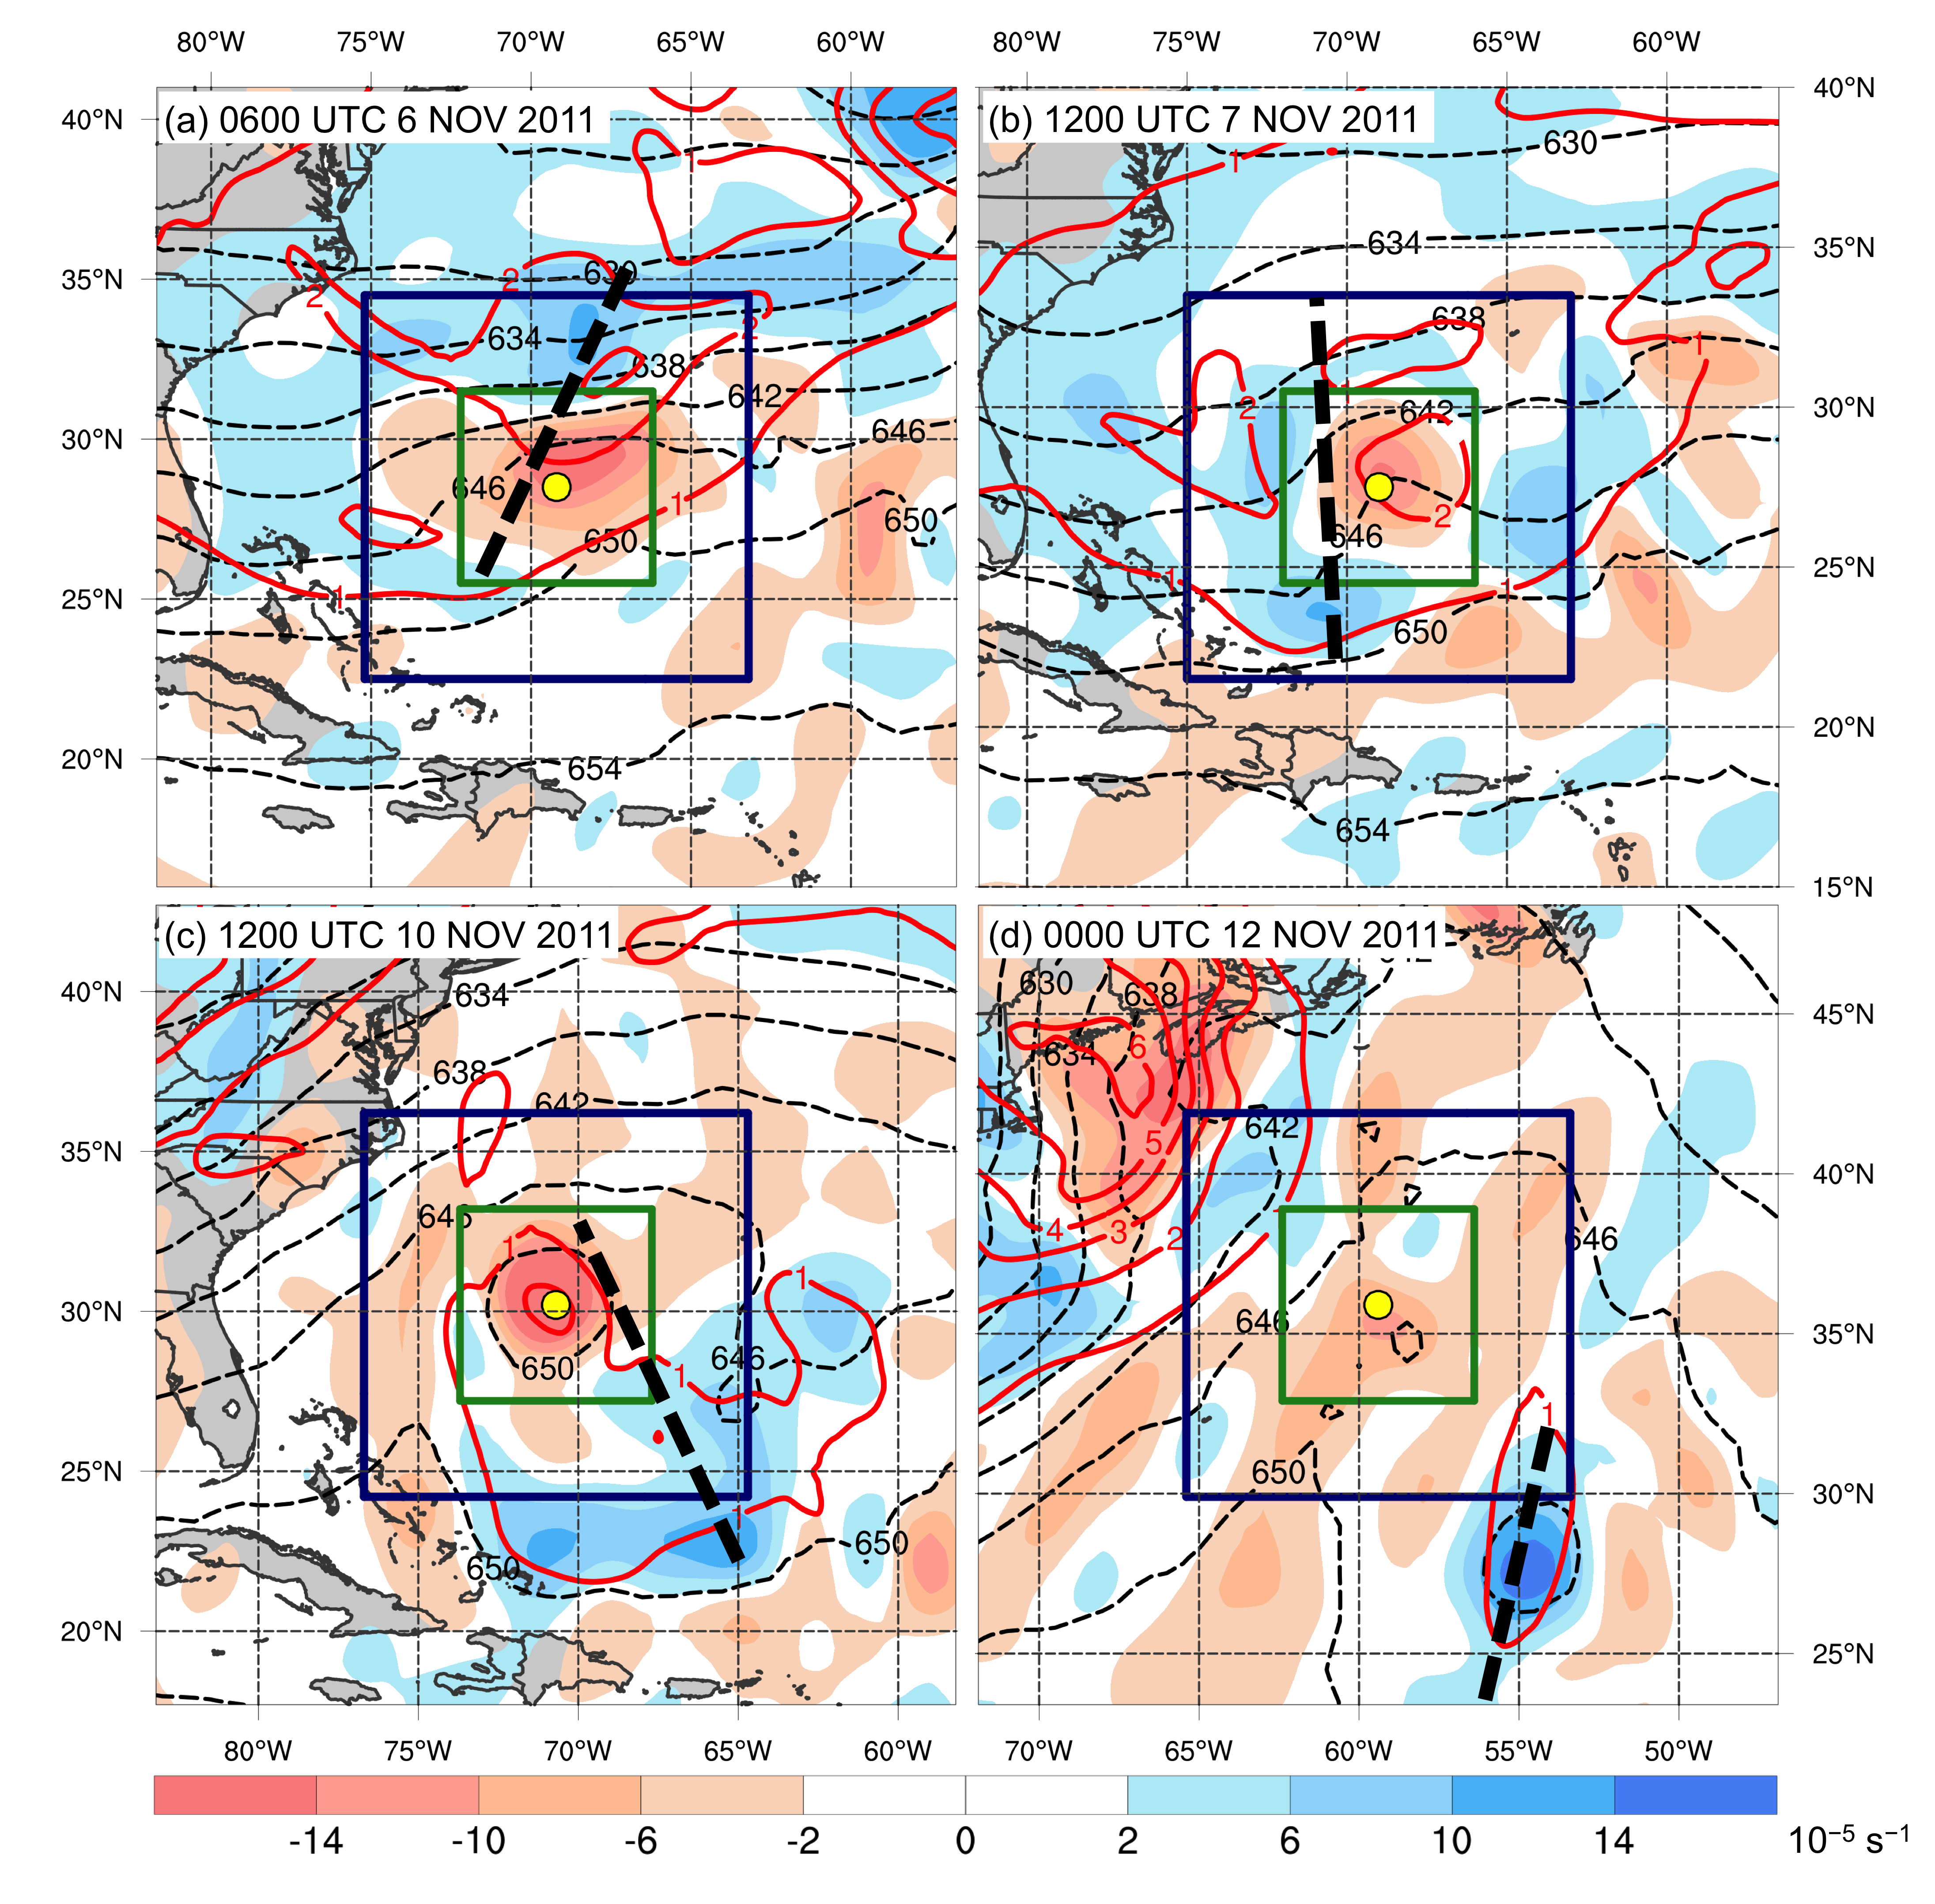
FIG. 6. Analyses depicting the fields used to calculate PV3 and ζ_{T} for STC Sean at (a) 0600 UTC 6 November, (b) 1200 UTC 7 November, (c) 1200 UTC 10 November, and (d) 0000 UTC 12 November 2011. Analyses show 500–200-hPa thickness (dashed black contours, dam), 500–200-hPa layer-averaged PV (red contours, PVU) (used to calculate PV3), and 500–200-hPa thermal vorticity (shaded, 10⁻⁵ s⁻¹) (used to calculate ζ_{T}). The yellow dot in each panel denotes the location of the cyclone center. The green box denotes the region within which PV3 is calculated. The dark blue box denotes the region within which ζ_{T} is calculated. The thick dashed black line denotes the location of the 200-hPa trough axis discussed in section 2d.

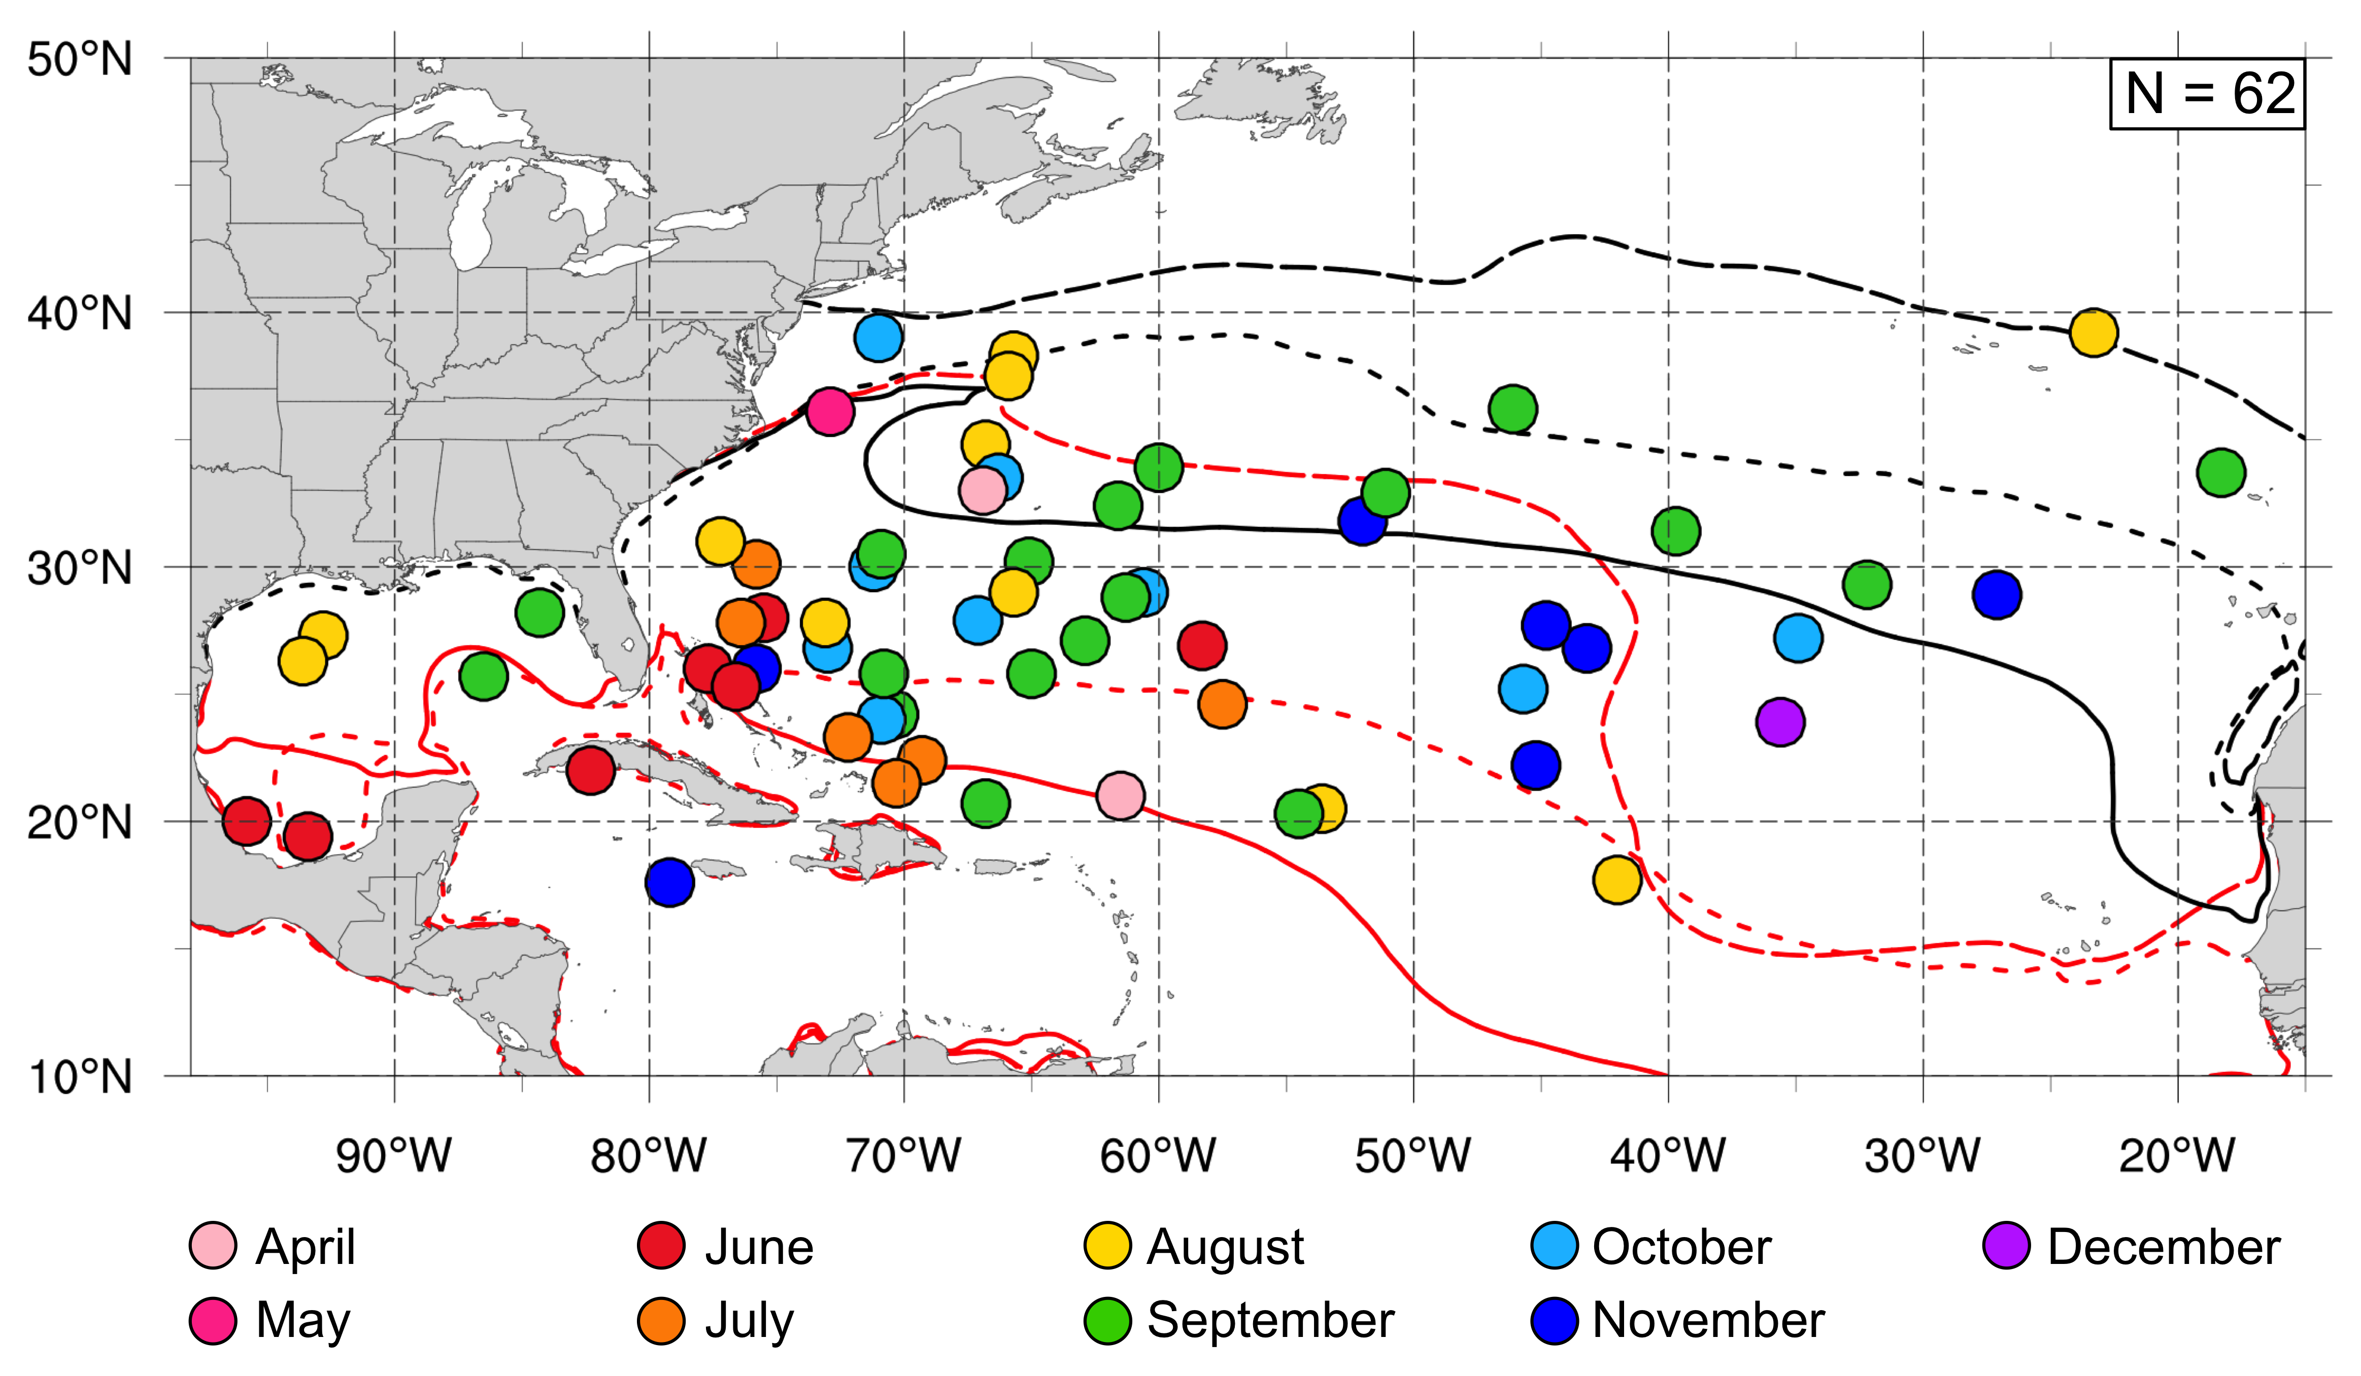

FIG. 7. Locations of STC formation in the NATL basin during 1979–2010. The color of each dot represents the month STC formation occurred, according to the legend. The solid red (black) line denotes the location of the 26.5°C (22.0°C) isotherm in the 1979–2010 mean SST field during April–June. The long dashed red (black) line denotes the location of the 26.5°C (22.0°C) isotherm in the 1979–2010 mean SST field during July–September. The short dashed red (black) line denotes the location of the 26.5°C (22.0°C) isotherm in the 1979–2010 mean SST field during October–December.

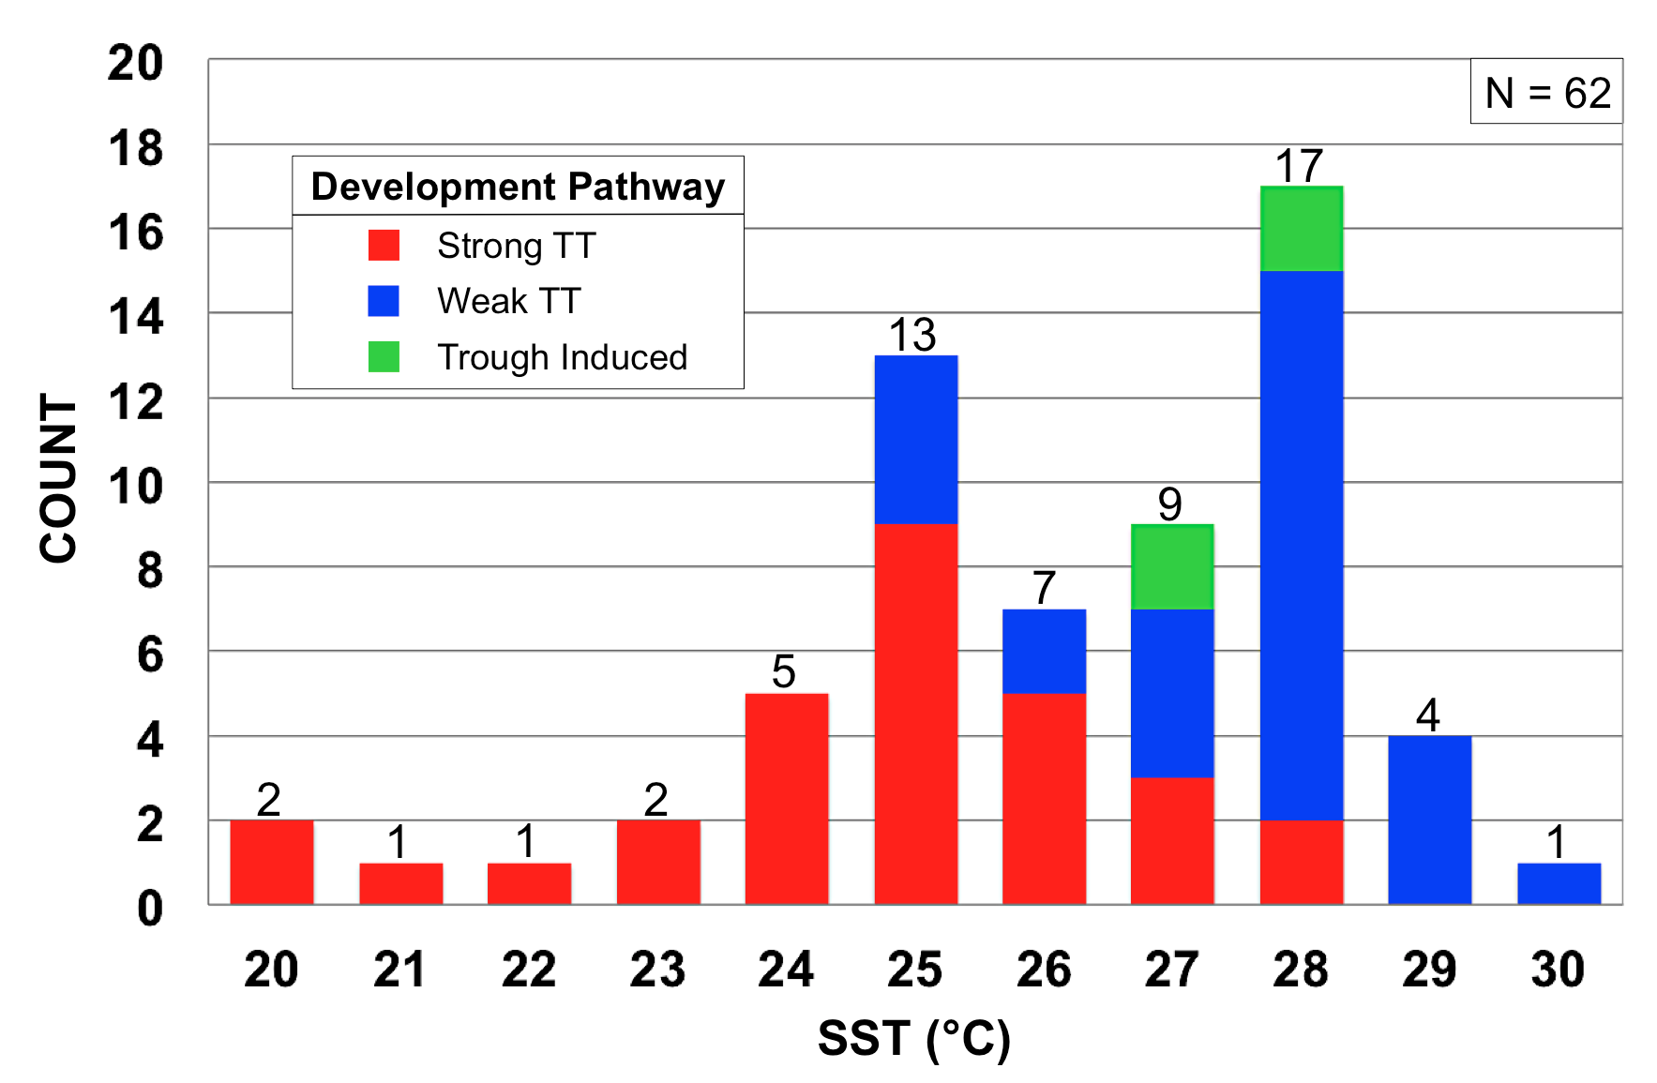

FIG. 8. Frequency distribution of STC formation in the NATL basin during 1979–2010 binned by SST (°C). SSTs are binned at 1°C intervals beginning at the given integer value (e.g., the 20°C bin contains all STCs forming over SSTs ≥20°C and <21°C). Red, blue, and green regions represent the number of STCs classified as Strong TT, Weak TT, and Trough Induced, respectively, in McTaggart-Cowan et al. (2013).

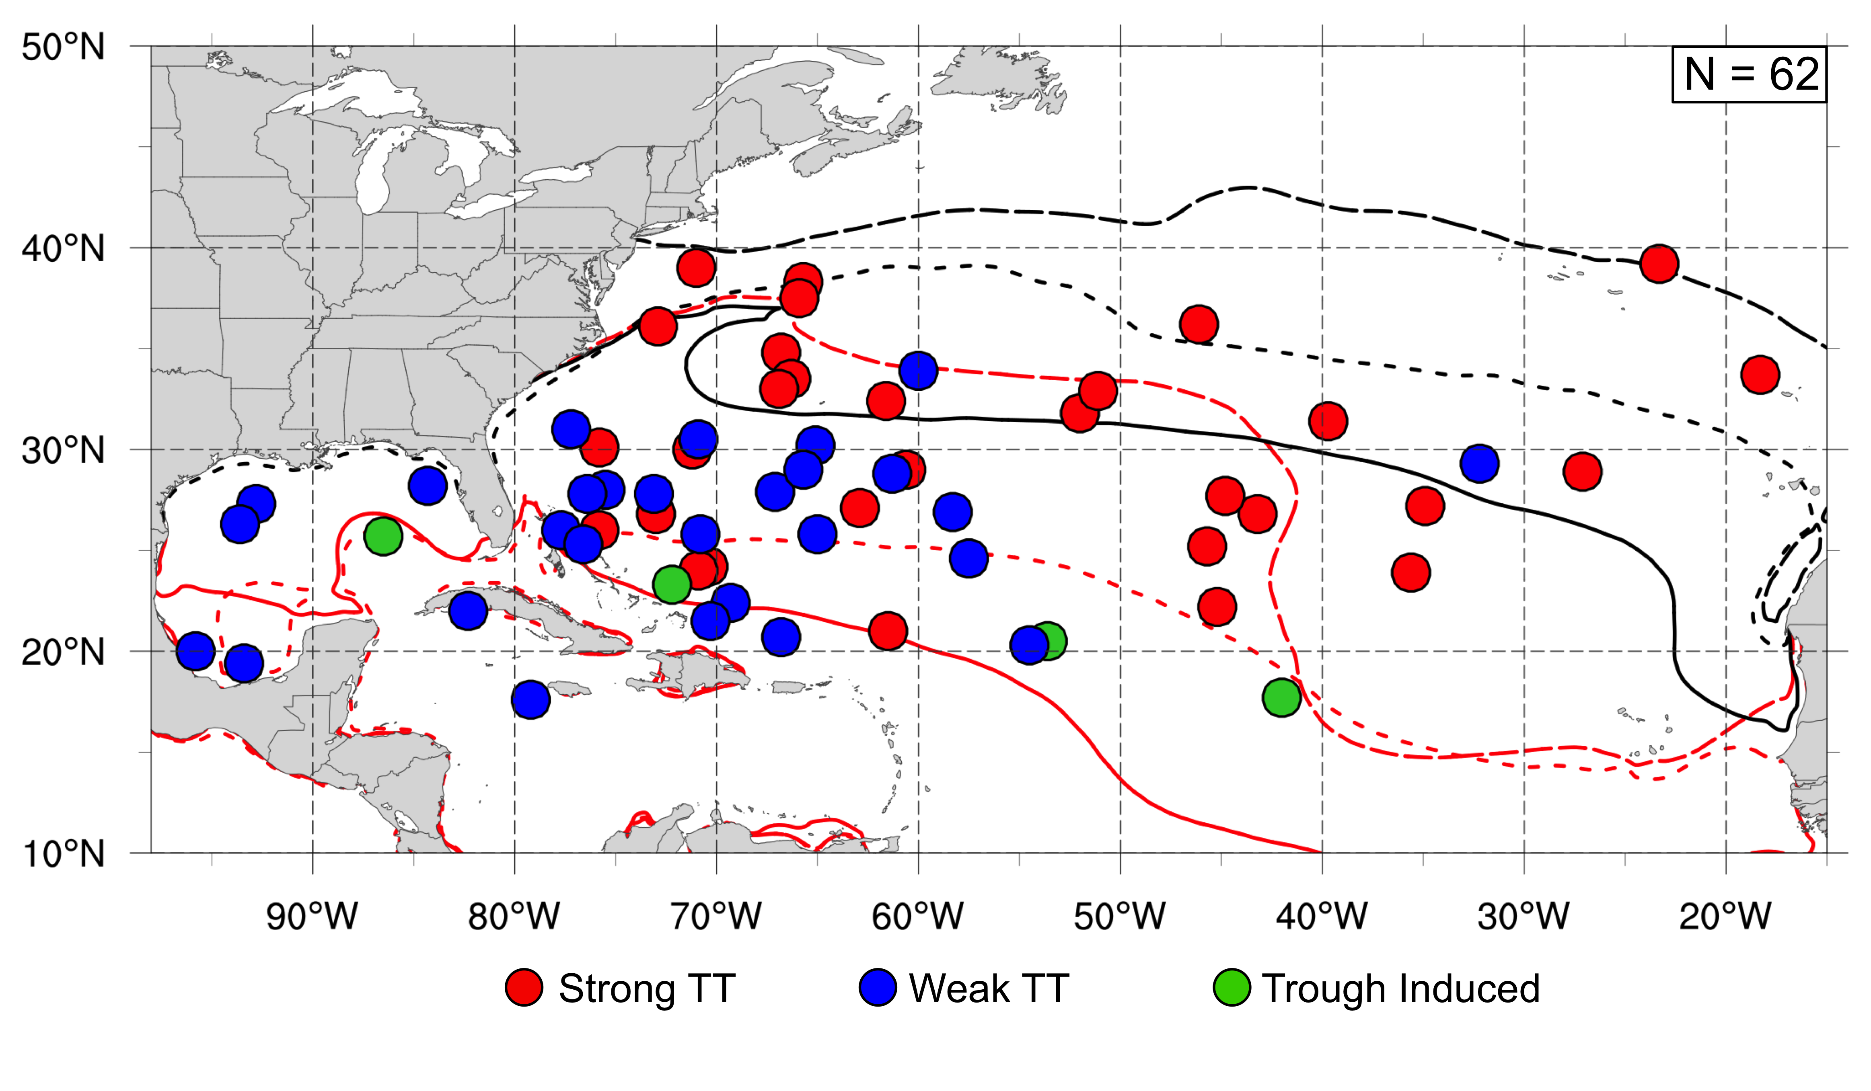
FIG. 9. As in Fig. 7, except the color of each dot represents the McTaggart-Cowan et al. (2013) development pathway associated with STC formation, according to the legend.

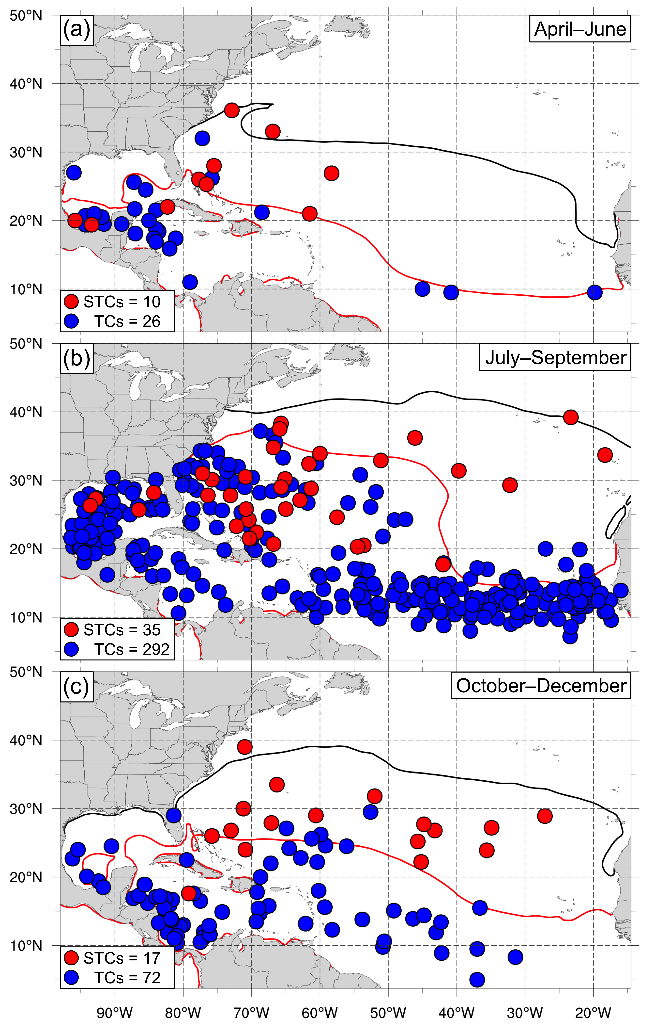
FIG. 10. Locations of STC formation and TC formation in the NATL basin during a) April–June, b) July–September, and c) October–December 1979–2010. A red dot denotes the location of STC formation, whereas a blue dot denotes the location of TC formation. The solid red (black) line denotes the location of the 26.5°C (22.0°C) isotherm in the 1979–2010 mean SST field during a) April–June, b) July–September, and c) October–December.

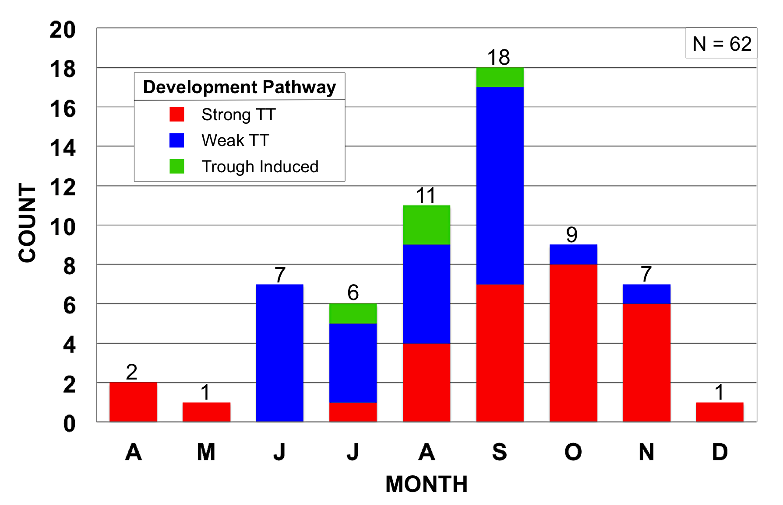

FIG. 11. Frequency distribution of STC formation in the NATL basin during 1979–2010 binned by month (April–December). Red, blue, and green regions represent the number of STCs classified as Strong TT, Weak TT, and Trough Induced, respectively, in McTaggart-Cowan et al. (2013).

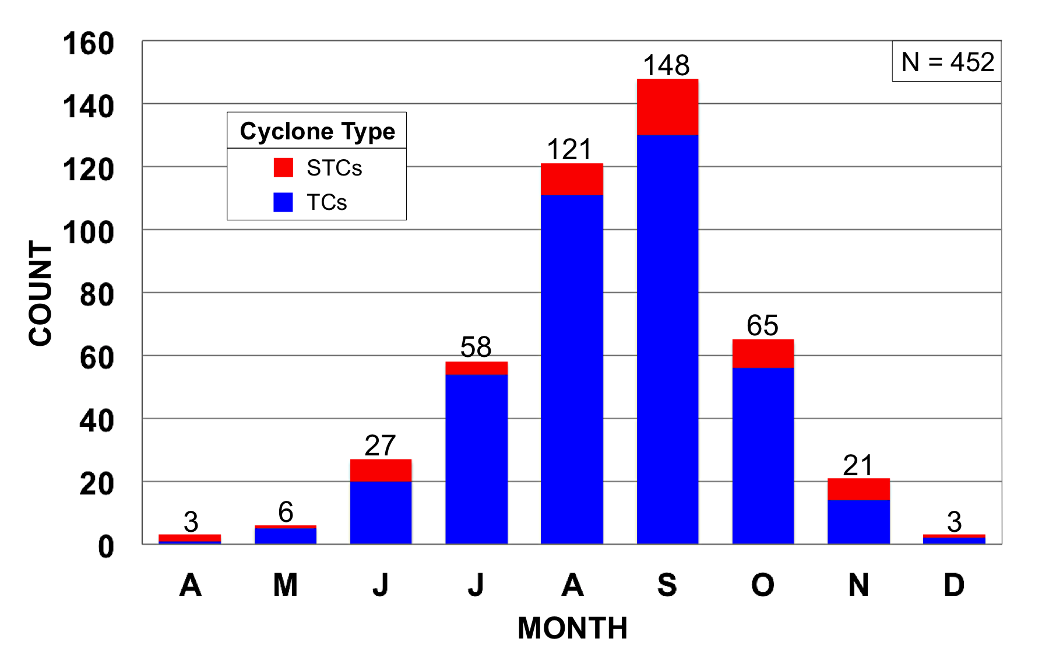

FIG. 12. Frequency distribution of STC formation and TC formation in the NATL basin during 1979–2010 binned by month (April–December). Red and blue regions represent the number of STCs and TCs forming each month, respectively.

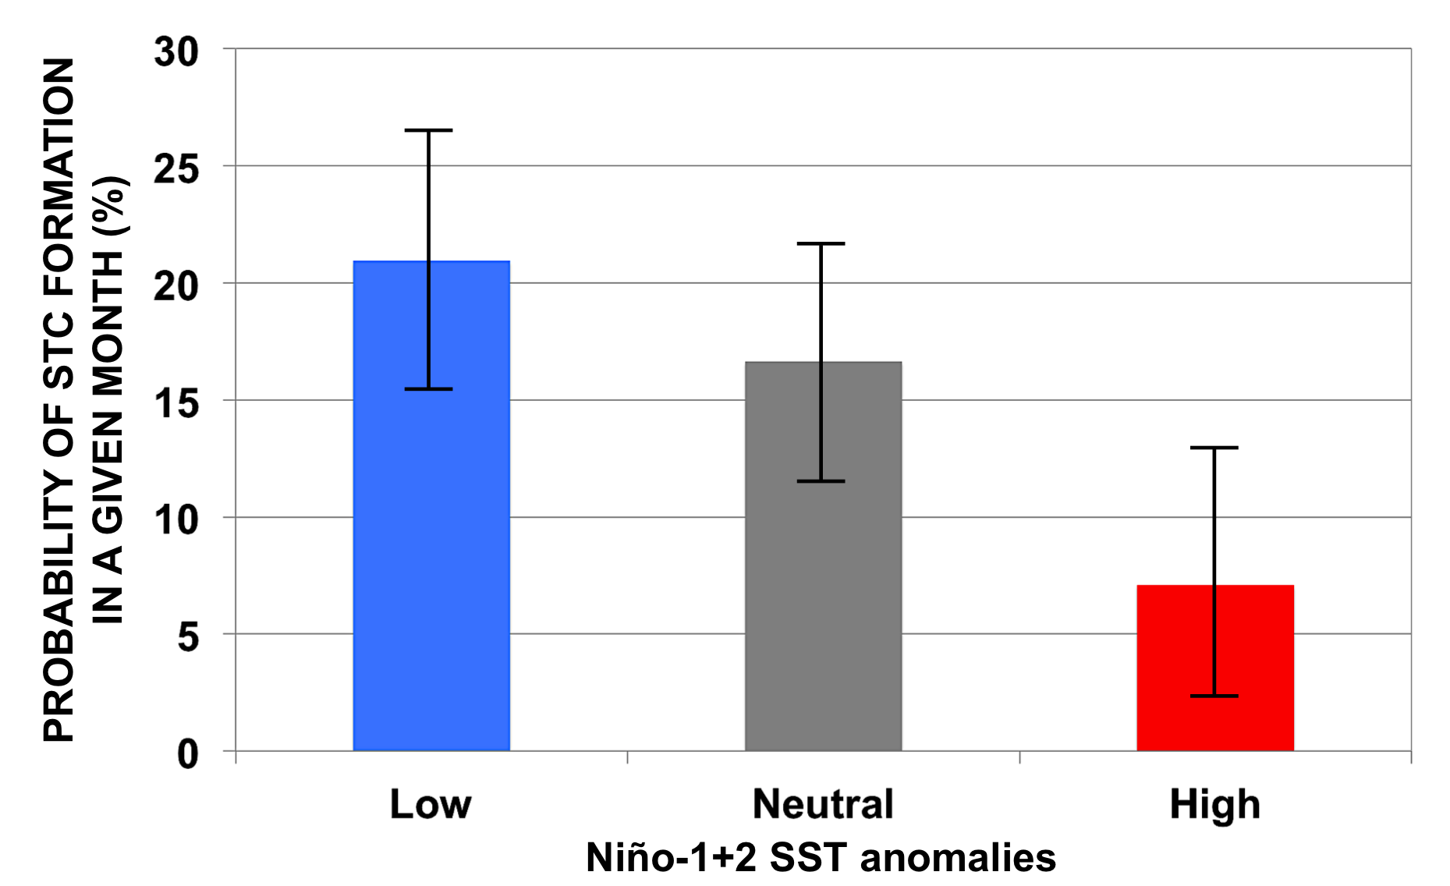

FIG. 13. The probability (%) of STC formation occurring in a given month when Niño-1+2 SST anomalies are low (<−0.5°C), neutral (−0.5°C–0.5°C), and high (>0.5°C). The 95% confidence interval for each bin is shown using a black line segment.

Corresponding author address: Alicia M. Bentley, Department of Atmospheric and Environmental Sciences, University at Albany, State University of New York, ES-234, 1400 Washington Ave., Albany, NY 12222. Email: ambentley@albany.edu

