Upper-Tropospheric Precursors to the Formation of Subtropical Cyclones
that Undergo Tropical Transition in the North Atlantic Basin

Alicia M. Bentley, Lance F. Bosart, and Daniel Keyser

Department of Atmospheric and Environmental Sciences, University at Albany,
State University of New York, Albany, New York

Submitted to
Monthly Weather Review
12 July 2016

Resubmitted to
Monthly Weather Review
20 October 2016

ABSTRACT
The opportunity to examine the structure and evolution of the various upper-tropospheric precursors to the formation of North Atlantic (NATL) subtropical cyclones (STCs) that undergo tropical transition (TT) motivates this study. Intraseasonal variability associated with the location and frequency of NATL STCs forming in the presence of similar upper-tropospheric features, as well as similarities and differences in the various upper-tropospheric precursors to the formation of NATL STCs that undergo TT, are examined. NATL STCs that undergo TT are categorized according to the upper-tropospheric features associated with their formation during 1979–2010 using the 0.5° NCEP Climate Forecast System Reanalysis dataset. This categorization allows for the documentation of the location and frequency of STCs forming in the presence of similar upper-tropospheric features and for the construction of cyclone-relative composites during the five days prior to STC formation.
NATL STCs that undergo TT are separated into one of three categories based on the upper-tropospheric features associated with their formation: 1) cutoff lows, 2) meridional troughs, and 3) zonal troughs. STCs included in the cutoff low and meridional trough categories typically develop poleward of ~25°N over the western, central, and eastern NATL during September–November and August–November, respectively. In contrast, STCs included in the zonal trough category typically develop equatorward of ~30°N over the western NATL during June–September. Cyclone-relative composites reveal that ~61% of the categorized NATL STCs that undergo TT form in association with an upper-tropospheric feature whose structure and evolution are linked to anticyclonic wave breaking.

- Introduction
Tropical cyclones (TCs) forming in the presence of an upper-tropospheric disturbance (i.e., an upper-tropospheric low or trough) comprise ~21% of TCs forming globally during 1948–2010 (McTaggart-Cowan et al. 2013). The percentage of North Atlantic (NATL) TCs forming in the presence of an upper-tropospheric disturbance during 1948–2010 (~46%) is more than twice the global average, likely associated with the frequent occurrence of upper-tropospheric disturbances over the NATL during boreal summer (Nieto et al. 2005; Wernli and Sprenger 2007). Previous studies by McTaggart-Cowan et al. (2013) and Galarneau et al. (2015) suggest that upper-tropospheric disturbances associated with NATL tropical cyclogenesis typically form in conjunction with anticyclonic wave breaking (AWB) (e.g., McIntyre and Palmer 1983; Thorncroft et al. 1993; Postel and Hitchman 1999; Martius et al. 2008), which occurs in response to the nonlinear amplification of Rossby waves (e.g., Abatzoglou and Magnusdottir 2006; Martius et al. 2010; Holton and Hakim 2013, section 12.3.2). Upper-tropospheric disturbances forming in conjunction with AWB are referred to by a variety of names [e.g., cutoff lows (e.g., Palmén and Newton 1969, section 10.2; Nieto et al. 2005); potential vorticity (PV) streamers (e.g., Appenzeller and Davies 1992; Martius et al. 2008; Galarneau et al. 2015); and tropical upper-tropospheric trough cells (e.g., Sadler 1976; Ferreira and Schubert 1999; Patla et al. 2009)]. These upper-tropospheric disturbances have the potential to induce NATL tropical cyclogenesis in environments characterized by relatively low sea surface temperatures (SSTs) (e.g., Mauk and Hobgood 2012; McTaggart-Cowan et al. 2015) and high vertical wind shear (VWS) (e.g., Bracken and Bosart 2000; McTaggart-Cowan et al. 2008, 2013).
According to Galarneau et al. (2015), NATL TCs forming in the presence of an upper-tropospheric disturbance develop from either the favorable interaction of a preexisting lower-tropospheric cyclonic vorticity center with an upper-tropospheric trough (e.g., Molinari et al. 1995) or the tropical transition (TT; Davis and Bosart 2003, 2004) of a subtropical cyclone (STC) (e.g., Roth 2002; Guishard et al. 2007; Evans and Guishard 2009; Guishard et al. 2009; González-Alemán et al. 2015; Bentley et al. 2016). A recent climatology of NATL STCs that undergo TT constructed by Bentley et al. (2016) from the global climatology of baroclinically influenced tropical cyclogenesis created by McTaggart-Cowan et al. (2013) reveals that 62 STCs undergo TT over the NATL during 1979–2010. STCs that undergo TT preferentially form over the western NATL (Bentley et al. 2016), likely associated with the frequent overlap of relatively high SSTs and intrusions of relatively cold upper-tropospheric air accompanying upper-tropospheric disturbances in that portion of the basin (Wernli and Sprenger 2007, their Fig. 6). An intrusion of relatively cold upper-tropospheric air accompanying an upper-tropospheric disturbance over the western NATL is likely to steepen lapse rates beneath the disturbance and facilitate the development of deep convection, which serves as a catalyst for STC formation (e.g., Guishard et al. 2009; Bentley et al. 2016).
Previous studies by Evans and Guishard (2009) and González-Alemán et al. (2015) used cyclone-relative composite analysis to examine the upper-tropospheric features associated with NATL STC formation. Evans and Guishard (2009) constructed cyclone-relative composites of 18 STCs identified over the western and central NATL during 1999–2004 using the 2.5° NCEP–NCAR reanalysis dataset (Kalnay et al. 1996), whereas González-Alemán et al. (2015) constructed cyclone-relative composites of 15 STCs identified over the northeastern NATL during 1979–2011 using the 0.75° ECMWF interim reanalysis dataset (Dee et al. 2011). Both Evans and Guishard (2009; their Fig. 7) and González-Alemán et al. (2015; their Fig. 5) indicate the presence of an upper-tropospheric trough located slightly upstream of and over the STC center at the time of STC formation that slowly approached the STC center from the west during the previous 24 h. Individual upper-tropospheric features differ in structure across composite members in Evans and Guishard (2009) and González-Alemán et al. (2015), suggesting that the upper-tropospheric precursors to the formation of NATL STCs that undergo TT may differ as well. The opportunity to examine the structure and evolution of the various upper-tropospheric precursors to the formation of NATL STCs that undergo TT motivates the present study.
In the present study, the climatological study of Bentley et al. (2016) is used as the basis for a comprehensive cyclone-relative composite analysis of the upper-tropospheric precursors to the formation of NATL STCs that undergo TT during 1979–2010. In contrast to STCs included in previously constructed cyclone-relative composites of NATL STC formation by Evans and Guishard (2009) and González-Alemán et al. (2015), STCs in the present study are required to undergo TT during their life cycle and are categorized according to the upper-tropospheric features associated with their formation. This categorization allows for the documentation of the location and frequency of NATL STCs forming in the presence of similar upper-tropospheric features and for the construction of cyclone-relative composites during the five days prior to NATL STC formation. Construction of cyclone-relative composites during the five days prior to STC formation is unique to the present study and allows for a detailed examination of the structure and evolution of the various upper-tropospheric precursors to the formation of NATL STCs that undergo TT.
The remainder of this paper is organized as follows. The data and methodology used to categorize NATL STCs that undergo TT, as well as construct cyclone-relative composites of the upper-tropospheric precursors to NATL STC formation, are described in section 2. Section 3 contains climatological results, including a discussion of the intraseasonal variability associated with the location and frequency of NATL STCs forming in the presence of similar upper-tropospheric features. Section 4 presents cyclone-relative composite analyses of the upper-tropospheric precursors to the formation of NATL STCs that undergo TT. Results of the present study are discussed and conclusions are presented in section 5.

- Data and methodology
a. Categorization of NATL STCs that undergo TT
In order to examine the upper-tropospheric precursors to the formation of NATL STCs that undergo TT, all 62 NATL STCs that undergo TT identified during 1979–2010 by Bentley et al. (2016) are separated into categories according to the upper-tropospheric feature associated with their formation. All 62 NATL STCs that undergo TT are required to form in the presence of a cold-core upper-tropospheric disturbance and be classified as TCs in the International Best Track Archive for Climate Stewardship dataset (Knapp et al. 2010) during their life cycle. The time of STC formation (i.e., t₀) is determined using the objective STC identification technique described in Bentley et al. (2016; their section 2c).
Previous studies of baroclinically influenced tropical cyclogenesis have subjectively categorized NATL TCs based on visual inspection of the upper-tropospheric features associated with their formation (e.g., Bracken and Bosart 2000; Galarneau et al. 2015). A similar approach will be used in the present study in order to categorize NATL STCs. Visual inspection of the 250–150-hPa layer-averaged PV, geopotential height, and wind fields over the NATL every 24 h between t₀ − 120 h and t₀ in the 0.5° NCEP Climate Forecast System Reanalysis (CFSR) dataset (Saha et al. 2010) results in the identification of three upper-tropospheric features associated with NATL STC formation: 1) cutoff lows, 2) meridional troughs, and 3) zonal troughs. These three upper-tropospheric features exhibit characteristic structures and evolutions between t₀ − 120 h and t₀ that distinguish them from each other.
Figures 1–3 show the 250–150-hPa layer-averaged PV, geopotential height, and winds over the NATL every 24 h between t₀ − 120 h and t₀ for representative examples of STCs forming in association with a cutoff low, meridional trough, and zonal trough, respectively. STCs forming in association with a cutoff low [e.g., Otto (2004); Fig. 1] were included in the cutoff low category (N = 15). In order for an STC to be included in this category, the cutoff low linked to STC formation develops in response to AWB occurring to the north of the location of STC formation between t₀ − 120 h and t₀. Figure 1 depicts AWB and cutoff low development occurring over the central NATL during the five days prior to the formation of Otto (2004), with STC formation occurring directly beneath the location of the cutoff low at t₀. STCs forming in association with a meridional trough [e.g., Olga (2001); Fig. 2] were included in the meridional trough category (N = 18). In order for an STC to be included in this category, the meridional trough linked to STC formation approaches the location of STC formation from the west between t₀ − 120 h and t₀ and develops in the absence of AWB. Figure 2 depicts the eastward progression of a meridional trough toward to location of STC formation during the five days prior to the formation of Olga (2001), without AWB occurring in association with meridional trough development. STCs forming in association with both cutoff lows and meridional troughs typically develop poleward of ~25°N in association with relatively high values of 250–150-hPa layer-averaged PV (to be discussed in section 3).
STCs forming in association with a zonal trough [e.g., Unnamed (1986); Fig. 3] were included in the zonal trough category (N = 17). In order for an STC to be included in this category, the zonal trough linked to STC formation develops in response to AWB occurring to the north of the location of STC formation and approaches the location of STC formation from the east between t₀ − 120 h and t₀. Figure 3 depicts AWB and zonal trough development occurring over the central NATL during the five days prior to the formation of Unnamed (1986), with the zonal trough approaching the location of STC formation from the east. In contrast to STCs forming in association with cutoff lows and meridional troughs, STCs forming in association with zonal troughs typically develop equatorward of ~30°N in association with relatively low values of 250–150-hPa layer-averaged PV (to be discussed in section 3). A total of 12 NATL STCs that undergo TT do not form in association with a cutoff low, meridional trough, or zonal trough and were considered unclassifiable. Unclassifiable NATL STCs will not be discussed in the remainder of the present study, but will be included in subsequent figures to facilitate visual comparison with the climatological results of Bentley et al. (2016).
The dominant upper-tropospheric structures associated with the formation of NATL STCs included in each subjectively constructed category are isolated and examined objectively by performing empirical orthogonal function (EOF) analysis (e.g., Richman 1986) on the 250–150-hPa layer-averaged PV fields associated with NATL STC formation at t₀. In order to proceed with the EOF analysis, all 250–150-hPa layer-averaged PV fields are shifted so that the location of STC formation is collocated with the mean location of STC formation (27.8°N, 63.4°W). Principal components (PCs) computed from the EOF analysis are defined based on the projection of individual 250–150-hPa layer-averaged PV fields on the EOFs. NATL STCs with similar PCs are associated with similar patterns of 250–150-hPa layer-averaged PV at t₀, and would ideally be included in the same subjectively constructed category.
Figure 4a depicts the relationship between the subjective categorization of NATL STCs that undergo TT and the location of each STC in a phase space defined by the first and second PCs of the EOF analysis (i.e., PC1 and PC2). Figure 4a illustrates that STCs included in the same subjectively constructed category are located in similar regions of the PC1–PC2 phase space, suggesting that the structures of subjectively identified upper-tropospheric features associated with STC formation within the same category are similar at t₀. Figures 4b,c, which depict the structure of the first and second EOFs (i.e., EOF1 and EOF2), reveal the dominant upper-tropospheric structures associated with the formation of NATL STCs that undergo TT. EOF1 describes the overall magnitude of the individual 250–150-hPa layer-averaged PV fields included in the EOF analysis, with positive values of EOF1 spanning the majority of the domain. Positive values of PC1 are associated with overall higher values of 250–150-hPa layer-averaged PV, whereas negative values of PC1 are associated with overall lower values of 250–150-hPa layer-averaged PV. The structure of the 250–150-hPa layer-averaged PV field associated with positive values of PC1 is consistent with NATL STCs forming at relatively high latitudes in association with relatively high values of 250–150-hPa layer-averaged PV. The structure of the 250–150-hPa layer-averaged PV field associated with negative values of PC1 is consistent with NATL STCs forming at relatively low latitudes in association with relatively low values of 250–150-hPa layer-averaged PV.
EOF2 describes an asymmetric dipole in the individual 250–150-hPa layer-averaged PV fields, with negative EOF2 values to the north of the location of STC formation and positive EOF2 values over and to the east of the location of STC formation (Fig. 4c). Positive values of PC2 are associated with lower values of 250–150-hPa layer-averaged PV to the north of the location of STC formation and higher values of 250–150-hPa layer-averaged PV over and to the east of the location of STC formation. Negative values of PC2 are associated with higher values of 250–150-hPa layer-averaged PV to the north of the location of STC formation and lower values of 250–150-hPa layer-averaged PV over and to the east of the location of STC formation. The structure of the 250–150-hPa layer-averaged PV field associated with positive values of PC2 is consistent with the signature of AWB occurring to the north of the location of STC formation, which manifests itself as a reversal in the sign of the upper-tropospheric meridional PV gradient (e.g., Postel and Hitchman 1999; Zhang et al. 2016). The structure of the 250–150-hPa layer-averaged PV field associated with negative values of PC2 is consistent with the absence of AWB occurring to the north of the location of STC formation (i.e., a more zonal-flow pattern).
Figures 4a,b reveal that STCs forming in association with cutoff lows and meridional troughs are associated with positive values of PC1, or overall higher values of 250–150-hPa layer-averaged PV. This result is consistent with the findings of the subjective categorization of NATL STCs that undergo TT, which indicate that cutoff lows and meridional troughs typically develop poleward of ~25°N in association with relatively high values of 250–150-hPa layer-averaged PV. In contrast, STCs forming in association with zonal troughs are associated with negative values of PC1, or overall lower values of 250–150-hPa layer-averaged PV. This result is also consistent with the findings of the subjective categorization of NATL STCs that undergo TT, which indicate that zonal troughs typically develop equatorward of ~30°N in association with relatively low values of 250–150-hPa layer-averaged PV. Figures 4a,c reveal that STCs forming in association with cutoff lows and zonal troughs are associated with neutral-to-positive values of PC2, or lower values of 250–150-hPa layer-averaged PV to the north of the location of STC formation and higher values of 250–150-hPa layer-averaged PV over and to the east of the location of STC formation. This result is consistent with the findings of the subjective categorization of NATL STCs that undergo TT, which indicate that cutoff lows and zonal troughs develop in response to AWB occurring to the north of the location of STC formation. In contrast, STCs forming in association with meridional troughs are typically associated with negative values of PC2, or higher values of 250–150-hPa layer-averaged PV to the north of the location of STC formation and lower values of 250–150-hPa layer-averaged PV over and to the east of the location of STC formation. This result is also consistent with the findings of the subjective categorization of NATL STCs that undergo TT, which indicate that meridional troughs develop in the absence of AWB.
Two small regions of overlap between STCs included in different subjectively constructed categories exist in the PC1–PC2 phase space (Fig. 4a), indicating that these STCs may be associated with similar patterns of 250–150-hPa layer-averaged PV at t₀. For example, four STCs included in the cutoff low category overlap with STCs included in the zonal trough category in Fig. 4a. This overlap may be explained by considering that the upper-tropospheric features included in both categories develop in association with AWB occurring to the north of the location of STC formation, and that the dominant upper-tropospheric structures associated with the formation of NATL STCs included in both categories may be similar at t₀. Despite their overlap, the four STCs forming in association with cutoff lows are considered separate from STCs forming in association with zonal troughs due to the distinct evolution of these upper-tropospheric features between t₀ − 120 h and t₀ that cannot be captured by the EOF analysis performed exclusively at t₀. The same justification can be used to explain the separation of STCs forming in association with cutoff lows and meridional troughs into different subjectively constructed categories, despite a small region of overlap in the PC1–PC2 phase space (Fig. 4a).

b. Cyclone-relative compositing methodology
Composite analyses of NATL STCs that undergo TT are constructed in a cyclone-relative framework. Fields associated with each STC are shifted so that the location of STC formation is collocated with the mean location of STC formation within each category at t₀: cutoff low (30.1°N, 51.5°W), meridional trough (30.0°N, 59.7°W), and zonal trough (24.4°N, 72.8°W). Cyclone-relative composites are constructed for each subjectively constructed category of NATL STCs that undergo TT using the NCEP CFSR dataset, which is available with 0.5° horizontal grid spacing at a 6-hourly time interval. In a subset of the cyclone-relative composites constructed for the meridional trough category, infrared (IR) brightness temperature values are obtained from the 3-hourly 0.07° NOAA Gridded Satellite dataset (Knapp et al. 2011), and Q vectors and Q-vector forcing for vertical motion are computed in pressure coordinates following Hoskins and Pedder (1980) using the 0.5° NCEP CFSR dataset. The statistical significance of composite fields is assessed with respect to a long-term (i.e., 1979–2009) climatology derived from the 0.5° NCEP CFSR dataset using a two-sided Student’s t test (e.g., Wilks 2006, section 5.2.1), where the long-term climatology is calculated every 6 h at each grid point by retaining the first four harmonics of the mean annual cycle. The position of geographical features relative to the mean location of STC formation within each category at t₀ is displayed in each cyclone-relative composite for reference. It is important to note, however, that the geographical features displayed in each cyclone-relative composite are not representative of all STCs included within each category due to differences in the location of STC formation within each category (see section 3). For this reason, the effects of topography, land-sea contrasts, and SST gradients on STC formation will not be discussed in the present study.

- Climatological results
All 62 NATL STCs that undergo TT identified during 1979–2010 by Bentley et al. (2016) have been separated into categories in section 2a of the present study according to the upper-tropospheric feature associated with their formation: 1) cutoff low (N = 15), 2) meridional trough (N = 18), 3) zonal trough (N = 17), and 4) unclassifiable (N = 12). Figure 5 compares the upper-tropospheric feature associated with NATL STC formation to the environment within which STC formation occurred, binning all 62 NATL STCs by the McTaggart-Cowan et al. (2013) development pathway associated with their formation: strong TT, weak TT, or trough induced. These respective development pathways are characterized by the presence of an upper-tropospheric disturbance and lower-tropospheric thermal gradients of progressively decreasing strength. STCs forming in association with cutoff lows and meridional troughs are primarily classified as strong TT by McTaggart-Cowan et al. (2013) (i.e., forming in the presence of strong lower-tropospheric thermal gradients). In contrast, STCs forming in association with zonal troughs are primarily classified as weak TT (i.e., forming in the presence of moderate lower-tropospheric thermal gradients) and trough induced (i.e., forming without appreciable lower-tropospheric thermal gradients). These results suggest that STCs forming in association with cutoff lows and meridional troughs typically develop at higher latitudes, corresponding to more baroclinic lower-tropospheric environments, than STCs forming in association with zonal troughs, consistent with the higher values of PC1 exhibited by STCs forming in association with cutoff lows and meridional troughs (Fig. 4a).
The results of Bentley et al. (2016; their Fig. 9) indicate that STCs classified as strong TT by McTaggart-Cowan et al. (2013) typically develop at higher latitudes than STCs classified as weak TT or trough induced. The results of the present study suggest that STCs forming in association with cutoff lows and meridional troughs develop at higher latitudes than STCs forming in association with zonal troughs. Figure 6 illustrates the location of STC formation in the NATL basin during 1979–2010, colored according to the upper-tropospheric feature associated with STC formation. STCs forming in association with cutoff lows and meridional troughs typically develop poleward of ~25°N over the western, central, and eastern NATL, comprising the majority of STCs classified as strong TT by McTaggart-Cowan et al. (2013) (Bentley et al. 2016; their Fig. 9). In contrast, STCs forming in association with zonal troughs typically develop equatorward of ~30°N over the western NATL, comprising the majority of STCs classified as weak TT and trough induced by McTaggart-Cowan et al. (2013) (Bentley et al. 2016; their Fig. 9). The correspondence between the spatial distributions of STCs forming in association with cutoff lows and meridional troughs (Fig. 6) and STCs classified as strong TT (Bentley et al. 2016; their Fig. 9) is reflected in the STC frequency distribution indicating that cutoff lows and meridional troughs are primarily classified as strong TT (Fig. 5). Similarly, the correspondence between the spatial distributions of STCs forming in association with zonal troughs (Fig. 6) and STCs classified as weak TT and trough induced (Bentley et al. 2016; their Fig. 9) is reflected in the STC frequency distribution indicating that zonal troughs are typically classified as weak TT and trough induced (Fig. 5).
The results of Bentley et al. (2016; their Fig. 11) indicate that considerable intraseasonal variability is associated with the McTaggart-Cowan et al. (2013) classification of NATL STCs during 1979–2010, suggesting that intraseasonal variability may also be associated with the subjective categorization of NATL STCs in the present study. Figure 7 illustrates the intraseasonal variability associated with STC formation in the NATL basin, binning STCs by the month during which they formed (April–December). STCs forming in association with cutoff lows typically develop during September–November, corresponding to the period when strong lower-tropospheric thermal gradients may be expected over the NATL (e.g., Guishard et al. 2009) and when the frequency of STCs classified as strong TT by McTaggart-Cowan et al. (2013) is maximized (Bentley et al. 2016; their Fig. 11). Similar to STCs forming in association with cutoff lows, STCs forming in association with meridional troughs typically develop during August–November. In contrast, STCs forming in association with zonal troughs typically develop during June–September, corresponding to the period when moderate-to-inappreciable lower-tropospheric thermal gradients may be expected over the NATL (e.g., Guishard et al. 2009) and when the frequency of STCs classified as weak TT and trough induced by McTaggart-Cowan et al. (2013) is maximized (Bentley et al. 2016; their Fig. 11).
The mean values of 250–150-hPa layer-averaged PV (UPV), SST, precipitable water (PW), VWS, and coupling index (CI), averaged within a 3° × 3° box centered over each STC at t₀, are given in Table 1 for STCs forming in association with cutoff lows, meridional troughs, and zonal troughs. The CI, a measure of bulk tropospheric stability, is defined as the difference between potential temperature on the dynamic tropopause (DT) and equivalent potential temperature at 850 hPa (Bosart and Lackmann 1995), while VWS is defined as the magnitude of the vector difference between the wind at 200 hPa and the wind at 850 hPa. STCs forming in association with cutoff lows exhibit a high mean UPV value, low mean SST and PW values, and an intermediate mean VWS value relative to STCs included in other categories (Table 1). Although low SST values and high VWS values have traditionally been deemed unfavorable for tropical cyclogenesis (e.g., Palmén 1948; Gray 1968; DeMaria et al. 2001), such detrimental factors may be overcome in regions of reduced bulk tropospheric stability (e.g., Davis and Bosart 2001, 2002; Mauk and Hobgood 2012; McTaggart-Cowan et al. 2015). STCs forming in association with cutoff lows exhibit a low mean CI value relative to other categories (Table 1), likely associated with the high UPV values and low DT potential temperature values (not shown) accompanying these upper-tropospheric features at t₀. Figure 8 illustrates the distribution of CI values associated with STC formation in the NATL basin, binning STCs by their CI value at t₀. Figure 8 reveals that STCs forming in association with cutoff lows have CI values considerably less than or close to the 22.5°C threshold for TT identified in McTaggart-Cowan et al. (2015), with individual CI values ranging from ~2.3°C to ~21.9°C (not shown).
STCs forming in association with meridional troughs exhibit intermediate mean UPV, SST, and PW values, as well as a high mean VWS value, relative to STCs included in other categories (Table 1). The mean CI value for STCs forming in association with meridional troughs is considerably higher than that for STCs forming in association with cutoff lows (Table 1), with individual CI values ranging from ~2.3°C to ~45.8°C (not shown). Figure 8 indicates that several individual CI values for STCs forming in association with meridional troughs exceed the 22.5°C threshold for TT identified in McTaggart-Cowan et al. (2015). It is possible that the vertical motion required for the development of deep convection is induced by quasigeostrophic (QG) forcing for ascent in the presence of reduced bulk tropospheric stability for STCs forming in association with meridional troughs, with stronger QG forcing for ascent potentially compensating for the relatively high mean CI value shown in Table 1.
STCs forming in association with zonal troughs exhibit low mean UPV and VWS values, as well as high mean SST and PW values, relative to STCs included in other categories (Table 1). The mean CI value for STCs forming in association with zonal troughs is similar to that of STCs forming in association with meridional troughs (Table 1), with individual CI values ranging from ~8.1°C to ~37.4°C (not shown). However, the relatively high mean SST and low VWS values exhibited by STCs forming in association with zonal troughs are considered favorable for tropical cyclogenesis (e.g., Palmén 1948; Gray 1968; DeMaria et al. 2001) and suggest that the environment surrounding these STCs is, on average, more conducive for tropical cyclogenesis than the environments surrounding STCs included in other categories.

- Cyclone-relative composite results
a. Cutoff low composites
Figure 9 displays cyclone-relative composite analyses of the upper-tropospheric precursors to STCs forming in association with a cutoff low at 24-h intervals between t₀ − 120 h and t₀. At t₀ − 120 h (Figs. 9a,b), a low-amplitude upper-tropospheric trough is located over western North America. This low-amplitude upper-tropospheric trough progresses eastward during the following 24 h (Figs. 9a–d), coinciding with downstream ridge amplification over central and eastern North America. By t₀ − 72 h (Figs. 9e,f), continued ridge amplification over eastern North America and subsequent trough formation over the central NATL indicate the development of an eastward dispersing Rossby wave train (RWT; e.g., Riemer et al. 2008; Harr and Dea 2009) with alternating northerly and southerly 250–150-hPa layer-averaged meridional winds extending from the west coast of North America into the central NATL.
Individual Rossby waves constituting the RWT progress eastward and amplify between t₀ − 72 h and t₀ − 48 h (Figs. 9e–h), coinciding with the elongation of a >35 m s⁻¹ upper-tropospheric jet over eastern North America. The upper-tropospheric ridge located over eastern North America at t₀ − 72 h (Figs. 9e,f) develops a positive tilt over the western NATL by t₀ − 48 h (Figs. 9g,h), indicative of the early stages of AWB. Vertically averaged irrotational winds
≥4 m s⁻¹ in the 250–150-hPa layer are directed from northwest to southeast across the upper-tropospheric ridge axis between t₀ − 72 h and t₀ − 48 h (Figs. 9e,g). A reduction in the zonal scale of the upper-tropospheric trough located over the central NATL is observed between t₀ − 72 h and t₀ − 48 h (Figs. 9e–h), consistent with the implied negative advection of 250–150-hPa layer-averaged PV by the 250–150-hPa layer-averaged irrotational wind along the western flank of the upper-tropospheric trough (Figs. 9e,g). CI values beneath the upper-tropospheric trough axis are <22.5°C at t₀ − 48 h (Fig. 9h), indicative of reduced bulk tropospheric stability over and surrounding the location of STC formation.
By t₀ − 24 h (Figs. 9i,j), the positive tilt of the upper-tropospheric ridge located over the western NATL has become even more pronounced than was observed at t₀ − 48 h (Figs. 9g,h). The upper-tropospheric trough located over the central NATL extends equatorward of 30°N at t₀ − 24 h, resulting in an expansion in the areal extent of CI values <22.5°C in the vicinity of the location of STC formation (Figs. 9h,j). AWB occurring over the western NATL leads to the southern portion of the upper-tropospheric trough developing into a cutoff low over the location of STC formation between t₀ − 24 h and t₀ (Figs. 9i–l) that is isolated from the midlatitude westerly flow. CI values beneath the cutoff low remain <22.5°C at t₀ (Fig. 9l), indicating that the bulk tropospheric stability over and surrounding the location of STC formation is sufficiently reduced for TT to occur (McTaggart-Cowan et al. 2015).
The presence of CI values <22.5°C over and surrounding the location of STC formation between t₀ − 48 h and t₀ (Figs. 9h,j,l) suggests that reduced bulk tropospheric stability may facilitate the development of the vertical motion required for the development of deep convection and STC formation. Figure 10a reveals a small region of 600–400-hPa layer-averaged ascent to the east of the location of STC formation at t₀ − 48 h, collocated with a region of CI values <22.5°C. As the areal extent of CI values <22.5°C increases over and surrounding the location of STC formation between t₀ − 48 h and t₀ − 24 h (Figs. 10a,b), so to does the magnitude and areal extend of 600–400-hPa layer-averaged ascent. By t₀ (Fig. 10c), CI values have decreased to <10°C over the location of STC formation in association with the upper-tropospheric cutoff low. A small region of 600–400-hPa layer-averaged ascent persists over the location of STC formation at this time, directly beneath the CI minimum. Lower-tropospheric relative vorticity values over the location of STC formation have increased considerably between t₀ − 24 h and t₀ (Figs. 10b,c), indicating that STC formation has occurred beneath the upper-tropospheric cutoff low.

b. Meridional trough composites
Figure 11 displays cyclone-relative composite analyses of the upper-tropospheric precursors to STCs forming in association with a meridional trough at 24-h intervals between t₀ − 120 h and t₀. At t₀ − 120 h (Figs. 11a,b), an upper-tropospheric trough is located over western North America. This upper-tropospheric trough progresses eastward during the following 24 h (Figs. 11a–d), coinciding with downstream ridge formation over central North America. By t₀ − 72 h (Figs. 11e,f), downstream ridge amplification over central North America and subsequent trough formation over the western NATL indicate the development of an eastward dispersing RWT with alternating northerly and southerly 250–150-hPa layer-averaged meridional winds extending from western North America into the central NATL.
Individual Rossby waves constituting the RWT remain almost stationary and continue to amplify between t₀ − 72 h and t₀ − 48 h (Figs. 11e–h). Northerly and southerly 250–150-hPa layer-averaged meridional winds, positioned upstream and downstream of the upper-tropospheric trough located over the western NATL, respectively, become statistically significant during this period (Figs. 11e,g). By t₀ − 48 h (Fig. 11g), a broad region of 250–150-hPa layer-averaged irrotational winds >1.5 m s⁻¹ develops just downstream of the upper-tropospheric trough located over the western NATL. Figure 12a reveals that this broad region of 250–150-hPa layer-averaged irrotational winds represents upper-tropospheric divergent outflow emanating from deep convection located just downstream of the upper-tropospheric trough at t₀ − 48 h, where deep convection is indicated by <−12°C IR brightness temperature values.
The upper-tropospheric trough located over the western NATL remains stationary and amplifies between t₀ − 48 h and t₀ − 24 h (Figs. 11g–j), with negative PV advection by the 250–150-hPa layer-averaged irrotational wind downstream of the upper-tropospheric trough helping to slow its eastward progression by t₀ − 24 h (Fig. 12b). Lower-tropospheric relative vorticity values increase to the south of the location of STC formation between t₀ − 48 h and t₀ − 24 h (Figs. 12b,c) as the STC begins to develop. The upper-tropospheric trough progresses slightly eastward between t₀ − 24 h and t₀ (Figs. 11i–l), consistent with the absence of negative PV advection by the 250–150-hPa layer-averaged irrotational wind downstream of the upper-tropospheric trough by t₀ (Fig. 12c). A relatively small region of CI values <22.5°C is positioned over the location of STC formation at t₀ (Fig. 11l), collocated with a local maximum in lower-tropospheric relative vorticity values (Fig. 12c).
The development of deep convection near and over the location of STC formation by t₀ − 48 h, prior to the development of CI values <22.5°C over the location of STC formation at t₀, suggests that the vertical motion required for the development of deep convection may be partially induced by QG forcing for ascent. Figures 13a,b reveal that 600–400-hPa layer-averaged Q-vector forcing for ascent is present near and over the location of STC formation between t₀ − 48 h and t₀ − 24 h. The meridional trough in the 600–400-hPa layer-averaged geopotential height field progresses eastward over the location of STC formation between t₀ − 24 h and t₀ (Figs. 13b,c). The vertical alignment of the meridional trough with the location of STC formation at t₀ is associated with the eastward shift of 600–400-hPa layer-averaged Q-vector forcing for ascent to the east of the location of STC formation (Fig. 13c) and the development of CI values <22.5°C over the location of STC formation (Fig. 11l).

c. Zonal trough composites
Figure 14 displays cyclone-relative composite analyses of the upper-tropospheric precursors to STCs forming in association with a zonal trough at 24-h intervals between t₀ − 120 h and t₀. An upper-tropospheric trough is located over the central NATL at t₀ − 120 h (Figs. 14a,b), deposited into the subtropics during a previous period of AWB occurring over the western NATL (not shown). The upper-tropospheric trough becomes increasingly zonally oriented during the following 24 h (Figs. 14a–d), well removed from the >25 m s⁻¹ upper-tropospheric jet located over eastern North America (Figs. 14b,d). By t₀ − 96 h (Figs. 14c,d), a positively tilted upper-tropospheric ridge has begun to amplify over the western NATL. This upper-tropospheric ridge continues to amplify and becomes increasing positively tilted between t₀ − 96 h and t₀ − 72 h (Figs. 14c–f), indicative of AWB occurring over the western NATL.
The upper-tropospheric trough located over the central NATL extends westward between t₀ − 72 h and t₀ − 48 h in association with the AWB occurring over the western NATL and the reconfiguration of the 250–150-hPa layer-averaged PV field by 250–150-hPa layer-averaged easterly winds near ~30°N (Figs. 14e–h). The upper-tropospheric trough continues to extend westward during the following 24 h (Figs. 14g–j), with divergent outflow in the 250–150-hPa layer-averaged irrotational wind field suggesting the development of midtropospheric ascent and deep convection over the southwestern NATL by t₀ − 24 h (Fig. 14i). Figures 15a,b reveal that a small region of 600–400-hPa layer-averaged ascent develops over the southwestern NATL between t₀ − 48 h and t₀ − 24 h, to the east of the upper-tropospheric trough.
The western flank of the upper-tropospheric trough reaches central Florida by t₀ (Figs. 14k,l), equatorward of the AWB occurring over the western NATL. Northerly 250–150-hPa layer-averaged meridional winds >6 m s⁻¹ and southerly 250–150-hPa layer-averaged meridional winds >2 m s⁻¹ are observed on the western and eastern flanks of the upper-tropospheric trough, respectively (Fig. 14k). CI values over the location of STC formation decrease from ~22.6°C to ~17.6°C between t₀ − 120 h and t₀ (not shown), indicating that the bulk tropospheric stability has been sufficiently reduced near the location of STC formation for TT to occur (McTaggart-Cowan et al. 2015). Figure 15c reveals a lower-tropospheric relative vorticity maximum over the location of STC formation at t₀, indicating that STC formation has occurred in association with the zonal trough.

5. Discussion and conclusions
The present study uses the climatological study of Bentley et al. (2016) as the basis for a comprehensive cyclone-relative composite analysis of the upper-tropospheric precursors to the formation of NATL STCs that undergo TT during 1979–2010. In contrast to STCs included in previously constructed cyclone-relative composites of NATL STC formation, STCs in the present study are required to undergo TT during their life cycle and are categorized according to the upper-tropospheric features associated with their formation. Visual inspection of the 250–150-hPa layer-averaged PV, geopotential height, and wind fields over the NATL every 24 h between t₀ − 120 h and t₀ for all 62 NATL STCs that undergo TT included in the climatological study of Bentley et al. (2016) results in the identification of three distinct upper-tropospheric features associated with NATL STC formation: 1) cutoff lows (N = 15), 2) meridional troughs (N = 18), and 3) zonal troughs (N = 17). A total of 12 NATL STCs that undergo TT do not form in association with a cutoff low, meridional trough, or zonal trough and are considered unclassifiable.
NATL STCs included in the cutoff low category are primarily classified as strong TT by McTaggart-Cowan et al. (2013), typically developing poleward of ~25°N over the western, central, and eastern NATL during September–November. STCs forming in association with a cutoff low exhibit a high mean UPV value, an intermediate mean VWS value, and low mean SST, PW, and CI values at t₀ relative to STCs included in other categories. Cyclone-relative composite analyses of the upper-tropospheric precursors to STCs forming in association with a cutoff low highlight the importance of Rossby wave dispersion and AWB in cutoff low development, as well as the role of reduced bulk column stability beneath the cutoff low in facilitating STC formation (e.g., Evans and Guishard 2009). A schematic representation of an STC forming in association with a cutoff low is shown in Fig. 16.
Similar to NATL STCs included in the cutoff low category, NATL STCs included in the meridional trough category are primarily classified as strong TT by McTaggart-Cowan et al. (2013), typically developing poleward of ~25°N over the western, central, and eastern NATL during August–November. STCs forming in association with a meridional trough exhibit intermediate UPV, SST, and PW values and a high VWS value at t₀ relative to STCs included in other categories. In contrast to STCs included in the cutoff low category, STCs included in the meridional trough category form in association with a relatively high mean CI value, suggesting that the vertical motion required for the development of deep convection is partially induced by QG forcing for ascent in the presence of reduced bulk tropospheric stability. Cyclone-relative composite analyses of the upper-tropospheric precursors to STCs forming in association with a meridional trough highlight the importance of Rossby wave dispersion the absence of AWB in meridional trough development, as well as the role of negative advection of 250–150-hPa layer-averaged PV by the 250–150-hPa layer-averaged irrotational wind downstream of the meridional trough in slowing its eastward propagation prior to STC formation. A schematic representation of an STC forming in association with a meridional trough is shown in Fig. 17.
In contrast to NATL STCs included in the cutoff low and meridional trough categories, NATL STCs included in the zonal trough category are primarily classified as weak TT and trough induced by McTaggart-Cowan et al. (2013), typically forming equatorward of ~30°N over the western NATL during June–September. STCs forming in association with a zonal trough exhibit high mean SST and PW values, low mean UPV and VWS values, and an intermediate mean CI value at t₀ relative to STCs included in other categories. Cyclone-relative composite analyses of the upper-tropospheric precursors to STCs forming in association with a zonal trough highlight the importance of AWB occurring to the north of the location of STC formation in facilitating the westward extension of the zonal trough, as well as the role of reduced bulk column stability beneath the zonal trough in facilitating STC formation. A schematic representation of an STC forming in association with a zonal trough is shown in Fig. 18.
The results of the present study indicate that 32 (~61%) of the 52 categorized NATL STCs that undergo TT form in association with an upper-tropospheric disturbance whose structure and evolution are linked to AWB [i.e., cutoff lows (N = 15) and zonal troughs (N = 17)]. This finding is consistent with the suggestion by McTaggart-Cowan et al. (2013) and Galarneau et al. (2015) that upper-tropospheric disturbances associated with NATL tropical cyclogenesis typically form in conjunction with AWB. It is important to note, however, that the presence of an upper-tropospheric disturbance forming in conjunction with AWB is not necessarily advantageous to NATL tropical cyclogenesis. A recent study examining NATL TCs forming equatorward of ~20°N by Zhang et al. (2016) reveals that the presence of relatively cold upper-tropospheric air and moderate VWS accompanying upper-tropospheric disturbances deposited in the tropics during AWB may be detrimental to the development of TCs from African easterly waves. In contrast to the formation of NATL TCs equatorward of ~20°N, the results of the present study suggest that the formation of NATL STCs poleward of ~20°N may be facilitated by the presence of relatively cold upper-tropospheric air and moderate VWS accompanying upper-tropospheric disturbances deposited in the subtropics during AWB. The cyclone-relative composites and schematic diagrams included in the present study highlight the various upper-tropospheric features associated with the formation of NATL STCs and provide insight into the preferential pathways for TT.

Acknowledgments. The authors are grateful to three anonymous reviewers whose specific and thoughtful suggestions greatly improved this paper. The authors thank Drs. Alan Brammer (University at Albany), Chris Davis (National Center for Atmospheric Research), Ron McTaggart-Cowan (Environment Canada), Paul Roundy (University at Albany), and Andrew Winters (University at Albany), as well as graduate students Kevin Biernat (University at Albany), Benjamin Moore (University at Albany), Philippe Papin (University at Albany), and Rebecca Steeves (University at Albany) for helpful discussions and research assistance. This research was funded by NSF Grants AGS-0935830 and AGS-1355960.

REFERENCES
Abatzoglou, J. T., and G. Magnusdottir, 2006: Planetary wave breaking and nonlinear reflection:
Seasonal cycle and interannual variability. J. Climate, 19, 6139–6152.
Appenzeller, C., and H. C. Davies, 1992: Structure of stratospheric intrusions into the
troposphere. Nature, 358, 570–572.
Bentley, A. M., D. Keyser, and L. F. Bosart, 2016: A dynamically based climatology of subtropical cyclones that undergo tropical transition in the North Atlantic basin. Mon. Wea. Rev., 144, 2049–2068.
Bosart, L. F., and G. M. Lackmann, 1995: Postlandfall tropical cyclone reintensification in a weakly baroclinic environment: A case study of Hurricane David (September 1979). Mon. Wea. Rev., 123, 3268–3291.
Bracken, W. E., and L. F. Bosart, 2000: The role of synoptic-scale flow during tropical cyclogenesis over the North Atlantic Ocean. Mon. Wea. Rev., 128, 353–376.
Davis, C. A., and L. F. Bosart, 2001: Numerical simulations of the genesis of Hurricane Diana (1984). Part I: Control simulation. Mon. Wea. Rev., 129, 1859–1881.
Davis, C. A., and L. F. Bosart, 2002: Numerical simulations of the genesis of Hurricane Diana (1984). Part II: Sensitivity of track and intensity prediction. Mon. Wea. Rev., 130, 1100–1124.
Davis, C. A., and L. F. Bosart, 2003: Baroclinically induced tropical cyclogenesis. Mon. Wea. Rev., 131, 2730–2747.
Davis, C. A., and L. F. Bosart, 2004: The TT problem: Forecasting the tropical transition of
cyclones. Bull. Amer. Meteor. Soc., 85, 1657–1662.
Dee, D. P., and Coauthors, 2011: The ERA-Interim reanalysis: Configuration and performance
of the data assimilation system. Quart. J. Roy. Meteor. Soc., 137, 553–597.
DeMaria, M., J. A. Knaff, and B. H. Connell, 2001: A tropical cyclone genesis parameter for the
tropical Atlantic. Wea. Forecasting, 16, 219–233.
Evans, J. L., and M. P. Guishard, 2009: Atlantic subtropical storms. Part I: Diagnostic criteria
and composite analysis. Mon. Wea. Rev., 137, 2065–2080.
Ferreira, R. N., and W. H. Schubert, 1999: The role of tropical cyclones in the formation of
tropical upper-tropospheric troughs. J. Atmos. Sci., 56, 2891–2907.
Galarneau, T. J., Jr., R. McTaggart-Cowan, L. F. Bosart, and C. A. Davis, 2015: Development of
North Atlantic tropical disturbances near upper-level potential vorticity streamers. J. Atmos.
Sci., 72, 572–597.
González-Alemán, J. J., F. Valero, F. Martín-León, and J. L. Evans, 2015: Classification and
synoptic analysis of subtropical cyclones within the northeastern Atlantic Ocean. J. Climate,
28, 3331–3352.
Gray, W. M., 1968: Global view of the origin of tropical disturbances and storms. Mon. Wea.
Rev., 96, 669–700.
Guishard, M. P., E. A. Nelson, J. L. Evans, R. E. Hart, and D. G. O’Connell, 2007: Bermuda subtropical storms. Meteor. Atmos. Phys., 97, 239–253.
Guishard, M. P., J. L. Evans, and R. E. Hart, 2009: Atlantic subtropical storms. Part II:
Climatology. J. Climate, 22, 3574–3594.
Harr, P. A., and J. M. Dea, 2009: Downstream development associated with the extratropical
transition of tropical cyclones over the western North Pacific. Mon. Wea. Rev., 137, 1295–
1319.
Holton, J. R., and G. J. Hakim, 2013: An Introduction to Dynamic Meteorology. 5th ed.
Academic Press, 532 pp.
Hoskins, B. J., and M. A. Pedder, 1980: The diagnosis of middle latitude synoptic development.
Quart. J. Roy. Meteor. Soc., 106, 707–719.
Kalnay, E., and Coauthors, 1996: The NCEP/NCAR 40-Year Reanalysis Project. Bull. Amer. Meteor. Soc., 77, 437–471.
Knapp, K. R., M. C. Kruk, D. H. Levinson, H. J. Diamond, and C. J. Neumann, 2010: The
International Best Track Archive for Climate Stewardship (IBTrACS): Unifying tropical
cyclone data. Bull. Amer. Meteor. Soc., 91, 363–376.
Knapp, K. R., and Coauthors, 2011: Globally gridded satellite observations for climate studies.
Bull. Amer. Meteor. Soc., 92, 893–907.
Martius, O., C. Schwierz, and M. Sprenger, 2008: Dynamical tropopause variability and
potential vorticity streamers in the Northern Hemisphere—A climatological analysis.
Adv. Atmos. Sci., 25, 367–380.
Martius, O., C. Schwierz, and H. C. Davies, 2010: Tropopause-level waveguides. J. Atmos. Sci.,
67, 866–879.
Mauk, R. G., and J. S. Hobgood, 2012: Tropical cyclone formation in environments with cool
SST and high wind shear over the northeastern Atlantic Ocean. Wea. Forecasting, 27, 1433–
1448.
McIntyre, M. E., and T. N. Palmer, 1983: Breaking planetary waves in the stratosphere. Nature,
305, 593–600.
McTaggart-Cowan, R., G. D. Deane, L. F. Bosart, C. A. Davis, and T. J. Galarneau Jr., 2008: Climatology of tropical cyclogenesis in the North Atlantic (1948−2004). Mon. Wea. Rev., 136, 1284–1304.
McTaggart-Cowan, R., T. J. Galarneau Jr., L. F. Bosart, R. W. Moore, and O. Martius, 2013: A global climatology of baroclinically influenced tropical cyclogenesis. Mon. Wea. Rev., 141, 1963–1989.
McTaggart-Cowan, R., E. L. Davis, J. G. Fairman Jr., T. J. Galarneau Jr., and D. M. Schultz,
2015: Revisiting the 26.5°C sea surface temperature threshold for tropical cyclone
development. Bull. Amer. Meteor. Soc., 96, 1929–1943.
Molinari, J., S. Skubis, and D. Vollaro, 1995: External influences on hurricane intensity. Part III:
Potential vorticity structure. J. Atmos. Sci., 52, 3593–3606.
Nieto, R., and Coauthors, 2005: Climatological features of cutoff low systems in the Northern
Hemisphere. J. Climate, 18, 3085–3103.
Palmén, E., 1948: On the formation and structure of tropical cyclones. Geophysica, 3, 26–38.
Palmén, E., and C. W. Newton, 1969: Atmospheric Circulation Systems: Their Structure and
Physical Interpretation. Academic Press, 603 pp.
Patla, J. E., D. Stevens, and G. M. Barnes, 2009: A conceptual model of the influence of TUTT
cells on tropical cyclone motion in the northwest Pacific Ocean. Wea. Forecasting, 24, 1215–
1235.
Postel, G. A., and M. H. Hitchman, 1999: A climatology of Rossby wave breaking along the
subtropical tropopause. J. Atmos. Sci., 56, 359–373.
Richman, M. B., 1986: Rotation of principal components. J. Climatol., 6, 293–335.
Riemer, M., S. C. Jones, and C. A. Davis, 2008: The impact of extratropical transition on the
downstream flow: An idealized modelling study with a straight jet. Quart. J. Roy. Meteor.
Soc., 134, 69–91.
Roth, D. M., 2002: A fifty year history of subtropical cyclones. Preprints, 25th Conf. on
Hurricanes and Tropical Meteorology, San Diego, CA, Amer. Meteor. Soc., P1.43.
[Available online at http://ams.confex.com/ams/pdfpapers/37402.pdf.]
Sadler, J. C., 1976: A role of the tropical upper tropospheric trough in early season typhoon development. Mon. Wea. Rev., 104, 1266–1278.
Saha, S., and Coauthors, 2010: The NCEP Climate Forecast System Reanalysis. Bull. Amer. Meteor. Soc., 91, 1015–1057.
Thorncroft, C. D., B. J. Hoskins, and M. E. McIntyre, 1993: Two paradigms of baroclinic-wave life-cycle behaviour. Quart. J. Roy. Meteor. Soc., 119, 17–55.
Wernli, H., and M. Sprenger, 2007: Identification and ERA-15 climatology of potential vorticity streamers and cutoffs near the extratropical tropopause. J. Atmos. Sci., 64, 1569–1586.
Wilks, D. S., 2006: Statistical Methods in the Atmospheric Sciences. 2nd ed. Academic Press,
627 pp.
Zhang, G., Z. Wang, T. J. Dunkerton, M. S. Peng, and G. Magnusdottir, 2016: Extratropical impacts on Atlantic tropical cyclone activity. J. Atmos. Sci., 73, 1401–1418.

TABLE

TABLE 1. Means and standard deviations of UPV, SST, PW, VWS, and CI, calculated within a 3° × 3° box centered over each STC at t₀.

 |  | UPV (PVU) | SST (°C) | PW (mm) | VWS (m s⁻¹) | CI (°C)
Cutoff low  (N = 15) | Mean | 4.8 | 25.1 | 36.5 | 14.0 | 9.6
 | Std dev | 2.1 | 2.5 | 7.7 | 7.5 | 5.6
Meridional trough  (N = 18) | Mean | 3.4 | 25.6 | 43.6 | 15.2 | 17.7
 | Std dev | 1.9 | 2.0 | 5.5 | 6.0 | 13.3
Zonal trough  (N = 17) | Mean | 1.1 | 28.3 | 52.5 | 10.1 | 17.6
 | Std dev | 0.9 | 0.8 | 5.5 | 4.2 | 9.1

FIGURE CAPTIONS
FIG. 1. Analyses showing 250–150-hPa layer-averaged PV (shaded according to color bar, PVU), geopotential height (black contours, every 5 dam), and winds (flags and barbs, kt) at (a) t₀ − 120 h, (b) t₀ − 96 h, (c) t₀ − 72 h, (d) t₀ − 48 h, (e) t₀ − 24 h, and (f) t₀ for an STC forming in association with a cutoff low [Otto (2004)]. The STC symbol in each panel denotes the location of STC formation at t₀.

FIG. 2. As in Fig. 1, but for an STC forming in association with a meridional trough [Olga (2001)].

FIG. 3. As in Fig. 1, but for an STC forming in association with a zonal trough [Unnamed (1986)].

FIG. 4. Graphical representation of the results of an EOF analysis applied to all 250–150-hPa layer-averaged PV fields associated with STC formation at t₀. Panel (a) depicts the locations of STCs in a phase space defined by PC1 and PC2. The color of each dot represents the subjective categorization of each STC, according to the legend. An X enclosed by a circle denotes the mean values of PC1 and PC2 associated with STCs included in each subjectively constructed cluster, shaded according to the legend. Panels (b) and (c) depict the structure of EOF1 and EOF2, respectively (shaded according to color bar, PVU), as well as the mean value of 250–150-hPa layer-averaged PV at t₀ for all STCs (black contours, PVU). The percentage of the variance described by each EOF appears in the lower-left corner of panels (b) and (c).

FIG. 5. Frequency distribution of STC formation in the NATL basin during 1979–2010 binned by McTaggart-Cowan et al. (2013) development pathway (strong TT, weak TT, trough induced). Colored regions represent the number of STCs forming in association with a particular upper-tropospheric feature, according to the legend.

FIG. 6. Locations of STC formation in the NATL basin during 1979–2010. The color of each dot represents the upper-tropospheric feature associated with STC formation, according to the legend. An X enclosed by a circle denotes the mean location of STC formation for STCs developing in association with a particular upper-tropospheric feature, shaded according to the legend.

FIG. 7. Frequency distribution of STC formation in the NATL basin during 1979–2010 binned by month (April–December). Colored regions represent the number of STCs forming in association with a particular upper-tropospheric feature, according to the legend.

FIG. 8. Frequency distribution of STC formation in the NATL basin during 1979–2010 binned by CI (°C) at t₀. Colored regions represent the number of STCs forming in association with a particular upper-tropospheric feature, according to the legend.

FIG. 9. Cyclone-relative composite analyses of the upper-tropospheric precursors to STCs forming in association with a cutoff low (N = 15). Analyses show 250–150-hPa layer-averaged PV (blue contours, every 0.5 PVU), irrotational wind (vectors, ≥1.5 m s⁻¹), and meridional wind (shaded according to the upper color bar, m s⁻¹; enclosed by black contours where significant at the 95% confidence level) at (a) t₀ − 120 h, (c) t₀ − 96 h, (e) t₀ − 72 h, (g) t₀ − 48 h, (i) t₀ − 24 h, and (k) t₀. Analyses also show 250–150-hPa layer-averaged geopotential height (gray contours, every 5 dam), wind (flags and barbs, kt), and wind speed (shaded according to the lower color bar, m s⁻¹), as well as CI (red contours, ≤22.5°C), at (b) t₀ − 120 h, (d) t₀ − 96 h, (f) t₀ − 72 h, (h) t₀ − 48 h, (j) t₀ − 24 h, and (l) t₀. The STC symbol in each panel denotes the composite location of STCs forming in association with a cutoff low at t₀. Thick solid and dashed black lines denote subjectively identified 250–150-hPa layer-averaged ridges and troughs, respectively.

FIG. 10. Cyclone-relative composite analyses of the upper-tropospheric precursors to STCs forming in association with a cutoff low (N = 15). Analyses show 250–150-hPa layer-averaged PV (blue contours, every 0.5 PVU), 250–150-hPa layer-averaged wind (flags and barbs, kt), 600–400-hPa layer-averaged ascent (red contours, every 0.5 × 10⁻³ hPa s⁻¹ less than or equal to −1.0 × 10⁻³ hPa s⁻¹), and 925–850-hPa layer-averaged relative vorticity (green contours, every 2.5 × 10⁻⁵ s⁻¹) at (a) t₀ − 48 h, (b) t₀ − 24 h, and (c) t₀. The STC symbol in each panel denotes the composite location of STCs forming in association with a meridional trough at t₀.

FIG. 11. As in Fig. 9, but for STCs forming in association with a meridional trough (N = 18).

FIG. 12. Cyclone-relative composite analyses of the upper-tropospheric precursors to STCs forming in association with a meridional trough (N = 18). Analyses show 250–150-hPa layer-averaged PV (blue contours, every 0.5 PVU), 250–150-hPa layer-averaged irrotational wind (vectors, ≥1 m s⁻¹), 250–150-hPa layer-averaged negative PV advection by the irrotational wind (orange contours, every 0.5 PVU day⁻¹ starting at −1.0 PVU day⁻¹), 600–400-hPa layer-averaged ascent (red contours, every 0.5 × 10⁻³ hPa s⁻¹ less than or equal to −1.0 × 10⁻³ hPa s⁻¹), 925–850-hPa layer-averaged relative vorticity (green contours, every 0.25 × 10⁻⁴ s⁻¹), and IR brightness temperature (shaded according to grayscale, °C) at (a) t₀ − 48 h, (b) t₀ − 24 h, and (c) t₀. The STC symbol in each panel denotes the composite location of STCs forming in association with a meridional trough at t₀.

FIG. 13. Cyclone-relative composite analyses of the upper-tropospheric precursors to STCs forming in association with a meridional trough (N = 18). Analyses show 600–400-hPa layer-averaged geopotential height (blue contours, every 3 dam), temperature (red dashed contours, every 2°C), Q (vectors, ≥1 × 10⁻¹¹ K m⁻¹ s⁻¹), and Q-vector forcing for vertical motion (shaded according to color bar, 10⁻¹⁶ Pa⁻¹ s⁻³) at (a) t₀ − 48 h, (b) t₀ − 24 h, and (c) t₀. The STC symbol in each panel denotes the composite location of STCs forming in association with a meridional trough at t₀.

FIG. 14. As in Fig. 9, but for STCs forming in association with a zonal trough (N = 17)

FIG. 15. As in Fig. 10, but for STCs forming in association with a zonal trough (N = 17).

FIG. 16. Schematic representation of an STC forming in association with a cutoff low. Black contours depict selected PVU contours in the 250–150-hPa layer-averaged PV field. Red arrows depict a selected streamline of the 250–150-hPa layer-averaged flow. The blue-shaded region indicates the location of a 250–150-hPa layer-averaged jet. The pink-shaded region indicates the location of CI values ≤ 22.5°C. The “AWB” label denotes a region where anticyclonic wave breaking is occurring.

FIG. 17. Schematic representation of an STC forming in association with a meridional trough. Black contours depict selected PVU contours in the 250–150-hPa layer-averaged PV field. Red arrows depict a selected streamline of the 250–150-hPa layer-averaged flow. The blue-shaded region indicates the location of a 250–150-hPa layer-averaged jet. The pink-shaded region indicates the location of CI values ≤ 22.5°C. The green-scalloped contour surrounds a region of 600–400-hPa layer-averaged QG forcing for ascent.

FIG. 18. As in Fig. 16, but for an STC forming in association with a zonal trough.

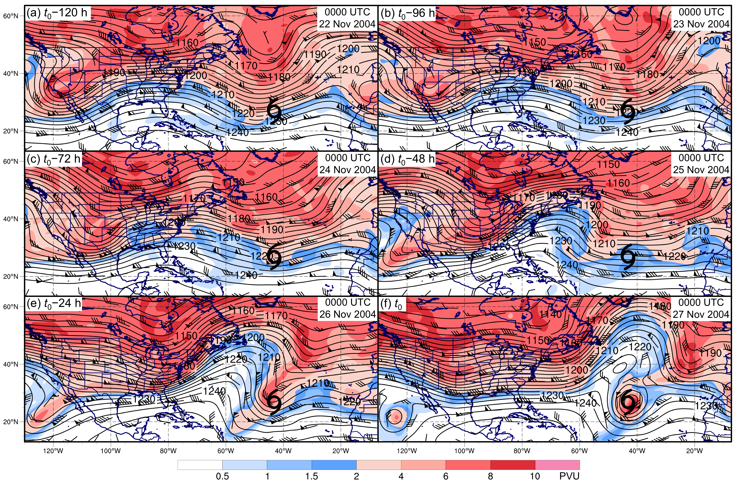

FIG. 1. Analyses showing 250–150-hPa layer-averaged PV (shaded according to color bar, PVU), geopotential height (black contours, every 5 dam), and winds (flags and barbs, kt) at (a) t₀ − 120 h, (b) t₀ − 96 h, (c) t₀ − 72 h, (d) t₀ − 48 h, (e) t₀ − 24 h, and (f) t₀ for an STC forming in association with a cutoff low [Otto (2004)]. The STC symbol in each panel denotes the location of STC formation at t₀.

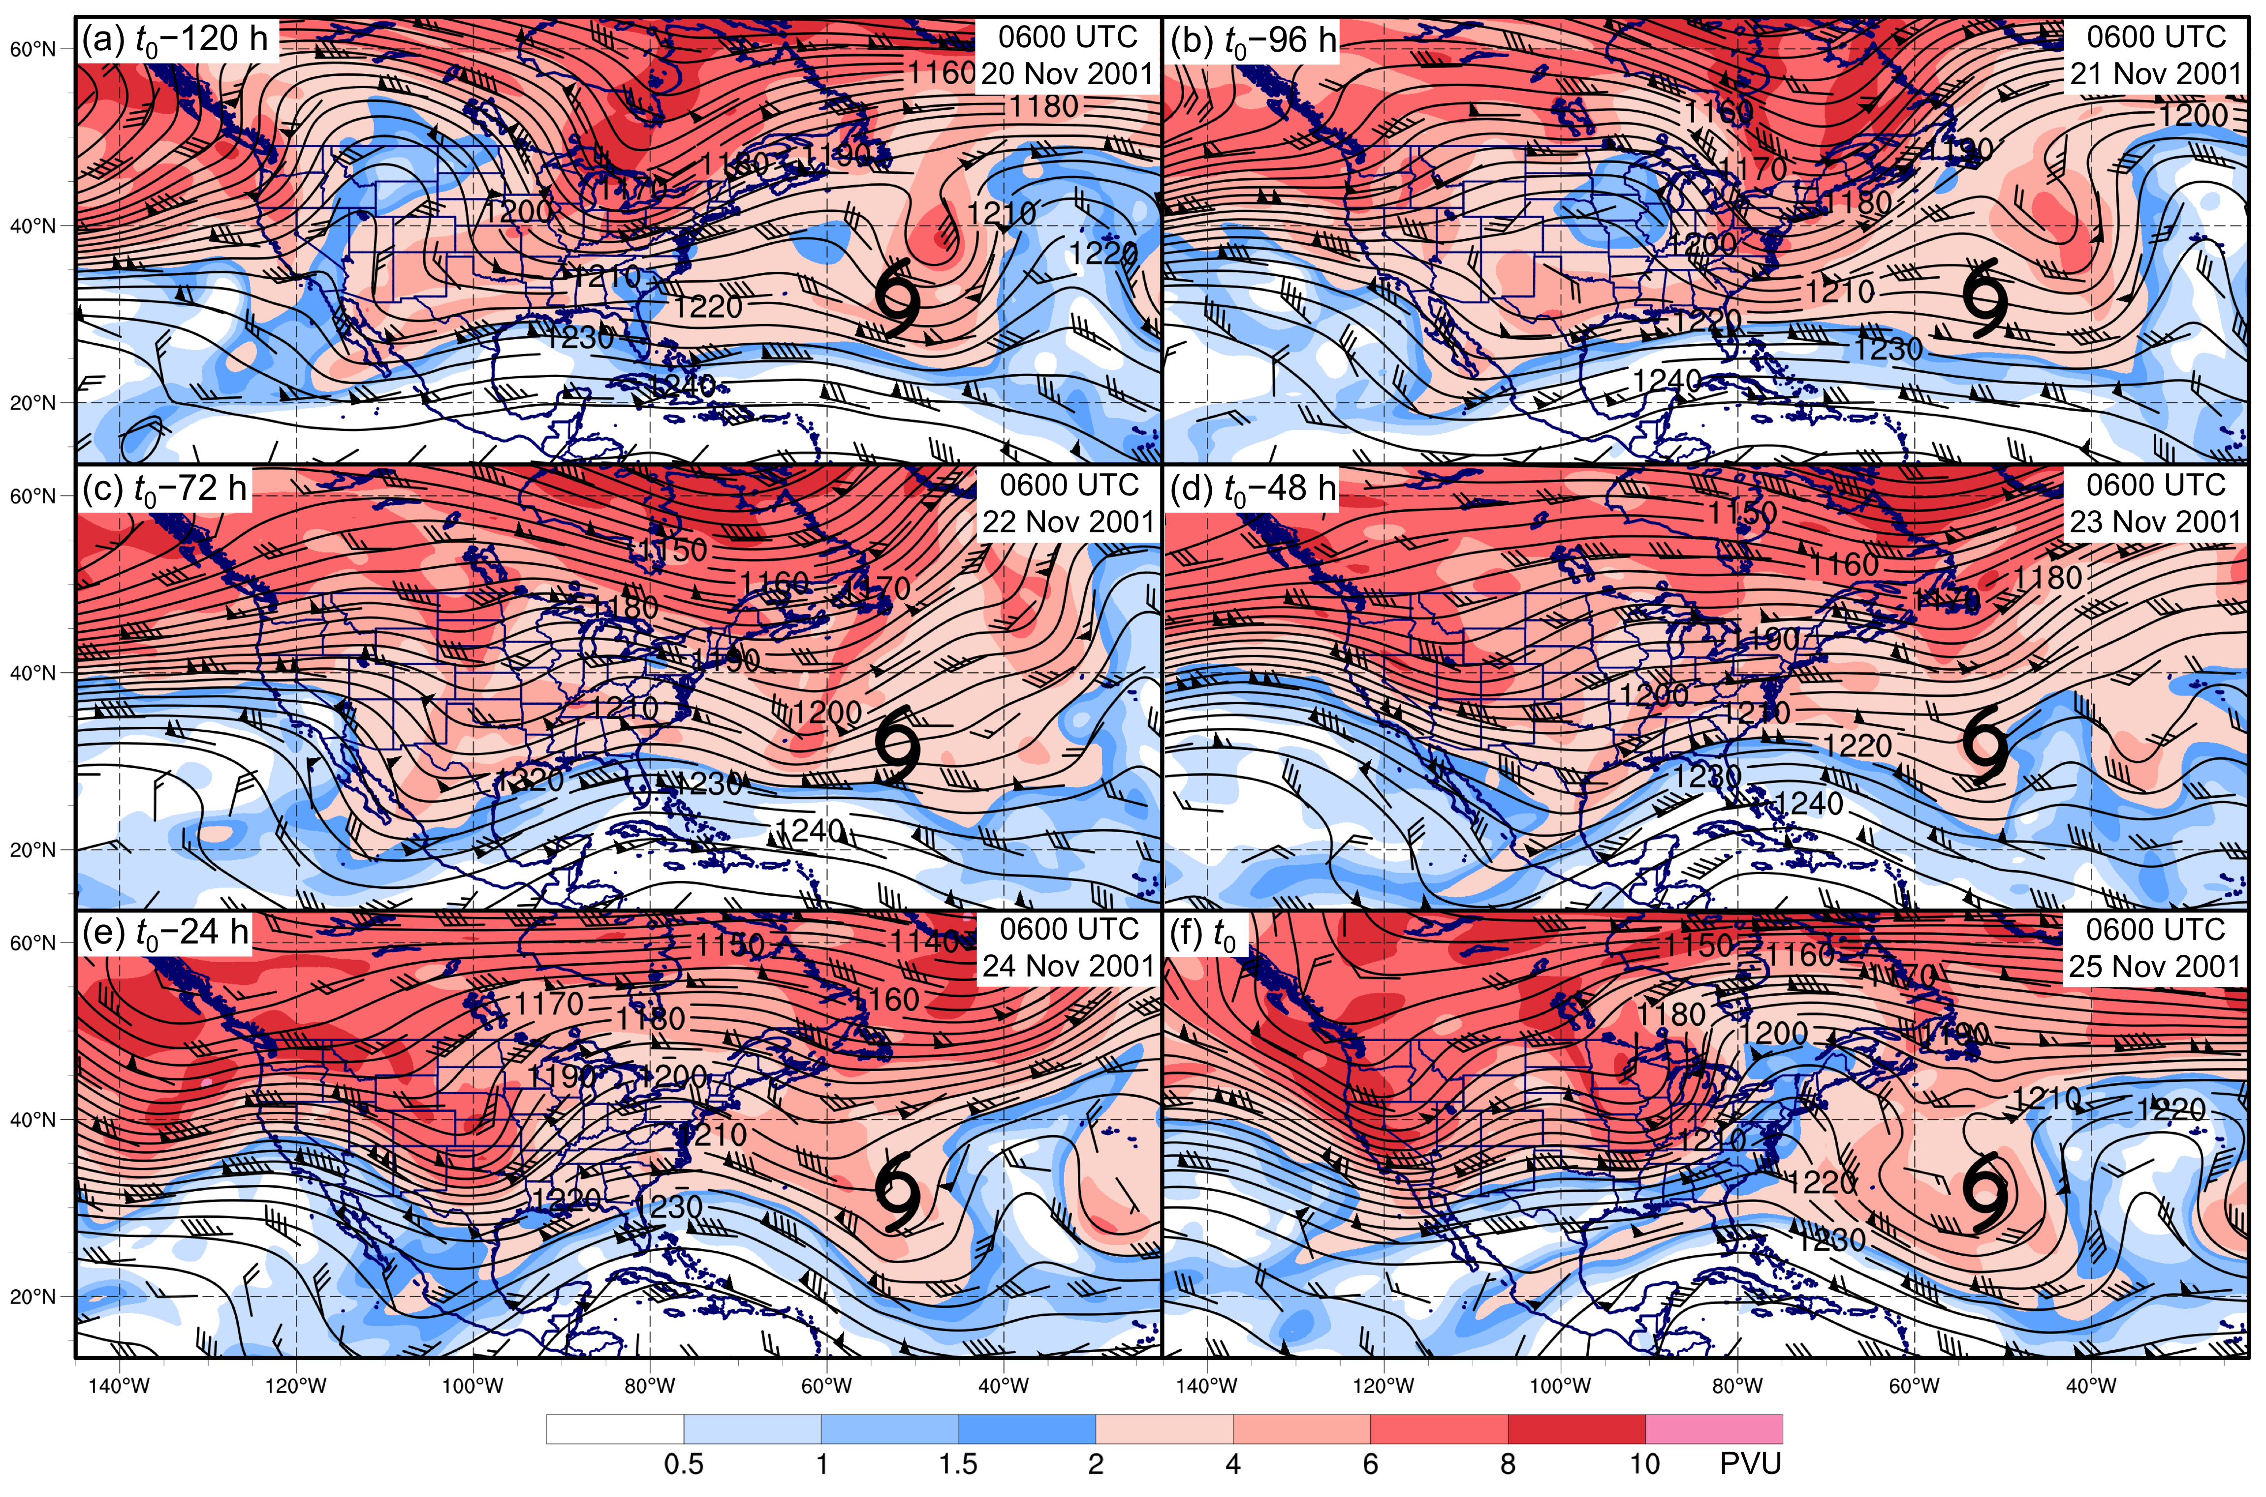

FIG. 2. As in Fig. 1, but for an STC forming in association with a meridional trough [Olga (2001)].

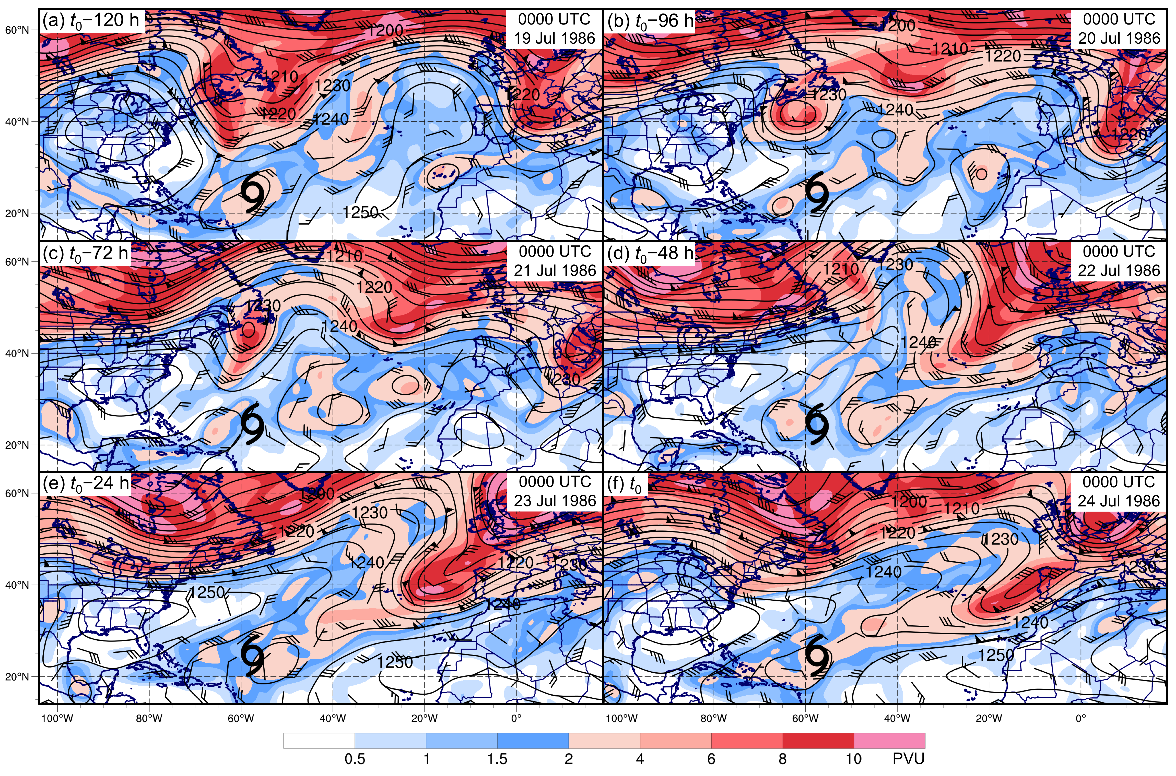

FIG. 3. As in Fig. 1, but for an STC forming in association with a zonal trough [Unnamed (1986)].

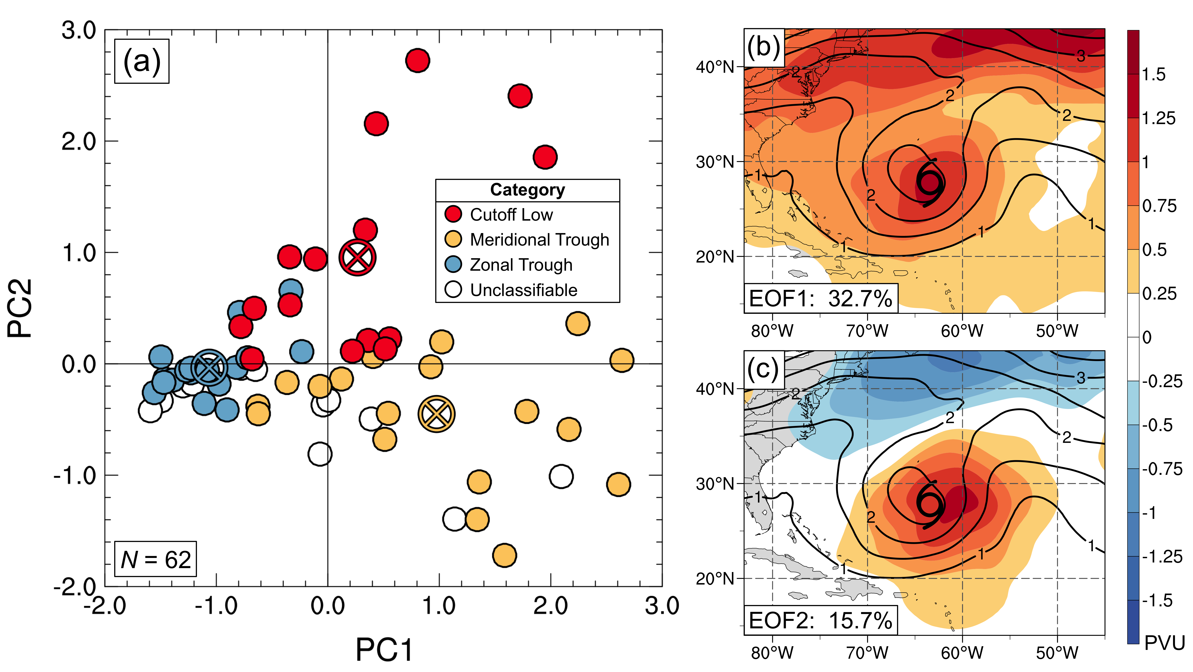

FIG. 4. Graphical representation of the results of an EOF analysis applied to all 250–150-hPa layer-averaged PV fields associated with STC formation at t₀. Panel (a) depicts the locations of STCs in a phase space defined by PC1 and PC2. The color of each dot represents the subjective categorization of each STC, according to the legend. An X enclosed by a circle denotes the mean values of PC1 and PC2 associated with STCs included in each subjectively constructed cluster, shaded according to the legend. Panels (b) and (c) depict the structure of EOF1 and EOF2, respectively (shaded according to color bar, PVU), as well as the mean value of 250–150-hPa layer-averaged PV at t₀ for all STCs (black contours, PVU). The percentage of the variance described by each EOF appears in the lower-left corner of panels (b) and (c).

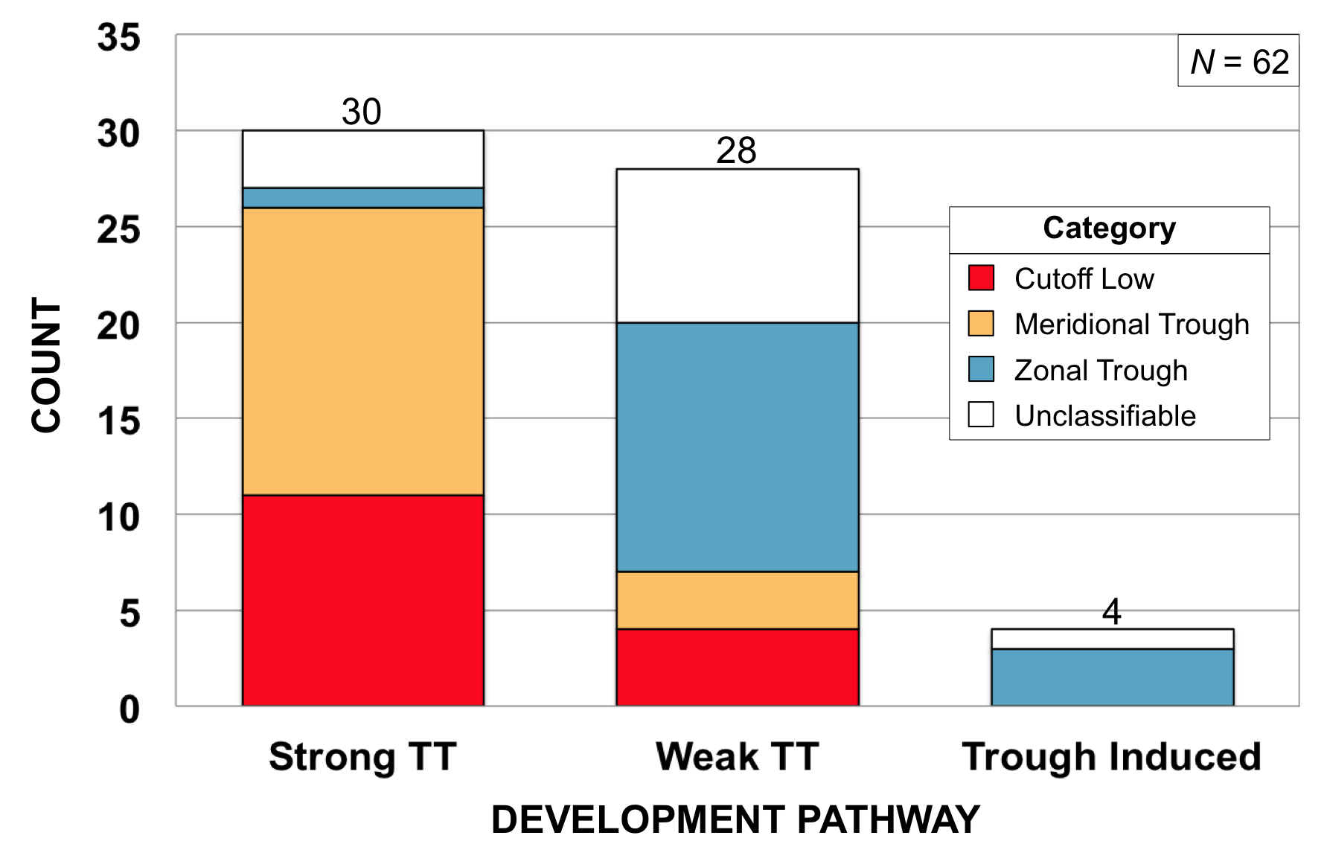

FIG. 5. Frequency distribution of STC formation in the NATL basin during 1979–2010 binned by McTaggart-Cowan et al. (2013) development pathway (strong TT, weak TT, trough induced). Colored regions represent the number of STCs forming in association with a particular upper-tropospheric feature, according to the legend.

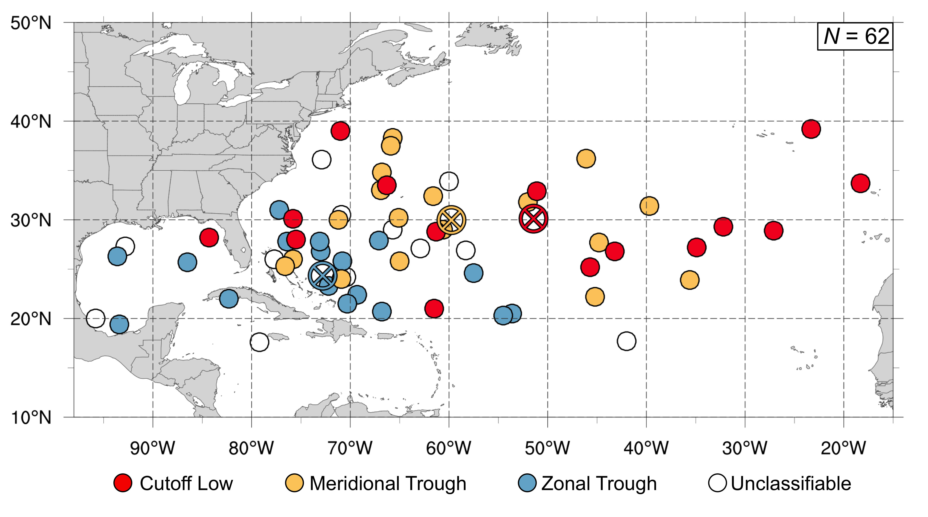
FIG. 6. Locations of STC formation in the NATL basin during 1979–2010. The color of each dot represents the upper-tropospheric feature associated with STC formation, according to the legend. An X enclosed by a circle denotes the mean location of STC formation for STCs developing in association with a particular upper-tropospheric feature, shaded according to the legend.

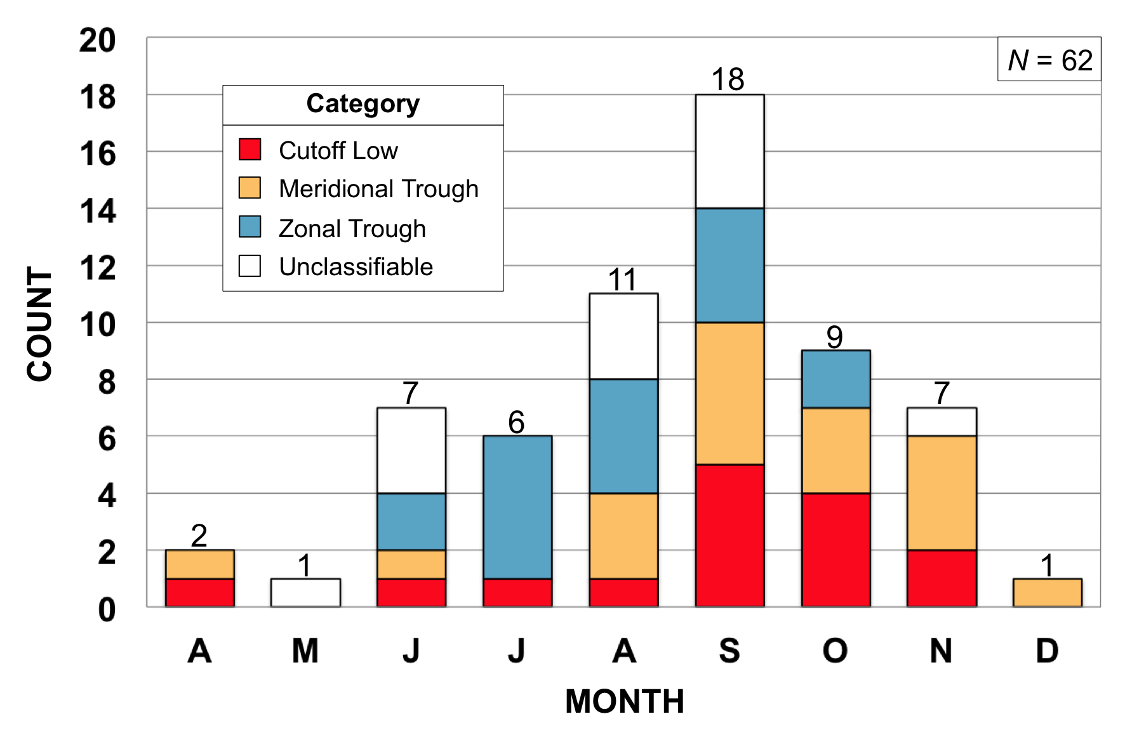
FIG. 7. Frequency distribution of STC formation in the NATL basin during 1979–2010 binned by month (April–December). Colored regions represent the number of STCs forming in association with a particular upper-tropospheric feature, according to the legend.

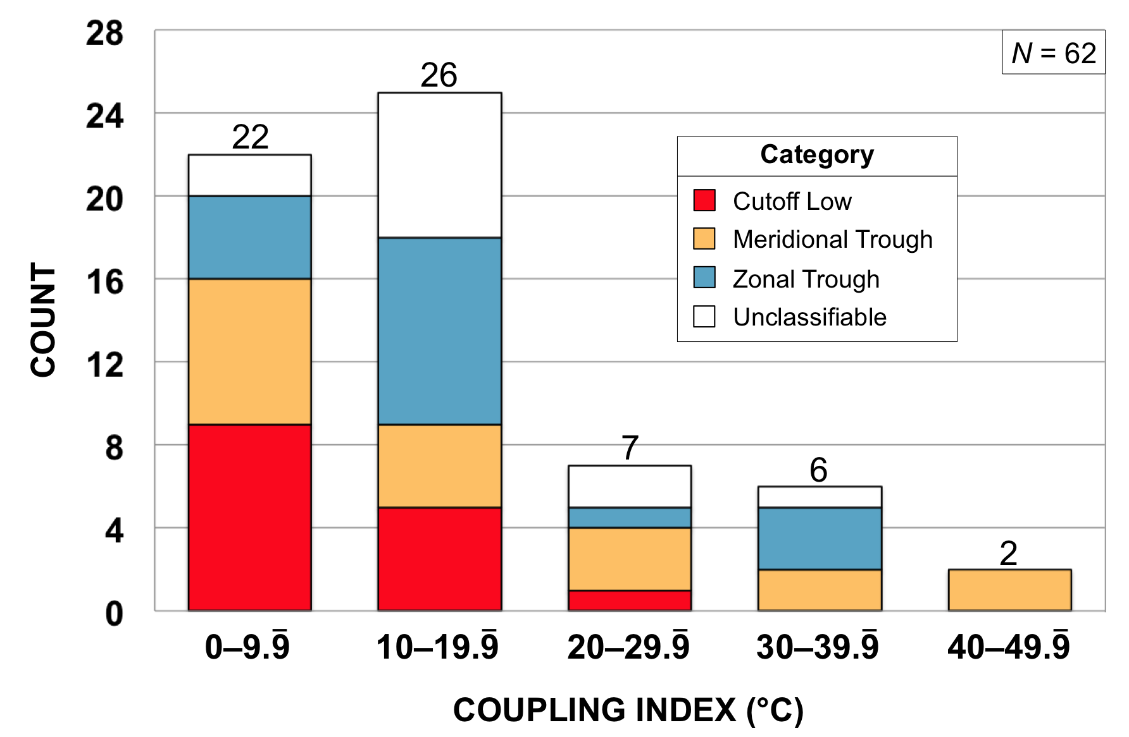

FIG. 8. Frequency distribution of STC formation in the NATL basin during 1979–2010 binned by CI (°C) at t₀. Colored regions represent the number of STCs forming in association with a particular upper-tropospheric feature, according to the legend.

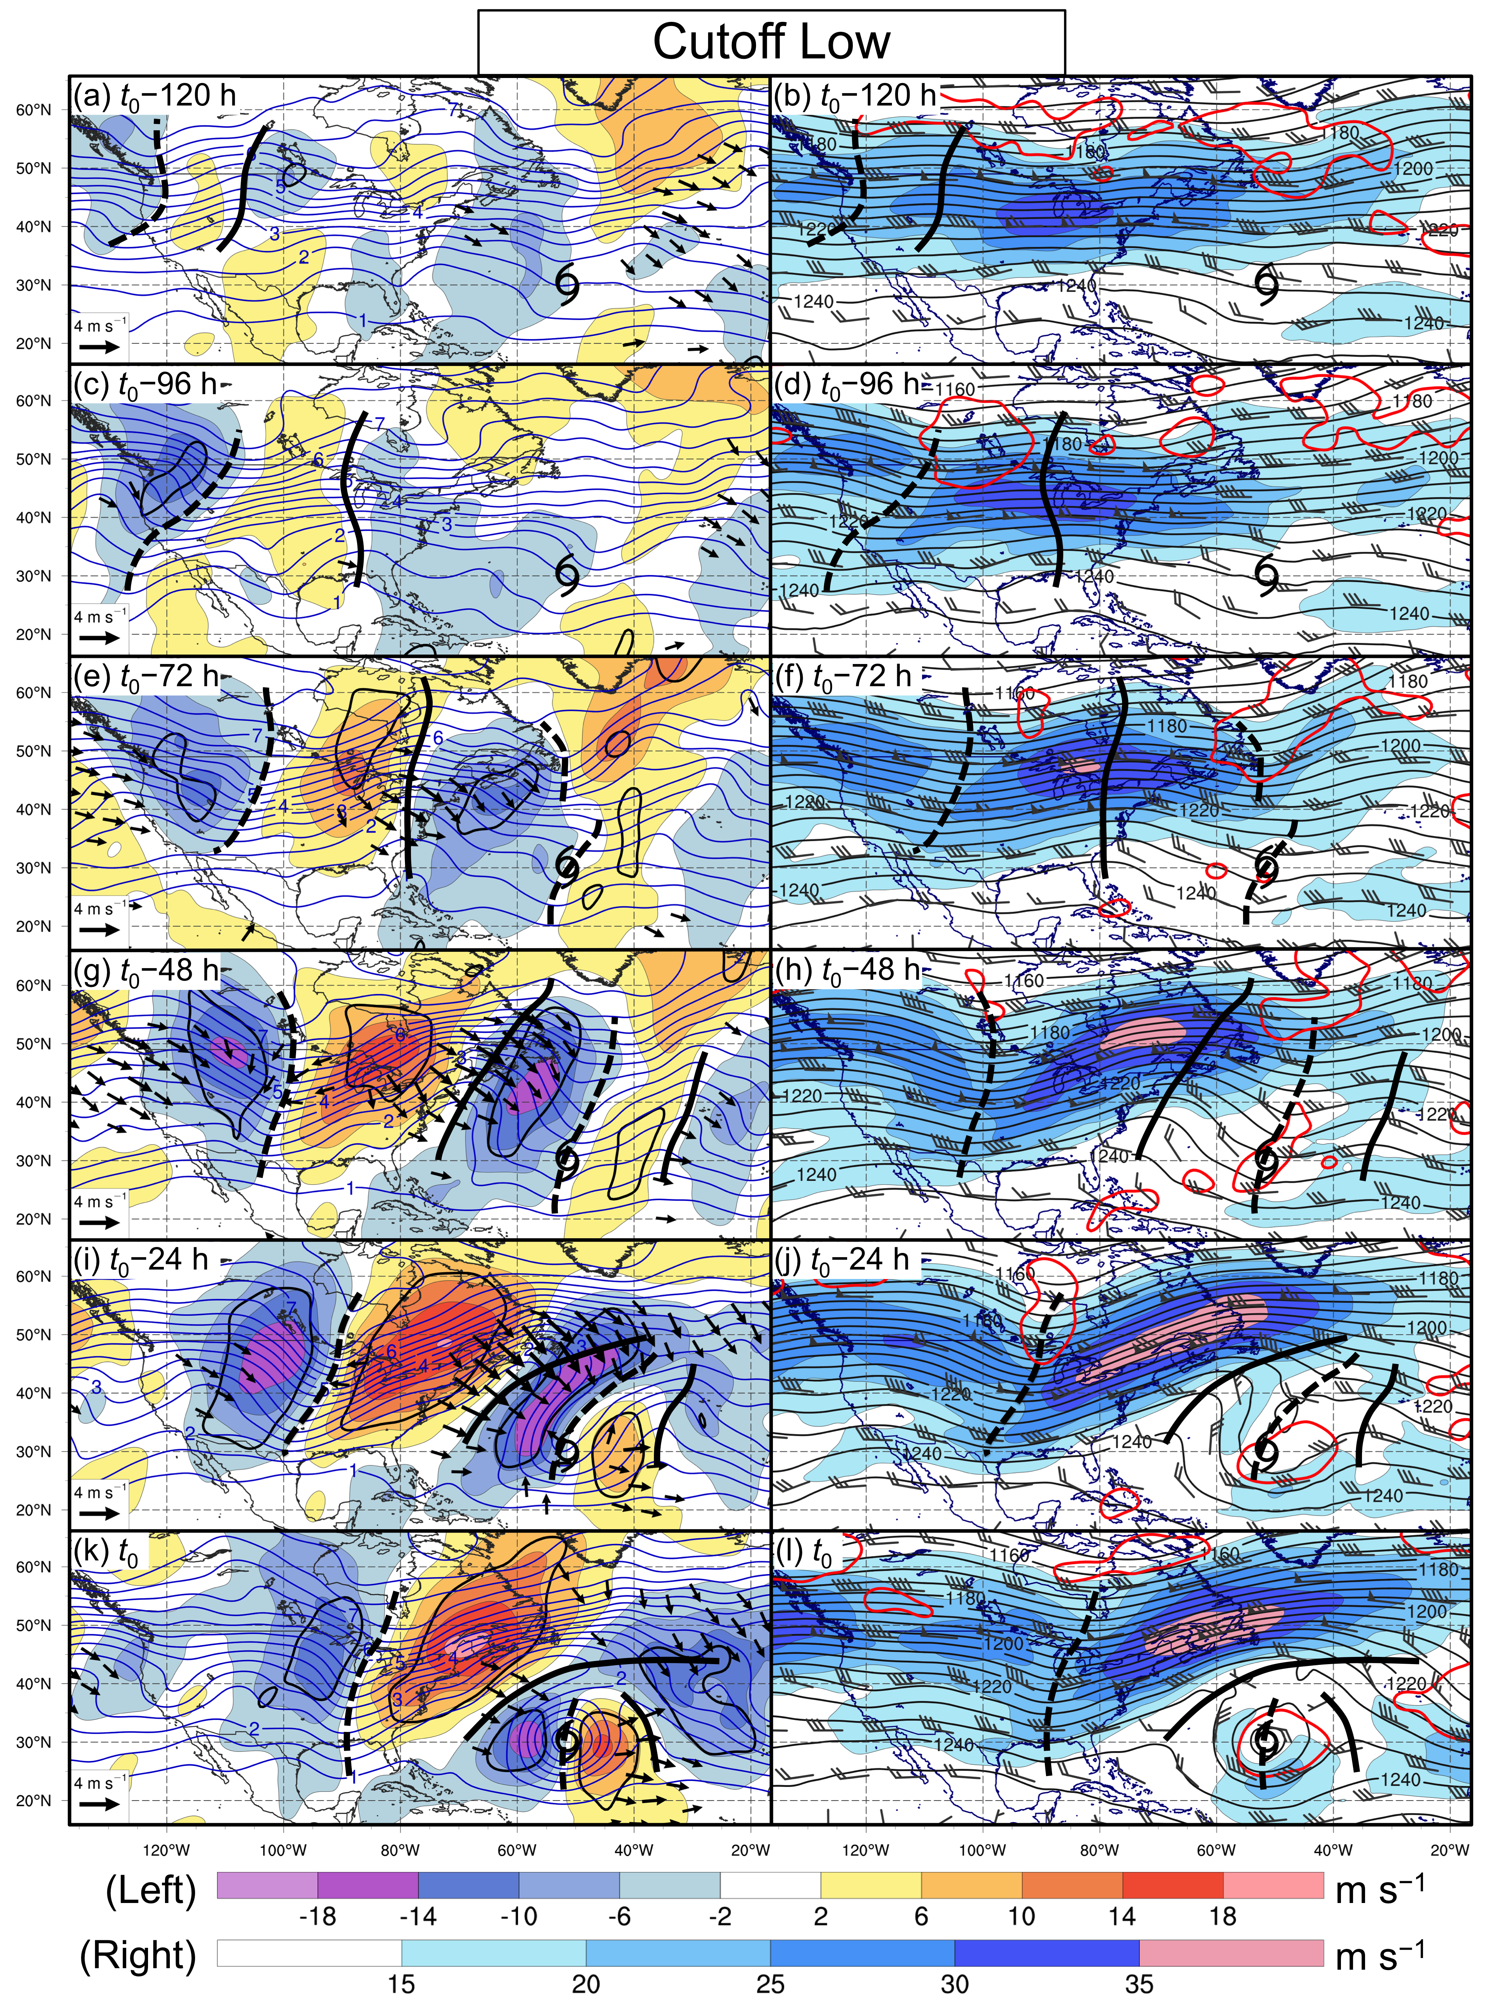
Figure 9
FIG. 9. Cyclone-relative composite analyses of the upper-tropospheric precursors to STCs forming in association with a cutoff low (N = 15). Analyses show 250–150-hPa layer-averaged PV (blue contours, every 0.5 PVU), irrotational wind (vectors, ≥1.5 m s⁻¹), and meridional wind (shaded according to the upper color bar, m s⁻¹; enclosed by black contours where significant at the 95% confidence level) at (a) t₀ − 120 h, (c) t₀ − 96 h, (e) t₀ − 72 h, (g) t₀ − 48 h, (i) t₀ − 24 h, and (k) t₀. Analyses also show 250–150-hPa layer-averaged geopotential height (gray contours, every 5 dam), wind (flags and barbs, kt), and wind speed (shaded according to the lower color bar, m s⁻¹), as well as CI (red contours, ≤22.5°C), at (b) t₀ − 120 h, (d) t₀ − 96 h, (f) t₀ − 72 h, (h) t₀ − 48 h, (j) t₀ − 24 h, and (l) t₀. The STC symbol in each panel denotes the composite location of STCs forming in association with a cutoff low at t₀. Thick solid and dashed black lines denote subjectively identified 250–150-hPa layer-averaged ridges and troughs, respectively.

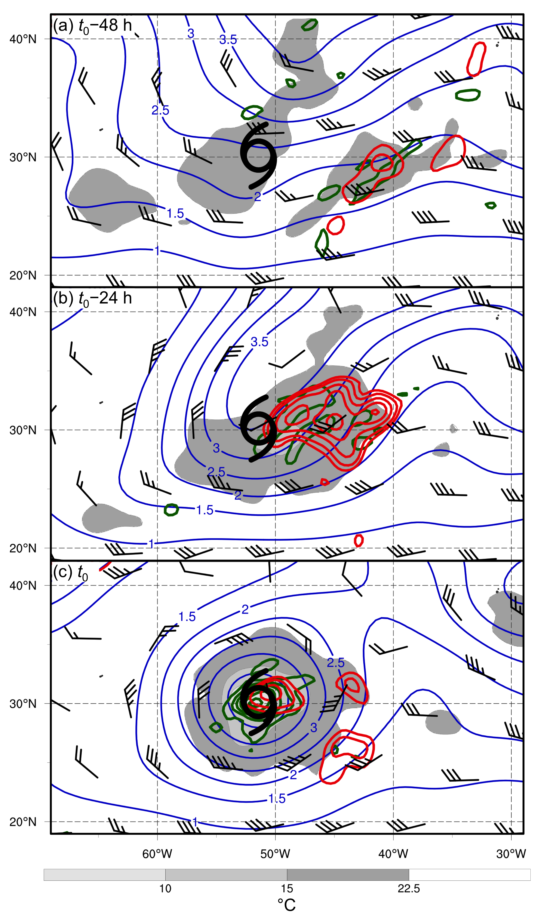

FIG. 10. Cyclone-relative composite analyses of the upper-tropospheric precursors to STCs forming in association with a cutoff low (N = 15). Analyses show 250–150-hPa layer-averaged PV (blue contours, every 0.5 PVU), 250–150-hPa layer-averaged wind (flags and barbs, kt), 600–400-hPa layer-averaged ascent (red contours, every 0.5 × 10⁻³ hPa s⁻¹ less than or equal to −1.0 × 10⁻³ hPa s⁻¹), and 925–850-hPa layer-averaged relative vorticity (green contours, every 2.5 × 10⁻⁵ s⁻¹) at (a) t₀ − 48 h, (b) t₀ − 24 h, and (c) t₀. The STC symbol in each panel denotes the composite location of STCs forming in association with a meridional trough at t₀.

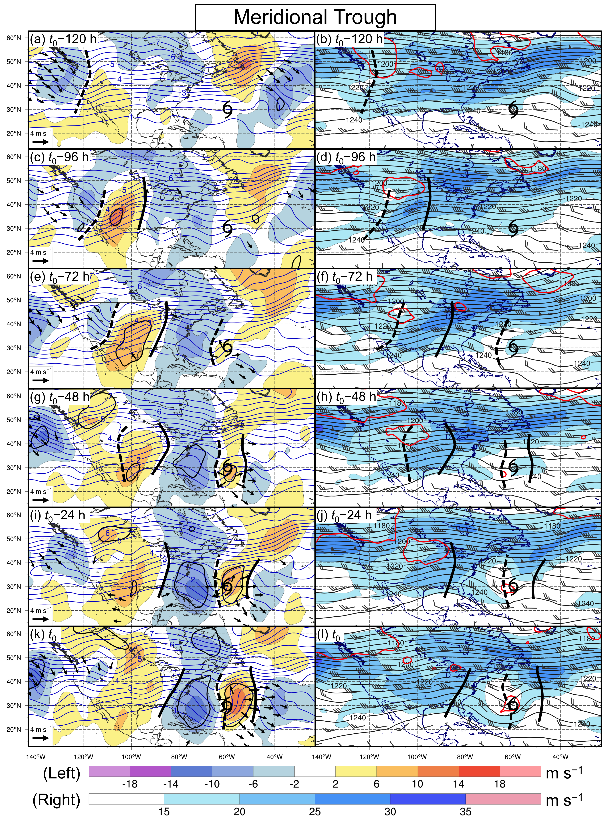FIG. 11. As in Fig. 9, but for STCs forming in association with a meridional trough (N = 18).
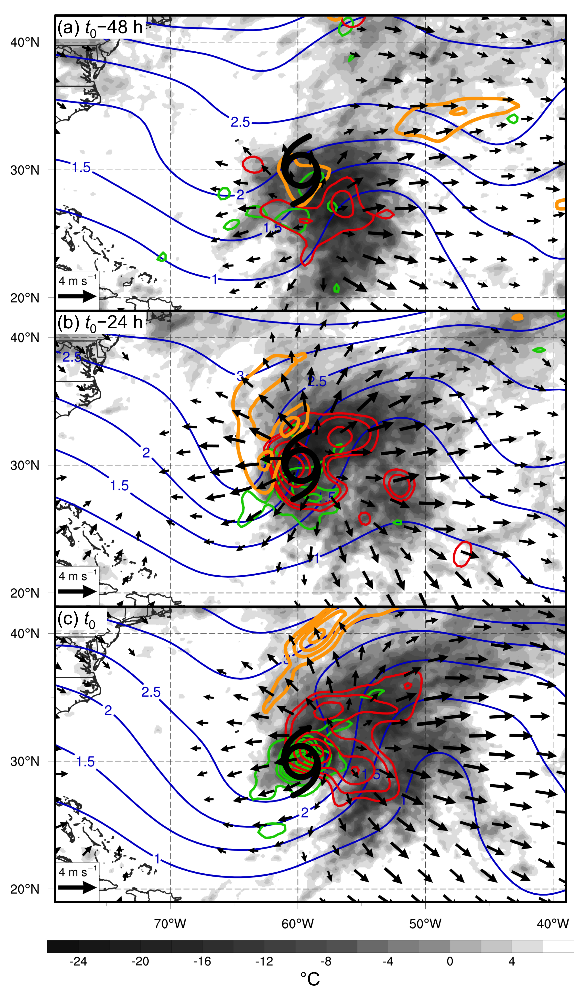

FIG. 12. Cyclone-relative composite analyses of the upper-tropospheric precursors to STCs forming in association with a meridional trough (N = 18). Analyses show 250–150-hPa layer-averaged PV (blue contours, every 0.5 PVU), 250–150-hPa layer-averaged irrotational wind (vectors, ≥1 m s⁻¹), 250–150-hPa layer-averaged negative PV advection by the irrotational wind (orange contours, every 0.5 PVU day⁻¹ starting at −1.0 PVU day⁻¹), 600–400-hPa layer-averaged ascent (red contours, every 0.5 × 10⁻³ hPa s⁻¹ less than or equal to −1.0 × 10⁻³ hPa s⁻¹), 925–850-hPa layer-averaged relative vorticity (green contours, every 0.25 × 10⁻⁴ s⁻¹), and IR brightness temperature (shaded according to grayscale, °C) at (a) t₀ − 48 h, (b) t₀ − 24 h, and (c) t₀. The STC symbol in each panel denotes the composite location of STCs forming in association with a meridional trough at t₀.
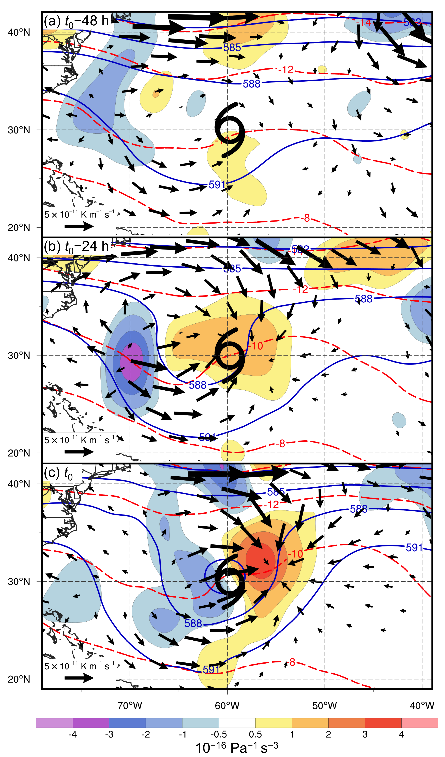

FIG. 13. Cyclone-relative composite analyses of the upper-tropospheric precursors to STCs forming in association with a meridional trough (N = 18). Analyses show 600–400-hPa layer-averaged geopotential height (blue contours, every 3 dam), temperature (red dashed contours, every 2°C), Q (vectors, ≥1 × 10⁻¹¹ K m⁻¹ s⁻¹), and Q-vector forcing for vertical motion (shaded according to color bar, 10⁻¹⁶ Pa⁻¹ s⁻³) at (a) t₀ − 48 h, (b) t₀ − 24 h, and (c) t₀. The STC symbol in each panel denotes the composite location of STCs forming in association with a meridional trough at t₀.

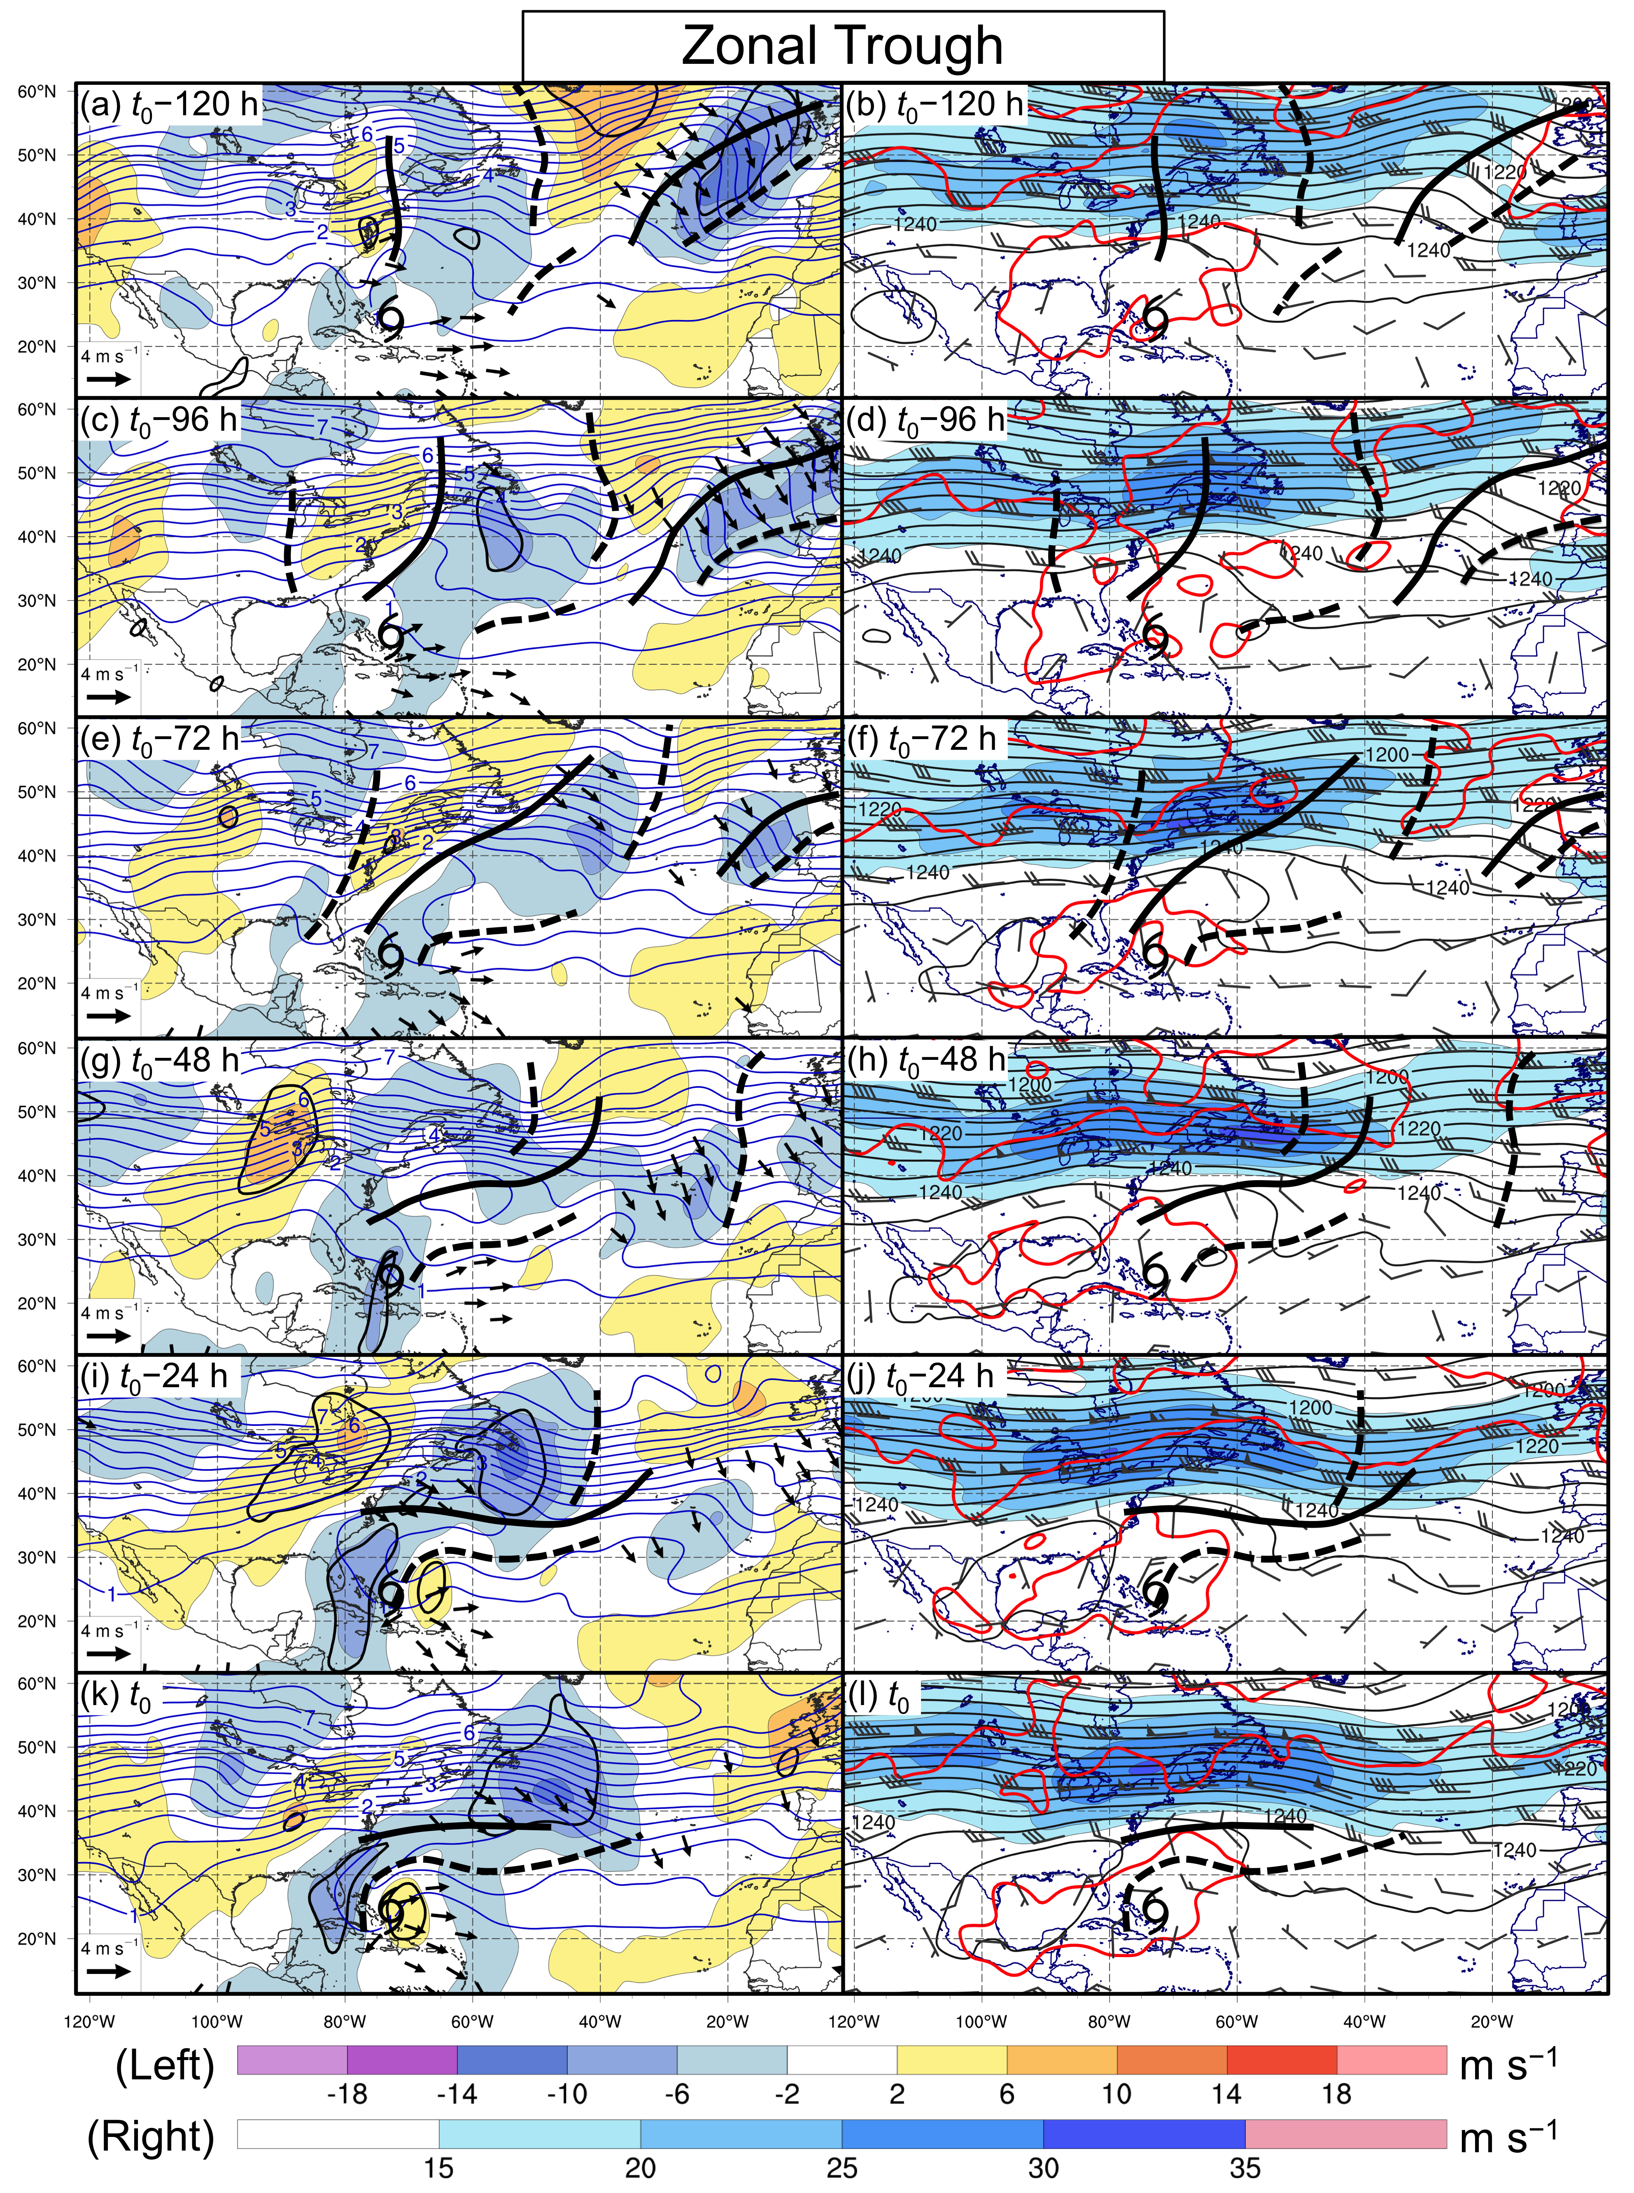
FIG. 14. As in Fig. 9, but for STCs forming in association with a zonal trough (N = 17).
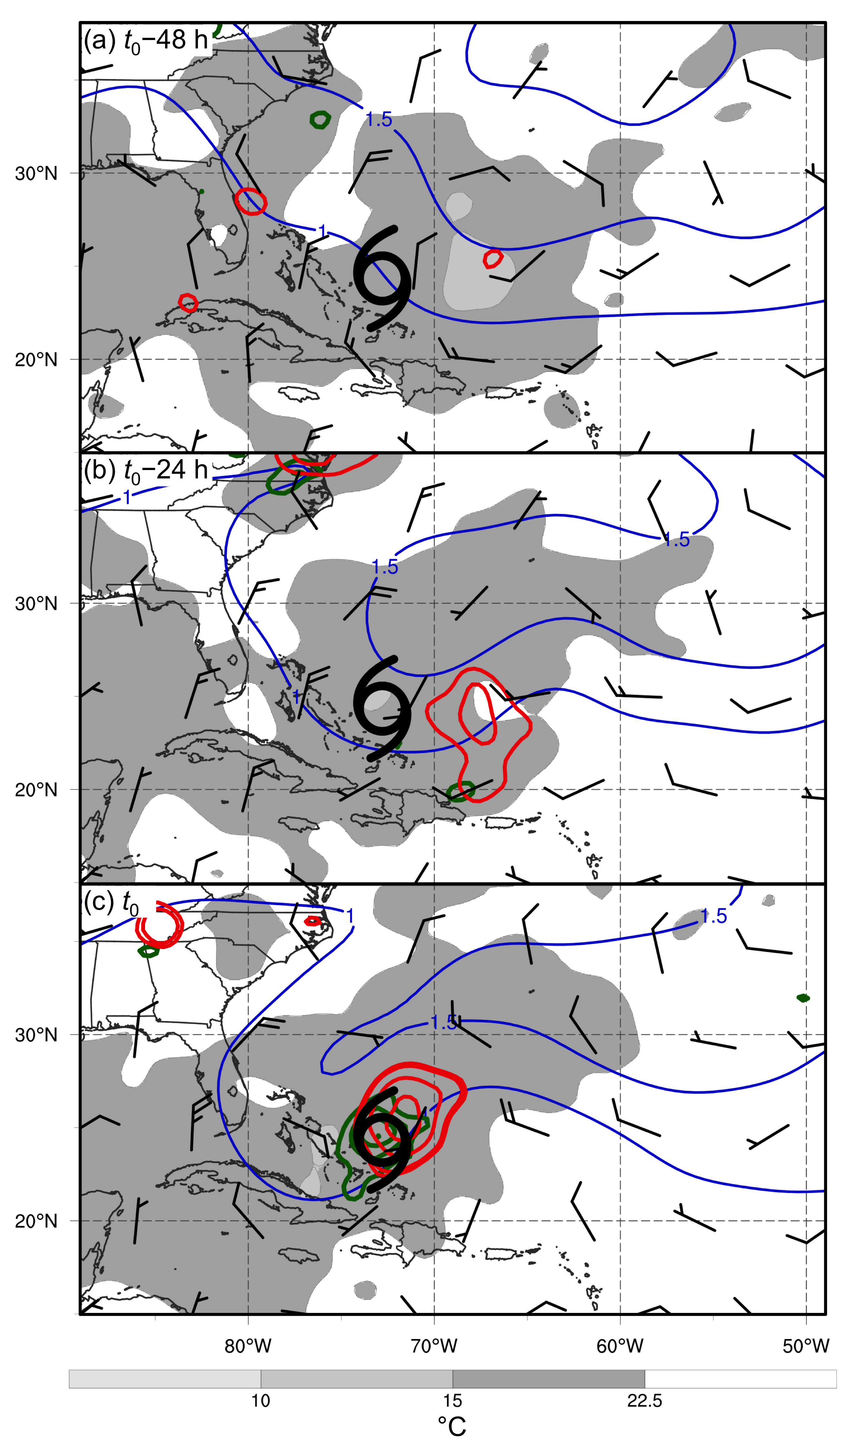

FIG. 15. As in Fig. 10, but for STCs forming in association with a zonal trough (N = 17).

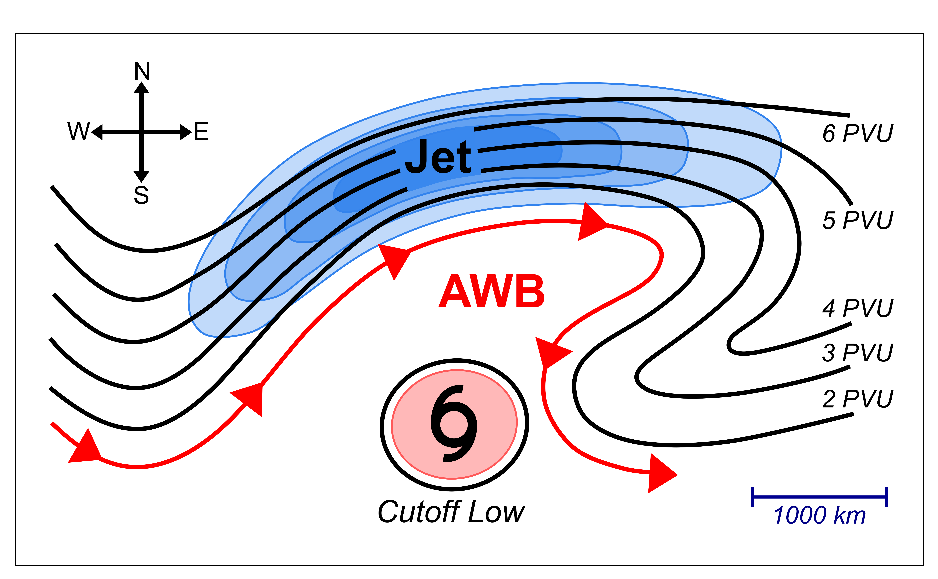
FIG. 16. Schematic representation of an STC forming in association with a cutoff low. Black contours depict selected PVU contours in the 250–150-hPa layer-averaged PV field. Red arrows depict a selected streamline of the 250–150-hPa layer-averaged flow. The blue-shaded region indicates the location of a 250–150-hPa layer-averaged jet. The pink-shaded region indicates the location of CI values ≤ 22.5°C. The “AWB” label denotes a region where anticyclonic wave breaking is occurring.

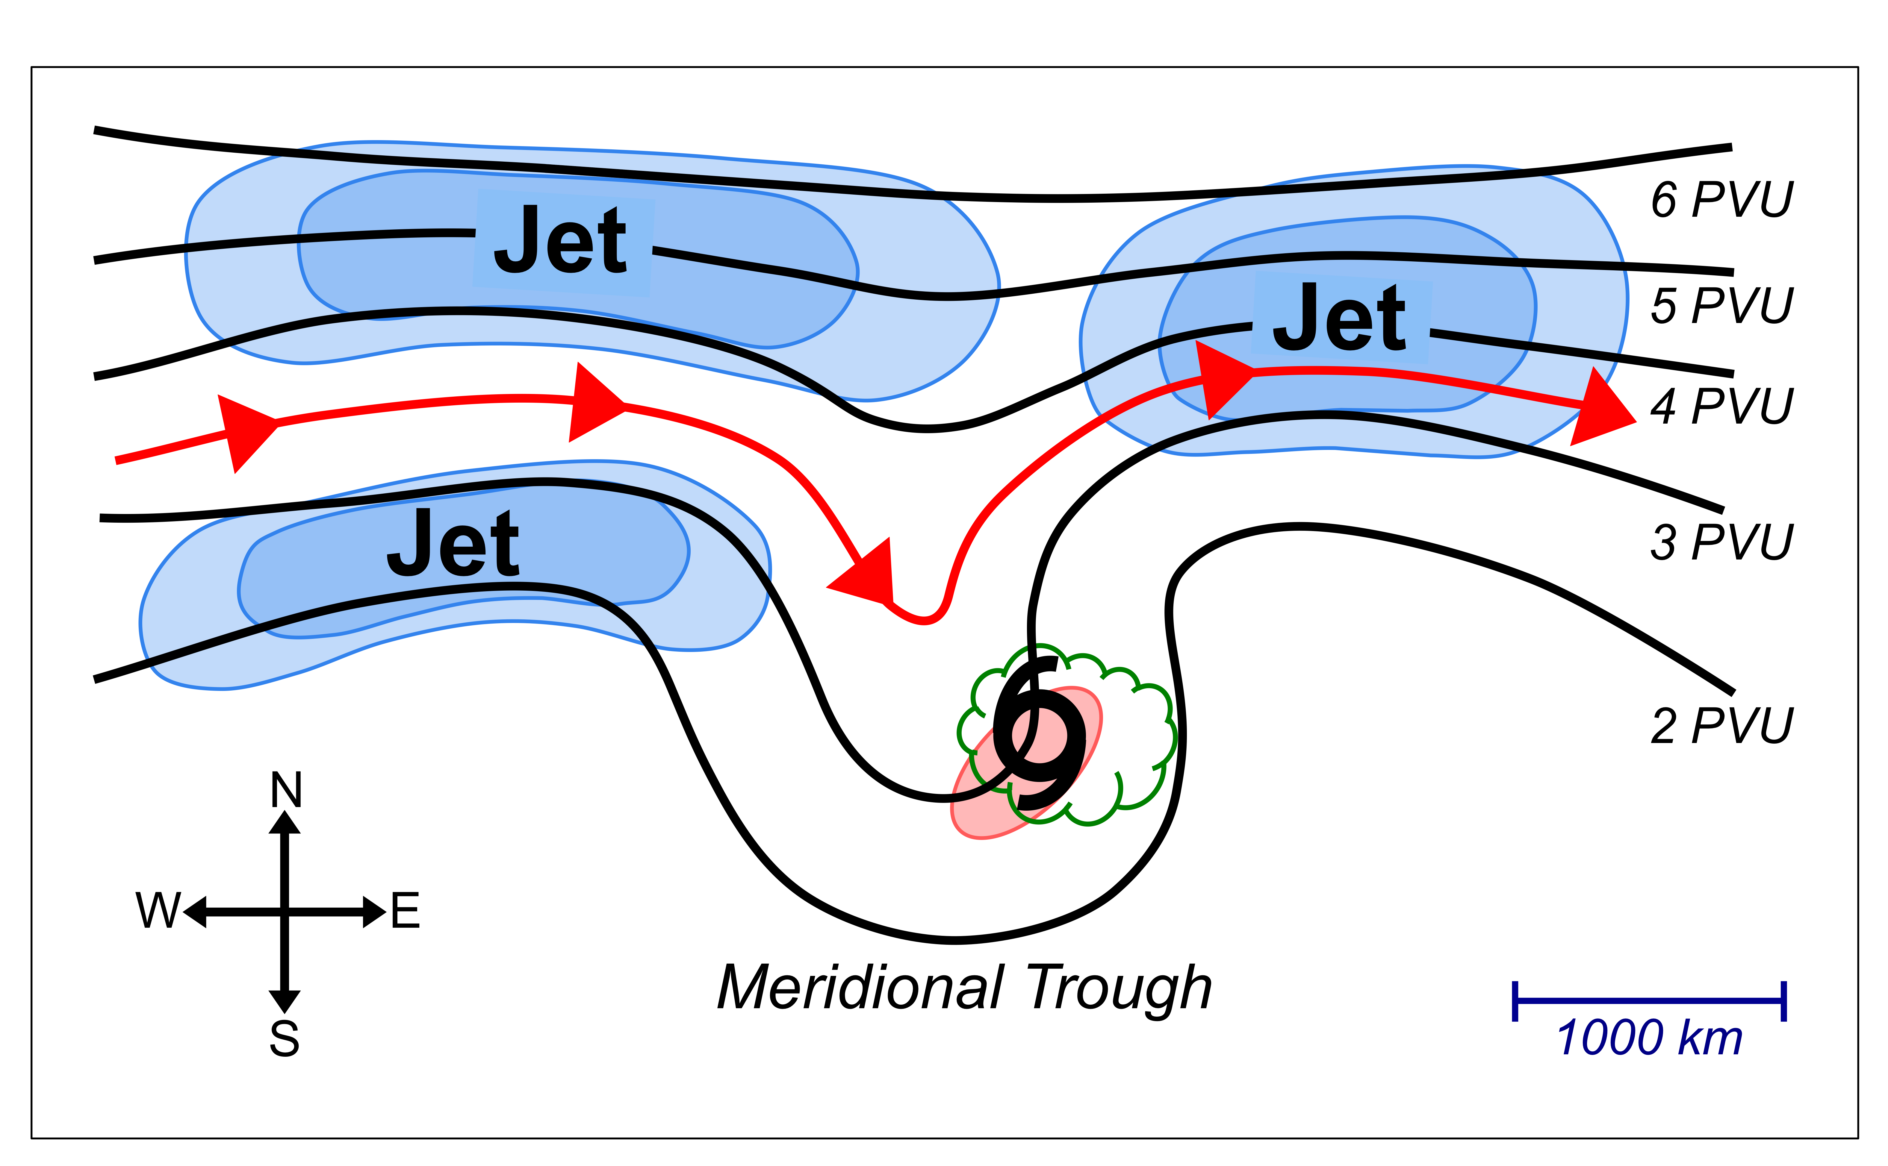
FIG. 17. Schematic representation of an STC forming in association with a meridional trough. Black contours depict selected PVU contours in the 250–150-hPa layer-averaged PV field. Red arrows depict a selected streamline of the 250–150-hPa layer-averaged flow. The blue-shaded region indicates the location of a 250–150-hPa layer-averaged jet. The pink-shaded region indicates the location of CI values ≤ 22.5°C. The green-scalloped contour surrounds a region of 600–400-hPa layer-averaged QG forcing for ascent.

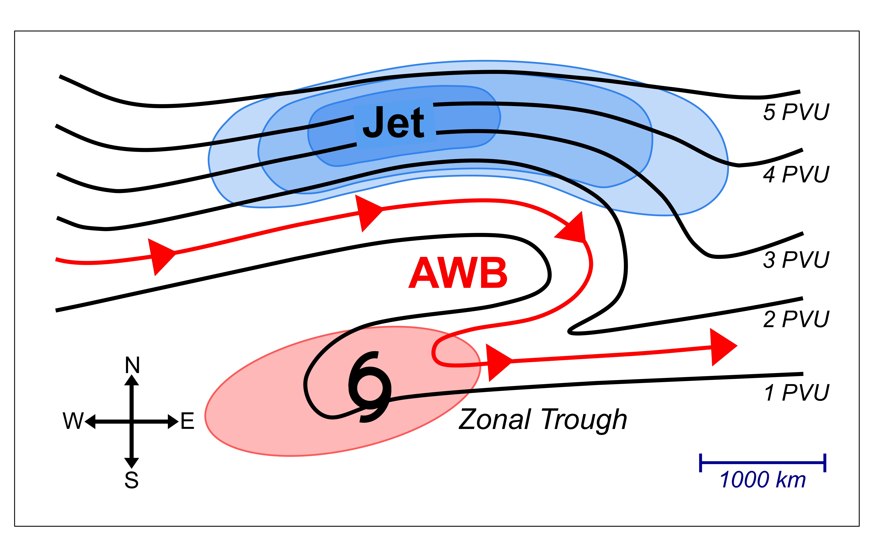
FIG. 18. As in Fig. 16, but for an STC forming in association with a zonal trough.

Corresponding author address: Alicia M. Bentley, Department of Atmospheric and Environmental Sciences, University at Albany, State University of New York, ES-234, 1400 Washington Ave., Albany, NY 12222. Email: ambentley@albany.edu

