The dominant upper-tropospheric structures associated with the formation of NATL STCs included in each subjectively constructed category are isolated and examined objectively using an empirical orthogonal function (EOF) analysis (e.g., Richman 1986) applied to all 250–150-hPa layer-averaged PV fields associated with NATL STC formation at *t*0. In order to proceed with the EOF analysis, all 250–150-hPa layer-averaged PV fields are shifted so that the location of STC formation is collocated with the mean location of STC formation (27.8°N, 63.4°W). Principal components (PCs) computed from the EOF analysis are defined based on the projection of individual 250–150-hPa layer-averaged PV fields on the EOFs. NATL STCs with similar PCs are associated with similar patterns of 250–150-hPa layer-averaged PV at *t*0, and would ideally be included in the same subjectively constructed category.

Figure 4a depicts the relationship between the subjective categorization of NATL STCs that undergo TT and the location of each STC in a phase space defined by the first and second PCs of the EOF analysis (i.e., PC1 and PC2). Figure 4a illustrates that STCs included in the same subjectively constructed category are located in similar regions of the PC1–PC2 phase space, suggesting that the structures of subjectively identified upper-tropospheric features associated with NATL STC formation within the same category are similar at *t*0. Figures 4b,c, which depict the structure of the first and second EOFs (i.e., EOF1 and EOF2) in the domain within which the EOF analysis is performed, reveal the dominant upper-tropospheric structures associated with the formation of NATL STCs that undergo TT. EOF1 describes the overall magnitude of the individual 250–150-hPa layer-averaged PV fields included in the EOF analysis, with positive values of EOF1 spanning the majority of the domain. Higher values of PC1 are associated with overall higher values of 250–150-hPa layer-averaged PV, whereas lower values of PC1 are associated with overall lower values of 250–150-hPa layer-averaged PV. The structure of the 250–150-hPa layer-averaged PV field associated with higher values of PC1 is consistent with NATL STCs forming at relatively high latitudes in association with relatively high values of 250–150-hPa layer-averaged PV. The structure of the 250–150-hPa layer-averaged PV field associated with lower values of PC1 is consistent with NATL STCs forming at relatively low latitudes in association with relatively low values of 250–150-hPa layer-averaged PV.

EOF2 describes an asymmetric dipole in the individual 250–150-hPa layer-averaged PV fields, with negative EOF2 values to the north of the location of STC formation and positive EOF2 values over and to the east of the location of STC formation. Higher values of PC2 are associated with lower values of 250–150-hPa layer-averaged PV to the north of the location of STC formation and higher values of 250–150-hPa layer-averaged PV over and to the east of the location of STC formation. Lower values of PC2 are associated with higher values of 250–150-hPa layer-averaged PV to the north of the location of STC formation and lower values of 250–150-hPa layer-averaged PV over and to the east of the location of STC formation. The structure of the 250–150-hPa layer-averaged PV field associated with higher values of PC2 is consistent with the signature of AWB occurring to the north of the location of STC formation, which manifests itself as a reversal in the sign of the upper-tropospheric meridional PV gradient (e.g., Postel and Hitchman 1999; Zhang et al. 2016). The structure of the 250–150-hPa layer-averaged PV field associated with lower values of PC2 is consistent with the absence of AWB occurring to the north of the location of STC formation.

Figure 4a reveals that STCs forming in association with cutoff lows and meridional troughs are associated with higher values of PC1, or overall higher values of 250–150-hPa layer-averaged PV, compared with STCs forming in association with zonal troughs. This result is consistent with the findings of the subjective categorization of NATL STCs that undergo TT, which indicate that cutoff lows and meridional troughs typically develop poleward of ~25°N in association with relatively high values of 250–150-hPa layer-averaged PV. Figure 4a also reveals that STCs forming in association with cutoff lows and zonal troughs are associated with higher values of PC2, or lower values of 250–150-hPa layer-averaged PV to the north of the location of STC formation and higher values of 250–150-hPa layer-averaged PV over and to the east of the location of STC formation, compared with STCs forming in association with meridional troughs. This result is also consistent with the findings of the subjective categorization of NATL STCs that undergo TT, which indicate that cutoff lows and zonal troughs develop in response to AWB occurring to the north of the location of STC formation.

Two small regions of overlap between STCs included in different subjectively constructed categories exist in the PC1–PC2 phase space (Fig. 4a), indicating that these STCs may be associated with similar patterns of 250–150-hPa layer-averaged PV at *t*0. For example, four STCs included in the cutoff low category overlap with STCs included in the zonal trough category in Fig. 4a. This overlap may be explained by considering that the upper-tropospheric features included in both categories develop in association with AWB occurring to the north of the location of STC formation, and that the dominant upper-tropospheric structures associated with the formation of NATL STCs included in both categories may be similar at *t*0. Despite their overlap, the four STCs forming in association with cutoff lows are considered separate from STCs forming in association with zonal troughs due to the distinct evolution of these upper-tropospheric features between *t*0 − 120 h and *t*0 that cannot be captured by the EOF analysis applied exclusively at *t*0. The same justification can be used to explain the separation of STCs forming in association with cutoff lows and meridional troughs into different subjectively constructed categories, despite a small region of overlap in the PC1–PC2 phase space (Fig. 4a).

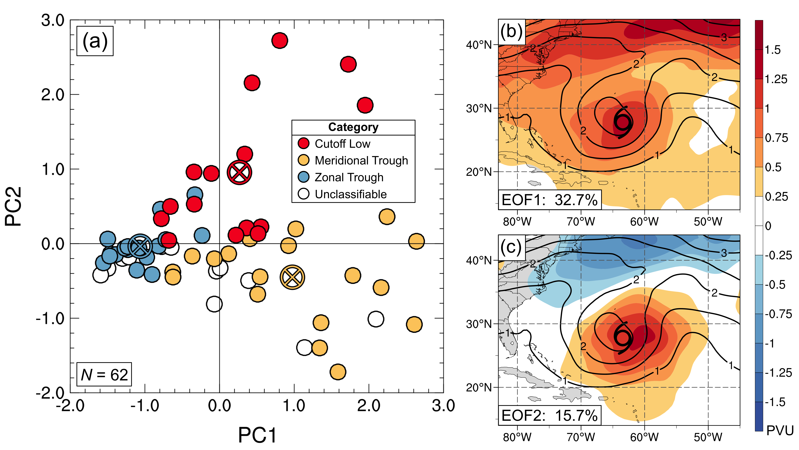

FIG. 4. Graphical representation of the results of an EOF analysis applied to all 250–150-hPa layer-averaged PV fields associated with STC formation at *t*0. Panel (a) depicts the locations of STCs in a phase space defined by PC1 and PC2. The color of each dot represents the subjective categorization of each STC, according to the legend. An X enclosed by a circle denotes the mean values of PC1 and PC2 associated with STCs included in each subjectively constructed cluster, shaded according to the legend. Panels (b) and (c) depict the structure of EOF1 and EOF2, respectively (shaded according to color bar, PVU), as well as the mean value of 250–150-hPa layer-averaged PV at *t*0 for all STCs (black contours, PVU). The percentage of the variance described by each EOF appears in the lower-left corner of panels (b) and (c).