**MWR-D-16-0263 | Bentley et al., Response to Reviewer 1**

The authors thank Reviewer 1 for their thoughtful and thorough review. We have incorporated your recommendations as described below. We have also listed (where appropriate) the sections(s)/line(s) where each change is located in the revised manuscript.

**General comments:**  
This study examines the formation of subtropical cyclones (STC) over the Atlantic. Different from previous studies, the present study focuses on STCs that undergo tropical transition, and STCs are categorized for different types of upper-level disturbances: cutoff lows, meridional troughs, zonal troughs and subtropical disturbances. The former two categories have higher upper-level PV values than the latter two and contribute to the strong tropical-transition pathway. The manuscript is well written, and the diagnoses provide an overall clear picture and help to better understand the evolution of STCs.   
   
1. Categorization of different upper-level features makes sense to me. However, the categorization is rather subjective. In particular, it is not clear how the subtropical disturbance category is defined and how it is distinguished from the others. In fact, it seems reasonable to me to combine it with the zonal trough category as i) both are related to AWB; ii) both have relative weak upper-level PV features; iii) the temporal evolutions are similar; iv) the forcing mechanisms as shown in the schematic are similar. v) they cluster together in the EOF phase space.

The reviewer makes an excellent point. Based on the reviewer’s comments, the upper-tropospheric features associated with the formation of NATL STCs that undergo TT were reexamined. This reexamination resulted in the removal of the subtropical disturbance category from the present study. The majority of STCs included in the subtropical disturbance category were re-categorized as zonal troughs. The cutoff low and meridional trough categories are essentially unchanged. Please see responses to the reviewer’s specific points (below) for more information.

2. The mechanisms for the STC formation in the meridional trough category are illustrated nicely through examination of the Q-vector and forced ascent. The other categories, however, lack in-depth analysis. Besides the reduction of the troposphere stability, it is not clear how the upper-level disturbances lead to the development of the low-level cyclonic circulation. Does it result from interaction between the upper-level and low-level disturbances, or the upper-level PV is strong and deep enough to enhance the circulation directly?

Based on the reviewer’s comments, two new 3-panel images (similar to the 3-panel images used to examine the meridional trough category) were created. These new figures reveal that upper-tropospheric disturbances in the cutoff low and zonal trough categories lead to the formation of lower-tropospheric cyclonic circulations directly, and that STC formation in these categories does not result from the favorable interaction of an upper-tropospheric disturbance and a preexisting lower-tropospheric system.   
  
3. The present study differs from previous ones by focusing on STCs that undergo TT during their life cycle. It is desirable to discuss what differences this implies for the STC evolution.

While the evolution of STCs that do and do not undergo TT is interesting, these topics are outside the scope of the present study (which focuses specifically on the time of and precursors to STC formation). Future work could certainly address various aspects of the evolution of STCs that do and do not undergo TT, relating back to the potential vorticity (PV) metrics included in the climatological study of Bentley et al. (2016).

Specific points:  
Fig. 1 and discussion on P7: Fig. 1 shows nice illustrations for each type of upper-level disturbance. However, it is not clear to me how to distinguish each type. The categorization of the subtropical disturbance type is particularly vague. For example, the zonal trough one seems quite similar to the cutoff low, except that the former is weaker. The flow pattern shown for Josephine is also similar to the unnamed storm shown in Fig. 1c, except that the latter has a more east-west extensive trough.

The reviewer makes an excellent observation- the evolution of upper-tropospheric features during the five days prior to STC formation (i.e., the basis for the subjective categorization of NATL STCs that undergo TT) cannot be seen in the original Fig. 1. Figure 1 has been replaced with new Figs. 1–3, which highlight the structure and evolution of upper-tropospheric features during the five days prior to STCs forming in association with a cutoff low, meridional trough, and zonal trough.   
  
L139: "a relatively thin upper-tropospheric trough". Do you mean that the trough has a shallow vertical structure or smaller meridional extent?

This sentence, which related to the subtropical disturbance category, was removed from the present study.

L140: "in response to AWB occurring to the west of the location of STC". I would assume that the AWB occurs to the northwest of the STC, similar to the cutoff low and zonal trough categories. Is this correct? Or the authors implied a different relative location which is important for the subsequent evolution?

This sentence, which related to the subtropical disturbance category, was removed from the present study.   
  
Fig. 2: Was the long-term mean seasonal cycle removed before the EOF analysis? To remove the geographically varying mean state, it is necessary to remove the 2D long-term mean seasonal cycle before shifting the PV field according to the STC formation location and performing the EOF analysis.

The authors originally removed the long-term mean seasonal cycle before performing the EOF analysis, but this approach did not reproduce the subjectively constructed categories (left image below). Instead, the authors decided to perform the EOF analysis on the original 250–150-hPa layer-averaged PV fields, arguing that these were the fields used in the subjective categorization and should be used to objectively identify similar upper-tropospheric structures. The EOF analysis performed on the original 250–150-hPa layer-averaged PV fields successfully captures the subjectively constructed categories (right image below), with caveats for the small regions of overlap discussed on L215–228.

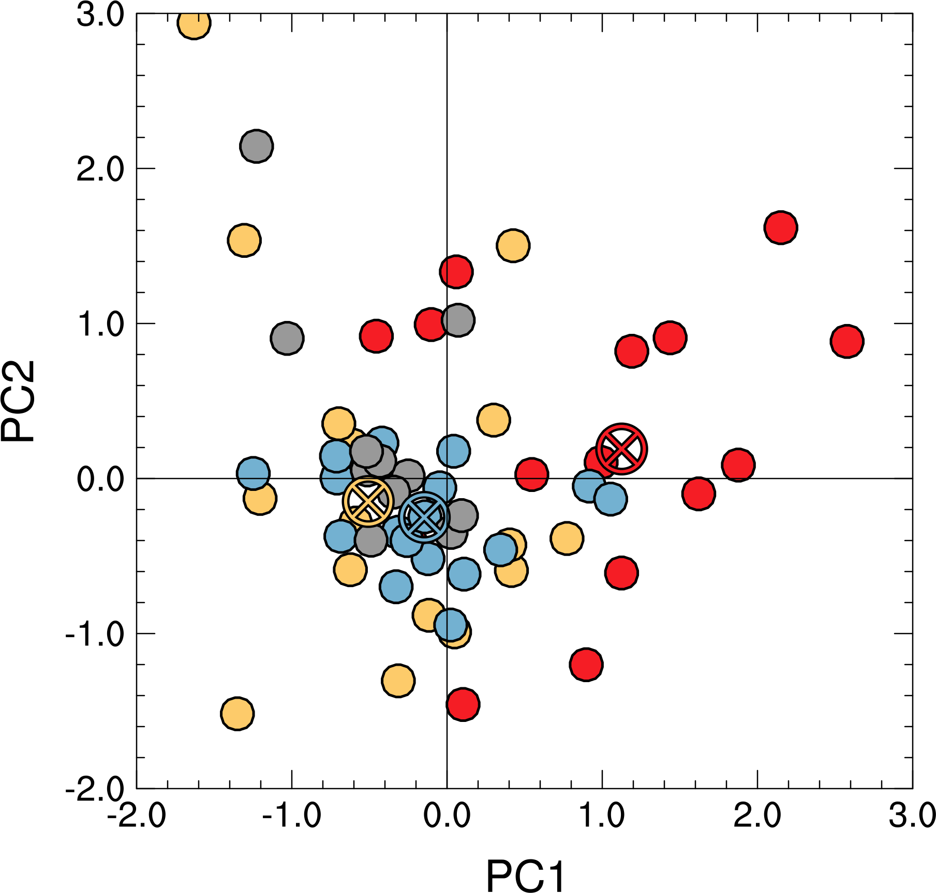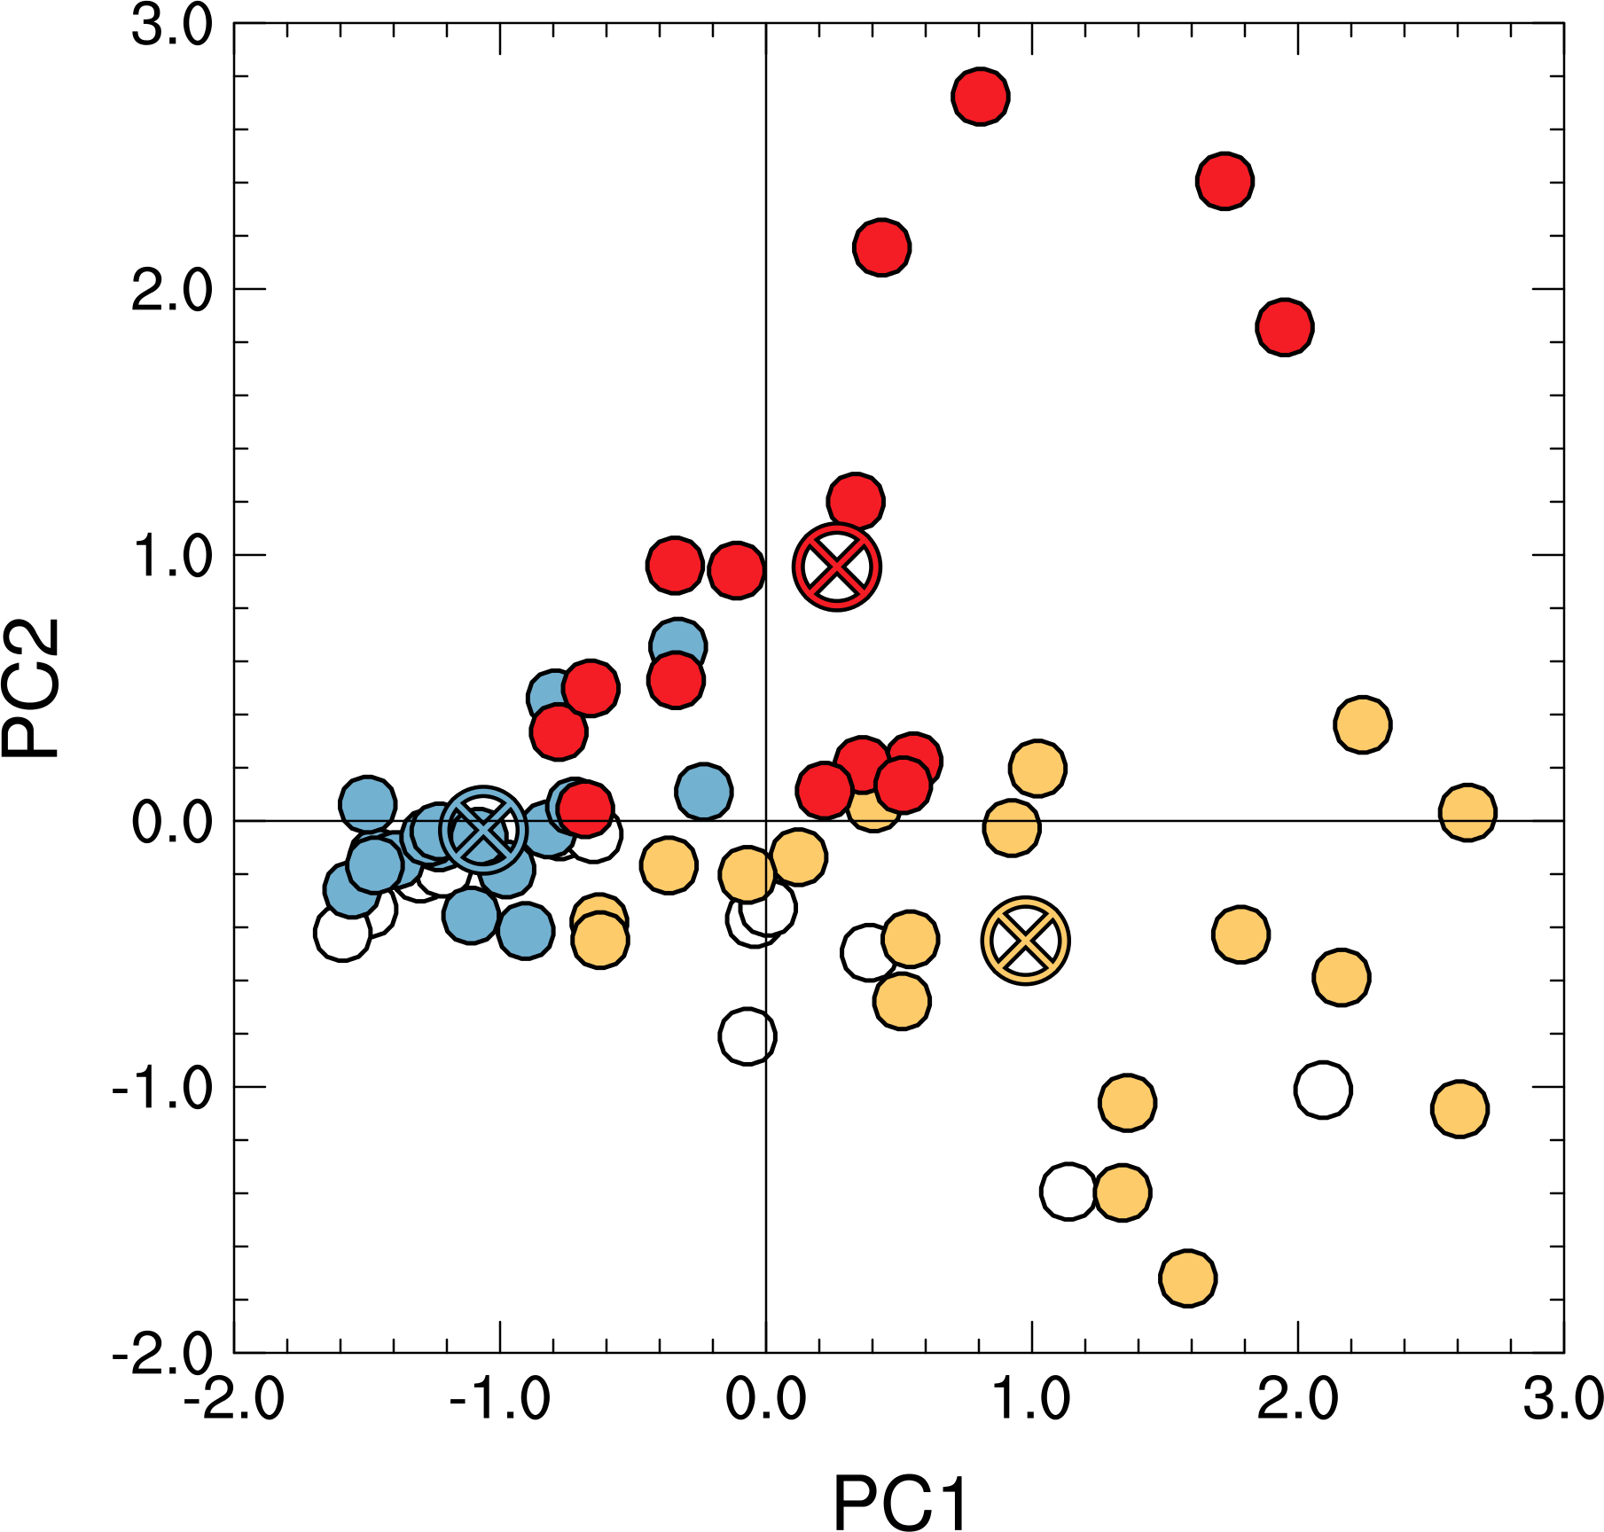

L157-158: Don't quite understand what is meant here.

This sentence has been rewritten to be clearer, as well as to tie in the PC phase space with the subjectively constructed categories (L158–160).   
  
L167-168: Not sure what is meant by "the overall magnitude of the individual 250-150-hPa layer-averaged PV fields included in the EOF analysis".

This sentence discusses aspects of the 250–150-hPa layer-averaged PV fields described by EOF1, which is shown in Fig. 2b to be either an increase or decrease in PV across the domain. This increase or decrease in PV across the domain represents a change in the “overall magnitude of the individual 250-150-hPa layer-averaged PV fields” used in the EOF analysis.   
  
P9: It seems to me that the low values (or negative values) of EOF1 represent a prominent trough. This is confirmed by Fig. 2a, which shows the "meridional trough" category falling into the left half of the phase space. To facilitate discussion, it may be better to reverse the sign of EOF1.

Good idea. The sign of EOF1, and corresponding sign of PC1, have been reversed in Figs. 2a,b to facilitate discussion.   
  
P9: The EOF2 pattern resembles a wave train pattern from the northwest and consistent with reduction or reversal of the meridional PV gradient. This is consistent with Fig. 2a showing the cutoff low category associated with high values of EOF2.

This statement is very true- specifically a Rossby wave train (RWT) that results in AWB to the north of the location of STC formation. References to RWTs and AWB can both be found in the cyclone-relative composite discussions contained in section 4.   
  
L225: How is the long-term climatology defined? Is it defined for each calendar day and over each grid point before the PV field is shifted to the mean STC formation location?

The long-term climatology is calculated every 6 h at each grid point by retaining the first four harmonics of the mean annual cycle, similar to the methodology used by Brammer and Thorncroft (2015), prior to when the PV field is shifted to the mean location of STC formation. How the long-term climatology is calculated is now on L246–247.   
  
L244: Suggest to remove "to STCs forming in association with cutoff lows and meridional troughs" and shorten the sentence to "In contrast, …"

This phrase has been removed (L267–L270).   
  
P12: Strong TT, weak TT and trough-induced pathways are associated with strong, medium and weak low-level baroclinicity respectively. Is the strong low-level baroclinicity a consequence of the strong PV signals in the cutoff low or meridional trough, or mainly related to the STC formation latitude?

Good question. The authors suspect that lower-tropospheric baroclinicity is driven more by the type of upper-tropospheric disturbance (as relatively low latitude cutoffs are still associated with strong lower-tropospheric thermal gradients). However, the results of this study indicate that there is a latitudinal preference for the type of upper-tropospheric disturbance associated with STC formation, so the two options listed by the reviewer are certainly linked.

L270-274: A very long sentence. Suggest to reword.

Removing mention of subtropical disturbances and the phrase beginning with “comprise” has shortened this sentence (L290–294).   
  
L307-308: The low CI for the cutoff low category may be attributed to the low-theta air originating from the extratropics.

Correct. Reference to the low DT potential temperature values associated with the cutoff low category now appears on L325.   
  
1st paragraph on P16: It seems to me that the zonal trough and subtropical disturbance categories are similar enough to be combined into one category. This is also supported by Fig. 2a.

Excellent point. The authors have removed the subtropical disturbance category from this study, this many cases moved to the zonal trough category. Figure 4a now includes the new subjectively constructed categories, which are much easier to identify.   
  
Fig. 7 and the related discussion: Is the reduction in tropospheric stability the major mechanism for TT associated with the cutoff low? Does the cutoff induce any surface circulation? Is there any ascent associated with the cutoff low?

A new 3-panel figure has been created that that explores the reviewer’s questions (Fig. 10). Figure 10 reveals that the reduction in bulk tropospheric stability facilitates the development of midtropospheric ascent and plays a key role in the formation of a lower-tropospheric cyclonic circulation. These processes are discussed in greater detail on L387–400.   
  
P20-P22: i) Again, I found the pattern of the zonal trough cases very similar to that of the subtropical disturbance cases Fig. 11 i&k vs. Fig. 12 i&k. ii) The upper-level PV features in Fig. 11 and Fig. 12 are rather weak. Is TT in these cases involved with interaction between the upper-level PV and some low-level disturbances? How does the low-level circulation develop in these cases?

The subtropical disturbance category has been removed from this study, while the zonal trough category has been retained. Figure 15, a new 3-panel figure examining the precursors to STCs forming in association with a zonal trough, indicates that the lower-tropospheric cyclonic circulation associated with STC formation develops between *t*0 − 24 h and *t*0, and does not result from the favorable interaction of the zonal trough and a preexisting lower-tropospheric circulation.

Figs. 11-12: The upper-level irritation flow was used as an indicator of deep convection. Doesn't it also indicate forced ascent by the upper-level dynamic processes?

Yes, it does. This is discussed in association with the thinning of the upper-tropospheric trough prior to cutoff low formation in the cutoff low category. However, a starburst-type pattern in the upper-tropospheric irrotational wind field can also be indicative of divergent outflow and deep convection. The authors have attempted to make this more clear in the text, as well as using vertical motion in Figs. 10,15.  
  
Fig. 14: An important mechanism in the meridional trough category is the forced ascent, which should be highlighted in the schematic.

Great idea. QG forcing for ascent has been added to the meridional trough schematic (Fig. 17).