“Southerly Mohawk Hudson Convergence”- An Exploratory Case Study of Terrain-Induced Wind Convergence on the Formation of Thunderstorms of New York’s Capital Region

# Christine E. Bloecker1, Hugh W. Johnson2

# 1Department of Atmospheric and Environmental Sciences

# State University of New York University at Albany

2US National Weather Service- Albany NY

Abstract

Research has been conducted that has indicated a favorable spot for convection initiation in the absence of other obvious synoptic and mesoscale features, at the apex of the Mohawk and Hudson Valleys, within the Capital region.

Winds channeled in a southwesterly fashion down the Mohawk Valley collide with a wind channeled in a more southerly direction from the Hudson Valley, to produce low level convergence, which might help initiate convection. This is the first comprehensive study dealing with this possibility, named Southern Mohawk Hudson convergence, referred to as SMHC.

For this study, data was collected and examined at the National Weather Service station in Albany, on Weather Experiment Simulator (WES). The years included ranged from 2003 to 2015. Only cases where significant convection ensued were examined, since there were the only ones fully documented. This of course might mean some incidents of SMHC might have been missed.

Climatology was compiled and showed that SMHC occurs on average several times a year, namely during the summer months. A case study was completed for an event on 22 June 2008 where SMHC was believed to be responsible for the formation of a supercell over Schenectady County, New York. Several ingredients which were found to be present likely contributed to the formation of this storm- ample instability and moisture in the boundary layer, convergence wind flow, gentle surface winds, and relatively weak synoptic forcing.

**“Southerly Mohawk-Hudson Convergence”- An Exploratory Study of Terrain-Induced Wind Fields on the Formation of Thunderstorms over New York’s Capital Region**

**Christine Bloecker1, and Hugh Johnson2**

1Department of Atmospheric and Environmental Sciences, University at Albany- SUNY

2US National Weather Service- Albany, NY

Introduction

Forecasting convection initiation continues to be a challenge for mesoscale weather prediction models and meteorological forecasters. Models such as the High-Resolution Rapid Refresh model (HRRR), the Rapid Refresh model (RAP), and the Weather Research and Forecast model (WRF) attempt to predict the initiation and location of such events, and while sometimes they are accurate on a larger spatial scale, they often fail to correctly forecast more localized weather phenomena.

There are several ingredients that need to be present for convection to form. The air mass in question needs to be nearly saturated, and in an area where instability is or will in the near future be present.If these ingredients are present, there must also be a “trigger” to initiate the convection. A trigger can be either synoptic- a jet streak, jet phasing region, or mid-level vorticity advection, or it can be mesoscale- a prefrontal trough, a convective thermal, or orographic lift, to name a few.

The specific trigger this project will investigate is one involving the collision, or convergence, of winds channeled through two local river valleys. When the wind around a synoptic low is effectively channeled through one or more distinct valleys, the difference in this direction can result in localized weather phenomena. In some cases, if the wind from two distinct different valleys meet at nearly an orthogonal direction, low level convergence can be realized. This localized convergence results in upward motion.

This type of phenomenon has been observed in cold season cases in a couple of river valleys in the Unites States- the Columbia and Snake River valleys in Washington, the Saint Lawrence River Valley of Canada, and the Mohawk and Hudson River valleys in Upstate New York.The Hudson River runs north to south, spanning over 320 kilometers from near Lake Champlain down to New York City. This places the bulk of the Hudson River watershed in the forecast regions of Brookhaven, NY (OKX) and Albany, NY (ALY). The Hudson River is bordered by a total of four mountain ranges- the Adirondacks and Catskills on the west side, and the Greens and Taconics on the east side. Relief on either side of the river reaches about 1000 meters (USGS Digital Elevation Map). Between the Catskills and Adirondacks lies the Mohawk River valley, which extends west to east across upstate New York, spanning about 160 kilometers from Rome to Albany where it empties into the Hudson River at Cohoes. The Mohawk River shares a similar relief shape with the Hudson Valley and meets the Hudson River at a nearly orthogonal angle.

A study by Mike Augustyniak (2008) that focused on cold season instances of this phenomenon found that the geography of the Mohawk and Hudson River Valleys influences the local flow of the surface wind. The surface wind tends to flow either northerly or southerly through the Hudson Valley depending on the position of surface highs and lows, even when the synoptic patterns and mean gradient wind would indicate a westerly or easterly flow. The northerly cases tend to occur with a departing coastal low, usually in the cold season. When the westerly winds along the Mohawk Valley meet the northerly Hudson Valley winds over the Capital Region, this leads to a phenomenon known as Mohawk-Hudson Convergence (MHC). Though the weather resulting from this event is usually non-life threatening, it can lead to additional precipitation in winter storms, further raising the cost for crews to clean the roads since the precipitation usually falls in the form of snow. MHC can happen with little warning (Augustyniak, 2008). One such event occurred on the morning of 3 January 2008 when MHC produced up to five inches of localized additional snow accumulation in Cohoes, NY, disrupting the morning travel.

In the warm season, a passing low over Ontario, Canada can create a southwest mean wind gradient over the state. This induces surface south-to-southeasterly flow up the Hudson Valley with southwesterly winds over the terrain of the Catskills and westerly winds in the vicinity of the Mohawk Valley. This unique wind pattern can create low-level convergence of the winds in the immediate Capital Region, along with slightly higher dew points transported from the Atlantic Ocean that pool in the Hudson Valley and lead to a localized humidity gradient. This type of event has been coined "reverse” or “southerly” Mohawk-Hudson Convergence (SMHC), and this low-level convergence can enhance or even spark new convection well ahead of a main line of thunderstorms. If low-level shear is great enough in the area of convergence, SMHC even has the potential to produce supercell thunderstorms. One such case that occurred on 22 June 2008 will be specifically examined in this study.

SMHC is exceptionally tricky to forecast, as the production of convection resulting from its occurrence is very sensitive to the slightest changes in wind direction and humidity, and often on days when conditions appear are right for SMHC to occur, it either does not or fails to produce any significant weather phenomena. Conversely, there are also times when SMHC occurs and the results are majorly enhanced convection, and in very rare occasions even supercell development. Because of the potential of SMHC to produce severe weather in a region of over one million residents and the busy Albany International Airport (ALB), it is important to be able to forecast these events as accurately as possible. The purpose of this study therefore is to identify the synoptic and mesoscale weather patterns that might contribute to the occurrence of SMHC. A partial climatology of cases based on observed Weather Surveillance Radar- Doppler 88 (WSR-88D) imagery and other variables is included to identify how often SMHC convection occurs given proper synoptic and mesoscale setup. From this climatology and a specific case study from 22 June 2008, the synoptic setup, mesoscale influence, and triggering mechanisms under which SMHC could be most likely to produce convection was more closely investigated and validated.

**2. Methodology**

In order to get a better understanding of what SMHC cases look like and to have a collection of cases from which a more in-depth study can be conducted, a partial archive of possible SMHC events in the warm season was built for the years of 2003 through 2015. A breakdown of events by months in which they occur is charted below in Figure 1. Days on which non-negligible convective weather occurred in the Albany National Weather Service’s (ALY) warning forecast area (WFO) were documented and the data were archived by the ALY forecasting office for review on the Advanced Weather Interactive Processing System(AWIPS). Archived data includes WSD-88D radar imagery, convective parameters, wind directions at reporting stations, and other real-time data provided within the AWIPS program interface during these events. Parameters used are discussed more thoroughly in the corresponding section of the methodology, after the climatological report.

This climatology spans a 12-year period of 2003 – 2015. It includes null cases, when SMHC did not occur when it could have, enhanced cases, where convective was likely bolstered by SMHC by over 10DBZ on the Base Reflectivity, and positive cases, when purely SMHC-driven convection occurred. These events were classified by the authors of this study and several semesters of interns participating in the State University of New York University at Albany’s internship program, in collaboration with ALY. Cases are defined by days on which convective weather occurred rather than by events because some events spanning multiple days produced null and enhanced cases or enhanced and pure cases. Cases listed as “possible” SMHC were defined to be positive for this chart, as the event used for the case study was listed as “possible”.

Figure - Climatological breakdown of SMHC null, enhanced, and positive cases by month for the years 2003 - 2013.

The chart shows that July had the most positive cases of any month, as well as the largest number of enhanced cases. Overall, SMHC occurred most often during the meteorological summer months. Based on this climatology and by investigating the recorded cases for the setup required to produce SMHC, the research party determined that it would be necessary for the following unique parameters and corresponding directions and values to be sustained for SMHC to occur.

1. Convective Available Potential Energy (CAPE)

For convection to initiate in the appropriate region, low-level instability should be present, and CAPE is the most commonly used variable for measuring low-level convective instability for thermally-driven rising parcels. During case studies of SMHC, it was determined that surface-bound CAPE levels usually exceeded 1000 J/kg for the Capital Region of Upstate New York with the highest amounts of surface instability occurring in the Hudson River Valley. Any amounts equal to or greater than the 1000 J/kg threshold should be sufficient enough for convective thermals to rise and condense, given they can break any existing cap.

1. Wind Direction and Speed

The convergence of winds in the vicinity of the Capital Region is a result of channeling through the Hudson and Mohawk river valleys in such a way that they collide where the two rivers meet. For this to occur, the wind field over the Hudson River, Mohawk River, and Catskill Mountains must be observed for favorable wind velocities. The Automated Surface Observing System (ASOS) at Albany International Airport (KALB) is checked for a south to south-southeasterly wind. For a profile of wind along the Mohawk River, the earlier years of the study used observations from the Utica, NY ASOS (KUCA). In 2007, the ASOS site was moved to the Rome Griffiss Airfield (KRME) in Oneida County and was used for the remainder of the climatological study. (Unfortunately KRME must be used despite its far distance from KALB due to a scarcity of reliable observing stations in the Mohawk River Valley.) KALB and KUCA/KRME were checked for a more westerly-to-southwesterly surface wind. Winds across the Catskills from the Hudson Valley to the Mohawk River tend to gradually turn from southerly to westerly. Unfortunately there are no reliable surface observing stations in the Catskills within fifty miles of KALY to confirm that this type of wind field was present for days on which SMHC may have occurred. In addition to direction, wind speed is also an important factor. For these events, it appears that SMHC was most likely to occur when surface wind speeds were around 5-10 knots at KALB. Convection associated with SMHC is usually in the form of single-cell thunderstorms that are most often associated with minimal speed shear. If vertical wind speed shear is too great, then convective storms created by the convergence could be torn apart. Vertical direction shear, however, is expected as the southerly wind through the Hudson Valley is a result of the orography of the region. Above the reach of the mountains, winds usually follow the lower-level synoptic direction of westerly or southwesterly.

1. Areal Extent

SMHC is a very localized phenomenon, occurring mainly in the vicinity of the Capital Region. For the purpose of this study, the areal extent of SMHC influence is defined as approximately within twenty kilometers of the Albany International Airport, more specifically, the region bound by the mouth of Normanskill Creek at the Port of Albany to the south, Troy to the east, Clifton Park to the north, and Altamont to the west (Figure 2). It is especially important to specify the farthest eastern extent because the Taconic Range induces orographic lift, which can almost appear like SMHC-driven convection in radar imagery. Convection caused by either of these two forcing mechanisms must be kept distinct and separate during the climatological classification process when possible, though this distinction is not always decisive. Sometimes convection can be influenced by both terrain upsloping and surface convergence.

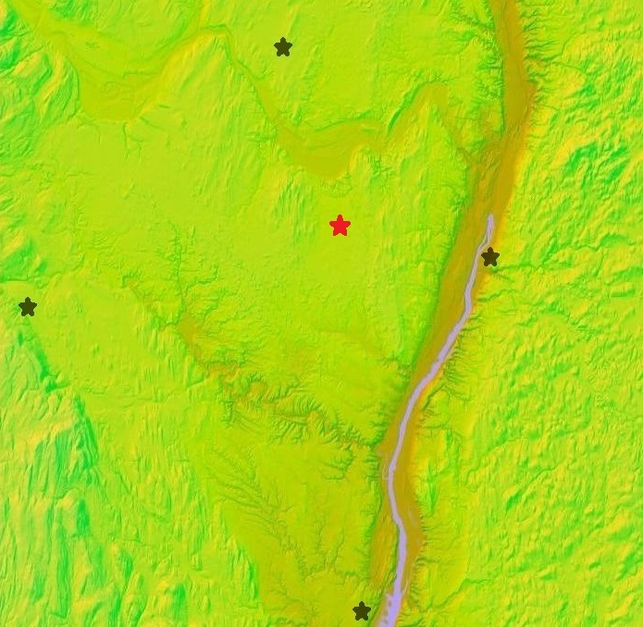

Figure 2- Elevation map showing the Capital Region where the black stars represent (from the top going clockwise) Clifton Park, Troy, Selkirk, and Altamont. The red star represents Albany International Airport. Notable geographic features are the Hudson River Valley next to Troy, the Mohawk River Valley just south of Clifton Park, the Taconic Range east of Troy, and the Catskills west of Altamont. Map is from the National Elevation Dataset (NED, 1/3 arc second imagery) of the United States Geological Survey (USGS), viewed using Google Maps Engine (information at mapsengine.google.com/map/)

1. Forcing for Ascent

With CAPE and a favorable wind field present, the main ingredient left that is needed to initiate convection would be a forcing mechanism for ascent. The typical synoptic setup for SMHC is for a low pressure center to be situated to the north or northwest of the area of interest in southwest Quebec or southern Ontario with higher pressure to the southeast off the Atlantic Coast. (This situation is quite typical during the warm season.) The pressure gradient created between the low center to the north/northeast and high center to the south/southeast generates the general wind pattern needed for SMHC. Most often the local ascent spawned by SMHC will be well ahead of the main synoptic (or even mesoscale) frontal feature, but in some cases when a main organized line moved into the Capital Region, it appeared to be enhanced prior to reaching the upslope terrain of the Taconics. SMHC may interact with synoptically-driven surface features, but otherwise synoptic-level forcing does not play a major role in initiating SMHC convection. Upper level winds in many but not all cases were found to be relatively light, and the area of interest was generally located well away from the greatest synoptic forcing. Considering SMHC is a mesoscale phenomenon, associated convection is initiated mostly by low-level mesoscale forcing rather than winds aloft.

Convection due to SMHC typically occurs well ahead of a cold front or prefrontal trough, boundaries which often eliminate the moisture gradient set up by the surface flow associated with SMHC. Southerly flow up the Hudson River valley brings high theta-e air up to the Capital Region, creating a discontinuity in dew points west and east of the Hudson River. Such a discontinuity, in conjunction with the difference in wind directions where the Mohawk River meets the Hudson River, disrupts the air flow and assists surface convergence along the moisture boundary.

The surface analysis for Figure 3 was obtained from the WPC (Weather Prediction Center, formerly HPC) Surface Analysis Archive. Aviation Routine Weather Reports (METAR observations) for KALB are obtained from the Plymouth State University Surface Data Text Listing. Data for the four-panel upper-level map and sounding was retrieved from the Iowa State University General Meteorological Package (GEMPAK) Data Archive. This data was originally compiled by the University Corporation for Atmospheric Science’s (UCAR’s) Unidata NOAAPORT feed (funding provided by the National Science Foundation). The map data is a reanalysis of Aviation model data (AVN, now known as the GFS) plotted using UCAR’s GEMPAK software package. Sounding data (RAOBS) was altered using UCAR’s NSHARP software package. The radar dataset is Next Generation RADAR (NEXRAD) Level II High Resolution Base Data, retrieved from the Albany WSD-88D site (KENX) and provided for download by the National Climatic Data Center’s (NCDC’s) HDSS Access System (HAS). Radar data was viewed and analyzed using the GR2Analyst software package, licensed by Gibson Ridge Software, LLC.

**3. June 22 2008 Case Study**

1. Pre-storm Environment- 0000 – 1200 UTC 22 June 2008

The overnight period preceding the day of interest began with a clear sky at temperatures around 25°C. Aviation Routine Weather Reports (METAR observations) show that winds were very light and out of the south to south-southeast when they were measureable. With conditions favorable for radiational cooling (clear sky and light and variable winds), temperatures began to drop by 2°C for every hour until 0300 UTC. It was within the 0300-0400 UTC period that a weak warm front entered the Capital Region from the south. Cloud cover changed from CLR to BKN110 and the temperature climbed 2°C back up to 21°C, remaining mostly steady through the rest of the night. Visibilities also began decreasing steadily by 1SM from 10SM at 0600 UTC down to 5SM by 1100 UTC, prompting an indication for haze in METAR reports at 1000 UTC. Winds remained light but not stagnant (3 – 6 kt) and kept their directions generally out of the south (160° – 200°). Although the WPC’s 1200 UTC surface analysis did not indicate the presence of a warm front in northern New York, a temperature gradient and wind shift to south-southeasterly can be seen from surface observations north of Albany through the Champlain Valley at the time of analysis (Figure 4).

In the 1200 – 1300 UTC period, a couple of thunderstorms resulting from isentropic lift and elevated instability were reported at ALB lasting from 1204 – 1228 UTC, then another was reported from 1241 – 1244 UTC with occasional cloud-to-cloud and cloud-to-ground lightning. These two storms were associated with a line of showers and storms along a boundary that moved through the Capital Region just after 1200 UTC, shown in METAR reports. One lone cell did form in the northern portions of Capital region, but this cell formed just ahead of the surface boundary and was associated with that feature, not SMHC. Radar imagery prior to the passage of the boundary showed that all storms occurring originated well southwest of the Capital Region over the Catskills and were not associated with SMHC. (One lone cell that formed just north of Albany at 1049 UTC was an exception, but this cell was associated with the approach of the surface boundary from the west, not SMHC.) (Figure 3) The storms continued through the 1300 UTC hour until the boundary moved beyond the region into Massachusetts and Vermont.

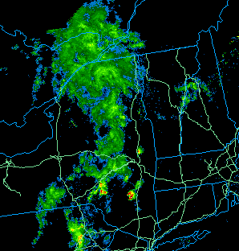

Figure - Radar imagery of western New England and eastern and central New York for 1049 UTC on 22 June 2008. Retrieved from the UCAR Image Archive (accessible at locust.mmm.ucar.edu/case-selection).

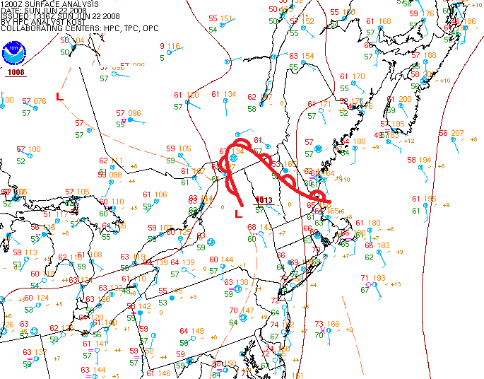

Figure 4- WPC Surface Analysis Archive. (Accessible at http://www.wpc.ncep.noaa.gov/archives/web_pages/sfc/sfc_archive.php)

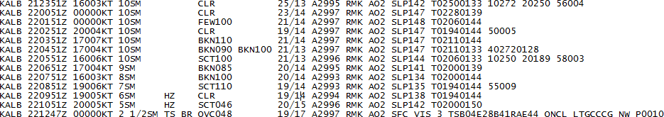

Figure - METAR observations for KALB for 0000 - 1300 UTC. Retrieved from the Plymouth State Weather Center. (Accessible at http://vortex.plymouth.edu/sa_parse-u.html)

1. Pre-storm Environment- 1200 UTC 22 June 2008

The synoptic setup for the event on the afternoon of 22 June 2008 featured a combination of weak forcing at all levels of the atmosphere that combined created a scenario similar to what was described in the methodology section of this paper. Figure 6 shows a four-panel plot of various synoptic-scale parameters examined.

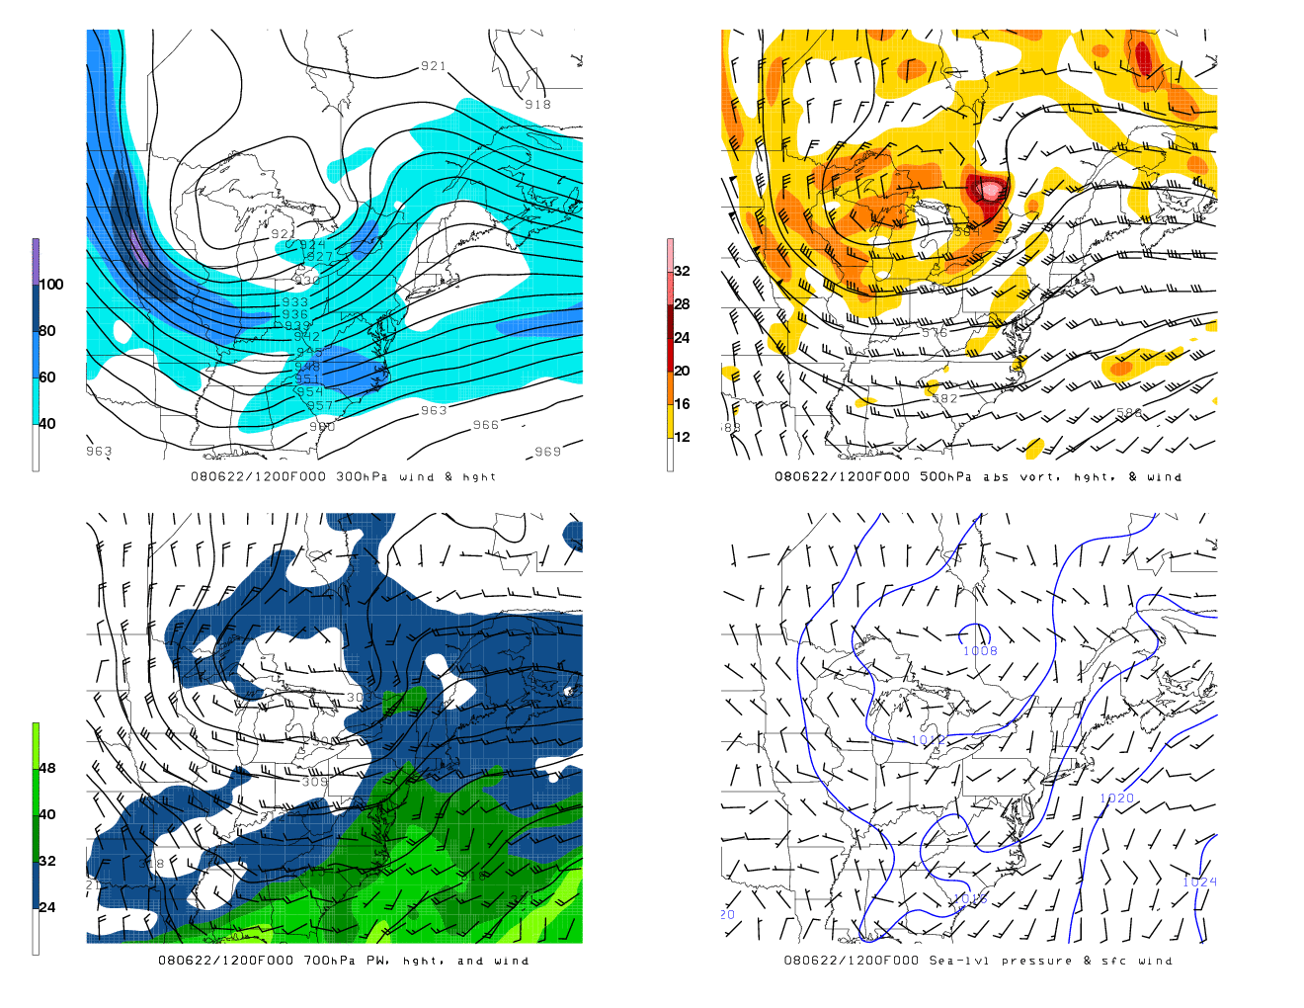

Figure 6- Four-panel plot showing a) 300 hPa isotachs (knots, filled) and heights (contours), b) 500 hPa absolute vorticity (filled), eights (contours), and winds (barbs), c) 700 hPa precipitable water (milliliters, filled), heights (contours), and winds (barbs), and d) sea-level pressure (millibars, contours) and wind (barbs). Data obtained from the University at Albany Department of Atmospheric and Environmental Sciences ash archive server.

Panel 1 shows the 300 hPa-level winds, which show a 921 dam upper-level cutoff low over the central Great Lakes. This center was well removed from the 100 kt jet streak upstream of the polar trough over northwest Iowa, separating it from the best area for upper-level divergence and ascent associated with the upper level jet. The phased jets separated east of the Mississippi River valley, allowing for a lack of strong jet interactions and forcing downstream of the trough. However, despite the best areas for forcing being removed from the cyclone, the trough pattern was relatively amplified for a mid-summer event. Panel 2 shows the only area of strong absolutely vorticity at 500 hPa was associated with a 564 dam shortwave feature northeast of Georgian Bay. This shortwave is also apparent in the 300 hPa flow, but the feature is perpendicular to eastern NY and thus did not provide any vorticity advection-driven forcing. Otherwise, cyclonic vorticity around the northeast is widely dispersed, which also does not allow for much vorticity advection. Panel 3 shows the 700 hPa level, and instead of forcing, this panel is provided to show the moisture advection around the low and up the Hudson River. The large-scale circulation shows the origin of much of this moisture being from the warm Gulf of Mexico and Caribbean waters, and much of this moisture is maintained as it is advected up the Eastern Seaboard. On close examination, the orographic effect of the Hudson River channeling can even be seen as a small tongue of 32 mL PW bulges up into the Hudson River valley. Finally, Panel 4 shows a broad surface low pressure center around associated with the cutoff low over the Great Lakes. The widely spaced isobars indicate light surface winds, around 5-10 kt throughout most of the Northeast, and the position puts Upstate New York in the region for southerly winds in the east and southwesterly wind in the western half of the state.

The sounding data for Albany provides more information on the local physical and thermodynamic conditions conducive for thunderstorm development in the immediate Capital Region through the calculation of stability indices (Figure 7). Unfortunately, no 1800 UTC sounding was launched due to 22 June 2008 being classified as only a “slight risk” day for the Northeast. In order to simulate what a late-afternoon sounding may have looked like, the 1200 UTC sounding from ALB was altered in UCAR’s NSHARP program to remove the surface inversion caused by radiational cooling overnight and the weak warm frontal passage earlier. The balloon was launched around 1100 UTC as per standard National Weather Service (NWS) practice, prior the passage of the thunderstorm boundary in the 1200 UTC hour.

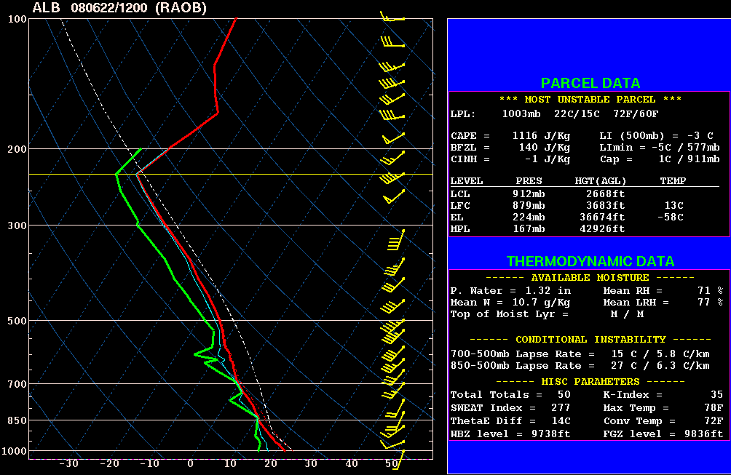

Figure 7- the 1200 UTC ALB sounding for 22 June 2008, altered in NSHARP to remove the surface radiational cooling inversion/cap. Base GEMPAK upper air data provided by the Iowa Environmental Mesonet GEMPAK Data Archive (accessible at mtarchive.geol.iastate.edu).

Assuming the inversion easily mixed out, which was the case on this day, CAPE values reached a total of about 1116 J/kg. As mentioned in the methodology, any value exceeding 1000 J/kg should be sufficient to allow convective storms to evolve. In addition to CAPE, there are two other kinematic/ thermodynamic values that can tell more about the potential for severe weather for the day- the Lifted Index (LI), Total Totals (TT), Severe Weather Threat Index (SWEAT), K-Index, and Bulk Richardson Number. (Showalter Index was originally considered also but nixed due to its absence from NSHARP’s parameters list.)

The LI determines stability be simulating a parcel lifted dry adiabatically from the surface to the lifted condensation level (LCL), then moist adiabatically lifted from the LCL to 500 hPa. The LI in this sounding is about -3C, which according to the NWS indicates “thunderstorms more probable, but few, if any severe”. The TT also determines stability by looking more at the temperature and moisture values at 850 hPa and 500 hPa, which is calculated here to be 51. Values of 50 or 51 indicate scattered heavy storms with a few severe storms and/or isolated tornadoes possible. The SWEAT Index takes wind shear into account and is calculated here as 277. Values under 300 are generally not considered favorable for severe storm development, but it’s still possible for strong storms to develop with SWEAT values below 300. KI indicates the possibility of air mass thunderstorms by concentrating mostly on moisture content, and the BRN (not pictured) determines the storm type by focusing on differential wind shear. The values for these two parameters are 35 and 53 respectively, suggesting an 80% chance of air mass thunderstorms and for storms to form in more of a multicellular structure than supercell structure.

Altogether, these parameters suggested that 22 June 2008 for the Capital Region would be a day of definite thunderstorm activity. Severe storm development would be limited, and the chance for tornadoes and supercells was minimal at best. Seeing these parameters and the weakness of synoptic forcing, the Storm Prediction Center (SPC) issued a “slight” risk for the Northeast on this day at about 0600 UTC. They placed the probability of tornadoes at 2%, the probability of damaging winds at 30%, and the probability of large hail at 15%. A mesoscale discussion (MD) was issued at 1300 UTC, but that MD’s valid time period did not coincide with the time of the SMHC event. Later, a 1700 UTC mesoscale discussion was issued and highlighted central and western New York with the border closing off right over Albany. This MD concerned the main line of the cold front and its potential for “damaging winds and hail” and the possibility of issuance of a watch, and it was the only other MD issued for New York that day, valid up until 1915 UTC. Indeed, a watch was issued at 1825 UTC by the SPC that covered most of Pennsylvania and upstate New York, extending to the easternmost boundaries of the ALY WFO, as shown in Figure 8.

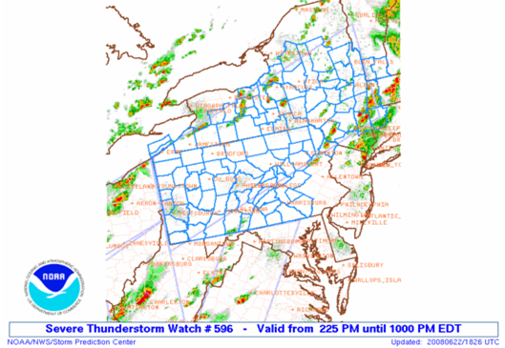

Figure 8- Severe Thunderstorm Watch issued by the SPC at 1825 UTC for 22 June 2008. Retrieved from the SPC Products and Reports Archive (accessible at [www.spc.noaa.gov/archive/](http://www.spc.noaa.gov/archive/))

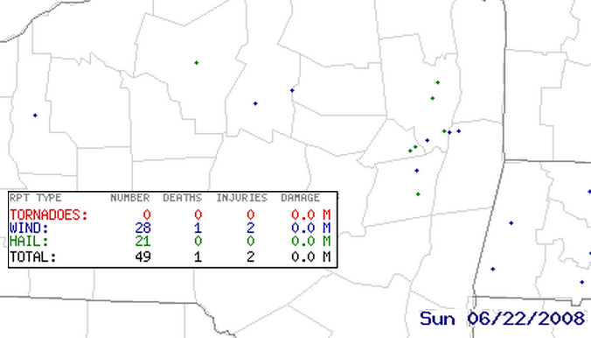

Figure 9- Storm reports for 0000 UTC 22 June 2008 – 0000 UTC 23 June 2008 for the Capital Region and central New York. From the SPC National Severe Weather Database Browser Online SeverePlot 3.0 (accessible at www.soc.noaa.gov/climo/online/sp3/plot.php)

The discussion text for the watch read as follows-

WIDELY SCATTERED TO SCATTERED THUNDERSTORMS WILL

DEVELOP DURING THE NEXT FEW HOURS ACROSS PA/NY ALONG SEVERAL

PRE-FRONTAL CONFLUENCE BANDS...AS WELL AS LAKE BREEZES OFF

ERIE/ONTARIO AND THE HIGHER TERRAIN. THE LARGER SCALE ENVIRONMENT

WILL BECOME MORE FAVORABLE FOR SEVERE STORMS LATER THIS AFTERNOON

WITH CONTINUED DESTABILIZATION AND THE APPROACH OF A MID LEVEL

TROUGH FROM THE OH VALLEY. DAMAGING WINDS AND LARGE HAIL WILL BE

THE PRIMARY SEVERE THREATS WITH MULTICELL CLUSTERS AND BOWING

SEGMENTS.

Despite the watch being centered on northern and central Pennsylvania and central and western New York, most of the storm reports in the watch area occurred in one cluster near University Park, Pennsylvania, and is a large spread over the Capital Region of New York. In fact, a large cluster of hail reports were sent near Schenectady and Saratoga, and there was a report of numerous trees down in Guilderland at 2030 UTC and Niskayuna at 2100 UTC. Other strong wind reports with damage evidence were sent in from locations in Rensselaer County and Saratoga Springs.

It appears as though the SPC underestimated the strengthening of the line as it approached the Capital Region. This line, which will be discussed in the next section, also accentuated this risk for severe weather. SMHC is a localized phenomenon that SPC would not have know about. SMHC is a rather unique phenomenon to the Capital Region that forecasters outside the ALY WFO could very well have not considered a possibility. Another reason it may have been overlooked is because SMHC is a planetary boundary layer phenomenon, mostly relegated to the layer of the atmosphere below 850 hPa. Most severe weather indices, however, concentrate on the layer of the atmosphere between 850 hPa and 500 hPa, a region where terrain plays little direct influence on severe weather.

1. Incoming Storms- 1800 UTC - 1930 UTC 22 June 2008

The SPC issued severe thunderstorm watch #596 shortly before 1830 UTC on 22 June 2008 as a line of thunderstorms with embedded discrete cells was moving into Upstate New York from the south. At 1800 UTC, the southwest-to-northeast oriented band was situated along the Hudson River up to around Rhinebeck where it made a 60-degree turn east across Massachusetts. Meanwhile, a pre-frontal trough was making its way through western New York. This line, as identified by the WPC, was a weak feature that produced a few small hail reports in Oneida County but not any severe storms. (The main line cold front moved through Albany the next day.) 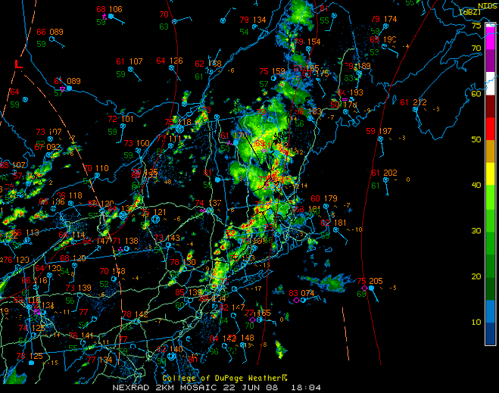

Figure 10- 1800 UTC WPC surface analysis overlaid (approximate, centered over KALB) on 1804 UTC radar imagery on 22 June 2008. Surface analysis from the NCDC SRRS Analysis and Forecast Charts archive (accessible at nomads.ncdc.noaa.gov/ncep/NCEP). Radar imagery from the UCAR Image Archive (accessible at locust.mmm.ucar.edu/case-selection).

Note the station plots south of Albany showing a south-southeasterly wind and the 55°F – 60°F dew points throughout the region. The moisture and wind direction are key ingredients leading to the supercell that developed two and a half hours later (the wind direction along the Mohawk River is unfortunately not viewable in Figure 10).

1. Supercell Event 1930 UTC – 2100 UTC

By 1936 UTC, the disorganized line of storms had drifted northward into central Ulster County, extending northeastward into southern Columbia County and western Massachusetts. Meanwhile, base velocity at KENX showed a southerly breeze up through Albany County, becoming more southwesterly towards the western edge of the county. A gust front associated with the storms in Columbia County can be seen about 55.5 km to the south-southeast of KENX. The main feature to point out, though, is a small area of weakly inbound velocities 14.8 km north-northwest of KENX. Although very weak, this feature stands out against the surrounding outbound velocities north of the radar site and represents where a mesocyclone developed. This was the cell that likely formed as the result of SMHC and later moved across eastern Schenectady County.

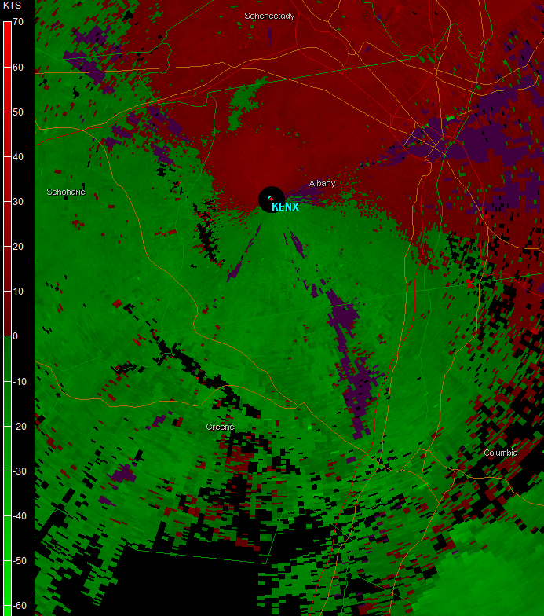

Figure 11- Base velocity product from KENX for 1936 UTC 22 June 2008. Plotted in GR2Analyst.

A three-dimensional model of the area of interest shows that at the same time, a convective cloud had started developing just south of the Albany-Schenectady County border over the area of interest with an area of 20 dBZ signatures expanding in a slanted upward column from the surface towards the northeast, the conventional growth pattern of a classic supercell. A cross-sectional cut of the area of convection shows the same growth pattern towards the northwest with a column of 30+ dBZ signatures in the updraft of the storm and a pocket of 40+ dBZ, which would become the supercell’s hail core, developing in the center of the deepest convection aloft.­­

.

A three-dimensional model of the area of interest shows that at the same time, a convective cloud had started developing just south of the Albany-Schenectady County border over the area of interest with an area of 20 dBZ signatures expanding in a slanted upward column from the surface towards the northeast, the conventional growth pattern of a classic supercell. A cross-sectional cut of the area of convection shows the same growth pattern towards the northwest with a column of 30+ dBZ signatures in the updraft of the storm and a pocket of 40+ dBZ, which would become the supercell’s hail core, developing in the center of the deepest convection aloft.­­

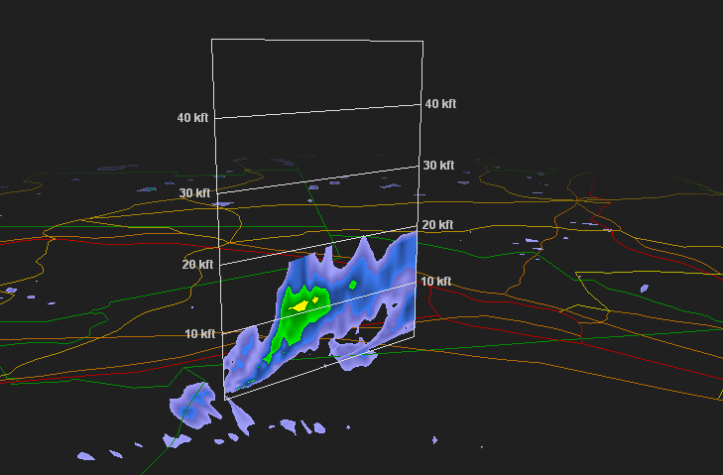

Figure 12- 2-dimensional cross dimensional reflectivity product from KENX for 1936 UTC showing a storm development just south of Schenectady County. Plotted in GR2Analyst.

The supercell continued to develop, and about 13 minutes later, a 65 dBZ hail core with ~0.63 in hail possible was pinpointed in the aloft cell according to GR2Analyst’s algorithm. Figure 13 shows the cell at 6.5° and 10.1° tilts with a well-defined hook at both as the storm began to track into Schenectady County. Meanwhile, base reflectivity started to show the cell producing moderate rainfall at the surface. 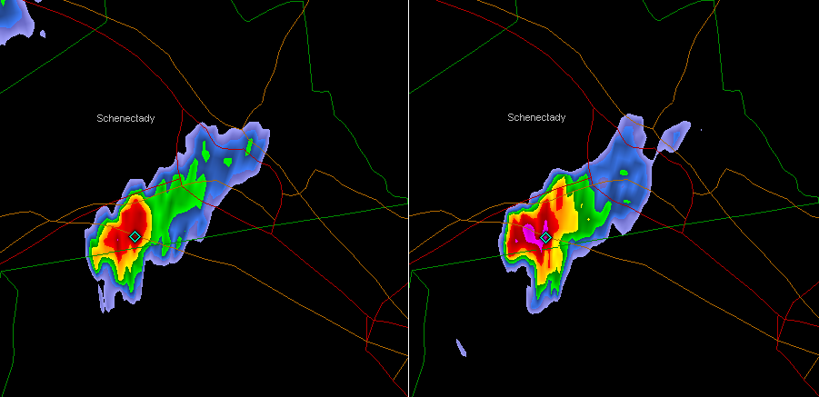

Figure 13- Cell at 1949 UTC with small hail core within 65 dBZ sector entering Schenectady County for 6.5 (left) and 10.1 (right) tilts. Plotted in GR2Analyst.

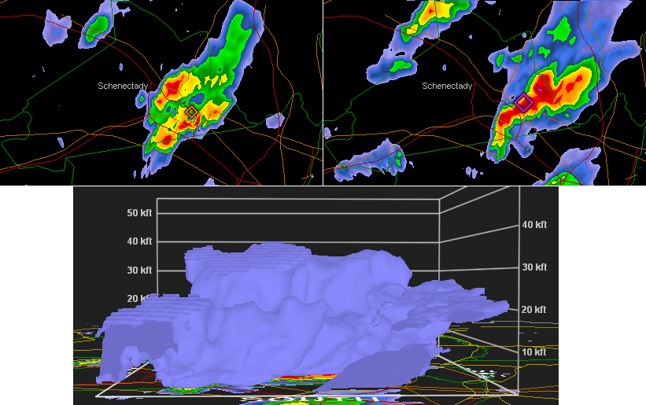

Figure 14- (Top) Base reflectivity of the supercell at 2008 UTC, then 2022 UTC with hail algorithms plotted on top. (Bottom) 3D model of the 18+ dBZ volume of the storm at 2022 UTC, as seen from the south. Plotted in GR2Analyst.

With an environment of favorable shear, the newly redeveloped supercell was able to produce a stronger rotating updraft than before. ALY spotted this rotation on Doppler radar and issued a tornado warning for Albany County, Schenectady County, and Saratoga Count at 2027 UTC set to expire at 2115 UTC.

The storm continued tracking to the ENE at a fairly slow 4.83 km/hr while producing moderate rainfall, but a split at 2004 UTC caused the storm to lose its structure and much of its strength. The left-moving part of the split cell quickly died after the full split at 2008 UTC while the right-moving cell rapidly regained its strength, building from 9.14 km to beginning to develop an anvil at 12.19 km from 2008 UTC to 2022 UTC.

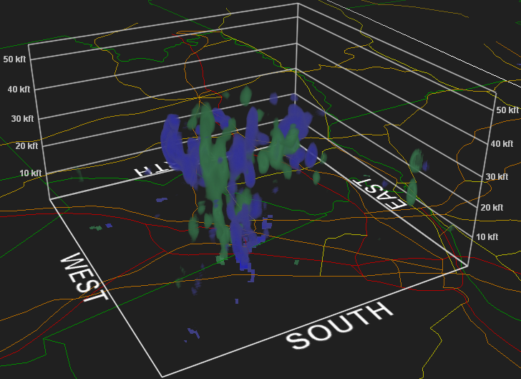

Figure 15- Rotation algorithm plotted for the supercell at 2022 UTC. Plotted in GR2Analyst.

The supercell continued to slowly track ENE, maintaining an area of surface rotation evident by a 20 kt inbound – 26 kt outbound velocity couplet at the surface at 2036 UTC. The tornado warning was updated as the storm passed near Schenectady, reporting that funnel cloud had been seen by trained spotters. According to local news station WRGB, funnel clouds were also spotted by the public at 2030 UTC from Guilderland, NY, where a wind report cited multiple trees down near I-90. Figure 16 shows the velocity couplet associated with the supercell as it moved out of Schenectady County. Although the couplet is clearly shown at the base by radar, the 3D viewer doesn’t depict any inbound velocities signatures above the surface, showing that the strong circulation to the surface and probably very weak aloft.

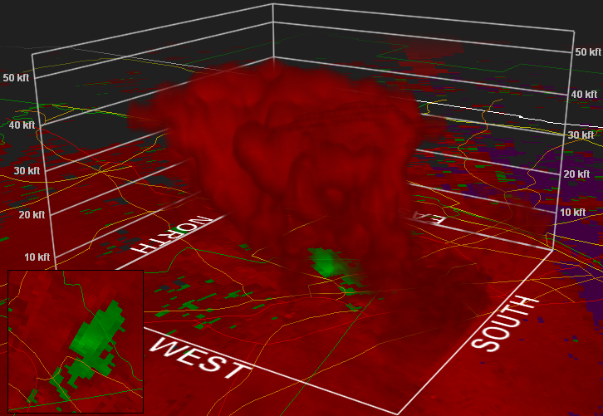

Figure - Base velocity 3D model of the supercell from 2031 UTC with outbound velocities in red and inbound velocities in green. Inset shows a top-down 2D view of the velocity couplet. Plotted in GR2Analyst.

By the time the storm’s velocity couplet started to strengthen and produce a funnel cloud, the supercell’s hook was beginning to occlude from the strongest area of precipitation. Where the area of 66dBZ was only three km north of the surface circulation at 2036 UTC, by 2041 UTC the highest dBZ area was about 9.5 km away, showing that the top of the storm was progressing faster than the bottom, causing the structure to become over-sheared (Figure 17). Being elongated and removed from the storm core, the updraft was no longer able to maintain its intensity and started to weaken. With it, the funnel cloud and mesoscyclone began to weaken as well. 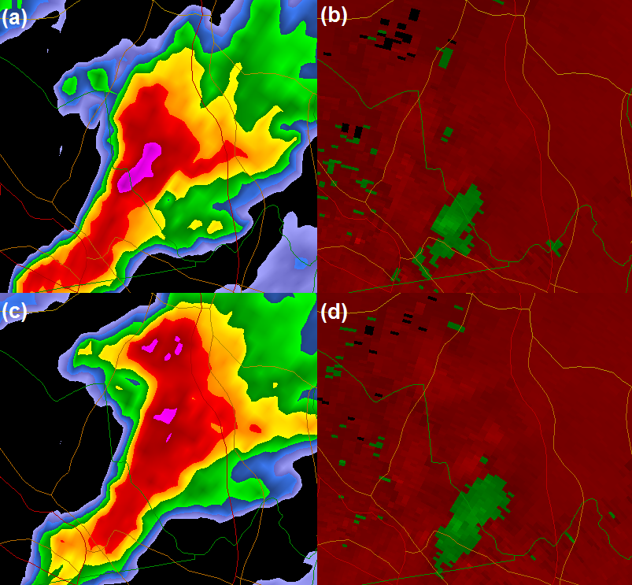

Figure - (a) Base reflectivity at 2036UTC. (b) Base velocity at 2036 UTC. (c) Base reflectivity at 2041 UTC. (d) Base velocity at 2041 UTC.

As the core continued to pull northward, the supercell split into two distinct cells (Figure 18). A left mover broke off from the main cell and header due north towards Saratoga, but this cell had almost no circulation and posed no tornado threat. However, it did produce a couple of small hail reports in Saratoga County and one wind report with a tree down by Saratoga Springs at 2021 UTC. The main cell maintained a weaker circulation, but the NWS no longer saw a tornado threat associated with it and allowed the tornado warnings for Albany, Schenectady, and Saratoga Counties to expire at 2115 UTC. The main cell brought down a few trees in Clifton Park at 2105 UTC, crossed the river, and brought down a few power lines in Reynolds in Rensselaer County at 2130 UTC. After 2130 UTC, it finally began to dissipate upon reaching to Taconic Mountains in northern Rensselaer County and weakened over time to a non-severe thunderstorm as it headed into southern Washington County.

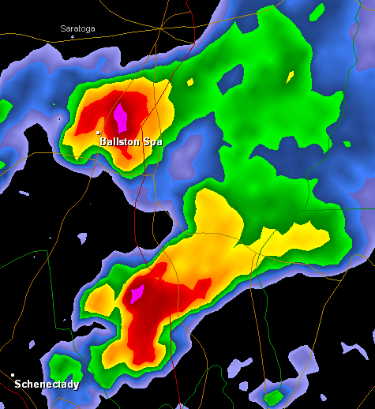

Figure - Base reflectivity at 2059 UTC. Plotted in GR2Analyst.

**4. Conclusions and Future Work**

SMHC is a localized, boundary-layer, meteorological phenomenon unique to the Capital Region of New York. It occurs mainly during the warm season when a low pressure system stations itself to the northwest of upstate New York, channeling the mean southwesterly flow over eastern New York by the Catskill, Adirondack, and Taconic Mountains westerly through the Mohawk River Valley and southerly through the Hudson River Valley. When these terrain-channeled winds converge where the Mohawk River meets the Hudson River, upward motion can be generated. If instability and moisture are present at the surface, upward motion can trigger thunderstorms. In general, SMHC is suspected to be triggered by four main ingredients in addition to favorable wind directions westerly at KUCA and southerly at KALB- moderate amounts of CAPE (surface instability) and light surface winds that produce convergence but little shear where the Mohawk and Hudson Rivers meet. The combination of these factors, along with a mesoscale boundary or discontinuity caused by a strong moisture gradient and weak synoptic forcing aloft, can be enough to trigger localized thunderstorms at the apex of the Mohawk and Hudson Valleys.

One specific event from 22 June 2008 in which SMHC was suspected to have created a supercell over Schenectady County was examined in detail to test this list of meteorological ingredients. High surface CAPE values and light westerly surface wind down the Mohawk Valley, which met the southerly wind from the Hudson Valley, seemed to be responsible for producing this lone supercell thunderstorm in the Capital Region. The region was not completely void of synoptic forcing as a relatively amplified trough was over Upstate New York, but overall synoptic forcing was not strong, and the cell was well ahead of an approaching synoptic-scale boundary. Meteorological conditions set forth in the methodology seemed to correlate well with the event that transpired on 22 June 2008.

More cases studies on positive events will need to be conducted in the future to further verify the parameters suggested and potentially discover new ingredients to SMHC convective initiation. Null cases should also be studied to investigate why convection did not occur when SMHC was in place and could have produced thunderstorms but didn’t. Currently, studying local wind fields for SMHC is very difficult due to the lack of reliable reporting stations in the Hudson and Mohawk River Valleys, but with a Mesonet being installed in upstate New York over the next year, more stations along the NYS Thruway from Utica to Albany should provide a better source for studying local winds on days when SMHC is observed. Also, a Doppler on Wheels (DOW) can be requested and, if obtained, used to take very high-resolution radar imagery of SMHC convective events. The velocity product can show wind fields immediately surrounding the convergence-forced storms granted the DOW is set up in a favorable spot.

There is much more research still to be done on this phenomenon. With enough research, forecasters may be able to better recognize the pattern preceding SMHC and better forecast when this type of event will occur which would benefit aviation and the public safety.

**5. Acknowledgements**

The research party would like to thank the Albany National Weather Service for providing the resources necessary to make case reviews for the climatology possible. Thanks also to the University at Albany Department of Atmospheric Sciences for providing the programs used for the case study. A special thanks goes to Mike Augustyniak whose paper, *A Multiscale Examination of Surface Flow Convergence in the Mohawk and Hudson Valleys,* was a very important precedent to this study. We want to also thank all the additional SUNY students who have helped document and study the climatological cases during the past five years.