MWR-D-24-0102, Biernat et al., Responses to Reviewers

The authors thank the reviewers for their thorough and thoughtful reviews. Our responses (red) to the comments (black) are given below. Line numbers corresponding to the revised manuscript indicate where changes were made.

Responses to Reviewer #1

Main comments:

Position and direction of the AC-centered composite maps:
The authors describe that the mean longitude and latitude for individual ACs were determined as a first step, but there was no statement about the direction of individual ACs when the authors constructed the composite map. The reviewer guesses that the composite was constructed by matching the centers of individual ACs (mean longitude and mean latitude) in east-west and north-south directions. Is it correct? Did the authors consider the direction of the AC track when the composite was calculated? Besides, the reviewer wonders why the composite AC has a certain location over the Arctic. Figure 3 shows that the composited AC traveled along the northern coast of the Eurasia Continent, but the AC in Fig. 3 was contracted from the 13 ACs. Does the position of the composited AC represent the average of the 13 low-skill ACs? If the location of composite AC is the average of the location of 13 low-skill ACs, I am not sure if it is reasonable and meaningful or not. If the authors describe just the structure of the composited AC, the maps of the continent might not be needed in Fig. 3. If so, I think removing the map, like the composite map shown in Clancy et al. (2023), would be better because it will lead the confusion of readers.

Response:
It is correct that the composites were constructed by matching the centers of individual ACs (mean longitude and mean latitude) in east-west and north-south directions. We did not consider the direction of the AC track when the composites were calculated. The position of the composited AC represents the average position of the 13 strong low-skill ACs. We decided not to remove the geography shown in Figs. 4–7 based on the longstanding practice in our research group of showing geography in event-centered composites in published studies (e.g., Bentley et al. 2017; Winters et al. 2020). Furthermore, we feel that removing the geography shown in Figs. 4–7 would result in a loss of sense of scale and direction.

Bentley et al. (2017, their section 2b) in their study of subtropical cyclones (STCs) have the following statements regarding geography in their cyclone-centered composites: “The position of geographical features relative to the mean location of STC formation within each category at t₀ is displayed in each cyclone-relative composite for reference. It is important to note, however, that the geographical features displayed in each cyclone-relative composite are not representative of all STCs included within each category due to differences in the location of STC formation within each category (see section 3). For this reason, the effects of topography, land–sea contrasts, and SST gradients on the precursors to STC formation will not be discussed in the present study.”

Winters et al. (2020, their section 4) have the following statement regarding geography in their event-centered composites for jet superpositions: “Although the forthcoming composites are plotted against a geographic map background to provide context for the average evolution of each event type, note that there is variability with respect to the location of each individual jet superposition event.”

The text on L215–220 of the revised manuscript (same text as in the previous version of the manuscript) provides similar reasoning for showing geography in the composites in the present study as that provided in the aforementioned quotes from Bentley et al. (2017) and Winters et al. (2020).

Relationship among the variables (PV, thickness, and IVT) in the ESA:
The results of ESA show the importance of the upper-troposphere PV trough and ridge, mid-troposphere thickness trough and ridge, and tropospheric IVT for the AC intensity forecast. The authors discussed these results separately, but the PV, thickness, and IVT relate to each other. For example, the positive sensitivity of IVT suggests more latent heating and an increase in the latent heating leads to positive and negative PV generation below and above the peak height of latent heating. The sensitivity of the thickness would also relate to the PV via the modulation of the vertical profile of temperature (modulation of stability). I recommend containing additional discussion about the relationship among the variables in section 3c and section 4.

Response:
We added text on L661–668 and L680–686 of the revised manuscript to discuss the relationship between upper-tropospheric PV and 1000–500-hPa thickness (this text also addresses Reviewer 1’s comment on L381–383 of the present document). We added text on L716–723 of the revised manuscript to discuss the relationship between latent heating and upper-tropospheric PV.

Minor comments:

Line 100: It would be better to separate the paragraph for the sentence of “The remainder of this paper is …”

Response:
We added new sentences on L144–151 of the revised manuscript in response to Reviewer 3’s comment on L691–696 of the present document. These new sentences discuss features and processes that are expected to play important roles in influencing the evolution and forecast skill of the intensity of strong low-skill ACs. We feel that these new sentences go well with the sentences on L151–155 of the revised manuscript (same text as in the previous version of the manuscript), and thus we have included these new sentences in the same paragraph as the sentences on L151–155 of the revised manuscript.

Line 87 or 109–112: Although it will repeat Biernat et al. (2023), it is better to include the definition of a low-skill period. Are the low-skill periods the same as the forecast busts mentioned in Rodwell (2013) and Yamagami and Matsueda (2021)? It would help readers understand the following analyses.

Response:
Since extensive text in Biernat et al. (2023, their section 2a) is used to describe how low-skill periods were determined, we will not repeat all of this text in the present study. Instead, we summarize some of that text into a sentence on L101–104 of the revised manuscript and refer the reader to Biernat et al. (2023, their section 2a) for further documentation on L104–105 of the revised manuscript.

The low-skill periods in Biernat et al. (2023) are not defined in the same manner as the forecast busts discussed in Rodwell et al. (2013) and Yamagami and Matsueda (2021). Rodwell et al. (2013) define a forecast bust over Europe for the ECMWF operational high-resolution forecast as a 144-h forecast of 500-hPa geopotential height in which the anomaly correlation coefficient (ACC) is < 40% and the root-mean-square error (RMSE) is > 60 m. Yamagami and Matsueda (2021) define a forecast bust over the Arctic for a given month and given operational NWP center as a 144-h control forecast of 500-hPa geopotential height in which the ACC is below the climatological 10th percentile, and the RMSE is above the climatological 90th percentile, for that month and operational NWP center.

Line 109–112: Does the definition of low-skill ACs are only about the intensity of ACs? Or does it contain the skill of position forecasts?

Response:
The definition of low-skill ACs is only based on the forecast skill of the intensity of the ACs and does not contain any information on the forecast skill of the position of the ACs.

Table 1: Including the date at the minimum SLP would be helpful.

Response:
The time and date of the lowest SLP within the Arctic for each strong low-skill AC has been added to Table 1. See L182–183 of the revised manuscript for revised Table 1 caption.

Fig. 1: The figure of the AC tracks over the central Arctic Ocean is complex, and I cannot find which yellow circle corresponds to which cyan circle in the figure. If possible, it would be better to provide the correspondence between yellow and cyan circles for individual AC tracks and the correspondence of the tracks with the listed AC in Table 1.

Response:
We now assign each strong low-skill AC a track number (i.e., 1–13) in Table 1 and have added a label for the track number of each strong low-skill AC next to the corresponding yellow and cyan circles in Fig. 1. See L182–183 of the revised manuscript for revised Table 1 caption and see L189–190 of the revised manuscript for new text in the Fig. 1 caption.

Lines 181–183 and Fig. 2: It would be better to change the color of the AC16 track and the line color of the minimum SLP after it is merged with another AC.

Response:
We have changed the color of the AC16 track in Fig. 2a and the color of the line for minimum SLP in Fig. 2b from red to blue for the time period after the merger of AC16 with another AC. See L234–237 of the revised manuscript for revised Fig. 2 caption.

Line 191: Why did the authors select the lead time of 120 hours? If the authors use the lead time of 144 hours, the verified lead time will be 16 August (minimum SLP of the AC16).

Response:
The lead time of 120 h was chosen because 120-h ensemble forecasts from the 11-member GEFS reforecast dataset version 2 initialized at 0000 UTC 10 August 2016 and verifying at 0000 UTC 15 August 2016 were identified in Biernat et al. (2023) as low-skill forecasts of the synoptic-scale flow over the Arctic. The aforementioned reasoning is provided on L244–248 of the revised manuscript (same text as in previous version of the manuscript). Also, Biernat et al. (2023) used the lead time of 120 h to evaluate forecast skill of the intensity and position of ACs. Although a lead time of 144 h could have been chosen for AC16 in the present study, we wanted to use the lead time of 120 h for consistency with Biernat et al. (2023).

Line 193: In addition to Bougeault et al. (2010), including Swinbank et al. (2016) as the reference of the TIGGE datasets is better.

Response:
Swinbank et al. (2016) has been added as a reference for TIGGE on L242 of the revised manuscript (full reference is on L995–996 of the revised manuscript).

Lines 195–199: Based on Yamagami et al. (2018, 2019), the forecast skill of the AC16 was diverse among NWP centers. The case of the AC16 was strong low-skill ACs during low-skill periods for GEFS. However, was the case still a low-skill AC case during low-skill periods for ECMWF?

Response:
Low-skill periods and corresponding low-skill ACs during low-skill periods were not systematically identified for the ECMWF ensemble prediction system (EPS) as was done for the GEFS reforecast dataset, version 2, in Biernat et al. (2023). Determining low-skill periods and low-skill ACs during low-skill periods for the ECMWF EPS is beyond the scope of the present study. The present study is intended to be an extension of Biernat et al. (2023) in which a subset of the low-skill ACs during low-skill periods that were determined in Biernat et al. (2023) are investigated in more detail. The large uncertainty in the intensity of AC16 at 0000 UTC 15 August (120 h) in the ECMWF EPS shown in Fig. 3 suggests that AC16 is a low-skill AC in the ECMWF EPS.

Lines 224–226: If possible, please provide the ensemble spread maps of PV, thickness, and IVT at each lead time as supplemental materials.

Response:

After careful consideration, we decided not to provide the suggested ensemble spread maps as supplemental materials. Although we feel providing these maps has merit, we feel that the amount of space needed to explain and provide context for these maps would lengthen the paper by too much. Also, we feel that these maps are not needed to explain the ESA results discussed in section 3c. Still, we provide these maps in the figures (Figs. 1–4) at the end of the present document. These figures show standard deviation for upper-tropospheric PV, 1000–500-hPa thickness, and lower-tropospheric integrated moisture flux convergence (IMFC). Note that ensemble standard deviation of lower-tropospheric IMFC is provided instead of ensemble standard deviation of lower-tropospheric IVT for consistency with the use of lower-tropospheric IMFC for the ESA in Fig. 15 of the revised manuscript. The times and geographic regions shown in Figs. 1–4 of the present document correspond to the same times and geographic regions shown in Figs. 12–15 of the revised manuscript, respectively, for consistency.

Lines 235–238: Do all member of ECMWF EPS predicts the existence of the AC16 at 0000UTC on 15 August? How did you treat the 4 ensemble members that predict the minimum SLP lower than that of ERA5?

Response:
Yes, all members of the ECMWF EPS predict the existence of AC16 at 0000 UTC 15 August. The 4 ensemble members that predict a minimum SLP lower than that of ERA5 were not treated any differently than the 47 other ensemble members and all 51 ensemble members were used in the calculation of the ESA.

Line 243: What do you mean the “baroclinicity”? Are the dense contours around the AC16 in Fig. 4a? Or crossing the thickness contour and SLP contour around the AC16?

Response:
The strong lower-to-midtropospheric baroclinicity in Fig. 4a is implied by the large gradients of 1000–500-hPa thickness in the vicinity of the composite AC.

Line 251–254: The reviewer feels that this sentence is not easy to understand. It would be better to rewrite a simpler sentence (or separate it into two or more sentences).

Response:
The two sentences of interest have been revised into a single, simpler sentence on L299–302 of the revised manuscript.

Fig. 4: There is no information about the difference between blue and red broken contours in the caption.

Response:
We now provide information about the dashed red and blue contours in the Fig. 4 caption on L307–308 of the revised manuscript and in the Fig. 8 caption on L494–495 of the revised manuscript.

Line 275–276: I guess that the importance of the baroclinic processes is similar to the high-skill ACs. Do the authors intend that these processes are more important for the low-skill ACs than for the high-skill ACs?

Response:
As stated on L857–861 of the revised manuscript (same text as in the previous version of the manuscript), it is speculated that features and processes influencing the evolution and forecast skill of the intensity of strong low-skill ACs may also influence the evolution and forecast skill of the intensity of strong high-skill ACs, but these features and processes would tend to be weaker for strong high-skill ACs compared to strong low-skill ACs. Thus, we would speculate that baroclinic processes may influence the evolution and forecast skill of strong high-skill ACs, but would tend to be weaker for strong high-skill ACs compared to strong low-skill ACs. These speculations could be tested by constructing AC-centered composites for strong high-skill ACs as done for strong low-skill ACs in the present study, and then comparing the AC-centered composites for the strong high-skill ACs to those for the strong low-skill ACs.

Lines 311–313: What does the baroclinic processes mean in this sentence? Do you mean the relationship between the position of surface AC16 and upper-troposphere PV trough? Or the location of surface AC16 and entrance/exit of the two jet streaks?

Response:
Baroclinic processes in this sentence correspond to the location of AC16 in a region of suggested lateral jet coupling at t_{low}−48 h (Fig. 4a) based on the location of AC16 with respect to the dual upper-tropospheric jet streaks in the vicinity of AC16 at this time, as discussed on L296–298 of the revised manuscript (same text as in the previous version of the manuscript).

Lines 349–350: I guess that not only low-skill ACs but also high-skill ACs become the equivalent barotropic structure after the peak intensity. Is it correct?

Response:
Since high-skill ACs were not examined in the present study, we cannot explicitly say whether or not high-skill ACs become equivalent barotropic after peak intensity. We speculate that TPVs would also tend to influence high-skill ACs and become vertically superposed with high-skill ACs. We further speculate that the vertical superposition of TPVs with high-skill ACs would tend to result in the high-skill ACs becoming equivalent barotropic. These speculations could be tested by constructing AC-centered composites for strong high-skill ACs as is done for strong low-skill ACs in the present study.

Lines 371-372: What is the mean of “the suggested region of lateral jet coupling”? The regions between two jet streaks in Fig. 4a?

Response:
Yes, “the suggested region of lateral jet coupling” is the region between the dual upper-tropospheric jet streaks in Fig. 4a as discussed on L296–298 of the revised manuscript (same text as in the previous version of the manuscript). We added “between the dual upper-tropospheric jet streaks” after “the suggested region of lateral jet coupling” on L420 of the revised manuscript for clarity.

Line 377-379: Does the "decrease" in this sentence indicate the decrease in IVT spatially (from southwest to northeast of the center of AC16)? Because the authors mentioned the temporal decrease in the IVT in lines 387–388 (tlow to tlow+12h), the sentence might lead to confusion for readers.

Response:
Yes, the “decrease” in this sentence indicates the decrease in IVT spatially just northeast of the composite AC center. To avoid confusion, “abrupt decrease” has been changed to “abrupt spatial decrease” on L426–427 of the revised manuscript.

Line 380: What is the mean of the “well-defined region” in this sentence? Is it defined by a threshold of IMFC value? Is the region of IMCF more than 100 W/m2?

Response:
The phrase “well-defined region” does not have an exact definition and is not defined by a specific threshold value of IMFC, but is used to describe the region of relatively large values of IMFC just northeast of the composite AC center in Figs. 7a–d. For clarity, “well-defined region” has been changed to “region of relatively large values” on L428, L430, L442, and L802 of the revised manuscript.

Lines 551–553: This ESA method detects the positive or negative perturbations at each lead time for predicting the lower minimum SLP at a lead time of 120 hours. In this AC16 case, because almost all members predict a higher minimum SLP than that analyzed minimum SLP in ERA5, adding positive and negative sensitivity to individual quantities would improve the minimum SLP forecast at a lead time of 120 hours. But, for example, when half of the members predict a higher minimum SLP than ERA5 and the others predict a lower minimum SLP than ERA5, adding positive and negative sensitivity to individual quantities cannot lead to the forecast improvement. Is this understanding correct?

Response:
The reviewer’s understanding is correct. When, for example, half of the ensemble members predict a higher minimum SLP than ERA5 and the other half of the ensemble members predict a lower minimum SLP than ERA5, adding positive and negative sensitivity to individual quantities cannot lead to forecast improvement in the intensity of AC16 at 120 h, but would lead to a lower minimum SLP of AC16 at 120 h.

Line 557–561: I am not sure that the use of the terms grow and propagate for the sensitivity region is suitable. Please check this usage.

Response:
Chang et al. (2013, their section 4a) use the term “propagates” with regards to regions of sensitivity in their ESA study. We could not find another study using the term “grow” for a sensitivity region. Torn and Romine (2015, their section 4b) use the phrase “increased in both spatial area and magnitude” when describing a sensitivity region. We have replaced “grows in size” with “increases in area” on L606, L639, L644 and L671 of the revised manuscript and have replaced “increases in size” with “increases in area” on L672 and L705 of the revised manuscript for consistency with the aforementioned changes.

Fig. 12: Plotting the location of the AC16 center at each date (panel) instead of the AC position at 120 h will help understand the sensitivity distribution and surface AC location.

Response:
Figures 13–15 have been revised such that the ERA5 position of AC16 for the time in each panel in which AC16 exists is plotted with a black “x”. The ERA5 position of AC16 at 120 h is still plotted for reference. See L656–657 of the revised manuscript for new text in the Fig. 13 caption, L691–692 of the revised manuscript for new text in the Fig. 14 caption, and L731–732 of the revised manuscript for new text in the Fig. 15 caption. Note that Fig. 12 has not been revised as AC16 does not exist during the times shown in Figs. 12a–d.

Lines 587–588: Figures 12c,d show the positive sensitivity around the southeastern side of T1. Do the authors describe the positive sensitivity in this sentence as the same as the positive sensitivity around the PV trough seen in Fig. 12d? The positive sensitivity region suddenly appeared at 24 hours. Do you have any information about the reason for the appearance of it?

Response:
Yes, the region of positive sensitivity on the southeastern side of T1 in Figs. 12c,d is the same region of positive sensitivity described on L587–588 of the previous version of the manuscript. We speculate that the appearance of this region of positive sensitivity is related to the southeastward propagation of the region of negative sensitivity between R1 and T1 during 1200 UTC 10–1200 UTC 11 August (12–36 h) (Figs. 12b–d) described on L606–610 of the revised manuscript (same text as in the previous version of the manuscript). We have embedded this discussion into the revised manuscript by changing the sentence on L587–590 of the previous version of the manuscript into the three sentences on L633–640 of the revised manuscript.

Line 619–620: The sensitivity of thickness showed positive and negative values, which was the opposite distribution of the sensitivity of PV. Some explanations about the relationship between PV sensitivity and thickness sensitivity are needed.

Response:
We have added some explanation about the relationship between PV sensitivity and thickness sensitivity on L661–668 and L680–686 of the revised manuscript.

Lines 661-662: The sensitivity of IVT suggests that the moisture transport more than northeast of the AC16 is important for central pressure deepening. I guess that the positive sensitivity of IVT is related to not only cyclone intensity but also cyclone position because ensemble members that predict lower central pressure tend to predict the correct position (Fig. 3). Thus, I guess that the more northward transport of moisture modulates cyclone position forecast. Do you have any ideas about the relationship between moisture transport and position forecast?

Response:
To clarify, Fig. 15 shows the sensitivity of J_{AC} to 1000–850-hPa IMFC, not IVT. We did not explicitly look at the relationship between moisture transport and the position forecast of AC16. It is suggested on L710–715 of the revised manuscript that a counterclockwise rotation in the regions of latent heating associated with AC16, which includes a northwestward shift in a region of relatively large values of lower-tropospheric IMFC associated with AC16, during 1200 UTC 13–1200 UTC 14 August (84–108 h) is associated with a stronger AC16, and a correspondingly more accurate intensity forecast of AC16, at 0000 UTC 15 August (120 h). We speculate that since ensemble members that predict a more accurate intensity of AC16 tend to predict a more accurate position of AC16 (Fig. 3), a northwestward shift in the region of relatively large values of lower-tropospheric IMFC associated with AC16 and an accompanying more northwestward transport of moisture during 1200 UTC 13–1200 UTC 14 August (84–108 h) may be associated with a more accurate position forecast of AC16 at 0000 UTC 15 August (120 h).

Line 676–678: Does latent heating become the source of forecast error? The authors did not mention the sensitivity of the IMFC and ACs in this sentence. The reviewer guesses that the latent heating processes are one of the most important for accurate prediction.

Response:
While the positions of regions of latent heating associated with AC16 may be a source of forecast error for the intensity of AC16, the sentence on L779–782 of the revised manuscript (same text as in the previous version of the manuscript) is only concerned with the propagation of upper-tropospheric forecast errors.

Line 639: Including the number of strong low-skill ACs in this sentence would be useful for readers.

Response:
The number of strong low-skill ACs is not applicable to the sentence on L639 in the previous version of the manuscript. The reviewer may be referring to a different line number.

Line 708–727: The authors describe that "This normalization allows various model state variables characterized by different units and different intrinsic variability to be compared quantitatively." Would it be possible to add discussions about the comparison of the most important term at each lead time for accurately predicting the AC16 intensity?

Response:
In response to this comment and in response to the comment of Reviewer 2 on L654–664 of the present document, we added a paragraph on L747–767 of the revised manuscript in which we compare the maximum magnitudes of the sensitivity of J_{AC} to upper-troposphere PV, 1000–500-hPa thickness, and lower-tropospheric IMFC during 0000 UTC 13–1200 UTC 14 August (72–108 h), every 12 h, in order to discuss which quantity J_{AC} is most sensitive to during this period. This period is considered because it is the period before the verification time of 0000 UTC 15 August (120 h) for which AC16 exists and sensitivities associated with various features related to AC16 can be compared. Also based on Reviewer 2’s comment on L662–664 of the present document, we indicate on L752–753 of the revised manuscript that it is important to note that these quantities cannot be considered independent due to expected correlations between these quantities.

Responses to Reviewer #2

**Better Distinguishing the Novelty**
Because Ban et al. (2023) is already a study focused on improving forecast skill of AC16, I think there needs to be clearer distinction in this manuscript regarding how the current work builds on Ban et al. (2023). In other words, the authors need to better articulate the "what is the novelty/contribution?" in the intro and summary, especially in relation to that recent paper. There are some differences I can see reading both (e.g., the approaches are different), but I think the biggest potential selling point (currently unrealized) is within Section 3a, which would allow for greater generalization if enhanced as I suggest below.

This section walks through various factors that impact the intensification of strong low-skill summer ACs: baroclinicity in the lower levels, upper-TPVs, and latent heating, showing how all these factors are strongly present during the 48 hours up to peak intensity of the storm composites. The authors also show the transition from baroclinic to barotropic structure at the point of maximum intensity. In other words, the subset of 13 storms being examined develop in the same manner as the 100 most intense ACs studied by Vessey et al. (2022) and the low-skill storms examined by Biernat et al. (2023).

The authors state that "The composite analysis for the strong low-skill ACs suggests that TPVs, TPV-AC interactions, baroclinic processes, and latent heating influence the evolution of these ACs" in their conclusion of Section 3a (Lines 392-394), which motivates their examination of these factors for forecast error. My criticism is that we could have come to this conclusion without Section 3a. We could have determined this just by examining the past literature about intense ACs and low-skill ACs.

What would make this section of greater interest would be if the authors showed that the processes important to strong low-skill ACs were distinct in some way from other strong ACs and from other low-skill ACs. Doing this would also clearly show how this work pushes beyond earlier work by Ban et al. (2023), who also showed similar reliance on accurate upper-tropospheric features for accurate forecasting of AC16. (The push beyond would come from the greater generalizability.)

I recognize that fitting that all into the current figures would be cumbersome. I think one elegant solution would be to reduce the number of times shown in each figure - reducing to three times from six might allow 3 by 3 plots showing low-skill, strong cyclones (left), and then their difference from low-skill cyclones in general (center) and strong cyclones in general (right). That's not the only way to make it work, though.

The authors were clearly thinking along similar lines for future work, but I think given the current research landscape, some of what they might prefer as future analysis needs to be in this current analysis to make it stand out.

Finally, I suppose the authors might convince me that my suggestion is excessive (i.e. they don't think they need to enhance Section 3A to shown distinctiveness of strong, low-skill cyclones). If so, they'll have to convince me that they can adequately build up the novelty of this paper just with textual edits - perhaps by reframing some of the motivation around comparing more explicitly to the conclusions of Ban et al. (2023) using a different method. I'm less confident this will suffice than the suggestion I outlined above, but I keep an open mind.

Response:
We accept the reviewer’s challenge to adequately establish the novelty of this paper through textual edits. Ban et al. (2023) illustrate dynamic and thermodynamic mechanisms influencing the forecast skill of AC16 by comparing maps and cross sections of various dynamic and thermodynamic quantities between two forecasts from the Polar Weather Research and Forecasting model. One forecast is initialized with three-dimensional variational (3DVAR) data assimilation and the other forecast is initialized with multi-resolution incremental four-dimensional variational (MRI-4DVAR) data assimilation. The forecast initialized with MRI-4DVAR produces a more accurate forecast of the intensity and position of AC16 compared with the forecast initialized with 3DVAR. We feel that our study complements and adds to the study of Ban et al. (2023) by using a different modeling system (i.e., the ECMWF ensemble prediction system), considering a much larger number of forecasts (51 versus 2), and using a different technical approach [i.e., the ensemble sensitivity analysis (ESA) technique].

The ESA technique allows us to explicitly examine the relationship between changes in a forecast metric representative of the forecast skill of the intensity of AC16 and changes in dynamic and thermodynamic quantities throughout the forecast. The ESA techniques allows us to objectively determine which dynamic and thermodynamic quantities the forecast skill of the intensity of AC16 is most sensitive, and objectively determine when and where changes to these quantities may have the greatest impact on the forecast skill of the intensity of AC16. The analysis from Ban et al. (2023) shows how various dynamic and thermodynamic quantities evolve differently between the two forecasts, but cannot explicitly determine which dynamic and thermodynamic quantities the forecast skill of AC16 is most sensitive to, and when and where changes to these quantities may have the greatest impact on the forecast skill of AC16.

Since the approaches of our study and Ban et al. (2023) differ from each other and use different modeling systems, comparing our results to those of Ban et al. (2023) allows for a more comprehensive understanding of features and processes influencing the forecast skill of AC16, and greater generalizability of common conclusions reached by both studies. In addition, our study examines the role of latent heating on the evolution and forecast skill of the intensity of AC16, which is not considered in Ban et al. (2023). We added much of the aforementioned text on L76–86 and L125–143 of section 1 of the revised manuscript as additional motivation for our study.

The reviewer points out the following conclusion from our present study “The composite analysis for the strong low-skill ACs suggests that TPVs, TPV–AC interactions, baroclinic processes, and latent heating influence the evolution of these ACs.” The reviewer states that we could have come to this aformentioned conclusion without section 3a and that we could have determined this aforementioned conclusion by examining the published literature about intense ACs and low-skill ACs. Composites for low-skill ACs have not been previously shown in the literature and the composites of the strong low-skill ACs allow us to demonstrate the generality of our conclusion. We are aware that Vessey et al. (2022) show composites of the top 100 strongest summer ACs, but Vessey et al. (2022) do not investigate the forecast skill of these strong ACs and thus do not explicitly examine the evolution of strong low-skill ACs. There also have been relatively few studies (e.g., Tao et al. 2017b; Yamagami et al. 2018; Capute and Torn 2021; Johnson and Wang 2021) that have examined features and processes influencing the forecast skill of the intensity and position of ACs, and there has been a dearth of research on the impact of latent heating on the evolution and forecast skill of the intensity of ACs.

We feel that the reviewer’s suggestion of comparing composites of strong low-skill ACs to composites of low-skill ACs in general and strong ACs in general has considerable merit, but that this suggestion is beyond the scope of the present study and that the revisions required to implement the reviewer’s suggestion would excessively lengthen the manuscript to the extent of requiring essentially a new manuscript. This suggestion thus may be more appropriately considered as an avenue for future research, as described in section 4, on L842–846 and 861–868, of the revised manuscript.

**Minor Comments**

Lines 83-84: Change "find" to "found" to be consistent with "conducted" earlier in the sentence.

Response:
We changed “find” to “found” on L95 of the revised manuscript.

Line 88: Change "that Arctic" to "the Arctic".

Response:
We changed “that Arctic” to “the Arctic” on L99 of the revised manuscript.

Line 92-95: The authors transition from discussing findings of their most recent relevant paper to the objective of the current one, which is a critical piece of the intro. Therefore, I think it helpful to be more specific about how this paper will "improve understanding of features and processes influencing evolution and forecast skill" compared to Biernat et al. (2023). Were there potentially important processes that are considered here but not in Biernat et al. (2023), for example? It's clear that one difference is the focus on high-intensity (strong) Arctic Cyclones, but is that the only advancement?

Response:
The focus on strong low-skill ACs is one advancement. An important difference between the present study and Biernat et al. (2023) is that the present study uses composite analysis, a case study, and an ESA to examine features and processes influencing the evolution and forecast skill of the intensity of ACs, whereas Biernat et al. (2023) only considered area averages of selected dynamic and thermodynamic quantities. The implications of this difference between the present study and Biernat et al. (2023) are now discussed on L109–112 and L120–124 of the revised manuscript. The sentence on L105–109 of the revised manuscript also has been modified to mention that the results from Biernat et al. (2023) discussed in this sentence were based on area averages of selected dynamic and thermodynamic quantities.

Line 194: Replace "and are utilized" with "is utilized".

Response:
This change was not made because “and are utilized” on L243 of the revised manuscript (same text as in the previous version of the manuscript) pertains to the “Ensemble forecasts” on L239 of the revised manuscript (same text as in the previous version of the manuscript), which is plural.

Figures 12-15: I like having the location of AC16 at 120 hours marked in each of the plots, and I think it would also be useful to mark the location of AC16 at the time of each panel (e.g., with a black "X"). I say this especially because authors reference the location of the developing storm at times (e.g., lines 590-591 and 616-617).

Response:
Our response to a similar comment from Reviewer 1 on L350–351 of the present document addresses this comment.

Lines 637-641: I am not sure a northwestward shift is exactly right for improving the intensity forecast. There are two areas of high IMFC adjacent to each other. On 0000 UTC 14 Aug (96 h), the larger (which the authors seem to focus on) is centered on the western Laptev Sea coast and the smaller is centered on the Ob River Estuary. To aligns these maxima with the warm-colored areas in the figure, one would need to nudge the larger to the northwest, as the authors say, but both the smaller to the southeast. This suggests a counterclockwise rotation in the IMFC areas is needed. I believe being more precise here also better aligns with the earlier characterization of the accentuation of the ridge/trough in 1000-500 hPa thickness (rather than, for example, a lateral shift).

(I note, though, that if the location of AC16 at 0000 UTC 14 Aug were marked on the panel, it might be more obvious whether that smaller IMFC maximum matters.)

Response:
The smaller region of lower-tropospheric IMFC that moves eastward over northern Russia from the Ob River Estuary (Figs. 15b–d) is related to AC16. The reviewer makes a good point regarding the counterclockwise rotation of these IMFC areas being associated with a stronger AC16. The paragraph on L694–715 of the revised manuscript has been modified to incorporate discussion of the smaller region of lower-tropospheric IMFC and the counterclockwise rotation of these IMFC areas being associated with a stronger AC16.

Because of the aforementioned changes, the line “and to a northwestward shift of a region of latent heating associated with AC16” on L657–658 of the previous version of the manuscript has been changed to “and a counterclockwise rotation of regions of latent heating associated with AC16” on L740–741 of the revised manuscript. In addition, “position of a region of latent heating” has been changed to “positions of regions of latent heating” on L27 and L826–827 of the revised manuscript

Lines 733 and 737: Change "over that Arctic" to "over the Arctic"

Response:
We changed “over that Arctic” to “over the Arctic” on L848 and L852 of the revised manuscript.

Discussion of Figures 12-15: The authors are using a unitless sensitivity metric (JAC) and plotting with the same color bar with the same interval in these figures. This suggests there is opportunity to discuss which of the three factors discussed has the strongest contribution to the forecast sensitivity of JAC. However, the authors focus on spatial patterns of sensitivity rather than magnitude. I think the authors would have a fuller discussion if they either a) described relative magnitude of JAC (and therefore relative importance of upper-level flow/TPVs, lower-/mid-level baroclinicity, and latent heating) for AC16, or b) made clear in the manuscript why that is not appropriate for this metric (e.g., if the metric is not as precise as it appears from the plotting interval chosen). The authors may have some hesitancy to do this since the three predictive properties are not independent, but correlation between factors can be noted in a discussion of relative magnitude of JAC.

Response:
Our response to this comment is the same as our response to the comment of Reviewer 1 on L431–434 of the present document. Also, we want to clarify that J_{AC} and the sensitivity of J_{AC} are not unitless, as they have units of hPa.

Responses to Reviewer #3

Major comments:

1) The introduction provides a very nice, detailed background of the previous knowledge of ACs and AC forecast skill. However, it seems to end a little prematurely. What are the authors
expecting to find that is different from the results of Biernat et al. (2023)? This could be
clarified by adding a simple hypothesis statement and/or further using Biernat et al. (2023)
to justify what specific features and processes the authors are expecting to find important to
the intensity of strong low-skill ACs in this study and why.

Response:
See our response to Reviewer 2’s comment on L580–586 of the present document on how the present study builds upon Biernat et al. (2023). In addition, we added two sentences that discuss features and processes that are expected to play important roles in influencing the evolution and forecast skill of the intensity of strong low-skill ACs on L144–151 of the revised manuscript. We refer back to these expectations in section 4 on L805–807 of the revised manuscript, L821–824 of the revised manuscript, L827–832 of the revised manuscript

2) What is the process that makes the TPV become superposed with the AC and is this different
from midlatitude cyclones? Martin (2013, Chapters 8 and 9) suggests that latent heating plays
an important role in the coupling between the surface- and upper-level potential vorticity
(PV) anomalies. Given the lower latent heating rates in the Arctic, could this be slowing the
occlusion process to extend an ACs lifetime relative to a typical midlatitude cyclone? Can
the authors please comment on this role of latent heating and how the two features become
vertically aligned?

Response:
For both ACs and midlatitude cyclones, there can be mutual interaction and a phase locking between an upper-level cyclonic PV anomaly and a lower-level cyclonic PV anomaly associated with the cyclone, such that the upper-level cyclonic PV anomaly and the lower-level cyclonic PV anomaly associated with the cyclone gradually become closer together until they are vertically aligned. What differentiates ACs from midlatitude cyclones is that the upper-level cyclonic PV anomalies associated with ACs are more often TPVs that have a lower tropopause compared to upper-level cyclonic PV anomalies associated with midlatitude cyclones. The lower tropopause above ACs compared to midlatitude cyclones was shown by Vessey et al. (2022), who compared composites of the 100 strongest winter North Atlantic extratropical cyclones to composites of the 100 strongest summer ACs. Vessey et al. (2022) show that at and after the time of maximum intensity, the tropopause extends downward to approximately 500 hPa and 300 hPa for the summer ACs and winter North Atlantic extratropical cyclones, respectively. Vessey et al. (2022) also show that the summer ACs transition from having a baroclinic structure to an axisymmetric cold-core structure throughout the troposphere at about the time the ACs reach peak intensity, without fully undergoing occlusion. In contrast, Vessey et al. (2022) show that the winter North Atlantic extratropical cyclones follow the process of occlusion in which cold air wraps around warmer air at the composite center at and around the time the cyclones reach peak intensity. Vessey et al. (2022) suggest that summer ACs are more strongly influenced by the stratosphere and, in particular, TPVs compared to winter North Atlantic extratropical cyclones, which may explain the aforementioned structural differences between the summer ACs and winter North Atlantic extratropical cyclones. Vessey et al. (2022) show that summer ACs typically have much longer lifetimes compared to winter North Atlantic extratropical cyclones, and suggest that the structural transition of summer ACs and the lack of a full occlusion may contribute to the longer lifetimes of summer ACs.

It is speculated that latent heating may contribute to the intensification of ACs by contributing to lower-tropospheric PV production, leading to stronger lower-tropospheric cyclonic PV anomalies associated with ACs, though this speculation is not explored in the present study. It is speculated that a stronger lower-tropospheric cyclonic PV anomaly associated with an AC may have stronger interaction with an upper-level cyclonic PV anomaly, e.g., a TPV, which may enhance the phase locking and vertical superposition between the lower-level and upper-level cyclonic PV anomalies. Given the expectation of lower latent heating rates over the Arctic compared with the middle latitudes, it is speculated there may be less lower-tropospheric warming in an around the center of ACs and a lower likelihood of ACs exhibiting a warm-core structure and full occlusion, which may prolong the lifetime of ACs. Also, lower latent heating rates and less vigorous diabatically forced deep ascent are expected in the vicinity of summer ACs compared to midlatitude cyclones as less moisture and less access to tropical air masses are expected for summer ACs compared to the midlatitude cyclones.

3) The ensemble sensitivity analysis (ESA) suggests that the forecast skill of the intensity of
AC16 sensitive to (1) the amplitude of an upper-tropospheric trough and the strength of
an embedded TPV, (2) the amplitude of an upper-tropospheric ridge east of AC16, (3) the
amplitude of a 1000–500-hPa thickness trough and of a 1000–500-hPa thickness ridge in the
vicinity of AC16, and (4) the position of a region of latent heating associated with AC16.
Are these the factors causing the low forecast skill, or is this characteristic of most cyclones?
What has been learned by knowing those four factors were important for the forecasts of
AC16? Will ACs of similar strength but high forecast skill not exhibit those factors?

Response:
We speculate from the ESA that forecast errors in these factors may contribute to forecast errors in the intensity of AC16. Forecast errors in these factors are speculated, to varying degrees, to be common sources of forecast errors in ACs and midlatitude cyclones. However, there have been relatively few studies in the literature to demonstrate that forecast errors in these factors are common sources of forecast errors in ACs. As discussed in section 1, although there have been numerous studies that have examined features and processes influencing the forecast skill of midlatitude cyclones, there have been relatively few studies (e.g., Tao et al. 2017b; Yamagami et al. 2018; Capute and Torn 2021; Johnson and Wang 2021) that have examined features and processes influencing the forecast skill of the intensity and position of ACs.

We expect that ACs of similar strength but high forecast skill may exhibit the aforementioned factors, but we would expect smaller forecast errors in the aforementioned factors compared to strong low-skill ACs. As discussed on L857–861 of the manuscript (same text as in the previous version of the manuscript), we speculate that features and processes influencing the evolution and forecast skill of the intensity of strong low-skill ACs may also influence the evolution and forecast skill of the intensity of strong high-skill ACs, but these features and processes would tend to be weaker for strong high-skill ACs compared to strong low-skill ACs. Correspondingly, we speculate that there may be smaller forecast errors in features and processes influencing the forecast skill of the intensity of strong high-skill ACs compared to strong low-skill ACs.

Minor comments:

1) 10-11: “Strong Arctic cyclones (ACs) characterized by low forecast skill of intensity” are
defined on lines 10 and 11 as “strong low-skill ACs”, but then not referred to as that on line
87.

Response:
The discussion on L98–101 and L114–115 of the revised manuscript (same text as in the previous version of the manuscript) is used to define the same strong low-skill ACs that are defined in the abstract on L10–11 of the revised manuscript (same text as in the previous version of manuscript), but with more detailed information than can be provided in the abstract. The strong low-skill ACs are a subset of the ACs discussed on L98–101 of the revised manuscript (same text as in the previous version of the manuscript).

2) 111: According to Biernat et al. (2023), it should be ≥ 70°N rather than > 70°N.

Response:
Although “over the Arctic” is defined in Biernat et al. (2023, their section 2a) as ≥ 70°N, “within the Arctic” is defined in Biernat et al. (2023, their section 2b) as > 70°N. Therefore, the statement “within the Arctic (> 70°N)” on L161 of the revised manuscript (same text as in the previous version of the manuscript) is correct.

3) 118-120: Is each AC track really analyzed manually following the output from the Crawford
et al. (2021) tracks? How many samples was this? And yet, not a single one needed to be
changed? Sounds like quite an effort. Or was this just the 13 strong low-skill ACs?

Response:
Only the ERA5 tracks of the 13 strong low-skill ACs were manually analyzed. To make this clear, the sentence “There are a total of 13 strong low-skill ACs.” has been moved to earlier in the paragraph on line L162 of the revised manuscript. In addition, “AC” has been replaced with “strong low-skill AC” on L167 and L169 in the sentences pertaining to the tracking of the strong low-skill ACs in ERA5 and the manual analysis of the ERA5 tracks of the strong low-skill ACs. We feel that all of these aforementioned changes should now make it clear that the tracking and manual analysis is only done for the 13 strong low-skill ACs.

4) Table 1: Is there any reason that none of the top 25% strongest low-skill ACs were between
2007 and 2010? Are the forecasts getting worse and/or ACs getting stronger over time?

Response:
There are a relatively small number of low-skill forecasts of the synoptic-scale flow over the Arctic during 2007 and 2009 and a relatively large number of low-skill forecasts of the synoptic scale flow over the Arctic during 2016–2017 (not shown). These low-skill forecasts of the synoptic-scale flow over the Arctic were defined in Biernat et al. (2023, their section 2a) and were used to determine low-skill periods of the synoptic-scale flow over the Arctic, which were referred to as low-skill periods. Biernat et al. (2023, their sections 2b,d) identified ACs during low-skill periods and low-skill ACs during low-skill periods. As discussed in section 1 of the present study, strong low-skill ACs in the present study are a subset of the low-skill ACs during low-skill periods. The relatively small number of low-skill forecasts of the synoptic-scale flow over the Arctic during 2007 and 2009 likely contributes to the absence of strong low-skill ACs during 2007–2009 (Table 1). In contrast, the relatively large number of low-skill forecasts of the synoptic-scale flow over the Arctic during 2016–2017 likely contributes to the relatively large number of strong low-skill ACs during 2016–2017 (Table 1). Also, there are 7 low-skill ACs during low-skill periods collectively during 2007 and 2009, but 20 low-skill ACs during low-skill periods collectively during 2016–2017. The mean value of the lowest SLP attained by the low-skill ACs during low-skill periods when located within the Arctic during low-skill periods is 989.2 hPa for 2007 and 2009 and 983.5 hPa for 2016–2017. The higher number and higher intensity of low-skill ACs during low-skill periods during 2016–2017 compared to 2007 and 2009 likely contribute to the difference in the number of strong low-skill ACs between 2016–2017 and 2007–2009.

There is no discernable trend in the 120-h intensity RMSE of ACs during low-skill periods during 2007–2017 (not shown). There is also no discernable trend in the lowest SLP attained by ACs during low-skill periods when located within the Arctic during low-skill periods during 2007–2017 (not shown). Therefore, forecasts do not appear to be getting worse over time and ACs do not appear to be getting stronger over time.

5) 167-168: Why bother showing geography if it does not represent any actual location? Seems
like this could only open the door for confusion.

Response:
Our response to this comment is addressed in our response to the comment of Reviewer 1 on L12–26 of the present document.

6) 418-420: Does the coupling of the two jet streaks correspond to a merger of two TPVs?

Response:
The gradual evolution of dual upper-tropospheric jet streaks into a cyclonically curved upper-tropospheric jet streak during 1200 UTC 14–1200 UTC 15 August (Figs. 8b–d), as described on L467–469 of the revised manuscript (same text as in the previous version of the manuscript), does not correspond to a merger of two TPVs. Figures 10b–d show that there is no merger of the two TPVs of interest discussed on L508–514 of the revised manuscript (same text as in the previous version of the manuscript) during 1200 UTC 14–1200 UTC 15 August.

7) 608-621: What does the analysis of 1000-500 hPa thickness (Figure 14) add that was not
already established with 250-hPa PV (Figure 13)?

Response:
The analysis of 1000–500-hPa thickness reveals the sensitivity of the intensity forecast of AC16 to the thermal structure of the lower-to-middle troposphere. Although, for example, a more amplified upper-tropospheric ridge evident in the 250-hPa PV field is expected to correspond to a more amplified 1000–500-hPa thickness ridge, we want to explicitly demonstrate the sensitivity of the intensity of AC16 to the thermal structure of the lower-to-middle troposphere given that AC16 intensifies in a region of strong lower-to-midtropospheric baroclinicity evident in the 1000–500-hPa thickness field in Figs. 8a–d.

Typos and misspellings:

1) 20: suggest → suggests

Response:
This change was not made because “suggest” refers to two subjects (i.e., “the composite analysis for the strong low-skill ACs” and “the synoptic-dynamic analysis of AC16”) on L19–20 of the revised manuscript (same text as in the previous version of the manuscript).

2) 84: find → found

Response:
We changed “find” to “found” on L95 of the revised manuscript.

3) 88: that → the

Response:
We changed “that Arctic” to “the Arctic” on L99 of the revised manuscript.

4) 304: remove “that there is”

Response:
We have removed “that there is” on L351 and L353 of the revised manuscript.

5) 315: is interaction → are interactions

Response:
We have changed “is interaction” to “are interactions” on L364 of the revised manuscript.

Other change:
We changed “hypothesized” to “speculated” on L743 of the revised manuscript for consistency with “speculations” on L734 of the revised manuscript (same text as in the previous version of the manuscript).

References

Ban, J., Z. Liu, D. H. Bromwich, and L. Bai, 2023: Improved regional forecasting of an extreme Arctic cyclone in August 2016 with WRF MRI-4DVAR. Quart. J. Roy. Meteor. Soc., 149, 3490–3512, https://doi.org/10.1002/qj.4569.

Bentley, A. M., L. F. Bosart, and D. Keyser, 2017: Upper-tropospheric precursors to the formation of subtropical cyclones that undergo tropical transition in the North Atlantic
basin. Mon. Wea. Rev., 145, 503–520, https://doi.org/10.1175/MWR-D-16-0263.1.

Biernat, K. A., D. Keyser, and L. F. Bosart, 2023: A climatological comparison of the Arctic environment and Arctic cyclones between periods of low and high forecast skill of the synoptic-scale flow. Mon. Wea. Rev., 151, 1957–1978, https://doi.org/10.1175/MWR-D-22-0318.1.

Bougeault, P., and Coauthors, 2010: The THORPEX Interactive Grand Global Ensemble. Bull. Amer. Meteor. Soc., 91, 1059–1072, https://doi.org/10.1175/2010BAMS2853.1.

Chang, E. K. M., M. Zheng, and K. Raeder, 2013: Medium-range ensemble sensitivity analysis of two extreme Pacific extratropical cyclones. Mon. Wea. Rev., 141, 211–231, https://doi.org/10.1175/MWR-D-11-00304.1.

Hamill, T. M., G. T. Bates, J. S. Whitaker, D. R. Murray, M. Fiorino, T. J. Galarneau Jr., Y. Zhu, and W. Lapenta, 2013: NOAA’s second-generation global medium-range ensemble reforecast dataset. Bull. Amer. Meteor. Soc., 94, 1553–1565, https://doi.org/10.1175/BAMS-D-12-00014.1.

Rodwell, J., and Coauthors, 2013: Characteristics of occasional poor medium-range weather forecasts for Europe. Bull. Amer. Meteor. Soc., 94, 1393–1405, https://doi.org/10.1175/BAMS-D-12-00099.1.

Swinbank, R., and Coauthors, 2016: The TIGGE project and its achievements. Bull. Amer. Meteor. Soc., 97, 49–67, https://doi.org/10.1175/BAMS-D-13-00191.1.

Torn, R. D., and G. S. Romine, 2015: Sensitivity of central Oklahoma convection forecasts to
upstream potential vorticity anomalies during two strongly forced cases during MPEX. Mon. Wea. Rev., 143, 4064–4087, https://doi.org/10.1175/MWR-D-15-0085.1.

Vessey, A. F., K. I. Hodges, L. C. Shaffrey, and J. J. Day, 2022: The composite development and structure of intense synoptic-scale Arctic cyclones. Weather Clim. Dynam., 3, 1097–1112, https://doi.org/10.5194/wcd-3-1097-2022.

Winters, A. C., D. Keyser, L. F. Bosart, and J. E. Martin, 2020: Composite synoptic-scale environments conducive to North American polar–subtropical jet superposition events. Mon. Wea. Rev., 148, 1987–2008, https://doi.org/10.1175/MWR-D-19-0353.1.

Yamagami, A., and M. Matsueda, 2021: Statistical characteristics of Arctic forecast busts and their relationship to Arctic weather patterns in summer. Atmos. Sci. Lett., 22, e1038. https://doi.org/10.1002/asl.1038.

Figures

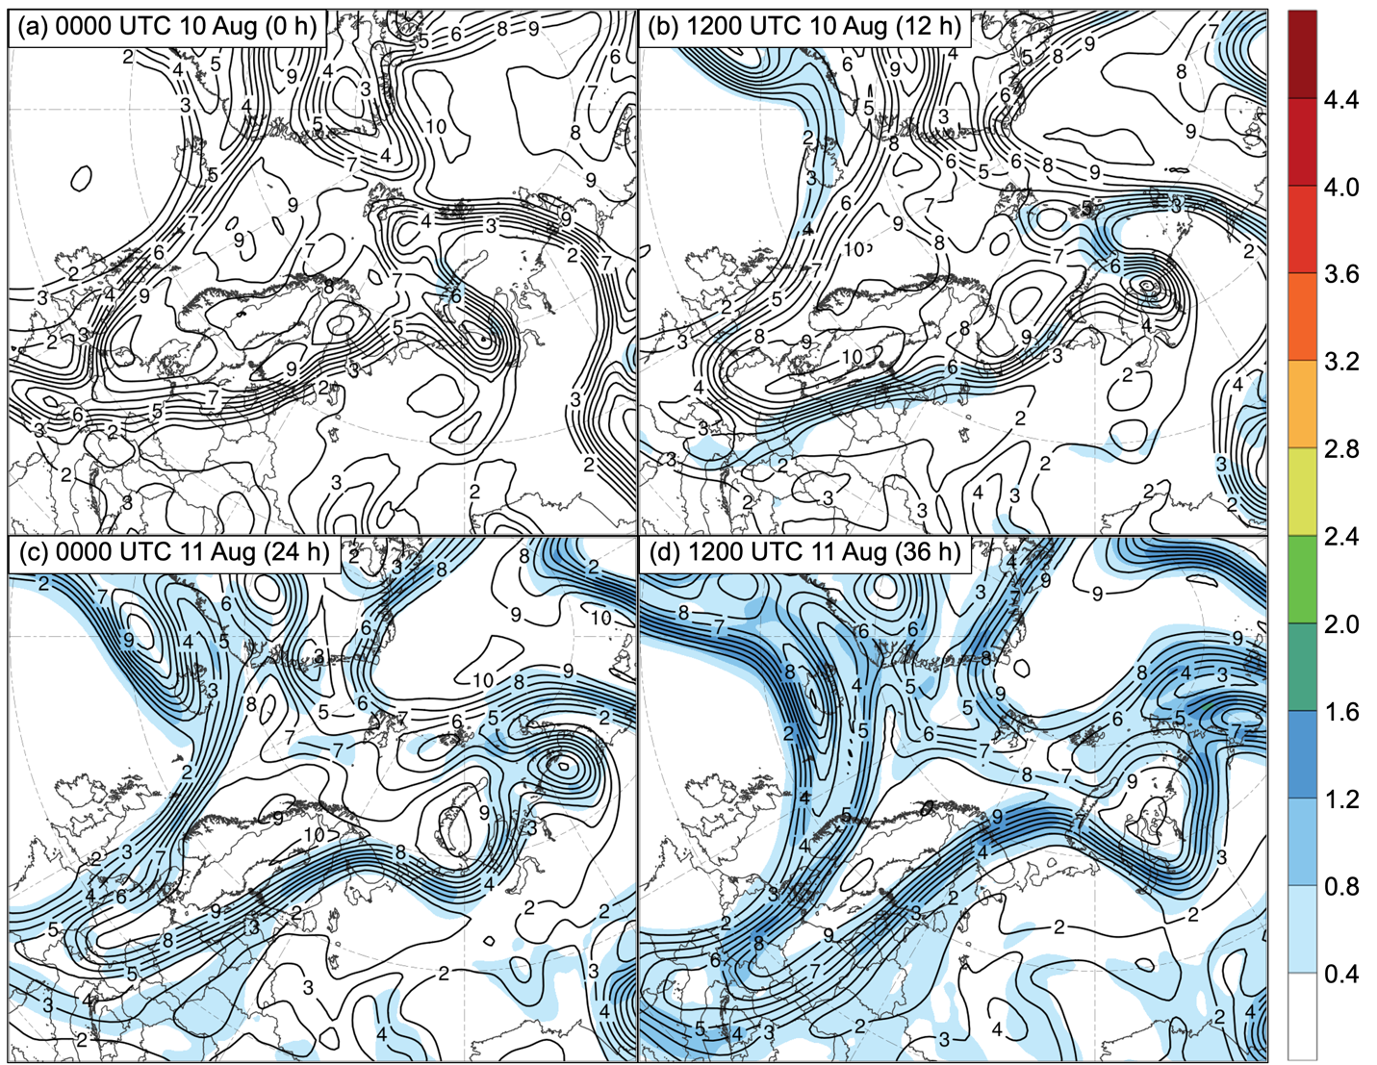

Fig. 1. Ensemble standard deviation of 250-hPa PV area averaged within 200 km of each grid point (PVU; shading) and ensemble mean 250-hPa PV area averaged within 200 km of each grid point (PVU; dark gray contours) for AC16 at (a) 0000 UTC 10 August (0 h), (b) 1200 UTC 10 August (12 h), (c) 0000 UTC 11 August (24 h), and (d) 1200 UTC 11 August 2016 (36 h).

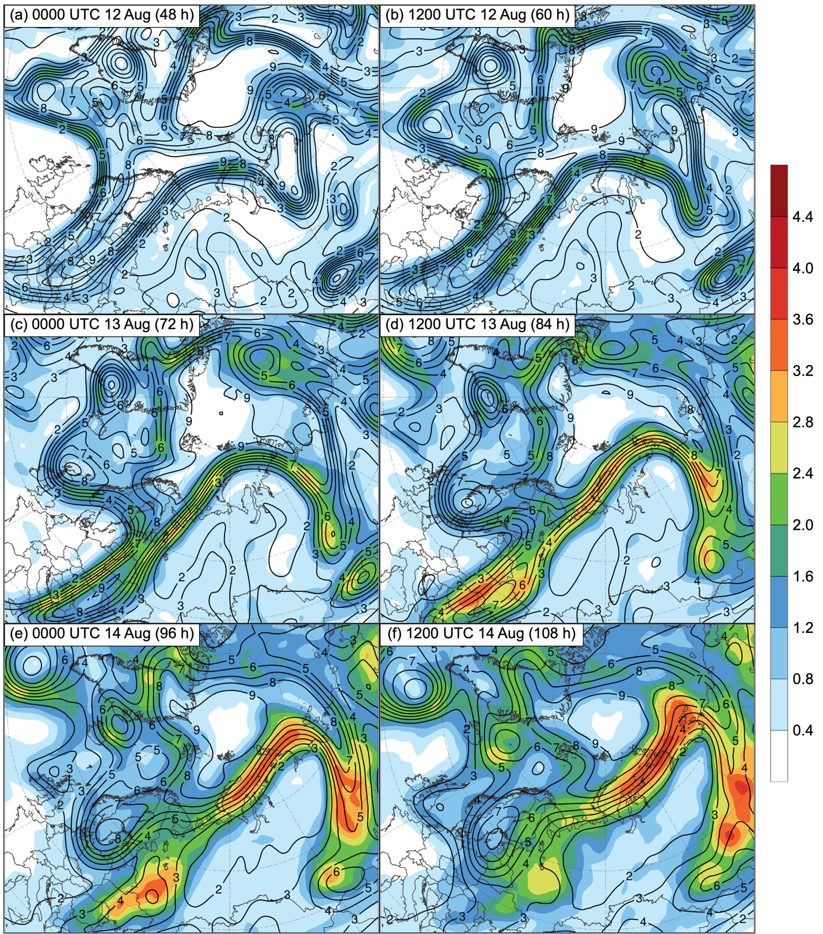

Fig. 2. As in Fig. 1, but at (a) 0000 UTC 12 August (48 h), (b) 1200 UTC 12 August (60 h), (c) 0000 UTC 13 August (72 h), (d) 1200 UTC 13 August (84 h), (e) 0000 UTC 14 August (96 h), and (f) 1200 UTC 14 August 2016 (108 h).

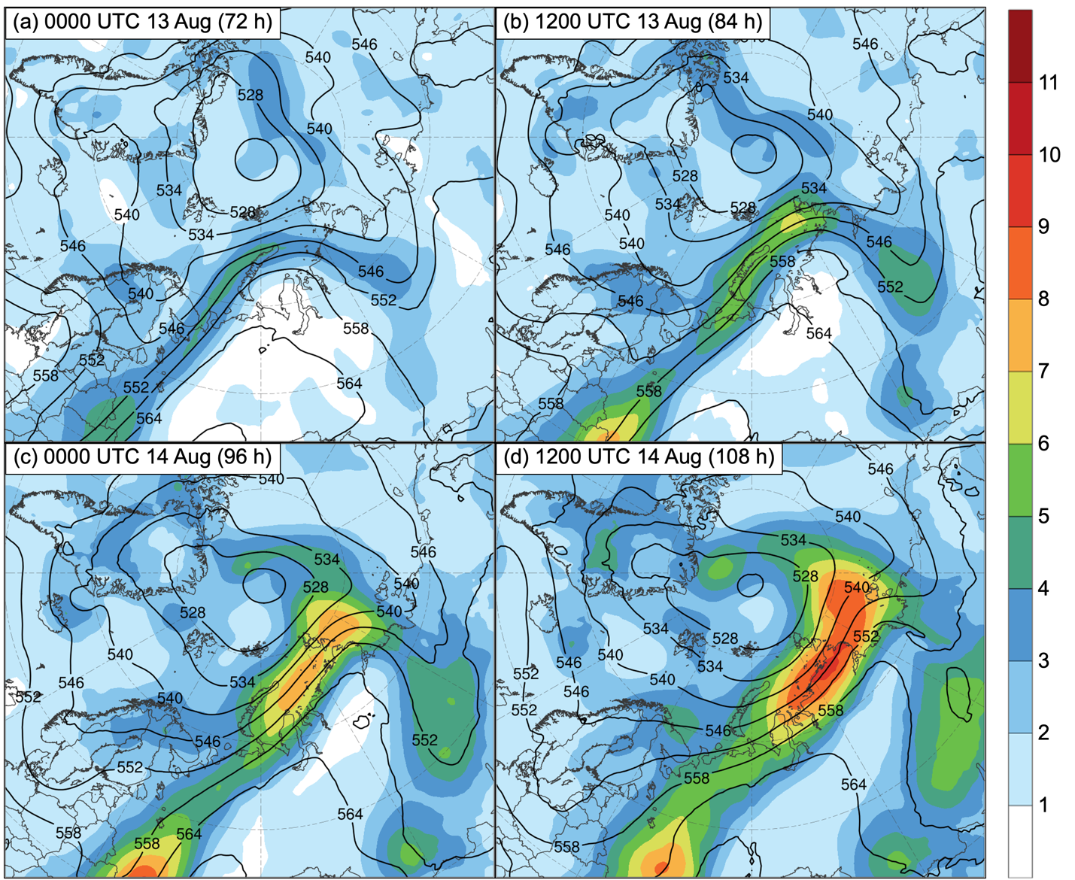

Fig. 3. Ensemble standard deviation of 1000–500-hPa thickness (dam; shading) and ensemble mean 1000–500-hPa thickness (dam; black contours) for AC16 at (a) 0000 UTC 13 August (72 h), (b) 1200 UTC 13 August (84 h), (c) 0000 UTC 14 August (96 h), and (d) 1200 UTC 14 August 2016 (108 h).

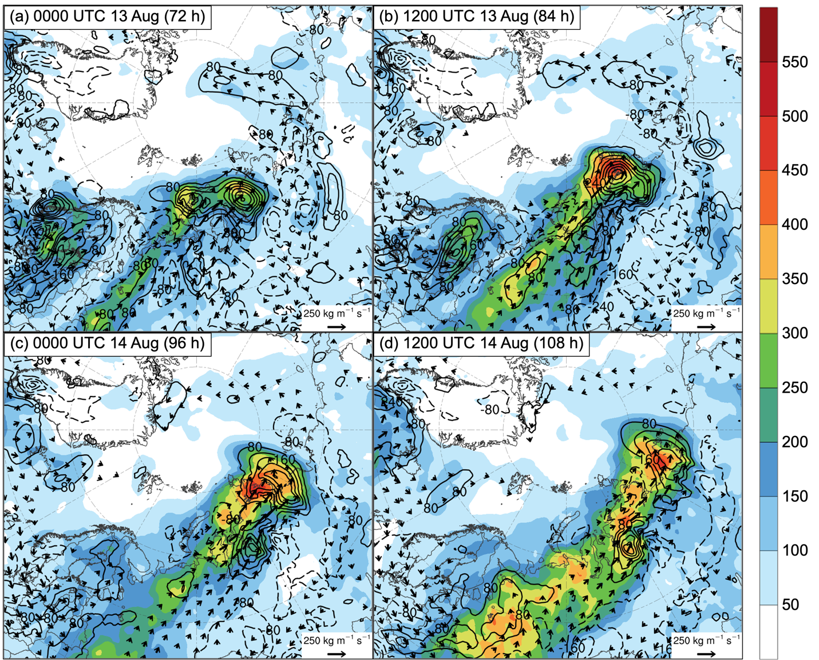

Fig. 4. Ensemble standard deviation of 1000–850-hPa IMFC area averaged within 200 km of each grid point (W m⁻²; shading), ensemble mean 1000–850-hPa IMFC area averaged within 200 km of each grid point [every 80 W m⁻²; black contours (solid for positive values and dashed for negative values)], and ensemble mean 1000–850-hPa IVT (kg m⁻¹ s⁻¹; vectors) for AC16 at (a) 0000 UTC 13 August (72 h), (b) 1200 UTC 13 August (84 h), (c) 0000 UTC 14 August (96 h), and (d) 1200 UTC 14 August 2016 (108 h).

