Spatial Variability in the Stratospheric Polar Vortex:

Implications on Northeast United States Temperature Anomalies

Chelsea Snide and Andrea Lang

University at Albany

Department of Atmospheric and Environmental Science

Departmental Honors Thesis

May 2019

**ABSTRACT**

With advancements in weather and climate forecasts, a prediction gap has arisen between the two-time ranges. This gap is defined as the sub-seasonal to seasonal (S2S) timeframe and describes forecasts at lead times of two weeks to two months. Creating reliable and useful S2S forecasts are difficult for primarily two reasons; long lead times means atmospheric initial conditions are lost and the interseasonal variations driven ocean variability are slower than the timescale. The community considers the slowly evolving winter stratospheric polar vortex as one source of variability that can influence the S2S timescale and as a consideration for improving S2S forecasts. The strength of the vortex and its correlation to temperature anomalies around the globe are well diagnosed in the literature, however, spatial variability in the polar vortex and it’s links to surface temperatures have not been well studied. Predictability can be improved by understanding how the shape and centroid influences temperature anomalies in conjunction with strong and weak conditions. This analysis examines the potential stratosphere–surface temperature teleconnections for the Northeast United States. The analysis quantifies stratospheric spatial variability using a best-fit ellipse fit to the 10-hPa stratospheric polar vortex. Then, Bayesian statistical analysis is applied to various stratospheric vortex scenarios. Probabilities of extreme warm of cold temperature anomalies are calculated based on the ratio of the vortex ellipse axes and centroid position.

**Introduction:**

**Sub-seasonal to seasonal forecasts:**

Increases in severe weather events such as droughts, major flooding, tropical cyclones and, extreme cold or heat events have been seen throughout the century. These events have serious implications for the communities that are impacted and better prediction of these can help mitigate their effects. The variability associated with the stratospheric polar vortex, the Madden Julian Oscillation and soil moisture can be used as considerations to improve the predictability of extreme events in the sub-seasonal to seasonal timeframe (S2S), ranging from two weeks to two months. This S2S timescale bridges the gap between the weather timescale, from 0 days to 2 weeks, and seasonal timescales, longer than 2 months. Forecasts in this timescale are categorized by poor forecast skill (Vitart et al. 2017). Despite the known prediction gap between weather and climate timescales, there are large socioeconomic decisions made that could utilize forecast information in these mid-range timescales. S2S forecasts are sought out by emergency managers, and people in the energy, water management and agriculture industries. The difficulty with S2S prediction arises from two primary factors, the lead time means that the memory of the initial conditions are generally lost and the lead time is too short of a timescale for the ocean to have a large influence on this variability (e.g., El Niño-Southern Oscillation). Forecasts made for the S2S time scale, must consider phenomena in the atmosphere, land and ocean that evolve slower than weather but faster than a season too accurately capture the sources of S2S forecast skill.

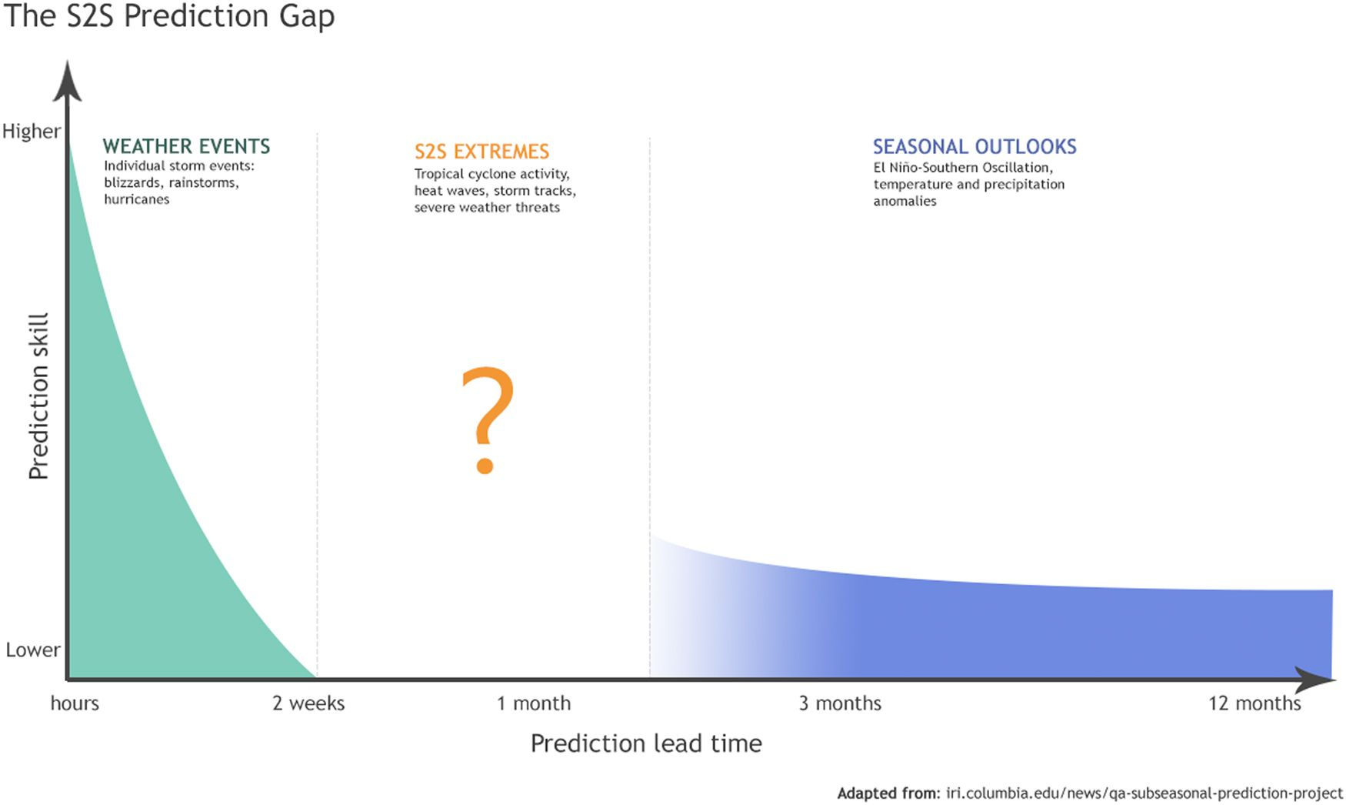

Figure 1: An adapted graph from IRI depicting forecast skill as a function of prediction lead time. There is a gap in predictability that bridges together weather and climate referred to as the sub-seasonal to seasonal timeframe.

**Challenges in S2S forecasts:**

There is a gap in knowledge and skill for S2S prediction and clear challenges in creating meaningful forecasts. The main challenges described by White et al. (2017) focus on understanding the ‘predictors’, systematic model deficiencies, quantifying uncertainty and an absence of forecast verification metrics. Understanding and identifying sources of forecast skill and teleconnections are important for understanding S2S predictability, this is an area of active research. Sources of S2S forecast skill come from phenomena that evolve in a predictable way over a series of weeks. These phenomena include stratosphere-troposphere interactions and the North Atlantic Oscillation (NAO), which are increasingly being utilized to create better S2S forecasts. Uncertainties in S2S forecasts result in limitations of the applications of these predictions and can be sourced from model initialization and deficiencies that arise from systematic errors in the model configuration. The systematic errors in the models create large uncertainties as the forecast lead time increases. An important component of improving S2S forecasts is to do forecast verification analysis, as well as examine detailed case studies, because these types of analyses will quantify forecast bias and systematic errors. Addressing these challenges ultimately create opportunities to improve atmospheric models and the understanding of atmospheric processes.

Summarizing Schreck et al. (2015) the natural gas industry is largely driven by heating and cooling demands and are particularly sensitive to variations in temperature extremes. In order for these companies to anticipate energy demands, temperature forecasts at the 2 to 4-week time frame are important. These temperature forecasts drive the prices of natural gas and energy. Particularly the region containing Chicago, New York City and Washington D.C. has a large influence on pricing and demand due to high population densities.

**Stratosphere-Troposphere interactions:**

The stratospheric polar vortex is a phenomenon that develops in winter season as the long nights cool the high-latitude regions. The stratospheric polar vortex is characterized by a westerly jet circulation that develops in the upper stratosphere around 60˚N as a result of the strong temperature gradient and thermal wind relationship. The troposphere can interact with the stratosphere through vertical Rossby (planetary) wave and gravity wave propagation. The wave propagation and wave breaking influences the momentum and thermal fields in the stratosphere, which can disrupt the stratospheric polar vortex. The momentum and thermal anomalies in the stratosphere can progress downward into the troposphere, producing a circulation response. According to Kidston et al. (2015), the variability in the stratospheric polar vortex is attributed to troposphere waves transporting momentum upward. The angular momentum is then deposited within the vortex through the wave activity flux convergence resulting in changes in the vortex circulations. When wave forcing is anomalously weak the polar vortex circulation will strengthen, if wave forcing becomes anomalously strong the opposite will occur and the polar vortex will therefore weaken. Ultimately, the changes in vortex strength and stratospheric wind speed will induce changes that impact tropopause height, surface pressure and the tropopause jet stream through adiabatic cooling and heating.

There are two main ways the stratospheric polar vortex variability can be categorized, vortex displacement and vortex splitting events. Weak polar vortex events are often described by the extreme conditions associated with a sudden stratospheric warming (SSW). SSWs characterized by the weakening of the polar westerlies to the point that they completely reverse to become easterlies in the mid-winter (e.g., Charlton and Polvani 2007). The two main SSW events are vortex splitting and vortex displacement events. The main difference between splitting and displacement events is the Rossby wavenumber that excites each of them. Splitting events are associated with a Rossby wavenumber of one and excite a barotropic mode, while displacement events are associated with wavenumber two and excite a baroclinic mode. As described by Tripathi et al. (2015), displacement events are associated with larger predictability than splitting events. When describing the impact of the polar vortex, three Northern Hemisphere locations are often used, Eastern Canada/United States, Northern Eurasia and the Middle East region (Baldwin and Dunkerton 2001).

Onsets of SSW events are associated with a negative North Annular Mode (NAM) and Arctic Oscillation (AO). This is categorized as by higher surface pressures over the Arctic, weaker zonal winds, equatorward shift of the tropopause jet stream and thus an increase in the movement of cold polar air into the mid-latitudes. According to (Tripathi et al. 2015) weak polar vortex events generally are followed by warm temperature anomalies in Eastern Canada and the Middle East but cold temperature anomalies in Northern Eurasia.  Generally, weak polar vortex events offer higher predictability in sub-seasonal forecasts in those three regions. Unlike weak events, strong polar vortex events are associated with a positive NAM/AO signal which is characterized by low pressure anomalies over the Arctic, strong zonal winds, a poleward shift in the jet stream and less frequent movement of polar air into the mid- latitudes. A strong polar vortex event is associated with warm temperature anomalies over Northern Eurasia and weak cold temperature anomalies in Eastern Canada. Generally, the teleconnections created by strong polar vortex events are much weaker than those caused by weak events.

Other phenomena, such as the Quasi-Biennial Oscillation (QBO), have to be considered when assessing the predictability of SSW events. The QBO is defined by the oscillation between easterly and westerly mean flow in the equatorial stratosphere, the oscillation take place about every two years. This has a large impact on the polar vortex strength from year to year. When the QBO is in a westerly phase, the polar vortex is more likely to become anomalously strong. Likewise, when the QBO is in an easterly phase the polar vortex will likely become anomalously weak. During an easterly phase SSW events become more likely due to a weaken circulation.

**Spatial variability in the polar vortex:**

The strength of the vortex and its correlation to temperature anomalies around the globe are well documented in the literature (Butler et al. (2017) and Lehtonen et al. (2016) ), however, spatial variability in the polar vortex has not been well studied. By examining how the shape and location of the stratospheric vortex influence the surface temperature anomalies associated with strong and weak vortex events, predictability can be improved. This research examines the relationship between the polar vortex morphology, quantified via the polar vortex ellipse metrics of ratio, rotation (angle from the dateline) as well as the centroid location, and their relation to Northeast temperature anomalies.

**Data and methodology:**

**Polar vortex and temperature:**

Daily temperature anomalies at 1200 UTC are calculated with respect to the 1979-2017 climatology using the ERA-Interim (ERAI) reanalysis dataset (Dee et al. 2011). Only the Northern Hemisphere cool season, defined as November, December, January, February and March (NDJFM), is considered for the years 1979–2016. The polar vortex dataset includes years 1979–2016. The stratospheric vortex ellipse is calculated by applying a best-fit ellipse to the 30-km contour of the 10-hPa geopotential height field in the ERAI data. From the best fit ellipse, metrics representing the ellipses long and short axis lengths, a centroid latitude and longitude location, vortex area, and rotation (long axis direction relative to 0˚ longitude) are calculated for the daily 0000 UTC data. Additionally, the ‘traditional’ stratospheric variability metrics the 10-hPa zonal mean U-wind at 60˚N and polar (75˚–90˚N) cap temperature were calculated.

The analysis uses three lag times, a three, a five and a seven-day lag with respect to the stratospheric state. A lag time is expressed as a temperature anomaly occurring a number of days after a vortex variable threshold is observed. This is used because there is a delay between the disturbance in the stratosphere and the downward signal that impacts the troposphere. Lastly the analysis is broken into three different categories of stratospheric events, (1) strong polar vortex, (2) weak polar vortex and (3) all events, which has no constraints on vortex extreme conditions. For the strong and weak events, we use the central dates as defined in Huang, et al. (2017) plus and minus five days. The central dates are evaluated using the 10-hPa NAM index where weak events are defined as having a NAM index that is -1 standard deviation from normal for 15 days and a strong event as a +1 standard deviation for 15 days. In this study 18 strong events and 22 weak events are considered, they are listed in Table 1.

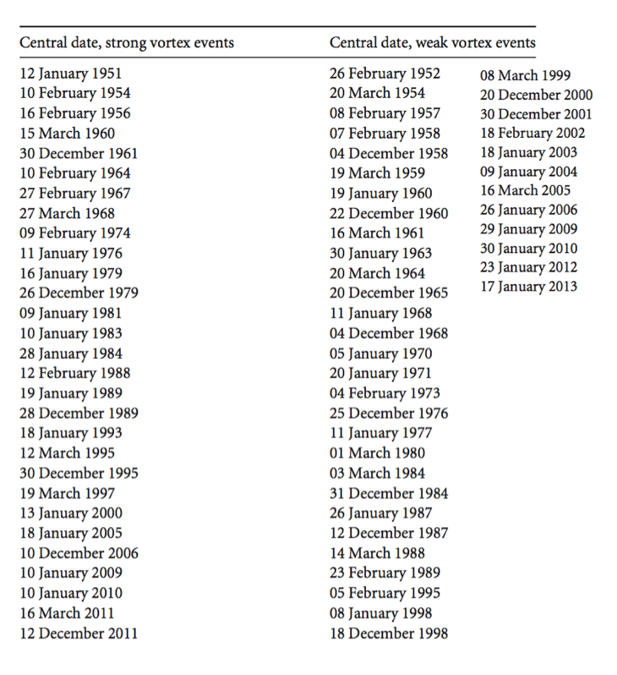

Table 1: A table showing the central dates for strong and weak vortex events. Adapted from Huang et al. (2017)

Temperature anomalies occurring only in the Northeast to Midwest regions of the United States are considered for this study. The northeast is defined as a box with latitude constraints of 37˚N and 43˚N and longitude constraints of 90˚W and 70˚W. This box was designed to include three major US cities, Chicago, Washington D.C. and New York City. The region inside the box is important to the energy industry because it is used to calculate heating degree days due to the high population density (Fig. 2). It is important to note that our North American box differs from other studies such as Tripathi et al. (2015b) where the box is defined in Eastern Canada and parts of the Northern United States.

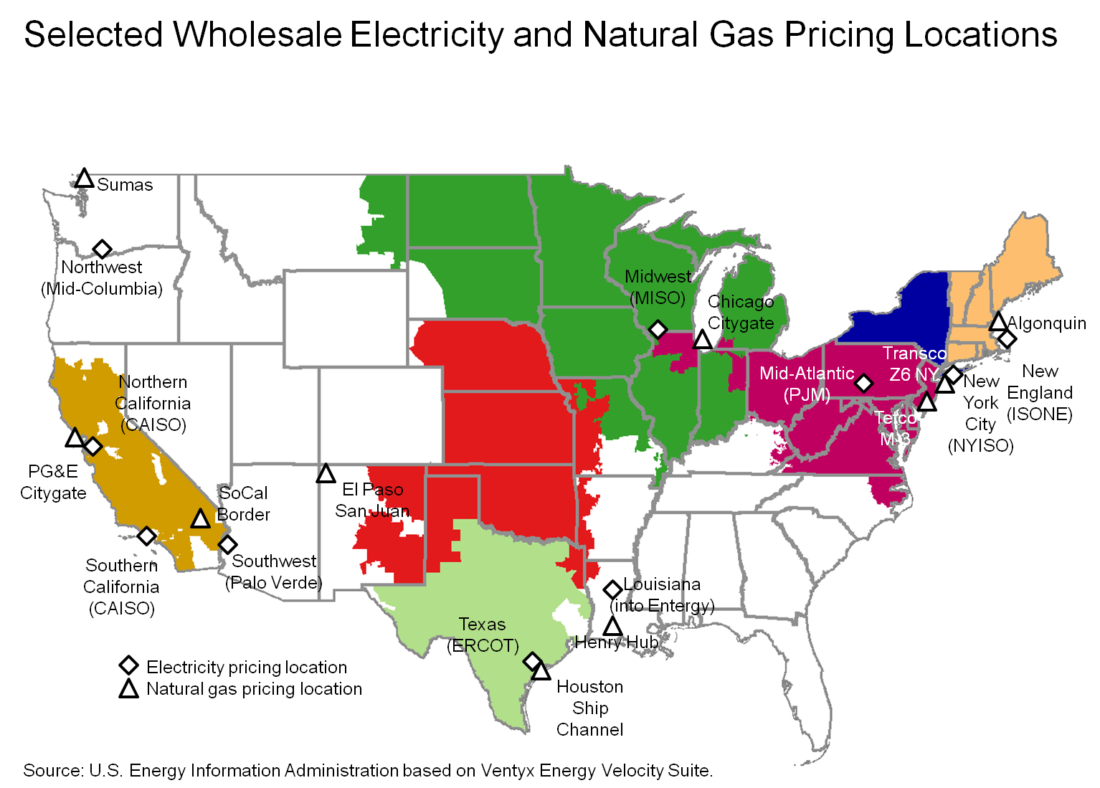

Figure 2: A map of the Eastern United States highlighting wholesale natural gas and electricity pricing locations.

**Calculating Polar Vortex Parameters:**

The three main polar vortex parameters that are used in this paper are the centroid location, the vortex rotation (angle from the prime meridian) and the vortex size. In order to calculate the ratio, the size must first be determined. This is done by using the 30-km geopotential height contour at 10-hPa as a guide to find the best-fit ellipse. Once the ellipse is determined the vortex ratio is quantified as the length of the short axis of the ellipse divided by the length of the long axis, the values range from 0.0 to 1.0, with smaller values representing a vortex that is more elliptical in shape and higher values representing a vortex that is more circular. To further categorize the shape of the vortex, the ratio is broken up into four categories by value, (a) 0.0 – 0.25, (b) 0.26 – 0.50, (c) 0.51 – 0.75 and (d) 0.76 – 1.0, these categories will be used in the analysis.

$$Ratio= \frac{Short Axis}{Long Axis}$$

Using the long axis, the orientation or rotation of the vortex can be calculated. For the analysis, the rotation is quantified as the angle between the Prime Meridian (0˚ Longitude) and the long axis that is pointed over the Western Hemisphere. The rotation angle ranges from 0˚, where the long axis pointed towards the United Kingdom, and -179˚ where the long axis is pointed toward the Bering Sea. Considering the rotation is relation to the ratio can give an idea of where the vortex is oriented towards and how elongated it is, two metrics that anecdotally have been used in forecast discussions to infer surface temperature impacts from stratospheric variability.

Lastly the centroid location is quantified by the latitude and longitude position of the center of the calculated ellipse. This is broken up into four quadrants and a polar region, similar to the Figure 3. The polar region is defined as all points falling poleward of 75˚N latitude and the four quadrants are broken up by longitude. Quadrant 1 is defined as 0˚ to -90˚ longitude (North Atlantic region), quadrant 2 is defined as -90˚ to -180˚ (Alaskan region), quadrant 3 is defined as -180˚ to 90˚ (Asian region) and lastly quadrant 4 is defined as 90˚ to 0˚ (European region).

It is important to note that all the calculated parameters for the polar vortex are based on the largest vortex present. Meaning if the vortex has split into multiple vortices as can happen in SSW events, the 30-km contour that contains the largest area will be the focus.

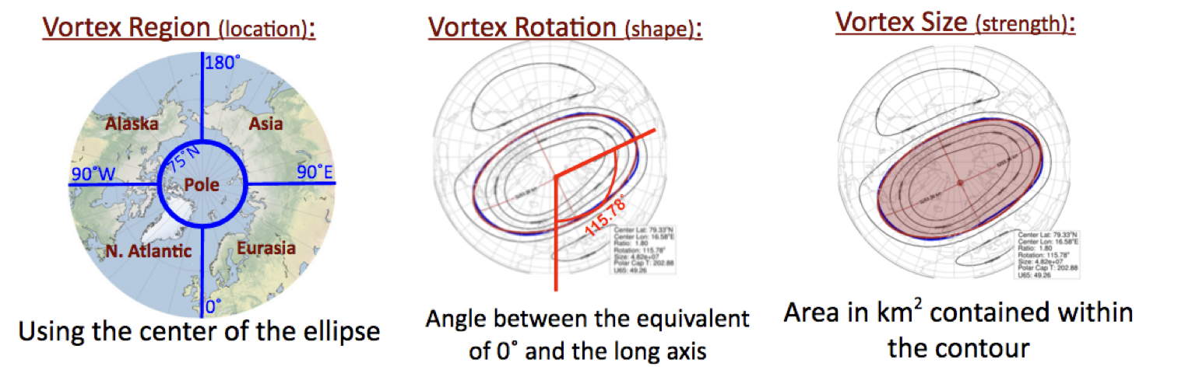

Figure 3: An adapted figure from Andrea Lang depicting the visualization of the stratospheric polar vortex parameters that are utilized. On the left is the vortex center location, in the middle is the rotation angle based on the prime meridian and on the right is the vortex size based on the 35-km contour.

**Bayesian statistics:**

It is common to use a frequentist method, based on a Boolean testing of whether an event occurs or not, for calculating statistics but there are numerous drawbacks to this method. One of the main disadvantages to this type of method is that it heavily relies on the sample size of the test group, meaning that different sample sizes can result in different answers. Applied to understanding the probability of certain thresholds of temperature anomaly, Bayesian statistics can be used to quantify the probability of a specific temperature anomaly knowing a given atmospheric state. In our analysis the given atmospheric state will be quantified by the polar vortex parameters, such as the category of ratio, by incorporating models and parameters. Using this method of statistical analysis allows for the inclusion of prior probabilities and therefore can assign a probability to a hypothesis rather than to an event. Using Bayesian statistics means that the probabilities are not a result of how frequent a scenario is but is a representation of how likely it is this scenario will occur. In this paper, a Bayesian analysis will be used to understand how probable it will be for a temperature anomaly to occur knowing information about the stratosphere. This will pin point scenarios that offer the highest and lowest probability of occurring to improve predictability.

$$P\left(H | E, I\right)= \frac{P\left(H | I\right)P(E|H,I)}{P(E|I)}$$

For example, in Bayes theorem shown above, the H represents the hypothesis that is being tested, E represents the evidence we have supporting the hypothesis, I is the information, and the function P(H|E) represents the probability of H given E conditions. More specifically, the posterior probability P(H|E,I) describes the probability of a temperature anomaly knowing the vortex ratio, the prior probability P(H|I) is the probability of the anomaly occurring, the likelihood P(E|H,I) is the probability of the ratio resulting in the anomaly and lastly the evidence P(E|I) is the probability of the ratio occurring. In order to determine the prior probability and the evidence a Gaussian curve is calculated and used as the model for these vortex and temperature variables. The distribution of temperature anomalies is approximately a normal distribution, a standard deviation (4.95) and a mean (0) is used to calculate probabilities (Fig. 4a). However, the ratio distribution cannot be assumed to be normal so the area under the curve is calculated for each interval (Fig. 4b). It is important to note the low probability of a ratio of 0.0 – 0.25 to occur during the analysis.

**A) B)**

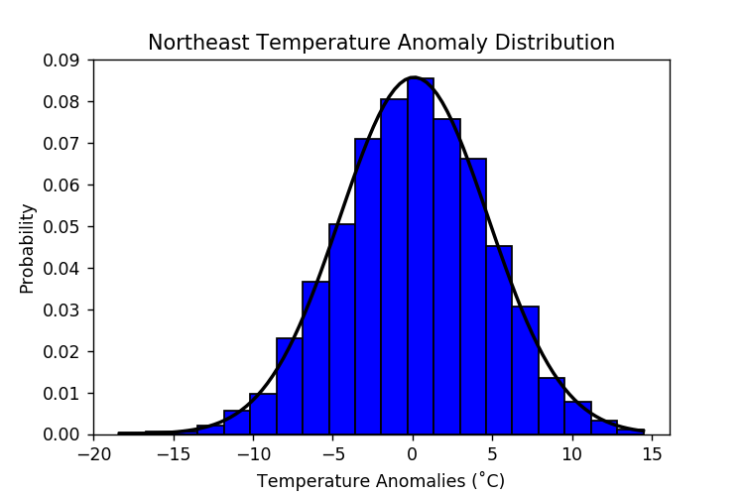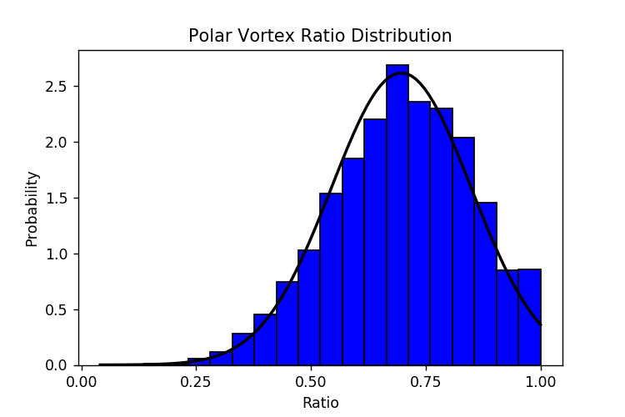

Figure 4: The (a) Northeast temperature anomaly distributions and (b) the polar vortex ratio distribution are the two modeled parameters used in the Bayesian probabilistic forecasts. In (a) is a PDF of Northeast temperature anomalies, this is assumed to be normally distributed and has a standard deviation of 4.95. In (b) is the distribution of the polar vortex ratio. Here the probabilities are calculated by finding the area under the curve.

|  |  |
| --- | --- |
| **Ratio** | **Probability** |
| **0 – 0.25** | **0.002** |
| **0.25 – 0.5** | **0.107** |
| **0.5 – 0.75** | **0.506** |
| **0.75 – 1.0** | **0.369** |

Table 2: A table showing the probabilistic values using the distribution in figure 3 for certain ratio categories. These are calculated by finding the area under the curve for each category.

**Results and Discussion:**

**Ellipticity Probabilistic Forecasts:**

The polar vortex ratio is used to create probabilistic forecasts to predict the Northeast United States temperature anomalies using three lag times, (a) 7-day, (b) 5-day and (c) 3-day lag. As an example, a 7-day lag takes into account a temperature anomaly that occurs 7-days after a parameter in the stratosphere is meets a certain threshold. A lag is used because the interactions that occur between the stratosphere and troposphere are not instant and takes time to affect the lower atmosphere. Different stratospheric vortex scenarios are considered in this analysis, these include all events (all observed data), weak polar vortex events and strong polar vortex events. The weak and strong events can be directly reflected in the vortex ratio and considering both the vortex strength and ratio can be useful in S2S forecasting. When the vortex is weak, this means that the mean circulation is either weak westerlies or have completely reversed to easterlies. During these weak vortex events, increase wave activity in the stratosphere meaning that the vortex is likely more disturbed, allowing the vortex to have a more elongated (low ratio values) shape. The opposite is true when the vortex circulation is stronger than climatology, the reduced wave activity in the stratosphere will allow for a more contained or circular (high ratio values) vortex. It is important to note because of the circular nature of a strong vortex a ratio of 0 – 0.25 does not occur in the observations. Figure 5 shows the results from the Bayesian probabilistic forecast calculations ±4.9˚C given the vortex ratio categories. Higher values represent higher probability that the temperature anomaly will occur when the ratio is observed in the stratosphere and vice versa for lower probabilities. Fig. 5b shows that at the 5-day lag time, the highest predictability is observed relative to the two other lag times, calculated in terms of number events that have a probability of 0.70 or higher. During the 5-day lag time, there are two large predictability scenarios, one for a cold anomaly when the vortex is weak and has a ratio of 0 – 0.25 and one for a warm anomaly when the vortex is strong and has a ratio of 0.51 – 0.75. Bayesian statistics are helpful when dealing with small sample sizes, for example the ratio category that is most elliptical has a very small sample size due to how unlikely it is to occur based on our observations. If using a frequentist method, the probabilities calculated from small sample sizes will have large uncertainties but this is eliminated through the use of Bayesian statistics.

**(a) 7-Day (b) 5-Day**

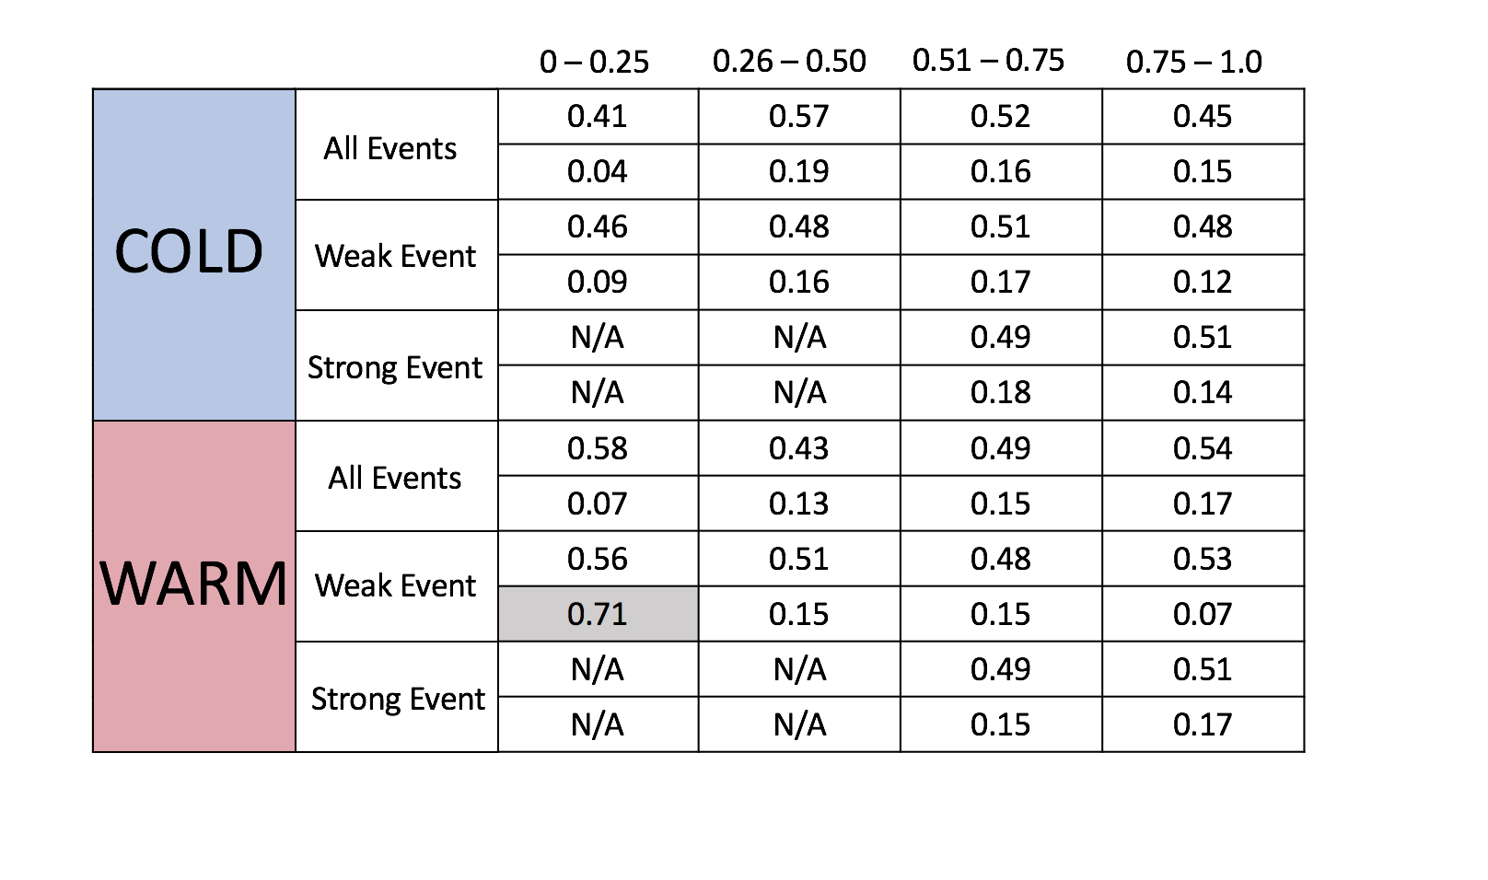 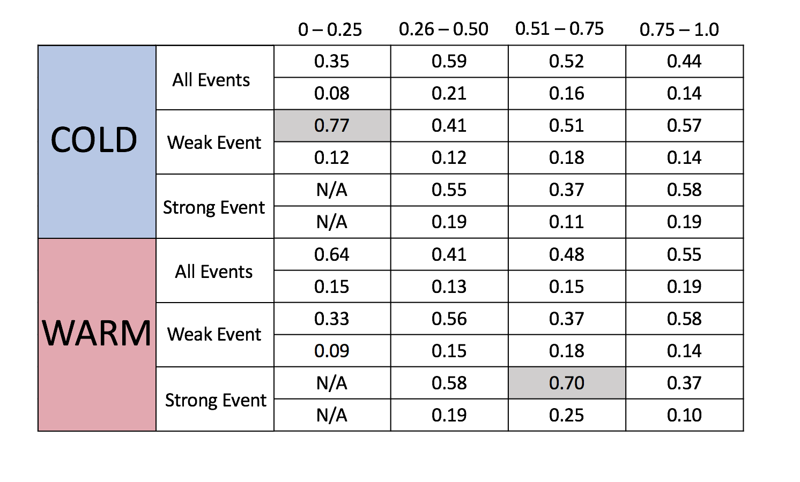

(c) **3-Day**

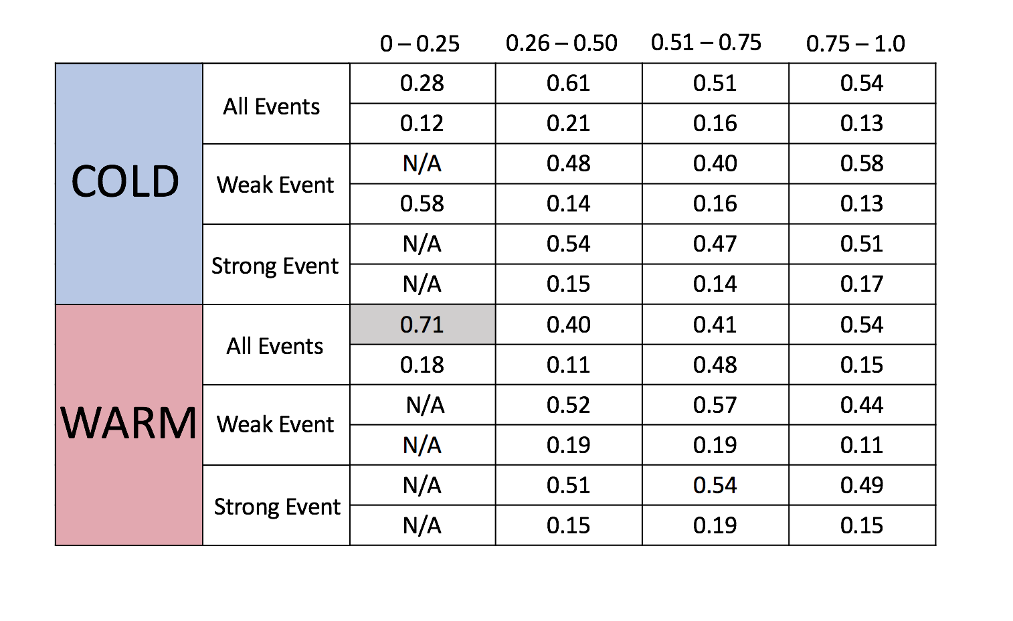

Figure 5: The results from the Bayesian probabilistic forecast calculations. The 7-day lag is pictured on the top left, the 5-day lag on the top right and the 3-day lag on the bottom. Shaded grey values show those that are above the 70% line representing the most probabilistic values. The top row for each event is for all cold/warm anomalies and the bottom row is the one standard deviation anomaly.

Next, we used the ERAI reanalysis as observations to construct a composit analysis of all cold anomalies that corresponded with a weak vortex event and a 0 – 0.25 ratio at the 5-day lag. It is important to note that these averages represent a small sample size (n = 3) due to the low frequency of the smallest ratio values in observation (27 January 1987, 14 March 1988 and 15 March 1988). The set up of major features are consistent between each event, meaning small spread in the atmospheric flow between the dates. At the 500-hPa level (Fig. 6), the average height anomalies depict a deep trough feature (negative height anomalies) that extends across most of eastern North America to the Gulf Coast, while anomlous ridging is apparent over Alaska and the Bering Sea. It is clear that there is a large amplitude pattern consistent with a negative Arctic Oscillation (AO) phase, where the higher heights over Greenland and anomalous low heights over the central Atlantic project onto the –AO pattern. The AO is important in the sense that it can indicate a weaker jet circulation that allows for a large amplitude pattern, however, it is a statistical index and it is important to consider the synoptic flow pattern. As indicated by the anomalous trough, a large region of low-level cold temperature anomalies can be seen across the majority of the Eastern United States at the 850-hPa level (Fig. 6). In the area of interest temperature anomalies reach up to the -8 to -10˚C range, indicating that it is an extreme cold outbreak. Lastly, looking at 10-hPa (Fig. 6), the same level the vortex paramenters are calculated at, there is one polar vortex, with anomalously lower heights stretched over Eurasia and an area of higher heights over the poles and North America. Typically, for baroclinic waves the geopotential ridge or trough anomalies tilt westward with height, meaning where we see anomalously high heights in the stratosphere we can expect to see corresponding anomalously low heights near the surface. This is consistent with the the 10-hPa and 500-hPa heights, where the troughing over the Northeast United States at 500-hPa is seen to tilt westward and at 10-hPa low heights are over the Pacific ocean.

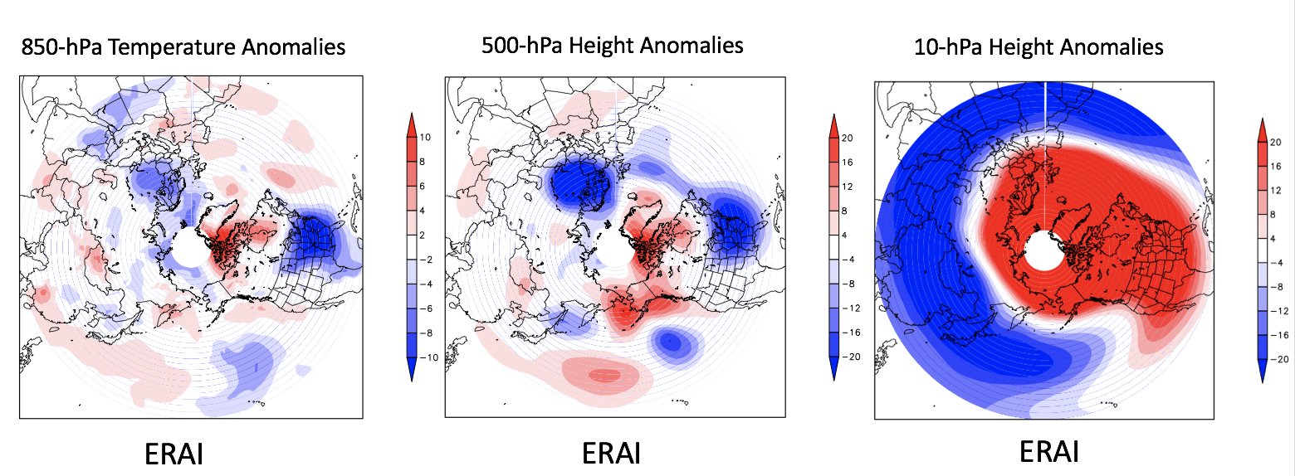

Figure 6: The average composite anomaly for cold anomalies associated with a weak event and a 0-0.25 ratio at the 5-day lag. On the left is the average anomaly for the 850-hPa temperature, centered is the average anomaly for 500-hPa height and on the right, is the average anomaly for the 10-hPa heights. There is a sample size of n=3.

The average synoptic set up for the warm anomalies occurring during a strong vortex event with a vortex ratio of 0.5 – 0.75 is being analyzed at the 5-day lag time. These events have a considerably larger sample size (n=38) than the previous group had. The average temperature anomaly signature at 850-hPa depicts warmer than normal conditions across the Central and Eastern United States and north into Canada (Fig. 7). This temperature pattern is consistent with the synoptic set up a the 500-hPa level (Fig. 7). Associated with the warm temperature anomalies is higher than average heights over most of the Eastern United States signifying riding over the region. Another notable feature is the lack of a Pacific ridge as shown by the negative height anomalies over Alaska. Without the Pacific ridge the pattern suggests a –PNA phase allowing for warm air to reach farther north in the east due to predominately southerly winds. As discussed above, because pressure slants westward with height, negative height anomalies are expected over the Eastern United States in the stratosphere (10-hPa) and positive anomalies over the Pacific region.

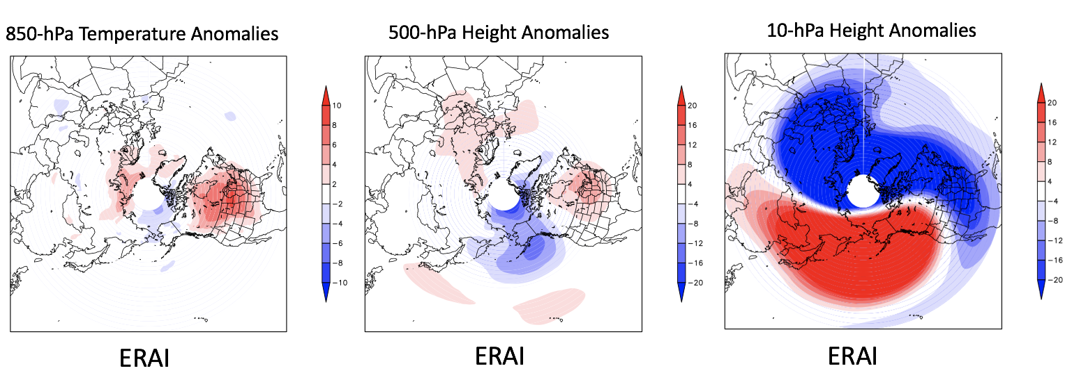

Figure 7: The average composite anomaly for warm anomalies associated with a strong event and a 0.5-0.75 ratio at the 5-day lag. On the left is the average anomaly for the 850-hPa temperature, centered is the average anomaly for 500-hPa height and on the right, is the average anomaly for the 10-hPa heights. There is a sample size of n=38.

**Vortex Rotation and Ratio**

Analyzing cold and warm anomalies as a function of vortex ratio and rotation can give insight on how temperature in the Northeast United States varies based on morphology of the stratospheric polar vortex. The warm anomalies observed over the Northeast US show large spread in the ratio and rotation fields with no clear correlations. However, there are very little to no values occurring with the small ratio group (0 – 0.25) unlike in the cold anomalies. Considering the cold anomalies in greater detail, there is quite large spread with no clear clustering of the temperature anomalies. Interestingly, the few anomalies that were associated with a small ratio fell between a rotation angle of 0˚ and -180˚ meaning the vortex is rotated towards the Europe. Furthermore, in all of these cases the vortex was split into two to three vortices signifying a sudden stratospheric warming event may have occurred around the time frames. Using the 10-hPa height anomalies there are largely positive height anomalies over the polar region indicative of an SSW because through the hyposmetric equation, higher heights mean larger mean column temperature. In the anomaly composite, there is arguably two centers of anomalously low heights, corresponding to the main vortex is stretched over Eurasia while a second smaller vortex is located over the Atlantic and North America. A synoptic examination of these cases was performed. Weak temperature anomalies as shown on the 850-hPa level spread over the majority of the Eastern US that is associated with troughing at the 500-hPa level over this same region. Although the scatter plots do not suggest large correlation this may be because of the number of vortices present during a given temperature anomaly. By filtering the number of vortices there may be a clearer relationship between the vortex rotation and ratio.

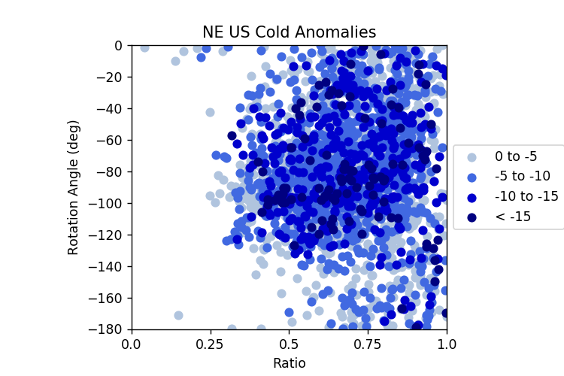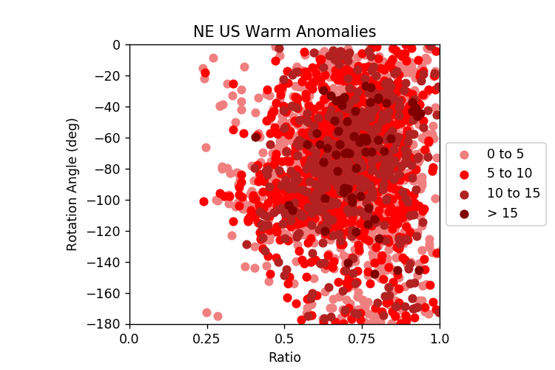

Figure 8: A scatter plot of temperature anomalies as a function of vortex rotation and ratio. On the left, is the cold temperature anomalies and on the right, is the warm temperature anomalies. Anomalies are color coded based on the magnitude.

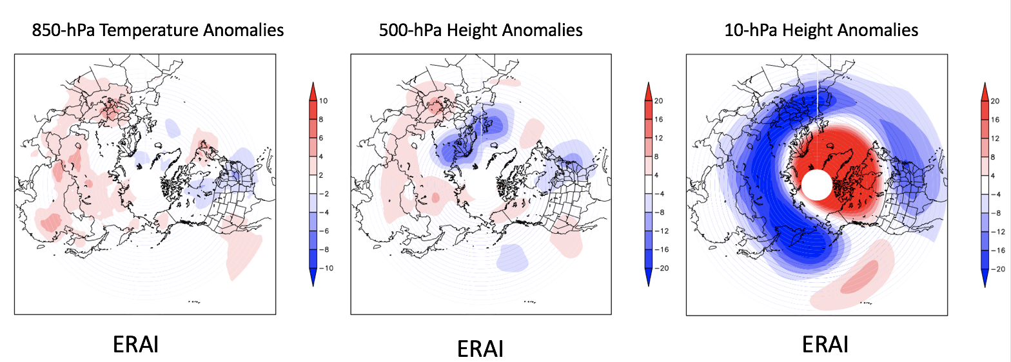

Figure 9: The average composite anomaly for cold anomalies associated with a rotation of -180/0 and a ratio of 0-0.25 at the 5-day lag. On the left is the average anomaly for the 850-hPa temperature, centered is the average anomaly for 500-hPa height and on the right, is the average anomaly for the 10-hPa heights. There is a sample size of n=9.

**Vortex Centroid and Ratio**

Information about how elliptical the polar vortex is as well as its center position is analyzed to determine what conditions may be favorable for warm or cold anomalies in the Northeast. In a climatological perspective, the centroid tends to favor quadrant 1, quadrant 4 and the polar region (Fig. 10). There are very few points centered in quadrants 2 and 3 which dominates the majority of the Pacific region. Overall there are no clear clusters that emerge when comparing these to parameters against each other. There is a higher density of points in the 0.5 – 075 ratio range that is a result of those occurring most often in nature.

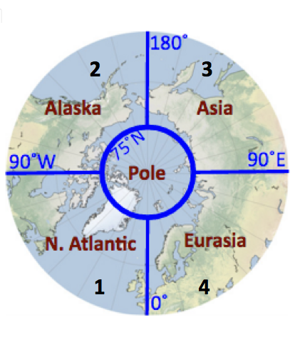

Figure 10: A figure demonstrating how the quadrants are broken up into. The polar region is defined as everything north of 75˚N and the four quadrants are labeled 1 through 4.

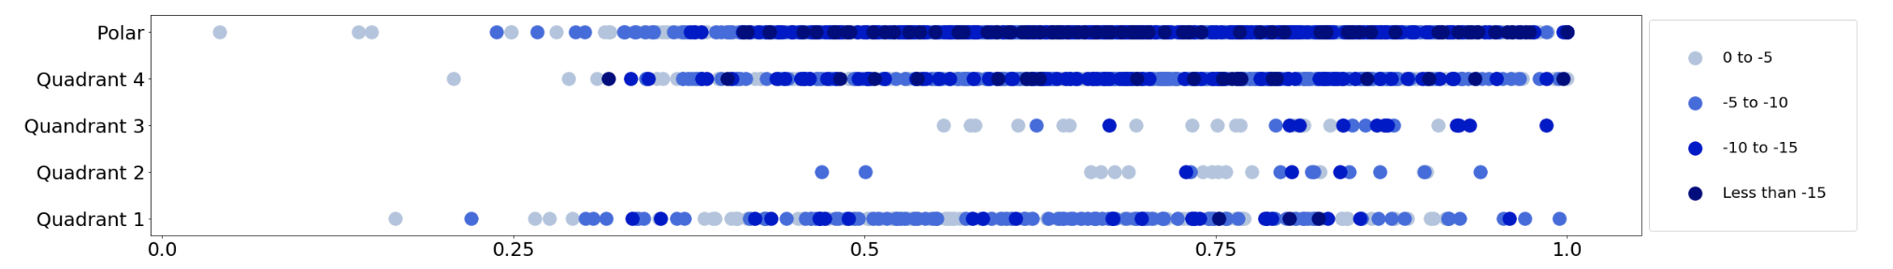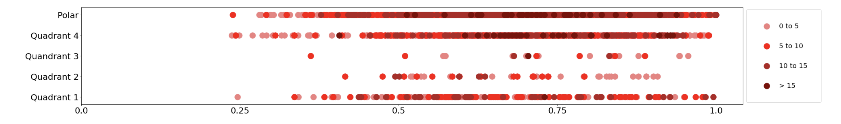

Figure 11: A plot of temperature anomalies as a function of vortex centroid position and ratio. On the topt, is the cold temperature anomalies and on the bottom, is the warm temperature anomalies. Anomalies are color coded based on the magnitude.

**Conclusion:**

Overall, it is important to consider all the parameters of the polar vortex in order to develop an informed temperature forecast for the Northeast United States. It was shown through Bayesian statistics that the best lag-time to create higher certainty forecasts is the 5-day lag. It is clear through papers such as (Baldwin and Dunkerton, 2001) and (Tripathi et al. 2015b) that there is a reliable teleconnection between the stratosphere and troposphere when considering weak and strong vortex events, but these do not include parameters about the spatial variability of the vortex. These results do not show strong correlations between the spatial variability of the vortex and the temperature anomalies occurring in the Northeast United States. However, in the future these parameters may help to improve sub-seasonal to seasonal forecasting when paired with weak and strong events. Other parameters such as number of vortices may also be an important variable to consider in a forecast as well.

**References:**

Baldwin, M. and T. Dunkerton, 2001: Stratospheric harbingers of anomalous weather regimes, Science, 294, 581-584 <http://science.sciencemag.org/content/294/5542/581.full>

Butler, A. H., J. P. Sjoberg, D. J. Seidel, and Karen H. Rosenlof, 2017: A sudden stratospheric warming compendium*, Earth Syst. Sci. Data*, <https://doi:10.5194/essd-9-63-2017>

Charlton, A.J. and L.M. Polvani, 2007: A New Look at Stratospheric Sudden Warmings. Part I: Climatology and Modeling Benchmarks. *J. Climate*, 20, 449–469, <https://doi.org/10.1175/JCLI3996.1>

Dee, D. P., Uppala, S. M., Simmons, A. J., Berrisford, P. , Poli, P. , Kobayashi, S. , Andrae, U. , Balmaseda, M. A., Balsamo, G. , Bauer, P. , Bechtold, P. , Beljaars, A. C., van de Berg, L. , Bidlot, J. , Bormann, N. , Delsol, C. , Dragani, R. , Fuentes, M. , Geer, A. J., Haimberger, L. , Healy, S. B., Hersbach, H. , Hólm, E. V., Isaksen, L. , Kållberg, P. , Köhler, M. , Matricardi, M. , McNally, A. P., Monge‐Sanz, B. M., Morcrette, J. , Park, B. , Peubey, C. , de Rosnay, P. , Tavolato, C. , Thépaut, J. and Vitart, F., 2011: The ERA‐Interim reanalysis: configuration and performance of the data assimilation system*. Q.J.R. Meteorol. Soc*., **137**: 553-597. <https://doi:10.1002/qj.828>

Huang, J. , Tian, W. , Zhang, J. , Huang, Q. , Tian, H. and Luo, J. (2017), The connection between extreme  stratospheric polar vortex events and tropospheric blockings. Q.J.R. Meteorol. Soc, 143: 1148-1164.   <https://rmets.onlinelibrary.wiley.com/doi/10.1002/qj.3001>

Kidston et al 2015: Stratospheric influence on tropospheric jet streams, storm tracks and surface weather. *Nature Geoscience* volume8, pages433–440 <https://www.nature.com/articles/ngeo2424>

Lehtonen, I., and Karpechko, A. Y., 2016: Observed and modeled tropospheric cold anomalies associated with sudden stratospheric warmings, *J. Geophys. Res. Atmos*., **121**, 1591– 1610, <https://doi:10.1002/2015JD023860>.

Tripathi et al 2015a: The predictability of the extratropical stratosphere on monthly time-scales and its impact on the skill of tropospheric forecasts. Quarterly Journal to the Royal Meteorological Soc. 141. <http://onlinelibrary.wiley.com/doi/10.1002/qj.2432/full>

Tripathi *et al* 2015b: Enhanced long-range forecast skill in boreal winter following stratospheric strong vortex conditions. *Environ. Res. Lett. 10* <http://iopscience.iop.org/article/10.1088/1748-9326/10/10/104007/meta>

Vitart, F., C. et al 2017: The Subseasonal to Seasonal (S2S) Prediction Project Database. *Bull. Amer. Meteor. Soc*., **98**, 163–173, https://doi.org/10.1175/BAMS-D-16-0017.1

White *et al* 2017: Potential Applications of Subseasonal-to-Seasonal (S2S) predictions. Meteorological Applications volume 24 pg 315-325. <https://rmets.onlinelibrary.wiley.com/doi/full/10.1002/met.1654>